Supplementary data
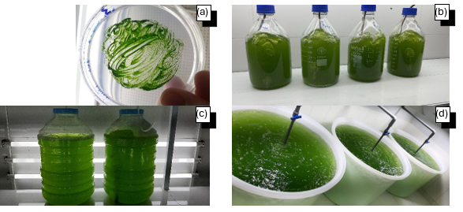
Fig S1. Incubating Desmodesmus sp. Strain microalgae by TAP medium in a) A petri dish, b) 2 L bottles, c) 20 L carboys, d) 1 m³ tanks.
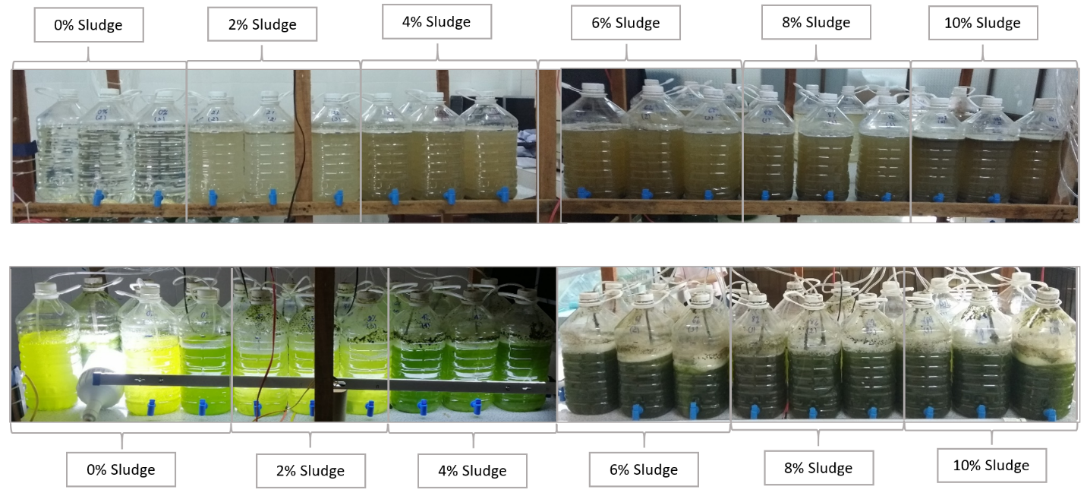
Fig S2. Visual observation of color changes in shrimp-pond wastewater after 10 days of Desmodesmus sp. cultivation in photobioreactors containing different sludge concentrations (0–10%).
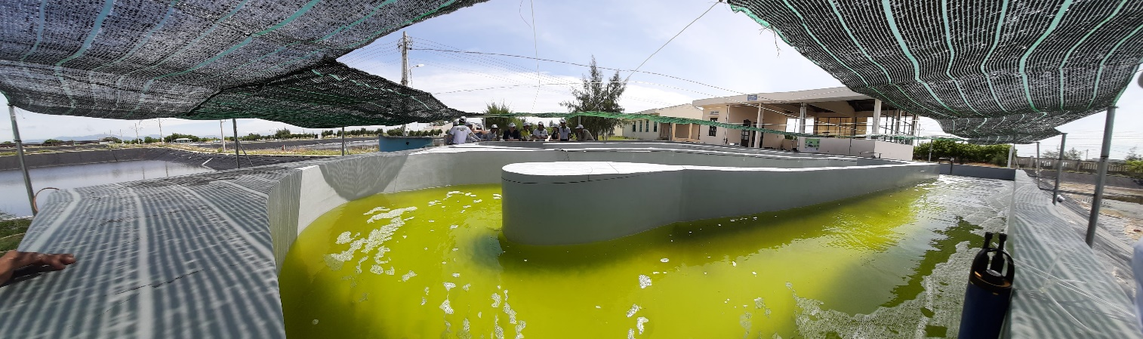
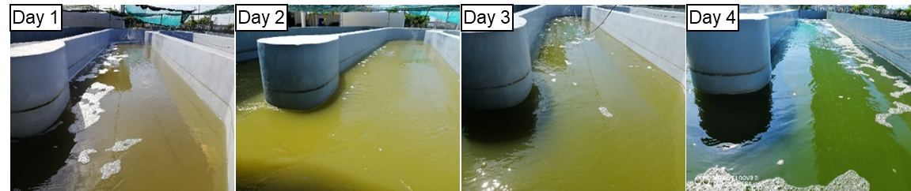
Fig S3. Experiment of growth microalgae in full scale 40 m3 HRAP adding sludge from shrimp-pond wastewater in tropical climate conditions and difference in cultivating time

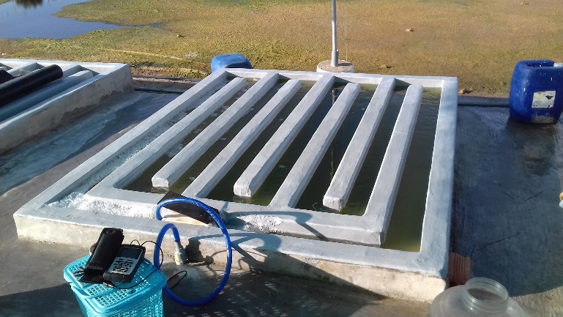
Fig S4. Pilot-scale cultivation of Desmodesmus sp. in a 350 L high-rate algal pond (HRAP) operated under outdoor conditions using shrimp-pond wastewater.
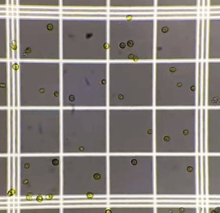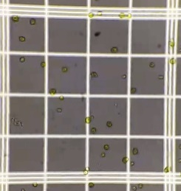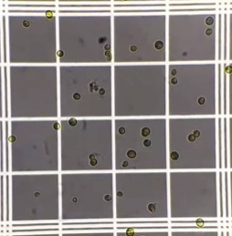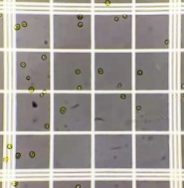
Fig S5. Microscopic observation of Desmodesmus sp. cells using a hemocytometer at 40× magnification for cell counting purposes.

Fig S6: Diurnal variations in environmental parameters during Desmodesmus sp. cultivation in outdoor HRAPs. a) Solar irradiation (W m⁻²), b) Water temperature (°C), c) pH levels on the final day of the exponential phase, and d) Dissolved oxygen (DO) concentration (mg L⁻¹) on the day preceding the exponential phase. Data are presented as mean ± standard deviation.

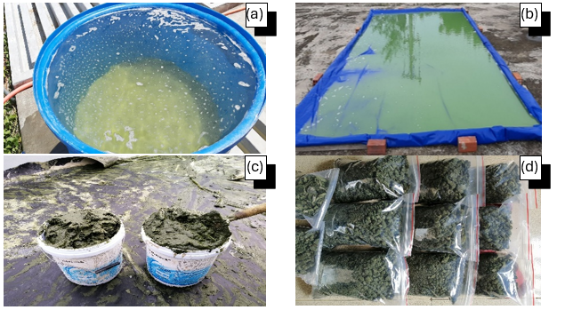
Fig S7. Microalgae harvesting process a) After flocculation and sedimentation in a 1.5 m³ tank, b) Harvested liquid spread out to dry under the sun, c) Wet biomass, d) Dried biomass
Table S1. Comparison of cultivation conditions, growth performance, and nutrient removal efficiency of Desmodesmus sp. in photobioreactor (5 L) and full-scale HRAP system (40 m³).
Parameters | Photobioreactor | HRAP
Working volume | 5 L | 40 m³
Cultivation condition | Indoors, 25 ± 1 °C,  40 ± 15 W·m⁻² | Outdoors, 36.6 ± 1.2 °C, solar radiation up to 770 W m⁻²
Cultivation time | 12 days | 4 days
Growth rate | 0.387 ± 0.139 day⁻¹ | 1.076 ± 2.157 day⁻¹
NH₄-N removal efficiency | 99.6 ± 0.03% | 89.76 ± 1.4%
PO₄-P removal efficiency | 50.77 ± 15.69% | 75.94 ± 3.28%
COD removal efficiency | 56 ± 8.3% | 85.38 ± 0%

