Assessing Irrigation Water Use Efficiency for Rice Cultivation Using Experimental and Modeling Approach

Author : Chan Arun PHOEURN
Promoteur(s) : Aurore Degré, Pinnara Ket, Chantha Oeung
2024


COMMUNAUTÉ FRANÇAISE DE BELGIQUE
UNIVERSITÉ DE LIÈGE – GEMBLOUX AGRO-BIO TECH

Assessing Irrigation Water Use Efficiency for Rice Cultivation Using Experimental and Modeling Approach

Chan Arun PHOEURN

Dissertation originale essai présenté en vue de l’obtention du grade de doctorat en sciences agronomiques et ingénierie biologique

Promoteur(s) : Aurore Degré, Pinnara Ket, Chantha Oeung
2024

© Chan Arun PHOUERN, 07 December 2024

Abstract

Cambodia is characterized by a tropical climate influenced by monsoon winds, causing 6 months dry and 6 months wet. The agricultural sector, of which the main product is rice, accounts for 24.4% of Cambodia's GDP. However, rice consumes a lot of water, which ranges from 1100 to 2500 mm per growing season, whereas the average annual precipitation of Cambodia was only between 1400 mm and 4000 mm. Insufficient irrigation limits the ability of Cambodian farmers to grow rice in the dry season. As a result, out of 3.58 million paddy land, only 19% were covered by dry-season or irrigated rice. The remaining rice cultivation areas are only possible for the rainfed rice.
Under these conditions, increasing water production in irrigated areas for dry-season rice was considered a more successful approach to improving food and water security. In addition, rice is very vulnerable to climate change. A dramatic temperature change is likely to affect agricultural productivity. For example, under heat stress, rice grain yield will decline by 10% for each 1ºC increase in growing-season minimum (night) temperature in the dry season. Rice yield in Cambodia was projected for a moderate decrease (-10.5%) under RCP 8.5 by the mid-century.
Alternative wetting and drying (AWD) is one of the water-saving methods. However, more research is needed to examine AWD in depth for different varieties and paddy soil environments. In addition, under potential climate change conditions, rice undergoing the AWD cycle may face drought alongside extreme heat. Investigating this hypothesis to confirm the viability of using the AWD method for dry-season rice in Cambodia as an adaptive technique is essential.
In this research, we first evaluate the possibility of saving water in dry rice production in Cambodia by quantifying the effects of AWD on rice yield and water use efficiency (WUE) with varying varieties and soil properties. We tested AWD at two threshold levels: safe AWD (AWD15) and moderate AWD (AWD20). Five field experiments were conducted from 2021 to 2023. Associative causal relationships between measurable and latent variables of rice grown under CF and AWD were tested using partial least squares structural equation modeling (PLS-SEM) and an analysis of variance (ANOVA).
Secondly, we assess AWD's potential to mitigate climate change's impact on short-cycle rice varieties with varying genotypes and maturity. We applied the AquaCrop Model and projected for climate change impact. We used two shared socioeconomic pathways scenarios (SSP3-7.0 and SSP5-8.5) developed within the Coupled Model Intercomparison Project Phase 6 (CMIP6) and projected the rice growth during 2040-2070. Data from field experiment 2023 was used to calibrate and validate the model. The results underscore the potential of AWD to mitigate the impact of climate change, providing hope for the future of rice production in Cambodia.
Our results showed that safe and mild AWD did not significantly affect grain yield, yield components, harvest index (HI), and root growth compared to conventional flooding (CF). Despite similar yields, AWD significantly reduced total water inputs by 10–30% in AWD15 and 22-24% in AWD20 compared to CF. Among the AWD treatments, AWD15 exhibited the highest WUE. Our study found that AWD15 and AWD20 treatments improved WUE over CF on sandy loam soil, and clay soil's WUE was higher than that of sandy soil. However, clay soil's WUE in AWD did not improve over CF. Our findings demonstrate that implementing safe and mild AWD has significant potential for rice growing on sandy loam.

Furthermore, the simulation results underscored the adaptability of AWD to different rice varieties. The effectiveness of AquaCrop in capturing crop development across treatments and varieties was demonstrated. The model's accuracy in simulating canopy cover (nRMSE = 14 - 32.5%), time series biomass (nRMSE = 22 - 42.5%), grain yield (Pd = 4.36 - 24.38%), and total biomass (nRMSE = 0.39 - 18.98%) was generally acceptable. The study found that varieties with growing periods longer than 93 days after transplanting (DAT), such as CAR15 and Sen Kra Ob, were most impacted by heat stress conditions, leading to reduced yield, harvest index (HI), and water use efficiency (WUE). In our case, CAR15 and Sen Kra Ob grain yields were reduced by 53% and 8%, respectively. However, AWD maintains superior WUE compared to CF regardless of the type of varieties, suggesting this technique is a robust and adaptable drought-adaptive strategy.
After all, this study underscores the need for further research to validate findings across a broader range of rice varieties and soil types, as it was conducted at a field experimental level. We also suggest a thorough investigation into the effect of heat stress on rice varieties and the water stress coefficient during severe AWD as this study did not address these aspects.

Résumé

Le Cambodge est caractérisé par un climat tropical influencé par des vents de mousson, entraînant 6 mois secs et 6 mois humides. Le secteur agricole, dont le principal produit est le riz, représente 24,4 % du PIB du Cambodge. Cependant, la culture du riz consomme beaucoup d'eau, qui varie de 1100 à 2500 mm, tandis que les précipitations annuelles moyennes du Cambodge varient de 1400 mm à 4000 mm. Un manque d'irrigation limite la capacité des agriculteurs cambodgiens à cultiver du riz pendant la saison sèche. En conséquence, sur 3,58 millions d'hectares de rizières, seulement 19 % étaient couverts par du riz de saison sèche ou irrigué. Les zones restantes de culture du riz ne sont possibles que pour le riz pluvial.

Dans ces conditions, l'augmentation de la production d'eau dans les zones irriguées pour le riz de saison sèche a été considérée comme une approche plus réussie pour améliorer la sécurité alimentaire et en eau. De plus, le riz est très vulnérable au changement climatique. Un changement de température dramatique est susceptible d'affecter la productivité agricole. Par exemple, en cas de stress thermique, le rendement des grains de riz diminuera de 10 % pour chaque augmentation de 1 °C de la température minimale (nocturne) pendant la saison de croissance en saison sèche. Le rendement du riz au Cambodge était prévu pour une diminution modérée (-10,5 %) sous le RCP 8.5 d'ici le milieu du siècle.
L'alternance de phases de submersion et de phases sèches (AWD) est l'une des méthodes d'économie d'eau. D'autre part, davantage de recherches doivent être menées pour examiner l'AWD en profondeur pour différentes variétés de riz et types de sol de rizières. De plus, dans le cadre des conditions potentielles de changement climatique, le riz suivant le cycle AWD peut faire face à la sécheresse ainsi qu'à des chaleurs extrêmes. Il est essentiel d'examiner cette hypothèse pour confirmer la viabilité de l'utilisation de la méthode AWD pour le riz de saison sèche au Cambodge en tant que technique d'adaptation.
Dans cette recherche, nous évaluons d'abord la possibilité d'économiser de l'eau dans la production de riz sec au Cambodge en quantifiant les effets de l'AWD sur le rendement du riz et l'efficacité de l'utilisation de l'eau (WUE) avec des variétés et des propriétés de sol diversifiées. Nous avons testé l'AWD à deux niveaux de seuil différents : AWD sûr (AWD15) et AWD modéré (AWD20). Cinq expériences sur le terrain ont été réalisées entre 2021 et 2023. Des relations causales associatives entre les variables mesurables et latentes du riz cultivé sous CF et AWD ont été testées en utilisant la modélisation par équations structurelles à moindres carrés partiels (PLS-SEM) et une analyse de variance (ANOVA).
Deuxièmement, nous évaluons le potentiel de l'AWD à atténuer l'impact du changement climatique sur les variétés de riz à cycle court avec des génotypes et des maturités variés. Nous avons appliqué le modèle AquaCrop et projeté l'impact du changement climatique. Nous avons utilisé deux scénarios de voies socio-économiques partagées (SSP3-7.0 et SSP5-8.5) développés dans le cadre du projet Coupled Model Intercomparison Project Phase 6 (CMIP6) et projeté la croissance du riz durant la période 2040-2070. Les données des expériences sur le terrain en 2023 ont été utilisées pour calibrer et valider le modèle. Les résultats soulignent le potentiel de l'AWD pour atténuer l'impact du changement climatique, offrant un espoir pour l'avenir de la production de riz au Cambodge.
Nos résultats ont montré que l'AWD sûr et sévère n'avait pas d'effet significatif sur le rendement en grains, les composants du rendement, l'indice de récolte (HI) et la croissance des racines par rapport à la submersion conventionnelle (CF). Malgré des rendements similaires, l'AWD a réduit significativement les apports totaux en eau de 10 à 30 % dans l'AWD15 et de 22 à 24 % dans l'AWD20 par rapport au CF. Parmi les traitements AWD, l'AWD15 a présenté la WUE la plus élevée. Notre étude a révélé que les traitements AWD15 et AWD20 amélioraient la WUE par rapport au CF sur un sol limoneux sableux, et que la WUE sur sol argileux était supérieure à celle sur sol sableux. Cependant, la WUE sur sol argileux en AWD ne s'est pas améliorée par rapport au CF. Nos résultats démontrent que la mise en œuvre d'AWD sûr et sévère a un potentiel significatif pour la culture du riz sur limon sableux.
De plus, les résultats de simulation ont souligné l'adaptabilité de l'AWD à différentes variétés de riz. L'efficacité d'AquaCrop à capturer le développement des cultures à travers les traitements et les variétés a été démontrée. La précision du modèle dans la simulation de la couverture du couvert végétal (nRMSE = 14 - 32,5%). Les séries chronologiques de biomasse (nRMSE = 22 - 42.5%), de rendement en grains (Pd = 4.36 - 24.38%) et de biomasse totale (nRMSE = 0.39 - 18.98%) étaient généralement acceptables.
L'étude a révélé que les variétés avec des périodes de croissance supérieures à 93 jours après la transplantation (DAT), telles que CAR15 et Sen Kra Ob, étaient les plus affectées par les conditions de stress thermique, entraînant une réduction du rendement, de l'indice de récolte (HI) et de l'efficacité d'utilisation de l'eau (WUE). Dans notre cas, les rendements en grains de CAR15 et Sen Kra Ob ont été réduits de 53 % et 8%. Cependant, l'AWD maintient une WUE supérieure par rapport au CF, quel que soit le type de variétés, ce qui suggère que cette technique est une stratégie robuste et adaptable face à la sécheresse.
Après tout, cette étude souligne la nécessité de recherches supplémentaires pour valider les résultats sur une gamme plus large de variétés de riz et de types de sol, car elle a été réalisée à un niveau expérimental sur le terrain. Nous suggérons également une enquête approfondie sur l'effet du stress thermique sur les variétés de riz et le coefficient de stress hydrique pendant les périodes sévères de gestion de l'eau alternée (AWD), car cette étude n'a pas abordé ces aspects.

Acknowledgments

For this long journey of four years, I would like to express my deepest appreciation to my dissertation advisors, Dr. Ket Pinnara, Dr. Aurore Degré, and Dr. Oeurng Chantha, for their guidance, valuable insights, and kindness throughout the research process. Their expertise and support have been instrumental in shaping this dissertation. I also would like to express my sincere appreciation to Dr. Aurore Degré, who proved that this long-distance supervision was a great experience and taught me many challenging but encouraging lessons for my personal, academic, and professional growth.

I am also grateful to the members of my dissertation committee. Their valuable feedback and suggestions have not just been helpful but have significantly enriched the quality of this work.

I would like to extend my heartfelt thanks to my mother and husband for their warm support, understanding, and encouragement during this challenging journey.

I thank Dr. Pascal Jouquet, Dr. Sok Ty, and Dr. Chhin Rattana for their technical support and my lunch team in room 310i for being part of my joyful moment and sharing. I also sincerely appreciate my research team, Lay Chenda, Khun Dararith, Kim Lengthong, and all the supporting students, especially Mr. Yan Sothea and Mr. Chheung Chnatrea, for contributing to the data collection and control of the experiments.

Lastly, I thank the Institute of Technology and the Ministry of Youth and Sport for financial support.

This dissertation would not have been possible without the contributions of all those mentioned above, and for that, I am truly grateful.
Contents

Abstract i
Résumé iii
Acknowledgments vi
List of Figures x
List of tables xiv
List of acronyms xv
Chapter 1 1
Introduction 1
1. Introduction 3
2. Context 6
3. Objectives 19
4. Hypotheses 19
5. Outlines 20
Chapter 2 22
Material and Methodology 22
1. Overall framework 23
2. Study area 24
3. Experimental design 26
4. Data collection 33
5. Crop Model Parameterization and Climate Projection 46
Chapter 3 54
Assessing the Feasibility of Alternative Wetting and Drying (AWD) Techniques for Improving Water Use Efficiency in Dry-Season Rice Production 54
Abstract 56
1. Introduction 57
2. Materials and Methods 59
3. Results 64
4. Discussion 81
5. Conclusion 84
Chapter 4 86
1. Introduction 89
2. Materials and methods 91
3. Result and discussion 97
4. Conclusions 115
Chapter 5 117
General Discussion and Conclusion 117
1. Feasibility of safe and mild AWD to save water in the present context 122
2. Potential of AWD as an adaptive irrigation Technique for dry-season rice farming amidst anticipated climate change impacts 125
3. Barriers and opportunities for AWD adaptation and economic for Cambodia farmers 129
4. Limitations of this research 131
5. General conclusion and perception 134
References 138
Annex 1 R scripts used for data analysis in this research 147
Annex 2: Means of grain yield, yield component, HI, effective root depth at CARDI from 2021 to 2023 156
Annex 3: outer loading, path coefficients, and indirect effect of the manifest and latent variables at CARDI 158
Annex 4: Analysis of variance for total dry biomass and canopy cover at CARDI from 2021 to 2023 and at Kampong Thom in 2022 160

List of Figures

Figure 1-1 : Rice ecosystem and growing condition in Cambodia (CARDI, 2017). WD: Water depth 5
Figure 1-2: Typical development of rice: short, medium and long cycle (FAO, 2012) 6
Figure 1-3: Type of AWD timing. Type 1: AWD apply for the whole growing seas, Type 2: AWD initiate from 2nd weeks after DAT, Type 3: AWD initiate from PI stage to end of flowering 10
Figure 1-4: Types of AWD thresholds 10
Figure 1-5 : Different types of AWD thresholds that were considered as safe, moderate and severe according to Isafaq et al. (2020) 11
Figure 2-1: Logical framework of the study 9
Figure 2-2 : Study areas located in Phnom Pench Capital City and Kompong Thom Province 11
Figure 2-3: Areas and shapes of the experimental plots at CARDI and Kampong Thom province (K1 and K2). Field at CARDI : Within AWD and CF block were individual randomized plots of 4 rice cultivars with three replications. Field at Kampong Thom : a split-split plot with four replications of one variety applied under three main irrigation management methods CF, AWD15, and AWD20. 15
igure 2-4 : Field design at CARDI in 2021 – 2023. Within AWD and CF block were individual randomized plots of 4 rice cultivars with three replications. 16
Figure 2-5: Field design at K1 on the left and K2 on the right, KTM Province in 2022. A split-split plot with four replications applied under three main irrigation management methods CF, AWD15, and AWD20. The variety used was CAR15. 16
Figure 2-6 : plastic film placed over the bundle to protect side leakage around block 17
Figure 2-7 : Images representing water management during the whole cycle of rice grown under CF and AWD regime 18
Figure 2-8 : Making of AWD pipe and the depth that the pipe was buried in the soil 18
Figure 2-9 : Soil profile at the four study sites within a 0.8 m depth column. Three replicates were collected from each horizon. 20
Figure 2-10: Particle size analysis using hydrometer for CARDI soil. Three horizons were identified and in one horizon, 3 replicates were collected. Samples were ranged from horizon 1 to 3 (left to right). 21
Figure 2-11: Sample preparation for measurement of water retention by pressure plates. a: an undisturbed sample from the field, b: sub-samples after 24 hours standing on the shallow water, c: samples on the pressure plate being loaded in the extractor 23
Figure 2-12: Ksat measurement using falling head technique. An undisturbed sample was placed in the metal ring, allowing water to pass through the bottom. The water was released from the burret, of which the drop was recorded continuously and automatically. 24
Figure 2-13: A sub-sample of panicles was randomly chosen from the ten plants to measure the number of spikelets and percentage of filling 27
Figure 2-14: To avoid the border effect, rice at the border (3 by 3 plants in row and column) was avoided during harvesting 28
Figure 2-15 : Plant height measured from the plant base to the tip of the highest leaf and effective root depth defined as a depth where 70% of roots are located. 28
Figure 2-16 : Border effect removal for canopy analysis in Adobe Photoshop. Only 3 by 4 crops in the middle were maintained. 29
Figure 2-17: Manually measuring of water level in AWD pipe 30
Figure 2-18: The plot of calibration data for Teros12 during a field experiment in 2013 (a,b). The soil specific calibration equation is shown in the upper right corner of the graph area 32
Figure 2-19: Temperature rising anticipated by the year 2100 according to SSP scenarios 35
Figure 3-1: Areas and shapes of the experimental plots at CARDI and Kampong Thom province (K1 and K2) 47
Figure 3-2: ETo and rainfall at four experimental fields (Site A and Site B in CARDI, K1 and K2 in Kampong Thom Province), over three growing seasons, 2021, 2022, and 2023 51
Figure 3-3: Typical water level management chronologically for both AWD and CF 58
Figure 3-4: Volumetric SMC of AWD15 plots at Site B (CARDI) (T0: one hour before and T1: one hour after irrigation) during the growth season 2023. Student t-tests at significant differences (P < 0.05) were used to assess the significant differences between T0 and T1 59
Figure 3-5: the Final PLS-SEM model diagram, shows the relationship between each variable and the distribution of yield and WUE at CARDI from 2021 to 2022. The circles represent latent variables and the rectangles represent manifest variables. Arrows represent paths, where path coefficient and p value are displayed adjacent to arrows (significant values are bold). Model R² inside the latent variables 60
Figure 3-6 : Boxplot of grain yields (tons/ha) (a), WUEs (kg/m³) (b), panicle number per m² (c), and Harvest index (d), at rice harvests of the two sites at CARDI from 2021 to 2023. Grain yields are shown for 14% moisture content equivalent. Different lowercase letters represent significant differences (P< 00.05) among treatment and location mean, analyzed by two-way ANOVA 62
Figure 3-7: Time series growth of canopy cover and dried biomass of rice grown under CF and AWD15 for both sites at CARDI (mean values) from 2021 to 2023 67
Figure 3-8: Time series growth of canopy cover and dried biomass grown under CF and AWD15 for both sites at Kampong Thom Province (mean values) during 2022 68
Figure 4-1: (a) mean observed VSMC and (b) mean observed soil potential during AWD cycle 86
Figure 4-2 : Simulated and measured canopy cover (CC) and time series B for the calibration under AWD regime. Error bars indicate the standard deviation across replicated measurements. 92
Figure 4-3: Simulated and measured canopy cover (CC) and time series B for the validation under CF regime. Error bars indicate the standard deviation across replicated measurements. 94
Figure 4-4: Simulating and observed SMC for the calibration (4 plots) and validation (4 plots) under AWD regime 94
Figure 4-5: Projected changes in surface air temperature (a,b), ETO (c), rainfall (d) under SSP3-7.0 (Medium emission trajectory) and SSP5-8.5 (highest emission trajectory) scenarios for 2041–70 for the baseline period 1996–2011. Solid lines indicate medians. 96
Figure 4-6: Simulated days to Maturity (a), grain yield (b), Percentage of damage (c), WUE (e), biomass (e), HI (f) of the four rice varieties in historical weather data and two climate change scenarios (SSP3-7.0 and SSP5-8.5) in 2041–70. Solid lines indicate medians. The percentage of crop damage equals the number of damaged years divided by 120 (30 years * 4 GCM). 99

List of tables
Table 1-1: List of studies that prove AWD could save more water conducted on various location and on AWD thresholds. 1
Table 2-1 : variety, amount of fertilizer, and date of the experiment at CARDI in 2021–2023 and in Kampong Thom Province in 2022 under continuous flooding (CF) and alternate wetting and drying (AWD) irrigation 11
Table 2-2 : Tasks and responsibilities of each counterpart during the field experiments in Phnom Penh and Kampong Thom Province 13
Table 2-3: timing, frequency, and amount of fertilization applied in the experiments 14
Table 2-4: timing, frequency, and doses of pesticide and fertiliser applied in the experiments 15
Table 2-5 : Comparison of canopy cover on soil before and after border removing 29
Table 2-6: Estimation of the bias correction factor ($f$) using daily observations and MIROC Model data for historical precipitation from 1996 to 2011. 37
Table 2-7: Corrected future rainfall of MIROC6 Model after the correcting factor ($f$) was applied for January 2041. The complete calculation was made from 2041 – 2070. 38
Table 3-1: variety, amount of fertilizer, and date of the experiment at CARDI in 2021–2023 and in Kampong Thom Province in 2022 under continuous flooding (CF) and alternate wetting and drying (AWD) irrigation 46
Table 3-2: timing, frequency, and amount of fertilization applied in the experiments 48
Table 3-3: Soil characteristics of the four experimental fields (CARDI and Kampong Thom). Layer, depth, texture, bulk density, permanent wilting point (PWP) in volumetric moisture content (V%), field capacity (FC), saturation (SAT), and saturated conductivity (Ksat) 52
Table 3-4: Number of days after transplanting (DAT) to flowering and maturity of rice grown under AWD15 and CF at both sites at CARDI from 2021 to 2023 54
Table 3-5: Number of days after transplanting (DAT) to flowering and maturity of rice grown under AWD20, AWD15, and CF in Kampong Thom in 2022 55
Table 3-6: Average total water input of rice grown under AWD20, AWD15, and CF at CARDI from 2021 to 2023 and at Kampong Thom during 2022. Irrigation water included 50 mm for land preparation for all treatments. 57
Table 4-1 : Parameters used for calibrating AquaCrop model 86
Table 4-2: Calibration and validation results of simulating biomass and grain yield production of the four varieties. Standard deviations are given in brackets. 90

List of acronyms

ANOVA : Analysis of variance
AVE : Average Variance Extracted
AWD : Alternative wetting and drying
B : Biomass
CAR : CAR15
CARDI : Cambodian agricutural research and development institute
CC : Canopy cover
CCx : Maximum canopy cover
CCo : Initial canopy cover
CF : Continous flooding
CIMP6 : Coupled Model Intercomparison Project Phase 6
CCPAP : Climate Change Priority Action Plan
CR : Composite dependability
DAT : Day after transplanting
ERD : Effective rooting depth
FWL : Field water level
GCM : Global climate model
HI : Harvest index
KTM : Kampong Thom province
NEX-GDDP-CMIP6 : NASA Earth Exchange Global Daily Downscaled
Projections for CMIP6
OM : OM5451
RCM : Regional climate model
SMC : Soil moisture content
SWP : Soil water potential
SK : Sen Kra Ob
SP : Sen Pidor
PLS-SEM : Partial least squares structural equation modeling
Pd : Percent of deviation
WUE : Water use efficiency
WP : Crop water productivity

Introduction

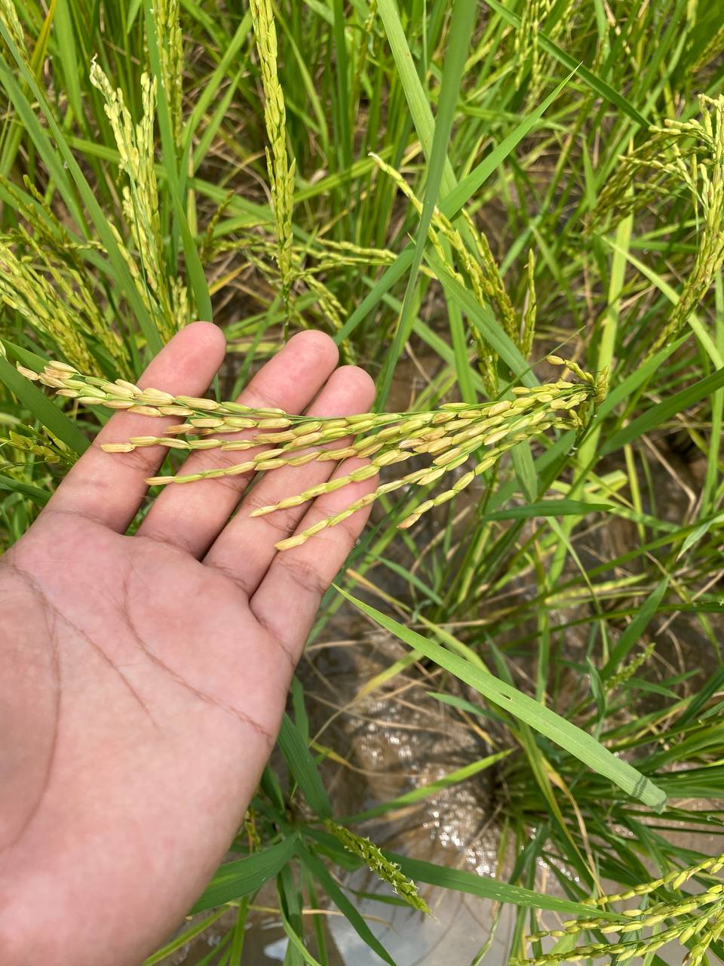

Introduction

Country background

Cambodia is located in Southeast Asia, sharing borders with Laos, Thailand, and Vietnam, and has a coastal area along the Gulf of Thailand. The Mekong River is a significant geographical landmark, flowing from Laos in the north down to Vietnam’s Mekong Delta in the south and feeding into Tonle Sap Lake. The country’s landscape features the flat central plains of the Mekong, which are encircled by mountainous and elevated areas. Cambodia has an estimated population of around 16.5 million individuals as of 2019, with about 76% of its residents residing in rural regions (The World Bank Group & Asian Development Bank, 2021).
Cambodia is characterized by a tropical climate influenced by monsoon winds, causing six months dry and six months wet. The dry season occurs from November to April, and the rainy season occurs between May to October. Annual precipitation and Average temperatures are relatively uniform across the country. Average annual precipitation levels vary from 1400 mm to 4000 mm. While temperatures remain between 25°C–27°C throughout the rest of the year, they can exceed 35°C in the summer months (FAO, 2024).
Cambodia is classified as one of the most vulnerable countries in the Southeast Asian region to the impacts of climate change (Yusuf & Francisco, 2010). In 2015 and 2016, droughts caused less rainfall, warmer weather, and delayed or shortened monsoon rains, affecting about 2.4 million people. According to NCCC (2013), Cambodia’s mean surface temperature has increased by 0.8°C since 1960. According to the IPCC 6th assessment report (IPCC, 2023), Cambodia is expected to experience an increase in temperature of 1.5°C to 2.5°C by the year 2050, with the greatest warming expected to occur in the dry season. The report also predicts that Cambodia will experience more frequent and intense heat waves, as well as more frequent and intense rainfall events.

1.2 Rice agrosystem in Cambodia

The agricultural sector in Cambodia represents 20.8% of the country's gross domestic product, with crop production making up 57.7% of this sector. Fisheries, livestock, and forestry follow in contribution. Rice is the primary crop in Cambodia, contributing 15% to agricultural value added, and occupies 75% of the cultivated land. The production, processing, and marketing of rice provide employment for approximately 3 million individuals, which is about 20% of the national workforce, making it a vital component of the country's subsistence farming (FAO, 2024).
Rice is typically cultivated in fields that are ‘puddled.’ Puddling involves harrowing or rototilling under shallow water conditions, aimed at controlling weeds, reducing soil permeability, and making transplanting easier. Once puddling is completed, the land is leveled while it is still wet. A typical vertical cross-section of a puddled rice field reveals a layer of water, approximately 0-0.10 m deep, a muddy topsoil layer of 0.10-0.20 m, a plow pan created from years of puddling, and an undisturbed layer of subsoil below (FAO, 2012).
Cambodia's total rice cultivation land was about 3,580 thousand hectares in 2024 (Sokkea, 2024). Out of that, there are four primary ecosystems: rainfed upland, rainfed lowland, deepwater, and dry season. The details of each ecosystem are as follows (Figure 1-1):
- Rainfed Lowland Rice is cultivated in bunded fields that primarily rely on rainfall and surface runoff for water supply. Floodwater levels can vary from 0 to over 25 cm, with instances of exceeding 50 cm for brief periods. This type of rice is grown across all provinces in Cambodia (81.1%), with the largest concentrations near main water sources such as the Tonle Sap, Tonle Bassac River, and Mekong River. For rainfed lowland rice, short-cycle varieties are planted in higher fields, medium-cycle varieties in middle fields, and long-cycle varieties in lower fields of these areas.
- Rainfed Upland rice, often referred to as mountain rice in Cambodia, is cultivated in unbunded fields scattered across hilly terrain, including mountainous regions. This type of rice relies solely on rainfall for its growth. The area dedicated to upland rice represents only a small fraction (0.9%) of the total rice-growing land in Cambodia.
- Deepwater rice, also known as floating rice (cover 1.3% of total irrigation area), thrives in low-lying areas and depressions that can accumulate floodwaters at depths of 50 cm or more, with some regions experiencing water levels as deep as 4 meters. The rise in water levels in these areas is usually exacerbated by local rainfall.
- The dry season rice ecosystem consists of areas that are either partially or fully irrigated, typically cultivated between November and April. Unlike the rainfed lowland ecosystem, which features varying maturity classes based on field levels, the dry season crop is restricted to photoperiod-insensitive varieties that mature within 120 days.

The dry-season rice ecosystem, which covers only 18% of the paddy land, is divided into three categories: fully irrigated, recession, and pre-rising water rice.
- Fully Irrigated Rice: This type of rice is grown in a fully controlled irrigation system comprising water dams, irrigation canals, underground water sources, and catchment ponds. Many farmers utilize fuel pumps to transfer water from canals to their fields. These fully irrigated areas are primarily part of the rainfed lowlands, where crops receive supplementary irrigation during the rainy season.
- Recession Rice: This rice is grown in areas where water recedes along inland valleys and lakes. The cultivation period is from October to February or March, following the receding water levels, with harvesting taking place between January and July, depending on the topography and water levels.

- Pre-Rising Water Rice: Using the water available from constructed canals, farmers can plant a second short-cycle rice crop after harvesting recession rice in February and March. This ensures the second crop is harvested before water levels rise, typically in August, hence the name pre-rising rice.

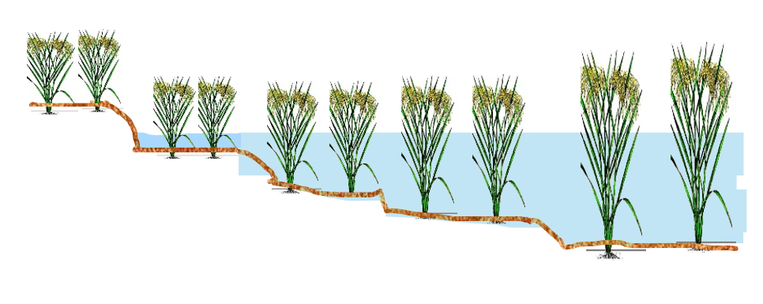
Floating rice
WD: >50 cm
Lower field
WD: 0-50 cm
Medium field
WD: 0-30 cm
Upper field
WD: 0-20 cm
Rainfed lowland and dry season rice
Upland rice
Figure 1-1 : Rice ecosystem and growing condition in Cambodia (CARDI, 2017). WD: Water depth

1.3 Rice growing stage

The rice plant takes 3-6 months to complete its life cycle from germination to maturity, depending on the variety and environmental conditions (Fageria, 2007). In Cambodia, rice was classified into three maturity natures such as early (short-cycle), medium (medium-cycle), and late (long-cycle). The short-cycle rice takes around 95 days (95 to 120 days from sowing), whereas the medium cycle takes 125 days (105 – 180 days from sowing), and the long cycle takes 155 days (130-190 days from sowing) from sowing to maturity (CARDI, 2017). Rice phenology is generally divided into vegetative (from emergence to panicle primordia initiation), reproductive (from panicle primordia initiation to flowering), and spikelet filling (from flowering to physiological maturity). Cultivar differences in growth duration are determined by changes in the time from germination to beginning flowering (60 to 150 days), while the time from beginning flowering to maturity is pretty constant and lasts about 30 days in the tropics (FAO, 2012). The rice growth stage is illustrated in Figure 1-2 below.
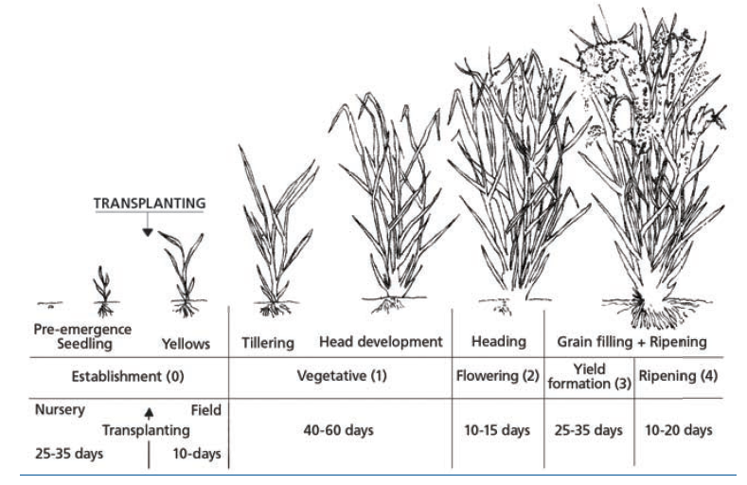
Figure 1-2: Typical development of rice: short, medium and long cycle (FAO, 2012)
1.4. Geomorphology of Cambodian Ricelands

According to Crock, (1962), the rice cultivation regions of Cambodia can be categorized into three distinct physiographic areas:

• Soils formed on old alluvial or colluvial plains;

• Soils that have developed in place from the underlying geological materials;

• Soils located on the active flood plains of rivers and lakes that receive yearly deposits of alluvial sediments.

Soils derived from old alluvium and/or colluvium

Old alluvial terraces:
These landforms in Cambodia's rice-growing provinces are former river, lake, or marine floodplains now elevated above regular flooding. The soils are alluvial, formed from ancient river deposits, but are now primarily nourished by rainwater, leading to nutrient loss due to leaching. Occasionally, they may experience short flooding from nearby rivers.
Colluvial-alluvial plains:
Result from erosion of surrounding hills, creating fans that overlap to form gently sloping plains. Wetland rice is mainly grown in the finer-textured lower areas of these plains. Alluviation plays a significant role in their formation, more so than colluviation, which involves soil movement down slopes. These plains are particularly important in rice cultivation in regions like Battambang, Banteay Meanchy, and Siem Reap, and in some areas, the original hills have been entirely eroded, forming vast plains.

Soils developed in situ from underlying parent material
These soils originate from the weathering and breakdown of the underlying rock from which they are developed. Additionally, in certain areas located on the lower slopes of hills, processes such as colluviation and alluviation may also play a role in their formation. In Cambodia, the soils are primarily derived from two key sources of parent material: 1) the sandstones and shales from the Palaeozoic era, which constitute much of the mountainous regions in the country, and 2) extruded volcanic materials. The sandstone originates from previously weathered substances. The magma was released from volcanic eruptions or cracks in the sandstone during more recent geological events. A variety of both acidic (like granites) and basic (such as diorites) rocks were expelled, leading to the development of diverse soils with different pH levels. Soils formed from these materials tend to be relatively young and fertile, especially those developed on basic rocks.

Soils of the active floodplains
Meander floodplains are found in the middle sections of rivers and consist of the river channel, natural levees, backslopes, and basins (see Figure 1-3). Typically, the natural levees keep the water contained within the channel. However, when excessive water causes the river to breach its levees, the basins become inundated. Sedimentation occurs at varying rates, influenced by water flow; the largest sediments, such as coarse sand and gravel, settle in the channel, while finer sand and silt accumulate on the levees, and clay is deposited in the basins.
Expansive floodplains (Figure 1-3) are significant landforms found in Cambodia and should be differentiated from meander floodplains. These expansive floodplains are situated along the lower sections of rivers and are defined by a main river channel accompanied by levees made of medium to heavy-textured soil. Behind these levees lies a broad, flat basin that may stretch several kilometers from the river channel, particularly in parts of Takeo and Kandal. Within the basin, there are shallow secondary channels without levees that allow water to flow during low water periods. Each year, these basins and much of the surrounding levees are submerged under more than 2 meters of water for extended durations. Additionally, marine floodplains can be found in the coastal regions, where rice cultivation is impacted by tidal fluctuations and saltwater intrusion; however, these areas represent only a small portion of rice-growing land in Cambodia.

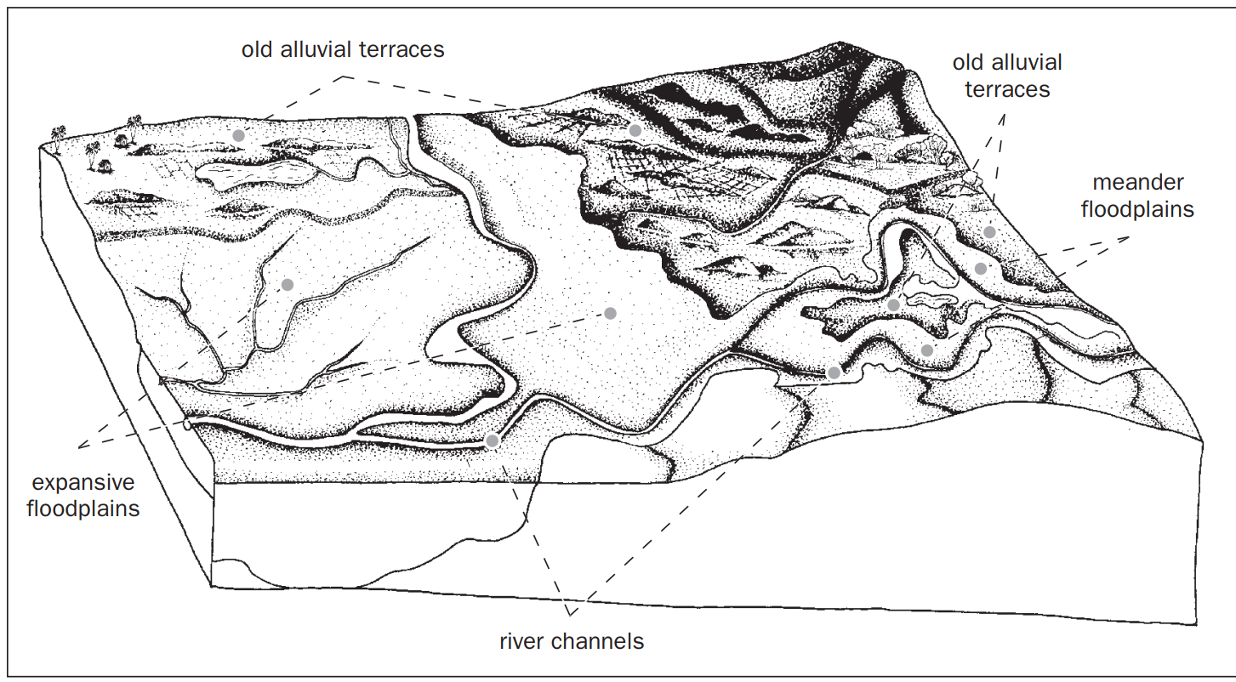
Figure 1-3: Expansive floodplains in connection with old alluvial terraces

Lacustrine floodplains (Figure 1-4) in Cambodia share similarities with expansive floodplains, exemplified by the area around Tonle Sap Lake, which is a well-developed lacustrine floodplain. These floodplains are typically flat and lack distinctive features, consisting of fine-textured sediments. The composition of these sediments is influenced by the local geology and the patterns of rivers that flow into the lake. The hydrological dynamics of Tonle Sap Lake are particularly noteworthy, as annual floodwaters from the Mekong River reverse direction and flow into the lake, facilitating sediment deposition. Additionally, numerous small and medium rivers contribute to the lake, leading to the formation of small deltas that are influenced by the seasonal fluctuations in water levels. This process has resulted in a complex soil composition, where coarse materials are found near the river mouths and alternating layers of coarse and fine sediments develop as river paths change over time.
Meandering rivers (Figure 1-5) alter their course over time, which changes the sediment distribution. When levees are breached, channels can become isolated and subsequently filled with sediment. This leads to a landscape featuring both old and new levees, along with abandoned meander patterns, as seen in the Mekong-Bassac river system.
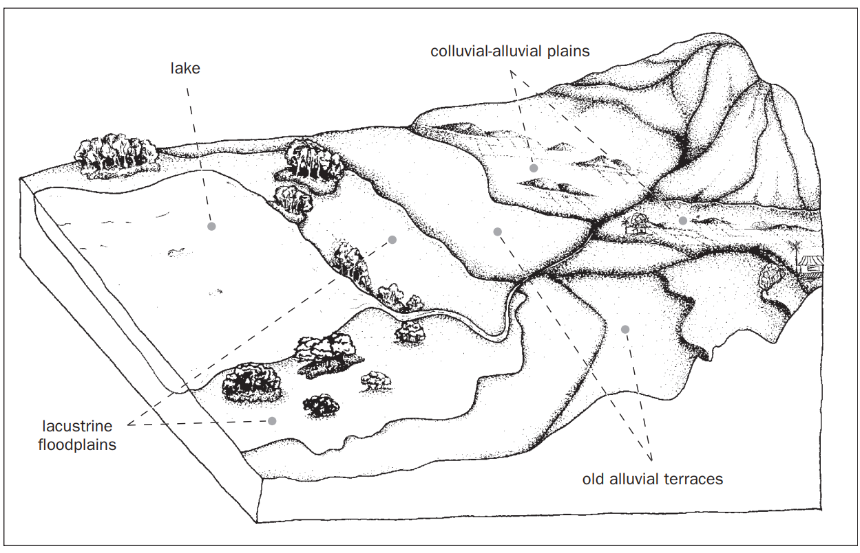
Figure 1-4: Lacustrine floodplains associated with old alluvial terraces and colluvial-alluvial plains

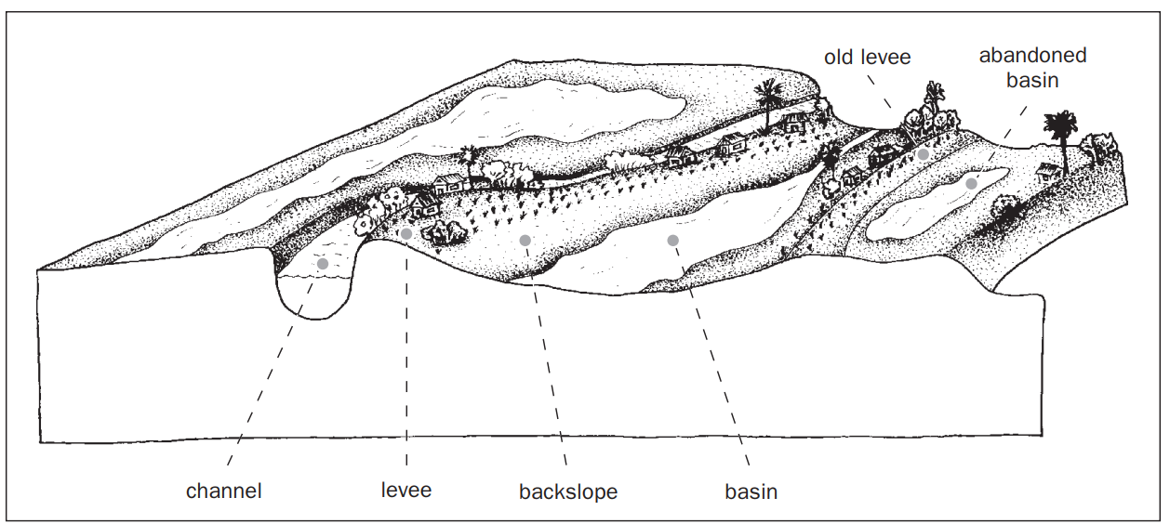
Figure 1-5: The river levee system
The soil classification system used by CARDI is derived from Crock's (1962) framework, which is structured into three tiers: soil groups, soil phases, and fertility capability classification (FCC). Soil groups are determined based on pedogenic criteria, focusing primarily on the soil's morphological features. In contrast, soil phases are based on agronomic factors and include characteristics that impact crop yield. The FCC quantifies the fertility limitations of the soil and offers management recommendations. This classification relies on just two diagnostic soil layers. Generally, the upper layer corresponds to the top 20 cm of soil, commonly referred to as topsoil. The layer underneath is known as subsoil, which is typically considered to extend to a depth of 50 cm unless stated otherwise. Within this framework, eleven groups of rice soil have been classified in Table 1-1. Preteah Lang and Bakan were used in this study.

Table 1-1: Overview of the group classification, details of each phase, and the estimated percentage of Cambodia's total rice area represented by each group.

Overview of group concept and phase explanation | Percentage of rice cultivation land
Group 0 - Prey Khmer  This soil is found on ancient alluvial terraces or colluvial-alluvial plains, featuring a sandy profile that extends more than 50 cm deep. There are two phases: the fine sandy phase, where the sand is mainly fine (less than 0.5 mm), and the coarse sandy phase, where the sand is primarily coarse (greater than 0.5 mm). | 10 - 12%
Group 1 - Prateah Lang  This soil also exists on old alluvial terraces or colluvial-alluvial plains, characterized by a sandy topsoil that is less than 40 cm thick, resting above a subsoil of loamy or clayey texture. The shallow phase indicates a topsoil depth of 20 cm or less, with clayey subsoil or the presence of a very hard layer, like a plow pan or a compacted iron pan, within the top 20 cm. The clayey subsoil phase has a topsoil depth of at least 20 cm without a very hard layer in the top 20 cm, and the subsoil is clayey. The loamy subsoil phase features a loamy textured subsoil, also without a very hard layer within 20 cm of the surface. | 25 - 30%
Group 2 – Labansiek  This soil is found on hill or mountain slopes and features a red, clay-like surface layer with a crumb structure, underlain by a clayey subsoil. In the petroferric phase, a hard layer of ironstone several centimeters thick is located within the upper 50 cm of the soil. The nonpetroferric phase does not have this ironstone layer within the top 50 cm. | 1%
Group 3 – Orung  This soil develops on old alluvial terraces, showcasing a topsoil that has a loamy to clayey texture and is less than 40 cm deep, sitting on a sandy sublayer that exceeds 10 cm in thickness. There are no distinct phases identified for the Orung. | 1 - 2%
Group 4 - Krakor  Characterized by a gray to brown, though not excessively dark, loamy or clayey topsoil overlying a sandy, loamy, or clayey subsoil, this soil is typically found in active floodplain areas. In the cracking phase, when the soil dries, moderate to large cracks appear on the surface, extending deeper than 5 cm. The noncracking phase does not feature these cracks or only presents shallow surface cracks that do not exceed 5 cm in depth. | 15%
Group 5 – Bakan  Found on colluvial-alluvial plains or ancient alluvial terraces, this soil consists of a loamy or clayey topsoil that either does not crack or only shows shallow surface cracks, resting atop a mottled loamy or clayey subsoil. No distinct phases are defined within this Bakan phase. | 10 - 15%
Group 6 - Kbal Po: This soil features a very dark gray to black clayey top layer, characterized by significant deep cracks that develop in the clay subsoil, typically found on active floodplains. Sandy layers may be present in the subsoil. In the thionic phase, the subsoil has a pH lower than 4.5, while in the nonthionic phase, the pH is above 4.5. | 13%
Group 7 - Kein Svay: This soil type has a brown, loamy or clayey character in both its topsoil and subsoil, resulting in a slightly developed profile formed on river levees and surrounding backslopes. Specific phases for Kein Svay have not been established. | 2%
Group 8 - Toul Samroung: Found on old alluvial terraces or colluvial-alluvial plains, this soil consists of a clayey or loamy topsoil that forms wide cracks deeper than 5 cm, sitting above a clayey or loamy subsoil. The topsoil appears gray or brown, but not a dark gray or black. In the brown phase, the surface soil is brown or light brown when wet, while in the gray phase, it appears gray or light gray when wet. | 7 - 10%
Group 9 - Koktrap: This soil, located on old alluvial terraces, has a dark gray to black topsoil with a clayey or loamy texture, which overlays a light gray or light brown loamy or clayey subsoil. In the infertile phase, unfertilized rice yields in fields typically fall below 1,200 kg per hectare, generally around 500 to 800 kg. Rice plants in these soils often show slight to severe leaf bronzing. The fertile phase, however, results in unfertilized yields exceeding 1,200 kg per hectare, usually over 1,500 kg, with no bronzing of the leaves. | 5%
Group 10 - Kompong Siem: This type of soil displays visible calcimorphic liestone or basalt stones and boulders either within its profile or on the surface. It has a black or dark gray clayey topsoil that develops deep cracks above a clayey subsoil. In the gravelly phase, numerous small, round black and brown ferro-manganese concretions are found throughout the profile, and gravel is noticeable in the surface soil. Conversely, the nongravelly phase lacks gravel throughout or only contains a few scattered concretions, or the gravel may only be concentrated in parts of the subsoil without being present in the surface soil. | 1-2%

1.5. System for Classifying Cambodian Rice Soils

Context

2.1. Issue on dry-season rice production in Cambodia

In comparison to other grain crops, lowland rice demands a higher quantity of water at the field level due to several factors. These include the significant water needed for wet land preparation, ongoing seepage and percolation caused by the water being ponded, and the increased evaporation rates from the surface of the ponded water. The total water input of rice per growing season ranged from 1100 to 2500 mm comprising 150–200 mm for nursery preparation, 200–300 mm for soaking, plowing and puddling of the main field, and 800–1200 mm in the main field from transplanting to harvest with daily consumption of 6–10 mm depending upon the agro-climatic situation in which the rice crop is being cultivated (Mote et al., 2021). Due to the high demand for water input, insufficient irrigation limits the ability of Cambodian farmers to grow rice in the dry season. As a result, out of 3.58 million paddy land, only 19% were covered by dry-season or irrigated rice. The remaining rice cultivation areas are only possible for the rainfed rice.
Under these conditions, increasing water production in irrigated areas for dry-season rice was considered a more successful approach to improving food and water security (Booker & Trees, 2020).
In addition, rice is very vulnerable to climate change. A dramatic temperature change is likely to affect agricultural productivity. Higher temperatures, in particular, impact the quantity and quality of rice grains, especially during the reproductive or filling stage (Bahuguna et al., 2015). Under heat stress, rice grain yield will decline by 10% for each 1ºC increase in growing-season minimum (night) temperature in the dry season (Fahad et al., 2016). Rice yield in Cambodia was projected for a moderate decrease (-10.5%) under RCP 8.5 by the mid-century.
In addition to being susceptible to temperature, reliance on rainfall for irrigation, lack of institutional capabilities, technically skilled personnel, climate-compatible technology, and financing for adaptation, Cambodia's agricultural sector is particularly vulnerable to the adverse effects of climate change (MAFF, 2023). Severe droughts, particularly those occurring between 1997-98, 2003-05, and late 2015-2016, severely impacted agriculture, resulting in substantial crop failures and decreased productivity in Cambodia (Abhisheka et al., 2021).
In this regard, improving water use efficiency (WUE), and long-term planning using climate projection are essential to improve farmers' productivity who grow dry season rice. Attempts have been made in Cambodia to test the water-saving methods, which proved a positive effect on rice, for example, direct seeding by Kong et al. (2020), alternative wetting and drying by Sandhu et al. (2017), and intermittent irrigation by Alvar‐Beltrán (2022).

2.2. Review of Water-Saving Methods

There are plenty of water-saving methods that have been developed to improve water use efficiency (WUE), such as:
- Perminnent raised-bed systems (Naresh et al., 2014): Creating suitable layouts specific to the crop can enhance irrigation water use efficiency. Raised beds are formed by moving soil from the furrows to the area of the bed, thus raising its surface level. The furrows serve as irrigation channels, drains, and traffic lanes. Generally, two to six rows are planted on the top of each bed for rice crops. In the permanently raised bed technique, the bed furrow system, once developed, is not destroyed season after season. The beds are only renovated and not misplaced. The ability to grow rice on raised beds eliminates the need for tillage, which later develop into a hardpan at a depth of 15–30 cm, and the increased bulk density and soil compaction impair root growth of crop.
- Dry direct seeding of rice (DDSR) (Ishafaq et al., 2020): offers opportunity to achieve optimum plant density while conserving water and labor. This method, which can be implemented using manual or mechanical drills with specifically spaced rows, involves planting rice in dry, non-puddled fields. By eliminating the need for water application for puddling and to maintain submerged soil conditions, DDSR significantly reduces overall water usage. Additionally, traditional rice farming uses labor for tasks such as nursery preparation, uprooting, transporting, and transplanting, which is scarce during peak seasons. From
- System of Rice Intensification (SRI) (Hardy et al., 2016): enhances the management of rice plants along with the soil, water, and nutrients that support their growth. It employs straightforward yet specific methods to create ideal conditions that allow rice plants to better express their genetic potential. The main elements of SRI include: (1) utilizing young seedlings at the two-leaf stage (8–15 days old, with one seedling per hill), (2) providing wide spacing between plants, ranging from 25 cm × 25 cm to 50 cm × 50 cm, (3) performing at least three hand weedings at intervals of 10–12 days, 22–25 days, and 40–42 days after transplanting, (4) incorporating organic matter like manure and compost to ensure adequate nutrient supply, and (5) allowing intermittent drainage and soil drying to promote aeration during the vegetative stage.
- Non-flooded mulching cultivation (Xu et al., 2007): The cultivation method involved non-flooding during the growing season, where pre-germinated seeds were sown directly into unsaturated soil and covered with plastic film as mulch. Irrigation was applied only during crucial stages sensitive to water (spike and anthesis) and when multiple water stress events occurred, indicated by soil water content or soil water potential that fall below the allowable threshold.
- Aerobic rice cultivation (Talukdar et al., 2022): In this cultivation approach, upland rice is grown under non-flooded conditions. The soil remains unsaturated and is kept aerated, receiving only rainfall. If the rainfall is inadequate to keep the soil moisture at the required level, irrigation is used to restore the soil water content to its field capacity.
- Saturated soil culture : In saturated soil cultivation, the soil is kept at low saturation levels to minimize water seepage and percolation. However, implementing this practice can be challenging, as it necessitates regular irrigation to maintain a minimal saturation level in the soil.
- Transplanting in non-puddled soil: In this method, rice seedlings grown in nurseries are transplanted as a mat into non-puddled soil at specified cultivation spaces using self-propelled mechanical rice transplanting equipment.
- Alternate wetting and drying (AWD) Fields under AWD are exposed to intermittent drying cycles during the growth season. As soon as the drying criteria are reached, fields are re-ponded (Isafaq et al., 2020).

Because of its simplicity of use, AWD is among the most commonly employed water-saving techniques. It has been used worldwide, including in Asia (Arai et al., 2021; Cao et al., 2020; Sriphirom et al., 2019), Europe (Oliver et al., 2019; Monaco et al., 2021), the United States (Artwill et al., 2023; Runkle et al., 2019), and Africa (Vries et al., 2009). Carrijo et al. (2017) conducted a meta-analysis of 56 distinct investigations and found that 31% of the studies were from China and more than 80% were from Asia.

2.3. Characteristics of AWD Irrigation

The three main components of the AWD are as follows (Figure 1-6): 1) A thin layer of 2–3 cm of standing water from panicle initiation (PI) to the end of flowering, as this period is susceptible to water deficit; 2) shallow flooding for the first 2 weeks following seeding or transplanting to recover seedlings from transplanting shock and to suppress weed emergence; and 3) AWD cycle during all other growth periods. The AWD system guarantees rice's physiological water need by regulating the amount of water supplied and allowing for the cut short of the irrigation (total water input). Ishfaq categorized the six categories in which AWD thresholds (Figure 1-7) are set as follows: 1) soil water potential or moisture (Nalley et al., 2015) , 2) a certain number of days without flooding, 3) the emergence of surface cracks in the soil, 4) the plant exhibiting signs of water stress, 5) the dropping of the field water level (FWL) to a specific soil depth, and 6) the use of ditch irrigation.
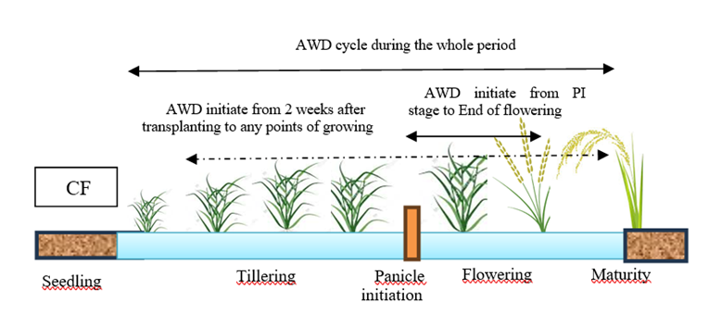
Figure 1-6: Type of AWD timing. Type 1: AWD apply for the whole growing seas, Type 2: AWD initiate from 2nd weeks after DAT, Type 3: AWD initiate from PI stage to end of flowering
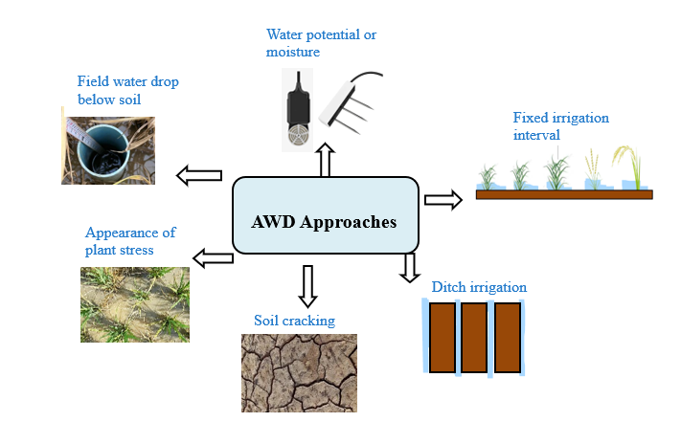
Figure 1-7: Types of AWD thresholds

Table 1-2 highlights AWD studies using different thresholds, soils, and varieties. For the rural farmers of Mekong, using PVC tubes for water level monitoring was a more straightforward and convenient approach. Isafaq et al. (2020) defined AWD as (1) safe when the soil water potential (SWP) was > -10 kPa or the FWL was ≤ 15 cm (AWD15); (2) mild/moderate when the SWP was ≥ -20 kPa or the FWL was = 15-20 cm (AWD20); and (3) severe when the SWP was < -20 kPa or the FWL was > 20 cm (Figure 1-8). It is now recommended that they use "safe AWD" among them. The "safe AWD" approach changes soil water regimes from flooding to non-flooding, saturated, or unsaturated states. Depending on the soil's textural class and soil organic matter, drying times can range from one to more than ten days.

Safe AWD
FWL ≤ 15 cm or
SWP > -10 kPa
Moderate AWD
FWL = 15-20 cm or
SWP ≥ -20 kPa
Severe AWD
FWL>20 cm​ or
SWP < -20 kPa
Figure 1-8 : Different types of AWD thresholds that were considered as safe, moderate and severe according to Isafaq et al. (2020)

2.4. Application of AWD in agriculture to improve Water use efficiency

AWD has been shown to conserve water by 2% to 72% and enhance Water Use Efficiency (WUE) by 5% to 113% while maintaining or improving yields, as evidenced by studies conducted in various regions globally, as presented in Table 1-2. However, occasionally, yields have decreased, resulting in a lower WUE since WUE is calculated as the yield ratio to the total volume of irrigation water used. Among studies mentioned in Table 1-2, AWD has been applied in conjunction with other methods (drip irrigation, biochar, etc.) and varying thresholds (safe to severe) to increase productivity and water saving. In addition, the threshold of AWD was applied using a single method, such as soil moisture content, field water level, dried day interval, or combination. These efforts aimed to identify the ideal AWD threshold and the factors that enhance this method.
For instance, in the United States, Artwill et al. (2023) examined various AWD thresholds ranging from safe to severe applications at the root zone, extending from soil level down to a depth of -40 cm. Their study proved that there was no significant impact of water stress on yield, seed quality, and net returns. As a result, he could save up to 48% of total water input. In addition, Atwill et al. (2023) found that water use efficiency (WUE) was negatively correlated with irrigation threshold. Within a specific irrigation level, the hybrid cultivars exhibited greater water use efficiency than the inbred cultivars due to their higher yield potential. Their study demonstrated an improvement in WUE of 58-104% compared to CF irrigation.
In a study by Pool et al. (2023), various planting techniques were compared, including transplanting at a puddled bed, transplanting at a non-puddled bed, and direct-seeded rice under alternate wetting and drying (AWD), continuous flood (CF), and drip irrigation. The results indicated that the water use efficiency (WUE) of AWD and CF was comparable and even higher than drip irrigation. However, AWD led to a 24.8% increase in water-saving and a 21.3% increase in water productivity compared to CF.
In China, Qune et al. (2017) demonstrated that using super rice cultivars that exhibit better yield performance than checked rice together with AWD achieved significant water use efficiency. On average, the WUE of super rice varied between 1.18 to 1.71 kg m–3, respectively, in CF, and AWD regimes, and was between 5 to 13%, higher than that of check rice.
Lampayan et al. (2015) also found that water savings under AWD15 and AWD25 treatment ranged from 42.8 to 53.7% without yield loss, with higher total water productivity than continuous flooding.

Table 1-2: List of studies that prove AWD could save more water conducted on various location and on AWD thresholds.
Soil type | AWD threshold | Yield | Average water saving | Country | Reference | WUE improved compared to CF
Sharkey clay | AWD10 to AWD40 | NS | 45% | USA | Artwill et al., 2023 | 28.5%
Silty- clay | AWD15 | NS | 43% | Vietnam | Arai et al., 2021 | -
Coarse-loamy | Tension & AWD15 and AWD20 | NS | 57% | China | Cao et al., 2020 | 33%
Sandy loam | AWD15 and biochar | NS | 12.4% | Thailand | Sriphirom et al., 2019 | -
Clay | AWD15 | NS | 5.3 – 24.5% | Philippine | Zhang et al., 2012 | 10%-43%
Clay | AWD10 & AWD15 | -8% | 72% | Senegal | De vries et al., 2010 | 5%-113%
Clay loam & Sandy clay loam | Tension, AWD15, AWD30 | Increase +10% and decrease 20-40% depending on the cultivar type | 20-60% | Japan | Matsuo & Mochizuki. 2009. | 42%-109%
Silk clay | Dried day interval | NS | 21–23% | Bangladesh | Maniruzzaman et al., 2015 | 30%
Silt loam | SMC at AWD10 | -0.88 to -18% | 21-57% | USA | Nalley et al., 2015 | 40%
Sandy loam | Tension | -10 to -36% | 5-12% | Peru | Jorge et al., 2020 | -8%
Sandy am | Tension | +8% | 25% | China | Wang et al., 2018 | 17%
Sandy loam | AWD15 | +7-9% | 3 to 7% | Cambodia | Sandhu et al., 2017 | -
Note: each study used different varieties, thresholds and grew in different seasons.

2.5. Influence of AWD on the plant protection products’ effectiveness

Though this thesis research has not had a chance to look into detail on the performance of AWD toward plant protection, many studies have shown evidence about its support to the plant protection as summarized in the following:

- Pest and Disease Dynamics

AWD alters the water management in rice fields, affecting the presence of pests and diseases, which in turn influences the effectiveness and timing of plant protection products:
- Pests: Research shows that AWD may lower the populations of specific rice pests, like the brown planthopper, by changing habitat conditions (IRRI, 2010). A reduced pest population can lead to less frequent need for chemical treatments.
- Diseases: AWD affects the development of diseases, particularly bacterial and fungal infections. For instance, the severity of blast disease is often reduced under AWD conditions due to drier soil, which limits pathogen growth (Kumar et al., 2019). However, the alternating wet and dry conditions can promote other diseases, such as sheath blight (R. solani), which thrive under these circumstances (Nandakumar et al., 2017).

- Effect on Chemical Efficacy and Longevity

- Leaching and Degradation: Intermittent drying can influence the residual activity of pesticides, as increased microbial activity may degrade them more quickly or leach them away during wet periods, thereby reducing their effectiveness (Siddiqui et al., 2018).
- Application Timing: Aligning chemical applications with water management practices is essential for maximizing effectiveness; for instance, certain herbicides and insecticides require specific moisture levels for optimal absorption (Morse et al., 2014).

- Environmental and Human Health Considerations

AWD minimizes overall water consumption, which can lead to reduced runoff and leaching of agricultural chemicals, thereby lowering contamination risks for water bodies (IRRI, 2016). This contributes to a lesser environmental footprint and enhanced safety for aquatic life.

4. Adjustments in Application Methods

Variations in soil moisture due to AWD can impact the effectiveness of foliar sprays, necessitating changes in the timing and techniques of application to ensure proper coverage and adherence, particularly during dry periods (Hossain et al., 2018).

2.6. What is missing in the knowledge of AWD

Based on the findings summarized in Table 1-2, we can identify several factors that influence the successful application of Alternate Wetting and Drying (AWD) irrigation:

1. Variety: The ability of rice to tolerate water stress is closely linked to its biological characteristics and root traits. For instance, Nalley et al. (2015) noted a decline in yield when AWD was applied to a variety suited only for continuous flooding. In contrast, a study by Artwill et al. (2023) in the same country of the USA demonstrated that AWD could save water without reducing yield when using different hybrid and inbred lines. Additionally, Matsuo and Mochizuki (2009) and Sandhu et al. (2017) emphasized that selecting the appropriate root traits is crucial for successfully implementing AWD.
  - Season: The effect of AWD was particularly enhanced by the cropping season. Arai et al. (2021) tested AWD in 15 cropping seasons and found that the application of AWD was notably better in the winter-spring cropping season, during which the nighttime and daily mean temperatures were the lowest of the three cropping seasons. Sriphirom et al. (2019) also stated that to maximize the benefits of AWD, it is essential to avoid its use in areas or seasons with anticipated heavy rainfall that could disrupt effective drainage during the tillering stage.
  - Severity of AWD: While increasing water stress levels can lead to more significant water savings, it may significantly impact grain yields (Maniruzzaman et al., 2015; Jorge et al., 2020; Cao et al., 2020).

The examples above indicate that achieving sustainable rice production through AWD requires an integrated approach encompassing agronomic, biological, and hydrologic strategies. However, the above studies and global AWD review (Isafaq et al., 2020; Talukdar et al., 2022) reveal a lack of deep investigation concerning the performance of AWD across soil properties in a target study area. Both Nalley et al. (2015) and Artwill et al. (2023) suggested filling the gaps in their study by focusing on soil characteristics.
Drawing back from our examples, when examining AWD performance on different soil types, even on specific soil types, for example, sandy loam (Table 1-2), concluding can be challenging due to variations in AWD timing, thresholds, and varieties used in those studies (Jorge et al., 2020; Wang et al., 2018; Sandhu et al., 2017; Sriphirom et al., 2019). These findings suggest the necessity of designing and implementing site-specific irrigation management strategies considering the soil's characteristics, drainage frequency, the length of flooding cycles, and the variety's adaptation (Mazza et al., 2016).
The rare cases of testing AWD within the same soil texture could be because testing AWD across multiple locations may prove challenging and costly.
In addition, apart from Sandhu et al.'s (2017) research, there is a lack of scientific data supporting the adoption of safe AWD practices in Cambodia. Sandhu concentrated on suitable root characteristics to increase yield under safe AWD. Compared with conventional flooding (CF), Sandhu's experiment in Cambodia showed that AWD15 improved yields by 7 to 9% and saved 3 to 7% of the water. These improvements were relatively small in encouraging farmers to adopt AWD. Therefore, Sandhu recommends the identification of new rice genotypes that can consistently produce high or stable yields under AWD across different ecosystems while achieving an average water saving of 20% in rice cultivation. In addition to safe AWD, it would be worth investigating the possibilities of using mild AWD in the context of Cambodia in order to save more water and prevent yield penalties.

2.7. Role of Crop Modeling for Field Condition Under Water Stress

Although field experiments are excellent tools to investigate the performance of AWD and CF across different geographic, water management, rice genotypes, fertilizer rates, and ambient temperatures, they are challenging and costly for studying the impact of climate change on crop development and production due to the need for multiple parameters and years of data.
Various techniques, including crop modeling, have been employed to investigate the effects of climate change on rice production. Crop simulation models, for example, explore how specific agronomic traits and management practices interact with genotypes and the environment (Chenu et al., 2017). Crop modeling has emerged as a crucial technique for analyzing plant growth and development across different environmental scenarios, particularly in relation to water stress in rice.
The review below concentrates on the crop modeling that integrates functions related to water stress.
- ORYZA: This model, specifically designed for rice, encompasses a variety of physiological processes, such as water absorption, transpiration, and photosynthesis. It is particularly effective in simulating the effects of water stress. ORYZA can model different stress scenarios like drought, waterlogging, and salinity, offering insights into yield responses and effective water management practices (Wang et al., 2014). This model, specifically designed for rice, incorporates detailed rice-specific physiological processes but requires detailed input data.
- DSSAT (Decision Support System for Agrotechnology Transfer): This popular crop simulation model includes rice as one of its options. DSSAT features functions related to water stress that take into account soil moisture levels, root water uptake, and crop water use efficiency, allowing it to project yield responses under varying water conditions (Jone et al., 2003). This model has modules for various crops, which are highly versatile and applicable to various crops and environments. However, it also required a lot of input.
- APSIM (Agricultural Production Systems Simulator): A versatile crop simulation model capable of modeling various crops, including rice, alongside their environmental interactions. APSIM incorporates detailed components for water balance, enabling it to simulate the impact of water stress on rice growth, development, and yield outcomes (Keating et al., 2003). This model can simulate complex interactions within and between crops, soil, and atmosphere, and it is highly flexible and customizable. However, it requires significant expertise to use compared to the rest of the models.
- AquaCrop: (FAO, 2012): a crop growth model used to assess the impact of environment and management on crop production, with a focus on water as a key limiting factor. It simulates the yield response of herbaceous crops to water availability by considering factors like climate, soil properties, and management practices. AquaCrop is designed for a wide range of crops and conditions, allowing for optimizing irrigation schedules, assessing drought risk, and improving water use efficiency in agriculture. This model is relatively simple, user-friendly, and requires fewer input parameters than the top three models.

Despite its simplicity, AquaCrop model reasonably accurately predicts crop growth indices and soil, plant, and environment continuum components. Various studies have demonstrated the capability of the AquaCrop model to successfully simulate growth of rice under AWD conditions (Xu et al., 2019; Maniruzzaman et al., 2015; Porras-Jorge et al., 2020; Mirfenderski et al., 2022).
The AquaCrop model provides default growing characteristics and parameter values specifically for rice crops. However, to enhance the accuracy and relevance of the model's predictions, it's essential to locally adjust certain key parameters that can be influenced by regional environmental conditions and farming practices. This localized calibration helps ensure that the model reflects the specific growth conditions and challenges faced by rice producers in different areas, ultimately leading to better-informed decision-making in crop management.

2.8. Literature Gap of Climate Projection on AWD Rice

To maximize the benefit of crop model application, integrating climate scenarios into crop model offers numerous benefits. This allows for measuring climate change's impact on rice production and the probability of specific weather patterns in the areas studied. This information helps prepare for adaptation strategies, such as:

- Yield Prediction and Optimization: Under different water stress and climate scenarios, researchers can identify optimal irrigation schedules and water management practices to maximize yield and minimize water use in the near, medium, and far future (Houma et al., 2021).
- Heat Stress Assessment: By simulating crop responses to extreme heat during different plant development stages, crop models can assess the potential impact of post-anthesis heat stress on grain yield and identify vulnerable regions and varieties in the future. This information can be used to develop heat-tolerant rice breeding programs (Shi et al., 2016).
- Water Use Efficiency (WUE) Improvement: Crop models can evaluate different irrigation strategies and identify those that maximize WUE, leading to more efficient water use and reduced environmental impact under different scenarios (Wang et al., 2014).
- Climate Change Impact Assessment: Crop models can assess the potential impacts of climate change on rice production compared to the historical data, including changes in temperature, precipitation patterns, and drought frequency. This information can be used to develop climate-resilient rice varieties and management practices (Osman et al., 2022, Shrestha et al., 2014).

Interestingly, global studies investigating climate impacts on rice growth under AWD irrigation are rare. So far, the only available study by Mirfenderski et al. (2020) is in Iran. Their study reported that the AWD strategy would be a more effective climate change adaptation than mid-season drainage from crop yield, WP, and EWP viewpoints. However, their studies did not include a comparison with CF and were limited to old versions of scenarios from the IPCC 5th assessment report. More evidence, especially from other geographic locations, climate conditions, and various cultivars, is required to support AWD irrigation as an adaptive technique for climate change in the future.
In Cambodia, on the other hand, applying a crop model to explore future climate scenarios with adaptation strategies such as the selection of suitable varieties and water management has rarely been explored in dry-season rice. Aquacrop was used to assess the impact of climate change on intermitted flood and continuous flooded condition for dry-season rice (Alvar‐Beltrán et al., 2022) but has not yet been attempted for AWD conditions.

3. Objectives

This thesis aims to reveal the feasibility of AWD management to maintain rice yield, improve WUE, and adapt to climate change by applying field experiments and modeling on different rice varieties and soil conditions. The sub-objective include:
- Quantifying the effects of AWD on rice yield and water use efficiency (WUE) using varying varieties and soil properties.
- Studying the interactions between water-saving irrigation regimes, variety, and soil properties.
- Investigating the potential for further reducing water input and increasing WUE by increasing the AWD threshold from -15 cm to -20 cm below the soil.
- Investigate future climate risks through model simulation to determine whether short-term rice varieties cultivated under AWD15 can withstand water stress in light of increased water demand and rising temperatures.

Hypotheses

The research question at the core of this work can be summarized as: Is it possible to optimize water use efficiency by revealing the effect of variables such as irrigation strategy , the cultivars , and soil , with decision-supporting tools such as modeling and field experiment, given the future outlook for reduced water availability and climate change? To answer this question, this thesis tests the following hypotheses :

- Rice varieties, soil type, and irrigation regime affect crop yield and WUE.
- Different soil textures require different amounts of water input to maintain optimum yield.
- Crop model that was successfully parameterized for dry-season rice in Cambodia and is able to quantitatively describe crop growth and soil water movement through alternate anaerobic-aerobic soil phases. The model would be successfully used in future emission scenario analyses of the potential impact of climate change on rice grown under AWD systems.
- In response to climate change and other external forces, the AWD method could effectively save irrigated water while at the same time producing the same or higher yield and maintaining the health of the rice crop that is planned under deficit water conditions.

Outlines

This thesis consists of a General Introduction (Chapter 1), a Material and Methodology (Chapter 2), two research papers (Chapters 3-4), and a General Discussion and Synthesis chapter (Chapter 5). Each research paper focuses on one of the objectives (section 4).

Chapter 1: General Introduction, focuses on the background issue of rice cultivation in Cambodia, the state of the art of AWD, research gaps in the literature on AWD, and the purpose and hypothesis of the studies.

Chapter 2: Material and Methodology typically outlines the procedures and techniques employed to conduct the research and gather data. It provides a detailed description of the materials, equipment, and methods used in the study.

Chapter 3: (Phoeurn et al., 2024, Paddy and Water Environment https://doi.org/10.1007/s10333-024-01012-5): The study aims to comprehensively assess the feasibility of AWD as a water-saving technique for rice yield and water use efficiency (WUE) by considering diverse rice varieties and soil properties. This study also examined the interactions between irrigation methods, rice variety, and soil characteristics. Additionally, the study investigates the potential for enhancing WUE by adjusting the AWD threshold from -15 cm to -20 cm below the soil surface, aiming to reduce water input further. To evaluate these objectives, experiments are conducted across four distinct sites with differing soil properties and fertility backgrounds during dry seasons. This allows for a comprehensive understanding of the AWD implications for water conservation and agricultural sustainability.

- Chapter 4: (Phoeurn et al., 2024, Environmental Monitoring and Assessment. 196:1190. https://doi.org/10.1007/s10661-024-13363-x): This study explores the potential of AWD as an adaptive irrigation technique for dry-season rice farming amidst anticipated climate change impacts. The research focuses on several sub-objectives, starting with calibrating and validating the AquaCrop model for four Cambodian rice varieties and different irrigation strategies. Additionally, the study seeks to understand how climate change affects various aspects of dry-season rice yield, including grain yield and water use efficiency (WUE), comparing outcomes between conventional flooding (CF) and AWD methods.

Chapter 5: General Discussion and Conclusion critically reflects on the research process and findings, offering insights into the broader significance of the study and its implications for theory, practice, and future research.

Material and Methodology

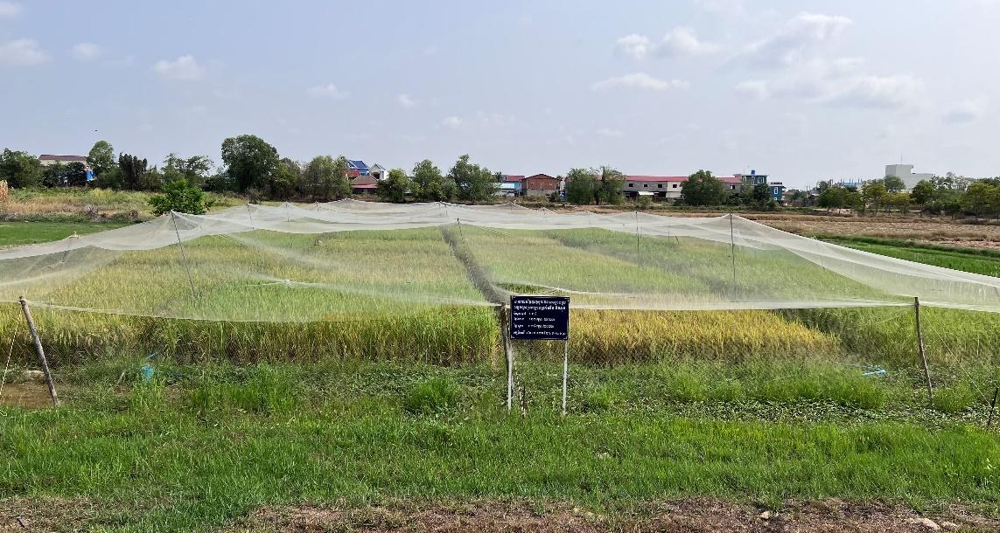

Overall framework
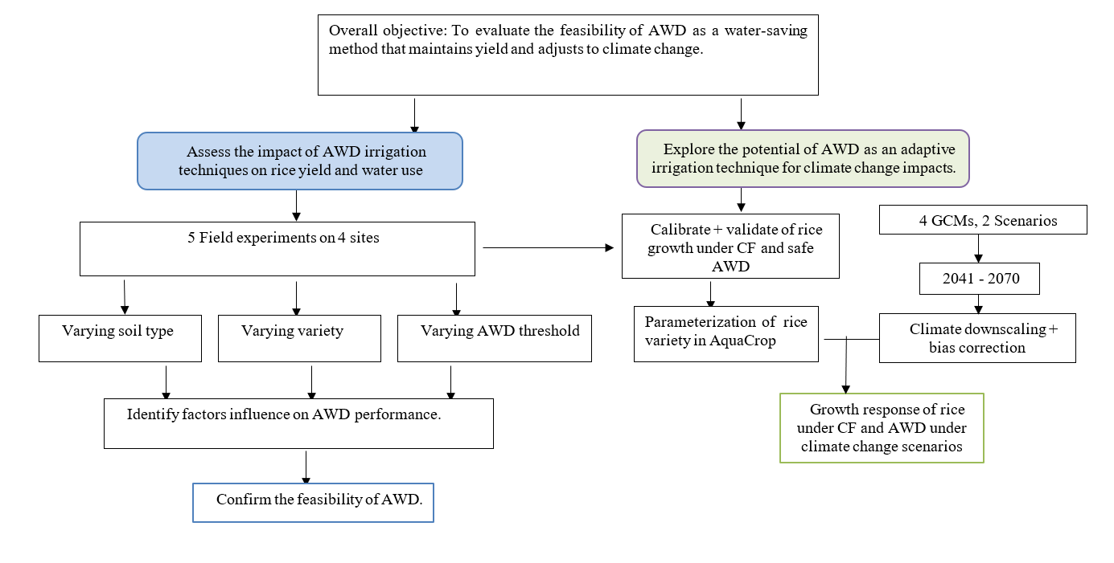

Figure 2-1: Logical framework of the study
The logical framework of the entire study is depicted in Figure 2-1, serving as a roadmap to address two research objectives: 1. to assess the feasibility of safe and moderate AWD irrigation techniques to maintain rice yield and improve WUE, and 2. building on the result from objective 1, we will investigate the potential of AWD as an adaptive irrigation technique for dry-season rice under future climate change. Under objective 1, five field experiments were conducted between 2020 and 2023 at the Cambodian Agricultural Research and Development Institute (CARDI) and Kampong Thom Province, focusing on four different soil properties, varieties, and AWD thresholds. Under objective 2, data from the field experiment at CARDI in 2023 were utilized for calibrating and validating the AquaCrop model. Once the model was adequately calibrated and validated, AquaCrop was employed under two emission scenarios using datasets from the NASA Earth Exchange Global Daily Downscaled Projections for CMIP6 (NEX-GDDP-CMIP6).

Study area

Five experiments were conducted in the dry season, as shown in Table 2-1. Three experiments were conducted at Cambodian Agricultural Research and Development Institute (CARDI) located in Phnom Penh (11º28’ N, 104º48’ E). The trial was carried out between 2020 - 2023 during the dry season from January to May (Figure 2-2).
The other two experiments were conducted in Tang Krasang Commune, Santuk District, Kampong Thom Province (KTM), at the same time during the dry season of 2022. K1 (12º33’ N, 105º2.6’ E) is 300 meters from K2 (12º33’ N, 105º2.8’ E).

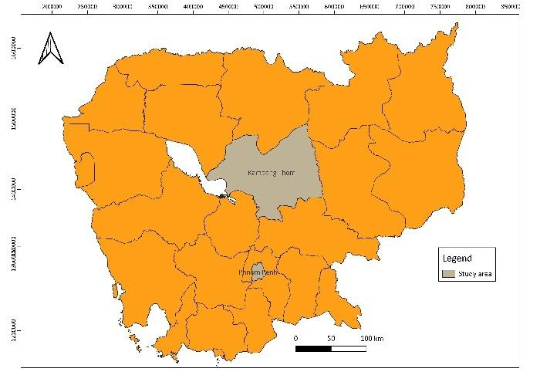
Figure 2-2 : Study areas located in Phnom Pench Capital City and Kompong Thom Province
Table 2-1 : variety, amount of fertilizer, and date of the experiment at CARDI in 2021–2023 and in Kampong Thom Province in 2022 under continuous flooding (CF) and alternate wetting and drying (AWD) irrigation
Location and soil texture | Regime | Variety | Fertilizer amount | Date of experiment | Classification adopted from CARDI (Crock, 1962)
CARDI (Site A)  Sandy loam | CF, AWD15 | OM5451, CAR15, Sen Kra Ob, Sen Pidor | 60:30:30 N:P₂O₅:K_{2O} | Feb-May, 2021  Mar-June, 2022 | Prateah Lang
CARDI (Site B)  Sandy loam | CF, AWD15 | OM5451, CAR15, Sen Kra Ob, Sen Pidor | 60:30:30 N:P₂O₅:K_{2O} | Jan-May, 2023 | Prateah Lang
KTM:  K1 : Sandy loam  K2 : Sandy clay loam | CF, AWD15, AWD20 | CAR15 | 60:30:30 N:P₂O₅:K_{2O} | Jan-Apr, 2022 | Prateah Lang  Bakan

Experimental design

3.1. Vegetal material

This study used four different rice varieties. They are short-cycle varieties with an average growing period of 80 – 100 days after transplanting (DAT) and are suited for the dry season. Among the most prevalent varieties in Cambodia (EuroCham, 2023), two varieties (Sen Kra Ob and Sen Pidor) were used in this study. Sen Kra Ob (SK) and Sen Pidao (SP) are varieties of long-grain, aromatic rice. They possess a robust fragrance and have a somewhat chewy consistency. SP yields between 3.5 and 7.4 tons/ha, while Sen Kro Ob yields 3.5 to 5.5 tons/ha (CARDI, 2017). After SP, CAR15 was released by CARDI in 2015 and originated from IRRI (IR04N155). It matures between 75 – 95 DAT and is found to be moderately resistant to brown planthoppers. The average yield is 4.0 t/ha and can reach up to 7.0 t/ha. Cultivar OM5451 is Vietnamese long-grain rice created by a crossbreed combination of Jasmine 85 and OM2490 varieties. This cultivar is primarily grown by farmers near Vietnam's borders and in other regions of Cambodia where there are buyers for export to Vietnam. With a growing cycle that lasts 90 to 95 days, OM5451 could yield an average of 4.5 to 6.5 tons/ha (Hin, 2021). OM5451 is one of the dominant rice species in the studied province and was used as a checked variety in the study area.
From an experimental perspective, their unique qualities will enable us to examine their resistance to various irrigation regimes.

3.2. Field management

Field management at CARDI, Phnom Penh

At CARDI, the experiment components such as soil preparation, field management, transplanting, plant nursery, and harvesting, were conducted by CARDI’s personnel. The PhD student was in charge of the following tasks :
- Oversee and monitor the whole experiment activity performed by CARDI to ensure it aligns with the study's objectives.
- Collect data exempted from the agreement between ITC and CARDI, such as soil texture and hydraulic property analysis, weekly canopy cover, bi-weekly biomass collection, and other parameters required for model simulation.
Table 2-2 summarizes the tasks and responsibilities of each counterpart.
Field management in Kampong Thom Province

In Kampong Thom Province, two volunteer farmers generously offer us their lands to conduct the experiments. However, since they were unfamiliar with the experimental protocol, one of our students was tasked with field management and data collection at both locations throughout the growing season, from January to April 2022. The PhD team from Phnom Penh visited the experiments and collected data every two weeks. The farmers were responsible for nurturing the seeds. After the seed was 21 days old and ready for transplanting, the research team, including PhD student and field supervisor, assumed full responsibility as indicated in Table 2-2.

Table 2-2 : Tasks and responsibilities of each counterpart during the field experiments in Phnom Penh and Kampong Thom Province
Growing stage | Activity to be performed | Data collection | Sites at CARDI | Site in the province
Before transplanting | Soil preparation, cleaning, Seedling, apply fertilizer | Fertilizer rate and date of application | CARDI | Farmers
Before transplanting | Soil sampling | Soil texture and physical characteristic | PhD student | PhD student
Transplanting | Transplanting | Date of transplanting,  Spacing between rows | CARDI | Research team
Vegetative stage to the Ripening stage | Take care of the crops, prevent pests, and apply fertilizer | Amount of irrigation, fertilizer, and pesticide information | CARDI | Field supervisor
Vegetative stage to the Ripening stage | Growth detection | Weekly Canopy Cover, Bi-weekly biomass | PhD student | PhD student
At Harvest | Harvest and measure the physiological parameters | Grain yield, biomass, panicle/m2, filled kernel, and plant height | CARDI | PhD student

3.3. Trial plot design

Figure 2-3 represents the field design for CARDI and KTM. The experimental site at CARDI (20 × 45 m) was split into two blocks, with alternate wetting and drying (AWD) and continuously flooded (CF) replicates adjacent to each other (Figure 2-4). Within each block were individual randomized plots of 4 rice cultivars (5 × 5 m). The rice varieties included Sen Kra Ob (SK), CAR15 (CAR), Sen Pidor (SP), and check rice: OM5451 (OM). In addition, the same amount of fertilizer, 60:30:30 N:P2O5:K2O, was applied to all field experiments (Table 2-1). The amount and frequency of fertilizer and pesticide application are shown in Tables 2-3 and Table 2-4. The experiment designs for the two fields (K1 and K2) in Kampong Thom were identical. A split-split plot with four replications (Figure 2-5) was applied under three main irrigation management methods: continuous flood (CF), AWD15, and AWD20. In Kampong Thom, only one variety, which was CAR15, was tested. The sub-subplot sizes were 5 × 5 m.
To prevent lateral seepage, plastic film was placed over the bundles for all the field experiments (Figure 2-6) and buried at 0.3 m.
Table 2-3: timing, frequency, and amount of fertilization applied in the experiments

Component | 60N:30P₂O₅:30K₂O | Before transplanting | 14th DAT | 30th DAT
N | 46-00-00 | 0.5 kg | 1.2 kg | 1.2 kg
P₂O₅ | 18-46-00 | 0.8 kg
K₂O | 00-00-60 | 1.1 kg

Table 2-4: timing, frequency, and doses of pesticide and fertiliser applied in the experiments
No | Utilization | Dose | Applying schedule
1 | snail | 3 | 1 day after transplanting | 7 days after transplanting | 2 weeks after transplanting
2 | brown plant hopper | 2 | 35 days after transplanting | 45 days after transplanting
3 | Fertiliser | 3 | 1 day before transplanting | 14 days after transplanting | 4 weeks after transplanting

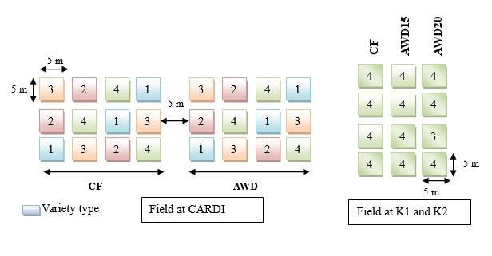
Figure 2-3: Areas and shapes of the experimental plots at CARDI and Kampong Thom province (K1 and K2). Field at CARDI : Within AWD and CF block were individual randomized plots of 4 rice cultivars with three replications. Field at Kampong Thom : a split-split plot with four replications of one variety applied under three main irrigation management methods CF, AWD15, and AWD20.
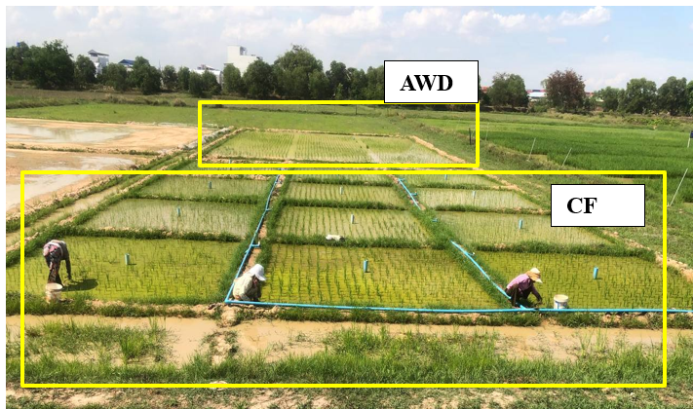Figure 2-4 : Field design at CARDI in 2021 – 2023. Within AWD and CF block were individual randomized plots of 4 rice cultivars with three replications.
AWD
CF

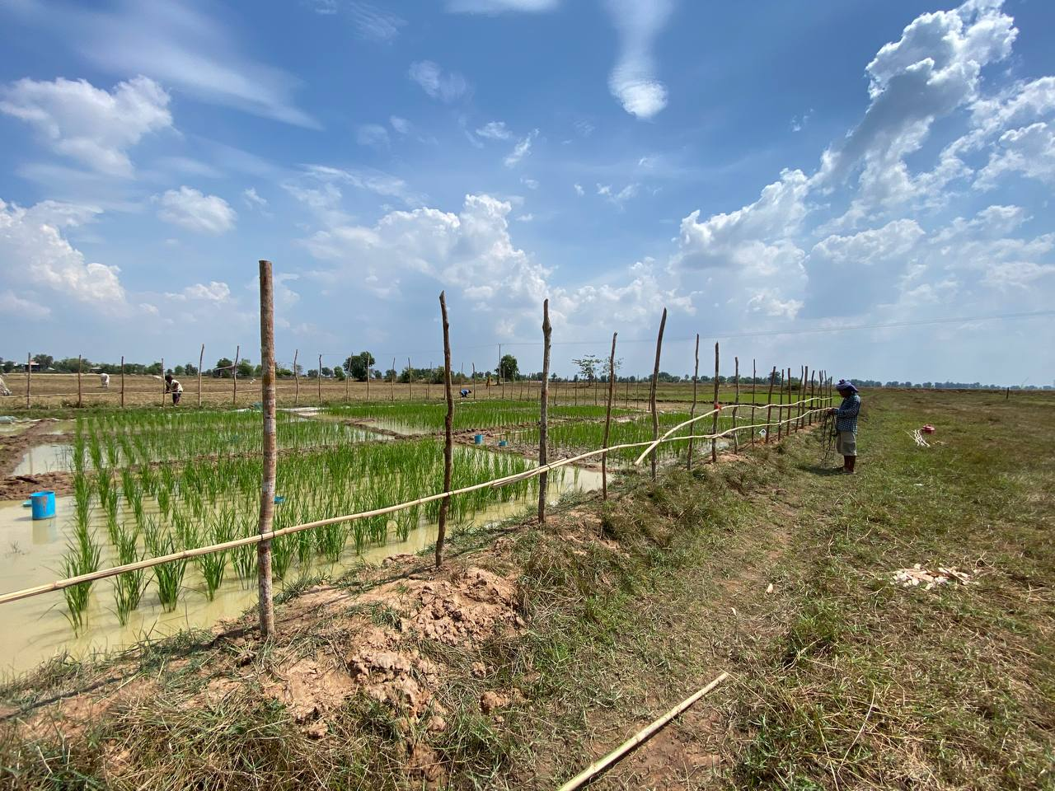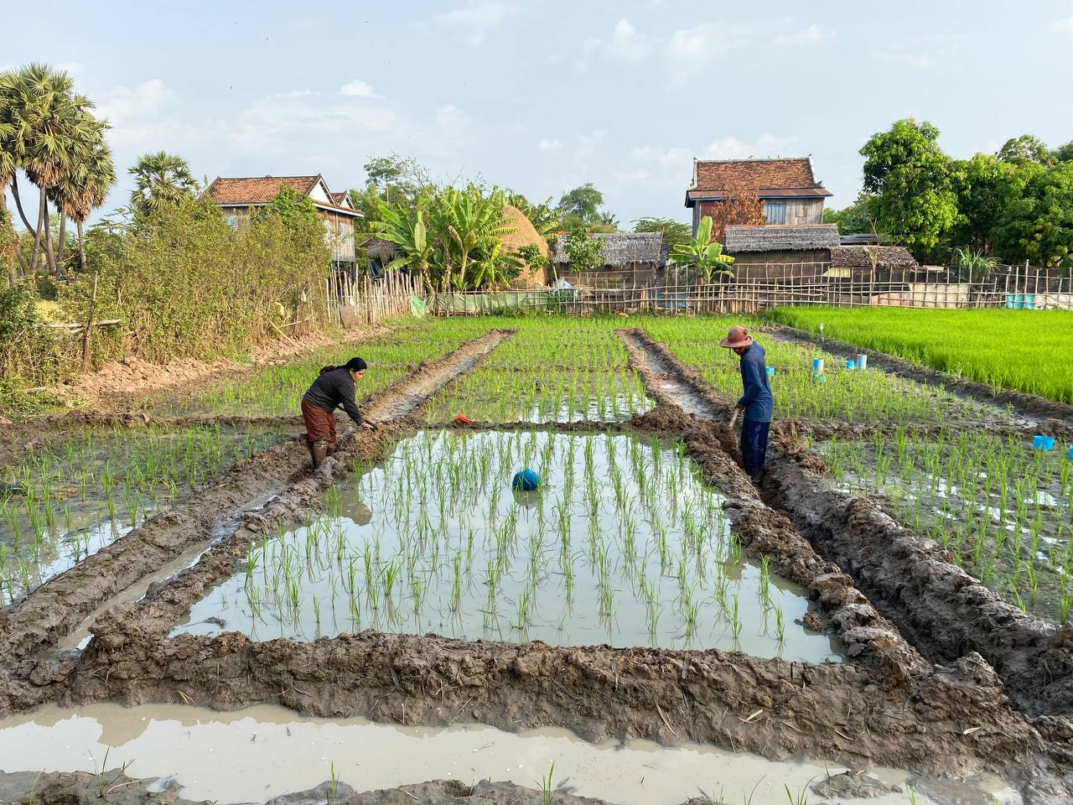
Figure 2-5: Field design at K1 on the left and K2 on the right, KTM Province in 2022. A split-split plot with four replications applied under three main irrigation management methods CF, AWD15, and AWD20. The variety used was CAR15.

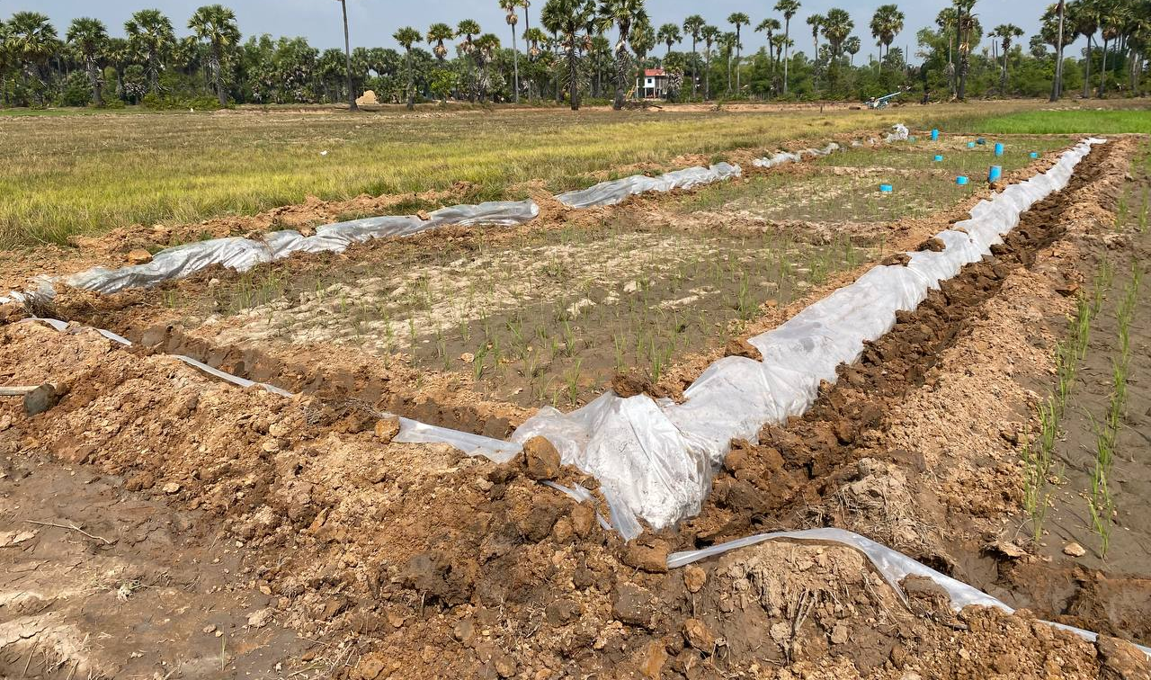
Figure 2-6 : plastic film placed over the bundle to protect side leakage around block

3.4. Water management

Irrigation was supplied by tubes connected to the pump. In CF regime, the ponded water depth in the entire field was kept between 1 and 5 cm from the 7 days after transplanting until the 10 days before maturity (Figure 2-7). In the AWD regime, hollow PVC tubes, 35 cm long and 10 cm in diameter, were placed vertically in each trial at a depth of -15 cm and -20 cm, respectively for AWD15 and AWD20. The tube was perforated with holes on all sides (Figure 2-8). In the AWD cycle, the soil was re-flooded to 5 cm after the field water disappeared from the tube. The cycle began three weeks after transplantation until one week before the peak flowering. During the cycle, surplus water from unexpected rainfall was drained. To prevent lateral seepage, plastic film was placed over the bundles. To stop water from flowing from CF to AWD treatments, the main plots were divided by gaps of five meters.

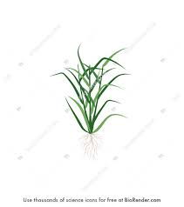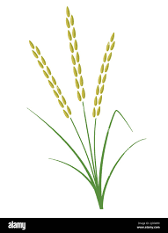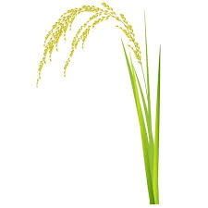

Seedling
Tillering
Flowering
Maturity
Panicle initiation
CF

Seedling
Tillering
Panicle initiation
Flowering
Maturity
AWD

Figure 2-7 : Images representing water management during the whole cycle of rice grown under CF and AWD regime

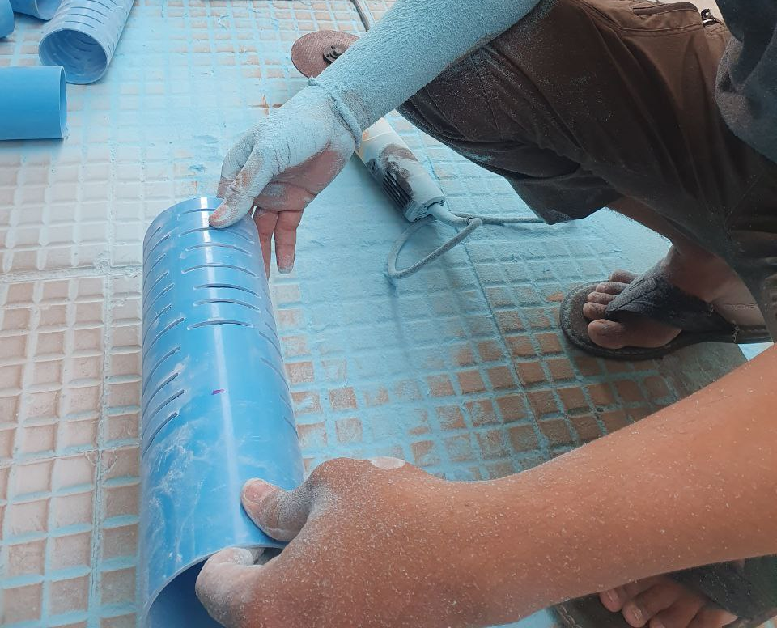

10 cm
20 cm

Figure 2-8 : Making of AWD pipe and the depth that the pipe was buried in the soil

4. Data collection

4.1. Soil sampling

Before transplanting, soil samples were collected from various horizons within a 0.8 m depth column at each site (Figure 2-9). For every horizon, three replicates were collected per parameter. The soil texture or particle size analysis was measured using hydrometers (ASTM D 422, Eijkelkamp, Nijverheidsstraat, EM Giesbeek, Netherlands). Field capacity and permanent wilting point were measured using a pressure plate (1600F1 and 1500 F2, Eijkelkamp, Nijverheidsstraat, EM Giesbeek, Netherlands) at the pressure of -33 and -1500 Kpa, respectively. Soil saturation was derived from the bulk density determined by the ring method. Saturated conductivity was measured using KSAT (Meter Group, Pullman, WA, USA).

      - Soil profile description

Location | Horizon | Depth (m) | Color | Texture | Structure | Notes
Site A | A | 0 – 15 | Light brown to pale brown | Sandy loam | Granular | Many fine roots, moist
Site A | B | 15 - 30 | Light brown with yellowish tint | Sandy loam | Granular | Few roots
Site A | C | 30 - 80 | Reddish brown | Loam | Platy | Some gravel, no roots visible
Site B | A | 0 - 30 | Yellowish brown | Sandy loam | Granular | Many fine roots, moist
Site B | B | 30 - 40 | Brown to dark yellowish brown | Sandy loam | Granular | no roots visible
Site B | C | 40 - 80 | Pale yellowish brown | Sandy loam | Platy | Some gravel, no roots visible
KTM K1 | A | 0 - 25 | Grayish brown | Sandy loam | Granular | Many fine roots, moist
KTM K1 | B | 25 - 50 | Yellowish brown with red mottles | Sandy loam | Granular | Several roots visible
KTM K1 | C | 50 - 80 | Grey with red streaks | Sandy clay | Platy | Some gravel, no roots visible
KTM K2 | A | 0 - 20 | Dark brown | Sandy clay loam | Granular | Many fine roots, moist
KTM K2 | B | 20 - 30 | Yellowish brown with red mottles | Clay loam | Granular | Some roots visible
KTM K2 | C | 30 - 80 | Grey with red streaks | Clay | Platy | Some gravel, no roots visible

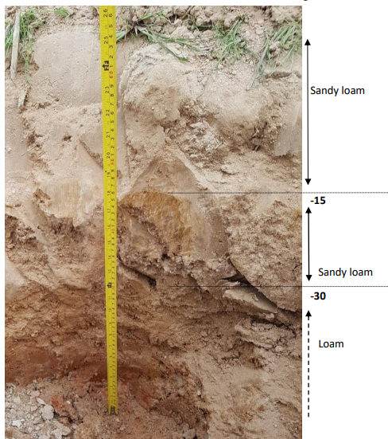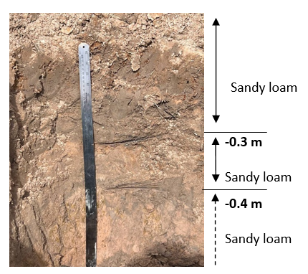
CARDI site A
CARDI site B
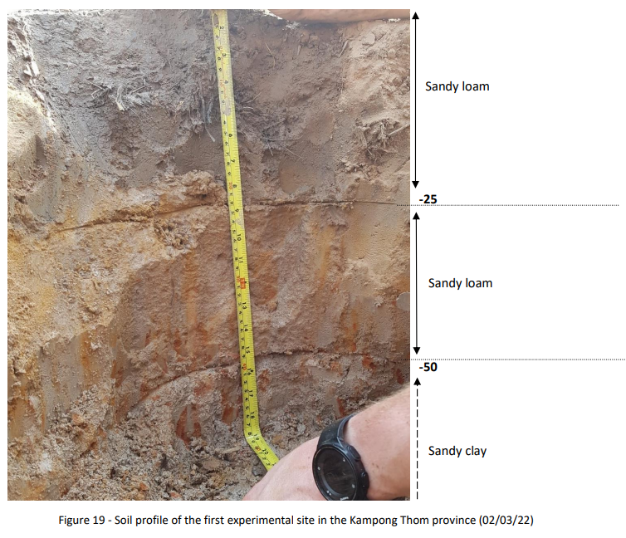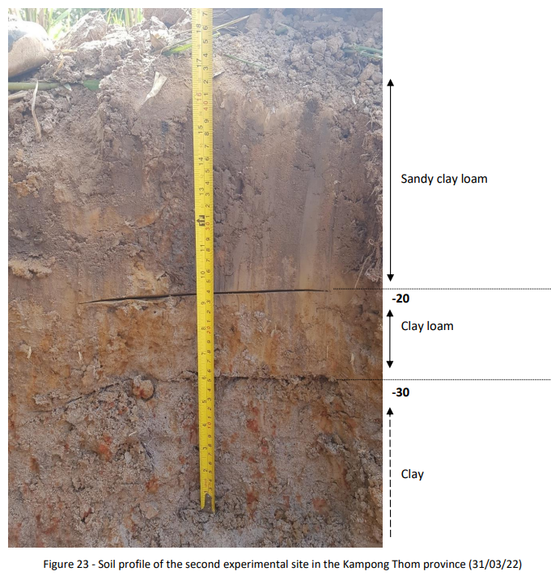
KTM K1
KTM K2
Figure 2-9 : Soil profile at the four study sites within a 0.8 m depth column. Three replicates were collected from each horizon.

4.1.2. Particle size analysis

In this method, the sample passed through the 2 mm sieve is cleaned from organic matter, after which it is dried and weighed. Oxidation of organic matter procedure followed the process required for soil cleaning before hydrometers (Eijkelkamp, 2009). The oxidation of organic matter involves weighing about 20 g of fine soil into a beaker, then adding water and 30% hydrogen peroxide (H₂O₂). The mixture is covered and left overnight, then heated at 80 °C with incremental additions of H₂O₂ until the organic matter is fully decomposed, indicated by a clear solution. Water is added to reach about 300 ml, and the solution is boiled for one hour to remove any remaining peroxide. After cooling, the sample is centrifuged or allowed to settle, and the supernatant is decanted.
Next, it is suspended in water and sieved for clay and silk ($≤50 μm)$. The solution that passes through the sieve $≤50 μm$ is transferred to a measuring cylinder with water. Hydrometer readings are taken at regular intervals. Sedimentation time and hydrometer readings are used to determine the grain sizes according to Stoke’s Law. The hydrometer used in this experiment is Hydrometer acc. ASTM D 422 (art. no.: 08.30.01.02), the scale of the hydrometers was between -5 to 6 +60 g/l (Figure 2-10).
After mixing the soil with a dispersing agent, sand is separated from the clay and silt using a 50 µm sieve. The sand fraction is then separated by dry sieving, while the clay and silt fractions are determined through hydrometer readings. The suspension with particles smaller than 50 µm is placed in a sedimentation cylinder along with a blank solution containing water and dispersing agent. After allowing the suspension to reach thermal equilibrium and recording the temperature, the cylinder is sealed and shaken thoroughly; a drop of amyl alcohol may be added to reduce foam. The hydrometer is then carefully lowered into the suspension to take an initial reading within 50 seconds after mixing. Subsequent readings are taken by reinserting the hydrometer at specified times—typically 5, 120, and either 960 or 1440 minutes—while rinsing and drying the instrument after each use. All readings, including those in the blank solution, are recorded along with the temperature to monitor sedimentation over time. Then, the calculation for the percentage of clay and silk followed Eijkelkamp (2009).

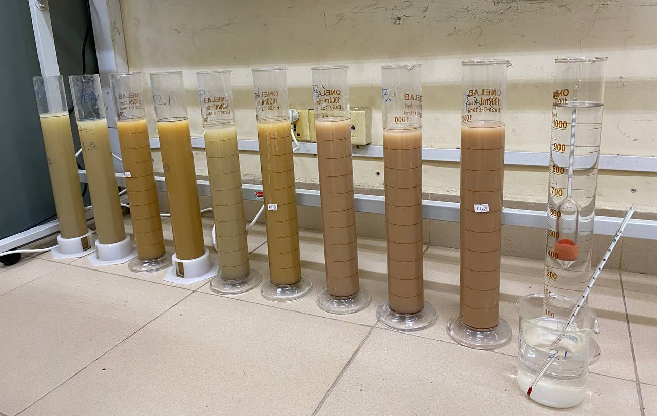
Figure 2-10: Particle size analysis using hydrometer for CARDI soil. Three horizons were identified and in one horizon, 3 replicates were collected. Samples were ranged from horizon 1 to 3 (left to right).

4.1.3. Bulk density
The bulk density was calculated with undisturbed samples taken from the field in metal rings. The samples were prepared and dried at 105°C during 24h. The bulk density was then calculated as:
$ρ_{soil}=\frac{m}{v}$ (2-1)
With m being the dry mass of the sample in g and v being its volume in cm³.
4.1.4. Measurement of Soil Water Retention Capacity
Field capacity and permanent wilting point
Field capacity (FC) and permanent wilting point (PWP) were measured using a pressure plate at pressures of -33 kPa and -1500 kPa, respectively. For the -33 kPa pressure, we utilized a 5 Bar Ceramic Plate Cell, while for -1500 kPa, we used a 15 Bar Ceramic Plate Cell.
Soil sub-samples were collected from an undisturbed soil sample (Figure 2-11a) and placed in sample retaining rings, which hold a 25 g sample and measure 1 cm in height and 5.5 cm in diameter. The samples were allowed to stand overnight above water (Figure 2-11b) to ensure saturation before being placed on each pressure plate cell, which can accommodate 12 samples.
The pressure plates were then loaded into the extractor (Figure 2-11c) and supplied with air pressure at -33 kPa until the soil moisture in the extractor reached an equilibrium state. A similar procedure was repeated for the 15 Bar pressure plate cell under -1500 kPa. Detailed instructions on how to set up and conduct the experiment can be found in the operating manual (Eijkelkamp, 2015 a,b). The volumetric water content at saturation (SAT), field capacity (FC), and permanent wilting point (PWP) were measured using the following equations:
SAT (% vol or cm/cm) = $\frac{Saturated soil weigth -Dry soil weigth }{Dry soil weigth}×ρ_{soil}×100$ (2-2)
FC (% vol or cm/cm) = $\frac{Soil weigth at-33 Kpa -Dry soil weigth }{Dry soil weigth}×ρ_{soil}×100$ (2-3)
PWP (% vol or cm/cm) = $\frac{Soil weigth at-1500 Kpa -Dry soil weigth }{Dry soil weigth}×ρ_{soil}×100$ (2-4)
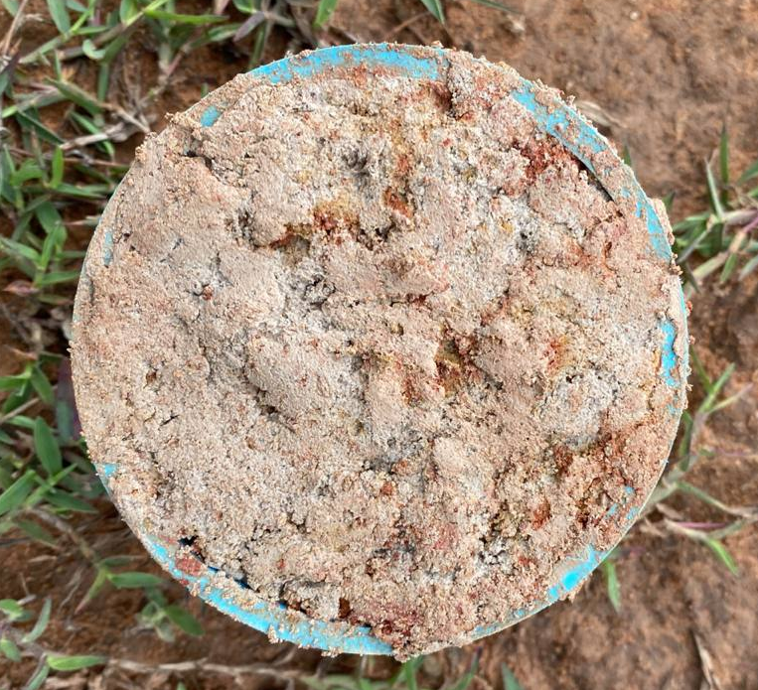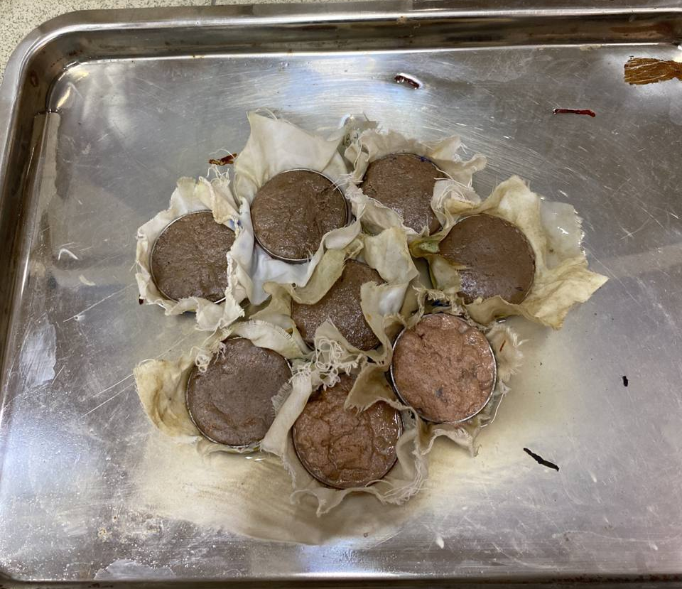
a
b
c
Figure 2-11: Sample preparation for measurement of water retention by pressure plates. a: an undisturbed sample from the field, b: sub-samples after 24 hours standing on the shallow water, c: samples on the pressure plate being loaded in the extractor
Saturated hydraulic conductivity (Ksat)
Sub-samples from an undisturbed soil sample were collected in the metal rings and placed in the KSAT device (Figure 2-12). The sub-samples were left standing in the shallow water until they were saturated.
The measurements were conducted using the falling head method, where the burette is initially filled with water, allowing it to flow through the sample without any refilling. A pressure sensor continuously measures the pressure head at short intervals and calculates the Ksat value based on this data. The information was gathered using the KSAT application. The sample collection, preparation and measurement by KSAT followed the Operation Manual of KSAT (UMS, 2013).
Water permeability (KS ) is calculated from the volumetric water flux V divided by the soil sample area A and time t, the length of the soil sample L and the hydraulic head gradient H along the flow direction. According to Darcy’s low :
$q=\frac{V}{A.t}=-K_{s}\frac{H}{L} and K_{s}=\frac{LV}{HAt}$ (2-5)
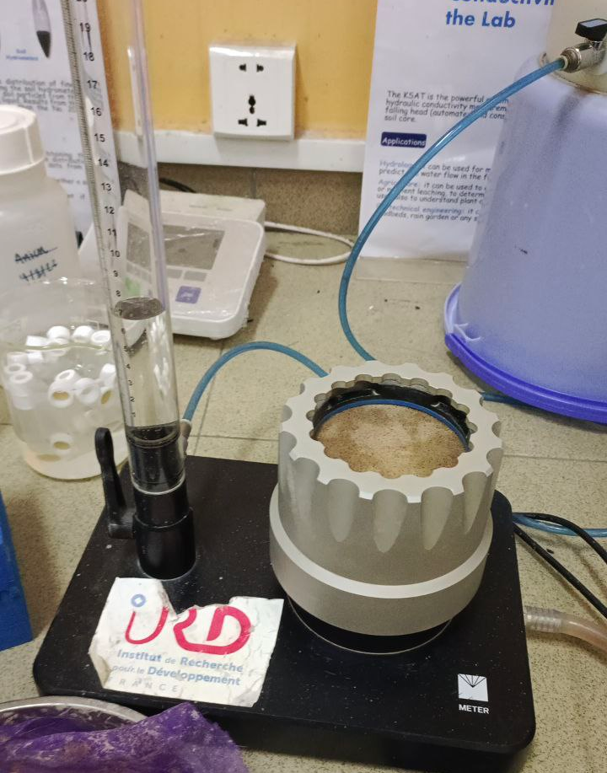
Figure 2-12: Ksat measurement using falling head technique. An undisturbed sample was placed in the metal ring, allowing water to pass through the bottom. The water was released from the burret, of which the drop was recorded continuously and automatically.

4.2. Measurement of yield, yield components and root depth

4.2.1 Indicative Parameters

The yield components of rice include the number of panicles per unit area, number of spikelets per panicle, weight of spikelet, grain weight and filled spikelet. Additionally, the above-ground dry biomass and the harvest index (HI) are also positively linked to the overall grain yield. These yield components and yield-associated parameters are formed during the crop growth cycle. Knowledge of yield components and yield-associated parameters is important to estimating potential rice yield and the impact of environmental stresses, e.g., potential water stress in AWD, on rice (Fageria, 2007). The yield components and yield-associated parameters used in this study were statistically assessed to determine if AWD would create water stress conditions in rice. Rice phenology such as flowering and maturity time were also studied.
Parameters used as indicators on AWD performance at different rice phenological stages (Ishfaq et al., 2020) were described below:

Yield:
  - Grain yield: typically reported as rough rice, which contains 14 percent moisture. Rough rice consists of the whole grain and the hull, which comprise approximately 20 percent of its weight (FAO, 2012).

Yield components:
  - Number of panicles per m²: Panicle number and tillering number are related. Tillering is affected by various environmental factors such as light, temperature, soil moisture, and nutrient levels in the main stem, and it is also influenced by genetic traits. A plant's ability to tiller effectively is closely linked to its capacity to utilize space and resources optimally. Tillering plays a crucial role in coping with biotic and abiotic stresses through compensation mechanisms. High tillering can offset the loss of plants when densities are low, whereas cultivars with limited tillering capacity lack this adaptability. Nevertheless, in optimal environmental conditions, high tillering cultivars do not provide any yield advantage over those with lower tillering characteristics (Fageria, 2007).
  - Total spikelets: The overall quantity of spikelets in a panicle is an important determinant of rice yield. Since each spikelet can potentially turn into a rice grain, an increased number of spikelets typically correlates with a higher possible yield. Varieties of rice that produce more spikelets may also show better adaptability to various growing conditions and stress factors (Liu et al., 2023).
  - Percentage of filled spikelets: Filled spikelets play a vital role in influencing rice yields, as they indicate the potential for grain production on a rice plant. A greater proportion of filled spikelets results in more grains per plant, contributing to a higher total yield (Mai et al., 2021).

Yield related parameters
  - Biomass: An increase in above-ground biomass is crucial because it has a strong correlation with grain yield. This biomass is determined by the genotype and shaped by environmental conditions. Severe water stress could trigger early canopy senescence, which reduces green canopy cover and results in lower biomass (FAO, 2017).
  - Harvest index: expresses the mass of the harvested product as a percentage of the total above-ground biomass. While the HI is typically presented as a ratio, it can also be shown in percentage form. The HI values for rice differed significantly based on the cultivar, location, season, and ecosystem, ranging from 0.35 to 0.62 (Fageria, 2007).

  - Plant height: Plant height refers to the measurement from the ground level to the top of the tallest panicle. When rice plants face water scarcity, they typically show limited growth, resulting in decreased plant height. Various rice varieties demonstrate different levels of height reduction in response to water stress. Some genotypes are more resilient and retain a relatively taller stature, while others are more susceptible and suffer considerable height loss (Singh et al., 2018).
  - Effective root depth (ERD): Defined as a depth where 70% of roots are located (Zhang et al., 2017). The effectiveness of roots in fulfilling their functions relies on their type, structure, and any modifications they may have. A root system that extends deeper into the soil can better tap into available water, potentially leading to higher yields during drought conditions. The root system's ability to adapt to variations in soil moisture and redox potential will influence how AWD treatment affects nutrient access, overall root system water potential, signaling, and the distribution of resources between the roots and shoots (Sandhu et al., 2017). The roots of rice plants generally reside within the plow pan and tend to be relatively shallow of 10 – 20 cm below soil.

  - Water use efficiency (WUE)
Water use efficiency (WUE) was defined as the grain yield per unit of total water input, including irrigation and precipitation. Crop WUE is especially an important consideration where available water resources are limited or diminishing.

4.2.2 Plant data collection

At maturity, ten plants were taken randomly outside a 6 m² area, where grain yield was determined. The 6 m² area was located in the middle of the plot where the AWD pipe was installed to avoid the border effect, as shown in Figure 2-14. Two main influences of the border effect in this study are covered by two aspects. First, due to soil loss during the bundle-making process, the soil elevation is generally lower at the plot's edges than in the middle. Due to this, the plant is far healthier in its initial growth stages than in other sections. Second, when there is damage from pests, the damage is started from the border toward the middle of the plot. Once we take the correct measures to stop the pest, the damage will remain only at the border. Plant height was measured from the plant base to the tip of the highest leaf (Figure 2-15). Panicle number was recorded from those ten plants. Three subsamples of panicles were randomly chosen from the ten plants (Figure 2-13). within the three subsamples, the filled and unfilled spikelets were identified by squeezing. The total number of panicles per meter square equals the total panicle per hill multiplied by the number of hills per m², which is 25. Aboveground total biomass was the total dry matter of straw, rachis, and spikelets after oven-drying to constant weight at 70 ◦C for 48 hours. Spikelets per panicle, grain-filling percentage (100 × filled spikelet number/total spikelet number), and harvest index (100 × filled spikelet weight/aboveground total biomass) were calculated. Grain yield was determined from a 6 m² area in each plot and adjusted to the standard moisture content, followed by Equation 2-6 of 0.14 g H₂O g⁻¹ fresh weight. One plant per plot was recorded for an effective root depth (Figure 2-15).
${Yield}_{adjust}={Yield}_{Harvest}×\frac{\frac{100-Harvest moisture}{100}}{\frac{100-standard moisture}{100}}$ (2-6)

Figure 2-13: A sub-sample of panicles was randomly chosen from the ten plants to measure the number of spikelets and percentage of filling

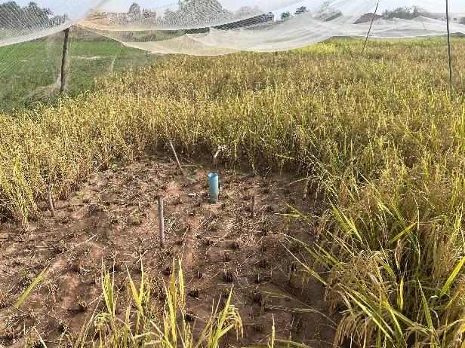
Figure 2-14: To avoid the border effect, rice at the border (3 by 3 plants in row and column) was avoided during harvesting
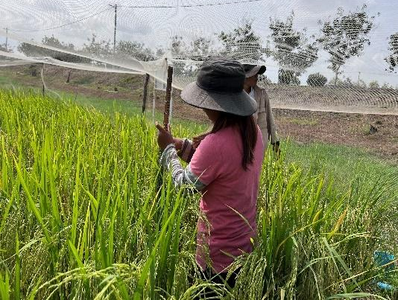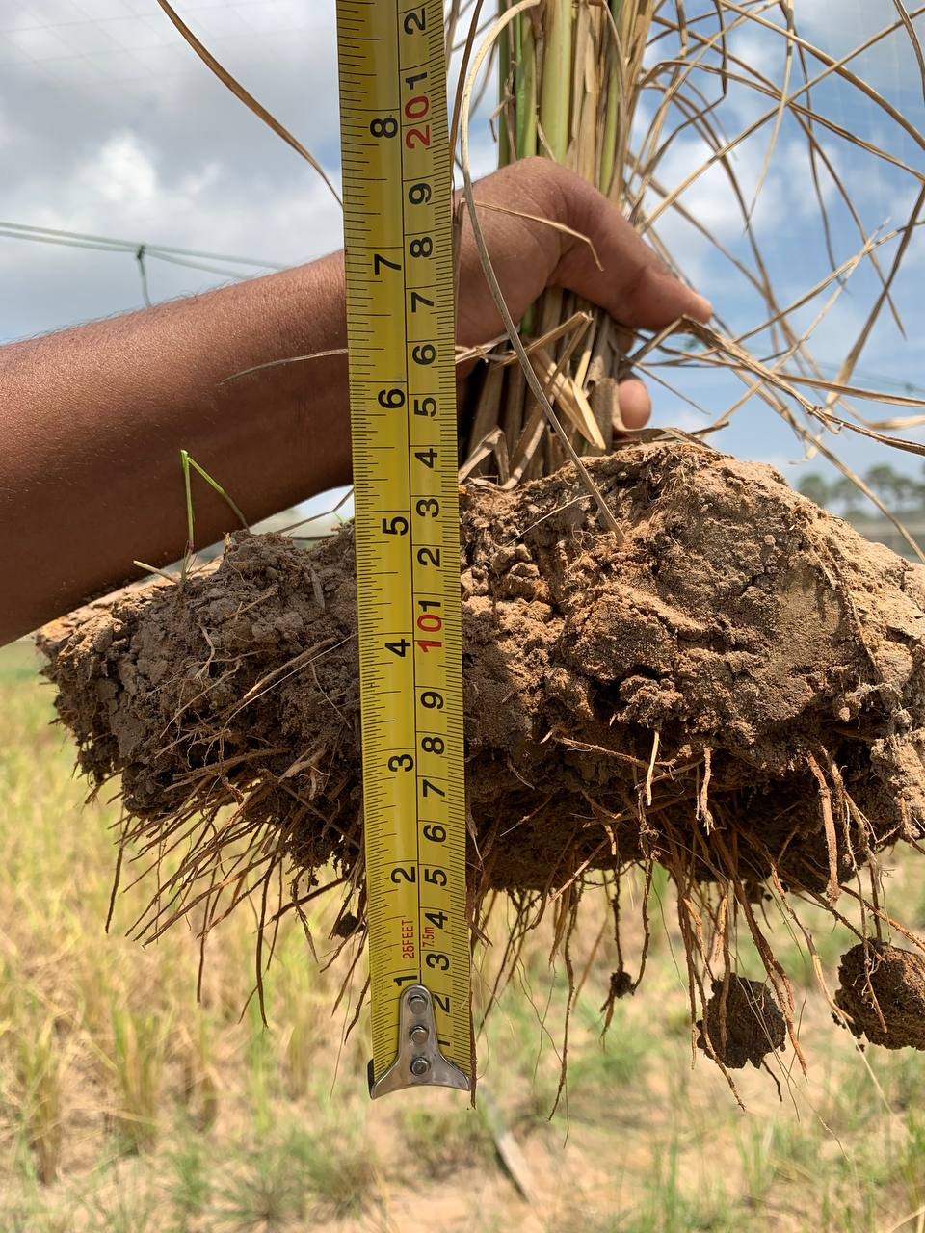
Figure 2-15 : Plant height measured from the plant base to the tip of the highest leaf and effective root depth defined as a depth where 70% of roots are located.

4.3. Canopy Cover Estimation Using Adobe Photoshop

According to FAO (2016a), canopy cover is estimated from overhead canopy images. For small plants, the camera can be placed directly above the plant, while for taller plants, an extension is used to increase the camera’s height. Drones equipped with high-resolution cameras can also be used to capture images of larger fields. After collecting the images, various applications such as Image J, Green Crop Tracker, Adobe Photoshop, and ENVI can be used to estimate canopy cover. Additionally, before using the software, the border effect should be removed from the images. This effect is caused by distortion from camera lenses. To eliminate it, visually identify well-captured areas of the overhead canopy and exclude the regions near the edges of the image.
Weekly data on canopy cover was collected by digital photos shot at a constant height of 1.8 meters, three points per replicate. The analysis of the images was done using Adobe Photoshop 2020. The fraction of the canopy covering the soil was determined by dividing the total number of crop pixels by the total number of picture pixels. Three by four plants in the center of the image, indicated in Figure 2-16, were retained in order to eliminate the border effect, which produces greater value of canopy cover, as shown in Table 2-5 (FAO, 2016a).

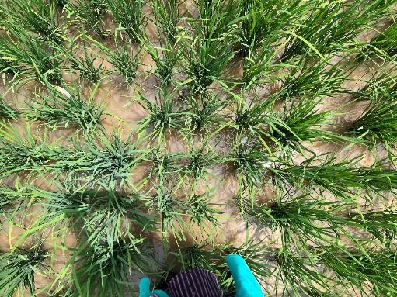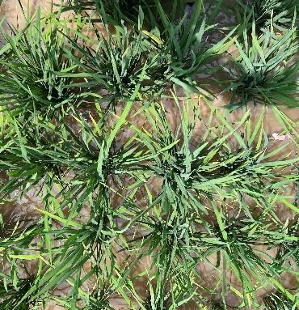

Figure 2-16 : Border effect removal for canopy analysis in Adobe Photoshop. Only 3 by 4 crops in the middle were maintained. The left-hand side photo would have a higher CC if the border effect was not removed.
Table 2-5 : Comparison of canopy cover on soil before and after border removing
No | CC%  Full image | CC% After cropping out the border | Difference of CC% before and after border removing
1 | 65.99 | 38.86 | 27.13
2 | 43.4 | 22.54 | 20.86
3 | 33.7 | 11.75 | 21.95
4 | 43.79 | 19.12 | 24.67
5 | 40.46 | 16.16 | 24.3
6 | 48.67 | 15.65 | 33.02
7 | 46.94 | 16.84 | 30.1
8 | 46.02 | 13.57 | 32.45

4.4. Water level measurement

Water levels were manually measured daily (Figure 2-17) and at an 8-hour timestep by a water level sensor (U20L-01, HOBO, Occasion, USA) for comparison purposes. For manual measurement, when water was ponded, the level was measured outside the tube from the top soil to the water level. When water dropped below the surface, the water depth was measured inside the tube.
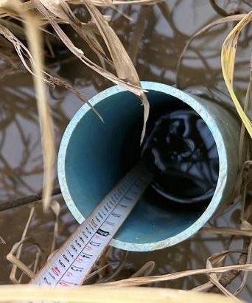
Figure 2-17: Manually measuring of water level in AWD pipe

4.5. Calibration of Teros 21 and Teros 12 for measurement of soil potential and volumetric water content

For Teros 21, calibration for different soil layers is not required. Because the sensors solely monitor the water potential of the ceramic discs in equilibrium with the soil, the soil type has no effect on the TEROS 21 calibration. As long as TEROS 21 is positioned correctly and has sufficient hydraulic contact (to guarantee timely water potential equilibrium between the sensor and the medium of interest), it can operate in any type of soil or other porous media (METER Group, 2017).
Because the TEROS 12 operates at a high measurement frequency, it is insensitive to changes in soil texture and electrical conductivity. As a result, for the majority of mineral soils up to 8 dS/m saturation extract, its generic calibration equation should produce an acceptable absolute accuracy of 0.03 m3/m3. However, users are advised to carry out soil-specific calibrations for increased accuracy (Meter Group, 2018). The sensor's manual includes details and alternative calibration (Meter Group, 2018).

The soil-specific calibration in this study was summarized as follows :
Undisturbed soil samples with an internal diameter of 157 mm and a height of 55 mm were collected from the first layer of the experimental field at CARDI, wrapped in plastic to prevent water loss. After air drying, the dry mass was measured, and the samples were saturated overnight. The sample was placed on the balance, and the Teros 12 sensor was then inserted into the sample. The wet mass was periodically noted from the balance every 30 minutes, allowing for the calculation of volumetric water content (VWC) and comparison with sensor readings. A scatter plot was created to establish a calibration function, using two separate models for VWC values above and below 31 cm³/cm³, which were then applied to the Teros 12 raw data for analysis (Figure 2-18).

Figure 2-18: The plot of calibration data for Teros12 during a field experiment in 2013 (a,b). The soil specific calibration equation is shown in the upper right corner of the graph area

Crop Model Parameterization and Climate Projection

5.1 Aquacrop Model Concept

The FAO AquaCrop model simulates crop yield through a series of steps: (i) crop development, (ii) crop transpiration, (iii) biomass production, and (iv) yield formation. Evapotranspiration calculations in the model are split into transpiration, which is linked to canopy cover (CC), and soil evaporation, which is proportional to bare soil. To determine potential crop transpiration, the CC is multiplied by the reference evapotranspiration (ETo) derived from the Penman-Monteith equation and the crop coefficient (Kc). Actual transpiration (Ta) is then calculated from potential evapotranspiration. Ta is further utilized to compute crop biomass (B) by multiplying it by water productivity (WP) (Eq. (1)). The harvest index (HI) is employed to determine crop yield (Y) based on crop biomass (B) (Eq. (2)) (Raes et al., 2017).

Crop biomass (B)as kg/ ha = ∑Ta ∗ WP (2-7)

Crop yield (Y)as kg/ha = HI ∗ B (2-8)

Crop development adjustment to temperature regime

The development of the green canopy cover and the deepening of the root system is simulated as a function of time in AquaCrop. The user has the option to simulate crop development in calendar days or growing degree days (GDD).

When adjusting crop parameters, the duration needed to reach a specific developmental stage is typically measured in calendar days. By translating calendar time into thermal time, the length and timing of crop development stages can be modified according to the temperature conditions of different years (FAO, 2016b).

The thermal time is determined by calculating the heat units (°C) accumulated each day, known as Growing Degree Days (GDD), by subtracting the base temperature from the average air temperature (Tavg):
0 ≤ GDD = Tavg - Tbase (2-9)

The base temperature (Tbase), which is crop specific conservative parameter, is the temperature below which crop development does not progress. If the average air temperature is below Tbase no heat units can be accumulated during that day and GDD is zero.

IPCC scenarios

In the Fifth Assessment Report (AR5), these input projections were known as representative concentration pathways (RCPs). In the Sixth Assessment Report (AR6), new sets of inputs are introduced, referred to as SSP scenarios, where SSP stands for shared socioeconomic pathways that encompass socioeconomic assumptions (IPCC, 2022).
The SSP scenarios cover a spectrum from ambitious mitigation efforts to continued growth in emissions, with the highest ambition aligned with the Paris Agreement's goal of limiting global temperature rise to well below 2°C, and ideally to 1.5°C. The SSPs provide plausible narratives for future societal developments without considering climate change, mitigation or adaptation. They highlight the challenges and successes in implementing mitigation and adaptation strategies based on factors like population, regional collaboration, and technological advancements. Five Shared Socioeconomic Pathways (SSPs), identified as SSP1–1.9, SSP1–2.6, SSP2–4.5, SSP3–7.0, and SSP5–8.5, were created to address specific shortcomings found in the Representative Concentration Pathways (RCPs). The first digit in the label represents the distinct set of socioeconomic factors influencing emissions and other climate-related inputs utilized by climate models, while the second digit indicates the level of radiative forcing anticipated by the year 2100 according to IPCC (2022) (Figure 2-19).
The five Shared Socioeconomic Pathways (SSPs) discussed in the article of O'Neill et al. (2014) are as follows:
- SSP1: Sustainability - Taking the Green Road: This scenario imagines a future that emphasizes global sustainability and fairness, marked by swift technological advancements and a strong commitment to environmental protection.
- SSP2: Middle of the Road: This scenario reflects a continuation of existing social and economic patterns, facing moderate challenges in terms of climate mitigation and adaptation.
- SSP3: Regional Rivalry - A Rocky Road: This scenario portrays a world where competition for resources intensifies and multilateral cooperation becomes fragmented, resulting in significant obstacles to both mitigation and adaptation.
- SSP4: Inequality - A Road Divided: This scenario describes a world increasingly defined by inequality, widening the divide between wealthy and poor populations, which presents minimal challenges to mitigation but substantial difficulties for vulnerable groups in terms of adaptation.
- SSP5: Fossil-Fueled Development: This scenario envisions a future that continues to depend heavily on fossil fuels, creating serious challenges for both mitigation and adaptation efforts.
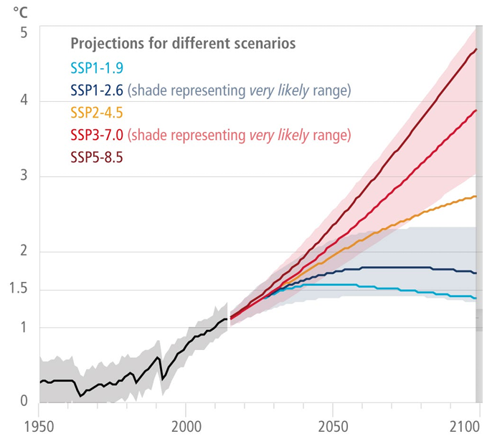
Figure 2-19: Temperature rising anticipated by the year 2100 according to SSP scenarios
(IPCC, 2022)

5.3. Retrieving downscaling climate data from Global Climate Model (GCM)

The need for downscaling outputs from General Circulation Models (GCMs) stems from two main shortcomings in current global simulations. First, many GCMs operate on relatively low-resolution grids (such as a few degrees or approximately 102 km), which restricts their capability to capture the finer details of climate patterns necessary for regional or local studies. Second, even the most sophisticated GCMs can generate projections that, while globally accurate, may exhibit local biases in their statistical features (such as mean, variance, etc.) when compared to actual observations (Thrasher et al. 2012). Downscaling methods help connect global climate model (GCM) outputs to higher-resolution climate projections that are crucial for impact assessments.

The dataset known as the NASA Earth Exchange Global Daily Downscaled Projections (NEX-GDDP-CMIP6) consists of climate scenarios that have been downscaled globally from the General Circulation Model (GCM) experiments carried out as part of the Coupled Model Intercomparison Project Phase 6 (CMIP6) (Eyring et al., 2016). With the help of the computational resources provided by NEX and the NASA Advanced Supercomputing (NAS) facility, bias correction was applied to produce a global dataset of downscaled CMIP6 climate projections to facilitate the assessment of climate change impacts. The dataset compiles climate projections from 35 CMIP6 GCMs and four SSP scenarios (SSP2-4.5, SSP5-8.5, SSP1-2.6, and SSP3-7.0) for the period from 2015 to 2100, as well as the historical experiment for each model for the period 1950-2014. Each climate projection is downscaled to a spatial resolution of 0.25 degrees x 0.25 degrees.

NEX-GDDP-CMIP6 was used to obtain the possible projections of future climate variables for 2041–2070. We adopted two shared socioeconomic pathways (SSP3-7.0 and SSP5-8.5) to represent medium and highest greenhouse gas emissions. We applied four different GCMs for each scenario, including EC-Earth3, FGOALS-g3, MIROC6, and MPI-ESM1-2-LR. The ETo for baseline and future data was estimated from T maximum and T minimum using the FAO-Penman–Monteith equation described in Allen et al. (1998).

The model data could be downloaded from NASA resources (https://doi.org/10.7917/OFSG3345). An R program extracted the model data in NetCDF format to the experimental site. The script used for point data extraction is in Annex 1.

5.4. Linear scaling for bias correction of the downscaling climate data

Though the NEX-GDDP-CMIP6 dataset was globally bias-corrected, applying correction using data from the actual site would significantly improve the errors before applied to AquaCrop (Maurer et al., 2008; Thrasher et al., 2012).
The linear scaling approach has proved its capability for bias correction of climate data (Daniel, 2023; Shrestha et al., 2017) and was adopted in this study. The CIMP6 dataset was adjusted for bias, utilizing baseline data T maximum, T minimum, and precipitation data from historical records spanning 1996 to 2011. The baseline data was from the nearby station (Pochentong Station: 104º50', 11º33', Altitude 11 m) obtained from the Ministry of Water Resources and Meteorology (MOWRAM). In the linear scaling approach outlined in equation (2-10, 2-11), the future CIMP6 data, such as precipitation is corrected with a multiplier, and the temperature is adjusted by the additive term:

$P_{f,m,d}^{C}=P_{f,m,d} ×\frac{μ(P_{ob,m})}{μ(P_{h,m})}$ (2-10)
$T_{f,m,d}^{C}=T_{f,m,d}×\left[μ(T_{ob,m)}-μ(T_{h,m})\right]$ (2-11)

where $P_{f,m,d}^{C}$ and $T_{f,m,d}^{C}$denote the corrected future precipitation and temperature, respectively; P_{h,m,d} and T_{h,m,d}, respectively, denote the historical precipitation and temperature from the original RCM outputs; P_{ob,m} and T_{ob,m} denote the observed historical precipitation and temperature; the subscripts d and m are specific days and months, respectively, and μ denotes the mean value. In this study, Table 2-6 captures how correction factor of rainfall was estimated from historical data for the MIROC6 model. Table 2-7, shows the corrected future rainfall after the correcting factor was applied.
Table 2-6: Estimation of the bias correction factor ($f$) using daily observations and MIROC Model data for historical precipitation from 1996 to 2011.
Month | $μP_{ob}$daily | $μP_{h}$daily | $$f=\frac{μP_{obdaily}}{μP_{h} daily }$$
1 | 0.59 | 0.54 | 1.09
2 | 0.14 | 0.54 | 0.26
3 | 1.07 | 1.51 | 0.71
4 | 3.08 | 3.07 | 1.00
5 | 4.11 | 5.16 | 0.80
6 | 5.72 | 6.22 | 0.92
7 | 5.37 | 6.73 | 0.80
8 | 6.22 | 8.11 | 0.77
9 | 8.83 | 9.59 | 0.92
10 | 8.89 | 8.74 | 1.02
11 | 4.12 | 4.35 | 0.95
12 | 1.19 | 1.44 | 0.82

Table 2-7: Corrected future rainfall of MIROC6 Model after the correcting factor ($f$) was applied for January 2041. The complete calculation was made from 2041 – 2070.
Day | Month | Year | P_{f} | P^{c}_{f} = P_{f}*f
1 | 1 | 2041 | 0.00 | 0.00
2 | 1 | 2041 | 0.00 | 0.00
3 | 1 | 2041 | 0.00 | 0.00
4 | 1 | 2041 | 0.00 | 0.00
5 | 1 | 2041 | 0.00 | 0.00
6 | 1 | 2041 | 0.00 | 0.00
7 | 1 | 2041 | 0.00 | 0.00
8 | 1 | 2041 | 0.00 | 0.00
9 | 1 | 2041 | 0.00 | 0.00
10 | 1 | 2041 | 0.02 | 0.03
11 | 1 | 2041 | 0.00 | 0.00
12 | 1 | 2041 | 0.00 | 0.00
13 | 1 | 2041 | 0.04 | 0.04
14 | 1 | 2041 | 0.00 | 0.00
15 | 1 | 2041 | 0.00 | 0.00
16 | 1 | 2041 | 0.53 | 0.58
17 | 1 | 2041 | 0.00 | 0.00
18 | 1 | 2041 | 0.00 | 0.00
19 | 1 | 2041 | 0.00 | 0.00
20 | 1 | 2041 | 0.00 | 0.00
21 | 1 | 2041 | 1.58 | 1.72
22 | 1 | 2041 | 0.11 | 0.12
23 | 1 | 2041 | 0.24 | 0.27
24 | 1 | 2041 | 0.00 | 0.00
25 | 1 | 2041 | 0.00 | 0.00
26 | 1 | 2041 | 0.00 | 0.00
27 | 1 | 2041 | 0.00 | 0.00
28 | 1 | 2041 | 0.00 | 0.00
29 | 1 | 2041 | 0.00 | 0.00
30 | 1 | 2041 | 0.00 | 0.00
31 | 1 | 2041 | 0.00 | 0.00

5.5. Application of statistical methods to define soil and cultivar influence on the performance of AWD

5.5.1. ANOVA and pairwise Test

To study the effect of water regime, varieties, and soil type on rice growth, R (version 4.2.2) was used to classify data (generate mean, min, max), generate graphics, and analyze variance (ANOVA) at a 95% significance level. The Tukey test was used to perform pairwise comparisons. Annex 1 presents all R scripts used to analyze environmental effects on rice growth and graphic building.

5.5.2. Partial Least Squares Structural Equation Modeling (PLS-SEM)

For rice grown under CF and AWD, associative causal relationships between measurable and latent variables were tested using partial least squares structural equation modeling (PLS-SEM). A collection of manifest variables can be used to express the latent variables. Known also as observed variables, manifest variables are amounts that are directly measurable or observable. Although latent variables are not directly observable, they can be created using one or more manifest variables and a theory or hypothesis. Measurement models and structural models are typically included in PLS-SEM. PLS-SEM is more suitable for exploratory research on small samples and can effectively evaluate the interaction between variables (Fan et al. 2016; Tenenhaus et al. 2005).

In this study, 10 evaluation indicators were compiled and calculated using grain yield, WUE, harvest index (HI), effective root depth, biomass, number of filled spikelets, percentage of filled spikelets, total number of spikelets, number of panicles per m², and plant height as manifest variables, and grain yield, yield components, WUE, soil, and variety as latent variables in PLS-SEM. Composite dependability (CR) (Jöreskog 1969) was used to assess the internal coherence dependability. A CR of greater than 0.7 and no less than 0.6 is the standard expectation. Convergent validity was verified using the Average Variance Extracted (AVE), which must be greater than 0.5 (Nasution et al. 2020).
Smart PLS 4 software was used to analyze and demonstrate PLS-SEM.

Chapter 3

Assessing the Feasibility of Alternative Wetting and Drying (AWD) Techniques for Improving Water Use Efficiency in Dry-Season Rice Production

Chan Arun Phoeurn, Chhourn Orn, Thanak Tho, Chantha Oeurng, Aurore Degré, Pinnara Ket

This study aims to comprehensively assess the impact of safe and mild AWD irrigation techniques on rice yield and water use efficiency (WUE) by considering diverse rice varieties and soil properties. This work has been published in Paddy and Water Environment. https://doi.org/10.1007/s10333-024-01012-5

Abstract

Alternate Wetting and Drying (AWD) Technique has effectively conserved water in various regions, particularly Asia. However, there is a lack of research on the feasibility of AWD in different paddy soil ecosystems, particularly in Cambodia. We evaluate the possibility of saving water in dry rice production in Cambodia by quantifying the effects of AWD on rice yield and water use efficiency (WUE) with varying varieties and soil properties. We tested AWD at two different threshold levels: safe AWD (AWD15) when the perched water table drops to 15 centimeters below the soil surface and mild AWD (AWD20) when it drops to 20 centimeters below the soil surface. Five field experiments were conducted from 2021 to 2023. Associative causal relationships between measurable and latent variables of rice grown under CF and AWD were tested using partial least squares structural equation modeling (PLS-SEM) and an analysis of variance (ANOVA).
Our results showed that safe and mild AWD did not significantly affect grain yield, yield components, harvest index (HI), and root growth compared to conventional flooding (CF). Despite similar yields, AWD significantly reduced total water inputs by 10-30% in AWD15 and 22-24% in AWD20 compared to CF. Among the AWD treatments, AWD15 exhibited the highest WUE. Our study found that both AWD15 and AWD20 treatments improved WUE over CF on sandy loam soil, and clay soil's WUE was higher than sandy soil. However, clay soil’s WUE in AWD did not improve over CF. Our findings demonstrate that implementing safe and mild AWD has significant potential for rice growing on sandy loam.

Keywords : Alternate wetting and drying, variety, soil property, water use efficiency, Water savings, dry-season rice

Introduction

By 2050, there will be 30 million people living in Cambodia, doubling the country's present 16 million inhabitants (MAFF, 2019). The agricultural sector, which is the main product of rice, accounts for 24.4% of Cambodia's GDP (MAFF, 2022). However, dry-season rice covers only 19% of the paddy land and produced 26.15% of the total paddy yield (wet and dry paddy) of 11,700 million tons between 2023 and 2024 (Sokkea, 2024). This is because of the limits in hydraulic infrastructure, making farmers who reside distant from water sources unable to crop during the dry season. Thus, rice is predominantly grown in the wet season around the floodplains, where the Mekong River or Tonle Sap Lake's yearly floods provide irrigation water. Apart from the restricted availability of water supplies in the dry season, farmers face significant uncertainty due to drought. More days of dryness, heavier rainfall events, and higher minimum and maximum temperatures were predicted for Cambodia (NCSD, 2015). More severe floods and droughts were predicted to harm 10% of Cambodia's GDP by 2050 (World Bank, 2021). Cambodia must increase food production to improve the economy and cope with the expected population growth. One of the key strategies to boost crops' overall output is to improve dry-season rice cultivation.
The conventional rice-growing method is highly productive but requires flooding the rice between 5 and 10 cm throughout the growth season (MAFF, 2019). Thus, much water is needed, and water productivity could be more efficient. There are plenty of water-saving methods that have been developed to improve water use efficiency (WUE), including raised-bed systems for direct seeding (Weerakoon et al., 2011), the system of rice intensification (Hardy et al., 2016), non-flooded mulching cultivation (Xu et al., 2007), aerobic cultivation (Lampayan et al., 2010), and alternate wetting and drying (AWD) irrigation (Carrijo et al., 2017).
Because of its simplicity of use, AWD is among the most employed water-saving techniques. It has been used worldwide, including in Asia (Arai et al., 2021; Cao et al., 2020; Sriphirom et al., 2019), Europe (Oliver et al., 2019; Monaco et al., 2021), the United States (Artwill et al., 2023; Runkle et al., 2019), and Africa (Vries et al., 2009). Carrijo et al. (2017) conducted a meta-analysis of 56 distinct investigations and found that 31% of the studies were from China, and more than 80% were from Asia. Fields under AWD are exposed to intermittent drying cycles during the growth season. As soon as the drying criteria are reached, fields are re-ponded. (Isafaq et al., 2020). Ishfaq categorized the six categories in which AWD thresholds are set, as follows: 1) soil water potential, 2) a certain number of days without flooding; 3) the emergence of surface cracks in the soil, 4) the plant exhibiting signs of water stress, 5) the dropping of the field water level (FWL) to a specific soil depth, and 6) the use of ditch irrigation. For the rural farmers of Mekong, using PVC tubes for water level monitoring was a more straightforward and convenient approach. Isafaq et al. (2020) defined AWD as (1) safe when the soil water potential (SWP) was > -10 kPa and the FWL was ≤ 15 cm (AWD15); (2) mild/moderate when the SWP was ≥ -20 kPa and the FWL was = 15-20 cm (AWD20); and (3) severe when the SWP was < -20 kPa and the FWL was > 20 cm. AWD has numerous advantages over the conventional continuous flooding (CF) method. For instance, it has the potential to save water in sub-tropical monsoon regions and tropical semi-arid regions by 20–40% (Vries et al., 2010; Yao et al., 2012). Additionally, according to Vries et al. (2010) and Lampayan et al. (2015), AWD could sustain low weed pressure and increase nitrogen recovery efficiency. AWD had improved soil redox potential and aeration, whereas CH4 levels were approximately 34% lower than in CF (Feng et al., 2021).
Additionally, there have been reports of varying effects on yield under the AWD system compared to the CF system, with some studies indicating an increase (Liang et al., 2016; Jabran et al., 2016), others showing similar results (Yao et al., 2012), and some suggesting a decrease (Feng et al., 2021; Lagomarsino et al., 2016). These conflicting findings suggest the necessity of designing and implementing site-specific irrigation management strategies considering the soil's characteristics, drainage frequency, the length of flooding cycles, and the variety's adaptation (Mazza et al., 2016). On the other hand, little research has been done to examine AWD in depth for different varieties and paddy soil environments.
Also, apart from Sandhu et al. (2017) research, there is a lack of scientific data supporting adopting safe AWD practices in Cambodia. Sandhu concentrated on suitable root characteristics to increase yield under safe AWD. Compared with conventional flooding (CF), Sandhu's experiment in Cambodia showed that AWD15 improved yields by 7 to 9% and saved 3 to 7% of the water. These improvements were relatively small in encouraging farmers to adopt AWD. Therefore, Sandhu recommends the identification of new rice genotypes that can consistently produce high or stable yields under AWD across different ecosystems while achieving an average water saving of 20% in rice cultivation. In addition to safe AWD, it would be worth investigating the possibility of using mild AWD in Cambodia to save more water and prevent yield penalties.

The specific objectives of this study were to (1) test the possibility of saving water in dry rice production in Cambodia by quantifying the effects of AWD on rice yield and irrigation water productivity using varying varieties and soil properties. In addition, the interactions between water-saving irrigation regimes, variety, and soil properties were studied. (2) We also investigate the potential for further reducing water input and increasing WUE by increasing the AWD threshold from -15 cm to -20 cm below the soil. To test the possibilities for saving irrigation water, we chose four sites that differed in soil property and fertility background and conducted the experiments in dry seasons from 2021 to 2023.

Materials and Methods

2.1. Experimental sites

In total, five experiments were conducted in the dry season, as shown in Table 3-1. Three experiments were conducted at the Cambodian Agricultural Research and Development Institute (CARDI) in Phnom Penh (11º28’ N, 104º48’ E) from 2021 to 2023. Two locations were used for CARDI experiments: Site A was used in 2021–2022, and Site B was used in 2023. The other two experiments were conducted in Kampong Thom Province (KTM) simultaneously during the dry season of 2022. K1 (12º33’ N, 105º2.6’ E) is 300 meters from K2 (12º33’ N, 105º2.8’ E).
CARDI’s soil types were classified as red-yellow podzols (Crock, 1962). Crock (1962) classified soil at K1 as lacustrine alluvial and K2 as alluvial lithosol. Prateah Lang is a soil found on the colluvial-alluvial plains and old alluvial terraces. It comprises a subsurface with a clayey or loamy texture and a sandy topsoil less than 40 cm thick (White et al., 1997). This soil occupies 25 -30% of the rice land and is the dominant type in Cambodia. CARDI and K1, which contain Prateah Lang soil type, were chosen to match actual practice. However, for comparison, the K2 soil type (commonly known as the Bakan soil type) was also chosen.
Cambodia is characterized by a tropical climate influenced by monsoon winds, causing 6 months dry and 6 months wet. The dry season occurs from November to April, and the rainy season occurs between May to October. Annual precipitation levels vary from 1400 mm to 4000 mm (FAO, 2024) across the country. In Cambodia, the average daily maximum temperature (Tmax) is approximately 28°C, and the average daily minimum temperature (Tmin) is around 22°C. The mean Tmin consistently stays above 25ºC throughout the monsoon season, although the mean Tmax can go over 35ºC during the pre-monsoon months (April and May). On the other hand, typical rainfall in the dry season typically occurs with unpredictable patterns and amounts.
The daily weather data for CARDI, which included air temperatures, rainfall, wind speed, relative humidity, and solar radiation, came from an automated weather station (iMETOS 3.3, Pessl Instruments, Werksweg, Weiz, Austria) situated at the experimental field, while KTM's data came from the Ministry of Water Resources and Meteorology. The weather station of the ministry is located less than 1 kilometer away (12º33’ N, 105º2’ E). ETO was estimated using the Penman-Monteith Method.
Table 3-1: variety, amount of fertilizer, and date of the experiment at CARDI in 2021–2023 and in Kampong Thom Province in 2022 under continuous flooding (CF) and alternate wetting and drying (AWD) irrigation
Location | Regime | Variety | Fertilizer amount | Date of experiment
CARDI:  Site A | CF, AWD15 | OM5451, CAR15, Sen Kra Ob, Sen Pidor | 60:30:30 N:P₂O₅:K₂O | Feb-May, 2021  Mar-June, 2022
Site B | CF, AWD15 | OM5451, CAR15, Sen Kra Ob, Sen Pidor | 60:30:30 N:P₂O₅:K₂O | Jan-May, 2023
KTM:  K1 and K2 | CF, AWD15, AWD20 | CAR15 | 60:30:30 N:P₂O₅:K₂O | Jan-Apr, 2022

2.2. Soil sampling

Before transplanting, soil samples were collected from various horizons within a 0.8 m depth column at each site. For every horizon, three replicates were collected. The soil texture was measured using hydrometers (ASTM D 422, Eijkelkam, Nijverheidsstraat, EM Giesbeek, Netherlands). Field capacity (FC) and permanent wilting point (PWP) were measured using a pressure plate (1600F1 and 1500 F2, Eijkelkam, Nijverheidsstraat, EM Giesbeek, Netherlands) at the pressure of -33, and -1500 kPa, respectively. Soil saturation (SAT) was derived from the bulk density determined by the ring method. Saturated conductivity (Ksat) was estimated using KSAT instrument (Meter Group, Pullman, WA, USA).

Experiment Set up

At CARDI, the experimental site (20 × 45 m²) was split into two blocks, with alternate wetting and drying (AWD) and continuously flooded (CF) replicates adjacent to each other. Within each block were individual randomized plots of four rice cultivars and three replications. The size of each plot was 5 × 5 m². The rice varieties included Sen Kra Ob (SK), CAR15 (CAR), Sen Pidor (SP), and check rice: OM5451 (OM). The varieties were short-cycle, taking between 89 – 100 days after transplanting (DAT) to maturity. A 60:30:30 N:P₂O₅:K_{2O} fertilizer ratio was used. The experiment designs for the two fields (K1 and K2) in Kampong Thom were identical. A split-split plot with four replications of the experimental design was applied under three main irrigation management methods: CF, AWD15, and AWD20. In Kampong Thom, only one variety, which was CAR15, was tested. The sub-subplot sizes were 5 × 5 m². Figure 3-1 represents a diagram showing the area and shape of the experimental plots in CARDI and Kampong Thom province.
Figure 3-1: Areas and shapes of the experimental plots at CARDI and Kampong Thom province (K1 and K2)
To prevent lateral seepage, plastic film was placed over the bundles. To stop water from flowing from CF to AWD treatments, the main plots were divided by gaps ranging from three to five meters. During the 7 days following transplanting until the 10 days before maturity, the ponded water depth in the entire field was maintained within the CF regime between 1 and 5 cm. PVC tubes measuring 35 cm in length and 10 cm in diameter were inserted into the AWD treatment at a depth of -15 cm for AWD15 and -20 cm for AWD20, respectively. The tube had holes drilled in it on all sides.
In the AWD treatment, the land was reflooded to 5 cm after the field water disappeared in the PVC tubes. Three weeks following transplantation, the first AWD treatment was started. This cycle was repeated up to the reproductive stage when the field was maintained submerged from one week before flowering until 10 days before harvesting. During the AWD cycle, surplus water from unexpected rainfall was drained.
The exact amount of fertilizer, 60:30:30 N:P₂O₅:K₂O was applied to all field experiments. Table 3-2 specifies the timing, frequency, and amount of fertilization. Irrigation was supplied by tubes connected to the pump. Due to technical impossibility, without the water meters, the irrigation volume was determined by multiplying the cross-section area of a plot by the water height at a plot's reference point without accounting for the infiltration rate. To confirm that the infiltration rate was negligible, Site B's time-series soil moisture content was examined. In 2023, hourly volumetric soil moisture content (SMC) was measured by Teros 12 (Meter Group, Pullman, WA, USA) from the 35th day after transplanting (DAT) until the 65th DAT (during AWD15 cycle) at 0.10 m depths in all AWD plots. An assumption was made that the results of the infiltration test from Site B represented all experimental sites because the soil texture of this site is similar to that of Site A and K1.
Water saving was calculated against control treatment. Water use efficiency (WUE) was defined as the grain yield per unit of total water input, including irrigation and precipitation.
Table 3-2: timing, frequency, and amount of fertilization applied in the experiments
Component | 60N:30P₂O₅:30K_{2O} | Before transplanting | 14th DAT | 30th DAT
N | 46-00-00 | 0.5 kg | 1.2 kg | 1.2 kg
P₂O₅ | 18-46-00 | 0.8 kg
K₂O | 00-00-60 | 1.1 kg

Plant materials and phenological record

Twenty-one-day-old seedlings were transplanted at a hill spacing of 20 cm by 20 cm in each trial. The flowering date was determined as the point at which 50% of the rice in a plot began to produce flowers. The maturity date was then calculated as 30 days after the flowering date.

Measurement of yield, yield components, and root depth

At maturity, 10 hills were taken randomly outside a 6 m² area, where grain yield was determined, avoiding the first and second row and column of rice in the plot to eliminate the border effect. Plant height was measured from the plant base to the tip of the highest leaf. Panicle number was recorded from those 10 hills. Three subsamples of panicles were randomly chosen from the ten plants. within the 3 subsamples, the filled and unfilled spikelets were identified by squeezing. The total number of panicles per meter square equals the total panicle per hill multiplied by the number of hills per m², which is 25. Aboveground total biomass was the total dry matter of straw, rachis, and spikelets after oven-drying to constant weight at 70 ºC for 48 hours. Spikelets per panicle, grain-filling percentage (100 × filled spikelets/total spikelets), and harvest index (HI) (100 × filled spikelet weight/aboveground total biomass) were calculated. Grain yield was determined from a 6 m² area in each plot and adjusted to the standard moisture content of 0.14 g H₂O/g fresh weight. One plant per plot was recorded for an effective root depth, defined as a depth where 70% of roots are located.

Time-series measurement

Time-series measurements of the total aboveground biomass and canopy cover were also recorded. The aboveground biomass of 10 plants was collected bi-weekly and oven-dried at 70ºC for 48 hrs. Weekly data on canopy cover was collected by digital photos shot at a constant height of 1.8 meters, three points per replicate. The fraction of the canopy covering the soil was determined by dividing the total number of crop pixels by the total number of picture pixels. Three by four plants in the center of the image were retained to eliminate the border effect, which produces torsion in an image and results in a greater value of canopy cover. The analysis of the images was done using Adobe Photoshop 2020.

Statistical analysis

For rice grown under CF and AWD, associative causal relationships between measurable and latent variables were tested using partial least squares structural equation modeling (PLS-SEM). A collection of manifest variables can be used to express the latent variables. Known also as observed variables, manifest variables are amounts that are directly measurable or observable. Although latent variables are not directly observable, they can be created using one or more manifest variables and a theory or hypothesis. Measurement models and structural models are typically included in PLS-SEM. PLS-SEM is more suitable for exploratory research on small samples and can effectively evaluate the interaction between variables (Fan et al. 2016; Tenenhaus et al. 2005).

In this study, 10 evaluation indicators were compiled and calculated using grain yield, WUE, harvest index (HI), effective root depth, biomass, number of filled spikelets, percentage of filled spikelets, total number of spikelets, number of panicles per m², and plant height as manifest variables, and grain yield, yield components, WUE, soil, and variety as latent variables in PLS-SEM. Composite dependability (CR) (Jöreskog 1969) was used to assess the internal coherence dependability. A CR of greater than 0.7 and no less than 0.6 is the standard expectation. Convergent validity was verified using the Average Variance Extracted (AVE), which must be greater than 0.5 (Nasution et al. 2020).
R (version 4.2.2) was used to analyze the data, and an analysis of variance (ANOVA) was done at a 95% significance level. The Tukey test was used to perform pairwise comparisons. Smart PLS 4 software was used to analyze and demonstrate PLS-SEM (Ringle et al. 2015).

Results

3.1 Weather conditions during the growing seasons

AWD cycles for short-cycle rice (growing span of 90–120 days) began on the 21st DAT and ended a week before the flowering stage, on average, the 53rd DAT. AWD cycles in all experimental sites followed the theoretical scheme. In contrast, at CARDI in 2022, the AWD cycles were interrupted by unexpected rainfall (Figure 3-2 and 3-3). The unexpected rainfall was drained out from the field afterward.
Mean daily ETo were 5 mm and 3 mm at CARDI and KTM, respectively. Except for 2022 at CARDI, where total rainfall is 15% higher than total ETo, total rainfall in the dry season of the other experiments met only 18% and 40% of total ETo (464 mm on average).

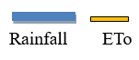
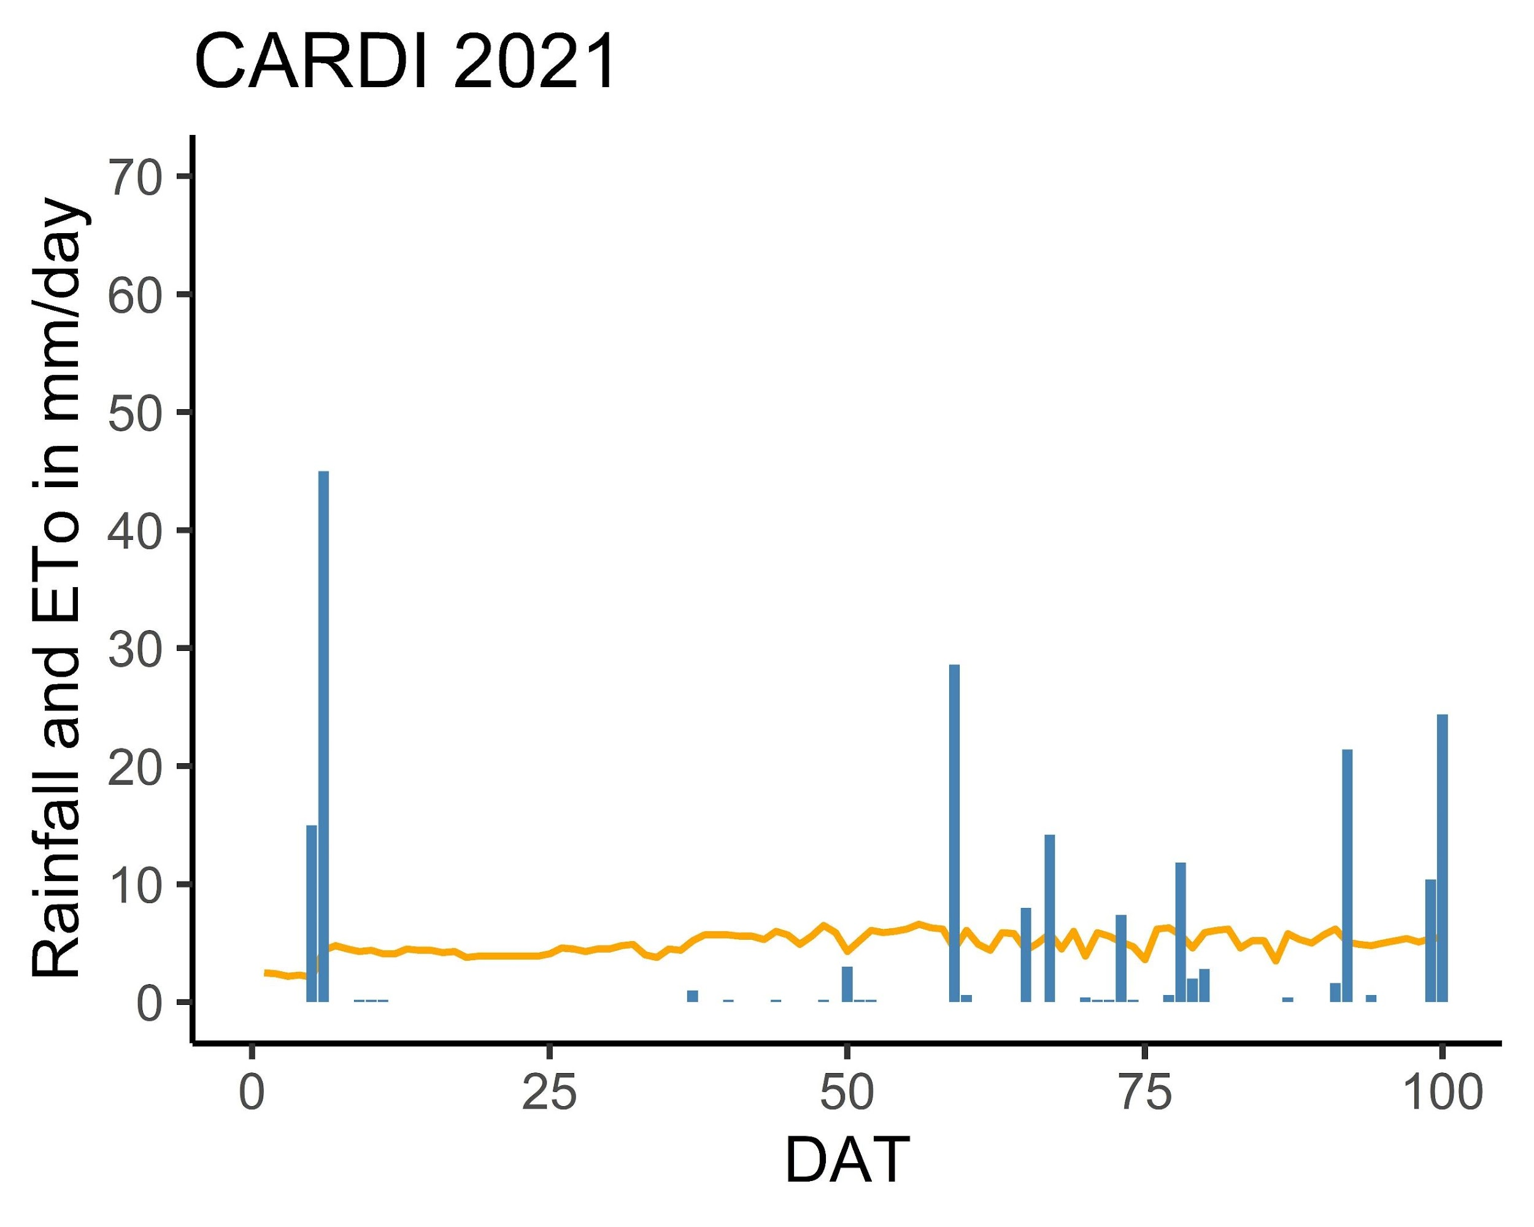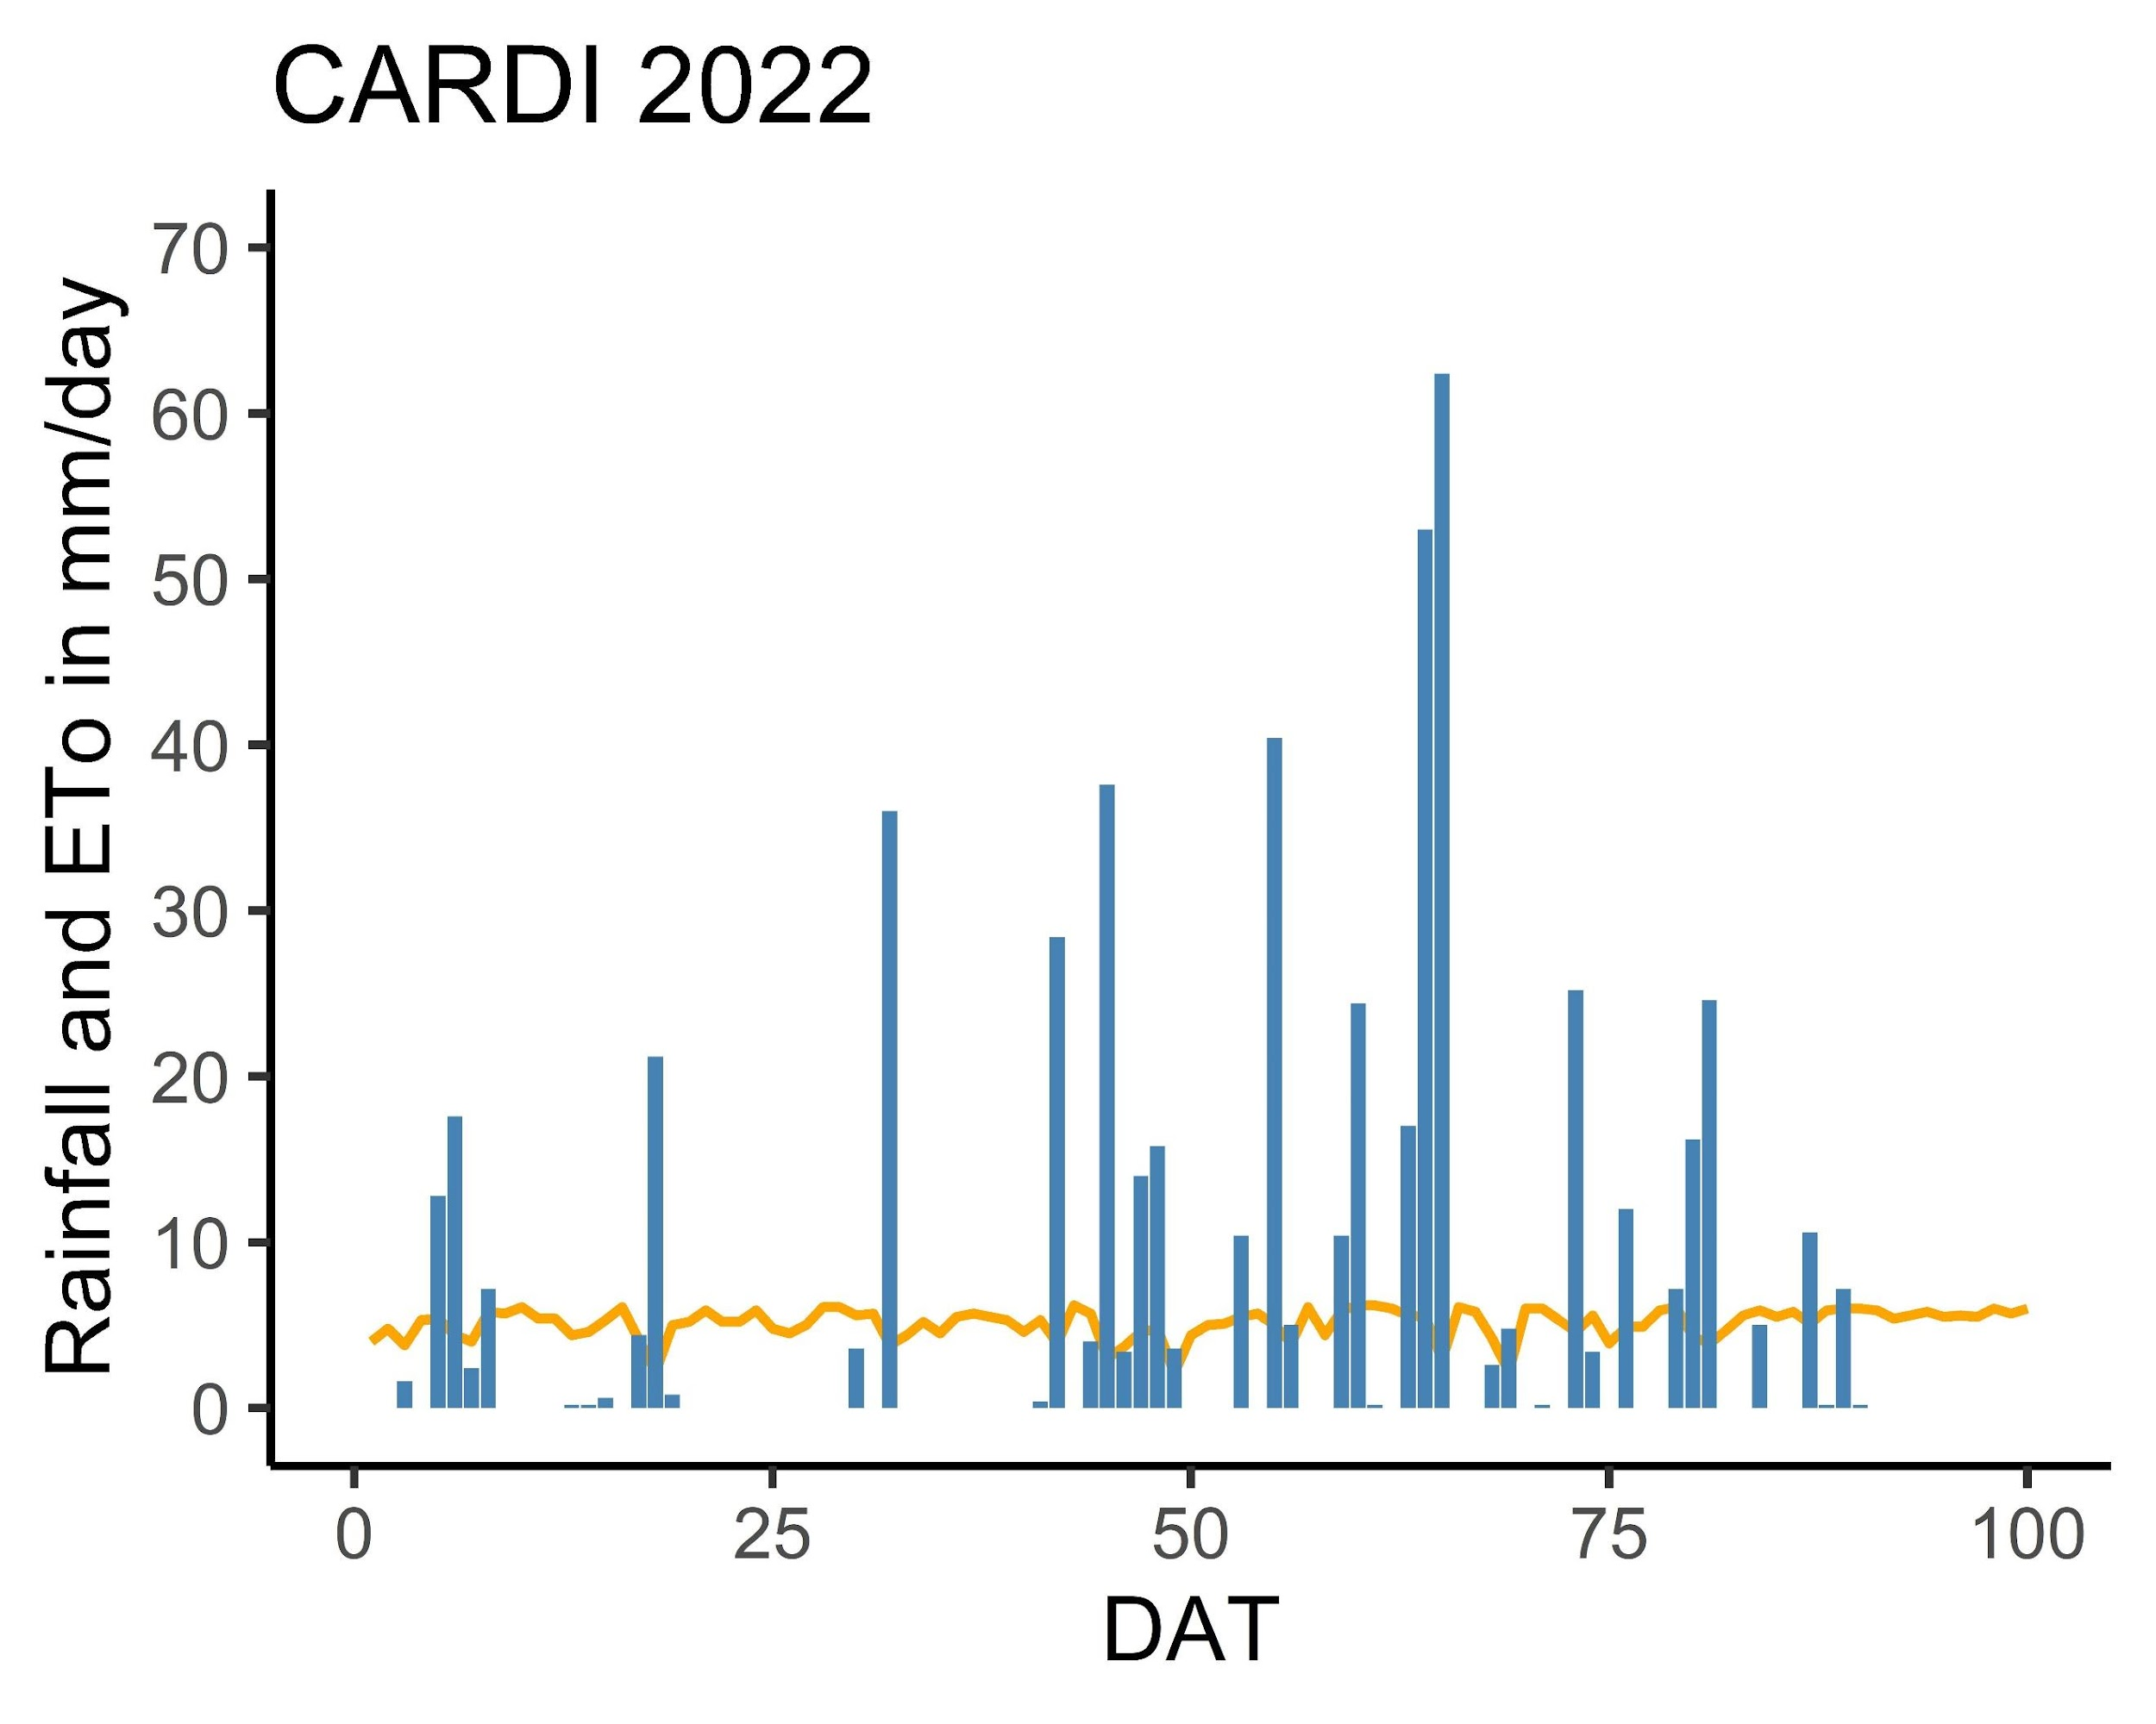
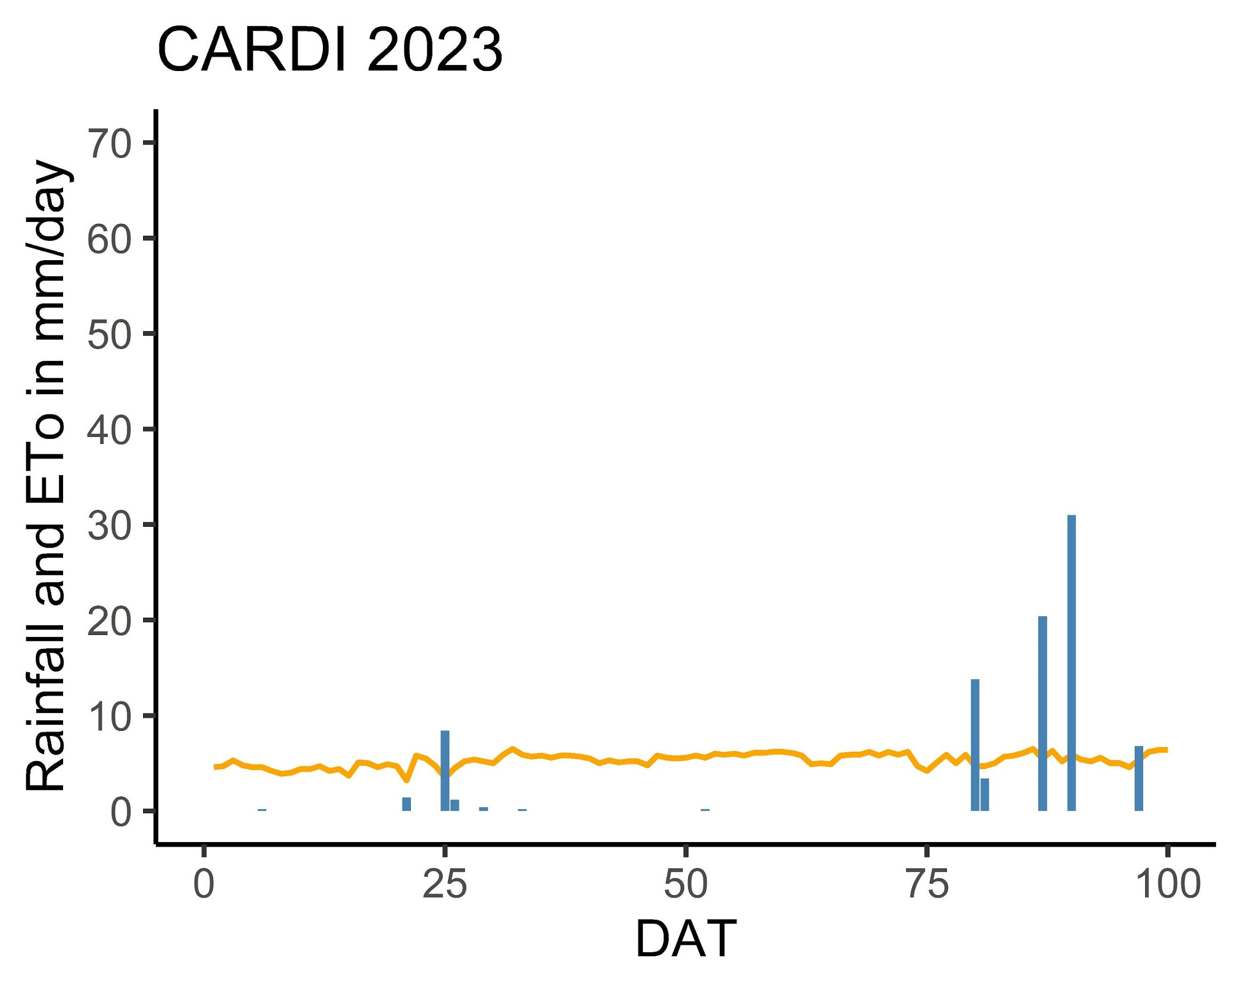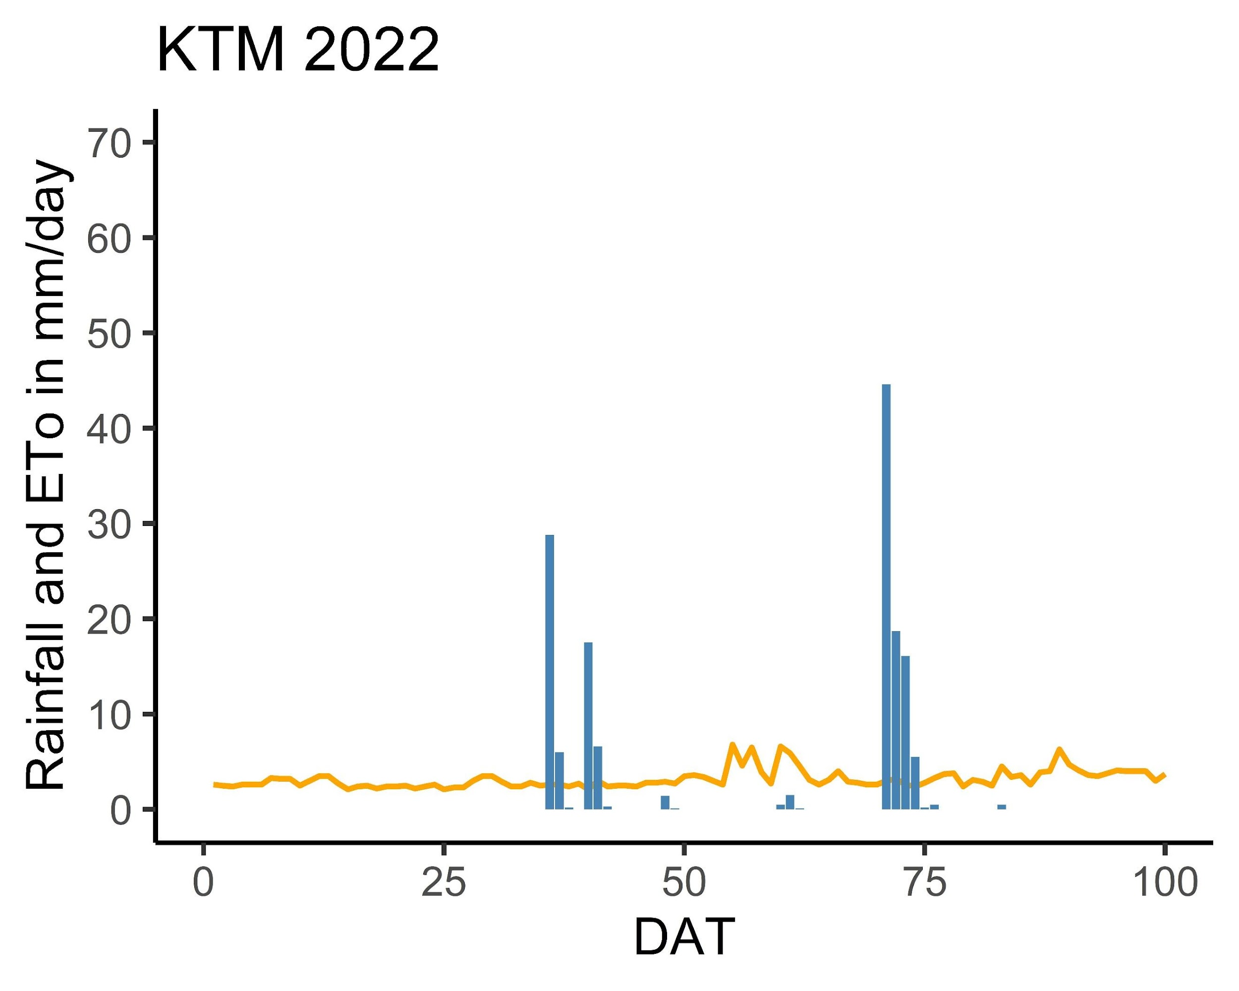

Figure 3-2: ETo and rainfall at four experimental fields (Site A and Site B in CARDI, K1 and K2 in Kampong Thom Province), over three growing seasons, 2021, 2022, and 2023

Physical characteristics of experimental soils

Table 3-3 shows that each trial location's soil characteristics are unique. Except for K2, which is sandy clay loam, all other sites have a sandy loam texture at the top but a different texture at the bottom, and their ability to retain water varies. Among all sites, K2, which is sandy clay loam, has the lowest Ksat, while K1 has the biggest Ksat.

Table 3-3: Soil characteristics of the four experimental fields (CARDI and Kampong Thom). Layer, depth, texture, bulk density, permanent wilting point (PWP) in volumetric moisture content (V%), field capacity (FC), saturation (SAT), and saturated conductivity (Ksat)

Year/Site | Layer | Depth (m) | Texture | Bulk density | PWP  (V%) | FC  (V%) | SAT  (V%) | Ksat  (mm/d)
2021-2022  CARDI Site A | 1 | 0-0.2 | Sandy loam | 1.76± 0.04 | 6.64 ± 3 | 17.8± 3 | 34.8± 4.3 | 16 ± 4.7
2021-2022  CARDI Site A | 2 | 0.2- 0.5 | Sandy loam | 2.07± 0.11 | 12 ± 3.5 | 21.7± 5.8 | 34.79± 5.5 | 2.5 ±1 .6
2021-2022  CARDI Site A | 3 | 0.5- 0.8 | Loam | 2.03± 0.03 | 12.22 ± 4 | 23.4± 7.9 | 35.92± 02 | 1.5±1.2
2023  CARDI Stie B | 1 | 0-0.3 | Sandy loam | 1.87± 0.14 | 9.6 ± 2.8 | 29 ± 2 | 39 ± 1 | 169 ± 97
2023  CARDI Stie B | 2 | 0.3 – 0.4 | Sandy loam | 1.89 ± 0.1 | 10 ± 2.8 | 23 ± 1 | 36 ± 4 | 5.5 ± 1.2
2023  CARDI Stie B | 3 | 0.4-0.8 | Sandy loam | 1.69 ± 0.1 | 9.5 ± 1.5 | 22 ± 3 | 37 ± 4 | 2.4 ± 1.9
2022  KTM K1 | 1 | 0-0.25 | Sandy loam | 1.71± 0.04 | 10.50± 0.6 | 19.6± 1.2 | 28.22 ± 3 | 100 ± 47
2022  KTM K1 | 2 | 025-0.5 | Sandy loam | 1.83± 0.03 | 12.27± 4.5 | 20± 3.1 | 27.54± 2.6 | 80 ± 40
2022  KTM K1 | 3 | 0.5-0.8 | Sandy loam | 1.73± 0.04 | 18.21± 2.5 | 24.8± 2.2 | 32.31± 0.3 | 25 ± 5
2022  KTM K2 | 1 | 0- 0.2 | Sandy clay loam | 1.72± 0.08 | 20.11± 2.1 | 28.73± 1 | 32.24± 0.6 | 6.68± 2.6
2022  KTM K2 | 2 | 0.2-0.3 | Clay loam | 1.70± 0.05 | 20.86 ± 0.4 | 28.77± 4 | 32.64 ± 1 | 1.3 ± 0.3
2022  KTM K2 | 3 | 0.3-0.8 | Clay | 1.70± 0.07 | 20.11 ± 2.3 | 21.1± 1.6 | 41.14± 3.7 | 10 ± 0.01

. Phenology
Tables 3-4 and 3-5 demonstrate that rice phonology varied by variety and location. In AWD, flowering occurred one to three days before or after CF. The difference in flowering dates for both regimens ranged from three to ten days. While the flowering date of all varieties in Site B increased by 7 to 9 days compared to Site A, Sen Pidor was 2 to 3 days shorter.
Compared to K2, K1's flowering date was ten days later. AWD15 and AWD20 flowered two days after CF in K1, whereas AWD20 appeared two to three days before CF and AWD15 in K2. Throughout all trial plots, the flowering date standard deviation varied from 1 to 3 days. However, there was no significant difference between the phenology of rice grown under different water regimes in all experiments.

Table 3-4: Number of days after transplanting (DAT) to flowering and maturity of rice grown under AWD15 and CF at both sites at CARDI from 2021 to 2023
Year/Site | SP |  | SK |  | CAR |  | OM
 | CF | AWD | CF | AWD | CF | AWD | CF | AWD
2021-2022
CARDI Site A
Flowering |  |  |  | 62.5 ± 1 | 54 ± 1 | 54.5 ± 2 | 50 ± 1 | 50 ± 1
  67.5 ± 1
  67 ± 1
  62.5 ± 1
Maturity |  | 97 ± 1 | 92.5 ± 1 | 92.5 ± 1 | 84 ± 1 | 84.5 ± 1 | 80 ± 1 | 80 ± 1
  97.5 ± 1
2023
CARDI Site B
Flowering | 62 | 63 | 69 | 69 | 61 ± 1 | 64 | 59 | 59
Maturity | 92 | 93 | 99 | 99 | 91 ± 1 | 94 | 89 | 89

Table 3-5: Number of days after transplanting (DAT) to flowering and maturity of rice grown under AWD20, AWD15, and CF in Kampong Thom in 2022

Year/Site | CAR15
 | AWD15 | AWD20 | CF
2022 KTM K1
Flowering | 70 ± 3 | 70 ± 3 | 68.25 ± 2
Maturity | 100 ± 3 | 100 ± 3 | 98.25 ± 2
2022 KTM K2
Flowering | 59 ± 2 | 56 ± 1 | 58 ± 2
Maturity | 89 ± 2 | 86 ± 1 | - ± 2

3.4 Water saving

The average total amount of water input for each trial is shown in Table 3-6. At CARDI, CF was irrigated an average of 15 times in 2021, 9 times in 2022, and 18 times in 2023. The average total input, including rainfall under CF, was 909, 462, and 998 mm for Site A in 2021, 2022 and Site B in 2023, respectively. Although Site B's topsoil texture was similar to Site A's (sandy loam), it used more water (Figure 3-3). Site B used an average of 97% and 20% more water than Site A, in the complete dry season of 2021 and when interfered with rainfall in 2022, respectively. This could be caused by the large Ksat at the top layer at Site B, which is 160 mm/day, compared to only 16 mm/day at Site A, which is ten times less. Furthermore, Site B's water holding capacity (the difference between FC and SAT) is lower than Site A's.
AWD15 saved, on average, 20% at Site B and between 11 to 31% at Site A as compared to CF. Table 6 shows that in 2022, the rainfall contributed 13% (K1) and 30% (K2) of the total irrigation due to the varying growth length. Under CF, K1 and K2's average total water intake, including rainfall, was 1113 mm for K1 and 500 mm for K2. For CF, there were 22.25 irrigations in K1, compared to 12.25 irrigations in K2. AWD15 and AWD20 saved 20–24% and 18–22%, respectively, compared to CF. Overall, when tested on various soil ecosystems, AWD15 decreased water input by 11% to 31%, while AWD20 saved 22-24%.
Furthermore, soil texture is a significant factor in determining the quantity of irrigation needed. The average water needs for sandy loam (Site A, Site B, and K1) was 24 to 80 % higher than that of sandy clay loam (K2) when there was no interruption by rainfall. Ksat was the driver for the length of the irrigation cycle and irrigation frequency. In this study, the value of Ksat at each location is negatively correlated with the total amount of irrigation. The irrigation cycle in AWD cycles varied depending on soil texture and ranged from 5 to 10 days (Figure 3-3). Compared to the other two sites, soil with greater Ksat, such as Site B and K1, loses water through percolation more quickly and requires more irrigation, as indicated in Figure 3-3.

Table 3-6: Average total water input of rice grown under AWD20, AWD15, and CF at CARDI from 2021 to 2023 and at Kampong Thom during 2022. Irrigation water included 50 mm for land preparation for all treatments.

Year/Site | Water regime | Irrigation (mm) | Irrigation frequency (time) | Rainfall (mm) | Saved water (%)
2021 CARDI  Site A | CF | 765 ± 25 | 15 | 144
2021 CARDI  Site A | AWD15 | 480± 25 | 10 | 144 | 31%
2022 CARDI  Site A | CF  AWD15 | 465 ± 25  363 ± 25 | 9  4 | 459  459 | 11%
2023 CARDI Stie B | CF | 915 ± 22 | 18 | 82.7
2023 CARDI Stie B | AWD15 | 713 ± 22 | 14 | 82.7 | 20%
2022 KTM  K1 | CF | 1113 ± 74 | 22.25 | 149
2022 KTM  K1 | AWD15 | 863 ± 41 | 17.25 | 149 | 20%
2022 KTM  K1 | AWD20 | 813 ± 55 | 16.25 | 149 | 24%
2022 KTM  K2 | CF | 613 ± 22 | 12.25 | 149
2022 KTM  K2 | AWD15 | 475 ± 56 | 9.25 | 149 | 18%
2022 KTM  K2 | AWD20 | 445 ± 22 | 8.25 | 149 | 22%


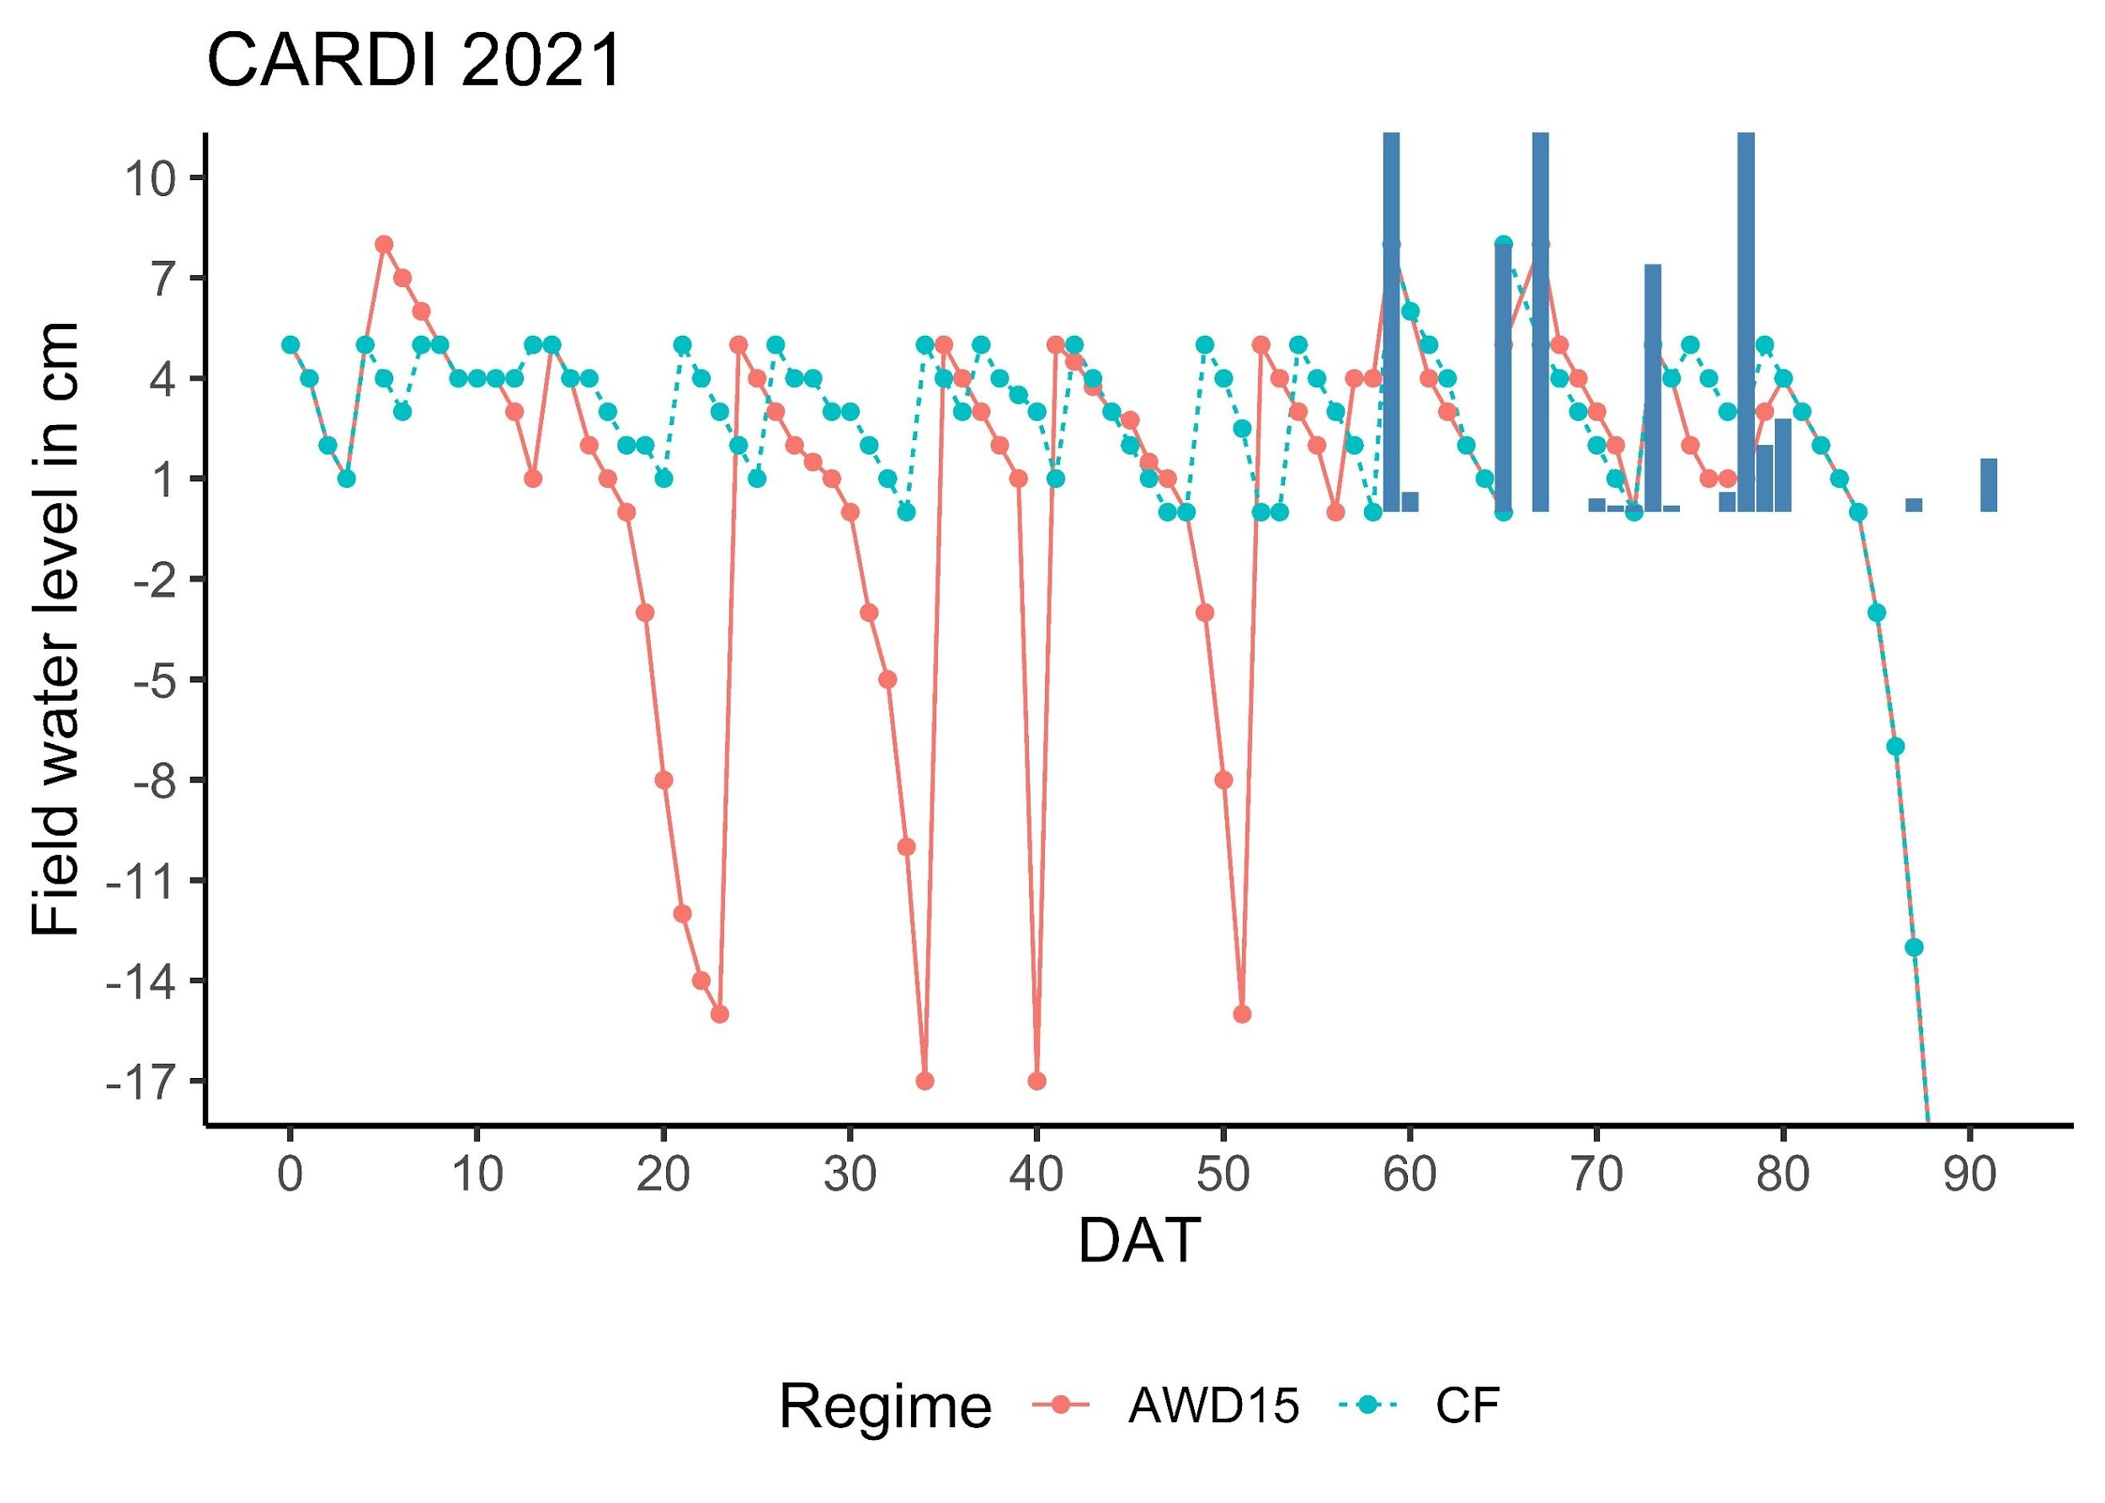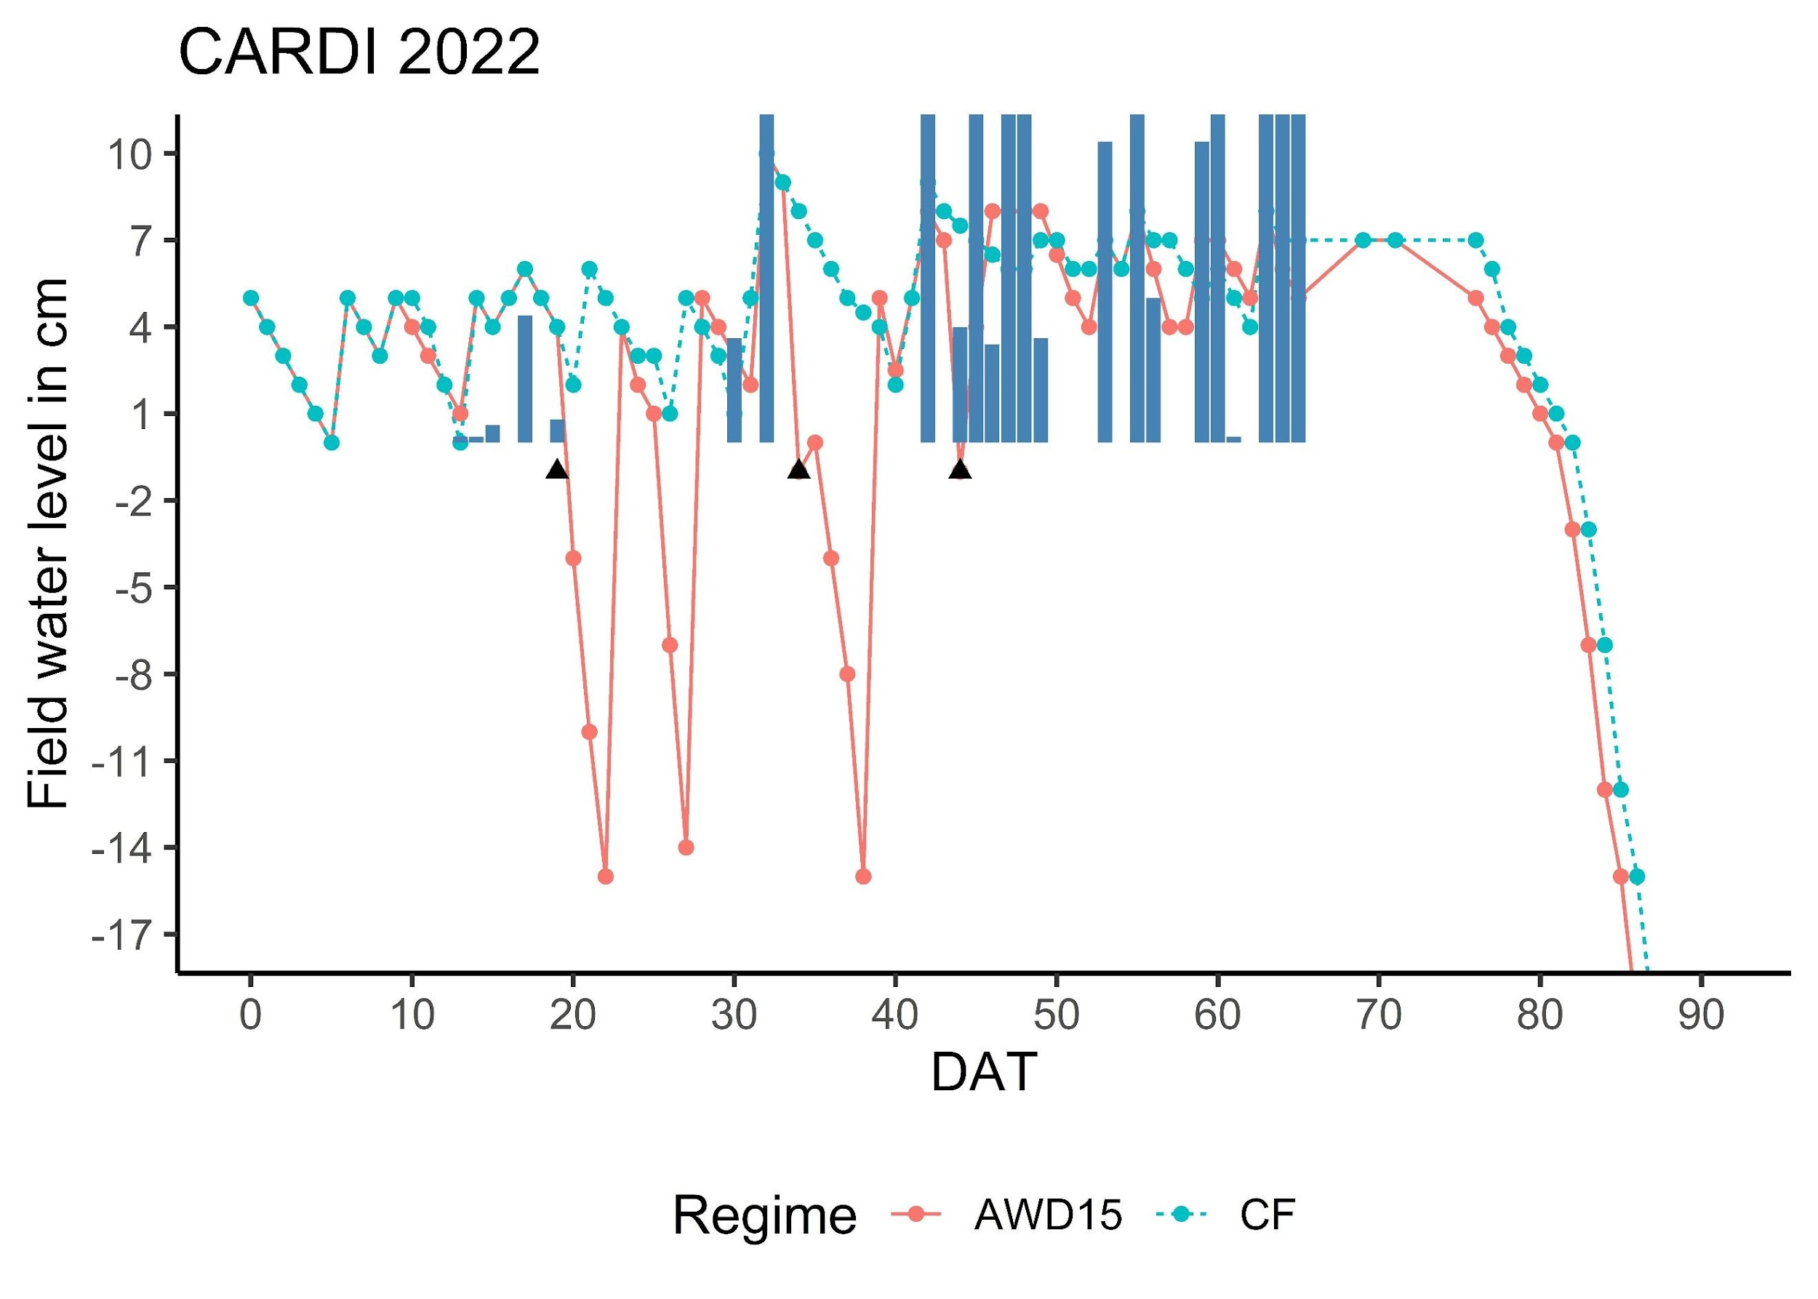
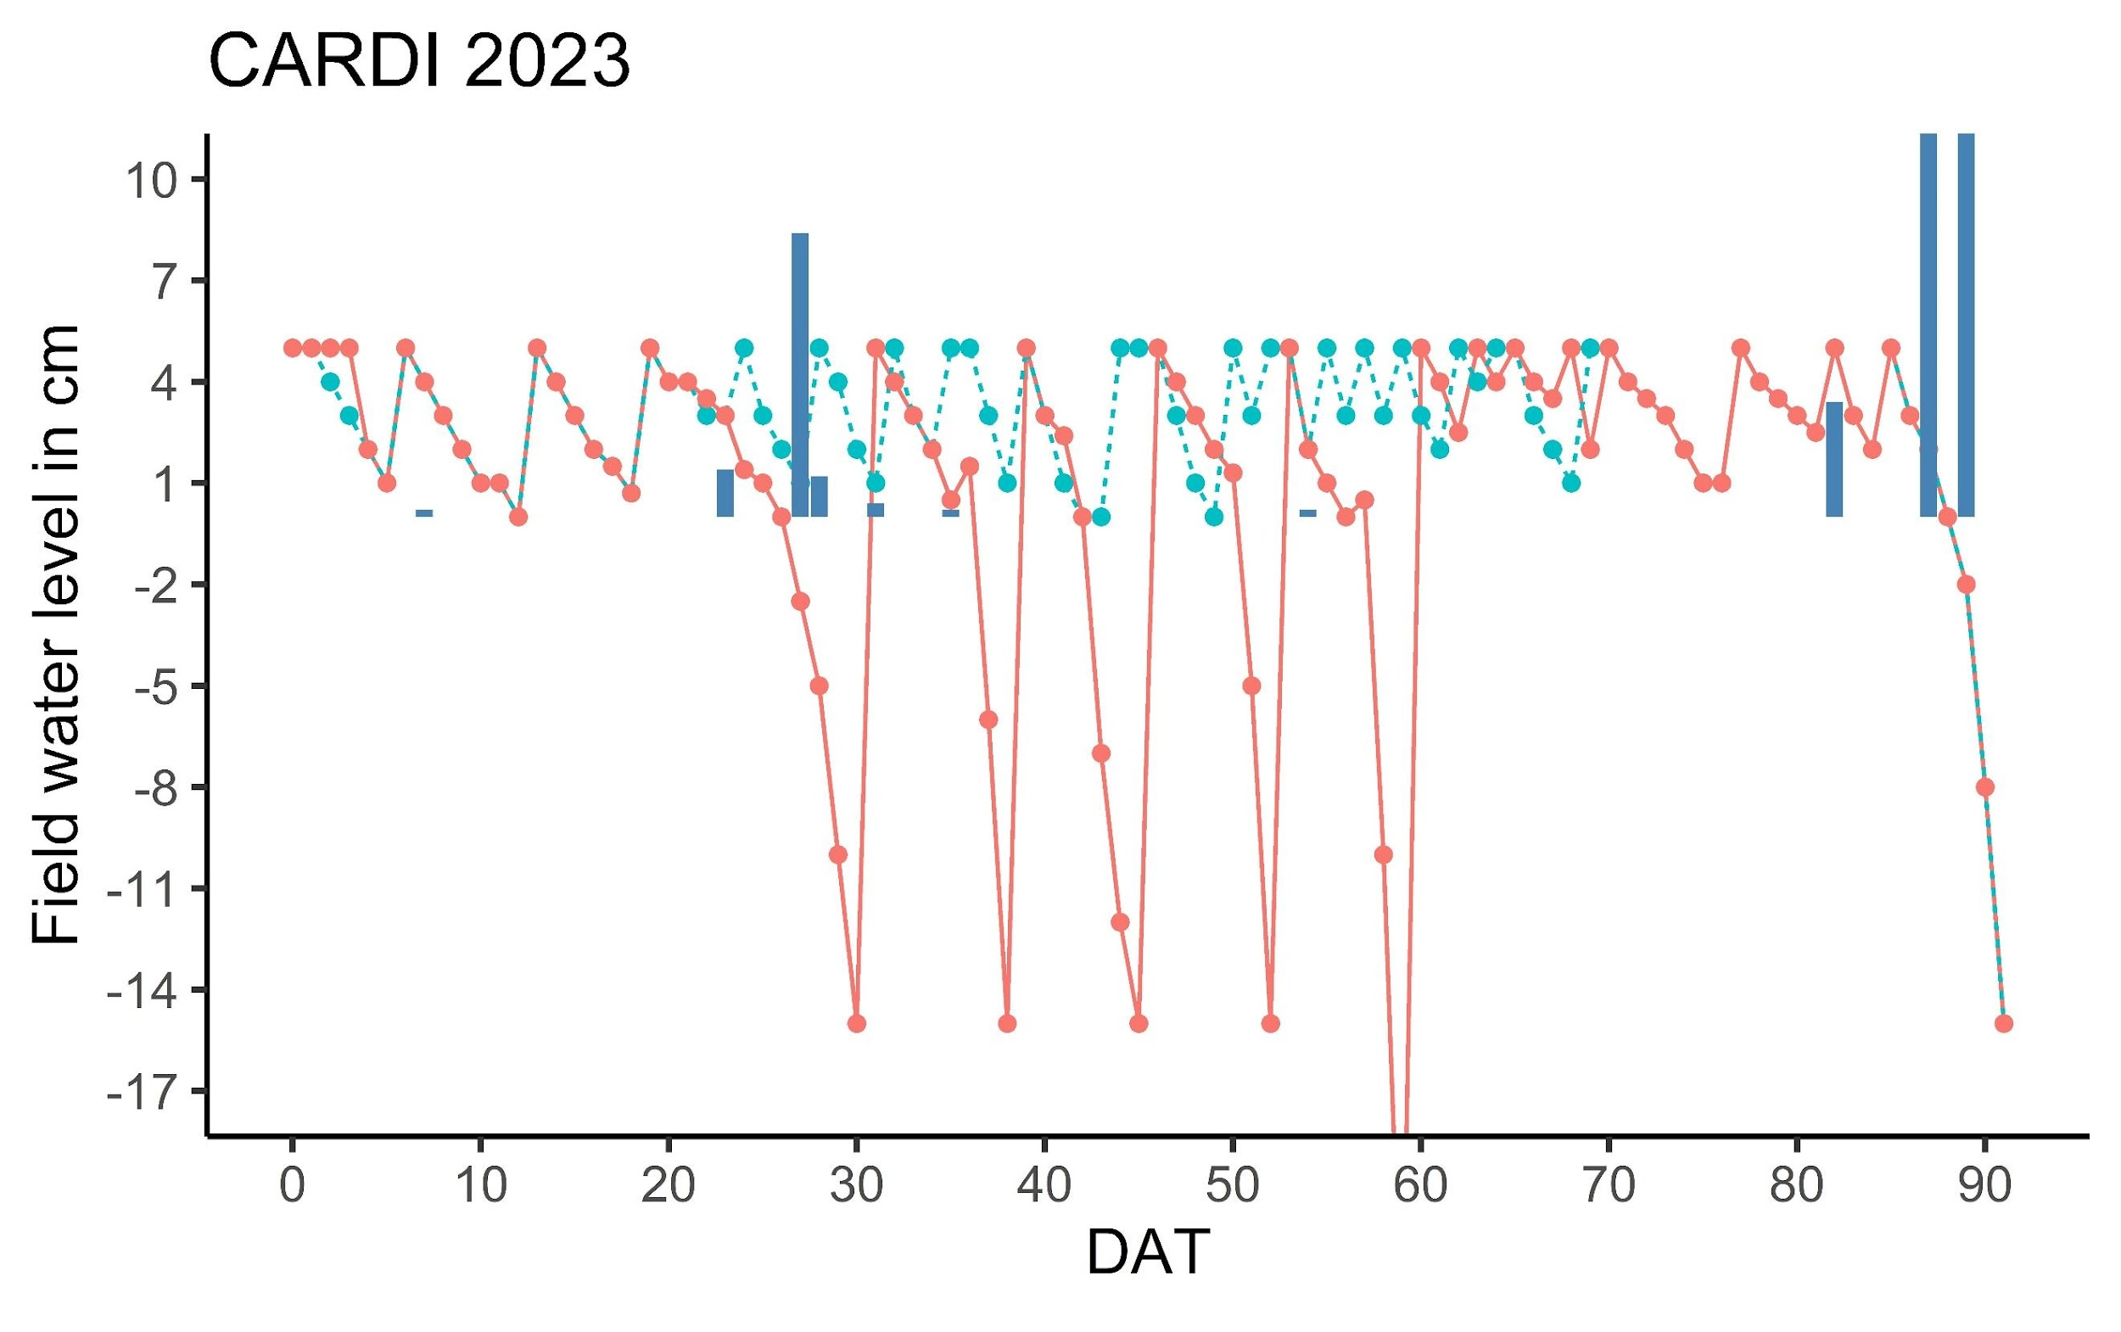
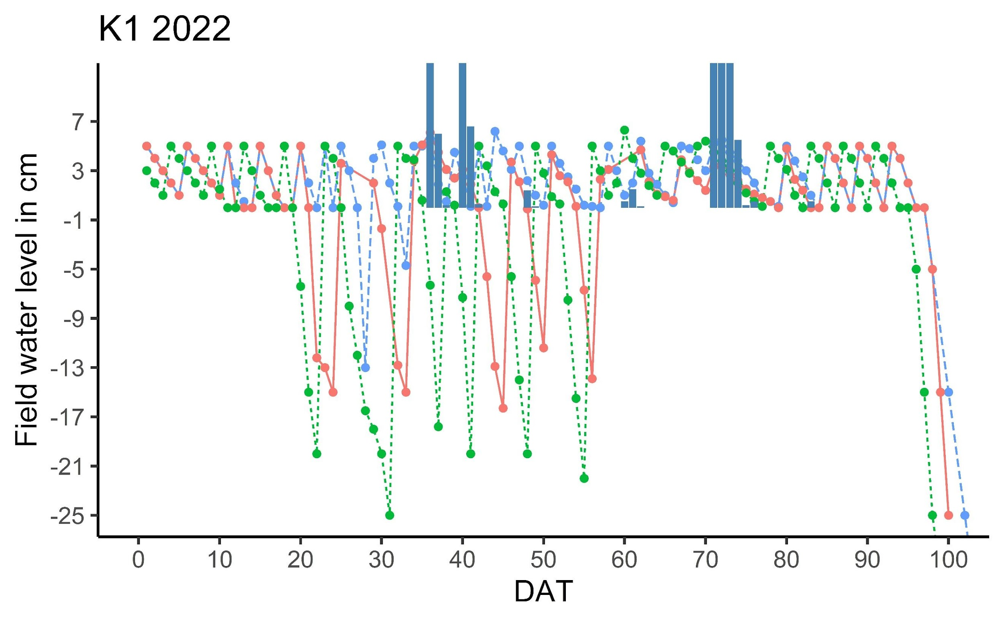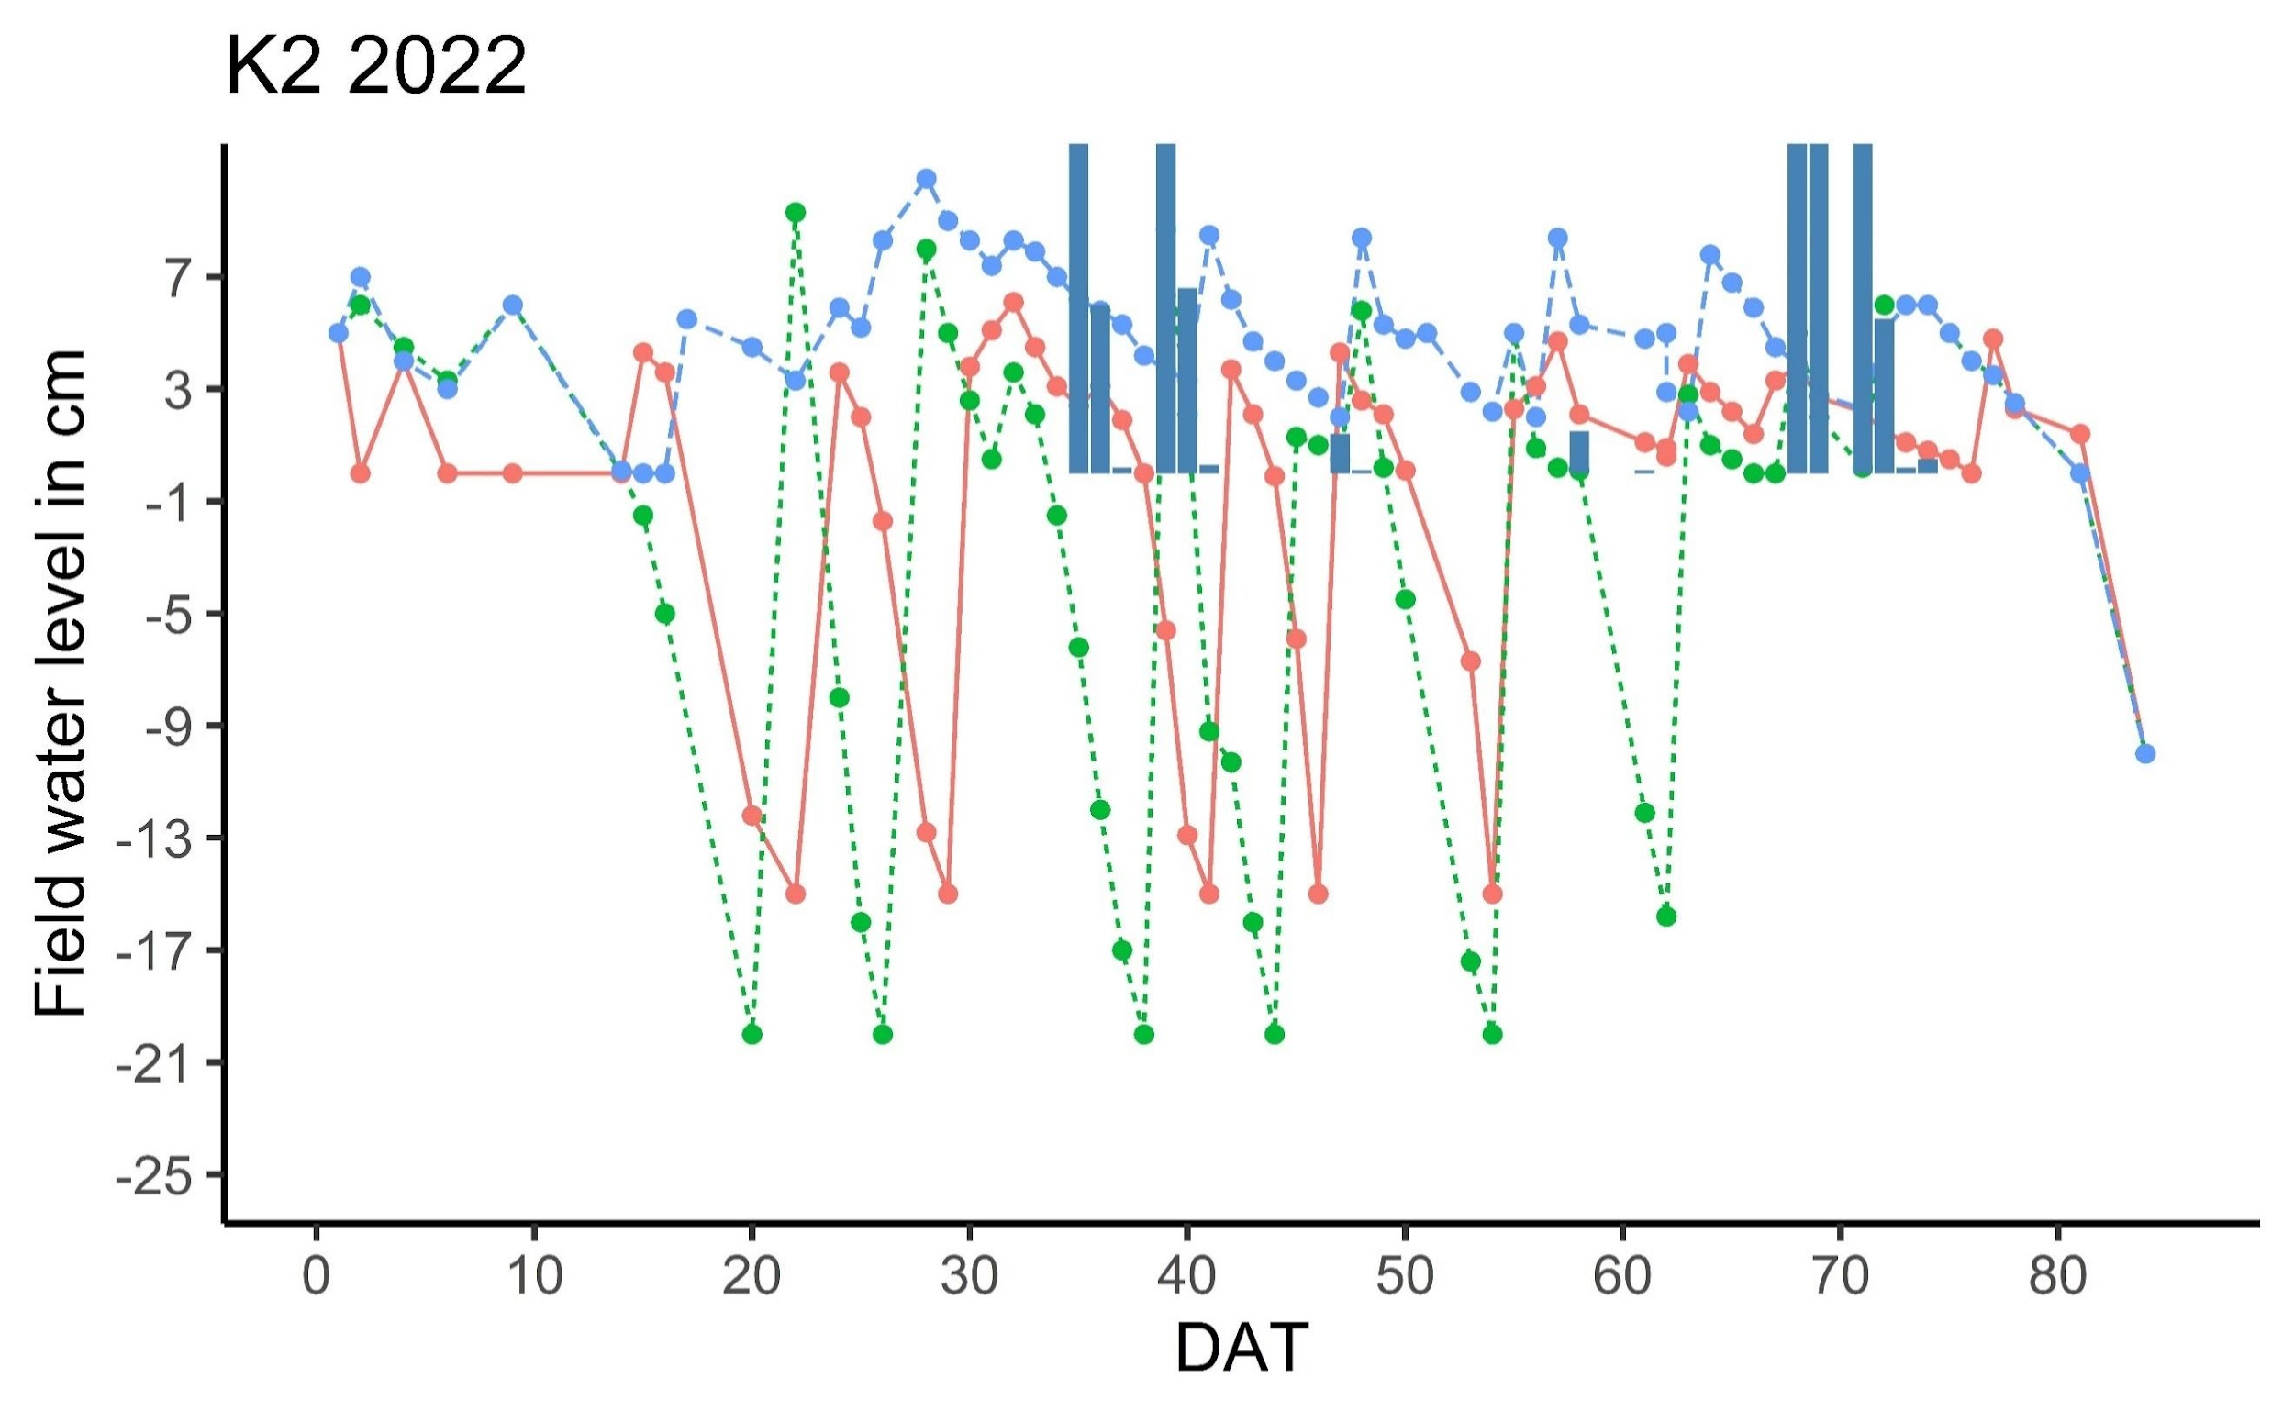

Figure 3-3: Typical water level management chronologically for both AWD and CF

3.5 Volumetric moisture content before and after one hour of irrigation

Figure 3-4 shows that at a soil depth of 5 to 15 cm, there was no significant difference in soil moisture content (SMC) one hour before and after each irrigation. This indicates that infiltration could be negligible when irrigation takes less than an hour. In our experiments, irrigation lasted 20 to 40 minutes in each plot. This result supports our hypothesis that the irrigation volume equals the water height times the plot area.

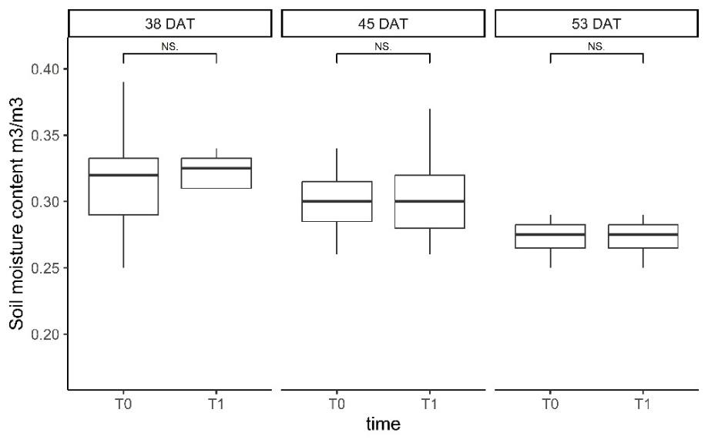
Figure 3-4: Volumetric SMC of AWD15 plots at Site B (CARDI) (T0: one hour before and T1: one hour after irrigation) during the growth season 2023. Student t-tests at significant differences (P < 0.05) were used to assess the significant differences between T0 and T1

3.6. Modeling the impact of manifest and latent factors on yield and WUE using PLS-SEM

The initial PLS-SEM models of the yield and WUE distribution from 2021 to 2023 illustrate the overall relationships between latent and manifest variables. The results indicate that among the 7 manifest variables, only HI, panicle number/m², and yield were well explained by the latent variable “Yield”, with significant outer loadings of p<0.01 and loading values of = 0.834, 0.657, and 0.929, respectively. The remaining 4 manifest variables are classified as "Yield component" latent variables. It was shown that the Yield Component was not significantly impacted by environmental parameters such as soil, variety, and regime. Latent variables like Yield Component and Variety that were not significant were removed to increase the model's fitness. The final model for CARDI is shown in Figure 3-5.

In the final model for CARDI, all factor loadings for all Yield indicators were higher than 0.5 with AVE = 0.66, CR (Rho-a) = 0.85. This indicates that all the factor loadings satisfy the requirement for structural validity (Moeinaddini et al., 2020). The latent variables, Yield, and WUE, were well explained by Soil and Regime (R2 = 53.5% and 82.2%, respectively). The results indicate that water management had no significant impacts on yield, but it did improve the WUE significantly at p <0.01 with a path coefficient of 0.98. Latent variable Yield and Regime directly influenced WUE. Soil had no direct effect on WUE. However, it influenced the yield and indirect effect on WUE with a path coefficient of 1.36 and 0.41, respectively. Annex 3 details outer loading, path coefficients, and indirect effect of the manifest and latent variables at CARDI.

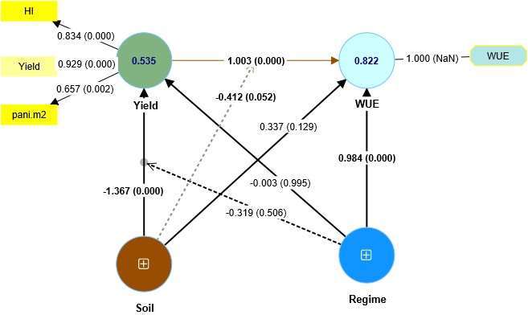
Figure 3-5: the Final PLS-SEM model diagram, shows the relationship between each variable and the distribution of yield and WUE at CARDI from 2021 to 2022. The circles represent latent variables and the rectangles represent manifest variables. Arrows represent paths, where path coefficient and p value are displayed adjacent to arrows (significant values are bold). Model R² inside the latent variables

3.7. Effect of soil properties and water management on Grain yield, and WUE

Figure 3-6 displayed indicators from the PLS-SEM model that described the performance of AWD under various soil conditions, including grain yield, HI, panicle/m², and WUE. In both sites, grain yield, HI, and panicle/m² of rice grown under AWD were not significantly different from those grown under CF. Site B was significantly more productive than Site A. Average yield, HI, panicle/m², and WUE of Site B was found to be 56%, 40%, 40%, and 43% higher than Site A's, respectively. Yields of Site B varied from 2.3 to 6.2 tons/ha, while yields of Site A varied between 2.2 to 3.5 tons/ha.
At Site A, WUE ranged from 0.35 to 0.56 kg/m³, while Site B varied from 0.25 to 0.77 kg/m³. For both sites, WUE of AWD15 was significantly higher than CF. On average, WUEs of AWD15 of Site A and Site B were 40% and 19% higher than those under CF, respectively. For more detail of all the parameters, Annex 2 provides the full information on grain yield, yield component, HI, and adequate root depth at CARDI from 2021 to 2023 with the result of the ANOVA test for each experiment.

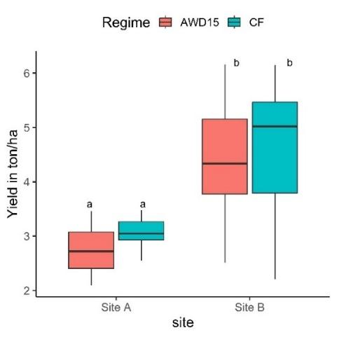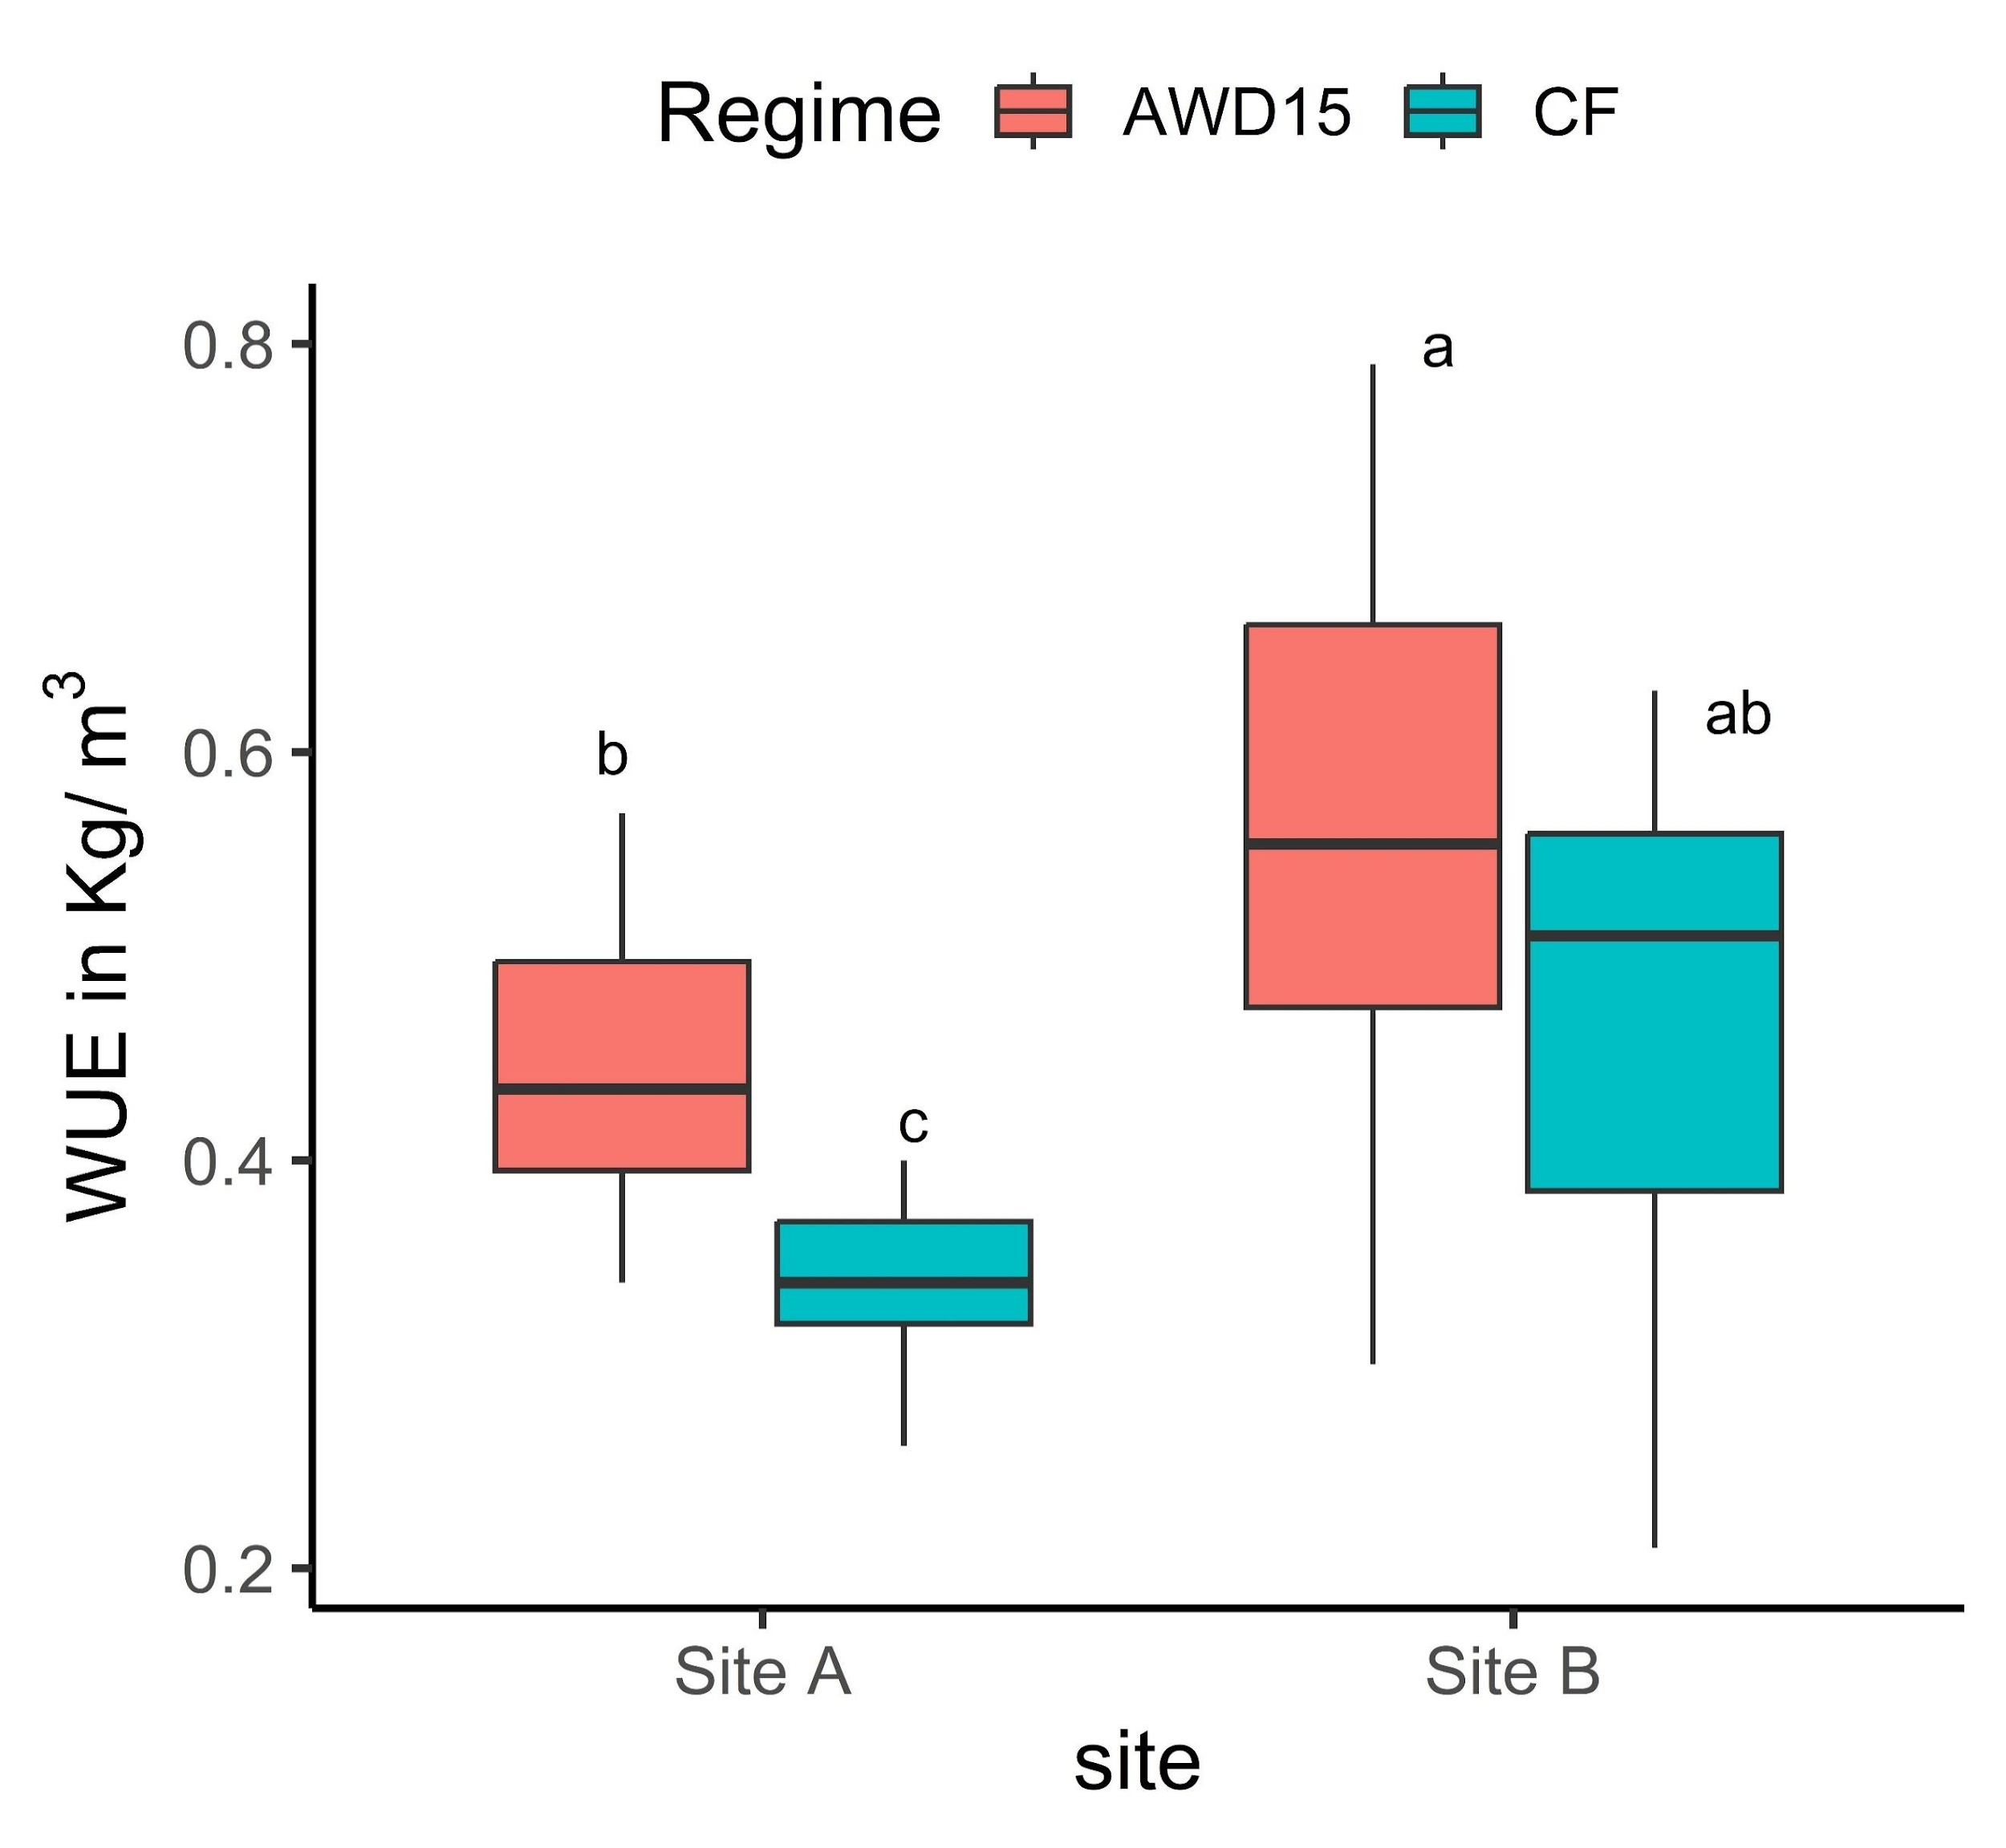
a
b)
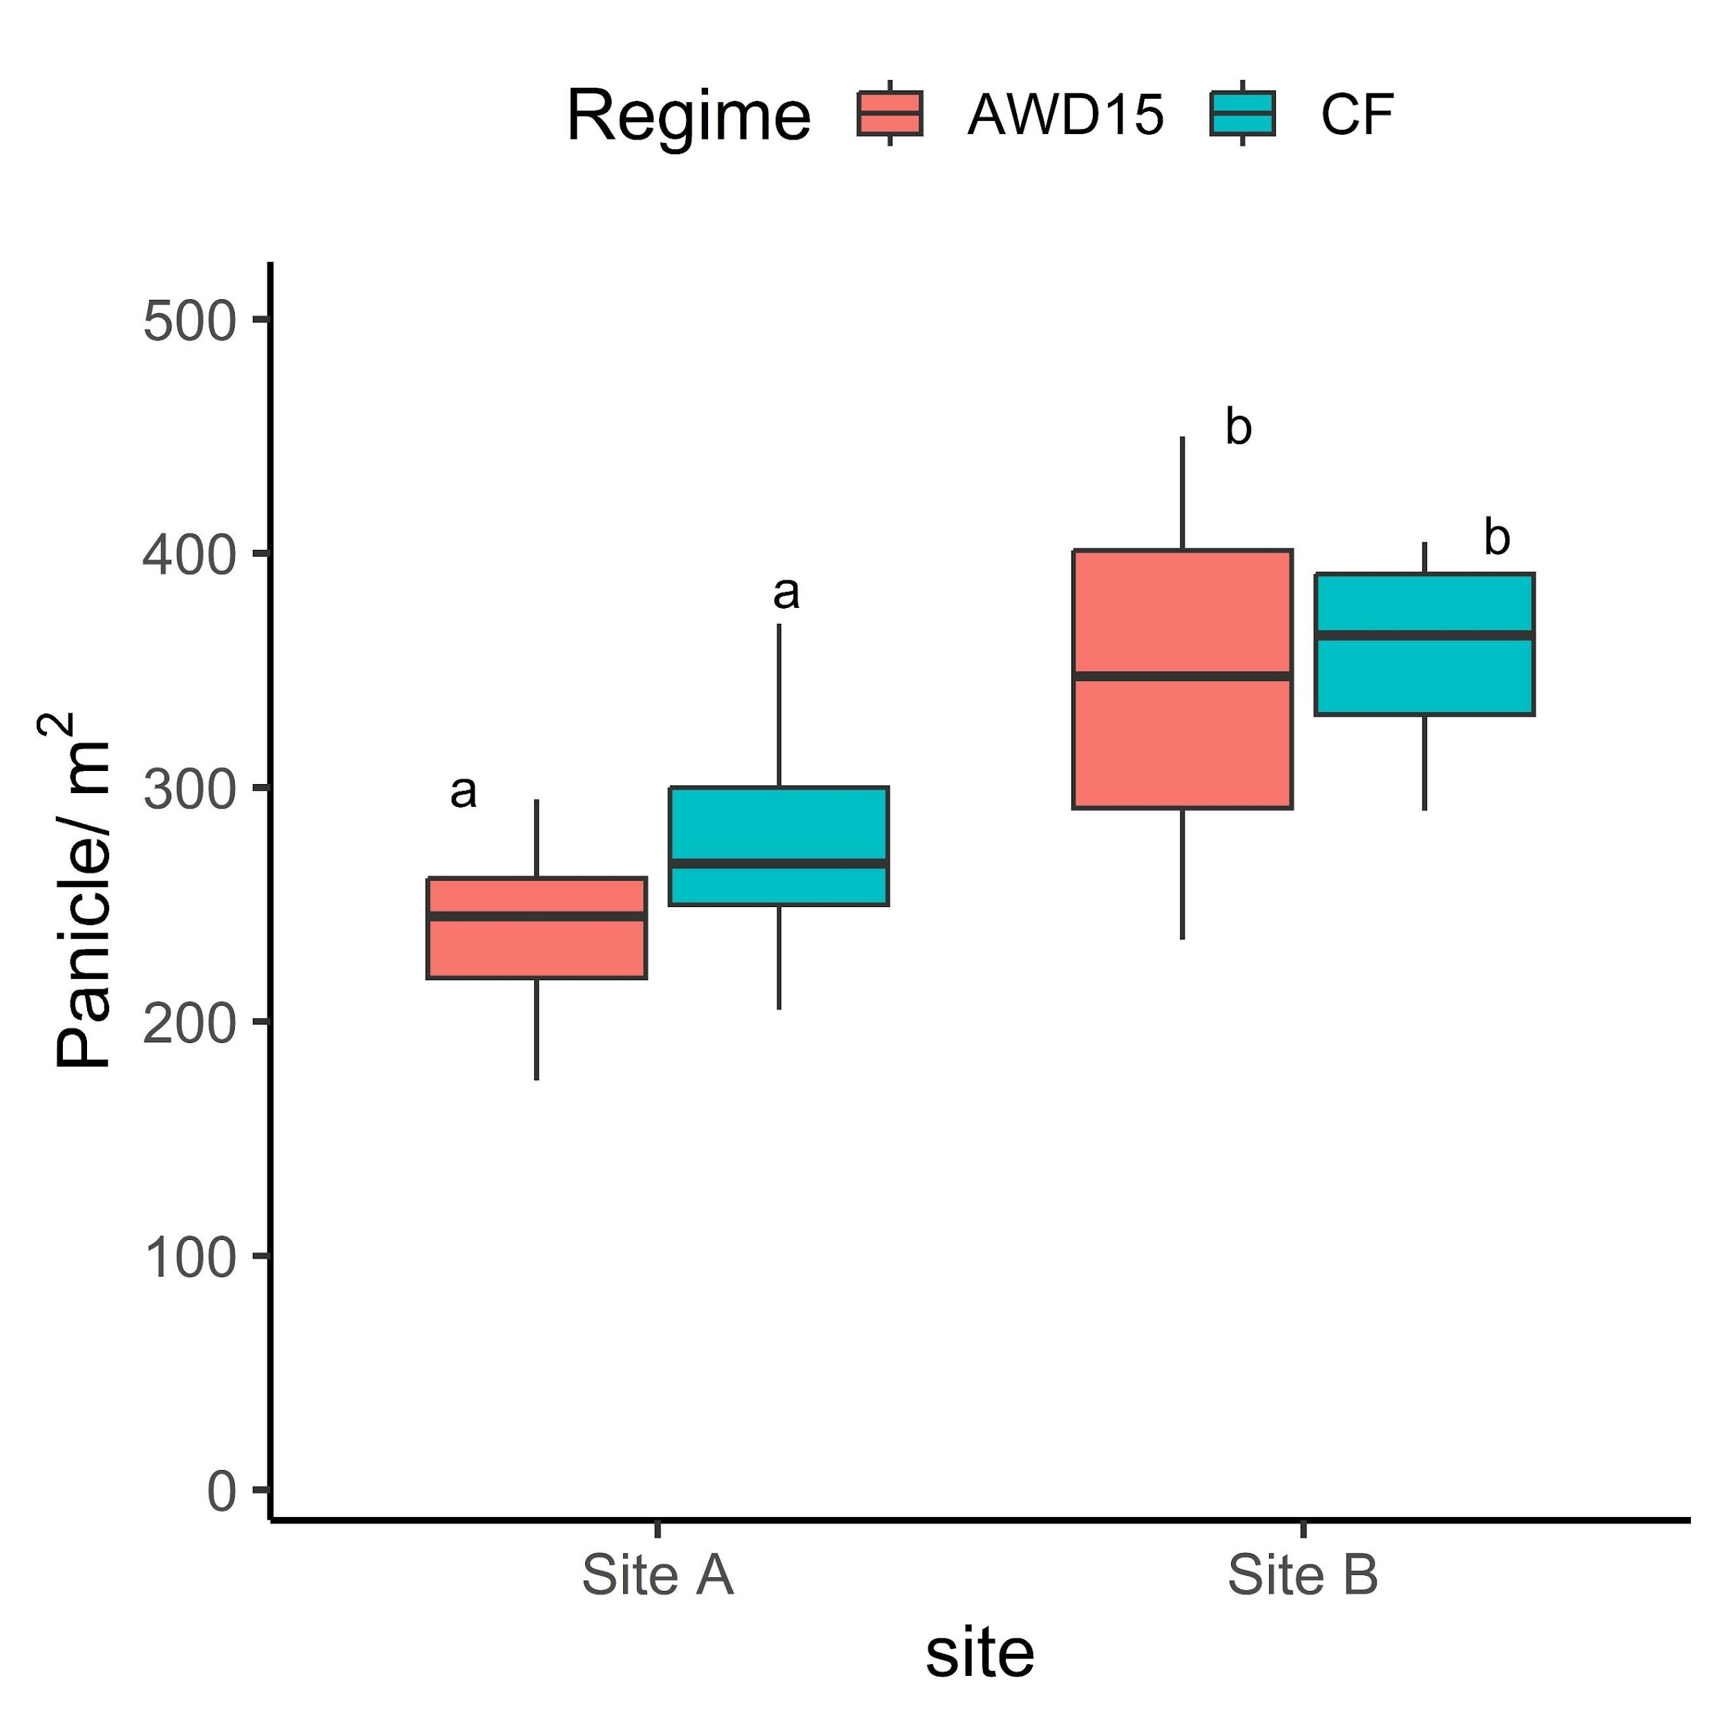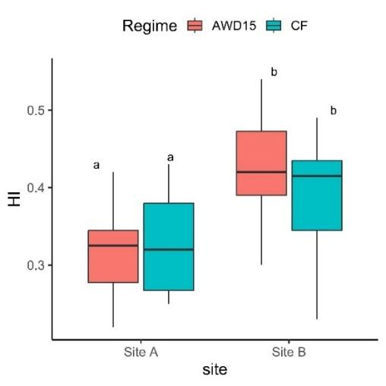
c)
d
c)
d)
Figure 3-6 : Boxplot of grain yields (tons/ha) (a), WUEs (kg/m³) (b), panicle number per m² (c), and Harvest index (d), at rice harvests of the two sites at CARDI from 2021 to 2023. Grain yields are shown for 14% moisture content equivalent. Different lowercase letters represent significant differences (P< 00.05) among treatment and location mean, analyzed by two-way ANOVA

3.8. Effect of variety on yield, yield component and WUE at CARDI

When the three experimental data sets were merged in PLS-SEM, the effect of variety on grain yield was negligible. This was because varietal differences in grain yield were significant at Site B but not at Site A. At Site B, OM had the greatest grain yield, whereas SK had the lowest. At Site B, OM produced, on average, 26%, 30%, and 116% higher yields than SP, CAR, and SK regardless of water treatment, respectively. In addition, OM demonstrated greater WUE under full and AWD15, followed by CAR15 for both sites. Aboveground biomass and plant height were insignificant and inconsistent across variety, location, and water treatments.
In both regimes, variety OM ranked at the top regarding filled spikelets. The number of filled spikelets was consistent across varieties, locations, and regimes (except for AWD15 at site A). The number of spikelets per panicle was similar across varieties, locations, and regimes (except in the CF of site B). Except for plant height, variety had no significant impact on root depth, HI, or the number of panicles per m².

3.9 Feasibility of mild AWD

Kampong Thom's average grain yields varied from 3.1 to 4.1 tons/ha in K1 and between 2.6 to 5.1 tons/ha in K2 (Table 3-7). Results of ANOVA demonstrated that soil influenced WUE, biomass, Panicle number/m², plant height, and number of spikelets per panicle but not on the rest of the variables. Rice grown at K2 produced greater WUE, plant height, and number of spikelets per panicle than K1, while at K1, biomass and Panicle number/m² were greater than K2. AWD15 and AWD20 did not significantly reduce the grain yield of CAR15 in both sites. WUE in K2 were significantly higher than those in K1. In K1, the average WUE under the three treatments ranged from 0.3 to 0.38 kg/m³, while in K2, it ranged from 0.5 to 0.88 kg/m³. However, there was no significant difference in WUE between the regimes in K2 (sandy clay loam), which was opposite to the findings in K1 and the two sites at CARDI (Sandy loam), where the WUE of AWD15 was significantly higher compared to those under CF. Panicle number/m² in K1 was significantly higher than in K2. Among all indicators, only HI was affected by the water regime. According to the pairwise test, HI in AWD20 was significantly higher than in CF and AWD15.
In AWD15 and AWD20, HI was slightly but significantly greater than in CF in K1. CF had the most spikelets per panicle, followed by AWD15 and AWD20 in K2. Root depth, percentage of filled spikelets, and number of filled spikelets were consistent in all regimes and both soil types. The interaction between soil and water was observed only on biomass and the number of spikelets per panicle.

Table 3-7 : Grain yield, WUE, biomass, panicle.m⁻², plant height, percentage of filled spikelet, number of filled spikelet, Harvest index, number of spikelet per panicle and root depth of variety “CAR15” under continuous flooding (CF) and alternate wetting and drying (AWD15 and AWD20) irrigation at Kampong Thom Province during 2022
Site/  regime | Grain yield  (t ha⁻¹) | WUE  (kg m³) | Biomass  (t ha⁻¹) | Paniclem⁻² | Plant Height (cm) | Filled spikelet (%) | Number of filled spikelet | HI | Spikelet  panicle⁻¹ | Root depth  (cm)
K1
CF | 3.64 a | 0.29 a | 13.46 a | 320 a | 93 a | 76 a | 292 a | 0.43 a | 384 a | 11 a
AWD15 | 3.8 a | 0.38 ab | 11.03 a | 273 a | 92 a | 77 a | 341 a | 0.45 ab | 443 a | 11 a
AWD20 | 3.28 a | 0.32 a | 11.58 a | 313 a | 89 a | 73 a | 292 a | 0.45 b | 406 a | 12 a
Mean | 3.57 | 0.33 | 12.17 | 302 | 91 | 75.17 | 308 | 0.44 | 411 | 11.33
K2
CF | 4.23 a | 0.56 a | 7.52 a | 250 a | 104 a | 72 a | 406 a | 0.45 a | 560 a | 11 a
AWD15 | 3.87 a | 0.62 a | 8.39 a | 265 a | 102 a | 71 a | 358 a | 0.43 a | 499 ab | 11 a
AWD20 | 3.31 a | 0.56 a | 8.91 a | 268 a | 100 a | 81 a | 305 a | 0.47 a | 381 b | 10 a
Mean | 3.80 | 0.58 | 8.27 | 262 | 102 | 74.50 | 356 | 0.45 | 480 | 11.21
ANOVA
Regime (R) | ns | ns | ns | ns | ns | ns | ns | * | ns | ns
Soil (S) | ns | ** | ** | * | ** | ns | ns | ns | * | ns
R*S | ns | ns | * | ns | ns | ns | ns | ns | * | ns

Within a column for each location, means followed by the same letter are not significantly different according to LSD (0.05). Lower-case letters indicate comparisons among three water treatments. In the ANOVA, ns means nonsignificant (P>0.05), * means P<0.05, ** means P<0.01

3.10. Effect of AWD on the growth of Canopy cover and biomass in all locations

The interaction of the water regime with soil and variety did not significantly affect time-series biomass and CC in all locations. From the vegetative to ripening stage, biomass and canopy cover increased independently regardless of water regimes. According to Figure 3-7 and 3-8, the mean canopy cover increased during the reproductive stage, from weeks 6 to 10, and then started to decline at CARDI in week 10 and KTM in week 11. In contrast, biomass rose until it reached its maximum before being harvested.
Soil and variety significantly influenced CC. Compared to the other varieties, which had CC values that were comparable, CAR15 had the greatest CC. Compared to Site A and K1, CC of Site B and K2 was noticeably higher. In both treatments, the maximum percentage of CC for CAR15, OM, SK, and SP was 60%, 47%, 50%, and 52%. A detailed analysis of the variance in total dry biomass and canopy cover at CARDI from 2021 to 2023 and at Kampong Thom in 2022 is in Annex 4.
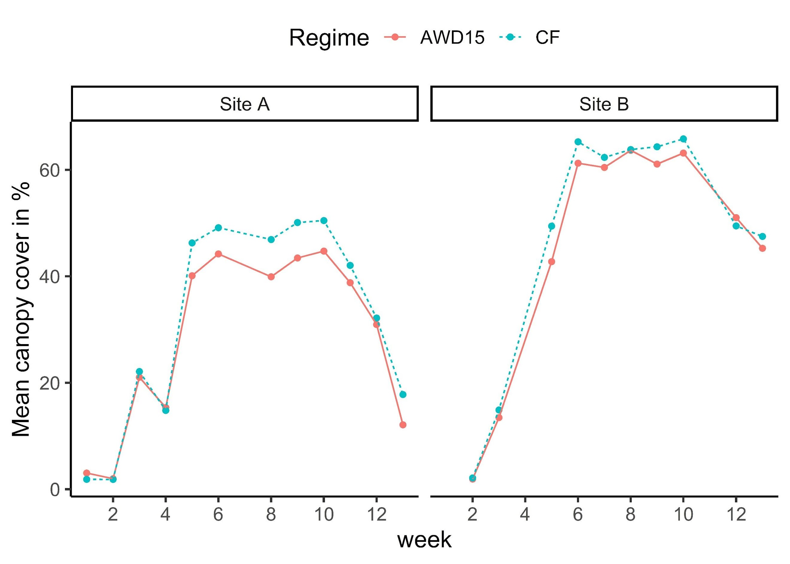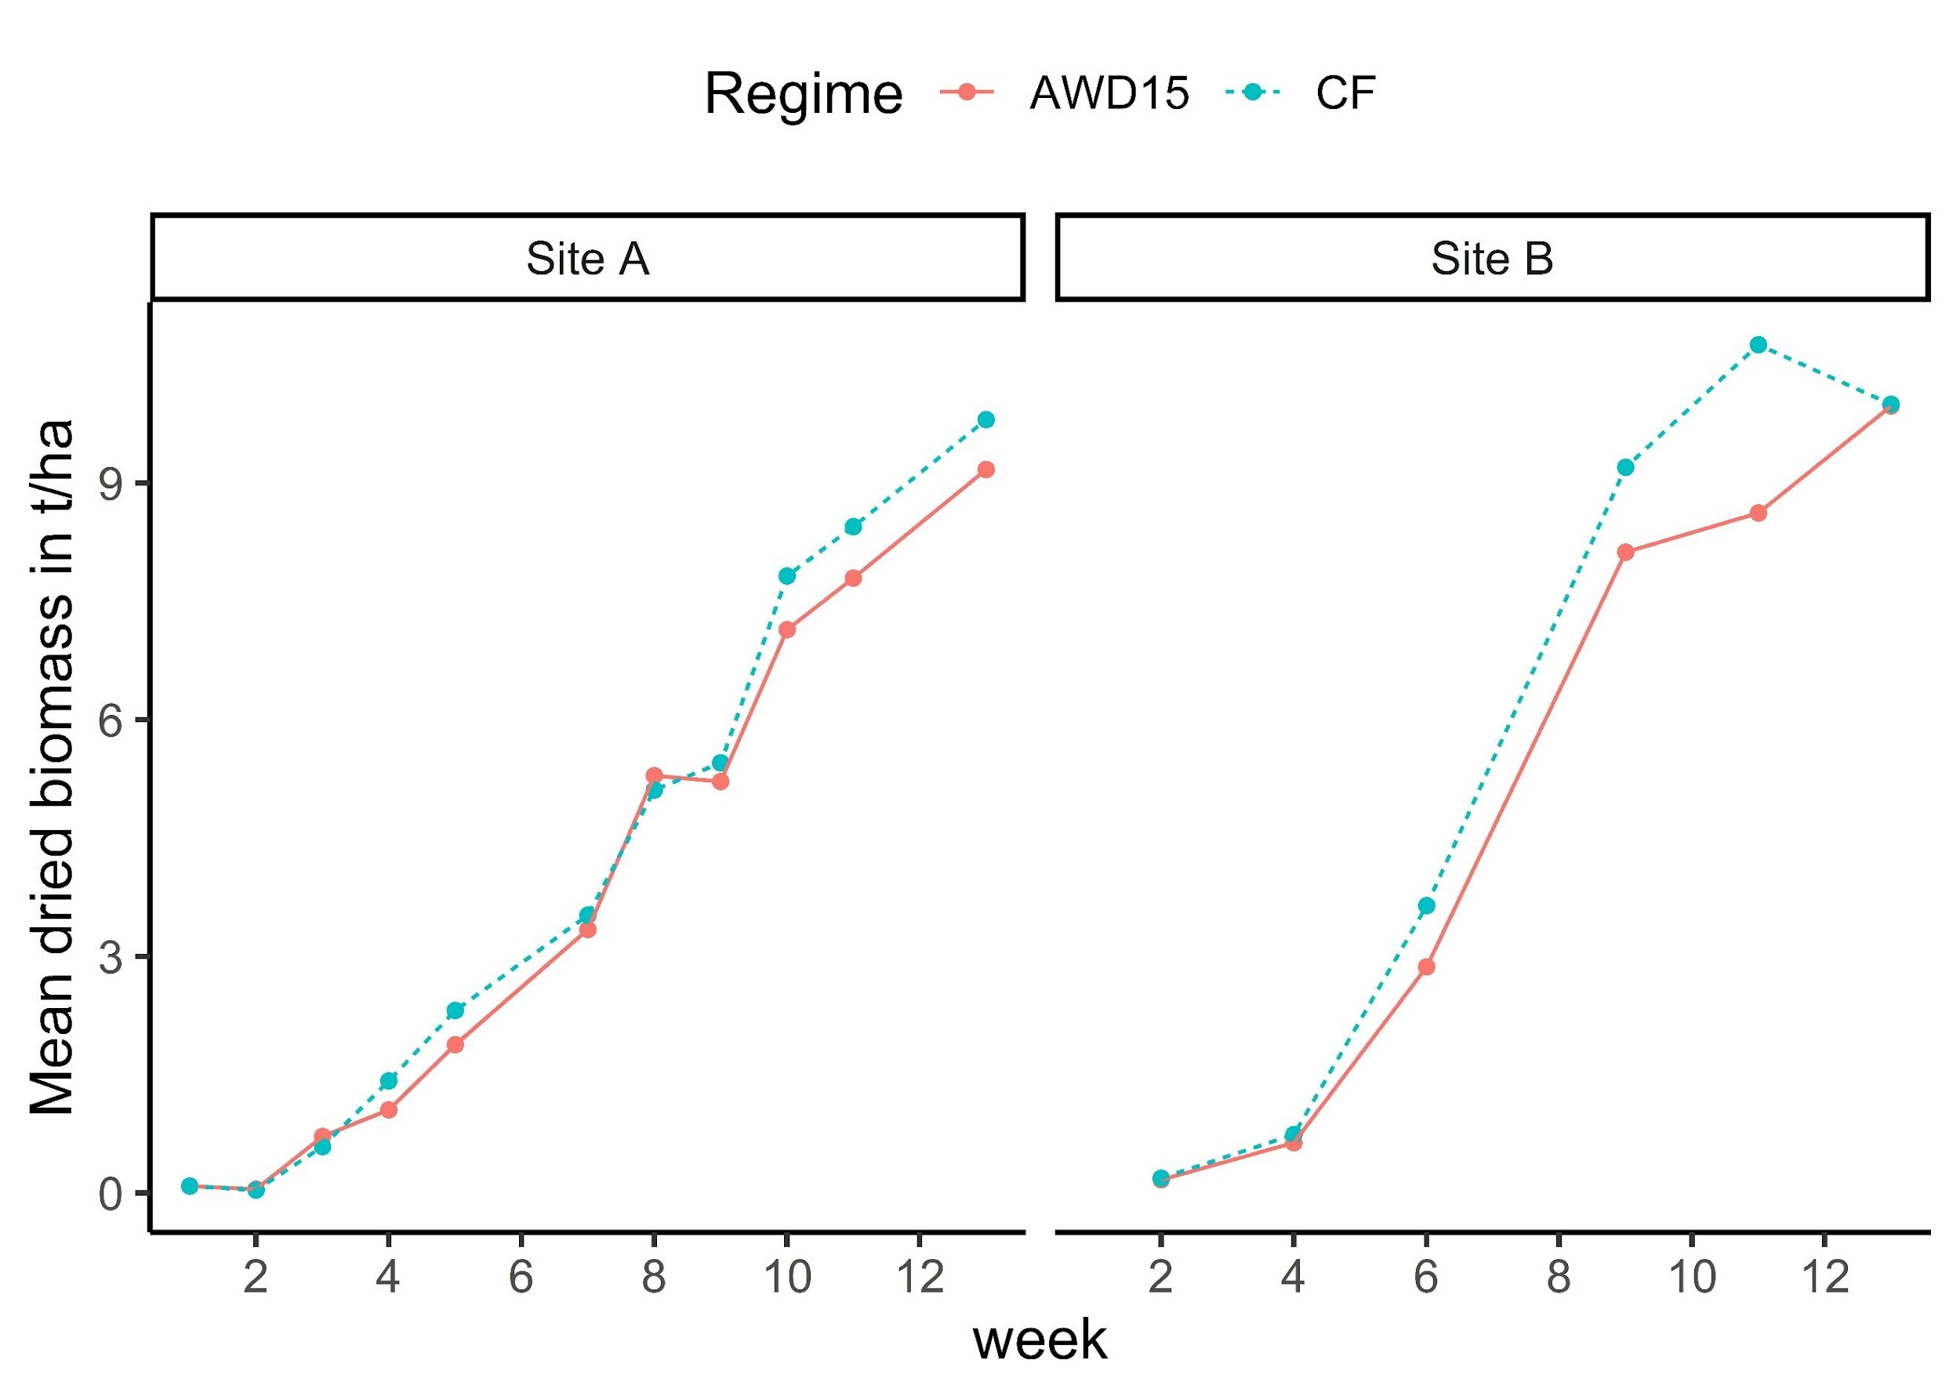
Figure 3-7: Time series growth of canopy cover and dried biomass of rice grown under CF and AWD15 for both sites at CARDI (mean values) from 2021 to 2023
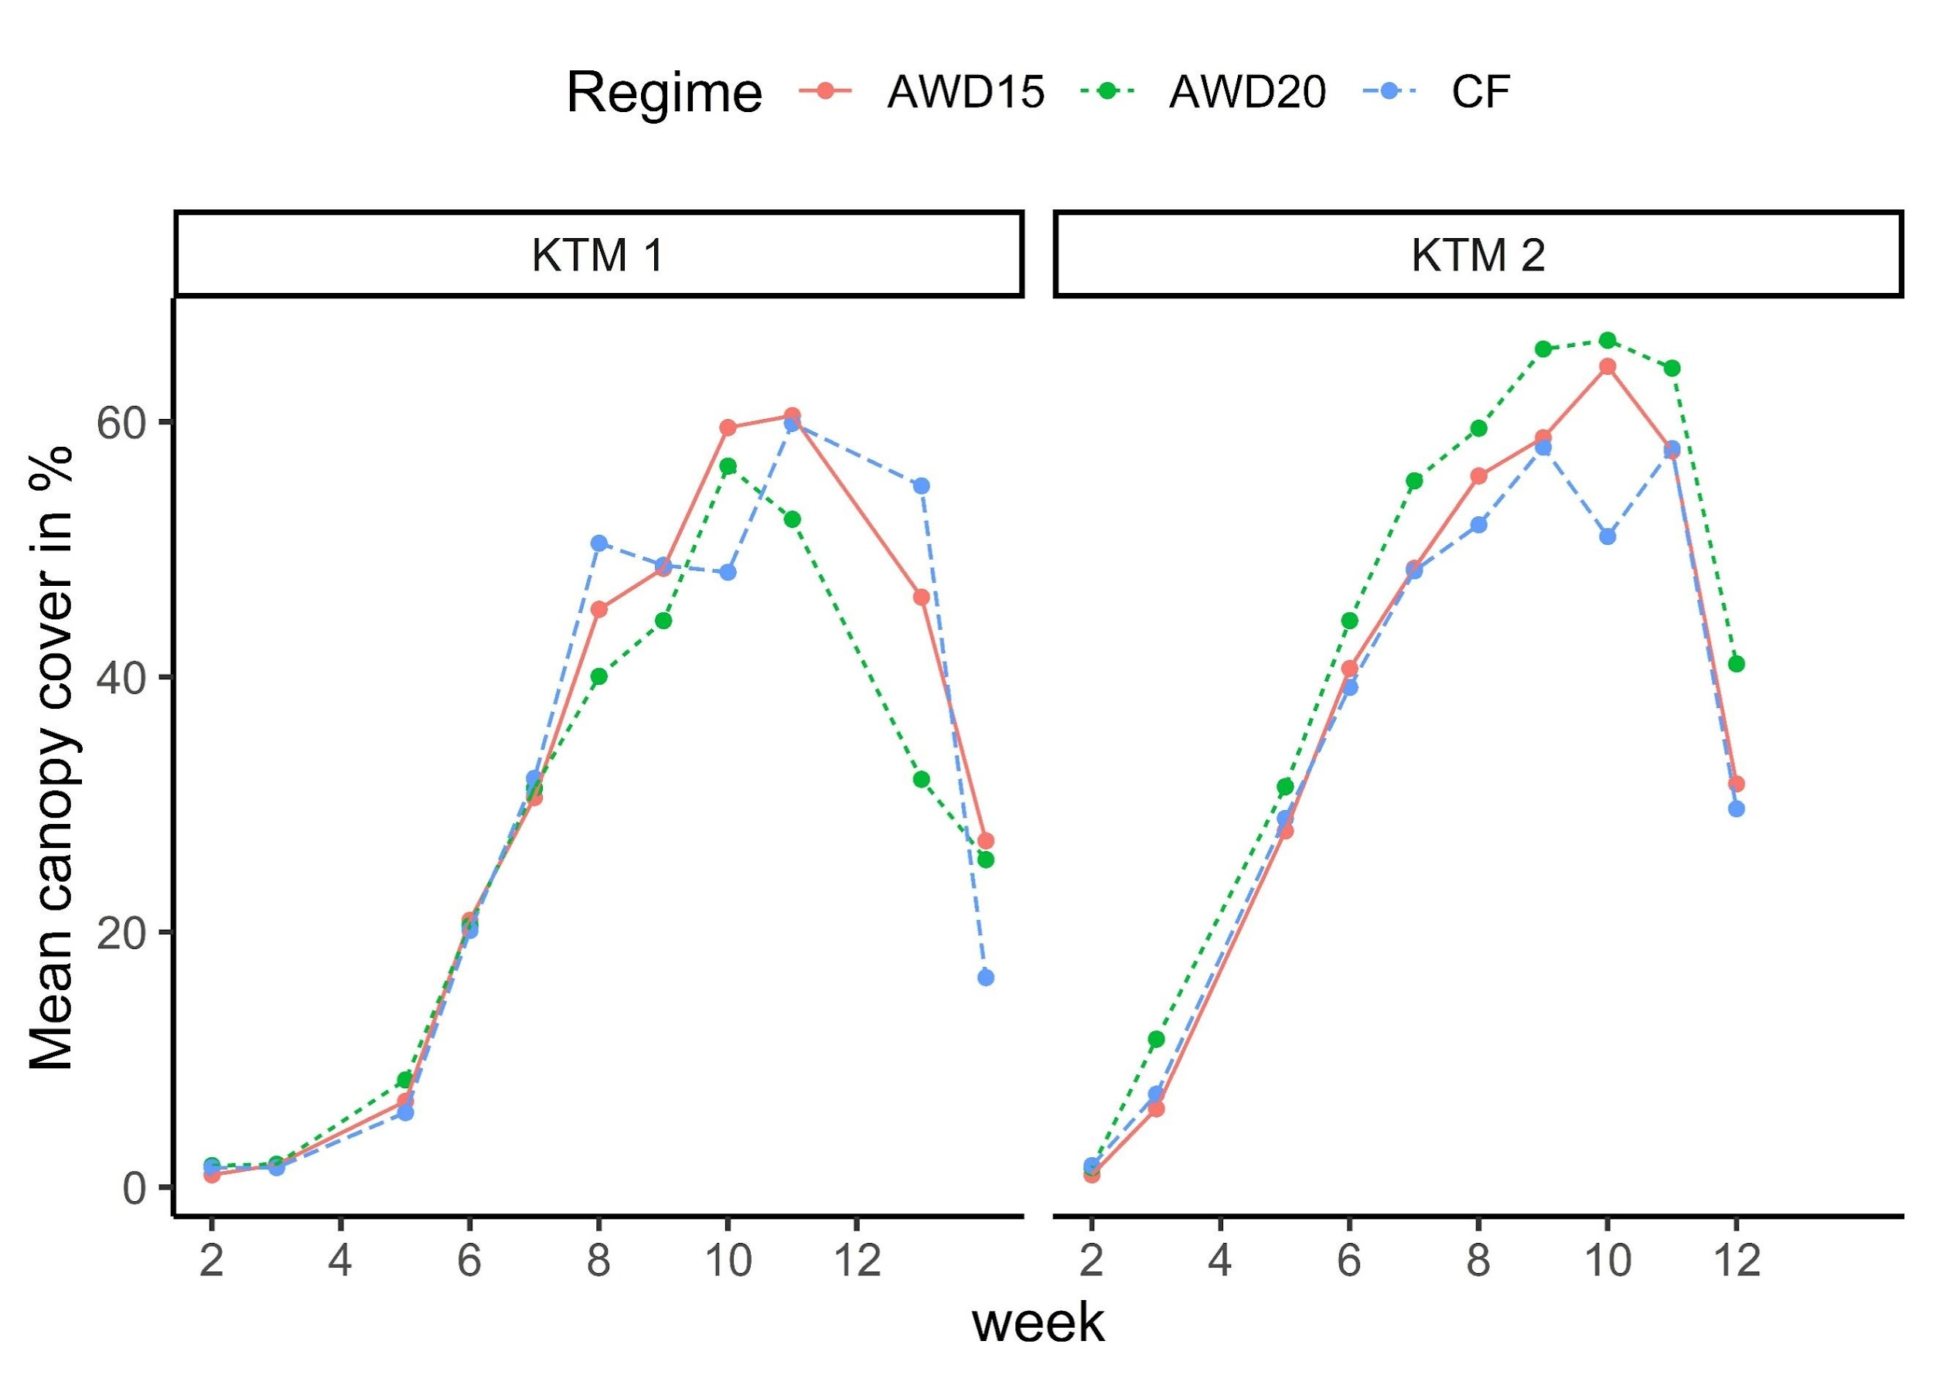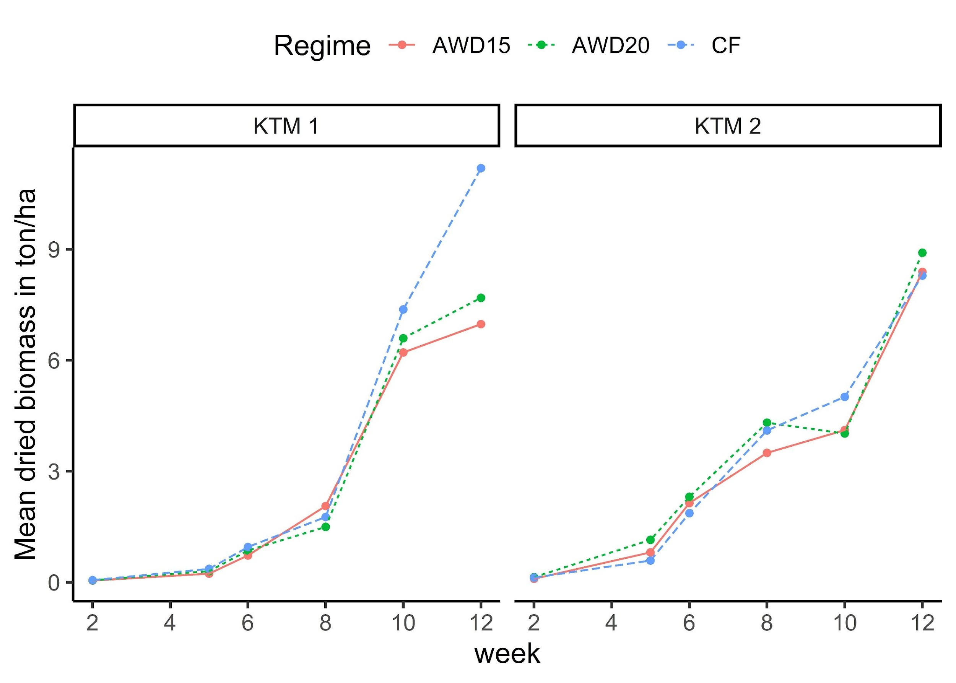

Figure 3-8: Time series growth of canopy cover and dried biomass grown under CF and AWD15 for both sites at Kampong Thom Province (mean values) during 2022

Discussion

Water saving, yield, and WUE of safe AWD

Three experiments were conducted at CARDI to investigate the potential benefits of AWD15 and the influence of soil and variety. The results indicate that for all tested soil properties, there were no significant differences between the rice paddies under the two water management systems regarding grain yield, yield components, harvest index, and root growth.
The possible explanations for this outcome are twofold: (1) our rice did not experience water stress during 3-4 days of water depletion when the water level dropped below -15 cm. The AWD cycle in this research ranged from five to ten days, consistent with what Sandhu et al. (2017) reported. (2) stopping AWD before the flowering stage did not affect the yield formation. Carrijo et al. (2017) reported that AWD is safe when the field water level is ≤ 15 cm, soil water potential is≥ –20 kPa, and when applied only during the vegetation stage instead of the whole season. When it came to rice phenological stages, applying AWD at the reproductive stage resulted in lower yields than applying it at the vegetative stage (Carrijo et al., 2017; Mote et al., 2018). However, opposite to the finding of Pascual and Wang (2017), our grain yields were not reduced as a result of the overlap between the AWD drying cycle and the panicle. Our findings support previous studies by Lampayan et al. (2015) and Yao et al. (2012) that found AWD15 can save water and maintain yield. However, these results contradict the findings of Sanhu et al. (2017), who conducted a previous study at the exact location and found that yields increased by 6-8% with AWD15 using different varieties. The mean grain yield in the rice paddies under both treatments was 3.42 ± 1.1 tons/ha, which is still lower than the reported grain yields of 3.8 to 8 tons/ha in the above studies.

Furthermore, AWD15 was found to save water by an average of 20 to 31% during completely dry seasons and 11% when rainfall occurred. This finding aligned with Yao et al. (2012) and was higher than previous studies by Sanhu et al. (2017). However, these savings were still lower (8 to 30%) than those reported in studies by Lampayan et al. (2015), Arai et al. (2021), and Xiao et al. (2021). The average WUE was 0.43 ± 0.12 kg/m³, ranging from 0.2 to 0.8 kg/m³, in the AWD15 treatment. WUE in this study was lower than that of other studies due to the lower grain yields observed. It is also important to note that the amount of water saved in this study did not account for the infiltration rate during irrigation due to technical limitations. The water content sensors are reassuring regarding the infiltration rate, which is limited during the irrigation activity.

Possibility to extend the AWD threshold

Another two experiments were carried out at Kampong Thom to explore the possible advantages of AWD20. We tested three different water regimes, namely CF, AWD15, and AWD20 while using only one rice variety, CAR15. The findings demonstrated that under the sandy loam and sandy clay loam rice soils in the experimental sites, lowering the threshold level of AWD by up to 20 cm remained safe. The results of the study support the previous recommendation by Bouman et al. (2007) and findings from Wiangsamut (2010) that implementing AWD is "safe" in terms of yield, as there is no penalty in yield but a significant reduction in water usage, as long as fields are irrigated when the water level falls to 15-20 cm below the ground surface. In addition, Carrijo et al. (2017) also reported that the interaction between soil property and water management was more critical only when applying severe AWD.
CAR15's grain yield, harvest index, root depth, and yield components were more significantly affected by soil conditions rather than the regime, similar to the findings observed at CARDI. The average yield for both locations was 3.68 ± 0.6 tons/ha, ranging from 2.7 to 4.6 tons/ha. Compared to CF, total water inputs were significantly reduced by 18–20% in AWD15 and 22-24% in AWD20, while yields remained the same. Safe and mild AWD did not significantly differ in total water input, consistent with findings by Sudhir-Yadav et al. (2010) and Lampayang et al. (2015). In K1 (sandy loam) but not K2 (sandy clay loam), WUE was significantly higher in the AWD treatments than in CF. The WUE of AWD15 was the highest among the AWD treatments at K2. No differences in aboveground biomass and CC were observed among water treatments at different stages of the crop.

Influence of soil property of AWD

The large variability of grain yields, yield components, HI, and WUE of rice under both treatments was caused by differences in the soil properties. For instance, Site B was the most productive; its yields were 56%, 28%, and 21% higher than those of Site A, K1, and K2. However, the response of rice to soil property in terms of yield component and HI was not consistent. In our finding, yield components such as biomass, number of filled spikelets, plant height, and number of spikelets per plant were all impacted by soil at KTM. However, only HI and panicle number per m² were influenced by soil at CARDI. Effective root depth was always consistent across regimes and locations. The varietal effect was not significant overall. Among the four chosen varieties, OM and CAR15 were suggested as having stable yield and WUE because they resist regime and geographic changes.

Additionally, the study found that AWD15 and AWD20 treatments improved WUE over CF on sandy loam soil. Soil texture, however, affects the duration of AWD cycles and the number of irrigation cycles. In this study, the value of Ksat at each location is negatively correlated with the total amount of irrigation. As a result, K1 and Site B, having higher values of Ksat, required more water and irrigation cycles for both CF and AWD. In addition, as clay soil (K2) consumes less water, its WUE is greater than sandy loam (CARDI and K1) under both CF and AWD. Our finding supports the finding of (Linquist et al., 2015), who pointed out that clayey soil has lower percolation losses and takes longer to reach the target soil moisture potential. Conversely, sandy loam soils have higher percolation losses and reach the drying stage faster (Sharma et al., 2002). This is because WUE is the ratio of grain yield over total irrigation water; thus, soil requiring less water will have greater WUE among varieties with comparable grain yield. Though clay soil's WUE was higher than that of sandy soil, our study found that clay soil’s WUE in AWD did not improve over CF. This was because we observed that K2 (clay soil) required less irrigation, and the amount of water saving was small to create a difference between WUE in CF and AWD.

Conclusion

The finding demonstrates that safe and moderate AWD as a water-saving technique is suitable for dry-season rice growing on sandy loam and sandy clay loam. A water depletion of -15 to -20 cm in the subsoil was found to be acceptable to maintain yield, while also achieving water savings of 10-30%. Additionally, the improvement in water use efficiency (WUE) was observed only in sandy loam soil. It is important to note that the success of AWD application may depend on the soil's saturated conductivity (Ksat) and grain yield, regardless of its texture. To achieve optimum yield and WUE in the AWD system, it is recommended to focus on improving soil nutrition and selecting high-quality rice varieties. However, it is important to note that this study was conducted on a field experimental scale, and further research is needed to assess the generality of these findings across different soil types and within a larger scale. Nonetheless, the results indicate that AWD has significant potential as a water-saving technique for rice cultivation.

Chapter 4
Evaluating the Impact of Climate Change on Yield and Water Use Efficiency of Different Dry-Season Rice Varieties Cultivated under Conventional and Alternate Wetting and Drying Conditions

Chan Arun Phoeurn, Aurore Degré, Chantha Oeurng, Pinnara Ket

This explores the potential of alternate wetting and drying (AWD) as an adaptive irrigation technique for dry-season rice farming amidst anticipated climate change impacts. This work has been published in Environmental Monitoring and Assessment. 196:1190. https://doi.org/10.1007/s10661-024-13363-x

Abstract

This study is the first attempt to assess rice cultivation under alternate wetting and drying (AWD) and continuous flooding (CF) using the latest scenarios from the Intergovernmental Panel on Climate Change (IPCC), utilizing AquaCrop Model. Field experiments were conducted during the dry season of 2023 to get the model calibration and validation input. We used two shared socioeconomic pathways scenarios (SSP3-7.0 and SSP5-8.5) developed within Coupled Model Intercomparison Project Phase 6 (CMIP6) and projected the rice growth during 2040-2070. The simulation results demonstrated the effectiveness of AquaCrop in capturing crop development across treatments and varieties. This model's accuracy in simulating canopy cover (nRMSE = 14 - 32.5%), time series biomass (nRMSE = 22 - 42.5%), grain yield (Pd = 4.36 - 24.38%), and total biomass (nRMSE = 0.39 - 18.98%) was generally acceptable. The analysis of future climate shows an increasing trend in the monthly average temperature by 0.8 ºC (Tmin) and 1.3 ºC (Tmax) in both scenarios. While ETo values were not anticipated, rainfall was expected to increase with average values of 5.62 mm to 11.25 mm. In addition, the study found that varieties with growing periods longer than 93 days after transplanting (DAT), such as CAR15 and Sen Kra Ob, were most impacted by heat stress conditions, leading to reduced yield, harvest index (HI), and water use efficiency (WUE). In our case, CAR15 and Sen Kra Ob grain yields were reduced by 53% and 8%, respectively. AWD maintains superior WUE compared to CF regardless of the type of varieties, suggesting this technique is a drought-adaptive strategy.

Keywords: Alternate wetting and drying, rice variety, water use efficiency, dry-season rice, climate-model ensembles, crop model

Introduction

The single food that more people on the planet consume than any other harvest is rice. Nearly 90% of the rice producers and consumers are from Asia. It is grown in over a hundred countries, with a combined harvested area of over 158 million hectares and an annual production of approximately 700 million tons (Sarwar et al., 2021).
Cambodia's economy is narrowly based and driven by four main sectors: garment, tourism, construction, and agriculture. Agriculture, of which rice is the dominant crop, contribute about 24.4% of GDP in 2021 (MAFF, 2022a). Agriculture's gross value added has increased annually by an average of 3 to 4 % between 2015 and 2021. Cambodia must increase its rice production twice by 2050 to secure future food security and exportation (MAFF, 2022b). To achieve this goal, there is a need to increase dry-season production, which is currently limited due to water scarcity. Dry-season rice covers only 19% of the paddy land (3.6 million ha) and produced 26.15% of the total paddy yield (wet and dry paddy) of 11,700 million tons between 2023 and 2024 (Sokkea, 2024).
In addition to water scarcity, climate change is another issue for rice producers. IPCC reports decreased precipitation in the Gulf of Thailand during winter and summer, especially at +4ºC higher temperatures. These climate risks are expected to lower crop yields and fish harvests, threatening food security in the region, including Cambodia. (FAO 2024). Climate change is projected to reduce total rice production by about 2.5% in 2030 and 9.8% in 2050 (MAFF, 2022b).
Traditional rice cultivation such as continuous flooding (CF) consumes much water. As a result, cultivated rice fields use about 30% of freshwater resources and 40% of irrigation worldwide (Sarwar et al., 2021). There are plenty of water-saving methods that have been developed to improve water use efficiency (WUE), including raised-bed systems for direct seeding, the system of rice intensification, non-flooded mulching cultivation, aerobic cultivation, and alternate wetting and drying (AWD) irrigation (Carrijo et al., 2017). Fields under AWD are exposed to intermittent drying cycles during the growth season. As soon as the drying criteria are reached, fields are re-ponded. (Isafaq et al., 2020). Because of its simplicity of use, AWD is among the most employed water-saving techniques. It has been used and proven to increase WUE worldwide, including in Asia (Arai et al., 2021; Cao et al., 2020; Sriphirom et al., 2019), Europe (Oliver et al., 2019; Monaco et al., 2021), the United States (Artwill et al., 2023; Runkle et al., 2019), and Africa (Vries et al., 2009). The above studies claimed 20% to 60% of water saving.
However, under potentially elevated temperatures caused by climate change in the future, rice under the drying cycle in AWD may suffer drought in addition to extreme heat. This hypothesis must be addressed to ensure that the AWD method is viable as an adaptive technique for dry-season rice in Cambodia.
Various techniques, including crop modeling, have been employed to investigate the effects of climate change on rice production. Crop simulation models, for example, explore how specific agronomic traits and management practices interact with genotypes and the environment (Chenu et al., 2017). AquaCrop, a crop water productivity model developed by the Food and Agriculture Organization (FAO, 2012), is among the various models available to assess water-limited crop yields under various environmental and management conditions. Despite its simplicity, the model reasonably accurately predicts crop growth indices and soil, plant, and environment continuum components. Various studies have demonstrated the capability of the AquaCrop model to successfully simulate growth of rice under AWD conditions (Xu et al., 2019; Maniruzzaman et al., 2015; Porras-Jorge et al., 2020; Mirfenderski et al., 2022). In Cambodia, Aquacrop was used to predict the yield of lettuce (Ket et al., 2018), maize (Na et al., 2017), and rice (Alvar‐Beltrán et al., 2022). Nevertheless, none has attempted to use the model under AWD conditions.
In addition, integrating climate scenarios into crop modeling offers numerous benefits. They allow for measuring climate change's impact on rice production and the probability of specific weather patterns in the areas studied. This information helps prepare for adaptation strategies, such as yield forecasting (Zachow et al., 2023), improving irrigation and fertilizer scheduling (Osman et al., 2022; Shrestha et al., 2014), selecting resilient crop varieties (Osman et al., 2022), selecting planting date (Deb et al., 2016) and mitigating the impact of abiotic stresses on rice yields (Abhishek et al., 2023). In Cambodia, on the other hand, applying a crop model to explore future climate scenarios with adaptation strategies such as the selection of suitable varieties and water management has rarely been explored in dry-season rice (Alvar‐Beltrán et al., 2022). Interestingly, global studies investigating climate impacts on rice growth under AWD irrigation are scarce. So far, the only available study by Mirfenderski et al. (2020) is in Iran. Their study reported that the AWD strategy would be a more effective climate change adaptation than mid-season drainage from crop yield, WP, and EWP viewpoints. However, their studies did not include a comparison with CF and were limited to old versions of scenarios from the IPCC 5th assessment report. More evidence, especially from other geographic locations, climate conditions, and various cultivars, is required to support AWD irrigation as an adaptive technique for climate change.
Our research fills the literature gap by utilizing the AquaCrop model, together with the latest emission scenarios from the Coupled Model Intercomparison Project Phase 6 (CMIP6), for the first time to test the hypothesis that AWD could be used as a water productivity improvement technique under climate change for the mid-century period (2041–2070) in Cambodia.
Therefore, this paper aims to (1) calibrate and validate Aquacrop on four rice varieties and various irrigation strategies and (2) assess the impact of climate change on yield and WUE of dry-season rice under CF and AWD in Cambodia. In our approach, we conducted a field experiment in Cambodia to parameterize the AquaCrop model. We downscaled data from multi-model ensembles to project future climate and explored how different short-cycle rice varieties and water management would respond to climate change.

Materials and methods
2.1. Study area and experiment detail

Crop trials were conducted at the Agricultural Research and Development Institute (CARDI) in Phnom Penh (11º28’ N, 104º48’ E). The region is classified as a tropical climate governed by monsoon winds. Total yearly precipitation varies nationwide, ranging from 1400 mm up to 4000 mm (FAO, 2024). In Cambodia, the average daily maximum temperature (Tmax) is approximately 28°C, while the average daily minimum temperature (Tmin) is approximately 22°C. Mean Tmin is consistently above 25ºC during the monsoon season, although mean Tmax may surpass 35ºC during the pre-monsoon months (April and May). The trial was carried out in 2023 during the dry season from January to April.
The experimental site (20 × 45 m²) was split into two blocks, with alternate wetting and drying (AWD) and continuously flooded (CF) replicates adjacent to each other. Within each block, there were individual randomized plots of four rice cultivars and three replications. The size of each plot was 5 × 5 m². The rice varieties included Sen Kra Ob (SK), CAR15 (CAR), Sen Pidor (SP), and check rice: OM5451 (OM). The varieties were short-cycle taking between 89 – 100 days after transplanting (DAT) to maturity. A 60:30:30 N:P₂O₅:K_{2O} fertilizer ratio was used.
Plastic film was placed over the bundles to prevent lateral seepage, a crucial factor in the experiment. This film acted as a barrier, ensuring that water did not seep laterally from the main plots. To further control water flow, the blocks were divided by gaps of five meters. During the continuous flooding (CF) regime, the water depth in the entire field was maintained at a level between 1 and 5 cm from 7 days after transplanting until ten days before maturity. In the AWD regime, 35 cm long and 10 cm in diameter hollow PVC tubes were placed vertically in the soil at a depth of 15 cm in each trial. The tube was perforated with holes on all sides. In the AWD cycle, the soil was re-flooded to 5 cm after the field water disappeared from the tube. The cycle began three weeks after transplantation and ended one week before peak flowering.

2.2. Data collection and measurement

Weather data inputs
The daily weather data, such as air temperatures, rainfall, wind speed, relative humidity, and solar radiation, were recorded from an automated weather station (iMETOS 3.3, Pessl Instruments, Werksweg, Weiz, Austria) located at the experimental site. ETO was determined using the Penman-Monteith Method.

Irrigation inputs
The pump was connected to tubes that supplied irrigation. The irrigation volume was calculated by multiplying the plot's cross-section area by the water height at the plot's reference point.

Crop inputs
Twenty-one-day-old seedlings were transplanted at a spacing of 20 cm × 20 cm in each trial. The flowering date was identified as when 50% of the rice plants in a plot started flowering, and the maturity date was calculated as 30 days after flowering. Regular measurements of aboveground biomass and canopy cover were taken over time. Aboveground biomass from 10 plants was harvested biweekly and dried in an oven at 70°C for 48 hours. Canopy cover data was collected weekly through digital photos taken at a consistent height of 1.8 meters, with three points per replicate. The fraction of canopy covering the soil was determined by dividing the total number of crop pixels by the total number of picture pixels. To eliminate border effects that can distort images and inflate canopy cover values, three by four plants in the center of the image were retained for analysis. Image analysis was conducted using Adobe Photoshop 2020.
At the point of maturity, ten randomly selected hills were sampled from a 6 m² area to assess grain yield (Y) and total aboveground biomass (B), with the exclusion of the first and second row and column of rice plants to mitigate border effects. The harvest index (HI), calculated as the ratio of grain yield to total aboveground biomass, was determined. Grain yield values were adjusted to a standard moisture content of 0.14 g H₂O g⁻¹ fresh weight. Once a month, one plant per plot was collected to measure the effective root depth (ERD), defined as the depth at which at least 70% of the roots are concentrated.

Soil inputs
Before planting rice seedlings, soil samples were taken in a column 0.8 meters deep from different horizons. Three replicates were collected for each horizon. Hydrometers (ASTM D 422, Eijkelkam, Nijverheidsstraat, EM Giesbeek, Netherlands) were used to identify the soil texture. A pressure plate (1600F1 and 1500 F2, Eijkelkam, Nijverheidsstraat, EM Giesbeek, Netherlands) was used to measure the field capacity and permanent wilting point at pressures of -33 and -1500 Kpa, respectively. Soil saturation was derived from the bulk density that was determined by the ring method. Saturated conductivity was measured by KSAT (Meter Group, Pullman, WA, USA). Teros 12 and Teros 21 (Meter Group, Pullman, WA, USA) were used to measure the hourly volumetric soil moisture content (SMC) and soil tension from the 35th to the 65th day after transplanting (DAT) during the AWD cycle.

2.3. Determination of Water Use Efficiency

The definition of water usage efficiency (WUE) is the yield of grain per unit of total water input, which includes irrigation and precipitation.

2.4. Description of AquaCrop model

The FAO AquaCrop model simulates crop yield through a series of steps: (i) crop development, (ii) crop transpiration, (iii) biomass production, and (iv) yield formation. Evapotranspiration calculations in the model are split into transpiration, which is linked to canopy cover (CC), and soil evaporation, which is proportional to bare soil. To determine potential crop transpiration, the CC is multiplied by the reference evapotranspiration (ETo) derived from the Penman-Monteith equation and the crop coefficient (Kc). Actual transpiration (Ta) is then calculated from potential evapotranspiration. Ta is further utilized to compute crop biomass (B) by multiplying it by water productivity (WP) (Eq. (4-1)). The harvest index (HI) is employed to determine crop yield (Y) based on crop biomass (B) (Eq. (4-2)) (Raes et al., 2017).

Crop biomass (B)as kg/ ha = ∑Ta ∗ WP (4-1)

Crop yield (Y)as kg/ha = HI ∗ B (4-2)

2.5. Model Calibration and Validation

The current investigation utilized Aquacrop model version 6.1. Calibration involved using AWD data and comparing it against observed canopy cover (CC), biomass, soil moisture content, and final grain yield for each replicate across all varieties. The model was run individually for each replicate to ensure accuracy. Before calibration, a sensitivity analysis adapted from Geerts et al. (2009) was conducted to identify crucial parameters needing adjustment during calibration. The model's projections were then adjusted through a trial-and-error method, focusing on one input variable at a time, and iteratively repeated until observed and model-simulated values closely matched for all treatments. Default settings were used for temperature and water stress, with no consideration for fertility or salinity stress.

In the validation phase, calibrated AquaCrop model data was converted to the growing degree days (GDD) mode and tested against CF data. GDD represents the accumulated temperature required for a crop to transition from one phenological stage to another. Using the GDD mode, it is feasible to compare simulated phenology under various future climatic scenarios. The statistical goodness-of-fit indicators used were Percent of deviation (Pd), coefficient of determination (R²), root mean square error (RMSE), normalized root means square error (nRMSE), and Willmott’s index of agreement (d). Percent of deviation (Pd) was determined by the following equation (Eq. 4-3):

$Pd= \left(\frac{S_{i}-M_{i}}{M_{i}}\right)×100 \%$ (4-3)
Where Mi and Si are the observed/measured and simulated values for the irrigation treatment data set.
Lower nRMSE values indicate good agreement between simulated and measured values. Simulation results can be considered excellent if nRMSE is smaller than 10%, good if it is between 10 and 20%, fair if it is between 20 and 30%, and poor if it is larger than 30% (Raes et al., 2012).

2.6. Climate data downscaling and bias correction

The dataset known as the NASA Earth Exchange Global Daily Downscaled Projections (NEX-GDDP-CMIP6) consists of climate scenarios that have been downscaled globally from the General Circulation Model (GCM) experiments carried out as part of the Coupled Model Intercomparison Project Phase 6 (CMIP6) (Eyring et al., 2016). These scenarios cover two out of the four primary greenhouse gas emissions pathways referred to as Shared Socioeconomic Pathways (SSPs) (O’Neill et al., 2016; Meinshausen et al., 2020). The CMIP6 GCM runs were created for the Sixth Assessment Report of the Intergovernmental Panel on Climate Change (IPCC AR6). This dataset contains downscaled projections from ScenarioMIP models distributed through the Earth System Grid Federation (O’Neill et al., 2016).
NEX-GDDP-CMIP6 was used to obtain the possible projections of future climate variables for the period of 2041–2070. We adopted two shared socioeconomic pathways (SSP3-7.0 and SSP5-8.5) to represent medium and highest greenhouse gas emissions. For each scenario, we applied 4 different GCMs including EC-Earth3, FGOALS-g3, MIROC6, and MPI-ESM1-2-LR. The ETo for baseline and future data was estimated from T maximum and T minimum using the FAO-Penman–Monteith equation as described in Allen et al. (1998).
Though the NEX-GDDP-CMIP6 dataset was globally bias-corrected (Maurer et al., 2008; Thrasher et al., 2012), the application of correction using data from the actual site would significantly improve the errors. The linear scaling approach has proved its capability for bias correction of climate data (Daniel, 2023; Shrestha et al., 2017) and was adopted in this study. The CIMP6 dataset was adjusted for bias, utilizing baseline data T maximum, T minimum, and precipitation data from historical records spanning 1996 to 2011. The baseline data was from the nearby station (Pochentong Station: 104º50', 11º33', Altitude 11 m) obtained from the Ministry of Water Resources and Meteorology (MOWRAM). In the linear scaling approach outlined in equation (4-5, 4-5), the future CIMP6 data, such as precipitation is corrected with a multiplier, and the temperature is adjusted by the additive term:
$P_{f,m,d}^{C}=P_{f,m,d} ×\frac{μ(P_{ob,m})}{μ(P_{h,m})}$ (4-4)
$T_{f,m,d}^{C}=T_{f,m,d}×\left[μ(T_{ob,m)}-μ(T_{h,m})\right]$ (4-5)

where $P_{f,m,d}^{}$ and $T_{f,m,d}^{}$denote the future precipitation and temperature, respectively; P_{h,m,d} and T_{h,m,d}, respectively, denote the historical precipitation and temperature from the original RCM outputs; P_{ob,m} and T_{ob,m} denote the observed historical precipitation and temperature; the subscripts d and m are specific days and months, respectively, C denotes the corrected value and μ denotes the mean value.

2.7. Statistical analysis
R (version 4.2.2) was used to analyze the future data, and an analysis of variance (ANOVA) was done at a 95% significance level.

Result and discussion

3.1. Result

3.1.1. Model Parameterization

Table 4-1 displays the calibrated parameters and their respective sensitivity levels. From the sensitive analysis, the initial soil condition, WP, and HI had a notable impact on Y and B, while Ksat was identified as a critical factor affecting SMC. Furthermore, stress factors such as canopy expansion, early senescence, and stomatal closure were low sensitive since the soil moisture and tension levels in this study had never experienced a drop below field capacity, as shown in Figure 4-1. Therefore, these parameters were set to default.

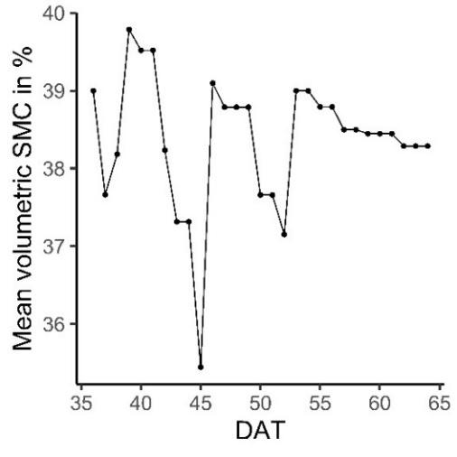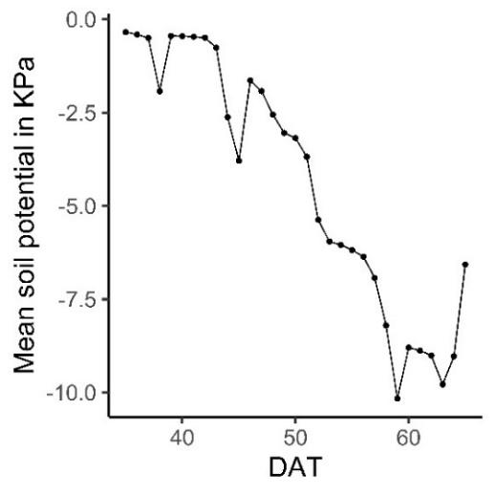
a
b
b
Figure 4-1: (a) mean observed VSMC and (b) mean observed soil potential during AWD cycle
Most of the model inputs were derived from averaging direct measurements, as detailed in section 2.2. The values for plant density, time to achieve maximum canopy cover, flowering duration, maximum ERD, and time taken to reach maximum ERD were consistent across all varieties. However, differences were noted in the observed values for HI, recovery time, maximum canopy cover (CCx), initial canopy cover (CCo), Canopy size seedling, time to flowering, and maturity across the various varieties.

The different varieties exhibited varying values for WP, CCo, seedling canopy size, and time to recovery. While canopy decline typically occurred in less than a week, it was set at 9 days, which is the minimum value allowed by AquaCrop. The rate of decline influenced the time to senescence. Effective Root Depth (ERD) ranged from 4 to 13 cm, but Aquacrop allowed a minimum depth of 10 cm. In cases where ERD fell below 10 cm, it was fixed at 10 cm for the entire season. The maximum Canopy Cover (CCx) ranged from 50 to 65% for all varieties and was usually achieved around 45 days after transplanting (DAT) during the flowering stage. These values were then used for model parameterization.

Table 4-1 : Parameters used for calibrating AquaCrop model
Inputs | Units | Value  observed (calibrated) |  |  |  |  | Sensitivity
 |  | CAR | OM |  | SK | SP
- Crop
Plant density | Plants/  ha | 250,000 | 250,000 |  | 250,000 | 250,000
Type of planting method | - | Transplanting | Transplanting |  | Transplanting | Transplanting
Initial canopy cover (CC_{o}) | % | (1.50) |  | (1.00) | (1.13) | (1.50) | Low
Canopy size seedling | cm2/  plant | (5) |  | (4) | (4.5) | (6) | Moderate
Canopy decline | Days | (9) |  | (9) | (9) | (9) | Moderate
Time to recovery | Days | (7) | (10) |  | (7) | (10) | Low
Time to maximum canopy cover | Days | 45 |  | 45 | 45 | 45 | Moderate
Time to senescence | Days | (85) | (80) |  | (90) | (86) | -
Time to maturity | Days | 94 | 89 |  | 99 | 93 | -
Maximum canopy cover (CCx) | % | 75 | 65 |  | 58 | 66 | Moderate
Time to flowering | Days | 64 | 59 |  | 69 | 63 | Low
Duration of the flowering | Days | 7 |  | 7 | 7 | 7 | -
Max. effective rooting depth | cm | 11-13 (10) |  | 11-13 (10) | 11-13 (10) | 11-13 (10) | Low
Time for maximum root depth | Days | 94 (CST) | 45 (CST) |  | 45 (CST) | 70 (CST) | Low
Crop water productivity (WP*) | kg/m3 | - (16) | - (19) |  | - (15) | - (16) | High
Harvest index (HI)-  measured | % | 38 | 50 |  | 28 | 41 | High
water stress: Default value
Effect of crop transpiration (KcTr) | - | 1.1 | 1.1 |  | 1.1 | 1.1 | -
Canopy expansion | - | Extremely sensitive to water stress | Extremely sensitive to water stress |  | Extremely sensitive to water stress | Extremely sensitive to water stress | Low
Stomatal closure | - | Moderately sensitive to water stress | Moderately sensitive to water stress |  | Moderately sensitive to water stress | Moderately sensitive to water stress | Low
Early canopy senescence | - | Moderately sensitive to water stress | Moderately sensitive to water stress |  | Moderately sensitive to water stress | Moderately sensitive to water stress | Low
Heat stress: Default value
Base temperature |  | 8 | 8 |  | 8 | 8 | -
Upper temperature |  | 30 | 30 |  | 30 | 30 | -
Start of heat-stress effect |  | 35 | 35 |  | 35 | 35 | -
Maximum heat-stress effect |  | 40 | 40 |  | 40 | 40 | -
- Field
Surface practice |  | Soil bund 0.25 m | Soil bund 0.25 m |  | Soil bund 0.25 m | Soil bund 0.25 m | -
- Soil profile
Layer 1: 0 - 0. 3 m
Texture |  | Sandy loam | Sandy loam |  | Sandy loam | Sandy loam | -
PWP (V%) |  | 9.6 ± 2.8 | 9.6 ± 2.8 |  | 9.6 ± 2.8 | 9.6 ± 2.8 | Moderate
FC (V%) |  | 29 ± 2 (39) | 29 ± 2 (39) |  | 29 ± 2 (39) | 29 ± 2 (39) | Moderate
SAT (V%) |  | 39 ± 1 (45) | 39 ± 1 (45) |  | 39 ± 1 (45) | 39 ± 1 (45) | Moderate
Ksat (mm/d) |  | 169 ± 97 (4) | 169 ± 97 (4) |  | 169 ± 97 (4) | 169 ± 97 (4) | Hight
Layer 2: 0.3 - 0. 4 m
Texture |  | Sandy loam | Sandy loam |  | Sandy loam | Sandy loam | -
PWP (V%) |  | 10 ± 2.8 | 10 ± 2.8 |  | 10 ± 2.8 | 10 ± 2.8 | Moderate
FC (V%) |  | 23 ± 1 (32) | 23 ± 1 (32) |  | 23 ± 1 (32) | 23 ± 1 (32) | Moderate
SAT (V%) |  | 36 ± 4 (38) | 36 ± 4 (38) |  | 36 ± 4 (38) | 36 ± 4 (38) | Moderate
Ksat (mm/d) |  | 5.5 ± 1.2 (7) | 5.5 ± 1.2 (7) |  | 5.5 ± 1.2 (7) | 5.5 ± 1.2 (7) | Hight
Layer 3: 0.4 - 0. 8 m
Texture |  | Sandy loam | Sandy loam |  | Sandy loam | Sandy loam | -
PWP (V%) |  | 9.5 ± 1.5 | 9.5 ± 1.5 |  | 9.5 ± 1.5 | 9.5 ± 1.5 | Moderate
FC (V%) |  | 22 ± 3 | 22 ± 3 |  | 22 ± 3 | 22 ± 3 | Moderate
SAT (V%) |  | 37 ± 4 | 37 ± 4 |  | 37 ± 4 | 37 ± 4 | Moderate
Ksat (mm/d) |  | 2.4 ± 1.9 (3) | 2.4 ± 1.9 (3) |  | 2.4 ± 1.9 (3) | 2.4 ± 1.9 (3) | Hight
- Initial condition
Soil moisture content |  | Saturated | Saturated |  | Saturated | Saturated | Hight

3.1.2. Model Calibration and Validation

Grain yield and final biomass

The results in Table 4-2 confirm the model's accuracy in simulating grain yield (Y) and biomass (B) within an acceptable range. The grain yield (Y) measured for different rice varieties ranged from 2.28 to 5.1 tons/ha under both irrigation management. The model's estimated grain yield for the genotypes fell within the 2.61 to 5.12 tons/ha range. Notably, OM5 displayed the highest yield, while SK exhibited the lowest. The measured biomass (B) for various rice varieties ranged from 7.91 to 11.03 tons/ha under both irrigation management, while the modeled values ranged from 9.34 to 11.47 tons/ha. CAR, OM, and SP varieties had comparable B, with SK presenting the lowest B.
SP variety, notably, showed the highest relative error in model validation for B and Y. During calibration and validation, the prediction errors for Y ranged from -4.36 to 11.49% and 1.59 to 24.38%. In contrast, B production ranged from -0.39 to 5.67% and -3.23 to 18.98%. Despite these variations, the model's overall accuracy in simulating grain yield and biomass production is evident.
Table 4-2: Calibration and validation results of simulating biomass and grain yield production of the four varieties. Standard deviations are given in brackets.
 | Grain yield (tons/ha) |  |  | Biomass (tons/ha)
 | Obs | Sim | Pe (±%) | Obs | Sim | Pe (±%)
Calibration
AWD
CAR | 4.12 (0.46) | 4.06 | 10.30 (5.36) | 10.67 (0.68) | 10.85 | 5.67 (4.23)
OM | 5.1 (0.27) | 4.86 | -4.36 (5.33) | 10.7 (0.2) | 10.13 | -5.32 (1.79)
SP | 4.44 (0.24) | 4.3 | -4.51 (5.31) | 10.32 (0.58) | 10.28 | -0.39 (0.5)
SK | 2.28(0.27) | 2.5 | 11.49 (14.26) | 8.55 (0.25) | 9.5 | 5.31 (3.05)
Validation
CF
CAR | 3.86 (0.33) | 4.29* | 8.88 (8.94) | 10.33 (0.87) | 11.47 | 8.68 (8.89)
OM | 5.04 (0.18) | 5.12 | 1.59 (4.02) | 11.03 (0.58) | 10.67 | -3.23(4.94)
SP | 3.63 (0.31) | 4.48 | 24.38 (10) | 9.19 (0.19) | 10.93 | 18.98 (2.39)
SK | 2.4 (0.21) | 2.61 | 12.23 (11.46) | 7.91 (1.2) | 9.34 | 18.01 (1)
*The simulating biomass and grain yield remained the same for each replication

CC and time series B

The model was calibrated using field data collected in the AWD regime. Generally, the calibrated CC and time series B matched the measured values well (see Figure 4-2). The average goodness-of-fit metrics obtained for modeling CC and time series B for the four varieties were as follows: R2 > 0.93, D > 0.94, RMSE <15% for CC and R2 > 0.95, D > 0.94, RMSE <1.5 tons/ha for B. The nRMSE of calibrated CC indicated a good fit (nRMSE = 17.5 - 27%). This suggests that the model calibration is robust. While the model accurately simulated CC patterns, it consistently underestimated B by 25-33.5%. This predictive error in simulating B for all rice varieties during the grain-filling stage was attributed to the substantial increase in total B weight.

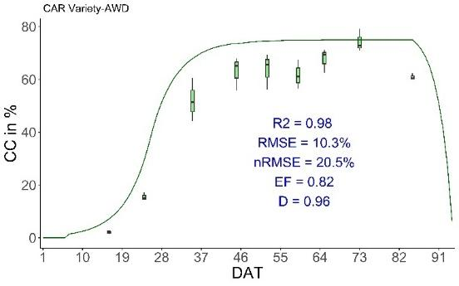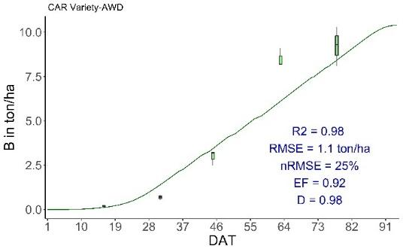
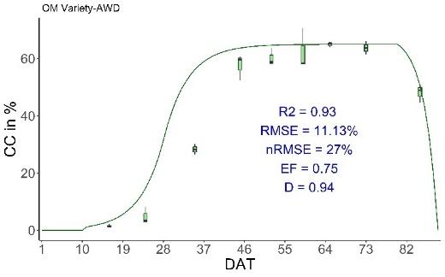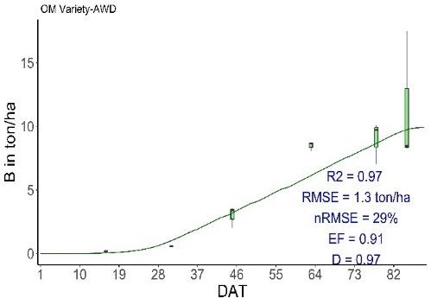
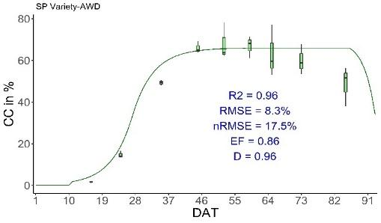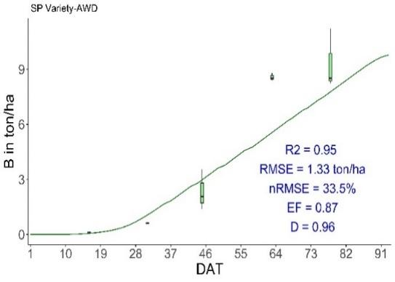
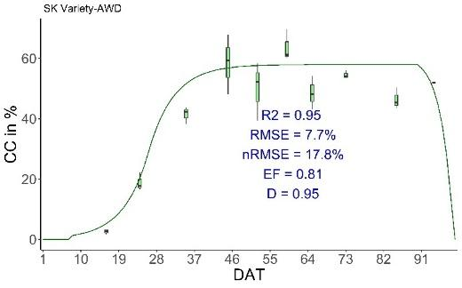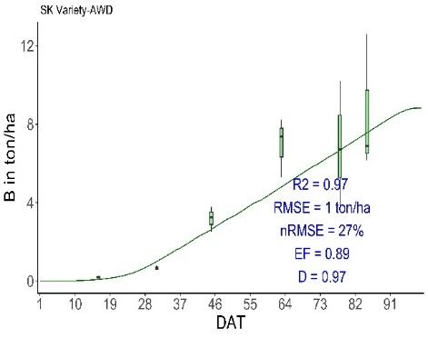
Figure 4-2 : Simulated and measured canopy cover (CC) and time series B for the calibration under AWD regime. Error bars indicate the standard deviation across replicated measurements.
The figures in Figure 4-3 depict indicators showing how closely the validated model matches the actual field observations. The average goodness-of-fit metrics for validating CC and time series B of the four varieties were as follows: R2 > 0.95, D > 0.92, RMSE < 15%, and R2 > 0.98, D > 0.92, with 1 < RMSE < 2.2 tons/ha. The nRMSE for the validated CC of the three varieties indicated a good fit (nRMSE < 20%), except for OM, where the nRMSE was 32.5%. This discrepancy occurred because the measured CC values in CF conditions were lower than in AWD conditions throughout the season. However, the poor fitting of OM did not impact the accuracy of the model's simulation for grain yield and final biomass.
Similarly, during the validation phase, like in the calibration phase, AquaCrop accurately simulated CC patterns but underestimated B by 22% - 45.2%. This underestimation was mainly due to the substantial increase in rice biomass during the grain-filling stage. Despite these challenges, the indices for CC and B in the validation phase indicated an acceptable model prediction.

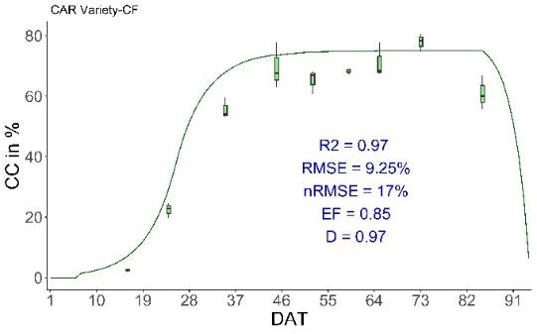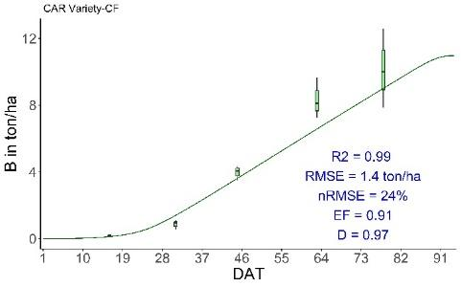
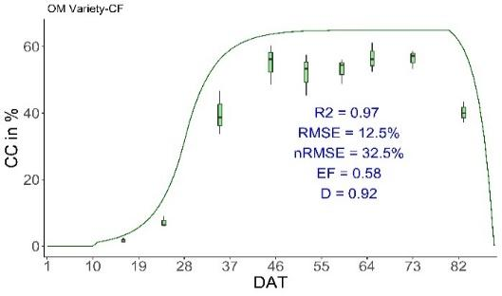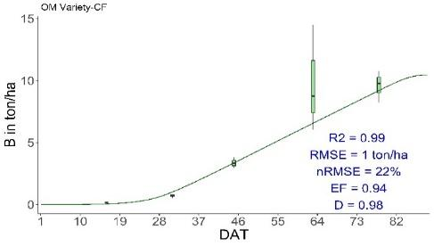
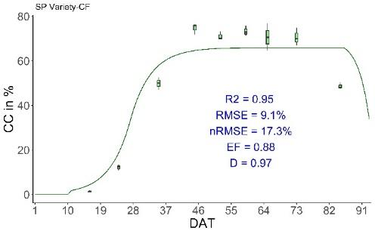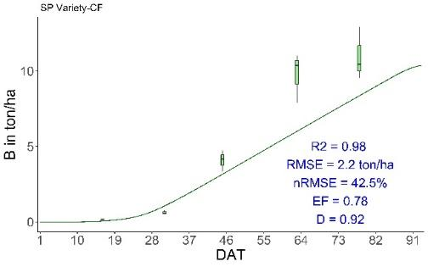
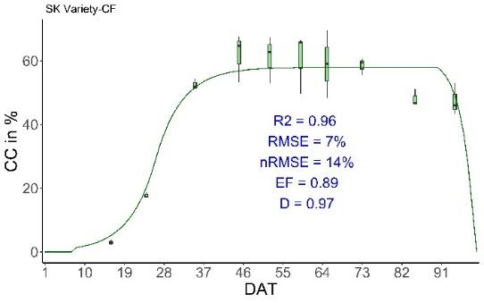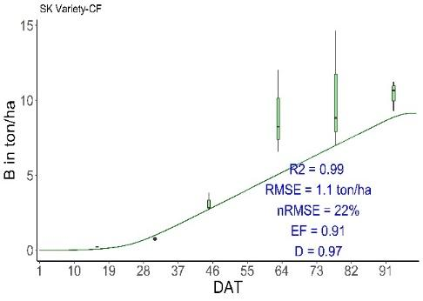

Figure 4-3: Simulated and measured canopy cover (CC) and time series B for the validation under CF regime. Error bars indicate the standard deviation across replicated measurements.

Soil Moisture Content

Though the model mimicked the soil moisture better in the calibration than validation (Figure 4-4), R² and D values were in the acceptable range of R² > 0.5, D > 0.5, and nRMSE < 10%. In calibration, we achieved R² = 0.51, RMSE = 4.25%, nRME = 5.55%, and D = 0.51. In validation, we achieved R² = 0.54, RMSE = 4.73%, nRME = 6.2%, and D = 0.57.
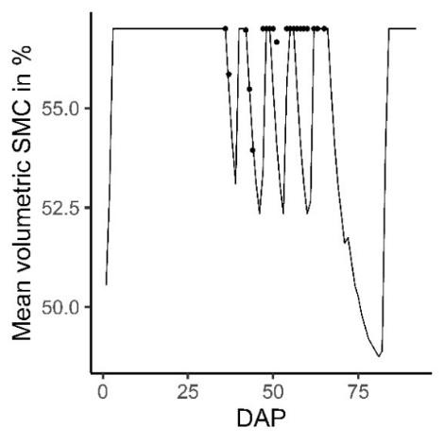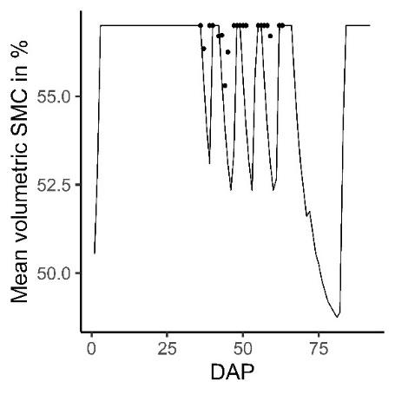
a
b

Figure 4-4: Simulating and observed SMC for the calibration (4 plots) and validation (4 plots) under AWD regime

3.1.3. Overview of future climate

Variability in mean monthly minimum and maximum temperature, ETO, and rainfall in the future (2041-2070) at CARDI under two climatic scenarios is shown in Figure 4-5. The temperature indicated a lowering trend from May to January and an increasing trend from February to April, according to the overall baseline trends and future estimates for Tmax and Tmin (Fig. 5a and 5b). In comparison to the baseline (1996-2011), the monthly temperature would rise on average by 0.88 ºC (Tmin) and 1.33 ºC (Tmax) under the SSP3-7.0 scenarios and by 0.99 ºC (Tmin) and 1.36 ºC (Tmax) under the SSP5-8.5 scenario. April showed the baseline highest minimum of 25.58 ºC and maximum temperature of 35.54 ºC, which were slightly close to the heat stress zone. The mean Tmax and Tmin of April were projected to increase by 0.96 and 1.23 ºC for SSP3-7.0 scenarios and by 0.76 and 1.27 ºC for SSP5-8.5 scenarios, respectively. Typically, the driest months occur during the dry-season rice growing period, which falls between March and May. During this time, the monthly baseline Evapotranspiration (ETO) ranged from 135 to 160 mm (Fig. 5c). While the mean ETO values for both the baseline and future periods were not much different, there was an expected increase in ETO in the future, with maximum values projected to reach up to 195 mm (a 31% increase) per month in April. Figure 5d illustrates a rising trend in rainfall across all months, with average values of 5.62 mm (4%) and 11.25 mm (9%) for SSP3-7.0 and SSP5-8.5, respectively. However, the future monthly rainfall from December to April would be lower than the total monthly ETO, indicating the need for additional water input to ensure the health of the rice plants.

b
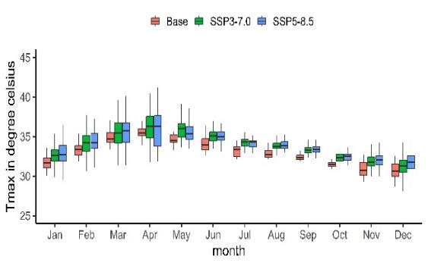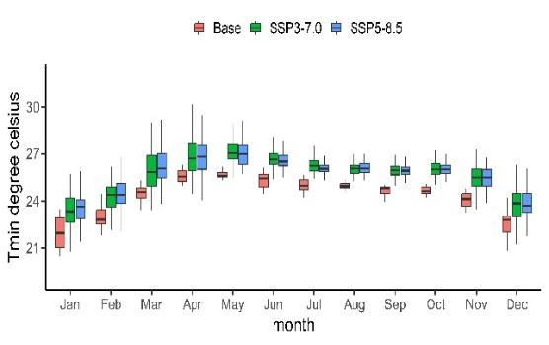
a
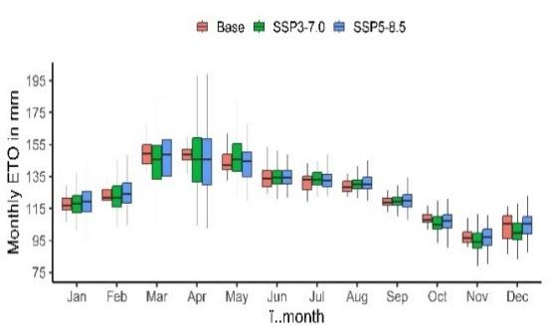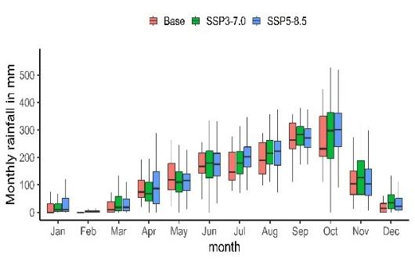
d
c
Figure 4-5: Projected changes in surface air temperature (a,b), ETO (c), rainfall (d) under SSP3-7.0 (Medium emission trajectory) and SSP5-8.5 (highest emission trajectory) scenarios for 2041–70 for the baseline period 1996–2011. Solid lines indicate medians.

3.1.4. Future impact of climate change on rice growing and WUE

The simulations of the effect of future climatic conditions on maturity, grain yield, crop damage, biomass, HI, and WUE under two water regimes for the mid-century (2041-2070) are shown in Figure 4-6. Figure 4-6a illustrates the effect of future climatic conditions on the maturity of the four rice cultivars.​ The projected maturity dates for varieties OM, CAR, and SP were expected to be earlier by 0.8 – 2.4 days (CF) and 1.2 - 5.19 days (AWD) under SSP3-7.0, while delays of 0.36 to 2.66 days were anticipated for both regimes under SSP5-8.5. In contrast, the days to maturity for variety SK were projected to be delayed by 5.17 days (SSP3-7.0) and 6 – 7.82 days (SSP5-8.5) under both regimes.
Compared to the baseline, the simulated average grain yield of SK showed a substantial reduction of approximately 53%, followed by CAR, which showed around an 8% decrease under future climate change scenarios across both water management approaches. Conversely, under both scenarios, OM and SP in both regimes demonstrated an increase in average grain yield of 18% and 14%, respectively (Figure 4-6b).
According to Figure 4-6c, the likelihood of crop damage incidents under both regimes was estimated at 17% (SSP3-7.0), 9% (SSP5-8.5) for CAR, and 23.5% (SSP3-7.0), 17% (SSP5-8.5) for SK. The crop damage for SP and OM was not anticipated under SSP3-7.0. Under SSP5-8.5, the damage of 1.2% for SP and 0.8% for OM was expected.

In Figure 4-6d, it was observed that the simulated average WUE of SK experienced a significant reduction of about 54%, followed by CAR with an approximately 8.3% decrease under future climate change scenarios across both water management strategies. In contrast, under both scenarios, OM and SP in both regimes exhibited an increase in average WUE of around 19% each. However, under any condition, the simulated average WUE of AWD15 surpassed that of CF under both future scenarios across all varieties and regimes. Under SSP3-7.0, the WUE of AWD was between 22% and 26% higher than those grown under CF, while under SSP5-8.5, the WUEs of AWD were between 18% and 25% greater. Except for SK (Figure 4-6e), all varieties were projected to experience an increase in average biomass ranging from 16% to 22% under future climate change scenarios across both water management approaches. However, the reduction in SK's biomass was minimal, approximately 1.5 tons. ha⁻¹ across all scenarios and regimes. As a result of the increased biomass, a decrease in average HI was simulated under future climate change scenarios across all varieties and regimes (Figure 4-6f). Regardless of water regime and climate scenarios, the simulated average HI was reduced by 54.2%, 23%, 3.5%, and 1.5% for SK, CAR, SP, and OM, respectively.

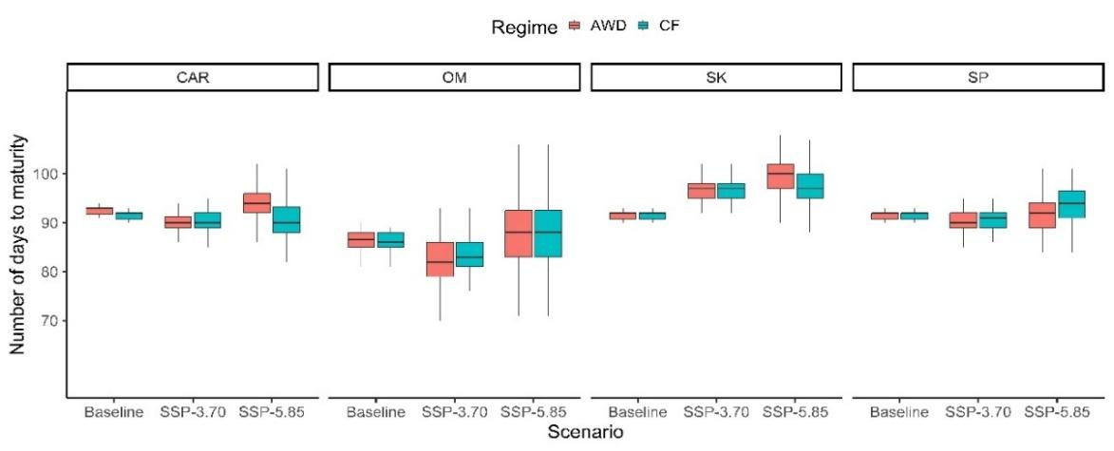
a
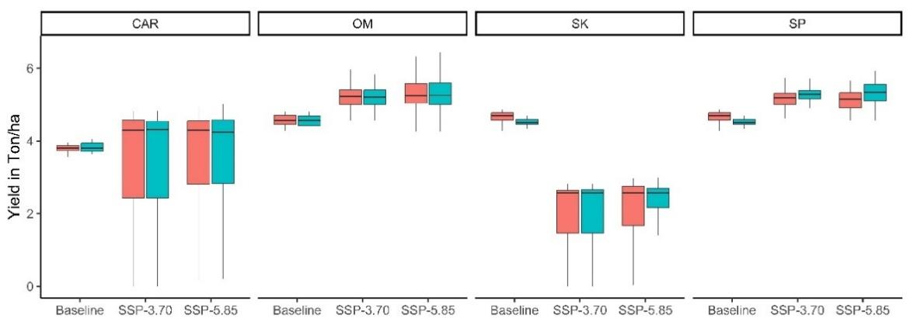
b
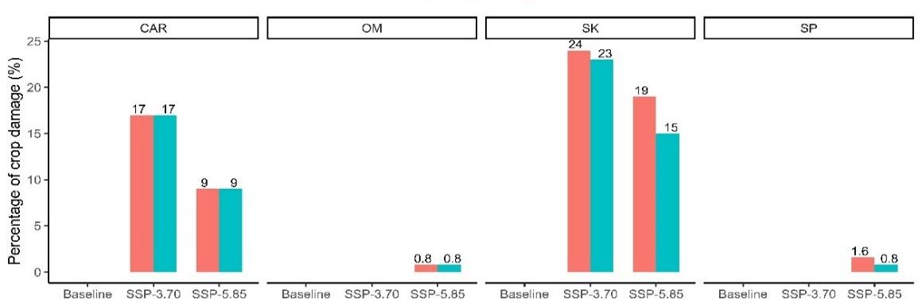
c
d
d
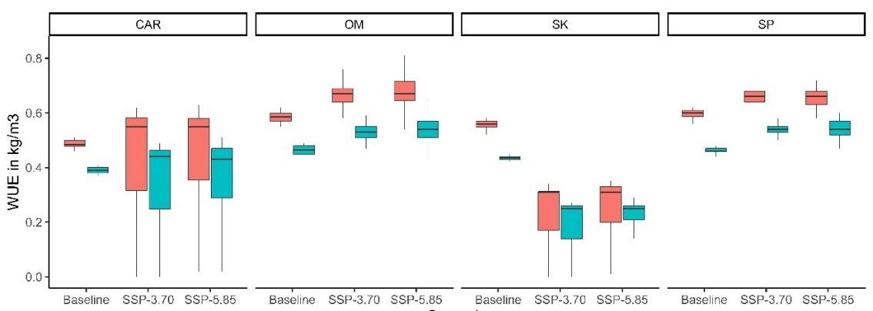
d
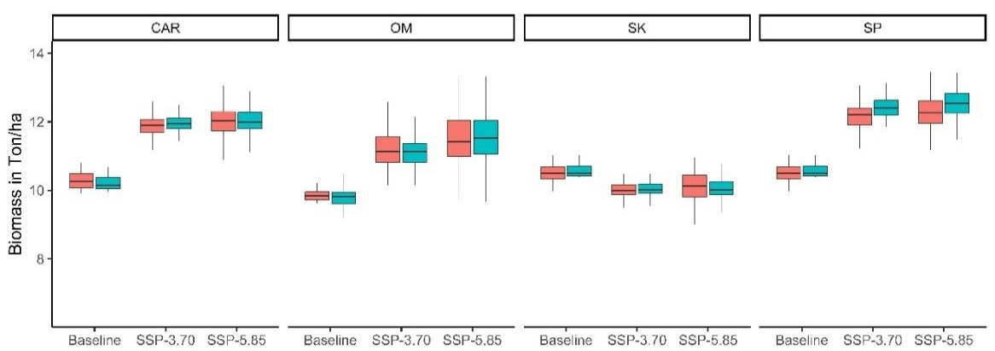
e
e

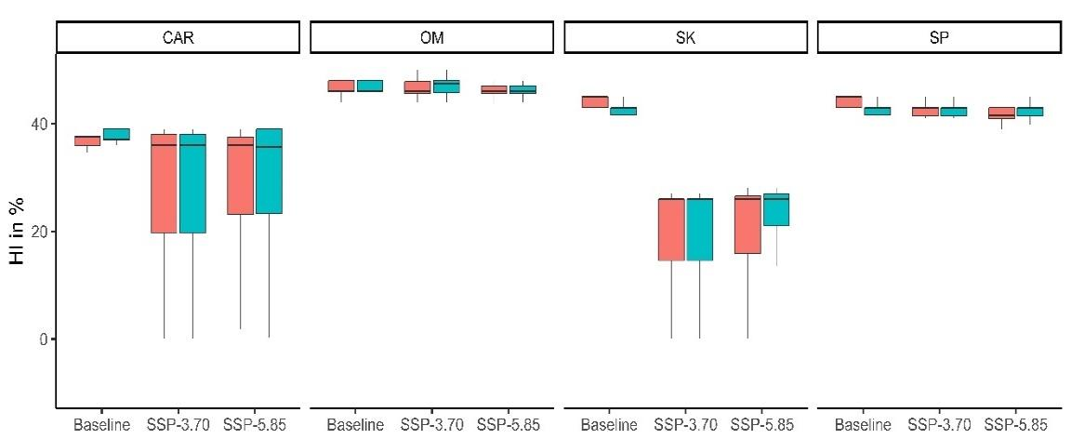
f
Figure 46: Simulated days to Maturity (a), grain yield (b), Percentage of damage (c), WUE (e), biomass (e), HI (f) of the four rice varieties in historical weather data and two climate change scenarios (SSP3-7.0 and SSP5-8.5) in 2041–70. Solid lines indicate medians. The percentage of crop damage equals the number of damaged years divided by 120 (30 years * 4 GCM).

3.2. Discussion

3.2.1. AquaCrop Performance for growth simulation in AWD and CF

Grain yield (Y) and total aboveground biomass (B)

Given the significant influence of variety, it is essential to calibrate the model against specific varieties for accurate simulation (FAO, 2012). Using different water management strategies, AquaCrop successfully simulated rice varieties' yield (Y) and biomass (B). The Percent of deviation (Pd) between the simulated and observed Y and B values was outstanding, consistent with other studies using AquaCrop for rice growth under AWD and water stress conditions (Maniruzzaman et al., 2015; Mirfenderski et al., 2022; Vahdati et al., 2020). However, the model overestimated Y and B of SP variety in the validated model (CF regime) due to differences in the measured values between both treatments.

CC and time series B and CC

The simulation results showed that AquaCrop effectively captured the development of crop canopies across all treatments and varieties. It was demonstrated through a variety of statistical measures that were calculated. The metrics of time series CC, in general, indicated good performance by the calibrated and validated model, as cited in AquaCrop studies by Maniruzzaman et al., 2015 and Raoufi et al., 2018. However, AquaCrop did not capture the CC growth for OM well, which is the improved variety. The nRMSE of OM was the highest compared to the three local varieties. This outstanding difference could be due to the difference in local growth behavior and improved variety (Saito et al., 2006). This finding contrasted with the finding of Raoufi et al. (2018), who observed a poorer prediction of CC in the local variety than the improved one. This model may require further investigation to differentiate between the canopy development of local and improved cultivars.
In general, the metrics of time series B indicated good to fair performance by the calibrated model, as cited in AquaCrop studies by Maniruzzaman et al., 2015 and Raoufi et al., 2018. Nonetheless, the normalized root mean square error (nRMSE) was higher than in those studies due to the substantial increase in total B weight during the grain-filling stage, which was primarily driven by the weight of the grains. The bias between observation and simulation in the grain-filling stage varied between 30 – 40 %. We tried to reduce such a bias by increasing the CCo and Canopy size seedling, which caused a slight overestimation of time series CC at the early growing stage. In addition, increasing B to fit the measured value also led to a huge bias in the final Y and B. Thus, we restricted the fitting in the way that the final Y and B were most fitted to the observed values, as these two variables were critical factors for the future climate projection.
This means the model's ability to simulate B for the selected type of varieties during the grain-filling stage needs improvement. The model's inability to distinguish grain yield density from total biomass at this stage limits its accuracy. However, an option is available and recommended by AquaCrop to update unexpected growth or damage (Raes et al., 2017). This adjustment is inconvenient during the numerous future climate projections under multiple scenarios. Therefore, model improvements that incorporate development rates of grain yield after the flowering stage would be highly desirable to enable the application of the calibrated model across a broader range of genetic conditions. This model weakness was not problematic for CC because CC became stable from 45 DAT and started reducing during the grain falling stage. Furthermore, the increase in time series B after flowering was due to the increasing weight of grain rather than the rice canopy, which had nothing to do with CC.

However, the imperfection of time series CC and time series B did not influence the final Y and B since we can calibrate WP to compromise the errors. The calibrated WP values were between 15.0 to 19.0 g m⁻², which falls within the range (15-20 g m⁻²) recommended for C3 crops by Raes et al. (2009).

Soil moisture content

The calibration and validation of SMC were only fair (R and D > 0.5; NRMSE < 10%). Since our paddy sub-soil was mostly near saturation, this agreed with the finding of Xu et al. (2019), whose AWD method was irrigating the field to saturation but not flooding. However, Perros-Jorge et al. (2020) better predicted when the soil was drier (soil potential between -10 and -20 kPa). In addition, while our experiments did not present severe water stress conditions on the crop, we did not see any gradient in model performance with the degree of water stress.

4.1.2. Impact of climate change on short-cycle rice during mid-century
In comparison to the baseline (1996-2011), projected temperature increases were expected to increase on average 0.93 ºC for Tmin and 1.35 ºC for Tmax under both SSP3-7.0 and SSP5-8.5 scenarios, with notable spikes in March and April, where temperatures could exceed 40 ºC. Heat stress in rice, as per Raes Dirk (2017), is triggered between 35 to 40 ºC. Fahad et al. (2016) suggested a 10% decline in rice grain yield for each 1 ºC rise in growing-season minimum temperature during the dry season. While rainfall was forecasted to rise by 4 – 9% monthly, ETo demand in April also would increase by 31%, posing a severe threat to crops if cultivated during that period. This month coincides with our experiment period, which ran from late January to April.
In our experiment, each short-cycle rice variety displayed distinct flowering times and growth durations. The impact of climate change was most pronounced on the yield, HI, and WUE of the CAR and SK varieties, which had longer grown periods than the other two varieties. The impact of water shortage during the projection were less important, as rice growth under full irrigation also suffered the same damage. SK, having the most extended growing period (99 days) in particular, faced significant exposure to heat stress conditions (Tmax ≥35°C) among the short-cycle varieties. While CAR had a mean maturity of one day longer time to flower than SP, it experienced severe damage, which may be due to high temperature. This finding aligns with previous research findings indicating that prolonged exposure to high temperatures greater than 35 °C during flowering, even from 1 hour to a day, can lead to spikelet sterility (Devkota et al., 2013; Shi et al., 2016; Van Oort & Dingkuhn, 2021). Short-cycle varieties with growing periods of less than 94 days, such as OM and SP in our case, were not affected by heat stress. However, under the highest emission scenario, SSP5-8.5, the overall risk of damage for these two varieties was very low, about 3-6%, regardless of water management.
Due to its correlation with yield, WUE was observed to increase in the SP and OM varieties but decrease in CAR and SK. AWD maintained superior WUE compared to CF throughout. This highlights AWD's potential as a drought-adaptive strategy going forward, maintaining yields while reducing water input for short-cycle rice varieties under 93 days. Interestingly, biomass showed low sensitivity to heat in our study, indicating that climate change impacts grain yield more than biomass.

Conclusions

AquaCrop demonstrated considerable potential in simulated rice varieties and water management. Under medium and high emission scenarios, the frequency of heat stress on rice would happen quite frequently in Cambodia when the maximum temperature exceeds the rice's tolerance level below 35 ºC. The ensemble projection indicated that rice grown longer than 93 DAT is more prone to damage. In our case, Sen Kra Ob experienced a significant reduction of about 54%, followed by CAR15 with an approximately 8.3% decrease under future climate change scenarios across both water management strategies.
OM5451 and Sen Kra Ob are the suitable varieties selected to adapt to climate change. Regarding WUE, AWD is a promising technique for saving water in the future.

To effectively address the challenges posed by climate change in rice production, it is crucial to prioritize the selection of rice varieties with traits that enhance climate resilience and support efficient water management. It is important to acknowledge that this study was conducted at a field experimental level, and further research is necessary to validate these findings across a broader range of rice varieties and on a larger scale. Additionally, a more thorough investigation into the water stress coefficient for rice varieties under more severe AWD conditions is recommended, as this aspect was not able to be explored in the current study. Nevertheless, the results suggest that AWD shows promising potential as a climate adaptation strategy for dry-season rice cultivation in Cambodia.

Chapter 5

General Discussion and Recommendation

This chapter presents the key findings of the study, outlines its limitations, and offers recommendations to support the practical application and adaptation of the results.

In comparison to other grain crops, lowland rice demands a higher quantity of water at the field level due to several factors. These include the significant water needed for wet land preparation, ongoing seepage and percolation caused by the water being ponded, and the increased evaporation rates from the surface of the ponded water (Mote et al., 2021).
In addition, rice is very vulnerable to climate change. A dramatic temperature change is likely to affect agricultural productivity. Higher temperatures, in particular, impact the quantity and quality of rice grains, especially during the reproductive or filling stage (Bahuguna et al., 2015). Under heat stress, rice grain yield will decline by 10% for each 1ºC increase in growing-season minimum (night) temperature in the dry season (Fahad et al., 2016).
In this regard, improving water use efficiency (WUE) and long-term planning using climate projection is essential to improve the productivity of farmers who grow dry-season rice.

Traditional rice cultivation, such as continuous flooding (CF), consumes much water, ranging from 1100 to 2500 mm. Plenty of water-saving methods have been developed to improve water use efficiency (WUE), including alternate wetting and drying (AWD) irrigation (Carrijo et al., 2017). Fields under AWD are exposed to intermittent drying cycles during the growth season. As soon as the drying criteria are reached, fields are re-ponded. (Isafaq et al., 2020). Because of its simplicity of use, AWD is among the most employed water-saving techniques. It has been used and proven to increase WUE worldwide, including in Asia (Arai et al., 2021; Cao et al., 2020; Sriphirom et al., 2019), Europe (Oliver et al., 2019; Monaco et al., 2021), the United States (Artwill et al., 2023; Runkle et al., 2019), and Africa (Vries et al., 2009). The above studies claimed 20% to 60% of water saving. However, little research has been done to examine AWD in depth for different varieties and paddy soil environments.
In addition, under potentially elevated temperatures caused by climate change in the future, rice under the drying cycle in AWD may suffer drought in addition to extreme heat. This hypothesis must be addressed to ensure that the AWD method is viable as an adaptive technique for dry-season rice in Cambodia.

This thesis aims to reveal the feasibility of AWD management to maintain rice yield, improve WUE, and adapt to climate change by applying field experiments and modeling on different rice varieties and soil conditions.
Two complementary approaches published in two distinguished articles were applied to answer this objective. These approaches allow us to see the reaction of different rice varieties toward AWD irrigation on different types of soil ecosystems. We could also visualize Cambodia's climate trend and how it would affect the rainfall amount, crop evapotranspiration, and temperature. From that, we can identify the varieties that are resilient to water scarcity and quantify the impact of extreme heat on rice grown under both conventional and AWD water management.

- In the first approach, the study aims to comprehensively assess the feasibility of safe and mild AWD as a water-saving technique for rice yield and water use efficiency (WUE) by considering diverse rice varieties and soil properties. This study also examined the interactions between irrigation methods, rice variety, and soil characteristics. Five field experiments were conducted from 2021 to 2023. Associative causal relationships between measurable and latent variables of rice grown under CF and AWD were tested using partial least squares structural equation modeling (PLS-SEM) and an analysis of variance (ANOVA).
Our results showed that safe and moderate AWD did not significantly affect grain yield, yield components, phenology, harvest index (HI), and root growth compared to conventional flooding (CF). AWD15 decreased water input by 11% to 31% (102 – 285 mm) when tested on various soil ecosystems, while AWD20 saved 22-24% (168 – 300 mm). Furthermore, soil texture is a significant factor in determining the quantity of irrigation needed. The average water needs for sandy loam (Site A, Site B, and K1) was 24 to 80 % higher than that of sandy clay loam (K2) when there was no interruption by rainfall. Ksat was the driver for the length of the irrigation cycle and irrigation frequency. In this study, the value of Ksat at each location is negatively correlated with the total amount of irrigation. Among the AWD treatments, AWD15 exhibited the highest WUE.
Soil influences the grain yield and specific yield components and indirectly affects WUE. Our study also found that on sandy loam soil, both AWD15 and AWD20 treatments improved WUE over CF, and clay soil's WUE (0.56-0.62 kg/m³) was higher than that of sandy soil (0.29-0.33 kg/m³). However, clay soil’s WUE in AWD did not improve over CF.
When the three experimental data sets were merged in PLS-SEM, the effect of variety on grain yield was negligible. This was because varietal differences in grain yield were significant only at specific locations.

- In the second approach, this study explores the potential of AWD as an adaptive irrigation technique for dry-season rice farming amidst anticipated climate change impacts. The research focuses on several sub-objectives, starting with calibrating and validating the Aquacrop model for four Cambodian rice varieties and different irrigation strategies. Additionally, the study seeks to understand how climate change affects various aspects of dry-season rice components, including grain yield, water use efficiency (WUE), maturity, biomass, HI, and potential damage, comparing outcomes between conventional flooding (CF) and AWD methods. Through these efforts, the research aims to shed light on AWD's potential role in bolstering the resilience of dry-season rice farming in the face of climate change challenges. This is the first-ever attempt to utilize the AquaCrop model in evaluating the effects of climate change on different rice varieties cultivated under AWD irrigation, employing climate model ensembles for the mid-century period (2041-2070) based on the most recent emission scenarios within the Coupled Model Intercomparison Project Phase 6 (CMIP6). Field experiments were conducted in 2023 to get the input for calibrating and validating the AquaCrop. We adopted SSP3-7.0 and SSP5-8.5 to represent medium and highest greenhouse gas emissions. For each scenario, we applied 4 different GCMs.
The results confirm the model's accuracy in simulating grain yield (Y) and biomass (B) within an acceptable range. During calibration and validation, the prediction errors for Y ranged from -4.36 to 11.49% and 1.59 to 24.38%. In contrast, B production ranged from -0.39 to 5.67% and -3.23 to 18.98%. However, the SP variety notably showed the highest relative error in model validation for B and Y.
In addition, the average goodness-of-fit metrics obtained for calibrating and validating CC and time series B suggest that the model calibration and validation were robust. While the model accurately simulated CC patterns, it underestimated B by 25-33.5%. This predictive error in simulating B for all rice varieties during the grain-filling stage was attributed to the substantial increase in total B weight. However, the calibration and validation of SMC were only fair (R and D > 0.5; NRMSE < 10%).
The ensemble-model projection indicated that rice grown longer than 93 DAT is more prone to damage in the future. In our case, CAR15 and Sen Kra Ob grain yields were reduced, and more than 60 - 70% of these two varieties were damaged under SSP3-7.0 scenarios, and between 33% - 50% were damaged under SSP5-8.5. The average grain yield is projected to decrease for CAR and SK (maturity from 94 – 99 DAT) and increase for OM and SP (maturity from 89 – 93 DAT).
Under any condition, the simulated average WUE of AWD15 surpassed that of CF under both future scenarios across all varieties and regimes. Under SSP3-7.0, the WUE of AWD was between 22% and 26% higher than those grown under CF, while under SSP5-8.5, the WUEs of AWD were between 18% and 25% greater.

Based on the results of both studies, we can engage in an overall discussion as follows:

Feasibility of safe and mild AWD to save water in the present context

1.1. There was no yield penalty under safe and moderate AWD

Achieving sustainable rice production through AWD requires an integrated approach encompassing agronomic, biological, and hydrologic strategies (Nalley et al., 2015). Furthermore, the effectiveness of AWD is influenced by several other factors, including soil texture, pH, organic carbon content, microbial activity, and climatic conditions (Isafaq et al., 2020). Both Nalley et al. (2015) and Artwill et al. (2023) suggested filling the gap by focusing on soil characteristics.

Our findings on four soil properties demonstrated that under the sandy loam and sandy clay loam rice soils, there were no significant differences in terms of grain yield, yield components, harvest index, and root growth between the rice paddies under CF, safe AWD (AWD15), and moderate AWD (AWD20). The results of the study support the previous recommendation by Bouman et al. (2007) and findings from Wiangsamut (2010) that implementing AWD is "safe" in terms of yield, as there is no penalty in yield but a significant reduction in water usage, as long as fields are irrigated when the water level falls to 15-20 cm below the ground surface. In addition, Carrijo et al. (2017) also reported that the interaction between soil property and water management was more critical only when applying severe AWD.
Regarding the grain yield, the possible explanations for this outcome are twofold: (1) our rice did not experience water stress during 3-4 days of water depletion when the water level dropped below -15 and - 20 cm. (2) stopping AWD before the flowering stage did not affect the yield formation. Carrijo et al. (2017) reported that AWD is safe when the field water level is ≤ 15 cm, soil water potential is ≥ –20 kPa, and when applied only during the vegetative stage instead of the whole season. When it came to rice phenological stages, applying AWD at the reproductive stage resulted in lower yields than applying it at the vegetative stage (Carrijo et al., 2017; Mote et al., 2018). However, opposite to the finding of Pascual and Wang (2017), our grain yields were not reduced as a result of the overlap between the AWD drying cycle and the panicle. Our findings support previous studies by Lampayan et al. (2015) and Yao et al. (2012) that found AWD15 can save water and maintain yield.

1.2. Without yield penalty, AWD did save water

AWD has the potential to save water in sub-tropical monsoon regions and tropical semi-arid regions by 20–40% (Vries et al., 2010; Yao et al., 2012). However, AWD15 saved only 3 to 7% of the water compared to CF during the experiment of Sandhu et al. (2017) in Cambodia. These improvements were relatively small in encouraging farmers to adopt AWD. Therefore, Sandhu recommends the identification of new rice genotypes that can consistently produce high or stable yields under AWD across different ecosystems while achieving an average water saving of 20% in rice cultivation.
In our study, water was saved on average from 18% to 31% by safe AWD and from 22-24% by mild AWD across the five locations during completely dry seasons. This finding aligned with Yao et al. (2012) and was higher than previous studies by Sanhu et al. (2017). However, these savings were still lower (8 to 30%) than those reported in studies by Lampayan et al. (2015), Arai et al. (2021), and Xiao et al. (2021). The difference in water input between the two AWDs was insignificant, consistent with findings by Sudhir-Yadav et al. (2010) and Lampayang et al. (2015).

1.3. Effluentless of Variety on AWD performance

The varietal effect was not significant overall. The large variability of grain yields, yield components, HI of rice under both treatments was caused by differences in the soil properties. For instance, Site B was the most productive; its yields were 56%, 28%, and 21% higher than those of Site A, K1, and K2. However, the response of rice to soil property in terms of yield component and HI was not consistent. In our finding, yield components such as biomass, number of filled spikelets, plant height, and number of spikelets per plant were all impacted by soil at KTM. However, only HI and panicle number per m² were influenced by soil at CARDI. Effective root depth was always consistent across regimes and locations. However, these results contradict the findings of Sanhu et al. (2017), who conducted a previous study at the exact location and found that yields increased by 6-8% with AWD15 using different varieties.

1.3. Impact of soil property on AWD performance

WUE, the critical indicator of AWD performance, was also driven by soil. The study found that AWD15 and AWD20 treatments improved WUE over CF on sandy loam soil but not clay soil. Soil texture also affects the duration of AWD cycles and the number of irrigation cycles. In this study, the value of Ksat at each location is negatively correlated with the total amount of irrigation. As a result, K1 and Site B, having higher values of Ksat, required more water and irrigation cycles for both CF and AWD. In addition, as clay soil (K2) consumes less water, its WUE is greater than sandy loam (CARDI and K1) under both CF and AWD. Our finding supports the finding of (Linquist et al., 2015), who pointed out that clayey soil has lower percolation losses and takes longer to reach the target soil moisture potential. Conversely, sandy loam soils have higher percolation losses and reach the drying stage faster (Sharma et al., 2002). This is because WUE is the ratio of grain yield over total irrigation water; thus, soil requiring less water will have greater WUE among varieties with comparable grain yield. Though clay soil's WUE was higher than that of sandy soil, our study found that clay soil’s WUE in AWD did not improve over CF. This was because we observed that K2 (clay soil) required less irrigation, and the amount of water saving in AWD was relatively small, which could not create a difference between WUE in CF and AWD.

  - Interaction between parameters

The interaction between soil texture and water regime on yield components was not significant at CARDI. However, at Kampong Thom, this interaction had a strong effect on final biomass and the number of spikelets per panicle. Additionally, the interaction between different varieties with soil texture and water regime was also found to be insignificant. This suggests that AWD, variety choice, and soil texture operate independently in this experiment. Therefore, using AWD to conserve water while selecting high-yield varieties, along with ensuring soil fertility, is crucial for maximizing the benefits of AWD application.

Potential of AWD as an adaptive irrigation Technique for dry-season rice farming amidst anticipated climate change impacts

AquaCrop could effectively simulate Rice Growth under AWD and CF irrigation, but its performance for improved variety and during the grain-filling stage is questionable

Various studies have demonstrated that the AquaCrop model can successfully simulate rice growth under AWD conditions (Xu et al., 2019; Maniruzzaman et al., 2015; Porras-Jorge et al., 2020; Mirfenderski et al., 2022).
The Percent of deviation (Pd) between the simulated and observed Y (< 15%) and B (<10%)values was outstanding, consistent with other studies using AquaCrop for rice growth under AWD and water stress conditions (Maniruzzaman et al., 2015; Mirfenderski et al., 2022; Vahdati et al., 2020).
The simulation results showed that AquaCrop effectively captured the development of crop canopies across all treatments and varieties. In general, the metrics of time series CC indicated good performance by the calibrated and validated model, as cited in AquaCrop studies by Maniruzzaman et al., 2015 and Raoufi et al., 2018. However, AquaCrop did not capture the CC growth for OM well, which is the improved variety. The nRMSE of OM was 32.5% in the validation model, which was the highest compared to the three local varieties. This difference could be due to local growth behavior and improved variety (Saito et al., 2006). This finding contrasted with the finding of Raoufi et al. (2018), who observed a poorer prediction of CC in the local variety than the improved one. This model may require further investigation to differentiate between the canopy development of local and improved cultivars.
The size of the canopy during the seedling stage and CCx moderately sensitivity canopy development throughout the growing season. Therefore, careful calibration of these two factors is essential to align with the final yield and biomass. These values were not measured on-site, so adjustments were made based on observed yield (Y) and biomass (B), while ensuring consistency with the actual cover development. For the varieties OM and CAR, there were notable overestimations from the vegetative to the panicle initiation stage. The calibration and validation errors for OM and CAR were 20-17% and 27-32%, respectively. Notably, OM had a higher error due to a larger difference in growth between the CF and AWD regimes, even though the differences in CC between these regimes for all the varieties was not significant. The SP variety showed a better fit with a 17% error, while SK demonstrated the lowest error range of 14-17%. Generally, there was an overestimation of the canopy during the senescent period for the varieties OM, CAR, and SP.

In general, the metrics of time series B indicated good to fair performance by the calibrated and validated model, as cited in AquaCrop studies by Maniruzzaman et al., 2015, and Raoufi et al., 2018. The simulated biomass was consistently over or underestimated during the simulated period under all examined water regimes of these two studies (Maniruzzaman et al., 2015; Raoufi et al., 2018).
Nonetheless, our nRMSE was higher than in those studies due to the huge underestimation of the model for B during the grain-filling stage. This was because of the substantial increase in the observed total B weight during the grain-filling stage, primarily driven by the weight of the grains. The bias between observation and simulation in the grain-filling stage varied between 30 – 40 %. We tried to reduce such a bias by increasing the CCo and Canopy size seedling, which caused a slight overestimation of time series CC at the early growing stage. In addition, increasing B to fit the measured value also led to a considerable bias in the final Y and B. Thus, we restricted the fitting in the way that the final Y and B were most fitted to the observed values, as these two variables were critical factors for the future climate projection.
This means the model's ability to simulate B for the selected type of varieties during the grain-filling stage needs improvement. The model's inability to distinguish grain yield density from total biomass at this stage limits its accuracy. However, an option is available and recommended by AquaCrop to update unexpected growth or damage (Raes et al., 2017). This adjustment is inconvenient during the numerous future climate projections under multiple scenarios. Therefore, model improvements that incorporate development rates of grain yield after the flowering stage would be highly desirable to enable the application of the model across a broader range of genetic conditions. This model weakness was not problematic for CC because CC became stable from 45 DAT and started reducing during the grain falling stage. Furthermore, the increase in time series B after flowering was due to the increasing weight of grain rather than the rice canopy, which had nothing to do with CC.

However, the imperfection of time series CC and time series B did not influence the final Y and B since we can calibrate WP to compromise the errors. The calibrated WP values were between 15.0 to 19.0 g m⁻², which falls within the range (15-20 g m⁻²) recommended for C3 crops by Raes et al. (2009).

The calibration and validation of SMC were only fair (R and D > 0.5; NRMSE < 10%). Since our paddy sub-soil was mostly near saturation, this agreed with the finding of Xu et al. (2019), whose AWD method was irrigating the field to saturation but not flooding. However, Perros-Jorge et al. (2020) better predicted when the soil was drier (soil potential between -10 and -20 kPa). In addition, while our experiments did not present severe water stress conditions on the crop, we did not see any gradient in model performance with the degree of water stress.

2.2. Rice may tolerate minor water stress but not heat stress

Under potential climate change conditions, rice undergoing the alternate wetting and drying (AWD) cycle may face drought alongside extreme heat. Investigating this hypothesis to confirm the viability of using the AWD method for dry-season rice in Cambodia as an adaptive technique is essential.
When considering the duration of these rice exposed to heat stress, short-cycle varieties with growing periods of less than 93 days, such as OM and SP, were unaffected by heat stress.
In the future, projected temperature increases were expected to increase on average 0.93 ºC for Tmin and 1.35 ºC for Tmax under both SSP3-7.0 and SSP5-8.5 scenarios, with notable spikes in March and April, where temperatures could exceed 40 ºC. As per Raes Dirk (2017), heat stress in rice is triggered between 35 to 40 ºC. Fahad et al. (2016) suggested a 10% decline in rice grain yield for each 1 ºC rise in growing-season minimum temperature during the dry season. While rainfall was forecasted to rise by 4 – 9% monthly, ETo demand in April also would increase by 31%, posing a severe threat to crops if cultivated during that period. This month coincides with our experiment period, which ran from late January to April.
Each short-cycle rice variety displayed distinct flowering times and growth durations in our experiment. The impact of climate change was most pronounced on the yield, HI, and WUE of the CAR and SK varieties, which had more extended growth periods than the other two varieties. The impact of water shortage during the projection was less critical, as rice growth under full irrigation also suffered the same damage. SK, having the most extended growing period (99 days) in particular, faced significant exposure to heat stress conditions (Tmax ≥35°C) among the short-cycle varieties. While CAR had a mean maturity of one day longer time to flower than SP, it experienced severe damage, which may be due to high temperature. This finding aligns with previous research findings indicating that prolonged exposure to high temperatures greater than 35 °C during flowering, even from 1 hour to a day, can lead to spikelet sterility (Devkota et al., 2013; Shi et al., 2016; Van Oort & Dingkuhn, 2021). Short-cycle varieties with growing periods of less than 93 days, such as OM and SP in our case, were not affected by heat stress. However, under the highest emission scenario, SSP5-8.5, the overall risk of damage for these two varieties was very low, about 3-6%, regardless of water management.
Due to its correlation with yield, WUE increased in the SP and OM varieties but decreased in CAR and SK. AWD maintained superior WUE compared to CF throughout. This highlights AWD's potential as a drought-adaptive strategy, maintaining yields while reducing water input for short-cycle rice varieties under 93 days. Interestingly, biomass showed low sensitivity to heat in our study, indicating that climate change impacts grain yield more than biomass.

Limitations of this research
The methodology we used to explore the viability of AWD has pitfalls and limitations that must be considered to avoid drawing incorrect and misleading conclusions. Below, we discuss the main errors from different sources.

3.1 Field management

Leakage between plots

To address leakage issues at the edges of the two main blocks, we covered the soil bund with plastic at a depth of 30 cm. However, it wasn't practical to cover all 24 plots due to budget and labor constraints. We attempted to reduce the cross-plot leakage, or border effect, by refraining from collecting samples from the first to the third rows and columns of rice plants.

Uneven levels of soil

Traditional plowing methods used prior to transplanting resulted in uneven soil levels. This inconsistency led to varying water levels across the plots, which caused disparities in plant growth. For instance, plants on higher ground may experience water shortages, while those in lower areas often face excess flooding, impacting their growth throughout the Alternate Wetting and Drying (AWD) cycle. In addition, due to soil loss during the bundle-making process, the soil elevation is generally lower at the plot's edges than in the middle. Due to this, the plant is far healthier in its initial growth stages than in other sections. The impact of the border was reduced since the designated harvest area in each plot is the central 6m². Furthermore, the cover crop and biomass data collection areas were positioned to avoid the outer three rows and columns near the soil bund.

The experiments conducted in an open space

The absence of shelters to protect the fields from rainfall adversely affected our experiments during AWD cycle 2022, compelling us to drain water unexpectedly. This issue was highlighted in the first accepted manuscript entitled “Assessing the Feasibility of Alternative Wetting and Drying (AWD) Techniques for Improving Water Use Efficiency in Dry-Season Rice Production”.

Crop damaged by animals

Damage caused by snails and rats at the borders resulted in a loss of around 15 to 30% of plants in some plots. The variances in plant density across different plots created competition for resources among plants within the same plot. Nonetheless, we minimized this border effect by averaging the data with other plots. Additionally, during the ripening phase, some sensors were cut by rats, resulting in missing data. Fortunately, the soil remained flooded, allowing us to assume that it was consistently saturated during the periods of missing data.

3.2. Sample collection

Multi-stage soil sampling

Due to the lack of ring samples for Ksat, we replicated the rings using PVC pipes matching external and internal diameters.

It is difficult to maintain the integrity of undisturbed samples without causing cracking or edge damage, particularly when the sub-soil samples are deep and dry. In this situation, we utilized larger sample rings (18 cm in diameter) to collect multiple samples in the field. Subsequently, we resampled them in the laboratory using smaller rings after applying minimal water to soften them when necessary. As clay expands when soil is wet, we ensure the amount of water added is minimal, which would not affect the shape of the soil significantly.

Inconsistent sampling points of time-series canopy cover (CC) and biomass

Bi-weekly random samples of CC and biomass were collected and analyzed in the laboratory. The accuracy of these measurements could be enhanced through a fixed camera or a scale. The issue with random sampling is that we might have selected samples that did not match the size of the reference samples gathered during the previous sampling period.

3.3. Data analysis

Exclusion of infiltration in irrigation amount

The water meter could not be connected to the irrigation pipes at the research center and the farmers' paddy fields. Irrigation amounts were calculated by multiplying the water height by the plot area and not accounting for the infiltration rate. However, the decision to overlook infiltration was supported by comparing the soil moisture before and after 1 hour of irrigation. Planning an extra budget for the water supply system connected to the water meter for a more precise measurement before conducting the field trial is advisable.

Overestimate of canopy cover during the grain filling stage

During the grain-filling stage, grain and green canopy mixed, with the grain cover mostly overlapping the leaves. If we were to remove the grain, we would lose the area of the leaves, making it impossible to make a precise calculation. It is important to note that the CC (canopy cover) at the grain-filling stage was overestimated due to the presence of grain.

Large data captured zone of sensors

The soil moisture and tension meters are approximately 5 cm in height or diameter. They take an average reading of the surrounding 5 cm of soil around the sensor surface. For instance, if they are buried at a depth of -10 cm below the soil, the reading will display the soil's average moisture content and tension between 2.5 to 17.5 cm in depth. Due to this limitation, the soil profile in AWD reading by the sensors is almost always saturated. This challenges the accuracy of observed data when comparing it with the simulation results from AquaCrop for soil moisture. In this case, applying sensors with smaller reading zones is recommended.

Unavailable of below-soil water level function in AquaCrop

Aquacrop does not include a function for re-irrigation when the water level drops to a certain point. In our case, we manually adjust the model to re-irrigate based on the experimental irrigation interval of around 10 days. When the Evapotranspiration (ETO) is higher, there is a possibility of underestimating the amount of water to be irrigated for AWD system.
3.4. Cold stress on rice at the very early stage in 2023

In 2023, a week after transplanting, the rice in many plots was affected by the cold stress, leading them to die. Fortunately, the team had planted more plants adjacent to the experiment plot to reserve for the incident, thus, we managed to replace the dead plants with the good ones.

- Recommendations

4.1. Addressing the barriers to AWD Adaptation

- Mitigating Yield Risks through Localized Research and Crop Selection
Though maintaining and increasing yield was proved. At conditions that do not support AWD, yield could be reduced. For example, in the Philippines, AWD reduced water usage by 24.5% compared to conventional flooding (CF), but this led to a 6.9% drop in grain yield due to faster leaf senescence (Zhang et al., 2012). The study found that the grain filling rate under AWD was higher at the beginning of the filling stage but decreased later, while under CF, the grain filling rate remained consistently high during the late filling stage. In Thailand, research by Sriphirom et al. (2019) showed that using biochar with AWD resulted a 12.4% decrease in water usage, and a 16.2% increase in soil organic carbon, although grain yield and farmer income were lower than those achieved through traditional methods.
It is recommended that localized agronomic trials be conducted across different agroecological zones in Cambodia to identify suitable rice varieties and optimal AWD scheduling. This will help minimize yield reductions caused by inappropriate AWD application, particularly during sensitive crop growth stages. Short-maturity, high-yielding rice varieties should be promoted to reduce vulnerability to water stress and climate variability.

- Promoting Suitability Assessment Tools and Technologies
To effectively implement AWD, all these influencing factors must be thoroughly researched by experts and evaluated through field trials, which poses challenges for local farmers. For instance, in Bangladesh, geospatial analysis was used to assess physical factors (such as slope, soil texture, moisture, drainage, permeability, and pH) alongside climatic factors (like rainfall and temperature) to determine the suitability of AWD (Md Rahedul Islam et al., 2024).

  - Enhancing Economic and Environmental Opportunities for AWD
• Strengthening Policy and Institutional Support
The Cambodian government should introduce financial incentives such as subsidies for AWD tools (e.g., perforated field tubes) and improved irrigation systems. Moreover, policies should officially recognize AWD as a climate-smart practice and integrate it into national agricultural extension, water-use efficiency, and climate adaptation strategies.
• Expanding Farmer Training and Extension Services
Extension programs must focus on building farmer capacity through tailored training sessions, demonstration plots, and field schools. Peer learning networks should be encouraged, allowing knowledge exchange between early adopters and new farmers. This grassroots approach increases farmer confidence and adoption rates.
- Promoting Community-Based Irrigation Management
Establishing farmer water user groups or community-based irrigation committees can ensure equitable water allocation and collective responsibility for irrigation scheduling. This is especially important in shared irrigation systems where AWD implementation must be coordinated.
- Developing Locally Adapted AWD Guidelines
Researchers and policymakers should collaborate to create practical, location-specific AWD manuals that consider local soil, water, and climate conditions. These guidelines should be disseminated through farmer cooperatives, NGOs, and government extension programs.
- Establishing Monitoring and Feedback Mechanisms
A national or regional framework should be developed to monitor AWD impacts on water savings, crop yield, and GHG emissions. This data can help refine AWD strategies and inform future policy and investment decisions. Involvement from academic institutions and NGOs in monitoring can strengthen transparency and evidence-based planning.
Scaling AWD to Reduce Production Costs and Improve Water Productivity
AWD has been shown to reduce electricity and water pumping costs, leading to overall lower production costs (Sriphirom et al., 2019). It is recommended that Cambodia scale up AWD demonstration sites to showcase its benefits under diverse farming conditions. This would also increase water use efficiency (WUE), which was shown to improve by 19–40% in the current study, depending on soil type and variety.

Leveraging AWD for Climate Change Mitigation
According to MOE (2020), agriculture emits 21.2 MtCO2e, which is 16.9% of total greenhouse gas emissions in Cambodia. Mitigate GHG through the application of AWD has been included in Cambodia’s Nationally Determined Contributions (NDCs) and greenhouse gas (GHG) inventories. Supporting farmers in transitioning to AWD can thus serve both agricultural and environmental policy goals.

Building Climate Resilience through Varietal Selection
When implemented correctly, AWD can maintain rice yields and enhance the resilience of rice production systems to climate change impacts. Short-cycle varieties are recommended compared to medium and long cycle varieties. This is to avoid the long exposure to heat stress that may happen more frequency in the future. Within short cycle rice varieties, the ones with shorter maturity but have higher yield are preferred. From our finding, short rice species with growing periods of less than 94 days, such as OM and SP in our case, were not affected by heat stress compared other two variety having maturity of 94 and 99 DAT.

Unlocking Financial and Market Incentives

1. Harnessing Climate Finance and Carbon Markets
Cambodia should actively pursue support from international funding mechanisms such as the Green Climate Fund (GCF) to implement AWD projects. Additionally, partnerships with the private sector can create opportunities for farmers to access carbon markets, where reduced methane emissions through AWD can be monetized.
- Fostering Public–Private Partnerships
Collaboration between government, NGOs, agri-tech companies, and input suppliers can improve access to AWD technologies and knowledge. Such partnerships can lower barriers to entry for smallholder farmers and enhance the sustainability of AWD adoption efforts.

Chapter 6

Conclusion and suggestions for future research

This chapter presents the overall conclusion of the study, and offers recommendations to for further research.

General conclusion and perception

This thesis aims to reveal the feasibility of AWD management to maintain rice yield, improve WUE, and adapt to climate change by applying field experiments and modeling on different rice varieties and soil conditions.

The central questions for this research were as follows:
- Can safe and mild AWD be a water-saving technique for rice yield and water use efficiency (WUE) by considering diverse rice varieties and soil properties?
- Can AWD be adopted as an adaptive irrigation technique for dry-season rice farming, particularly amid anticipated climate change impacts?

Five field experiments were conducted from 2021 to 2023. Associative causal relationships between measurable and latent variables of rice grown under CF and AWD were tested using partial least squares structural equation modeling (PLS-SEM) and an analysis of variance (ANOVA). We adopted SSP3-7.0 and SSP5-8.5 scenario to represent medium and highest greenhouse gas emissions. For each scenario, we applied 4 different GCMs to get ensemble projection of future grain yield and biomass using AquaCrop model.
The finding demonstrates that safe and moderate AWD as a water-saving technique is suitable for dry-season rice growing on sandy loam and sandy clay loam. There was no effect of the variety on the performance of AWD. A water depletion of -15 to -20 cm in the subsoil was found to be acceptable to maintain yield while also achieving water savings of 10-30%. Additionally, the improvement in water use efficiency (WUE) was observed only in sandy loam soil. It is important to note that the success of AWD application may depend on the soil's saturated conductivity (Ksat) and grain yield, regardless of its texture.
In addition, AquaCrop demonstrated considerable potential in simulated rice varieties and water management. Under medium and high emission scenarios, the frequency of heat stress on rice would happen quite frequently in Cambodia when the maximum temperature exceeds the rice's tolerance level below 35 ºC. The ensemble projection indicated that rice grown longer than 93 DAT is more prone to damage. In our case, Sen Kra Ob experienced a significant reduction of about 54%, followed by CAR15 with an approximately 8.3% decrease under future climate change scenarios across both water management strategies. OM5451 and Sen Kra Ob are suitable varieties for adapting to climate change. Regarding WUE, AWD is a promising technique for saving water in the future.
  - Suggestion for future research

Based on these results in our study, the following points are recommended for further studies on AWD practices:

- To achieve optimum yield and WUE in the AWD system, it is recommended that soil nutrition be improved and high-yield rice varieties be used.
- Additionally, a more thorough investigation into the water stress coefficient for rice varieties under more severe AWD conditions is recommended, as this aspect could not be explored in the current study.
- Further research should consider conducting field experiments to quantify the effects of heat stress on identified rice varieties, such as OM5451 and Sen Pidor, to confirm their tolerance to extreme heat.
- The following study should include water balance to estimate the water saving in AWD accurately.
- Integration of intelligent technology, such as drones and time-series measurements of CC and biomass, would save much effort and be more accurate.
- Consider AWD as part of integrated watershed management and integrate this method with other options to maximize water allocation and improve water quantity and quality.
- Maximize the uses of AWD by integrating it with other climate-smart agriculture methods to improve productivity (yield, water) and reduce the input cost (fertilizer, pumping cost).
- It is essential to acknowledge that this study was conducted at a field experimental level, and further research is necessary to validate these findings across a broader range of rice varieties and soil types and on a larger scale.

References

- Abhishek, A., Das, N. N., Ines, A. V., Andreadis, K. M., Jayasinghe, S., Granger, S., Ellenburg, W. L., Dutta, R., Quyen, N. H., Markert, A. M., Mishra, V., & Phanikumar, M. S. (2022). Corrigendum to: “Evaluating the impacts of drought on rice productivity over Cambodia in the Lower Mekong Basin” [J. Hydrol. 599 (2021) 126291]. Journal of Hydrology, 615, 128616. https://doi.org/10.1016/j.jhydrol.2022.128616
- Abhishek, A., Phanikumar, M. S., Sendrowski, A., Andreadis, K. M., Hashemi, M. G., Jayasinghe, S., Prasad, P. V., Brent, R. J., & Das, N. N. (2023). Dryspells and Minimum Air Temperatures Influence Rice Yields and their Forecast Uncertainties in Rainfed Systems. Agricultural and Forest Meteorology, 341, 109683. https://doi.org/10.1016/j.agrformet.2023.109683
- Allen, RG., Pereira, LS., Raes, D., Smith, M. (1998). Crop evapotranspiration. In Guidelines for computing crop water requirements. Irrigation and drainage (pp. 56). FAO.
- Alvar‐Beltrán, J., Soldan, R., Ly, P., Seng, V., Srun, K., Manzanas, R., Franceschini, G., & Heureux, A. (2022). Modelling climate change impacts on wet and dry season rice in Cambodia. In Journal of Agronomy and Crop Science (Vol. 208, Issue 5, pp. 746–761). Wiley. https://doi.org/10.1111/jac.12617
- Arai, H., Hosen, Y., Chiem, N. H., & Inubushi, K. (2021). Alternate wetting and drying enhanced the yield of a triple-cropping rice paddy of the Mekong Delta. In Soil Science and Plant Nutrition (Vol. 67, Issue 4, pp. 493–506). Informa UK Limited. https://doi.org/10.1080/00380768.2021.1929463
- Atwill, R. L., Spencer, G. D., Bond, J. A., Walker, T. W., Phillips, J. M., Mills, B. E., & Krutz, L. J. (2023). Establishment of thresholds for alternate wetting and drying irrigation management in rice. In Agronomy Journal (Vol. 115, Issue 4, pp. 1735–1745). Wiley. https://doi.org/10.1002/agj2.21366
- Carrijo, D. R., Lundy, M. E., & Linquist, B. A. (2017). Rice yields and water use under alternate wetting and drying irrigation: A meta-analysis. In Field Crops Research (Vol. 203, Issue March). Elsevier B.V. https://doi.org/10.1016/j.fcr.2016.12.002
- Crocker, C. D. (1962). The general soil map of the Kingdom of Cambodia and the exploratory survey of the soils of Cambodia. Phnom Penh.
- Daniel, H. (2023). Performance assessment of bias correction methods using observed and regional climate model data in different watersheds, Ethiopia. In Journal of Water and Climate Change (Vol. 14, Issue 6, pp. 2007–2028). IWA Publishing. https://doi.org/10.2166/wcc.2023.115
- Deb, P., Tran, D. A., & Udmale, P. D. (2015). Assessment of the impacts of climate change and brackish irrigation water on rice productivity and evaluation of adaptation measures in Ca Mau province, Vietnam. In Theoretical and Applied Climatology (Vol. 125, Issues 3–4, pp. 641–656). Springer Science and Business Media LLC. https://doi.org/10.1007/s00704-015-1525-8
- de Vries, M. E., Rodenburg, J., Bado, B. V., Sow, A., Leffelaar, P. A., & Giller, K. E. (2010). Rice production with less irrigation water is possible in a Sahelian environment. In Field Crops Research (Vol. 116, Issues 1–2, pp. 154–164). Elsevier BV.
- Devkota, K. P., Manschadi, A. M., Devkota, M., Lamers, J. P. A., Ruzibaev, E., Egamberdiev, O., Amiri, E., & Vlek, P. L. G. (2013). Simulating the Impact of Climate Change on Rice Phenology and Grain Yield in Irrigated Drylands of Central Asia. In Journal of Applied Meteorology and Climatology (Vol. 52, Issue 9, pp. 2033–2050). American Meteorological Society. https://doi.org/10.1175/jamc-d-12-0182.1
- EuroCham. (2023). Sourcing from Cambodia. Product & Supplier Brochure. Phnom Penh.
- Eijkelkamp, 2009. Operating instructions (Hydrometer set). EM Giesbeek, The Netherlands.
- Eijkelkamp (2015). Operating instructions (5 bar pressure plat extractor). EM Giesbeek, The Netherlands.
- Eijkelkamp (2015). Operating instructions (15 bar pressure plat extractor). EM Giesbeek, The Netherlands.
- Eyring, V., Bony, S., Meehl, G. A., Senior, C. A., Stevens, B., Stouffer, R. J., & Taylor, K. E. (2016). Overview of the Coupled Model Intercomparison Project Phase 6 (CMIP6) experimental design and organization. In Geoscientific Model Development (Vol. 9, Issue 5, pp. 1937–1958). Copernicus GmbH. https://doi.org/10.5194/gmd-9-1937-2016
- Fageria, N. K. (2007). Yield Physiology of Rice, Journal of Plant Nutrition, 30:6, 843-879, https://doi.org/10.1080/15226510701374831
- Fahad, S., Hussain, S., Saud, S., Hassan, S., Ihsan, Z., Shah, A. N., Wu, C., Yousaf, M., Nasim, W., Alharby, H., Alghabari, F., & Huang, J. (2016). Exogenously Applied Plant Growth Regulators Enhance the Morpho-Physiological Growth and Yield of Rice under High Temperature. In Frontiers in Plant Science (Vol. 7). Frontiers Media SA. https://doi.org/10.3389/fpls.2016.01250
- Feng, Z. Y., Qin, T., Du, X. Z., et al. (2021). Effects of irrigation regime and rice variety on greenhouse gas emissions and grain yields from paddy fields in central China. Agricultural Water Management, 250.
- Food and Agriculture Organization (FAO). (2012). Crop yield response to water. Irrigation and drainage paper. Rome. Italy.
- Food and Agriculture Organization (FAO), a. (2016). Evaluation of simulation results AquaCrop - Training module Nr. 6.5 (Online video). https://www.youtube.com/watch?v=ae_K1AocnvU&list=PLuC6brhH7CVk8OmZ8CcoTTdr9Fm8ByUQL&index=36
- Food and Agriculture Organization (FAO), b. (2016). Crop Parameters Part 3 - Training module Nr. 4.1 (Online video). https://www.youtube.com/watch?v=GLLpR1frtj8&list=PLzp5NgJ2-dK7H85cyEmGc8KSodqm8gCf2&index=17
- Food and Agriculture Organization (FAO). (2017). Book 1: Understanding AquaCrop. AquaCrop Training Handbook. Rome. Italy.
- Food and Agriculture Organization (FAO). (2024). Country Brief. Office of Climate Change, Biodiversity, and Environment.
- Geerts, S., Raes, D., Garcia, M., Miranda, R., Cusicanqui, J. A., Taboada, C., Mendoza, J., Huanca, R., Mamani, A., Condori, O., Mamani, J., Morales, B., Osco, V., & Steduto, P. (2009). Simulating Yield Response of Quinoa to Water Availability with AquaCrop. In Agronomy Journal (Vol. 101, Issue 3, pp. 499–508). Wiley. https://doi.org/10.2134/agronj2008.0137s
- Houma, A. A., Kamal, M. R., Mojid, M. A., Abdullah, A. F. B., & Wayayok, A. (2021). Climate change impacts on rice yield of a large-scale irrigation scheme in Malaysia. Agricultural Water Management, 252, 106908. https://doi.org/10.1016/j.agwat.2021.106908
- Hossain, M. S., Akter, N., & Jahan, T. (2018). Effect of water management practices on fungicide efficacy against rice sheath blight. Journal of Plant Protection Research, 58(2), 149–157. https://doi.org/10.24425/119124
- Intergovernmental Panel on Climate Change. (2022). Climate change 2022: Impacts, adaptation, and vulnerability. Working Group II contribution to the sixth assessment report of the Intergovernmental Panel on Climate Change. https://www.ipcc.ch/report/ar6/wg2/downloads/outreach/IPCCAR6WGII_IntroductionWGII.pdf
- International Rice Research Institute. (2016). Water-saving rice: Impact of AWD on water use and farming systems. https://www.irri.org
- International Rice Research Institute. (2010). Genetic and agronomic
improvement of rice for water-saving cultivation. https://www.irri.org
- Ishfaq, M., Farooq, M., Zulfiqar, U., Hussain, S., Akbar, N., Nawaz, A., & Anjum, S. A. (2020). Alternate wetting and drying: A water-saving and ecofriendly rice production system. In Agricultural Water Management (Vol. 241, p. 106363). Elsevier BV. https://doi.org/10.1016/j.agwat.2020.106363
- Islam, M.R., Kim, H., Takeuchi, W. (2024). Physio-Climatic and Socio-Economic Suitability Assessment of Alternate Wetting and Drying (AWD) Irrigation Water Management in Bangladesh. In: Ahamed, T. (eds) Remote Sensing Application II. New Frontiers in Regional Science: Asian Perspectives, vol 77. Springer, Singapore. https://doi.org/10.1007/978-981-97-1188-8_14
- Jabran, K., Hussain, M., Fahad, S., Farooq, M., Bajwa, A. A., Alharrby, H., & Nasim, W. (2016). Economic assessment of different mulches in conventional and water-saving rice production systems. Environmental Science and Pollution Research, 23, 9156–9163.
- Jones, J. W., Hoogenboom, G., Hunt, L. A., & Tsuji, G. Y. (2003). The DSSAT cropping systems research management model. European Journal of Agronomy, 18(2-3), 235-265.
- Keating, B. A., Carberry, P. S., Hammer, G. L., Probert, M. E., Robertson, M. J., Holzworth, D., ... & Smith, C. J. (2003). An overview of APSIM, a model designed for farming systems simulation. European journal of agronomy, 18(3-4), 267-288.
- Ket, P., Garré, S., Oeurng, C., Hok, L., & Degré, A. (2018). Simulation of crop growth and water-saving irrigation scenarios for lettuce: A monsoon-climate case study in Kampong Chhnang, Cambodia. Water, 10(5), 666. https://doi.org/10.3390/w10050666
- Kong, K., Hin, S., Seng, V., Fukai, S., Rodriguez, D., & Martin, R. J. (2020). Potential yield and nutrient requirements of direct-seeded, dry-season rice in Cambodia. Experimental Agriculture, 56(2), 255–264. https://doi.org/10.1017/S0014479719000346
- Kumar, S., Singh, A., Prasad, R., & Sharma, R. (2019). Effect of water management on rice blast disease epidemics. Field Crops Research, 232, 65–74. https://doi.org/10.1016/j.fcr.2018.12.003
- Lagomarsino, A., Agnelli, A. E., Linquist, B., Adviento-Borbe, M. A., Agnelli, A., Gavina, G., Ravaglia, S., & Ferrara, R. M. (2016). Alternate wetting and drying of rice reduced CH4 emissions but triggered N2O peaks in a clayey soil of central Italy. Pedosphere, 26, 533–548.
- Lampayan, R. M., Bouman, B. A. M., de Dios, J. L., et al. (2010). Yield of aerobic rice in rainfed lowlands of the Philippines as affected by nitrogen management and row spacing. Field Crops Research, 116, 165–174.
- Lampayan, R. M., Samoy-Pascual, K. C., Sibayan, E. B., et al. (2015). Effects of alternate wetting and drying (AWD) threshold level and plant seedling age on crop performance, water input, and water productivity of transplanted rice in Central Luzon, Philippines. Paddy and Water Environment, 13, 215–227.
- Liang, K., Zhong, X., Huang, N., Lampayan, R. M., Pan, J., & Tian, K. (2016). Grain yield, water productivity and CH4 emission of irrigated rice in response to water management in south China. Agricultural Water Management, 163, 319–331.
- Linquist, B. A., Anders, M. M., Adviento-Borbe, M. A., Chaney, R. L., Nalley, L. L., Rosa, E. F. D., & Kessel, C. V. (2015). Reducing greenhouse gas emissions, water use, and grain arsenic levels in rice systems. Global Change Biology Bioenergy, 21, 407–417.
- Liu, K., Zhang, K., Zhang, Y., Cui, J., Li, Z., Huang, J., Li, S., Zhang, J., Deng, S., Zhang, Y., Huang, J., Ren, L., Chu, Y., Zhao, H., & Chen, H. (2023). Optimizing the Total Spikelets Increased Grain Yield in Rice. Agronomy, 14(1), 152. https://doi.org/10.3390/agronomy14010152
- Mai, W., Abliz, B., & Xue, X. (2021). Increased Number of Spikelets per Panicle Is the Main Factor in Higher Yield of Transplanted vs. Direct-Seeded rice. Agronomy, 11(12), 2479. https://doi.org/10.3390/agronomy11122479
- Lovell, R. J. (2019). Identifying Alternative Wetting and Drying (AWD) Adoption in the Vietnamese Mekong River Delta: A Change Detection Approach. ISPRS International Journal of Geo-Information, 8(7), 312. https://doi.org/10.3390/ijgi8070312
- Maniruzzaman, M., Talukder, M. S. U., Khan, M. H., Biswas, J. C., & Nemes, A. (2015). Validation of the AquaCrop model for irrigated rice production under varied water regimes in Bangladesh. In Agricultural Water Management (Vol. 159, pp. 331–340). Elsevier BV. https://doi.org/10.1016/j.agwat.2015.06.022
- Maurer, E. P., & Hidalgo, H. G. (2008). Utility of daily vs. monthly large-scale climate data: an intercomparison of two statistical downscaling methods. In Hydrology and Earth System Sciences (Vol. 12, Issue 2, pp. 551–563). Copernicus GmbH. https://doi.org/10.5194/hess-12-551-2008
- Mazza, G., Agnelli, A. E., Orasen, G., Gennaro, M., Valè, G., & Lagomarsino, A. (2016). Reduction of global warming potential from rice under alternate wetting and drying practice in a sandy soil of northern Italy. Italian Journal of Agrometeorology, 2, 35–40.
- Meinshausen, M., Nicholls, Z. R. J., Lewis, J., Gidden, M. J., Vogel, E., Freund, M., Beyerle, U., Gessner, C., Nauels, A., Bauer, N., Canadell, J. G., Daniel, J. S., John, A., Krummel, P. B., Luderer, G., Meinshausen, N., Montzka, S. A., Rayner, P. J., Reimann, S., … Wang, R. H. J. (2020). The shared socio-economic pathway (SSP) greenhouse gas concentrations and their extensions to 2500. In Geoscientific Model Development (Vol. 13, Issue 8, pp. 3571–3605). Copernicus GmbH. https://doi.org/10.5194/gmd-13-3571-2020
- Ministry of Agriculture, Forestry and Fisheries. (2019). Adaptation Technologies Guide – Agriculture. Phnom Penh.
- Ministry of Agriculture, Forestry and Fisheries. (2022a). Annual report 2021 and Planning 2022.
- Ministry of Agriculture, Forestry and Fisheries. (2022b). National Agricultural Development Policy 2022-2030.
- Ministry of Environment (MOE). (2020). Cambodia's Updated Nationally Determined Contribution.
- Mirfenderski, R., Darzi-Naftchali, A., & Karandish, F. (2021). Climate-resilient agricultural water management to alleviate negative impacts of global warming in rice production systems. In Theoretical and Applied Climatology (Vol. 147, Issues 1–2, pp. 409–422). Springer Science and Business Media LLC. https://doi.org/10.1007/s00704-021-03813-8
- , M., Asadi-Shekari, Z., Aghaabbasi, M., Saadi, I., Shah, M. Z., & Cools, M. (2020). Applying non-parametric models to explore urban life satisfaction in European cities. Cities, 105.
- Monaco, S., Volante, A., Orasen, G., Cochrane, N., Oliver, V., Price, A. H., Teh, Y. A., Martínez-Eixarch, M., Thomas, C., Courtois, B., & Valé, G. (2021). Effects of the application of a moderate alternate wetting and drying technique on the performance of different European varieties in Northern Italy rice system. In Field Crops Research (Vol. 270, p. 108220). Elsevier BV. https://doi.org/10.1016/j.fcr.2021.108220
- Mote, K., Rao, V. P., Ramulu, V., Kumar, K. A., & Devi, M. U. (2021). Performance of rice (Oryza sativa (L.)) under AWD irrigation practice—A brief review. Paddy and Water Environment, 20(1), 1–21. https://doi.org/10.1007/s10333-021-00873-4
- Mote, K., Praveen, R. V., Ramulu, V., Avil, K. K., & Uma, D. M. (2018). Standardization of Alternate Wetting and Drying (AWD) Method of Water Management in Lowland Rice (Oryza sativa L.) for Upscaling in Command Outlets. Irrigation and Drainage, 67, 166–178.
- Nandakumar, R., Singh, V., Rajendran, R., & Sinha, P. (2017). Alternate wetting and drying irrigation reduces sheath blight severity in rice. Crop Protection, 97, 206–212. https://doi.org/10.1016/j.cropro.2017.03.008
- National Council for Sustainable Development. (2015). Cambodia’s Second National Communication under the United Nations Framework Convention on Climate Change. Phnom Penh.
- Na, R., Vote, C., Oeurng, C., Song, L., & Lim, V. (2017). Predicting maize yield response to climate change: Case study in Cambodia. 2nd international symposium on conservation and Management of Tropical Lakes.
- O’Neill, B. C., Tebaldi, C., van Vuuren, D. P., Eyring, V., Friedlingstein, P., Hurtt, G., Knutti, R., Kriegler, E., Lamarque, J.-F., Lowe, J., Meehl, G. A., Moss, R., Riahi, K., & Sanderson, B. M. (2016). The Scenario Model Intercomparison Project (ScenarioMIP) for CMIP6. In Geoscientific Model Development (Vol. 9, Issue 9, pp. 3461–3482). Copernicus GmbH. https://doi.org/10.5194/gmd-9-3461-2016
- Oliver, V., Cochrane, N., Magnusson, J., Brachi, E., Monaco, S., Volante, A., Courtois, B., Vale, G., Price, A., & Teh, Y. A. (2019). Effects of water management and cultivar on carbon dynamics, plant productivity and biomass allocation in European rice systems. In Science of The Total Environment (Vol. 685, pp. 1139–1151). Elsevier BV. https://doi.org/10.1016/j.scitotenv.2019.06.110
- Osman, R., Ata-Ul-Karim, S. T., Tahir, M. N., Ishaque, W., & Xu, M. (2022). Multi-model ensembles for assessing the impact of future climate change on rainfed wheat productivity under various cultivars and nitrogen levels. European Journal of Agronomy, 139, 126554. https://doi.org/10.1016/j.eja.2022.126554
- Porras-Jorge, R., Ramos-Fernández, L., Ojeda-Bustamante, W., & Ontiveros-Capurata, R. (2020). Performance assessment of the AquaCrop model to estimate rice yields under alternate wetting and drying irrigation in the coast of Peru. In Scientia agropecuaria (Vol. 11, Issue 3, pp. 309–321). Universidad Nacional de Trujillo. https://doi.org/10.17268/sci.agropecu.2020.03.03
- Raes, D., Steduto, P., Hsiao, TC., and Fereres, E. (2009). Crop Water Productivity. Calculation Procedures and Calibration Guideline. AquaCrop version 3.0. FAO. Land and Water Development Division, Rome.
- Raes, D., Steduto, P., Hsiao, T.C., & Fereres, E. (2012). Reference Manual of AquaCrop Model. Chapter 2, Users Guide, FAO Land and Water Division, Rome Italy. 164p
- Raes, D., Steduto, P., Hsiao, T, C., and Fereres, E. (2017). AquaCrop Reference manual (Version 6.0). http://www.fao.org/land-water/databases-and-software/aquacrop/en/
- Raes, D., Waongo, M., Vanuytrecht, E., & Mejias Moreno, P. (2021). Improved management may alleviate some but not all of the adverse effects of climate change on crop yields in smallholder farms in West Africa. In Agricultural and Forest Meteorology (Vols. 308–309, p. 108563). Elsevier BV. https://doi.org/10.1016/j.agrformet.2021.108563Runkle, B. R. K., Suvočarev, K., Reba, M. L., Reavis, C. W., Smith, S. F., Chiu, Y.-L., & Fong, B. (2018). Methane Emission Reductions from the Alternate Wetting and Drying of Rice Fields Detected Using the Eddy Covariance Method. In Environmental Science &amp; Technology (Vol. 53, Issue 2, pp. 671–681). American Chemical Society (ACS). https://doi.org/10.1021/acs.est.8b05535
- Raoufi, R. S., Soufizadeh, S., Larijani, B. A., AghaAlikhani, M., & Kambouzia, J. (2018). Simulation of growth and yield of various irrigated rice (Oryza sativa L.) genotypes by AquaCrop under different seedling ages. Natural Resource Modeling, 31(2). https://doi.org/10.1111/nrm.12162
- Sarwar, N., Atique-ur-Rehman, Ahmad, S., & Hasanuzzaman, M. (2022). Modern Techniques of Rice Crop Production. In Modern Techniques of Rice Crop Production. https://doi.org/10.1007/978-981-16-4955-4
- Shrestha, M., Acharya, S. C., & Shrestha, P. K. (2017). Bias correction of climate models for hydrological modelling – are simple methods still useful? In Meteorological Applications (Vol. 24, Issue 3, pp. 531–539). Wiley. https://doi.org/10.1002/met.1655
- Shrestha, S., Deb, P., & Bui, T. T. T. (2014). Adaptation strategies for rice cultivation under climate change in Central Vietnam. In Mitigation and Adaptation Strategies for Global Change (Vol. 21, Issue 1, pp. 15–37). Springer Science and Business Media LLC. https://doi.org/10.1007/s11027-014-9567-2
- Shi, P., Zhu, Y., Tang, L., Chen, J., Sun, T., Cao, W., & Tian, Y. (2016). Differential effects of temperature and duration of heat stress during anthesis and grain filling stages in rice. In Environmental and Experimental Botany (Vol. 132, pp. 28–41). Elsevier BV. https://doi.org/10.1016/j.envexpbot.2016.08.006
- Siddiqui, M. A., Rahman, M., Alam, S., & Khan, M. A. (2018). Impact of water management on pesticide fate in flooded rice systems. Environmental Pollution, 237, 562–573. https://doi.org/10.1016/j.envpol.2017.10.116
- Sokkea Hoy (2024) Grain and Feed Annual. USDA. Phnom Penh
P., Chidthaisong, A., Yagi, K., Tripetchkul, S., & Towprayoon, S. (2019). Evaluation of biochar applications combined with alternate wetting and drying (AWD) water management in rice field as a methane mitigation option for farmers’ adoption. In Soil Science and Plant Nutrition (Vol. 66, Issue 1, pp. 235–246). Informa UK Limited. https://doi.org/10.1080/00380768.2019.1706431
- Singh, S., Prasad, S., Yadav, V., Kumar, A., Jaiswal, B., Kumar, A., Khan, N., & Dwivedi, D. (2018). Effect of drought stress on yield and yield components of rice (Oryza sativa L.) genotypes. Int.J.Curr.Microbiol.App.Sci, 7, 2752-2759.
- Talukdar, O., Bhattacharya, S., Gogoi, N. (2022). Alternate wet and dry irrigation technology as a sustainable water management and disease vector control tool. Environmental Quality Management, 33(1), 23–42. https://doi.org/10.1002/tqem.21935
- The World Bank Group & Asian Development. (2021). BankClimate Risk Profile: Cambodia.
- Thrasher, B., Maurer, E. P., McKellar, C., & Duffy, P. B. (2012). Technical Note: Bias correcting climate model simulated daily temperature extremes with quantile mapping. In Hydrology and Earth System Sciences (Vol. 16, Issue 9, pp. 3309–3314). Copernicus GmbH. https://doi.org/10.5194/hess-16-3309-2012
- Fahad S, Hussain S, Saud S, Hassan S, Ihsan Z, Shah AN, Wu C, Yousaf M, Nasim W, Alharby
- H, Alghabari F, Huang J (2016) Exogenously applied plant growth regulators enhance the morpho-physiological growth and yield of rice under high temperature. Front Plant Sci 7:1250
- UMS . (2013). KSAT. Operation Manunal. Munich.
- Vahdati, A., Mohebalipour, N., Amiri, E., Ebadi, A. A., & Faramarzi, A. (2020). Simulating the Production of Rice Genotypes by Flood Management and End-Season Water Stress Conditions Using AquaCrop Model. In Communications in Soil Science and Plant Analysis (Vol. 51, Issue 16, pp. 2137–2146). Informa UK Limited. https://doi.org/10.1080/00103624.2020.1813750
- Van Oort, P. A. J., & Dingkuhn, M. (2021). Feet in the water and hands on the keyboard: A critical retrospective of crop modelling at AfricaRice. In Field Crops Research (Vol. 263, p. 108074). Elsevier BV. https://doi.org/10.1016/j.fcr.2021.108074
- Wang, W., Yu, Z., Zhang, W., Shao, Q., Zhang, Y., Luo, Y., Jiao, X., & Xu, J. (2014). Responses of rice yield, irrigation water requirement and water use efficiency to climate change in China: Historical simulation and future projections. Agricultural Water Management, 146, 249–261. https://doi.org/10.1016/j.agwat.2014.08.019
- Xu, J., Bai, W., Li, Y., Wang, H., Yang, S., & Wei, Z. (2019). Modeling rice development and field water balance using AquaCrop model under drying-wetting cycle condition in eastern China. In Agricultural Water Management (Vol. 213, pp. 289–297). Elsevier BV. https://doi.org/10.1016/j.agwat.2018.10.028
- Yao, F., Huang, J., Cui, K., Nie, L., Xiang, J., Liu, X., Wu, W., Chen, M., & Peng, S. (2012). Agronomic performance of high-yielding rice variety grown under alternate wetting and drying irrigation. In Field Crops Research (Vol. 126, pp. 16–22). Elsevier BV. https://doi.org/10.1016/j.fcr.2011.09.018
- Zachow, M., De S Nóia Júnior, R., & Asseng, S. (2023). Seasonal climate models for national wheat yield forecasts in Brazil. Agricultural and Forest Meteorology, 342, 109753. https://doi.org/10.1016/j.agrformet.2023.109753
- Zhang, Y., Han, K., Jung, K., Cho, H., Seo, M., & Sonn, Y. (2017). Study on the Standards of Proper Effective Rooting Depth for Upland Crops. Korean Journal of Soil Science and Fertilizer, 50(1), 21-30. https://doi.org/10.7745/KJSSF.2017.50.1.021

Annex 1 R scripts used for data analysis in this research

Paper 1 : Assessing the Feasibility of Alternative Wetting and Drying (AWD) Techniques for Improving Water Use Efficiency in Dry-Season Rice Production

- Plotting of Rainfall and ETo Graphic

setwd("C:/Users/D-ell/OneDrive - itc.edu.kh/Documents/R/CARDI23")
E=read.csv("ETO-rain-23.csv")
E1=read.csv("ETO-rain-21.csv")
E2=read.csv("ETO-rain-22.csv")
E3=read.csv("ETO-KTM.csv")

library(ggplot2)
library(patchwork) # To display 2 charts together
library(hrbrthemes) # To display 2 charts together
###2023###
p= ggplot(data=E, aes(x=DAT, y=ETO)) +
geom_line()+
geom_point()+ylab("Rainfall and ETO in mm")+labs(title = "CARDI 2023")
p

p2= p+geom_bar(aes(x=DAT, y=Precipitation),stat="identity", fill = "steelblue") +
theme_ipsum()+ theme(legend.position="bottom")+scale_y_continuous(breaks=seq(0,35,by=5))
p2

ggsave("ETO23.jpg", height = 3, width = 5, dpi=1200)

## Repeat the procedure with all the sites (E1, E2, E3)

- Water level management for both AWD and CF

setwd("C:/Users/D-ell/OneDrive - itc.edu.kh/Documents/R/R/CARDI23")
library(ggplot2)
library(patchwork) # To display 2 charts together
library(hrbrthemes) # To display 2 charts together

#Water level at CARDI 2021-23 and K1&K2 2022
D=read.csv("waterlevel22.csv")
B= read.csv("waterlevel23.csv")
f=read.csv("water-level-k1-1.csv")
Q=read.csv("water-level-k2.csv")
E=read.csv("waterlevel21.csv")
head(E)
p= ggplot(E, aes(DAT, level)) +
geom_line(aes(linetype=Regime, color=Regime))+labs(title = "CARDI 2021")
p1=p+geom_point(aes(colour = factor(Regime)))

p1

p2= p1+geom_bar(aes(DAT, Rain),stat="identity", fill = "steelblue") +
theme_ipsum()
p2
p3=p2 + coord_cartesian(xlim = c(0, 91), ylim = c(-17, 10))+scale_y_continuous(breaks=seq(-17,10,by=3))+
scale_x_continuous(breaks=seq(0,91,by=10))
p3
p4=p3+theme_classic(base_size = 15)+
theme(legend.position="bottom")+ylab("Field water level in cm")
p4
ggsave("waterlevel21.jpg", height = 5, width = 7, dpi=1200)

##Repeat for D,f,Q,B

- Volumetric moisture content before and after irrigation

setwd("C:/Users/D-ell/OneDrive - itc.edu.kh/Documents/R/CARDI23")
library(ggplot2)
library("ggsignif")
s<-read.csv("SMC-after-irrigation.csv")
#### Plot in a box plot
## to remove outlier (outlier.shape = NA)
s1=ggplot(s, aes(time,SMC))+geom_boxplot(outlier.shape = NA)+ facet_wrap(~DAT)+ ylab("Soil moisture content m3/m3")
s2=s1+geom_signif(comparisons = list(c("T0", "T1")), test = "t.test",
map_signif_level = TRUE, textsize = 3 )

s3=s2+ theme_classic(base_size = 15)
s3
ggsave("SMCb4-after-irri2.jpg", height = 5, width = 8, dpi=1200)

- Effect of soil properties and water management on Grain yield, and WUE

setwd("C:/Users/D-ell/OneDrive - itc.edu.kh/Documents/R/R/CARDI23")
library(multcompView)
library(multcomp)
y<-read.csv("yield&WUE.csv")

##### Plot box plot by site ###
library("ggsignif")
library(ggplot2)
library(dplyr)

##Yield CARDI
a=aov(y$Yield~y$site*y$Regime)
cld311 <- multcompLetters4(a, TukeyHSD(a))
cld311
w1=ggplot(y, aes(site,Yield,fill=Regime))+geom_boxplot(outlier.shape = NA)
w1
w2=w1+annotate("text", x = 0.8, y=3.6, label = "a")+annotate("text", x = 1.2, y=3.6, label = "a")+
annotate("text", x = 1.9, y=6.2, label = "b")+annotate("text", x = 2.3, y=6.2, label = "b")
w2

w3=w2+ theme_classic(base_size = 15)+
theme(legend.position="top")+ylab("Yield in ton/ha")
w3
ggsave("yield-CARDI-2wayaov.jpg", height = 5, width = 5, dpi=1200)

###Repeat for WUE, HI and Panicle number

- ANOVA tests for grain yield, root depth, and yield components in KTM
setwd("~/R/KTM")

kk=read.csv("Yield16-12-22-nocardi.csv")
colnames(kk) = c("Regime", "plot", "spikelet", "fill.P", "yield",
"bio", "HI", "WUE", "site","Fill", "PH", "PN","RD")

## test on specific site
k1=kk[kk$site =='KTM 1',]
k2=kk[kk$site =='KTM 2',]

1. #if p> 0.05 it is normal distributed
#test K1
shapiro.test(k1$spikelet)
shapiro.test(k1$fill.P)
shapiro.test(k1$yield)
shapiro.test(k1$bio)
shapiro.test(k1$HI)
shapiro.test(k1$WUE)

##ALL are N.D
###Repeat for K2

1. #one way
################
#####k1 and k2########
###################
### Yield of AWD15 and AWD20 AT k1

B11<- aov(k1$yield ~k1$Regime)
B21 <- aov(k1$WUE~k1$Regime)
B31 <- aov(k1$bio~k1$Regime)
B41 <- aov(k1$HI~k1$Regime)
B51 <- aov(k1$fill.P~k1$Regime)
B61<- aov(k1$spikelet~k1$Regime)
B71<- aov(k1$PH~k1$Regime)
B81<- aov(k1$PN~k1$Regime)

summary(B11)
cld1 <- multcompLetters4(B21, TukeyHSD(B21))
cld1
cld4 <- multcompLetters4(B41, TukeyHSD(B41))
cld4

## Repeat for K2
# Overall both site

c11<- aov(kk$yield ~kk$site)
c21 <- aov(kk$WUE~kk$site)
c31 <- aov(kk$bio~kk$site)
c41 <- aov(kk$HI~kk$site)
c51 <- aov(kk$fill.P~kk$site)
c61<- aov(kk$spikelet~kk$site)
c71<- aov(kk$PH~kk$site)
c81<- aov(kk$PN~kk$site)
c91<- aov(kk$RD~kk$site)

summary(c11)
# Repeat for regime
# In case of two way ANOVA, add * and repeat for all the parameters
#Ex : c11<- aov(kk$yield ~kk$site* kk$regime)

- Time series growth
k<-read.csv("biomass-ktm.csv")

#######plot time series biomass
##############
ma3=aggregate(k$biomass, list(k$Regime,k$site,k$week), FUN=mean, na.rm=TRUE)

colnames(ma3) = c("Regime", "site", "week", "bio" )
BK= ggplot(ma3, aes(x=week,y=bio, group=Regime))+geom_point(aes(color=Regime))+
geom_line(aes(linetype=Regime, color=Regime))+ theme(legend.position="bottom")+
ylab("Mean dried biomass in t/ha")+ facet_wrap(~site)
BK

ggsave("timeseries-bio-KTM.jpg", height = 5, width = 7, dpi=1200)

#######plot time series CC##############
CC=read.csv("CC-KTM.csv")
ma4=aggregate(CC$CC, list(CC$Regime,CC$site,CC$Week), FUN=mean, na.rm=TRUE)
colnames(ma4) = c("Regime", "site", "week", "cc" )
CK= ggplot(ma4, aes(x=week,y=cc, group=Regime))+geom_point(aes(color=Regime))+
geom_line(aes(linetype=Regime, color=Regime))+ theme(legend.position="bottom")+
ylab("Mean canopy cover in %")+ facet_wrap(~site)
CK
CK1=CK+scale_x_continuous(breaks=seq(0,16,by=2))
CK1
ggsave("timeseries-cc-KTM.jpg", height = 5, width = 7, dpi=1200)

Paper 2: Evaluating the Impact of Climate Change on Yield and Water Use Efficiency of Different Dry-Season Rice Varieties Cultivated under Conventional and Alternate Wetting and Drying Conditions

- Mean observed VSMC and soil potential during AWD cycle

setwd("C:/Users/D-ell/OneDrive - itc.edu.kh/Documents/R/R/CARDI23/paper 2")

#1. Plot mean daily SMC
s<-read.csv("SWC-paper2.csv")
head(s)

library(ggplot2)
a=ggplot(s,aes(DAT,Mean*100))+geom_point(aes())+geom_line(aes())
a
a1=a+ theme_classic(base_size =20)+ylab("Mean volumetric SMC in %")
a1
ggsave("meanVSMC-P2.jpg", height = 5, width = 5, dpi=1200)

#2. Plot mean daily potential
p<-read.csv("potential_paper2.csv")
head(p)
colnames(p) = c( "No","DAT","tension")
head(p)

b=ggplot(p,aes(DAT,tension))+geom_point(aes())+geom_line(aes())
b
b1=b+ theme_classic(base_size =20)+ylab("Mean soil potential in KPa")
b1
ggsave("meanpotential-P2.jpg", height = 5, width = 5, dpi=1200)

- Plotting of calibrating versus observation of CC and B from AquaCrop
setwd("D:/R code")
library(ggplot2)

a=read.csv("time-serie-CC-AW.csv")###CC-AWD
b=read.csv("time-serie-CC-CF.csv")###CC-AWD

colnames(a) = c("DAT", "CC_Sim", "CC_Obs","Var","Regime")
head(a)
OM=a[a$Var =='OM',]
CAR=a[a$Var =='CAR',]
SK=a[a$Var =='SK',]
SP=a[a$Var =='SP',]

##AWD
A1=ggplot(OM,aes(x=as.factor(DAT), y=CC_Obs)) +
geom_boxplot(fill="lightgreen")+
geom_line(aes(x=DAT, y=CC_Sim),color="darkgreen")

A1
A2=A1+scale_x_discrete(breaks=seq(1,100,by=9))+theme_classic()+xlab("DAT")
A3 =A2+theme(legend.position="top",)+ylab("CC in %")+
ggtitle(" OM Variety-AWD")
A4=A3+theme(axis.title.x = element_text(size = 20),axis.title.y = element_text(size = 20))

A4
A5=A4+ annotate(geom="text", size=6, x=60, y=25,
label="R2 = 0.93\n RMSE = 11.13%\n nRMSE = 27%\n EF = 0.75\n D = 0.94\n ",color="blue")+
theme(,
axis.text.x=element_text(size=17),axis.text.y=element_text(size=17))
A5
ggsave("OM-AWD.jpg",height = 5, width = 8, dpi=1200)

##Repeat for CAR15, SP and SK in AWD regime and all parameters in CF regime

- Soil Moisture Content
setwd("C:/Users/D-ell/OneDrive - itc.edu.kh/Documents/R/R/CARDI23/paper 2")
e=read.csv("AWD-SMC-calib.csv")
head(e)
q=ggplot(e,aes(DAP,sensor))+geom_line(aes())+geom_point(aes(DAP,Aquacrop))
q

q1=q+ theme_classic()+ylab("Mean volumetric SMC in %")
ggsave("calib_SMC-P2.jpg", height = 5, width = 5, dpi=1200)

##validation
f=read.csv("AWD-SMC-valid.csv")
head(f)
Q=ggplot(f,aes(DAP,Aquacrop))+geom_line(aes())+geom_point(aes(DAP,Sensor))
Q
Q1=Q+ theme_classic()+ylab("Mean volumetric SMC in %")
ggsave("valid_SMC-P2.jpg", height = 5, width = 5, dpi=1200)

- Overview of future climate
setwd("C:/Users/D-ell/OneDrive - itc.edu.kh/Documents/R/R/CARDI-CIMP6")
r=read.csv("box-plot-climate-data.csv")

library(ggplot2)
library(forcats)## to convert month to factor and display by order
#create monthly vector that we want to reorder
a=c('Jan','Feb','Mar','Apr','May','Jun','Jul','Aug','Sep','Oct','Nov','Dec')

r$month=forcats::fct_relevel(r$month,a)

#For Tmax
c1=ggplot(r,aes(month,Tx,fill=SSP))+geom_boxplot(outlier.shape = NA)
c1
c2=c1+ theme_classic()+ylab("Tmax in degree celcius")+
theme(legend.position="top")+
theme(legend.title=element_blank())#to remove legend title
c2
c3=c2+theme(text = element_text(size = 20))
c3
ggsave("Tx-paper2.jpg", height = 5, width = 8, dpi=700)

##Repeat for Tmin, monthly rainfall, and monthly ETo

- Aquacrop projected for rice under climate change
a=read.csv("Aquacrop-projection.csv")
head(a)

#Yield
y=ggplot(a, aes(x=SCENARIO, y= YieldPart,fill=Regime))+
geom_boxplot(outlier.shape = NA)+
facet_wrap(~Cul,nrow = 1) +theme_classic(base_size = 25)
y
y2=y+theme(legend.position="top")+
ylab("Yield in Ton/ha")
y2

ggsave("Yield-projected.jpg", height = 8, width = 20, dpi=700)
## Repeat for WUE, B, HI, and maturity

- Crop Damage
setwd("C:/Users/D-ell/OneDrive - itc.edu.kh/Documents/R/R/CARDI23/paper 2/R code for Aquacrop data presenting")
library(ggplot2)
b=read.csv("yield-loss.csv")
y=ggplot(b, aes(x=scenario, y= damage,fill=Regime))+
geom_bar(stat="identity", position = "dodge", width=0.7)+
facet_wrap(~Var,nrow = 1)+ theme_classic(base_size = 25)
y
y2=y+theme(legend.position="top")+
ylab("Percentage of crop damage (%)")
y2
y3=y2+ geom_text(aes(label=damage), position=position_dodge(width=0.9), vjust=-0.25,size=7)
y3

ggsave("crop-damage.jpg",height = 8.5, width = 20, dpi=1200)

- Code to extract value from net cdf file
library(RNetCDF)
a=open.nc("tasmax_day_MIROC6_ssp245_r1i1p1f1_gn_2025.nc")
print.nc(a)

T=var.get.nc(a,"tasmax")##rto get variable data
d=data.frame(Tmax=T)#add variable data to dataframe
print(d)
library(xlsx)##convrt them to excel
write.xlsx(d, file = "nc.xlsx", append = TRUE)

Annex 2: Means of grain yield, yield component, HI, effective root depth at CARDI from 2021 to 2023
Location | Regime | Variety | Yield | WUE | Biomass | HI | %filled  spikelet | Number of filled spikelet | Total spikelet | Plant height (m) | Panicles/ m⁻² | Effective root depth (m)
Site A | CF
Site A | CF | SP | 2.71 a | 0.29 b | 10.37 a | 0.31a | 71.5 a | 264 a | 123 a | 95 b | 301.5 a | 13 a
Site A | CF | SK | 3.09 a | 0.33ab | 10.145a | 0.32a | 70 a | 275 a | 131 a | 111 a | 259 a | 14.5 a
Site A | CF | CAR | 3.035a | 0.34 ab | 9.595 a | 0.33a | 64.5 a | 257 a | 133 a | 103 ab | 299 a | 13 a
Site A | CF | OM | 3.19 a | 0.35 a | 9.695 a | 0.35a | 79.5 a | 297 a | 123.5 a | 101 ab | 249 a | 12.5 a
Site A | CF | Mean | 3.01 | 0.34 | 9.95 | 0.33 | 71 | 273 | 128 | 103 | 277 | 13
Site A | AWD15
Site A | AWD15 | SP | 2.51 a | 0.40 a | 9.485ab | 0.3 a | 71.5 ab | 199 a | 122 ab | 88.5 b | 245 a | 12 a
Site A | AWD15 | SK | 2.59 a | 0.42 a | 8.2 b | 0.30a | 73 ab | 176 a | 113 ab | 107.5 a | 222 a | 12.5 a
Site A | AWD15 | CAR | 2.98a | 0.49 a | 10.87 a | 0.3 a | 69.5 b | 197 a | 136.5 b | 104 ab | 269 a | 13 a
Site A | AWD15 | OM | 2.9 a | 0.475a | 8.37 ab | 0.35a | 83 a | 175 a | 102.5 a | 101 ab | 225 a | 12.5 a
Site A | AWD15 | Mean | 2.75 | 0.45 | 9.23 | 0.32 | 74 | 187 | 119 | 100 | 240 | 13
Site B | CF
Site B | CF | SP | 5.17 ab | 0.53 ab | 10.52 a | 0.42 ab | 65 ab | 267 ab | 136 a | 111 a | 420 a | 12 a
Site B | CF | SK | 2.65 c | 0.25 c | 8.55 b | 0.27c | 77 a | 331 a | 144 a | 122 b | 270 a | 11 a
Site B | CF | CAR | 4.64 b | 0.47 b | 10.15 a | 0.39b | 53 b | 182 b | 114 a | 113 a | 370 a | 12 a
Site B | CF | OM | 5.92 a | 0.61 a | 10.7 a | 0.47a | 73 a | 330 a | 151 a | 96 ab | 373 b | 11 a
Site B | CF | Mean | 4.6 | 0.47 | 9.98 | 0.39 | 67 | 278 | 136 | 111 | 358 | 12
Site B | AWD15
Site B | AWD15 | SP | 4.32 b | 0.55 b | 8.77 b | 0.45  ab | 71 ab | 287 a | 134 a | 101 b | 332 a | 13 a
Site B | AWD15 | SK | 2.86 c | 0.34 c | 8.46 b | 0.32c | 81 a | 360 a | 148 a | 121 a | 295 a | 12 a
Site B | AWD15 | CAR | 4.55 b | 0.58 b | 10.19ab | 0.42b | 60 b | 273 a | 151 a | 110 ab | 417 a | 12 a
Site B | AWD15 | OM | 6 a | 0.77 a | 11.03 a | 0.5 a | 80 a | 367a | 154 a | 97 b | 437 a | 12 a
Site B | AWD15 | Mean | 4.43 | 0.56 | 9.61 | 0.42 | 73 | 322 | 147 | 107 | 370 | 12
Within a column for each water treatment, means followed by the same letter are not significantly different according to LSD (0.05). Lower-case letters indicate comparisons among the four rice varieties.

Annex 3: outer loading, path coefficients, and indirect effect of the manifest and latent variables at CARDI

2.1 outer loading
Construct | Original sample (O) | Sample mean (M) | Standard deviation (STDEV) | T statistics | P values
Yield
HI | 0.83 | 0.84 | 0.05 | 15.97 | **
Yield | 0.93 | 0.93 | 0.01 | 86.58 | **
pani.m2 | 0.66 | 0.63 | 0.22 | 2.95 | **
Variety
CAR | -0.22 | 0.05 | 0.33 | 0.68 | ns
OM | -0.74 | -0.05 | 0.71 | 1.04 | ns
SK | 0.86 | -0.01 | 0.82 | 1.05 | ns
SP | 0.10 | 0.08 | 0.26 | 0.40 | ns
Plant component |  |  |  |  | ns
plant height | 0.40 | 0.48 | 0.31 | 1.31 | ns
total spikelet | 0.50 | 0.39 | 0.32 | 1.57 | ns
%FIL-spikelet | -0.64 | -0.21 | 0.54 | 1.18 | ns
FIL-spikelet | -0.54 | -0.30 | 0.45 | 1.23 | ns
Biomass | 0.53 | 0.20 | 0.43 | 1.23 | ns
WUE
WUE | 1 | 1 | 0 | n/a | n/a
Regime
CF | 0 | 0 | 0 | n/a | n/a
AWD | 1 | 1 | 1 | n/a | n/a
Location
Site A | 1 | 1 | 0 | n/a | n/a
Site B | 0 | 0 |  | n/a | n/a

2.2 Path coefficients

 | Original sample (O) | Mean | STDEV | T statistics | P values
Soil -> WUE | 0.19 | 0.19 | 0.16 | 1.19 | ns
Soil -> Yield | -1.367 | -1.367 | 0.344 | 3.972 | **
Soil -> Yield component | -0.40 | -0.28 | 0.51 | 0.78 | ns
Regime -> WUE | 0.984 | 0.993 | 0.143 | 6.874 | **
Regime -> Yield | 0.02 | 0.05 | 0.40 | 0.05 | ns
Regime -> Yield component | -0.41 | -0.03 | 0.46 | 0.89 | ns
Variety -> WUE | 0.19 | 0.00 | 0.23 | 0.82 | ns
Variety -> Yield | 0.57 | 0.09 | 0.80 | 0.71 | ns
Variety -> Yield component | -1.31 | -0.11 | 1.54 | 0.85 | ns
Yield -> WUE | 1.003 | 1.032 | 0.102 | 9.853 | **
Regime x Soil -> Yield | -0.33 | -0.37 | 0.41 | 0.80 | ns
Soil x Regime -> WUE | 0.41 | 0.46 | 0.23 | 1.83 | ns
Variety x Regime -> Yield | 0.00 | -0.03 | 0.39 | 0.01 | ns
Variety x Regime -> Yield component | -0.30 | 0.05 | 0.58 | 0.52 | ns
Variety x Soil -> Yield component | -0.02 | 0.05 | 0.78 | 0.03 | ns

2.3 Indirect effect
 | Original sample (O) | Mean | STDEV | T statistics | P values
Regime -> WUE | -0.003 | 0.01 | 0.49 | 0.005 | ns
Soil -> WUE | -1.372 | -1.43 | 0.46 | 2.965 | **
Regime x Soil -> WUE | -0.320 | -0.34 | 0.47 | 0.676 | ns

Annex 4: Analysis of variance for total dry biomass and canopy cover at CARDI from 2021 to 2023 and at Kampong Thom in 2022

CARDI: 4 Varieties
Parameters | Canopy cover growth | Dried biomass
Variety | * | ns
Week | ** | **
Regime | ns | ns
Soil | ** | ns
Soil * Regime | ns | ns
Soil*Variety | ns | ns
Variety * Regime | ns | ns
K1&K2 : Variety: CAR15
Week | ** | **
Regime | ns | ns
Site | ** | ns
R*S | ns | ns

