Biosolids application to agricultural soil: heavy metal as key driver of antibiotic resistance under co-occurrence of multiple selective pressures

Tao Sun^{1,2}, Pierre Delaplace², Guihua Li¹, Anina James¹, Junting Pan¹*, Jianfeng Zhang^{1,3}*

¹ State Key Laboratory of Efficient Utilization of Arable Land in China, Institute of Agricultural Resources and Regional Planning, Chinese Academy of Agricultural Sciences, Beijing 100081, China
² Gembloux Agro Bio Tech, University of Liège, 5030, Belgium
³ Institute of Special Animal and Plant Sciences, Chinese Academy of Agricultural Sciences, Changchun, 130112, China

*Corresponding author

Prof. Junting Pan (panjunting@caas.cn)
Prof. Jianfeng Zhang (zhangjianfeng@caas.cn)

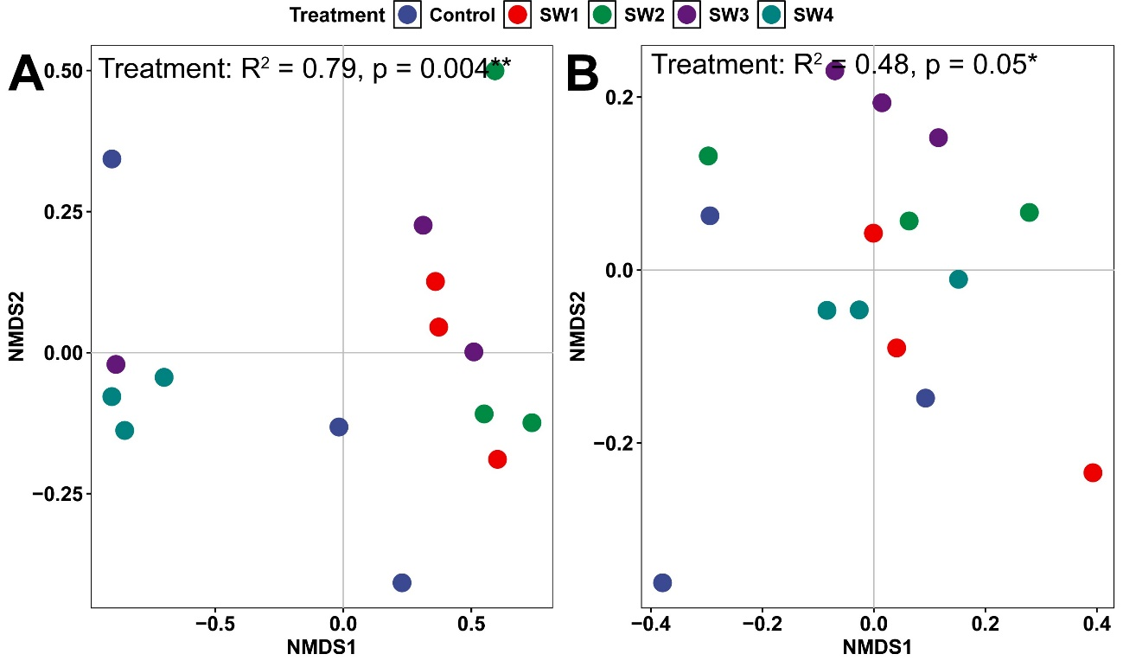
Fig. S1. The effect of biosolids application on antibiotic resistance genes (A) and metal resistance genes (B) communities in soils
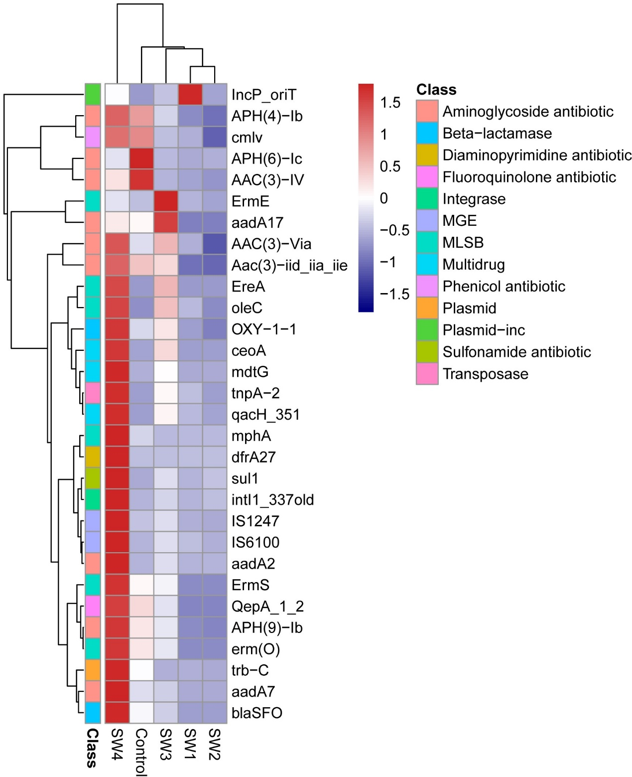
Fig. S2. The effect of biosolids application on antibiotic resistance genes abundance.

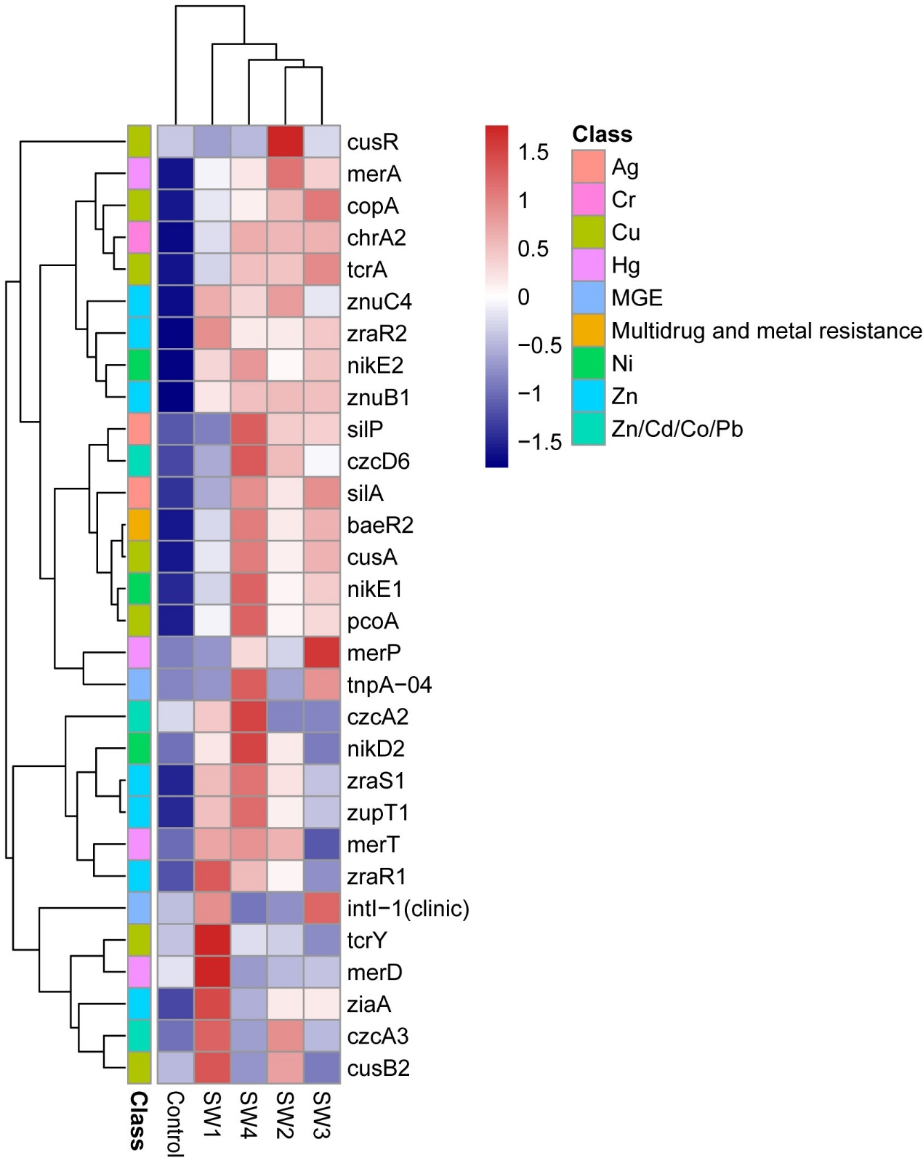
Fig. S3. The effect of biosolids application on metal resistance genes abundance.

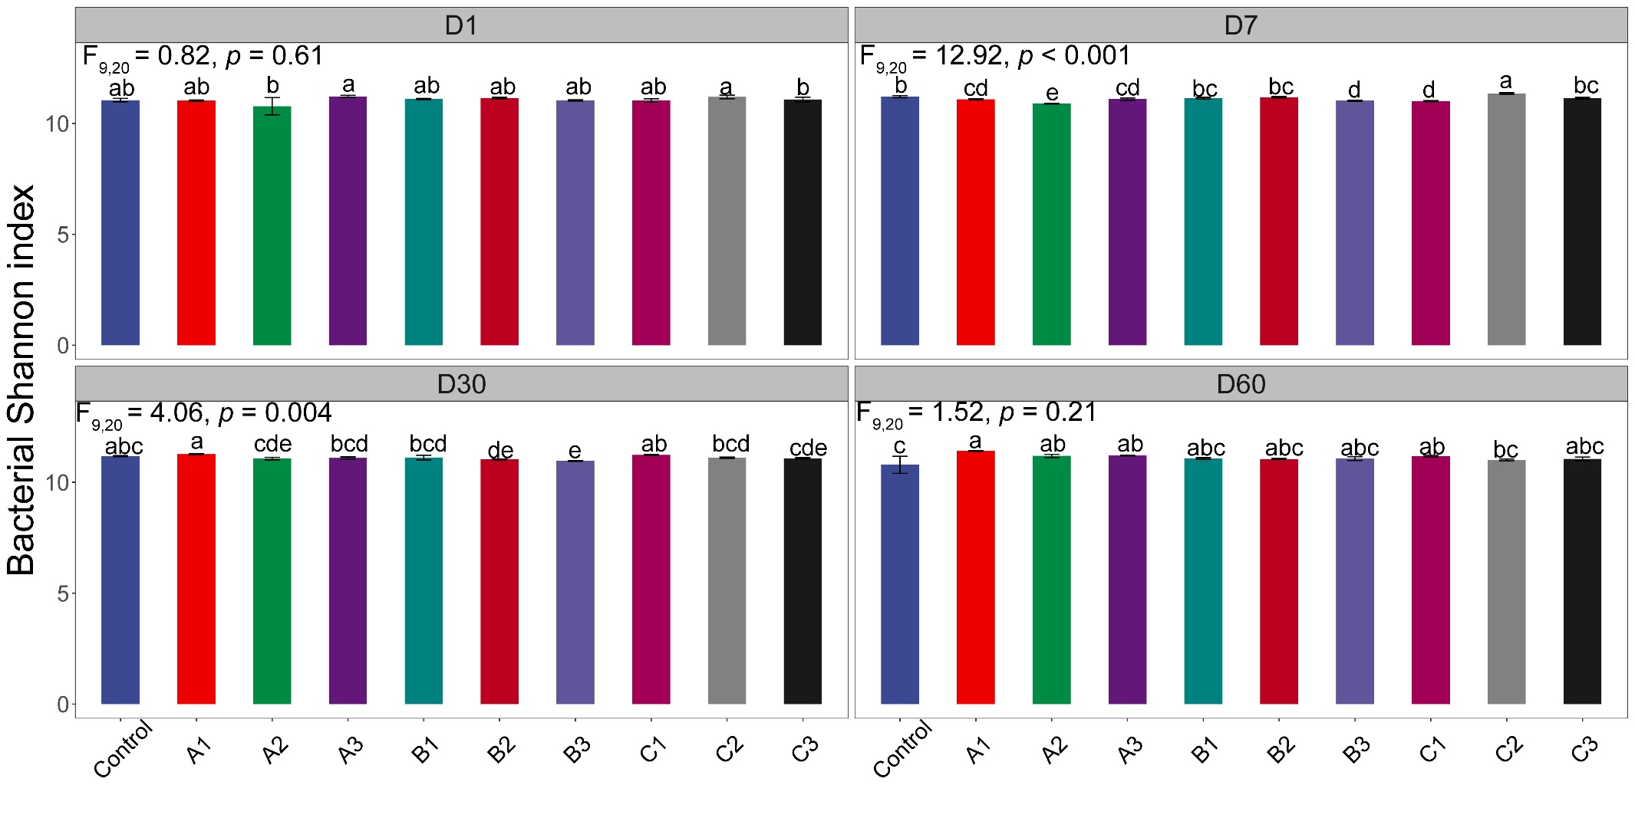
Fig. S4. The effect of antibiotic, heavy metal and their combined additions on soil bacterial diversity at Day 1, Day 7, Day 30 and Day 60.
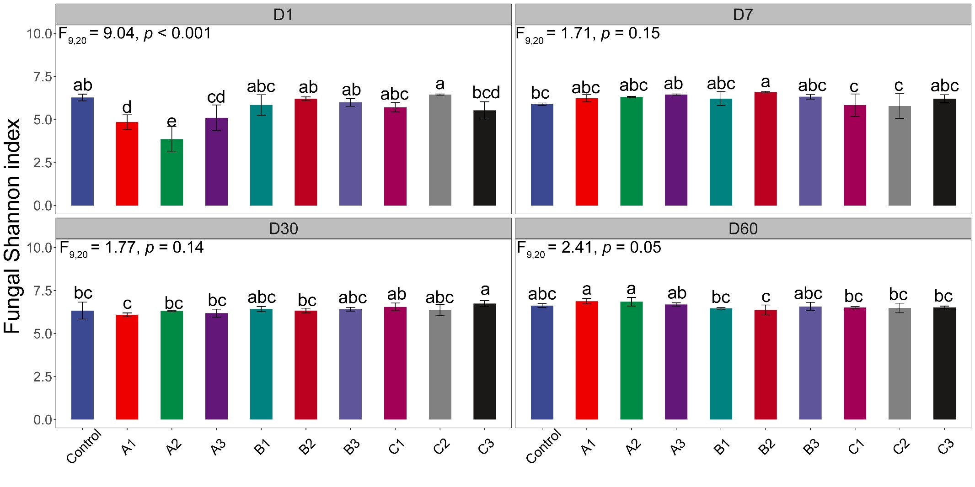
Fig. S5. The effect of antibiotic, heavy metal and their combined additions on soil fungal diversity at Day 1, Day 7, Day 30 and Day 60.
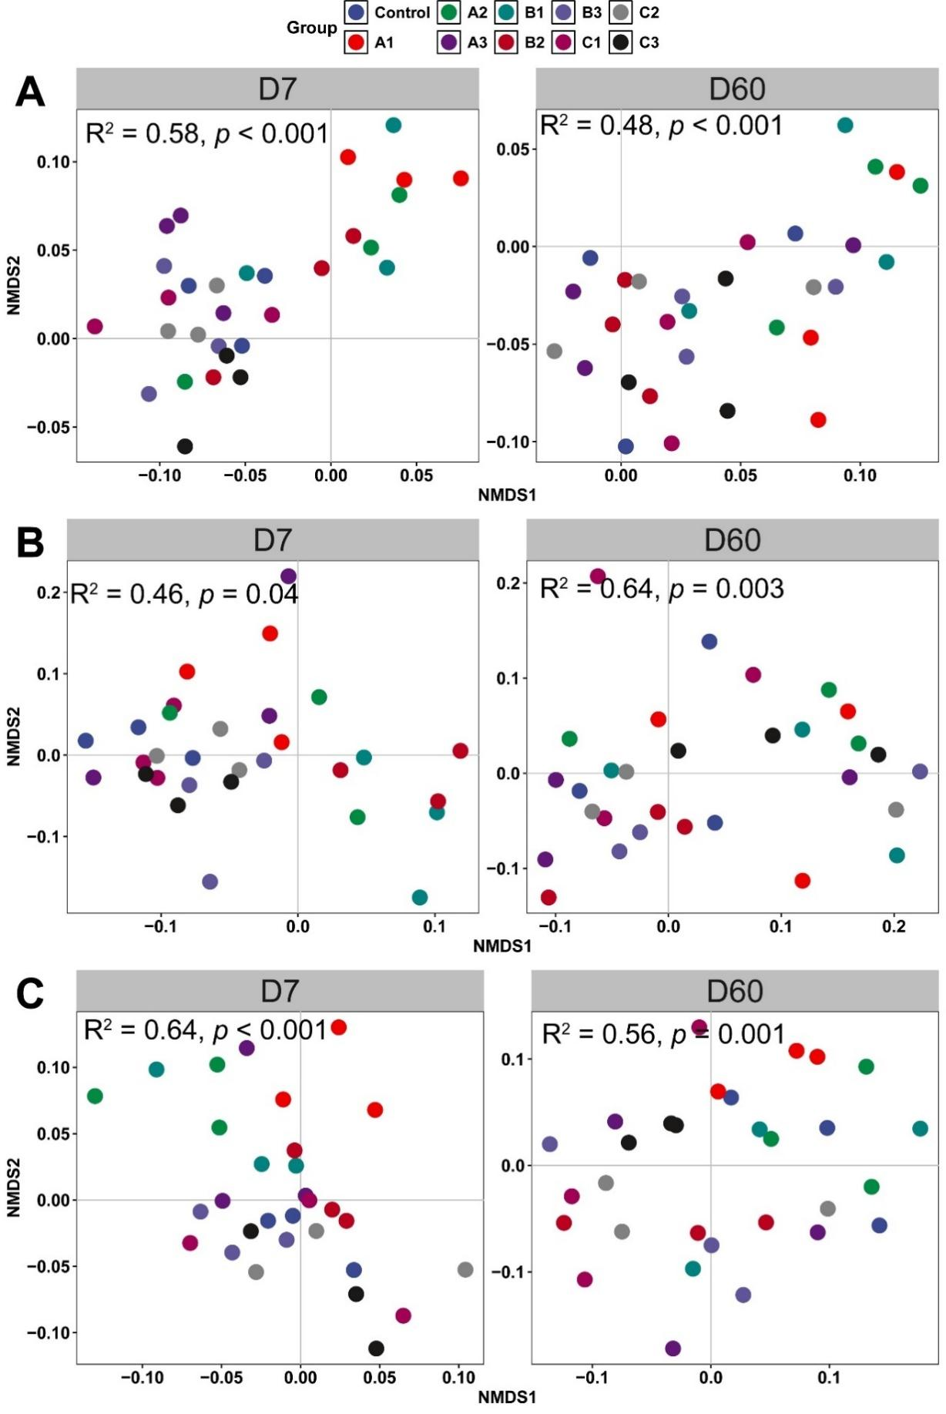
Fig. S6. The effect of antibiotic, heavy metal and their combined additions on soil ARGs (A), MRGs (B) and MGEs (C) communities at Day 7 and Day 60.

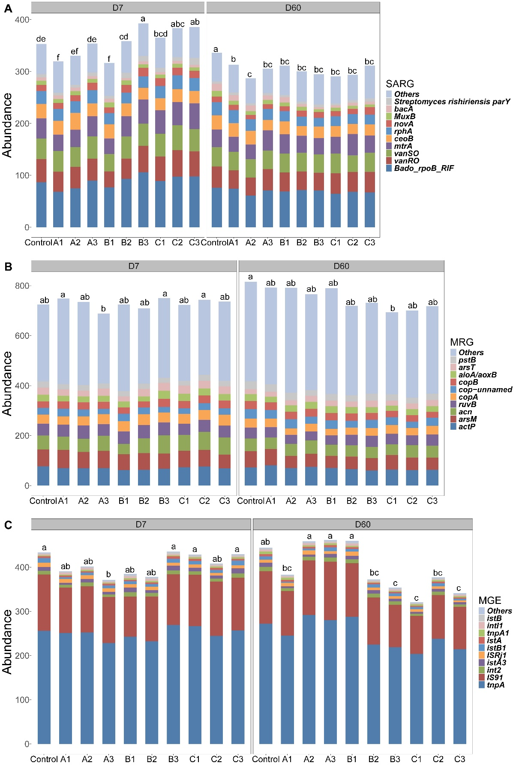
Fig. S7. The effect of antibiotic addition, heavy metal and their combined additions on the compositions of SARG, MRG, MGE at Day 7 and Day 60.
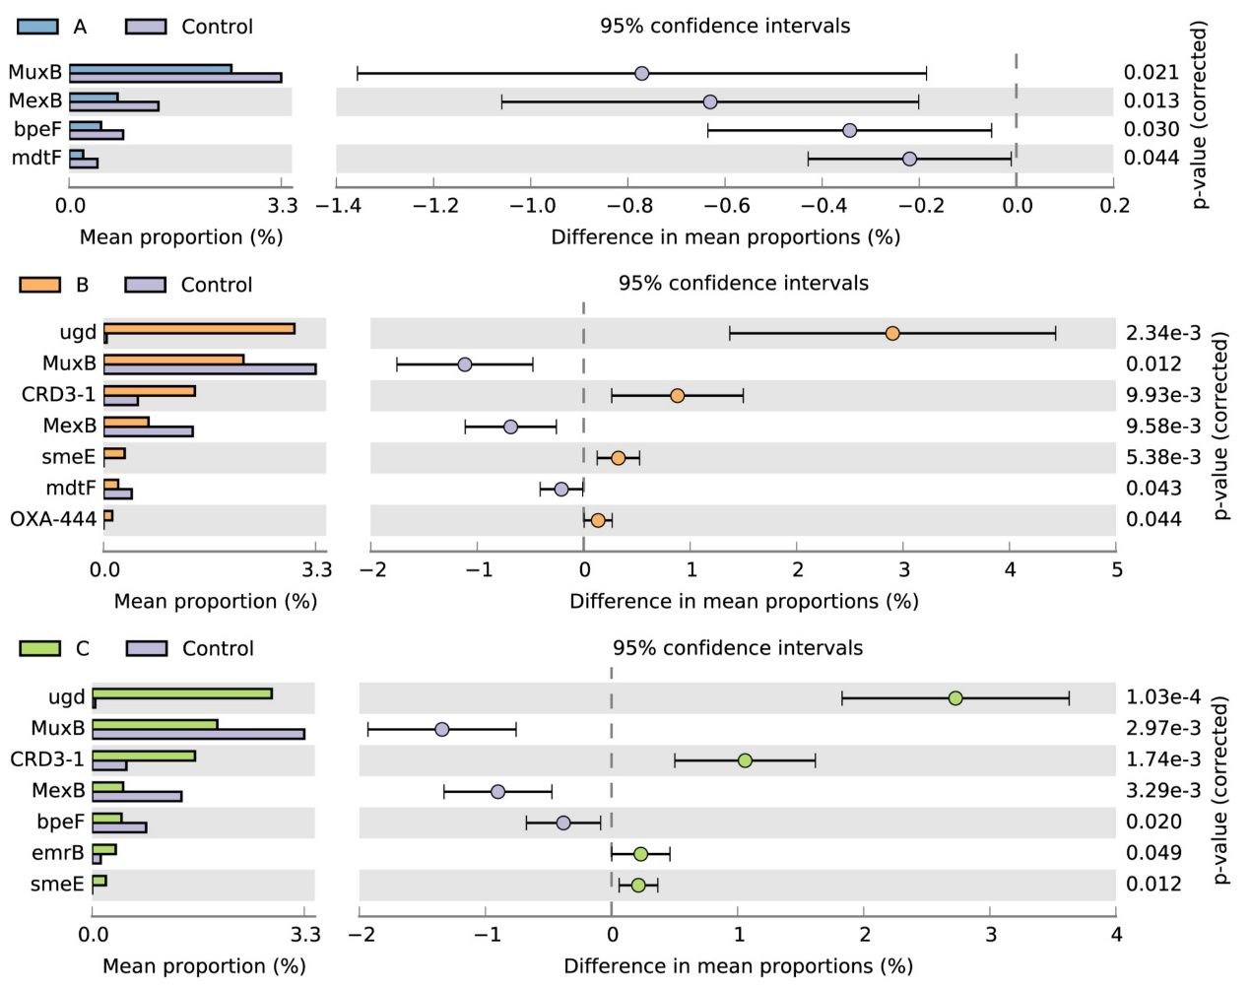
Fig. S8. The effect of antibiotic additions on soil ARGs on Day 60.

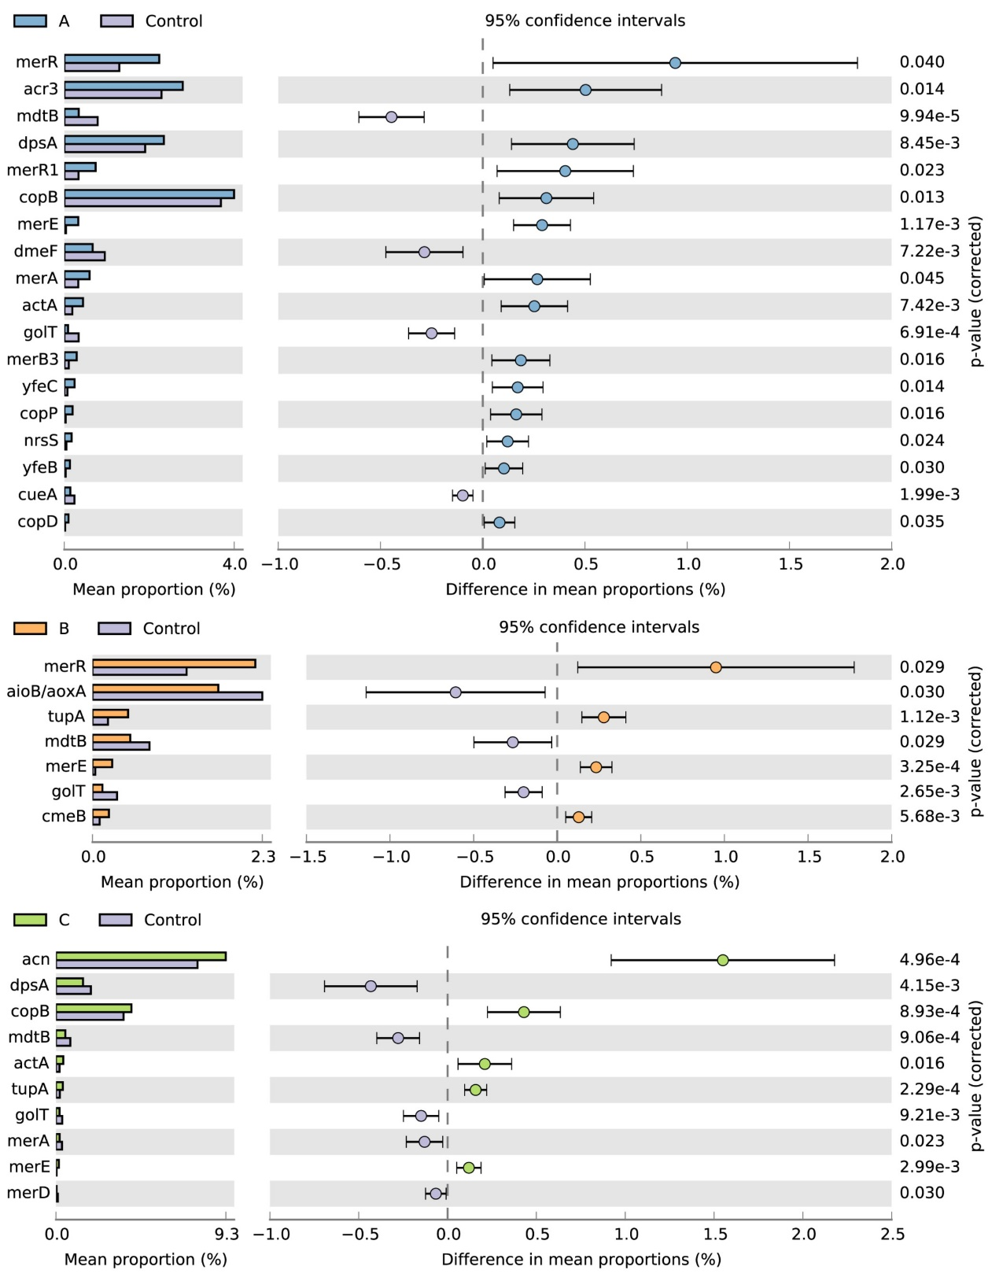
Fig. S9. The effect of antibiotic additions on soil MRGs on Day 7.

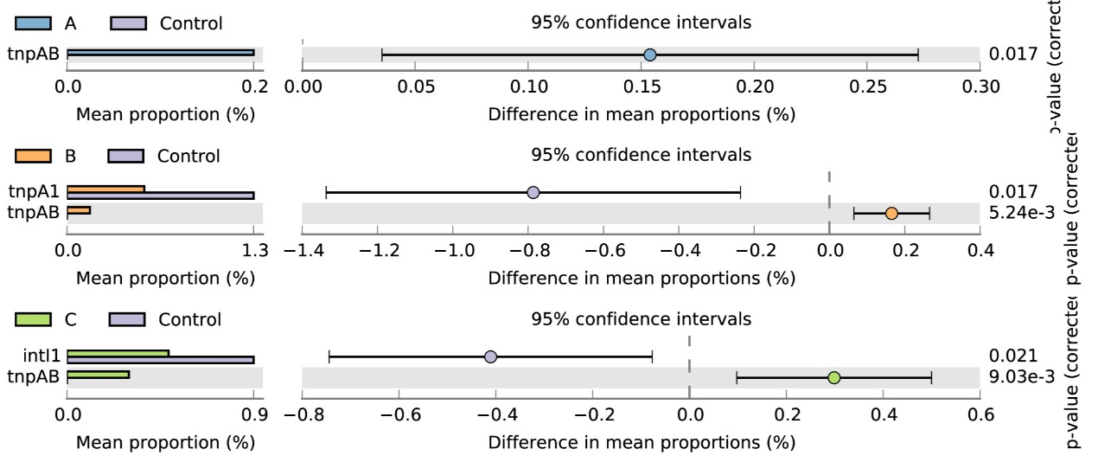
Fig. S10. The effect of heavy metal additions on soil MRGs on Day 60.

Fig. S11. The effect of combined antibiotic and heavy metal additions on soil MGEs on Day7.

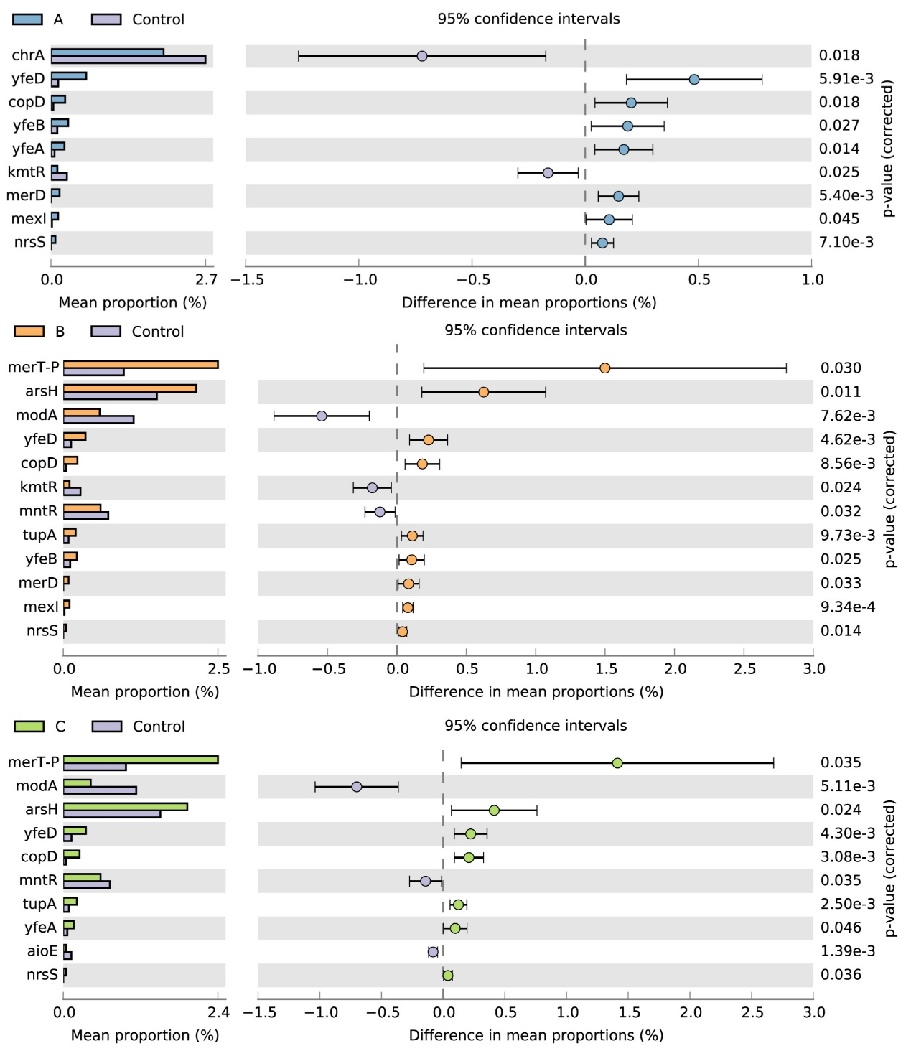
Fig. S12. The effect of combined antibiotic and heavy metal additions on soil MGEs on Day 60.

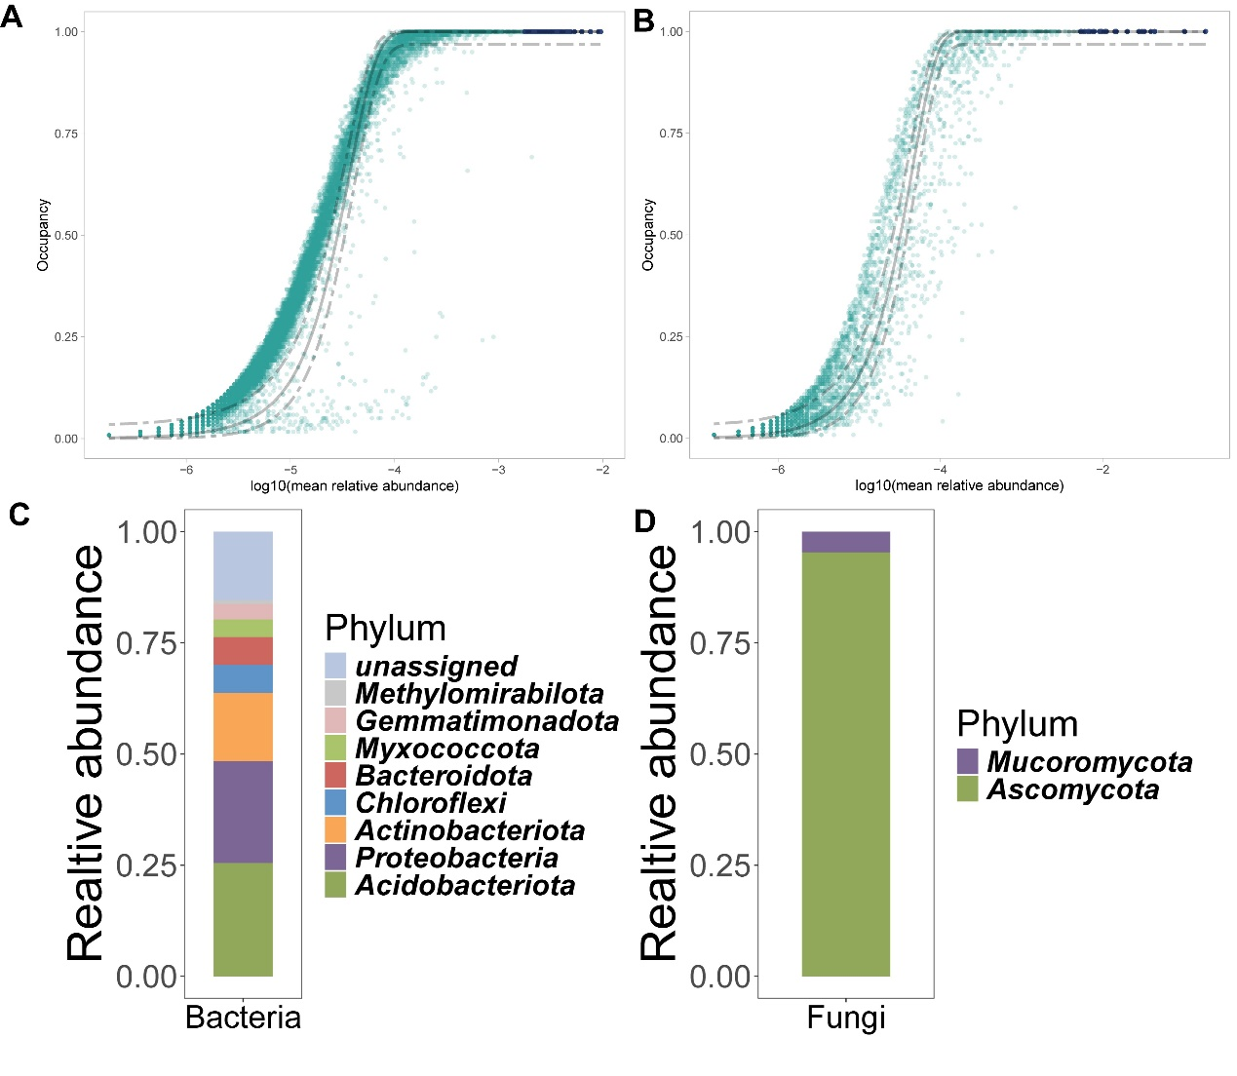
Fig. S13. Abundance-occupancy distributions for bacteria (A) and fungi (B). Relative abundance of core microbiomes at phylum level for bacteria (C) and fungi (D).

Table S1. The effects of biosolids applications on heavy metals in the field study
 | Cr (mg/kg) | Ni(mg/kg) | Cu(mg/kg) | Zn (mg/kg) | As (mg/kg) | Cd (mg/kg) | Pb (mg/kg)
Control | 64.72 ± 2.88ab | 28.37 ± 1.22a | 27.13 ± 2.04d | 102.77 ± 15.26d | 15.93 ± 0.62a | 0.23 ± 0.01d | 23.71 ± 1c
SW1 | 60.80 ± 4.03b | 27.73 ± 2.21a | 29.58 ± 1.34d | 109.45 ± 11.61d | 15.87 ± 1.2a | 0.24 ± 0.02d | 23.28 ± 0.6c
SW2 | 64.22 ± 2.75ab | 28.88 ± 1.11a | 35.09 ± 1.16c | 141.65 ± 9.43c | 15.96 ± 0.98a | 0.28 ± 0.02c | 25.07 ± 0.22b
SW3 | 65.29 ± 1.7ab | 29.26 ± 0.8a | 43.52 ± 2.53b | 198.16 ± 14.92b | 16.64 ± 0.51a | 0.32 ± 0.02b | 25.93 ± 1.07b
SW4 | 68.10 ± 0.83a | 29.68 ± 0.28a | 57.34 ± 2.24a | 281.88 ± 12.77a | 16.89 ± 0.37a | 0.39 ± 0.03a | 28.33 ± 0.39a

Table S2. The Zn content in the microcosm experiment after incubation
Treatment | Zn (mg/kg)
B1 | 114.93 ± 4.56e
B2 | 242.12 ± 9.64c
B3 | 469.51 ± 5.28b
C1 | 122.20 ± 3.58d
C2 | 249.32 ± 6.15c
C3 | 490.94 ± 15.56a

Table S3. The effect of antibiotic, heavy metal and their combined additions on soil network complexity across different days.
Treatment | Day | Network complexity
Control | D1 | 0.92 ± 0.01a | A
Control | D7 | 0.92 ± 0.01a | A
Control | D30 | 0.92 ± 0a | A
Control | D60 | 0.92 ± 0.01a | A
A1 | D1 | 0.89 ± 0.03b | A
A1 | D7 | 0.92 ± 0a | A
A1 | D30 | 0.91 ± 0.01ab | A
A1 | D60 | 0.9 ± 0ab | A
A2 | D1 | 0.87 ± 0.06b | A
A2 | D7 | 0.92 ± 0a | A
A2 | D30 | 0.92 ± 0a | A
A2 | D60 | 0.91 ± 0.01ab | A
A3 | D1 | 0.88 ± 0.06b | A
A3 | D7 | 0.92 ± 0a | A
A3 | D30 | 0.92 ± 0a | A
A3 | D60 | 0.92 ± 0a | A
B1 | D1 | 0.82 ± 0a | B
B1 | D7 | 0.72 ± 0b | B
B1 | D30 | 0.72 ± 0b | B
B1 | D60 | 0.82 ± 0a | B
B2 | D1 | 0.77 ± 0a | CD
B2 | D7 | 0.62 ± 0c | CD
B2 | D30 | 0.62 ± 0c | CD
B2 | D60 | 0.67 ± 0b | CD
B3 | D1 | 0.72 ± 0a | E
B3 | D7 | 0.52 ± 0.01b | E
B3 | D30 | 0.52 ± 0b | E
B3 | D60 | 0.48 ± 0.04c | E
C1 | D1 | 0.82 ± 0.01a | B
C1 | D7 | 0.71 ± 0c | B
C1 | D30 | 0.72 ± 0c | B
C1 | D60 | 0.75 ± 0b | B
C2 | D1 | 0.72 ± 0a | C
C2 | D7 | 0.66 ± 0.01b | C
C2 | D30 | 0.67 ± 0.01b | C
C2 | D60 | 0.65 ± 0.01c | C
C3 | D1 | 0.72 ± 0a | D
C3 | D7 | 0.6 ± 0.0b | D
C3 | D30 | 0.61 ± 0b | D
C3 | D60 | 0.6 ± 0.0b | D

Table S4. Important microbial predicators of ARGs abundance.
 | %IncMSE | p | Phylum | Class | Order | Family | Genus
BOTU2 | 2.147906 | 0.049505 | Actinobacteriota | Actinobacteria | Frankiales | Geodermatophilaceae | Blastococcus
BOTU33 | 2.284509 | 0.039604 | Gemmatimonadota | AKAU4049 | norank | norank | norank
BOTU34 | 2.349376 | 0.029703 | Actinobacteriota | Actinobacteria | Propionibacteriales | Nocardioidaceae | Aeromicrobium
BOTU24 | 2.551005 | 0.049505 | Actinobacteriota | MB_A2_108 | norank | norank | norank
FOTU25 | 3.057342 | 0.049505 | Ascomycota | Sordariomycetes | Sordariales | Chaetomiaceae | Chaetomium
FOTU1 | 3.125931 | 0.039604 | Ascomycota | Sordariomycetes | Hypocreales | Nectriaceae | Fusarium
BOTU12 | 3.157447 | 0.019802 | Proteobacteria | Alphaproteobacteria | Sphingomonadales | Sphingomonadaceae | Sphingomonas
BOTU40 | 3.801523 | 0.019802 | Proteobacteria | Alphaproteobacteria | Sphingomonadales | Sphingomonadaceae | Sphingomonas
FOTU26 | 6.497503 | 0.019802 | Ascomycota | Sordariomycetes | Sordariales | Chaetomiaceae | Chaetomium
BOTU31 | 2.800369 | 0.009901 | Acidobacteriota | Vicinamibacteria | Vicinamibacterales | Vicinamibacteraceae | norank
BOTU60 | 2.941457 | 0.009901 | Acidobacteriota | Blastocatellia | Pyrinomonadales | Pyrinomonadaceae | RB41
BOTU47 | 4.066159 | 0.009901 | Proteobacteria | Alphaproteobacteria | Sphingomonadales | Sphingomonadaceae | Sphingomonas
BOTU14 | 4.732933 | 0.009901 | Myxococcota | bacteriap25 | norank | norank | norank
BOTU25 | 5.324896 | 0.009901 | Proteobacteria | Alphaproteobacteria | Sphingomonadales | Sphingomonadaceae | Sphingomonas
FOTU7 | 5.842301 | 0.009901 | Ascomycota | Sordariomycetes | Hypocreales | Nectriaceae | Fusarium
BOTU19 | 6.096104 | 0.009901 | Proteobacteria | Alphaproteobacteria | Sphingomonadales | Sphingomonadaceae | Sphingomonas
FOTU18 | 6.558762 | 0.009901 | Ascomycota | Sordariomycetes | Hypocreales | Nectriaceae | Fusarium
BOTU21 | 7.563134 | 0.009901 | Chloroflexi | Chloroflexia | Thermomicrobiales | JG30_KF_CM45 | norank
BOTU36 | 12.12324 | 0.009901 | Gemmatimonadota | Gemmatimonadetes | Gemmatimonadales | Gemmatimonadaceae | uncultured
Significance is indicated by p < 0.05 *, p < 0.01 * *, and p < 0.001 * **.

Table S5. Important microbial predicators as predictors of MRGs abundance.
 | %IncMSE | p | Phylum | Class | Order | Family | Genus
BOTU18 | 2.472956 | 0.049505 | Acidobacteriota | Vicinamibacteria | Vicinamibacterales | uncultured | norank
FOTU19 | 2.550776 | 0.029703 | Ascomycota | Dothideomycetes | Pleosporales | Pleosporaceae | Curvularia
BOTU19 | 3.021307 | 0.029703 | Proteobacteria | Alphaproteobacteria | Sphingomonadales | Sphingomonadaceae | Sphingomonas
FOTU9 | 3.689331 | 0.039604 | Ascomycota | Saccharomycetes | Saccharomycetales | Saccharomycetaceae | Hagleromyces
BOTU44 | 4.552806 | 0.029703 | Proteobacteria | Alphaproteobacteria | Sphingomonadales | Sphingomonadaceae | Sphingomonas
BOTU41 | 2.945111 | 0.009901 | Acidobacteriota | Blastocatellia | Pyrinomonadales | Pyrinomonadaceae | RB41
Significance is indicated by p < 0.05 *, p < 0.01 **, and p < 0.001 ***.

Table S6. Important microbial predicators as predictors of MGEs abundance.
 | %IncMSE | p | Phylum | Class | Order | Family | Genus
BOTU1 | 2.194836 | 0.029703 | Bacteroidota | Bacteroidia | Chitinophagales | Chitinophagaceae | Vibrionimonas
FOTU18 | 2.799869 | 0.049505 | Ascomycota | Sordariomycetes | Hypocreales | Nectriaceae | Fusarium
FOTU7 | 2.817296 | 0.029703 | Ascomycota | Sordariomycetes | Hypocreales | Nectriaceae | Fusarium
FOTU11 | 2.865789 | 0.019802 | Ascomycota | Dothideomycetes | Pleosporales | Didymellaceae | Didymella
FOTU3 | 3.126119 | 0.029703 | Ascomycota | Sordariomycetes | Sordariales | Chaetomiaceae | Chaetomium
BOTU35 | 3.36783 | 0.019802 | unassigned | unassigned | unassigned | unassigned | unassigned
FOTU23 | 4.504728 | 0.029703 | Ascomycota | Sordariomycetes | Sordariales | Chaetomiaceae | Chaetomium
FOTU4 | 4.791187 | 0.019802 | Ascomycota | Sordariomycetes | Sordariales | Chaetomiaceae | Chaetomium
BOTU15 | 4.796396 | 0.019802 | Proteobacteria | Gammaproteobacteria | Burkholderiales | Comamonadaceae | Variovorax
FOTU12 | 5.138471 | 0.009901 | Ascomycota | Sordariomycetes | Sordariales | Chaetomiaceae | Chaetomium
FOTU15 | 8.184549 | 0.009901 | Ascomycota | Sordariomycetes | Sordariales | Chaetomiaceae | Humicola
Significance is indicated by p < 0.05 *, p < 0.01 **, and p < 0.001 ***.

