Biosolids application to agricultural soil: heavy metal as key driver of antibiotic resistance under co-occurrence of multiple selective pressures

Tao Sun^{1,2}, Pierre Delaplace², Guihua Li¹, Anina James¹, Junting Pan¹*, Jianfeng Zhang^{1,3}*

¹ State Key Laboratory of Efficient Utilization of Arable Land in China, Institute of Agricultural Resources and Regional Planning, Chinese Academy of Agricultural Sciences, Beijing 100081, China
² Gembloux Agro Bio Tech, University of Liège, 5030, Belgium
³ Institute of Special Animal and Plant Sciences, Chinese Academy of Agricultural Sciences, Changchun, 130112, China

*Corresponding author

Prof. Junting Pan (panjunting@caas.cn)
Prof. Jianfeng Zhang (zhangjianfeng@caas.cn)

Abstract
The application of biosolids can improve soil fertility and nutrient cycling but also can pose risks of heavy metals and antibiotics introduction. The individual effects of heavy metals and antibiotics accumulation on soil microbial communities and functions have been reported, however, their combined effects during biosolids application to agricultural soil remain unclear. In order to explore the effects of long-term biosolids application on soil microbial communities, we sampled soil from a field experiment spanning 16 years of biosolids application and determined the abundance of resistance genes in the soil. The results showed that long-term biosolids application significantly increased the abundance of antibiotic resistance genes (ARGs) and metal resistance gene (MRGs), especially of aminoglycoside and Zn resistance genes. Based on these results we conducted a microcosm experiment that involved the addition of both a heavy metal and an antibiotic to the soil. This experiment showed that both heavy metals and antibiotics significantly affected soil microbial communities, with heavy metals acting as the primary selective pressure, potentially driving the simultaneous enrichment of both metal and antibiotic resistance genes. Further, core microbiome abundance was positively related to ARGs, MRGs and mobile genetic elements (MGEs) abundance, and explained the variations in antibiotic genes. In addition, core microbiome abundance showed positive relationship with microbial community stability. These findings emphasize the need for careful management of biosolids application to mitigate the risks associated with resistance genes accumulation, which could pose long-term ecological and agricultural challenges. Additionally, the positive relationship between core microbiome abundance and microbial community stability underscores the potential role of microbial communities in enhancing soil resilience against environmental stressors.
Keywords: Metal resistance genes; mobile genetic elements; core microbiome; microbial community shift

1. Introduction
The application of biosolids has been recognized as an effective method for enhancing soil fertility and improving crop productivity (Elgarahy et al., 2024; Boudjabi et al., 2021). However, long-term application of biosolids poses a risk of accumulating heavy metals and antibiotics in the soil (Sun et al., 2024; Mossa et al., 2020). Soil microbial communities play essential roles in soil ecosystems, including nutrient cycling, organic matter decomposition, and plant growth regulation (Raza et al., 2023; Bhattacharyya et al., 2022). These communities are highly sensitive and vulnerable to changes in soil physicochemical properties, such as pH, and metal ion concentration and antibiotic presence (Fu et al., 2023; Naz et al., 2022). Several studies have demonstrated that biosolid-amended soils harbor higher levels of antibiotic resistance genes (ARGs) due to the accumulation of heavy metals and antibiotics in the soil, indicating the potential for ARG dissemination through land application of biosolids (Huang et al., 2022; McLain et al., 2017). Heavy metals such as zinc (Zn) and copper (Cu) can disrupt microbial cell membrane integrity and function, and antibiotics exert selective pressure on microorganisms, leading to the accumulation of antibiotic-resistant genes (ARGs) (Engin et al., 2023; Nguyen et al., 2019). These impacts can reduce soil microbial diversity and alter ecosystem functioning, ultimately impacting soil health. Although the individual impacts of heavy metals and antibiotics accumulation on soil microbial communities and ecosystem functions have been reported, the combined effects of both pollutants during the biosolids application in soil remain unclear. Understanding how heavy metals and antibiotics impact separately and together in soils, and how they influence soil microbial communities and their functions, is crucial for maintaining environmental and ecological health.
In soils exposed to both heavy metals and antibiotics, the combined effect of these pollutants may be more complex than their individual impact (Zhou et al., 2022; Rahman, 2020). Studies have shown that antibiotics and heavy metals can act synergistically in what is termed as a co-selection process (Murray et al., 2024; Vats et al., 2022). In this process, microorganisms that are resistant to one pollutant may also develop resistance to the other, leading to a broader spread of resistance genes (Engin et al., 2023; Imran et al., 2019; Yu et al., 2017). Due to the longer persistence of heavy metals in the environment, they might exert a more pronounced influence on microbial community shifts and resistance gene accumulation compared to antibiotics. This complexity is exacerbated by the fact that the accumulation of both heavy metals and antibiotics in the soil is often associated with the long-term persistence of resistance genes, which can be transferred through mobile genetic elements (MGEs) (Mazhar et al., 2021; Hu et al., 2017). The horizontal transfer of ARGs and metal resistance genes (MRGs) among microorganisms can significantly affect the diversity and stability of microbial communities, further complicating the long-term ecological impacts of biosolids application (Sun et al., 2025; Qin et al., 2022; Feng et al., 2021). These processes, when combined, may lead to a “resistance reservoir” in the soil, posing further risks to soil health and biodiversity. Understanding the mechanisms through which heavy metals and antibiotics jointly impact microbial communities is essential for predicting the ecological consequences of long-term biosolids application. Further, the primary driver of antibiotic resistance under co-occurrence of multiple selective pressures during long-term biosolids application remains unknown.
Core microbiome persists across a wide range of environmental conditions and play fundamental roles in maintaining soil functions (Hartmann & Six, 2023; Hattori et al., 1976). In the context of heavy metal and antibiotic pollution, core microbes may help maintain ecosystem functions by tolerating and adapting to these stressors (Wang et al., 2019; Prabhakaran et al., 2016). These microorganisms may also contribute to the degradation of organic pollutants and the cycling of nutrients, such as nitrogen and carbon, in the presence of pollutants (Ahmad et al., 2022; Mbachu et al., 2020). Thus, core microbes could be critical in mitigating the impacts of heavy metal and antibiotic pollution on microbial community stability. They may act as key drivers in maintaining the structure and functionality of the microbial community in the face of such environmental stressors (Gillieatt & Coleman, 2024; Burdon et al., 2020). Understanding how these core microbes interact with heavy metals and antibiotics, and how their abundance and diversity change over time, could provide valuable insights into how to enhance the resilience of soil ecosystems subjected to prolonged pollution.
To provide a comprehensive understanding of how long-term biosolids application affects soil microbial communities and their functional stability, soil samples from a long-term field experiment that had been exposed to biosolids for 16 years were collected and the abundance of antibiotic and heavy metal resistance genes was determined. Based on this field experiment’s results, a microcosm experiment was designed that involved the addition of both a heavy metal and an antibiotic whose resistance genes were found to be of the highest concentration to the soil applied with biosolids. This study hypothesizes that in the co-selection process, the heavy metal rather than the antibiotic plays a dominant role in driving resistance genes and microbial community changes. The other hypothesis is that changes in core microbiome could explain the observed changes in the abundance of resistance genes in response to the combined presence of the heavy metal and the antibiotic. The results of this study will provide a roadmap for making an informed decision on the optimal rate of application of biosolids while taking into consideration its potential to augment antibiotic resistance in the environment.

2. Materials and methods
2.1 Soil sampling and microcosm experimental design
As previously described by our group (Sun et al., 2024), soil samples were collected from all five treatments (SW0–SW4) of a 16 years long-term field experiment with biosolids application rates of 0 t ha⁻¹ (SW0), 4.5 t ha⁻¹ (SW1), 9 t ha⁻¹ (SW2), 18 t ha⁻¹ (SW3), and 36 t ha⁻¹ (SW4). SW0 served as the control without biosolids application. Biosolids application significantly increased the heavy metal concentration, especially of Cu and Zn contents (Table S1). Gene abundances of ARGs and MRGs in the field soils were first quantified using high-throughput quantitative PCR (HT-qPCR), targeting a broad panel of resistance genes. The results showed that aminoglycoside resistance genes and zinc-resistance genes exhibited the highest relative abundances among the detected ARGs and MRGs. Based on these results, SW0 soil was used for the microcosm experiment, in which gentamicin and ZnSO₄ were added exogenously to simulate biosolids-induced contamination. Gentamicin sulfate was applied at concentrations of 5, 10, and 30 mg/kg, while ZnSO₄ was supplemented at concentrations of 125, 250, and 500 mg/kg. These concentrations were selected based on previous studies that used similar ranges to simulate environmentally relevant and sub-inhibitory levels of antibiotics and heavy metals in soil microcosm experiments (Santás-Miguel et al., 2023; Sanchez-Cid et al., 2021). These levels have been shown to induce measurable shifts in microbial communities and resistance gene dynamics under controlled conditions (Santás-Miguel et al., 2023; Sanchez-Cid et al., 2021). The experimental treatments were categorized as follows: treatment without antibiotic or heavy metal additions (Control); antibiotic-only treatments: A1 (5 mg/kg), A2 (10 mg/kg), and A3(30 mg/kg); heavy metal-only treatments: B1 (125 mg/kg), B2 (250 mg/kg), and B3 (500 mg/kg); combined antibiotic and heavy metal treatments: C1 (5 mg/kg; 125 mg/kg), C2 (10 mg/kg; 250 mg/kg), and C3 (30 mg/kg; 500 mg/kg). A total of 180 bottles were used in the experiment, corresponding to 10 treatments with 18 replicates each.
2.2 Soil preconditioning and incubation
The air-dried SW0 soil was adjusted to 15% moisture content (approximately 60% of field capacity) and placed in sterile, opaque 150 mL glass bottles. The bottles were pre-incubated at 25 °C under constant temperature and humidity conditions for 14 days to activate microbial activity. Following pre-incubation period, the soil was thoroughly mixed and evenly divided. Each incubation bottle contained 50 g of dry soil with 20 % moisture content, and the bottles were wrapped in aluminum foil to maintain dark conditions. The incubation was conducted at 25 °C for 60 days. Destructive sampling was performed at Day 1, Day 3, Day 7, Day 15, Day 30, and Day 60, with three aliquots removed per treatment at each time point. The collected soil samples were stored at -20 °C for the determination of microbial community and functioning. Microbial community composition analysis was conducted on soil samples collected at Day 1, Day 30, and Day 60. Metagenomic sequencing was performed on samples from Day 7 and Day 60.
2.3 Soil DNA extraction, sequencing and bioinformatic analysis
Total genomic DNA was extracted from 0.5 g of soil using the MagaBio Soil DNA Extraction Kit (Bioer Technology, China), following the manufacturer’s protocol. DNA quantity and purity were assessed using a NanoDrop spectrophotometer and 1% agarose gel electrophoresis. Extraction blanks (water) were included as negative controls to monitor potential contamination during the extraction process. To analyze the bacterial community, the V4 region of the 16S rRNA gene was amplified using primers 515F (5'-GTGCCAGCMGCCGCGGTAA-3') and 806R (5'-GGACTACHVGGGTWTCTAAT-3') (Walters et al., 2016). Fungal communities were targeted via the ITS region using primer pair ITS3F/ITS4R (Op De Beeck et al., 2014), while arbuscular mycorrhizal fungi (AMF) were detected using primer combinations AML1/AML2 and AMV4.5NF/AMDGR as described by Van Geel et al. (2014). All primers were synthesized by Invitrogen (Thermo Fisher Scientific). Paired-end reads were demultiplexed based on unique sample-specific barcodes. After merging the reads, quality filtering and chimera removal were conducted using the DADA2 pipeline. Taxonomic assignments were performed using the SILVA v138 database for bacteria (Green et al., 2022), the UNITE v8.0 database for fungi (Eshaghi et al., 2021), and the MaarjAM database for AMF (Öpik et al., 2010).
High-throughput quantitative PCR (HT-qPCR) was employed to quantify antibiotic resistance genes (ARGs) and mobile genetic elements (MGEs), following the thermal cycling protocols (Su et al., 2015). The array comprised 296 primer sets, including 285 targeting eight major ARG classes, eight transposase genes, two integron-integrase genes (one clinical and one class 1), and the 16S rRNA gene as a reference. DNA samples were diluted to 15 ng/μL and analyzed in triplicate using the Wafergen SmartChip Real-time PCR system (Fremont, CA, USA). Only reactions with a single melting peak and amplification efficiency between 1.7 and 2.3 across all three replicates were considered valid. A CT threshold of 31 was used to define detection. Relative abundances of ARGs and MGEs were calculated using the 2^−ΔCT method, with 16S rRNA gene as the internal reference (Zhang et al., 2017).
Shotgun metagenomic libraries were prepared by Shanghai Biozeron Biological Technology Co., Ltd. using the TruSeq DNA Library Prep Kit (Illumina, catalog no. FC-121-2001). Library concentrations were measured using a Qubit Fluorometer with the High Sensitivity dsDNA Kit (Thermo Fisher Scientific). Sequencing was conducted on an Illumina platform with a paired-end 150 bp (PE150) strategy. Metagenomic reads were quality-filtered using Trimmomatic (v0.39) and assembled with MEGAHIT (v1.2.9). Open reading frames (ORFs) were predicted using Prodigal (v2.6.3). Identification of antibiotic resistance genes (ARGs) was performed by aligning protein sequences against the Structured Antibiotic Resistance Gene (SARG v2.0) database using DIAMOND (v0.9.29) with a minimum identity of 80% and minimum alignment coverage of 70%. Mobile genetic elements (MGEs), including integrases, insertion sequences, and transposases, were identified using the mobileOG-db with the same alignment thresholds. Metal resistance genes (MRGs) were annotated using the BacMet (v2.0) database, also employing DIAMOND with ≥80% identity and ≥70% coverage as selection criteria. Gene abundance was normalized using the counts per million (CPM) method based on the number of reads mapped to each gene and the total number of high-quality reads per sample.
2.4 Statistical analysis
All data analyses were conducted using R (version 4.1.0). Soil microbial community stability was assessed using the average variation degree (AVD), which reflects the deviation of species' relative abundances from a normal distribution (Xun et al., 2021). A higher AVD indicates greater community variability, while a lower AVD suggests increased stability; therefore, community stability was expressed 1/AVD. Core microbiome identification was conducted using abundance–occupancy relationships, with neutral model fitting based on Sloan’s approach (Stopnisek and Shade, 2021). Non-metric multidimensional scaling (NMDS) was employed to assess the effects of the antibiotic and heavy metal spiking on soil microbial communities and antibiotic resistance genes over time. Two-way ANOVAs were employed to evaluate the variations in microbial diversity and antibiotic resistance genes abundances over time. STAMP was used to compare the difference in antibiotic resistance genes among different treatments. Ordinary least squares (OLS) were employed to determine the relationship between core microbiome abundances and antibiotic resistance genes abundances as well as microbial community stability. Random forest regression analysis was employed to predict the important microbial amplicon sequence variants (ASVs) for antibiotic genes.

3. Results
3.1 Effects of biosolids amendments on ARGs and MRGs
Long-term biosolids application significantly affected abundances of both ARGs and MRGs in the agricultural field soils (Fig. 1; Fig. S1). Specifically, ARGs abundance was significantly increased in the high biosolids application rates of SW3 and SW4 compared to Control (Fig. 1A; Fig. S2). However, there was no significant influence of low biosolids application in SW1 and SW2 treatments (Fig. 1A). Among all genes, aminoglycoside antibiotic and MLSB were the most abundant classes of antibiotic resistance genes. The abundance of aminoglycoside antibiotic was significantly enriched in SW4 treatment, and MLSB abundance increased in both SW3 and SW4 treatment (Fig. 1A). MRGs abundances were significantly increased in all biosolids treatments compared to Control (Fig. 1B; Fig. S3). The genes resistant to Zn and Ni were the most abundant classes among all MRGs, and their abundances significantly increased after biosolids application. In addition, biosolids application significantly increased the abundance of Cu resistance genes.
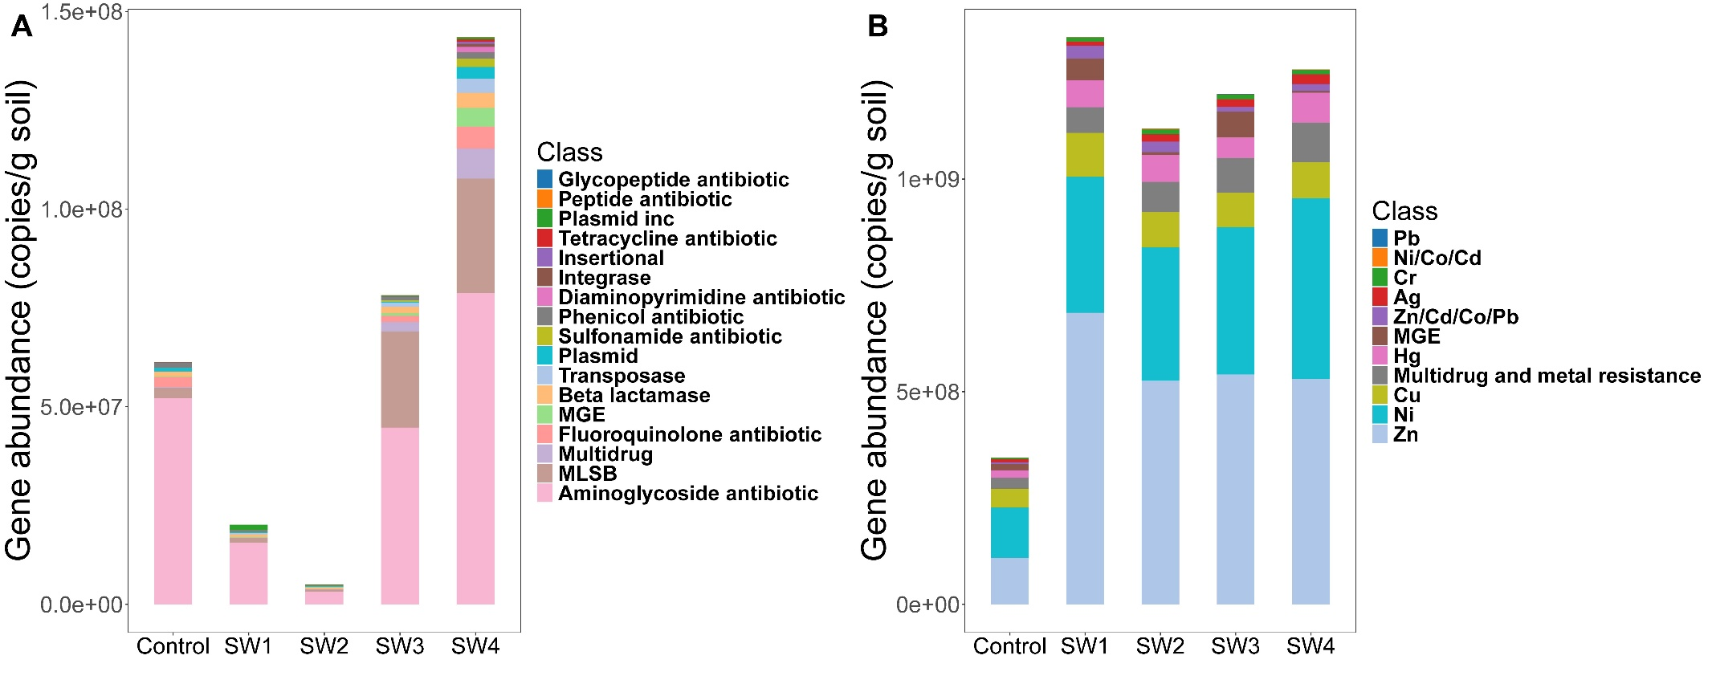
Fig. 1. The effect of biosolids application on the abundance of (A) antibiotic resistance genes (ARGs) and associated mobile genetic elements (MGEs), and (B) metal resistance genes (MRGs) in soil.
3.2 Effects of heavy metal and antibiotic on soil microbial community
ZnSO₄ and gentamicin sulfate were added to the soil to simulate biosolids-induced contamination and to explore their effects on soil microbial community. As expected, the soil Zn concentration increased proportionally with the level of ZnSO₄ amendment, confirming the effectiveness of the spiking treatment (Table S2). For the microbial indicators, bacterial Shannon index was significantly different on Day 7 and Day 30 (Fig. S4) while the fungal community was significantly different on Day 1 (Fig. S5). For Day 7, antibiotic addition significantly decreased bacterial diversity while heavy metal addition showed no significant influence on bacterial diversity. Compared to Control, bacterial diversity decreased in C1 treatment while it increased in C2 treatment in the Day 7. During Day 60, antibiotic addition significantly increased bacterial diversity while heavy metal addition showed no significant influence on bacterial diversity (Fig. S4). As regards the fungal diversity, antibiotic addition significantly decreased fungal diversity while heavy metal addition and combined addition of both antibiotic and heavy metal showed no significant influence on fungal diversity on Day 1. Overall, both bacterial and fungal communities were significantly affected by the addition of heavy metal and antibiotic individually and by their combined addition at all days tested (Fig. 2).
The microbial co-occurrence networks revealed distinct responses to the addition of antibiotics, heavy metals and their combination (Fig. 3; Table S3). Microbial networks had highest network complexity throughout all time points in the Control treatment (Fig. 3; Table S3). Antibiotic addition exerted relatively mild effects on network structure. Although minor reductions in node and edge numbers were observed with increasing dosage, the overall network integrity and complexity remained largely comparable to the control (Fig. 3; Table S3). In contrast, heavy metal treatment induced significant network deterioration. Increasing metal concentrations resulted in substantial declines in both node density and interaction strength, as evidenced by sharp decreases in network complexity. This suggests a strong inhibitory effect of metals on microbial co-association and resilience (Fig. 3; Table S3). Combined treatments of antibiotics and heavy metals mirrored the network degradation observed in the soil with heavy metal addition. Despite the dual-stress condition, no synergistic suppression was detected; instead, network complexity in Group C was comparable to that in the heavy metal-only group (Fig. 3; Table S3).
The results of metagenomic studies revealed that ARGs, MRGs and MGEs communities were significantly affected by antibiotic and heavy metal addition in both Day 7 and Day 60 samples (Fig. 3). The most abundant gene of ARGs, MRGs and MGEs across all the treatment are Bado_rpoB _RIF, actP and tnpA, respectively (Fig. S7). Further, the ARGs OXA-444, mdtF, and CRD3-1 were found to be enriched after antibiotic and heavy metal additions as well as their combination on Day 7 (Fig. 4). However, no genes were found to be enriched after only antibiotic addition on Day 60, while ugd, CRD3-1 smeE, and OXA-444 were enriched after heavy metal addition (Fig. S8). Most of these genes (ugd, CRD3-1 and smeE) were also enriched during the combined addition of antibiotic and heavy metal on Day 60 (Fig. S8). As regards MRGs tnpA was found to enriched in all three treatments compared to Control on Day 7, and tnpA1 was found to be enriched after heavy metal only and combined addition on Day 7 (Fig. S9). On Day 60, MRG tnpAB was found to be enriched in all three treatments compared to Control (Fig. S10). For MGEs, on Day 7, genes merR, acr3, merE, copB, merR1, dpsA, merA, actA, yfeB, nrsS, copP, yfeC, merB3 were found to be enriched after antibiotic addition. The genes merR, tupA, merE and, cmeB were enriched after heavy metal addition, and acn, copB, actA, tupA and merE were enriched after the combined addition (Fig. S11). On Day 60, MGEs yfeD, copD, yfeB, yfeA, merD, mexI and nrsS were found to be enriched after antibiotic addition. The MGEs merT-P, arsH, yfeD, copD, tupA, and nrsS were enriched after the heavy metal and the combined additions (Fig. S12).

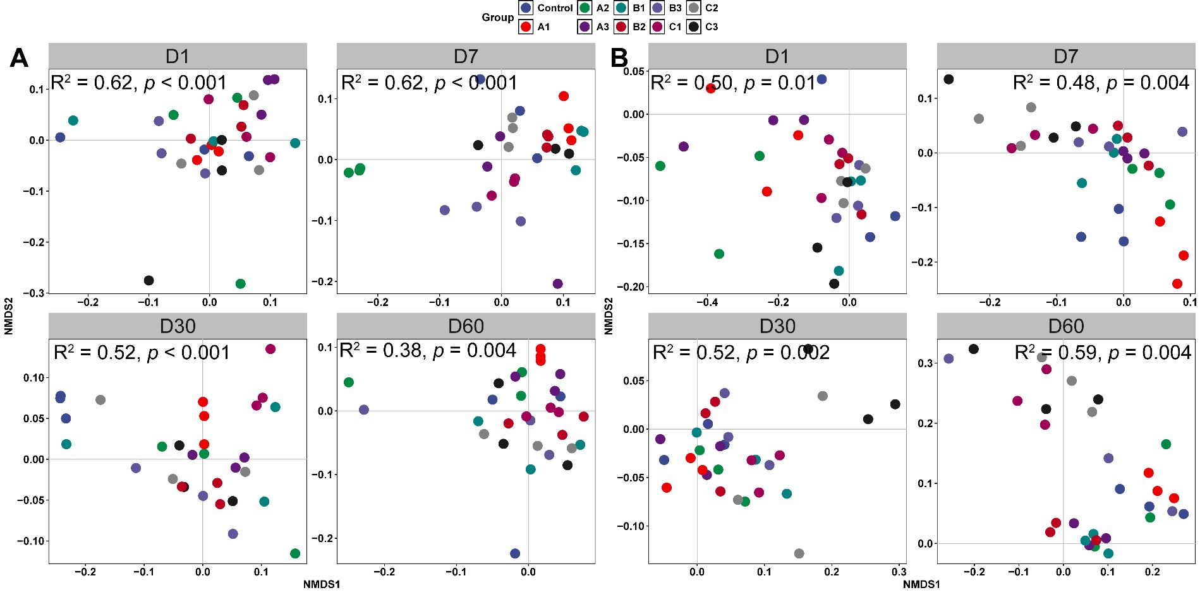
Fig. 2. The effect of antibiotic, heavy metal and their combined additions on soil bacterial (A) and fungal (B) communities at Day 1, Day 7, Day 30 and Day 60.

Fig. 3. The effect of antibiotics, heavy metal and their combined additions on soil bacterial-fungal co-occurrence network.

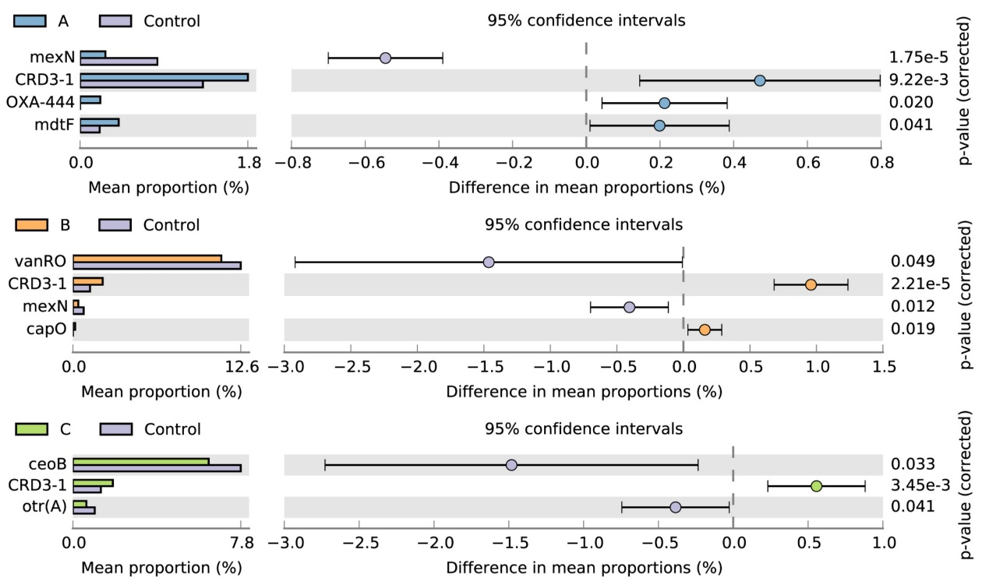
Fig. 4. The effect of antibiotic, heavy metal and their combined additions on soil ARGs (A), MRGs (B) and MGEs (C) on Day 7.
3.3 The relationship between core microbiome and resistance gene abundance
There were 64 bacterial and 28 fungal OTUs identified as core microbiome across all soil samples (Fig. S13 A, B). Most core bacteria and fungi belonged to Acidobacteriota and Ascomycota (Fig. S13 C, D). The abundance of core bacteria was positively related to ARGs, MRGs and MGEs gene abundances (Fig. 5A, C, E). The abundance of core fungi was positively related to both ARGs and MGEs gene abundances (Fig. 5B, F). The result of random forest regression analysis showed that core microbiomes explained 12 %, 21 % and 50 % variations in ARGs, MRGs, and MGEs gene abundances (Table S4, S5, S6). Bacterial OTU36 and OTU21, bacterial OTU44 and fungal OTU9, fungi OUT15 and OTU12, were the most important predictors of ARGs, MRGs, and MGEs gene abundances (Table S4, S5, S6). Furthermore, the relationship between core microbiome abundance and microbial stability was explored to assess whether persistent taxa play a stabilizing role under pollutant stress, beyond simply contributing to total community abundance. The result found that there were positive correlations between core microbiome abundance and microbial stability (Fig. 6).
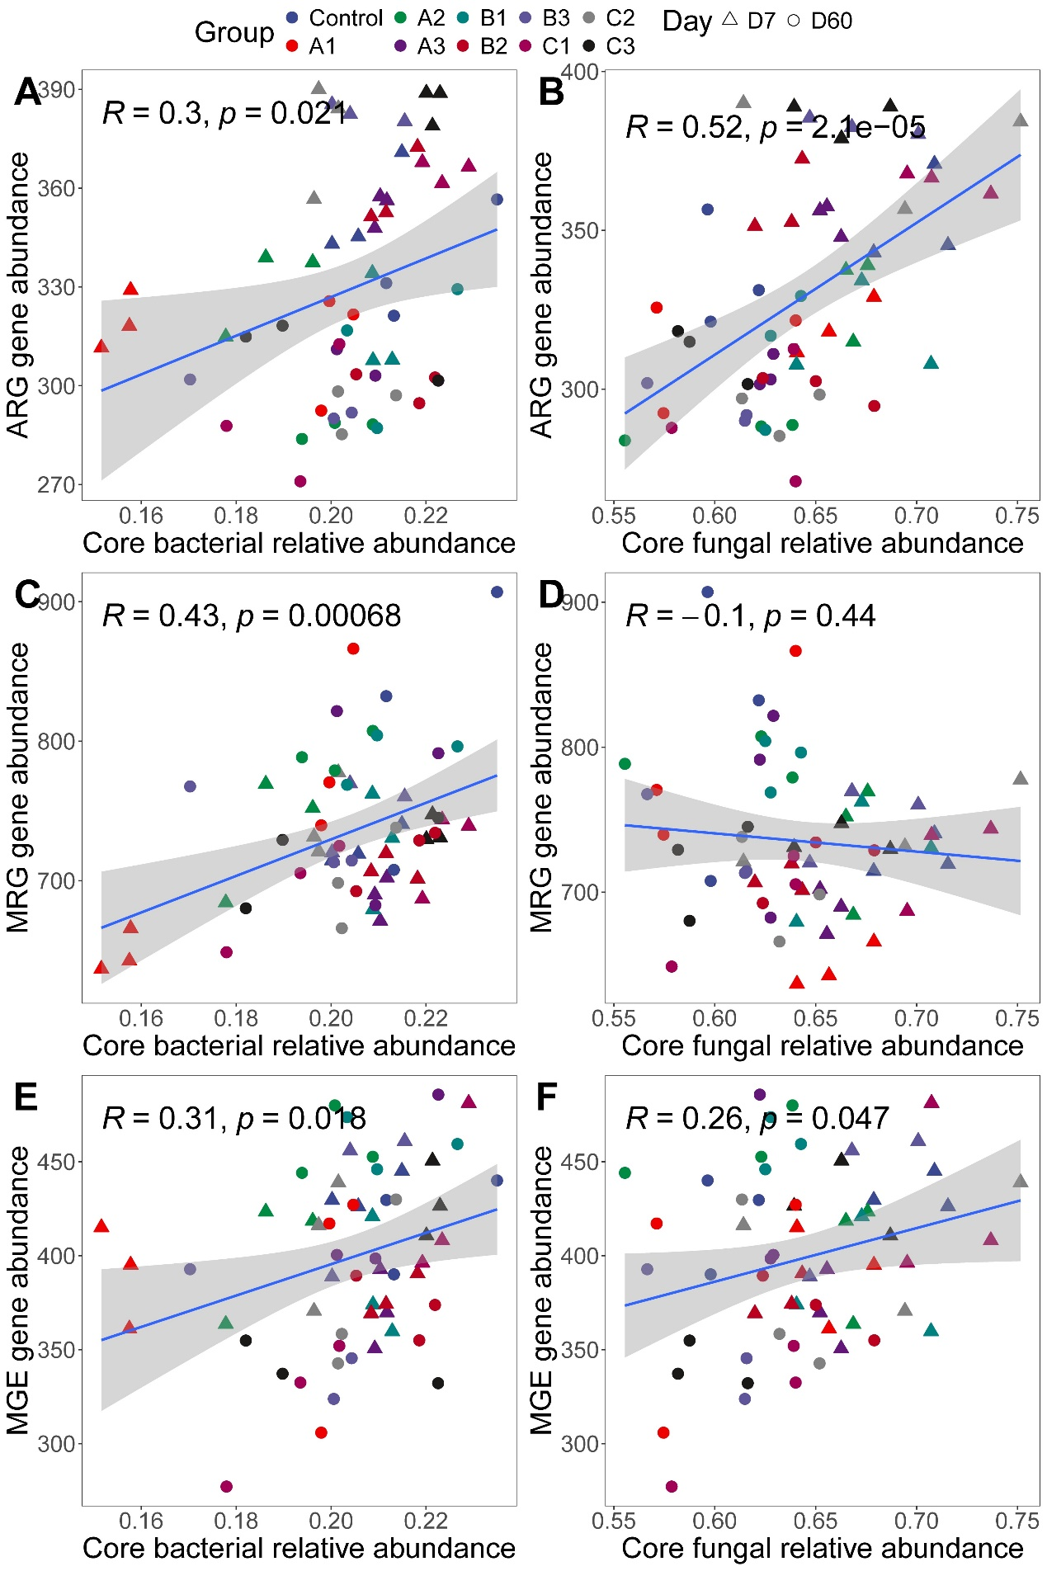
Fig. 5. The relationship between core microbiome abundance and the abundance of ARGs, MRGs and MGEs.
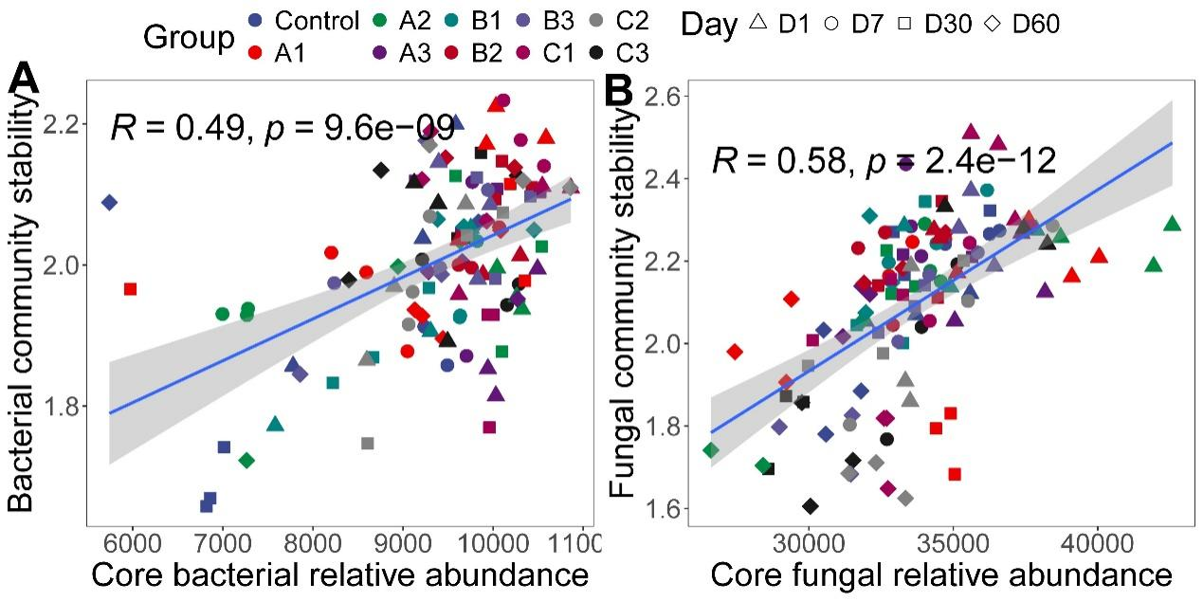
Fig. 6. The relationship between core microbiome abundance and community stability.

4. Discussion
Biosolids application to agricultural soils as fertilizers is a recognized technique to increase soil fertility, nonetheless, biosolids have been reported to introduce heavy metals and antibiotics into the soil (Pritchard et al., 2010; Urbaniak et al., 2024). Consequently, the propagation of ARGs via biosolids application to agricultural soils is a serious threat. The results of the present study are consistent with studies previous studies on confirming that biosolids indeed spread ARGs (Qin et al., 2022; Yang et al., 2018). In this study, biosolids application also increased the presence of MGEs. MGEs are conduits of ARGs (Wu et al., 2022), hence the simultaneously presence of both ARGs and MGEs is a matter of concern. Additionally, we report for the first time the increased abundance of MRGs, particularly those associated with Zn, Ni and Cu, in soils applied with biosolids. The co-selection of antibiotics and heavy metals resistance genes represents a critical challenge in contemporary microbial ecology and public health (Mazhar et al., 2021; Imran et al., 2019; Di Cesare et al., 2016). While antibiotics have historically drawn the majority of attention as selective agents for antibiotic resistance genes, an increasing body of evidence suggests that the presence of heavy metals can significantly exacerbate this problem (Vats et al., 2020). Heavy metals not only exert their own selective pressures but may also co-select for antibiotic resistance genes through various mechanisms, including co-resistance (where resistance genes for metals and antibiotics reside on the same genetic elements) and cross-resistance (where a single resistance mechanism confers tolerance to multiple stressors) (Engin et al., 2023; Vats et al., 2020). This discussion focuses on three key aspects: (1) the dominant role of heavy metals, relative to antibiotics, in shaping both functional gene composition and microbial diversity under co-selection pressures; (2) the explanation of how changes in the core microbiome account for shifts in antibiotic resistance genes (ARGs) under combined antibiotic and heavy metal stress; and (3) the importance of the core microbiome in promoting overall community stability under these dual selection pressures.
4.1. Heavy metals as the dominant selective force under co-occurrence of multiple selective pressures
Heavy metal contamination can serve as a potent and sometimes dominant selective force driving microbial community structure and functional gene profiles even in the presence of other contaminants such as antibiotics. Unlike antibiotics, which can degrade over time or become diluted, many heavy metals persist indefinitely in the environment. For instance, metals such as copper, zinc, cadmium, and lead do not undergo microbial or abiotic degradation, hence, their concentrations can remain relatively stable or even accumulate over time, consequently applying continuous selective pressure on microbial communities (Shuaib et al., 2021; Prabhakaran et al., 2016). This characteristic persistence may give heavy metals a disproportionately large influence compared to antibiotics, whose activity may decline due to chemical breakdown or adsorption onto sediment particles (Nguyen et al., 2019).
Heavy metals can select microbial populations equipped with metal-resistance genes, sometimes harbored on mobile genetic elements (MGEs) like plasmids or transposons (Das et al., 2016; Silver et al., 1996). These genetic elements frequently co-carry antibiotic resistance genes, thereby linking metal resistance to antibiotic resistance (Cai et al., 2023; Mosaka et al., 2023). Consequently, microbes possessing MGEs with metal and antibiotic resistance genes gain a fitness advantage in environments contaminated with both metals and antibiotics. The prolonged presence of heavy metals ensures that these co-resistant microbes are continuously favored, thus amplifying the spread and persistence of antibiotic resistance genes even when antibiotic levels fluctuate or decline (Maurya et al., 2020). This phenomenon underscores the notion that heavy metals can serve as “primary” selective agents with antibiotics acting as “secondary” stressors, particularly in ecosystems with a longstanding history of heavy metal pollution (Vats et al., 2020). However, there are no studies determining the driver of ARGs in agricultural soils in the presence of both heavy metals and antibiotics. To understand this phenomenon, common heavy metal and antibiotic resistance genes that are present in high abundances in biosolids were identified. Accordingly, gentamicin and ZnSO₄ spiked-soils were studied to determine the key driver/s of ARGs in agricultural soils with biosolids application. Our results showed that the composition of ARGs, MRGs, and MGEs was significantly altered following addition of the antibiotic and heavy metal on both Day 7 and Day 60, highlighting the persistent and multifaceted selective pressures exerted by these contaminants (Fig. S6). Alarmingly, a broader set of resistance genes, including CRD3-1, OXA-444, mdtF, vanRO, mexN, capO, and ceoB, were enriched after both antibiotic and metal exposure on Day 7, suggesting a rapid initial response to combined stressors (Fig. 4A). Alarmingly, by Day 60, enrichment of ARGs was observed in soils treated with the heavy metal and and with both heavy metal and antibiotic (Fig. S6). The ARGs ugd, CRD3-1, and smeE were elevated, while no ARGs were significantly enriched in treatments with antibiotic alone (Fig. S8). This indicates that the selective pressure of the heavy metal was more pronounced than that of antibiotic. Similarly, several MRGs, particularly tnpA and its variants, were enriched across treatments on Day 7 and persisted under the heavy metal influence on Day 60 (Fig. S8, Fig. S9). In line with this, MGEs such as merR, tupA, copB, and nrsS showed consistent enrichment under heavy metal and antibiotic alone treatments and in treatments with both heavy metal and antibiotic, particularly at Day 60 (Fig. S11, Fig. S12). This reinforces the notion that metal contamination sustains the mobilization potential of resistance genes over time (Zhang et al., 2024). Further, this study also shows the presence of increased abundances of the ARG CRD3 across all treatments. This ARG encodes a beta-lactamase that confer resistance to beta-lactam antibiotics (Ma et al., 2023). Taken together, these results empirically validate that heavy metals can act as persistent and dominant selective agents, not only shaping the community composition of ARGs and MRGs but also promoting their potential spread through MGEs in soils supplemented with biosolids.
Furthermore, exposure to heavy metals can induce stress responses that reshape the overall functional gene repertoire of the community (Ma et al., 2022; Zeng et al., 2020). Genes encoding for metal-efflux pumps, metal-binding proteins, and detoxification enzymes become more prevalent, reflecting an increased selective pressure (Adhikary et al., 2024; Das et al., 2016). In our study, annotation with the SARG database showed significant enrichment of efflux pump-related resistance genes under Zn exposure, providing gene-level evidence supporting this potential mechanism. Numerous studies have confirmed that these shifts at the gene level can drive a broader restructuring of the microbial community (Fu et al., 2023; Ji et al., 2012). As microbial taxa adapt differentially to heavy metals, either by possessing inherent resistance mechanisms or by acquiring new ones via horizontal gene transfer, community composition and diversity can change dramatically (Gillieatt et al., 2024). The removal or reduction of sensitive taxa may open ecological niches for more metal-tolerant or opportunistic species, thereby decreasing overall diversity and altering functional capacities (Sazykin et al., 2023; Wen et al., 2023). This disruption or realignment of community structure has significant ecological consequences, including shifts in nutrient cycling and interactions with higher trophic levels (Hempson et al., 2018; Jia et al., 2023). In short, heavy metals often occupy a primary role in driving selection pressures under co-selection scenarios. Their recalcitrant nature and capacity to co-select for antibiotic resistance underscore why heavy metals remain a pivotal factor in shaping both microbial functional genes and overall diversity.
4.2. Core microbiome changes explaining shifts in antibiotic resistance genes
Interestingly, in this study it was found that core microbiome could explain fluctuations in antibiotic resistance gene abundance. Core microbiome refers to a set of microbial taxa that are consistently found across similar habitats or conditions. Even under stress, these core taxa tend to remain relatively stable, maintaining essential ecosystem functions such as nutrient cycling, organic matter decomposition, and various symbiotic interactions (Neu et al., 2021; Berg et al., 2020). However, when faced with the concurrent stress of antibiotics and heavy metals, the structure of this core microbiome may shift in subtle yet significant ways (Rasheela et al., 2024).
One important mechanism underlying these shifts is the transfer of mobile genetic elements. In an environment with multiple selection pressures, horizontally transferable elements carrying multiple resistance determinants have a better chance of spreading within the community (Liu et al., 2024; Lin et al., 2021). Core microbiome members, often being the more dominant or competitively successful taxa, can serve as central “hubs” for genetic exchange (Coyte et al., 2015). This can lead to an increased abundance of ARGs in the core taxa, either by new acquisition or by selective amplification of existing resistance genes. This is because core microbiome members are well-adapted to local environmental conditions, their survival and proliferation can effectively “lock in” the newly acquired resistance traits within the community (Wang et al., 2021). These generalist defense mechanisms can facilitate cross-resistance, thereby enhancing the core microbiome’s capability to thrive in the presence of multiple types of stress (Murugaiyan et al., 2022). Over time, even moderate co-selection pressures can cause a gradual enrichment of these dual (or multiple) resistance traits within the stable taxa. For the core microbiome, random forest analysis identified their key roles in the variation in ARGs, MRGs, and MGEs, indicating their potential roles as biological drivers of resistance gene dynamics under co-contamination stress. For example, Chloroflexi and Gemmatimonadota emerged as top predictors of ARG shifts (Table S1). These taxa are frequently detected in polluted or oligotrophic environments and are known for their resilience under environmental stress (Mujakić et al., 2022). Their enrichment has been previously reported to coincide with increased abundance of ARGs such as OXA-444, mdtF, and ceoB as seen in this study (Mujakić et al., 2022). The genera Sphingomonas and RB41 were identified as primary predictors of MRGs (Table S2). Species of Sphingomonas are widely recognized for their intrinsic resistance to heavy metals, including copper and arsenic, often mediated through efflux systems and metal detoxification pathways (Silver and Phung, 1996). RB41 is frequently detected in metal-rich or acidic soils and participates in essential metal cycling processes (Garris et al., 2018). Fungal taxa Chaetomium and Humicola, both belonging to Chaetomiaceae, were strong predictors of MGE variation (Table S4). Although fungi are not considered primary hosts of antibiotic resistance genes, fungi can influence bacterial community composition and function by releasing secondary metabolites, competing for nutrients, or modifying microenvironments through their hyphal networks. These interactions can, in turn, affect the abundance and activity of ARG-carrying bacteria (Yang et al., 2023). Moreover, fungal hyphae may facilitate horizontal gene transfer among bacteria by creating physical networks that bring microbial cells into close contact (Zhang et al., 2014). In our study, these saprotrophic fungi contribute to organic matter decomposition and microbial turnover, potentially enhancing the conditions for horizontal gene transfer in the soil microbiome (Challacombe et al., 2019).
The result of these genetic and ecological processes shows an observable shift in the suite of ARGs present in the microbial community. Formerly rare or absent ARGs may become prominent if they are linked to metal resistance mechanisms that are strongly selected (Larsson & Flach, 2022; Sun et al., 2021). Meanwhile, certain ARGs that were prevalent but not co-linked to heavy metal resistance may diminish if they do not confer a competitive advantage under the new conditions (Ejileugha, 2022). Hence, by closely examining alterations in core microbiome composition, one can gain insights into the overall trajectory of antibiotic resistance in environments subject to multiple selection pressures. Furthermore, shifts in the core microbiome can serve as an indicator of broader ecological impacts (Neu et al., 2021). This is because core taxa often underpin key ecosystem functions, and changes in their composition might correspond to shifts in processes such as nitrogen cycling, carbon sequestration, or pollutant degradation (Hu et al., 2024). Elevated levels of certain metal and antibiotic-resistant core taxa could result in alterations to these ecosystem services (Li et al., 2021). Ultimately, better understanding of how the core microbiome responds to and drives ARGs shifts under co-selection will be critical for predicting the long-term stability and functional resilience of microbial ecosystems.
It should be noted that the concentrations of gentamicin and Zn applied in the microcosm experiment were higher than typical background levels in biosolid-amended soils. This high-dose exposure design was intended to establish a strong selection gradient, allowing for more distinct identification of microbial community shifts and resistance gene dynamics under controlled conditions. However, such concentrations may not fully represent environmentally realistic scenarios, and therefore, the extrapolation of results to field conditions should be made with caution. Despite this limitation, high-concentration exposure experiments remain a widely adopted approach in mechanistic studies aiming to reveal causal relationships between pollutants and resistance propagation. The insights obtained from this study provide a theoretical foundation for understanding the potential risks under chronic or pulse exposure conditions, especially in hotspots where biosolid accumulation is high or poorly managed. Future studies may consider using environmentally relevant concentrations and gradient designs to validate and expand upon the findings presented here. Furthermore, given the potential risks associated with the accumulation of heavy metals and antibiotics in biosolid-amended soils, several remediation and mitigation strategies should be considered to ensure safe agricultural application. These include pre-treatment of biosolids to remove or reduce contaminant loads, selective use of biosolid sources with lower levels of pollutants, and the co-application of soil amendments such as biochar, clay minerals, or organic matter that can immobilize heavy metals and reduce their bioavailability. Additionally, the use of beneficial microorganisms, such as arbuscular mycorrhizal fungi (AMF), has shown promise in mitigating both heavy metal toxicity and the spread of antibiotic resistance genes by enhancing microbial network stability and plant health. Integrating these strategies into biosolid management practices may help balance the agronomic benefits of biosolids with environmental safety.

5. Conclusions
In conclusion, long-term biosolids application to agricultural soil that spanned 16 years significantly impacted the communities of antibiotic resistance genes and metal resistance genes, leading to increased abundance of these genes, particularly the aminoglycoside and zinc resistance genes. The microcosm experiment demonstrated that both heavy metal and antibiotic significantly affected soil microbial communities, with the heavy metal acting as the dominant selective force under the co-occurrence of multiple selective pressures. Furthermore, the abundance of the core microbiome was positively correlated with the abundance of ARGs, MRGs, and MGEs, explaining variations in the antibiotic resistance genes. Additionally, the core microbiome abundance showed a positive relationship with microbial community stability. These findings underscore the importance of carefully managing biosolids applications to reduce the risk of resistance genes accumulation, which could pose long-term ecological challenges as well as significant threat. Moreover, the positive relationship between core microbiome abundance and microbial community stability highlights the potential role of microbial communities in enhancing soil resilience to environmental stressors. Hence, this study underscores the need for exercising caution while applying biosolids as fertilizers to agricultural soils due to the strong possibility of the presence of heavy metals functioning as key drivers in propagating ARGs and MRGs aided by MGEs. Future research should focus on quantifying the long-term ecological impacts of biosolid-borne resistance genes under different soil types and environmental conditions. In particular, identifying specific core microbial taxa that actively mediate resistance gene attenuation or stabilization would provide valuable insights into potential microbial remediation strategies. Moreover, incorporating environmentally relevant concentrations and multi-metal scenarios in future experiments could better reflect real-world conditions. Integrating multi-omics approaches and functional validation of core microbiota will also be critical for elucidating the mechanisms by which microbial communities buffer the spread of resistance under complex pollutant stress.

CRediT authorship contribution statement
Tao Sun: Conceptualization, Investigation, Methodology, Formal analysis, Writing - Original Draft. Pierre Delaplace: Writing - Review & Editing. Guihua Li: Writing - Review & Editing. Anina James: Writing - Review & Editing. Junting Pan: Conceptualization, Investigation, Writing - Review & Editing, Supervision. Jianfeng Zhang: Conceptualization, Resources, Funding acquisition, Project administration.

Declaration of Competing Interest
The authors declare that they have no known competing financial interests or personal relationships that could have appeared to influence the work reported in this paper.

Acknowledgments
This study was supported by the National Natural Science Foundation of China (22176215), the Shandong Provincial Key Research and Development Program (2023TZXD087), and the China Scholarship Council (No. 202393250064).

References
Adhikary, S., Saha, J., Dutta, P., & Pal, A. (2024). Bacterial Homeostasis and Tolerance to Potentially Toxic Metals and Metalloids through Diverse Transporters: Metal-Specific Insights. Geomicrobiology Journal, 41(5), 496-518.
Ahmad, H. A., Ahmad, S., Cui, Q., Wang, Z., Wei, H., Chen, X., ... & Tawfik, A. (2022). The environmental distribution and removal of emerging pollutants, highlighting the importance of using microbes as a potential degrader: A review. Science of The Total Environment, 809, 151926.
Berg, G., Rybakova, D., Fischer, D., Cernava, T., Vergès, M. C. C., Charles, T., ... & Schloter, M. (2020). Microbiome definition re-visited: old concepts and new challenges. Microbiome, 8, 1-22.
Bhattacharyya, S. S., Ros, G. H., Furtak, K., Iqbal, H. M., & Parra-Saldívar, R. (2022). Soil carbon sequestration–An interplay between soil microbial community and soil organic matter dynamics. Science of the Total Environment, 815, 152928.
Boudjabi, S., & Chenchouni, H. (2021). On the sustainability of land applications of sewage sludge: how to apply the sewage biosolid in order to improve soil fertility and increase crop yield? Chemosphere, 282, 131122.
Burdon, F. J., Bai, Y., Reyes, M., Tamminen, M., Staudacher, P., Mangold, S., ... & Stamm, C. (2020). Stream microbial communities and ecosystem functioning show complex responses to multiple stressors in wastewater. Global change biology, 26(11), 6363-6382.
Cai, P., Chen, Q., Du, W., Yang, S., Li, J., Cai, H., ... & Wang, J. (2023). Deciphering the dynamics of metal and antibiotic resistome profiles under different metal (loid) contamination levels. Journal of Hazardous Materials, 455, 131567.
Challacombe, J. F., Hesse, C. N., Bramer, L. M., McCue, L. A., Lipton, M., Purvine, S., Kuske, C. R., 2019. Genomes and secretomes of Ascomycota fungi reveal diverse functions in plant biomass decomposition and pathogenesis. BMC genomics, 20, 1-27.
Coyte, K. Z., Schluter, J., & Foster, K. R. (2015). The ecology of the microbiome: networks, competition, and stability. Science, 350(6261), 663-666.
D.L. Pritchard, N. Penney, M.J. McLaughlin, H. Rigby, K. Schwarz Land application of sewage sludge (biosolids) in Australia: risks to the environment and food crops Water Sci. Technol., 62 (1) (2010), pp. 48-57.
Das, S., Dash, H. R., & Chakraborty, J. (2016). Genetic basis and importance of metal resistant genes in bacteria for bioremediation of contaminated environments with toxic metal pollutants. Applied microbiology and biotechnology, 100, 2967-2984.
Di Cesare, A., Eckert, E., & Corno, G. (2016). Co-selection of antibiotic and heavy metal resistance in freshwater bacteria. Journal of Limnology, 75.
Ejileugha, C. (2022). Biochar can mitigate co-selection and control antibiotic resistant genes (ARGs) in compost and soil. Heliyon, 8(5).
Elgarahy, A. M., Eloffy, M. G., Priya, A. K., Yogeshwaran, V., Yang, Z., Elwakeel, K. Z., & Lopez-Maldonado, E. A. (2024). Biosolids management and utilizations: A review. Journal of Cleaner Production, 141974.
Engin, A. B., Engin, E. D., & Engin, A. (2023). Effects of co-selection of antibiotic-resistance and metal-resistance genes on antibiotic-resistance potency of environmental bacteria and related ecological risk factors. Environmental Toxicology and Pharmacology, 98, 104081.
Eshaghi, A., Bommersbach, C., Zittermann, S., Burnham, C. A. D., Patel, R., Schuetz, A. N., Kus, J. V., 2021. Phenotypic and genomic profiling of Staphylococcus argenteus in Canada and the United States and recommendations for clinical result reporting. Journal of clinical microbiology, 59(6), 10-1128.
Feng, G., Huang, H., & Chen, Y. (2021). Effects of emerging pollutants on the occurrence and transfer of antibiotic resistance genes: A review. Journal of Hazardous Materials, 420, 126602.
Fu, Y., Zhu, Y., Dong, H., Li, J., Zhang, W., Shao, Y., & Shao, Y. (2023). Effects of heavy metals and antibiotics on antibiotic resistance genes and microbial communities in soil. Process Safety and Environmental Protection, 169, 418-427.
Garris, H. W., Baldwin, S. A., Taylor, J., Gurr, D. B., Denesiuk, D. R., Van Hamme, J. D., Fraser, L. H., 2018. Short-term microbial effects of a large-scale mine-tailing storage facility collapse on the local natural environment. PloS one, 13(4), e0196032.
Gillieatt, B. F., & Coleman, N. V. (2024). Unravelling the mechanisms of antibiotic and heavy metal resistance co-selection in environmental bacteria. FEMS Microbiology Reviews, 48(4), fuae017.
Green, G. B., Williams, M. B., Chehade, S. B., Morrow, C. D., Watts, S. A., Bej, A. K., 2022. High-throughput amplicon sequencing datasets of the metacommunity DNA of the gut microbiota of Zebrafish Danio rerio fed diets with differential quantities of protein and fat contents. Data in Brief, 42, 108313.
Hartmann, M., & Six, J. (2023). Soil structure and microbiome functions in agroecosystems. Nature Reviews Earth & Environment, 4(1), 4-18.
Hattori, T., Hattori, R., & McLaren, A. D. (1976). The physical environment in soil microbiology: an attempt to extend principles of microbiology to soil microorganisms. CRC critical reviews in microbiology, 4(4), 423-461.
Hempson, T. N., Graham, N. A., MacNeil, M. A., Hoey, A. S., & Wilson, S. K. (2018). Ecosystem regime shifts disrupt trophic structure. Ecological Applications, 28(1), 191-200.
Hu, H. W., Wang, J. T., Li, J., Shi, X. Z., Ma, Y. B., Chen, D., & He, J. Z. (2017). Long-term nickel contamination increases the occurrence of antibiotic resistance genes in agricultural soils. Environmental science & technology, 51(2), 790-800.
Hu, M., Sardans, J., Sun, D., Yan, R., Wu, H., Ni, R., & Peñuelas, J. (2024). Microbial diversity and keystone species drive soil nutrient cycling and multifunctionality following mangrove restoration. Environmental Research, 251, 118715.
Hung, W. C., Miao, Y., Truong, N., Jones, A., Mahendra, S., & Jay, J. (2022). Tracking antibiotic resistance through the environment near a biosolid spreading ground: resistome changes, distribution, and metal (loid) co-selection. Science of the Total Environment, 823, 153570.
Imran, M., Das, K. R., & Naik, M. M. (2019). Co-selection of multi-antibiotic resistance in bacterial pathogens in metal and microplastic contaminated environments: An emerging health threat. Chemosphere, 215, 846-857.
Ji, X., Shen, Q., Liu, F., Ma, J., Xu, G., Wang, Y., & Wu, M. (2012). Antibiotic resistance gene abundances associated with antibiotics and heavy metals in animal manures and agricultural soils adjacent to feedlots in Shanghai; China. Journal of hazardous materials, 235, 178-185.
Jia, J., Zhang, J., Li, Y., Koziol, L., Podzikowski, L., Delgado-Baquerizo, M., ... & Zhang, J. (2023). Relationships between soil biodiversity and multifunctionality in croplands depend on salinity and organic matter. Geoderma, 429, 116273.
Jiayue Ma, Xiaorui Song, Mingchao Li, Zengyuan Yu, Weyland Cheng, Zhidan Yu, Wancun Zhang, Yaodong Zhang, Adong Shen, Huiqing Sun, Lifeng Li, Global spread of carbapenem-resistant Enterobacteriaceae: Epidemiological features, resistance mechanisms, detection and therapy, Microbiological Research, Volume 266, 2023, 127249.
Larsson, D. J., & Flach, C. F. (2022). Antibiotic resistance in the environment. Nature Reviews Microbiology, 20(5), 257-269.
Li, Y., Chen, H., Song, L., Wu, J., Sun, W., & Teng, Y. (2021). Effects on microbiomes and resistomes and the source-specific ecological risks of heavy metals in the sediments of an urban river. Journal of Hazardous Materials, 409, 124472.
Lin, Z., Yuan, T., Zhou, L., Cheng, S., Qu, X., Lu, P., & Feng, Q. (2021). Impact factors of the accumulation, migration and spread of antibiotic resistance in the environment. Environmental geochemistry and health, 43, 1741-1758.
Liu, C., Cui, Y., Li, X., Yao, M. (2021). microeco: an R package for data mining in microbial community ecology. FEMS microbiology ecology, 97(2), fiaa255.
Liu, Z. T., Ma, R. A., Zhu, D., Konstantinidis, K. T., Zhu, Y. G., & Zhang, S. Y. (2024). Organic fertilization co-selects genetically linked antibiotic and metal (loid) resistance genes in global soil microbiome. Nature Communications, 15(1), 5168.
Lu Yang, Wuxing Liu, Dong Zhu, Jinyu Hou, Tingting Ma, Longhua Wu, Yongguan Zhu, Peter Christie, Application of biosolids drives the diversity of antibiotic resistance genes in soil and lettuce at harvest, Soil Biology and Biochemistry, Volume 122, 2018, Pages 131-140.
M. Urbaniak, A. Baran, J. Giebułtowicz, A. Bednarek, L. Serwecińska The occurrence of heavy metals and antimicrobials in sewage sludge and their predicted risk to soil - is there anything to fear? Sci. Total Environ., 912 (2024), Article 168856.
Ma, S., Qiao, L., Liu, X., Zhang, S., Zhang, L., Qiu, Z., & Yu, C. (2022). Microbial community succession in soils under long-term heavy metal stress from community diversity-structure to KEGG function pathways. Environmental Research, 214, 113822.
Maurya, A. P., Rajkumari, J., Bhattacharjee, A., & Pandey, P. (2020). Development, spread and persistence of antibiotic resistance genes (ARGs) in the soil microbiomes through co-selection. Reviews on environmental health, 35(4), 371-378.
Mazhar, S. H., Li, X., Rashid, A., Su, J., Xu, J., Brejnrod, A. D., ... & Rensing, C. (2021). Co-selection of antibiotic resistance genes, and mobile genetic elements in the presence of heavy metals in poultry farm environments. Science of The Total Environment, 755, 142702.
Mbachu, A. E., Chukwura, E. I., & Mbachu, N. A. (2020). Role of microorganisms in the degradation of organic pollutants: a review. Energy Environ Eng, 7(1), 1-11.
McLain, J. E., Rock, C. M., & Gerba, C. P. (2017). Environmental antibiotic resistance associated with land application of biosolids. Antimicrobial resistance in wastewater treatment processes, 241-252.
Mosaka, T. B., Unuofin, J. O., Daramola, M. O., Tizaoui, C., & Iwarere, S. A. (2023). Inactivation of antibiotic-resistant bacteria and antibiotic-resistance genes in wastewater streams: Current challenges and future perspectives. Frontiers in microbiology, 13, 1100102.
Mossa, A. W., Bailey, E. H., Usman, A., Young, S. D., & Crout, N. M. (2020). The impact of long-term biosolids application (> 100 years) on soil metal dynamics. Science of the Total Environment, 720, 137441.
Mujakić, I., Piwosz, K., & Koblížek, M., 2022. Phylum Gemmatimonadota and its role in the environment. Microorganisms, 10(1), 151.
Murray, L. M., Hayes, A., Snape, J., Kasprzyk-Hordern, B., Gaze, W. H., & Murray, A. K. (2024). Co-selection for antibiotic resistance by environmental contaminants. npj Antimicrobials and Resistance, 2(1), 9.
Murugaiyan, J., Kumar, P. A., Rao, G. S., Iskandar, K., Hawser, S., Hays, J. P., ... & van Dongen, M. B. (2022). Progress in alternative strategies to combat antimicrobial resistance: focus on antibiotics. Antibiotics, 11(2), 200.
Naz, M., Dai, Z., Hussain, S., Tariq, M., Danish, S., Khan, I. U., ... & Du, D. (2022). The soil pH and heavy metals revealed their impact on soil microbial community. Journal of Environmental Management, 321, 115770.
Neu, A. T., Allen, E. E., & Roy, K. (2021). Defining and quantifying the core microbiome: challenges and prospects. Proceedings of the National Academy of Sciences, 118(51), e2104429118.
Nguyen, C. C., Hugie, C. N., Kile, M. L., & Navab-Daneshmand, T. (2019). Association between heavy metals and antibiotic-resistant human pathogens in environmental reservoirs: A review. Frontiers of Environmental Science & Engineering, 13, 1-17.
Op De Beeck, M., Lievens, B., Busschaert, P., Declerck, S., Vangronsveld, J., & Colpaert, J. V. (2014). Comparison and validation of some ITS primer pairs useful for fungal metabarcoding studies. PloS one, 9(6), e97629.
Öpik, M., Vanatoa, A., Vanatoa, E., Moora, M., Davison, J., Kalwij, J. M., Zobel, M. (2010). The online database MaarjAM reveals global and ecosystemic distribution patterns in arbuscular mycorrhizal fungi (Glomeromycota). New Phytologist, 188(1), 223-241.
Prabhakaran, P., Ashraf, M. A., & Aqma, W. S. (2016). Microbial stress response to heavy metals in the environment. Rsc Advances, 6(111), 109862-109877.
Qin, X., Zhai, L., Khoshnevisan, B., Pan, J., & Liu, H. (2022). Restriction of biosolids returning to land: Fate of antibiotic resistance genes in soils after long-term biosolids application. Environmental Pollution, 301, 119029.
Rahman, Z. (2020). An overview on heavy metal resistant microorganisms for simultaneous treatment of multiple chemical pollutants at co-contaminated sites, and their multipurpose application. Journal of Hazardous Materials, 396, 122682.
Rasheela, A. R. P., Khalid, M. F., Abumaali, D. A., Alatalo, J. M., & Ahmed, T. (2024). Impact of Abiotic Stressors on Soil Microbial Communities: A Focus on Antibiotics and Their Interactions with Emerging Pollutants. Soil Systems, 9(1), 2.
Raza, T., Qadir, M. F., Khan, K. S., Eash, N. S., Yousuf, M., Chatterjee, S., ... & Oetting, J. N. (2023). Unraveling the potential of microbes in decomposition of organic matter and release of carbon in the ecosystem. Journal of Environmental Management, 344, 118529.
Sanchez-Cid, C., Guironnet, A., Wiest, L., Vulliet, E., & Vogel, T. M. (2021). Gentamicin adsorption onto soil particles prevents overall short-term effects on the soil microbiome and resistome. Antibiotics, 10(2), 191.
Santás-Miguel, V., Rodríguez-González, L., Núñez-Delgado, A., Álvarez-Rodríguez, E., Díaz-Raviña, M., Arias-Estévez, M., & Fernández-Calviño, D. (2023). Soil bacterial community tolerance to three tetracycline antibiotics induced by Ni and Zn. Spanish Journal of Soil Science, 13, 10799.
Sazykin, I., Khmelevtsova, L., Azhogina, T., & Sazykina, M. (2023). Heavy metals influence on the bacterial community of soils: a review. Agriculture, 13(3), 653.
Shuaib, M., Azam, N., Bahadur, S., Romman, M., Yu, Q., & Xuexiu, C. (2021). Variation and succession of microbial communities under the conditions of persistent heavy metal and their survival mechanism. Microbial Pathogenesis, 150, 104713.
Silver, S., & Phung, L. T. (1996). Bacterial heavy metal resistance: new surprises. Annual review of microbiology, 50(1996), 753-789.
Su, J. Q., Wei, B., Ou-Yang, W. Y., Huang, F. Y., Zhao, Y., Xu, H. J., & Zhu, Y. G. (2015). Antibiotic resistome and its association with bacterial communities during sewage sludge composting. Environmental science & technology, 49(12), 7356-7363.
Sun, F., Xu, Z., & Fan, L. (2021). Response of heavy metal and antibiotic resistance genes and related microorganisms to different heavy metals in activated sludge. Journal of Environmental Management, 300, 113754.
Sun, T., Delaplace, P., Li, G., James, A., Pan, J., & Zhang, J. (2025). Novel insights into the effect of arbuscular mycorrhizal fungi inoculation in soils under long-term biosolids application: emphasis on antibiotic and metal resistance genes, and mobile genetic elements. Environmental Pollution, 125846.
Sun, T., Li, G., Mazarji, M., Delaplace, P., Yang, X., Zhang, J., & Pan, J. (2024). Heavy metals drive microbial community assembly process in farmland with long-term biosolids application. Journal of Hazardous Materials, 468, 133845.
Van Geel, M., Busschaert, P., Honnay, O., Lievens, B. (2014). Evaluation of six primer pairs targeting the nuclear rRNA operon for characterization of arbuscular mycorrhizal fungal (AMF) communities using 454 pyrosequencing. Journal of Microbiological Methods, 106, 93-100.
Vats, P., Kaur, U. J., & Rishi, P. (2022). Heavy metal‐induced selection and proliferation of antibiotic resistance: a review. Journal of applied microbiology, 132(6), 4058-4076.
Wang, M., Chen, S., Chen, L., & Wang, D. (2019). Responses of soil microbial communities and their network interactions to saline-alkaline stress in Cd-contaminated soils. Environmental Pollution, 252, 1609-1621.
Wang, S., Bao, X., Feng, K., Deng, Y., Zhou, W., Shao, P., ... & Liang, C. (2021). Warming-driven migration of core microbiota indicates soil property changes at continental scale. Science Bulletin, 66(19), 2025-2035.
Wen, Z., Yang, M., Han, H., Fazal, A., Liao, Y., Ren, R., ... & Yang, Y. (2023). Mycorrhizae enhance soybean plant growth and aluminum stress tolerance by shaping the microbiome assembly in an acidic soil. Microbiology spectrum, 11(2), e03310-22.
Xu, Y., Xu, J., Mao, D., Luo, Y., 2017. Effect of the selective pressure of sub-lethal level of heavy metals on the fate and distribution of ARGs in the catchment scale. Environmental Pollution, 220, 900-908.
Xuechao Qin, Limei Zhai, Benyamin Khoshnevisan, Junting Pan, Hongbin Liu, Restriction of biosolids returning to land: Fate of antibiotic resistance genes in soils after long-term biosolids application, Environmental Pollution, Volume 301, 2022, 119029.
Xun, W., Liu, Y., Li, W., Ren, Y., Xiong, W., Xu, Z., ... & Zhang, R. (2021). Specialized metabolic functions of keystone taxa sustain soil microbiome stability. Microbiome, 9, 1-15.
Y. Zhang, H. Wang, M. Hu, R. Cai, Y. Miao, X. Zhu Heavy metals potentially drive co-selection of antibiotic resistance genes by shifting soil bacterial communities in paddy soils along the middle and lower Yangtze River Pedosphere, 34 (3) (2024), pp. 606-619.
Yang, Z., Lou, Y., Yan, X., Pan, H., Wang, H., Yang, Q., ... & Zhuge, Y. (2023). The microbiome and antibiotic Resistome in soil under biodegradable composite carbon source amendment. Journal of Xenobiotics, 13(3), 424-438.
Yu, Z., Gunn, L., Wall, P., & Fanning, S. (2017). Antimicrobial resistance and its association with tolerance to heavy metals in agriculture production. Food microbiology, 64, 23-32.
Zeng, X. Y., Li, S. W., Leng, Y., & Kang, X. H. (2020). Structural and functional responses of bacterial and fungal communities to multiple heavy metal exposure in arid loess. Science of the Total Environment, 723, 138081.
Zhang, M., Pereira e Silva, M. D. C., De Mares Maryam, C., & van Elsas, J. D. (2014). The mycosphere constitutes an arena for horizontal gene transfer with strong evolutionary implications for bacterial-fungal interactions. FEMS Microbiology Ecology, 89(3), 516-526.
Zhang, Y. J., Hu, H. W., Gou, M., Wang, J. T., Chen, D., & He, J. Z. (2017). Temporal succession of soil antibiotic resistance genes following application of swine, cattle and poultry manures spiked with or without antibiotics. Environmental Pollution, 231, 1621-1632.
Zhou, L., Li, S., & Li, F. (2022). Damage and elimination of soil and water antibiotic and heavy metal pollution caused by livestock husbandry. Environmental Research, 215, 114188.

