Sign-Tracking and Alcohol Consumption: A Translational Computerized Task Assessing Individual Differences in Humans

Michelle Heck*^{a,}, Jessica Simonª,Damien Lesenfantsª, Vincent Didoneª, Patrick Anselme^{b**} & Etienne Quertemont^{a**}
ª Université de Liège, Psychology & Neuroscience of Cognition - PsyNCog, Place des orateurs 2, 4000 Liège, Belgium
^{b} Ruhr-University Bochum, Department of Biopsychology, Universitätsstraße 150, D-44780 Bochum, Germany
Author Note
**These authors contributed equally as last authors.
Authors have no conflict of interest to disclose.
Data availability statement: The data reported in the manuscript are available at https://osf.io/tn7bv/.
Funding: This research was supported by the University of Liège, Belgium, and the Fonds de la Recherche Scientifique (FNRS) through a research fellowship (MH). It was also carried out in collaboration with funding from the German Research Foundation (DFG), Germany, through An1067/4-1 (PA).
Corresponding concerning this article should be addressed to Michelle Heck, University of Liège, PsyNCog Research Unit, Place des orateurs 2, B4000 Liege, Belgium., Tel.: +32 43662009. E-mail: m.heck@uliege.be
Michelle Heck https://orcid.org/0000-0001-8382-1581
Jessica Simon https://orcid.org/0000-0002-5966-2063
Damien Lesenfants https://orcid.org/0000-0003-3066-2403
Patrick Anselme https://orcid.org/0000-0001-6650-0962
Etienne Quertemont https://orcid.org/0000-0002-9859-0779
Abstract
Individuals differ in their tendency to assign motivational value to reward-predictive cues, conceptualized as “sign-tracker” (ST) versus “goal-tracker” (GT) behaviors in animal models. STs approach a reward-predictive cue, while GTs go to the location of reward delivery. An intermediate phenotype (INT) is sometimes identified. These profiles have been linked to addiction vulnerability, because of a higher propensity to sign-track in drug-addicted rats. However, efforts to translate this model to humans have yielded inconsistent findings, partly due to variability in experimental paradigms. The present observational study hypothesized that distinct profiles based on gaze behavior could be identified in humans and that these profiles would differ on addiction-related variables, such as alcohol consumption and impulsivity. One hundred six adults completed three computerized tasks: a simple reward task, a Pavlovian conditioned approach (PCA) task, with gaze behavior measured via eye-tracking, and a dot-probe task. Participants were categorized as STs, GTs, or INTs with a latent profile analysis (LPA). Alcohol consumption and personality traits were assessed via questionnaires. The three profiles significantly differed in alcohol consumption level, with a small-to-medium effect size observed (χ² = 8.10, p = 0.01, η² = 0.059). STs displayed higher levels of alcohol consumption than GTs (p = 0.03). No significant differences emerged for other alcohol-related or personality variables. These findings demonstrate the feasibility of identifying ST/GT profiles (or analogues) in humans using a simple PCA task. The observed link between sign-tracking and alcohol consumption supports the notion that sign-tracking may serve as a vulnerability marker of alcohol use.

Keywords: Sign-Tracking, Incentive Salience, Individual Differences, Alcohol

Sign-tracking and Alcohol Consumption: A Translational Computerized Task Assessing Individual Differences in Humans
Drug (ab)use has been part of human society since the dawn of time (Saah, 2005) and its detrimental effects on health have been recognized for ages (Crocq, 2007). Alcohol being one of the most widely used psychoactive substances (Sumantri Oei & Hasking, 2013), alcohol use disorders (AUDs) are among the most prevalent mental disorders worldwide (Grant et al., 2015). In the European countries, 8.8% of the population aged 15 years+ suffer from AUDs (World Health Organization, 2018). Even more alarming, harmful alcohol use results in 3 million deaths each year (5.3% of all deaths around the world) (World Health Organization, 2018).
Given the relatively high prevalence and devastating impact of AUDs on individuals and society, it is important to address the mechanisms that contribute to its development in order to provide the best treatments. Indeed, people are not all equal in the face of AUDs, an observation that suggests the presence of vulnerability markers for this disorder. Impulsivity, for instance, has consistently been shown to be a vulnerability marker for substance use disorders (SUDs, for a review see Verdejo-Garcia & Albein-Urios, 2021). Other personality traits such as novelty or sensation seeking could also play a causal role in the development of SUDs (Foulds et al., 2017). Individual differences in the propensity to attribute incentive salience – a higher motivational value – to reward-predictive stimuli were also shown to be relevant for the identification of risk profiles with respect to SUDs in animal studies (Anselme & Robinson, 2020; Flagel et al., 2011; Tomie et al., 2008).
The “sign-tracker/goal-tracker” (ST/GT) animal model has extensively examined individual differences in cue-triggered behavior in rats and other species (Boakes, 1977; Hearst & Jenkins, 1974). Typically, animals are repeatedly exposed for a few seconds to a conditioned stimulus (CS), such as a lever with rodents, which consistently precedes the delivery of a food reward in a food dish, without any action required by the individuals. Following a few sessions, the animals gradually diverge in their behaviors, leading to the identification of two main behavioral phenotypes. Individuals called “sign-trackers” (STs) approach and interact with the CS when available (e.g., rats sniff, nibble, and press the lever), attributing a predictive but also an incentive value to it. In contrast, during the CS presentation, individuals called “goal-trackers” (GTs) approach and interact with the location where the reward is to be delivered, attributing only a predictive (no incentive) value to the CS (Flagel et al., 2009; Robinson & Flagel, 2009). Intermediate (INTs) profiles, showing less consistent approach behaviors, have also been reported (Flagel et al., 2009). In other words, the attribution of incentive salience to the CS makes it attractive (or “wanted”), captures attention, and elicits approach behavior.
In the last two decades, the ST phenotype has consistently been linked to a higher vulnerability to drug addiction in animal research (Anselme & Robinson, 2020; Berridge, 2007; Flagel et al., 2008, 2009, 2009; Robinson et al., 2014; Saunders & Robinson, 2011; Tomie et al., 2008). Moreover, ST individuals are prone to display behavioral characteristics that overlap with human addictive behaviors (Colaizzi et al., 2020), such as a greater impulsivity (Tomie & Morrow, 2018), lower top-down attentional control (Paolone et al., 2013) and greater novelty seeking (Beckmann et al., 2011). The ST/GT model therefore seems appropriate to capture a neurobehavioral endophenotype that could be relevant for the investigation of addiction vulnerability as well as other psychiatric disorders (Colaizzi et al., 2020, p. 84; Lovic et al., 2011; Robinson et al., 2014; Saunders & Robinson, 2013). More specifically, this model may constitute a translational and transdiagnostic model for the etiology and maintenance of a variety of compulsive reward-seeking behaviors (Pool & Sander, 2019), including SUDs. However, there is currently no consensus on a valid methodology to translate this animal model to humans (Colaizzi et al., 2020; Heck et al., 2025).
To date, human ST and GT behaviors have mostly been measured through computerized tasks based on reaction time (Albertella, Le Pelley et al., 2019; Albertella, Watson, et al., 2019; Le Pelley et al., 2015; Liu et al., 2021; Watson et al., 2019) and eye-tracking (Cherkasova et al., 2024; Dinu et al., 2024; Garofalo & di Pellegrino, 2015; Schad et al., 2020). Physical Pavlovian Conditioning Approach (PCA) tasks, using levers and collectable rewards similarly to the animal model, have only been tested in a few studies (Colaizzi et al., 2023; Colom, 2023; Cope et al., 2023).
In a translational perspective close to the animal paradigm, Colaizzi et al. (2023) implemented a setup in which sign- and goal-tracking (defined as non-ST in this study) could be assessed in children. In their paradigm (Joyner et al., 2018), a lever CS predicted monetary reward delivery. As with laboratory rodents, the ST/GT categorization was based on a response bias score (RBS), derived from both the number of physical contacts and the time latency to contact the CS and the reward delivery location. Their results indicated that children with a propensity to sign-track were prone to externalizing behaviors, adding further evidence to the idea that the ST/GT model represents a translational marker of human vulnerability for impulse-control related disorders. Cope et al. (2023) used a similar paradigm to investigate human sign-tracking behavior, based on both physical approach and eye gaze. They successfully identified three phenotypes (STs, GTs, and INTs), and found a significant association between impulsivity and the ST profile.
A major issue in the emerging literature on the human ST/GT models is the heterogeneity in the methods used to measure the phenotypes. Additionally, critical differences from the animal model are frequent and may prevent a proper translation of the paradigm in humans (Heck et al., 2025). For instance, the value-modulated attentional capture (VMAC) task has sometimes been used to investigate ST behaviors in humans. The task aims to measure how a CS delays the identification of a target stimulus, an effect presumably induced by the attribution of incentive salience to the CS (Le Pelley et al., 2015, 2024). However, VMAC tasks differ in many respects from the standard ST/GT paradigm and are not designed to easily classify individuals according to their ST or GT phenotypes (Heck et al., 2025). On the other hand, direct measures of behavioral approach toward reward-predicting cues—such as the lever-directed behaviors commonly observed in laboratory animals—are challenging to implement in humans. This difficulty may arise because such behaviors are less natural for humans, potentially influenced by the internalization of social norms in adulthood that discourage touching objects that do not belong to them (Heck et al., 2025). Moreover, implementing such measures in human studies often requires specialized and potentially costly equipment, as well as trained personnel to manage and operate the apparatus effectively.
In the present study, we sought to create a translational experimental design based on the virtual “approach” to a CS versus the reward location, to measure ST and GT in adult humans using a procedure as close as possible to the typical animal paradigm (often referred to as Pavlovian autoshaping). Our computerized PCA task was coupled with an eye-tracking device, since eye gaze is sometimes used as an index of approach behavior in humans (Stephens et al., 2010). Moreover, previous studies have successfully used gaze metrics to distinguish between sign-trackers and goal-trackers (Garofalo & di Pellegrino, 2015; Schad et al., 2020). Similar tasks have emerged since the development of our experiment (Cherkasova et al., 2024; Dinu et al., 2024), but they have not been used to investigate the relationship between sign- and goal-tracking and alcohol use. In an exploratory perspective, a dot-probe task was also included to compare the attentional capture by the “sign” and the “goal” stimuli learned during the former computerized PCA task. Indeed, a parallel has been established between sign-tracking and attentional bias (Anselme & Robinson, 2020; Stephens et al., 2010), although the occurrence of an attentional bias for the CS in a ST/GT task has never been tested so far. It was predicted that the attentional bias score derived from the dot-probe task would positively correlate with the ST/GT score.
In addition to differentiating participants into STs and GTs, we aimed to determine whether the sign-tracking score (supposed to reflect individual differences in the attribution of incentive salience to a reward-paired cue) correlates with variables directly related to substance misuse, such as individual alcohol consumption levels. Other questionnaires were also used to investigate the relationship between the sign-tracking score and variables indirectly related to alcohol consumption (drinking occasion index, alcohol sensitivity, compulsivity-related problems), as well as factors associated with sign-tracking (such as impulsivity and psychological distress, see Albertella, Le Pelley, et al., 2019). Finally, the present study investigated how the ST and GT phenotypes are influenced by the experience of reward (anticipated pleasure) and the sensitivity to reinforcement (reward interest and reward reactivity). Indeed, pleasure anticipation and reward sensitivity are related to reward motivation (Gard et al., 2006; Geaney et al., 2015) and were suggested being additional risk factors for substance use (Cope et al., 2019). We predicted that sign-tracking would correlate with a higher impulsivity, a greater alcohol consumption and more severe alcohol-related problems, as well as with a greater reactivity to reward and anticipation of pleasure. Measures of subjective liking for conditioned stimuli were also included to assess the breadth of appetitive conditioning. Indeed, after Pavlovian conditioning, subjective liking for reward-paired pictures was shown to increase significantly, when compared to unrewarded cues (Garofalo et al., 2020). Levels of subjective liking were thus predicted to increase following the experimental tasks.

Materials and Methods
Participants
This study involved 106 volunteers (71 females, 34 males and 1 identified as non-binary; mean age = 21.98, sd = 2.73, Table 1). They were invited to complete an online screening questionnaire to check for inclusion criteria. Inclusion required no history of severe neurological diseases, no regular substance use (defined as more than twice in the last two months, except for tobacco and alcohol), no ADHD, no colorblindness, and being at least occasional alcohol consumers (abstinent people were not included). All participants had normal or corrected-to-normal vision. Table 1 shows means and standard deviations for age, education level, alcohol consumption severity score (AUDIT-C) and recent drinking index in the present sample.

Table 1
Sample Description.
Variable | GTs |  | INTs |  | STs
 | Mean (std) | Min-Max | Mean (std) | Min-Max | Mean(std) | Min-Max
Age | 22.15 (2.93) | 19-31 | 22.10(3.08) | 18-32 | 21.69 (2.15) | 18-26
Education level | 14.45 (2.02) | 8-20 | 14.97 (2.26) | 12-20 | 13.80 (1.35) | 12-17
AUDIT-C | 4.10 (2.26) | 1-10 | 3.87 (2.11) | 1-10 | 5.37 (2.37) | 1-10
Recent Drinking Index | 13.88 (17.00) | 0-68 | 21.00 (58.72) | 0-315 | 25.34 (27.63) | 0-100
Gender  Male  Female  Non-binary | N=15  N= 25  N= 0 |  | N=10  N= 20  N= 1 |  | N=9  N= 26  N= 0

Note. Recent drinking index = number of alcoholic drinks consumed during the past 2 weeks x number of drinking occasions during the past 2 weeks.

A minimum of 94 subjects were needed based on an a priori power analysis, with an alpha threshold of .05, power of .80, and an effect size of .085 (between small and medium) for the regression analysis of the ST/GT score on alcohol consumption level.
Initially, 126 participants took part in this study. Seven were excluded because they failed the attention check item and were considered careless responders. Thirteen participants were removed from the analysis due to one of the data quality check criteria (see Section “Eye-Tracking”). The final sample therefore included 106 participants.
The study was conducted in accordance with institutional guidelines and the Declaration of Helsinki. It was approved by the local Ethics Committee.
Participants were recruited via word of mouth, social media or advertising posters. The study was initially explained to the participants as investigating the factors that influence fluid intelligence, assessed through reaction time measures. After filling out the online screening, participants meeting the inclusion criteria were contacted to take part in the experimental phase of the study (on-site). All participants gave informed consent to take part in the study and had the chance to participate in a price draw to win a 20-euro gift voucher. Recruitment and testing took place from December 2022 to July 2023, at the university's facilities.
Experiment
Procedure
The in-person testing consisted of three phases: pre-experimental questionnaires (10 minutes), ST/GT task completion (approximately 20 min), and post-experimental questionnaires (15 minutes). Participants were tested in a quiet room. They were allowed to take short breaks between the different steps to avoid fatigue. At the end of the experimental session, the real purpose of the study was revealed to the participants, after which they had the possibility to give a second informed consent.
Stimuli
Before starting the ST/GT task, participants were instructed that they could collect a certain number of points in the next tasks, and that more points collected would unlock more glorious expertise badges. We chose accumulation of points and unlocking of badges to reflect reward amount because this procedure does not impact the participants’ motivation to seek rewards (Albertella, Watson, et al., 2019; Watson et al., 2020). The stimuli for the PCA task and the dot-probe task were as follows:
- Goal and sign pictures: Blue rectangles (11 cm length x 6.5 cm height) filled with either blue squares or blue dots, counterbalanced across participants.
- Reward: Either a yellow 5-point coin or a yellow 10-point coin in the design of a casino coin.
- Expertise badges: Fancy and colorful badges reflecting performance (ranging from the categories bronze, silver, gold, platinum, diamond, and expert).
- Dot-probe training pictures: Five white and blue pictures of pets.
- Dot-probe new pictures: The same kind of pictures as used for the goal and sign but filled with triangle or cross shapes.
The stimuli were presented on a computer screen (1920 x 1080 pixels) with a grey background. A battery of three computer tasks was implemented: (1) the simple reward task, (2) the PCA task, and (3) the dot-probe task. The three tasks were run on a homemade custom Matlab software (version R2019b).
Simple Reward Task
The participants had to press a key when a coin was displayed on the goal picture, at the goal location. Goal location was counterbalanced across participants (bottom or upper part of the screen). The coin appeared for 1.5 seconds on the goal shape, and the sound of a falling coin could immediately be heard when the participant pressed the key to collect the reward. There was a 20% chance that the coin was a “10-point coin” to maintain a level of curiosity and avoid monotony during the task.
The aim of this first task was for the participants to learn where to collect the rewards and was designed to mimic the magazine training phase in animal models, where rewards are regularly delivered without any CS presentation. The simple reward task consisted of 15 trials, with a variable inter-trial interval (ITI) from 4 to 8 seconds. Prior to starting the task, participants were instructed as follows: “When you are ready, we will start the first task. It will last approximately 4 minutes. During this task, objects will be displayed in a blue rectangle. These will allow you to earn points. Your objective is to respond as quickly as possible to their presentation by pressing the "enter" key.” At the end of the task, the earned badge was displayed on the screen.
PCA Task
The PCA task was designed to match as much as possible the autoshaping procedure used in animal ST/GT studies. The goal and sign cues were the same as in the previous task. The goal shape was permanently present and could be located at the bottom or upper part of the screen (the location being the same as in the simple reward task). The sign shape was displayed on the opposite part of the screen (upper or bottom) for 3 seconds and disappeared just before a coin was presented on the goal shape for 3 seconds. Therefore, the sign shape was defined as a CS announcing reward delivery. Reward delivery followed the CS presentation with an 80% probability, given that probabilistic reward schedules are more effective in generating CS-directed responses than fully predictable ones (Anselme et al., 2013; Glueck et al., 2018; Robinson et al., 2023). We chose 80% rather than a lower probability (e.g., 50% or 25%) because our aim was to stimulate participants’ attention to the cue by introducing non-rewarded trials, instead of studying the effects of reward uncertainty per se. We therefore used a relatively low level of uncertainty.
When participants pressed the “enter” key after a coin was displayed, the sound of a falling coin could immediately be heard, informing them that they collected the reward. The reward then disappeared from the goal shape. The task consisted of two blocks of 20 trials with a variable ITI ranging from 4 to 8 seconds. Like in the previous task, there was a 20% chance that a “10-point coin” was obtained.
Prior to starting the PCA task, participants were instructed as follows: “This task is similar to the first one, except that we are no longer measuring your reaction time here. You can also score points. Use the "enter" key as before. Please keep your attention on the computer screen and don't look at the keyboard.” At the end of the task, the earned badge was displayed on the screen.
Figure 1 illustrates the layout of our newly created computerized PCA task alongside a reference to the traditional animal PCA paradigm, highlighting the similarities designed to ensure cross-species comparability in assessing sign-tracking behavior.

Figure 1
Layout of the Developed Computerized Pavlovian Conditioning Approach (PCA) Task in Comparison to the Original Animal Task
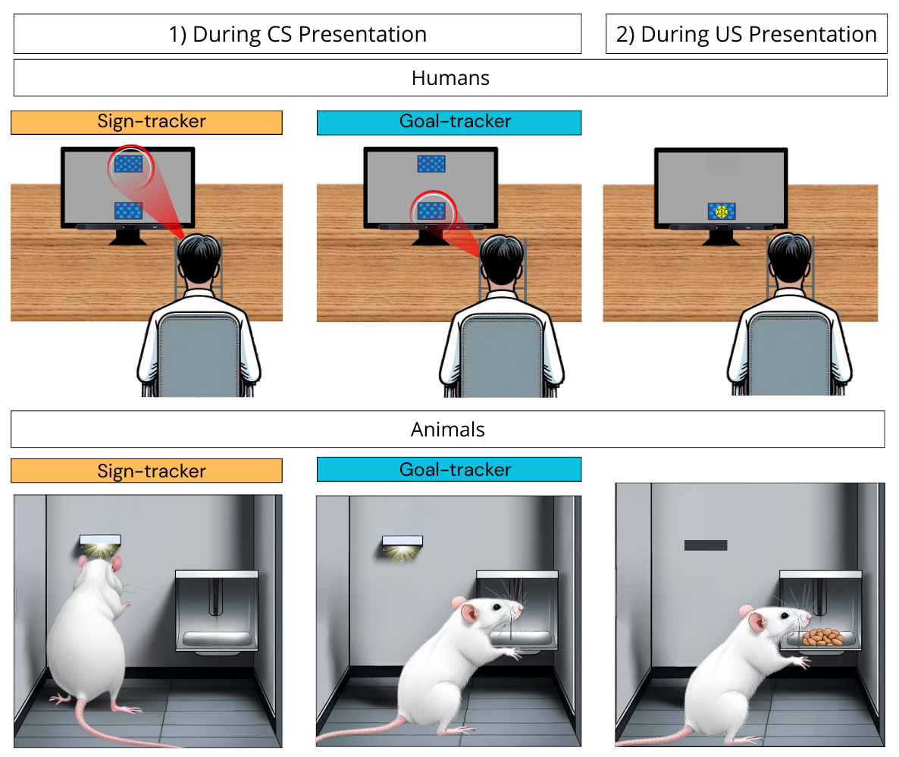
Note. The lower part of the figure shows the traditional animal PCA paradigm (adapted from Tomie & Morrow, 2018), while the upper part represents our developed task in humans. The left part represents the typical ST/GT behaviors during CS presentation; the right part represents the US delivery. In the human PCA task, the person is seated in front of a computer screen, with their head in a chinrest. The task consists of multiple presentations of a predicting cue (upper blue rectangle, CS) followed by a reward cue (coin, US). Approach behavior is inferred from eye-gaze behavior. For the animal paradigm, a retractable, illuminated lever (CS) is presented before food pellet delivery (US). (Image created using Canva AI, 2025).
Dot-Probe Task
Training Phase. The training phase consisted of 15 trials, in which two out of five pet pictures were simultaneously shown for 500 ms on each side of a central fixation cross on the screen. Their presentation was randomized. After removal of the two pictures, a single randomized letter (E or F) became immediately visible on the location where one of the two pictures was previously displayed. The location of the letter behind the right or left picture was also randomized. The task of the participants was to press as quickly as possible the corresponding key (E or F) on the keyboard. If the participant failed to answer within 1.5 seconds, the trial was recorded as a time-out. The ITI was variable, between 2 and 4 seconds. Prior to starting the training phase, participants were instructed as follows: “Here, you will be presented with a fixation cross in the center of the screen, followed by a pair of pictures. Start by fixing the middle cross. Once the pictures have disappeared from the screen, a white letter will appear on the left or right side of the screen. Your task is to press the corresponding key as quickly as possible. For this task, the options are the "E" key, or the "F" key. Once you have answered, another cross will appear, followed by a new series of pictures. You will perform several of these trials. Please keep your attention on the computer screen and don't look at the keyboard. You will start with a practice run of 15 trials”.
Test phase. The task was identical to the training phase, except that the stimuli displayed on the screen were the “goal shape” and “sign shape” (see section “Experiment” – “Stimuli”) of the PCA task and two additional new shapes. Stimuli display duration was 100 ms (a shorter latency was chosen to minimize the risk of cognitive processing of cues), and the ITI varied between 0.5 and 1.5 seconds. This task consisted of 128 trials. Time-outs were rare, ranging from 0% to 7.81% of trials across participants, and the total number of trials was large. Thus, a fixed number of trials without repetition was used during the task (of note, one participant was excluded due to time-outs exceeding 70% of trials). Prior to starting this task, participants were instructed that they had to proceed as before and that the task would last about 10 minutes. For the correlational analyses, only the trials in which the sign cue was opposed to the goal cue were considered. If a participant had developed an attentional bias for either the sign or the goal cues, s/he was expected to respond quicker when the letter was displayed behind that cue. For further exploration of the attentional bias scores, trials in which the sign and the goal were opposed to new stimuli were also considered.
Data Collection
Questionnaires
For conciseness, a more detailed description of the questionnaires is provided in the supplemental materials (S1). In the screening phase, all participants completed socio-demographic online questionnaires including the history of neurological problems that could affect cognitive functioning, and regular use of tranquilizers or illicit drugs. They also completed the short version of the alcohol use disorder identification test (AUDIT-C, Bush et al., 1998) and the short version of the UPPS-P Impulsive Behavior Scale (UPPS-P French translation, Billieux et al., 2012).
In the pre-experimental phase, all participants completed electronic versions of the following questionnaires:
- The Reinforcement Sensitivity Theory of Personality Questionnaire (RST-PQ, Corr & Cooper, 2016) . In the present study, we only measured three dimensions (total number of items = 24): Reward interest (RI), Goal-drive persistence (GDP) and reward reactivity (RR).
- The Temporal Experience of Pleasure Scale (TEPS, Gard et al., 2006) Only the anticipatory scale, consisting of 10 items, was measured.
- Four visual analog scales ranging from 0 to 100 asked the participants about their level of subjective liking of the four visual stimuli used in the study (sign, goal and the two new items of the dot-probe task).
In the post-experimental phase, participants completed electronic versions of the following questionnaires:
- The short Depression, Anxiety, Stress Scale (DASS-21, Lovibond et al., 1995).
- The Alcohol Sensitivity Questionnaire (ASQ, O’Neill et al., 2002).
- Questions about current alcohol consumption. To gain insight into participants' recent drinking behavior, we included the following two questions into the protocol: "How many drinks have you had in the last 14 days?" and "On how many occasions have you drunk alcohol in the last 14 days?". A recent drinking index was computed by multiplying these two numbers.
- The Brief Assessment Tool for Compulsivity Associated Problems (BATCAP, Albertella, Le Pelley, et al., 2019).

Eye-Tracking
A Tobii 5 eye-tracking system (with an image sampling rate of 133 Hz) was mounted on a 60.5 cm diagonal computer screen. The eye tracker was calibrated using a six-point procedure at the beginning of the experiment. A chinrest was used to standardize the head-screen distance at 70 cm. Tobii Experience software was used to calibrate the eye-tracking system.
To compute eye gaze-based ST/GT scores, the screen was virtually separated into 9 regions of interest (ROI, 3 equal parts on each axis). Eye gaze position was collected throughout the PCA task. The two main ROIs used to compute the scores were the upper center and the bottom center of the screen, where the goal and the sign stimuli were located (see Figure 2 for a visualization of eye tracking during the task). The in-between region (middle center) was also of interest for later analyses (latent profile analysis, LPA).
We used a custom implementation of the Velocity Threshold Algorithm for fixation identification. First, eye position in pixels was converted to visual degrees. Then velocity was computed in degrees/sec for axes X and Y. To distinguish fixations from saccades, we used individualized thresholds for each subject based on their gaze velocity during mandatory fixations in the dot-probe task (training phase). Each threshold was computed by adding 1.95*standard deviation to their mean gaze velocity during fixations (= confidence interval of 95%). In probability and statistics, the 97.5th percentile point of the standard normal distribution is a number commonly used for statistical calculations. The approximate value of this number is 1.96, meaning that 95% of the area under a normal curve lies within approximately 1.96 standard deviations of the mean. Because of the central limit theorem, this number is used to approximate 95% confidence intervals.
Eye movements were considered fixations when they were strictly below the personalized threshold. Too short fixations (<100 ms) were removed to smoothen eye-gaze data. For each identified fixation, duration and ROI were collected. Two outcome measures were obtained: Fixation count (number of fixations) and dwell time (total fixation time on each ROI), two classic parameters when working with fixation-based measures (Mahanama et al., 2022).
Figure 2
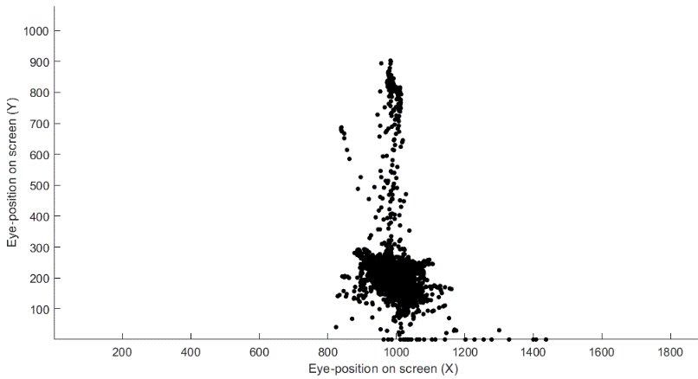
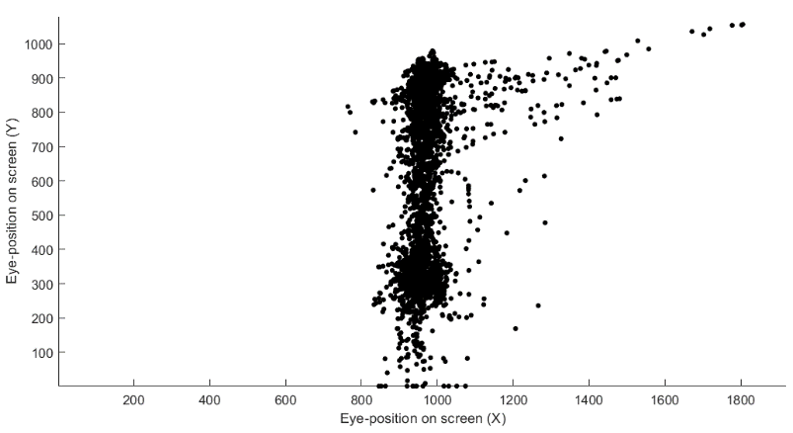
Representative Visual Patterns of Eye-Gazes on the Computer Screen During the PCA Task in Two Different Participants.

Note. Each black dot represents the eye position on the screen, every 50 ms during the task. No filter was applied at this stage; the graph only helps visualize gaze behavior. The sign was in the upper middle zone of the screen for both participants, while the goal was in the bottom middle part.

Three main criteria were used for data quality check and poor quality data exclusions: A participant was excluded (1) if the gaze stagnated in the middle zone throughout the whole task, without variation (perhaps an indicator of poor calibration or other technical problem, n = 0), (2) if there were more than 30% of gazes at the outer edge of the screen (5% of the screen) compared to the rest of the screen (poor calibration, n = 2), and (3) if on average the individual gazed less than 1 second per CS presentation at either of the ROI (goal and sign) or at the center of the screen (due to too few data to compute a meaningful sign-tracking score, n = 11).
Eye-Tracking Based Sign- and Goal-Tracking Scores. Eye-tracking based ST/GT scores were computed similarly to the RBS classically used in animal research (e.g., Meyer, Lovic, et al., 2012). Dwell time on the “goal” was subtracted from dwell time on the “sign” and divided by the total dwell time on both ROIs (during the 3s CS presentation). Thus, the ST/GT score ranged from -1 to 1, with negative scores suggesting “goal-tracking” phenotypes, positive scores indicating a “sign-tracking” phenotypes, and scores around 0 meaning a rather intermediate tendency. This score was computed for the first and second blocks of the PCA task, the number of fixations, and the total dwell time—leading to 4 ST/GT scores. Distribution of these scores are displayed in the supplementals (S2). Since some time was required for the participants to become familiar with the task and for specific conditioned responses to emerge (Colaizzi et al., 2023; Cope et al., 2023; Garofalo & diPellegrino, 2015), only the second block score was considered in the main analyses. Analyses involving all computed scores (for the first hypothesis) are available in the supplementals (S3).
Reaction time
For the dot-probe task, scores were calculated by subtracting the reaction time index (mean reaction time divided by the percentage of correct trials) for the goal picture from the reaction time index for the sign picture. A positive score was therefore indicative of an attentional bias for the sign cue and a negative score for the goal cue. For the computation of the dot-probe task score, only the sign vs. goal trials were considered, although both stimuli were also in competition with new pictures in other trials (see supplementals for these analyses, S4).
Data Analysis
Statistical analyses were performed using R 4.3.3 (R Core Team, 2024). Alpha level was set at 0.05, but corrections for multiple correlations were applied as indicated. Given that the questionnaires were administered electronically, no missing data was recorded, as participants were required to answer all questions to proceed.
Latent profile analysis (LPA) was performed to identify whether the 3-profile model of STs, GTs, and INTs fitted our data. LPA is a categorical latent variable modeling approach (Collins & Lanza, 2010) that focuses on identifying latent subpopulations within a population based on a certain set of variables (Collins & Lanza, 2010; Howard & Hoffman, 2018; Spurk et al., 2020). In this analysis, the following variables from the second block of the sign-tracking task were included as indicator variables: Number of fixations on the “goal”, number of fixations on the “sign”, number of fixations on the in-between zone, total dwell time on the “sign”, total dwell time on the “goal”, and total dwell time on the in-between zone. A series of three models was run with each having an additional number of profiles. The final choice of the number of relevant profiles is made on the basis of theoretical assumptions but also several fit indices (Collins & Lanza, 2010), such as the Bayesian Information Criterion (BIC), the Akaike Information Criteria (AIC), and entropy close to 1. When computing the profiles, our model specifications allowed the covariances among the indicator variables to be freely estimated within a profile, but both variances and covariances were constrained to be the same across profiles (Pastor et al., 2007). Once consistent profiles were obtained, a Kruskal-Wallis rank-sum test was run again to test for differences between these groups on alcohol consumption severity (AUDIT-C). Further, we ran a Kruskal-Wallis rank-sum test for significant differences between these groups to test whether the LPA derived profiles were coherent with our ST/GT index.
To examine whether alcohol consumption levels are significantly associated with the ST vs. GT profiles, including the INT subgroup as identified through LPA, we conducted a Kruskal-Wallis rank-sum test. In this analysis, the three profile groups served as the independent variable, while the AUDIT-C score was the dependent variable. This test was chosen because the AUDIT-C scores failed to meet the normality assumption. Additionally, given that previous studies have categorized participants using a tertile split approach (Cherkasova et al., 2024; Dinu et al., 2024; Duckworth et al., 2022), we conducted the same analysis using groups based on tertile splits of “gaze duration” scores. However, it is important to note that this categorization may be of limited relevance in the present case, as the ST/GT score distribution is left-skewed (results in supplemental S3).
To test the relationship between the ST/GT profile and other alcohol-consumption related variables, Spearman correlation coefficients were computed. A Benjamini & Hochberg (1995) (B-H) correction was applied to adjust the p-values for multiple comparisons. Similarly, Spearman correlation coefficients were calculated to test the relationships between the ST/GT index score and personality related variables (impulsivity, reward reactivity, reward interest, anticipated pleasure, psychological distress). Additionally, we examined whether the ST/GT score differed by gender. This question is particularly relevant given the well-established role of sex in both alcohol consumption and sign-tracking tendencies. Numerous studies have shown that men consume significantly more alcohol, have a greater tendency for solitary drinking, and exhibit a higher prevalence of alcohol use disorder (AUD) compared to women (Global Burden of Disease, 2020; Skrzynski & Creswell, 2021; Wilsnack et al., 2000; World Health Organization, 2018). In contrast, recent findings suggest that females exhibit stronger sign-tracking behavior, both in rodent models (Hakus et al., 2025) and in humans (Degni & Garofalo, 2025). In this study, we asked participants to report their gender; therefore, our analyses are based on gender rather than biological sex. Although this was not part of our initial hypotheses, we conducted this exploratory analysis and report the results in Supplemental 5. It is also important to note that our study may be underpowered to detect potential gender differences in sign-tracking due to limited and unequal sample sizes for each gender (Women, N= 71, Men, N=34).
To test whether subjective liking of the sign and goal stimuli at the end of the experiment differed among the three groups, we performed a mixed model ANOVA with the subjective liking scores as dependent variables and group (ST, GT, INT, based on the eye-tracking scores) and cue-type (sign vs. goal) as the independent variables.
Since the dot-probe task was included in an exploratory perspective, we tested whether there was a correlation between the bias score derived from the dot-probe paradigm and the ST/GT index score as well as alcohol-related consumption-related variables. A positive correlation was expected since both tasks assess a bias for either the “sign” or the “goal”. To further explore the relevance of this task, ST, GT and INT groups were compared (Kruskal-Wallis rank sum tests) regarding the index bias variable when the sign and goal pictures were opposed with new ones.
Finally, we aimed to check the properties of this new ST/GT task through an assessment of the internal consistency. A Cronbach’s alpha was calculated for the 20 trials, in the first and second blocks, using the ST/GT score (see Section "Eye-Tracking Based Sign- and Goal-Tracking Scores" for details on score calculation) based on dwell time. To test whether gaze (towards the sign and the goal) significantly changed across the two experimental blocks (i.e., associative learning took place) for the 3 behavioral profiles, we ran a linear mixed model with participants nested within profiles as the random factor. Since these analyses were not part of the main hypotheses of this experiment, the results are shown in the supplementary materials (Supplementals S6).
Transparency and Openness
We have reported how the sample size was determined, all data exclusions, all manipulations, and all measures in the study, and we have followed Journal Article Reporting Standards - JARS (Appelbaum et al., 2018). The experimental data are available at https://osf.io/tn7bv/.
The code for the experimental task is available upon request from the authors. Data were analyzed using R, version 4.3.3 (R Core Team, 2024). Packages used and their references are available in Appendix 1. This study’s design and its analysis were not pre-registered. Data analysis code is not available.
Use of IA
Artificial intelligence was used solely for the creation of Figure 1, which was developed using Canva’s AI-based image tool (Canva AI, 2025). No AI tools were used to generate scientific ideas, analyses, or interpretations of this manuscript. The authors take full responsibility for the content and accuracy of the information presented in this article.

Results
Hypothesis 1. Differentiating Human Sign- and Goal-Trackers
In the LPA, the best model based on fit indices was the 3-profile model (AIC = 1130.96, BIC = 1240.16, entropy = 0.93). Table 2 shows the fit indices for the three models. Posterior probabilities (i.e., probabilities for each participant to belong to each of the three profiles) indicated good confidence in the most likely profile membership. For profile 1, the probabilities ranged from 0.71 to 0.99 (mean = 0.97, sd = 0.06). For profile 2, they ranged from 0.69 to 0.99 (mean = 0.96, sd = 0.08). For profile 3, they ranged from 0.93 to 1.00 (mean = 0.99, sd = 0.01). Figures 3 and 4 show means and standard errors for the indicator variables in the three profiles. Based on the examination of these graphs, groups 1, 2, and 3, were labeled respectively, “GT”, “INT”, and “ST”.
Table 2
Model Fit Indices for the Three Latent Profile Analyses.
Tested Model | AIC | BIC | Entropy | Profile Sizes | Bootstrapped Likelihood Test (p-value)
1 Profile | 1194.52 | 1266.43 | - | - | -
2 Profiles | 1184.85 | 1275.40 | 0.83 | Profile 1: 44%  Profile 2: 56% | .05
3 Profiles | 1130.96 | 1240.16 | 0.93 | Profile 1: 38%  Profile 2: 29%  Profile 3: 33% | .01

Figure 3
Number of Fixations on Each Region of Interest in the Three LPA-Extracted Profiles.
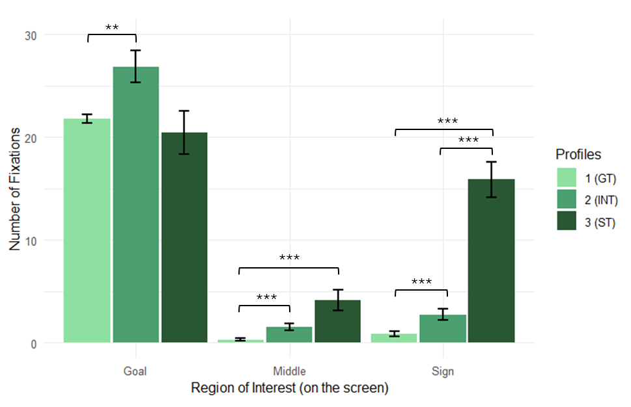
Note. The figure shows the means and standard errors. ***<0.001, **<0.01
Figure 4
Total Dwell Time on Each Region of Interest in the Three LPA-Extracted Profiles.
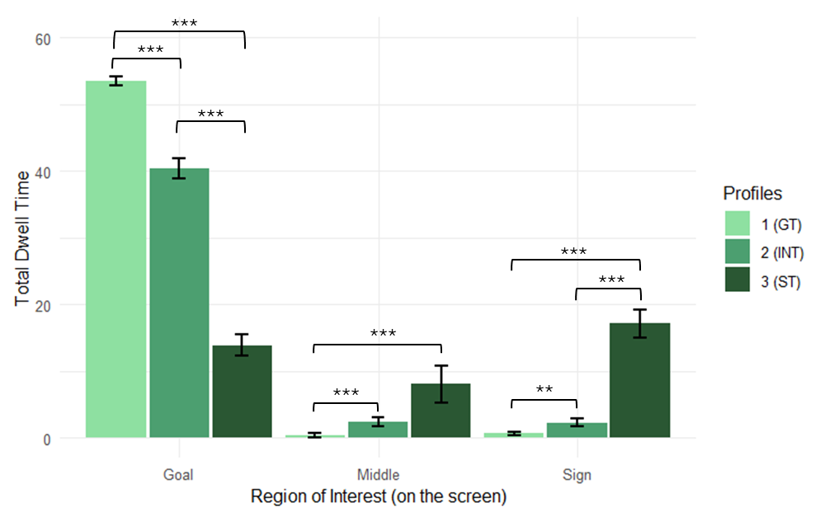
Note. The figure shows the means and standard errors. ***<0.001, **<0.01

A way to further test the validity for these profiles is to estimate the differences that may exist across profiles in relation to theoretically relevant outcomes (Spurk et al., 2020)— i.e., in this context, alcohol consumption levels.
When testing whether the LPA-derived profiles differed with regard to our ST/GT index (RBS based on gaze duration in the second block), the Kruskal-Wallis rank-sum test was significant with a large-sized effect (χ² = 73.04, p < 0.001, η²(H) = 0.690, 95% CI = [0.61, 0.79]). Figure 5 shows the distribution of the ST/GT scores among the three groups created by the LPA. Post hoc pairwise Wilcoxon tests (corrected with a Benjamini-Hochberg correction for multiple comparisons) indicated that all groups significantly differed from each other (all p < 0.001).
Figure 5
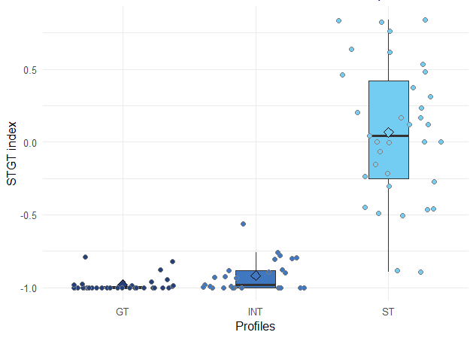
Distribution of ST/GT Scores in the LPA Created Profiles.

Note. Horizontal lines are the medians, the lower and upper limits of the boxes are lower and upper quartiles, the ends of the whiskers represent the lower and upper extremes.

A Kruskal-Wallis rank-sum test on these three profiles, aimed to assess differences in alcohol consumption (AUDIT-C), showed a significant effect of small to medium size (χ² = 8.10, p = 0.01, η²(H) = 0.059, 95% CI = [-0.09, 0.13]). Figure 6 shows the distribution of AUDIT-C scores in STs, GTs, and INTs, based on LPA-created profiles. Post hoc pairwise Wilcoxon tests indicated that the differences between STs and GTs (p = 0.03) and between STs and INTS (p = 0.02) were significant. No significant difference was obtained between GTs and INTs (p = 0.65). The same analysis, using ST, GT, and INT groups based on a tertile split (RBS), yielded highly similar results with a medium effect size (p = 0.004, η2(H) = 0.084, 95% CI = [-0.07, 0.16], supplementals S3).
Figure 6
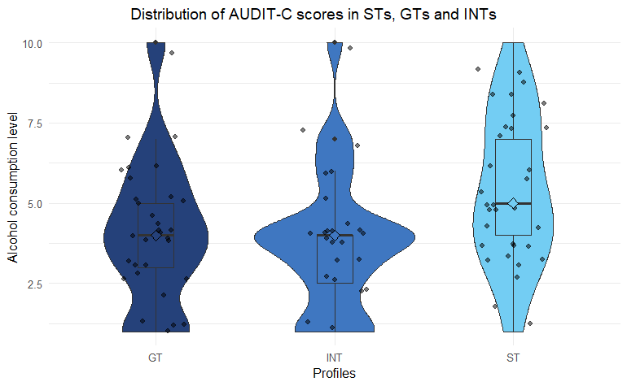
AUDIT-C in STs, GTs and INTs, Based on LPA Created Profiles.
Note. Horizontal lines are the medians, the lower and upper limits of the boxes are lower and upper quartiles, the ends of the whiskers represent the lower and upper extremes. The lines around the boxes represent the distribution of the data in each group.

Hypothesis 2. Relationships Between Human Sign-Tracking and Variables Related to Alcohol Consumption
We examined the relationship between the ST/GT scores and other alcohol consumption/addiction related variables—i.e., alcohol-compulsivity related problems (BATCAP-Alc), alcohol sensitivity (ASQ), the recent drinking index, and AUDIT-C. Only the correlation between AUDIT-C and the ST/GT score was significant (R_{S}= 0.29, p=0.01). Table 3 shows correlation coefficients, p-values and confidence intervals for each Spearman correlation coefficient. For the sake of completeness, the full correlation matrix between the ST/GT score and alcohol-related variables is available in Appendix 2.
Table 3
Correlation Coefficients, P-values and Confidence Intervals for Spearman Correlations Between the ST/GT Score and Alcohol-Related Variables.
Variable | Spearman Rho | Adjusted P-Value | Raw P-Value | CI Lower (Adjusted) | CI Upper (Adjusted)
ASQ | -0.03 | 0.795 | 0.795 | -0.27 | 0.22
BATCAP (Alcohol) | 0.10 | 0.442 | 0.332 | -0.16 | 0.34
Recent Drinking Index | 0.19 | 0.093 | 0.047 | -0.05 | 0.42
AUDIT-C | 0.29* | 0.010 | 0.003 | 0.05 | 0.50

Note. ASQ = Alcohol sensitivity questionnaire, BATCAP (alcohol) = alcohol-related problems (assessed with the Brief Assessment Tool for Compulsivity Associated Problems), DrinkOccas = recent drinking index (number of alcoholic drinks consumed during the past two weeks x number of alcohol drinking occasions during the past two weeks), AUDIT-C = short version of the Alcohol Use Disorder Identification Test (see 2.6.“Questionnaires”). *p<0.05

Hypothesis 3. Relationships Between Human Sign-Tracking and Personality-Related Variables
Regarding the association between the ST/GT score and personality-related variables, no significant correlations were obtained using the Spearman correlation coefficients, after B-H correction. However, it is noteworthy that the correlation coefficient between the ST/GT score and the “positive urgency” dimension of impulsivity is of medium size even though it did not reach the significance threshold after correction (R_{S} = 0.25, raw p = 0.01, adjusted p = 0.064). Table 4 shows correlation coefficients, p-values and confidence intervals for each Spearman correlation coefficient. For the sake of completeness, the full correlation matrix between the ST/GT scores and personality-related variables is available in Appendix 2.
Table 4
Correlation Coefficients, P-Values and Confidence Intervals for Spearman Correlations Between the ST/GT Score and Personality-Related Variables.
Variable | Spearman rho | Adjusted p | Raw p | CI Lower  (Adjusted) | CI Upper (Adjusted)
Psychological Distress | 0.06* | 0.651 | 0.54 | -0.20 | 0.31
UPPS-P- Urgency | 0.18 | 0.202 | 0.07 | -0.08 | 0.42
UPPS-P- Positive Urgency | 0.25 | 0.064 | 0.01 | -0.01 | 0.48
UPPS-P- Lack of Premeditation | 0.14 | 0.286 | 0.14 | -0.12 | 0.39
UPPS-P- Lack of Perseverance | 0.07 | 0.651 | 0.48 | -0.19 | 0.32
UPPS-P- Sensation Seeking | 0.00 | 0.990 | 0.99 | -0.26 | 0.26

Note. TEPS = temporal experience of pleasure scale, UPPS-P = short version of the UPPS impulsivity scale (see section “Data Collection” - “Questionnaires”).

Hypotheses 4 and 5. Subjective Liking and Attentional Bias Score
A mixed model ANOVA on subjective liking for both types of stimuli, did not reveal any statistically significant effect among the three groups (Table 5).
Table 5
Statistics for Mixed Model ANOVA on Subjective Liking.
Effect | F | p | ges
Group (ST/GT/INT) | 0.939 | 0.394 | 0.009
Stimulus (Goal vs. Sign) | 0.673 | 0.413 | 0.003
Group*Stimulus | 1.774 | 0.175 | 0.016
Note. ges = generalized eta squared

Regarding the ST/GT index that was derived from the reaction times in the Dot-Probe task, there was no significant correlation for any variables tested: Neither the ST/GT index (eye-tracking), nor the alcohol consumption-related variables. Results are shown in supplemental (S4) for the sake of completeness. In the same vein, the goal and sign bias scores when these stimuli were in competition with new ones did not differ between groups of STs, GTs, and INTs (supplemental S4).

Discussion
The main purpose of this study was to implement a new computerized Pavlovian Conditioning Approach task to determine its relevance at differentiating human ST and GT profiles. This study also aimed to determine whether the sign-tracking profile derived from eye-tracking responses related to alcohol consumption and personality variables, which are typically associated with sign-tracking in animal studies. Finally, a dot-probe task was included to test whether attentional biases could parallel sign-tracking behavior, and thus correlate with the eye-tracking-derived ST/GT score.
Our task successfully identified three distinct behavioral profiles based on visual attention directed toward a conditioned reward-predicting cue and the (virtual) reward delivery location. LPA indicated that the three-profile model provided the best fit to the data, considering the number of fixations and dwell time allocated to the sign, the goal, and the intermediate zone. Based on theoretical frameworks, we classified these profiles as STs, GTs and INTs. Notably, these groups exhibited significant differences in alcohol consumption levels, with STs displaying significantly higher AUDIT-C scores compared to both GTs and INTs. The identification of distinct behavioral profiles—STs, GTs, and INTs—through eye-tracking is consistent with prior findings (Cope et al., 2023; Schettino et al., 2024), although several studies have only distinguished between STs and non-STs (Colaizzi et al., 2023; Joyner, 2019). Given the pronounced left-skew distribution of the RBS in our sample (suggesting a higher prevalence of goal-tracking behavior), a tertile split approach was deemed less appropriate, and a data-driven multivariate method (LPA) was preferred for group classification. However, it is important to note that both methods yielded highly similar results, reinforcing the robustness of our findings. Both approaches converged in showing a significantly higher level of alcohol consumption among STs (Supplemental S3). Furthermore, when testing whether LPA-derived profiles differed significantly on the ST/GT score, a large and significant effect emerged. The left-skewed distribution of the RBS (towards goal-tracking) may be attributed to the novelty of the task, including the nature of its stimuli, which may not have been sufficiently engaging to elicit strong visual interactions. Alternative explanations include potential variations in attentional capture mechanisms due to the task’s low cognitive demands, which may have influenced response tendencies, as well as a sampling bias toward goal-tracking individuals. Given the relatively low RBS scores found even in STs, one could argue that our participants did not exhibit strong sign-tracking tendencies. However, since we conceptualize Pavlovian conditioned approach behavior as a continuum, the group labeled 'STs' still represents the upper extreme of sign-tracking tendencies within the distribution observed in our sample.
Nevertheless, the present study identified a significant relationship between alcohol consumption levels and the ST phenotype in humans, as individuals classified as STs exhibited higher AUDIT-C scores than GTs. Regarding the intermediate profile (INT), the participants exhibited significantly lower alcohol consumption levels compared to the ST group, while their consumption was comparable to that of the GT group. Furthermore, the ST/GT score was positively correlated with AUDIT-C, and a similar trend was observed with the recent drinking index. However, after applying the Benjamini-Hochberg correction, the correlation with the recent drinking index did not reach statistical significance (Table 3). This may reflect the limited timeframe captured by this index, potentially reducing its ability to detect meaningful associations.
These findings are consistent with what has been shown in several studies using the VMAC task to model sign-tracking behavior in humans, in which a significant association with problematic alcohol use and relapse was found (Albertella et al., 2021; Albertella, Watson, et al., 2019; Watson et al., 2024). The direction of this causal relation is still to be uncovered. Animal studies have suggested that STs are predisposed to addiction (and relapse) due to both heightened reward-cue and drug-cue reactivity (Tomie, 2018). It is therefore considered a preexistent vulnerability factor. Indeed, ST individuals are more likely to stay close to or to approach drug-paired cues (Meyer, Ma, et al., 2012; Yager et al., 2015), they find these cues more rewarding compared to GT individuals (Saunders & Robinson, 2010), they tend to prefer drugs such as cocaine over food compared to GTs (Tunstall & Kearns, 2015), and they are more likely to relapse following repeated drug consumption (Saunders et al., 2013; Saunders & Robinson, 2013). Specifically, alcohol cues are more attractive and act as more efficient conditioned reinforcers in STs compared to GTs (Villaruel & Chaudhri, 2016). However, this relationship could also work the other way round—i.e., increased substance use could render individuals more vulnerable to their predictive cues and thus turn them into STs (Kruse et al., 2017; Madayag et al., 2017; McClory & Spear, 2014). For example, alcohol exposure in adolescent rats increased the probability of developing sign-tracking behavior to reward-predicting cues (Kruse et al., 2017; Madayag et al., 2017 (only in females); McClory & Spear, 2014). However, there is also non-supporting evidence of increased goal-tracking behavior in selectively bred alcohol-preferring rats, and increased sign-tracking in alcohol non-preferring rats (Peña-Oliver et al., 2015). Causal effects might also go both directions and further research is needed to clarify this question.
The eye-gaze indices from which our ST/GT groups were derived differed in their ability to distinguish behavioral profiles. Figures 3 and 4 show that dwell time better differentiates the three profiles than number of fixations. Indeed, when examining dwell time for each region across the profiles (Figure 4), GTs gazed longer to the goal than STs and INTs; STs gazed longer on the sign than the other two groups; and both STs and INTs gazed longer on the middle region than GTs. On the other hand, the number of fixations on the goal (Figure 3) was less effective in differentiating profiles, with INTs showing significantly more gazes on every region compared to GTs. This is consistent with the idea that the intermediate category is more ambivalent and more susceptible to alternate their gazes between the sign and the goal (resulting in more frequent eye-movements), increasing their total number of gazes in the three regions. Interestingly, while INTs did not significantly differ from GTs in terms of alcohol consumption, their distinct eye-gaze pattern suggests a unique attentional profile. This supports the notion that INTs represent a separate subgroup rather than a transitional or indistinct category. Despite some heterogeneity among previous studies using similar eye-gaze indexes to categorize ST/GT groups, dwell time —recorded as total gaze duration for each area of interest—is the most commonly used measure (Cherkasova et al., 2024; Cope et al., 2023; Garofalo & di Pellegrino, 2015; Lehner et al., 2017; Schettino et al., 2024). The number of fixations has less often been used in previous studies (Dinu et al., 2024).
Unlike previous studies on human sign-tracking (Cope et al., 2023; Garofalo & di Pellegrino, 2015), our study did not find a significant association between impulsivity and the ST profile per se. However, this divergence may stem from methodological differences, particularly the use of a different self-report measure of impulsivity (Barratt Impulsiveness Scale vs. UPPS-P). These scales likely capture distinct facets of impulsivity, some of which may not be directly reflected in sign-tracking behavior. For instance, self-reported “lack of premeditation” in humans differs conceptually from assessments of impulsive action or impulsive choice in rodent models, such as the 5-choice serial reaction time task (Esteves et al., 2021). Encouragingly, the correlation coefficient between the ST/GT score and the “positive urgency” dimension of impulsivity was of medium size, suggesting a meaningful relationship despite not reaching significance after B-H correction. Moreover, an analysis of the full correlation matrix between impulsivity dimensions and the ST/GT score (Appendix 2) identified this correlation as statistically significant (R_{S} = 0.25, adj. p = 0.023). While modest, this finding aligns with theoretical expectations and provides additional support for the validity of our paradigm. However, further research is required to confirm and expand upon these findings. Moreover, a consensus on the specific dimensions of impulsivity to assess within the ST/GT paradigm is crucial to ensure a robust translational perspective.
Regarding the relationship between sign-tracking and other personality-related variables, such as anticipatory pleasure (TEPS scale) and reward responsiveness (RST-PQ subscales), the present study did not show any significant correlation. Yet, drive and fun seeking, two subdimensions of the behavioral approach system (BAS), were found significantly related to alcohol use (Ivory & Kambouropoulos, 2012; Loxton & Dawe, 2001), alcohol cue-reactivity (Kambouropoulos & Staiger, 2001), and dysfunctional eating (Loxton & Tipman, 2017; May et al., 2016). Anticipatory pleasure (as measured through TEPS-anticipatory) has been linked to individual differences in reward motivation (Gard et al., 2006; Geaney et al., 2015) and more recently to ST/GT/INT profiles in humans (Schettino et al., 2024). The lack of positive results regarding these aspects in our study could be due to the poor factor structure of our translated versions of these questionnaires. Indeed, model fit indices were mediocre to bad for the TEPS and RST-PQ questionnaires (see supplementals S7 for details about CFA). These analyses should therefore be repeated with higher-quality versions of the questionnaires.
In our study, we did not observe statistically significant gender differences in sign- and goal-tracking tendencies. Although men exhibited significantly higher AUDIT-C scores compared to women, this difference in alcohol use did not appear to be associated with ST/GT phenotype. However, recent research has suggested that gender may play a role in sign-tracking behavior, with some studies reporting a greater propensity for sign-tracking among females in both human and animal models (e.g., Degni & Garofalo, 2025; Hakus et al., 2025). These findings highlight the importance of further investigating the potential influence of gender—and ideally, assigned sex at birth—on individual differences in cue-triggered behavior in future studies.
The lack of positive findings for the dot-probe task based on an attentional bias score and the subjective liking scores for sign vs. goal pictures might be due to the abstract nature of the stimuli used (blue rectangles filled with different shapes). Moreover, they were visually quite similar and, given the modest number of associations between them and the reward (n = 40), they might not have induced a significant attentional bias during the 250ms presentations in the dot-probe task. In most studies using a dot-probe task, stimuli frequently encountered in the real world are typically used (e.g., faces or alcoholic beverages). Another factor that may have disrupted the dot-probe task as an indicator of attentional bias towards one of the two stimuli was the location of the cues on the screen. In the Pavlovian conditioning phase, the two stimuli (sign and goal) were presented in the upper vs. bottom part of the screen (following the task design established by Garofalo and di Pellegrino, 2015). In contrast, the dot-probe task presented stimuli on the left and right sides, in line with standard protocols commonly used to assess attentional biases. Although this change in spatial location may have introduced an attentional shift or distraction, it also helped ensure that attention in the dot-probe task was driven by the motivational properties of the stimuli themselves, rather than by residual spatial associations from the conditioning phase. The absence of an effect in the dot-probe task may also suggest that the attribution of incentive salience, as reflected in sign-tracking approach behavior, is more effectively captured through direct behavioral measures in the Pavlovian conditioning task. This motivational process may not translate well to a subsequent attentional task, such as the dot-probe, especially in the absence of reward or direct contingency with the previously learned associations.
Our study did not question the ecological relevance of using a PCA task in humans. However, this does not represent a real limitation of the study, in the sense that our objective was to translate the animal ST/GT model. We observed in the literature that obtaining a clear dissociation between STs and GTs with humans is more difficult than with rats. Explaining the origin of these differences is therefore crucial to understand the processes at stake, and perhaps find optimal conditions in which sign- and goal-tracking can reliably be obtained in humans. One option would be to study these behaviors in real-life settings, as already suggested (Schettino et al., 2022). For example, ecological momentary assessments might be useful to assess motivational salience attributed to daily-life reward-predicting cues. This has been investigated by Schettino et al. (2022), who found that people with increased impulsive, obsessive-compulsive, and addiction-prone tendencies were prone to find the cues more attractive than the rewards. Although they did not identify ST or GT phenotypes, this approach may represent a promising step in the translation of the animal model to real life in humans. Developing an ecological approach to sign- and goal-tracking might also help better predict how the ST and GT profiles interact with the use of illicit substances and with their clinical outcomes. At present, only two studies have investigated this question. They found that sign-tracking was predictive of non-abstinence (pseudo-relapse) during a one-month abstinence challenge in a non-clinical sample (Albertella et al., 2021) and of relapse during a 3-month follow-up in AUD patients (Watson et al., 2024). These studies used the VMAC task to model sign-tracking behavior and did not actually compare STs to GTs, but rather correlated the response bias scores related to attentional capture by reward associated cues with alcohol-use variables.
Finally, while our task for classifying behavioral profiles based on gaze behavior is newly developed and requires further validation to confirm its consistency, it was closely modeled on established animal studies and previous human research (Flagel et al., 2008; Garofalo & di Pellegrino, 2015). Additionally, despite the skewed distribution of the RBS score, the strength of our findings — particularly the expected differences in alcohol consumption across profiles, as well as the small yet expected association with impulsivity—supports the relevance of this task, paving the way for future research to further refine and confirm the usefulness of such computerized paradigms. Future research is needed to replicate these findings and further assess the task’s sensitivity and reliability.
In conclusion, this study successfully identified human phenotypes that likely reflect individual differences in reward-cue interaction—classified as STs, GTs, and INTs—which exhibited significant differences in alcohol consumption levels. This finding adds to the growing body of evidence demonstrating that computerized Pavlovian Conditioned Approach (PCA) tasks can effectively differentiate human sign- and goal-tracking behaviors based on eye-gaze metrics (Cherkasova et al., 2024; Dinu et al., 2024; Garofalo & di Pellegrino, 2015; Lehner et al., 2017; Schettino et al., 2024). Furthermore, our study underscores the relevance of these individual differences in addictive behaviors (Albertella et al., 2021; Albertella, Le Pelley, et al., 2019; Watson et al., 2024), reinforcing the potential importance of the ST/GT model in understanding how variations in incentive salience attribution to cues may contribute to addiction vulnerability. Identifying sign- vs. goal-tracking phenotypes could not only help target at-risk individuals but also might improve prevention efforts through psychoeducational strategies, akin to the “scientific short stories” developed by Tomie’s team (Levitch et al., 2018). Their findings suggest that increasing awareness of how the loss of self-control can lead to addiction could be a promising approach for prevention programs. Despite some limitations, this study was carefully designed to closely align with the animal model of sign- and goal-tracking, providing a robust translational framework. By bridging human and animal research, these findings pave the way for future translational studies aimed at further elucidating the mechanisms underlying incentive salience attribution and its role in addiction.
Funding
This research was supported by the University of Liège, Belgium, and the Fonds de la Recherche Scientifique (FNRS) through a research fellowship (MH). It was also carried out in collaboration with funding from the DFG, Germany, through An1067/4-1 (PA).
Conflicts of Interest/Competing Interests
The authors have no competing interests to declare that are relevant to the content of this article.
Author Contributions (CRediT)
MH: Conceptualization, Methodology, Formal Analysis, Investigation, Data Curation, Writing - Original Draft, Writing - Review & Editing, Visualization, Project administration. JS: Conceptualization, Methodology, Writing - Review & Editing. DL: Software, Formal Analysis, Data Curation, Writing - Review & Editing, Visualization. VD: Formal analysis, Writing - Review & Editing. PA: Conceptualization, Methodology, Writing - Review & Editing, Supervision, Project administration. EQ: Conceptualization, Methodology, Resources, Writing - Review & Editing, Supervision, Project administration
Appendices
Appendix 1. R Packages and associated references
Data handling and pre-processing were done using readxl (v1.4.3, Wickham & Bryan, 2023), tidyverse (v2.0.0, Wickham et al., 2019) packages. Visualizations were done using ggplot2 (v3.5.0, through tidyverse, Wickham et al., 2019), and ggpubr (v0.6.0, Kassambara, 2023a) packages. Main analyses (including anova, model assumptions verification, Kruskall-Wallis tests) were run with rstatix (v0.7.2, Kassambara, 2023b). Correlational analyses and internal consistency measures were computed with psych package (v2.4.3, Revelle, 2024). Linear mixed effects models for learning analyses were run with lme4 (v1.1-34, Bates et al., 2015) and car (v3.1-2, Fox & Weisberg, 2014) packages. Latent profile analyses were run with tidyLPA package (v1.1.0, Rosenberg et al., 2018). Confirmatory factor analyses were run with lavaan package (v0.6-19, Rosseel, 2012).
References
- Bates, D., Maechler, M., Bolker, B., & Walker, S. (2015). Fitting linear mixed-effects models using lme4. Journal of Statistical Software, 67(1), 1-48. https://doi.org/10.18637/jss.v067.i01
- Fox, J., & Weisberg, S. (2014). An R companion to applied regression (3rd ed.). Sage. https://socialsciences.mcmaster.ca/jfox/Books/Companion/
- Kassambara, A. (2023a). rstatix: Pipe-friendly framework for basic statistical tests (Version 0.7.2) [R package]. https://CRAN.R-project.org/package=rstatix
- Kassambara, A. (2023b). ggpubr: 'ggplot2' based publication ready plots (Version 0.6.0) [R package]. https://CRAN.R-project.org/package=ggpubr
- Revelle, W. (2024). psych: Procedures for psychological, psychometric, and personality research (Version 2.4.3) [R package]. Northwestern University. https://CRAN.R-project.org/package=psych
- Rosenberg, J. M., Beymer, P. N., Anderson, D. J., Van Lissa, C. J., & Schmidt, J. A. (2018). tidyLPA: An R package to easily carry out latent profile analysis (LPA) using open-source or commercial software. Journal of Open Source Software, 3(30), 978. https://doi.org/10.21105/joss.00978
- Rosseel, Y. (2012). lavaan: An R Package for Structural Equation Modeling. Journal of Statistical Software, 48(2), 1-36. https://doi.org/10.18637/jss.v048.i02
- Wickham, H., & Bryan, J. (2023). readxl: Read Excel files (Version 1.4.3) [R package]. https://CRAN.R-project.org/package=readxl
- Wickham, H., Averick, M., Bryan, J., Chang, W., McGowan, L. D., François, R., Grolemund, G., Hayes, A., Henry, L., Hester, J., Kuhn, M., Pedersen, T. L., Miller, E., Bache, S. M., Müller, K., Ooms, J., Robinson, D., Seidel, D. P., Spinu, V., Takahashi, K., Vaughan, D., Wilke, C., Woo, K., & Yutani, H. (2019). Welcome to the tidyverse. Journal of Open Source Software, 4(43), 1686. https://doi.org/10.21105/joss.01686

Appendix 2. Full correlation matrices
- Full Correlation Matrix for Table 3 (Alcohol Variables)
Variable | ST/GT Score
ASQ | R_{S} = -0.03  Adj. p = 0.864 | ASQ
BATCAP | R_{S} = 0.10  Adj. p = 0.395 | R_{S} = -0.004  Adj. p = 0.968 | BATCAP- Alcohol
Recent Drinking Index | R_{S} = 0.19  Adj. p = 0.061 | R_{S} = 0.20  Adj. p = 0.059 | R_{S} = 0.34*  Adj. p = 0.002 | Recent Drinking Index
AUDIT-C | R_{S} = 0.29**  Adj. p = 0.006 | R_{S} = 0.26*  Adj. p = 0.014 | R_{S} = 0.22*  Adj. p = 0.045 | R_{S} = 0.65***  Adj. p <0.001

Note. ASQ = Alcohol sensitivity questionnaire, BATCAP (alcohol) = alcohol-related problems (assessed with the Brief Assessment Tool for Compulsivity Associated Problems), DrinkOccas = recent drinking index (number of alcoholic drinks consumed during the past two weeks x number of alcohol drinking occasions during the past two weeks), AUDIT-C = short version of the Alcohol Use Disorder Identification Test (see 2.6.“Questionnaires”). The p-value differences between Table 3 and Appendix 2 reflect the scope of each analysis: Table 3 shows correlations only between ST/GT scores and alcohol variables, while Appendix 2 includes all correlations, including among alcohol variables. Thus, the number of comparisons (and the adjusted p-values) differs. *<0.05, **<0.01, ***<0.001.

- Full Correlation Matrix for Table 4 (Personality Variables, Except Impulsivity, including RST-PQ)
Variable | ST/GT Score
TEPS | R_{S} = 0.07  p = 0.520 | TEPS
Psychological Distress | R_{S} = 0.06  p = 0.591 | R_{S} = 0.11  p = 0.341 | Psych. Distress
RST-PQ-RR | R_{S} = 0.09  p = 0.434 | R_{S} = 0.58*  p < 0.001 | R_{S} = 0.12  p = 0.295 | RST-PQ-RR
RST-PQ-Goal-per | R_{S} = -0.01  p = 0.909 | R_{S} = 0.22  p = 0.051 | R_{S} = -0.07  p = 0.520 | R_{S} = 0.38*  p < 0.001 | RST-PQ-Goal-per
RST-PQ-Goal-plan | R_{S} = -0.17  p = 0.143 | R_{S} = 0.19  p = 0.106 | R_{S} = -0.04  p = 0.696 | R_{S} = 0.18*  p = 0.125 | R_{S} = 0.52*  p <0.001 | RST-PQ-Goal-plan
RST-PQ- RI | R_{S} = -0.13  p = 0.253 | R_{S} = 0.17  p = 0.143 | R_{S} = -0.14  p = 0.240 | R_{S} = 0.37*  p < 0.001 | R_{S} = 0.30*  p = 0.004 | R_{S} = 0.32*  p = 0.002

Note. P-values are adjusted, *< 0.05. TEPS = temporal experience of pleasure scale, RST-PQ = The Reinforcement Sensitivity Theory of Personality Questionnaire, RR= reward reactivity, Goal-per= goal persistence, Goal-plan= goal planning, RI= reward interest

- Full Correlation Matrix for Table 4 (Personality Variables, Impulsivity Dimensions)
Variable | ST/GT Score
Urgency | R_{S} = 0.18  Adj. p= 0.101 | Urgency
Positive Urgency | R_{S} = 0.25*  Adj. p= 0.023 | R_{S} = 0.45***  Adj. p <0.001 | Pos. Urgency
Lack Premeditation | R_{S} = 0.14  Adj. p = 0.184 | R_{S} = 0.47***  Adj. p <0.001 | R_{S} = 0.49***  Adj. p <0.001 | Lack Premed.
Lack Perseverance | R_{S} = 0.07  Adj. p = 0.507 | R_{S} = 0.24*  Adj. p = 0.023 | R_{S} = 0.20  Adj. p = 0.066 | R_{S} = 0.36***  Adj. p <0.001 | Lack Persev.
Sensation Seeking | R_{S} = -0.001  Adj. p = 0.990 | R_{S} = 0.14  Adj. p = 0.185 | R_{S} = 0.20  Adj. p = 0.073 | R_{S} = 0.16  Adj. p = 0.149 | R_{S} = 0.08  Adj. p = 0.438

Note. *<0.05, ***<0.001.

References
Albertella, L., Le Pelley, M. E., Chamberlain, S. R., Westbrook, F., Fontenelle, L. F., Segrave, R., Lee, R., Pearson, D., & Yücel, M. (2019). Reward-related attentional capture is associated with severity of addictive and obsessive–compulsive behaviors. Psychology of Addictive Behaviors, 33(5), 495‑502. https://doi.org/10.1037/adb0000484
Albertella, L., Vd Hooven, J., Bovens, R., & Wiers, R. W. (2021). Reward-related attentional capture predicts non-abstinence during a one-month abstinence challenge. Addictive Behaviors, 114, 106745. https://doi.org/10.1016/j.addbeh.2020.106745
Albertella, L., Watson, P., Yücel, M., & Le Pelley, M. E. (2019). Persistence of value-modulated attentional capture is associated with risky alcohol use. Addictive Behaviors Reports, 10, 100195. https://doi.org/10.1016/j.abrep.2019.100195
Anselme, P., & Robinson, M. J. F. (2020). From sign-tracking to attentional bias: Implications for gambling and substance use disorders. Progress in Neuro-Psychopharmacology and Biological Psychiatry, 99, 109861. https://doi.org/10.1016/j.pnpbp.2020.109861
Anselme, P., Robinson, M. J. F., & Berridge, K. C. (2013). Reward uncertainty enhances incentive salience attribution as sign-tracking. Behavioural Brain Research, 238, 53‑61. https://doi.org/10.1016/j.bbr.2012.10.006
Appelbaum, M., Cooper, H., Kline, R. B., Mayo-Wilson, E., Nezu, A. M., & Rao, S. M. (2018). Journal article reporting standards for quantitative research in psychology: The APA Publications and Communications Board task force report. American Psychologist, 73(1), 3‑25. https://doi.org/10.1037/amp0000191
Beckmann, J. S., Marusich, J. A., Gipson, C. D., & Bardo, M. T. (2011). Novelty seeking, incentive salience and acquisition of cocaine self-administration in the rat. Behavioural Brain Research, 216(1), 159‑165. https://doi.org/10.1016/j.bbr.2010.07.022
Benjamini, Y., & Hochberg, Y. (1995). Controlling the False Discovery Rate: A Practical and Powerful Approach to Multiple Testing. Journal of the Royal Statistical Society. Series B (Methodological), 57(1), 289‑300.
Berridge, K. C. (2007). The debate over dopamine’s role in reward: The case for incentive salience. Psychopharmacology, 191(3), 391‑431. https://doi.org/10.1007/s00213-006-0578-x
Billieux, J., Rochat, L., Ceschi, G., Carré, A., Offerlin-Meyer, I., Defeldre, A.-C., Khazaal, Y., Besche-Richard, C., & Van der Linden, M. (2012). Validation of a short French version of the UPPS-P Impulsive Behavior Scale. Comprehensive Psychiatry, 53(5), 609‑615. https://doi.org/10.1016/j.comppsych.2011.09.001
Boakes, R. A. (1977). Performance on Learning to Associate a Stimulus with Positive Reinforcement. In H. David & H. M. B. Hurwitz, Operant-Pavlovian Interactions, 67‑101. Routledge.
Bush, K., Kivlahan, D. R., McDonell, M. B., Fihn, S. D., & Bradley, K. A. (1998). The AUDIT alcohol consumption questions (AUDIT-C): An effective brief screening test for problem drinking. Ambulatory Care Quality Improvement Project (ACQUIP). Alcohol Use Disorders Identification Test. Archives of Internal Medicine, 158(16), 1789‑1795. https://doi.org/10.1001/archinte.158.16.1789
Canva. (2025). Canva AI. [AI image generation tool]. https://www.canva.com
Cherkasova, M. V., Clark, L., Barton, J. J. S., Stoessl, A. J., & Winstanley, C. A. (2024). Risk-promoting effects of reward-paired cues in human sign- and goal-trackers. Behavioural Brain Research, 461, 114865. https://doi.org/10.1016/j.bbr.2024.114865
Colaizzi, J. M., Flagel, S. B., Gearhardt, A. N., Borowitz, M. A., Kuplicki, R., Zotev, V., Clark, G., Coronado, J., Abbott, T., & Paulus, M. P. (2023). The propensity to sign-track is associated with externalizing behavior and distinct patterns of reward-related brain activation in youth. Scientific Reports, 13, 4402. https://doi.org/10.1038/s41598-023-30906-3
Colaizzi, J. M., Flagel, S. B., Joyner, M. A., Gearhardt, A. N., Stewart, J. L., & Paulus, M. P. (2020). Mapping sign-tracking and goal-tracking onto human behaviors. Neuroscience & Biobehavioral Reviews, 111, 84‑94. https://doi.org/10.1016/j.neubiorev.2020.01.018
Collins, L., & Lanza, S. (2010). Latent Class and Latent Transition Analysis: With Applications in the Social, Behavioral, and Health Sciences. Wiley. https://doi.org/10.1002/9780470567333.indsub
Colom, M. (2023). Neurobiological and behavioural studies of individual variation in cue-evoked motivation across rodents and humans [PhD Thesis, The Open University]. Open Research Online. https://oro.open.ac.uk/90812/
Cope, L. M., Gheidi, A., Martz, M. E., Duval, E. R., Khalil, H., Allerton, T., & Morrow, J. D. (2023). A mechanical task for measuring sign- and goal-tracking in humans: A proof-of-concept study. Behavioural Brain Research, 436, 114112. https://doi.org/10.1016/j.bbr.2022.114112
Cope, L. M., Martz, M. E., Hardee, J. E., Zucker, R. A., & Heitzeg, M. M. (2019). Reward activation in childhood predicts adolescent substance use initiation in a high-risk sample. Drug and Alcohol Dependence, 194, 318‑325. https://doi.org/10.1016/j.drugalcdep.2018.11.003
Corr, P. J., & Cooper, A. J. (2016). The Reinforcement Sensitivity Theory of Personality Questionnaire (RST-PQ): Development and validation. Psychological Assessment, 28(11), 1427‑1440. https://doi.org/10.1037/pas0000273
Crocq, M.-A. (2007). Historical and cultural aspects of man’s relationship with addictive drugs. Dialogues in Clinical Neuroscience, 9(4), 355‑361.
Degni, L. A. E., & Garofalo, S. (2025). Toward a Translational Model of Sex‐Associated Pavlovian Phenotypes. Addiction Biology, 30(6), e70054. https://doi.org/10.1111/adb.70054
Dinu, L.-M., Georgescu, A.-L., Singh, S. N., Byrom, N. C., Overton, P. G., Singer, B. F., & Dommett, E. J. (2024). Sign-tracking and goal-tracking in humans: Utilising eye-tracking in clinical and non-clinical populations. Behavioural Brain Research, 461, 114846. https://doi.org/10.1016/j.bbr.2024.114846
Duckworth, J. J., Wright, H., Christiansen, P., Rose, A. K., & Fallon, N. (2022). Sign‐tracking modulates reward‐related neural activation to reward cues, but not reward feedback. European Journal of Neuroscience, 56(7), 5000‑5013. https://doi.org/10.1111/ejn.15787
Esteves, M., Moreira, P. S., Sousa, N., & Leite-Almeida, H. (2021). Assessing Impulsivity in Humans and Rodents : Taking the Translational Road. Frontiers in Behavioral Neuroscience, 15. https://doi.org/10.3389/fnbeh.2021.647922
Flagel, S. B., Akil, H., & Robinson, T. E. (2009). Individual differences in the attribution of incentive salience to reward-related cues: Implications for addiction. Neuropharmacology, 56 Suppl 1, 139‑148. https://doi.org/10.1016/j.neuropharm.2008.06.027
Flagel, S. B., Clark, J. J., Robinson, T. E., Mayo, L., Czuj, A., Willuhn, I., Akers, C. A., Clinton, S. M., Phillips, P. E. M., & Akil, H. (2011). A selective role for dopamine in stimulus–reward learning. Nature, 469(7328), 53‑57. https://doi.org/10.1038/nature09588
Flagel, S. B., Watson, S. J., Akil, H., & Robinson, T. E. (2008). Individual differences in the attribution of incentive salience to a reward-related cue: Influence on cocaine sensitization. Behavioural Brain Research, 186(1), 48‑56. https://doi.org/10.1016/j.bbr.2007.07.022
Foulds, J. A., Boden, J. M., Newton-Howes, G. M., Mulder, R. T., & Horwood, L. J. (2017). The role of novelty seeking as a predictor of substance use disorder outcomes in early adulthood. Addiction, 112(9), 1629‑1637. https://doi.org/10.1111/add.13838
Gard, D. E., Gard, M. G., Kring, A. M., & John, O. P. (2006). Anticipatory and consummatory components of the experience of pleasure: A scale development study. Journal of Research in Personality, 40(6), 1086‑1102. https://doi.org/10.1016/j.jrp.2005.11.001
Garofalo, S., & di Pellegrino, G. (2015). Individual differences in the influence of task-irrelevant Pavlovian cues on human behavior. Frontiers in Behavioral Neuroscience, 9. https://doi.org/10.3389/fnbeh.2015.00163
Garofalo, S., Sagliano, L., Starita, F., Trojano, L., & di Pellegrino, G. (2020). Subliminal determinants of cue-guided choice. Scientific Reports, 10(1), 11926. https://doi.org/10.1038/s41598-020-68926-y
GBD 2020 Alcohol Collaborators. Population-level risks of alcohol consumption by amount, geography, age, sex, and year: a systematic analysis for the Global Burden of Disease Study 2020. The Lancet. 14 July 2022. doi:10.1016/S0140-6736(22)00847-9.
Geaney, J. T., Treadway, M. T., & Smillie, L. D. (2015). Trait Anticipatory Pleasure Predicts Effort Expenditure for Reward. PLOS ONE, 10(6), e0131357. https://doi.org/10.1371/journal.pone.0131357
Glueck, A. C., Torres, C., & Papini, M. R. (2018). Transfer between anticipatory and consummatory tasks involving reward loss. Learning and Motivation, 63, 105‑125. https://doi.org/10.1016/j.lmot.2018.05.001
Grant, B. F., Goldstein, R. B., Saha, T. D., Chou, S. P., Jung, J., Zhang, H., Pickering, R. P., Ruan, W. J., Smith, S. M., Huang, B., & Hasin, D. S. (2015). Epidemiology of DSM-5 Alcohol Use Disorder: Results From the National Epidemiologic Survey on Alcohol and Related Conditions III. JAMA Psychiatry, 72(8), 757. https://doi.org/10.1001/jamapsychiatry.2015.0584
Hearst, E., & Jenkins, H. M. (1974). Sign-tracking: The stimulus-reinforcer relation and directed action. Psychonomic Society.
Hakus, A., Foo, J. C., Casquero-Veiga, M., Gül, A. Z., Hintz, F., Rivalan, M., Winter, Y., Priller, J., Hadar, R., & Winter, C. (2025). Sex-associated differences in incentive salience and drinking behaviour in a rodent model of alcohol relapse. Addiction Biology, 30(1), e70009. https://doi.org/10.1111/adb.70009
Heck, M., Durieux, N., Anselme, P., & Quertemont, E. (2025). Implementations of sign- and goal-tracking behavior in humans: A scoping review. Cognitive, Affective, & Behavioral Neuroscience, 25(2), 263‑290. https://doi.org/10.3758/s13415-024-01230-8
Howard, M. C., & Hoffman, M. E. (2018). Variable-Centered, Person-Centered, and Person-Specific Approaches: Where Theory Meets the Method. Organizational Research Methods, 21(4), 846‑876. https://doi.org/10.1177/1094428117744021
Ivory, N. J., & Kambouropoulos, N. (2012). Coping mediates the relationship between revised reinforcement sensitivity and alcohol use. Personality and Individual Differences, 52(7), 822‑827. https://doi.org/10.1016/j.paid.2012.01.013
Joyner, M. (2019). Examining behavioral phenotypes of overeating and obesity: Environmental, psychological, and neurobiological influences on food motivation and palatable food consumption [PhD Thesis, University of Michigan]. University of Michigan Library – Deep Blue. http://deepblue.lib.umich.edu/handle/2027.42/151531
Joyner, M. A., Gearhardt, A. N., & Flagel, S. B. (2018). A Translational Model to Assess Sign-Tracking and Goal-Tracking Behavior in Children. Neuropsychopharmacology: Official Publication of the American College of Neuropsychopharmacology, 43(1), 228‑229. https://doi.org/10.1038/npp.2017.196
Kambouropoulos, N., & Staiger, P. K. (2001). The influence of sensitivity to reward on reactivity to alcohol-related cues. Addiction, 96(8), 1175‑1185. https://doi.org/10.1080/09652140120060761
Kruse, L. C., Schindler, A. G., Williams, R. G., Weber, S. J., & Clark, J. J. (2017). Maladaptive Decision Making in Adults with a History of Adolescent Alcohol use, in a Preclinical Model, Is Attributable to the Compromised Assignment of Incentive Value during Stimulus-Reward Learning. Frontiers in Behavioral Neuroscience, 11. https://doi.org/10.3389/fnbeh.2017.00134
Le Pelley, M. E., Pearson, D., Griffiths, O., & Beesley, T. (2015). When goals conflict with values: Counterproductive attentional and oculomotor capture by reward-related stimuli. Journal of Experimental Psychology: General, 144(1), 158‑171. https://doi.org/10.1037/xge0000037
Le Pelley, M. E., Watson, P., & Wiers, R. W. (2024). Biased choice and incentive salience: Implications for addiction. Behavioral Neuroscience. https://doi.org/10.1037/bne0000583
Lehner, R., Balsters, J. H., Bürgler, A., Hare, T. A., & Wenderoth, N. (2017). Food-Predicting Stimuli Differentially Influence Eye Movements and Goal-Directed Behavior in Normal-Weight, Overweight, and Obese Individuals. Frontiers in Psychiatry, 8, 230. https://doi.org/10.3389/fpsyt.2017.00230
Levitch, E. A., Marcinkowski-Paulis, S. E., & Tomie, A. (2018). Telling Stories about Sign-Tracking Boosts Awareness of Loss of Self-Control Related to Drug Use. In A. Tomie & J. Morrow, Sign-Tracking and Drug Addiction. MAIZE BOOKS.
Liu, C., Yücel, M., Suo, C., Le Pelley, M. E., Tiego, J., Rotaru, K., Fontenelle, L. F., & Albertella, L. (2021). Reward-Related Attentional Capture Moderates the Association between Fear-Driven Motives and Heavy Drinking. European Addiction Research, 27(5), 351‑361. https://doi.org/10.1159/000513470
Lovibond, S. H., Lovibond, P. F., & Psychology Foundation of Australia. (1995). Manual for the depression anxiety stress scales. Psychology Foundation of Australia.
Lovic, V., Saunders, B. T., Yager, L. M., & Robinson, T. E. (2011). Rats prone to attribute incentive salience to reward cues are also prone to impulsive action. Behavioural Brain Research, 223(2), 255‑261. https://doi.org/10.1016/j.bbr.2011.04.006
Loxton, N. J., & Dawe, S. (2001). Alcohol abuse and dysfunctional eating in adolescent girls: The influence of individual differences in sensitivity to reward and punishment. International Journal of Eating Disorders, 29(4), 455‑462. https://doi.org/10.1002/eat.1042
Loxton, N. J., & Tipman, R. J. (2017). Reward sensitivity and food addiction in women. Appetite, 115, 28‑35. https://doi.org/10.1016/j.appet.2016.10.022
Madayag, A. C., Stringfield, S. J., Reissner, K. J., Boettiger, C. A., & Robinson, D. L. (2017). Sex and Adolescent Ethanol Exposure Influence Pavlovian Conditioned Approach. Alcoholism: Clinical and Experimental Research, 41(4), 846‑856. https://doi.org/10.1111/acer.13354
Mahanama, B., Jayawardana, Y., Rengarajan, S., Jayawardena, G., Chukoskie, L., Snider, J., & Jayarathna, S. (2022). Eye Movement and Pupil Measures: A Review. Frontiers in Computer Science, 3. https://www.frontiersin.org/articles/10.3389/fcomp.2021.733531
May, C. N., Juergensen, J., & Demaree, H. A. (2016). Yum, cake!: How reward sensitivity relates to automatic approach motivation for dessert food images. Personality and Individual Differences, 90, 265‑268. https://doi.org/10.1016/j.paid.2015.11.022
McClory, A. J., & Spear, L. (2014). Effects of ethanol exposure during adolescence or in adulthood on Pavlovian conditioned approach in Sprague-Dawley rats. Alcohol (Fayetteville, N.Y.), 48(8), 755‑763. https://doi.org/10.1016/j.alcohol.2014.05.006
Meyer, P. J., Lovic, V., Saunders, B. T., Yager, L. M., Flagel, S. B., Morrow, J. D., & Robinson, T. E. (2012). Quantifying individual variation in the propensity to attribute incentive salience to reward cues. PloS One, 7(6), e38987. https://doi.org/10.1371/journal.pone.0038987
Meyer, P. J., Ma, S. T., & Robinson, T. E. (2012). A cocaine cue is more preferred and evokes more frequency-modulated 50-kHz ultrasonic vocalizations in rats prone to attribute incentive salience to a food cue. Psychopharmacology, 219(4), 999‑1009. https://doi.org/10.1007/s00213-011-2429-7
O’Neill, S., Sher, K., & Bartholow, B. (2002). Alcohol susceptibility and tolerance in young adults. Alcoholism: Clinical and Experimental Research, 26(5), 119A. https://doi.org/10.1111/j.1530-0277.2002.tb05675.x
Paolone, G., Angelakos, C. C., Meyer, P. J., Robinson, T. E., & Sarter, M. (2013). Cholinergic Control over Attention in Rats Prone to Attribute Incentive Salience to Reward Cues. Journal of Neuroscience, 33(19), 8321‑8335. https://doi.org/10.1523/JNEUROSCI.0709-13.2013
Pastor, D. A., Barron, K. E., Miller, B. J., & Davis, S. L. (2007). A latent profile analysis of college students’ achievement goal orientation. Contemporary Educational Psychology, 32(1), 8‑47. https://doi.org/10.1016/j.cedpsych.2006.10.003
Peña-Oliver, Y., Giuliano, C., Economidou, D., Goodlett, C. R., Robbins, T. W., Dalley, J. W., & Everitt, B. J. (2015). Alcohol-Preferring Rats Show Goal Oriented Behaviour to Food Incentives but Are Neither Sign-Trackers Nor Impulsive. PLOS ONE, 10(6), e0131016. https://doi.org/10.1371/journal.pone.0131016
Pool, E. R., & Sander, D. (2019). Vulnerability to relapse under stress: Insights from affective neuroscience. Swiss Medical Weekly, 149. https://doi.org/10.4414/smw.2019.20151
R Core Team (2024). _R: A Language and Environment for Statistical Computing_. R Foundation for Statistical Computing, Vienna, Austria. <https://www.R-project.org/>.
Robinson, M. J. F., Bonmariage, Q. S. A., & Samaha, A.-N. (2023). Unpredictable, intermittent access to sucrose or water promotes increased reward pursuit in rats. Behavioural Brain Research, 453, 114612. https://doi.org/10.1016/j.bbr.2023.114612
Robinson, T. E., & Flagel, S. B. (2009). Dissociating the predictive and incentive motivational properties of reward-related cues through the study of individual differences. Biological Psychiatry, 65(10), 869‑873. https://doi.org/10.1016/j.biopsych.2008.09.006
Robinson, T. E., Yager, L. M., Cogan, E. S., & Saunders, B. T. (2014). On the motivational properties of reward cues: Individual differences. Neuropharmacology, 76 Pt B, 450‑459. https://doi.org/10.1016/j.neuropharm.2013.05.040
Saah, T. (2005). The evolutionary origins and significance of drug addiction. Harm Reduction Journal, 2(1), 8. https://doi.org/10.1186/1477-7517-2-8
Saunders, B. T., & Robinson, T. E. (2010). A cocaine cue acts as an incentive stimulus in some but not others: Implications for addiction. Biological Psychiatry, 67(8), 730‑736. https://doi.org/10.1016/j.biopsych.2009.11.015
Saunders, B. T., & Robinson, T. E. (2011). Individual Variation in the Motivational Properties of Cocaine. Neuropsychopharmacology, 36(8), 1668‑1676. https://doi.org/10.1038/npp.2011.48
Saunders, B. T., & Robinson, T. E. (2013). Individual variation in resisting temptation: Implications for addiction. Neuroscience & Biobehavioral Reviews, 37(9, Part A), 1955‑1975. https://doi.org/10.1016/j.neubiorev.2013.02.008
Saunders, B. T., Yager, L. M., & Robinson, T. E. (2013). Cue-Evoked Cocaine “Craving”: Role of Dopamine in the Accumbens Core. Journal of Neuroscience, 33(35), 13989‑14000. https://doi.org/10.1523/JNEUROSCI.0450-13.2013
Schad, D. J., Rapp, M. A., Garbusow, M., Nebe, S., Sebold, M., Obst, E., Sommer, C., Deserno, L., Rabovsky, M., Friedel, E., Romanczuk-Seiferth, N., Wittchen, H.-U., Zimmermann, U. S., Walter, H., Sterzer, P., Smolka, M. N., Schlagenhauf, F., Heinz, A., Dayan, P., & Huys, Q. J. M. (2020). Dissociating neural learning signals in human sign- and goal-trackers. Nature Human Behaviour, 4(2), Article 2. https://doi.org/10.1038/s41562-019-0765-5
Schettino, M., Ceccarelli, I., Tarvainen, M., Martelli, M., Orsini, C., & Ottaviani, C. (2022). From skinner box to daily life: Sign-tracker phenotype co-segregates with impulsivity, compulsivity, and addiction tendencies in humans. Cognitive, Affective, & Behavioral Neuroscience. https://doi.org/10.3758/s13415-022-01014-y
Schettino, M., Mauti, M., Parrillo, C., Ceccarelli, I., Giove, F., Napolitano, A., Ottaviani, C., Martelli, M., & Orsini, C. (2024). Resting-state brain activation patterns and network topology distinguish human sign and goal trackers. Translational Psychiatry, 14(1), 1‑10. https://doi.org/10.1038/s41398-024-03162-w
Skrzynski, C. J., & Creswell, K. G. (2021). A systematic review and meta-analysis on the association between solitary drinking and alcohol problems in adults. Addiction, 116(9), 2289‑2303. https://doi.org/10.1111/add.15355
Spurk, D., Hirschi, A., Wang, M., Valero, D., & Kauffeld, S. (2020). Latent profile analysis: A review and “how to” guide of its application within vocational behavior research. Journal of Vocational Behavior, 120, 103445. https://doi.org/10.1016/j.jvb.2020.103445
Stephens, D. N., Duka, T., Crombag, H. S., Cunningham, C. L., Heilig, M., & Crabbe, J. C. (2010). Reward sensitivity: Issues of measurement, and achieving consilience between human and animal phenotypes. Addiction Biology, 15(2), 145‑168. https://doi.org/10.1111/j.1369-1600.2009.00193.x
Sumantri Oei, T. P., & Hasking, P. A. (2013). Alcohol Use Disorders. In Peter M. Miller (Eds.) Principles of Addiction (p. 647‑655). Elsevier. https://doi.org/10.1016/B978-0-12-398336-7.00066-8
Tomie, A. (2018). Sign-Tracking and Drug Addiction. Michigan Publishing, University of Michigan Library. https://doi.org/10.3998/mpub.10215070
Tomie, A., Grimes, K. L., & Pohorecky, L. A. (2008). Behavioral characteristics and neurobiological substrates shared by Pavlovian sign-tracking and drug abuse. Brain Research Reviews, 58(1), 121‑135. https://doi.org/10.1016/j.brainresrev.2007.12.003
Tomie, A., & Morrow, J. (2018). Sign-Tracking and Drug Addiction. Maize Books. https://doi.org/10.3998/mpub.10215070
Tunstall, B. J., & Kearns, D. N. (2015). Sign-tracking predicts increased choice of cocaine over food in rats. Behavioural Brain Research, 281, 222‑228. https://doi.org/10.1016/j.bbr.2014.12.034
Verdejo-Garcia, A., & Albein-Urios, N. (2021). Impulsivity traits and neurocognitive mechanisms conferring vulnerability to substance use disorders. Neuropharmacology, 183, 108402. https://doi.org/10.1016/j.neuropharm.2020.108402
Villaruel, F. R., & Chaudhri, N. (2016). Individual Differences in the Attribution of Incentive Salience to a Pavlovian Alcohol Cue. Frontiers in Behavioral Neuroscience, 10, 238. https://doi.org/10.3389/fnbeh.2016.00238
Watson, P., Pearson, D., Most, S. B., Theeuwes, J., Wiers, R. W., & Pelley, M. E. L. (2019). Attentional capture by Pavlovian reward-signalling distractors in visual search persists when rewards are removed. PLOS ONE, 14(12), e0226284. https://doi.org/10.1371/journal.pone.0226284
Watson, P., Pearson, D., Theeuwes, J., Most, S. B., & Le Pelley, M. E. (2020). Delayed disengagement of attention from distractors signalling reward. Cognition, 195, 104125. https://doi.org/10.1016/j.cognition.2019.104125
Watson, P., Prior, K., Ridley, N., Monds, L., Manning, V., Wiers, R. W., & Le Pelley, M. E. (2024). Sign-tracking to non-drug reward is related to severity of alcohol-use problems in a sample of individuals seeking treatment. Addictive Behaviors, 154, 108010. https://doi.org/10.1016/j.addbeh.2024.108010
Wilsnack, R. W., Vogeltanz, N. D., Wilsnack, S. C., Harris, T. R., Ahlström, S., Bondy, S., Csémy, L., Ferrence, R., Ferris, J., Fleming, J., Graham, K., Greenfield, T., Guyon, L., Haavio-Mannila, E., Kellner, F., Knibbe, R., Kubicka, L., Loukomskaia, M., Mustonen, H., … Weiss, S. (2000). Gender differences in alcohol consumption and adverse drinking consequences: Cross-cultural patterns. Addiction (Abingdon, England), 95(2), 251‑265. https://doi.org/10.1046/j.1360-0443.2000.95225112.x
World Health Organization. (2018). Global status report on alcohol and health 2018. World Health Organization. https://apps.who.int/iris/handle/10665/274603
Yager, L. M., Pitchers, K. K., Flagel, S. B., & Robinson, T. E. (2015). Individual Variation in the Motivational and Neurobiological Effects of an Opioid Cue. Neuropsychopharmacology, 40(5), 1269‑1277. https://doi.org/10.1038/npp.2014.314

