Appendix

 | baseline |  | intervention |  | rest
 | Core | moonbird | Core | moonbird | Core | moonbird
Heart Rate  [beats/min] | 65.11  [60.53-72.78] | 67.82  [60.61-72.94] | 67.97  [60.79-74.33] | 65.30  [59.64-72.06] | 66.29  [58.46-70.21] | 64.34  [60.15-69.80]
HRV SD NN  [ms] | 68.03  [55.87-89.65] | 64.18  [56.77-85.76] | 103.70  [77.73-136.64] | 113.90  [80.86-130.53] | 85.51  [59.26-102.64] | 81.22  [60.95-105.44]
HRV RMSSD NN [ms] | 64.71  [44.94-77.79] | 59.62  [39.39-73.51] | 68.77  [47.86-90.51] | 71.09  [48.16-93.49] | 65.95  [39.49-74.11] | 69.63  [48.13-80.04]
HRV pNN50  [%] | 45.09  [23.80-51.46] | 35.97  [17.00-50.69] | 32.16  [20.47-42.09] | 35.83  [25.81-40.65] | 41.07  [18.30-46.75] | 41.41  [26.42-52.38]
HRV LFn  [a.u.] | 0.31  [0.23-0.36] | 0.30  [0.22-0.42] | 0.67  [0.56-0.74] | 0.69  [0.52-0.80] | 0.38  [0.25-0.51] | 0.31  [0.25-0.45]
HRV HFn  [a.u.] | 0.43  [0.33-0.50] | 0.35  [0.29-0.56] | 0.20  [0.16-0.25] | 0.19  [0.12-0.26] | 0.32  [0.20-0.44] | 0.33  [0.24-0.50]
HRV LF/HF  [a.u.] | 0.68  [0.47-1.19] | 0.79  [0.42-1.31] | 3.57  [2.28-4.16] | 3.69  [2.63-6.57] | 1.32  [0.59-2.61] | 0.90  [0.55-2.21]
HRV ApEn  [a.u.] | 1.33  [1.23-1.40] | 1.30  [1.22-1.40] | 1.04  [0.94-1.19] | 1.05  [0.94-1.14] | 1.25  [1.21-1.35] | 1.25  [1.18-1.33]
Table A.1: Summary of ECG-derived measures. (median [Q1-Q3])

 | baseline |  | intervention |  | rest
 | Core | moonbird | Core | moonbird | Core | moonbird
Respiratory Rate  [breaths/min] | 15.11  [12.98-17.72] | 16.96  [12.43-17.91] | 5.20  [5.08-6.15] | 5.19  [5.09-6.19] | 14.06  [11.42-16.71] | 13.45  [11.23-16.77]
PDR  [a.u.] | 0.80  [0.72-0.86] | 0.74  [0.71-0.83] | 1.05  [0.73-1.18] | 0.81  [0.64-1.01] | 0.81  [0.72-0.90] | 0.83  [0.72-0.92]
RRV SD BB  [ms] | 887.17  [599.52-1133.80] | 645.88  [455.90-841.00] | 2103.13  [1851.89-2913.58] | 1889.76  [1536.63-2560.12] | 1115.71  [661.34-1660.38] | 1000.52  [637.99-1292.22]
RRV RMSSD BB  [ms] | 871.00  [743.42-1293.69] | 704.94  [595.99-967.87] | 3028.95  [2689.06-3739.37] | 2930.60  [1995.15-3303.95] | 1082.44  [755.58-1691.98] | 1106.23  [814.78-1330.71]
Table A.2: Summary of respiration-derived measures. (median [Q1-Q3])

 | baseline |  | intervention |  | rest
 | Core | moonbird | Core | moonbird | Core | moonbird
delta | 0.4924 [0.3668-0.6166] | 0.4662 [0.3149-0.6502] | 0.5778 [0.3480-0.7107] | 0.5153 [0.3691-0.7559] | 0.4230 [0.3270-0.5975] | 0.4533 [0.2830-0.6305]
theta | 0.0750 [0.0387-0.1094] | 0.0605 [0.0346-0.1096] | 0.0561 [0.0395-0.1331] | 0.0549 [0.0392-0.0920] | 0.0620 [0.0393-0.1510] | 0.0745 [0.0415-0.1187]
alpha | 0.3813 [0.2677-0.4273] | 0.3897 [0.1956-0.4625] | 0.3249 [0.2001-0.3882] | 0.2344 [0.1685-0.3803] | 0.3892 [0.2707-0.4700] | 0.3562 [0.2272-0.4939]
beta | 0.0256 [0.0162-0.0405] | 0.0253 [0.01440.0353] | 0.0258 [0.0133-0.0389] | 0.0216 [0.0132-0.0385] | 0.0233 [0.0148-0.0419] | 0.0215 [0.0152-0.0404]
gamma | 0.0030 [0.0019-0.0047] | 0.0032 [0.0022-0.0050] | 0.0031 [0.0020-0.0040] | 0.0035 [0.0018-0.0051] | 0.0028 [0.0021-0.0056] | 0.0030 [0.0016-0.0052]
Table A.3: Summary of EEG relative power. (median [Q1-Q3])

 | baseline |  | intervention |  | rest
 | Core | moonbird | Core | moonbird | Core | moonbird
delta | 0.1890 [0.1198-0.2532] | 0.1727 [0.1176-0.2013] | 0.1515 [0.1040-0.1883] | 0.1344 [0.1192-0.2074] | 0.1826 [0.1222-0.2350] | 0.1736 [0.1293-0.2102]
theta | 0.2280 [0.2041-0.3998] | 0.2021 [0.1390-0.3545] | 0.2771 [0.1866-0.3897] | 0.2159 [0.1615-0.3161] | 0.2134 [0.1572-0.3479] | 0.2502 [0.1944-0.3869]
alpha | 0.5591 [0.3969-0.6521] | 0.5086 [0.3657-0.6053] | 0.4963 [0.3965-0.5998] | 0.4594 [0.4074-0.6251] | 0.5466 [0.4191-0.6055] | 0.5431 [0.4260-0.5903]
beta | 0.2386 [0.1743-0.3375] | 0.2668 [0.1895-0.3611] | 0.2559 [0.1454-0.2924] | 0.2096 [0.1662-0.3310] | 0.2272 [0.1630-0.3433] | 0.2399 [0.1576-0.3405]
gamma | 0.1312 [0.0925-0.1841] | 0.1343 [0.1027-0.1829] | 0.1182 [0.0950-0.1512] | 0.1141 [0.0915-0.1691] | 0.1330 [0.1086-0.1925] | 0.1488 [0.1113-0.1739]
Table A.4: Summary of EEG mean connectivity. (median [Q1-Q3])

 | baseline |  | intervention |  | rest
 | Core | moonbird | Core | moonbird | Core | moonbird
broadband | 0.4011 [0.3743-0.4477] | 0.4290 [0.3755-0.4459] | 0.4068 [0.3698-0.4383] | 0.4286 [0.3766-0.4501] | 0.4102 [0.3721-0.4430] | 0.4031 [0.3647-0.4469]
Table A.5: Summary of EEG mean complexity. (median [Q1-Q3])

 | Main Analysis |  | Sensitivity Analysis on Period 1
 | Estimate of the mean change from baseline + 95%CI |  | Median change from baseline (P-value)
Question | Core | moonbird | Core | moonbird
QA3 clearhead | 0.111 [-1.053; 1.275] | 0.389 [-0.775; 1.553] | 1.0 (0.2101) | 0.5 (1.0000)
QA4 energy | -0.083 [-1.009; 0.842] | -0.194 [-1.120; 0.731] | 0.5 (0.6072) | 0.0 (0.7744)
QA5 well rested | -1.556 [-2.774; -0.337] * | -0.611 [-1.829; 0.607] | 0.0 (1.0000) | 0.5 (1.0000)
QA6 relaxing | -0.681 [-1.788; 0.427] | -0.042 [-1.149; 1.066] | 0.5 (0.8036) | 0.0 (1.0000)
QA7 negative | 0.847 [-0.341; 2.035] | 0.875 [-0.313; 2.063] | 0.0 (1.0000) | 0.5 (0.1460)
QA9 sleepiness | -0.458 [-1.432; 0.515] | 0.292 [-0.682; 1.265] | 0.0 (1.0000) | 1.0 (0.3323)
Table A.6. Questionnaire A - Change from baseline during intervention phase. This table shows the estimated change from baseline during the intervention phase and 95% CI per device after correcting for (possible) period effect. These estimates come from a mixed effects model with change from baseline as a dependent variable and Period and Device as fixed effects, with random effect for subject.

 | Main Analysis |  | Sensitivity Analysis on Period 1
 | Estimate of the mean change from baseline + 95%CI |  | Median change from baseline (P-value)
Question | Core | moonbird | Core | moonbird
QA3 clearhead | 0.764 [-0.153; 1.681] | 0.903 [-0.014; 1.819] | 1.0 (0.2379) | 0.5 (0.1460)
QA4 energy | 0.278 [-0.668; 1.223] | 0.167 [-0.779; 1.112] | 0.5 (0.8036) | 0.5 (0.8036)
QA5 well rested | -0.736 [-1.603; 0.131] | -0.375 [-1.242; 0.492] | -0.5 (0.2668) | 0.0 (1.0000)
QA6 relaxing | 0.736 [-0.355; 1.827] | 0.653 [-0.438; 1.744] | 0.0 (0.7905) | 1.0 (0.2101)
QA7 negative | -0.694 [-1.623; 0.234] | 0.083 [-0.845; 1.011] | 0.0 (0.1250) | 0.0 (1.0000)
QA9 sleepiness | -0.167 [-0.922; 0.588] | 0.389 [-0.366; 1.144] | 0.0 (0.5811) | 1.0 (0.1185)
Table A.7. Questionnaire A - Change from baseline during post-intervention resting phase. This table shows the estimated change from baselines during post-intervention rest phase and 95% CI per device after correcting for (possible) period effect. These estimates come from a mixed effects model with change from baseline as a dependent variable and Period and Device as fixed effects, with random effect for subject.

 | Main Analysis |  |  |  | Sensitivity Analysis on Period 1
Question | Estimate  moonbird - Core | 95%CI |  | P-value | Median moonbird - Median Core | Mean moonbird - Mean Core | P-value
QA3 clear head | 0.3333 | [-0.8808; 1.5475] |  | 0.5805 | -0.5 | -0.9444 | 0.3042
QA4 energy | 0.1111 | [-0.7375; 0.9598] |  | 0.7918 | 1 | -0.5000 | 0.7860
QA5 well rested | 0.7500 | [-0.4995; 1.9995] |  | 0.2309 | 0 | -0.5556 | 0.5636
QA6 relaxing | 0.9444 | [-0.1594; 2.0483] |  | 0.0911 | 1 | 0.0000 | 0.9618
QA7 negative | -0.5833 | [-1.8247; 0.6581] |  | 0.3463 | 1.5 | 0.8889 | 0.3343
QA9 sleepiness | 0.6389 | [-0.2958; 1.5736] |  | 0.1739 | 1 | -0.2778 | 0.7852
The main analysis estimates the treatment difference of moonbird - Core, using the Hill's Armitage approach for cross-over studies. The sensitivity analysis only looks at Period 1, in case there is a carry-over (or Period*Treatment) effect. For this a non-Parametric Mann-Whitney U test is performed. We also show the differences (moonbird - Core) of the means and medians. N = 36.
Table A.8. Questionnaire A - Comparison of devices during intervention phase

 | Main Analysis |  |  |  | Sensitivity Analysis on Period 1
Question | Estimate  moonbird - Core | 95%CI |  | P-value | Median moonbird - Median Core | Mean moonbird - Mean Core | P-value
QA3 clear head | 0.1944 | [-0.7695; 1.1584] |  | 0.6844 | 0 | -0.2222 | 0.9480
QA4 energy | 0.1111 | [-0.6100; 0.8322] |  | 0.7561 | -1 | -0.5556 | 0.4055
QA5 well rested | 0.1667 | [-0.6901; 1.0234] |  | 0.6951 | 0 | -0.6111 | 0.4780
QA6 relaxing | 0.2222 | [-0.8321; 1.2766] |  | 0.6711 | -1 | -0.4444 | 0.5537
QA7 negative | 0.1667 | [-0.7166; 1.0499] |  | 0.7038 | 0 | 1.1111 | 0.1624
QA9 sleepiness | 0.4444 | [-0.1250; 1.0139] |  | 0.1220 | 1 | 0.5556 | 0.2156
The main analysis estimates the treatment difference of moonbird - Core, using the Hill's Armitage approach for cross-over studies. The sensitivity analysis only looks at Period 1, in case there is a carry-over (or Period*Treatment) effect. For this a non-Parametric Mann-Whitney U test is performed. We also show the differences (moonbird - Core) of the means and medians. N = 36
Table A.9. Questionnaire A - Comparison of devices during post-intervention resting phase

 | Main Analysis |  |  |  | Sensitivity Analysis on Period 1
Question | Estimate  moonbird - Core | 95%CI |  | P-value | Median moonbird - Median Core | Mean moonbird - Mean Core | P-value
QB1 ease of use | 0.9167 | [-0.1471; 1.9805] |  | 0.0889 | 0 | -0.3333 | 0.7224
QB2 ease to hold | 1.2500 | [0.3914; 2.1086] |  | 0.0056 | 0 | 0.0556 | 0.9485
QB3 guidance: pleasantness | 1.3056 | [0.1434; 2.4677] |  | 0.0288 | 1 | 0.2778 | 0.7379
QB4 guidance: ease to follow | 0.9167 | [-0.2625; 2.0958] |  | 0.1234 | -1.5 | -0.7222 | 0.3268
QB5 relaxing effect | 1.0833 | [-0.03811; 2.2048] |  | 0.0578 | 0.5 | -0.1111 | 0.8224
The main analysis estimates the treatment difference of moonbird - Core, using the Hill's Armitage approach for cross-over studies.The sensitivity analysis only looks at Period 1, in case there is a carry-over (or Period*Treatment) effect. For this a non-Parametric Mann-Whitney U test is performed. We also show the differences (moonbird - Core) of the means and medians. N = 36. Statistical significance is indicated with *.
Table A.10. Questionnaire B - Comparison of devices during intervention

 | Main Analysis |  |  |  | Sensitivity Analysis on Period 1
Question | Estimate  moonbird - Core | 95%CI |  | P-value | Median moonbird - Median Core | Mean moonbird - Mean Core | P-value
QC1 fast breathing | -0.1389 | [-0.5252; 0.2474] |  | 0.4697 | 0 | -0.1732 | 0.6248
QC2 fast heartbeat | -0.05065 | [-0.4202; 0.3189] |  | 0.7821 | 0 | -0.0523 | 0.9860
QC6 relaxed feeling | 0.08007 | [-0.3656; 0.5257] |  | 0.7171 | 0 | 0.2712 | 0.4158
QC7 calm feeling | 0.08170 | [-0.2779; 0.4413] |  | 0.6469 | 0 | 0.1209 | 0.8582
QC8 sleepy tired | 0.2239 | [-0.1512; 0.5989] |  | 0.2332 | 1 | 0.1209 | 0.7977
QC9 falling asleep | -0.02614 | [-0.3581; 0.3058] |  | 0.8737 | 0 | -0.1471 | 0.7718
The main analysis estimates the treatment difference of moonbird - Core, using the Hill's Armitage approach for cross-over studies.
The sensitivity analysis only looks at Period 1, in case there is a carry-over (or Period*Treatment) effect. For this a non-Parametric Mann-Whitney U test is performed. We also show the differences (moonbird - Core) of the means and medians. N = 36
Table A.11. Questionnaire C - Comparison of devices during post-intervention resting phase

Figures

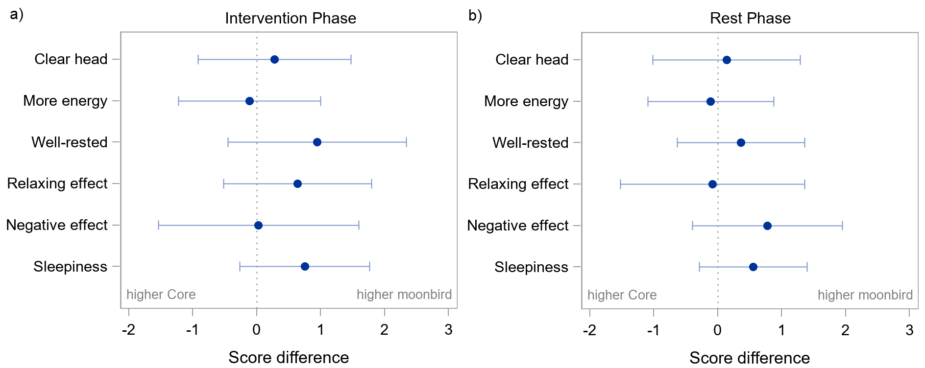
Figure A.1. Questionnaire A: general experience - Estimated differences between devices (moonbird minus Core) adjusted for baseline and 95% confidence intervals during intervention (a) and post-intervention phase (b).

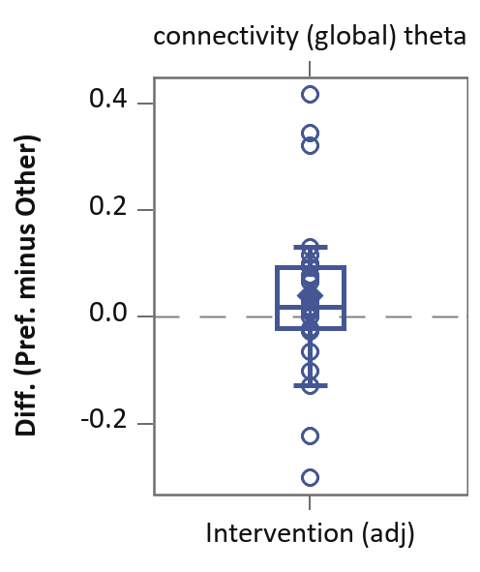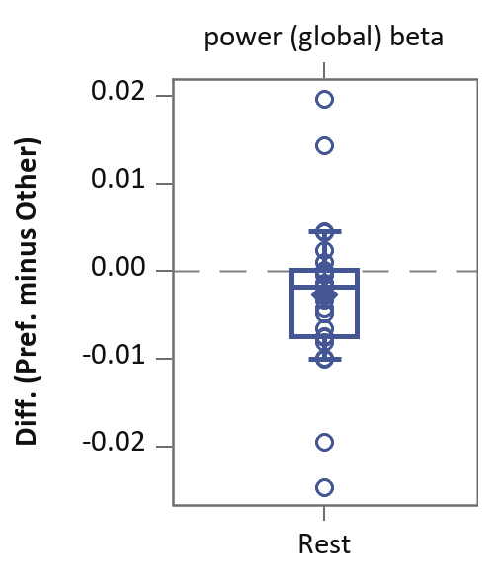
QE1 (General Preference)

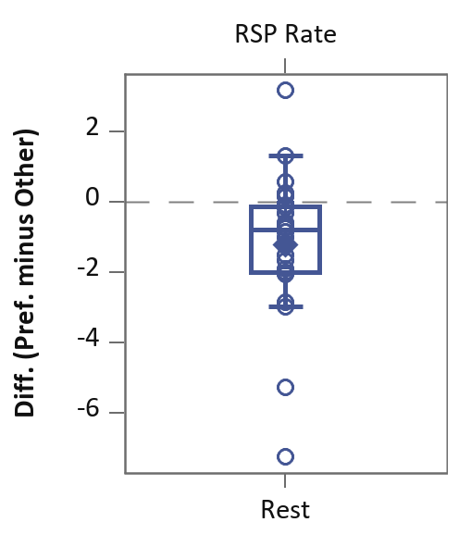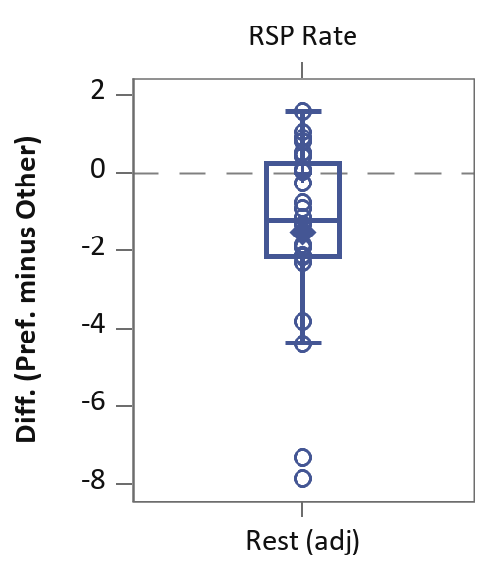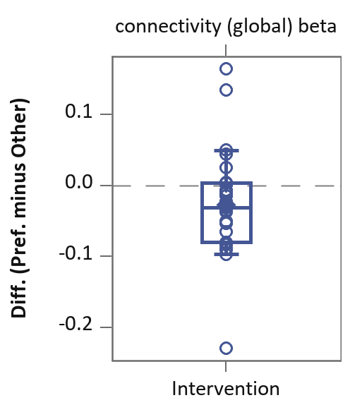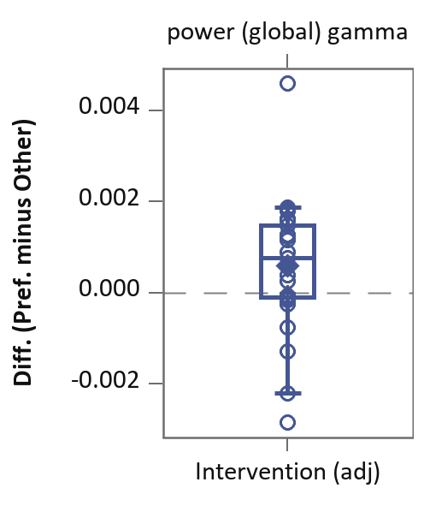
QE2 (Use Preference)
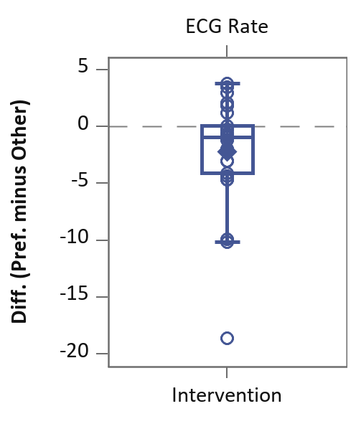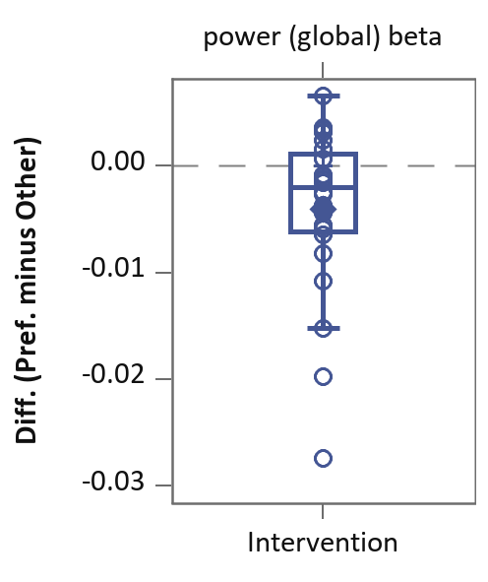
QE3 (Guidance Preference)

Figure A.2: Boxplots of the within-subject differences (preferred device minus the other), for the significantly different results. The results are presented by preference type, because some patients had a different preferred device depending on the question, e.g., there were patients that generally preferred moonbird, but preferred the guidance of the Core device. When values from the intervention phase, respectively rest phase, were adjusted for baseline before calculating the within-subject difference, this is presented in the plot as intervention (adj), respectively rest (adj).

QE1 (General preference)
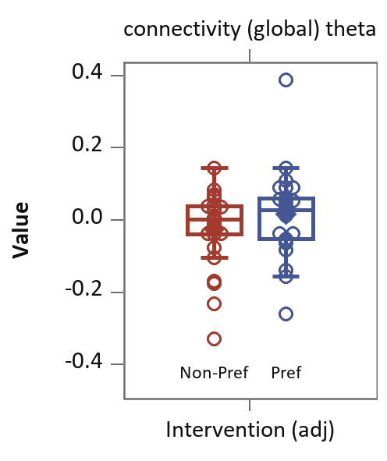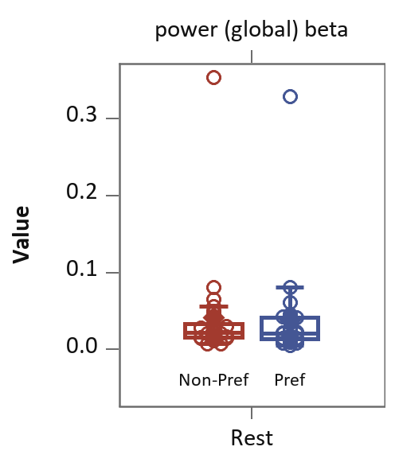
QE2 (Use Preference)
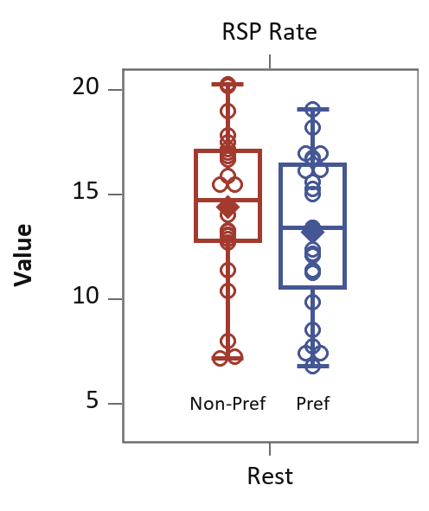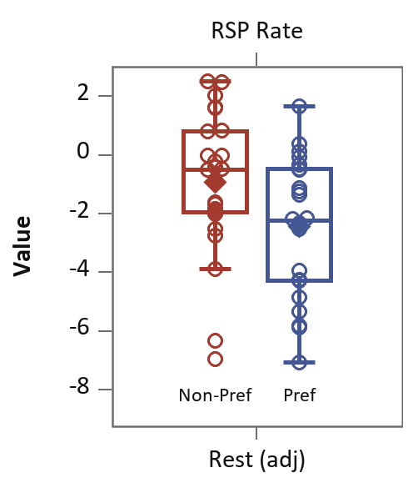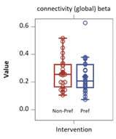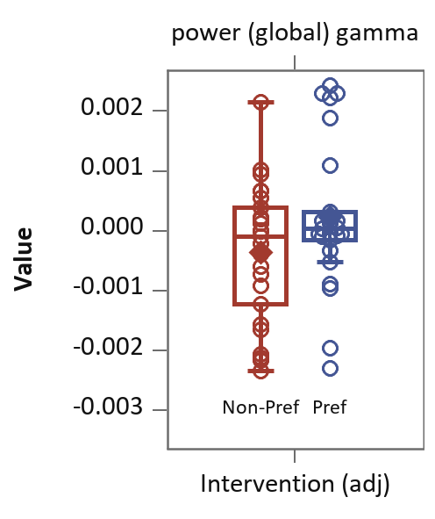

QE3 (Guidance preference)
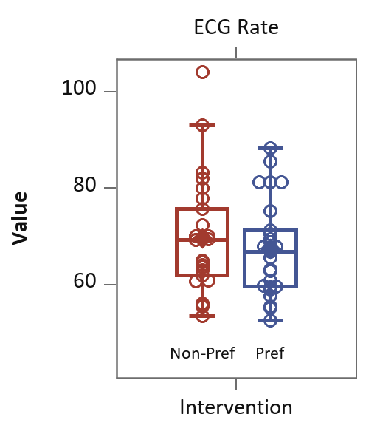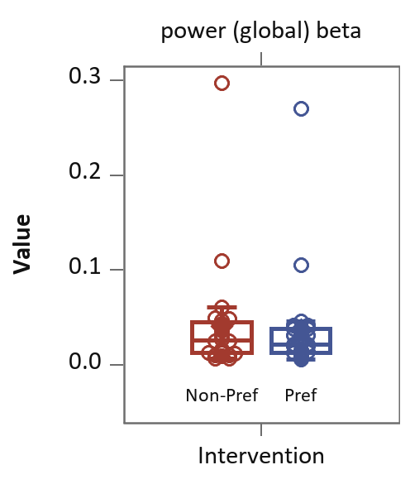
Figure A.3: Boxplots of the parameter values by preferred/non-preferred device for the significantly different results. The results are presented by preference type, because some patients had a different preferred device depending on the question, e.g., there were patients that generally preferred moonbird, but preferred the guidance of the Core device. When values from the intervention phase, respectively rest phase, were adjusted for baseline before calculating the within-subject difference, this is presented in the plot as intervention (adj), respectively rest (adj).

