SUPPLEMENTAL MATERIALS
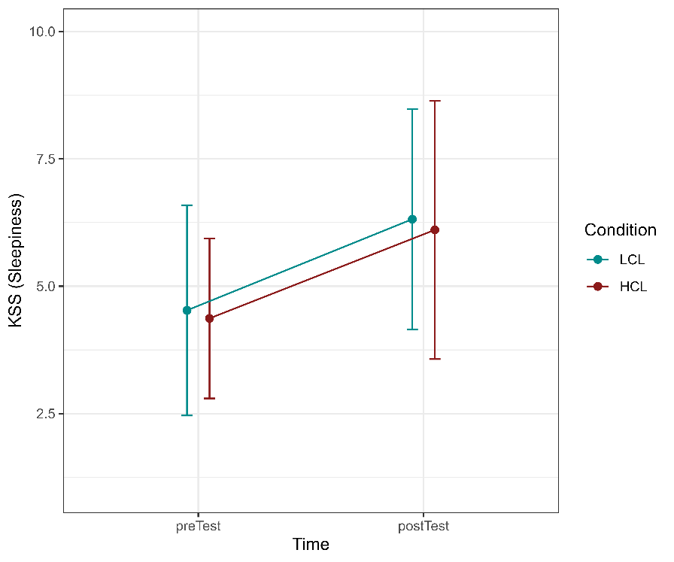
Figure S1. LMM fitted on KSS scores revealed a main effect of Time (β = 0.88, SE = 0.19, t₍₁₈₎ = 4.60, p < .001) but no effect of Condition (β = -0.09, SE = 0.36, t₍₁₈₎ = -0.42, p = 0.679) and Time*Condition interaction effect (β = -0.01, SE = 0.14, t₍₁₈₎ = -0.09, p = 0.927) suggesting sleepiness increased in a similar manner in both TLDB conditions.
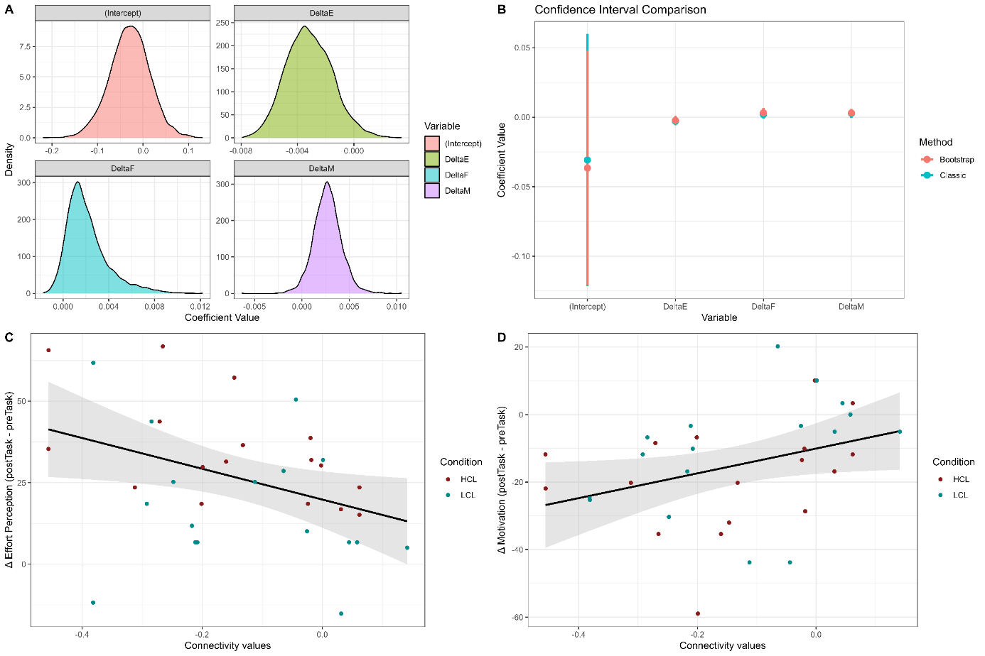
Figure S2. Models comparison with boostrapping showing the association between mPFC connectivity values and changes in fatigue, effort, and motivation. (A) Distributions of bootstrap-estimated regression coefficients for the intercept, ΔEffort (DeltaE), ΔFatigue (DeltaF), and ΔMotivation (DeltaM), derived from a linear model predicting mPFC functional connectivity with right SMG. Each panel shows the density of 5,000 bootstrap samples for one coefficient, indicating the uncertainty around the estimates. (B) Comparison of 95% confidence intervals (CIs) for each coefficient based on classical (blue) and bias-corrected and accelerated (BCa) bootstrap (red) methods. Coefficient point estimates are marked for each method. DeltaE shows a consistently negative estimate across methods, whereas DeltaF and DeltaM are positive. (C) Scatterplot illustrating the relationship between changes in Effort Perception and mPFC connectivity values, colored by task condition: High Cognitive Load (HCL, red) and Low Cognitive Load (LCL, blue). (D) Scatterplot showing the relationship between changes in Motivation and mPFC1 connectivity values, also separated by condition.
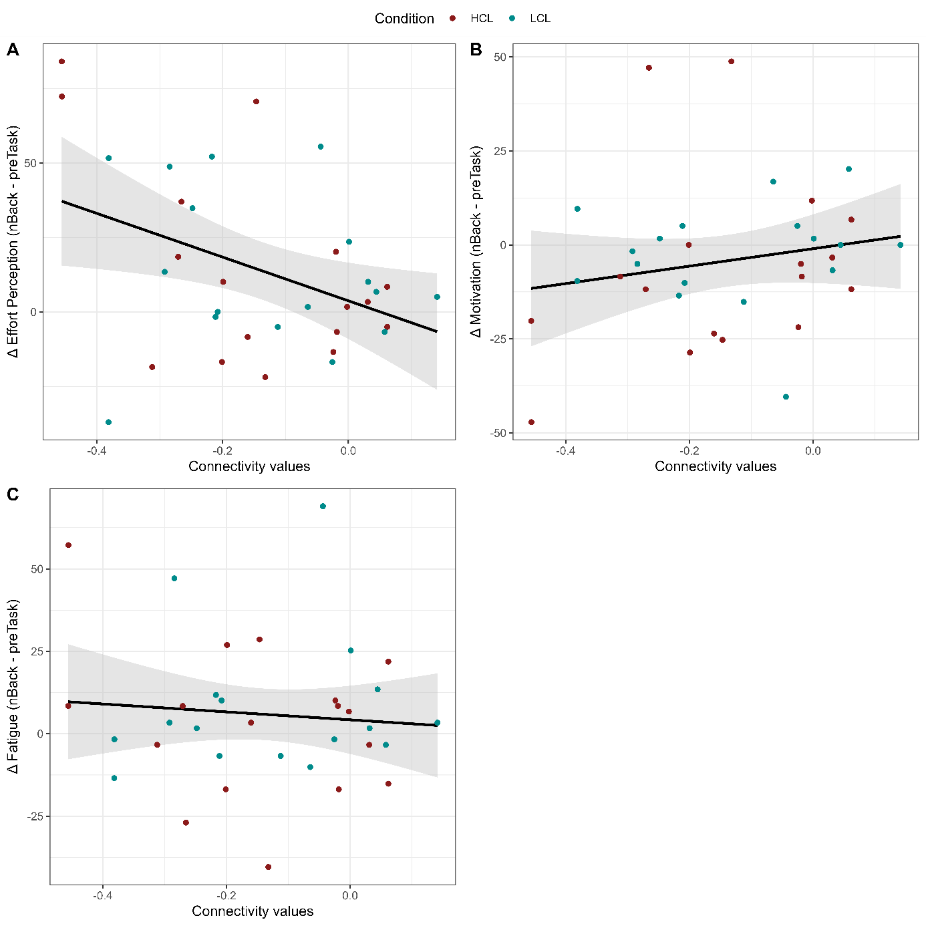
Figure S3. Scatterplots illustrating the relationship between changes in mPFC connectivity values and changes in state variable after the nBack task (VAS pre - VAS nBack), colored by TLDB condition: High Cognitive Load (HCL, red) and Low Cognitive Load (LCL, blue). (A) Results for effort perception. (B) Results for motivation. (C) Results for mental fatigue.
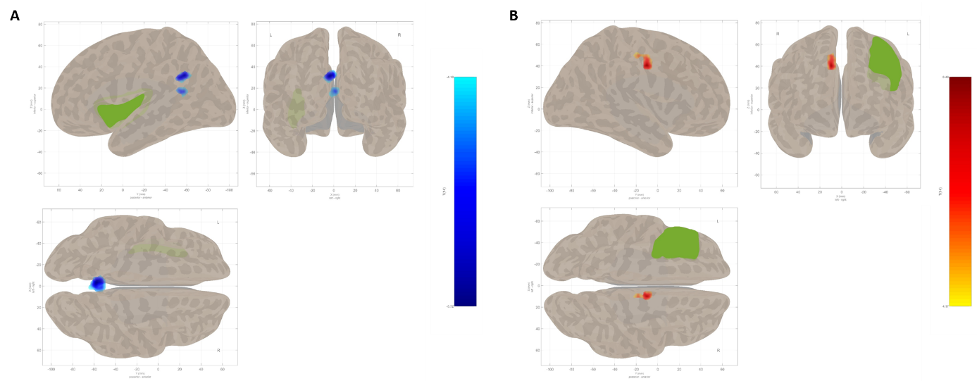
Figure S4. Changes in brain connectivity between cognitive load conditions. (A) Changes in brain functional connectivity from LCL to HCL between the left insula as the seed region (in green) and clusters of voxels using an SBC approach. Blue clusters highlight lower connectivity in HCL compared to LCL with clusters located in the precuneus and posterior cingulate cortex, respectively. (B) Changes in brain functional connectivity from LCL to HCL between the left middle frontal gyrus as the seed region (in green) and a cluster of voxels using an SBC approach. Red cluster indicates higher connectivity in HCL compared to LCL with a cluster located in anterior cingulate cortex.

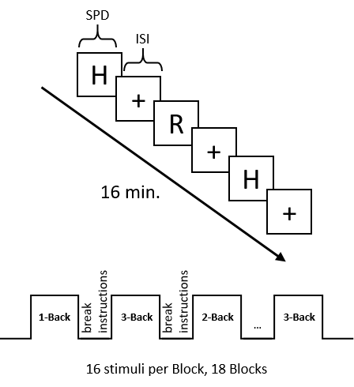
Figure S5. Following fatigue induction, participants realized a 16-minute fMRI acquisition (see Guillemin et al. (2025)) while performing a working memory n-back task of varying difficulty (Kirchner, 1958): 1 to 3-Back . In the n-back task, participants had to detect if “yes” or “no” the presented letter matched n-letters before. Stimuli were presented at a fixed pace of 1700ms (SPD), followed by a 500ms-duration inter-stimulus fixation cross (ISI). The task was composed of 18 successive 1-minute blocks of 16 stimuli, and each block started with instructions (difficulty for the block) displayed during 5000ms. Frequent breaks (approximately 15 seconds every minute) were administered throughout the fMRI session, at the end of each block, to prevent further fatigue induction.

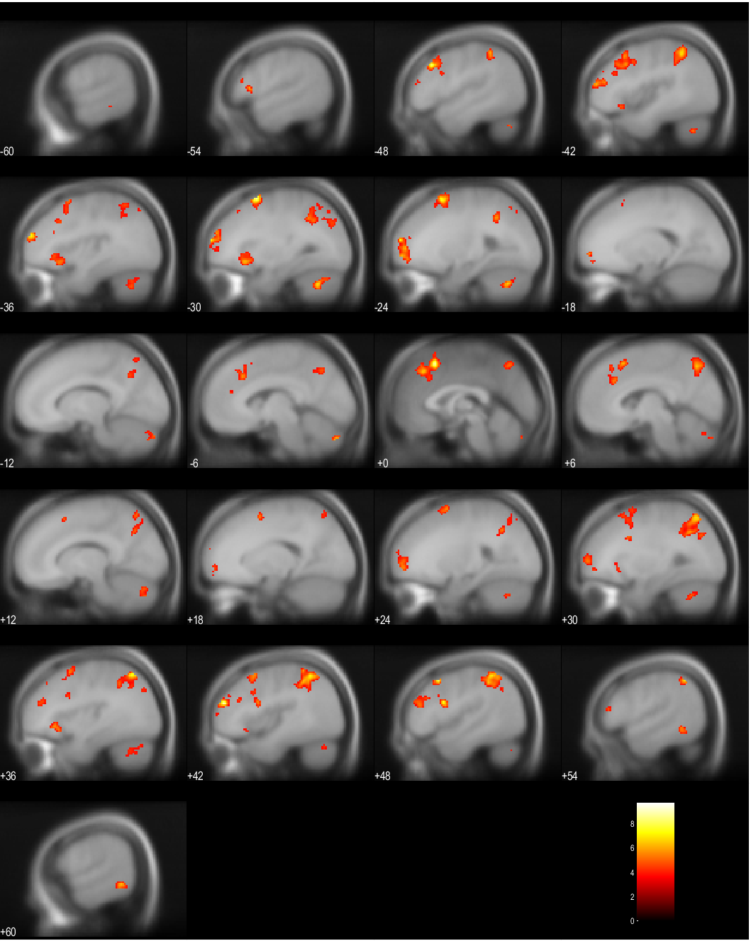
Figure S6. Parametric modulation of the BOLD response during the n-back task. Statistical parametric maps show regions with significant parametric modulation of BOLD signal as a function of the 3 difficulty-levels of working memory load (contrast: HCL + LCL), controlling for age and sex. Results are displayed at a height threshold of T = 3.69, p < 0.001 uncorrected, with an extent threshold of k = 20 voxels. Maximum intensity projections highlight clusters of activation in bilateral fronto-parietal and cingulate regions. Table S6 reports significant clusters corrected for search volume, with local maxima listed in MNI coordinates.

Table S1. Linear mixed models fitted on fatigue, effort and motivation including the FSMC cognitive subscale score as a covariate of no interest.
 | Fatigue |  |  |  | Effort |  |  |  | Motivation
Predictors | Estimates | CI | p | df | Estimates | CI | p | df | Estimates | CI | p | df
(Intercept) | 15.31 | -7.12 – 37.73 | 0.168 | 17.00 | 53.82 | 28.98 – 78.66 | <.001 | 17.00 | 86.11 | 58.37 – 113.85 | <.001 | 17.00
Condition1 | -0.49 | -6.07 – 5.10 | 0.857 | 18.00 | 3.16 | -1.02 – 7.33 | 0.130 | 18.00 | -1.23 | -5.35 – 2.89 | 0.537 | 18.00
Bin2-1 | 6.91 | -7.12 – 37.73 | 0.089 | 18.00 | 25.98 | 18.33 – 33.63 | <.001 | 18.00 | -14.25 | -21.39 – -7.11 | 0.001 | 18.00
FSMC Cog | 1.30 | 0.47 – 2.13 | 0.004 | 17.00 | 0.07 | -0.86 – 0.99 | 0.882 | 17.00 | -0.76 | -1.79 – 0.27 | 0.136 | 17.00
Condition1:Bin2-1 | -2.84 | -6.96 – 1.29 | 0.166 | 18.00 | 9.44 | 3.57 – 15.32 | 0.003 | 18.00 | -3.38 | -6.53 – -0.23 | 0.037 | 18.00

Table S2. Post-Hoc contrasts.
 | d’ |  |  |  |  |  |  |  | Criterion
 | Estimates |  | SE |  | df | t |  | P_{FDR} | Estimates |  | SE |  | df | t | P_{FDR}
HCL Bin1 – HCL Bin2 | 0.53 |  | 0.15 |  | 249 | 3.41 |  | <.01 | -0.15 |  | 0.08 |  | 251 | -1.93 | 0.0823
HCL Bin2 – HCL Bin3 | 0.04 |  | 0.15 |  | 249 | 0.25 |  | 0.8551 | 0.015 |  | 0.08 |  | 251 | 0.20 | 0.8875
HCL Bin3 – HCL Bin4 | 0.04 |  | 0.15 |  | 249 | 0.24 |  | 0.8551 | -0.21 |  | 0.08 |  | 251 | -2.68 | <.05
HCL Bin4 – HCL Bin5 | 0.01 |  | 0.15 |  | 249 | 0.04 |  | 0.9752 | 0.01 |  | 0.08 |  | 251 | 0.18 | 0.8932
HCL Bin5 – HCL Bin6 | -0.09 |  | 0.15 |  | 249 | -0.59 |  | 0.6558 | -0.001 |  | 0.08 |  | 251 | -0.02 | 0.9878
HCL Bin6 – HCL Bin7 | 0.23 |  | 0.15 |  | 249 | 1.5 |  | 0.1948 | -0.09 |  | 0.08 |  | 251 | -1.13 | 0.3253
HCL Bin7 – HCL Bin8 | 0.18 |  | 0.15 |  | 249 | 1.15 |  | 0.3377 | -0.07 |  | 0.08 |  | 251 | -0.85 | 0.4692
LCL Bin1 – LCL Bin2 | 0.16 |  | 0.15 |  | 249 | 1.06 |  | 0.3726 | 0.03 |  | 0.08 |  | 251 | 0.35 | 0.7808
LCL Bin2 – LCL Bin3 | 0.01 |  | 0.15 |  | 249 | 0.06 |  | 0.9727 | 0.04 |  | 0.08 |  | 251 | 0.54 | 0.6534
LCL Bin3 – LCL Bin4 | -0.01 |  | 0.15 |  | 249 | -0.08 |  | 0.9649 | -0.03 |  | 0.08 |  | 251 | -0.41 | 0.7451
LCL Bin4 – LCL Bin5 | -0.08 |  | 0.15 |  | 249 | -0.51 |  | 0.6853 | -0.6 |  | 0.08 |  | 251 | -0.77 | 0.5057
LCL Bin5 – LCL Bin6 | 0.25 |  | 0.15 |  | 249 | 1.63 |  | 0.1558 | -0.7 |  | 0.08 |  | 251 | -0.86 | 0.4692
LCL Bin6 – LCL Bin7 | 0.04 |  | 0.15 |  | 249 | 0.24 |  | 0.8551 | -0.07 |  | 0.08 |  | 251 | -0.88 | 0.4582
LCL Bin7 – LCL Bin8 | -0.05 |  | 0.15 |  | 249 | -0.35 |  | 0.8030 | 0.13 |  | 0.08 |  | 251 | 1.68 | 0.1337
HCL Bin1 – LCL Bin1 | -0.87 |  | 0.21 |  | 48.5 | -4.12 |  | <.001 | 0.17 |  | 0.1 |  | 64 | 1.73 | 0.1255
HCL Bin2 – LCL Bin2 | -1.23 |  | 0.21 |  | 48.5 | -5.83 |  | <.0001 | 0.35 |  | 0.1 |  | 64 | 3.50 | <.01
HCL Bin3 – LCL Bin3 | -1.26 |  | 0.21 |  | 48.5 | -5.96 |  | <.0001 | 0.38 |  | 0.1 |  | 64 | 3.77 | <.001
HCL Bin4 – LCL Bin4 | -1.31 |  | 0.21 |  | 48.5 | -6.20 |  | <.0001 | 0.55 |  | 0.1 |  | 64 | 5.54 | <.0001
HCL Bin5 – LCL Bin5 | -1.40 |  | 0.21 |  | 48.5 | -6.60 |  | <.0001 | 0.48 |  | 0.1 |  | 64 | 4.80 | <.0001
HCL Bin6 – LCL Bin6 | -1.06 |  | 0.21 |  | 48.5 | -4.99 |  | <.0001 | 0.41 |  | 0.1 |  | 64 | 4.14 | <.001
HCL Bin7 – LCL Bin7 | -1.25 |  | 0.21 |  | 48.5 | -5.91 |  | <.0001 | 0.43 |  | 0.1 |  | 64 | 4.33 | <.001
HCL Bin8 – LCL Bin8 | -1.48 |  | 0.21 |  | 48.5 | -6.99 |  | <.0001 | 0.63 |  | 0.1 |  | 64 | 6.30 | <.0001
Table S3. Multiple Linear Regression models fitted to predict connectivity values as a function of changes in subjective states scores (VAS post – pre).
 |  | R²/Adj-R² |  | T |  |  | SE |  |  | Estimate |  | p
lIns_PreCun |  | 0.06/-0.04
(Intercept) |  |  |  | -1.87 |  |  | 0.05 |  |  | -0.09 |  | 0.07
Δ Fatigue |  |  |  | 0.80 |  |  | 0.001 |  |  | 0.001 |  | 0.43
Δ Effort |  |  |  | -0.99 |  |  | 0.002 |  |  | -0.002 |  | 0.33
Δ Motivation |  |  |  | 0.58 |  |  | 0.002 |  |  | 0.001 |  | 0.57
lIns_PCC |  | 0.01/-0.09
(Intercept) |  |  |  | -2.56 |  |  | 0.05 |  |  | -0.12* |  | < .05
Δ Fatigue |  |  |  | 0.53 |  |  | 0.001 |  |  | 0.001 |  | 0.60
Δ Effort |  |  |  | 0.05 |  |  | 0.001 |  |  | 0.0001 |  | 0.96
Δ Motivation |  |  |  | 0.18 |  |  | 0.001 |  |  | 0.003 |  | 0.86
lMidFG_ACC |  | 0.09/-0.01
(Intercept) |  |  |  | -3.66 |  |  | 0.02 |  |  | -0.09*** |  | < .001
Δ Fatigue |  |  |  | 0.13 |  |  | 0.001 |  |  | 0.0001 |  | 0.90
Δ Effort |  |  |  | 1.06 |  |  | 0.001 |  |  | 0.001 |  | 0.30
Δ Motivation |  |  |  | -0.67 |  |  | 0.001 |  |  | -0.001 |  | 0.51
mPFC_SMG |  | 0.24/0.16
(Intercept) |  |  |  | -0.69 |  |  | 0.04 |  |  | -0.03 |  | 0.49
Δ Fatigue |  |  |  | 1.30 |  |  | 0.001 |  |  | 0.002 |  | 0.20
Δ Effort |  |  |  | -2.05 |  |  | 0.001 |  |  | -0.003* |  | < .05
Δ Motivation |  |  |  | 1.62 |  |  | 0.002 |  |  | 0.003 |  | 0.11
mPFC_Cereb |  | 0.03/-0.06
(Intercept) |  |  |  | 1.78 |  |  | 0.05 |  |  | 0.08 |  | 0.09
Δ Fatigue |  |  |  | -0.05 |  |  | 0.001 |  |  | -0.0001 |  | 0.96
Δ Effort |  |  |  | -0.96 |  |  | 0.002 |  |  | -0.001 |  | 0.35
Δ Motivation |  |  |  | -0.29 |  |  | 0.002 |  |  | -0.0005 |  | 0.78
mPFC_dlPFC |  | 0.05/-0.04
(Intercept) |  |  |  | 3.06 |  |  | 0.05 |  |  | 0.14** |  | < .01
Δ Fatigue |  |  |  | 0.57 |  |  | 0.001 |  |  | 0.001 |  | 0.57
Δ Effort |  |  |  | 0.62 |  |  | 0.002 |  |  | 0.001 |  | 0.54
Δ Motivation |  |  |  | -0.39 |  |  | 0.002 |  |  | -0.001 |  | 0.70
Note. lIns = left insula; PreCun = precuneus; PCC = posterior cingulate cortex ; lMidFG = left middle frontal gyrus; ACC = anterior cingulate gyrus; mPFC = medial prefrontal cortex; SMG = supramarginal gyrus; Cereb = cerebellum; dlPFC = dorsolateral prefrontal cortex.

Table S4. Hierarchical Multiple Linear Regression models fitted to predict connectivity between mPFC and right SMG as a function of changes in subjective states scores (VAS post – pre; Model 1), and Condition (HCL vs. LCL) and Interactions (Model 2).
 | R²/Adj-R² | T | SE | Estimate | p
Model 1 | 0.24/0.16
(Intercept) |  | -0.69 | 0.04 | -0.03 | 0.49
Δ Fatigue |  | 1.30 | 0.001 | 0.002 | 0.20
Δ Effort |  | -2.05 | 0.001 | -0.003* | < .05
Δ Motivation |  | 1.62 | 0.002 | 0.003 | 0.11
Model 2 | 0.39/0.22
(Intercept) |  | 0.28 | 0.05 | 0.01
Δ Fatigue |  | 2.35 | 0.002 | 0.004* | < .05
Condition1 |  | 1.33 | 0.05 | 0.07 | 0.19
Δ Effort |  | -3.11 | 0.002 | -0.005** | <.01
Δ Motivation |  | 1.94 | 0.002 | 0.003 | 0.06
Δ Fatigue:Condition1 |  | -1.51 | 0.002 | -0.003 | 0.14
Condition1:Δ Effort |  | -0.48 | 0.002 | -0.001 | 0.63
Condition1:Δ Motivation |  | -1.05 | 0.002 | -0.001 | 0.30

Table S5. Hierarchical Multiple Linear Regression models fitted to predict connectivity between mPFC and right SMG as a function of changes in subjective states scores (VAS n-back – pre; Model 1), and Condition (HCL vs. LCL) and Interactions (Model 2).
 | R²/Adj-R² | T | SE | Estimate | p
Model 1 | 0.27/0.20
(Intercept) |  | -3.76 | 0.03 | -0.10*** | < .001
Δ Fatigue |  | 2.11 | 0.002 | 0.004* | < .05
Δ Effort |  | -3.06 | 0.001 | -0.003** | < .01
Δ Motivation |  | 1.74 | 0.002 | 0.003 | 0.09
Model 2 | 0.28/0.09
(Intercept) |  | -3.55 | 0.03 | -0.01** | < . 01
Δ Fatigue |  | 1.68 | 0.002 | 0.004 | 0.10
Condition1 |  | 0.33 | 0.03 | 0.01 | 0.74
Δ Effort |  | -2.67 | 0.001 | -0.003* | <.05
Δ Motivation |  | 1.34 | 0.002 | 0.003 | 0.19
Δ Fatigue:Condition1 |  | -0.46 | 0.002 | -0.001 | 0.65
Condition1:Δ Effort |  | -0.06 | 0.001 | -0.00007 | 0.95
Condition1:Δ Motivation |  | -0.37 | 0.002 | -0.0008 | 0.71

Table S6. Significant clusters highlighted by the parametric modulation of BOLD response during the n-back task (contrast: HCL + LCL).
Label | Cluster |  |  |  | Peak |  |  |  | Coordinates (mm)
 | p(FWE-corr) | p(FDR-corr) | size | p(unc) | p(FWE-corr) | p(FDR-corr) | T | p(unc) | x | y | z
Frontal_Mid_2_L | 6.7159E-07 | 9.5971E-07 | 771 | 5.6454E-08 | 0.00315352 | 0.03613276 | 9.69813156 | 2.1003E-08 | -28 | 10 | 62
 |  |  |  |  | 0.02336174 | 0.03613276 | 8.17596054 | 2.0885E-07 | -50 | 24 | 36
 |  |  |  |  | 0.31745021 | 0.11310983 | 6.0877037 | 7.8505E-06 | -44 | 16 | 38
Frontal_Mid_2_R | 0.00110185 | 0.00039386 | 320 | 9.2672E-05 | 0.00792727 | 0.03613276 | 9.06573868 | 5.2797E-08 | 44 | 48 | 22
 |  |  |  |  | 0.74235664 | 0.23389577 | 5.20383835 | 4.348E-05 | 48 | 38 | 18
 |  |  |  |  | 0.96064756 | 0.39959904 | 4.60531902 | 0.00014626 | 48 | 30 | 26
Frontal_Sup_Medial_L | 4.571E-06 | 4.3547E-06 | 642 | 3.8424E-07 | 0.01369364 | 0.03613276 | 8.61458969 | 1.0478E-07 | 0 | 20 | 52
 |  |  |  |  | 0.24683061 | 0.10351991 | 6.30004835 | 5.2849E-06 | 0 | 34 | 42
 |  |  |  |  | 0.53780466 | 0.1669688 | 5.59402227 | 2.0169E-05 | -6 | 26 | 36
Frontal_Inf_Oper_R | 0.01524635 | 0.00399181 | 194 | 0.00129147 | 0.01507055 | 0.03613276 | 8.53510189 | 1.1852E-07 | 46 | 10 | 22
 |  |  |  |  | 0.77987468 | 0.25661409 | 5.1281929 | 5.0573E-05 | 30 | 12 | 32
 |  |  |  |  | 0.83350036 | 0.28020511 | 5.01167154 | 6.391E-05 | 44 | 16 | 34
Parietal_Inf_R | 2.3777E-12 | 6.7953E-12 | 1788 | 1.9986E-13 | 0.02299647 | 0.03613276 | 8.18875027 | 2.0462E-07 | 46 | -46 | 52
 |  |  |  |  | 0.05085801 | 0.05051332 | 7.55384064 | 5.7902E-07 | 34 | -66 | 54
 |  |  |  |  | 0.09629448 | 0.05923316 | 7.05185127 | 1.368E-06 | 40 | -56 | 52
Frontal_Sup_2_L | 1.2023E-05 | 6.8722E-06 | 580 | 1.0106E-06 | 0.02496817 | 0.03613276 | 8.12208176 | 2.2768E-07 | -26 | 60 | 14
 |  |  |  |  | 0.04177865 | 0.04743287 | 7.70961189 | 4.4645E-07 | -22 | 58 | -4
 |  |  |  |  | 0.07171339 | 0.05725969 | 7.28322172 | 9.1658E-07 | -34 | 56 | 16
Frontal_Mid_2_L | 8.3862E-05 | 3.9948E-05 | 462 | 7.0497E-06 | 0.03168089 | 0.04025434 | 7.9303422 | 3.1053E-07 | 48 | 16 | 46
 |  |  |  |  | 0.2416499 | 0.10351991 | 6.3175807 | 5.1164E-06 | 22 | 6 | 64
 |  |  |  |  | 0.33440265 | 0.11310983 | 6.04254436 | 8.5466E-06 | 34 | 8 | 56
Parietal_Inf_L | 1.0933E-05 | 6.8722E-06 | 586 | 9.1899E-07 | 0.09356922 | 0.05923316 | 7.07439041 | 1.3153E-06 | -44 | -48 | 50
 |  |  |  |  | 0.36983655 | 0.12484267 | 5.95351505 | 1.0113E-05 | -26 | -50 | 40
 |  |  |  |  | 0.73685532 | 0.23389577 | 5.21466303 | 4.2553E-05 | -32 | -56 | 38
Cerebelum_Crus1_L | 0.00103985 | 0.00039386 | 323 | 8.7454E-05 | 0.1090827 | 0.05945239 | 6.95388508 | 1.6243E-06 | -28 | -62 | -36
 |  |  |  |  | 0.80393571 | 0.26333477 | 5.077456 | 5.5988E-05 | -42 | -62 | -40
Temporal_Inf_R | 0.10051072 | 0.01892155 | 116 | 0.00890426 | 0.21576182 | 0.10351991 | 6.41049099 | 4.3123E-06 | 58 | -50 | -8
Frontal_Inf_Tri_L | 0.51466259 | 0.12153495 | 53 | 0.06076748 | 0.25156188 | 0.10351991 | 6.28431416 | 5.441E-06 | -58 | 18 | 8
Ins_L | 0.00285671 | 0.00090582 | 272 | 0.00024048 | 0.28232282 | 0.11215605 | 6.18778133 | 6.5098E-06 | -32 | 22 | -10
 |  |  |  |  | 0.54365785 | 0.1669688 | 5.58263063 | 2.062E-05 | -34 | 28 | -4
Cerebelum_Crus2_L | 0.01708498 | 0.00410426 | 189 | 0.00144856 | 0.33323099 | 0.11310983 | 6.04560757 | 8.4974E-06 | -8 | -80 | -36
 |  |  |  |  | 0.7249906 | 0.23059758 | 5.2378273 | 4.0635E-05 | 10 | -74 | -30
 |  |  |  |  | 0.89056065 | 0.31169918 | 4.86700869 | 8.5645E-05 | 4 | -82 | -34
Frontal_Sup_2_R | 0.00316436 | 0.00090582 | 267 | 0.00026642 | 0.39198622 | 0.13097646 | 5.9009757 | 1.1174E-05 | 22 | 58 | -4
 |  |  |  |  | 0.43080529 | 0.14092644 | 5.81356239 | 1.3204E-05 | 28 | 60 | 4
 |  |  |  |  | 0.93044072 | 0.35084139 | 4.73878241 | 0.00011123 | 20 | 62 | 14
Insula_R | 0.06208385 | 0.01308457 | 135 | 0.00538777 | 0.50641031 | 0.16213705 | 5.65599108 | 1.7884E-05 | 36 | 28 | -6
Cerebelum_Crus1_R | 0.02253677 | 0.00501134 | 177 | 0.0019161 | 0.87191318 | 0.30265715 | 4.91775036 | 7.7267E-05 | 22 | -66 | -34
 |  |  |  |  | 0.87247952 | 0.30265715 | 4.91626883 | 7.75E-05 | 32 | -60 | -34
 |  |  |  |  | 0.99547775 | 0.53047177 | 4.25008774 | 0.00030549 | 42 | -68 | -30
Frontal_Mid_2_R | 0.875536 | 0.33085376 | 26 | 0.17515787 | 0.9105974 | 0.33157945 | 4.80683851 | 9.68E-05 | 34 | 38 | 42
Occipital_Mid_L | 0.10051072 | 0.01892155 | 116 | 0.00890426 | 0.92674907 | 0.35084139 | 4.75226879 | 0.0001082 | -34 | -72 | 50
 |  |  |  |  | 0.97540837 | 0.43098689 | 4.51160049 | 0.00017745 | -30 | -78 | 34
 |  |  |  |  | 0.98825172 | 0.48319707 | 4.38563538 | 0.00023037 | -26 | -70 | 40
Frontal_Inf_Tri_L | 0.93644191 | 0.41453343 | 20 | 0.23165103 | 0.99501823 | 0.53047177 | 4.26272392 | 0.00029754 | -46 | 12 | 26

