TITLE: 16/50 words
The Role of Mineral Heterogeneity, Trabecular Orientation, and Collagen Fibers Arrangement on Tissue-Level Trabecular Bone Mechanics
E Pedrinazzi (1,2), S Blouin (3), A. Hego (1), A Simar (2), MA Hartmann (3), D Ruffoni (1)
1. University of Liège, Belgium;
2. Catholic University of Louvain, Belgium;
3. Ludwig Boltzmann Institute of Osteology, Austria.
TEXT: 400/400 words (with captions and references)
Trabecular bone is a porous tissue, with a multiscale heterogeneous and anisotropic microstructure. At the architectural length scale, it features a complex network of beams (i.e. trabeculae). At the tissue level each trabecula comprises multiple bone packets, with different shapes, mineral content, and collagen arrangement [1]. The influence of material heterogeneity and structural anisotropy on the mechanical behaviour of trabecular bone remains poorly understood. Here, tissue-level mechanical properties of trabecular bone were considered in individual bone packets, in relation to local mineral content and collagen organization. A post-mortem trabecular bone sample was extracted from the iliac crest of a healthy 93 y.o. woman. Quantitative backscattered electron imaging (qBEI) generated 2-dimensional maps of the mineral content, while micro-computed tomography (micro-CT) provided 3D information on the trabecular network below the exposed surface. By superimposing the two techniques, trabeculae showing similar Ca content and oriented parallel and perpendicular to the qBEI plane were selected, to address microstructural anisotropy. Indentation elastic modulus was measured on the selected trabeculae using nanoindentation (nIND). Second harmonic generation microscopy (SHG) was employed to assess collagen organization qualitatively. Results from qBEI and nIND for all indents are shown in Fig. 1, demonstrating that for comparable values of mineral content, the measured elastic modulus tends to be higher for perpendicular trabeculae, which were in average 1.38 stiffer than horizontal trabeculae. SHG images (Fig. 2) reveal well-defined lamellar patterns in both trabeculae. Discontinuities at cement lines separating different bone packets were observed, with some neighbouring packets displaying differently oriented lamellae. Notably, SHG images of perpendicular trabeculae showed a weaker signal (darker grey levels) compared to parallel trabeculae, indicating a higher degree of out-of-plane fibril orientation, as SHG signals arise mainly from in-plane collagen fibril [2]. Thus, collagen fibrils are predominantly aligned along the trabecular axis, this is consistent with the mechanical anisotropy shown by nIND, as reported in literature [3]. These results will inform a computational model to unravel the interplay between trabecular microstructure and material heterogeneity in trabecular bone mechanics.
[1] Smith et al., Journal of Biomechanics 43, 2010
[2] Collins et al., Materialia 9, 2020
[3] Reznikov et al., Bone 71, 2015
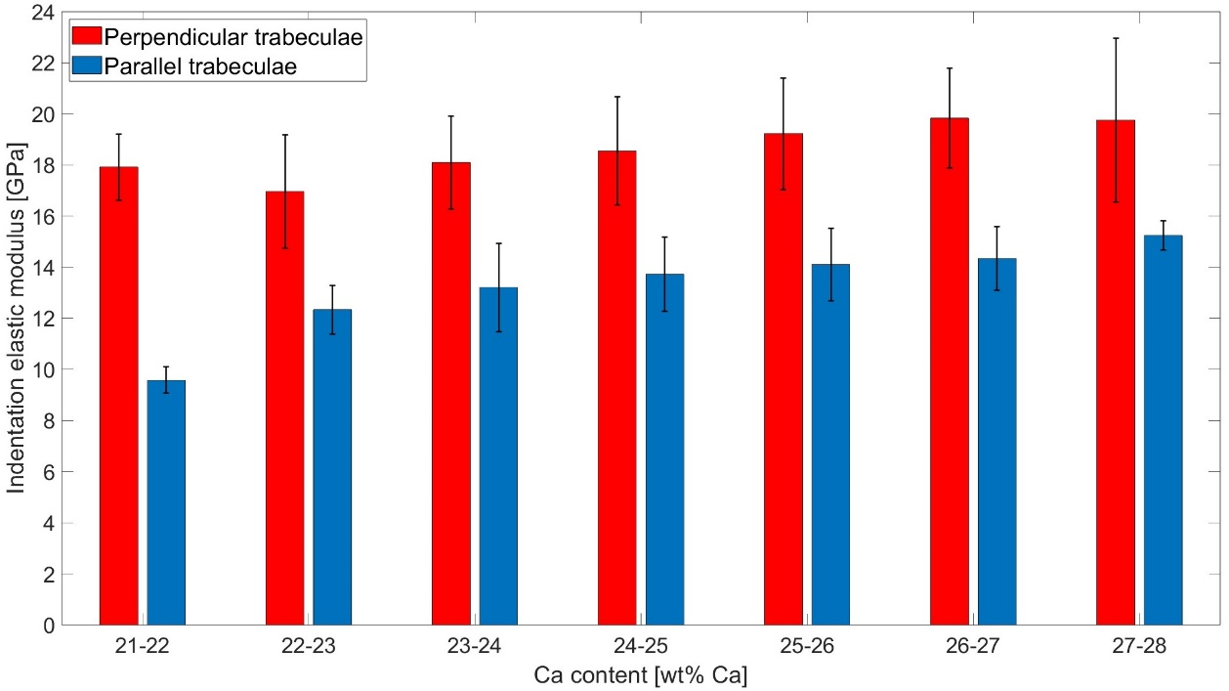
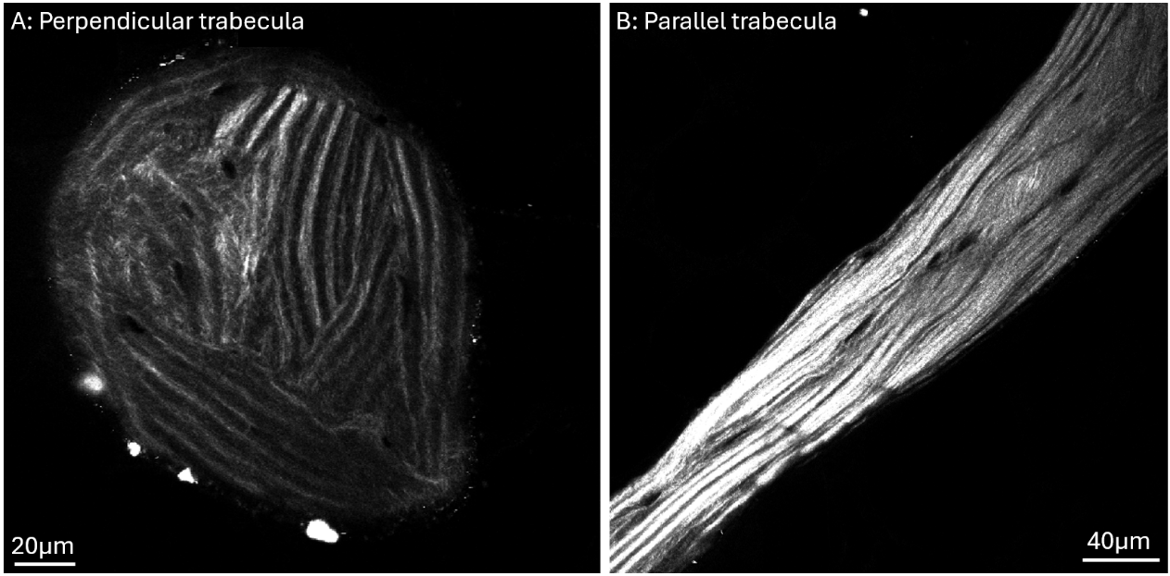
Fig. 1: Average indentation modulus for specific Ca content values. Indents are grouped in two categories: perpendicular and parallel trabeculae. Data shown as mean value ± standard deviation.
Fig. 2: SHG images of two analyzed trabeculae oriented roughly (A) perpendicular and (B) parallel to the imaging plane.

