Occurrence and environmental risk assessment of 4 estrogenic compounds in surface water in Belgium, using chemical analysis based on LC-MS/MS and achieving the limits of quantification required by the EU Watch List

Alex Glineur^{a,b,*}, Katherine Nott^{b}, Philippe Carbonnelle^{b}, Sébastien Ronkart^{b}, Thomas Pollet^{c}, Giorgia Purcaro^{a,∗}
ªLaboratory of Analytical Chemistry, Gembloux Agro-Bio Tech, University of Liège, Passage des Déportés 2, 5030 Gembloux, Belgium
^{b}La Société wallonne des eaux, Rue de la Concorde 41, 4800 Verviers, Belgium
^{c}Biodiversity and landscape, Gembloux Agro-Bio Tech, University of Liège, Avenue Maréchal juin 27, 5030 Gembloux, Belgium

* Corresponding authors. Contact information:
Alex Glineur, alex.glineur@uliege.be
Giorgia Purcaro, gpurcaro@uliege.be
Gembloux Agro-Bio Tech, University of Liège
Bât. G1 Chimie des agro-biosystèmes, Passage des Déportés 2,
5030 Gembloux, Belgium
Office phone: +32 (0)81 62 22 20

Abstract
The presence of natural estrogens estrone (E1), 17β-estradiol (E2), estriol (E3) and synthetic estrogen 17α-ethynylestradiol (EE2) in the aquatic environment has raised concerns because of their high potency as endocrine disrupting chemicals. The European Commission (EC) established a Watch List of contaminants of emerging concerns including E1, E2 and EE2. The proposed environmental quality standards (EQSs) are 3.6, 0.4, 0.035 ng/L, for E1, E2, EE2, respectively. A thorough evaluation of analytical procedures developed by several studies aiming to perform sampling campaigns in different European countries highlighted that the required limits of quantification in surface water were not reached, especially for EE2 and to a lesser extent for E2. Moreover, data regarding the occurrence of these contaminants in Belgian surface water are very limited. A sampling campaign was therefore performed on a wide range of rivers in Belgium (accounting for a total of 63 samples). The detection frequencies of E1, E2, E3 and EE2 were 100, 98, 86 and 48 %, respectively. E1 showed the highest mean concentration (=4.433 ng/L). In contrast, the mean concentration of EE2 was 0.042 ng/L. The risk quotients (RQs) were calculated based on the respective EQS of each analyte. The frequency of exceedance of the EQS was 31.7 % for E1, EE2, while it increased to 44.4 % for E2. The extent of exceedance of the EQS, represented by the 95th percentile of the RQ dataset, was higher than 1 for E1, E2, EE2. The use of a confusion matrix was investigated to try to predict the risk posed by E2, EE2, based on the concentration of E1.
Keywords: EU Watch List, estrogenic compounds, Belgian river waters, environmental risk assessment, risk prediction, LC-MS/MS

A)
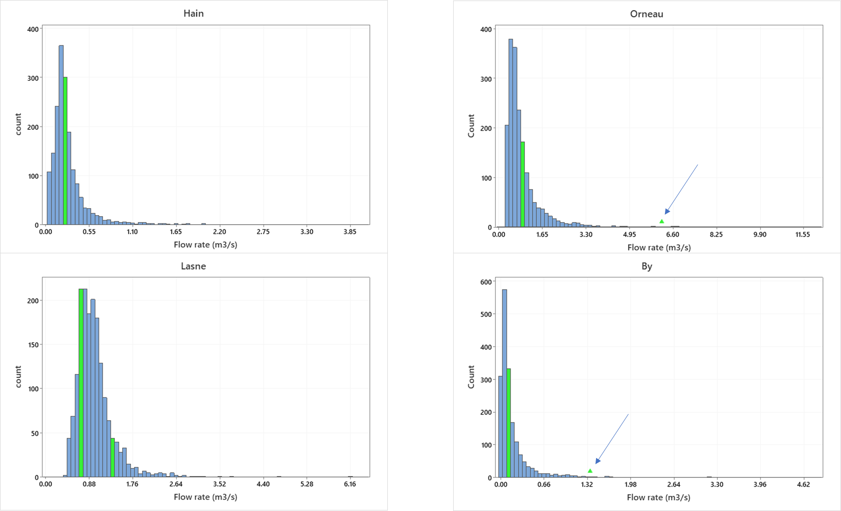

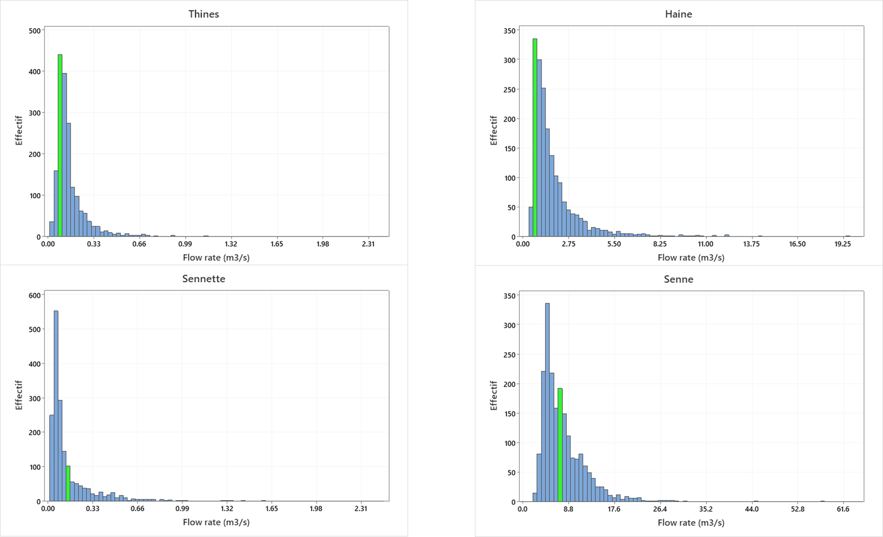
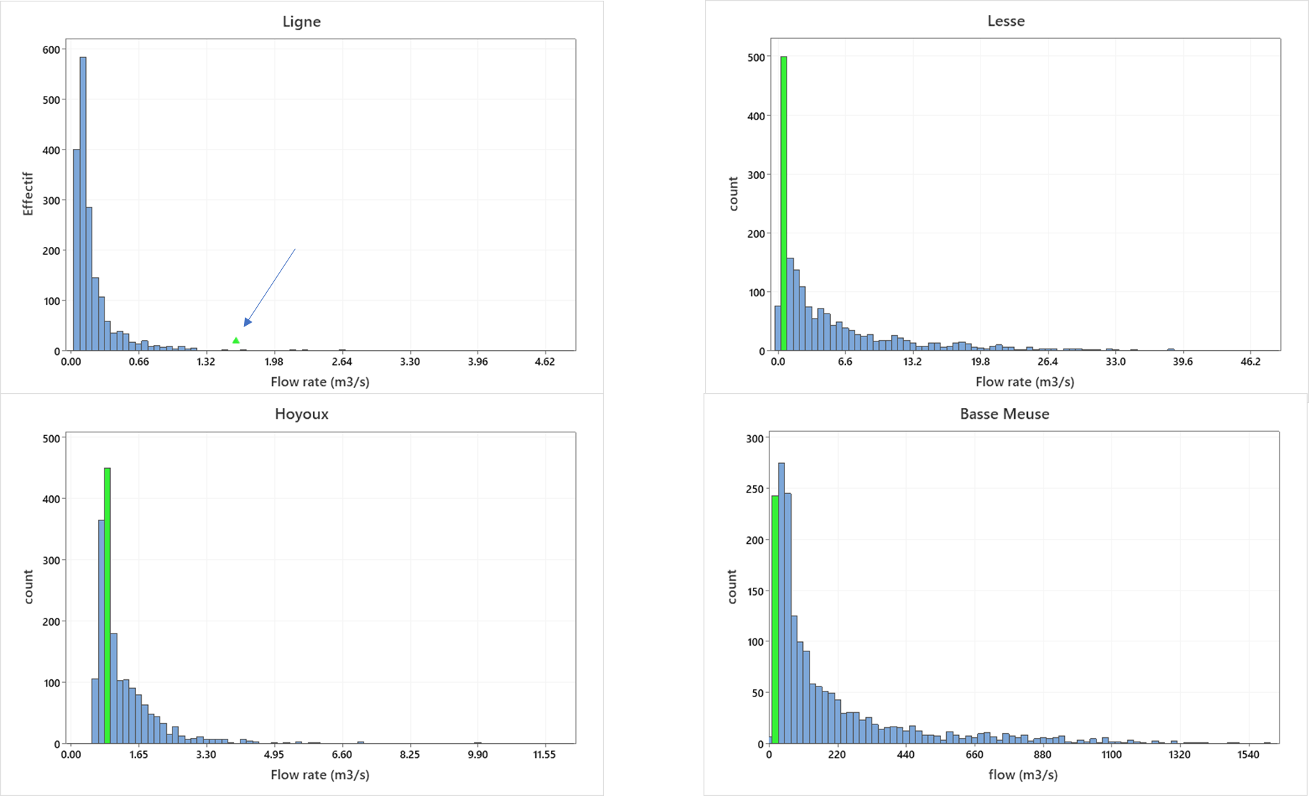
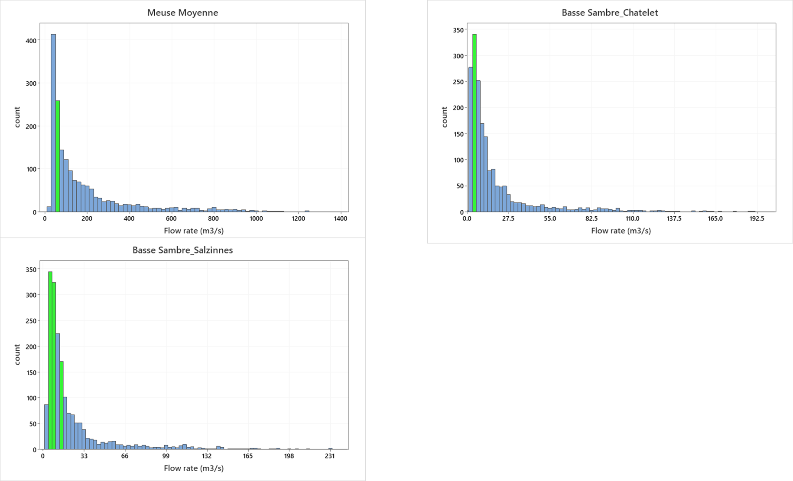
Figure S1. Histogram charts of daily mean flow rates over a five-year period for different rivers in Belgium
Figure S2A. Location of sampling points and nearby wastewater treatment plants in several of the watersheds investigated (a: Senne, b: Meuse aval, c: Sambre, d: Meuse amont, e: Dyle-Gette, f: Lesse)
Figure S2B. Location of sampling points and nearby wastewater treatment plants in several of the watersheds investigated (a: Senne, b: Meuse aval, c: Sambre, d: Meuse amont, e: Dyle-Gette, f: Lesse)
Figure S2C. Location of sampling points and nearby wastewater treatment plants in several of the watersheds investigated (a: Senne, b: Meuse aval, c: Sambre, d: Meuse amont, e: Dyle-Gette, f: Lesse)
Figure S2D. Location of sampling points and nearby wastewater treatment plants in several of the watersheds investigated (a: Senne, b: Meuse aval, c: Sambre, d: Meuse amont, e: Dyle-Gette, f: Lesse)
Figure S2E. Location of sampling points and nearby wastewater treatment plants in several of the watersheds investigated (a: Senne, b: Meuse aval, c: Sambre, d: Meuse amont, e: Dyle-Gette, f: Lesse)
Figure S2F. Location of sampling points and nearby wastewater treatment plants in several of the watersheds investigated (a: Senne, b: Meuse aval, c: Sambre, d: Meuse amont, e: Dyle-Gette, f: Lesse)

Table S1. Location of sampling sites and nearby wastewater treatment plant. The number of each sampling site code corresponds to the location on the river (from upstream to downstream on a river).
Sampling location | GPS coordinates | River/water resource (sampling site code) | Watershed | Wastewater treatment plant (WWTP) | WWTP GPS coordinates | WWTP capacity (Population Equivalent, PE) | Upstream (Up)/Downstream (Dw) | Other information
Thuin | 50.3416 N, 4.28735 E | Sambre (1) | Sambre | / | / | / | / | /
Charleroi | 50.40574 N, 4.44105 E | Sambre (2) | Sambre | Montignies-sur-Sambre | 50.40262 N, 4.45783 E | 200,000 | Up | /
Châtelet | 50.40702 N, 4.51926 E | Sambre (3) | Sambre | Montignies-sur-Sambre | 50.40262 N, 4.45783 E | 200,000 | Dw | /
Franière | 50.44283 N, 4.73396 E | Sambre (4) | Sambre | Mornimont | 50.44809 N, 4.70492 E | 45,000 | Dw | /
Namur | 50.46432 N, 4.85599 E | Sambre (5) | Sambre | Floreffe | 50.44832 N, 4.79175 E | 20,700 | Dw | upstream of confluence of Meuse and Sambre
Mazy | 50.51137 N, 4.67784 E | Orneau (1) | Sambre | Corroy-Le-Château | 50.53692 N, 4.68714 E | 19,800 | Dw | /
Jemeppes-sur-Sambre | 50.47551 N, 4.67775 E | Orneau (2) | Sambre | / | / | / | / | /
Saint-Martin | 50.50585 N, 4.64988 E | Ligne (1) | Sambre | Wanfercee-Baulet | 50.48002 N, 4.59729 E | 10,800 | Dw | /
Profondeville | 50.36513 N, 4.87227 E | Meuse (1) | Meuse amont | Godinne | 50.34343 N, 4.85979 E | 9,800 | Dw | /
Namur | 50.46068 N, 4.8699 E | Meuse (2) | Meuse amont | Pont de Wepion | 50.39505 N, 4.88005 E | 13,450 | Dw | Upstream of confluence of Meuse and Sambre
Namur | 50.46466 N, 4.87914 E | Meuse (3) | Meuse amont | / | / | / | / | Downstream of confluence of Meuse and Sambre
Yvoir | 50.33741 N, 4.90684 E | Bocq (1) | Meuse amont | / | / | / | / | /
Namêche | 50.46837 N, 4.99482 E | Meuse (4) | Meuse aval | Namur-Brumagne | 50.4799 N, 4.95892 E | 93,100 | Dw | /
Engis | 50.5807 N, 5.40553 E | Meuse (5) | Meuse aval | Amay+Engis | 50.53643 N, 5.31529 E and 50.56843 N, 5.3835 E | 76,400 | Dw | /
Liège | 50.61732 N, 5.57963 E | Meuse (6) | Meuse aval | Liège Sclessin | 50.61591 N, 5.5434 E | 135,000 | Dw | /
Hermalle-sous-Argenteau | 50.71061 N, 5.68225 E | Meuse (7) | Meuse aval | Liège Oupeye | 50.72077 N, 5.66986 E | 401,850 | Up | /
Visé | 50.73606 N, 5.68989 E | Meuse (8) | Meuse aval | Liège Oupeye | 50.72077 N, 5.66986 E | 401,850 | Dw | /
Wasseiges | 50.62531 N, 5.03011 E | Mehaigne (1) | Meuse aval | Eghezée+Wasseiges | 50.60264 N, 4.90928 E and 50.62267 N, 4.99132 E | 5,400 | Dw | /
Moha | 50.5513 N, 5.18353 E | Mehaigne (2) | Meuse aval | / | / | / | / | /
Huy | 50.50555 N, 5.23765 E | Hoyoux (1) | Meuse aval | Marchin | 50.48625 N, 5.25849 E | 2,250 | Dw | /
Han-sur-Lesse | 50.12623 N, 5.18501 E | Lesse (1) | Lesse | Resteigne+Belvaux | 50.09164 N, 5.1799 E and 50.11056 N, 5.20525 E | 2,070 | Dw | Downstream of camping
Anseremme | 50.22555 N, 4.90384 E | Lesse (2) | Lesse | / | / | / | / | Downstream of camping
La Hulpe | 50.73759 N, 4.48671 E | Argentine (1) | Dyle-Gette | / | / | / | / | /
Jodoigne | 50.74427 N, 4.87182 E | Grande Gette (1) | Dyle-Gette | / | / | / | / | /
Terlanen | 50.76852 N, 4.6048 E | Lasne (1) | Dyle-Senne | Rosières | 50.74321 N, 4.55958 E | 100,000 | Dw | /
Rhode-Sainte-Agathe | 50.78762 N, 4.63531 E | Dyle (1) | Dyle-Senne | Grez-Doiceau | 50.76026 N, 4.64864 E | 20,000 | Dw | /
Werchter | 50.96606 N, 4.69417 E | Dyle (2) | Dyle-Senne | / | / | / | / | Upstream of confluence of Dyle and Demer
Muizen | 51.01146 N, 4.52103 E | Dyle (3) | Dyle-Senne | / | / | / | / | Downstream of Planckendael zoo
Hal | 50.73266 N, 4.23724 E | Senne (1) | Dyle-Senne | / | / | / | / | /
Bruxelles | 50.90715 N, 4.41197 E | Senne (2) | Dyle-Senne | / | / | / | / | /
Bruxelles | 50.91767 N, 4.4204 E | Senne (3) | Dyle-Senne | Bruxelles-Nord | 50.90498 N, 4.40979 E | 1,400,000 | Dw | /
Bruxelles | 50.93025 N, 4.41488 E | Senne (4) | Dyle-Senne | / | / | / | / | /
Bruxelles | 50.94376 N, 4.43836 E | Senne (5) | Dyle-Senne | / | / | / | / | /
Eppegem | 50.9605 N, 4.45583 E | Senne (6) | Dyle-Senne | / | / | / | / | After Bruxelles urban agglomeration
Bruxelles | 50.92545 N, 4.42357 E | Senne former path (a) | Dyle-Senne | / | / | / | / | /
Braine-Le-Château | 50.68103 N, 4.25766 E | Hain (1) | Senne | Vallée Du Hain (L'orchis) | 50.67571 N, 4.24159 E | 92,000 | Up | /
Tubize | 50.68183 N, 4.22861 E | Hain (2) | Senne | Vallée Du Hain (L'orchis) | 50.67571 N, 4.24159 E | 92,000 | Dw | /
Nivelles | 50.59338 N, 4.25548 E | Thines (1) | Senne | Nivelles | 50.59908 N, 4.29488 E | 44,450 | Dw | /
Seneffe | 50.52966 N, 4.25902 E | Samme (1) | Senne | Seneffe (Soudromont) | 50.51477 N, 4.26389 E | 58,500 | Dw | /
Ecaussinnes | 50.57691 N, 4.18218 E | Sennette (1) | Senne | Ecaussinnes | 50.55677 N, 4.17602 E | 5,000 | Dw | /
Duffel | 51.09415 N, 4.50719 E | Nete (1) | Nete | Lier | 51.12034 N, 4.56484 E | 34,000 | Dw | /
Uilenberg | 51.12588 N, 4.76128 E | De Wimp (1) | Nete | Morkhoven | 51.11269 N, 4.80638 E | 48,000 | Dw | /
Westmeerbeek | 51.06419 N, 4.83503 E | Grote Nete (1) | Nete | Westerlo | 51.08127 N, 4.90881 E | 34,000 | Dw | /
Boom | 51.08349 N, 4.36565 E | Rupel (1) | Escaut aval | / | / | / | / | Upstream of confluence of Rupel and Escaut
Haine-Saint-Paul | 50.45653 N, 4.18106 E | Haine (1) | Haine | Morlanwelz | 50.45459 N, 4.22707 E | 18,000 | Dw | /
Maurage | 50.45862 N, 4.09834 E | Haine (2) | Haine | Trivières | 50.44515 N, 4.13235 E | 19,000 | Dw | /
Quaregnon | 50.45272 N, 3.85472 E | Haine (3) | Haine | Wasmuel | 50.45103 N, 3.83902 E | 250,000 | Up | /
Saint-Ghislain | 50.45504 N, 3.80993 E | Haine (4) | Haine | Wasmuel | 50.45103 N, 3.83902 E | 250,000 | Dw | /
Mons | 50.43041 N, 3.95925 E | By (1) | Haine | Frameries | 50.41327 N, 3.92332 E | 18,000 | Dw | /
Mons | 50.45057 N, 3.93033 E | Trouille (1) | Haine | / | / | / | / | Upstream of confluence of Trouille and Haine
Durbuy | 50.34327 N, 5.42473 E | Eau de Somme (1) | Ourthe | / | 50.34243 N, 5.42692 E | / | Up | Nursing home
Durbuy | 50.34193 N, 5.4301 E | Eau de Somme (2) | Ourthe | / | 50.34243 N, 5.42692 E | / | Dw | Nursing home
Comblain-au-Pont | 50.47745 N, 5.5891 E | Ourthe (1) | Ourthe | / | 50.47863 N, 5.59054 E | / | Up | Nursing home
Comblain-au-Pont | 50.47952 N, 5.58896 E | Ourthe (2) | Ourthe | / | 50.47863 N, 5.59054 E | / | Dw | Nursing home
Embourg | 50.58743 N, 5.59019 E | Ourthe (3) | Ourthe | Embourg | 50.58864 N, 5.59065 E | 24,300 | Up | /
Embourg | 50.59527 N, 5.5907 E | Ourthe (4) | Ourthe | Embourg | 50.58864 N, 5.59065 E | 24,300 | Dw | /
Angleur | 50.61276 N, 5.61145 E | Ourthe (5) | Ourthe | Liège (Grosses Battes) | 50.61324 N, 5.60778 E | 53,137 | Up | /
Angleur | 50.61796 N, 5.59187 E | Ourthe (6) | Ourthe | Liège (Grosses Battes) | 50.61324 N, 5.60778 E | 53,137 | Dw | /

Table S2. Sampling date and hour, sampling site code, river flow rate on the day of sampling (F_{i}). Median, mean and 95th percentile of the daily mean flow rates, over a five-year period (from 2016 to 2021).
Sampling date | Sampling hour | Sampling location | River/water resource (sampling site code) | Watershed | Flow rate, F_{i} (m³/s) | Flow rate, median (F_{m} , m³/s) | Flow rate, mean (m³/s) | Flow rate, percentile 95 (p95), F₉₅ (m³/s)
10-06-20 | 10:00:00 | Thuin | Sambre (1) | Sambre | / | / | / | /
10-06-20 | 10:55:00 | Charleroi | Sambre (2) | Sambre | 4.58 | 9.45 | 18.85 | 78.81
10-06-20 | 11:42:00 | Châtelet | Sambre (3) | Sambre | 4.14 | 9.45 | 18.85 | 78.81
10-06-20 | 12:42:00 | Franière | Sambre (4) | Sambre | 5.03 | 12.45 | 23.43 | 92.39
24-06-20 | 10:50:00 | Namur | Sambre (5) | Sambre | 9.99 | 12.45 | 23.43 | 92.39
10-12-20 | 09:30:00 | Namur | Sambre (5) | Sambre | 15.02 | 12.45 | 23.43 | 92.39
04-02-21 | 11:33:00 | Mazy | Orneau (1) | Sambre | 6.27 | 0.66 | 0.90 | 2.21
15-04-21 | 13:20:00 | Mazy | Orneau (1) | Sambre | 0.83 | 0.66 | 0.90 | 2.21
04-02-21 | 12:20:00 | Jemeppes-sur-Sambre | Orneau (2) | Sambre | / | / | / | /
12-01-21 | 09:50:00 | Saint-Martin | Ligne (1) | Sambre | 1.64 | 0.14 | 0.24 | 0.73
22-07-20 | 12:10:00 | Profondeville | Meuse (1) | Meuse amont | / | / | / | /
24-06-20 | 08:50:00 | Namur | Meuse (2) | Meuse amont | / | / | / | /
24-06-20 | 09:46:00 | Namur | Meuse (3) | Meuse amont | / | / | / | /
22-07-20 | 11:50:00 | Yvoir | Bocq (1) | Meuse amont | / | / | / | /
24-06-20 | 11:40:00 | Namêche | Meuse (4) | Meuse aval | 50.17 | 102.78 | 193.94 | 716.44
01-07-20 | 09:00:00 | Engis | Meuse (5) | Meuse aval | 59.03 | 102.78 | 193.94 | 716.44
01-07-20 | 10:20:00 | Liège | Meuse (6) | Meuse aval | 52.51 | 102.78 | 193.94 | 716.44
01-07-20 | 11:00:00 | Hermalle-sous-Argenteau | Meuse (7) | Meuse aval | 16.39 | 94.11 | 202.66 | 798.64
01-07-20 | 11:50:00 | Visé | Meuse (8) | Meuse aval | 15.38 | 94.11 | 202.66 | 798.64
12-08-20 | 10:22:00 | Wasseiges | Mehaigne (1) | Meuse aval | / | / | / | /
12-08-20 | 09:36:00 | Moha | Mehaigne (2) | Meuse aval | / | / | / | /
12-08-20 | 09:05:00 | Huy | Hoyoux (1) | Meuse aval | 0.83 | 0.97 | 1.34 | 2.97
22-07-20 | 09:50:00 | Han-sur-Lesse | Lesse (1) | Lesse | 0.33 | 2.29 | 5.28 | 20.62
22-07-20 | 10:30:00 | Anseremme | Lesse (2) | Lesse | / | / | / | /
15-09-20 | 11:00:00 | La Hulpe | Argentine (1) | Dyle-Gette | / | / | / | /
12-08-20 | 10:58:00 | Jodoigne | Grande Gette (1) | Dyle-Gette | / | / | / | /
15-09-20 | 10:30:00 | Terlanen | Lasne (1) | Dyle-Senne | 0.69 | 0.93 | 1.00 | 1.64
20-01-21 | 10:00:00 | Terlanen | Lasne (1) | Dyle-Senne | 1.33 | 0.93 | 1.00 | 1.64
15-09-20 | 10:00:00 | Rhode-Sainte-Agathe | Dyle (1) | Dyle-Senne | / | / | / | /
29-07-20 | 11:20:00 | Werchter | Dyle (2) | Dyle-Senne | / | / | / | /
29-07-20 | 10:30:00 | Muizen | Dyle (3) | Dyle-Senne | / | / | / | /
29-07-20 | 09:10:00 | Hal | Senne (1) | Dyle-Senne | / | / | / | /
15-04-21 | 09:45:00 | Bruxelles | Senne (2) | Dyle-Senne | / | / | / | /
15-04-21 | 10:10:00 | Bruxelles | Senne (3) | Dyle-Senne | 7.31 | 6.70 | 7.79 | 15.59
15-04-21 | 11:10:00 | Bruxelles | Senne (4) | Dyle-Senne | / | / | / | /
15-04-21 | 11:30:00 | Bruxelles | Senne (5) | Dyle-Senne | / | / | / | /
29-07-20 | 09:50:00 | Eppegem | Senne (6) | Dyle-Senne | / | / | / | /
15-04-21 | 10:35:00 | Bruxelles | Senne former path (a) | Dyle-Senne | / | / | / | /
10-05-21 | 16:10:00 | Braine-Le-Château | Hain (1) | Senne | 0.27 | 0.24 | 0.30 | 0.75
10-05-21 | 15:40:00 | Tubize | Hain (2) | Senne | 0.27 | 0.24 | 0.30 | 0.75
30-11-20 | 11:15:00 | Nivelles | Thines (1) | Senne | 0.08 | 0.12 | 0.17 | 0.39
30-11-20 | 11:50:00 | Seneffe | Samme (1) | Senne | / | / | / | /
30-11-20 | 10:10:00 | Ecaussinnes | Sennette (1) | Senne | 0.15 | 0.08 | 0.18 | 0.58
26-08-20 | 10:50:00 | Duffel | Nete (1) | Nete | / | / | / | /
26-08-20 | 11:36:00 | Uilenberg | De Wimp (1) | Nete | / | / | / | /
26-08-20 | 12:08:00 | Westmeerbeek | Grote Nete (1) | Nete | / | / | / | /
26-08-20 | 10:12:00 | Boom | Rupel (1) | Escaut aval | / | / | / | /
30-11-20 | 08:50:00 | Haine-Saint-Paul | Haine (1) | Haine | / | / | / | /
30-11-20 | 09:20:00 | Maurage | Haine (2) | Haine | 0.78 | 1.35 | 1.85 | 4.71
10-05-21 | 13:45:00 | Quaregnon | Haine (3) | Haine | / | / | / | /
04-02-21 | 09:25:00 | Saint-Ghislain | Haine (4) | Haine | / | / | / | /
10-05-21 | 14:20:00 | Saint-Ghislain | Haine (4) | Haine | / | / | / | /
04-02-21 | 10:22:00 | Mons | By (1) | Haine | 1.38 | 0.09 | 0.20 | 0.75
08-04-21 | 09:40:00 | Mons | By (1) | Haine | 0.11 | 0.09 | 0.20 | 0.75
04-02-21 | 09:50:00 | Mons | Trouille (1) | Haine | / | / | / | /
12-01-21 | / | Durbuy | Eau de Somme (1) | Ourthe | / | / | / | /
12-01-21 | / | Durbuy | Eau de Somme (2) | Ourthe | / | / | / | /
12-01-21 | / | Comblain-au-Pont | Ourthe (1) | Ourthe | / | / | / | /
12-01-21 | / | Comblain-au-Pont | Ourthe (2) | Ourthe | / | / | / | /
19-01-21 | / | Embourg | Ourthe (3) | Ourthe | / | / | / | /
19-01-21 | / | Embourg | Ourthe (4) | Ourthe | / | / | / | /
19-01-21 | / | Angleur | Ourthe (5) | Ourthe | / | / | / | /
19-01-21 | / | Angleur | Ourthe (6) | Ourthe | / | / | / | /

Table S3. Sampling date and hour, sampling site code, raw data concentration (based on the mean of two analysis of the same sample), measured environmental concentration (ng/L) and risk quotient.
Sampling date | Sampling hour | Sampling location | River/water resource (sampling site code) | Watershed | Raw data concentration (ng/L) |  |  |  | Estrogenic compounds concentration (ng/L), MEC ª |  |  |  | Risk quotient (RQ) ^{b}
 |  |  |  |  | E1 | E2 | EE2 | E3 | E1 | E2 | EE2 | E3 | E1 | E2 | EE2 | E3
10-06-20 | 10:00:00 | Thuin | Sambre (1) | Sambre | 1.824 | 0.405 | <LOD | 0.135 | 1.824 | 0.405 | 0.014 | 0.135 | 0.5 | 1.0 | 0.4 | 0.0
10-06-20 | 10:55:00 | Charleroi | Sambre (2) | Sambre | 4.015 | 0.739 | <LOQ | 0.523 | 4.015 | 0.739 | 0.014 | 0.523 | 1.1 | 1.8 | 0.4 | 0.0
10-06-20 | 11:42:00 | Châtelet | Sambre (3) | Sambre | 8.616 | 1.404 | <LOQ | 0.481 | 8.616 | 1.404 | 0.014 | 0.481 | 2.4 | 3.5 | 0.4 | 0.0
10-06-20 | 12:42:00 | Franière | Sambre (4) | Sambre | 2.968 | 0.277 | <LOQ | 0.181 | 2.968 | 0.277 | 0.014 | 0.181 | 0.8 | 0.7 | 0.4 | 0.0
24-06-20 | 10:50:00 | Namur | Sambre (5) | Sambre | 2.315 | 0.247 | <LOD | <LOD | 2.315 | 0.247 | 0.014 | 0.015 | 0.6 | 0.6 | 0.4 | 0.0
10-12-20 | 09:30:00 | Namur | Sambre (5) | Sambre | 1.326 | 0.218 | <LOD | 0.790 | 1.326 | 0.218 | 0.014 | 0.790 | 0.4 | 0.5 | 0.4 | 0.0
04-02-21 | 11:33:00 | Mazy | Orneau (1) | Sambre | 1.306 | 0.249 | <LOD | 0.424 | 1.306 | 0.249 | 0.014 | 0.424 | 0.4 | 0.6 | 0.4 | 0.0
15-04-21 | 13:20:00 | Mazy | Orneau (1) | Sambre | 2.023 | 0.518 | <LOD | 1.747 | 2.023 | 0.518 | 0.014 | 1.747 | 0.6 | 1.3 | 0.4 | 0.0
04-02-21 | 12:20:00 | Jemeppes-sur-Sambre | Orneau (2) | Sambre | 1.851 | 0.276 | <LOD | 0.920 | 1.851 | 0.276 | 0.014 | 0.920 | 0.5 | 0.7 | 0.4 | 0.0
12-01-21 | 09:50:00 | Saint-Martin | Ligne (1) | Sambre | 20.956 | 2.956 | 0.144 | 9.245 | 20.000 | 2.956 | 0.144 | 5.000 | 5.6 | 7.4 | 4.1 | 0.1
22-07-20 | 12:10:00 | Profondeville | Meuse (1) | Meuse amont | 0.396 | 0.066 | <LOD | <LOQ | 0.396 | 0.066 | 0.014 | 0.029 | 0.1 | 0.2 | 0.4 | 0.0
24-06-20 | 08:50:00 | Namur | Meuse (2) | Meuse amont | 0.626 | 0.083 | <LOD | 0.097 | 0.626 | 0.083 | 0.014 | 0.097 | 0.2 | 0.2 | 0.4 | 0.0
24-06-20 | 09:46:00 | Namur | Meuse (3) | Meuse amont | 0.678 | 0.103 | <LOQ | 0.092 | 0.678 | 0.103 | 0.014 | 0.092 | 0.2 | 0.3 | 0.4 | 0.0
22-07-20 | 11:50:00 | Yvoir | Bocq (1) | Meuse amont | 0.298 | 0.082 | <LOD | 0.213 | 0.298 | 0.082 | 0.014 | 0.213 | 0.1 | 0.2 | 0.4 | 0.0
24-06-20 | 11:40:00 | Namêche | Meuse (4) | Meuse aval | 1.089 | 0.146 | <LOQ | 0.109 | 1.089 | 0.146 | 0.014 | 0.109 | 0.3 | 0.4 | 0.4 | 0.0
01-07-20 | 09:00:00 | Engis | Meuse (5) | Meuse aval | 0.615 | <LOD | <LOD | 0.096 | 0.615 | 0.014 | 0.014 | 0.096 | 0.2 | 0.0 | 0.4 | 0.0
01-07-20 | 10:20:00 | Liège | Meuse (6) | Meuse aval | 0.965 | 0.154 | <LOD | 0.560 | 0.965 | 0.154 | 0.014 | 0.560 | 0.3 | 0.4 | 0.4 | 0.0
01-07-20 | 11:00:00 | Hermalle-sous-Argenteau | Meuse (7) | Meuse aval | 2.269 | 0.435 | <LOD | 0.889 | 2.269 | 0.435 | 0.014 | 0.889 | 0.6 | 1.1 | 0.4 | 0.0
01-07-20 | 11:50:00 | Visé | Meuse (8) | Meuse aval | 1.471 | 0.222 | <LOD | 0.683 | 1.471 | 0.222 | 0.014 | 0.683 | 0.4 | 0.6 | 0.4 | 0.0
12-08-20 | 10:22:00 | Wasseiges | Mehaigne (1) | Meuse aval | 3.925 | 0.436 | <LOQ | 1.059 | 3.925 | 0.436 | 0.014 | 1.059 | 1.1 | 1.1 | 0.4 | 0.0
12-08-20 | 09:36:00 | Moha | Mehaigne (2) | Meuse aval | 0.569 | 0.078 | <LOD | 0.180 | 0.569 | 0.078 | 0.014 | 0.180 | 0.2 | 0.2 | 0.4 | 0.0
12-08-20 | 09:05:00 | Huy | Hoyoux (1) | Meuse aval | 0.215 | 0.113 | <LOD | 0.101 | 0.215 | 0.113 | 0.014 | 0.101 | 0.1 | 0.3 | 0.4 | 0.0
22-07-20 | 09:50:00 | Han-sur-Lesse | Lesse (1) | Lesse | 0.395 | <LOQ | <LOD | <LOD | 0.395 | 0.021 | 0.014 | 0.015 | 0.1 | 0.1 | 0.4 | 0.0
22-07-20 | 10:30:00 | Anseremme | Lesse (2) | Lesse | 0.403 | 0.130 | <LOD | <LOD | 0.403 | 0.130 | 0.014 | 0.015 | 0.1 | 0.3 | 0.4 | 0.0
15-09-20 | 11:00:00 | La Hulpe | Argentine (1) | Dyle-Gette | 0.835 | 0.137 | <LOD | <LOD | 0.835 | 0.137 | 0.014 | 0.015 | 0.2 | 0.3 | 0.4 | 0.0
12-08-20 | 10:58:00 | Jodoigne | Grande Gette (1) | Dyle-Gette | 0.756 | 0.094 | <LOD | <LOD | 0.756 | 0.094 | 0.014 | 0.015 | 0.2 | 0.2 | 0.4 | 0.0
15-09-20 | 10:30:00 | Terlanen | Lasne (1) | Dyle-Senne | 1.329 | 0.160 | 0.039 | 0.552 | 1.329 | 0.160 | 0.039 | 0.552 | 0.4 | 0.4 | 1.1 | 0.0
20-01-21 | 10:00:00 | Terlanen | Lasne (1) | Dyle-Senne | 2.270 | 0.331 | 0.039 | 0.829 | 2.270 | 0.331 | 0.039 | 0.829 | 0.6 | 0.8 | 1.1 | 0.0
15-09-20 | 10:00:00 | Rhode-Sainte-Agathe | Dyle (1) | Dyle-Senne | 1.154 | 0.112 | 0.038 | 0.364 | 1.154 | 0.112 | 0.038 | 0.364 | 0.3 | 0.3 | 1.1 | 0.0
29-07-20 | 11:20:00 | Werchter | Dyle (2) | Dyle-Senne | 1.289 | 0.104 | <LOQ | 0.288 | 1.289 | 0.104 | 0.014 | 0.288 | 0.4 | 0.3 | 0.4 | 0.0
29-07-20 | 10:30:00 | Muizen | Dyle (3) | Dyle-Senne | 1.052 | 0.145 | <LOD | <LOD | 1.052 | 0.145 | 0.014 | 0.015 | 0.3 | 0.4 | 0.4 | 0.0
29-07-20 | 09:10:00 | Hal | Senne (1) | Dyle-Senne | 3.335 | 0.481 | <LOD | 0.769 | 3.335 | 0.481 | 0.014 | 0.769 | 0.9 | 1.2 | 0.4 | 0.0
15-04-21 | 09:45:00 | Bruxelles | Senne (2) | Dyle-Senne | 9.400 | 1.240 | 0.128 | 2.585 | 9.400 | 1.240 | 0.128 | 2.585 | 2.6 | 3.1 | 3.6 | 0.0
15-04-21 | 10:10:00 | Bruxelles | Senne (3) | Dyle-Senne | 10.215 | 1.934 | 0.138 | 5.441 | 10.215 | 1.934 | 0.138 | 5.000 | 2.8 | 4.8 | 3.9 | 0.1
15-04-21 | 11:10:00 | Bruxelles | Senne (4) | Dyle-Senne | 9.800 | 2.696 | 0.151 | 5.253 | 9.800 | 2.696 | 0.151 | 5.000 | 2.7 | 6.7 | 4.3 | 0.1
15-04-21 | 11:30:00 | Bruxelles | Senne (5) | Dyle-Senne | 12.215 | 3.832 | 0.150 | 8.993 | 12.215 | 3.832 | 0.150 | 5.000 | 3.4 | 9.6 | 4.3 | 0.1
29-07-20 | 09:50:00 | Eppegem | Senne (6) | Dyle-Senne | 18.983 | 1.644 | 0.116 | 0.880 | 18.983 | 1.644 | 0.116 | 0.880 | 5.3 | 4.1 | 3.3 | 0.0
15-04-21 | 10:35:00 | Bruxelles | Senne former path (a) | Dyle-Senne | 1.278 | 0.617 | <LOD | 0.067 | 1.278 | 0.617 | 0.014 | 0.067 | 0.4 | 1.5 | 0.4 | 0.0
10-05-21 | 16:10:00 | Braine-Le-Château | Hain (1) | Senne | 11.289 | 2.762 | 0.051 | 1.520 | 11.289 | 2.762 | 0.051 | 1.520 | 3.1 | 6.9 | 1.5 | 0.0
10-05-21 | 15:40:00 | Tubize | Hain (2) | Senne | 5.662 | 1.380 | 0.166 | 1.361 | 5.662 | 1.380 | 0.166 | 1.361 | 1.6 | 3.4 | 4.7 | 0.0
30-11-20 | 11:15:00 | Nivelles | Thines (1) | Senne | 6.979 | 1.072 | 0.054 | 2.490 | 6.979 | 1.072 | 0.054 | 2.490 | 1.9 | 2.7 | 1.5 | 0.0
30-11-20 | 11:50:00 | Seneffe | Samme (1) | Senne | 6.585 | 1.847 | 0.045 | 8.949 | 6.585 | 1.847 | 0.045 | 5.000 | 1.8 | 4.6 | 1.3 | 0.1
30-11-20 | 10:10:00 | Ecaussinnes | Sennette (1) | Senne | 8.985 | 1.274 | 0.063 | 2.957 | 8.985 | 1.274 | 0.063 | 2.957 | 2.5 | 3.2 | 1.8 | 0.0
26-08-20 | 10:50:00 | Duffel | Nete (1) | Nete | 5.618 | 0.310 | 0.057 | 2.102 | 5.618 | 0.310 | 0.057 | 2.102 | 1.6 | 0.8 | 1.6 | 0.0
26-08-20 | 11:36:00 | Uilenberg | De Wimp (1) | Nete | 3.951 | 0.436 | 0.052 | <LOD | 3.951 | 0.436 | 0.052 | 0.015 | 1.1 | 1.1 | 1.5 | 0.0
26-08-20 | 12:08:00 | Westmeerbeek | Grote Nete (1) | Nete | 0.907 | 0.112 | <LOD | <LOD | 0.907 | 0.112 | 0.014 | 0.015 | 0.3 | 0.3 | 0.4 | 0.0
26-08-20 | 10:12:00 | Boom | Rupel (1) | Escaut aval | 0.297 | <LOQ | <LOD | <LOD | 0.297 | 0.021 | 0.014 | 0.015 | 0.1 | 0.1 | 0.4 | 0.0
30-11-20 | 08:50:00 | Haine-Saint-Paul | Haine (1) | Haine | 46.515 | 13.438 | 0.183 | 27.976 | 20.000 | 5.000 | 0.183 | 5.000 | 5.6 | 12.5 | 5.2 | 0.1
30-11-20 | 09:20:00 | Maurage | Haine (2) | Haine | 29.832 | 5.906 | 0.118 | 12.959 | 20.000 | 5.000 | 0.118 | 5.000 | 5.6 | 12.5 | 3.4 | 0.1
10-05-21 | 13:45:00 | Quaregnon | Haine (3) | Haine | 83.881 | 19.346 | 0.122 | 19.455 | 20.000 | 5.000 | 0.122 | 5.000 | 5.6 | 12.5 | 3.5 | 0.1
04-02-21 | 09:25:00 | Saint-Ghislain | Haine (4) | Haine | 2.878 | 0.442 | <LOQ | 3.044 | 2.878 | 0.442 | 0.014 | 3.044 | 0.8 | 1.1 | 0.4 | 0.1
10-05-21 | 14:20:00 | Saint-Ghislain | Haine (4) | Haine | 86.257 | 16.395 | 0.198 | 22.265 | 20.000 | 5.000 | 0.198 | 5.000 | 5.6 | 12.5 | 5.7 | 0.1
04-02-21 | 10:22:00 | Mons | By (1) | Haine | 1.319 | 0.474 | <LOQ | 1.759 | 1.319 | 0.474 | 0.014 | 1.759 | 0.4 | 1.2 | 0.4 | 0.0
08-04-21 | 09:40:00 | Mons | By (1) | Haine | 2.896 | 0.817 | <LOQ | 5.169 | 2.896 | 0.817 | 0.014 | 5.000 | 0.8 | 2.0 | 0.4 | 0.1
04-02-21 | 09:50:00 | Mons | Trouille (1) | Haine | 1.622 | 0.261 | <LOD | 1.175 | 1.622 | 0.261 | 0.014 | 1.175 | 0.5 | 0.7 | 0.4 | 0.0
12-01-21 | / | Durbuy | Eau de Somme (1) | Ourthe | 2.097 | 0.351 | <LOD | 0.277 | 2.097 | 0.351 | 0.014 | 0.277 | 0.6 | 0.9 | 0.4 | 0.0
12-01-21 | / | Durbuy | Eau de Somme (2) | Ourthe | 2.252 | 0.492 | <LOD | 0.167 | 2.252 | 0.492 | 0.014 | 0.167 | 0.6 | 1.2 | 0.4 | 0.0
12-01-21 | / | Comblain-au-Pont | Ourthe (1) | Ourthe | 0.281 | 0.112 | <LOD | 0.082 | 0.281 | 0.112 | 0.014 | 0.082 | 0.1 | 0.3 | 0.4 | 0.0
12-01-21 | / | Comblain-au-Pont | Ourthe (2) | Ourthe | 0.305 | 0.150 | <LOD | 0.092 | 0.305 | 0.150 | 0.014 | 0.092 | 0.1 | 0.4 | 0.4 | 0.0
19-01-21 | / | Embourg | Ourthe (3) | Ourthe | 0.307 | 0.133 | <LOD | 0.169 | 0.307 | 0.133 | 0.014 | 0.169 | 0.1 | 0.3 | 0.4 | 0.0
19-01-21 | / | Embourg | Ourthe (4) | Ourthe | 0.316 | 0.139 | <LOD | 0.168 | 0.316 | 0.139 | 0.014 | 0.168 | 0.1 | 0.3 | 0.4 | 0.0
19-01-21 | / | Angleur | Ourthe (5) | Ourthe | 0.324 | 0.176 | <LOD | 0.188 | 0.324 | 0.176 | 0.014 | 0.188 | 0.1 | 0.4 | 0.4 | 0.0
19-01-21 | / | Angleur | Ourthe (6) | Ourthe | 0.314 | 0.182 | <LOD | 0.187 | 0.314 | 0.182 | 0.014 | 0.187 | 0.1 | 0.5 | 0.4 | 0.0

ª MEC: measured environmental concentration (ng/L); if <LOQ, = LOQ/2; if <LOD, = LOD/2; concentrations higher than the maximum value of the calibration curve were set to 20 ng/L (E1) and to 5 ng/L (E2, E3), corresponding to the last calibration point.
^{b} EQS values for E1 = 3.6 ng/L; E2 = 0.4 ng/L; EE2= 0.035 ng/L; PNEC value for E3 = 60 ng/L

Note about Table 2 in the main manuscript
As recommended by Eurachem guide (Eurachem, Kruve et al. 2015), the sample should be fortified at a concentration close to the expected LOQ in a representative surface water sample, as LOQ is a performance parameter depending on the matrix (Kruve et al. 2015). Five replicates are recommended over a long period and for robustness assessment, different surface water samples (considered as different matrices representative of the field of application) should be selected according to different chemical parameters that are for instance total organic carbon content, suspended particulate matter, pH, and concentrations of some ions. Precision and trueness should be investigated in a matrix that will be monitored in routine use (i.e. surface water). Instrumental precision/trueness evaluated through the analysis of analytes in pure solvents is not sufficient for an appropriate validation procedure. As recommended by Kruve et al. 2015, AFNOR NF T90-210, at least 6 different surface water samples should be selected, accounting for the matrix variability encountered during the routine application of the method. Moreover, the spiking concentration levels should be distributed to cover the expected concentration range including the EQS to evaluate the precision and trueness. The number of replicate measurements at each spiking level should be between 5 and 10 (as recommended by Kruve et al. 2015). The replicates should be performed on a sufficient timespan to consider the variability of different factors thus preferably over a minimum period of one month (intermediate precision) as a preliminary validation.
References
A. Kruve, R. Rebane, K. Kipper, M.L. Oldekop, H. Evard, K. Herodes, P. Ravio, I. Leito, Tutorial review on validation of liquid chromatography-mass spectrometry methods: Part I, Anal. Chim. Acta. 870 (2015) 29–44. doi:10.1016/j.aca.2015.02.017.
AFNOR NF T 90-210, Qualité de l’eau-Protocole d’évaluation initiale des performances d’une méthode dans un laboratoire, (2018).

