Supplement 1
Supraglacial Lake Evolution and its Drivers in Dronning Maud Land, East Antarctica.
Anirudha Mahagaonkar^{1,2}, Geir Moholdt¹, Quentin Glaude³, Thomas V Schuler²
Correspondence to: anirudha.vm@gmail.com

Detailed methodology for lake mapping and depth estimation
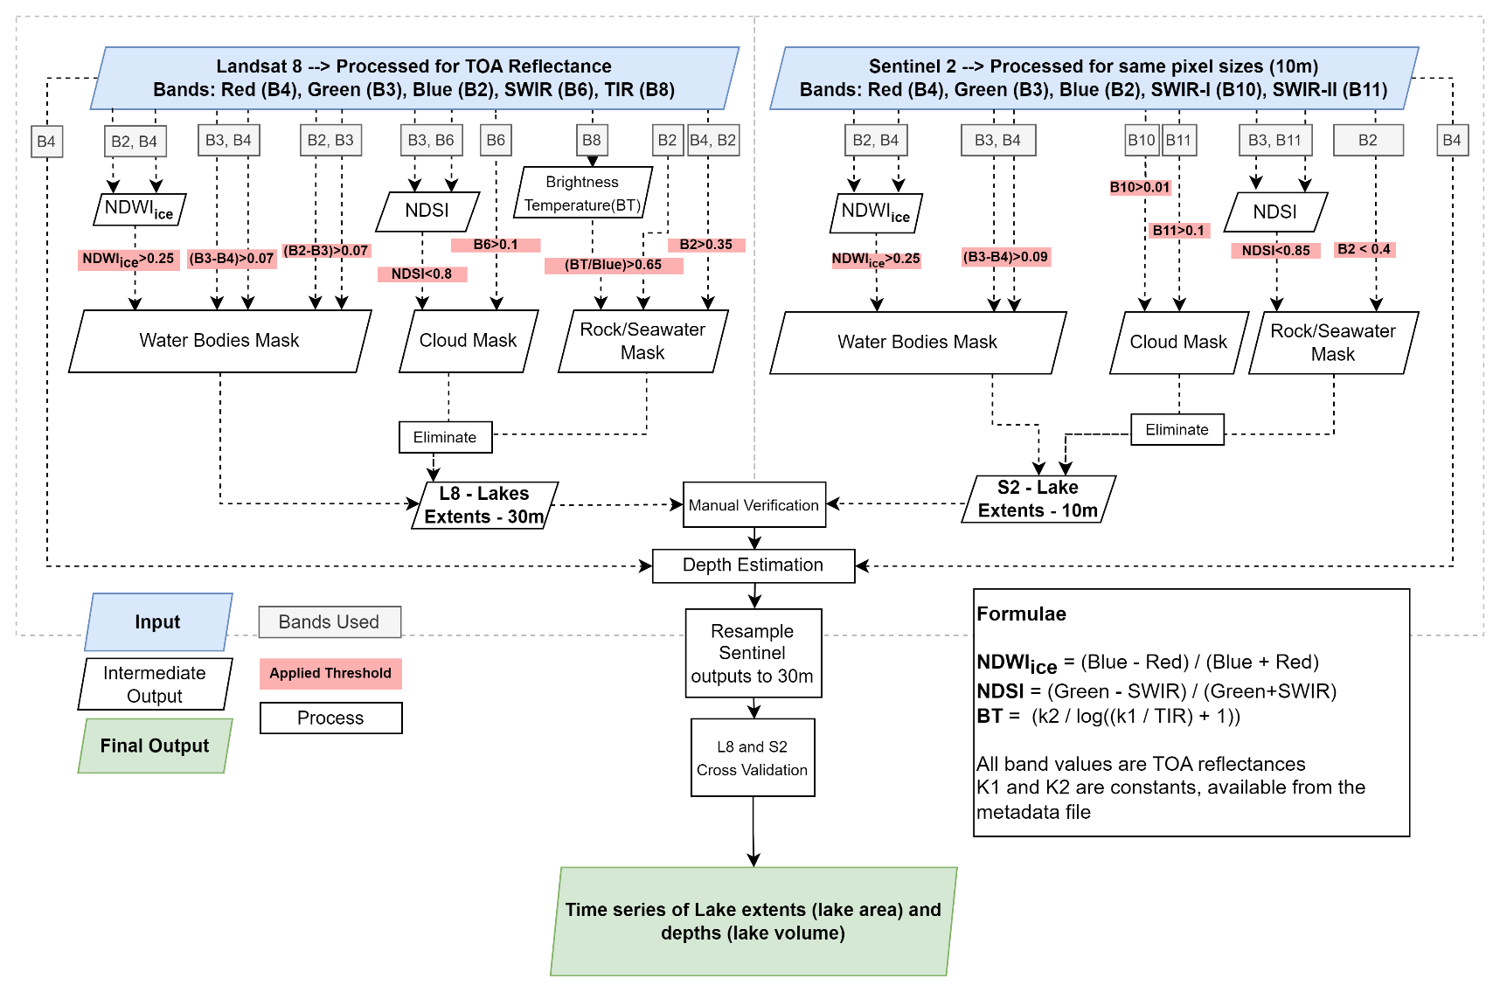
For mapping of lakes and estimating lake depths (Pope and others, 2016) we closely followed recommendations of (Moussavi and others, 2020) throughout the process. The process is detailed in the following sections.
Fig. S1. Methodological flowchart for lake mapping and depth estimation using Landsat 8 and Sentinel-2 scenes. This approach is constructed following recommendations of Moussavi and others (2020). Formulae used for calculation of NDWI_{ice}, NDSI and BT are shown in the inset box.

Satellite Data Acquisition
All available Landsat 8 and Sentinel-2 scenes from the austral summer (01 November to 31 March) between 2014 and 2021 having partial or complete coverage over the areas of interest were considered. This covers seven melt seasons in accordance with Landsat 8 availability, whereas Sentinel-2 products were only available since 2016. Each scene was manually inspected for usability. Filtration of scenes based on automatic cloud detection algorithms was avoided as it may also exclude useful scenes that have clear areas over lakes despite extensive cloud cover elsewhere. Of the ~2500 scenes that were inspected, ~1100 scenes were found suitable (listed in Supplement 2) in terms of coverage and visibility of lakes. These scenes were downloaded and processed further for generating the lake extent masks and lake depth grids.

Data Preprocessing
A semi-automated lake detection and mapping algorithm (Fig. S1), based on a band-reflectance thresholding method, was implemented following the approach of Moussavi and others (2020). Following Moussavi and others (2020), we used Band 2 (corresponding to Blue wavelength in the visible spectrum with 30m spatial resolution), Band 3 (Green – 30m), Band 4 (Red – 30m), Band 6 (shortwave infrared, SWIR – 30m) and Band 10 (thermal infrared, TIR – 100m provided as 30m) from Landsat 8 scenes, whereas from Sentinel-2 we used Band 2 (Blue – 10m), Band 3 (Green – 10m), Band 4 (Red – 10m), Band 10 (SWIR Cirrus – 60m) and Band 11 (SWIR2 – 20m). In case of Landsat 8 bands, the raw band values were converted to top of atmosphere (TOA) reflectance using the pixel-by-pixel sun illumination angle information from the ANG.txt file and the additive and multiplicative factors available with the image metadata (Williamson and others (2018); scripted by Neil Arnold, University of Cambridge). Since Sentinel-2 Level-1C products are pre-processed at source and provided as TOA reflectance directly, they did not require conversion. However, since Band 10 and Band 11 of Sentinel-2 were provided at different resolutions, they were resampled to 10m to match other Sentinel-2 bands. Cloud, Rock, and Seawater masks were generated by implementing thresholds recommended by Moussavi and others (2020) on Normalized Difference Snow Index (NDSI; Eq. (1) where Green and SWIR are TOA values of respective bands), and other band combinations (as detailed in Fig. S1) to eliminate clouds, exposed rock outcrops and sea water pixels.
$$NDSI =\frac{Green-SWIR}{Green+SWIR}$$ | (1)

Delineation of Supraglacial lakes
Pixels representing supraglacial lakes were derived by applying thresholds to the Normalized Difference Water Index adapted for ice (NDWI_{ice}; Gao, 1996; Yang and Smith, 2013), Band 3 (Green) – Band 4 (Red) differences, and Band 2 (Blue) – Band 3 (Green) differences. NDWI_{ice} is calculated following Eq. (2), where Blue and Red are the TOA values of respective bands:
$${NDWI}_{ice} =\frac{Blue -Red }{Blue +Red }$$ | (2)
Yang & Smith (2013) found that NDWI_{ice} performs better in identifying water over glaciated areas than the traditional NDWI which is more suitable for water on land. Instead of 0.19 (as recommended by Moussavi and others (2020)) we used a threshold of 0.25 (NDWI_{ice} > 0.25) to map deeper lakes (following Arthur and others, 2020a; Dell and others, 2020; Williamson and others, 2018), and exclude shallow lakes (having NDWI_{ice} values in the range 0.19 – 0.25) to avoid overestimation (Arthur and others, 2020a; Dell and others, 2020) due to misclassification of slush and small water-filled crevasses. This threshold was effective in detecting similar extents for both Landsat 8 and Sentinel-2 (Sect. S1.5). The outputs obtained after applying thresholds were filtered using the Cloud, Rock, and Seawater masks generated earlier, eliminating the potentially misclassified pixels. Further following the recommendations from Moussavi and others, (2020), we identified all connected groups of pixels and eliminated groups that were <= 2 pixels (i.e., <= 1800 m2) in size, as they would represent slush (Pope and others, 2016) or other outliers (e.g., misclassified rock or clouds, overexposed rock faces, insignificant water pockets and shadows). In Sentinel-2 outputs, this is equivalent to <= 18 pixels (i.e., <= 1800 m2) due to its finer spatial resolution. Manual inspection was performed after this step to check the results and eliminate larger misclassified areas that occasionally can occur (see Fig. S5 for examples). Due to the potential ambiguity between streams and elongated lakes, we do not further classify the identified supraglacial features into lakes and streams, instead collectively refer them as supraglacial lakes (following Arthur and others, 2020a).

Estimation of Lake Depths and Volumes
We used the physically based radiative transfer model (Pope and others, 2016) to estimate lake depths, based on the attenuation of light relative to depth in the water column (Pope and others, 2016; Sneed and Hamilton, 2007). The validity of this technique is dependent on three assumptions: 1) there is no suspended or dissolved matter in the water column, 2) the water surface is not severely impacted by waves or ripples, and 3) the bottom of the water body is homogenous, having similar slopes and albedo (Pope and others, 2016). These are reasonable assumptions for the relatively clean and homogeneous looking lakes in our study area, and the technique has been widely used for estimating depths of East Antarctic supraglacial lakes previously (e.g., Arthur and others, 2020a; Dell and others, 2020; Tuckett and others, 2021). Several studies have used the red and panchromatic bands for this estimation, doing separate calculations and reporting the mean value as the final lake depth (e.g. Moussavi and others, 2020; Williamson and others, 2018). However, since Sentinel-2 has no panchromatic band, we used only the red band to estimate lake depths for the Landsat 8 and Sentinel-2 datasets, thereby ensuring consistency in the technique. As the red wavelength from the visible spectrum is strongly attenuated in a water column, it allows for calculating measurable changes in even small variations of depth (Box and Ski, 2007). For pixels representing water, depth (z) was estimated using the rate of light attenuation (g), lake-bottom albedo (A_{d}), reflectance of the pixel ($R_{pix}$) relative to reflectance of optically deep water ($R_{∞}$) (Philpot, 1989) in the following Eq. (3):
$$z=\frac{[\ln\left(A_{d}-R_{∞}\right)-\ln\left(R_{pix}-R_{∞}\right)]}{g}$$ | (3)
The lake-bottom albedo (A_{d}) cannot be directly measured, so it was estimated feature-by-feature using the average red-band reflectance from the edge pixels identified by a 2-pixel buffer surrounding the respective water body (Pope and others, 2016). We assume that the reflectance from the lake bed is similar to the reflectance from the edges around the lake as their values would be comparable if the lake bed was at the surface (Pope and others, 2016). The reflectance of optically deep water (R∞) can be approximated by the reflectance values from the open ocean water (Williamson and others, 2018). However, since most of our Landsat 8 and Sentinel-2 scenes do not have pixels representing open ocean, we used zero in our calculations following Arthur and others (2020b), Banwell and others (2019), MacDonald and others (2018) and Dell and others (2020). The depth difference between these two choices of value for R∞ has been found to be smaller than 10% (Arthur and others, 2020). The reference pixel reflectance (R_{pix}) was extracted pixel-by-pixel from the red band TOA reflectance. The rate of light attenuation (g) is slightly different for Landsat 8 and Sentinel-2 scenes due to their different wavelengths in the red band. While we used a g value of 0.7507 for Landsat 8 (Pope and others, 2016), we used 0.8304 for Sentinel-2 (Williamson and others, 2018). We found close agreement in depth estimated using the red bands of Landsat 8 and Sentinel-2 captured on the same day over the same region (Sect. S1.5). Subsequently, lake volumes were calculated by multiplying the depths with pixel area (900 m² for Landsat 8 and 100m² for Sentinel-2). After deriving lake depths for all scenes, the Sentinel-2 outputs (area and depth) were resampled from 10 m to 30 m spatial resolution and reprojected to WGS 84 / Antarctic Polar Stereographic – EPSG:3031 projection to be consistent with Landsat 8. These time series of supraglacial lake area and volume were then used to assess seasonal evolution for each austral summer in each ice-shelf region. For interannual statistics, we only used the seasonal peak in area or volume considering the limited temporal coverage of data in certain melt seasons (e.g., 2018/19 over Fimbulisen).
Table S1: List of image pairs from Landsat-8 and Sentinel-2 captured on the same day for Landsat 8 vs Sentinel-2 depth assessment and comparison
Pair # | Date | Sensor | Scene ID
1 | 14 January 2019 | L8 - OLI | LC08_L2SR_154110_20190114_20201016_02_T2
1 | 14 January 2019 | S2 - MSI | S2B_MSIL1C_20190114T063829_N0207_R091_T35DNB_20190114T084121
2 | 01 February 2017 | L8 - OLI | LC08_L1GT_178111_20170201_20201016_02_T2
2 | 01 February 2017 | S2 - MSI | S2A_MSIL1C_20170201T082931_N0204_R135_T30DXF_20170201T082929
3 | 12 January 2018 | L8 - OLI | LC08_L1GT_161110_20180112_20201016_02_T2
3 | 12 January 2018 | S2 - MSI | S2A_MSIL1C_20180112T073911_N0206_R063_T34DDG_20180112T111340
4 | 31 December 2019 | L8 - OLI | LC08_L1GT_179111_20191231_20201016_02_T2
4 | 31 December 2019 | S2 - MSI | S2B_MSIL1C_20191231T093009_N0208_R107_T29CMV_20191231T105324
4 | 31 December 2019 | S2 - MSI | S2B_MSIL1C_20191231T093009_N0208_R107_T29DMA_20191231T105324

Cross-validation of area and depth from Landsat 8 and Sentinel-2
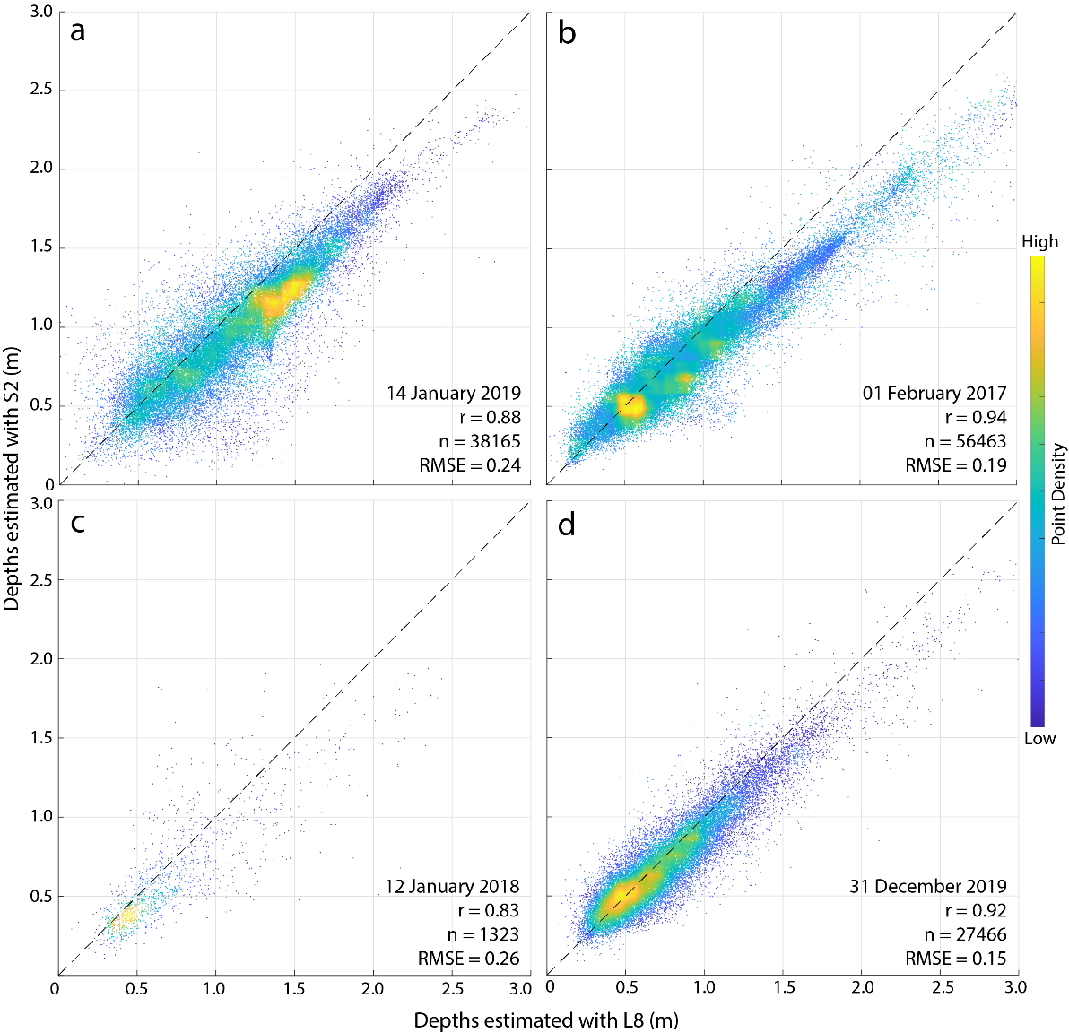
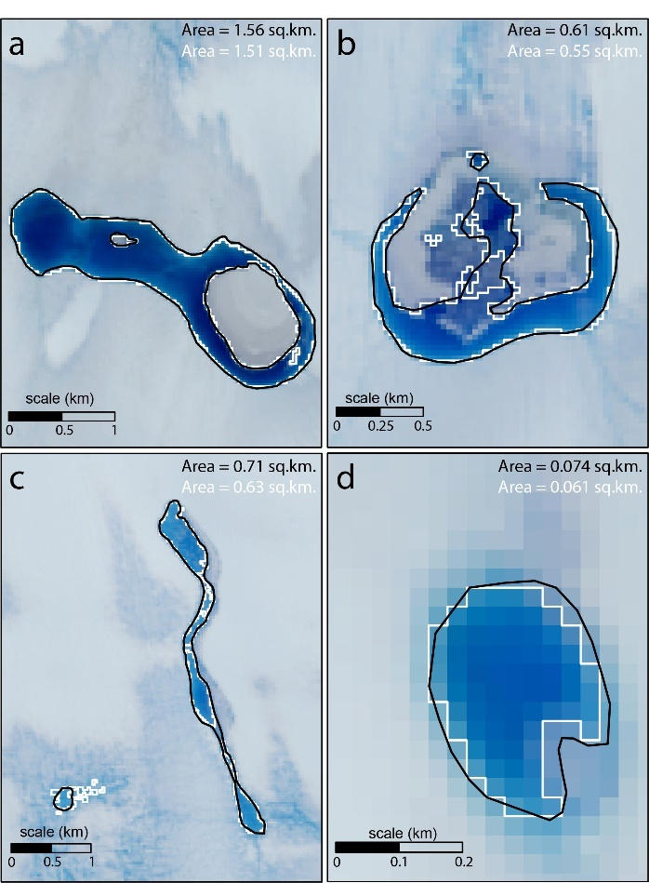
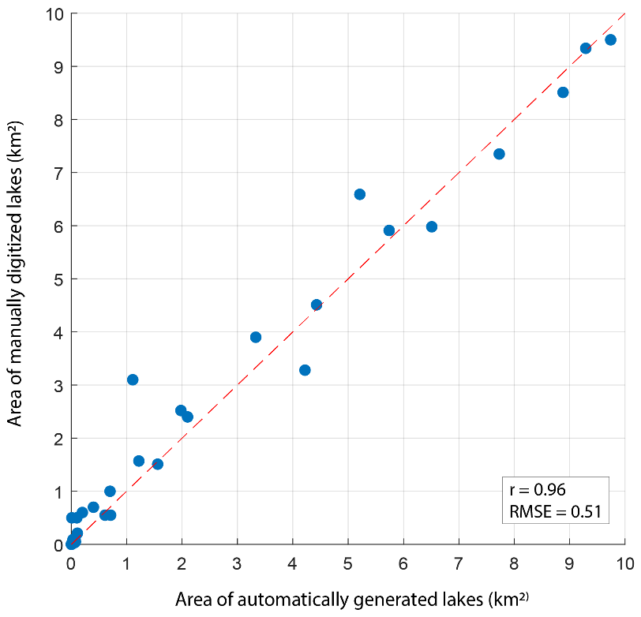
To ensure that the lake mapping and depth estimation process estimated precise areas and depths in both Landsat 8 and Sentinel-2 products, we identified four image pairs of Landsat 8 and Sentinel-2 (listed in Table S1) that were captured on the same day of the melt season and compared the lake areas and depths in the overlapping regions. We found that 3% - 5% of the derived water pixels from Sentinel-2 were classified as non-water in Landsat 8. These pixels were typically located around the lake edges or in highly inhomogeneous terrain or were completely isolated. This may be attributed to the finer resolution of Sentinel-2 (10 m) than Landsat 8 (30 m), making it easier to detect small water bodies and differentiate shallow and deep lake edges. For depth validation, we first identified common water pixels for Landsat 8 and Sentinel-2 and then plotted their depths against each other (Fig. S2). The depths estimated using Landsat 8 and Sentinel-2 are highly consistent with an average r = 0.89, mean bias = 0.08 m and root mean square error (RMSE) = 0.21 m (assessed using four pairs of images from the same dates). However, depths estimated by Landsat 8 appear to be slightly higher than Sentinel-2 estimates. Such differences could arise from cloud adjacency effect (Pope and others, 2016; Williamson and others, 2018) or due to the difference in their original spatial and spectral resolutions. Despite the different sensor characteristics, there is good agreement between the lake areas and volumes derived from Landsat 8 and Sentinel-2 products, justifying their combined use in our time-series.
Fig. S2. Correlation between depths estimated using Landsat-8 and Sentinel-2 products. Each of the plot represents a different pair of Landsat-8 and Sentinel-2, picked from different regions of the study area. The dashed line is the 1:1 line between Landsat-8 and Sentinel-2 depths. The average r is 0.89 and RMSE is 0.21m. The difference between Landsat-8 and Sentinel-2 depths (Mean Bias = 0.08 m, RMSE ~ 0.21 m) could be due to cloud adjacency effect (Pope and others, 2016; Williamson and others, 2018) or due to the difference in their original spatial and spectral resolutions. However, the depths estimated by Sentinel-2 fall within the error range of Landsat-8 estimated depths (0.28. for red band; Pope and others, 2016).

Fig. S3. Comparison of automatically generated lakes (using NDWI_{ice}) and manually digitized lakes. Panels a., b., c., and d. present examples of four lake outlines (automatic in white, and manual in black) that are of different sizes. Panel e. presents the comparison of areas of 34 lakes (estimated using automatically generated outlines and manually digitized outlines) over a scatter plot. Lakes used in this assessment were randomly chosen from homogenous and inhomogeneous (slushy) areas, broadly representing the study area. Small sized lakes had the highest difference between the 2 methods, whereas the larger ones produced relatively similar areas. Background images in Panels a and c are Landsat-8 scenes captured on 22-01-2017 and those in Panels b and d are Landsat-8 scenes captured on 15-01-2020 (Source: USGS) scenes.

Errors and Uncertainties
Due to absence of any ground-truth data, we assessed different sources of errors for a selection of scenes to empirically quantify an uncertainty range for the generated lake area and volume estimates. Firstly, we manually removed obvious false positives by visually comparing lake masks with the underlying RGB imagery, accounting for roughly 0.3 – 0.5% of classified pixels. Major contributors of false positives were shadows, blue ice, nunataks, and crevassed areas. We then compared the automatically generated lake extents with manually digitized lake boundaries for 34 lakes of different sizes and shapes spread over four randomly selected areas that contain water bodies of both homogenous and inhomogeneous (slushy) character, broadly representing the supraglacial lake characteristics over the study area. We found very close agreement between the two methods (Fig. S3) with an r = 0.96 and RMSE = 0.51. Smaller lakes (<0.01 km²) had the largest differences in percentage, but due to their small size, their contribution to absolute differences was much smaller. Several small water pockets in slushy areas were not classified as lakes during manual digitization but were classified as lakes in the automated approach. In the case of larger lakes, both methods produced similar areas. On average, the difference in total lake area between the automated and manual approach was ~ 0.5 – 0.7 % for each of the four sampled areas. Considering these error sources and ranges, we assign a relative uncertainty of 1% to the lake area estimates in our study, similar to Stokes and others (2019) and Arthur and others (2020b). Given the strong relationship between lake areas and lake volumes (Liang and others, 2012; Trusel and others, 2012), we apply this uncertainty range to volume estimates as well, in addition to a depth uncertainty of 0.21m determined from the RMSE between separate Landsat 8 and Sentinel-2 depth estimates (Fig. S2).
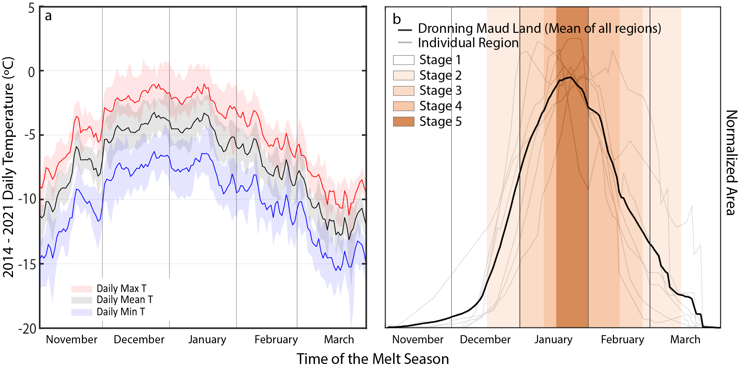
Periods with cloud cover and limited satellite overpasses make it difficult to find a series of scenes representing the full melt season evolution in some cases, e.g., 2018/19 for Fimbulisen and 2019/20 for Eastern Roi Baudouin Ice Shelf. Therefore, our estimates of peak lake areas and volumes are limited to the parts of the melt season that were actually captured. From the climate reanalysis data (Fig. S4a), the temperature peaks around mid-January, and the actual peak in lake areas and volumes is captured between 16 – 31 January (Fig. S4b). To account for uncertainties related to the timing of available data with respect to the actual peak of lake area and volume, we have conceptualized the melt season evolution into different stages (Table 1) based on the observed seasonal cycles of lake area which approximates a Gaussian distribution with symmetric seasonal growth and decay (Fig. S4b). Stage 1 represents the starting or ending phases of meltwater ponding, whereas stage 5 represents the period with peak area and volume of supraglacial lakes. For each stage, we quantified the average lake area (or volume) using data samples with full seasonal coverage (Table S2). We then outlined 5 different scenarios for data availability, ranging from only having data from the initiation and freeze-up periods (stage 1, worst-case scenario) to having data from the period with expected peak area/volume (stage 5, best-case scenario). Using this information, we assigned relative uncertainties for estimated peak area (or volume) for each scenario, ranging from a worst case of 95% (only stage 1 coverage) to a best case of 5% (including stage 5 coverage). As an example, if the latest image we had was from Stage 4, then we assume that 65% of the peak area (or volume) is captured by the scene, and 30-35% of meltwater information remains lost due to absence of a scene from Stage 5 – therefore assuming an uncertainty of 35%. This is irrespective of the number of scenes from previous stages, in this case Stage 1, 2 or 3.
Fig. S4: Daily near surface temperature and seasonal lake evolution between November and March. a) NDJFM Average Daily Maximum, Mean and Minimum temperatures for Dronning Maud Land (using ERA5 data); b) NDJFM average normalized lake area plotted (using lake areas estimated in this work) against time for each region (grey lines) and overall for Dronning Maud Land (black line). The colours in the background correspond to the stages defined in Table 1.

Table S2. Typical stages and periods for meltwater ponding, advection and freeze-up. Percentage uncertainty for the seasonal peak of lake area and volume is estimated for 5 different scenarios (right columns) based on the availability of scenes from different stages of the melt season. Stage-wise scene availability is defined by 1 = Scene available; 0 = Scene not available. X = Not important as scene from a higher stage is available.
Phase | Stage | Date Range |  | Lake Area / Volume Covered % | Accumulated meltwater in particular stage  % | Scenarios (left to right) for stage-wise scene availability (top to bottom)
Ponding Initiation Phase | Stage 1 | 01 November | 15 December | 5% | 5% | 1 | X | X | X | X
Increased Ponding & minimal advection Phase | Stage 2 | 16 December | 31 December | 20% | 15% | 0 | 1 | X | X | X
Continued Ponding & enhanced advection phase | Stage 3 | 01 January | 10 January | 40% | 20% | 0 | 0 | 1 | X | X
Continued Ponding & enhanced advection phase | Stage 4 | 11 January | 15 January | 65% | 25% | 0 | 0 | 0 | 1 | X
Continued Ponding & enhanced advection phase | Stage 5 | 16 January | 31 January | 95-100% | 35% | 0 | 0 | 0 | 0 | 1
Surface  Freezing Phase | Stage 4 | 01 February | 15 February | 65% |  | 0 | 0 | 0 | 1 | X
Surface  Freezing Phase | Stage 3 | 16 February | 25 February | 40% |  | 0 | 0 | 1 | X | X
Surface  Freezing Phase | Stage 2 | 26 February | 15 March | 20% |  | 0 | 1 | X | X | X
Surface  Freezing Phase | Stage 1 | 16 March | 31 March | 5% |  | 1 | X | X | X | X
Uncertainty range based on scene availability |  |  |  |  |  | 95% | 80% | 60% | 35% | 5%
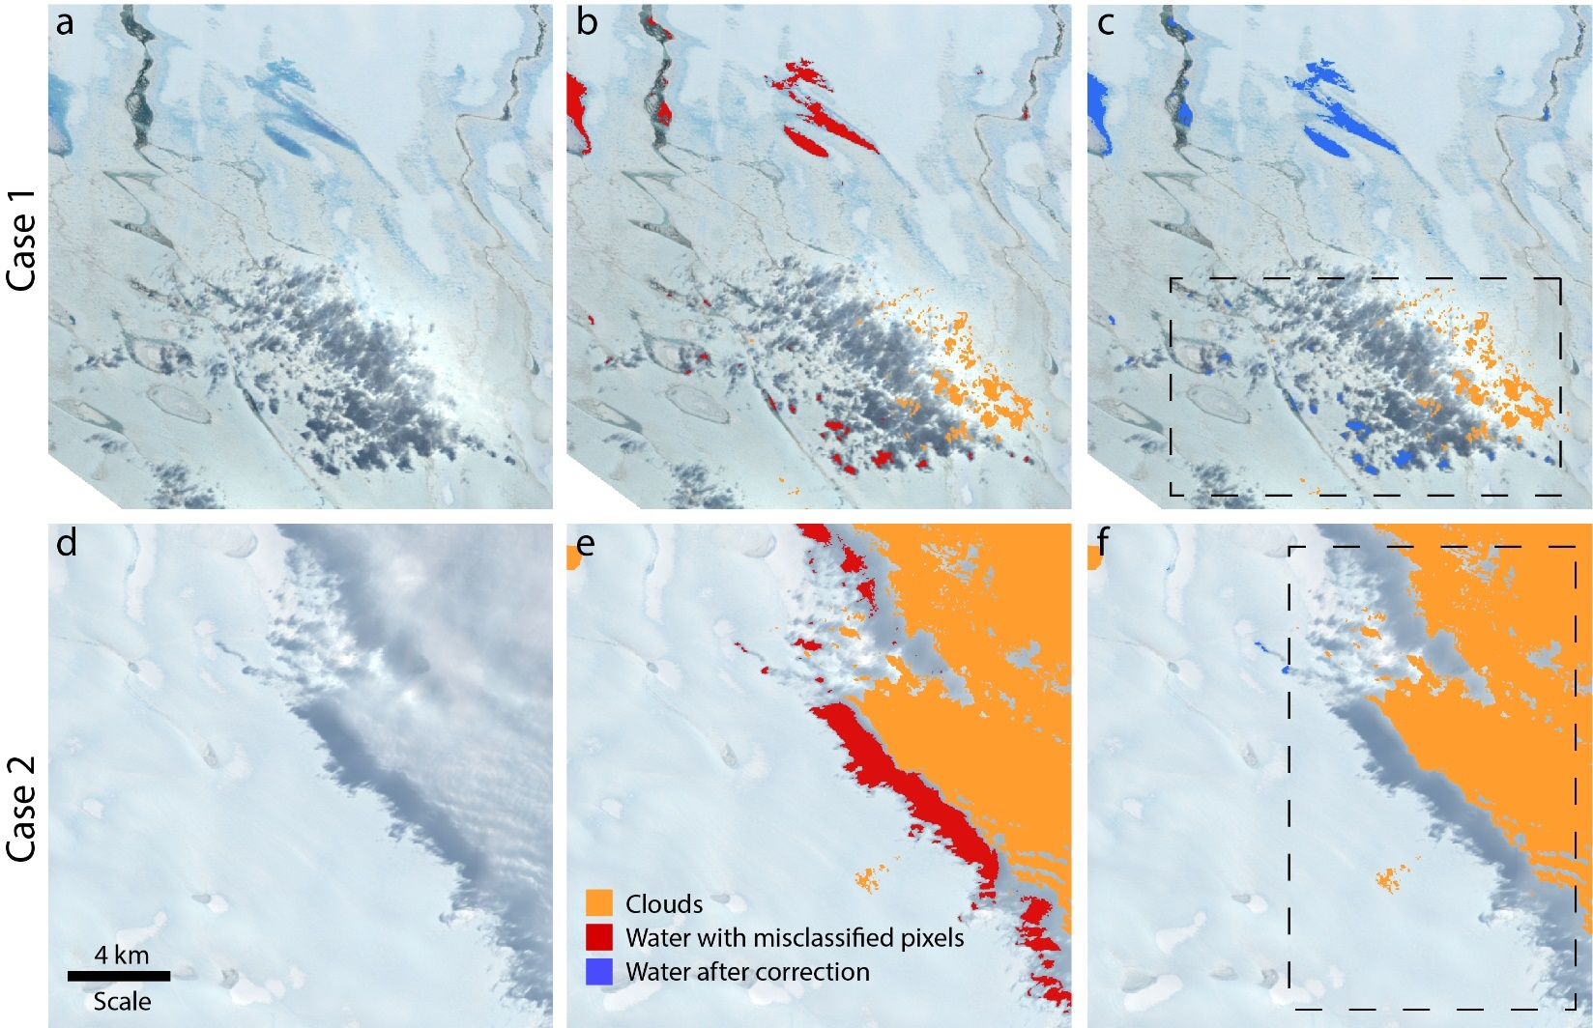
Fig. S5. Examples of manual post processing for elimination of misclassified pixels. Case 1 (a-c) represents a scenario where no manual post processing was done since the misclassified pixels were small. Case 2 (d-f) represents a scenario where manual post processing was required to eliminate large groups of misclassified pixels. Panels a. and d. are satellite images (Landsat 8; 13-02-2020 and Landsat 8; 12-03-2015, respectively; Source: USGS), b and e represent pixels classified as water (red) and clouds (orange) by the algorithm, and panels c and f shows water pixels (blue pixels) after manual correction. Background images in panels b, c and e, f are same as a and d, respectively
Table S3: Maximum Lake areas and lake volumes mapped on various ice shelves of Dronning Maud Land covering each melt-season between 2014 and 2021.
STUDY AREA |  | 2014/15  (Value ± Error*) | 2015/16  (Value ± Error) | 2016/17  (Value ± Error) | 2017/18  (Value ± Error) | 2018/19  (Value ± Error) | 2019/20  (Value ± Error) | 2020/21  (Value ± Error) | Ice Shelf Average  (Value ± Std. Error**)
RIISER LARSEN | Area km² | 0.96 ± 4.17 | 0.77 ± 4.17 | 62.76 ± 4.17 | 65.30 ± 4.17 | 21.21 ± 4.17 | 83.41 ± 4.17 | 0.40 ± 29.19 | 33.54 ± 14.66
RIISER LARSEN | Volume km³ | 0.0003 ± 0.004 | 0.0005 ± 0.005 | 0.07 ± 0.005 | 0.06 ± 0.005 | 0.012 ± 0.005 | 0.09 ± 0.005 | 0.0002 ± 0.03 | 0.0329 ± 0.02
FIMBULISEN | Area km² | 0.70 ± 0.20 | 0.42 ± 0.20 | 2.77 ± 0.20 | 1.08 ± 0.20 | 1.92 ± 2.41 | 4.01 ± 0.20 | 0.57 ± 0.20 | 1.64 ± 0.55
FIMBULISEN | Volume km³ | 0.0005 ± 0.0002 | 0.0003 ± 0.0002 | 0.003 ± 0.0002 | 0.0008 ± 0.0002 | 0.002 ± 0.002 | 0.004 ± 0.0002 | 0.0003 ± 0.0002 | 0.002 ± 0.001
NIVLISEN | Area km² | 62.91 ± 35.58 | 6.33 ± 5.08 | 86.26 ± 5.08 | 96.69 ± 5.08 | 101.64 ± 5.08 | 86.77 ± 5.08 | 20.38 ± 5.08 | 65.85 ± 15.55
NIVLISEN | Volume km³ | 0.06 ± 0.03 | 0.006 ± 0.005 | 0.07 ± 0.005 | 0.08 ± 0.005 | 0.1 ± 0.005 | 0.09 ± 0.005 | 0.02 ± 0.005 | 0.06 ± 0.01
MUNINISEN | Area km² | 1.23 ± 2.58 | 0.39 ± 4.42 | 7.36 ± 0.37 | 1.63 ± 0.37 | 1.35 ± 0.37 | 4.89 ± 0.37 | 0.18 ± 0.37 | 2.43 ± 1.09
MUNINISEN | Volume km³ | 0.0005 ± 0.002 | 0.0003 ± 0.004 | 0.006 ± 0.0003 | 0.001 ± 0.0003 | 0.0008 ± 0.0003 | 0.005 ± 0.0003 | 0.0001 ± 0.0003 | 0.002 ± 0.001
ROI BAUDOUIN WEST | Area km² | 8.60 ± 1.00 | 2.19 ± 1.00 | 19.97 ± 1.00 | 9.65 ± 1.00 | 7.45 ± 1.00 | 15.16 ± 1.00 | 1.22 ± 1.00 | 9.18 ± 2.73
ROI BAUDOUIN WEST | Volume km³ | 0.007 ± 0.001 | 0.001 ± 0.001 | 0.02 ± 0.001 | 0.008 ± 0.001 | 0.006 ± 0.001 | 0.01 ± 0.001 | 0.0006 ± 0.001 | 0.09 ± 0.003
ROI BAUDOUIN CENTER | Area km² | 35.22 ± 4.19 | 11.67 ± 4.19 | 39.55 ± 4.19 | 66.61 ± 4.19 | 44.29 ± 4.19 | 83.85 ± 4.19 | 3.14 ± 4.19 | 40.62 ± 11.58
ROI BAUDOUIN CENTER | Volume km³ | 0.03 ± 0.004 | 0.007 ± 0.004 | 0.04 ± 0.004 | 0.07 ± 0.004 | 0.05 ± 0.004 | 0.08 ± 0.004 | 0.002 ± 0.004 | 0.0387 ± 0.01
ROI BAUDOUIN EAST | Area km² | 248.25 ± 29.53 | 252.58 ± 29.53 | 590.68 ± 206.74 | 502.53 ± 206.74 | 18.77 ± 354.41 | 159.98 ± 354.41 | 12.32 ± 29.53 | 255.02 ± 90.94
ROI BAUDOUIN EAST | Volume km³ | 0.14 ± 0.02 | 0.18 ± 0.02 | 0.46 ± 0.16 | 0.46 ± 0.16 | 0.01 ± 0.28 | 0.11 ± 0.28 | 0.01 ± 0.02 | 0.1947 ± 0.08
DRONNING MAUD LAND | Area km² | 357.87 ± 35.58 | 274.35 ± 29.53 | 809.37 ± 206.74 | 743.50 ± 206.74 | 196.64 ± 354.41 | 438.08 ± 354.41 | 38.19 ± 29.53 | 408.28 ± 115.03
DRONNING MAUD LAND | Volume km³ | 0.2337 ± 0.0343 | 0.20 ± 0.02 | 0.67 ± 0.16 | 0.68 ± 0.16 | 0.18 ± 0.28 | 0.39 ± 0.28 | 0.03 ± 0.02 | 0.34 ± 0.10
*Error is calculated based on the uncertainty and error estimation approach explained in Section S1.6 of the supplement.
**Standard Error is calculated using the formula Std. Error = Std Dev of values from each melt year / √ number of melt-years – 1

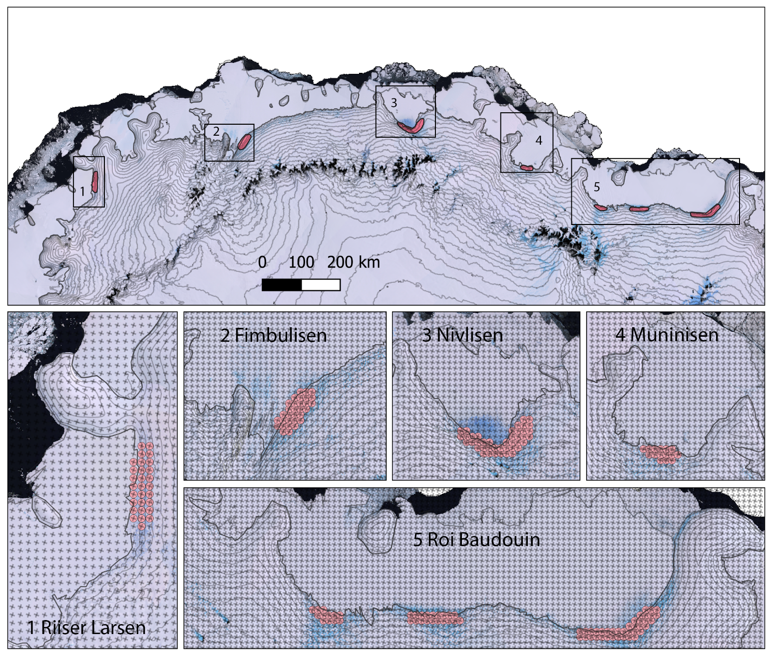
Fig. S6: Choice of MAR grid points for climate relationship assessments. The top panel shows the seven lake areas in Dronning Maud Land and polygons (red) drawn to find intersecting grid points for assessments. The polygons are drawn focussing on locations where meltwater production majorly occurs (near the grounding zone). Intersecting (chosen) MAR grid points are shown in lower panels (1-5) in red dots, whereas all available MAR grid points are shown as ‘x’.

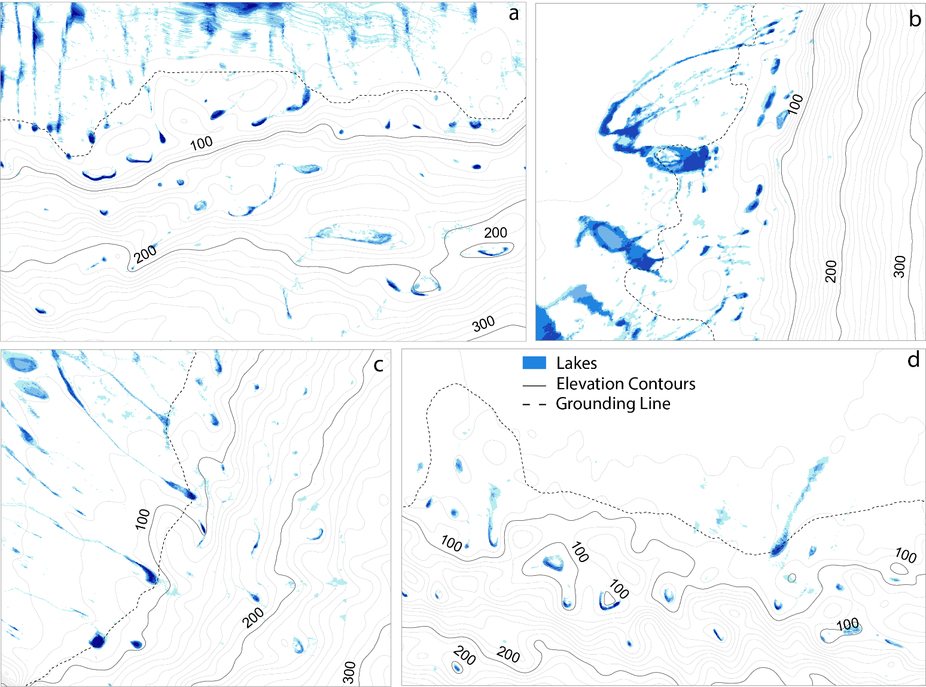
Fig. S7: Formation of lakes in topographical depressions over four selected areas in Dronning Maud Land; a) Roi Baudouin Center, b) Riiser Larsen, c) Nivlisen and d) Muninisen. The grey lines represent 10 m a.s.l contours, and the dotted black line is the grounding line separating floating ice shelves and grounded ice sheet. Blue colored polygons are lakes from different years. Contours were generated using the Reference Elevation Model of Antarctica (REMA, Howat and others (2019)).

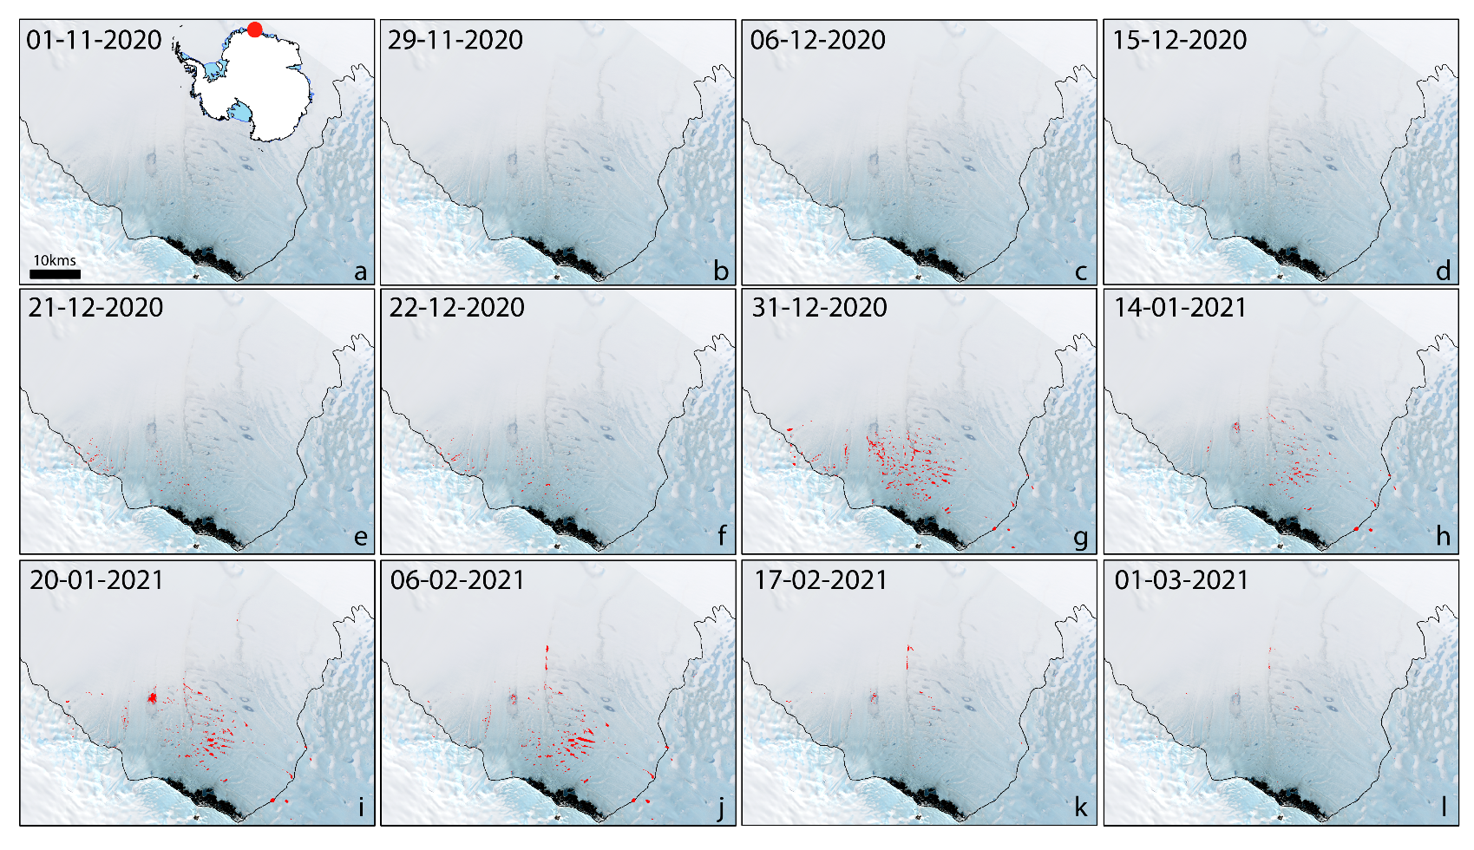
Fig. S8: Seasonal evolution of supraglacial lakes over Nivlisen in Dronning Maud Land during a low ponding year (2020/21) with red colour representing the extent of lakes on a specified date. The lateral transfer of meltwater, although observable, is not as apparent due to the limited volume of available meltwater during low melt/pond years (Supplementary Animation 1). The background image used for representation is a Landsat 8 RGB Composite from 03 November 2017 (Source: USGS).

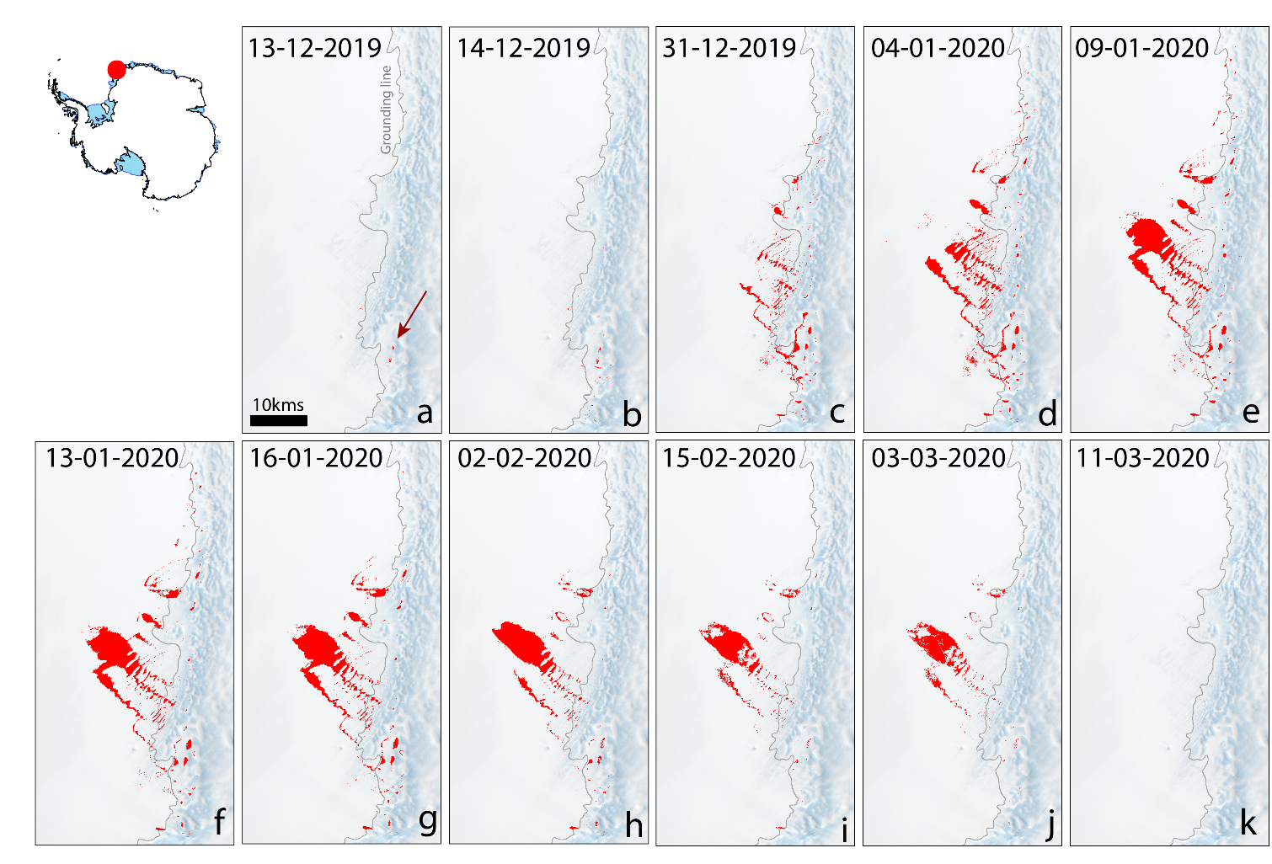
Fig. S9. Seasonal evolution of supraglacial lakes over Riiser Larsen in Dronning Maud Land during high ponding year (2019/20) with red color representing the extent of lakes on a specified date. By following each panel in chronological order, the lateral transfer of meltwater can be observed (See Supplement Animation 1). The background image used for representation is a Landsat 8 RGB Composite from 03 November 2017 (Source: USGS). Red arrows indicate poorly visible small-sized ponds.

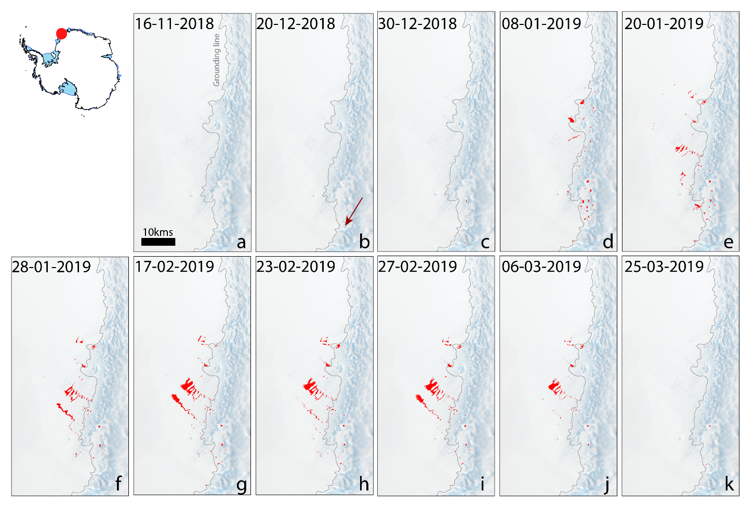
Fig. S10. Seasonal evolution of supraglacial lakes over Riiser Larsen in Dronning Maud Land during low ponding year (2018/19) with red colour representing the extent of lakes on a specified date. The lateral transfer of meltwater, although observable, is not as apparent due to the limited volume of available meltwater. The background image used for representation is a Landsat 8 RGB Composite from 03 November 2017 (Source: USGS). Red arrows indicate poorly visible small-sized ponds.
Fig. S11: Values of correlation (r) and significance of correlation (p) between different lake areas in Dronning Maud Land and various climatic variables (Columns 1 – 22). Additional variable present in this figure are Shortwave Incoming Radiation and Longwave Incoming Radiation.

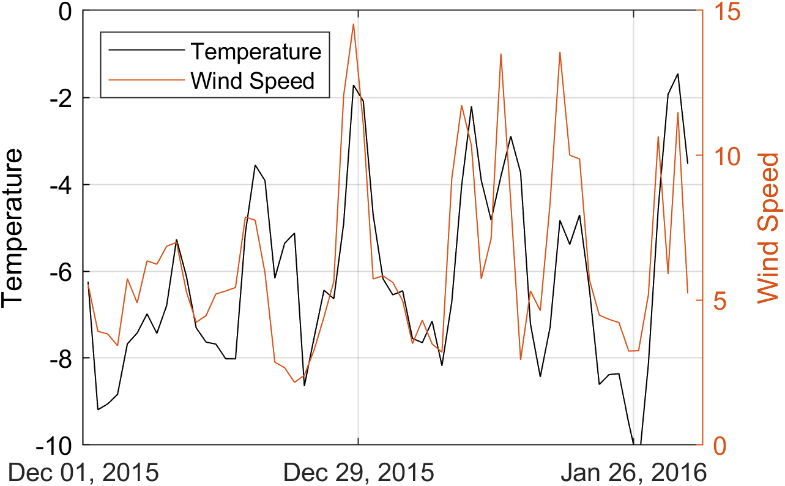
Fig. S12: Relationship between temperature (°C) and wind speed (m s⁻¹) over Roi Baudouin East in Dronning Maud Land. The above example is from summer (DJ) of 2015/16. Data source: MAR.

Fig. S13. Extracted MAR values of all climatic variables used in the study.
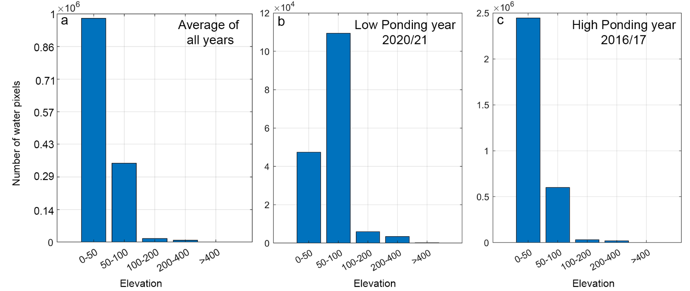
Fig. S14. Topographical distribution of water pixels (lakes) in Dronning Maud Land. a) Average distribution for all years. b) Distribution during low ponding year 2020/21 and c) Distribution during high ponding year 2016/17. Elevations are extracted from the REMA 100m Digital Elevation Model (Howat and others, 2019)

References
Arthur JF, Stokes CR, Jamieson SSR, Rachel Carr J, Leeson A and Verjans V (2022) Large interannual variability in supraglacial lakes around East Antarctica. Nature Communications 13(1) (doi:10.1038/s41467-022-29385-3)
Arthur JF, Stokes CR, Jamieson SSR, Carr JR and Leeson A (2020) Distribution and seasonal evolution of supraglacial lakes on Shackleton Ice Shelf, East Antarctica. The Cryosphere 14(11), 4103–4120 (doi:10.5194/tc-14-4103-2020)
Banwell AF, Willis IC, Macdonald GJ, Goodsell B and MacAyeal DR (2019) Direct measurements of ice-shelf flexure caused by surface meltwater ponding and drainage. Nature Communications 10(1), 1–10 (doi:10.1038/s41467-019-08522-5)
Box JE and Ski K (2007) Remote sounding of Greenland supraglacial melt lakes: implications for subglacial hydraulics. Journal of Glaciology 53(181), 257–265 (doi:10.3189/172756507782202883)
Dell R and six others (2020) Lateral meltwater transfer across an Antarctic ice shelf. Cryosphere 14(7), 2313–2330 (doi:10.5194/tc-14-2313-2020)
Gao B (1996) NDWI—A normalized difference water index for remote sensing of vegetation liquid water from space. Remote Sensing of Environment 58(3), 257–266 (doi:10.1016/S0034-4257(96)00067-3)
Howat IM, Porter C, Smith BE, Noh M-J and Morin P (2019) The Reference Elevation Model of Antarctica. The Cryosphere 13(2), 665–674 (doi:10.5194/tc-13-665-2019)
Liang YL and seven others (2012) A decadal investigation of supraglacial lakes in West Greenland using a fully automatic detection and tracking algorithm. Remote Sensing of Environment 123, 127–138 (doi:10.1016/j.rse.2012.03.020)
MacDonald GJ, Banwell AF and Macayeal DR (2018) Seasonal evolution of supraglacial lakes on a floating ice tongue, Petermann Glacier, Greenland. Annals of Glaciology 59(76pt1), 56–65 (doi:10.1017/aog.2018.9)
Moussavi M, Pope A, Halberstadt ARW, Trusel LD, Cioffi L and Abdalati W (2020) Antarctic Supraglacial Lake Detection Using Landsat 8 and Sentinel-2 Imagery: Towards Continental Generation of Lake Volumes. Remote Sensing 12(1), 134 (doi:10.3390/rs12010134)
Philpot WD (1989) Bathymetric mapping with passive multispectral imagery. Applied Optics 28(8), 1569 (doi:10.1364/AO.28.001569)
Pope A and six others (2016) Estimating supraglacial lake depth in West Greenland using Landsat 8 and comparison with other multispectral methods. Cryosphere 10(1), 15–27 (doi:10.5194/tc-10-15-2016)
Stokes CR, Sanderson JE, Miles BWJ, Jamieson SSR and Leeson A (2019) Widespread distribution of supraglacial lakes around the margin of the East Antarctic Ice Sheet. Scientific Reports 9(1), 1–14 (doi:10.1038/s41598-019-50343-5)
Trusel LD, Frey KE and Das SB (2012) Antarctic surface melting dynamics: Enhanced perspectives from radar scatterometer data. Journal of Geophysical Research: Earth Surface 117(2), 1–15 (doi:10.1029/2011JF002126)
Williamson AG, Banwell AF, Willis IC and Arnold NS (2018) Dual-satellite (Sentinel-2 and Landsat 8) remote sensing of supraglacial lakes in Greenland. Cryosphere 12(9), 3045–3065 (doi:10.5194/tc-12-3045-2018)
Yang K and Smith LC (2013) Supraglacial streams on the greenland ice sheet delineated from combined spectral-shape information in high-resolution satellite imagery. IEEE Geoscience and Remote Sensing Letters 10(4), 801–805 (doi:10.1109/LGRS.2012.2224316)

