A bibliographical enigma.
The H-1773 :08 edition of Raynal’s Histoire des deux Indes.
David Adams (Manchester) - Daniel Droixhe (Bruxelles-Liège)
Mens manet immota
2021 saw the publication, under the direction of C.P. Courtney de l'Université de Cambridge of a Bibliographie des éditions de Guillaume-Thomas Raynal 1747-1843. The work constitutes a completely new version of the one which opened the critical edition of the first volume of Raynal’s Histoire philosophique et politique des établissements et du commerce des Européens dans les deux Indes, published in 2010 under the direction of Anthony Strugnell. This article focuses on the edition of the Histoire des deux Indes which bears the number H-1773 : 08 in Courtney’s Bibliographie. The title-pages of the six volume are reproduced below (figure 1).

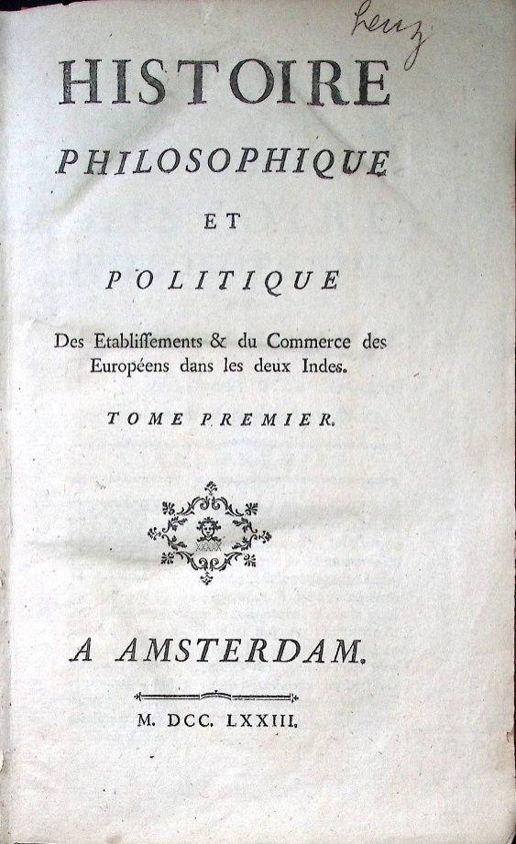  H-1773:08, volume I.  Collection D. Droixhe-A. Piette | 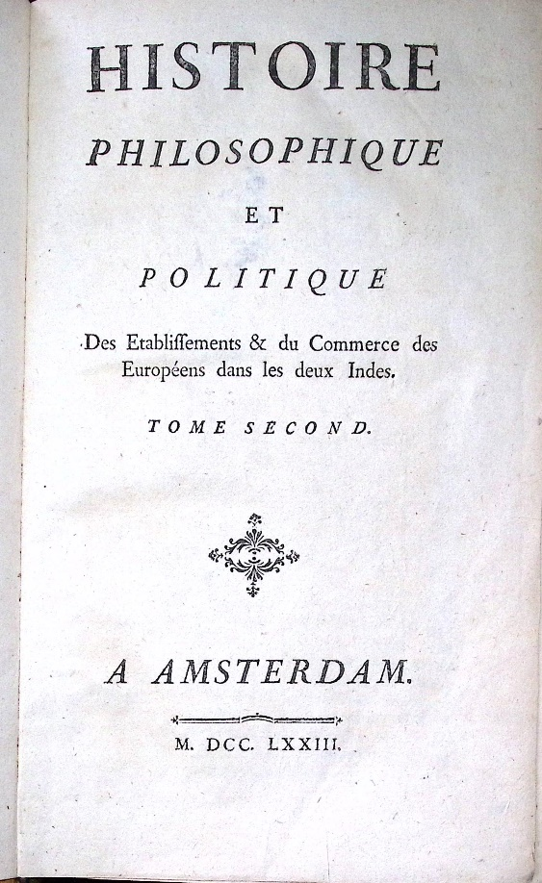  H-1773:08, volume II.  Collection D. Droixhe-A. Piette
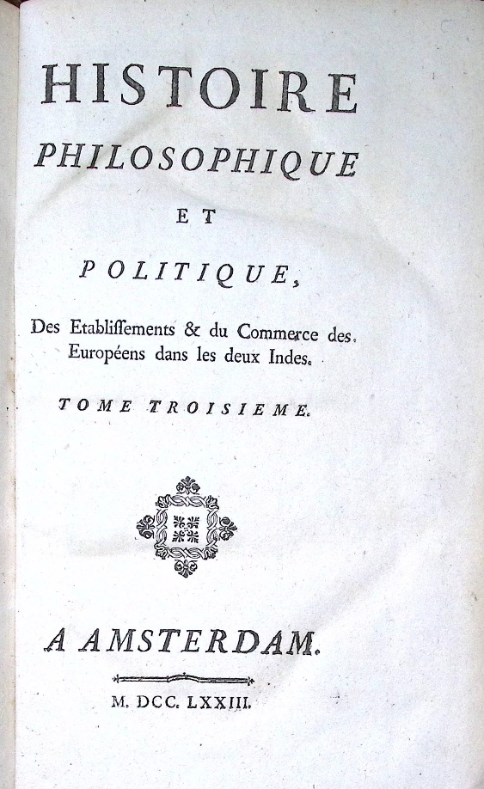  H-1773:08, volume III.  Collection D. Droixhe-A. Piette | 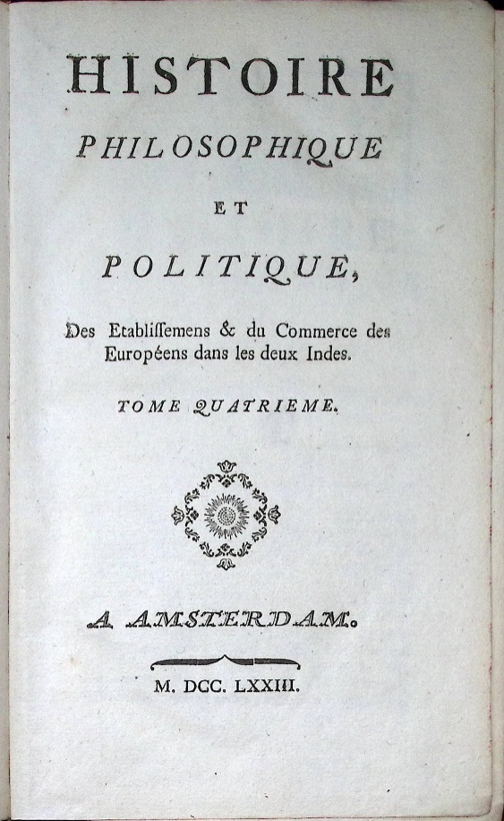  H-1773:08, volume IV.  Collection D. Droixhe-A. Piette
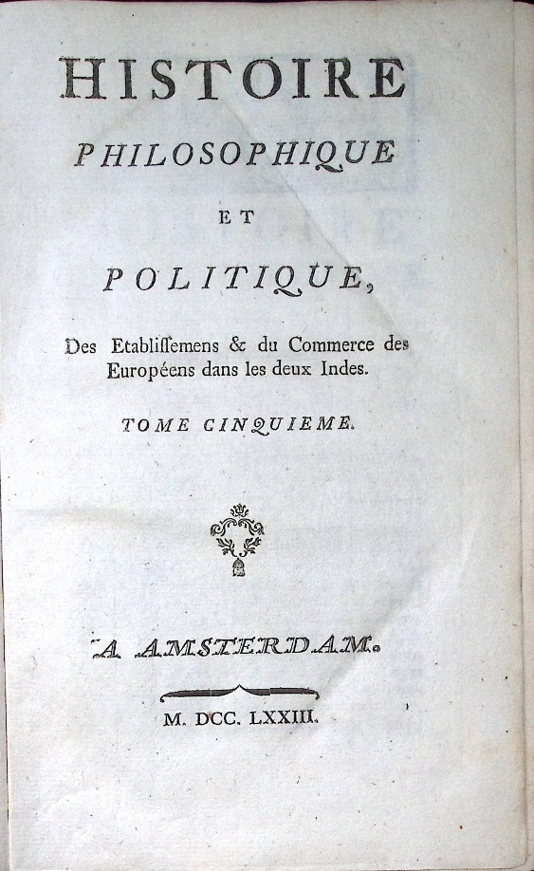  H-1773:08, volume V.  Collection D. Droixhe-A. Piette | 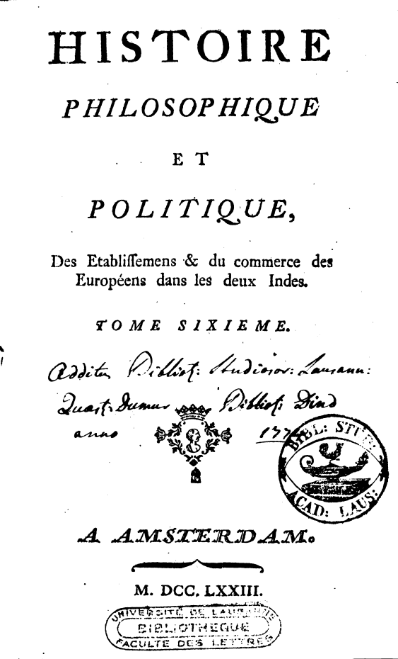  H-1773:08, volume VI.  Université de Lausanne, Bibliothèque, Faculté des Lettres
Figure 1.
- Compound tailpieces on title-pages : Dufour’s register
The demonstrative value of compound ornaments to determine the origin of an edition has been established for a long time. That is why compound tailpieces will be considered first, not only on title-pages but also in the various volumes.
Two compound tailpieces of title-pages appear in editions produced by the bookseller-printer Jean-Edme or Jean-Edmé Dufour (1728-1789), established in Maastricht, now in the Netherlands. As Courtney writes, Dufour, originating from Paris, had been, in 1762, a proof-reader for the Liège bookseller-printer Jean-François Bassompierre. He then established a business in Maastricht in 1766 and became a printer around 1772. But as early as 1771, he was occupying a house in Maastricht, at the intersection of the Grand-Rue and of the rue des Éperons (Sporenstraat), where he undertook to install new printing equipment for the purchase of which he borrowed 9,500 French livres. Courtney mentions his first declaration of bankruptcy in June 1773, but indicates that ‘his trade was again prosperous in September 1774’. That year, indeed, Dufour published what seems to be the original edition of the Vrai sens du système de la nature attributed to Helvétius and in 1776-1777 he would publish a clandestine edition of Helvétius’ Œuvres completes which reproduces d’Holbach’s Système de la nature, as David Smith has shown. His clandestine production alternates libertine literature, such as Dulaurens’s works, and classical literature of the XVIIth century, as Muriel Collart has recently demonstrated. As Courtney mentions, he went bankrupt again after July 1782 and in 1789.
A tailpiece of the first tome of H-1773:08 appears in an edition that may be attributed to Dufour : the Éléments de la politique by Louis-Gabriel Du Buat-Nançay, published with the false address ‘Londres’ in 1773 (figure 2). The catalogue of the Bibliothèque nationale de France indicates : ‘impr. en France, peut-être à Paris’, which is wrong. The correspondence between the two editions had been mentioned in the chapter 10 of the ‘Signatures clandestines et autres essais sur les contrefaçons de Liège et de Maastricht au XVIIIe siècle’ (2001). This chapter, entitled ‘Les premières contrefaçons de l’Histoire des deux Indes’, was published with the collaboration of I. Kachur and N. Vanwelkuyzen.
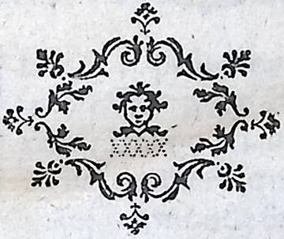  Histoire des deux Indes. H-1773:08, t. I, p. de t. - Coll. D. Droixhe-A. Piette | Du Buat, Éléments de la politique,  Londres [Maastricht, Dufour], 1773, t. I, p. xliv
Bibliothèque nationale de France, NUMM-94013 < 1 > | Du Buat, Éléments de la politique,t. I, p. xliv
Figure 2
Another tailpiece is more relevant as it appears in a edition officially acknowledged by Dufour, and bearing his correct address: the Œuvres complettes by Joseph-François-Édouard Desmahis, also published in 1773 (figure 3).
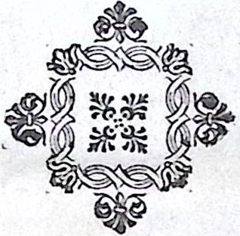  Histoire des deux Indes. H-1773:08 ; t. I, p. 237 - Coll. D. Droixhe-A. Piette | Desmahis, Œuvres complettes., Maestricht, Jean Edme Dufour, Dufour, 1773, p. 69, p. 90, p. 106; Du Buat, Éléments de la politique, Dufour, t. V, p. 13 ; t. VI, p. 122 ; t. VI, p. 269
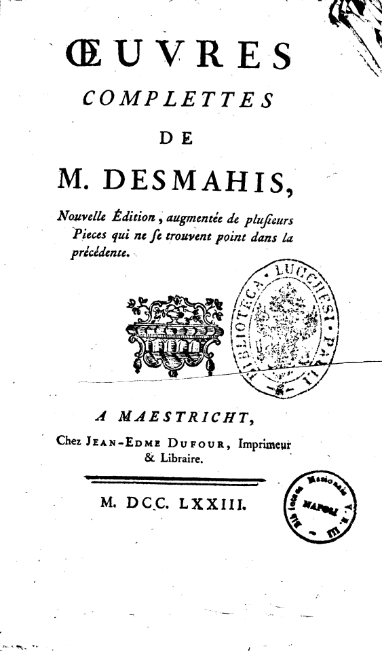  Biblioteca Nazionale di Napoli, Biblioteca Lucchesi Palli | Desmahis, Œuvres complettes, Maestricht, Dufour, 1773, p. 69
Figure 3
- Compound headpieces: Dufour’s register
Two headpieces also appear in Dufour’s edition of Du Buat (figure 4).

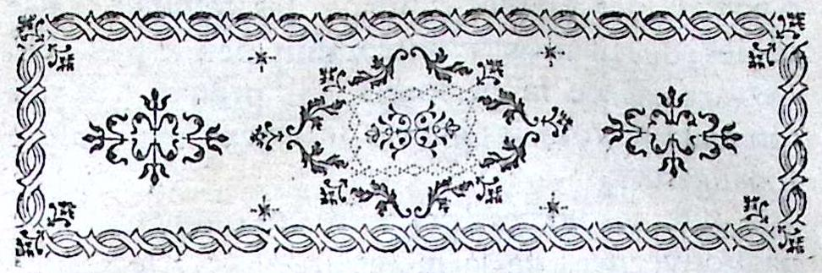
H-1773:08, t. I, p. 121
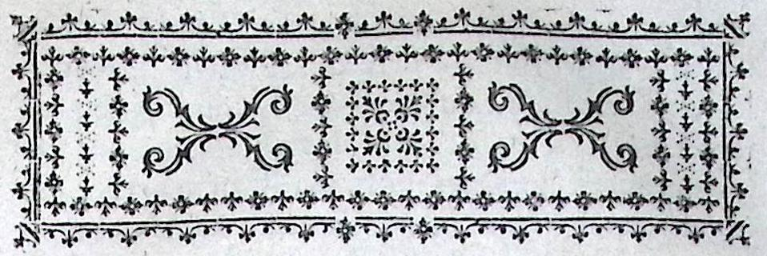
H-1773:08, t. I, p. 237
Du Buat, Éléments, Dufour, t. I, p. 1. | Du Buat, Éléments, Dufour, t. I, p. 47.
Figure 4
At this point in the study, the compound ornaments indicate only that the title-page and p. 1 of volume I were produced by the same printer, that is to say Jean-Edme Dufour. However, it is possible to argue that another headpiece, in volume II, could also be due to Dufour.
- The Dufour headpiece of H-1773:08, volume II: the reconstruction of a puzzle compound
The headpiece of volume II can be broken down into three modules which constitute what is inside the rectangular frame : a) a central module which represents a head seen from the front, between two leaf-shaped typographic ornaments over another with a kind of palm ; b) two symmetrical modules where two + one ornaments are decorated on the sides with vertical lines made up of flowers and stars ; c) a group of two ornaments reversed.
In an article on Voltaire’s counterfeits produced in Rouen by Pierre Machuel in the XVIIIth century, I have proposed to classify compound ornaments according to ‘matrices’, that is to say basic modules, on which a determinate series of tailpieces could be assembled. In the headpiece of volume II of the Histoire des deux Indes, the central module consists of a face between two leaves above another leafy element. This appears as a lateral module in another headpiece used by Dufour in Du Buat’s edition (figure 5).
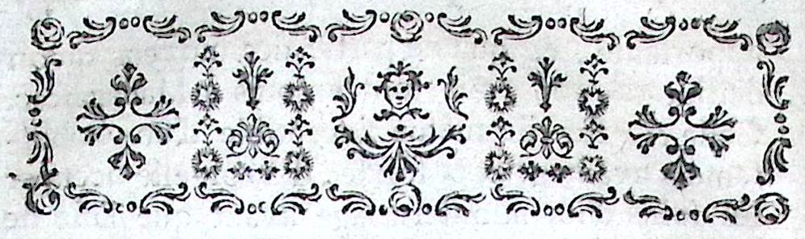
H-1773:08, t. II, p. 146

Du Buat, Éléments, Dufour, t. I, p. 13 ; t. III, p. 229
Figure 5.

On the other hand, the symmetrical arrangement of the ornaments – flowers, stars, a tall plant – which accompany the central module in the headpiece of the Histoire des deux Indes characterises a central module in another headpiece of Du Buat (figure 6).
Figure 6.
Du Buat, Éléments, Dufour, t. V, p. 1
By combining the two modules in Du Buat, Dufour could begin the construction of a model corresponding to the headpiece of H-1773 :08, t. II.
The productivity of such a ‘puzzle reconstruction’, used in material bibliography and ornamental research, can be illustrated by another correspondence between the Histoire des deux Indes and Du Buat’s edition (figure 7). If the external rectangular frame of H-1773:08 is different, that which is internal is the same as in Du Buat ; the vertical lateral lines are constructed with the same ornaments (flowers, dotted crosses, ‘black snowflakes’) ; the ‘hippocamp’ are assembled differently; the central module has ornaments which are differently oriented. Almost all the ornaments used in Du Buat could be used to construct the Histoire des deux Indes headpiece.
Du Buat, Éléments,Dufour, t. IV, p. v
H-1773:08, t. I, p. 237
Figure 7
- Engraved drop caps in the various volumes: Plomteux’s register
If the compound tailpieces and headpieces of volumes I and II of the Histoire des deux Indes indicate volumes printed by Dufour, the engraved tailpieces and headpieces introduce a problematic disruption, as they come from another printer, Clément Plomteux.
The following engraved drop caps or ornate initial letters are common to the Histoire des deux Indes and to the Sermons sur la morale et sur les mystères of Charles Joseph Perrin published by Plomteux in 1768. They are reversed in the occurrences and reproduced here in large dimensions so that the details may be compared, especially a break in the frame of the ' I ', which is more worn in 1773 (figure 8).
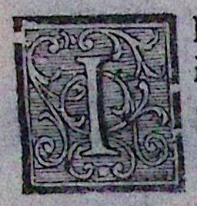  H-1773:08, t. I, p. 1 | 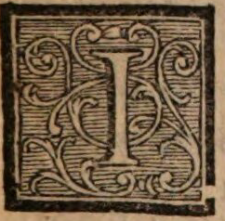  Perrin, Sermons, 1768, t. III, p. 365 ; t. IV, p. 1
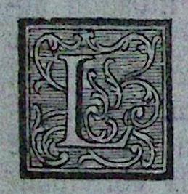  H-1773:08, t. IV, p. 3 | 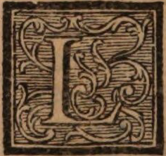  Perrin, Sermons, 1768, t. II, p. 94 ; t. III, p. 137
Figure 8
Clément Plomteux was one of the most important booksellers-printers in Liège during the twenty years preceding the Revolution. His portrait has been featured in previous studies. He began officially to print in 1766 when he was associated with the Liège bookseller-printer Éverard Kints, whose daughter he had married. In the first years, he mainly printed religious literature under his own address. But in 1771, he began to publish a huge collection of Voltaire’s Œuvres which would be continued to 1777 and consist of 32 volumes. For this edition, he called on a distinguished local artist, Louis Dreppe. If the location of Plomteux’s establishment in Liège has not yet been determined, the views of his printing workshops were widely disseminated from the four paintings created before 1789 by Léonard Defrance (figure 8).

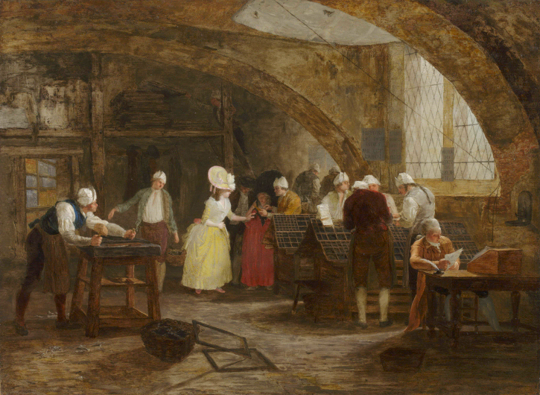
Figure 8.
Léonard Defrance, Visite à l’imprimerie, Musée de Grenoble.
The correspondence of the engraved drop caps reproduced above suggests that volumes I and IV of H-1773 :08 were printed by Plomteux.
- The engraved headpieces of the various volumes: Plomteux’s register
The engraved headpiece of H-1773 :08 confirms that the texts of volumes III, IV, V and VI were entirely printed by Plomteux, because all these headpieces also correspond to models noted in his edition of Perrin’s Sermons. We reproduce one of the most significant headpieces, with a cherub holding a basket of flowers and fruits between foliage and two trees (figure 9). Its occurrence has also been noted, in collaboration with I. Kachur and N. Vanwelkenhuyzen, in other religious books which have Plomteux’s official address. Thus, he published in 1768, as the ‘Imprimeur de Messeigneurs les États’ of Liège, Le Chapelain’s Panégyrique de sainte Thérèse and Henry’s Explications, ou notes courtes et faciles sur le catéchisme.
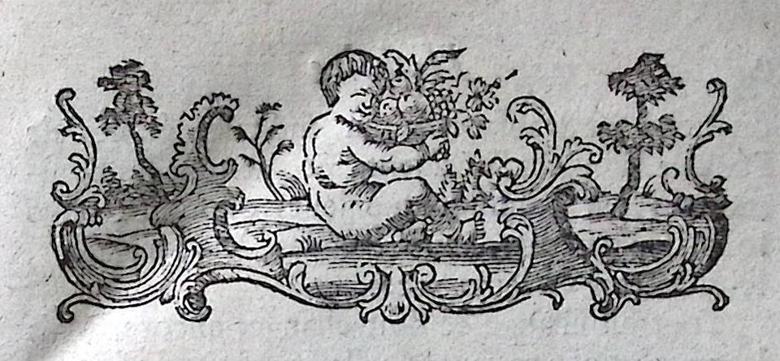
Figure 9.
H-1773:08, t. I, p. 1 - Charles-Jean-Baptiste Le Chapelain, Panégyrique de sainte Thérèse, Liège, Clément Plomteux, 1768, p. A) – Pierre-Joseph Henry, Explication, ou notes courtes et faciles sur le catéchisme, Liège, Clément Plomteux, 1768, p. A2– Charles Joseph Perrin, Sermons sur la morale et sur les mystères, Liège, Plomteux, 1768,t. IV, p. 194.
- The spelling of the titles
The spelling of the titles of volumes varies, and that of the titles of the Livres in each volume is not uniform. The modern spelling (e.g.–ents as in ‘établissements’) is generally used by Dufour in his editions, as in Du Buat’s Éléments or Desmahis’s Œuvres complettes, mentioned above. It is used here in the titles of volumes I-II-III, in the corresponding titles of the Livres and in the text of these volumes – which are supposed to have been printed by Dufour. The old, traditional spelling in –ens is generally used by Plomteux, as in Perrin’s Sermons, Cicero’s Lettres à Atticus (1773), etc. It is used here in titles and text of the volumes IV-V-VI. Volume III is a special case : its title-page has ‘Etablissements’, in Dufour’s style, but the title of its Livres 6-7-8 and the corresponding text have ‘établissemens’, in Plomteux’s style (figure 10).
 | Titles of Volumes |  | Titles of Livres
 | Etablissements | Etablissemens | Établissements | établissemens
T. I | x |  | x
T. II | x |  | x
T. III | x |  |  | x
T. IV |  | x |  | x
T. V |  | x |  | x
T. VI |  | x |  | x
Figure 10.
- Other distinctive features : rod, ampersand, fonts, swash
The rods used in title-pages of volumes consist of a double line rounded in the middle in volumes I-II-III and in brackets in volumes IV-V-VI (figure 11).
H-1773:08 | Rounded rod | Bracket
Volumes I-II-III | 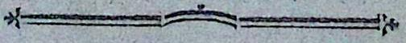
Volumes IV-V-VI |  | 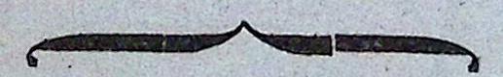
Figure 11
The form of the ampersands, in the titles of the Livres, is decisive in a different way. This character clearly opposes the two first volumes to the others (figure 12)
Volumes I-II, Livres 1-5 | x
Volumes III-VI Livres 6-18 |  | x
Figure 12
The distinction concerning ampersands corresponds to a distinction established by I. Kachur concerning the fonts, especially when it relates to certain letters of the title-pages such as T, E and Q. Fournier fonts are used in volumes I-II and Enschedé fonts are used in the other volumes. The T and E have simpler horizontal bars in Fournier; the bars are longer and, so to say, angular in Enschedé. The 'Q' has a simple line under the circle in Fournier ; it has a curved line in Enschedé. It must be correlated to the fact that Dufour elsewhere uses Fournier fonts, and Plomteux uses Enschedé. Furthermore, an even simpler distinctive elements lies in the comma used after 'politique' in the Plomteux/Enschedé titles (figure 13).
Dufour/Fournier fonts | Plomteux/Enschedé
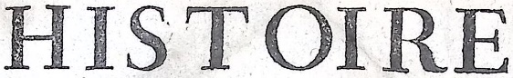 | 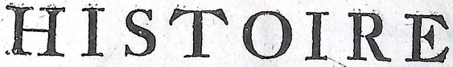
 | 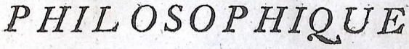
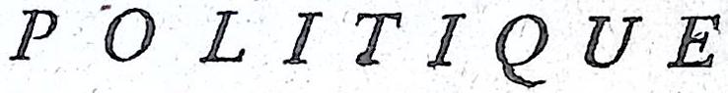 | 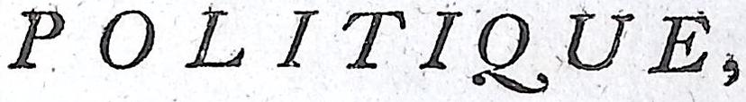
Figure 13
Another element noticed by I. Kashur confirms the distinction. It lies in the use of the swash in the mention of the volume number opening a signature or section of pages printed on one leaf. The ' T ' has the Fournier shape that is to say without swash in volumes I-II and the Enschedé shape with a swash in volumes III-VI (figure 14).
Dufour/Fournier volume number | Plomteux/Enschedé volume number
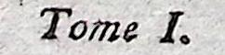 | 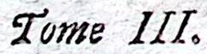
Figure 14
Dufour’s style is illustrated by his edition of Du Buat’s Éléments de la politique of 1773, with simple T, E and 'Volume I '. Plomteux’s style is characterized in John Leland’s Nouvelle démonstration evangelique of 1768 by its angular 'T' and 'E' on the title-page and 'Volume I ' in swash.
- State of the question and hypothesis
At this point, a hypothesis may be argued, on the basis of the differences between the volumes.
In volumes I-II, the title-pages present characteristics specific to Dufour: Fournier fonts, modern spelling and a tailpiece which he uses elsewhere. The first pages of the same volumes share these characteristics but they have engraved headpieces and engraved drop caps which come from Plomteux.
In volumes IV-V-VI, the title-pages and all the first pages present characteristics specific to Plomteux : the Enschedé fonts, traditional or antiquated spelling and engraved headpieces and drop caps that he uses elsewhere.
Thus, it seems that these volumes were brought together to form a single edition of the Histoire des deux Indes. Which one was supposed to complement the other? Everything indicates that the H-1773: 08 collection was undertaken first, to continue the previous counterfeits provided by Plomteux in 1772-1773, which were completely his own. The immediate success of his editions of such a best-seller demanded a rapid renewal. The Lyon printers were in the race. Volumes I and II of the H-1773: 07 must have been sold faster and more widely: the amateur interested in a work sometimes buys the first volumes of a collection but gives up after reading them.
If the first volumes were missing, at some point, Plomteux kept in stock the following volumes, which were needed for the collection to be completed. That he reused this stock is attested by the fact that volume IV of H-1773 : 07, as described by Courtney, is the same as volume IV of H-1773: 08. In both, p. 102 is paginated 202. If the first has 292 p. (A-S⁸ T²) and the other 296 p. (A-S⁸ T-V²), that is because the first has no ‘Table des matières’ and the other has it. Thus, it is logical that, undertaking the new H-1773: 08 edition, Plomteux integrated this new ‘Table des matières’.
Could the same reason explain the fact that volume V of H-1773: 07 has 296 p. (without ‘Table des matières’) and that of H-1773 : 08 has 310 p. (with it) ? H-1773 : 07 has p. 285 paginated '85’, as Courtney observes, but H-1773 : 08 no longer has the mistake, in our copy as in that kept at the Bibliothèque de la Faculté des Lettres de l’Université de Lausanne. In this case, spelling differences allow us to suggest that the text of H-1773 : 08 results from a different composition : ‘Guiane’ in H-1773 : 07, p. 31 versus ‘Guyane’ in H-1773 : 08, p. 31; ‘Sainte-Lucie’, p. 36, 42 versus ‘sainte-Lucie’ ; ‘défrîcher’, p. 42 versus ‘défricher’ ; ‘fort roial’, p. 56 versus ‘fort Royal’, etc. We leave it to others to verify the correspondences concerning volume VI.
Volume III is special, as it mixes, in the title-page and page 1, the two specific characteristics determined above. The mixture is illustrated by two images. In the title-page, Dufour’s compositor retains the workshop fonts and spelling of volumes I-II at the beginning of a book whose text is provided by Plomteux, with the latter’s fonts, engraved ornaments and spelling (figures 15-16).
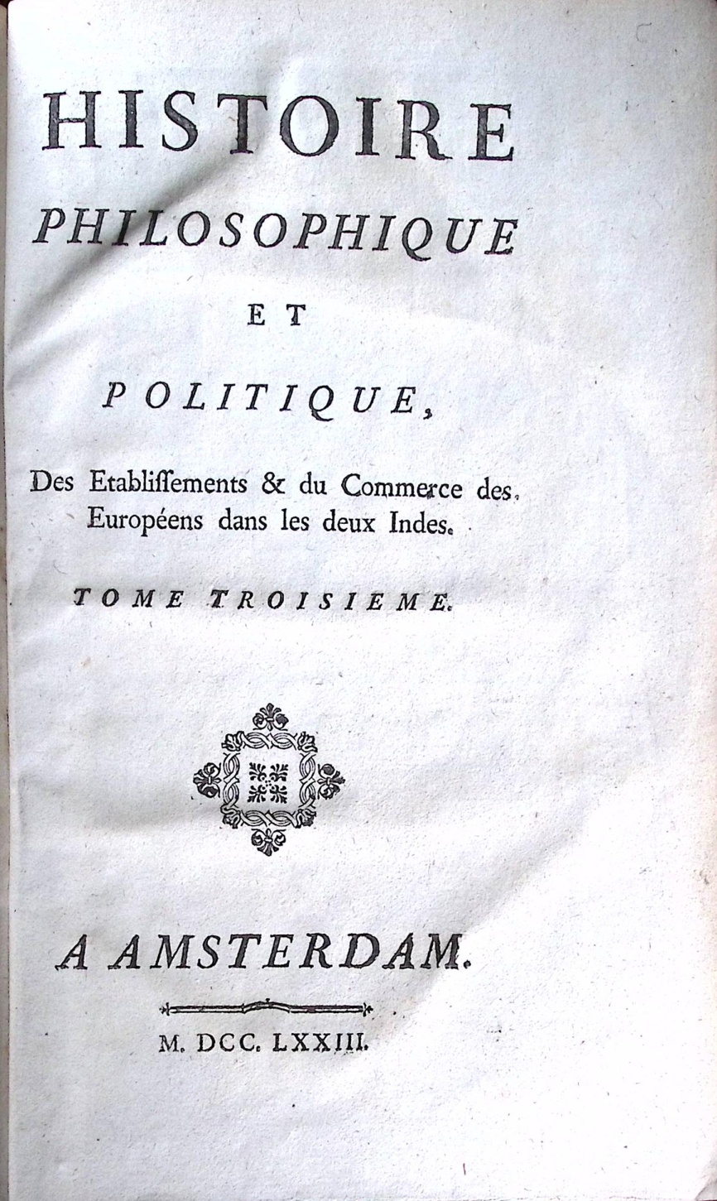
Figure 15
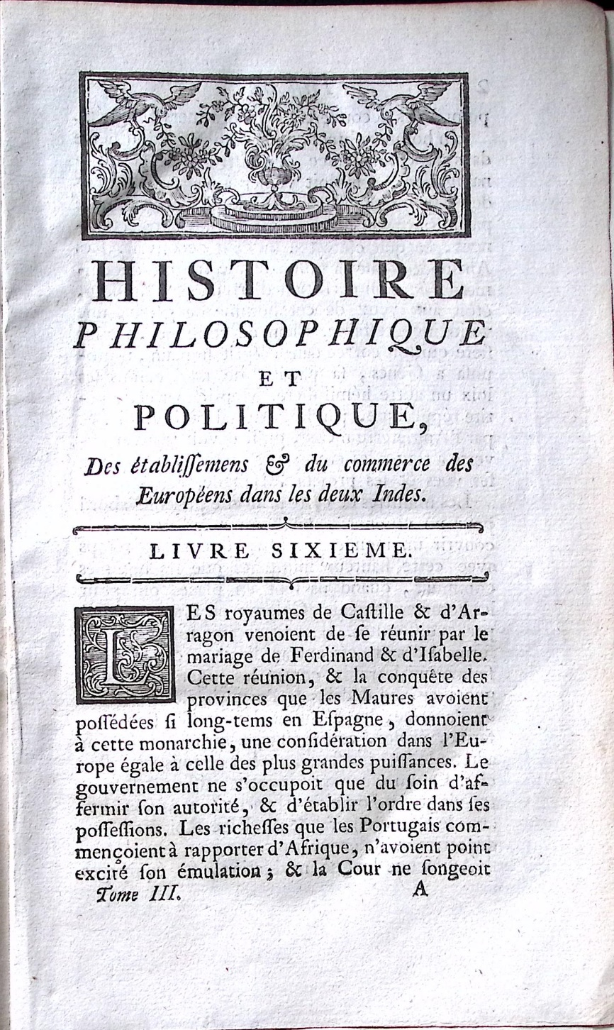
Figure 16
- Conclusion
We can easily assume that Plomteux, who was in a hurry, was not able to print another complete new edition of the Histoire des deux Indes in 1773, and that he asked Dufour to help him by printing volumes I and II which sold faster. Dufour also printed the title-pages and added the title-page of volume III – whose text was ready, having been provided by Plomteux. The latter reused his previous edition of volume IV and printed at least a new volume V.
This scenario leaves intact the difficulty of explaining how the first page of the text in volumes I and II, printed by Dufour, has headpieces and tailpieces from Plomteux. The hypothesis that Dufour could have copied these engraved headpieces and tailpieces is unsustainable. They were slow and costly to make. When you commit money for this for this purpose, you use it. And Dufour, who had a constant and limited stock of engraved ornaments, would not use these in his own editions? Thus, we must suppose that the engraved ornaments were sent, by post or by boat, from Liège to Maastricht. The two towns were only about thirty kilometres apart and they were linked during the second half of the XVIIIth century by a stagecoach service. The latter was established on the ‘quai de Maestricht’, n° 2, where a commemorative plaque was placed in 1950 (figure 16).

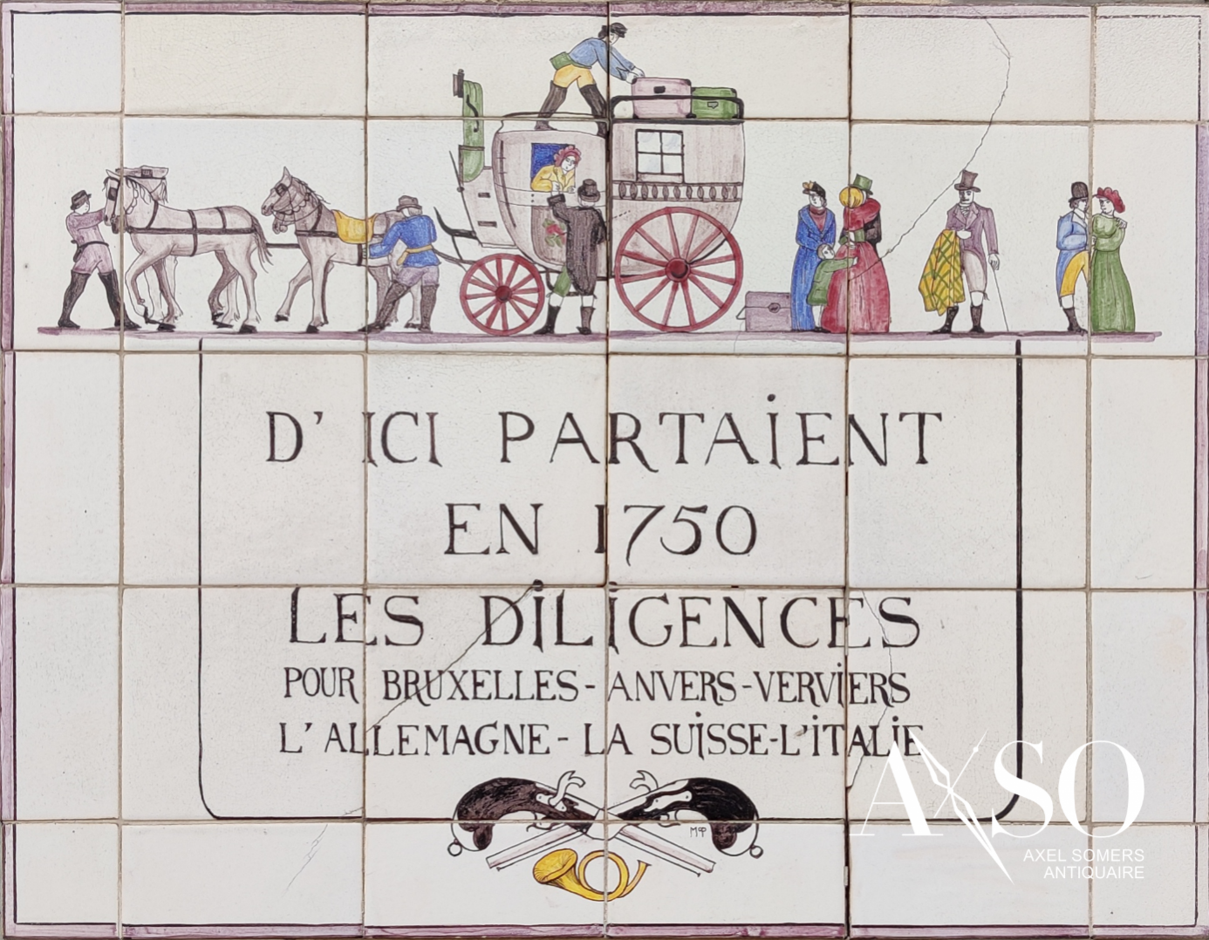
Figure 17.
Boats also linked Liège and Maastricht from the same dock. Around 1850, they went twice a day from Liège to Maastricht in two and a half hours. This was actually sufficient for a quick exchange of typographic materials.
Could the buyers see the differences of swelling fonts, ampersands, swashes, etc.? Plomteux fonts looked more ancient, and closer to the curved or coiled rococo style of Louis XV furniture, while those used by Dufour, which broke, so to speak, with rococo forms, looked more modern as they came back to simple, straight shapes. Plomteux had developed as a rival to old Bassompierre. Dufour wanted to be much more than a former student from Bassompierre’s workshop and to surpass the master. Bassompierre and Plomteux were living in a catholic state, under the cross of a prince-bishop. Dufour was determined to exploit the possibilities for greater intellectual modernity offered to him by the Protestant political regime in Maastricht. Typography did not bother with the border.
Another personal copy of H-1773: 08 raises a final question. From which edition did Dufour or Plomteux borrow frontispiece added to the volume (figure 18)? The engraving is signed left ‘C. Eisen inv.’ And right ‘D. Nee sculp. 1773’. As far as we know, no previous edition involves this engraving, which was however reused for H-1774:02.
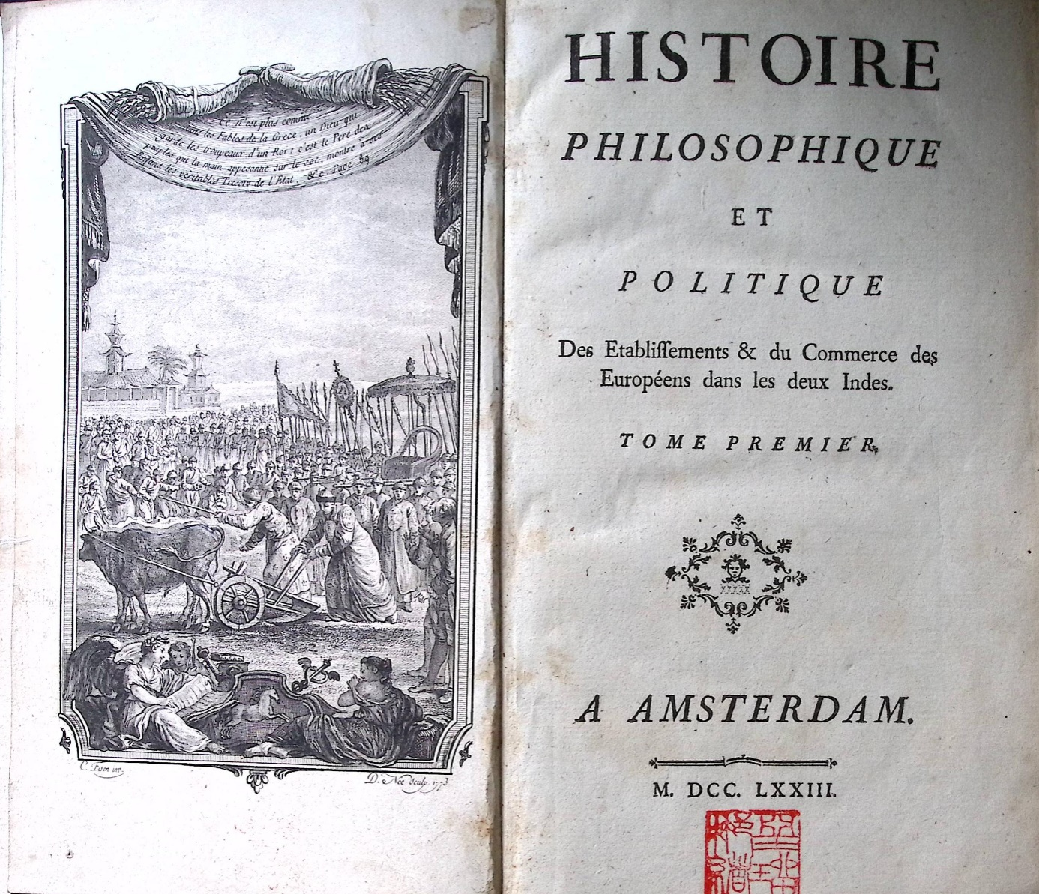
Figure 18.
Collection D. Droixhe-Piette.
Exlibris Juan Narbona with motto mens manet immota
‘The mind remains unmoved’.

 | Engraved headpieces | Engraved tailpieces | Spelling  mens/ments | Compound tailpieces | Compound headpieces
1773 :08  t. I | Plomteux | Plomteux | Dufour | Dufour | Dufour
1773 :08  t. II | Plomteux |  | Dufour |  | Dufour
1773 :08  t. III | Plomteux |  | Dufour (Volume)
1773 :08  t. III | Plomteux |  | Plomteux (Livre + text)
1773 :08  t. IV | Plomteux | Plomteux | Plomteux
1773 :08  t. V | Plomteux |  | Plomteux
1773 :08  t. VI | Plomteux |  | Plomteux

Courtney, Cecil Patrick Courtney (dir.), avec la collaboration de David Adams, Gilles Bancarel, Daniel Droixhe, Claudette Fortuny, Gianluiggi Goggi, Iryna Kachur, Hans-Jürgen Lüsebrink et Nadine Vanwelkenhuyzen, Bibliographie des éditions de Guillaume-Thomas Raynal 1747-1843, Paris, Champion, 2021. I especially thank David Adams for having corrected my English, as usual, and provided useful observations. I also thank booksellers Itziar Arranz, Matthieu Martin and Dieter Zipprich for their professional answers to my request, as well as Muriel Collart, Cecil Courtney and my wife Alice Piette for their help.
Raynal, Guillaume-Thomas, Histoire philosophique et politique des établissements et du commerce des Européens dans les deux Indes. Édition critique.Volume I, Strugnell, Comité éditorial Anthony (dir.), Andrew Brown, Cecil Patrick Courtney, Georges Dulac, Gianluiggi Goggi et Hans-Jürgen Lûsenbrink, Ferney-Voltaire, Centre international d’Étude du XVIIIe siècle, 2010.
Daniel Droixhe, ‘Signatures clandestines et autres essais sur les contrefaçons de Liège et de Maastricht au XVIIIe siècle’, Studies on Voltaire and the eighteenth century, 2001, p. 20-204 [https://hdl.handle.net/2268/2215]; Muriel Collart, ‘Des beaux ornements aux belles bibliothèques. À propos de l’édition clandestine des Œuvres de Brantôme par Jean-Edme Dufour (Maastricht, 1779)’, Histoire et civilisation du livre 13, 2017, p. 167-83 ; ‘David Adams and Daniel Droixhe, ‘Quelle contrefaçon rouennaise du Théâtre de Diderot a été imprimée par Louis-Joseph Oursel pour Pierre Machuel en 1770-1771 ?’, Recherches sur Diderot et sur l'Encyclopédie 58, 2023, p. 211-218 [https://hdl.handle.net/2268/309739]; Daniel Droixhe, ‘L’édition 1765-O1 des Œuvres de Montesquieu : une contrefaçon roueannaise imprimée par Abraham-François Viret pour Pierre Machuel’, Gutenberg Jahrbuch 99, 2024, p. 174-189 [https://hdl.handle.net/2268/320351] ; Daniel Droixhe, 'La contrefaçon rouennaise du Candide imprimée par Louis-Joseph Oursel pour Pierre Machuel en 1775', Cahiers Voltaire: Revue Annuelle de la Société Voltaire, 23 (2025), pp. 101-111; Daniel Droixhe, 'Une contrefaçon du Siècle de Louis XIV de Voltaire imprimée par Abraham-François Viret pour Pierre Machuel en 1764. Style ornemental et identification numérique', Revue Voltaire, 25 (2025), pp. 223-237.<https://hdl.handle.net/2268/328471> [accessed 20 June 2025].
Daniel Droixhe, Une histoire des Lumières au pays de Liège. Livre, idées, société, Liège, Les Éditions de l’Université de Liège, 2007, p. 185-86
Muriel Collart, 'Des beaux ornements aux belles bibliothèques. À propos de l’édition clandestine des Œuvres de Brantôme par Jean-Edme Dufour (Maastricht, 1779)', Histoire et civilisation du livre. Revue internationale, 13, 2017, p. 167-83.
Droixhe, ‘Signatures clandestines’, p. 177-96.
Daniel Droixhe, ‘The Rouen nebula of counterfeiting. AI, the BnF and Voltaire’s editions’, to appear.
Droixhe, Une histoire,p. 185-87.
Daniel Droixhe, ‘Images de livres: Raynal, Buffon, Mercier dans une Visite à l'imprimerie perdue et retrouvée’, Histoire et civilisation du livre: revue internationale 7, 2011, p. 99-113. https://hdl.handle.net/2268/105973. The other Defrance’s Visites à l’imprimerie have sometimes be considered as representing the workshops of Jean François Bassompierre. See https://www.youtube.com/channel/UC9IYv51pIMo-sCEoNvoSGiw
Correspondences of the other headpieces : H-1773: 08, t. II, p. 3/Perrin, Sermons, t. II, p. 267 ; H-1773: 08, t. III, p. 1/Perrin, Sermons, t. IV, p. 414 ; H-1773: 08, t. IV, p. 3/Perrin, Sermons, t. II, p. 355 ; t. IV, p. 242 ; H-1773: 08, t. V, p. 3/Perrin, Sermons, t. IV, p. 330.
Volume I : gouvernements (p. 9), tourments (p. 35), aliments (p. 39), débordements (p. 49), etc. ; t. II : enfants (p. 8), expédients (p. 11), établissements (p. 11), habitans (p. 23), etc.
Volume IV : monumens (p. 4), saillans (p. 4), changemens (p. 12), défrichemens (p. 24) ; volume V : encouragemens (p. 4), entreprenans (p. 4), défrichemens (p. 34), bâtimens (p. 56) ; volume VI : penchans (p. 9), logemens (p. 69), mouvemens (p. 81), sentimens (p. 105), etc.
Volume III : ornemens (p. 4), malfaisans (p. 6), éclaircissemens (p. 8), etc.
John Leland, Nouvelle démonstration evangélique, Liège, Plomteux, 1768. Bavarian State Library, 598-1.
Axel Somers (Antiquaire), ‘Les Diligences’, https://axso.be/
Bibliographie, p.175. Communication D. Adams.

