Memory benefit after exploring a novel virtual environment: There is more than spatial novelty

Anaïs SERVAIS, Christine BASTIN
GIGA Research CRC Human Imaging, University of Liège, Allée du 6 Août 8, B30, 4000 Liège, Belgium.
Faculty of Psychology, Psychology and Neuroscience of Cognition, University of Liège, Place des Orateurs 1, B33, 4000 Liège, Belgium

Emails: Anais.Servais@uliege.be; Christine.Bastin@uliege.be

Corresponding author
Christine BASTIN, University of Liège, Building B30 - GIGA Research CRC Human Imaging, Quartier Agora, Allée du 6 Août, 8, 4000 Liège, Belgium. Tel: +32 4 3662369. Email: Christine.Bastin@uliege.be

ABSTRACT
Animal studies show that novelty boosts memory for unrelated information encountered shortly after. Evidence for this effect is lacking in humans. Using Virtual Reality (VR) to simulate spatial novelty has yielded conflicting results. Schomaker et al. (2014) found that word recall was higher when encoding followed novel rather than familiar exploration, which we failed to replicate in two prior studies. Instead, we observed enhanced recall after initial VR exposure. This study examined the broader effect of VR experience on memory. As VR could improve memory, we included 35 younger adults and 32 older adults to directly investigate whether the effect is maintained when episodic memory declines. We compared memory performance on word lists encoded after exploring a VR environment, watching a documentary (a more common experience), or completing a control condition that involved no exploration. Recall was better after VR than after both the control condition and the documentary, suggesting that the effects of VR go beyond spatial novelty. Both age groups benefited from the VR effect on memory. The effect of VR on subsequent memory was modulated by novelty judgments: the more participants experienced VR as a novel experience, the larger the memory boost. We discuss how VR could constitute in itself another type of novelty that could be taken into consideration in future studies.
Keywords: Spatial novelty; Virtual reality; Episodic memory; Recollection; Declarative memory

- INTRODUCTION
Non-human animal studies have provided robust evidence that exposure to novelty positively impacts memory for unrelated information encountered within a narrow time window around the novel experience (e.g., Davis et al., 2004; Lemon & Manahan-Vaughan, 2006; Straube et al., 2003), with rodent studies showing that the positive effects of spatial novelty on memory can persist for up to 30 minutes after exposure (Li et al., 2003). Novel experiences induce a "halo" of enhanced memory, causing an initial consolidation that extends forward in time, enhancing the retention of otherwise trivial memories that would normally be forgotten. For example, in humans, it can be illustrated by the fact of being able to recall what and where we ate on the first night of our trip to Paris while not being able to recall what we ate for dinner one week ago.
Neurobiological models explain this phenomenon by showing that encountering novelty activates neural activity in various brain regions, including the frontal, parietal, and temporal areas, as well as the limbic system and hippocampus. This activation also boosts the synthesis and release of neurotransmitters like dopamine, norepinephrine, and acetylcholine (Düzel et al., 2010; Lisman & Grace, 2005), which play important roles in memory. More precisely, animal studies have highlighted two brain pathways that can enhance novelty-related memory. First, according to a prominent model, new information or environment activates the hippocampus, which, in turn, forms a functional loop with the dopaminergic neurons of the ventral tegmental area (VTA; Lisman & Grace, 2005). Upon hippocampal activation, the novelty signal travels through the subiculum, nucleus accumbens, and ventral pallidum to reach the VTA (Lisman & Grace, 2005), where it activates novelty-dependent cells. The second pathway would involve the noradrenergic fibers from the locus coeruleus (LC), which project to the dorsal hippocampus, co-releasing dopamine and norepinephrine (McNamara & Dupret, 2017; Takeuchi et al., 2016; Yamasaki & Takeuchi, 2017). Both pathways trigger the release of dopamine within the hippocampus, enhancing plasticity and lowering the threshold for long-term potentiation, thereby facilitating memory formation in the presence of novelty (Davis et al., 2004; Kempadoo et al., 2016; Takeuchi et al., 2016).
The tendency to have better memories for novel experiences (Tulving & Kroll, 1995) as well as for information encountered within a narrow time window around it (Fernández & Morris, 2018) is thought to be an adaptive feature of memory consolidation (Cowan et al., 2021), which is assumed to be also present in human beings. However, while the above-mentioned novelty-induced increased plasticity seems well-established in animal studies (mostly rodents), it has been more rarely studied in humans.
A potential reason explaining the lack of studies in humans could reside in the fact that it is difficult to experimentally expose people to a new environment while controlling for the environmental factors. Studies are, therefore, constrained to use novel images, scenes, or video clips to induce novelty (e.g., Abrahan et al., 2020; Biel & Bunzeck, 2019; Fenker et al., 2008). In that regard, the advent of Virtual Reality (VR) has provided methods to address this issue. In the last decade, researchers have started to use VR environments to investigate the effect of novelty exposure on subsequent memory tasks as these environments have the advantage of being well-controlled while providing a high feeling of immersion, which makes it more ecological.
Schomaker et al. (2014) created a within-subject paradigm using VR in which young participants performed a memory task (encoding and recalling a list of words) after exploring either a novel (never-seen-before) or a familiar virtual environment (previous familiarization phase included in the experimental protocol). The authors reported a positive effect of novelty exposure, as participants performed significantly better on the recall memory task when the encoding took place after the novel exploration compared to the familiar one. Nevertheless, other studies have found conflicting results: while positive outcomes were observed in a few comparable studies (Schomaker & Wittmann, 2021), other similar studies failed to detect the positive novelty effect on memory (Aron et al., 2024; Quent & Henson, 2022; Servais, Schomaker & Bastin, 2024). Existing results are not unanimous, and the circumstances under which the novelty effect influences human memory remain unknown.
In our lab, we have previously conducted two studies (Aron et al., 2024; Servais, Schomaker & Bastin, 2024), which failed to replicate the novelty benefit using within-subject designs with VR, inspired by Schomaker et al. (2014). In the most recent (Servais, Schomaker & Bastin, 2024), participants completed three sessions. The first session assessed baseline memory performance on a memory task, which consisted of encoding a list of 40 words before freely recalling as many words as possible. In the second session, participants started with a familiarization phase with a VR environment and then explored the familiar (i.e., the one explored during the familiarization phase) or a novel (i.e., never-seen-before) environment before performing the same memory task as the one performed during the first session, but with different words. Finally, in the third session, participants explored either the familiar or novel virtual environment (according to the condition they did not fulfill in the second session depending on the counterbalanced conditions) before performing the same memory task again with a different word list. Besides negative results regarding the novelty-related memory benefit, we made an interesting observation. There seemed to be an effect of the session on memory performance. Memory recall was higher in the second than in the third session–that means improved recall after the very first exposure to VR technology. Actually, this order effect showed up in previous studies as well (Aron et al., 2024; Schomaker & Wittmann, 2021). Moreover, the addition of the baseline memory performance (not previously used by the reference study of Schomaker et al., 2014) revealed that memory recall was higher after exploring a VR environment (regardless of it being novel or familiar) compared to the baseline. Hence, the first experience with the VR technology could itself promotes memory processes.
This leads us to the first main objective of the current study, which targets this question by comparing memory performance after exploring a VR natural environment (as an unusual experience, distinct from other past events), after exploring a different natural environment through watching a documentary (more common experience) or in a control condition with no spatial exploration at all. Both environments were expected to induce spatial novelty, but they differed in terms of the use of VR, which was associated with novelty due to its ability to provide immersive, multi-sensory and interactive experiences that are different from the traditional media. According to our hypothesis, we expected the memory recall to be the best after using VR, which was assumed to trigger stronger multi-dimension novelty, compared to the two other conditions. We also expect the memory recall to be higher after watching the documentary than during the control condition as it is supposed to provoke spatial novelty.
Our second main objective was to administer the three above-mentioned conditions to two age groups—a group of young adults (between 18 and 30 years old) and a group of older participants (above 65 years old)—to investigate whether the novelty-related memory benefit is maintained in aging. As VR-based memory rehabilitation programs could be valuable in clinical practices, it is important to verify whether VR also boosts episodic memory in memory-impaired populations. Although episodic memory declines with age (Park & Reuter-Lorenz, 2009; Salthouse, 2009), and novelty-exposure interventions are believed to have the potential to counteract or slow age-related memory decline (Düzel et al., 2010), it remains uncertain whether the positive effects of novelty on memory, as previously mentioned, also apply to older adults. Recently, to address this gap, Schomaker et al. (2022) investigated the effect of spatial novelty on episodic memory across the lifespan using a design similar to that of Schomaker et al. (2014). The authors observed a novelty-related memory benefit in younger adults (between 18 and 44 years old), but a detrimental novelty effect on memory performance in older adults (> 45 years old). Age-related degeneration of the VTA and LC could potentially reduce the beneficial effects of novelty on memory, as this would impact dopamine delivery to the hippocampus (Mather and Harley, 2016); however, this hypothesis does not fully explain the observed detrimental effect of novelty in aging (Schomaker et al., 2022). Besides, the ability to detect distinctive novelty and to better remember distinct items appeared to be present in healthy older adults using a Von-Restorff-type experimental task (Servais, Barbeau & Bastin, 2024; Vitali et al., 2006). The Von-Restorff-type paradigm (Von Restorff, 1933) consists of studying lists of words in which a minority of the words are different from the others by their distinctive aspect (e.g., the color, the font size). Older participants recalled the distinct words better than the other words (Servais, Barbeau & Bastin, 2024; Vitali et al., 2006). However, to our knowledge, the impact of VR-related novelty on memory for unrelated items appearing in a close time window remains under-investigated in aging. Here, we expected a positive VR-related novelty effect on memory in both younger and older participants even though smaller in older participants, in line with the decreased release of dopamine.
- METHODS
2.1 Participants
The sample size was estimated a priori by means of the G*Power 3.1 software (Faul et al., 2007). As there was no prior study with a similar design, we determined the sample size for detecting medium size effects. To be able to detect an a priori medium size effects of .50 according to Cohen’s convention with a statistical power of .80 and an α threshold of .05 on a repeated measures ANOVA, the recommended sample size was 67 participants in total. The power analysis was conducted to ensure sufficient sensitivity to detect the main effect of the condition. Participants were recruited through posts on social media, word of mouth, announcements in associations for older people, and via the SONA platform set up by the University of Liège, which allowed us to reach a larger population of young subjects and helped us recruit 20 of our participants.
To be included in the study, participants had to be between 18 and 30 years old for the young group, and 65 to 80 years old for the older group. Exclusion criteria were the presence of psychiatric or neurological conditions, as well as the chronic use of medications that could impair cognitive function. Additionally, patients suffering from migraines or dizziness were not included due to the use of VR, which can exacerbate these symptoms and increase the risk of cyber sickness. Older participants’ data were excluded if they obtained a score below 23 on the MoCA (Carson et al., 2017). In our older group, the average MoCA score was 28.2 (SD = 1.13).
We recruited 70 participants: 36 young and 34 older. Three participants were excluded. Among them, two had a psychiatric condition (one young and one older) and another older participant did not attend the last two sessions. See Table 1 for demographics of the two age groups.
Table 1. Demographics of groups. Mean (± SD) for Age and Education. F: female; M: male; N: number of participants including in the analyses.
 | Younger | Older
N | 35 | 32
Age (years) | 21.7 ± 3.45 | 70.1 ± 3.94
Sex | 20 F; 15 M | 18 F; 14 M
Education (years) | 12.6 ± 1.52 | 14.5 ± 3.58

This study was conducted in accordance with the ethical guidelines described in the Declaration of Helsinki (1964) and received approval from the ethics committee of the Faculty of Psychology of the University of Liège. All participants signed a written informed consent form before their inclusion.
2.2 Materials
2.2.1 Memory tasks
We created three lists of 20 words each. The words were drawn from the 20 categories of Dubois and Poitou (2002). Lists were equivalent in terms of average word length and frequency (according to the lexique.org website, recapitulative table of word characteristics for each of the 3 lists are presented in the Appendices 1 and the entire word lists are freely available at OSF). Each word list including one word from each of the following semantic categories: animal, fruit, tree, tool, furniture, clothes, flower, vegetable, sport, job, drink, music instrument, fish, transport, building, insect, utensil, toy, metal, and weapon.
During each session, a list of 20 words was presented to the participants in the form of paper flashcards (one card, one word). Each word was displayed for 4 seconds, with the presentation timing monitored using a stopwatch. During encoding, participants had to respond for each word whether they found it pleasant or unpleasant. Before recall, participants were asked to count backwards for 30 seconds (starting from 100) to prevent them from rehearsing the words during the retention interval. Then, participants were asked to recall as many words as possible (immediate free recall) with no time limit.
2.2.2 Procedure and experimental conditions
Participants took part in three sessions (within-subject design) spread over three days within a period of three weeks (sessions were separated with a minimum of 24 hours). Each session lasted around 30 minutes and was dedicated to one of our two experimental conditions (exploring a VR environment or watching a documentary) or to the control condition (starting with a vocabulary test). The order of conditions was counterbalanced, with participants randomly assigned to different sequences. Rather than assessing baseline memory performance solely at the beginning of the experiment—implying that improvements could occur due to training effects—participants were distributed across counterbalanced groups to mitigate this potential bias. After completing the tasks specific to each condition, the participants encoded a list of 20 words followed by a free recall test. The word list encoded after each condition was also randomized across conditions between participants. See Fig. 1. for an illustration of the experimental procedure. The number of words per list (n = 20) was determined based on pilot data to avoid floor and ceiling effects in both age groups.
After the VR exploration, participants completed the French-speaking version (Laboratoire de Cyberpsychologie de l’UQO, Bouchard et al., 2011) of the Simulator Sickness Questionnaire (SSQ, Kennedy et al., 1993) to assess cyber sickness. None of the participants experienced cyber sickness (SSQ scores ranged from 0 to 11 with an average of 2.57). After both the VR and the documentary, participants answered a questionnaire assessing the feeling of presence that has been developed at University of Liège (validation in preparation by Wagener & Simon; previously used and described by Della Libera et al., 2023) as well as a questionnaire that we created to assess the interest, motivation, pleasantness, emotions, and the level of novelty attributed to the experience (VR or documentary). This last questionnaire included 5-level Likert-scale items to briefly evaluate each of the five above-mentioned factors. Interest was evaluated by asking whether the exploration captivated their attention and whether they considered the exploration stimulating and engaging. Novelty was assessed by asking whether the participant had previous experience with VR and how much they considered this activity novel and original. Motivation was estimated by asking how much the activity encouraged them to explore. The pleasant character of the activity was evaluated by asking the participant how much the activity was pleasant and immersive and whether they took pleasure in participating. Emotions were assessed by asking whether the activity provoked positive or negative emotions. The formulation of the questions was slightly adapted depending on the related activity: VR or documentary. The full questionnaire is freely available at OSF. This questionnaire aimed at investigating the specific role of novelty by controlling the potential influence of the other factors.
2.2.2.1 Virtual environment
We used the Oculus Rift headset and its associated Touch Bundle controllers. We ran the environment on an MSI GT75VR7RE Titan computer, equipped with an NVIDIA GeForce GTX 1070 8GB VRAM graphics card. For the environment, we chose the Nature Treks VR by Meta, which allows the user to freely explore and interact with a natural environment. The interface allows the user to plant trees, flowers, and shrubs, or even make animal species appear. Besides the realistic scenery, Nature Treks VR also plays natural sounds such as waves crashing and birds singing. The soundtrack also included a calm, meditative-style music. The sound volume was tailored to each participant's comfort level at the beginning of the session. Some authors emphasize the immersive nature of the environments offered by the Nature Trek VR application (Sonney et al., 2021). It is also reputed to be easy to use, and to provide good visual comfort and reduced cyber sickness (Clifton & Palmisano, 2019). After a brief explanation of the use of the Touch Bundle controllers, participants were invited to test the different controls. Then, the participants were invited to explore freely the Nature Treks VR environment for 15 minutes. The instructions were: “You will explore a virtual environment for about 15 minutes. You are free to do as you please; there is no specific goal other than to walk around the environment and enjoy the experience.”. For a more realistic experience, participants were standing during their exploration and could move within of ​​approximately 2 square meters.
2.2.2.2 Documentary
We showed a documentary named “Norway - Dovrefjell-Sunndalsfjella” offered by the Arte Family channel and directed by Damien Augeyrolles in 2021 to the participants. This documentary is part of a series of programs called “Natural Parks… in Miniature” that explores natural parks around the world. In the selected episode, participants explored the Dovrefjell-Sunndalsfjella park in Norway via the educational presentation of the fauna and flora. Participants were comfortably seated and the documentary was presented on a screen in front of them to resemble similar everyday situations. The documentary was shown on the MSI GT75VR7RE Titan computer using the screen of the laptop. This condition was chosen for its ecological aspect. Watching a documentary on a screen is more common, and, therefore, presumably less novel than VR. It resembles usual situations where participants watched television or videos on the internet while allowing us to display a natural spatial environment.
To limit confounding variables (other than novelty) that could affect memory performance, we tried to place the participants in the same conditions as in the VR session. Watching the documentary lasted 15 minutes. The documentary also focused on a natural environment since many studies suggested that exposure to a natural environment could itself have a positive impact on cognitive performance (Berman et al., 2008; Bratman et al., 2015; Fan et al., 2024; Kaplan, 1995). The soundtrack featured calm, meditative music and ambient soundscapes, such as the sound of waves or birdsong–aiming for a similar degree of immersion and engagement (Dickey, 2005; Bulger et al., 2008). For the documentary however, there was also a female voice-over describing the national park (though she does not speak continuously). The sound volume was adjusted based on the comfort of each participant at the start of the session. The instructions simply informed the participant that they were about to watch a natural documentary for 15 minutes.
2.2.2.3 Control condition
For our control condition, participants were not exposed to any visual or spatial stimulation, neither VR nor documentary. To prevent participants from immediately performing the memory task at the beginning of the session, we first asked them to complete a questionnaire on their sociodemographic characteristics such as age, number of years of education, profession, and then to perform the Mill Hill vocabulary test (Raven & Deltour, 2007). We did not record the time taken to complete the Mill Hill test. Based on experience, completion time varies between 10 and 20 minutes depending on the individual.
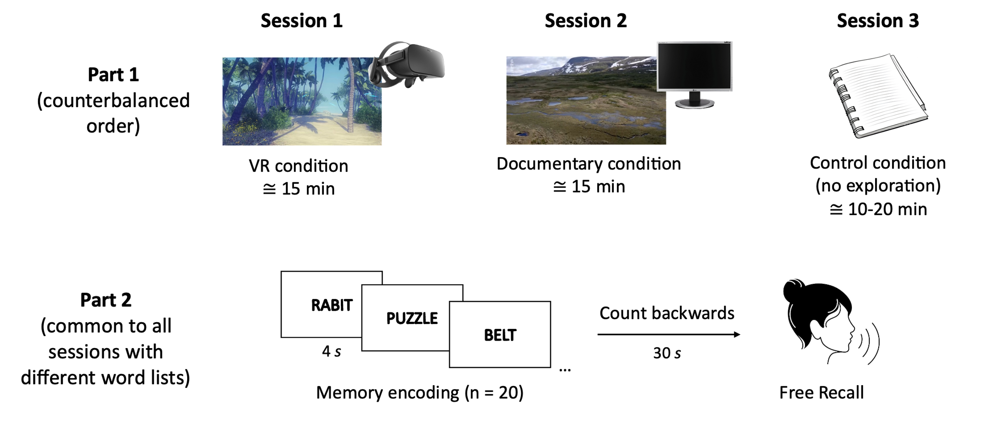
Fig.1. Illustration of the experimental procedure for our within-subject design. Each condition took place on three different days within a period of three weeks. During each session, memory encoding took place directly after the task specific to the concerned condition was done. Free recall was then performed after a short 30-second distractive task. The order of the experimental conditions as well as which word list was used in every conditions were counterbalanced across participants.
2.2.3 Analyses
All statistical analyses were performed with JASP (Version 0.19). The threshold of significance α was .05.
To verify the assumptions under which VR induces higher scores on feeling of presence, novelty, motivation, pleasantness, interest, and emotion, we compared the scores on these questionnaires after VR and documentary conditions across all the participants using Student t-tests for dependent samples.
To investigate whether memory performance (number of recalled words) differed across our three conditions (VR, documentary, and control condition) and groups (young vs. older), we ran a 3 x 2 mixed ANOVA with the conditions as a within subject-factor and the groups as a between-subject factor. Levene tests were non-significant, meaning the assumption of homoscedasticity in our data was met, a condition for valid statistical results (Olejnik & Algina, 1984). Moreover, after running the mixed ANOVA with covariates, the Q-Q plot of the residuals approximated a normal distribution, which was sufficient given the robustness of ANOVAs (see Appendices 2). Post Hoc comparisons were used to compare memory performance after exploring a VR environment compared to the control condition and to watching a documentary. Memory performance after watching a documentary was also compared to the control condition. Holm correction was used to adjust the p-values for multiple comparisons.
Then, to investigate which aspects of VR influence the session effect on memory performance, we added six covariates to the same 3 x 2 mixed ANOVA design. Levene tests were non-significant, meaning the assumption of homoscedasticity in our data was still met. Moreover, after running the mixed ANOVA with covariates, the Q-Q plot of the residuals approximated a normal distribution (see Appendices 3), meeting the second condition for the reliable interpretation of the results. The six covariates included the scores on the different parts of the questionnaire after completing the VR exploration (feeling of presence, novelty, motivation, pleasantness, interest, and emotion). The feeling of presence was a score from 0 to 276 (46 items with 7-level Likert-scale). For the five other variables, the responses on the two 5-level Likert-scale items were summed for the statistical analyses. These covariates were included to better understand which characteristic of VR modulates the most its impact on memory.
As the session order has been shown to affect the results in previous studies (e.g., Aaron et al., 2024; Servais, Schomaker et al., 2024), we investigated whether it had an impact on our pattern of results. To do so, we ran a mixed ANOVA on the number of recalled words (dependent variable) with the age group (younger vs. older) and the session order (six possible random orders) as between-subjects variables and the experimental conditions as a within-subject variable (VR, documentary, and control).
To further investigate whether each age group (younger and older adults) benefited from VR-related novelty to improve their memory performance, we computed two scores reflecting VR-related memory benefit compared to either the control condition or the documentary. The VR-related memory benefit compared to the documentary condition was calculated as free recall scores following the documentary subtracted from free recall scores following the VR exploration, divided by the sum of these two free recall scores. The VR-related memory benefit compared to the control condition was calculated as free recall scores from the control condition subtracted from free recall scores following the VR exploration, divided by the sum of these two free recall scores.
These individual VR-related memory benefit scores were entered into four unilateral one sample t-tests computed (for each age group separately) in order to assess if their novelty-related memory benefit was superior to zero. We assumed that memory would benefit from VR-related novelty in both groups. Then, to explore whether the VR-related memory benefit score differed between the two age groups, we computed two Bayesian t-tests for independent samples with the group as grouping variable and the score reflecting VR-related memory benefit (either compared to the control or documentary condition) as the dependent variable. Unlike the frequentist approach, which only rejects the null hypothesis, the Bayesian method quantifies how much evidence there is toward either the null or the alternative hypothesis (Quintana & Williams, 2018). We calculated the Bayes Factor (BF₁₀) value, which represents how many times a model is more or less likely to explain the data with respect to the null model (Quintana & Williams, 2018). BF₁₀ values below 1 indicate evidence in favor of the null model while values above 1 indicate evidence in favor of the alternative hypothesis. As rule of thumb (Quintana & Williams, 2018), values between 3 and 10 or between .33 and .10 are interpreted as moderate evidence for the alternative model and the null model respectively, while values above 10 or below .10 are interpreted as strong evidence for the alternative model and the null model respectively. We hypothesized that older adults would have a smaller benefit than younger adults.
- RESULTS
3.1 Questionnaires
Compared to watching a documentary, exploring a VR environment induced significantly higher levels of feeling of presence (t(66) = 23.07, p < .001), novelty (t(66) = 18.56, p < .001), motivation (t(66) = 7.19, p < .001), pleasantness (t(66) = 6.83, p < .001), interest (t(66) = 7.55, p < .001), and emotion (t(66) = 5.53, p < .001). The above-mentioned analyses were conducted across all participants; see Fig. 2 for the average scores of each age group separately.
Note that, as expected, VR induced high scores of novelty (score out of 10) across all our participants with a global average score of 8.83 (CI95% = [8.57, 9.11]; min = 6; max = 10), meaning our participants had no or very little experience with VR prior to their inclusion in the study.
Fig. 2. Barplots for variables in the Questionnaires per age group. A) Differences between VR and watching a documentary for the five variables included in our questionnaire; B) Difference of feeling of presence between VR and watching a documentary. Error bars represent the confidence intervals at 95%.
During the control condition, older participants obtained on average a score of 27.27 (SD = 3.56) on the Mill Hill vocabulary test against an average of 21.18 (SD = 5.11) for the younger participants. After computing individual z-scores based on the French norms by Deltour (1993), younger participants obtain on average a z-score of -1.36 (SD = 1.26) and the older participants an average of -.99 (SD = 1.13). Setting the threshold for z-scores at -1.66 (corresponding to percentile 5), 14 younger and 8 older participants scored below the norms.
3.2 Memory performance across groups and experimental conditions
The average number of recalled words in each experimental condition and each group are presented in Table 2. The mixed ANOVA on the number of words correctly recalled by participants according to the condition (VR, documentary, and control condition) and the group (young vs. older) revealed a main effect of the group as older participants recalled less words than the younger group, F(1,65) = 5.63, η²_{p} = .08, p = .02, but also a significant main effect of the conditions, F(2,130) = 26.61, η²_{p} = .29, p < .001. However, the interaction between the group and the condition was not significant, F(2,130) = 1.25, η²_{p} = .02, p = .29.
Post-hocs comparisons (reported p-values are corrected with Holm correction) exploring the effect of the condition showed significantly improved memory performance after performing VR compared to the control (t(66) = 6.76, p < .001) and documentary (t(66) = 5.46, p < .001) conditions, but no significant improvement after watching the documentary compared to the control condition (t(66) = 1.49, p =.14) (see Fig. 3.).
Table 2. Mean (± SD) of number of recalled words for each experimental condition and each age group.
 | VR | Documentary | Control
Younger | 12.27 ± 2.77 | 10.97 ± 2.75 | 10.94 ± 3.04
Older | 11.09 ± 2.55 | 9.76 ± 2.50 | 9.09 ± 2.47

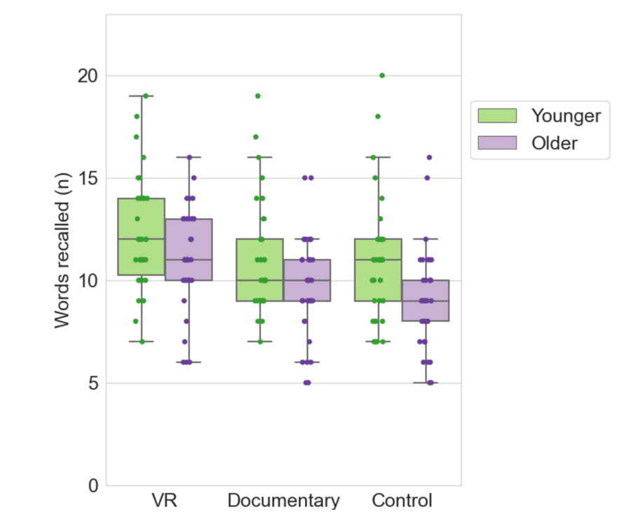
Fig. 3. Boxplots representing the number of recalled words after each of the three experimental conditions for the two age groups. The middle lines of the boxplots represent the median values; the boxes extend from the first quartile (Q1) to the third quartile (Q3), and the whiskers indicate 1.5 times the interquartile range.
3.3 Factors influencing memory performance across conditions
Interestingly, after adding the scores at the questionnaires after the VR exploration as covariates into our mixed ANOVA design, we found a significant effect of the covariates motivation (F(1,59) = 6.09, η²_{p} = .09, p = .02) and novelty (F(1,59) = 7.22, η²_{p} = .11, p = .009), as well as a significant interaction effect of the novelty score on the conditions (F(2,118) = 4.89, η²_{p} = .08, p = .009). The greater the perception of VR as a novel experience (i.e., as something entirely new and never experienced before), the greater the improvement in memory after the VR condition compared to the baseline or documentary condition. All the other covariates’ effects and their interaction with the conditions were not statistically significant. Importantly, we also notice that the main effect of the conditions, which was statistically significant before the addition of the covariates, became not significant after their addition (F(2,118) = 1.18, η²_{p} = .02, p = .31).
Fig. 4. Regression plots for the memory performance benefit in VR condition compared to the control condition (A) and the documentary condition (B). The memory benefit is calculated by subtracting the memory performance during either the control or the documentary condition to the one from the VR condition before dividing the results by the sum of it. The self-evaluation of the different dimensions corresponds to what participants reported after experiencing VR. The results are presented separately for the two age groups.
3.4 Memory performance across groups, experimental conditions, and order of the sessions
The mixed ANOVA on the number of words correctly recalled by participants according to the condition (VR, documentary, and control condition), the order of the sessions (6 possible orders), and the group (young vs. older) showed a main effect of the group as older participants recalled less words than the younger group, F(1,55) = 5.28, η²_{p} = .09, p = .03, and a significant main effect of the conditions, F(2,110) = 25.79, η²_{p} = .32, p < .001, but no significant main effect of the order of the sessions, F(5,55) = 1.10, η²_{p} = .09, p = .37. None of the interactions was significant. See Appendices 4 for visualization of these results.
3.5 Aging effect on memory benefit of VR compared to control and documentary
The unilateral one sample t-tests against zero revealed that both the younger (t(33) = 3.18, d = .54, p = .002) and the older participants (t(32) = 6.16, d = 1.07, p < .001) showed significant VR-related novelty benefit on memory compared to the control condition (see Fig., 5A). Similarly, the unilateral one sample t-tests against zero revealed that both the younger (t(33) = 3.37, d = .58, p < .001) and the older participants (t(32) = 3.87, d = .67, p < .001) showed significant VR-related novelty benefit on memory compared to the documentary condition (see Fig., 5B).
The Bayesian t-test for independent samples revealed anecdotal evidence in favor of the null hypothesis, BF₁₀ = .698, suggesting that the VR-related memory benefit compared to the control condition was not significantly different in older and younger participants even though it is not clear to conclude with confidence to the absence of difference either. The Bayesian t-test for independent samples revealed moderate evidence in favor of the null hypothesis, BF₁₀ = .267, suggesting that the VR-related memory benefit compared to the documentary was similar in older and younger participants.
Fig. 5. A) Boxplots of the VR-related memory benefit score (compared to the control condition) for the two age groups. B) Boxplots of the VR-related memory benefit score (compared to the documentary) for the two age groups. The middle lines of the boxplots represent the median values; the boxes extend from the first quartile (Q1) to the third quartile (Q3), and the whiskers indicate 1.5 times the interquartile range.
- DISCUSSION
In the presence of contradictory results and the difficulty of replicating (Aron et al., 2024; Servais, Schomaker & Bastin, 2024) the initial observation of a positive impact of spatial novelty (mostly induced by the exploration of a novel virtual environment) on subsequent memory performance (Schomaker et al., 2014; Schomaker et al., 2021), the present study investigated whether the use of VR itself improves memory. As the memory improvement following VR exploration could be due to various factors (for example, the immersive nature of VR or the associated positive emotions), we explored what features of VR amongst the novelty, the motivation, the induced emotions, the pleasantness, the interest, and the feeling of presence are linked to the enhancement of memory recall in order to improve the understanding of the underlying mechanisms.
Consistent with our predictions, our results revealed higher memory performance after exploring a VR environment (i.e., a distinct, more novel experience) compared to the control condition and to viewing a nature documentary (more common experience). Furthermore, contrary to previous studies (Quent & Henson, 2022; Schomaker et al., 2014; Schomaker et al., 2021), we added a questionnaire assessing perceived novelty, motivation, pleasantness, emotions, interest and feeling of presence for VR. Adding these scores in our statistical model provided, for the first time, insight into the potential aspects of VR that contribute to memory enhancement. The motivation and novelty scores both showed a significant effect of the corresponding covariate, meaning these variables explain part of the variation in memory performance, independently of experimental conditions and age groups. More interesting, however, is the significant interaction between the novelty scores for the VR (covariate) and the conditions. This reveals that the way the experimental conditions influence memory performance was modulated by the perceived degree of distinct novelty associated with the VR experience. The more the VR was perceived as a novel experience (i.e., like a unique experience that had never been lived before), the more memory was improved after the VR condition in comparison to the baseline or watching a documentary. This supports our hypothesis that the positive effect of exploring a novel environment in VR on episodic memory performance is not only linked to spatial novelty but also involves additional factors, including the fact that VR constitutes a novel experience that is sufficiently distinct from the past lived events, i.e., a form of distinct novelty (according to the terminology by Duszkiewicz et al. 2019).
Exploring an environment in VR could, therefore, involve two types of novelty. On the one hand, exploring a novel environment is commonly known as spatial novelty. On the other hand, the first exposure to the VR technology could be understood as distinct novelty. This hypothesis is consistent with the fact that, not only spatial, but also distinct novelty is suggested to have benefits on memory (Duszkiewicz et al., 2019; Takeuchi et al., 2016). Both novelty types are assumed to act via the release of dopamine on the hippocampus, but from different nuclei: from the VTA in the case of spatial novelty and from the LC in presence of distinct novelty (Duszkiewicz et al., 2019). This emerging hypothesis should be empirically tested in future studies as it might, at least partially, explain the pattern of results of previous studies (Aron et al., 2024; Servais, Schomaker & Bastin, 2024).
As participants from previous studies (Aron et al., 2024; Servais, Schomaker & Bastin, 2024) reported no previous experience with VR, using this technology was a unique event for them. By consequence, although these experiments were designed to assess the impact of exposure to spatial novelty on memory performance, we cannot exclude an additional impact of distinct novelty: the experience of using virtual reality generated a novelty effect that was combined with the spatial novelty effect, or even overcame it, explaining the reported order effect. However, our results do not fully explain the pattern of results found by Quent & Henson (2022) on novelty of retrospective memory performance. While the authors compared a condition where participants explored a VR environment for the first time (i.e., a condition that involved both distinct and spatial novelty) to participants who were familiarized with the same VR environment before (i.e., a condition that involved neither distinct nor spatial novelty), they found no significant difference in memory performance between conditions. We would like to highlight the fact that Quent & Henson (2022) used VR in both of their conditions without controlling for whether participants still perceived the second (“familiarized”) VR experience as novel. It would be very interesting to replicate their study while incorporating a questionnaire to assess the degree of novelty that is experienced during the second VR session. This would help determine whether participants continued to perceive it as novel, potentially eliminating differences in memory scores across conditions. Furthermore, we would like to highlight the potential differences between studies that introduce the novel experience before learning (as in the present study and Schomaker et al., 2014) versus those that place it afterward (e.g., Quent et al., 2022). This distinction is important to consider, as there are even fewer studies demonstrating a positive retroactive novelty effect. Additionally, proactive manipulation cannot rule out psychological mechanisms, such as motivation, which, notably, is one of the key predictors of memory performance in the reported results.
Interestingly, in our study, the main effect of the experimental conditions was statistically significant and had a medium effect size (η²_{p} = .29) before becoming non-significant (η²_{p} = .02) after the addition of the emotions, interest, motivation, pleasantness, novelty and feeling of presence for the VR as covariates, meaning the VR did not have an effect independently of the covariates. The covariates showed strong difference between conditions and hence could explain most of the variance. Moreover, the motivation for VR and its novelty explained a significant part of the variance in memory scores. Despite its significance, however, the interaction between the degree of novelty associated with VR and the experimental conditions on the memory performance had only a small effect size (η²_{p} = .08). We believe this could be due to the brevity of our questionnaire. Except for the feeling of presence, which was more largely evaluated with a full questionnaire (see Della Libera et al., 2023 for a description), each of the other factors associated with VR was assessed with only two 5-level Likert-scale questions. In line with previous work (e.g., Chirico et al., 2017; Somarathna et al., 2021), our results highlighted higher motivation, interest, pleasantness, emotions, and novelty, as well as feeling of presence for the VR condition compared to watching a documentary. Although sufficient to highlight differences between our experimental conditions and explore the modulation of the impact of the conditions on memory, these tools do not constitute a fine evaluation. In future studies, more extensive assessments will likely provide higher sensitivity to investigate further how different aspects of VR can modulate its impact on memory.
Based on the literature, besides distinct novelty, many factors possibly contribute to the memory-boosting effect after using VR. The factors that were briefly explored in our study did not show a significant effect, but the succinctness of our assessment does not allow us to exclude their potential effect. Future studies might be interested in digging deeper into the emotions, the arousal, and the self-efficacy that are induced in VR. A recent systematic review has shown that VR is an efficient affective medium (Mancuso et al., 2023). Indeed, VR is arousing and is a strong tool to foster positive emotions thanks to its immersive power and the sense of presence it induces (Pavic et al., 2022). VR can trigger the “awe” reaction—a positive emotion within the spectrum of self-transcendent experiences, which occurs rarely in everyday life (Quesnel & Riecke, 2018). Since arousal and positive emotions can positively impact attention and memory, these factors might be at play. Similarly, a VR experience can strengthen the sense of self-efficacy by offering participants greater control, full immersion, and real-time feedback (Huang et al., 2010). As a result, this may lead to increased self-confidence during the following memory recall task. In direct relation to the self-efficacy hypothesis, participants in the control condition of our experiment scored relatively low on the Mill-Hill test compared to the norms (Deltour, 1993). Therefore, we cannot exclude the possibility that the difficulty they experienced while completing this test may have negatively affected their feeling of self-efficacy before performing the memory test. In that case, the memory performance has possibly been underestimated during the control condition, but cognitive effort in the different condition has not been measured. Future studies may want to assess cognitive effort since effortful tasks prior to encoding can impair memory (e.g., Ecker, Tay & Brown, 2015). Also, as the Mill-Hill test administered in the control condition and the documentary included a verbal component, we cannot firmly exclude that the possibility that they caused more interference with the memory test.
Another undeniable limitation of our design is that the VR condition involved active exploration contrary to the documentary, which could be rather considered as a passive exploration. Schomaker et al. (2021) suggested that the novelty-related memory benefit requires active spatial exploration. This, therefore, could constitute a significant confounding factor that should be controlled in future studies. Here, this passive exploration could partly explain why we did not observe significant memory improvement after watching the documentary compared to the control condition. To overcome this limitation, future studies may choose to deliver a virtual environment, which can be explored actively, on a desktop computer screen rather than watching a documentary.
Since the VR headset generates a stronger immersion, it provokes higher positive emotions and higher feeling of presence than a desktop version of the same exploration (Lønne et al., 2023). Moreover, this experimental set-up could also help to target the influence of distinct vs. spatial novelty. As almost everybody is used to being in front of a computer, we would expect lower levels of distinct novelty for the desktop than for the headset condition, while the spatial novelty would be comparable in both situations as Schomaker et al. (2022) found a positive effect of spatial novelty using a desktop set-up. Exploring actively in both conditions could cancel the possibility that participants perceived VR actions as a competitive game, increasing their engagement (e.g., a few participants reported setting goals such as finding animals or climb a cliff). This would also allow to use the same environments across conditions, preventing one environment from one condition to be systematically more enticing than the other. In our experiment, we cannot exclude that the VR environment was more attractive (see screenshots in Fig. 1). Similarly, in the attempt of dissociating the effect of spatial and distinct forms of novelty, future studies may want to keep a similar design to what we have and include a group comparison between expert VR users and unexposed participants. Given the results of the present study, we expect the VR-related memory benefit to be modulated by the distinct novelty of VR. We, therefore, hypothesize a stronger memory boost after using VR in the unexposed group compared to the expert VR users. If spatial novelty also plays a role in the VR-related memory benefit, we assume that the performance of the experts would be impacted by the environment they explored (familiar vs. novel). Note that while using similar designs, future studies should try to eliminate potential confounds. For example, future studies might try to avoid the differences in physical positions (standing for VR versus sitting for documentary) as even low-intensity physical activity (standing, walking) before encoding can enhance memory performance (Sng et al., 2018).
Concerning the impact of aging, episodic memory performance was overall lower in the older than in the younger group, which is expected given the well-known episodic memory decrease in aging. However, our results showed no difference in the memory benefit of exploring a VR environment compared to watching a documentary between younger and older adults. Both age groups showed significantly higher memory performance after exploring the VR environment compared to watching the documentary. Moreover, the Bayesian t-test provided moderate evidence in favor of the absence of difference in the amplitude of the VR-related novelty benefit on memory between age groups. Considering VR as a novelty induction, we expected its effect on memory to diminish with age (as in Schomaker et al., 2022) following deterioration of the VTA and LC, and thus hippocampal dopamine levels (Chowdhury et al., 2013; Mather and Harley, 2016; Rieckmann et al., 2018). Contrary to a prior study by Schomaker et al. (2022), which showed no novelty-related memory boost in older adults (on average 53 years old), our study suggests that novelty-related memory boost may be preserved in an even older group (on average 70 years old). While it is possible that our sample exhibited high cognitive functioning (Mean MoCA score = 28.2), which could indicate less hippocampal decline, we believe the discrepant results are more likely due to methodological differences. Specifically, Schomaker et al. (2022) compared memory performance following two VR explorations (one involving a novel VR environment and the other involving a familiarized VR environment), which may have masked potential differences attributable to the use of VR itself.
By consequence, a hypothetical explanation is that, in our experiment, VR induced novelty that was simultaneously spatial (a never before explored environment) and distinct (first exposure to VR technology). This could have caused dopamine release from the VTA and LC, providing sufficient hippocampal dopamine to stimulate long-term potentiation and maintain the expected level of improvement in behavioral performance on our word list memory test. An alternative explanation is that the effect of virtual reality extends beyond its novelty. As noted above, the positive effect of VR on memory, and cognitive functioning in general, could be due to other factors such as emotions, motivation, arousal, and self-efficacy, which can be preserved in aging. Regardless of the involved cognitive processes, from a clinical point of view, this encourages the use of VR in memory rehabilitation programs (Plechatá et al., 2021).
From a more cognitive science perspective, we would like to emphasize the need for future investigation of the mechanisms underlying the novelty-effect on memory across ages and novelty types. Animal studies provide robust evidence demonstrating that novelty exposure can maintain dopamine levels within the hippocampus and enable cognitive resilience against Beta-Amyloid, a marker of Alzheimer’s disease (Li et al. 2013; Velázquez-Delgado et al., 2024). In humans, novelty could be used to build cognitive reserve, but so far, the outstanding questions concern how different types of novelty might evolve differently during aging and how each of them interacts with memory.
Beyond the insights for cognitive science, our research presents the first systematic investigation comparing VR-related memory boost with another spatial condition (watching a nature documentary), while simultaneously examining aging effects on novelty-enhanced memory. This dual focus also provides insights for neuropsychological clinical applications. Although not unveiling the precise cognitive mechanisms that make VR an episodic memory booster, our study encourages future research to consider multiple dimensions of VR when using it in rehabilitation programs.
CONCLUSION
In conclusion, our study highlights that exploring a novel environment in VR, which has been used in previous studies to investigate the impact of spatial novelty on episodic memory (Aron et al., 2024; Quent & Henson, 2022; Schomaker et al., 2014; Schomaker et al., 2021; Servais, Schomaker & Bastin, 2024), involves more than just spatial novelty. VR also induces another type of novelty, called distinct novelty. Our results showed that memory performance was significantly enhanced after exploring a VR environment compared to watching an environmental documentary and a control condition. Moreover, this VR-related effect on memory was influenced by how novel the VR experience was for the participants. Future research should aim to disentangle these two types of novelty when using VR to investigate the impact of novelty on memory. Additionally, our results suggest further investigation into the mediating effects of variables such as feeling of presence, arousal, emotions, and self-efficacy to better understand their contributions to memory improvement.
ACKNOWLEDGMENTS
The authors would like to thank Angélina Torres for her help in collecting the data. We are also grateful to the ULiège group Research with IT for useful feedback on the results.
CONTRIBUTIONS
CB acquired funding, conceptualized and supervised the study. AS analyzed and interpreted the data, and created the visualizations. AS wrote the draft manuscript and CB provided critical feedback and revisions. Both authors approved the final version of the manuscript.
FUNDING
This work was supported by a grant from the University of Liège (FSR2017 KNOVELTY) and Funds for research in neurodegenerative brain disorders by the Fondation Roi Baudouin (grant 2021-J1990130-222080). CB is a Senior Research Associate at the F.R.S.-FNRS.
DECLARATION OF INTEREST STATEMENT
The authors report there are no competing interests to declare.
DATA AVAILABILITY STATEMENT
The design was not preregistered. Data and analytic code are available at the following OSF repository: https://osf.io/wkyuz/

REFERENCES
Abrahan, V. D., Psyrdellis, M., & Justel, N. (2020). Novelty exposure modulates visual and verbal emotional memory: An experimental design with adults. Acta Psychologica, 205, 103029. doi:10.1016/j.actpsy.2020.103029
Aron, C., Schomaker, J., & Bastin, C. (2024, August 8). The effect of exposure to novelty of virtual environments on memory as a function of level of processing at encoding. Preprint PsyRXiv. doi:10.31234/osf.io/4be7p
Ballarini, F., Martínez, M. C., Díaz Perez, M., Moncada, D., & Viola, H. (2013). Memory in Elementary School Children Is Improved by an Unrelated Novel Experience. PloS One, 8(6), e66875. doi:10.1371/journal.pone.0066875
Bastin, C., Delhaye, E., Moulin, C., & Barbeau, E. J. (2019). Novelty processing and memory impairment in Alzheimer's disease: A review. Neuroscience and Biobehavioral Reviews, 100, 237–249. doi:0.1016/j.neubiorev.2019.02.021
Berman, M. G., Jonides, J., & Kaplan, S. (2008). The cognitive benefits of interacting with nature. Psychological Science, 19(12), 1207–1212. doi:10.1111/j.1467- 9280.2008.02225.x
Biel, D., & Bunzeck, N. (2019). Novelty Before or After Word Learning Does Not Affect Subsequent Memory Performance. Frontiers in Psychology, 10, 1379. doi:10.3389/fpsyg.2019.01379
Bouchard, S. Robillard, G., Renaud, P., & Bernier, F. (2011). Exploring new dimensions in the assessment of virtual reality induced side-effects. Journal of Computer and Information Technology, 1(3), 20-32.
Bratman, G. N., Daily, G. C., Levy, B. J., & Gross, J. J. (2015). The benefits of nature experience : improved affect and cognition. Landscape and Urban Planning, 138, 41-50. doi:10.1016/j.landurbplan.2015.02.005
Bulger, M., Mayer, R. E., Almeroth, K. C., & Blau, S. (2008). Measuring learner engagement in Computer-Equipped College classrooms. Journal of Educational Multimedia and Hypermedia, 17(2), 129-143.
Carson, N., Leach, L., & Murphy, K. J. (2017). A re‐examination of Montreal Cognitive Assessment (MoCA) cutoff scores. International Journal of Geriatric Psychiatry, 33(2), 379‐388. doi:10.1002/gps.4756
Chirico, A., Cipresso, P., Yaden, D. B., Biassoni, F., Riva, G., & Gaggioli, A. (2017). Effectiveness of Immersive Videos in Inducing Awe: An Experimental Study. Scientific Reports, 7(1), 1218. https://doi.org/10.1038/s41598-017-01242-0
Chowdhury, R., Guitart-Masip, M., Lambert, C., Dayan, P., Huys, Q., Düzel, E., & Dolan, R. J. (2013). Dopamine restores reward prediction errors in old age. Nature Neuroscience, 16(5), 648–653. doi:10.1038/nn.3364
Clifton, J., & Palmisano, S. (2019). Effects of steering locomotion and teleporting on cybersickness and presence in HMD-based virtual reality. Virtual Reality, 24(3), 453‐468. doi:10.1007/s10055-019-00407-8
Cowan, E. T., Schapiro, A. C., Dunsmoor, J. E., & Murty, V. P. (2021). Memory consolidation as an adaptive process. Psychonomic Bulletin & Review, 28(6), 1796–1810. https://doi.org/10.3758/s13423-021-01978-x
Davis, C. D., Jones, F. L., & Derrick, B. E. (2004). Novel environments enhance the induction and maintenance of long-term potentiation in the dentate gyrus. The Journal of Neuroscience, 24(29), 6497–6506. https://doi.org/10.1523/JNEUROSCI.4970-03.2004
Della Libera, C., Simon, J., Larøi, F., Quertemont, E., & Wagener, A. (2023). Using 360-degree immersive videos to assess multiple transdiagnostic symptoms: A study focusing on fear of negative evaluation, paranoid thoughts, negative automatic thoughts, and craving. Virtual Reality, 1–16. Advance online publication. https://doi.org/10.1007/s10055-023-00779-y
Deltour, J. J. (1993). Echelle de vocabulaire Mill Hill de J. C. Raven : Adaptation française et normes comparées du Mill Hill et du Standard Progressive Matrices (PM38). Manuel et Annexes : Application des Techniques Modernes.
Dickey, M. D. (2005). Engaging by design : How engagement strategies in popular computer and video games can inform instructional design. Educational Technology Research and Development, 53(2), 67-83. doi:10.1007/bf02504866
Dubois, D. & Poitou, J. (2002). Des «normes catégorielles » : Structuration cognitive et/ou linguistique des catégories sémantiques. Intellectica Revue de l’Association pour la Recherche Cognitive, 35(2), 217-249. doi:10.3406/intel.2002.1668
Duszkiewicz, A. J., McNamara, C. G., Takeuchi, T., & Genzel, L. (2019). Novelty and Dopaminergic Modulation of Memory Persistence: A Tale of Two Systems. Trends in Neurosciences, 42(2), 102-114. doi:10.1016/j.tins.2018.10.002
Düzel, E., Bunzeck, N., Guitart-Masip, M., & Düzel, S. (2010). NOvelty-related motivation of anticipation and exploration by dopamine (NOMAD): implications for healthy aging. Neuroscience and Biobehavioral Reviews, 34(5), 660–669. https://doi.org/10.1016/j.neubiorev.2009.08.006
Ecker, U. K., Tay, J. X., & Brown, G. D. (2015). Effects of prestudy and poststudy rest on memory: Support for temporal interference accounts of forgetting. Psychonomic Bulletin & Review, 22(3), 772–778. https://doi.org/10.3758/s13423-014-0737-8
Fan, L., & Baharum, M. R. (2024). The effects of digital nature and actual nature on stress reduction: A meta-analysis and systematic review. Internet Interventions, 38, 100772. https://doi.org/10.1016/j.invent.2024.100772
Faul, F., Erdfelder, E., Lang, A.-G., & Buchner, A. (2007). G*Power 3: A flexible statistical power analysis program for the social, behavioral, and biomedical sciences. Behavior Research Methods, 39, 175-191. doi:10.3758/BF03193146
Fenker, D. B., Frey, J. U., Schuetze, H., Heipertz, D., Heinze, H. J., & Duzel, E. (2008). Novel scenes improve recollection and recall of words. Journal of Cognitive Neuroscience, 20(7), 1250–1265. doi:10.1162/jocn.2008.20086
Fernández, G., & Morris, R. G. M. (2018). Memory, Novelty and Prior Knowledge. Trends in Neurosciences, 41(10), 654–659. https://doi.org/10.1016/j.tins.2018.08.006
Huang, H., Rauch, U., & Liaw, S. (2010). Investigating learners’ attitudes toward virtual reality learning environments : Based on a constructivist approach. Computers And Education/Computers & Education, 55(3), 1171-1182. doi:10.1016/j.compedu.2010.05.014
Jeewajee, A., Lever, C., Burton, S., O'Keefe, J., & Burgess, N. (2008). Environmental novelty is signaled by reduction of the hippocampal theta frequency. Hippocampus, 18(4), 340–348. https://doi.org/10.1002/hipo.20394
Kaplan, S. (1995). The restorative benefits of nature : toward an integrative framework. Journal of Environmental Psychology, 15(3), 169-182. doi:10.1016/0272- 4944(95)90001-2
Kempadoo, K. A., Mosharov, E. V., Choi, S. J., Sulzer, D., & Kandel, E. R. (2016). Dopamine release from the locus coeruleus to the dorsal hippocampus promotes spatial learning and memory. Proceedings of the National Academy of Sciences of the United States of America, 113(51), 14835–14840. doi:10.1073/pnas.1616515114
Kennedy, R. S., Lane, N. E., Berbaum, K. S., & Lilienthal, M. G. (1993). Simulator Sickness Questionnaire (SSQ) [Database record]. APA PsycTests. https://doi.org/10.1037/t04669-000
Kim, J. H. (2010). Determining the Factors Affecting the Memorable Nature of Travel Experiences. Journal of Travel & Tourism Marketing, 27, 8, 780-796, doi:10.1080/10548408.2010.526897
Lemon, N., & Manahan-Vaughan, D. (2006). Dopamine D1/D5 receptors gate the acquisition of novel information through hippocampal long-term potentiation and long-term depression. The Journal of Neuroscience, 26(29), 7723–7729. https://doi.org/10.1523/JNEUROSCI.1454-06.2006
Li, S., Cullen, W. K., Anwyl, R., & Rowan, M. J. (2003). Dopamine-dependent facilitation of LTP induction in hippocampal CA1 by exposure to spatial novelty. Nature Neuroscience, 6(5), 526–531. https://doi.org/10.1038/nn1049
Lisman, J. E., & Grace, A. A. (2005). The hippocampal-VTA loop: controlling the entry of information into long-term memory. Neuron, 46(5), 703–713. https://doi.org/10.1016/j.neuron.2005.05.002
Lønne, T. F., Karlsen, H. R., Langvik, E., & Saksvik-Lehouillier, I. (2023). The effect of immersion on sense of presence and affect when experiencing an educational scenario in virtual reality: A randomized controlled study. Heliyon, 9(6), e17196. doi:10.1016/j.heliyon.2023.e17196
McNamara, C. G., & Dupret, D. (2017). Two sources of dopamine for the hippocampus. Trends in Neurosciences, 40(7), 383–384. https://doi.org/10.1016/j.tins.2017.05.005
Mancuso, V., Bruni, F., Stramba-Badiale, M., Riva, G., Cipresso, P., & Pedroli, E. (2023). How do emotions elicited in virtual reality affect our memory? A systematic review. Computers in Human Behavior, 146, 107812. https://doi.org/10.1016/j.chb.2023.107812
Mather, M., & Harley, C. W. (2016). The Locus Coeruleus: Essential for Maintaining Cognitive Function and the Aging Brain. Trends in Cognitive Sciences, 20(3), 214–226. doi:10.1016/j.tics.2016.01.001
Olejnik, S.F., & Algina, J. (1984). Parametric ANCOVA and the Rank Transform ANCOVA When the Data are Conditionally Non-Normal and Heteroscedastic. Journal of Educational Statistics, 9, 129 - 149.
Park, D. C., & Reuter-Lorenz, P. (2009). The adaptive brain: aging and neurocognitive scaffolding. Annual Review of Psychology, 60, 173–196. doi:10.1146/annurev.psych.59.103006.093656
Pavic, K., Vergilino-Perez, D., Gricourt, T., & Chaby, L. (2022). Because I’m Happy—An Overview on Fostering Positive Emotions Through Virtual Reality. Frontiers in Virtual Reality, 3. doi:10.3389/frvir.2022.788820
Plechatá, A., Nekovářová, T., & Fajnerová, I. (2021). What is the future for immersive virtual reality in memory rehabilitation? A systematic review. NeuroRehabilitation, 48(4), 389–412. doi:10.3233/NRE-201534
Quent, J. A., & Henson, R. N. (2022). Novel immersive virtual reality experiences do not produce retroactive memory benefits for unrelated material. The Quarterly Journal of Experimental Psychology, 75(12), 2197‐2210. doi:10.1177/17470218221082491
Quesnel, D., & Riecke, B. E. (2018). Are You Awed Yet? How Virtual Reality Gives Us Awe and Goose Bumps. Frontiers in Psychology, 9, 2158. doi:10.3389/fpsyg.2018.02158
Quintana, D. S., & Williams, D. R. (2018). Bayesian alternatives for common null-hypothesis significance tests in psychiatry: a non-technical guide using JASP. BMC Psychiatry, 18(1), 178. https://doi.org/10.1186/s12888-018-1761-4
Ramirez Butavand, D., Hirsch, I., Tomaiuolo, M., Moncada, D., Viola, H., & Ballarini, F. (2020). Novelty Improves the Formation and Persistence of Memory in a Naturalistic School Scenario. Frontiers in Psychology, 11, 48. doi:10.3389/fpsyg.2020.00048
Raven, J. C., & Deltour, J.-J. (2007). Échelle de vocabulaire Mill Hill. Oxford Psychologists Press, Oxford, Paris, 2007
Rieckmann, A., Johnson, K. A., Sperling, R. A., Buckner, R. L., & Hedden, T. (2018). Dedifferentiation of caudate functional connectivity and striatal dopamine transporter density predict memory change in normal aging. Proceedings of the National Academy of Sciences of the United States of America, 115(40), 10160–10165. doi:10.1073/pnas.1804641115
Salthouse, T. A. (2009). When does age-related cognitive decline begin?. Neurobiology of Aging, 30(4), 507–514. doi:10.1016/j.neurobiolaging.2008.09.023
Schomaker, J., Baumann, V., & Ruitenberg, M. F. L. (2022). Effects of exploring a novel environment on memory across the lifespan. Scientific Reports, 12(1), 16631. doi:10.1038/s41598-022-20562-4
Schomaker, J., van Bronkhorst, M. L., & Meeter, M. (2014). Exploring a novel environment improves motivation and promotes recall of words. Frontiers in Psychology, 5, 918. doi:10.3389/fpsyg.2014.00918
Schomaker, J., & Wittmann, B. C. (2021). Effects of active exploration on novelty-related declarative memory enhancement. Neurobiology of Learning and Memory, 179, 107403. doi:10.1016/j.nlm.2021.107403
Servais, A., Barbeau, E. J., & Bastin, C. (2024). Contextual novelty detection and novelty-related memory enhancement in amnestic mild cognitive impairment. Cortex, 172, 72–85. doi:10.1016/j.cortex.2023.12.005
Servais, A., Schomaker, J., & Bastin, C. (2024). Investigation of the impact of exploring a novel virtual environment on episodic memory performance. Preprint PsyRXiv. https://doi.org/10.31234/osf.io/4hrpy
Sng, E., Frith, E., & Loprinzi, P. D. (2018). Temporal Effects of Acute Walking Exercise on Learning and Memory Function. American Journal of Health Promotion : AJHP, 32(7), 1518–1525. https://doi.org/10.1177/0890117117749476
Somarathna, R., Bednarz, T.P., & Mohammadi, G. (2021). Virtual Reality for Emotion Elicitation – A Review. IEEE Transactions on Affective Computing, 14, 2626-2645. https://doi.org/10.1109/TAFFC.2022.3181053
Sonney, J., Björling, E. A., Rodriguez, S., & Carr, N. (2021b). Pivoting to “No Contact” : A Protocol for Conducting a Virtual Reality Relaxation Home Study for Teens Amidst the COVID-19 Pandemic. Journal of Pediatric Health Care, 35(5), 552‐558. https://doi.org/10.1016/j.pedhc.2021.01.002
Straube, T., Korz, V., Balschun, D., & Frey, J. U. (2003). Requirement of beta-adrenergic receptor activation and protein synthesis for LTP-reinforcement by novelty in rat dentate gyrus. The Journal of Physiology, 552(Pt 3), 953–960. https://doi.org/10.1113/jphysiol.2003.049452
Takeuchi, T., Duszkiewicz, A. J., Sonneborn, A., Spooner, P. A., Yamasaki, M., Watanabe, M., Smith, C. C., Fernández, G., Deisseroth, K., Greene, R. W., & Morris, R. G. (2016). Locus coeruleus and dopaminergic consolidation of everyday memory. Nature, 537(7620), 357–362. doi:10.1038/nature19325
Tulving, E., & Kroll, N. (1995). Novelty assessment in the brain and long-term memory encoding. Psychonomic Bulletin & Review, 2(3), 387–390. https://doi.org/10.3758/BF03210977
Velázquez-Delgado, C., Hernández-Ortiz, E., Landa-Navarro, L., Tapia-Rodríguez, M., Moreno-Castilla, P., & Bermúdez-Rattoni, F. (2024). Repeated exposure to novelty promotes resilience against the amyloid-beta effect through dopaminergic stimulation. Psychopharmacology, 10.1007/s00213-024-06650-5. doi:10.1007/s00213-024-06650-5
Vitali, P., Minati, L., Chiarenza, G., Brugnolo, A., Girtler, N., Nobili, F., De Leo, C., Rosati, P., & Rodriguez, G. (2006). The Von Restorff effect in ageing and Alzheimer's disease. Neurological Sciences : Official Journal of the Italian Neurological Society and of the Italian Society of Clinical Neurophysiology, 27(3), 166–172. doi:10.1007/s10072-006-0662-3
Von Restorff, H. (1933). Uber die Wirkung von Bereichsbildungen im Spurenfeld [The effects of field formation in the trace field]. Psychologische Forschung, 18, 199-234.
Yamasaki, M., & Takeuchi, T. (2017). Locus Coeruleus and Dopamine-Dependent Memory Consolidation. Neural Plasticity, 8602690. doi:10.1155/2017/8602690
Appendices
Appendices 1. Average (and SD) word length and word frequency for each of the word list.
 | Word list 1 | Word list 2 | Word list 3
Word length (n letters) | 7.20 (2.51) | 7.30 (2.11) | 7.30 (2.87)
Word frequency | 12.00 (29.64) | 12.42 (12.08) | 12.38 (26.77)

Appendices 2. Q-Q plot of the residuals from the mixed ANOVA.
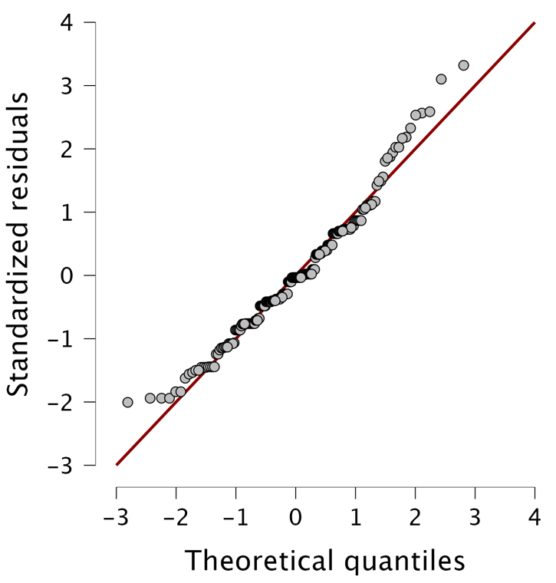

Appendices 3. Q-Q plot of the residuals from the mixed ANOVA with covariates.

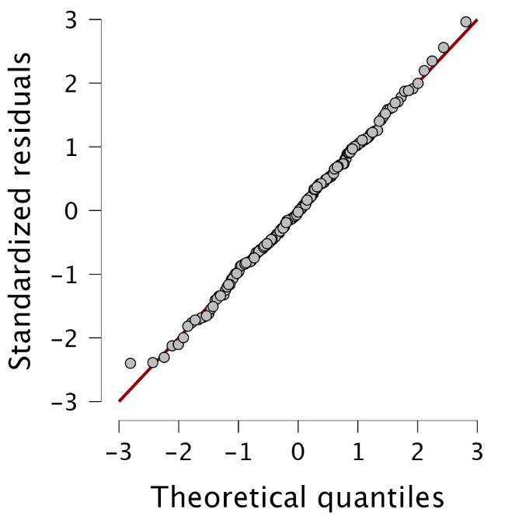

Appendices 4. Plots of the number of recalled words per group and per experimental condition depending on the order of the sessions. VR: Virtual Reality. Error bars are confidence intervals at 95%.
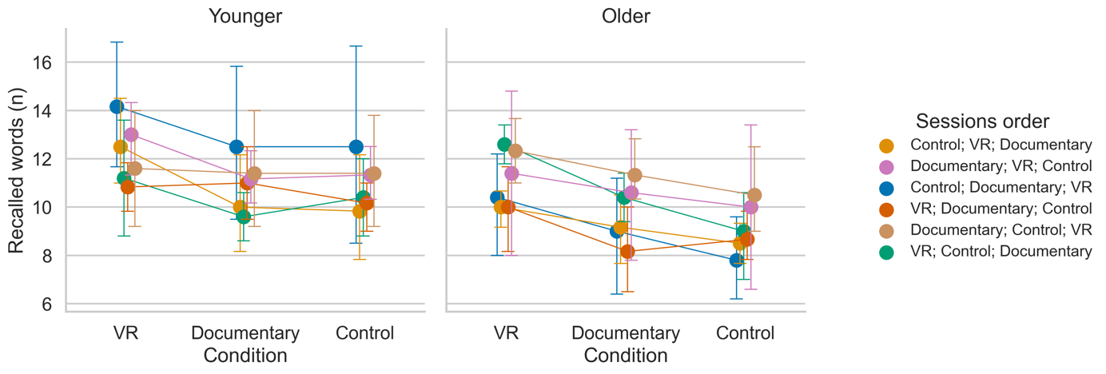

https://osf.io/wkyuz/

