Supplemental information
Glycine-gated extrasynaptic NMDARs activated during glutamate spillover drive burst firing in nigral dopamine neurons
Sofian Ringlet, Zoraide Motta, Laura Vandries, Vincent Seutin, Kevin Jehasse, Laura Caldinelli, Loredano Pollegioni, and Dominique Engel
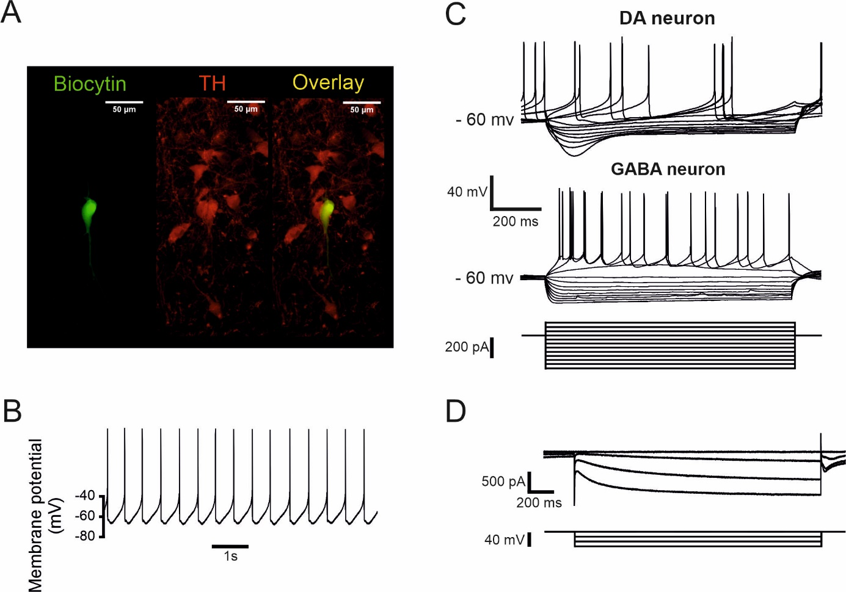
Figure S1 | Identification of SNc DA neurons.
A, Epifluorescence photomicrographs of a DA neuron filled with biocytin and stained using fluorescein isothiocyanate (FITC)-conjugated avidin (left) and for tyrosine hydroxylase (TH, center). The overlay of FITC and TH is at the right.
B, Low frequency (typically ~1 – 4 Hz) spontaneous action potential firing recorded in a DA neuron in current-clamp with no current injection.
C, Voltage responses of a whole-cell recorded DA neuron (top) and a GABA neuron (middle) to 1-sec hyper- or depolarizing current pulses (−30 to 70 pA, 10 pA increment, bottom). Note the presence of a rectification in the membrane potential (sag) in the DA neuron in response to a hyperpolarizing current step which is absent in the GABA neuron.
D, Current traces in whole-cell voltage clamp in response to hyperpolarizing voltage steps showing slowly increasing currents typical for the activation of hyperpolarisation-activated cyclic nucleotide-gated (HCN) channels.
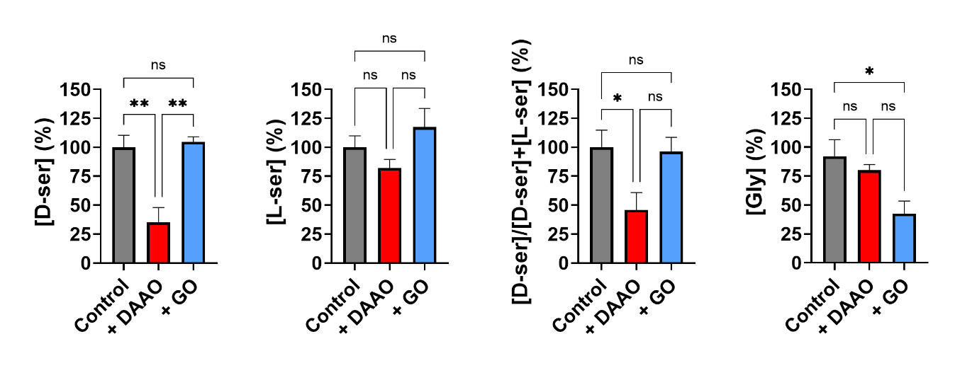
Figure S2 | Specificity of DAAO and GO effects in the substantia nigra.
Summary plots showing the average concentrations of D-serine, L-serine (and the D-serine/total Ser ratio) and glycine determined by HPLC analysis of aCSF medium from substantia nigra slices perfusion retrieved following experiments with control and samples treated with 0.2 U/mL of RgDAAO (+DAAO) or BsGO (+GO). Data are reported as percentage considering the control as 100% and as means ± SEM for n= 9 (control), n=6 (DAAO) and n=5 (GO); One-way anova (*P < 0.05; **P< 0.002). See text for details.
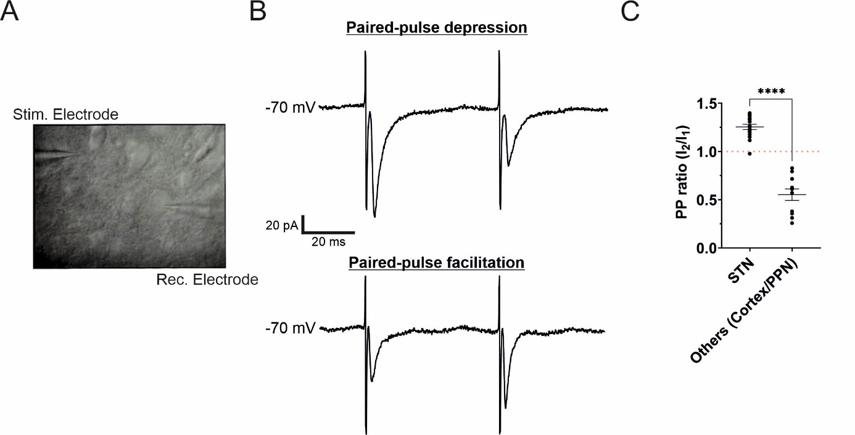
Figure S3 | Paired-pulse ratio of afferent fibers originating from the STN.
A, Infrared-Differential interference contrast photomicrograph of a DA neuron during whole-cell recording (right). The focal double-barreled synaptic stimulating theta electrode was placed rostrally from the recorded neuron at approximatively 50-100 µm from the soma.
B, Current traces in response to a paired-pulse protocol (50 Hz) showing a paired-pulse depression when stimulating PPN fibers (top) and paired-pulse facilitation when stimulating STN fibers (bottom). Low stimulation levels were used (typically 20–80 µA) to evoke eEPSCs.
C, Summary plot showing the PPR as a function of the origin of the fibers stimulated. For STN fibers (n=17), the PPR ≥ 1 and for PPN fibers (n=11), the PPR ≤ 1 (STN, 1.26 ± 0.03 ; PPN, 0.6 ± 0.1, p<0.0001) ; Unpaired t-test.
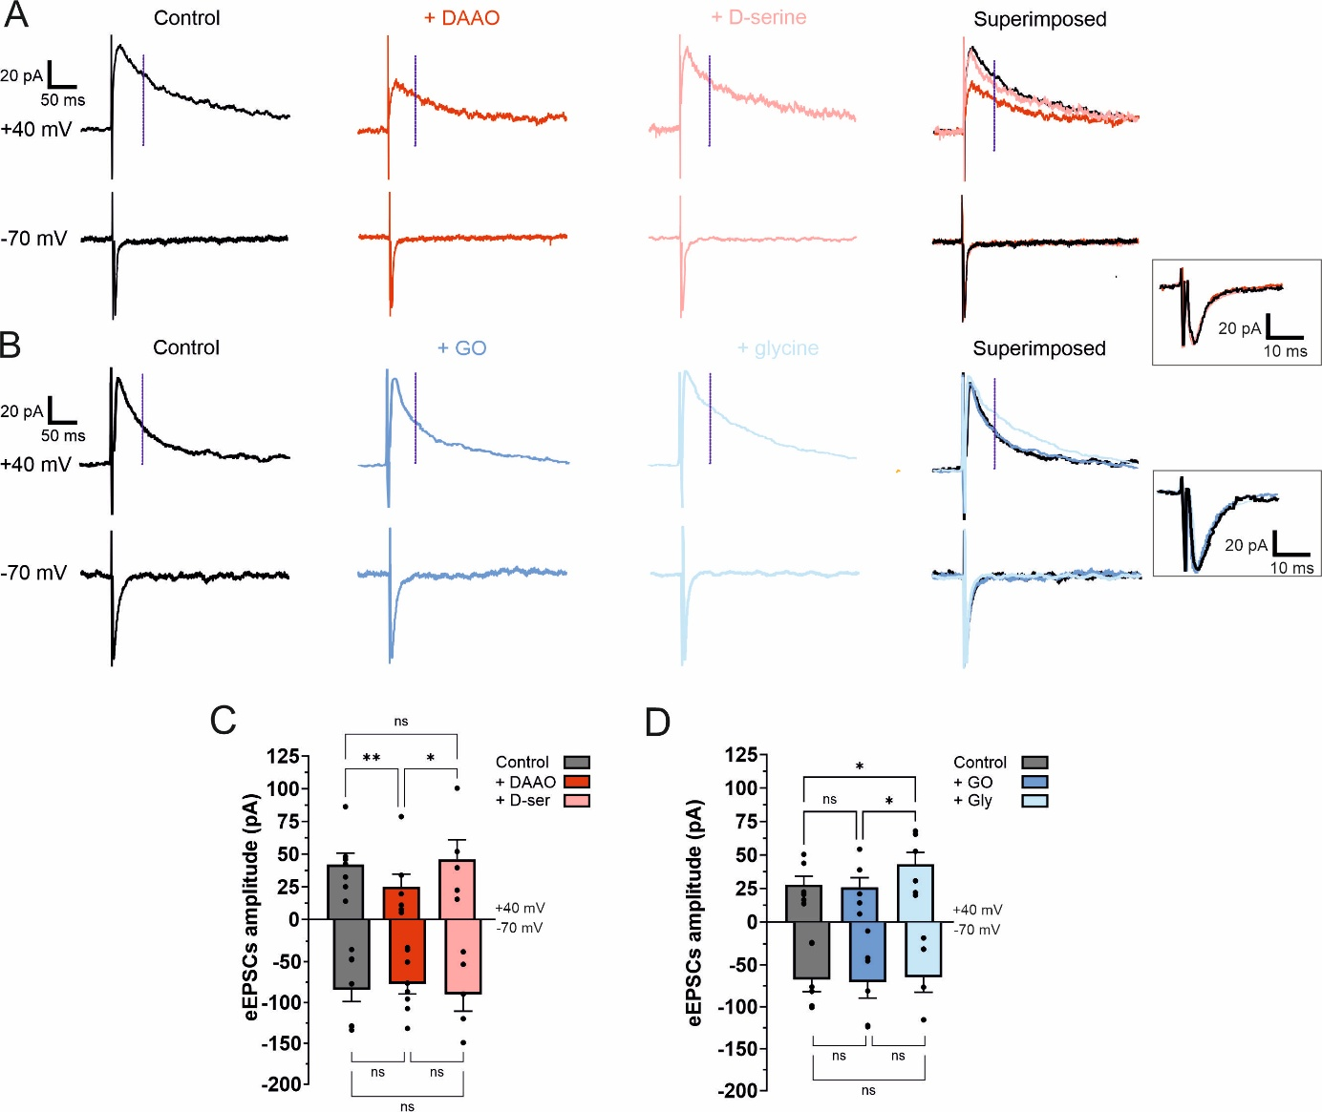
Figure S4 | D-serine is the main co-agonist of NMDA receptors in STN-SNc synapses.
A, Averaged traces (~30 events) of eEPSCs at +40 mV (upper traces) and -70 mV (lower traces) in control, in DAAO and in DAAO+D-serine (100 µM). At the right are superimposed traces from the three conditions. A focal double-barreled synaptic stimulating theta electrode was used to activate afferent fibers originating from the STN. For each condition, traces were recorded in the presence of picrotoxin (50 μM), CGP 55845 (1 μM) and strychnine (10 μM). Amplitude of NMDAR-mediated component was measured at +40mV (vertical dashed lines). In the square at the right is an enlargement of the superimposed currents traces at -70 mV.
B, Averaged traces (~30 events) of eEPSCs at +40 mV (upper traces) and -70 mV (lower traces) in control, in GO and in GO+glycine (1 mM). At the right are superimposed traces from the three conditions. In the square at the right is an enlargement of the superimposed currents traces at -70 mV.
C, Summary bar graph of experiments as in (A). At +40 mV, control: 42.1 ± 8.7 pA; DAAO, 25.1 ± 9.7 pA; DAAO+D-serine: 46.0 ± 15.1 pA. NMDAR-mediated current was decreased after DAAO treatment (Anova 1 test followed by Tukey’s post hoc test, **P < 0.01 versus control). NMDAR current was increased in DAAO+D-serine (Anova 1 test followed by Tukey’s post hoc test, *P < 0.05 versus DAAO) but was not changed in comparison to control (Anova 1 test followed by Tukey’s post hoc test, ns for DAAO+D-serine versus control). At -70 mV, control: -85.2 ± 14.5 pA; DAAO: -77.9 ± 12.5 pA; DAAO+D-serine: -90.8 ± 20.6 pA. AMPAR-mediated currents were changed in neither conditions (Anova 1 test followed by Tukey’s post hoc test). Data points are in control, n=7; DAAO, n=7; DAAO+D-serine, n=5.
D, Summary bar graph of traces recorded as in (B). At +40 mV, control: 27.9 ± 6.3 pA; GO: 25.9 ± 7.2 pA; GO+glycine: 43.2 ± 8.8 pA. NMDAR current was not changed in GO (Anova 1 test followed by Tukey’s post hoc test, ns versus control). NMDAR current was increased in GO+glycine (Anova 1 test followed by Tukey’s post hoc test, *P < 0.05 versus GO). NMDAR mediated current in GO+glycine was similar to current in control (Friedman test followed by Dunn’s post hoc test, ns versus control). At -70 mV, control: -67.9 ± 14.3 pA; GO: -71.0 ± 18.9 pA; GO + glycine: -65.1 ± 18.0 pA. AMPAR-mediated currents were changed in neither conditions (Anova 1 test followed by Tukey’s post hoc test). Bars represent mean ± SEM; points indicate data from individual experiments. Data points are in control, n=7; GO, n=7; GO+glycine, n=5.
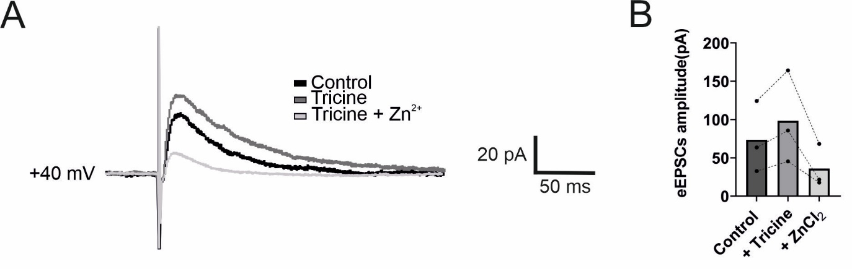
Figure S5 | GluN2A-containing NMDARs in prefrontal cortical L5 pyramidal neurons.
A, Averaged eEPSCs (30 events) recorded from a wild-type C57/black6 mouse (postnatal p43) prefrontal cortical L5 pyramidal neuron at +40 mV in control conditions (black traces), after incubation with tricine (gray trace) and subsequently after tricine+Zn²⁺ (light grey trace). A focal double-barreled stimulating electrode was placed close to the basal dendrites of the pyramidal neuron (50-100 µm away from the pyramidal neuron soma). For each condition traces were recorded in the presence of picrotoxin (50 µM), CGP 55485 (1 µM), CNQX (10 µM), and strychnine (10 µM). Tricine was used at 10 mM and Zn²⁺ at 60 µM (to have 300 nM free Zn²⁺)
B, Bar chart for the mean amplitude of NMDAR-eEPSCs (top) in control conditions (dark grey bar), in tricine (grey bar) and in tricine+Zn²⁺ (light grey bar). At +40 mV, control: 73.5 ± 26.9 pA; tricine: 98.4 ± 34.9 pA; tricine+Zn²⁺: 35.9 ± 16.2 pA. NMDAR-eEPSCs were increased in tricine (ns versus control) and decreased in tricine+Zn²⁺. Data points are in control, n=3; tricine, n=3; tricine+Zn²⁺, n=3.
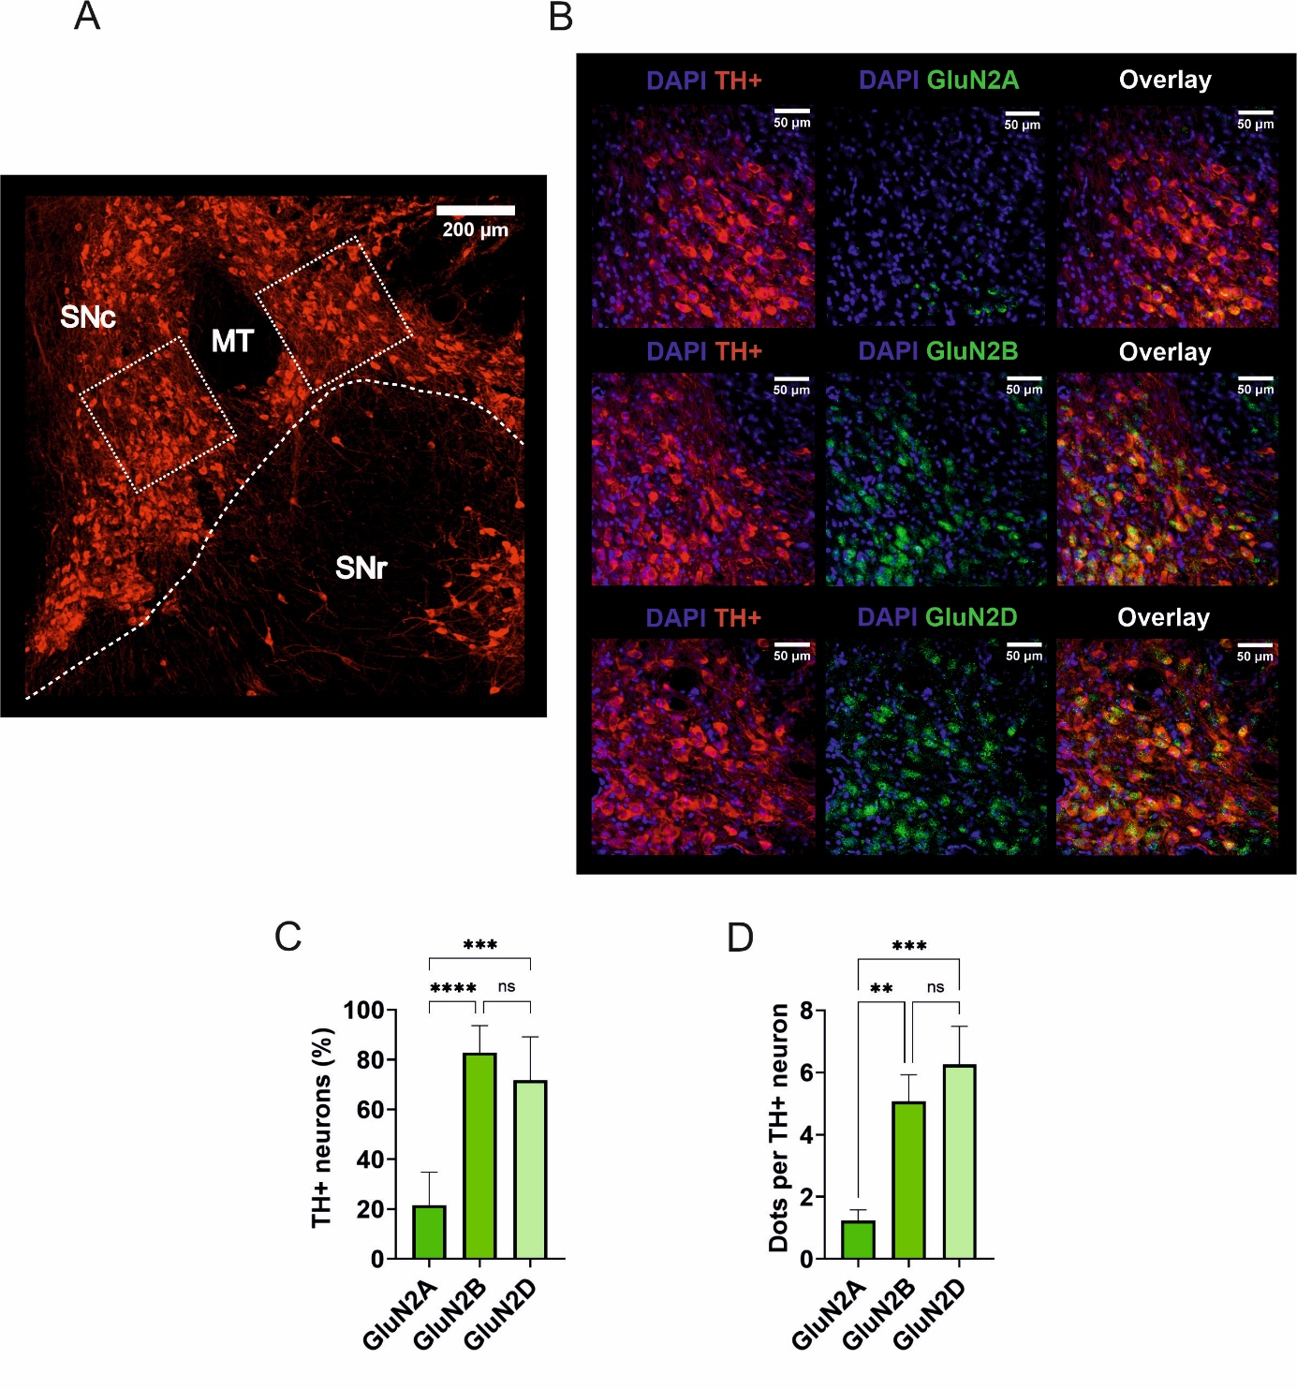
Figure S6 | Expression of GluN2 NMDAR subunits in nigral DA neurons.
A, Light-micrograph of substantia nigra, showing immunolabeling for tyrosine hydroxylase (TH). MT refers to medial terminal nucleus of the accessory optic tract and has been used as an orientation point for the localization of the SNc. The white discontinuous line delineate the separation between SNr and SNc. The white squares indicate the region in which patch-clamp recordings were performed and immunohistochemistry labelling analysed.
B, Confocal light-micrograph of TH immunoreactivity (left), GluN2A immunoreactivity (top, center), GluN2B immunoreactivity (middle, center), GluN2D immunoreactivity (bottom, center), and overlay of GluN2A and TH (top, right), GluN2B and TH (middle, right) and GluN2D and TH (bottom, right); single confocal sections. Immunohistochemistry analysis was performed in both white squares (for each animal [N = 7 animals]) as shown in A.
C, Summary bar graph showing the percentage of TH+ neurons expressing GluN2A, GluN2B or GluN2D. GluN2A: 21.5 ± 3.6 %; GluN2B, 82.8 ± 2.9 pA,; GluN2D, 71.7 ± 4.7 %. There are more GluN2B and GluN2D than GluN2A expressed in TH+ neurons (Kruskal-Wallis test followed by a post hoc Dunn’s test, ****P < 0.0001, ***P < 0.001 and ns). Bars are means ± SEM for N=7.
D, Summary bar graph of the average number of fluorescent dots of either GluN2A, GluN2B or GluN2D in a TH+ neuron. GluN2A: 1.2 ± 0.4; GluN2B, 5.1 ± 0.9; GluN2D, 6.3 ± 0.2). There are more fluorescent dot of GluN2B and GluN2D than GluN2A expressed in TH+ neurons (Kruskal-Wallis test followed by a post hoc Dunn’s test, **P < 0.01, ***P < 0.001 and ns). Bars are means ± SEM for N=7.
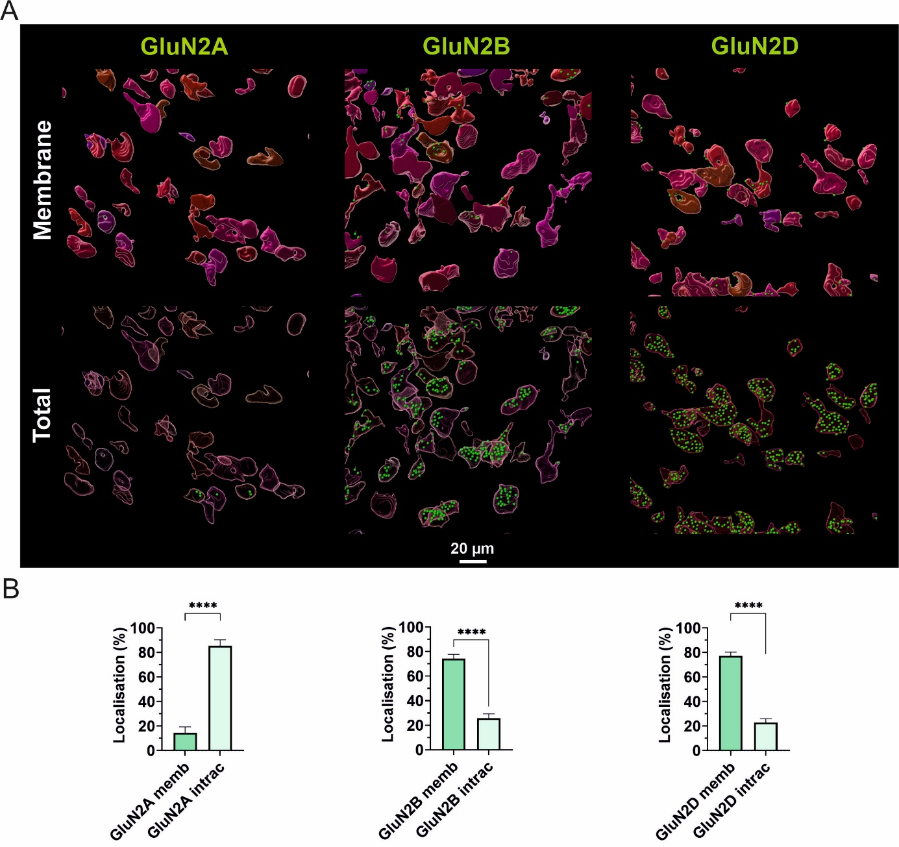
Figure S7 | Spatial distribution of GluN2 NMDAR subunits in SNc DA neurons.
A, 3D reconstruction of confocal images with DA neurons in red (TH+) and NMDAR subunits (green dots ●). Top panel represents the NMDAR subunits expressed only in the membrane of DA neurons (individualized by shades of red) and the bottom panel represents the expression of NMDAR subunits at the membrane, as well as, intracellularly. Picture were obtained from videos (Video S1 to S6).
B, Bar chart showing the localization of NMDAR subunits for GluN2A (left; in membrane, 14.5 ± 4.9 % ; intracellular, 85.5 ± 4.9 %, Mann-Whitney test, ****P < 0.0001) , GluN2B (middle; in membrane, 74.2 ± 3.6 % ; intracellular, 25.8 ± 3.6 %, Mann-Whitney test, ****P < 0.0001) and GluN2D (right; in membrane, 77.2 ± 3.1 % ; intracellular, 22.8 ± 3.1 %, Mann-Whitney test, ****P < 0.0001). Bars are means ± SEM for N=7 animals (n=70 neurons) for each subunit.
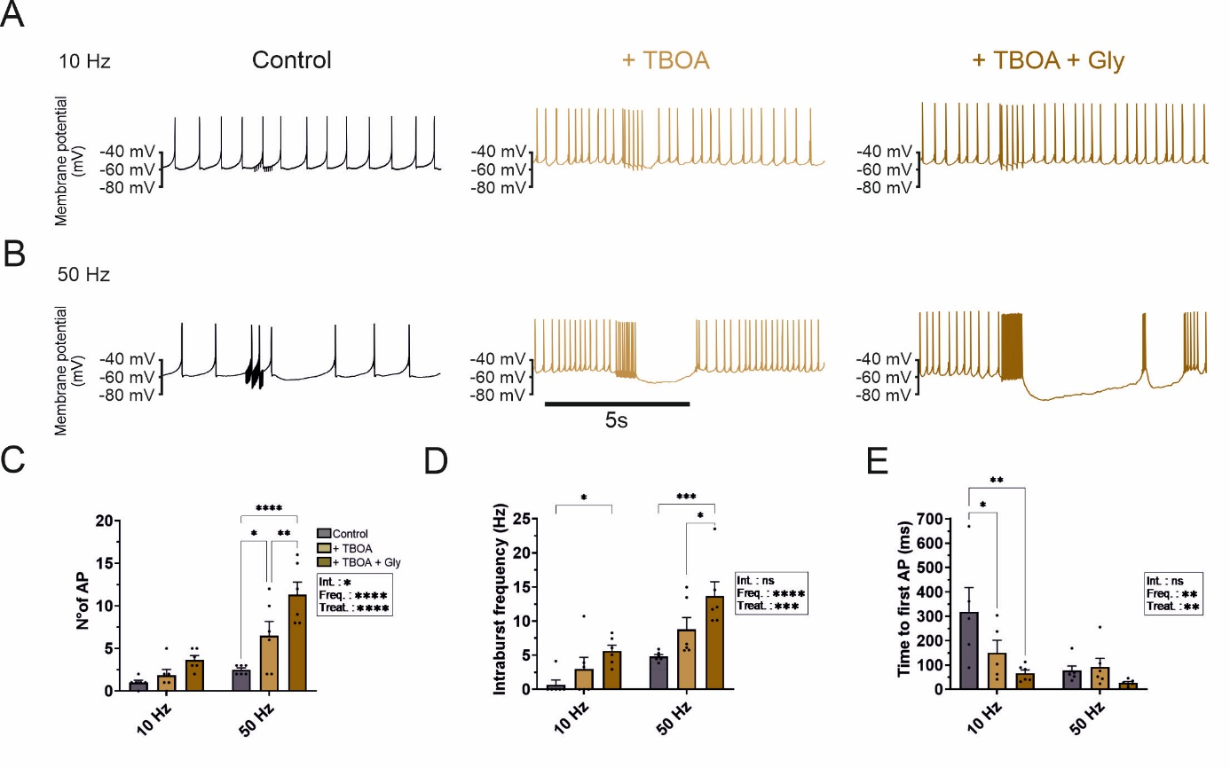
Figure S8 | Regulation of glutamate spillover during high synaptic activity. A, Voltage traces in CC from a SNc DA during synaptic stimulation at 10 Hz for 500 ms in control (left), in TBOA (30 µM, middle) and in TBOA+glycine (1 mM, right). Voltage traces were recorded with CNQX (10 µM), picrotoxin (50 µM), CGP 55485 (1 µM) and strychnine (10 µM). B, Voltage traces in a SNc DA during synaptic stimulation at 50 Hz for 500 ms in control (left), in TBOA (middle) and in TBOA+glycine (right). C, Summary plot showing the mean number of APs generated during stimulation at 10 Hz (left). Control: 1.0 ± 0.3; TBOA: 1.8 ± 0.7; and TBOA+glycine: 3.7 ± 0.5. AP number was unchanged under TBOA or TBOA+glycine. AP number for synaptic stimulation at 50 Hz (right). Control: 2.5 ± 0.2; TBOA: 6.5 ± 1.7; TBOA+glycine: 11.3 ± 1.5. AP number increased in TBOA and in TBOA+glycine (P < 0.05 for TBOA versus control and P < 0.0001 for TBOA+glycine versus control). D, Summary plot for the intraburst frequency during stimulation at 10 Hz (left). Control: 0.7 ± 0.7 Hz; TBOA: 3.0 ± 1.7 Hz; TBOA+glycine: 5.6 ± 0.8 Hz. Intraburst frequency was unchanged in TBOA (ns) and increased in TBOA+glycine (P < 0.05 for TBOA+glycine vs control). Intraburst frequency for stimulation at 50 Hz (right). Control: 4.8 ± 0.3 Hz; TBOA, 8.8 ± 1.7 Hz; TBOA+glycine, 13.7 ± 2.1 Hz. Intraburst frequency was increased in TBOA+glycine (P < 0.001 for TBOA+glycine vs control and P < 0.05 for TBOA+glycine vs TBOA). E, Summary plot showing the time to the first AP during stimulation at 10 Hz (left). Control: 318.9 ± 99.0 ms; TBOA: 149.8 ± 51.4 ms; TBOA+glycine: 66.3 ± 13.5 ms. Time to first AP was decreased in TBOA and TBOA+glycine (P < 0.05 for TBOA vs control and P < 0.01 for TBOA+glycine vs control). Time to first AP for stimulation at 50 Hz (right). Control: 76.9 ± 19.1 ms; TBOA: 92.8 ± 34.6 ms; TBOA+glycine: 27.0 ± 5.0 ms. Time to first AP was not changed in TBOA and in TBOA+glycine (ns versus control). C-E, Data points are in control, n=6; TBOA, n=6; TBOA+glycine, n=6. Bars are means ± SEM; points indicate data from individual experiments. The p values are from Anova 2 followed by Tukey’s post hoc Test.
Experimental conditions | Burst duration (s) | AP/burst | Burst set rate  (Hz)
Control  (N=6) | 0.9 ± 0.2 | 3.6 ± 0.5 | 0.4 ± 0.1
DAAO  (n= 6) | 0.8 ± 0.1  ( p = 0.6171) | 4.3 ± 0.7  (p = 0.9519) | 0.26 ± 0.04  (p = 0.1376)
DAAO + D-Serine (100 µM)  (n= 6) | 1.4 ± 0.2  (p = 0.0124) | 6.2 ± 1.1  (p = 0.0014) | 0.23 ± 0.03  (p = 0.1684)
Control  (n= 8) | 0.9 ± 0.2 | 2.8 ± 0.2 | 0.5 ± 0.1
GO  (n= 8) | 1.1 ± 0.2  (p = 0.7976) | 2.9 ± 0.3  (p > 0.9999) | 0.2 ± 0.1  (p = 0.0042)
GO + glycine (1 mM)  (n= 8)  Numerical values are given as mean ± SEM | 1.9 ± 0.5  (p = 0.0190) | 4.7 ± 1.1  (p = 0.0281) | 0.2 ± 0.1  (p = 0.0053)
Table S1 | Effects of enzymatic treatment with DAAO and GO on bursting activity, related to Figure 1
Video S1. Surface expression of GluN2A subunits in nigral DA neurons.
Video S2. Total expression of GluN2A subunits in nigral DA neurons.
Video S3. Surface expression of GluN2B subunits in nigral DA neurons.
Video S4. Total expression of GluN2B subunits in nigral DA neurons.
Video S5. Surface expression of GluN2D subunits in nigral DA neurons.
Video S6. Total expression of GluN2D subunits in nigral DA neurons.

