They have eyes and see not…

Jean-Marie Choffray*
Liège, April 25, 2025.

ARK Invest recently updated its bitcoin price targets for 2030, projecting bear, base, and bull cases of ~$300,000, ~$710,000, and ~$1.5 million per bitcoin, respectively. Of course, given the unpredictable nature of markets and other future events, relying on forecasts is inherently risky. While ARK Invest believes that there is a sound basis for the forecasts presented, they are provided for illustrative purposes only and no representations are made as to their accuracy. Their analysis is for informational purposes and should not be considered investment advice or a recommendation to buy, sell, or hold any security or cryptocurrency.

* Emeritus Professor of Computer Science, University of Liege School of Management.
PhD-77, Management Science, Massachusetts Institute of Technology.

“Strategy₿. has made a decision to securitize bitcoin as an asset
class and will live or die based on bitcoin.”

They have eyes and see not…

The need for irreversible, incorruptible and inviolable digital transactions is real in a world of uncertainty, excessive debt and monetary debasement. If bitcoin had to fail – a possibility even if its current valuation makes it the seventh largest asset in terms of market capitalization –, a similar technology would inevitably appear on the world stage. That’s why I am sharing my key takeaways from Ark Invest’s last update on its bitcoin price targets for 2030.

In ARK’s Big Ideas 2025 report, the Company updated its bitcoin price targets for 2030, projecting bear, base, and bull cases of ~$300,000, ~$710,000, and ~$1.5 million per bitcoin, respectively, as shown below.

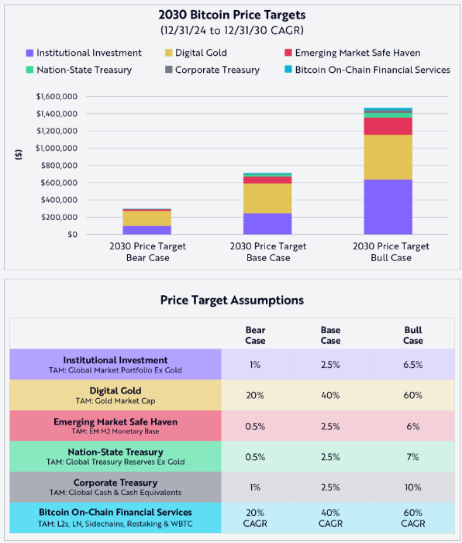

Of course, given the unpredictable nature of markets and other future events, relying on forecasts is inherently risky. While ARK Invest believes that there is a sound basis for the forecasts presented, they are provided for illustrative purposes and no representations are made as to their accuracy.

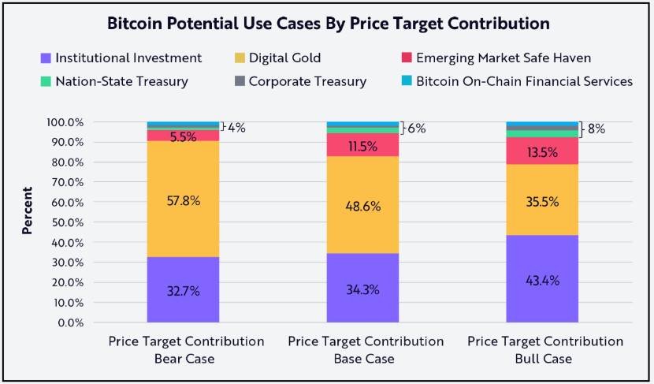

This analysis is for informational purposes only and should not be considered investment advice or a recommendation to buy, sell, or hold any security or cryptocurrency.

* * *

