Supplementary Table 1: Initially proposed and elicited addictive charactseristics of gambling products and related messages, results of the Delphi process, and final 10 pictograms and their reworded definitions for laypeople
Addictive structural characteristics of gambling products and related messages | Results of priority rating in round 1 |  |  |  |  |  |  | Rewording for loop 2 following comments of experts in loop 1 | Results of priority rating in round 2 |  |  |  |  | Pictogram |  | Definition reworded for laypeople:  “This pictogram regards a gambling game .…”
 | Not a priority | Low priority |  | Medium priority |  | High Priority | Essential | Rewording for loop 2 following comments of experts in loop 1 | Not a priority | Low priority | Medium priority | High Priority | Essential
Initially proposed characteristics

Frequent betting opportunities (possibility to bet several times successively so that the gambler keeps gambling during a certain period of time) | 0 (0.0%) | 2 (4.8%) |  | 9 (21.4%) |  | 18 (42.9%) | 13 (31.0%) | { One has never long to wait until the next opportunity to bet/stake | 0 (0.0%) | 0 (0.0%) | 7 (14.9%) | 36 (76.6%) | 4 (8.5%)
High event frequency (virtually unlimited opportunity to play) | 0 (0.0%) | 1 (2.4%) |  | 9 (21.4%) |  | 18 (42.9%) | 14 (33.3%) | { Possibility to bet several times successively so that the gambler keeps gambling during a certain period of time, virtually unlimited opportunity to play | 0 (0.0%) | 0 (0.0%) | 8 (17.0%) | 28 (59.6%) | 11 (23.4%) | 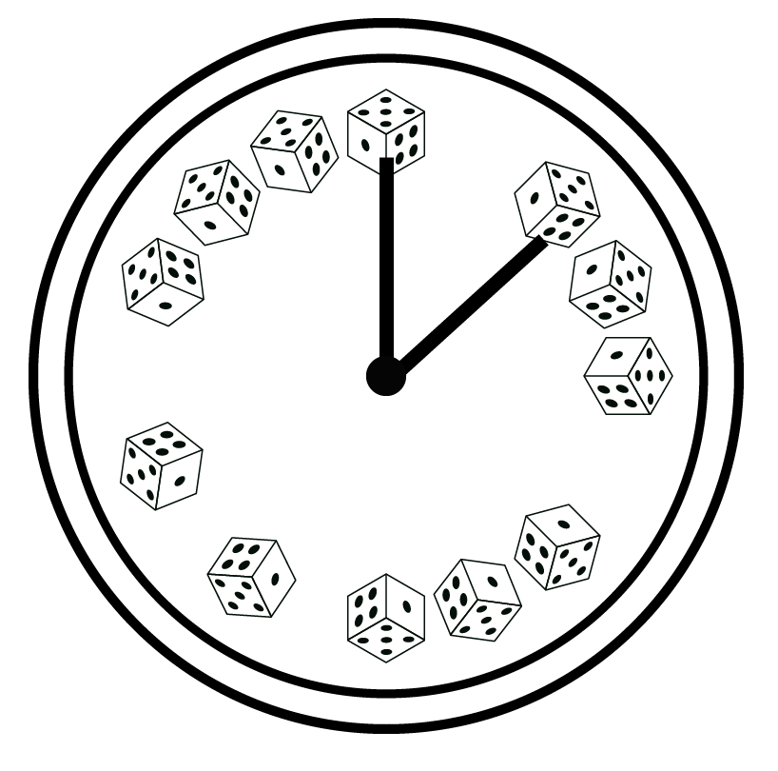 |  | "... where it is possible to bet several times in a row so that the gambler can continue to play practically without a break."
Behavioral learning and rapid feedback (the player has to learn a certain behavior and rapidly receives feedback on his or her performance) | 4 (9.5%) | 10 (23.8%) |  | 14 (3.3%) |  | 9 (21.4%) | 5 (11.9%) |  | 3 (6.4%) | 11 (23.4%) | 20 (42.6%) | 11 (23.4%) | 2 (4.3 %)
Progressive gains linked to immersion/in-game progress (the player has to go through a number of successive challenges to have the opportunity of gains) | 3 (7.1%) | 7 (16.7%) |  | 17 (40.5%) |  | 14 (33.3%) | 1 (2.4%) |  | 1 (2.1%) | 15 (31.9%) | 21 (44.7%) | 10 (21.3%) | 0 (0.0%)
Fast game (high event frequency and limited scope for decision making) | 0 (0.0%) | 0 (0.0%) |  | 14 (33.3%) |  | 14 (33.3%) | 14 (33.3%) |  | 0 (0.0%) | 0 (0.0%) | 5 (10.6%) | 25 (53.2%) | 17 (36.2%) | 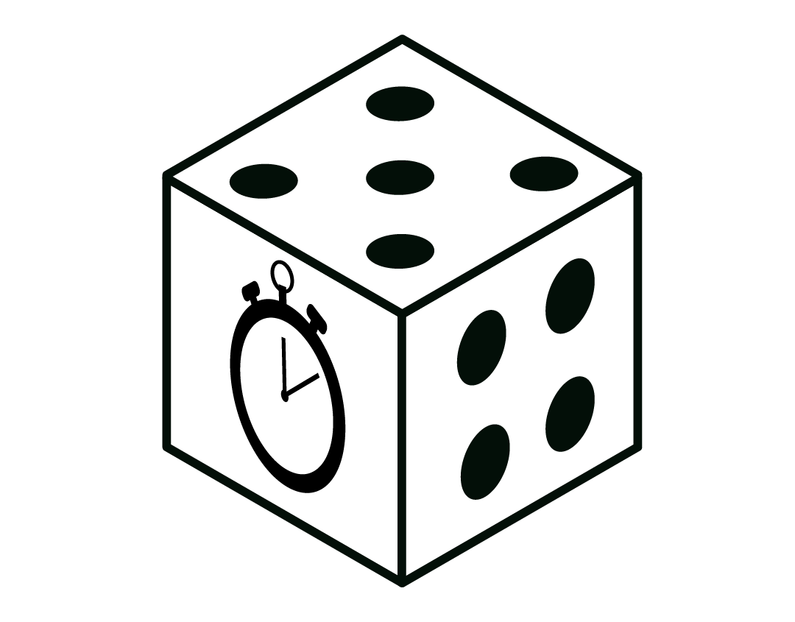 |  | “...where it is possible to wager frequently but with a limited time to think before each wager.”
In-game actions overly suggesting control of the outcome (in-game actions suggesting control of chance, whereas they do not or only poorly influence the outcome) | 0 (0.0%) | 0 (0.0%) |  | 8 (19.0%) |  | 18 (42.9%) | 16 (38.1%) |  |  |  |  |  |  |  |  | "...with actions that give the player the feeling that he or she can control the outcome (win/loss) when this is not the case."
Autoplay (lack of (physical) interaction, such as even pressing a button) | 1 (2.4%) | 10 (23.8%) |  | 19 (45.2%) |  | 9 (21.4%) | 3 (7.1%) |  | 1 (2.1%) | 12 (25.5%) | 30 (63.8) | 4 (8.5%) | 0 (0.0%)
In-running betting (e.g., live betting) | 0 (0.0%) | 3 (7.1%) |  | 11 (26.2%) |  | 17 (40.5%) | 11 (26.2%) |  | 0 (0.0%) | 1 (2.1%) | 8 (17.0%) | 32 (68.1%) | 6 (12.8%) | 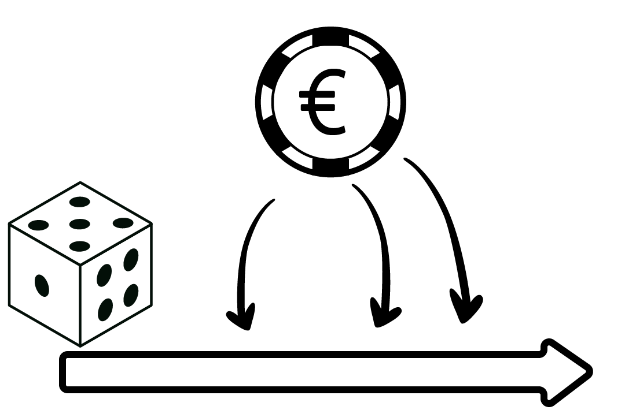 |  | “"...where the gambler plays at the same time as the action is in progress (e.g., live betting, sports betting during a match)."
Short payout interval (includes rapid provision of money and automatically adding money win to credit) | 1 (2.4%) | 1 (2.4%) |  | 10 (23.8%) |  | 17 (40.5%) | 13 (31.0%) |  | 0 (0.0%) | 1 (2.1%) | 5 (10.6%) | 31 (66.0%) | 10 (21.3%) | 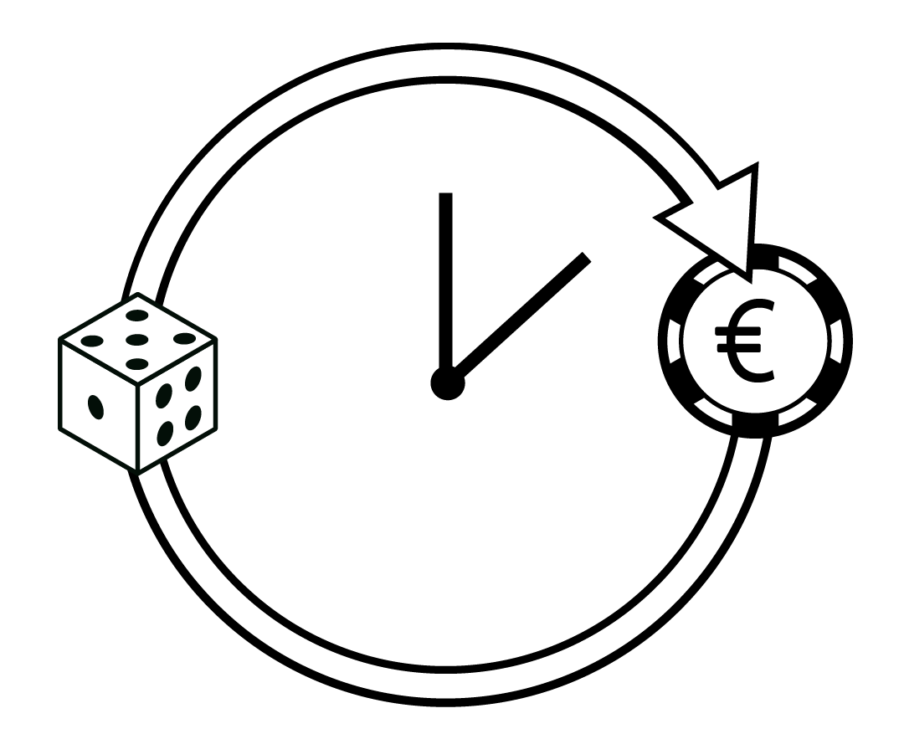 |  | “...with a short payout period: the money won is very quickly paid into the gambler's account, inviting the gambler to keep on gambling.”
Rapid provision of monetary rewards (the gambler receives winnings rapidly after the outcome) | 2 (4.8%) | 5 (11.9%) |  | 11 (26.2%) |  | 18 (42.9%) | 6 (14.3%) |  | 0 (0.0%) | 2 (4.3%) | 11 (23.4%) | 28 (59.6%) | 6 (12.8%)
Automatically adding monetary rewards to total (winnings appear directly in a total amount and not for a particular bet) | 1 (2.4%) | 10 (23.8%) |  | 11 (26.2%) |  | 16 (38.1%) | 4 (9.5%) |  | 1 (2.1%) | 4 (8.5%) | 15 (31.9%) | 26 (55.3%) | 1 (2.1%)
High maximum jackpot (large amount of money announced as the maximum jackpot) | 1 (2.4%) | 11 (26.2%) |  | 10 (23.8%) |  | 12 (28.6%) | 8 (19.0%) |  | 0 (0.0%) | 14 (29.8%) | 15 (31.9%) | 13 (27.7%) | 5 (10.6%)
Changing maximum jackpot (the maximum jackpot is not fixed and changes over time) | 2 (4.8%) | 16 (38.1%) |  | 9 (21.4%) |  | 12 (28.6%) | 3 (7.1%) |  | 1 (2.1%) | 29 (61.7%) | 11 (23.4%) | 4 (8.5%) | 2 (4.3%)
Moderate volatility (unpredictability of reward but not very low reward frequency) | 2 (4.8%) | 14 (33.3%) |  | 16 (38.1%) |  | 17 (16.7%) | 3 (7.1%) | Volatility (irregular interval and randomization of prizes, which acts as an intermittent reinforcement) | 0 (0.0%) | 11 (23.4%) | 29 (61.7%) | 4 (8.5%) | 3 (6.4%)
Early win (frequent wins at the beginning of a gambling session) | 2 (4.8%) | 4 (9.5%) |  | 13 (31.0%) |  | 17 (16.7%) | 8 (19.0%) |  | 3 (6.4%) | 4 (8.5%) | 8 (17.0%) | 28 (59.6%) | 4 (8.5%)
Losses disguised as wins (gain inferior to the amount staked) | 0 (0.0%) | 4 (9.5%) |  | 7 (16.7%) |  | 16 (38.1%) | 15 (35.7%) |  | 0 (0.0%) | 0 (0.0%) | 5 (10.6%) | 29 (61.7%) | 13 (27.7%) | 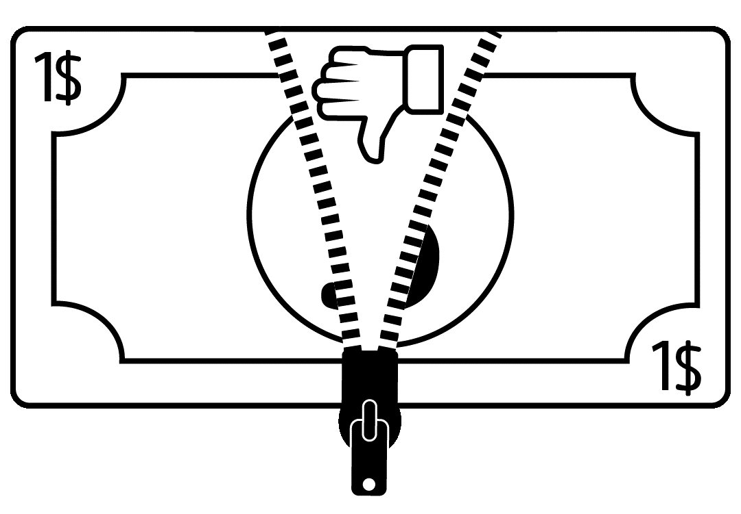 |  | “...where losses are disguised as gains. For example, you buy a gambling game for 3 euros. You scratch and the gambling game indicates that you have won 1 euro, when in reality you have lost 2 euros."
Misleading winning-related sensory stimulus for a non-winning outcome (e.g., sounds, colors usually appearing while winning, presented for a near miss) | 0 (0.0%) | 1 (2.4%) |  | 14 (33.3%) |  | 18 (42.9%) | 9 (21.4%) |  | 0 (0.0%) | 2 (4.3%) | 7 (14.9%) | 32 (68.1%) | 6 (12.8%)
Near miss and equivalent of near miss situations (outcome that suggests an outcome close to a winning situation, whereas outcome is binary: win or lose) | 0 (0.0%) | 0 (0.0%) |  | 8 (19.0%) |  | 20 (47.6%) | 14 (33.3%) |  |  |  |  |  |  | 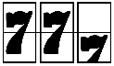 |  | “...in which the outcome suggests to the gambler that he/she has ‘almost’ won, while the outcome is binary (win or lose) and he/she has lost."
Possibility of high stake (various stakes possible up to high stakes) | 0 (0.0%) | 3 (7.1%) |  | 19 (45.2%) |  | 15 (35.7%) | 5 (11.9%) |  | 0 (0.0%) | 5 (10.6%) | 28 (59.6%) | 14 (29.8%) | 0 (0.0%)
Extreme return-to-player rate (very low or very high) (very high or very low value of prizes redistributed to players of the same game as a proportion of the total amount wagered on that game over the long term) | 3 (7.1%) | 5 (11.9%) |  | 18 (42.9%) |  | 14 (33.3%) | 2 (4.8%) | { Very high or very low value of prizes redistributed to players of the same game as a proportion of the total amount wagered on that game over the long term | 0 (0.0%) | 9 (19.1%) | 28 (59.6%) | 7 (14.9%) | 3 (6.4%)
Non-cash payment instruments (e.g., token, bank transfer...) | 3 (7.1%) | 10 (23.8%) |  | 12 (28.6%) |  | 10 (23.8%) | 7 (16.7%) |  | 0 (0.0%) | 12 (25.5%) | 19 (40.4%) | 16 (34.0%) | 0 (0.0%)
No monitoring of duration of play or obvious clock | 0 (0.0%) | 5 (11.9%) |  | 19 (45.2%) |  | 10 (23.8%) | 8 (19.0%) |  | 0 (0.0%) | 5 (10.6%) | 25 (53.2%) | 17 (36.2%) | 0 (0.0%)
Proposition/use of bonus/free spins (possibility to play with the operator's money) | 1 (2.4%) | 5 (11.9%) |  | 13 (31.0%) |  | 17 (40.5%) | 6 (14.3%) |  | 1 (2.1%) | 7 (14.9%) | 13 (27.7%) | 24 (51.1%) | 2 (4.3%)
Messages associated with the game suggesting control of chance (advertisement, instruction) (e.g., advertisement claiming that you have particular ability over the others to win) | 1 (2.4%) | 1 (2.4%) |  | 9 (21.4%) |  | 12 (28.6%) | 19 (45.2%) |  | 0 (0.0%) | 0 (0.0%) | 4 (8.5%) | 16 (34.0%) | 27 (57.4%) |  |  | “"...in which the advertising messages or instructions suggest that the gambler has control over chance (e.g., the advertisement claims that the gambler has a greater ability to win than others).”
Announcement of other gamblers’ gains (e.g., big winner poster) | 2 (4.8%) | 7 (16.7%) |  | 16 (38.1%) |  | 11 (26.2%) | 6 (14.3%) |  | 2 (4.3%) | 8 (17.0%) | 23 (48.9%) | 12 (25.5%) | 2 (4.3%)
Customization, avatar (tools to personalize the game) | 8 (19.0%) | 17 (40.5%) |  | 13 (31.0%) |  | 3 (7.1%) | 1 (2.4%)
Design using familiar context (theme referring to familiar activity for most people, hero, movie...) | 5 (11.9%) | 16 (38.1%) |  | 15 (35.7%) |  | 4 (9.5%) | 2 (4.8%)
Design or advertisement using a celebrity as a spokesperson/a gambler (e.g., TV advertisement showing a movie star playing on a poker website) | 3 (7.1%) | 14 (33.3%) |  | 8 (19.0%) |  | 11 (26.2%) | 6 (14.3%) |  | 6 (12.8%) | 16 (34.0%) | 12 (25.5%) | 11 (23.4%) | 2 (4.3%)
Stressful environment (sensory overstimulation) | 2 (4.8%) | 10 (23.8%) |  | 15 (35.7%) |  | 10 (23.8%) | 5 (11.9%) | Stressful environment (related to the game design or venue) (e.g., sensory overstimulation, high levels of audiovisual sensory feedback) | 3 (6.4%) | 13 (27.7%) | 23 (48.9%) | 8 (17.0%) | 0 (0.0%)
Possibility of multi-playing (multi-tabling, multiline) | 1 (2.4%) | 4 (9.5%) |  | 14 (33.3%) |  | 13 (31.0%) | 10 (23.8%) |  | 0 (0.0%) | 4 (8.5%) | 21 (44.7%) | 21 (44.7%) | 1 (2.1%)
Unlimited temporal access to the game (24/7 venue, online…) | 0 (0.0%) | 2 (4.8%) |  | 8 (19.0%) |  | 13 (31.0%) | 19 (45.2%) |  | 0 (0.0%) | 0 (0.0%) | 5 (10.6%) | 16 (34.0%) | 26 (55.3%) | 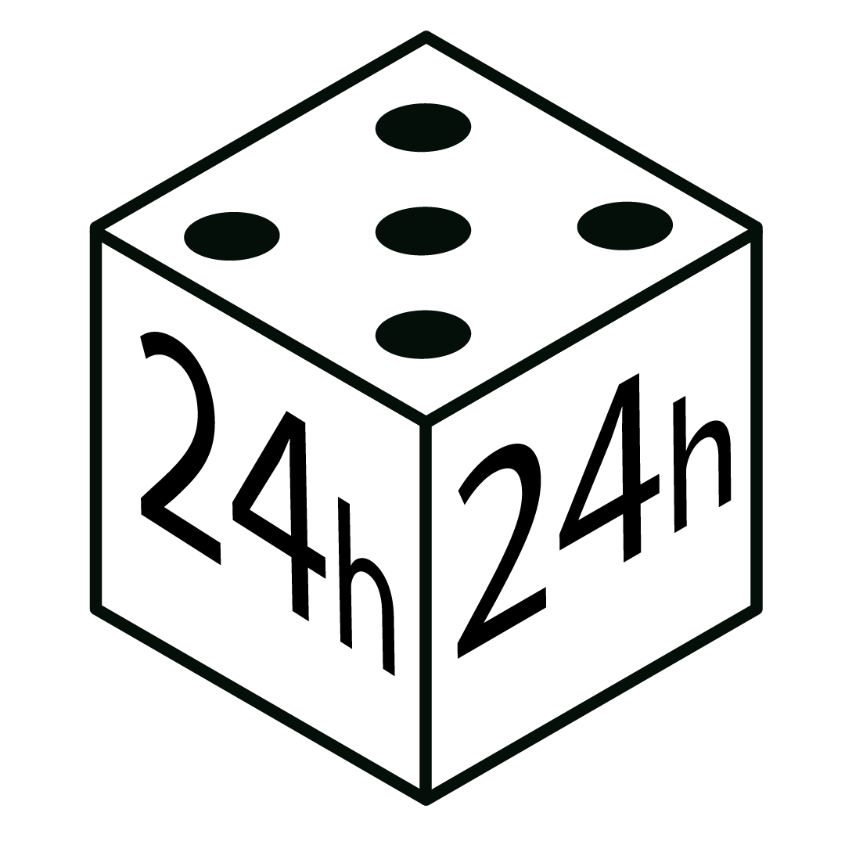 |  | “  "... with an access unlimited in time (24/7, online”)."
Messages promoting ease of gambling (including bonus and rapid cash-out messages) | 1 (2.0%) | 2 (3.9%) |  | 12 (23.5%) |  | 16 (31.4%) | 20 (39.2%) |  | 0 (0.0%) | 3 (6.4%) | 5 (10.6%) | 17 (36.2%) | 22 (46.8%) | “  "... for which advertising messages or instructions encourage gambling (e.g., ‘safe first bet,’ bonus, rapid cash-out”)."
Missing information on bet characteristics (e.g., gross stake amount not shown) | 0 (0.0%) | 6 (14.3%) |  | 14 (33.3%) |  | 13 (31.0%) | 9 (21.4%) | { e.g., gross stake amount not shown. It could be that stakes do not appear directly but are presented minus previous winnings | 0 (0.0%) | 5 (10.6%) | 20 (42.6%) | 16 (34.0%) | 6 (12.8%)
New characteristics elicited by the
experts in phase 1
Complexity (complexity of the game, which can lead to unrealistic expectations from the gamblers) | / | / |  | / |  | / | / |  | 2 (4.3%) | 12 (25.5%) | 22 (46.8%) | 9 (19.1%) | 2 (4.3%)
Community (e.g., presence of a chat between gamblers, which could lead to a peer-related incentive effect) | / | / |  | / |  | / | / |  | 3 (6.4%) | 15 (31.9%) | 20 (42.6%) | 9 (19.1%) | 0 (0.0%)
Cashless version available  (possibility to gamble for free in cashless/demo/practice versions of the same game) | / | / |  | / |  | / | / |  | 1 (2.1%) | 12 (25.5%) | 19 (40.4%) | 12 (25.5%) | 3 (6.4%)
Informational asymmetry  (information on gamblers' behavior is processed and/or exploited by vendors) | / | / |  | / |  | / | / |  | 4 (8.5%) | 6 (12.8%) | 14 (29.8%) | 16 (34.0%) | 7 (14.9%)
Dynamic features (game features adapt in response to gamblers' behavior) | / | / |  | / |  | / | / |  | 3 (6.4%) | 8 (17.0%) | 9 (19.1%) | 22 (46.8%) | 5 (10.6%)
Facilitation of multiplying the bet (e.g., proposition to multiply the bet in the same round x2) | / | / |  | / |  | / | / |  | 1 (2.1%) | 6 (12.8%) | 15 (31.9%) | 21 (44.7%) | 4 (8.5%)
Uneasy unsubscription or self-exclusion (easy reversal, process not available or complex to complete) | / | / |  | / |  | / | / |  | 0 (0.0%) | 9 (19.1%) | 8 (17.0%) | 20 (42.6%) | 10 (21.3%)
Game in the game (e.g., random jackpot or gain added to the game, promising a multiplication of gain) | / | / | / |  | / |  | / |  | 0 (0.0%) | 10 (21.7%) | 17 (37.0%) | 16 (34.8%) | 3 (6.5%)
..….. Concepts that reached consensus for retention since the first round
……... Concepts that reached consensus for exclusion at 1st or 2nd round
…….. Factors not reworded between the 2 rounds or elicited in phase 1
Only the explanation was reworded

