Heavy metals drive microbial community assembly process in farmland with long-term biosolids application

Tao Sun1,2#, Guihua Li1#, Mahmoud Mazarji1, Pierre Delaplace2, Xing Yang3,Jianfeng Zhang1*, Junting Pan1*

1 State Key Laboratory of Efficient Utilization of Arid and Semi-arid Arable Land in Northern China, Institute of Agricultural Resources and Regional Planning, Chinese Academy of Agricultural Sciences, Beijing 100081, China

2 Gembloux Agro Bio Tech, University of Liège, 5030, Belgium

3 Key Laboratory of Agro-Forestry Environmental Processes and Ecological Regulation of Hainan Province, School of Ecology and Environment, Hainan University, Renmin Avenue, Haikou 570228, China

**\*Corresponding author**

Prof. Jianfeng Zhang (zhangjianfeng@caas.cn)

Prof. Junting Pan (panjunting@caas.cn)

#These authors contributed equally to this work.

**Supplementary material**

**Materials and method**

**Microbial DNA extraction, PCR, and Illumina sequencing**

PCR reactions were performed using 25 µL 2x Premix Taq (Takara Biotechnology, Dalian Co. Ltd., China), 1 µL each primer (10 µM), and 3 µL DNA (20 ng/µL) template in a 50 µL volume, subjected to thermocycling: 5 min at 94°C for initialization; 30 cycles of 30s denaturation at 94°C, 30s annealing at 52°C, and 30s extension at 72°C; followed by a final 10 min elongation at 72°C using the BioRad S1000 instrument. PCR products' length and concentration were assessed via 1% agarose gel electrophoresis. Samples showing normal, bright main strips were selected for subsequent experiments. The PCR products were equidensity-ratio mixed using GeneTools Analysis Software (SynGene). This mixture was purified with the E.Z.N.A. Gel Extraction Kit (Omega, USA). Sequencing libraries were generated using NEBNext® Ultra™ II DNA Library Prep Kit for Illumina® (New England Biolabs, MA, USA) with added index codes. Library quality was evaluated using the Qubit@ 2.0 Fluorometer (Thermo Fisher Scientific, MA, USA). Sequencing was conducted on an Illumina Nova6000 platform, producing 250 bp paired-end reads (Guangdong Magigene Biotechnology Co., Ltd. Guangzhou, China)/ Quality control was performed on initial pair-end reads using Trimmomatic v0.39 (Bolger et al., 2014) to remove sequences with a quality score below 20. Subsequently, FLASH v1.2.7 combined the pair-end reads, followed by denoising and chimera filtering using the 'USEARCH' algorithm (Edgar, 2010). Reads shorter than 200 bp were excluded. High-quality reads were grouped into amplicon sequence variants (ASVs) at 100% identity threshold, and assigned to respective databases (SILVA, UNITE, MaarjAM) for bacteria, fungi, and AMF, respectively.

**Statistical analyses**

Based on Null model analysis, the iCAMP approach was employed to statistically quantify different ecological processes in shaping the soil microbial metacommunity (Ning et al., 2020). The null model expectation was generated by performing 999 randomizations, β-Nearest-Taxa-Index (βNTI) was calculated as the difference between the observed β-Mean-Nearest-Taxon-Distance (βMNTD) and the average value of the null distribution of βMNTD, measured in units of standard deviation. A βNTI > 2 indicates a significantly higher phylogenetic turnover than expected, suggesting the influence of heterogeneous selection in the community assembly process. Conversely, a βNTI<-2 indicates a considerably lower phylogenetic turnover than expected, indicating the presence of homogeneous selection. When |βNTI| < 2, stochastic processes shape the microbial community change. We further calculated Bray-Curtis-based Raup-Crick (RCbray) by measuring the deviation between the observed Bray-Curtis dissimilarity and the null distribution to analyze the assembly processes within communities. If |βNTI| < 2 and RCbray < −0.95, then the microbial community is shaped by a homogenizing dispersal process. Furthermore, in the case of |βNTI| < 2 and RCbray > 0.95, the community assembly is primarily driven by dispersal limitation processes, and |βNTI| < 2 and RCbray > −0.95 refer to the drift processes (Stegen et al. 2012).

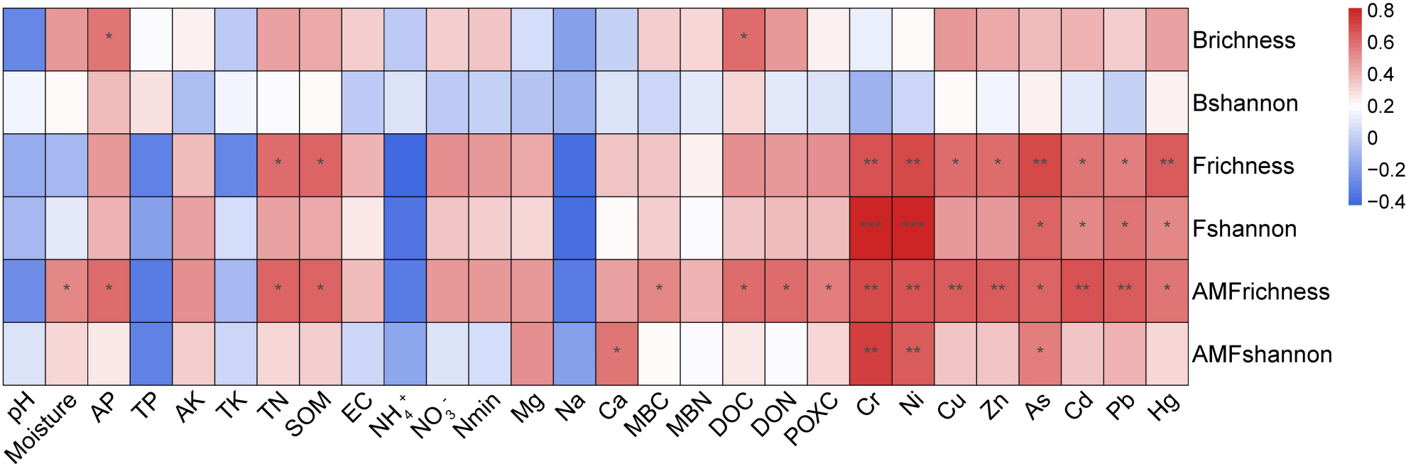

Fig. S1 The relationships between soil nutrients and heavy metal contents and bacterial, fungal, as well as AM fungal richness and Shannon diversity.



Fig. S2. The correlations between soil nutrients, heavy metal contents, and bacterial (A) and fungal (V) phyla, as well as AM fungal family (C) abundance.

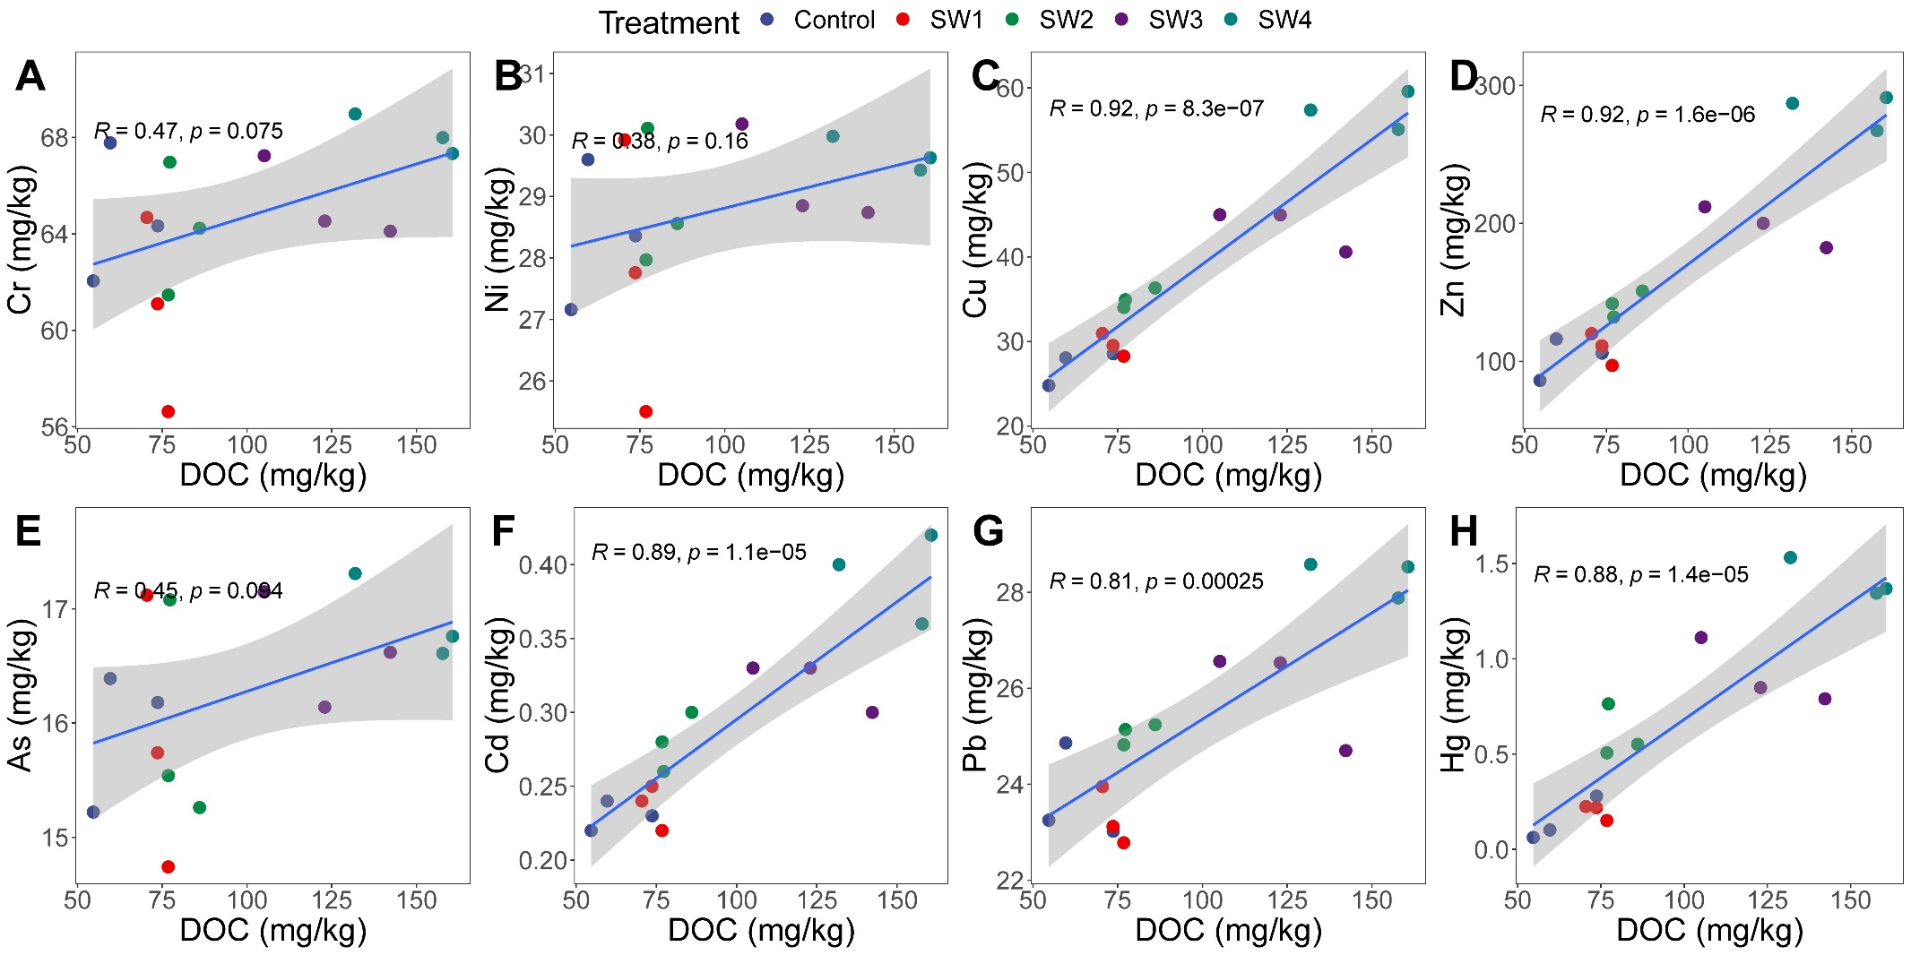

Fig. S3. The correlations between DOC contents and heavy metal contents

Table S1. The rate of biosolids and mineral fertilizers used in the long-term field experiment (2006–2022).

|  |  |  |  |  |
| --- | --- | --- | --- | --- |
| Treatment | Chemical fertilizers (kg ha− 1 yr− 1) | | | Biosolids |
| Nitrogen | Phosphorus | Potassium | t ha− 1 yr− 1 |
| Control | 0 | 79 | 199 | 0 |
| SW1 | 150 | 79 | 199 | 4.5 |
| SW2 | 150 | 79 | 199 | 9.0 |
| SW3 | 150 | 79 | 199 | 18.0 |
| SW4 | 150 | 79 | 199 | 36.0 |

Table S2 Basic characteristics of biosolids applied in this study.

|  |  |
| --- | --- |
| Item | Biosolids |
| pH | 7.61±0.41 |
| Organic matter (%) | 36.0±7.7 |
| N (%) | 2.68±0.58 |
| P2O5 (%) | 4.06±1.0 |
| K2O (%) | 0.57±0.26 |
| Zn/mg·kg-1 | 1 033±369 |
| Cu/mg·kg-1 | 190±52 |
| Cd/mg·kg-1 | 1.79±1.2 |
| Cr/mg·kg-1 | 84.2±45 |
| As/mg·kg-1 | 13.0±6.9 |
| Hg/mg·kg-1 | 9.50±4.1 |
| Pb/mg·kg-1 | 38.6±20 |
| Ni/mg·kg-1 | 30.9±17 |