The clouds of history: digital ecologies and bovine livestock reproduction

0 is a digit. 1 is also a digit. I guess that’s where this weird world “digital” comes from. The mathematical understanding that a single number is a digit. 0 and 1 are digits.

A, C, G, T, are letters. These are not digits. A stands for Adenine. C stands for Cytosine. G stands for Guanine. T stands for Thymine. These are not digits. These are letters that represent the different four types of bases that are present in a DNA molecule. There are billions of such bases in most living organisms. There are billions of bases in a mammal body. A, C, G, T, are letters. But there are so many letters out there. You need zeros and ones to count them all and to make sense of the sort of weird message these four letters are delivering. You need software, you need databases, you need zeros, you need ones.
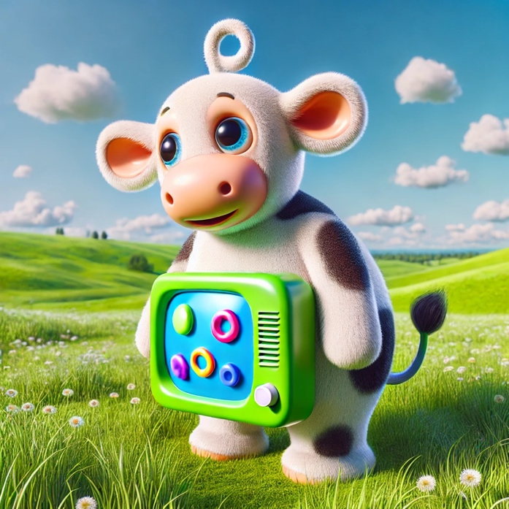
Teletubbies cow is a cow going digital. It has been generated using Chat GPT, a tool made of loads of zeros and ones. Like a shitload of zeros and ones. I asked Chat GPT: “can you generate an image of a cow with a screen in it like a Teletubbies?” Chat GPT answered: “It seems there was an issue generating the image. Let me adjust a few details and try again for that friendly cow with a screen on its side, similar to the Teletubbies style”. I wondered why would that cow be friendly at all? That cow stands in a harmonious, natural landscape. Nature is good. Nature is a category of modern thought. Nature designates all sort of beings. Alive beings and non-alive beings. Human beings. Animal beings. Vegetal beings. Mushroom beings. Built and unbuilt environments. Nature is a termite mount, a hive, a city, a mountain pasture, a canalized river, a white shore, a hatchery, a leave that falls, a nitrogen spread. Probably this list is not limitative. Most likely.

Nature is desert. Nature is made out of desertic parts where there are no shades. Nature is thousands of cows. Nature is soaring temperatures. Nature is high humidity in the air. Nature is a weak wind. Result is thousands of dead cows. Kansas, 2022. Nature is global heat shocks. Cows are nature. Domesticated. Domestication is nature made culture. Domestication is also culture made nature. Or the other way around. Nature is out there. Nature is within us. We shit natural shit with manmade molecules and food additives in it. So do the cows, on antibiotics. Antibiotics are becoming nature. Nature is domestication. Nature is what you make it. Nature is a relationship. Nature hurts. Nature is a plantation of cows in the middle of the desert. Dead cows suffering from heat shocks. Dead productive cows that give a lot of milk, provided that they received a lot of water and a lot of feed intake. There is no water in the desert. There is no feed in the desert. Nature is hostile. Supplies are running low. Wind doesn’t blow. Temperatures surge. Cows die.
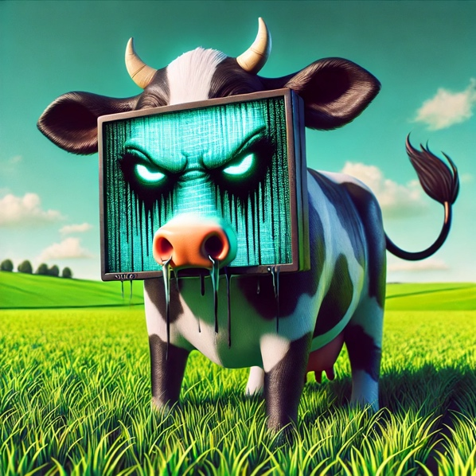
Cow is unhappy. Sky has turned green. The cow has no face. The cow has a screen. The screen decomposes the cow face. The cow is decomposed. She… it… she… it… it is recomposed. It is unhappy. Cow is a domesticated animal. Livestock. A stock that is alive. Natural resource. Cattle means capital. Capital made out of A, C, G, T. A stands for Adenine. It is a type of base in the DNA molecule.

The letter A originates in the head of the bull. An idea. “The” head of “the” bull. An essence. “A” like Adenine and “A” like the head of the bull. Letters mark the beginning of human history. Humans are in history. Cows are in history. History is what happened. Cows are our history. Humans are cows’ history. The letter A testifies for that joint history. Humans became humans with cows. Cows became cows with humans. Humans own cows and own capital. Cows own humans and no capital. Humans provide water. Humans provide feed. Humans sometimes screw up. Blame it on the climate. It’s the heat, stupid! My cow has a human. That human is sometimes sloppy. Cow is unhappy. There is no recovery from history. There is no recovery from history.

The sire has many faces. Cattle is being reproduced. Artwork is being reproduced. Artwork in the age of mechanical reproduction. Cows in the age of artificial insemination. More of the same. Same of the same. Same of the more… and more, and more, and more. Flesh inflates. Different colors. The label says “United colors of Belgian blue”. United in diversity. Diversified in homogenization. [APPEARS] To reproduce you need ones and zeros. Zeros and ones. Zeros and ones give you letters. Zeros and ones give you A, C, G and T’s. [APPEARS] A, C, G, T, are letters. A lot of letters make a prediction. A sire is a good sire if it will give you a good offspring. A productive offspring. Zeros and ones give you letters that give you a genotype. Genotype predicts the phenotype. Letters precedes the body. Colors precedes the sameness. Pedigrees. Genes. Genealogies. Selection. Reproduction. Selection. Reproduction. Selection. Reproduction. Over and over. Over and over again. Genealogies. Sires. Pedigrees. Histories precedes phenotypes. Histories precedes bodies. More of the same. Same same but different. More productive.
The sire mounts another sire. For semen production. The sire releases sperm. Sperm is a bodily fluid needed for reproduction. Sperm is conditioned in a straw. A colored straw. Orange straws. Green straws. Pink straws. Yellow straws. Blue straws. With a code. Semen is a commodity. Sperm is a bodily fluid.

Sperm is tested. Analyzed. Measured. Ranked. Performance. Sperm is conditioned in a straw. In straws. Colored straws. All different colors of standard straws. Same straws with different colors. Orange straws. Green straws. Pink straws. Yellow straws. Blue straws. With a code. A unique code. Unique codes by the thousand. Unique codes by the ten thousand. Unique codes by the hundred thousand. Sperm becomes semen. Semen is conditioned. Semen is packaged. Semen is frozen. Semen is stored in liquid nitrogen. Semen is shipped out. Cows are inseminated. Nitrogen is all over the place.
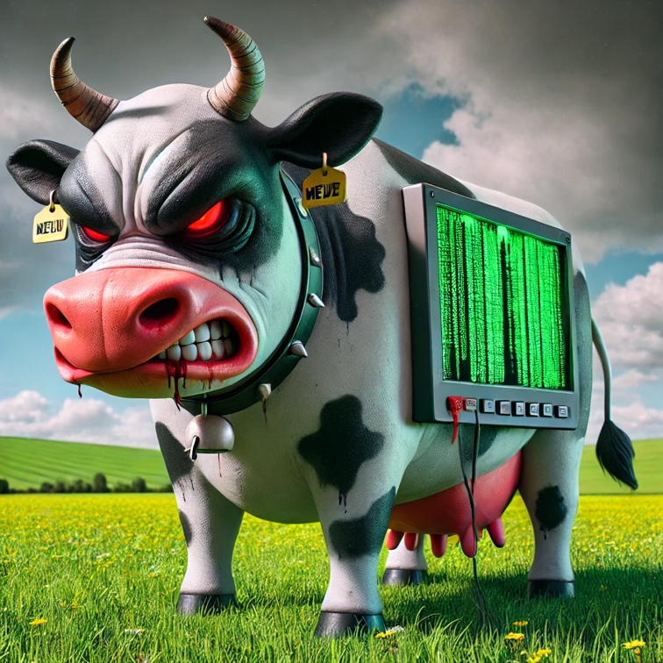
“Chat GPT, chat GPT on the screen, who is the fairest of them all?” Try this, chat GPT answers. “Here's the more eerie version of the cow, now with some added blood splatters for an extra unsettling effect. Let me know if there's anything else you'd like to adjust!”. Thank you for your service, chat GPT. Thank you for your service, chat A, C, G, T. It is truly appreciated. This

cow now has a face. Big dark clouds are gathering around it. Greenhouse gases perhaps. Carbon dioxide. Or is it methane? Na. Methane is more discrete and volatile than carbon dioxide. The landscape is no longer so bucolic. It is unsettling. The cow has a porthole on the belly. This porthole makes no rumen visible. This porthole displays a matrix. Zeros and ones. Zeros and ones along the body. The cow is angry. The cow now has an angry face. A stands for Adenine. A is the first letter of the alphabet. A bears an idea of the idealized bull. The idea of the bull is angry. A for angry. Very, very angry. The clouds of history are so, so, so loaded.

