International Journal of Quantum Chemistry

RESEARCH ARTICLE
Configurational and Conformational Studies of
Quinolizidine and Beta-Carboline Moieties in the
Corynanthe-Tryptamine Alkaloids
Dmitry A. Grigoriev¹ | Valentin A. Semenov¹ | Luc Angenot² | Leonid B. Krivdin¹
¹A. E. Favorsky Irkutsk Institute of Chemistry, Siberian Branch of the Russian Academy of Sciences, Irkutsk, Russia | ²Laboratory of Pharmacognosy, Center of
Interdisciplinary Research on Medicines, Faculty of Medicine, University of Liège, Liège, Belgium
Correspondence: Valentin A. Semenov (semenov@irioch.irk.ru)
Received: 4 September 2024 | Revised: 13 November 2024 | Accepted: 13 December 2024
Funding: This work was supported by Russian Science Foundation, grant number 23-23-00267.
Keywords: ¹H and ¹³C NMR spectra | computational NMR | Corynanthe-Strychnos type | DFT | dimeric bisindole alkaloids | stereochemistry

ABSTRACT
Configurational and conformational assignments of 11 Corynanthe-Tryptamine alkaloids (usambarane skeleton) were performed based on the correlation of the high-level calculated and experimental ¹H and ¹³C NMR chemical shifts. For some compounds, the reassignment of a number of individual signals together with spectral assignment of experimentally unresolved peaks was suggested. The different conformations of the C/D quinolizidine ring system appear strictly dependent of the structure of the side chain (ethyl-, vinyl- or ethylidenic); in the latter case, the configuration (E or Z) of the 19-20 double bond of the ethylidenic chain is determinant to establish a cis- or a trans-quinolizidine system of rings C/D. The conformation is also influenced by the equatorial or axial conformation of (C15) substituents.

1 | Introduction
Bisindole alkaloids make up an important class of natural products originally discovered in plants. The first bisindole alkaloids to be structurally elucidated are the active principles of Calabash-curare that was prepared from different South-American Strychnos [1]. These products are symmetrical dimeric alkaloids containing two quaternary ammonium compounds and they represent the first group of the Strychnos-Strychnos type; instead of being convulsant poisons like strychnine, they present very potent neuro-muscular blocking properties causing paralysis of the musculature including finally the respiratory muscles [2]. These dimeric alkaloids are also the toxic principles of the hunting poison prepared from rootbark of Strychnos usambarensis at the border between Rwanda and Tanzania [3, 4].
The second type of bisindole alkaloids present in the Strychnos genus was accidentally discovered during the study of leaves and rootbark of above-mentioned S. usambarensis [3–5]; they are representative of the Corynanthe-Tryptamine type consisting of a tryptamine unit and a Corynanthe fragment; they are found mainly in the genus Strychnos belonging to the Loganiaceae family but they are also present in Apocynaceae and Rubiaceae families.
----------------------------------------------------------------------------------------------------------------------------------------------------------------------------------------------------------------------------------
© 2024 Wiley Periodicals LLC.
International Journal of Quantum Chemistry, 2025; 125:e70008 https://doi.org/10.1002/qua.70008
Consequently, the first Corynanthe-tryptamine alkaloids belong to the usambarane group like usambarensine, usambarine and theirderivatives.Laterstudiesrevealednewderivativesfoundnot
only in S. usambarensis, but also notably in S. ngouniensis [6], S. potatorum [7],S.dale[8],andin Aspidosperma marcgravianum (Apocynaceae) [9].
It should be noted that this type of bisindole alkaloids could also lead to new drugs in medicine, because they don’t show any paralyzing or convulsant activity by contrast to diquaternary bisindole (Strychnos-Strychnos type) or to strychnine monomer. Therefore, the study of their structure and properties provides a powerful impulse in modern pharmaceuticals. It was found that most of the Corynanthe-Tryptamine alkaloids provide high amoebicidal activity, among those are usambarensine, usambarine, and 18,19-dihydrousambarine. The latter three compounds are even more active than emetine and metronidazole [10]. In addition, 3′,4′-dihydrousambarensine, usambarensine, strychnopentamine, isostrychnopentamine, and 10′-hydroxyusambarensine exhibited stable antiplasmodial activity [10–12]. Moreover isostrychnopentamine has been found to provide appreciable in vivo antimalarial properties [13]. These facts indicate on the prospective use of such compounds in the development of new sensu lato antiparasitic drugs.
Furthermore, usambarensine, strychnopentamine, and isostrychnopentamine have also been shown to have antitumor activity. These substances intercalate into DNA and induce apoptosis in human leukemia HL60 cells [14]. Moreover, isostrychnopentamine, induces at a concentration about 50–100 times higher than its antiplasmodial properties cell cycle arrest and apoptosis in the human colon cancer cells [15]. It was also shown that this alkaloid had potential antitumor activity against apoptosis-resistant cancer cells [16].
Overall, listed results together with many others open new horizons in pharmaceutical methods and confirm the hypothesis about the potential role of this group of alkaloids in the development of new anticancer and antiparasitic drugs.
Recent papers underline indeed the potential antitumoral effect of usambarensine (that has been identified in red kale) on colorectal cancer cells on the one hand [17] and the potential antifungal effect of the same alkaloid that has been identified as a main component of the “Pink Pigment” of Erwinia persicina on the other hand [18]. Other studies involving molecular dockings have identified new targets for drug candidates against the Chagas disease (Trypanosoma cruzi). Among 67 compounds with antiparasitic activity that have been tested only usambarensine and three other products have been selected for their calculated interactions [19]. In the fight against COVID-19, molecular dockings and dynamics simulations have shown that five compounds including 10′-hydroxyusambarensine and strychnopentamine were selected among 226 African phytochemicals with documented antiviral, antimalarial and antifungalproperties. Theseproductsexhibitstrongaffinitybinding and could be incorporated in a cocktail of anti-coronavirus treatments [20].
It should also be noted that mentioned compounds of this group are also interesting from the point of view of developing a methodology for calculating NMR chemical shifts to establish a reliablestereochemical structure ofnatural products. At thesame time, they are somewhat difficult to identify their stereochemical structure by means of the NMR, which is because they have several asymmetric centers and also consist of two very similar indole-type subunits, the latter not being an exact copy of each other with only three rings.
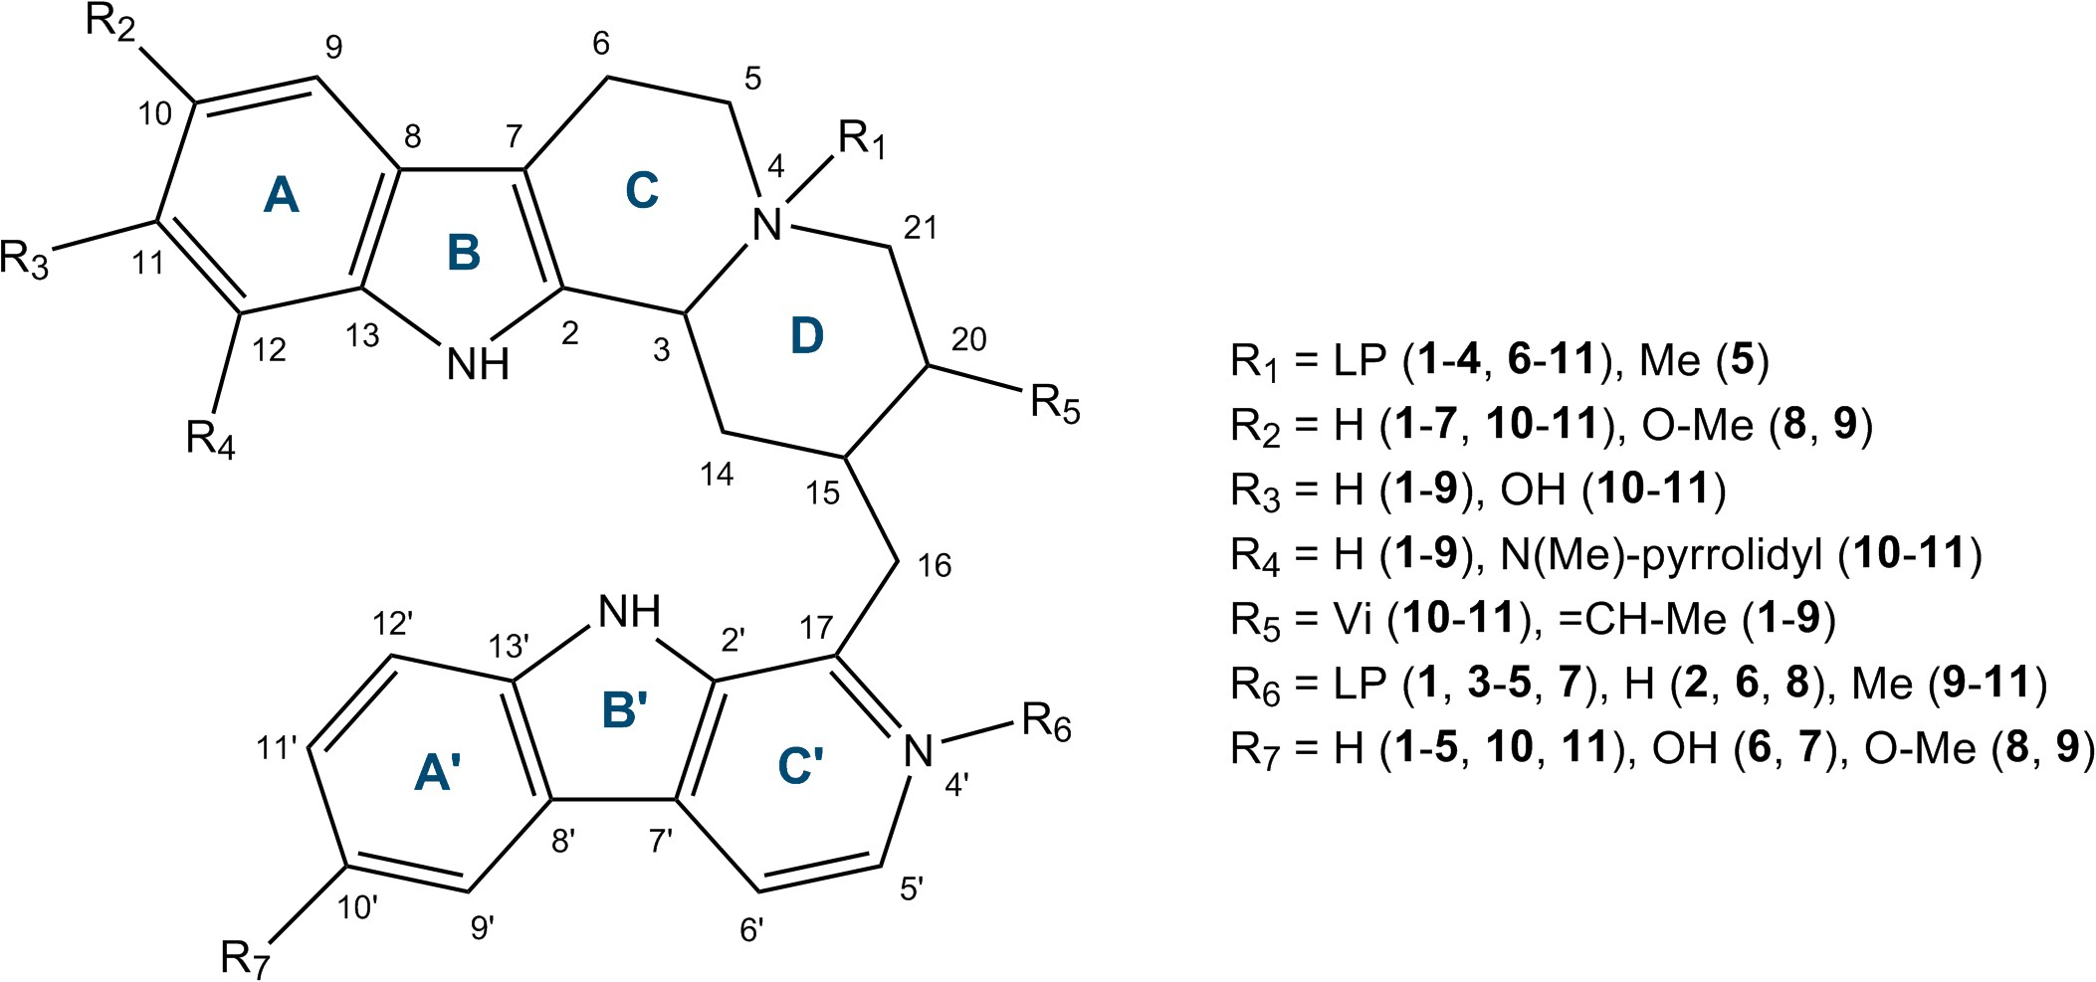
SCHEME 1 | General layout of rings and numbering of bisindole Corynanthe-Tryptamine alkaloids 1–11.
Despite the rapid development of modern NMR techniques, when determining the structure of newly isolated natural products, there arise certain inconsistencies in the assignment of available spectral data. Indeed, dubious situations often arise when it is difficult, and in some cases even impossible, to make a reliable assignment of NMR signals [21–28]. The development of computational ¹H and ¹³C NMR [29–33] opens up new possibilities in studying the structures and properties of bioorganic molecules. Quantum-chemical calculations of NMR chemical shifts are intended to clarify the reliable assignment of NMR experimental data on bisindole alkaloid structures, which is demonstrated in the present paper.

2 | Computational Details

2.1 | Conformational Search and Geometry Optimization
In the first stage of this study, a low-level conformational search was initially performed to establish the three-dimensional structure of each of the studied alkaloids 1-11 using the OPLS3 force field in the liquid phase of chloroform, employing the MacroModel module implemented in the Schrödinger Maestro 11.5 package [34]. During this search, approximately 10⁵ steps were performed to identify the most probable conformers. The structural features of the arrangement of the two bisindole subunits relative to each other were carefully established. When constructing the 3D model, available data on NOE correlations were taken into account whenever possible. Thus, the conformational search was mainly reduced, on the one hand, to identifying the exactrotationanglesoftheC-15–C-16andC-16–C-17bonds,and on the other hand, to searching for the exact conformations of the C and D rings. Thus, in the process of the conformational search in the energy range of 0–15kcal/mol relative to the minimum for each of the alkaloids, several groups of rotamers were identified at the C-15–C-16 and C-16–C-17 bonds, which properly correspond to the stereochemical structure of the quinolizidine system under consideration, see Figure 2. As a result of the conformational search, from all the established conformers for each compound, two of them with the cis- and trans-conformations of the quinolizidine C/D system were selected. Then, the geometric parameters of these two low-energy conformers were optimized using the GAUSSIAN 09 program [35] at the M06-2X/pecG-2 level [36–38]. The solvation effect was taken into account using the IEF-PCM model developed by Tomasi [39, 40].

2.2 | Calculation of Chemical Shifts
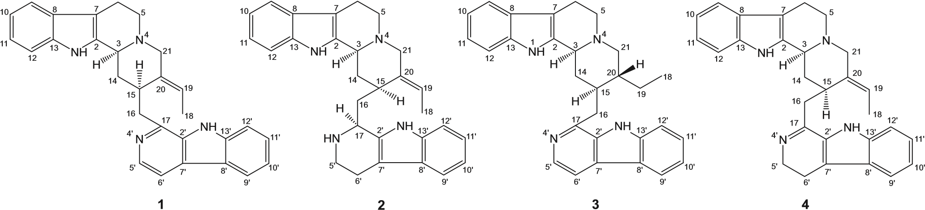9 6 9 6 9 6 9 6
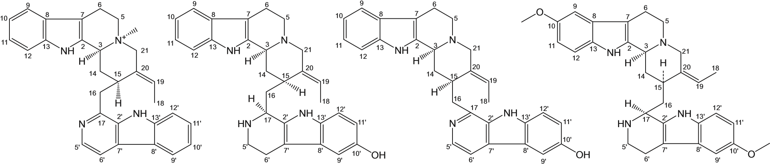
5 6 7 8
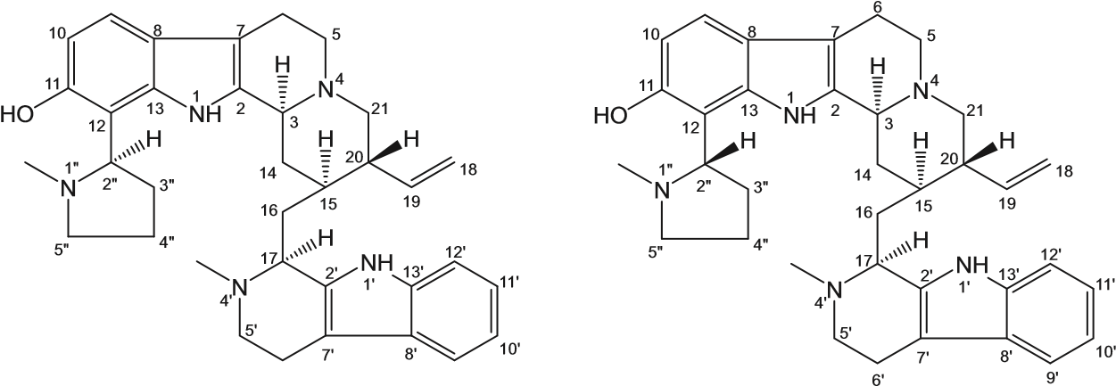
9 6 9 6 9
NH
N
N
NH
O
O
H
H
H
2
3
5
7
8
10
11
12
13
14
15
16
17
18
19
20
21
'
2
5
'
7
'
8
'
10
'
11
'
12
'
13
'
6' 9' 6' 9'
9 10 11
SCHEME 2 | Bisindole Corynanthe-Tryptamine alkaloids 1–11.
Calculations of ¹H and ¹³C NMR isotropic magnetic shielding constants and corresponding chemical shifts were carried out at the DFT level in the liquid phase of chloroform using the GAUSSIAN 09 program. In these calculations, we employed the one-parameter hybrid functional PBE0 [41], which was used in combination with Rusakov’s basis set pecS-2 [42].
To take into account systematic errors of calculated chemical shifts, we have established correlations between their experimental chemical shifts (x) and isotropic magnetic shielding constants (y), which were further used to find the linear correlation equations of the y = ax+ b type. The parameters a and b were then used for recalculating theoretical chemical shifts using the equation 𝛿recalc =(𝜎calc − b)/a.
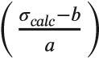
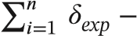
Corrected mean absolute errors (CMAE) were calculated as:
CMAE ₌ (1)
n

where 𝜎_{calc} are the unscaled shielding constants for each of the n nuclei in the molecule, while a and b are the slope and intercept of the linear regression 𝜎_{calc} = a𝛿_{exp} + b.
The root-mean-square deviations (RMSD) were evaluated as:
RMSD 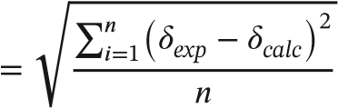 (2)
where ^{𝛿}_{exp} and ^{𝛿}_{calc} are accordingly, experimental and scaled chemical shifts of each of the n nuclei.

3 | Results and Discussion

3.1 | Indolo-General Overview
Corynantheanalkaloidsoriginatefromtheparentgeissoschizine, which contains an indolo-quinolizidine skeleton providing a number of different conformations. Mainly, this concerns the cisand trans-conformation of the C and D rings, see Scheme 1. It is knownthatthemorestable trans-conformationismostpreferred; however, in some cases the exceptions are possible. Moreover, the reasons for the stabilization of less favorable stereochemical structures in natural plant products are not completely clear.
The mentioned structural features of the quinolizidine system of this group of bisindole alkaloids prompted us to conduct a more detailed study in order to determine the specificity of their conformational structure. We selected several alkaloids of different conformations, for which complete experimental ¹³C NMR data and some ¹H NMR data had been published. Present study is devoted to the stereochemical analysis of 11 natural Corynanthe-Tryptamine type alkaloids, namely usambarensine (1) [3, 41–43], 4′,17S-tetrahydrousambarensine (2) [6], 19,20dihydrousambarensine (3) [7], 5′,6′-dihydrousambarensine (4) [34, 44, 45], N-4-methyl-usambarensine (5) [3, 5, 34], 10′hydroxy-4′,17S-tetrahydrousambarensine (6) [6], 10′-hydroxyusambarensine (7) [46], 10,10′-dimethoxy-3S,17S-Z-tetrahydrousambarensine (8) [8], 10,10′-dimethoxy-N-4′-methyl-3S, 17S-Z-tetrahydrousambarensine (9) [8], strychnopentamine (10) [47, 48], and isostrychnopentamine (11) [39, 40]. The structures and enumeration of carbons of these alkaloids are shown in Scheme 2. Since 1978 the IUPAC numbering of the beta-carboline part of usambarensine and derivatives has been abandoned in favor of the phytochemical numbering. Consequently, 3′-4′-dihydrousambarensine becomes 5′-6′-dihydrousambarensine.
3.2 | Calculation of ¹H and ¹³C NMR Chemical

Shifts
At the initial stage of the study, a conformational search was carried out for the named 11 bisindole alkaloids of the Corynanthe- geometric parameters.
For the optimized structures, the shielding constants along with the corresponding ¹H and ¹³C NMR chemical shifts were calculated at the DFT level using the PBE0 functional [49] in combination with our recently proposed pecS-2 basis set, which was specifically designed for the calculation of shielding constants in large synthetic and natural compounds [50, 51]. This basis set allows to achieve better agreement of calculated chemical shifts with experimental data at acceptable computational costs. The method of calculating NMR chemical shifts is described in more detail in the Computational details section.
Taking into account all known experimental chemical shifts together with their calculated values, a correlation estimation was performed using statistical descriptors such as CMAE and RMSD, see Figure 1. These descriptors allows to estimate the accuracy of the prediction of chemical shifts and determine the degree of correspondence between their experimental and calculated values [52]. According to the results of the present study,
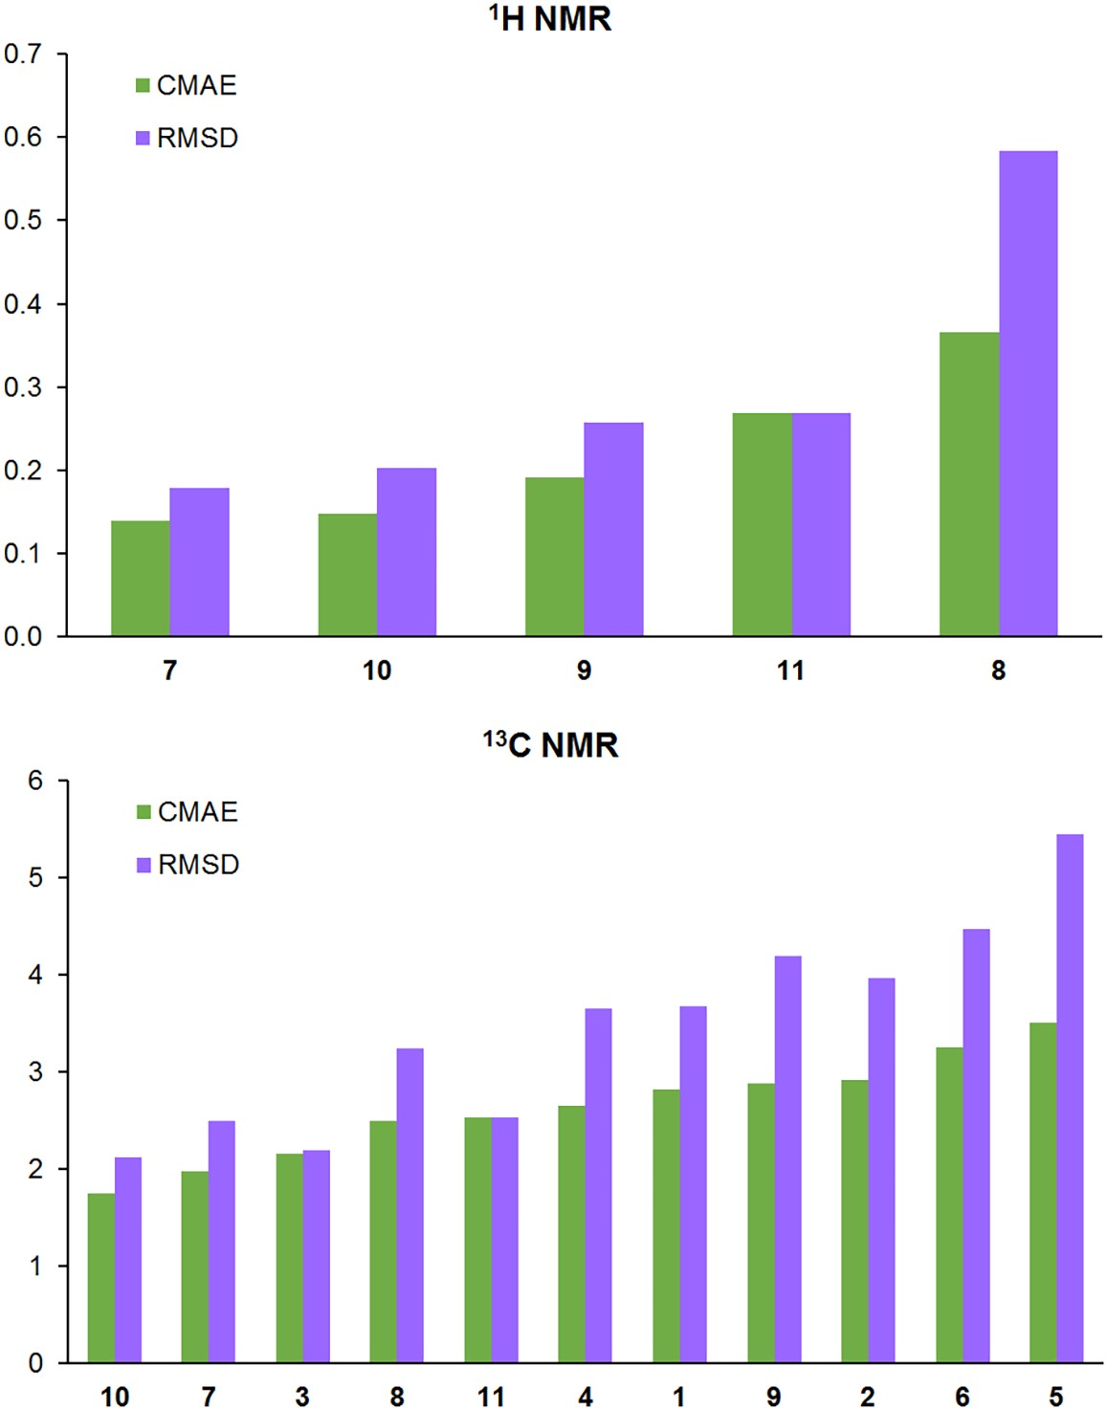
FIGURE 1 Corrected mean absolute error (ppm) and root-mean-square deviation (ppm) of calculated| ¹H and ¹³C NMR chemical shifts of 1–11. The graphs are arranged in the order of increasing their CMAE values.
Nucleus | 1 | 2 | 4 | 5 | 6 | 8 | 10 | 11
¹H NMR
H-14𝛼 |  |  |  |  |  |  | 0.77 (1.14)
H-14𝛽 |  |  |  |  |  |  | 2.09 (1.76)
H-16𝛽 |  |  |  |  |  |  |  | 2.62 (2.28)
H-17 |  |  |  |  |  |  |  | 3.21 (3.65)
H-18 | 0.94 (1.65)
H-21𝛽 | 3.78 (3.02)
H-9′ |  |  |  |  |  | 7.56 (6.95)
H-2′′ |  |  |  |  |  |  |  | 4.40 (3.20)
H-3′′𝛽 |  |  |  |  |  |  | 1.23 (1.75) | 1.25 (1.77)
H-4′′𝛼 |  |  |  |  |  |  |  | 2.36 (1.77)
H-4′′𝛽 |  |  |  |  |  |  | 2.35 (1.97) | 2.71 (1.94)
N-1′′-Me |  |  |  |  |  |  |  | 1.83 (2.33)
¹³C NMR
C-2  C-5 | 43.4 (51.1) |  |  | 55.9 (63.4)
C-19 | 128.3 (120.9) |  |  | 139.5 (121.6)
C-20 |  | 144.7 (134.5) | 142.4 (134.5) |  | 147.2 (133.1)
C-21 |  |  | 60.8 (51.4) | 65.9 (59.8)
C-2′ | 132.4 (140.2) |  |  | 131.9 (140.9)
C-7′ | 127.5 (119.8) |  |  | 128.7 (119.3)
C-8′ |  |  |  | 121.3 (128.7)
C-2′′ |  |  |  |  |  |  |  | 52.5 (65.4)
TABLE 1 Selected ambiguous values of calculated NMR chemical shifts (ppm) in 1, 2, 4-6, 8, 10, and 11. Experimental values are given in parentheses.|
generallyagoodagreementbetweencalculatedandexperimental data was achieved. Nevertheless, the deviations of protons shifts in the calculated spectra (in model systems at the DFT level) can be an underestimation of complex stereoelectronic effects that occur in real systems notably around the angular protons in indolo(a)quinolizidines; however these deviations were less sensitive in ¹³C NMR spectra. Consequently, theoretical calculations of all studied natural products 1-11 confirmed their previously assumed configurational structures.
The average calculation error for ¹H NMR chemical shifts was 0.22ppm in the range of−1.20 to+0.60ppm, while for the ¹³C NMR shifts, it was 2.69ppm in the range of−6.9 to+7.2ppm. For usambarensine (1), 4′,17S-tetrahydrousambarensine (2), 19,20-dihydrousambarensine (3), 5′,6′-dihydrousambarensine (4), N-4-methyl-usambarensine, (5) and 10′-hydroxy-4′,17Stetrahydrousambarensine (6), tabular experimental data on ¹H NMR chemical shifts are incomplete or unknown. Moreover, for compounds 1, 3, and 6 the assignment of peaks in the aromatic part of experimental ¹H NMR spectra is ambiguous. Present theoretical calculations were aimed to fill this gap. The parameters of statistical descriptors for almost all compounds of this series (2-4, 6, 7, 9-11) provide correlations of approximately the same level with some small exceptions, see Table 1.
Below we consider each of the studied alkaloids in more detail. In a number of cases, unambiguous assignments of ¹H NMR multiplets representing strongly coupled spin systems and, as a consequence, not explicitly assigned in the original publications were performed in the present work. For all structures, we checked the configurational assignments based on the correlation of calculated and experimental NMR chemical shifts. In some special cases, we report the reassignment of individual resonance signals (marked in the schemes by blue arrows) and experimentally unresolved signals, which are shown in blue, see Scheme 3. More detailed comments on each compound of this series are given below.
Usambarensine (1) was used as the basic structure for the studied series 1-11 in view of the fact that it demonstrates steric structural features that were determined quite accurately by means of the x-ray analysis [33]. This starting point clearly forms the direction in establishing the exact structure for related alkaloids. However, original publications [3, 34] provide rather incomplete experimental NMR data, that were assigned in 1973 and 1980 when it wasimpossibletouse2DHSQCspectroscopy.Inthisregard,comparing calculated versus experimental ¹H NMR chemical shifts for this alkaloid will be incomplete but nevertheless instructive, see Scheme 3.

SCHEME 3 | Essential (re)assignments and missing NMR data for 1–6; computational assignments based on the performed calculations (blue).
4′,17S-tetrahydrousambarensine (2). In general, experimental ¹³C NMR data for this compound agree quite well with the calculated values except for C-20, which obviously deviates from experiment. There is also incomplete information on ¹H NMR [6, 9]. Herewith, we provide estimated values of missing experimental shifts.
19,20-Dihydrousambarensine (3). Despite the incomplete set of experimental ¹³C NMR data [7], we observe excellent agreement of calculated data with experiment. ¹H NMR shifts were not completely assigned, which provides very scarce practical information.
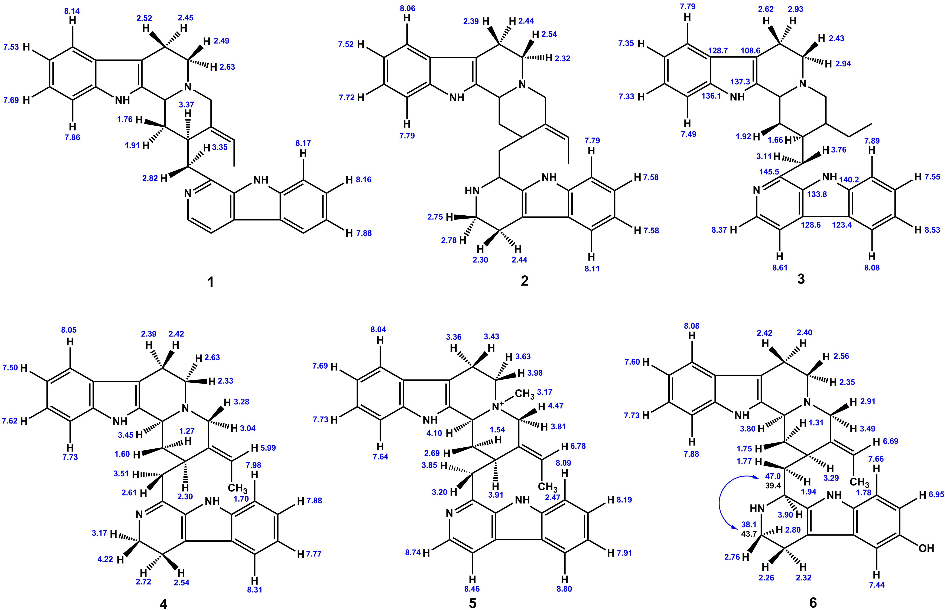
5′,6′-Dihydrousambarensine (4). For this compound, it is worth noting that calculated values of C-20 and C-21 chemical shifts provide rather significant deviations from experiment. In this case, to verify the determination of the C/D ring configuration performed in the previous studies [9, 34, 36, 37], we calculated both cis- and trans-conformations for the quinolizidine system. However, this series of calculations did not generally clarify the situation; the correlation of theoretical and experimental NMR chemical shifts remained at the same level, see SI, Data S1. This finding suggests that in a real system there is some probability of the simultaneous presence of two conformers. The remaining assignments of experimental ¹³C NMR signals generally showed good agreement with the performed calculations. There are no ¹H NMR experimental data for this compound, and thus we have simply provided the expected (calculated) values with cis- C/D ring in twist-boat conformation of ring D.

N-methyl-usambarensine (5). For this molecule, no experimental ¹H NMR data were provided in the first publications [5], so we just report here our calculated chemical shifts. As for ¹³C NMR chemical shifts, significant deviations of calculated values from experiment were observed for C-19′, and C-21′.
For 10′-hydroxy-4′,17S-tetrahydrousambarensine (6), there are a few experimental data for some protons, but a complete ¹³C NMR experiment is available [6], which generally correlates well with calculated data. It is only worth noting the obvious mutual reassignment for the atoms C-5′ and C-16 together with a dubious value of C-20 chemical shift, which clearly stands out from a general correlation and requires more detailed study.
10′-Hydroxyusambarensine (7). For this bisindole alkaloid, a set of experimental data on chemical shifts of both carbon and hydrogen is known [38] that correlates well with the performed calculations.
Calculation of ¹³C NMR chemical shifts of 10,10′-dimethoxy-3S, 17S-Z-tetrahydrousambarensine (8) agrees well with experimental data [8]. For ¹H NMR, the correlation is mostly satisfactory, except for the H-9′ atom.
10,10′-dimethoxy-N-4′-methyl-3S,17S-Z-tetrahydrousambarens ine (9) is one of the noticeable examples of the remarkable agreement between theory and experiment, both for ¹H NMR and ¹³C NMR chemical shifts.

Strychnopentamine (10). A fairly reliable set of experimental ¹³C NMRchemicalshiftdataisavailableintheliteratureforthiscompound [39, 40], which was well reproduced by the performed calculations. The same is true for ¹H NMR chemical shifts, however, significant deviations are observed for protons H-14b, H-3′′b, and H-4′′b.
Isostrychnopentamine (11). Our theoretical study of this alkaloid confirmed its previously established stereochemical structure [39, 40]. Despite the low level of correlation between theory and experiment in the case of ¹H NMR data, for carbon chemical shifts there is only one position, C-2′′, providing obvious uncertainty. This established discrepancy between calculation and experiment may probably be due to the underestimation of the internal rotation of the pyrrolidine fragment.

3.3 | Conformational Behavior of the Quinolizidine Moiety
As it was mentioned earlier, bisindole alkaloids of the Corynanthe-Tryptamine type are characterized by the quinolizidine system adopting both cis- and trans-conformations, as shown in Figure 2a. This conformational equilibrium can be significantly affected by the substituents at the C and D rings. The calculations performed generally confirm the energetic preference to the formation of the cis- or trans-conformation of the C/D system each of compounds 1-11, see Table 2. The schematic designation of the rings of the studied bisindole alkaloids is shown in Scheme 1.
In the case of compounds under study, this concerns mainly the D ring. Indeed, it has been previously noted [53] that simultaneous presence of a tryptamine unit at C-15 (ring D) and ethylidene chain at C-20 with the latter having E-configuration, causes an inversion of the nitrogen atom at position 4. This leads to the interconversion of cis-decalin ring. When the ethylidene chain is saturated, the more stable trans-conformation of the C/D rings is preferred. However, in some rare cases, the geometry of the ethylidene chain adopting Z-configuration allows the trans-conformation of the C/D rings without an interaction of H-18 with the (C15) substituent. Remind us that an E-configuration of the side chain presents such an interaction that leads to a cis-conformation of the C/D rings.
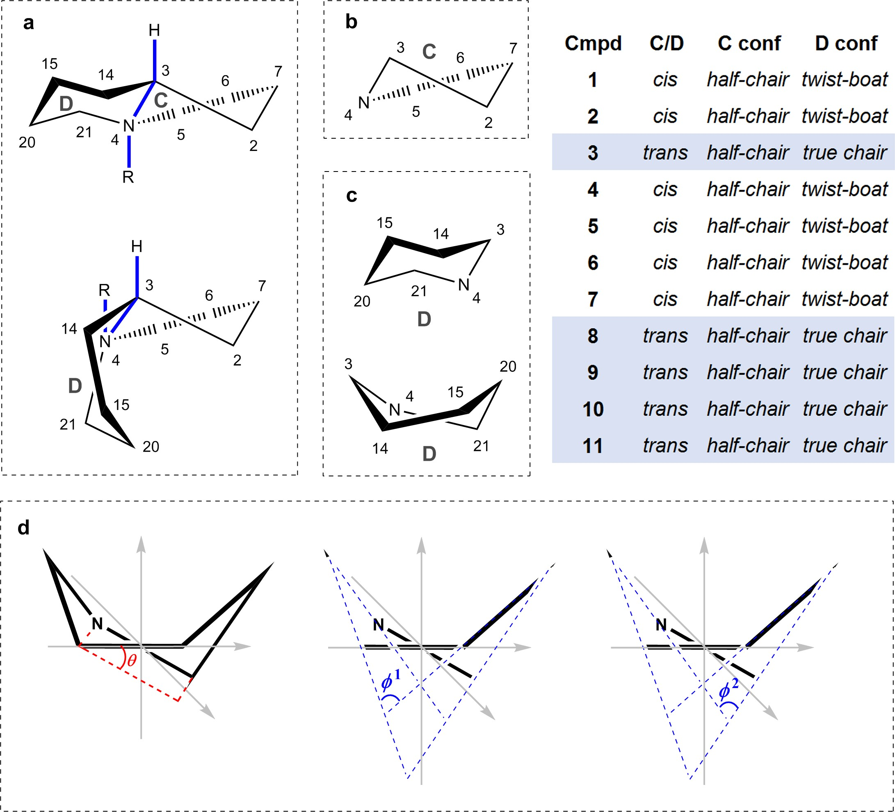
FIGURE 2 Conformational features of quinolizidine moiety of Corynanthe-Tryptamine bisindole alkaloids: (a) cis- and trans-conformations of quinolizidine system; (| b) half-chair conformation of ring S; (c) true chair and twist-boat conformations of ring D; (d) schematic representation of the torsional and dihedral angles of the twist-boat conformation of ring D.
With respect to structures 1-11, it can be concluded that conformation of cycle C for both the cisoid and transoid types of the quinolizidine system, takes the half-chair form, see Figure 2b.
However, based on the results of the optimization of geometric parameters of 1-11, it was found that for the quinolizidine system in the transoid form, the true chair conformation is most preferable for the D cycle, as shown in Figure 2c without taking account of the nature and position of the substituents. At the same time, for this same cycle, the cisoid form of the C/D system takes both the true chair and twist-boat conformations depicted in Figure 2c. It is worth noting that for systems 1-11, the energy barriers for the true chair ↔ twist-boat transition of the D cycle are very small amounting to about 5–7kcal/mol.
The torsion angle 𝜃_{N4-C21-C15-C14} varying within 30˚–33˚ characterize the degree of “twisting” of the D cycle in the twist-boat conformation, see Figure 2d. The dihedral angles 𝜑¹_{S3-C14-C15-C20} and 𝜑²_{S3-N4-C21-C20} of the tilts of the planes formed by the C3-N4-C14 and C15-C20-C21 chains are about 170˚ and 120˚, respectively.
TABLE 2 Free energy characteristics and dipole moments of the cis- and| trans-conformers of compounds 1-11 optimized at the M06-2X/pecG-2 level.
Dipole
moment,
D
Relative free
energy, kcal/mol
Cmpd
trans
cis
trans
cis
1
4.99
5.37
0.42
0
2 3.66 | 5.03 | 1.11 | 0
3 6.01 | 6.54 | 5.17 | 0
4 4.77 | 4.89 | 0.85 | 0
5 12.30 | 11.99 | 0 | 0.33
6 3.36 | 5.82 | 1.09 | 0
7 3.11 | 2.75 | 0 | 0.26
8 1.63 | 2.95 | 4.02 | 0
9 2.54 | 2.75 | 4.28 | 0
10 6.96 | 8.06 | 1.64 | 0
11 3.23 | 4.74 | 9.61 | 0

In order to understand how the conformation of quinolizidine system affects the values of ¹³C NMR chemical shifts, the analysis of their available experimental data was carried out. Figure 3 shows the distribution of ¹³C NMR chemical shift of the quinolizidine C/D rings system in compounds 1-11 in the form of the color diagram in accord with their downfield-highfield bias.
It follows that most ¹³C NMR chemical shifts are dependent on the conformation of the quinolizidine system. For example, chemical shifts of C-3, C-5, C-6, C-15, and C-20 in cis-conformation tend to provide a highfield shift. On the other hand, chemical shift of C-2 has a pronounced downfield bias. In the case of trans-conformation of the quinolizidine system, a pronounced downfield shift is observed for C-6, C-15, C-20, and C-21.Onthecontrary,theC-2atomischaracterizedbyanobvious highfield shift.
As can be seen in Figure 3, there are minor exceptions in the established trends, so that it is not always possible to find clear regularities. Please notice that the downfield shifts observed for some carbons of product 5 are due to the quaternarization of N-4. However, we strongly believe that established trends of the ¹³C NMR chemical shifts of the quinolizidine C/D rings in the studied series of compounds will provide some help in performing spectral assignments in a wider range of bisindole alkaloids.

3.3.1 | Final Results
As a final illustration, we present correlation plots of calculated versus experimental values of the original and reassigned ¹H and ¹³C NMR chemical shifts of the studied Corynanthe-Tryptamine alkaloids, see Figure 4. In general, these data illustrate the efficiency of the proposed computational protocol used for stereochemical analysis of natural products. It can be seen that final CMAE of the reassigned chemical shifts are 0.22ppm for protons and 2.69ppm for carbons, which are accordingly, 3% and 2% of the total ¹H and ¹³C NMR chemical shift ranges. All calculated

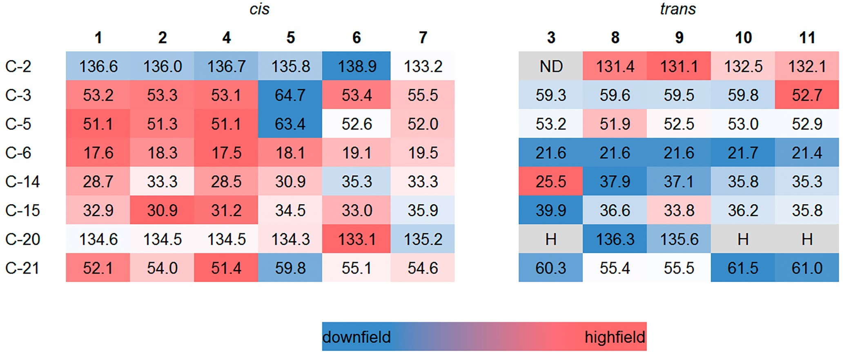
FIGURE 3 Distribution of ¹³C NMR chemical shift values for atoms of cis- and trans-conformations of the quinolizidine C/D rings system of compounds 1|–11.
FIGURE 4 | Correlation plots of calculated vs. experimental ¹H and ¹³C NMR chemical shifts of 1–11, ppm.
¹H and ¹³C NMR chemical shifts of the studied compounds are given in the Data S2, see Supporting Information.

4 | Conclusions
Configurational assignments of 11 Corynanthe-Tryptamine alkaloids were performed based on the correlation of the high-level calculated and experimental ¹H and ¹³C NMR chemical shifts. Thus for a number of compounds, unambiguous assignments of ¹H NMR multiplets representing strongly coupled spin systems and, as a consequence, not explicitly assigned in the original publications were carried out. Configurations of all structures were verified based on the correlation of calculated and experimental NMR chemical shifts. In some cases, the reassignment of individual resonance signals together with experimentally unresolved signals were reported. Theoretical calculations of 11 natural products confirmed their previously assumed (but not experimentally established) configurational structures.
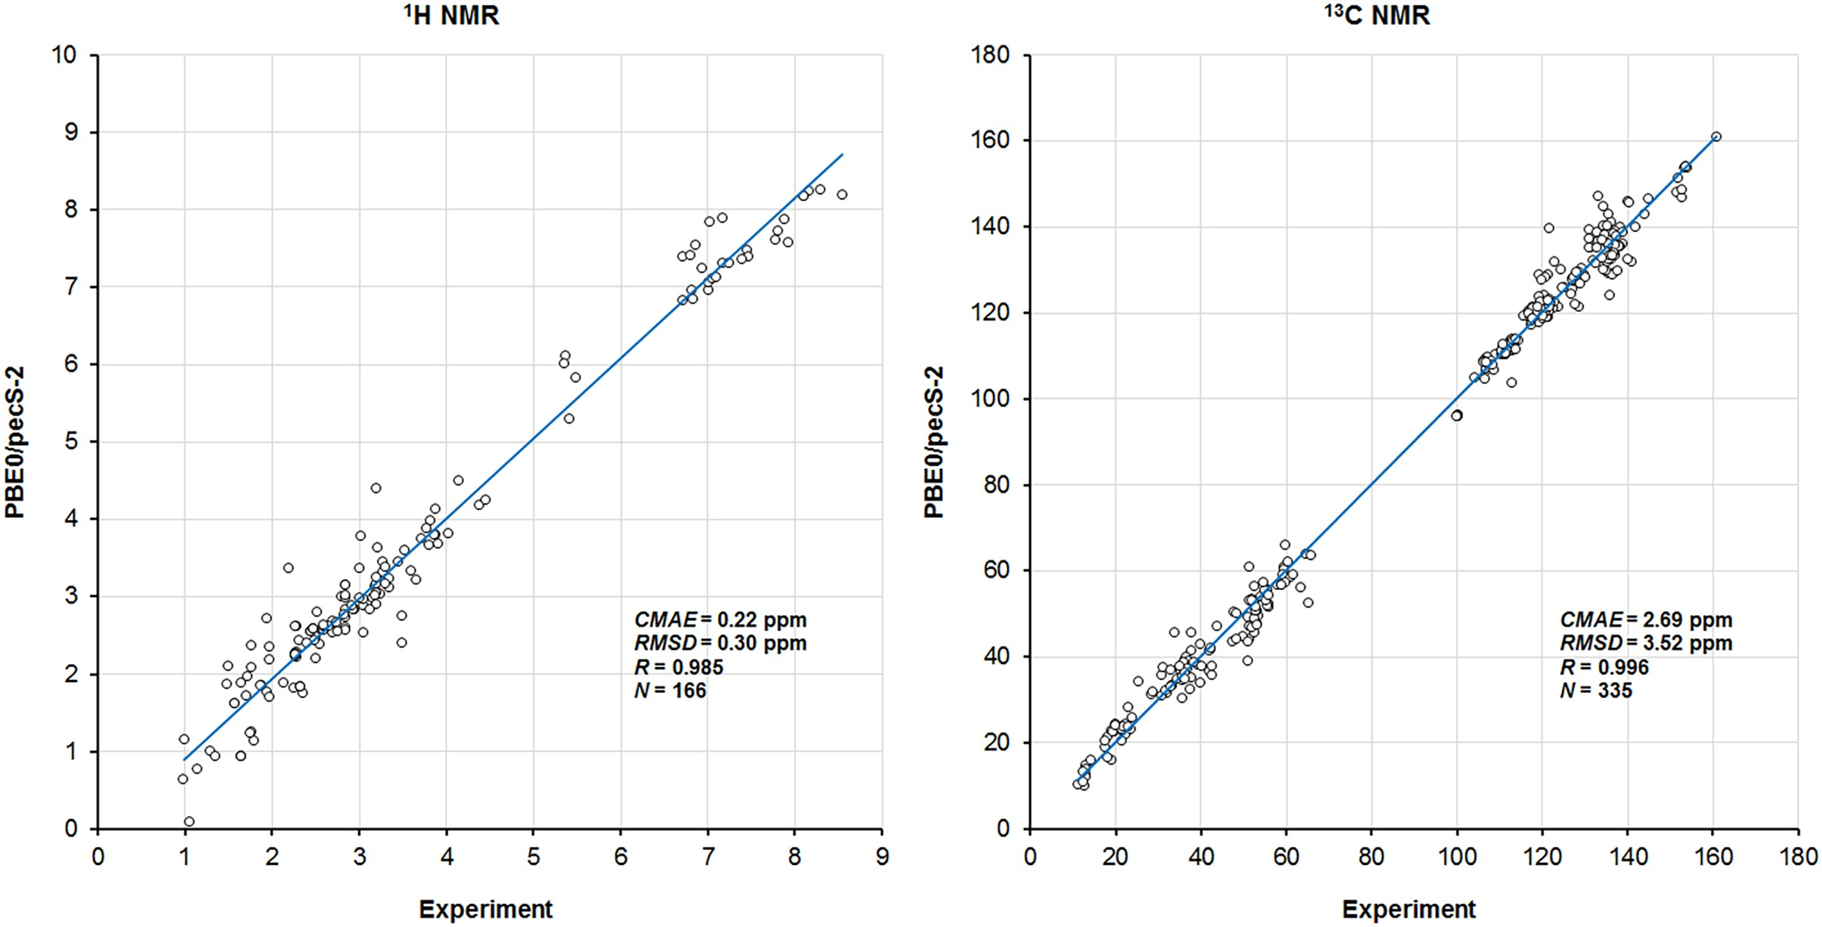
Generally, a good correlation was found between calculated and experimental ¹H and ¹³C NMR chemical shifts for all compounds of this series. The average calculation error for the ¹H NMR chemical shifts was 0.22ppm in the range of−1.20 to+0.60ppm, while for the ¹³C NMR shifts, it was 2.69ppm in the range of−6.9 to+7.2ppm. Essential (re)assignments and missing NMR spectral data for seven compounds were suggested. For compounds with the unpublished ¹H NMR, the highly reliable computational data were provided. Conformational behavior of the quinolizidine moiety of the bisindole alkaloids of the Corynanthe-Tryptamine type was established in much detail. In general, these data illustrate the efficiency of

the proposed computational protocol used for stereochemical analysis of natural products.

Author Contributions
Valentin A. Semenov: conceptualization, methodology, software, visualization, validation, project administration; Dmitry A. Grigoriev: data curation, investigation, formal analysis, investigation, writing – original draft preparation; Luc Angenot: resources, writing; Leonid B. Krivdin: supervision, editing. All authors have read and agreed to the published version of the manuscript.

Acknowledgments
All calculations were performed at Irkutsk Supercomputer Center of the Siberian Branch of the Russian Academy of Sciences using the HPC cluster “Academician V.M. Matrosov” (http://hpc.icc.ru, accessed on October 2, 2024) and at A.E. Favorsky Irkutsk Institute of Chemistry using the facilities of Baikal Analytical Center (http://ckp-rf.ru/ckp/3050, accessed on October 2, 2024).
Conflicts of Interest
The authors declare no conflicts of interest.

Data Availability Statement
The data that supports the findings of this study are available in the Supporting Information of this article.

References
- D. A. Grigoriev, V. A. Semenov, L. Angenot, and L. B. Krivdin, “Stereochemical and NMR Computational Study of Some Natural Dimeric Bisindole Alkaloids,” International Journal of Quantum Chemistry 124 (2024): e27323.
- N. G. Bisset, “Arrow and Dart Poisons,” Journal of Ethnopharmacology 25 (1989): 1–41.

- L. Angenot, Thesis—Contribution to the Study of Strychnos usambarensis GILG, Main Ingredient of an African Curarizing Arrow Poison (French Text) (Liège, Belgium: University of Liège, 1973).
- L. Angenot, M. Dubois, C. Ginion, W. van Dorsser, and A. Dresse,“Chemical Structure and Pharmacological (Curarizing) Properties of Various Indole Alkaloids Extracted From an African Strychnos,” Archives Internationales de Pharmacodynamie et de Thérapie 215 (1975): 246–258.
- L. Angenot and N. G. Bisset, “Isolement et structure de nouveauxalcaloïdes extraits du Strychnos usambarensis du Rwanda,” Journal de Pharmacie de Belgique 26 (1971): 585–588.
- G. Massiot, P. Thépenier, M. J. Jacquier, et al., “Further AlkaloidsFrom Strychnos longicaudata and Strychnos ngouniensis,” Tetrahedron 39 (1983): 3645–3656.
- G. Massiot, P. Thepenier, M. J. Jacquier, L. Le Men-Olivier, and J. LeMen, “Alkaloids From Roots of Strychnos potatorum,” Phytochemistry 31 (1992): 2873–2876.
- R. Verpoorte, G. Massiot, M. J. Jacquier, P. Thépenier, and L. Le MenOlivier, “New Semidimeric Alkaloids From Strychnos dale,” Tetrahedron Letters 27 (1986): 239–242.
- G. M. T. Robert, A. Ahond, C. Poupat, P. Potier, and H. Jacquemin,“Aspidosperma de Guyane: Alcaloïdes de Aspidosperma marcgravianum,” Journal of Natural Products 46 (1983): 694–707.
- C. W. Wright, D. Allen, Y. Cai, et al., “Selective Antiprotozoal Activityof Some Strychnos Alkaloids,” Phytotherapy Research 8 (1994): 149–152.
- M. Frederich, M. P. Hayette, M. Tits, P. De Mol, and L. Angenot,“In Vitro Activities of Strychnos Alkaloids and Extracts Against Plasmodium falciparum,” Antimicrobial Agents and Chemotherapy 43 (1999): 2328–2331.
- C. Passemar, M. Saléry, P. Njommang Soh, et al., “Indole andAminoimidazole Moieties Appear as Key Structural Units in Antiplasmodial Molecules,” Phytomedicine 18 (2012): 1118–1125.
- M. Frédérich, M. Tits, E. Goffin, et al., “In Vitro and In Vivo Antimalarial Properties of Isostrychnopentamine, an Indolomonoterpenic Alkaloid From Strychnos usambarensis,” Planta Medica 70 (2004): 520–525.
- L. Dassonneville, N. Wattez, C. Mahieu, et al., “The Plant AlkaloidUsambarensine Intercalates Into DNA and Induces Apoptosis in Human HL60 Leukemia Cells,” Anticancer Research 19 (1999): 5245–5250.
- M. Frederich, M. Bentires, M. Tits, et al., “Isostrychnopentamine,an Indolomonoterpenic Alkaloid From Strychnos usambarensis, Induces Cell Cycle Arrest and Apoptosis in Human Colon Cancer Cells,” Journal of Pharmacology and Experimental Therapeutics 304 (2002): 1103–1110.
- E. Saidou Balde, V. Mégalizzi, M. Cao, et al., “Isostrychnopentamine, an Indolomonoterpenic Alkaloid From Strychnos usambarensis, With Potential Anti-Tumor Activity Against Apoptosis-Resistant Cancer Cells,” International Journal of Oncology 36 (2010): 961–965.
- K. Rachwał, I. Niedzwied´ z, A. Wa´ sko, et al., “Red Kale (´ Brassica oleracea L. Ssp. Acephala L. Var. Sabellica) Induces Apoptosis in Human Colorectal Cancer Cells in Vitro,” Molecules 28 (2023): 6938.
- Y. Zhang, X. Liu, X. Li, et al., “Physicochemical Properties andAntibiosis Activity of the Pink Pigment of Erwinia persicina Cp2,” Agriculture 12 (2022): 1641.
- R. O. Trevisan, M. M. Santos, C. S. Desidério, et al., “In Silico Identification of New Targets for Diagnosis, Vaccine, and Drug Candidates Against Trypanosoma cruzi,” Disease Markers 9130719 (2020): 1–15.
- O. M. Ogunyemi, G. A. Gyebi, A. A. Elfiky, S. O. Afolabi, A. P.
Adegunloye, and I. M. Ibrahim, “Alkaloids and Flavonoids From African Phytochemicals as Potential Inhibitors of SARS-Cov-2 RNA-Dependent RNA Polymerase: An In Silico Perspective,” Antiviral Chemistry & Chemotherapy 28 (2020): 1–15.
- A. Bagno and G. Saielli, “Addressing the Stereochemistry of ComplexOrganic Molecules by Density Functional Theory-NMR,” WIREs Computational Molecular Science 5 (2015): 228–240.
- F. V. Toukach and V. P. Ananikov, “Recent Advances in Computational Predictions of NMR Parameters for the Structure Elucidation of Carbohydrates: Methods and Limitations,” Chemical Society Reviews 42 (2013): 8376–8415.
- N. Grimblat and A. M. Sarotti, “Computational Chemistry to the Rescue: Modern Toolboxes for the Assignment of Complex Molecules by GIAO NMR Calculations,” Chemistry 22 (2016): 12246–12261.
- W. Hehre, P. Klunzinger, B. Deppmeier, et al., “Efficient Protocol forAccurately Calculating ¹³C Chemical Shifts of Conformationally Flexible Natural Products: Scope, Assessment, and Limitations,” Journal of Natural Products 82 (2019): 2299–2306.
- M. W. Lodewyk, M. R. Siebert, and D. J. Tantillo, “Computational Prediction of ¹H and ¹³C Chemical Shifts: A Useful Tool for Natural Product, Mechanistic, and Synthetic Organic Chemistry,” Chemical Reviews 112 (2012): 1839–1862.
- F. L. P. Costa, A. C. F. de Albuquerque, R. G. Fiorot, et al., “Structural Characterisation of Natural Products by Means of Quantum Chemical Calculations of NMR Parameters: New Insights,” Organic Chemistry Frontiers 8 (2021): 2019–2058.
- V. A. Semenov and L. B. Krivdin, “Computational NMR of NaturalProducts,” Russian Chemical Reviews 91 (2022): RCR5027.
- Z. Zeng, G. Kociok-Köhn, T. J. Woodman, M. G. Rowan, and I. S.Blagbrough, “Structural Studies of Norditerpenoid Alkaloids: Conformation Analysis in Crystal and in Solution States,” European Journal of Organic Chemistry 2021 (2021): 2169–2179.
- L. B. Krivdin, “Computational ¹H and ¹³C NMR in Structural and Stereochemical Studies,” Magnetic Resonance in Chemistry 60 (2022): 733–828.
- L. B. Krivdin, “Computational Protocols for Calculating ¹³C NMR Chemical Shifts,” Progress in Nuclear Magnetic Resonance Spectroscopy 112–113 (2019): 103–156.
- L. B. Krivdin, “Computational ¹H NMR: Part 1. Theoretical Background,” Magnetic Resonance in Chemistry 57 (2019): 897–914.
- L. B. Krivdin, “Computational ¹H NMR: Part 2. Chemical Applications,” Magnetic Resonance in Chemistry 58 (2020): 5–14.
- L. B. Krivdin, “Computational ¹H NMR: Part 3. Biochemical Studies,” Magnetic Resonance in Chemistry 58 (2020): 15–30.
- Schrodinger Release, “Maestro; Schrodinger, LLC,” (2018) New York,NY, USA, https://www.schrodinger.com/freemaestro.
- M. J. Frisch, G. W. Trucks, H. B. Schlegel, et al., “Gaussian 09, Revision, C.01,” (2009) Gaussian, Inc.: Wallingford, CT, USA, http://www .gaussian.com.
- Y. Y. Rusakov, Y. A. Nikurashina, and I. L. Rusakova, “On the UtmostImportance of the Geometry Factor of Accuracy in the Quantum Chemical Calculations of ³¹P NMR Chemical Shifts: New Efficient pecG-n (n = 1, 2) Basis Sets for the Geometry Optimization Procedure,” Journal of Chemical Physics 160 (2024): 084109.
- Y. Y. Rusakov, V. A. Semenov, and I. L. Rusakova, “Quelling the Geometry Factor Effect in Quantum Chemical Calculations of ¹³C NMR Chemical Shifts With the Aid of the pecG-n (n = 1, 2) Basis Sets,” International Journal of Molecular Sciences 25 (2024): 10588.
- Y. Zhao and D. G. Truhlar, “The M06 Suite of Density Functionals for Main Group Thermochemistry, Thermochemical Kinetics, Noncovalent Interactions, Excited States, and Transition Elements: Two New Functionals and Systematic Testing of Four M06-Class Functionals and 12 Other Functionals,” Theoretical Chemistry Accounts 120 (2008): 215–241.
- J. Tomasi, B. Mennucci, and E. Cances, “The IEF Version of the PCMSolvation Method: An Overview of a New Method Addressed to Study Molecular Solutes at the QM Ab Initio Level,” THEOCHEM 464 (1999): 211–226.
- J. Tomasi, B. Mennucci, and R. Cammi, “Quantum mechanical continuum solvation models,” Chemical Reviews 105 (2005): 2999–3093.
- O. Dideberg, L. Dupont, and L. Angenot, “Determination de lastructure cristalline et de la configuration absolue d’un dérivé de l’usambarensine,” Acta Cryst B31 (1975): 1571–1575.
- C. Coune, L. Angenot, and J. Denoël, “¹³C NMR des alcaloïdes des Strychnos: Les dérivés de l’harmane et de l’usambarensine,” Phytochemistry 19 (1980): 2009–2011.
- H. Seki, A. Hashimoto, and T. Hino, “The ¹H- and ¹³C-Nuclear Magnetic Resonance Spectra of Harman. Reinvestigation of the Assignments by One- and Two-Dimensional Methods,” Chemical & Pharmaceutical Bulletin 41 (1993): 1169–1172.
- K. Yamada, K. Aoki, and D. Uemura, “Synthesis and Stereochemistryof (+−)-3′,4′-Dihydrousambarensine,” Journal of Organic Chemistry 40 (1975): 2572–2573.
- C. Richard, C. Delaude, L. Le Men-Olivier, and J. Le Men, “Alcaloïdesdu Strychnos tchibangensis,” Phytochemistry 17 (1978): 539–541.
- M. Fréderich, M. Tits, M.-P. Hayette, et al.,
“10’-Hydroxyusambarensine, a New Antimalarial Bisindole Alkaloid From the Roots of Strychnos usambarensis,” Journal of Natural Products 62 (1999): 619–623.
- D. Tavernier, W. Zhang, L. Angenot, M. Chierici-Tits, and J. Leclercq,“The Structure of Isostrychnopentamine, a Bisindole Monoterpene Alkaloid From Strychnos usambarensis,” Phytochemistry 26 (1987): 557–560.
- L. Dupont, J. Lamotte-Brasseur, O. Dideberg, H. Campsteyn, M. Vermeire, and L. Angenot, “La structure cristalline et moléculaire d’un nouvel alcaloïde bisindolique: la Strychnopentamine C₃₅H₄₃N₅O,” Acta Cryst B33 (1977): 1801–1807.
- C. Adamo and V. Barone, “Toward Chemical Accuracy in the Computation of NMR Shieldings: The PBE0 Model,” Chemical Physics Letters 298 (1998): 113–119.
- Y. Rusakov and I. L. Rusakova, “New pecS-n (n = 1, 2) Basis Sets for Quantum Chemical Calculations of the NMR Chemical Shifts of H, C, N, and O Nuclei,” Journal of Chemical Physics 156 (2022): 244112.
- Y. Y. Rusakov, V. A. Semenov, and I. L. Rusakova, “On the Efficiencyof the Density Functional Theory (DFT)-based Computational Protocol for ¹H and ¹³C Nuclear Magnetic Resonance (NMR) Chemical Shifts of Natural Products: Studying the Accuracy of the pecS-n (n = 1, 2) Basis Sets,” International Journal of Molecular Sciences 24 (2023): 14623.
- V. A. Semenov and L. B. Krivdin, “Simple and Versatile Scheme for theStereochemical Identification of Natural Products and Diverse Organic Compounds With Multiple Asymmetric Centers,” Journal of Physical Chemistry A 125 (2021): 10359–10372.
- R. Eckermann and T. Gaich, “The Double Bond Configurationof Corynanthean Alkaloids and Its Impact on Monoterpenoid Indole Alkaloid Biosynthesis,” Chemistry—A European Journal 22 (2016): 5749–5755.

Supporting Information
Additional supporting information can be found online in the Supporting Information section.

