SUPPLEMENTARY INFORMATION

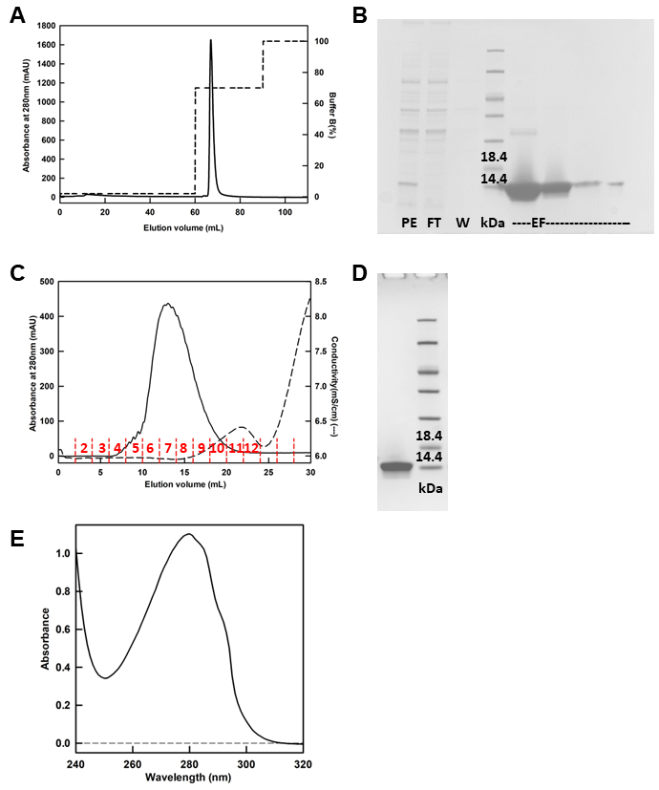
Figure S1. A) NbE201 was purified by IMAC using a 1 mL NiPDC column and the chromatogram is shown. Buffer A was 50 mM KPi buffer pH 8.0 and buffer B was 50 mM KPi buffer pH 8.0 with 500 mM imidazole. B) SDS-PAGE analysis after the IMAC purification on 4 to 20% SDS-PAGE combined with Coomassie blue staining. PE, periplasmic extract; FT, Flow-through; W, wash; EF, eluted fractions corresponding to the peak in panel A. The first two fractions were pooled for the next step. Lane 4 corresponds to the molecular mass marker. C) Chromatogram of the buffer exchange chromatography carried with the fractions pooled after the IMAC. The running buffer was 50 mM NaPi buffer pH 7.0. The red bars indicate the fractions of elution. D) SDS-PAGE analysis after the buffer exchange chromatography of fractions 5-9 pooled together on 4 to 20% SDS-PAGE combined with Coomassie blue staining. Lane 2 corresponds to the molecular mass marker. E) UV-vis spectrum of purified NbE201.

Figure S2. Circular Dichroism spectra from 200 to 250 nm of NbE201 in its native form and in its denatured form. A) Far UV CD spectra of NbE201 before and after urea denaturation recorded using a 0.2 nm pathlength cell. NbE201 spectra are taken in its native form (black, 0 M urea) and in its denatured form (red, 9 M urea). B) Far UV CD spectra of NbE201 before and after heat-induced denaturation recorded using a 1 nm pathlength cell. NbE201 spectra are taken in its native form (black, 25°C) and in its denatured form (red, 97°C). A,B) The far UV-CD spectrum of NbE201 in its native form has two negative maxima around 215 and 229 nm typical of immunoglobulin domains (Dumoulin et al., doi: 10.1110/ps.34602).

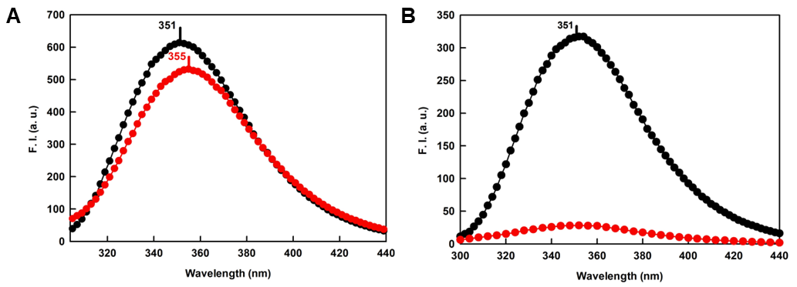
Figure SI3. Intrinsic fluorescence spectra from 300 to 440 nm of NbE201 in its native and denatured forms. A) Intrinsic fluorescence spectra of NbE201 before and after urea denaturation. NbE201 spectra are taken in its native (black, 0 M urea) and denatured (red, 8 M urea) forms. B) Intrinsic fluorescence spectra of NbE201 before and after heat-induced denaturation. NbE201 spectra are taken in its native (black, 25°C) and denatured (red, 97°C) forms. A,B) The intrinsic fluorescence spectrum of native NbE201 has a maximum at 351 nm, typical of the exposition to the solvent of at least one tryptophan.

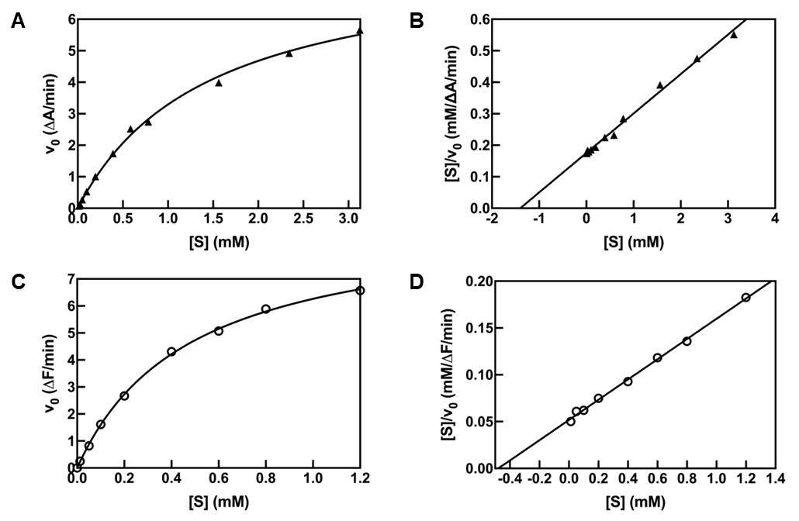
Figure S4. Representative curves for the determination of K_{m} for the substrate N-Succinyl-Ala-Ala-Ala-pNA and hNE (, A,B) and for the substrate MeOSuc-Ala-Ala-Pro-Val-AMC and mNE (○, C,D). A,C) Michaelis-Menten curve for K_{m} determination of hNE and mNE, respectively. B,D) Hanes-Woolf linearization plot for K_{m} determination of hNE and mNE respectively. (B,D) From the interpolation on the x-axis of the curve, it is possible to derive the -K_{m} value.
The K_{m} of hNE for N-Succinyl-Ala-Ala-Ala-pNA was determined by incubating 50 nM hNE with different substrate concentrations (12, 24, 48, 96, 192, 391, 586, 781, 1562, 2344 and 3125 µM) in the presence of BSA (346 nM). The reaction was monitored as described in the main text (Material and Methods section). The initial rates of hydrolysis (v₀) were plotted as a function of [S] and linearized with the Hanes-Woolf method in order to derive the K_{m} value.
The K_{m} of mNE for MeOSuc-Ala-Ala-Pro-Val-AMC was determined by incubating 14.7 nM mNE with different substrate concentrations (0.025, 0.5, 0.1, 0.2, 0.4, 0.6, 0.8, 1.2 mM). The reaction was monitored as described in the main text (Material and Methods section) in the microplate format. The initial rates of hydrolysis (v₀) were plotted as a function of [S] and linearized with the Hanes-Woolf method in order to derive the K_{m} value.

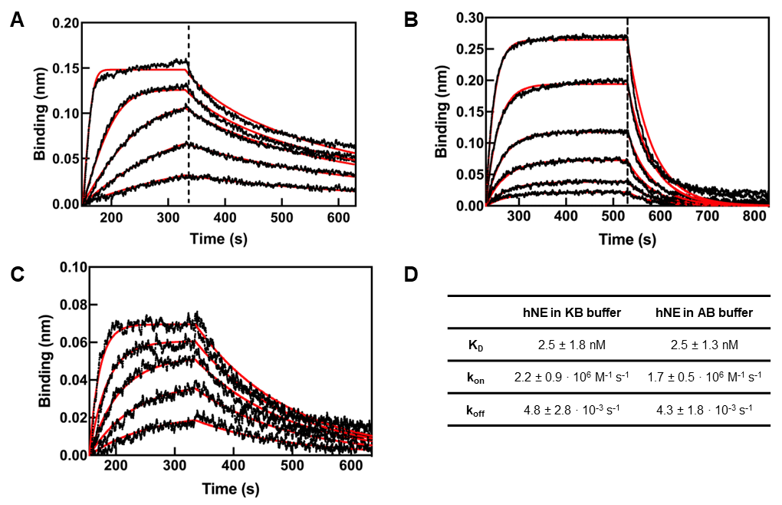
Figure S5. A,B,C,D) The affinity of NbE201 for hNE and mNE was measured by BLI with the Octet HTX machine using various settings. NbE201 was produced in the pHEN25 vector which codes for a C-terminal cysteine and this latter was used to site-specifically biotinylate the protein using EZ-Link Maleimide-PEG2-Biotin (ThermoFisher) and Tris(2-carboxyethyl)phosphine, immobilized on Agarose CL-4B (Sigma-Aldrich), incubating for 2 h 30 min at RT in agitation in 50 mM NaPi buffer pH 7.0, 2 mM EDTA. Excess of biotin was removed by gel filtration. A,B,C) The dashed line separates the association step from the dissociation step. In black, the experimental signal. In red, the fitting. Experiments were carried out at 30°C in 96-wells black-bottom microplates in polypropylene (Greiner Bio-One, Belgium) and with orbital agitation (1000 rpm). A) Representative sensorgrams of the association and dissociation steps of the interaction between NbE201 and different concentrations of hNE, fitted with a mass transport 1:1 model. Data are the same of Figure 2A, with a different fitting model. For hNE, the biotinylated NbE201 (0.5 µg∙mL⁻¹) was immobilized on streptavidin biosensors (SA, Sartorius) following the provider’s indications. Then, the biosensors were immersed in a solution of hNE at different concentrations (25 – 6.25 – 3.12 – 1.56 – 0.75 nM, from top to bottom). Association and dissociation kinetics were measured for 180 s and 300 s respectively, in 10X KB buffer (PBS pH 7.4, 1% BSA, 0.5% Tween20, 0.5% NaN₃). The experiment was done in triplicate (N=3). The sensorgrams obtained were fitted to a 1:1 binding model with mass transport model by using the Data Analysis Octet Software Version 10.0 (Sartorius) to derive the rate constants for association (k_{on} = 6.35 ± 1.66 · 10⁶ M⁻¹ s⁻¹) and dissociation (k_{off} = 1.17 ± 0.99 · 10⁻² s⁻¹) and the equilibrium dissociation constant (K_{D} = 1.88 ± 1.66 nM). B) Representative sensorgrams of the association and dissociation steps of the interaction between NbE201 and different concentrations of mNE. The biotinylated NbE201 (1 µg∙mL⁻¹) was immobilized on streptavidin biosensors (SA, Sartorius) following the provider’s indications. Then, the biosensors were immersed in a solution of mNE at different concentrations (100 – 50 – 25 – 12.5 – 6.25 – 3.12 nM, from top to bottom). Association and dissociation kinetics were measured for 300 s each, in mNE Assay Buffer (50 mM Tris, 1 M NaCl, 0.05% Brij-35, pH 7.5). The obtained sensorgrams were fitted to a 1:1 binding model by using the Data Analysis Octet Software Version 10.0 (Sartorius) to derive the rate constants for association (k_{on}) and dissociation (k_{off}) and the equilibrium dissociation constant (K_{D}). The kinetics parameters measured are indicated in Figure 2B. The experiment was done in triplicate (N=3). C) Representative sensorgrams of the association and dissociation steps of the interaction between NbE201 and different concentrations of hNE, using the mNE Assay Buffer. The biotinylated NbE201 (0.5 µg∙mL⁻¹) was immobilized on streptavidin biosensors (SA, Sartorius) following the provider’s indications. Then, the biosensors were immersed in a solution of hNE at different concentrations (25 – 12.5 – 6.25 – 3.12 – 1.56 nM from top to bottom). Association and dissociation kinetics were measured for 180 s and 300 s respectively, in mNE Assay Buffer (50 mM Tris, 1 M NaCl, 0.05% Brij-35, pH 7.5). The obtained sensorgrams were fitted to a 1:1 binding model by using the Data Analysis Octet Software Version 10.0 (Sartorius) to derive the rate constants for association (k_{on}) and dissociation (k_{off}) and the equilibrium dissociation constant (K_{D}). The kinetics parameters measured are indicated in panel D. The experiment was done in triplicate (N=3). D) K_{D}, k_{on} and k_{off} values describing the binding between NbE201 and hNE in two different buffers: KB 10X and mNE Assay Buffer. This comparison was done to demonstrate that the difference in the buffer used for BLI experiments was not the cause of a lower affinity of NbE201 for mNE. The results indicate that the nature of the buffer does not affect the affinity of NbE201 for NE. Independent replicates of the experiment were carried out (N=3 for both buffers) and the mean (± SD) of the kinetics parameters measured are indicated. The error for the K_{D} were calculate using Eq 4.

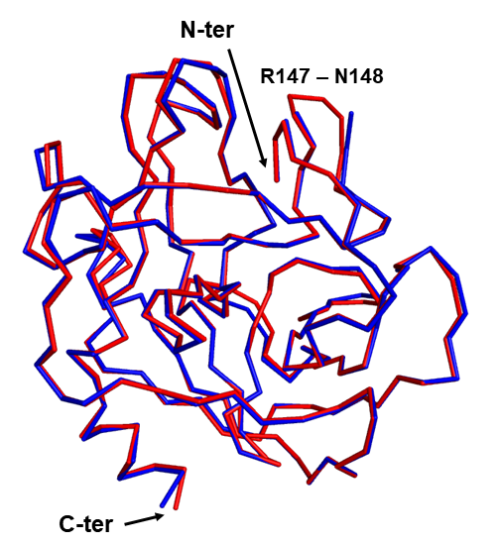
Figure S6. Superposition of the X-ray crystal structure of hNE bound to NbE201 (PDB entry 8QGX, in blue) and that of free hNE (PDB entry 3Q76, in red). The proteins are represented in a ribbon style configuration, showing only the Cα. RMSD = 0.42 Å (214 to 214 atoms). The N-terminal and C-terminal of each molecule are indicated with a black arrow.

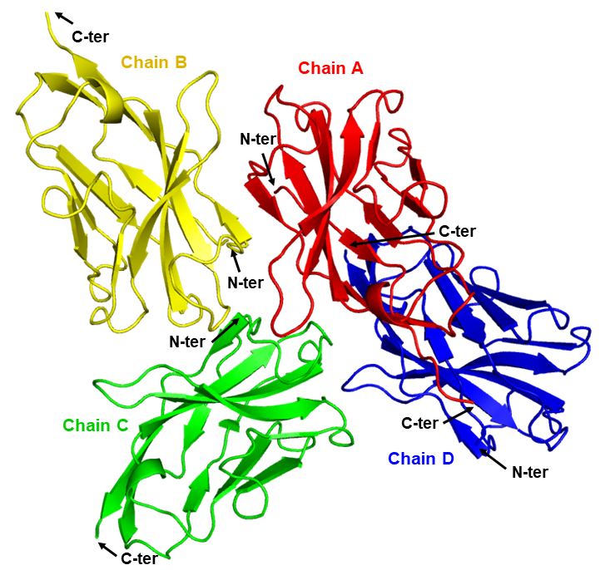
Figure S7. 3D structure of NbE201 (PDB entry 8QGZ). Asymmetric unit of the X-ray crystal structure of NbE201. Four molecules of NbE201 are present (chain A in red, chain B in yellow, chain C in green and chain D in blue). The N-terminal and C-terminal of each molecule are indicated with a black arrow.

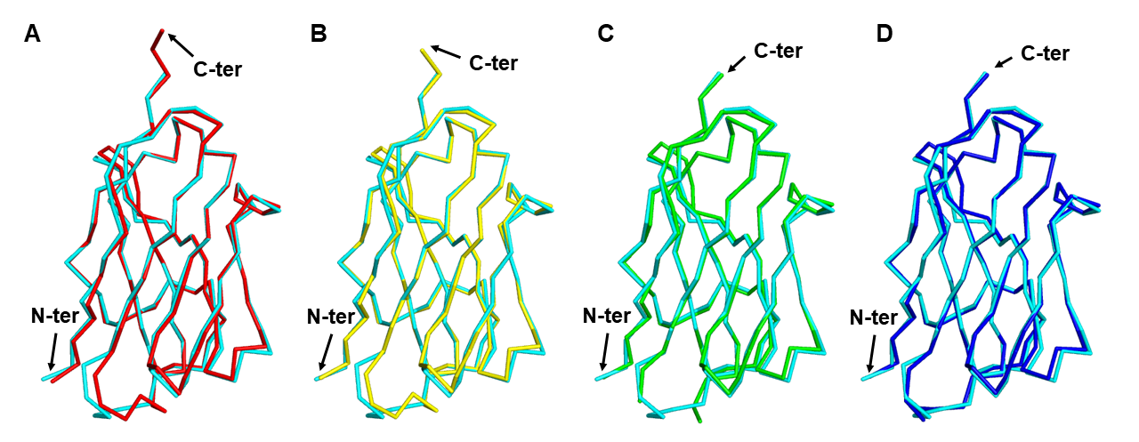
Figure SI8. Superpositions on the Cα of the structure of NbE201 bound to hNE (PDB entry 8QGX) and that of free NbE201 (PDB entry 8QGZ) from the 3D crystal structures. The different panels (A, B, C, and D) show the superpositions of NbE201 from NbE201 + hNE complex crystal structure and the NbE201 from the four different molecules of VHH (A, B, C and D) found in the asymmetric unit for the crystal of the VHH alone. In grey, hNE from NbE201 + hNE complex crystal structure. In cyan, NbE201 from NbE201 + hNE complex crystal structure (123 Cα). A) In red, NbE201 chain A from NbE201 alone crystal structure. RMSD = 0.648 Å (121 to 121 atoms). B) In yellow, NbE201 chain B from NbE201 alone crystal structure. RMSD = 0.636 Å (121 to 121 atoms). C) In green, NbE201 chain C from NbE201 alone crystal structure. RMSD = 0.643 Å (123 to 123 atoms). D) In blue, NbE201 chain D from NbE201 alone crystal structure. RMSD = 0.614 Å (123 to 123 atoms). All panels illustrate the proteins in a ribbon style representation, showing only the Cα. The N-terminal and C-terminal of each molecule are indicated with a black arrow.

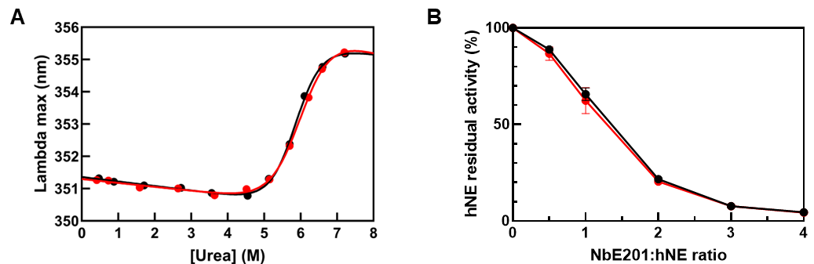
Figure S9. Reversibility of urea-induced denaturation of NbE201. To check the reversibility of the unfolding process by urea, two protein samples at 2 mg·mL⁻¹ were prepared, one in the buffer without urea (native protein) and one in 7.6 M urea (denatured protein) and incubated 1 h at 25 °C, which allows complete unfolding. These two protein samples were then diluted at 0.2 mg/mL at various final concentrations of urea (0.76, 1, 2, 3, 4, 5, 5.5, 6, 6.5, 7 and 7.6 M) and incubated overnight at 25 °C to allow monitoring of the unfolding and refolding processes, respectively. The intrinsic fluorescence spectra of each series (i.e., from denaturation and renaturation) were recorded and compared. The sample renatured in 0.76 M urea was used to investigate the biological reversibility (panel C, red), and compared (panel C, black) to the sample in 0.76 M urea that has not been denatured. A) Transition curve for the denaturation/renaturation of NbE201 induced by urea followed by intrinsic fluorescence. In black, the curve corresponding to NbE201 denaturation starting from the protein in its native (N) form. In red, the curve corresponding to NbE201 renaturation starting from the protein in its denatured (D) form. The superposition of the two curves indicates the reversibility of NbE201 urea-induced unfolding process. B) Curves of hNE residual activity in the presence of NbE201 denatured and renatured (red) and NbE201 non-denatured (black) (N=3). The black and the red curves are superimposable, meaning that the refolded VHH has the same inhibitory capacity on hNE than the non-denatured VHH, confirming that the urea-induced unfolding of NbE201 is fully reversible also from a functional point of view.

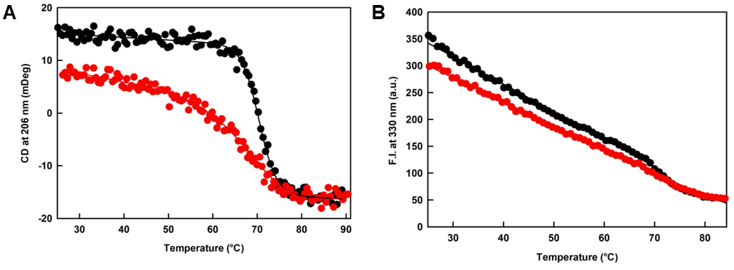
Figure S10. Heat-induced denaturation and re-naturation transitions for NbE201. A) Example of the heat-induced denaturation and renaturation curve for NbE201 monitored by far UV-CD at 206 nm. In the graph are reported the curve for the denaturation transition from 25 to 97°C (black) and the curve for the renaturation transition from 97°C to 25°C (red). B) Example of the heat-induced denaturation and renaturation curves for NbE201 monitored by intrinsic fluorescence following the fluorescence intensity at 330 nm. In the graph, the curves for the denaturation transition from 25 to 83°C (black) and for the renaturation transition from 83°C to 25°C (red) are reported.

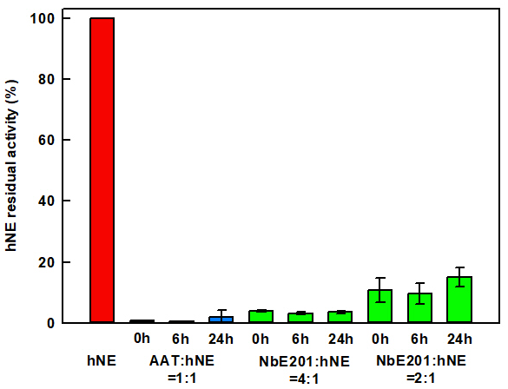
Figure S11. Histograms representing the stability of the inhibitory activity of AAT and of NbE201 after deamidation. On the y-axis, is the residual activity of hNE in different conditions: alone (red), in presence of AAT (blue) and in presence of NbE201 (green). The ratios of inhibitor:hNE used for each inhibitor are: 1:1 for AAT:hNE, and 4:1 and 2:1 for NbE201:hNE. Each bar represents a different time point in the experiment: 0-6-24 h after chemical modification. The experiment was done in duplicate, n=2.
To test the protein deamidation the sample was diluted in 25 mM NH₄HCO₃ pH 10.0 (protein final concentration 0.5 mg∙mL⁻¹ and incubated at 37 °C. After 0 h,6 h, and 24 h a 10 μL aliquot was taken and analyzed by an activity inhibition test.

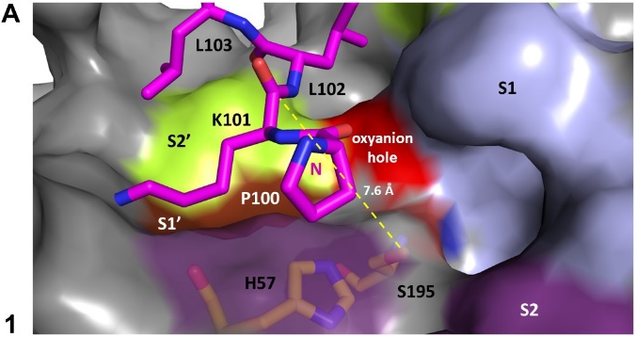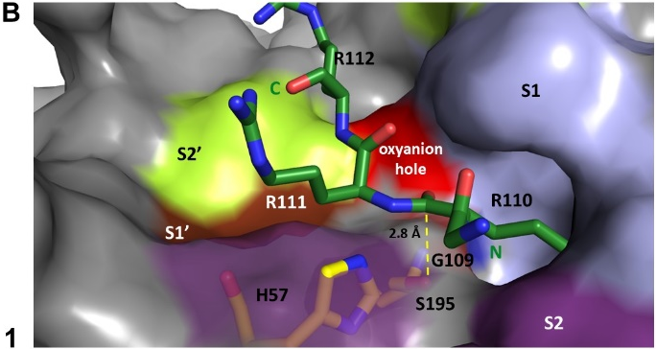
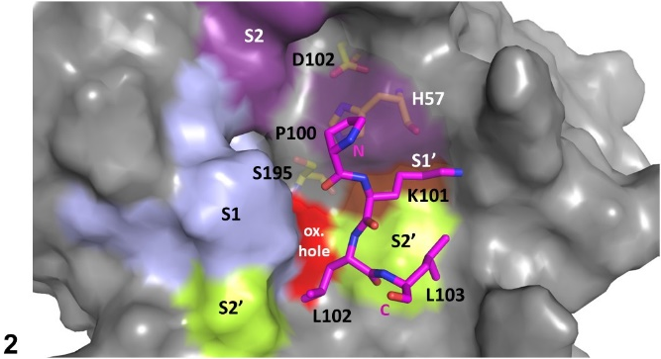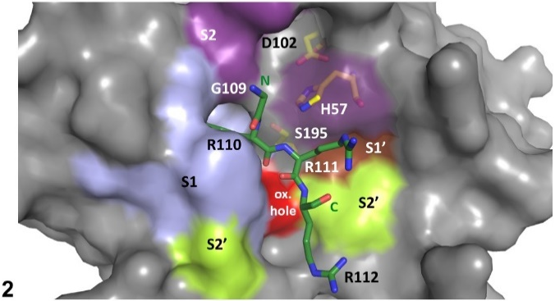
Figure S12. Differences in the enzyme pocket orientation of the scissile bond P1-P1’ between NbE201 and Nb4 for hNE and uPA, respectively. The enzyme is shown as a grey surface and the substrate pockets are highlighted in different colours: S1 in light blue, S1’ in brown, S2 in violet and S2’ in lime green. The catalytic triad is in yellow sticks. In red is colored the G193, the amide group of which forms the oxyanion hole together with the amide group of S195. P100-L103 of NbE201 (P1-P1’ is K101-L102) is in magenta sticks. G109-R112 of Nb4 (P1-P1’ is R110-R111) is in dark green sticks. A) NbE201 P1-P1’ bond in the hNE substrate pocket. B) Nb4 P1-P1’ bond in the uPA substrate pocket. (1,2) Different orientation of the scissile bond in the substrate pocket of the enzyme. In yellow dashed lines is represented the distance between S195 and the scissile bond P1-P1’ (the distance is indicated in Å).

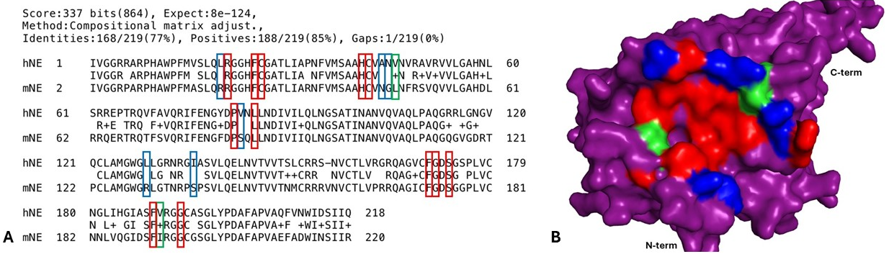
Figure S13. Comparison of sequence of hNE and mNE highlighting residues binding to NbE201. A) Sequence alignment of mature hNE and mNE carried out with BLAST® blastP (NCBI) (https://blast.ncbi.nlm.nih.gov/). The proteins share 77% of sequence identity. Residues responsible for the interaction with NbE201 on hNE, are framed. B) NbE201 binding pocket conservation on mNE. mNE is represented as surface, in purple. The structure was predicted with AlphaFold2 (DOI: 10.1038/s41586-021-03819-2) starting from the sequence of mNE Uniprot: Q3UP87. A,B) In red, residues that are conserved between hNE and mNE; in green, residues that are not conserved but have similar chemical properties; in blue, residues that are not conserved and that have different chemical properties.
60% of residues involved in the interaction with NbE201 are shared between hNE and mNE, with an additional 10% of residues that have similar chemical properties between the two enzymes (Figure S13A). Interestingly, the residues that differ between the two are located at the extremities of the binding pocket, instead the central core of the binding pocket is conserved (Figure S13B).

 | hNE:NbE201 | NbE201
PDB code | 8QGX | 8QGZ
Data Collection:
Wavelength | 0.9786 | 0.98011
Space group | P2₁2₁2₁ | P2₁2₁2₁
a, b, c (Å) | 65.06 73.36 85.32 | 61.68 88.68 86.56
α, β, γ (°) | 90, 90, 90 | 90, 90, 90
Resolution range (Å)ª | 48.5 – 2.3 (2.42 – 2.3) | 44.35 – 1.8 (1.85 – 1.8)
Rmerge (%)ª | 12.8 (191.4) | 16.8 (208)
<I>/<σI> ª | 11.6 (1.0) | 8.24 (1.3)
Completeness (%)ª | 99.7 (98.1) | 97.9 (99)
Redundancy ª | 13.2 (12.6) | 9.5 (9.5)
CC 1/2ª | 0.999 (0.886) | 0.994 (0.626)
Refinement:
No. of unique reflections | 18530 | 43692
No. of total reflections | 249564 | 414275
R work (%) | 22.4 | 21.69
R free (%) | 27.1 | 25.43
RMS deviations from ideal stereochemistry
Bond lengths (Å) | 0.01 | 0.006
Bond angles (º) | 1.13 | 0.884
Mean B factor (Å²)

Protein atoms | 85.0 | 32.7
Solvent atoms | 70.4 | 35.1
Ramachandran plot:
Favoured region (%) | 97.0 | 98.55
Allowed regions (%) | 2.7 | 1.45
Outlier regions (%) | 0.3 | 0
ª Numbers in parenthesis refer to the highest resolution shell.
Table S1. Data collection and refinement statistics for the X-ray crystal structures of NbE201 alone and in complex with hNE.

Eq SI1$${IC}_{50}=K_{i}\left(1+\frac{\left[S\right]}{Km}\right)+\frac{1}{2} {\left[E\right]}_{T}$$
Where IC₅₀ is the half maximal inhibitory concentration, K_{i} is the constant of inhibition, [S] is the concentration in substrate, K_{m} is the Michaelis constant and [E]_{T} is the total enzyme concentration.

