Outcomes of Laparoscopic versus Robotic-Assisted Sacrocolpopexy for Pelvic Organ Prolapse-A Comprehensive Rétrospective Analysis

Chloé Dehan¹, Sarah Marcelle¹, Michelle Nisolle¹, Carine Munaut, Laurent de Landsheere¹

¹Department of Obstetrics and Gynecology, University of Liège, Hospital La Citadelle, Boulevard du 12 e de Ligne, n°1, 4000 Liège, Belgium

²Laboratory of Tumor and Development Biology, Giga‑Cancer, University of Liege, 4000 Liege, Belgium

Keywords: Sacrocolpopexy; Minimally invasive; Robot-assisted laparoscopy; Operative time

Abstract:
Introduction and Hypothesis Minimally invasive abdominal sacrocolpopexy (SC) is the gold standard for managing symptomatic pelvic organ prolapse (POP). Robot-assisted laparoscopy (RSC) offers a promising surgical option compared to conventional laparoscopy (LSC). This study compares the clinical and operative outcomes of these techniques to determine if RSC is superior to LSC.
Methods We conducted a retrospective, single-center study in the Gynecology Department at the Citadelle Hospital in Liège, Belgium. Data from all patients who underwent SC between January 2019 and December 2023 were collected. We evaluated demographic and clinical data, perioperative complications, operative time (OT), length of stay, risk of recurrence and follow-up duration. Statistical analysis was performed to compare outcomes between the groups.
Results Data from 208 patients (97 LSC and 111 RSC) were analyzed. No significant differences were found between the groups. A higher body mass index trend was observed in the RSC group (mean BMI: 26.63, range: 20-43) compared to the LSC group (mean BMI: 25.45, range: 15-34; p = 0.0625). The median OT was similar (LSC: 111 min vs RSC 119 min; p = 0.104), with a notable reduction in OT compared to the literature. Additionally, more RSC procedures could be performed per day (3 RSC vs. a maximum of 2 for LSC).
Conclusion Robot-assisted laparoscopy was not demonstrated to be superior to LSC. However, both procedures had comparable OT, significantly shorter than previously reported. RSC’s operational efficiency might allow for a higher number of daily procedures, translating into practical benefits in clinical settings.

Abbreviations
LSC | Conventional laparoscopy
OT | Operative time
POP | Pelvic organ prolapse
RSC | Robot-assisted laparoscopy
SC | Sacrocolpopexy

Introduction
Surgical approach in the treatment of symptomatic pelvic organ prolapse (POP) can be achieved through various approaches: vaginal, open abdominal, simple laparoscopic and robot-assisted laparoscopic. Each of these approaches presents advantages and disadvantages that influence therapeutic decision making.
Vaginal surgery is often favored for its less invasive nature and shorter recovery time. However, this approach has several limitations. It is associated with less satisfactory anatomical outcomes with a 20% failure rate compared with 6% for the laparoscopic approach (95% CI). Patients may also experience postoperative pain and dyspareunia due to scarring and changes in vaginal structure [1, 2].
With better anatomical results and no increased risk of failure, the abdominal sacrocolpopexy approach allows optimal visibility and access to pelvic structures but carries major disadvantages. Indeed, the abdominal sacrocolpopexy (ASC) technique is associated with a greater intraoperative blood loss (mean difference 107 ml; 95% CI), a longer hospital stay (mean difference 1.71 days; 95% CI) and a higher risk of postoperative ileus or small bowel obstruction (odds ratio, 2.88; 95% CI). Additionally, postoperative pain is often more intense and prolonged, necessitating rigorous management and close postoperative care [1, 3, 4].
Laparoscopic surgery is a minimally invasive technique that has gained popularity because of its numerous advantages. Recovery time is significantly shorter, allowing patients to resume daily activities within a few days [5]. Robotic-assisted laparoscopic surgery represents a further advancement in minimally invasive POP surgery. This technique effectively increases precision and dexterity, facilitating deep pelvic dissection and multiple intracorporeal sutures owing to its ergonomic design. Numerous literature reviews have compared data from laparoscopic sacrocolpopexy performed via simple laparoscopy (LSC) and robot- assisted laparoscopy (RSC), without finding significant differences between these two approaches. Currently, there are insufficient data to conclude that RSC is overall superior, both clinically and economically [6-8].
However, an international Delphi study involving 26 experts suggests that RSC might be perceived as more effective and safer than LSC. Experts highlight that the enhanced ergonomics of robotic surgery facilitate the procedure, including improved visualization, greater range of motion, and precise instrument articulation. They believe that these advantages reduce perioperative and postoperative complications and decrease physical fatigue among surgeons [9].

Sharing the same clinical sentiment, we sought to delve deeper into the comparison between LSC and RSC in the treatment of symptomatic POP to identify key differences between these two approaches and confirm our hypothesis that RSC would be more effective.

Materials and Methods
This monocentric observational study was conducted at the Citadelle Hospital in Liège (Belgium) and included patients with symptomatic POP greater than stage 2 [10]. Data were retrospectively collected from all patients who underwent minimally invasive sacrocolpopexy between January 2019 and December 2023. Two groups were studied based on the surgical approach: the LSC group and the RSC group using the Da Vinci Xi robot. All interventions were performed by the same surgeon (LdL), with expertise in both conventional laparoscopic and robotic-assisted surgery, using the same surgical technique and the same surgical materials, in a standardized approach. The choice of the surgical approach took into account risk factors, surgical history, as well as type and grade of prolapse. Among these, the body masse index (BMI) and the availability of the robot were the primary decision-making factors.
The preoperative evaluation included a detailed medical history, a clinical examination with the performance of a screening cervico-vaginal smear, an accurate Pelvic Organ Prolapse Quantification (POP-Q) staging, and endovaginal ultrasound. Urodynamic assessment was performed in advanced POP (stage ≥ 2), in the case of POP recurrence after surgery, or in the presence of associated urinary incontinence symptoms. Recorded comorbidities included hypertension, diabetes, chronic obstructive pulmonary disease, thyroid disorders, cardiovascular diseases, and the presence of genetic factors such as Ehlers-Danlos and Marfan syndromes. Surgical history was collected and classified by previous abdominal surgery, prolapse repair, and stress urinary incontinence repair. In cases of suspected malignant urogenital or anorectal pathological conditions, additional examinations and/or imaging were performed.
All the procedures were performed under general anesthesia and the patients underwent standard operative care. The patients were placed in a dorsal lithotomy and steepTrendelenburg position at approximately 30°. The Veress needle was used for insufflation through the Palmer point to generate pneumoperitoneum to an intra-abdominal pressure of 14 mmHg. Laparoscopic sacrocolpopexy was conducted with a 10-mm port for the 0° endoscope, two lateral ports of 5 mm in the lower lateral quadrants, and one port of 10/12 mm in the suprapubic area. Each robotic sacro-colpopexy was performed using the da Vinci Xi Surgical System®, Intuive Surgical®) in a technique similar to conventional laparoscopy, using five ports placed at the level of the umbilicus, one port for the 30° endoscope, two on the left side for the ProGrasp forceps and the fenestrated bipolar and two on the right side for the monopolar scissors or the needle driver and the assistant port. The robotic patient cart was docked on the left side of the patient.

A uterine preservation or supracervical hysterectomy was performed in the majority of cases to reduce the risk of erosion and enhance the support of the uterine apex [11]. In instances of pre-invasive cervical dysplasia or with a history of conization, a total hysterectomy was carried out. After landmark identification of the surgical field and optimal exposition of the promontory and the pelvis, the sacral promontory was dissected, followed by the opening of the right pararectal peritoneum, dissection of the rectovaginal space, as deep as possible, and the levator ani muscles.
Then the vesico-vaginal space was dissected, up to the level of the trigone, identified by the Foley catheter. An anterior mesh was then interposed and attached to the anterior vaginal wall with absorbable sutures, and a posterior mesh was fixed with non-absorbable sutures to the levator ani muscles on each side and with absorbable sutures to the posterior vaginal wall. The meshes were fixed to the cervix with non-absorbable sutures or tackers in cases of supracervical hysterectomy or pass through the right broad ligament if the uterus and ovaries were preserved. The meshes were finally attached to the longitudinal anterior vertebral ligament of the promontory using one or two non-absorbable sutures, and the procedure concludes with peritonealization using a barbed suture. In cases of supracervical hysterectomy, the uterus was extracted at the end of the procedure, placed in an endobag and morcellated, if needed, using the ExCITE technique developed by Advincula and Truong [12]. In the case of sacrocolpopexy for apical pro- lapse after hysterectomy or in the case of uterine preservation, a polypropylene Restorelle mesh, Colpoplast®, was used. In the case of concomitant supracervical hysterectomy, a pre-cut polypropylene Sacromesh, Cousin Biotech® was used. In most of the cases (80% vs 81%), an anterior and posterior mesh was placed. If the patient presented isolated anterior or posterior prolapse, the placement of a contralateral mesh was not systematically performed, depending on the patient’s preference after preoperative counselling. Addi- tional procedures such as bilateral salpingo-oophorectomy were performed only in specific cases, either when in the presence of associated adnexal pathology or at the explicit request of the patient. Concomitant surgical procedures for stress urinary incontinence were performed simultaneously only in the case of severe SUI, after urodynamic testing and patient counselling. The postoperative examination was con- ducted by the surgeon himself 6 to 8 weeks after the surgery, including a thorough symptom review and a postoperative clinical POP-Q assessment. All patients received prior information about the surgical approach and signed written consent to undergo the described procedure and authorize the use of their data.
Pelvic organ prolapse was classified according to the POP-Q system published by the International Continence Society [10]. Operative time (OT) was defined as the interval between skin incision and closure, including docking time for the RSC. Length of stay was measured in days. Perioperative complications included visceral, urological, or vascular injuries. Postoperative evaluation was conducted on an outpatient basis, and postoperative complications were assessed within 30 days following surgery.

The severity of postoperative complications was classified using the Clavien-Dindo severity system, ranging from a minor deviation from normal postoperative recovery (grade 1) to the need for surgical reintervention (grade 3) [13].
A descriptive analysis of the collected data was performed. The results are presented as follows: quantitative variables are summarized by median, minimum, and maximum values, whereas qualitative variables are expressed as percentages. Statistical analyses were conducted using GraphPad Prism software (GraphPad Prism version 10.2.3 for macOS, GraphPad Software, Boston, MA, USA www. graphpad.com). The Chi-squared analysis or Fisher’s exact test was used for categorical variables, and the Wilcoxon signed-rank test and the Mann-Whitney U test were applied for continuous variables. Statistical significance was set at p < 0.05 (95% confidence interval).

Results
During the study period, 208 patients were eligible for the SC analysis. Among them, 97 underwent the procedure via LSC and 111 via RSC. Clinical baseline characteristics of the included patients were comparable between the groups. No difference was found in terms of age, BMI, parity, menopausal status, comorbidities, surgical history and preoperative urodynamic study (UDS) (Table 1).
Perioperative data are shown in Table 2. No significant differences were observed regarding the type of hysterectomy (uterine preservation, total/supracervical hysterectomy, or post-hysterectomy), or the type of mesh used (anterior only, anterior and posterior, or posterior only).
In the case of concomitant surgical procedures, only the placement of a TVT-Altis suburethral sling was significantly higher in the LSC group with 22 cases compared with the RSC group with 13 cases (p = 0.0349). The frequency of SUI repair during sacrocolpopexy decreased over time in both groups (Fig. 1).
Further analysis of other types of surgical interventions performed simultaneously included posterior colpoperineorrhaphy via the vaginal route (n = 8), umbilical hernia repair (n = 2), appendectomy (n = 1), cystoscopy (n = 1), and partial removal of a suburethral sling for its erosion (n = 1).
Mean operative time (OT) was not significantly different between the two groups, with 111 min for the LSC group and 119 min for the RSC group (p = 0.104). The evolution of average operative time (in minutes) for the LSC and RSC displays a trend of decreasing average operative time for both groups over time.

Table 1 Baseline patient characteristics
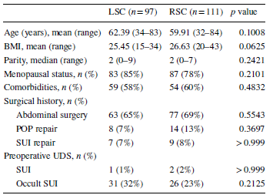

Table 2 Perioperative data
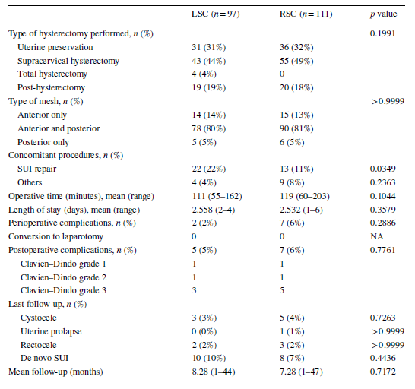

Figure 1 Number of stress urinary incontinence repairs performed in laparoscopy (LSC) and robot-assisted laparoscopy (RSC) groups during the study period
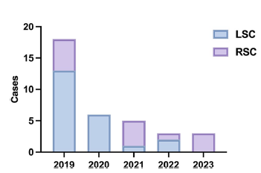

Figure 2 Evolution of average operative time over time for laparoscopy (LSC) and robot-assisted laparoscopy (RSC) groups

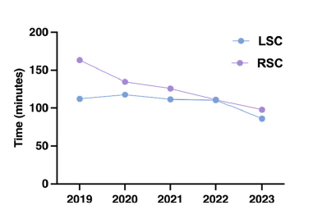

Initially, the RSC group had a higher average operative time than the LSC group, but this difference gradually reduces. By the end of the study period, the average operative times for both groups converge, indicating improved operative efficiency for both techniques. All surgeries were performed by the same surgeon, ensuring consistency in the operative approach and skill level (Fig. 2). There was no difference in the length of stay (2.558 days in LSC versus 2.532 days in the RSC group; p = 0.3579) and in perioperative complications (LSC 2% vs. RSC 6%; p = 0.2886). Overall, seven perioperative complications were observed in the RSC group: one bladder perforation during a redo after previous sacrocolpopexy, two vaginal tears (one patient with a history of vaginal anterior colporrhaphy and one after a previous hysterectomy), a spontaneously resolving hematoma in the vesico-uterine space, and a hemorrhage in the mesentery of the small intestine in the context of thrombocytosis. Only two modifications of the initially planned surgery were noted in the RSC group: one change to Kapandji-Dubuisson sacrocolpopexy due to an inaccessible promontory and one procedure was stopped after the supracervical hysterectomy owing to unexplained patient desaturation. The surgery was postponed and safely performed 6 months later.

In the LSC group, two complications were noted: a harmless bowel perforation that was sutured intraoperatively in the context of numerous previous surgeries and a hematoma in the lumbar-ovarian ligament after concomitant adnexectomy. It is important to note the absence of conversion to laparotomy during the study.
There was no statistical difference between the two groups in terms of postoperative complications (5% in LSC vs 6% in RSC, p = 0.7761). Specifically, in the LSC cohort, we observed one fecaloma, two erosions of the TVT-Altis slings, with only one requiring surgical revision, and two hernias at the trocar sites. Conversely, in the RSC cohort, we had one spontaneously resolving bowel obstruction, a collection at a trocar site that resolved spontaneously after a 7-day course of antibiotics, two hernias at the trocar sites, a pelvic abscess drained 8 days after surgery, peritonitis of indeterminate origin, and leakage at the promontory requiring surgical revision.
The average follow-up duration in our study was 8.28 months in the LSC group, compared with 7.28 months in the RSC group. This difference is not statistically significant (p = 0.7172).
Subjects in both groups showed statistically significant changes in individual POP-Q stage before and after surgery, confirming the effectiveness of the surgical technique, regardless of the approach. No difference was recorded between the two groups regarding the postoperative stage of anterior, apical, and posterior prolapse (Table 3). At the last follow-up, there was no significant difference in the complaints recorded, namely, cystocele, rectocele, and the occurrence of de novo SUI.
A detailed analysis of operative efficiency revealed a difference in the number of surgeries performed per day (Fig. 3). Both groups exhibit similar median and minimum values, indicating comparable average efficiency. However, the RSC group shows greater variability and higher maximum values, suggesting the potential to perform more operations on certain days. Despite this variability, statistical analysis using the Mann-Whitney test revealed that the differences between the two groups were not statistically significant (p > 0.05).

Table 3 Pre- and postoperative data
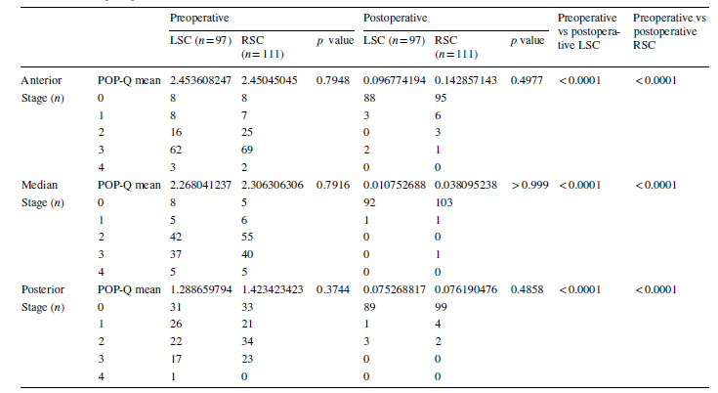
Figure 3 Violin plot to illustrate the number of cases performed per day for the laparoscopy (LSC) and robot-assisted laparoscopy (RSC) groups
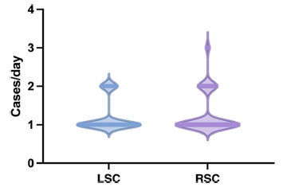

Discussion
The choice of surgical approach for correcting POP remains a subject of debate. This study has the advantage of including a large cohort of patients (n = 208) with a balanced distribution between the two techniques (97 in the LSC group and 111 in the RSC group), allowing for an optimal comparison of the two approaches. The data reveal that the demographic and clinical characteristics of patients treated with LSC and RSC are comparable, with no statistically significant differences in the studied variables. The anatomical follow-up results were very satisfactory in both cohorts, confirming the effectiveness of both procedures.
However, it is important to note that the difference in BMI between the two groups approaches statistical significance (p = 0.0625). This trend indicates that 70% of patients with a BMI over 30 were operated on using RSC (LSC n = 12; RSC n = 29). In this sub-population, the RSC group exhibited greater variability in BMI (30-43) than the LSC group (30-34).

This observation suggests that patients with severe and morbid obesity (BMI > 35) might all have been operated on using RSC in our study. Consequently, RSC emerges as the preferred approach in cases with higher technical complexity. Despite this, the literature has not demonstrated a difference in clinical outcomes or operative time based on BMI between the two techniques [9, 14, 15].
In our comparison, only one parameter was significantly different: the concomitant treatment of stress urinary incontinence (SUI) was more frequent in the LSC group (p = 0.0349). A study by Wei et al. on masked SUI demonstrated that placing a suburethral sling concomitantly with sacrocolpopexy resulted in lower SUI rates at 3 and 12 months, but led to long-term morbidity, including higher rates of bladder perforation, urinary tract infections, hemorrhagic complications, and incomplete bladder emptying 6 weeks post-surgery [16]. The Cochrane study published at the end of 2018 confirmed that the treatment of masked SUI can be deferred without affecting postoperative outcomes [17]. Consequently, a change in practice was observed during our study, with a reduction in concomitant SUI repairs over time. This procedure was thus performed only in patients with symptomatic SUI preoperatively.
The clinical, perioperative, and postoperative outcomes of our study are consistent with those reported in the literature and do not support the superiority of one surgical approach over the other [6, 18-20]. Our findings significantly contribute to the assessment of the effectiveness, safety, and feasibility of each surgical approach.
Regarding length of stay, no significant difference was observed between the two approaches, both in the literature [7, 21] and in our study, with a p value of 0.35. However, our total length of stay are longer than those reported in the literature, at 2.54 days compared with 1.55 days. This variation is probably a result of the distinct practices followed by the surgeon and the hospital department.
However, some results differ from those previously published, particularly in terms of average operative time (OT). We observed that the OT for RSC varied from one study to another: in a large retrospective cohort study, Nosti et al. reported an OT of 316 min (109-604 min) for 262 RSC cases [5], whereas Ploumidis et al. reported a median OT of 101 min (90-120 min) for 95 RSC cases [22]. In our cohort, the OT is significantly shorter than these reported values, with 118 min (60-203 min) for RSC and 110.6 min (55-162 min) for LSC. Furthermore, the OTs of the two procedures are comparable, with a p value of 0.104. This contrasts with recent meta-analyses, where a significant difference in operative time favored LSC, with reductions of 29.53 min and 37.5 min respectively; our study does not show a statistically significant difference [6, 8]. To ensure that the results were not influenced by concomitant procedures performed, we consulted the literature review and meta-analysis by Yang et al. in 2021. They found that 25% and 21.7% of patients had undergone SUI repair and hysterectomy respectively during RSC [6]. In our cohort, only 11% of patients had undergone SUI repair and 49% had had a concomitant hysterectomy.

Furthermore, the median OT is influenced by the surgeon’s experience in performing the procedure. Our study has the advantage of evaluating the learning curve of a single surgeon, unbiased by varying operative practices from different surgeons. Figure 2 shows the clear evolution of median OTs over time. According to Teplitz’s theory, the surgeon is likely still in the steep part of their learning curve, suggesting that OTs could continue to improve in the coming years before reaching a plateau [23]. This decrease in OT correlates with the ergonomic advantages of RSC. According to a study by Shugaba et al., robotic surgery appears to have less of an impact on concentration and muscle tension experienced by surgeons than LSC [24]. The Delphi study conducted among experts supports this, with experts convinced that the robotic platform reduces operative time for high-volume surgeons owing to its ergonomics [9]. A trend observed over the duration of our study seems to corroborate this hypothesis, with up to three RSC procedures being performed in a single day, which was never observed with LSC. This observation allows us to quantify the impact of the robotic technique’s ergonomics in clinical practice.
This retrospective monocentric study provides valuable insights into the comparison of LSC and RSC. One of the key strengths of this study is the inclusion of a large cohort of patients (n = 208), which enhances the statistical robustness and generalizability of the findings. Additionally, all surgical interventions were performed by the same surgeon, which minimizes inter-surgeon variability and allows for a more consistent comparison of the two techniques.
However, several limitations must be considered. The retrospective nature of the study limits the statistical power and may reduce the ability to detect subtle differences or effects, making it difficult to generalize the results. This design also constrains the ability to precisely define the criteria for choosing between techniques, which could introduce selection bias and influence the results. Certain data, such as postoperative pain experienced by patients and the use of standard questionnaires before and after the procedure, could not be analyzed owing to the retrospective nature of the study. Furthermore, the fact that all surgeries were performed by a single surgeon introduces potential bias, as skills, techniques, and experiences can vary between surgeons. Therefore, the results observed in this study may not be fully representative of outcomes achieved by other surgeons.
Prospective or randomized controlled trials are needed to further elucidate the factors influencing the choice between robotic and laparoscopic SCP. Such studies could help to establish more precise guidelines for selecting the most appropriate surgical approach based on individual patient characteristics and surgical requirements. Additionally, incorporating a longer follow-up period is crucial for evaluating long-term complications. Expanding these trials to include a broader range of surgeons would provide insights into the learning curve and operative time associated with each technique, leading to more representative and applicable results for future clinical practice.

In conclusion, this study on sacrocolpopexy compares two surgical techniques within a well-balanced cohort of 208 patients. Our clinical and perioperative findings are consistent with the existing literature and do not indicate the superiority of RSC over LSC.
However, we observed that patients undergoing RSC tend to have a higher BMI (> 30) while maintaining similar operative times and clinical outcomes. The median operative times of the two techniques were not significantly different (LSC: 111 min; RSC: 119 min; p = 0.104) and were shorter than those reported in other studies.
Additionally, the study suggests that the ergonomic advantages of robotic surgery might help to reduce operative times and potentially increase the number of procedures performed per day. This finding underscores the practical benefits of robotic technology in enhancing surgical efficiency in clinical practice.

Authors’ Contributions
C. Dehan: data collection, data analysis, manuscript writing; S. Marcelle: data collection; C. Munaut: data analysis, manuscript editing; M. Nisolle: project development, L. de Landsheere: protocol and project development, data collection, manuscript editing.
Declarations
Conflicts of Interest
None.
Ethical/Institutional Review Board Approval
This study did not require IRB approval because it utilized publicly available data sets with no identifiable information

References
- Maher C, Feiner B, Baessler K, Schmid C. Surgical management of pelvic organ prolapse in women. Cochrane Database Syst Rev 2013;30(4):CD004014.
- Siddiqui NY, Grimes CL, Casiano ER, Abed HT, Jeppson PC, Olivera CK, et al. Mesh sacrocolpopexy compared with native tis- sue vaginal repair: a systematic review and meta-analysis. Obstet Gynecol. 2015;125(1):44-55.
- Campbell P, Cloney L, Jha S. Abdominal versus laparoscopic sacrocolpopexy: a systematic review and meta-analysis. Obstet Gynecol Surv. 2016;71(7):435-42.
- De Gouveia De Sa M, Claydon LS, Whitlow B, Dolcet Artahona MA. Laparoscopic versus open sacrocolpopexy for treatment of prolapse of the apical segment of the vagina: a systematic review and meta-analysis. Int Urogynecol J. 2016;27(1):3-17.
- Nosti PA, Umoh Andy U, Kane S, White DE, Harvie HS, Lowenstein L, et al. Outcomes of abdominal and minimally invasive sacrocolpopexy: a retrospective cohort study. Female Pelvic Med Reconstr Surg. 2014;20(1):33-7.
- Yang J, He Y, Zhang X, Wang Z, Zuo X, Gao L, et al. Robotic and laparoscopic sacrocolpopexy for pelvic organ prolapse: a systematic review and meta-analysis. Ann Transl Med. 2021;9(6):449.
- Mozon AO, Kim JH, Lee SR. Robotic sacrocolpopexy. Obstet Gynecol Sci. 2024;67(2):212-7.
- Chang CL, Chen CH, Chang SJ. Comparing the outcomes and effectiveness of robotic-assisted sacrocolpopexy and laparoscopic sacrocolpopexy in the treatment of pelvic organ prolapse. Int Urogynecol J. 2022;33(2):297-308.
- Simoncini T, Panattoni A, Aktas M, Ampe J, Betschart C, Bloe- mendaal ALA, et al. Robot-assisted pelvic floor reconstructive surgery: an international Delphi study of expert users. Surg Endosc. 2023;37(7):5215-25.
- Bordeianou LG, Anger JT, Boutros M, Birnbaum E, Carmichael JC, Connell KA, et al. Measuring pelvic floor disorder symptoms using patient-reported instruments: Proceedings of the Consensus Meeting of the Pelvic Floor Consortium of the American Society of Colon and Rectal Surgeons, the International Continence Society, the American Urogynecologic Society, and the Society of Urodynamics, Female Pelvic Medicine and Urogenital Reconstruction. Urogynecology. 2020;26(1):1.
- Van Zanten F, Schraffordt Koops SE, O’Sullivan OE, Lenters E, Broeders I, O’Reilly BA. Robot-assisted surgery for the management of apical prolapse: a bi-centre prospective cohort study. BJOG. 2019;126(8):1065-73.
- Advincula AP, Truong MD. ExCITE: Minimally invasive tis- sue extraction made simple with simulation. OBG Manag. 2015;27(12):40-5.
- Mitropoulos D, Artibani W, Graefen M, Remzi M, Rouprêt M, Truss M, et al. Reporting and grading of complications after uro- logic surgical procedures: an ad hoc EAU guidelines panel assessment and recommendations. Eur Urol. 2012;61(2):341-9.
- Yong PJ, Thurston J, Singh SS, Allaire C. Guideline no. 386— gynaecologic surgery for patients with obesity. J Obstet Gynaecol Can. 2019;41(9):1356-70.e7.
- Kissane LM, Calixte R, Grigorescu B, Finamore P, Vintzileos A. Impact of obesity on robotic-assisted sacrocolpopexy. J Minim Invasive Gynecol. 2017;24(1):36-40.
- Wei JT, Nygaard I, Richter HE, Nager CW, Barber MD, Kenton K, et al. A midurethral sling to reduce incontinence after vaginal prolapse repair. N Engl J Med. 2012;366(25):2358-67.
- Baessler K, Christmann-Schmid C, Maher C, Haya N, Crawford TJ, Brown J. Surgery for women with pelvic organ prolapse with or without stress urinary incontinence. Cochrane Database Syst Rev. 2018;8(8):CD013108.
- De Gouveia De Sa M, Claydon LS, Whitlow B, Dolcet Artahona MA. Robotic versus laparoscopic sacrocolpopexy for treatment of prolapse of the apical segment of the vagina: a systematic review and meta-analysis. Int Urogynecol J. 2016;27(3):355-66.
- Tan-Kim J, Menefee SA, Luber KM, Nager CW, Lukacz ES. Robotic-assisted and laparoscopic sacrocolpopexy: comparing operative times, costs and outcomes. Female Pelvic Med Reconstr Surg. 2011;17(1):44-9.
- Pan K, Zhang Y, Wang Y, Wang Y, Xu H. A systematic review and meta-analysis of conventional laparoscopic sacrocolpopexy versus robot-assisted laparoscopic sacrocolpopexy. Int J Gynaecol Obstet. 2016;132(3):284—91.
- Deshpande HG, Madkar CS, Kiwalkar SR. Relationship of decubitus ulcer on cervix in pelvic organ prolapse with POP-Q staging. J Obstet Gynaecol India. 2019;69(3):266-71.
- Ploumidis A, Spinoit AF, De Naeyer G, Schatteman P, Gan M, Ficarra V, et al. Robot-assisted sacrocolpopexy for pelvic organ prolapse: surgical technique and outcomes at a single high-volume institution. Eur Urol. 2014;65(1):138-45.
- Teplitz C. The learning curve deskbook: a reference guide to theory, calculations, and applications. New York: Quorum; 1991.
- Shugaba A, Lambert JE, Bampouras TM, Nuttall HE, Gaffney CJ, Subar DA. Should all minimal access surgery be robot-assisted? A systematic review into the musculoskeletal and cognitive demands of laparoscopic and robot-assisted laparoscopic surgery. J Gastrointest Surg. 2022;26(7):1520-30.

