Live or die based on Bitcoin

Jean-Marie Choffray*
Liège, October 15, 2024

For Peter Schiff, a respected economist and financial advisor, bitcoin (the token) IS NOT digital gold. Even ChatGPT appears to agree with his analysis! On the contrary, for Michael Saylor, Executive Chairman of MicroStrategy, bitcoin IS digital capital, and he is willing to bet his financial future on its success. For him, Bitcoin (the network) is fundamentally a store of value and, accessorily, a payment system. Bitcoin Core is an Operating System that guarantees the irreversibility, the incorruptibility and the confidentiality of peer-to-peer transactions in a decentralized (network-based) environment. It’s a mathematically elegant computer code – software – aimed at deciding which blockchain contains valid transactions. I believe that Michael Saylor is right! The need for irreversible, incorruptible and confidential transactions is real in a world of uncertainty, excessive debt and monetary debasement. If Bitcoin had to fail – a possibility even if its current valuation is well above one Trillion dollars –, a similar technology would inevitably appear on the world stage. That’s why I am sharing my summary of Saylor and Chhugani’s Bitcoin Crash Course and Digital Gold Rush Presentation.

* Emeritus Professor of Computer Science, University of Liege School of Management.
PhD-77, Management Science, Massachusetts Institute of Technology.

“MicroStrategy has made a strategic decision to securitize Bitcoin
as an asset class and will live or die based on Bitcoin.”

“Our strategy recognizes that not everyone will be 150% Bitcoin, but our job is to be the Bitcoin vehicle in the 2% or 3% of your portfolio
that seeks Bitcoin exposure.”

“Bitcoin is the most powerful crypto network in the world. It has the most popular, regulatory, and technical support, backed by the
most digital, political, and economic power.”
Bitcoin Crash Course

Live or die based on Bitcoin

I believe that Michael Saylor is right!

The need for irreversible, incorruptible and confidential transactions is real in a world of uncertainty, excessive debt and monetary debasement. If Bitcoin had to fail – a possibility even if its current valuation is well above one Trillion dollars –, a similar technology would inevitably appear on the world stage. That’s why I am sharing my summary of Saylor and Chhugani’s Bitcoin Crash Course and Digital Gold Rush Presentation.

The investor dilemma is that nearly all the return in the S&P 500 comes from just 1% of the companies – the FAANG stocks, the Magnificent 7… Nearly all the alternative investments are either illiquid or they're not scalable… Most of the traditional strategies are underperforming the monetary inflation level (13% per annum)… Bitcoin ARR (Average Rate of Return) is 46% 6yr, 78% 8yr, 65% 10yr, 103% 12yr, 168% 14yr. Bitcoin is the strongest asset in 11 of the past 14 years… This is property rights for 8 billion people on the planet. This is an escape from economic malaise for 300 million companies. This is the solution to the investor's dilemma.

Satoshi's contribution is the discovery of digital energy, that you can program on a computer and channel through time and space… Capital is a form of energy… People invest in a lot of things. They’re invested in bonds ($300tn:Trillion), real estate ($330tn), equities ($115tn), money ($120tn), art ($18tn) and gold ($16tn). Bitcoin is just 0.1% ($1.3tn) of that wealth in the world… It's long term capital preservation… Bitcoin represents the transformation of our capital from financial and physical assets to digital assets… Satoshi discovered a method to transfer value without a trusted intermediary… Bitcoin represents digital capital… Bitcoin is the most compelling capital preservation tool that we've ever seen in the history of the world…

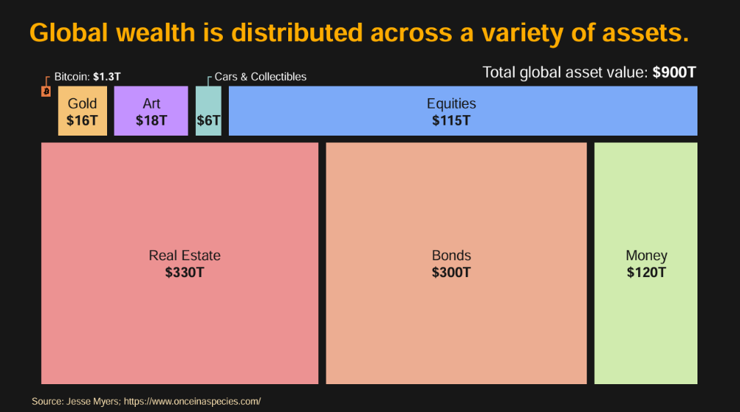

The statistics are what they are… Over the past 4 years Bitcoin (49% p.a.) is outperforming the S&P (14% p.a.) by about a factor of 3 to 4. It is doubling the performance of the Magnificent 7 (27% p.a.). It's 5x real estate (10% p.a.), 7x gold (7% p.a.), and it's utterly crushing bonds (-5% p.a.)... All the major cryptos are collapsing against Bitcoin… Bitcoin is the bank that's too big to fail in cyberspace… IBIT (BlackRock) is the most successful ETF in the history of Wall Street, and of course, the most successful Bitcoin ETF…

Bitcoin is backed by 700 exahash (i.e. one quintillion hashes per second) of computer power… That is more power than Amazon has in AWS, that's more power than all of the Facebook data centers or all the Microsoft data centers… There's 200 million people that have some bitcoin investment… When talking about an investment thesis, you want to get rich, find something everybody needs, nobody can stop and nobody understands… Basically, the three big prongs of institutional adoption are bank acceptance, fair value accounting, and regulatory acceptance in the form of spot ETFs that you can buy, sell, and option… 99% of the Bitcoin will have been mined and sold into the open market by January 2, 2035… At “point99”, the creation of Bitcoin is offset by the lost Bitcoin; the supply becomes fixed. It becomes the world’s first deflationary asset…

This ushers in the age of institutional adoption of Bitcoin… The factors driving Bitcoin adoption include the approval of banking, custody, trading, and credit. The BNY Mellon move into Bitcoin is something to watch… You can count on every government in the world to issue more currency and more debt, inflate the money supply, and drive the nominal value of Bitcoin up… If you want to model the future of Bitcoin, there’s an open-source model we call Bitcoin24… My forecast is the base case: Bitcoin appreciates from 0.1% of the assets in the world to 7%, it grows 29% ARR, we get $13 mn /Bitcoin by the year 2045. A bear case is $3mn; a bull case is $49mn…

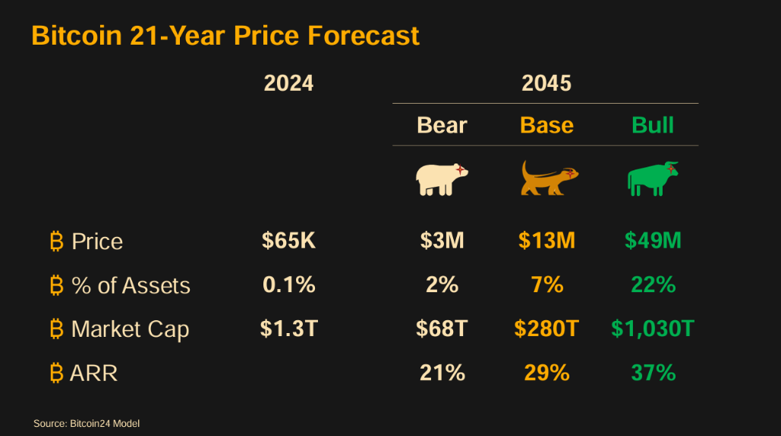

The MicroStrategy Bitcoin Story... We started, as I said, because it was either take a risk or die quickly or die slowly… So why do you buy MicroStrategy equity? Because you want 1.5 times the performance of Bitcoin, or you want 1.5x the volatility of Bitcoin. What's on top of it? Derivatives like MSTX and MSTU. They give you three times the volatility of Bitcoin and three times the performance of Bitcoin… Right now, we've got $15bn to $16bn of Bitcoin and $4bn of debt. But the debt is no recourse, unsecured, no covenants, no liens, at 80 basis points interest. It’s just about the most innocuous capital you could buy… 80 basis points – no liens, no covenants, no restrictions – with a four or five year duration...

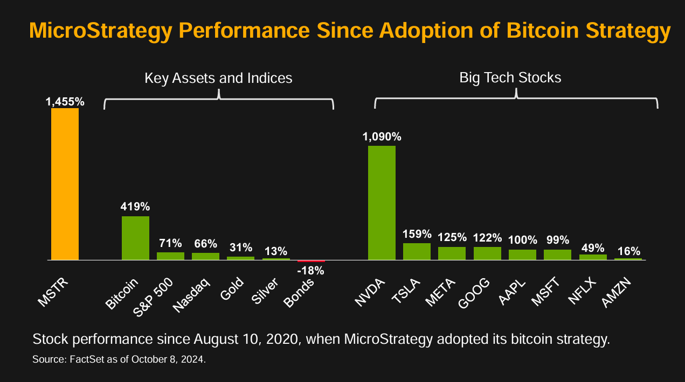

Bitcoin is the most valuable asset in the world. The end game is to be the leading Bitcoin Bank, or Merchant bank, or you could call it a Bitcoin Finance Company… MicroStrategy's idea is simple. Instead of trying to figure out how to loan money to individuals and corporations and get a spread. We're selling securities to investors, guaranteeing them the performance or giving them a performance upside in equity or converts, or we'll give them a preferred yield, and we're loaning the money to the Bitcoin network… Everybody knows exactly what we’re going to do, when we’re going to do it, and how we’re going to handle it. So, we’ve created a very special company… The capital we raise flows into Bitcoin, and that’s reflexive because you can’t create more Bitcoin…

MicroStrategy is 1.5x. If you're a Bitcoin maximalist, you're always going to want that. If you look at MSTX and MSTU, these two derivative ETFs, they've raised $600 million in about a week and a half. Why? Because they offer 2x MicroStrategy performance and indirectly 3x Bitcoin, people just want the leverage… MicroStrategy has made a strategic decision to securitize Bitcoin as an asset class and will live or die based on Bitcoin. If you're willing to take some Bitcoin exposure, we can outperform Bitcoin and every other instrument available. MicroStrategy's convertible securities are better to all others issued in the market. The people that bought our convert 3 weeks ago made $300mn or something in 3 weeks with the downside protection. Our strategy recognizes that not everyone will be 150% Bitcoin, but our job is to be the Bitcoin vehicle in the 2% or 3% of your portfolio that seeks Bitcoin exposure…

It’s much more intelligent to borrow a billion dollars from the fixed income market and lend it to Bitcoin at a 50% ARR, with no counterparty risk… There are 50,000 companies that use Treasury bills as a capital asset. When you use treasuries, you get about 3% after tax, while the cost of capital is 12 to 13%. This means you're losing 10% of your capital in treasuries every year…

The majority of the network hash rate is outside the U.S., and no single country has control over the majority of the network. Even when China had about 50-55% of the hash rate and made Bitcoin mining illegal, it didn’t stop the network; it simply migrated outside of China. The government can’t stop it any more than it can stop a virus or the English language… As long as there are property rights anywhere in the world, a digital property network will be fine…

* * *

For Peter Schiff, a respected economist and financial advisor, bitcoin (the token) IS NOT digital gold. Even ChatGPT appears to agree with his analysis! On the contrary, for Michael Saylor, Executive Chairman of MicroStrategy, bitcoin IS digital capital, and he is willing to bet his financial future on its success. For him, Bitcoin (the network) is fundamentally a store of value and, accessorily, a payment system. Bitcoin Core is an Operating System that guarantees the irreversibility, the incorruptibility and the confidentiality of peer-to-peer transactions in a decentralized (network-based) environment. It’s a mathematically elegant computer code – software – aimed at deciding which blockchain contains valid transactions. I believe that Michael Saylor is right! The need for irreversible, incorruptible and confidential transactions is real in a world of uncertainty, excessive debt and monetary debasement. If Bitcoin had to fail – a possibility even if its current valuation is well above one Trillion dollars –, a similar technology would inevitably appear on the world stage. That’s why I am sharing my summary of Saylor and Chhugani’s Bitcoin Crash Course and Digital Gold Rush Presentation.

* * *

