Contrasting patterns of diversification in pelagic tetrapods across the Triassic–Jurassic transition

Antoine Laboury¹, Thomas L. Stubbs², Andrzej S. Wolniewicz^{3,4,5}, Jun Liu⁴, Torsten M. Scheyer⁶, Marc E.H. Jones⁷ and Valentin Fischer¹

¹ Evolution & Diversity Dynamics Lab, University of Liège, 4 Allée du 6 Août, Liège 4000, Belgium
² School of Life, Health & Chemical Sciences, Open University, Walton Hall, Kents Hill, Milton Keynes MK7 6AA, United Kingdom
³ Department of Earth Sciences, University of Cambridge, Downing Street, Cambridge CB2 3EQ, United Kingdom
⁴ School of Resources and Environmental Engineering, Hefei University of Technology, 193 Tunxi Road, Baohe District, 230009 Hefei, Anhui, China
⁴5Institute of Paleobiology, Polish Academy of Sciences, Twarda 51/55, 00-818 Warsaw, Poland
⁶ Department of Palaeontology, University of Zurich, Karl-Schmid-Strasse 4, 8006 Zürich, Switzerland
⁷ Natural History Museum, Cromwell Road, London SW7 5BD, United-Kingdom

Corresponding author:
Antoine Laboury¹
Email address: a.laboury@uliege.be

Electronic supplementary material

Institutional abbreviations

BESC, Material including this abbreviation in the label are located in the MSNM; BGS, The British Geological Survey, Keyworth, Nottingham, UK; BRSMG, City of Bristol Museum and Art Gallery, Bristol, UK; BRSUG, University of Bristol, Bristol, UK; CAMSM, Sedgwick Museum of Earth Sciences, Cambridge University, Cambridge, UK; CMNH, Chongqing Museum of Natural History, Chongqing, China; FMNH, Field Museum of Natural History, Chicago, USA; GMPKU, Geological Museum of Peking University, Beijing, China; GMR, Geological Survey of Guizhou Province, Guiyang, People’s Republic of China ; GNG, Guanling National Geopark of Fossil Biota; GPIT, Palaeontological Collection of Tübingen University, Tubingen, Germany; GSM, British Geological Survey, Keyworth, UK; GZG, Geoscience Centre, Georg-August University Göttingen; HAUFF, Urwelt-Museum Hauff, Holzmaden, Germany; IRSNB, Royal Belgian Institute of Natural Sciences, Brussels, Belgium; IVPP, Institute of Vertebrate Paleontology and Paleoanthropy, Chinese Academy of Sciences, Beijing, China; JLW, Private collection Jos Lankamp, Borne, The Netherlands; LACM, Natural History Museum of Los Angeles County, Los Angeles, USA; LEICS, Leicestershire Museums, Arts and Records Service, Leicester,UK; LPV, Luoping Vertebrate Collection, Chengdu Institute of Geology and Mineral Resources, Chengdu, China; LWL-MFN, LWL-Museum für Naturkunde, Munster, Germany; LYMPH, Lyme Regis Philpot Museum, Lyme Regis, UK; MAMSPLP, Musée des Amis de la Mine, Saint-Pierre La Palud, France; MANCH, The Manchester Museum, Manchester, UK; MB, Naturkundmuseum Berlin, Berlin, Germany; MFSN, Museo Friulano di Storia Naturale; MHN, Museon, The Hague, The Netherlands; MHNTV, Muséum d’Histoire naturelle de Toulon et du Var, Toulon, France; MMM, Musée Municipal de Milleau, Aveyron, France; MNHL, National Museum of Natural History (Naturalis), Leiden, The Netherlands; MNHN, National Museum of Natural History, Paris, France; MNHNL, National Museum of Natural History, Luxembourg, Grand Duchy of Luxembourg; NSM-LV, Neveada State Museum, Las Vegas Collections, USA; MSNM, Museo di Storia Naturale di Milano, Milan, Italy; MTSN, Museo Tridentino di Scienze Naturali, Trento, Italy; MUPA-ATZ, Museo de Paleontología de Castilla-La Mancha, Cuenca, Spain; NHMUK, National History Musem, London, UK; NLMH, Niedersächsisches Landesmuseum, Hannover, Germany; NME, Natuurmuseum Enschede, Enschede, The Netherlands; NMING, National Museum of Ireland, Dublin, Ireland; NMO, Naturmuseum Olten, Olten, Switzerland; NMNS, National Museum of Natural Science, Taichung, Taiwan, China; NMW, National Museum of Wales, Cardiff, UK; OUMNH, Oxford University Museum of Batural History, Oxford, UK; PIMUZ, Paläontologisches Institut der Universität Zürich, Zürich, Switzerland; PLV, Palaeontology collections, Katholieke Universiteit Leuven; ROM, Royal Ontario Museum, Toronto, Canada; SGU, Saratov State University, Saratov, Russia; SIPG, Steinmann-Institut, Paläontologie, Universität Bonn, Germany; SMNS, Staatliches Museum für Naturkunde, Stuttgart, Germany; TCD, Geological Museum, Trinity College Dublin, Dublin, Ireland; TMP, Royal Tyrrell Museum of Palaeontology, Drumheller, Canada; TR, Material including this abbreviation in their label are located in the YGMIR, China; TTNCM, Somerset County Museum, Taunton, UK; TWE, Museum TwentseWelle, Esnchede, The Netherlands; UCMP, Museum of Paleontology, University of California, Berkeley, USA; UNM, University of Nottingham Museum, Nottingham, UK; WHITM, Whitby Museum, Whitby, UK; Wijk, Material including this abbreviation in their label are located in the NMNHL, The Netherlands; WS, Keichousaurus Museum of Xingyi National Geological Park, Xingyi, Guizhou, China; YGMIR, Yichang Institute of Geology and Mineral Resources, Yichang, China; ZIN PH, Zoological Institute of the Russian Academy of Sciences, St Petersburg, Russia; ZMNH, Zheijiang Museum of Natural History, Hangzhou, China

Morphofunctional ratios and traits

Definition of quantitative ratios
- Longirostry: snout length/ skull length.
Characterizes the hydrodynamic potential of the snout such as the amount of drag during the locomotion (Busbey, 1995),the resistance to lateral shaking (Holzman et al., 2012) or the water volume expelled on the closure of the mouth (Mccurry et al., 2017).

- Snout shape ratio: snout width / skull length.
Proxy for the size of the potential ingested prey (MacLaren et al., 2022) and for the water volume that need to be expelled during the closure of the mouth (Mccurry et al., 2017).

- Relative overbite length: overbite length / mandible length. Only applicable for ichthyosaurians. The overbite is calculated as the length between the anterior tips of the snout and the mandible. The snout of some early parvipelvians is marked by a greater elongation than the mandible such as in Excalibosaurus costini and even more in Eurhinosaurus longirostris. The presence of a remarkable overbite can be seen on the extant swordfish (Xiphias gladius) and the comparison with this species has always been clear (McGowan, 1979; McGowan, 1986; Ellis, 2013). The overbite would have served to slash and maim before ingesting them rather than be used as a spear (Stillwell & Kohler, 1985; Ellis, 2013). It is nevertheless noteworthy to notice that the snouts of E. costini and E. longirostris are dentigerous throughout their length whereas the snout of the swordfish is edentulous (McGowan, 1979; McGowan 1986).

- Jaw robusticity: Jaw height at mid-dentigerous length / mandible length.
Characterizes the aspect ratio of the jaw and is a proxy of the robustness and the stiffness in the jaw under biting loads (Anderson et al., 2011; Stubbs & Benton, 2016; MacLaren et al., 2017, 2022). The height of the jaw was measured at the mid-dentigerous zone.

- Relative symphysial length: Symphyseal length / mandible length.
Characterizes the robustness of the anterior portion of the jaw and its resistance during the prey capture (Stubbs & Benton, 2016; Fischer et al., 2017; MacLaren et al., 2017; Bennion et al., 2022).

- Functional toothrow length: Dentigerous mandible length / mandible length.
Describe the proportion of the jaw which serves to the capture of the potential prey (MacLaren et al., 2017) . Furthermore, differences in the length of the toothrow reflects different strategies in prey capture, a long dental row would indeed increase the variation in bites forces and speed which would result in more functional variability, as reflected by great differences between the anterior and posterior mechanical advantages (Stubbs & Benton, 2016).

- Anterior mechanical advantage: Distance between the fulcrum and the mid-point of attachment for the adductor muscles on the dorsal surface of the mandible / distance between the fulcrum and the anterior tip of mandible.
The vertebrate mandible can be modelled as a third-order lever (Stubbs & Benton, 2016). The mechanical advantage (MA) is an estimation of the ability of a system to transfer the muscles force of the mandible to the prey and can be calculated as the ratio of the inlever and the outlever measurements (Stayton, 2006; Stubbs & Benton, 2016). The anterior mechanical advantage (AMA) can be defined as the lowest potential MA along the dental row (Stubbs & Benton, 2016). Here, the inlever is the distance between the fulcrum (skull articulation with the mandible) to the mid-point of the adductor muscles area insertion while the outlever is represented by the distance from the fulcrum to the base of the anterior-most tooth. It has been demonstrated that animals with weak and rapid bites have low values for AMA while higher values are characteristics of powerful and slower bites (Anderson, 2009).

- Posterior mechanical advantage: Distance between the fulcrum and the mid-point of attachment for the adductor muscles on the dorsal surface of the mandible / distance between the fulcrum and the last mandible tooth.
The principle of the posterior mechanical advantage (PMA) is the same than the AMA with the exception that the outlever is measured from the fulcrum to the base of the posterior-most tooth of the mandible. This morphological trait therefore estimates the highest force transfer along the mandibular dentition (Anderson et al., 2011; Stubbs & Benton, 2016).

- Opening mechanical advantage: Distance between the fulcrum and the retroarticular process / distance between the fulcrum and the mid-point of attachment for the adductor muscles on the dorsal surface of the mandible.
Characterizes the velocity during the opening of the jaw (MacLaren et al., 2017; Bennion et al., 2022). The inlever can be measured as the distance between the fulcrum and the posterior end of retroarticular process and the outlever, as the distance from the fulcrum to the base of the anteriormost tooth of the mandible.

- Nares position: Distance between the anterior margin of the nares and the tip of the snout / skull length.
Proxy describing the ability to take a breath during a constant state swim (MacLaren et al., 2022).

- Relative naris size: Length of the nares / skull length.
Amount of air that can be inhaled during a breath (MacLaren et al., 2022).

- Relative orbit size: Mean diameter of the orbit / skull length. Characterizes the importance of the visual component in the multiple functions that skulls have to perform (MacLaren et al., 2022).

- Occular offset: Distance from the centre of the orbit to the plane containing the upper tooth row / skull length.
Characterizes the position of the eyes in relation to the jaws.

- Sclerotic opening aperture: sclerotic opening diameter / skull length.
Only applicable for ichthyosaurians. Define relative space available between the sclerotic rings allowing light to enter in the pupil.

- Relative parietal foramen length: Length of the parietal foramen / skull length.
Characterizes the length of the parietal foramen and is a proxy for the relative size of the pineal gland (MacLaren et al., 2022).

- Tooth crown shape: Tooth crown height / crown base width.
Characterizes the slenderness of the tooth and the resistance to bite forces (Massare, 1987; Foffa et al., 2018; Zverkov et al., 2018; MacLaren et al., 2022; Fischer et al., 2022). Measurements have been taken on mid-dentigerous region and not on fangs for eosauropterygians.

- Absolute crown height: Tooth crown height raw measurement.
This absolute trait has been shown to be a determinant of diet in modern cetaceans (Ridgway & Harrison, 1999) and have been recently used in marine reptile dataset (Fischer et al., 2020; Bennion et al., 2022).

- Heterodonty index: Anterior tooth crown shape / posterior tooth crown shape.
Characterizes quantitatively the level of heterodonty in the dentition of taxa. A value close to 1 indicates no or very low level of heterodonty while a value which exceed 1 reflects a certain level of heterodonty. This quantitative trait however doesn’t inform about the global morphology of the teeth should therefore be used in combination with discrete characters which describe the morphology of the tooth crown.

- Crown curvature: tooth crown tip offset at mid-base with / tooth crown height. Only applicable for eosauropterygians in this study. Due to the labiol-lingual orientation of the ichthyosaurian crown curvature, the measurement of the crown tip offset on teeth located in mandible or snout could not be gathered (this is the case for the majority of our specimens), leaving this trait too incomplete for inclusion. According to McLaren et al. (2022), this trait describes the dental curvature which represent a proxy for potential prey items.

- Relative skull length: Skull length / trunk length.
Characterizes the proportion of the body used for prey capture and sensory capabilities.

- Neck proportion: Neck length / trunk length.
Characterizes the general body plan but is also a proxy for potential feeding arch and reach of cranium away from the trunk (O’Keefe, 2001).

- Trunk proportion: Trunk length / body length.
Characterizes the proportion of the body length available for lungs and digestive track.

- Tail proportion: Tail length / body length.
Characterizes the proportion of the body used for the locomotion. The evolution of Ichthyosauria and Eosauropterygia is marked by a shortening of the tail suggesting that a long one would represent a more primitive condition (Gutarra et al., 2023). Indeed, the eosauropterygian stem groups Pachypleurosauroidea and Nothosauroidea are regarded as lateral undulatory swimmers even if the fore- and the hindflippers played an important role in the propulsion as there are morphologically derived (Carroll, Gaskill & Whittington,1985; Sues,1987; Krahl,2021). By comparison to the propelled-tail locomotion of ichthyosaurians, plesiosaurians evolved to an underwater flight by using their four hydrofoil-like flippers (Krahl, 2021). In this locomotion style, the tail would rather act as a rudder (Fish & Lauder, 2017; Gutarra et al., 2023).

- Propodial variation: Humerus proximo-distal length / femur proximodistal length.
Characterizes the appendicular body plan. The length of the humerus and the femur relative to each other can be considered as indicative of forelimb, hindlimb or equally driven underwater locomotion (Zeffer, Johansson & Marmebro, 2003; Hinić-Frlog & Motani, 2010).

- Propodial size: Humerus proximo-distal length / skull length.
Characterizes the elongation of the limbs relative to the skull size. This trait is indicative of the ecology of taxa as species with long limbs and small head will swim and feed in a different way than taxa with a small limbs and large head (Taylor, 1987; Massare, 1988).

- Humerus flare: Humerus distal width / humerus proximo-distal length
Characterizes the area of muscular insertion on the humerus and the mechanical efficiency of the pectoral girdle. This trait describes the implication of the forelimb in swimming. A high value of this ratio indicates a relative wider distal extremity of the humerus and is indicative of the aquatic locomotion adaptation in various clades such as cetaceans (Cooper et al., 2007), or cheloniids (Rivera & W. Blob, 2010) as clearly mentioned by (Gutarra et al., 2023).

- Femur flare: Femur distal width / femur proximo-distal length
Characterizes the area of muscular insertion on the femur and the mechanical efficiency of the pelvic girdle. This trait describes the implication of the hindlimb in swimming and pelagic specialisation and is based on the same principle than the humerus flare (Gutarra et al., 2023).

- Brachial index: Radius length / humerus length.
The forelimb can be considered as a third-order lever and the brachial index can be thus calculated as the ratio of the inlever and the outlever measurements. As Gutarra et al. (2023) and Caldwell (2002) stated, the brachial index may be indicative of the locomotion mode and thus of the degree of adaptation to oceanic environments. Indeed, low brachial index value indicates a shortening epipodial compared to the propodial and is a typical feature of pelagic animals (Caldwell, 2002; Gutarra et al., 2023)

- Crural index: Tibia length / femur length.
The functional implication of this ratio is the same as for the brachial index as the hindlimb can also be considered as a third-order lever.

- Forelimb aspect ratio: Forelimb antero-posterior width / forelimb proximo-distal length.
Describes potential water displacement by the forelimbs or the pectoral paddles.

- Hindlimb aspect ratio: Hindlimb antero-posterior width / forelimb proximo-distal length.
Describes potential water displacement by the hindlimbs or the pelvic paddles.

Definition of discrete traits
- Jaw or snout anterior constriction: Absent (0), Present (1). Only applicable for eosauropterygians in this study.
Discrete character which represents a proxy for the preferential use of the anterior jaw for prey capture (MacLaren et al., 2022).

- Bulbous crushing dentition: Absent (0), Present (1).
Discrete character which serves to differentiate taxa with bulbous, blunt and rounded (globidont) dentition. This dental feature is characteristic of the durophage guild made up with taxa capable of crushing hard-shelled prey (Massare, 1987; Fischer et al., 2022).

- Enlarge procumbent fang dentition: Absent (0), Present (1). Only applicable for eosauropterygians.
Discrete character which serves to differentiate taxa that possess fangs on lower and upper jaws. These fangs would have served to pierce pelagic preys (Massare, 1987; Grossman, 2007) or to create a fish-trap to prevent preys from escaping out of the buccal cavity (Rieppel, 2002).

- Edentulous dentary: Absent (0), Present (1). Only applicable for ichthyosaurians in this study. A remarkable reduction in dentition size of edentulous dentary is indicative of a suction feeding mechanism to catch preys (Heyning & Mead, 1996; Sander et al., 2011).

- Cutting edge dentition: Absent (0), Present (1). Only applicable for ichthyosaurians in this study as the enamel of some post Early Jurassic pliosaurids are marked by the presence of carinae (Zverkov et al., 2018; Fischer et al., 2022). These cutting edges serve to slice efficiently preys and is indicative of a megapredatory diet (Massare, 1987; Frobisch et al., 2013; Fischer et al., 2022).

- Apicobasal crown ridges or marked serration: Absent (0), Present (1).
Dental ridges appeared independently in numerous aquatic-feeding tetrapods (Young et al., 2014, Zverkov et al., 2018; McCurry et al., 2019; Boessenecker et al., 2020; Street et al., 2021; Bennion et al., 2023). It has recently been proposed that even if this ornamentation could secondarily strengthen the tooth (Young et al., 2014; McCurry et al., 2019), its main function would be to increase the cutting performance by maximizing, the grip, the puncture, and the removal efficiency (McCurry et al.,2019). This type of ornamentation is characteristic of generalized macrophagous diet for which crushing and slicing are essential (Young et al., 2014)

Location of 3D models on MorphoSource

- Laboury et al. 3D models of Triassic eosauropterygians (https://www.morphosource.org/projects/000508432?locale=en)

- Nothosaurus giganteus: SMNS 18058
- Nothosaurus giganteus: SMNS 80217
- Nothosaurus giganteus: SMNS 1589b
- Nothosaurus giganteus: SMNS 159157
- Nothosaurus giganteus: SMNS 17822c
- Nothosaurus giganteus: SMNS 81311
- Nothosaurus mirabilis: SMNS 13155
- Nothosaurus mirabilis: SMNS 15714
- Nothosaurus mirabilis: SMNS 56826
- Nothosaurus mirabilis: SMNS 59074
- Nothosaurus mirabilis: SMNS 84550
- Simosaurus gaillardoti: GPIT-PV-60638
- Simosaurus gaillardoti: SMNS 10360
- Simosaurus gaillardoti: SMNS 16363
- Simosaurus gaillardoti: SMNS 16638
- Simosaurus gaillardoti: SMNS 50714
- Simosaurus gaillardoti: SMNS 59366
- Simosaurus gaillardoti: SMNS 7861
- Simosaurus gaillardoti: SMNS 14733
- Simosaurus gaillardoti: SMNS 7956
- Simosaurus gaillardoti: SMNS 17223
- Simosaurus gaillardoti: SMNS 17590
- Simosaurus gaillardoti: SMNS 18287
- Augustasaurus hagdorni: FMNH PR1974

- Natural History Museum UK marine reptile gallery
(https://www.morphosource.org/projects/000519988?locale=en)

- Eurhinosaurus longirostris: NHMUK PV R5465
- Ichthyosaurus breviceps: NHMUK PV R 216
- Ichthyosaurus breviceps: NHMUK PV R 3367
- Ichthyosaurus communis: NHMUK PV R 2013
- Ichthyosaurus communis: NHMUK PV R 3372
- Ichthyosaurus communis: NHMUK PV OR 39492
- Ichthyosaurus communis: NHMUK PV OR 41159
- Ichthyosaurus somersetensis: NHMUK PV OR 2013b
- Temnodontosaurus eurycephalus: NHMUK PV R 1157
- Temnodontosaurus platyodon: NHMUK PV R1158
- Temnodontosaurus platyodon: NHMUK PV OR 2003
- ‘Temnodontosaurus risor’: NHMUK PV OR 43971
- Plesiosaurus dolichodeirus: NHMUK PV OR 14113
- Plesiosaurus dolichodeirus: NHMUK PV OR 22656
- Archaeonectrus arcuatus: NHMUK PV R 1317
- Avalonnectes arturi: NHMUK PV OR 14550
- Rhomaleosaurus cramptoni: NHMUK PV R 34
- Attenborosaurus conybeari: NHMUK PV OR 40140
- Attenborosaurus conybeari: NHMUK PV R 1339
- Thalassiodracon hawkinsii: NHMUK PV OR 2018
- Thalassiodracon hawkinsii: NHMUK PV OR 2020

- Early Jurassic marine reptiles
(https://www.morphosource.org/projects/000614685?locale=en)

- Eurhinosaurus longirostris: MNHN 1946-20
- Eurhinosaurus longirostris: SMNS 18648
- Ichthyosaurus communis: CAMSM J35187
- ‘Temnodontosaurus risor’: CAMSM J68446
- Suevoleviathan integer: SMNS 15390
- Suevoleviathan integer: Hauff uncatalogued
- Temnodontosaurus platyodon: LYMPH 2013/20
- Temnodontosaurus trigonodon: SMNS 50000
- Rhomaleosaurus zetlandicus: WITHM 851S

Supplementary methods

Phylogenetic analyses.
Phylogenetic ichthyosaurian relationships were analysed by using the recently published extensive dataset of Laboury et al. (2022), an updated version of the matrix of Maxwell & Cortés (2020). This latter derives from the dataset of Moon (2017), the largest available to date. The authors are aware of reserves expressed by some colleagues (e.g. Bindellini et al. (2021)) about using this cladistic matrix, considering the small numbers of specimens personally examined by Moon (2017). However, considering the progressive update by various subsequent works (Maxwell et al., 2019; Maxwell & Cortés, 2020; Klein et al., 2020; Sander et al., 2021; Laboury et al., 2022) and the fact that a thorough re-evaluation of ichthyopterygian relationships is beyond the scope of this paper, we consider using the latest version of this original dataset appropriate to provide a global phylogenetic framework for analyses requiring a such context. As no cladistic matrices or analyses to date thoroughly investigated the phylogenetic relationships of all (non-plesiosaurian and plesiosaurian) eosauropterygians together, we created a composite phylogenetic tree combining topologies generated separately for Triassic eosauropterygians and for Early Jurassic plesiosaurians. Recent studies recovered two main overall topologies for Triassic taxa wherein nothosauroids are either closely related to pachypleurosauroids (Hu et al. 2024) or appeared more derived by being the sister lineage of pistosauroids (Xu et al. 2022; 2023). To test the influence of such diverging phylogenetic relationships on our disparity and ordination analyses, we used both datasets of Hu et al. (2024) and of Xu et al. (2022) and grafted the respective topology on phylogenetic trees generated for the Early Jurassic with the dataset of Wintrich et al. (2017). All phylogenetic analyses have been performed in TNT (v1.6) (Goloboff, In & Morales, 2023) within an implied weighting maximum parsimony framework to minimize the impact of homoplasy. We use different values of the concavity constant k (6, 9 and 12) to vary the weight on homoplastic characters on the estimation of phylogenetic relationships. The number of trees was set to 100,00 and we used the New Technology Search (ratchet activated: 200 iterations; drift activated: 10 cycles; 10 hits and 10 trees per replication). We applied a tree bisection-reconnection (TBR) algorithm on trees recovered by the ratchet to thoroughly explore most parsimonious tree islands. All of our most parsimonious trees were generated with a k value of 12 and one tree for each analysis was randomly selected.
As the three cladistic datasets used don’t include all ichthyosaurian and eosauropterygian specimens sampled in our ecomorphological dataset we also grafted missing taxa on their corresponding phylogenies based on the literature, using the phytools (v2.0-3) and paleotree (v3.4.5) packages (Bapst, 2012; Revell, 2012) in the R statistical environment (v4.2.3) (R Core Team, 2023). For ichthyosaurians, the synonymy of Temnodontosaurus platyodon and ‘Temnodontosaurus risor’ (McGowan, 1994) has been recently questioned due to numerous morphological differences (Bennion et al., 2024). Considering the need of taxonomic revision for ‘T. risor’ (Bennion et al., 2024), we decided to separate these two and add ‘T. risor’ as the sister lineage of T. platyodon while waiting for an updated apomorphy-based definition of this taxon. Concerning the eosauropterygians, we added six Triassic taxa on the phylogenetic trees generated with the datasets of Hu et al. (2024) and Xu et al. (2022): as in Laboury et al. (2023), we split the OTU “Neusticosaurus” into its three species, Neusticosaurus pusillus as the sister taxa of the clade composed of Neusticosaurus edwardsii and Neusticosaurus peyeri (Klein et al., 2022); and Luopingosaurus imparilis as the sister lineage of Honghesaurus longicaudalis (Xu et al., 2023) Brevicaudosaurus jiyangshanensis as the sister lineage of Nothosauridae (Shang, Wu & Li, 2020); Nothosaurus luopingensis as the sister lineage of Nothosaurus yangjuanensis (Shang, Li & Wang, 2022). Some additional modifications are exclusive to the dataset of Hu et al. (2024). Indeed, we manually added four supplementary taxa in the topology generated with this cladistic matrix: Nothosaurus cristatus as the sister lineage of Nothosaurus mirabilis (Hinz, Matzke & Pfretzschner, 2019), Lariosaurus winkelhorsti as the sister lineage of Lariosaurus buzzii (Laboury et al., 2023) and Lariosaurus vosseveldensis as the sister lineage of the clade comprising L. winkelhorsti and L. buzzii (Laboury et al., 2023). Furthermore, we decided to remove the taxa ‘Araeoscelidia’, ‘Archosauromorpha’ and ‘Younginiformes’ they are beyond the scope of this paper. Finally, we renamed the taxa Ceresiosaurus as Lariosaurus calcagnii and Paranothosaurus as Nothosaurus giganteus according to their taxonomic revision (Rieppel & Wild, 1996; Rieppel, 1998). We also grafted on the phylogenetic tree generated with the dataset of Wintrich et al. (2017), the taxon Microcleidus melusinae as the most primitive member of Microcleidus (Vincent et al., 2017). Our ichthyosaurian and composite eosauropterygian trees were timescaled by using the node dating Hedman algorithm, a method constraining the age of a clade based on the ages of consecutive older groups which thereby act as the clade’s outgroup (Hedman, 2010; Lloyd et al., 2016).

Ordination analyses: cluster dendrograms and tanglegrams.
Our matrices were submitted to a cluster dendrogram analysis using the Ward clustering criterion to investigate ecomorphological similarities among each lineage. We applied a multiple bootstrapping procedure named the ‘Approximatively Unbiased P-value’ implemented in the pvclust package (v.2.2-0) (Suzuki, Terada & Shimodaira, 2019) to determine the statistical support of the resulting clusters. This method, which used the multiscaled bootstrapping by creating subsamples of different sizes from the original distance matrix, appears to be less biased than traditional bootstrapping (Suzuki, Terada & Shimodaira, 2019) and the most suitable method when missing data are present in datasets (Kelley & Motani, 2015; Fischer et al., 2020). We ran it from 0.5 to 10 times the size of our matrix with 0.5 increments and 1,000 bootstraps per replication. The phenotypic distances and the phylogenetic placement of taxa were compared by creating tanglegrams (Figures S9-S12) using the dendextend (v.1.17.1) (Galili, 2015) but also tested by computing Mantel test (1,000 permuations) using the vegan package (v.2.6-4) (Oksanen et al., 2022).

Convergences analyses.
Our ordination analyses the ichthyosaurian morphological evolution tend to infer possible craniodental convergences (see figure S13) between phylogenetically and temporally well-separated taxa mentioned (tables S8 and S9).We thus statistically tested these patterns of morphological convergent evolution by applying to the selected pairs of taxa the novel Ct1, Ct2, Ct3 and Ct4 metrics (Grossnickle et al., 2023) updated from the widely used C1, C2, C3 and C4 metrics of Stayton (2015). In contrary to these latter (which successfully identify convergence and conservatism), the Ct measures differed by incorporating a time-based component and by differentiating divergent to convergent lineages. To briefly summarize, these distance-based measures test the extent to which the convergence process reduces the dissimilarity between two lineages, considering the morphology of their respective ancestors (Fischer et al., 2020). Ct1 and Ct2 (formerly C1 and C2) quantify the phenotypic distance, ideally in a phylomorphospace, between two taxa (tips) compared to their ancestors (nodes) that show the maximum of dissimilarity whereas Ct3 and Ct4 (formerly C3 and C4) include the overall amount of phenotypic evolution (reflected in the sum of all phenotypic distances) of clade defined by their last common ancestor (Stayton, 2015; Fischer et al., 2020; Laboury et al., 2023). We randomly selected one of our most parsimonious phylogenetic trees and the significance of these measures was tested by simulating the evolution of the character under 1,000 Brownian simulations with the convevol package (v. 2.0.0) (Brightly & Stayton, 2023) using respectively the first two, the first five and all axes of the PCoA.
In addition to the Ct metric to fully explore these patterns of morphological convergences, we also used the method developed by Castiglione et al. (2019) implemented in the RRphylo package (v.2.8.0) (Castiglione et al., 2018). This latter focuses on whether the observed morphological dissimilarity between supposedly convergent taxa, measured by the angle Ø between their phenotypic vectors, is smaller than expected by their phylogenetic distance calculated under a Brownian Motion model of evolution (Castiglione et al., 2019). Indeed, the phenotypic distance between two non-convergent taxa is supposed to increase with the time spent since their cladogenesis event and the opposite phenomenon can be interpreted as evidence of morphological convergence (Fischer et al., 2020).

Supplementary tables

Table S1 List and data sources of ichthyosaurian species present in ecomorphospace occupation and fin shape analyses. Species that have only been integrated in the phenogram analyses due to their overall incompleteness, excepted Ophthalmosaurus icenicus which is younger that Early Jurassic, are indicated by an *. Previously considered as a junior synonym of Temnodontosaurus platyodon, the taxonomic attribution of ‘Temnodontosaurus risor’ is controversial and in need of revision as stated by Bennion et al. (2024). We agree with the authors that this species should no longer be synonymized with T. platyodon as it shares lots of morphological similarities with Ichthyosaurus and/or Protoichthyosaurus. While waiting an apomorphy-based redescription of this species, we decide to consider ‘T. risor’ as distinct of T. platyodon in our analyses.

Taxon | Clade | Group | Age range | Source of measurements
Mixosaurus cornalianus | Mixosauridae | Early ichthyosaurians | 247.2 – 242 | First-hand measurements and photographs from Renesto et al. (2020)
Mixosaurus kuhnschnyderi* | Mixosauridae | Early ichthyosaurians | 247.2 – 242 | Photographs from Brinkman (1998)
Mixosaurus panxianensis | Mixosauridae | Early ichthyosaurians | 247.2 – 242 | First-hand measurements
Phalarodon atavus* | Mixosauridae | Early ichthyosaurians | 247.2 – 242 | Measurements from Gutarra et al. (2023)
Phalarodon callawayi* | Mixosauridae | Early ichthyosaurians | 247.2 – 242 | Photographs from Schmitz et al. (2004)
Phalarodon fraasi | Mixosauridae | Early ichthyosaurians | 247.2 – 242 | First-hand measurements
Cymbospondylus buscheri* | Cymbospondylidae | Early ichthyosaurians | 247.2 – 242 | First-hand photographs
Cymbospondylus duelferi | Cymbospondylidae | Early ichthyosaurians | 247.2 – 242 | Photographs from Klein et al. (2020)
Cymbospondylus youngorum | Cymbospondylidae | Early ichthyosaurians | 247.2 – 242 | Photographs from Sander et al. (2021)
Cymbospondylus petrinus | Cymbospondylidae | Early ichthyosaurians | 247.2 – 242 | First-hand photographs
Xinminosaurus catactes* | Cymbospondylidae | Early ichthyosaurians | 247.2 – 242 | Photographs from Jiang et al. (2008)
Besanosaurus leptorhynchus | Shastasauridae | Shastasaurid-grade merriamosaurians | 247.2 – 242 | First-hand measurements, photographs from Bindellini et al. (2021)
Callawayia neoscapularis | Shastasauridae | Shastasaurid-grade merriamosaurians | 227 – 216.4 | First-hand measurements and photographs
Guanlingsaurus liangae | Shastasauridae | Shastasaurid-grade merriamosaurians | 237 – 227 | First-hand photographs and from Yin et al. (2000) and Sander et al. (2011)
Guizhouichthyosaurus  tangae | Shastasauridae | Shastasaurid-grade merriamosaurians | 237 – 227 | First-hand photographs and from Shang & Li (2009) and Li & You (2002)
Guizhouichthyosaurus  wollongangense | Shastasauridae | Shastasaurid-grade merriamosaurians | 237 – 227 | Photographs (Chen et al.,2007)
Shastasaurus pacificus* | Shastasauridae | Shastasaurid-grade merriamosaurians | 237 – 227 | Schemes from Dal Sasso & Pinna (1996)
Shastasaurus sikkanniensis* | Shastasauridae | Shastasaurid-grade merriamosaurians | 227 – 208.5 | First-hand measurements and photographs
Qianichthyosaurus xingyiensis* | Toretocnemidae | Shastasaurid-grade merriamosaurians | 242 – 237 | Photographs from Yang et al. (2013)
Qianichthyosaurus  zhoui | Toretocnemidae | Shastasaurid-grade merriamosaurians | 237 – 227 | First-hand measurements, first-hand photographs and from Xiaofeng et al. (2008), measurement from the dataset of Gutarra et al. (2023)
Californosaurus perrini* | Californosauridae | Shastasaurid-grade merriamosaurians | 233.5 – 228.4 | Schemes from Dal Sasso & Pinna (1996)
Macgowania janiceps | Parvipelvia | Early parvipelvians | 216.4 – 211.4 | First-hand measurements and photographs
Eurhinosaurus  longirostris | Leptonectidae | Early parvipelvians | 182.7 – 174.1 | First-hand measurements and photographs, 3D models
Excalibosaurus  costini | Leptonectidae | Early parvipelvians | 199.3 – 190.8 | First-hand measurements and photographs, 3D models
Leptonectes moorei | Leptonectidae | Early parvipelvians | 190.8 – 182.7 | First-hand measurements and photographs
Leptonectes solei* | Leptonectidae | Early parvipelvians | 199.3 – 190.8 | 3D model
Leptonectes tenuirostris | Leptonectidae | Early parvipelvians | 201.3 – 199.3 | First-hand measurements, first-hand photographs and from Maisch & Reisdorf (2006),  3D model
Hauffiopteryx typicus | Hauffiopteryx | Early parvipelvians | 182.7 – 174.1 | First-hand measurements, photographs from Maxwell & Cortés (2020), 3D model
Ichthyosaurus anningae | Ichthyosauridae | Thunnosaurians | 190.8 – 182.7 | First-hand photographs
Ichthyosaurus breviceps | Ichthyosauridae | Thunnosaurians | 199.3 – 190.8 | First-hand measurements,3D scan created by the authors
Ichthyosaurus communis | Ichthyosauridae | Thunnosaurians | 201.3 – 199.3 | 3D models created by the authors
Ichthyosaurus conybeari | Ichthyosauridae | Thunnosaurians | 199.3 – 190.8 | 3D model, photographs from Bennet et al. (2012) and Massare & Lomax (2016)
Ichthyosaurus somersetensis | Ichthyosauridae | Thunnosaurians | 201.3 – 199.3 | 3D model, photographs from Lomax & Sachs (2017)
Protoichthyosaurus appplebyi | Ichthyosauridae | Thunnosaurians | 201.3 – 190.8 | First-hand measurements, photographs from Srdic et al. (2019)
Stenopterygius quadriscissus | Stenopterygiidae | Thunnosaurians | 182.7 – 174.1 | First-hand measurements and photographs
Stenopterygius triscissus | Stenopterygiidae | Thunnosaurians | 182.7 – 174.1 | First-hand measurements and photographs, 3D model
Stenopterygius uniter | Stenopterygiidae | Thunnosaurians | 182.7 – 174.1 | First-hand measurements and photographs, 3D model
Suevoleviathan integer | Suevoleviathan | Thunnosaurians | 182.7 – 174.1 | First-hand measurements and photographs, 3D model
Temnodontosaurus azerguensis* | Temnodontosaurus | Early parvipelvians | 182.7 – 178.2 | First-hand photographs
Temnodontosaurus crassimanus* | Temnodontosaurus | Early parvipelvians | 182.7 – 174.1 | Photographs from Swaby & Lomax (2020)
Temnodontosaurus eurycephalus | Temnodontosaurus | Early parvipelvians | 199.3 – 190.8 | First-hand photograph, 3D model
Temnodontosaurus platyodon | Temnodontosaurus | Early parvipelvians | 199.3 – 190.8 | First-hand measurements and 3D models
Temnodontosaurus ‘risor’ | Temnodontosaurus | Early parvipelvians | 199.3 – 190.8 | 3D models
Temnodontosaurus trigonodon | Temnodontosaurus | Early parvipelvians | 182.7 –174.1 | First-hand measurements and photographs, 3D models.  3D model of SMNS 1950 has been provided by Pardo-Pérez et al. (2018)
Ophthalmosaurus icenicus* | Ophthalmosauridae | Thunnosaurians | 166.1 – 152.1 | Photographs from Moon & Kirton (2016)

Table S2: List of ichthyosaurian specimens and completeness for all morphological regions. Taxa only integrated in phenogram analyses due to their overall incompleteness, excepted Ophthalmosaurus icenicus which is younger that Early Jurassic, are indicated by an * and their completeness is inapplicable.

Taxon | Specimens | Craniodental completeness | Postcranial  completeness | Whole body completeness
Mixosaurus cornalianus | BESC SC 1000,  BESC SC 1001,  NHMUK PV R 5702,  PIMUZ T4848,  PIMUZ T4858,  PIMUZ T5925,  PIMUZ T4923, | 95.83% | 100% | 97.22%
Mixosaurus kuhnschnyderi* | PIMUZ T 1324 | — | — | —
Mixosaurus panxianensis | GMPKU-P-1008,  GMPKU-P-1033,  GMPKU-P-1039,  PIMUZ T2418 | 87.5% | 75% | 83.33%
Phalarodon atavus* | LPV 30872 | — | — | —
Phalarodon callawayi* | CMC VP 7275 | — | — | —
Phalarodon fraasi | PIMUZ T2417 | 79.17% | 25% | 61.11%
Cymbospondylus buscheri* | PIMUZ T3451 | — | — | —
Cymbospondylus duelferi | LACM DI 158109 | 66.67% | 25% | 52.78%
Cymbospondylus youngorum | LACM DI 157871 | 95.83% | 16.67% | 69.44%
Cymbospondylus petrinus | UCMP 9913,  UCMP 9950 | 83.33% | 8.33% | 58.33%
Xinminosaurus catactes* | GMPKU-P-1071 | — | — | —
Besanosaurus leptorhynchus | BESC 999,  PIMUZ T4376 | 95.83% | 100% | 97.22%
Callawayia neoscapularis | ROM 41993 | 79.17% | 25% | 61.11%
Guanlingsaurus  liangae | GMR 014,  YGMIR SPCV03107,  YGMIR SPCV03108 | 83.33% | 83.33% | 83.33%
Guizhouichthyosaurus  tangae | GNG dq-46,  IVPP V11853,  IVPPV11865,  IVPPV11869,  TR0001 | 91.66% | 91.67% | 91.66%
Guizhouichthyosaurus wollonggangense | SPCV10305 | 75% | 0% | 50%
Shastasaurus sikanniensis* | TMP 94.378.2 | — | — | —
Shastasaurus pacificus* | UCMP 9076 | — | — | —
Qianichthyosaurus xingyiensis* | WS2011-46-R1 | — | — | —
Qianichthyosaurus zhoui | CMNH V1412/C1120,  GMPKU-P-1208,  IVPP V11839,  YIGMR TR00047,  YGMIR XTw-Q3 | 83.33% | 100% | 88.88%
Californosaurus perrini* | UCMP 9082 | — | — | —
Macgowania janiceps | ROM 41992,  RTMP 2009.121.0001 | 95.83% | 0% | 63.89%
Eurhinosaurus longirostris | GPIT 1491/4,  GPIT_RE_9412,  MNHN 1946_20,  NHMUK PV R5465,  ROM 47696,  SMNS 14931,  SMNS 18648,  SMNS 81842, | 100% | 100% | 100%
Excalibosaurus costini | BRSMG Cc881,  ROM 47697 | 87.5% | 91.67% | 88.89%
Leptonectes moorei | NHMUK PV R14370 | 83.33% | 33.33% | 66.67%
Leptonectes solei* | MHN 96270 | — | — | —
Leptonectes tenuirostris | NHMUK PV R 2160,  NHMUK PV OR 36182,  NHMUK PV R 498,  NHMUK PV R 47436,  NMO 26575,  OUMNH J10305,  ROM VP47698 | 91.67% | 100% | 94.44%
Hauffiopteryx typicus | GPIT RE 12905,  GPIT 1491/4,  SMNS 51552,  SMNS 81962 | 91.67% | 100% | 94.44%
Ichthyosaurus anningae | NHMUK PV OR 120 | 83.33% | 83.33% | 83.33%
Ichthyosaurus breviceps | NHMUK PV R 216,  NHMUK PV R 3367,  NHMUK PV OR 39263,  NHMUK PV OR 43006 | 91.67% | 58.33% | 80.56%
Ichthyosaurus communis | CAMSM J 35187,  NHMUK PV R1162,  NHMUK PV R 1163,  NHMUK PV R 2013,  NHMUK PV R 3372,  NHMUK PV OR 39492,  NHMUK PV OR 39845,  NHMUK PV OR 41159 | 87.5% | 100% | 91.67%
Ichthyosaurus conybeari | BGS 956,  NHMUK PV R 15907,  NMW 93.5G.2 | 87.5% | 91.67% | 88.88%
Ichthyosaurus somersetensis | NHMUK PV OR 2013,  NLMH106234 | 91.66% | 100% | 94.44%
Protoichthyosaurus applebyi | NHMUK PV R 1164,  UNM.G.2017.1 | 75% | 25% | 58.33%
Stenopterygius quadriscissus | MNHN 1909_29,  MNHNL TU664,  MNHNL TU904,  SMNS 15033,  SMNS 50963,  SMNS 51948,  SMNS 54816,  SMNS 55748,  SMNS 80115,  TMP 846601 | 100% | 100% | 100%
Stenopterygius triscissus | SMNS 14846,  SMNS 54027,  SMNS 80113,  SMNS 96899 | 95.83% | 100% | 97.22%
Stenopterygius uniter | SMNS 17500,  SMNS 57532,  SMNS 97006 | 100% | 100% | 100%
Suevoleviathan integer | SMNS 15390,  SMNS 4629,  Hauff uncat | 100% | 100% | 100%
Temnodontosaurus azerguensis* | MAMSPLP | — | — | —
Temnodontosaurus crassimanus* | YORYM: 497 | — | — | —
Temnodontosaurus eurycephalus | NHMUK PV R1157 | 79.17% | 0% | 52.77%
Temnodontosaurus platyodon | IRSNB R122,  LYMPH 2013/20,  NHMUK PV R 1158,  NHMUK PV OR 2003 | 95.83% | 100% | 97.22%
'Temnodontosaurus’ risor | CAMSM J68446,  NHMUK PV OR 43971 | 83.33% | 0% | 55.56%
Temnodontosaurus trigonodon | GPIT RE9414,  GPIT PV30026,  SMNS 15950,  SMNS 17560,  SMNS 50000,  SMNS 50004,  SMNS 50006 | 69.56% | 100% | 100%
Ophthalmosaurus icenicus* | NHMUK PV R 10031,  NHMUK PV R 2134 | — | — | —

Table S3: List of ichthyosaurian taxa and their corresponding information used to compute the temporal evolution of dorsal centra height across the Triassic-Jurassic transition. The symbol * indicates that the height has been measured on the last cervical vertebra, which in ichthyosaurians has a similar length to the dorsal centra.
Taxon | Specimen | Data source | Group | Stage | Mid-Age | Dorsal centrum height (in mm)
Euichthyosauria indet | ZIN PH 16/250 | Zverkov et al. (2022) | Inderterminate | Lower Carnian | 234.5 | 32.5
Guanlingsaurus liangae | GMR 014 | Yin et al. (2000) | Shastasaurid grade merriamosaurians | Carnian | 232.0 | 72.5
Guizhouichthyosaurus_tangae | TR0001 | First-hand photographs | Shastasaurid grade merriamosaurians | Carnian | 232.0 | 55.2
Shastasaurus sp. | UCMP 9609 | First-hand photographs | Shastasaurid grade merriamosaurians | Carnian | 232.0 | 108.0
Shastasaurid like | ZIN PH 1/250 | Zverkov et al. (2022) | Shastasaurid grade merriamosaurians | Carnian | 232.0 | 115.0
Shonisaurus popularis | NSM-LV collections VM-2014- 057-FS- 001 (according to Kelley et al. (2022)) | Camp (1980) | Shastasaurid grade merriamosaurians | Carnian | 232.0 | 202.9
Shonisaurus cf. popularis | MTSN 4896 | Dalla Vecchia & Avanzini (2002) | Shastasaurid grade merriamosaurians | Carnian | 232.0 | 150.0
Qianichthyosaurus xingyiensis | WS2011-46-R1 | Yang et al. (2013) | Shastasaurid grade merriamosaurians | Carnian | 232.0 | 18.9
Qianichthyosaurus zhoui | CMNH V1412/C1120; GMPKU-P_1208;  IVPP V11839 | First-hand photographs and et Nicholls al. (2003) | Shastasaurid grade merriamosaurians | Carnian | 232.0 | 21.7
Toretocnemus californicus | ERNO-A3 | Lucas (2002) | Shastasaurid grade merriamosaurians | Carnian | 232.0 | 30.9
Auroroborealia incognita | ZIN PH 3/250;  ZIN PH 23/250 | Zverkov et al. (2022) | Inderterminate | Lower Norian | 221.7 | 32.5
Callawayia neoscapularis | ROM 41993 | First-hand measurements + 3D model | Shastasaurid grade merriamosaurians | Lower Norian | 221.7 | 27.7
Euichthyosauria indet | ZIN PH 9/250 | Zverkov et al. (2022) | Inderterminate | Lower Norian | 221.7 | 38.0
Euichthyosauria indet | ZIN PH 11/250 | Zverkov et al. (2022) | Inderterminate | Lower Norian | 221.7 | 34.0
Hudsonelpidia brevirostris | ROM 41993 | First-hand photographs | Early parvipelvians | Lower Norian | 221.7 | 14.0
Macgowania janiceps* | TMP 20091210001 | First-hand measurements | Early parvipelvians | Middle Norian | 213.9 | 31.5*
Shastasaurus sikkaniensis | TMP 94.378.002 | First-hand photographs | Shastasaurid grade merriamosaurians | Middle Norian | 213.9 | 225.0
Shastasaurid like | GZG.V.26007 | Karl et al. (2014) | Shastasaurid grade merriamosaurians | Upper Norian | 209.9 | 210.4
Shastasauridae sp | PIMUZ A/III 1470 (a to g) | Sander et al. (2022) | Shastasaurid grade merriamosaurians | Upper Norian | 209.9 | 181.5
Shastasaurid like | PLV 1932 | First-hand measurements | Shastasaurid grade merriamosaurians | Rhaetian | 204.9 | 115.2
Shastasaurid like | PLV 1950 | First-hand measurements | Shastasaurid grade merriamosaurians | Rhaetian | 204.9 | 124.9
Shastasaurid like | PLV 1948 | Fischer et al. (2014) | Shastasaurid grade merriamosaurians | Rhaetian | 204.9 | 131.8
'Ichthyosaurus_rhaeticus' | PLV 1961 | Fischer et al. (2014) | Shastasaurid grade merriamosaurians | Rhaetian | 204.9 | 79.7
Shastasaurid like | MHNTV PAL-1_10/2012 | Fischer et al. (2014) | Shastasaurid grade merriamosaurians | Rhaetian | 204.9 | 109.3
Shastasaurid sp. A | PIMUZ A/III 744a | Sander et al. (2022) | Shastasaurid grade merriamosaurians | Rhaetian | 204.9 | 240.1
Euichthyosauria indet. | Specimen from Zapfe (1976) | Sander et al. (2022) | Shastasaurid grade merriamosaurians | Rhaetian | 204.9 | 156.2
Parvipelvia indet. | BRSMG Csb85-48 | Mears et al. (2016) | Early parvipelvians | Rhaetian | 204.9 | 38.2
Ichthyosaurus larkini | BRSUG 25300 | Lomax & Massare (2017) | Thunnosaurians | Hettangian | 200.4 | 33.4
Ichthyosaurus somersetensis | NHMUK PV OR 2013; NLMH106234 | 3D model and Lomax & Sachs (2017) | Thunnosaurians | Hettangian | 200.4 | 53.0
Leptonectes tenuirostris | OUMNH J10305 | First-hand photographs | Early parvipelvians | Hettangian-Pliensbachian | 192,0 | 34.3
Ichthyosaurus communis | NHMUK PV R1162;  NHMUK PV R 2013;  NHMUK PV R 3372 | 3D model | Thunnosaurians | Hettangian-Pliensbachian | 192,0 | 33.3
Ichthyosaurus breviceps | NHMUK PV R 216; NHMUK PV R 3367;  NHMUK PV OR 43006 | 3D model | Thunnosaurians | Sinemurian | 195.1 | 16.8
Ichthyosaurus conybeari | NMW 93.5G.2;  NHMUK PV R 15907 | Massare & Lomax (2016) and Bennet et al (2012) | Thunnosaurians | Sinemurian | 195.1 | 14.2
Excalibosaurus costini | ROM 47697 | First-hand measurements | Early parvipelvians | Sinemurian | 195.1 | 56.1
Temnodontosaurus platyodon | IRSNB R123 | First-hand measurements | Early parvipelvians | Sinemurian | 195.1 | 105.5
Eurhinosaurus longirostris | GPIT RE 9412;  ROM specimen;  SMNS 14931;  SMNS 81842 | 3D model and first-hand measurements | Early parvipelvians | Toarcian | 178.4 | 62.0
Hauffiopteryx typicus | SMNS 51552;  SMNS 81962 | 3D models | Thunnosaurians | Toarcian | 178.4 | 39.0
Stenopterygius quadriscissus | SMNS 15033;  SMNS 50963;  SMNS 54816;  SMNS 55748;  TMP 846601 | first-hand measurements and photographs | Thunnosaurians | Toarcian | 178.4 | 48.0
Stenopterygius triscissus | SMNS 54027;  SMNS 80113;  SMNS 96899 | first-hand measurements and photographs | Thunnosaurians | Toarcian | 178.4 | 35.3
Stenopterygius uniter | SMNS 17500;  SMNS 96899 | first-hand measurements and photographs | Thunnosaurians | Toarcian | 178.4 | 42.6
Suevoleviathan integer | SMNS 15390;  Hauff uncat | 3D models | Early parvipelvians | Toarcian | 178.4 | 51.1
Temnodontosaurus azerguensis | MAMSPLP specimen | First-hand photographs | Early parvipelvians | Toarcian | 178.4 | 111.11
Temnodontosaurus trigonodon | SMNS 15950;  SMNS 50000 | 3D models | Early parvipelvians | Toarcian | 178.4 | 115.0

Table S4. List of eosauropterygian specimens present in the disparity analyses and data sources. Taxa only integrated in phenogram analyses due to their overall incompleteness are indicated by an *.
Taxon | Clade | Age range | Source of measurements
Anarosaurus heterodontus | Pachypleurosauroidea | 246.36 – 243.99 | First-hand measurements and photographs from Klein (2009, 2012)
Dawazisaurus brevis | Pachypleurosauroidea | 244.94 – 243.99 | Photographs from Cheng et al. (2016)
Diandongosaurus acutidentatus | Pachypleurosauroidea | 244.94 – 243.99 | Photographs from Shang et al. (2011) and Sato et al. (2013)
Dianmeiosaurus gracilis | Pachypleurosauroidea | 244.94 – 243.99 | Photographs from Shang & Li (2015)
Dianopachysaurus dingi | Pachypleurosauroidea | 244.94 – 243.99 | Photographs from Liu et al. (2011)
Honghesaurus longicaudalis | Pachypleurosauroidea | 244.94 – 243.99 | Photographs from Xu et al. (2022)
Luopingosaurus  Imparilis | Pachypleurosauroidea | 244.94 – 243.99 | Photographs from Xu et al. (2023)
Keichousaurus hui | Pachypleurosauroidea | 239.1 – 237 | First-hand measurements and photographs from Holmes & Cheng (2008)
Neusticosaurus edwardsii | Pachypleurosauroidea | 239.1 – 237 | First-hand measurements
Neusticosaurus peyeri | Pachypleurosauroidea | 241.5 – 239.1 | First-hand measurements
Neusticosaurus pusillus | Pachypleurosauroidea | 241.5 – 239.1 | First-hand measurements
Odoiporosaurus teruzzi | Pachypleurosauroidea | 243.99 – 241.5 | Photographs from Renesto et al. (2014)
Panzhousaurus rotundirostris | Pachypleurosauroidea | 244.94 – 243.99 | Photographs from Jiang et al. (2019)
Prosantosaurus scheffoldi | Pachypleurosauroidea | 241.5 – 239.1 | First-hand measurements
Qianxisaurus chajiangensis | Pachypleurosauroidea | 239.1 – 237 | Photographs from Cheng et al. (2012)
Serpianosaurus mirigiolensis | Pachypleurosauroidea | 243.99 – 241.5 | First-hand measurements
Wumengosaurus delicatomandibularis | Pachypleurosauroidea | 244.94 – 243.99 | Photographs from Jiang et al. (2008) and Wu et al. (2020)
Brevicaudosaurus jiyangshanensis | Nothosauroidea | 239.1 – 237 | Photographs from Shang et al. (2020)
Lariosaurus calcagnii | Nothosauroidea | 241.5 – 239.1 | First-hand measurements
Lariosaurus balsami | Nothosauroidea | 239.1 – 237 | First-hand measurements
Lariosaurus buzzii | Nothosauroidea | 243.99 – 241.5 | First-hand measurements
Lariosaurus hongguoensis | Nothosauroidea | 244.94 – 243.99 | Photographs from Jiang et al. (2006)
Lariosaurus xingyensis | Nothosauroidea | 239.1 – 237 | Photographs Rieppel et al. (2003) and Lin et al. (2017)
Lariosaurus vosseveldensis | Nothosauroidea | 246.36 – 243.99 | Photographs from Klein et al. (2016)
Lariosaurus winkelhorsti | Nothosauroidea | 246.36 – 244.94 | First-hand measurements,photographs made by the authors
Lariosaurus youngi | Nothosauroidea | 239.1 – 237 | Photographs from Ji et al. (2014)
Nothosaurus cristatus | Nothosauroidea | 239.1 – 237 | First-hand measurements
Nothosaurus luopingensis | Nothosauroidea | 244.94 – 243.99 | Photographs from Shang et al. (2022)
Nothosaurus giganteus | Nothosauroidea | 243.99 – 233.5 | First-hand measurements and 3D models created by the authors
Nothosaurus jagisteus | Nothosauroidea | 241.5 – 239.1 | First-hand measurements
Nothosaurus marchicus | Nothosauroidea | 246.5 – 241.5 | First-hand measurements, photographs from Klein et al. (2015) and Voeten et al. (2018)
Nothosaurus mirabilis | Nothosauroidea | 243.99 – 239.1 | First-hand measurements and 3D models created by the authors
Simosaurus gaillardoti | Nothosauroidea | 241.5 – 237 | 3D models created by the authors
Augustasaurus hagdorni | Pistosauroidea | 243.99 – 241.5 | 3D models created by the authors
Wangosaurus brevirostris | Pistosauroidea | 239.1 – 237 | Photographs from Ma et al. (2015)
Yunguisaurus liae | Pistosauroidea | 239.1 – 237 | Photographs from Cheng et al. (2006) and Sato et al. (2014)
Stratesaurus taylori | Plesiosauria | 201.3 – 199.3 | Photographs from Benson & Taylors (2015)
Plesiosauurs dolichodeirus | Plesiosauroidea | 199.3 – 190.8 | First-hand measurements, photographs and 3D models created by the authors
Eoplesiosaurus antiquior* | Plesiosauroidea | 201.3 – 199.3 | Photographs from Benson et al. (2012)
Microcleidus brachypterygius | Microcleididae | 182.7 – 178.2 | First-hand measurements
Microcleidus homaleospondylus | Microcleididae | 182.7 – 178.2 | First-hand measurements
Microcleidus melusinae | Microcleididae | 182.7 – 178.2 | First-hand measurements
Seeleyosaurus guilelimperatoris | Microcleididae | 182.7 – 178.2 | First-hand measurements and photographs
Anningasaura lymense | Rhomaleosauridae | 201.3 – 190.8 | First-hand measurements,
Archaeonectrus  Rostratus | Rhomaleosauridae | 199.6 – 190.3 | First-hand measurements and 3D models created by the authors
Avalonnectes arturi | Rhomaleosauridae | 201.3 – 199.3 | 3D model created by the authors
Meyerasaurus victor | Rhomaleosauridae | 182.7 – 178.2 | First-hand measurements and photographs from Smith & Vincent (2010)
Rhomaleosaurus cramptoni | Rhomaleosauridae | 182 – 178.2 | 3D model created by the authors, photographs from Smith (2007) and Smith & Dyke (2008)
Rhomaleosaurus megacephalus | Rhomaleosauridae | 201.3 – 199.3 | Photographs Cruikshank (1994) and Smith (2007)
Rhomaleosaurus zetlandicus | Rhomaleosauridae | 182 – 178.2 | 3D model created by the authors
Attenborosaurus conybeari | Pliosauridae | 196.5 – 190.8 | First-hand measurements, 3D model created by the authors
Hauffiosaurus tomistomimus* | Pliosauridae | 182 – 178.2 | Photographs from Benson et al. (2011b)
Hauffiosaurus zanoni | Pliosauridae | 182 – 178.2 | Photographs and measurements from Vincent (2011)
Rhaeticosaurus mertensi* | Pliosauridae | 208.5 – 201.5 | Photographs from Wintrich et al. (2017)
Thalassiodracon hawkinsii | Pliosauridae | 201.3 – 199.3 | First-hand measurements, 3D models, photographs from Benson & Taylors (1996), Benson et al. (2011a)

Table S5. List of eosauropterygian specimens and completeness for all morphological regions.

Taxon | Specimens | Craniodental completeness | Postcranial  completeness | Whole body completeness
Anarosaurus heterodontus | NME 480000125,  NME 480000130, NMNHL RGM 443855,  NMNHL RGM 443856,  SIPG R 594,  SIPG R 595,  SIPG R 596,  NMNHL Wijk06-38,  NMNHL Wij06-266, NMNHL Wijk09-582, NMNHL RGM.443858 | 91.30% | 40% | 74.29%
Dawazisaurus brevis | NMNS000933-F034397 | 86.96% | 100% | 88.57%
Diandongosaurus acutidentatus | IVPP V17760,  NMNS-000933-F03498 | 86.96% | 100% | 91.43%
Dianmeiosaurus gracilis | IVPP V 17054,  IVPP V 18630 | 86.96% | 100% | 91.43%
Dianopachysaurus dingi | LPV 31365 | 65.22% | 80% | 71.43%
Honghesaurus longicaudalis | IVPP V30380 | 91.30% | 100% | 88.57%
Luopingosaurus  imparilis | IVPP V19049 | 78.26% | 80% | 80%
Keichousaurus hui | NMNS-cyn-2003-25, NMNS-cyn-2005-05,  NMNS-cyn-2005-12, SMNS 81780,  SMNS 59705 | 95.65% | 100% | 97.14%
Neusticosaurus edwardsii | PIMUZ T2810,  PIMUZ T2811,  PIMUZ T3430,  PIMUZ T3439,  PIMUZ T3453,  PIMUZ T3452,  PIMUZ T3460,  PIMUZ T3708,  PIMUZ T3758,  PIMUZ T3759,  PIMUZ T3776,  PIMUZ T4761 | 100% | 100% | 100 %
Neusticosaurus peyeri | PIMUZ T3393,  PIMUZ T3394,  PIMUZ T3395,  PIMUZ T3396,  PIMUZ T3403,  PIMUZ T3410,  PIMUZ T3422,  PIMUZ T3423,  PIMUZ T3431,  PIMUZ T3445,  PIMUZ T3461,  PIMUZ T3464,  PIMUZ T3467,  PIMUZ T3474,  PIMUZ T3476,  PIMUZ T3479,  PIMUZ T3497,  PIMUZ T3511,  PIMUZ T3542,  PIMUZ T3546,  PIMUZ T3607,  PIMUZ T3710,  PIMUZ T3728,  PIMUZ T3744,  PIMUZ T3902 | 100% | 100% | 100%
Neusticosaurus pusillus | PIMUZ T3902,  PIMUZ T3400,  PIMUZ T3421,  PIMUZ T3426,  PIMUZ T3429,  PIMUZ T3442,  PIMUZ T3468,  PIMUZ T3509,  PIMUZ T3530,  PIMUZ T3536,  PIMUZ T3538,  PIMUZ T3547,  PIMUZ T3556,  PIMUZ T3574,  PIMUZ T3598,  PIMUZ T3601,  PIMUZ T3604,  PIMUZ T3605,  PIMUZ T3612,  PIMUZ T3614,  PIMUZ T3625,  PIMUZ T3627,  PIMUZ T3639,  PIMUZ T3649 A,  PIMUZ T3649 B,  PIMUZ T3649 C,  PIMUZ T3653,  PIMUZ T3654,  PIMUZ T3658,  PIMUZ T3658,  PIMUZ T3671,  PIMUZ T 3672,  PIMUZ T3703,  PIMUZ T3739,  PIMUZ T3741 B,  PIMUZ T3803 B,  PIMUZ T3803 D,  PIMUZ T3934,  PIMUZ T4289,  PIMUZ T5942 | 100% | 100% | 100%
Odoiporosaurus teruzzi | MSNM BES SC 1893 | 82.61% | 5% | 68.57%
Panzhousaurus rotundirostris | GMPKU-P- 1059 | 65.22% | 80% | 65.71%
Prosantosaurus scheffoldi | PIMUZ A/III 1197,  PIMUZ A/III 1240,  PIMUZ A/III 1273,  PIMUZ A/III 1274,  PIMUZ A/III 1275,  PIMUZ A/III 4566 | 95.65% | 80% | 91.43%
Qianxisaurus chajiangensis | NMNS-KIKO-F044630 | 86.96% | 80% | 85.71%
Serpianosaurus mirigiolensis | PIMUZ T96,  PIMUZ T951,  PIMUZ T1071,  PIMUZ T 3675,  PIMUZ T3676,  PIMUZ T3677,  PIMUZ T3680,  PIMUZ T3685,  PIMUZ T3742,  PIMUZ T3931,  PIMUZ T3933 | 100% | 100% | 100%
Wumengosaurus delicatomandibularis | GMPKU-P-1210,  IVPP V15314,  NMNS-KIKO-F071129-Z,  ZMNH M8758 | 86.95% | 100% | 91.43%
Brevicaudosaurus jiyangshanensis | IVPP V 18625 | 73.91% | 100% | 82.86%
Lariosaurus balsami | PIMUZ T4856 | 82.61% | 80% | 82.86%
Lariosaurus buzzii | PIMUZ T2804 | 78.26% | 20% | 57.14%
Lariosaurus calcagnii | PIMUZ T2460,  PIMUZ T2461,  PIMUZ T2462,  PIMUZ T2464,  PIMUZ T4836,  PIMUZ T5151,  PIMUZ T5559 | 91.30% | 100% | 94.28%
Lariosaurus hongguoensis | GMPKU-P-1011 | 82.60% | 50% | 71.43%
Lariosaurus vosseveldensis | TWE 480000504 | 65.22% | 0% | 42.86%
Lariosauris xingyiensis | IVPP V 1886,  XNGM WS-30-R19 | 95.65% | 60% | 82.86%
Lariosaurus winkelhorsti | TWE 4800000474 | 60.87% | 0% | 40%
Lariosaurus youngi | WS-30-R24 | 80.61% | 80% | 82.85%
Nothosaurus cristatus | GPIT-PV-75067 | 69.57% | 0% | 45.71%
Nothosaurus luopingensis | IVPP V 24895 | 69.57% | 60% | 68.57%
Nothosaurus giganteus | PIMUZ T4829,  SMNS 18058,  SMNS 57047,  SMNS 80217,  SMNS 1598b,  SMNS 159157,  SMNS 17822c,  SMNS 81311 | 95.65% | 100% | 91.42%
Nothosaurus jagisteus | SMNS 56618 | 65.22% | 0% | 42.86%
Nothosaurus marchicus | JLW 300,  NMNHL RGM 449995,  TWE 480000375,  TWE 4800000473,  TWE 4800000474 | 86.96% | 60% | 74.29%
Nothosaurus mirabilis | SMNS 13155,  SMNS 15714,  SMNS 16433,  SMNS 56826,  SMNS 59074,  SMNS 84550 | 69.56% | 10% | 48.57%
Simosaurus gaillardoti | GPIT-PV-60638,  SMNS 10360,  SMNS 16363,  SMNS16638,  SMNS 50714,  SMNS 59366,  SMNS 7861,  SMNS 17223,  SMNS 14733,  SMNS 17590 | 100% | 20% | 71.43%
Augustasaurus hagdorni | FMNH PR1974 | 82.60% | 0% | 54.29%
Wangosaurus brevirostris | GMPKU-P-1529 | 73.91% | 70% | 71.42%
Yunguisaurus liae | IVPP V14993,  NMNS 004529/F003826,  ZMNH M8738 | 95.65% | 100% | 97.14%
Stratesaurus taylori | OUMNH J.10337,  GSM 26035 | 78.26% | 0% | 51.42%
Plesiosaurus dolichodeirus | NHMUK PV OR 14113,  NHMUK PV OR 22656,  NHMUK PV OR 36183,  NHMUK PV OR 39490,  NHMUK PV R 255,  NHMUK PV R 1756 | 95.65% | 90% | 94.29%
Eoplesiosaurus antiquior* | TTNCM 8348 | — | — | —
Microcleidus brachypterygius | GPIT-RE-3185,  SMNS 51143 | 69.57% | 90% | 77.14%
Microcleidus homaleosondylus | NHMUK PV OR 36184 | 52.17% | 0% | 34.29%
Microcleidus melusinae | MNHNL TV343 | 95.65% | 10% | 65.72%
Seeleyosaurus  guilelimperatoris | MB.R.1992,  SMNS 12039 | 65.22% | 100% | 74.28%
Anningasaura lymense | NHMUK PV OR 49202 | 86.95% | 0% | 57.14%
Archaeonectrus rostratus | NHMUK PV OR 38525,  NHMUK PV R 37 | 65.22% | 100% | 77.14%
Avalonnectes_arturi | NHMUK PV OR 14550 | 0% | 30% | 8.57%
Meyerasaurus victor | SMNS 12478 | 60.87% | 100% | 74.28%
Rhomaleosaurus cramptoni | NHMUK PV R 34 | 69.57% | 100% | 80%
Rhomaleosaurus megacephalus | LEICS G22.1851,  TCD.47762.a | 52.17% | 100% | 62.85%
Rhomaleosaurus zetlandicus | WHITM 851S | 56.52% | 90% | 65.71%
Attenborosaurus conybeari | NHMUK PV OR 40140,  NHMUK PV R 1339 | 65,22% | 70% | 65.71%
Hauffiosaurus tomistomimus* | MANCH LL 8004 | — | — | —
Hauffiosaurus zanoni | HAUFF uncat | 69.57% | 100% | 80%
Rhaeticosaurus mertensi* | LWL-MFN P 64047 | — | — | —
Thalassiodracon  hawkinsii | CAMSM J46986;  NHMUK PV OR 2018;  NHMUK PV OR 2020;  NHMUK PV OR 2022;  NHMUK PV OR 2039 | 91.30% | 100% | 94.29%

Table S6: List of eosauropterygian taxa and their corresponding information used to compute the temporal evolution of dorsal centra height across the Triassic-Jurassic transition.
Taxon | Specimen | Data source | Group | Stage | Mid-Age | Dorsal centrum height (in mm)
Nothosaurus giganteus | SMNS 58453 | Rieppel & Wild (1996) | Nothosauroidea | Lower Carnian | 234.5 | 34.7
Nothosaurus cf. giganteus | MFSN. 16850 | Dalla Vecchia (1994) | Nothosauroidea | Lower Carnian | 234.5 | 29.4
Simosaurus gaillardoti | MFSN 31870 | Dalla Vecchia (2008) | Nothosauroidea | Lower Carnian | 234.5 | 38.4
Paludidraco multidentatus | MUPA-ATZ0101 | de Miguel Chavez et al. (2018) | Nothosauroidea | Carnian-Norian | 222.8 | 61.1
Bobosaurus forojuliensis | MFSN 27285 | Dalla Vecchia (2006) | Pistosauroidea | Lower Carnian | 234.5 | 44.2
Alexeyisaurus karnoushenkoi | SGU 104a/36 | Sennikov & Arkhangelsky (2010) | Plesiosauroidea | Lower-Middle Norian | 219.2 | 92.9
Rhaeticosaurus mertensi | LWL-MFN P 64047 | Wintrich et al. (2017) | Pliosauridae | Rhaetian | 204.9 | 34.1
'Plesiosaurus bitractensis' | PLV 1936;  PLV 1937 | First-hand measurement | Basal plesiosaurian | Rhaetian | 204.9 | 66.0
Stratesaurus taylori | OUMNH J.10337 | Benson et al. (2015) | Basal plesiosaurian | Hettangian | 200.6 | 35.0
Eoplesiosaurus antiquor | TTNCM 8348 | Benson et al. (2012) | Basal plesiosaurian | Hettangian | 200.6 | 34.4
Macroplata tenuiceps | NHMUK PV R34588 | First-hand photographs | Rhomaleosauridae | Hettangian | 200.6 | 79.1
Eurycleidus arcuatus | NHMUK PV R 2027 | First-hand photographs | Rhomaleosauridae | Hettangian | 200.6 | 70.8
Rhomaleosaurus megacephalus | NMING F10194 | Smith (2007) | Rhomaleosauridae | Hettangian | 200.6 | 85.7
Avalonnectes arturi | NHMUK PV OR 14550 | 3D model | Rhomaleosauridae | Hettangian | 200.6 | 27.0
Plesiosaurus dolichodeirus | MNHN A. C. 8592;  NHMUK PV OR 22656 | 3D model and Vincent (2008) | Plesiosauroidea | Sinemurian | 195.2 | 36.4
Archaeonectrus rostratus | NHMUK PV OR 38525; NHMUK PV OR 28318 | First-hand measurement and 3D model | Rhomaleosauridae | Sinemurian | 195.2 | 58.6
Attenborosaurus conybeari | NHMUK PV R 1339 | First-hand measurement | Pliosauridae | Sinemurian | 195.2 | 58.2
Westphaliasaurus simonsensii | LWL-MFN P 58091 | Schwermann & Sander (2011) | Plesiosauroidea | Pliensbachian | 186.8 | 52.8
Microcleidus brachypterygius | GPIT-RE-3185 | First-hand photographs | Plesiosauroidea | Toarcian | 180.5 | 40.6
Microcleidus tournemirensis | MMM J. T. 86-100 | Bardet et al. (1999) | Plesiosauroidea | Toarcian | 180.5 | 45.3
Seeleyosaurus guilelmiimperatoris | MB.R.1992 | first-hand photographs | Plesiosauroidea | Toarcian | 180.5 | 33.0
Hauffiosaurus tomistomimus | MANCH LL 8004 | Benson et al. (2011b) | Pliosauridae | Toarcian | 180.5 | 56.0
Rhomaleosaurus thorntoni | NHMUK PV R4853 | Smith & Benson (2014) | Rhomaleosauridae | Torcian | 180.5 | 153.9

Table S7. NPMANOVA results testing for the statistically significant temporal separation in the postcranial ecomorphospace occupation for ichthyosaurian and eosauropterygians. The four time bins chosen are Ani-Lad (= Anisian-Ladinian); Car-Nor (=Carnian-Norian); Het-Sin (=Hettangian-Sinemurian) and Pli-Toa (=Pliensbachian-Toarcian). The NPMANOVA tests are based on the use of all axes of the PCoA for postcranial dataset. As the Car-Nor interval only contain one eosauropterygian taxon (Nothosaurus giganteus), NPMANOVA tests could not have been calculated for this interval for this clade.
Time intervals | Clade | Group size | F test | R² | p-value | Corrected p-value
Ani-Lad VS  Car-Nor | Ichthyosauria | 3-3 | 1.79997 | 0.31034 | 0.20000 | 1
Ani-Lad VS  Car-Nor | Eosauropterygia | — | — | — | — | —
Ani-Lad VS  Het-Sin | Ichthyosauria | 3-7 | 3.02653 | 0.27448 | 0.01099 | 0.06590
Ani-Lad VS  Het-Sin | Eosauropterygia | 28-3 | 2.70387 | 0.08529 | 0.00100 | 0.003
Ani-Lad VS  Pli-Toa | Ichthyosauria | 7-11 | 1.90168 | 0.10623 | 0.02597 | 0.15600
Ani-Lad VS  Pli-Toa | Eosauropterygia | 28-6 | 4.51169 | 0.12357 | 0.00100 | 0.003
Car-Nor VS  Het-Sin | Ichthyosauria | 6-10 | 1.07393 | 0.07124 | 0.32867 | 1
Car-Nor VS  Het-Sin | Eosauropterygia | — | — | — | — | —
Car-Nor VS  Pli-Toa | Ichthyosauria | 6-11 | 2.14984 | 0.12536 | 0.00799 | 0.04800
Car-Nor VS  Pli-Toa | Eosauropterygia | — | — | — | — | —
Het-Sin VS  Pli-Toa | Ichthyosauria | 11-10 | 1.40182 | 0.06871 | 0.13786 | 0.82700
Het-Sin VS  Pli-Toa | Eosauropterygia | 3-6 | 0.99740 | 0.12472 | 0.42657 | 1

Table S8: Results of the ichthyosaurian convergence tests using the Ct metrics derived from the Stayton C-measures for selected pairs of taxa using the first two the first five and all the axes of PCoA analyses on the craniodental dataset. The phylogenetic tree used has been timescaled with the Hedman method. Abbreviations: Cymb.y, Cymbospondylus youngorum; Guiz.t, Guizhouichtyosaurus tangae; Guiz.w, Guizhouichthyosaurus wolonggangense, Hauf.t, Hauffiopteryx typicus; Icht.c, Ichthyosaurus communis; Lept.m, Leptonectes moorei; Sten.q, Stenopterygius quadriscissus; Temn.e, Temnodontosaurus eurycephalus.

Taxon pair | Ct1 | p-value | Ct2 | p-value | Ct3 | p-value | Ct4 | p-value
Qian.z - Lept.m – 2 | 0.17174 | 0 | 0.0035 | 0.0 | 0.0049 | 0.0 | 0.00087 | 0
Qian.z - Lept.m – 5 | -1.75144 | 0 | -0.03804 | 0 | -0.04680 | 0 | -0.00711 | 0
Qian.z - Lept.m – all | -6.97669 | 0.006 | -0.29986 | 0.003 | -0.24825 | 0.004 | -0.03723 | 0
Cymb.y - Temn.e – 2 | 0.79757 | 0.003 | 0.18255 | 0.001 | 0.24492 | 0.004 | 0.03762 | 0.002
Cymb.y - Temn.e – 5 | -0.54138 | 0.094 | -0.14645 | 0.22 | -0.14510 | 0.136 | -0.02164 | 0.181
Cymb.y - Temn.e – all | -0.69788 | 0.025 | -0.22483 | 0.113 | -0.16735 | 0.042 | -0.02167 | 0.043
Mixo.c - Hauf.t – 2 | 0.46305 | 0.01 | 0.06342 | 0.005 | 0.08423 | 0.009 | 0.01463 | 0.006
Mixo.c - Hauf.t – 5 | -0.45716 | 0.02 | -0.07292 | 0.027 | -0.08239 | 0.025 | -0.01235 | 0.024
Mixo.c - Hauf.t – all | -0.69788 | 0.025 | -0.22483 | 0.113 | -0.16735 | 0.042 | -0.02167 | 0.043
Guiz.t - Icht.c – 2 | -1.59030 | 0.822 | -0.07895 | 0.47 | -0.15941 | 0.526 | -0.02019 | 0.422
Guiz.t - Icht.c – 5 | -0.27856 | 0.302 | -0.04910 | 0.233 | -0.06562 | 0.25 | -0.00932 | 0.217
Guiz.t - Icht.c – all | -0.405937 | 0.329 | -0.11289 | 0.201 | -0.09285 | 0.195 | -0.01427 | 0.131
Guiz.w - Sten.q – 2 | -1.27112 | 0.677 | -0.06372 | 0.330 | -0.12096 | 0.388 | -0.01629 | 0.306
Guiz.w - Sten.q – 5 | -0.97086 | 0.642 | -0.0677 | 0.208 | -0.09174 | 0.244 | -0.01285 | 0.188
Guiz.w - Sten.q – all | -0.58362 | 0.329 | -0.13428 | 0.143 | -0.10176 | 0.15 | -0.01698 | 0.092

Taxon pair | ang.state | p.ang.state | ang.state.time | p.ang.state.time
Qian.z - Lept.m – 2 | 2.69443 | 0.0165 | 0.03299 | 0.0095
Qian.z - Lept.m – 5 | 12.54163 | 0.002 | 0.15356 | 0.002
Qian.z - Lept.m – all | 59.95517 | 0.012 | 0.73410 | 0.001
Cymb.y - Temn.e – 2 | 9.10430 | 0.0705 | 0.14711 | 0.0615
Cymb.y - Temn.e – 5 | 70.56040 | 0.3025 | 1.14011 | 0.2885
Cymb.y - Temn.e – all | 79.24468 | 0.162 | 1.28043 | 0.297
Mixo.c - Hauf.t – 2 | 14.27239 | 0.093 | 0.17477 | 0.071
Mixo.c - Hauf.t – 5 | 55.40441 | 0.201 | 0.67844 | 0.073
Mixo.c - Hauf.t – all | 68.42040 | 0.04 | 0.83783 | 0.004
Guiz.t - Icht.c – 2 | 69.09518 | 0.402 | 1.01704 | 0.339
Guiz.t - Icht.c – 5 | 65.40516 | 0.2635 | 0.96272 | 0.1835
Guiz.t - Icht.c – all | 80.78400 | 0.195 | 1.18909 | 0.216
Guiz.w - Sten.q – 2 | 32.56706 | 0.2195 | 0.37508 | 0.1375
Guiz.w - Sten.q – 5 | 59.9909 | 0.222 | 0.69093 | 0.078
Guiz.w - Sten.q – all | 88.53650 | 0.3805 | 1.01970 | 0.0685
Table S9: Results of ichthyosaurian convergence tests by using the Castiglione et al. (2019) method for selected pairs of taxa using the first two, the first five and all the axes of PCoA analyses on the craniodental dataset. The phylogenetic tree used has been timescaled with the Hedman method. Abbreviations: Cymb.y, Cymbospondylus youngorum; Guiz.t, Guizhouichtyosaurus tangae; Guiz.w, Guizhouichthyosaurus wolonggangense, Hauf.t, Hauffiopteryx typicus; Icht.c, Ichthyosaurus communis; Lept.m, Leptonectes moorei; Sten.q, Stenopterygius quadriscissus; Temn.e, Temnodontosaurus eurycephalus.

Table S10: Results of the ichthyosaurian convergence tests using the Ct metrics derived from the Stayton C-measures for selected pairs of taxa using the first two the first five and all the axes of PCoA analyses on the craniodental dataset. The phylogenetic tree used has been timescaled with the minimum branch length approach. Abbreviations: Cymb.y, Cymbospondylus youngorum; Guiz.t, Guizhouichtyosaurus tangae; Guiz.w, Guizhouichthyosaurus wolonggangense, Hauf.t, Hauffiopteryx typicus; Icht.c, Ichthyosaurus communis; Lept.m, Leptonectes moorei; Sten.q, Stenopterygius quadriscissus; Temn.e, Temnodontosaurus eurycephalus.

Taxon pair | Ct1 | p-value | Ct2 | p-value | Ct3 | p-value | Ct4 | p-value
Qian.z - Lept.m – 2 | 0.92333 | 0.001 | 0.20050 | 0.007 | 0.28940 | 0.008 | 0.05168 | 0.017
Qian.z - Lept.m – 5 | 0.72925 | 0 | 0.16097 | 0.01 | 0.20464 | 0.01 | 0.03024 | 0.05
Qian.z - Lept.m – all | 0.01723 | 0.003 | 0.00601 | 0.003 | 0.00529 | 0.003 | 0.00074 | 0.003
Cymb.y - Temn.e – 2 | 0.78623 | 0.011 | 0.17040 | 0.008 | 0.24025 | 0.023 | 0.03575 | 0.022
Cymb.y - Temn.e – 5 | -0.56015 | 0.345 | -0.14971 | 0.476 | -0.15618 | 0.308 | -0.02231 | 0.338
Cymb.y - Temn.e – all | - 0.79048 | 0.439 | -0.24150 | 0.595 | -0.19372 | 0.3 | -0.02317 | 0.23
Mixo.c - Hauf.t – 2 | 0.42587 | 0.024 | 0.05454 | 0.019 | 0.08593 | 0.022 | 0.01301 | 0.0300
Mixo.c - Hauf.t – 5 | 0.40239 | 0.037 | -0.06670 | 0.05 | -0.08395 | 0.044 | -0.01158 | 0.028
Mixo.c - Hauf.t – all | -0.79048 | 0.439 | -0.24150 | 0.595 | -0.19372 | 0.3 | -0.02317 | 0.23
Guiz.t - Icht.c – 2 | -1.51232 | 0.771 | -0.07741 | 0.504 | -0.15222 | 0.474 | -0.02029 | 0.406
Guiz.t - Icht.c – 5 | -0.52266 | 0.442 | -0.07735 | 0.359 | -0.10349 | 0.301 | -0.01479 | 0.244
Guiz.t - Icht.c – all | -0.74578 | 0.606 | -0.16703 | 0.499 | -0.13861 | 0.312 | -0.02088 | 0.195
Guiz.w - Sten.q – 2 | -0.89640 | 0.535 | -0.05382 | 0.323 | -0.12567 | 0.345 | -0.01411 | 0.281
Guiz.w - Sten.q – 5 | -0.14242 | 0.119 | -0.01714 | 0.093 | -0.02696 | 0.096 | -0.00328 | 0.085
Guiz.w - Sten.q – all | -0.77883 | 0.426 | -0.15953 | 0.255 | -0.14572 | 0.187 | -0.01994 | 0.092

Table S9: Results of ichthyosaurian convergence tests by using the Castiglione et al. (2019) method for selected pairs of taxa using the first two, the first five and all the axes of PCoA analyses on the craniodental dataset. The phylogenetic tree used has been timescaled with the Hedman method. Abbreviations: Cymb.y, Cymbospondylus youngorum; Guiz.t, Guizhouichtyosaurus tangae; Guiz.w, Guizhouichthyosaurus wolonggangense, Hauf.t, Hauffiopteryx typicus; Icht.c, Ichthyosaurus communis; Lept.m, Leptonectes moorei; Sten.q, Stenopterygius quadriscissus; Temn.e, Temnodontosaurus eurycephalus.

Taxon pair | ang.state | p.ang.state | ang.state.time | p.ang.state.time
Qian.z - Lept.m – 2 | 2.69433 | 0.014 | 0.03816 | 0.005
Qian.z - Lept.m – 5 | 12.54163 | 0.002 | 0.17764 | 0.002
Qian.z - Lept.m – all | 59.95517 | 0.011 | 0.84922 | 0.002
Cymb.y - Temn.e – 2 | 9.10430 | 0.047 | 0.16287 | 0.029
Cymb.y - Temn.e – 5 | 70.56040 | 0.283 | 1.26226 | 0.189
Cymb.y - Temn.e – all | 79.24468 | 0.182 | 1.41762 | 0.178
Mixo.c - Hauf.t – 2 | 14.27239 | 0.087 | 0.19961 | 0.054
Mixo.c - Hauf.t – 5 | 55.40441 | 0.190 | 0.77489 | 0.041
Mixo.c - Hauf.t – all | 68.42040 | 0.038 | 0.95693 | 0.004
Guiz.t - Icht.c – 2 | 69.09518 | 0.379 | 1.16912 | 0.261
Guiz.t - Icht.c – 5 | 65.40516 | 0.271 | 1.10669 | 0.146
Guiz.t - Icht.c – all | 80.78400 | 0.206 | 1.36690 | 0.165
Guiz.w - Sten.q – 2 | 32.56706 | 0.220 | 0.41914 | 0.119
Guiz.w - Sten.q – 5 | 59.9909 | 0.225 | 0.77208 | 0.046
Guiz.w - Sten.q – all | 88.53650 | 0.390 | 1.13947 | 0.03

Supplementary figures

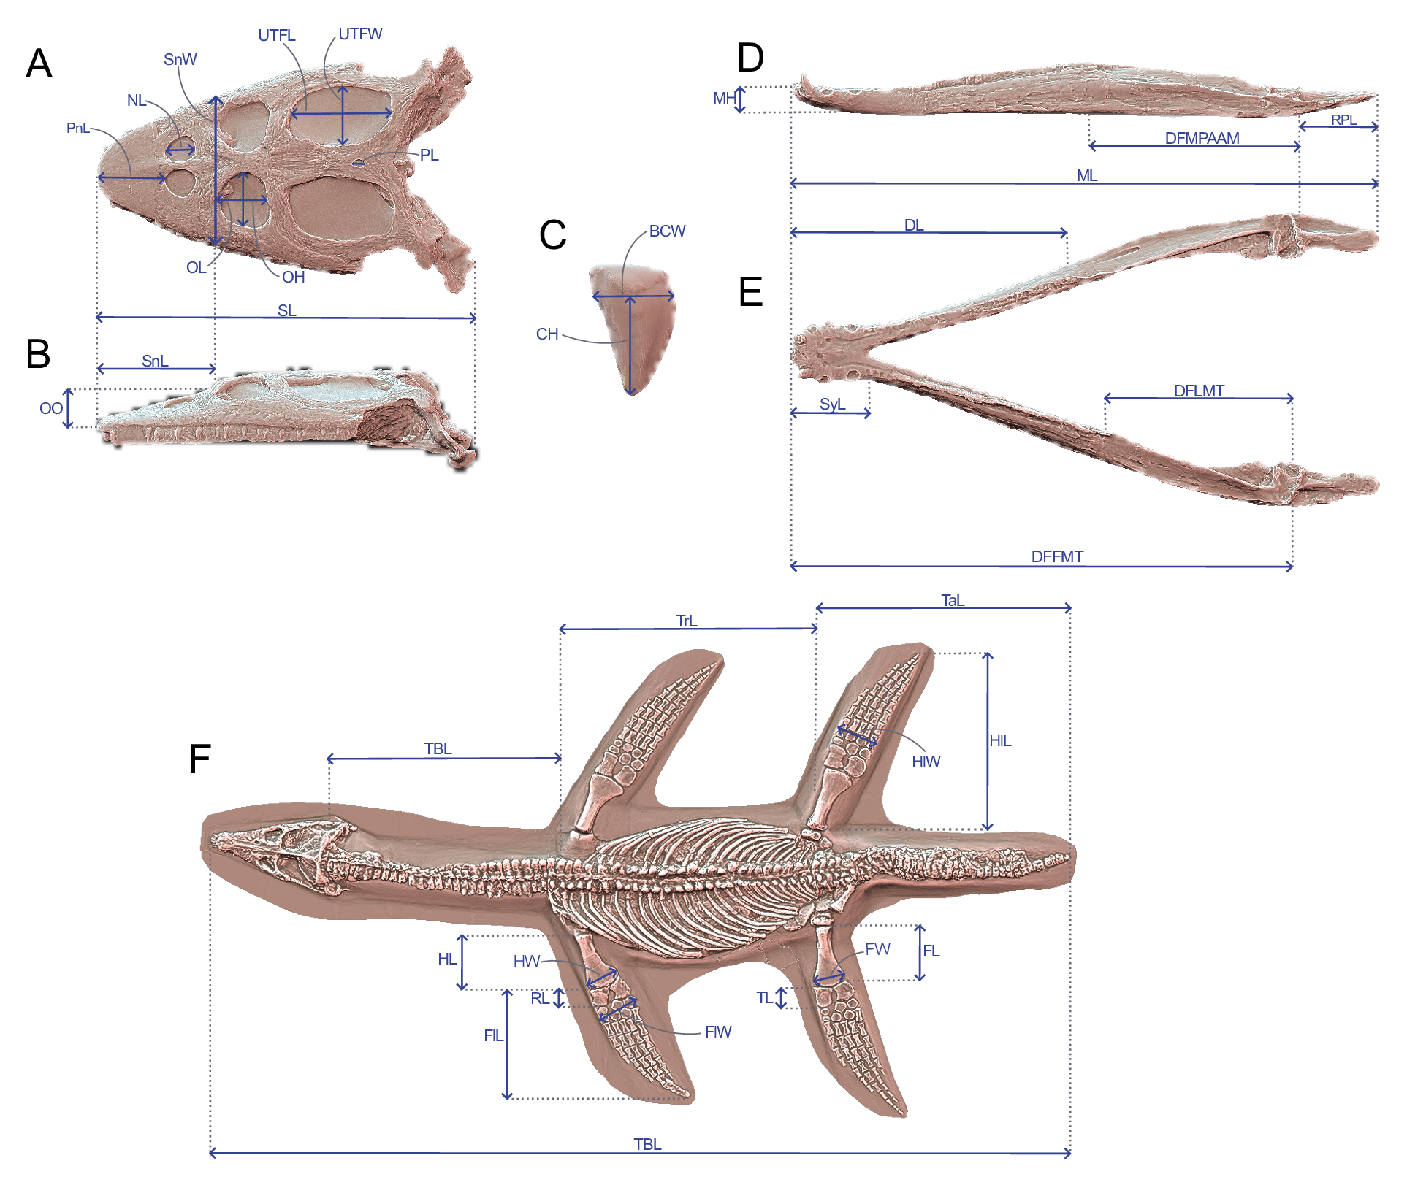

Supplementary figure 1. Linear measurements used to calculate ecomorphological traits used in our disparity analyses. (A and B) cranial measurements shown on the 3D model of Simosaurus gaillardoti (SMNS 16363) in (A) dorsal and in (B) lateral views; (C) tooth measurements shown on the 3D tooth model of Simosaurus gaillardoti (GPIT-PV-60638) in labial view; (D and E) mandibular measurements shown on the 3D model of Nothosaurus giganteus (SMNS 18058) in (D) dorsal and in (E) lateral views; (F) postcranial measurements shown on the specimen of Rhomaleosaurus cramptoni (NHMUK PV R 34). Abbreviations: BCW, basal crown width; CH; crown height; DFFMT, distance fulcrum—first mandible tooth; DFMLT, distance fulcrum—last mandible tooth; DFMPAAM, distance fulcrum—mid-point of attachment of the adductor muscles; DL, dentigerous length; FL, femur proximodistal length; FW, femur distal width; FlL, forelimb length; FlW, forelimb width; HL, humerus proximodistal length; HW, humerus distal width; HlL, hindlimb length; HlW, hindlimb width; MH, mandible height; ML, mandible length; NeL; neck length; NL, naris length; OL, orbit length; OH, orbit height; OO, ocular offset; PL, parietal foramen length; RL, Radius proximodistal length; RPL, retroarticular process length; PnL, prenarial length; SL, skull length; SW, skull width; SnL, snout length; SnW, snout width; SyL, symphysial length; TBL, total body length; TL, tibia proximodistal length, TaL, tail length; TrL, trunk length; UTFL, upper temporal fenestra length; UTFW, upper temporal fenestra width.

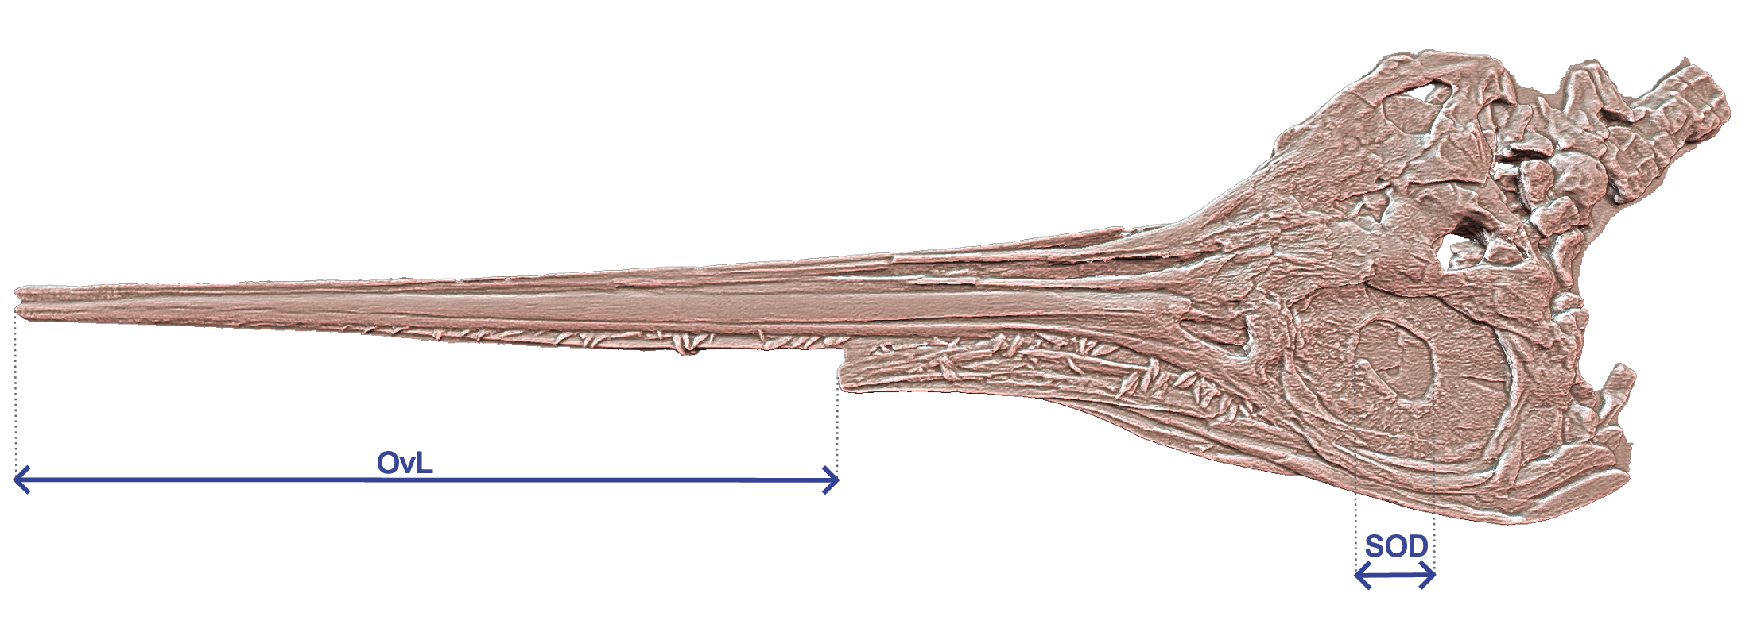

Supplementary figure 2. Craniodental linear measurements only applicable for ichthyosaurians used to calculate ecomorphological traits shown on the 3D model of Eurhinosaurus longirostris (NHMUK PV R 3938). Abbreviations: OvL, overbite length; SOD, sclerotic opening diameter.

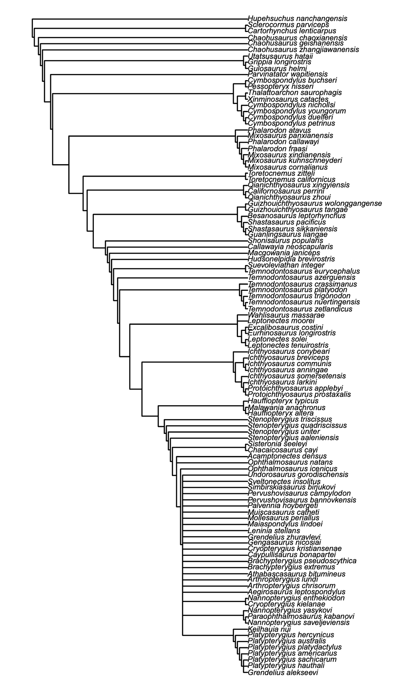

Supplementary figure 3. Ichthyosaurian strict consensus arising from implied weighting analysis (k=12). This analysis recovered 92 trees with a length of 69.88 steps. The dataset stems from the phylogenetic matrix of Laboury et al. (2022) with the addition of 3 taxa based on the literature (see Material and Methods): Cymbospondylus duelferi, Cymbospondylus youngorum and ‘Temnodontosaurus risor’.
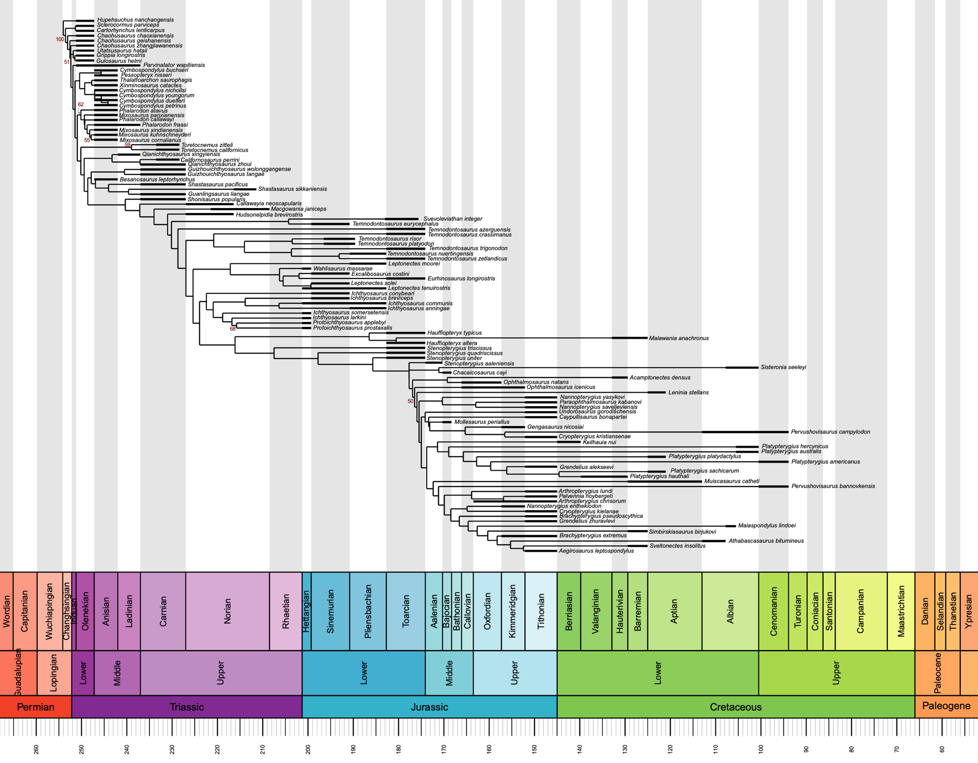

Supplementary figure 4. Time-scaled phylogeny arising from implied weighting (k=12) Maximum Parsimony analysis using Hedman calibration method. The tree has a length of 69.88 steps. The dataset stems from the phylogenetic matrix of Laboury et al. (2022) with the addition of 3 taxa based on the literature (see Material and Methods): Cymbospondylus duelferi, Cymbospondylus youngorum and‘Temnodontosaurus risor’. Values of the symmetric resampling ≥50 are indicated at their corresponding nodes.

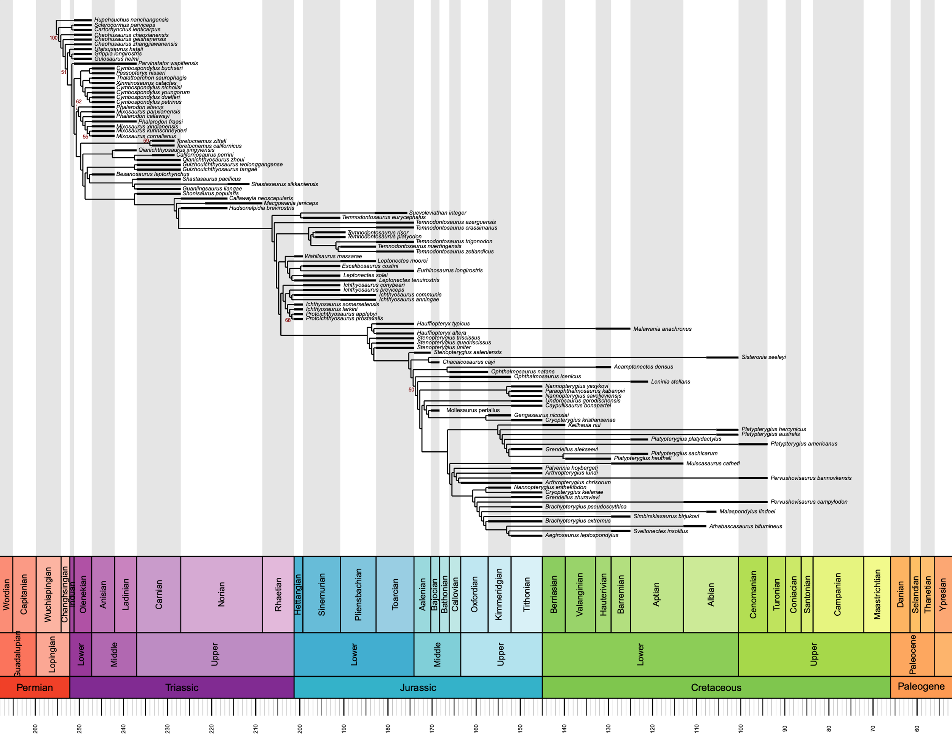

Supplementary figure 4. Time-scaled phylogeny arising from implied weighting (k=12)
Maximum Parsimony analysis using minimum branch length calibration method. The tree has a length of 69.88 steps. The dataset stems from the phylogenetic matrix of Laboury et al. (2022) with the addition of 3 taxa based on the literature (see Material and Methods): Cymbospondylus duelferi, Cymbospondylus youngorum and ‘Temnodontosaurus risor’. Values of the symmetric resampling ≥ 50 are indicated at their corresponding nodes.

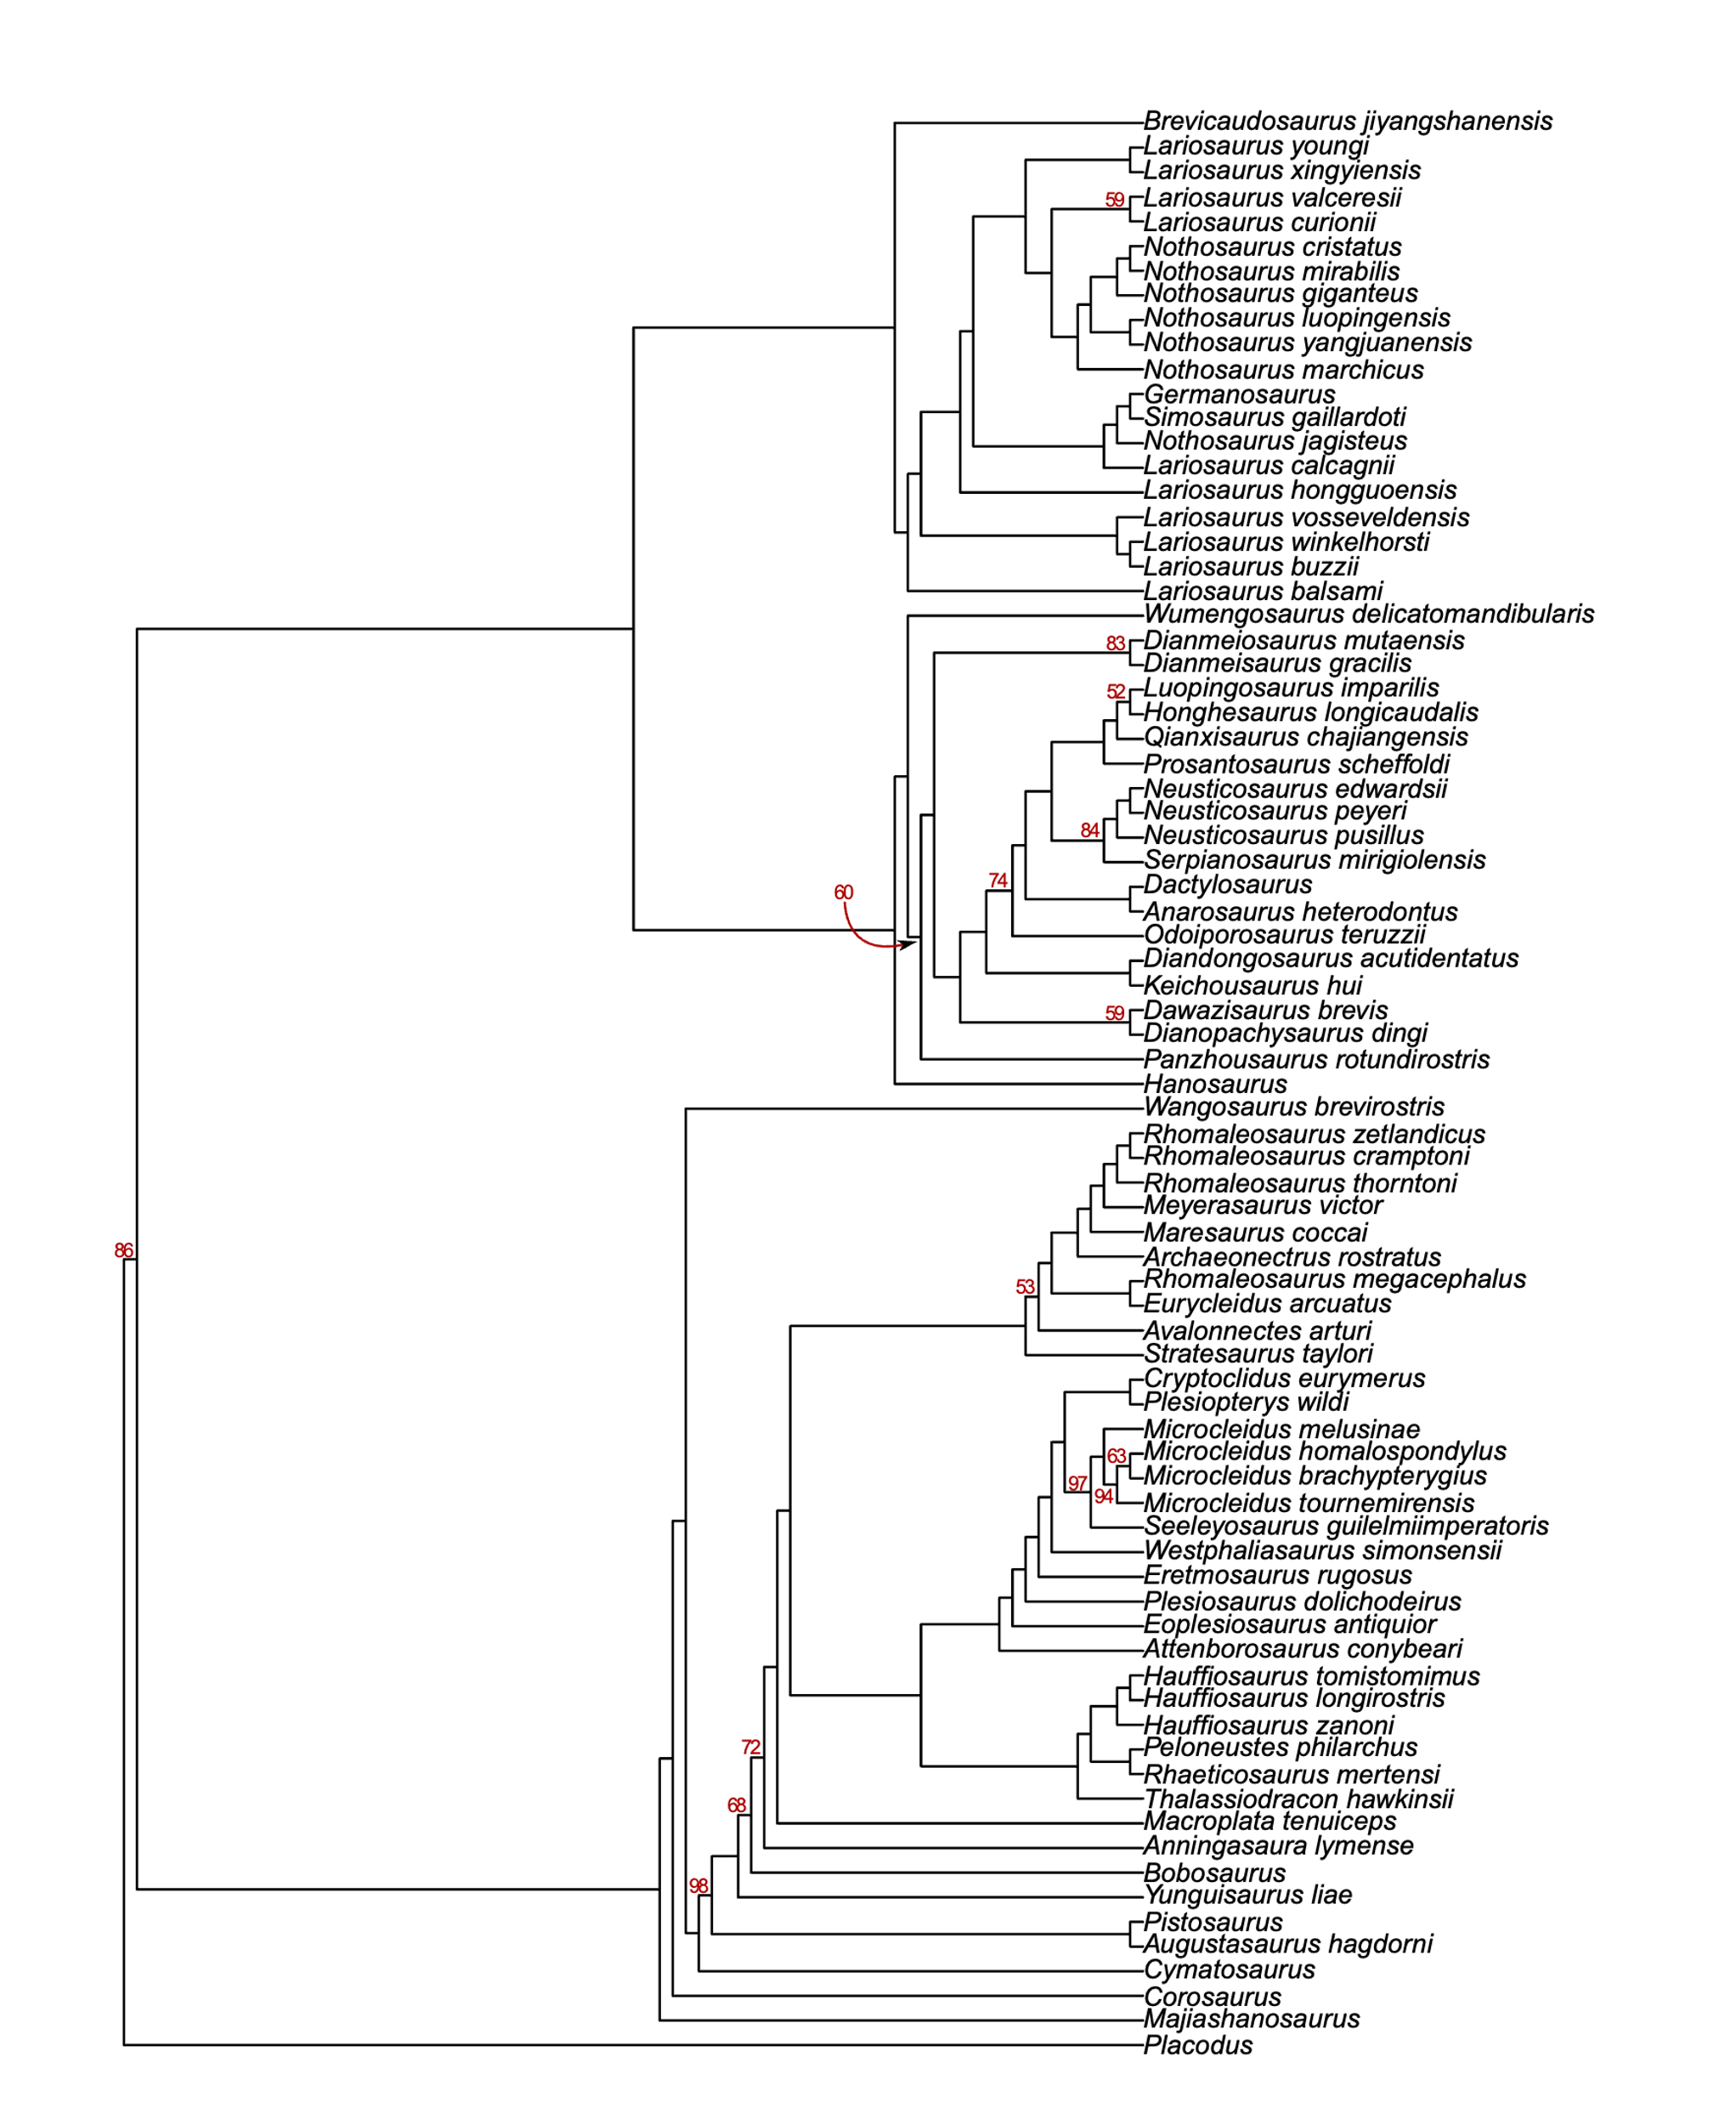

Supplementary figure 5. Composite phylogenetic tree based on Hu et al. (2024) for Triassic eosauropterygians and Wintrich et al. (2017) for Jurassic plesiosaurians. Both phylogenetic matrices have been analysed within an implied weighting parsimony framework (k=12). Each tree has a length of 32.64 and 28.96 steps. Values of symmetric resampling have been generated for each phylogeny separately and values ≥ 50 are indicated at their corresponding nodes.

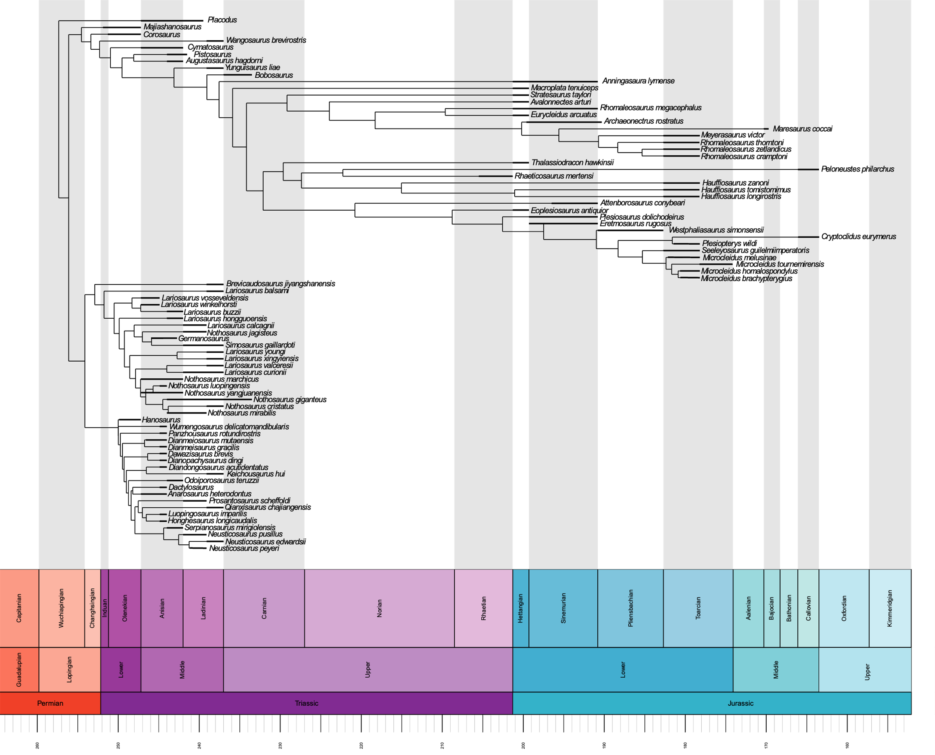
Supplementary figure 6. Time-scaled composite phylogenetic tree based on the phylogenetic analyses of Hu et al. (2024) and Wintrich et al. (2017) with the Hedman calibration method. Taxa present in our ecomorphological datasets but absent in both phylogenetic matrices have been added according to the literature (see the electronic supplementary material, supplementary methods).

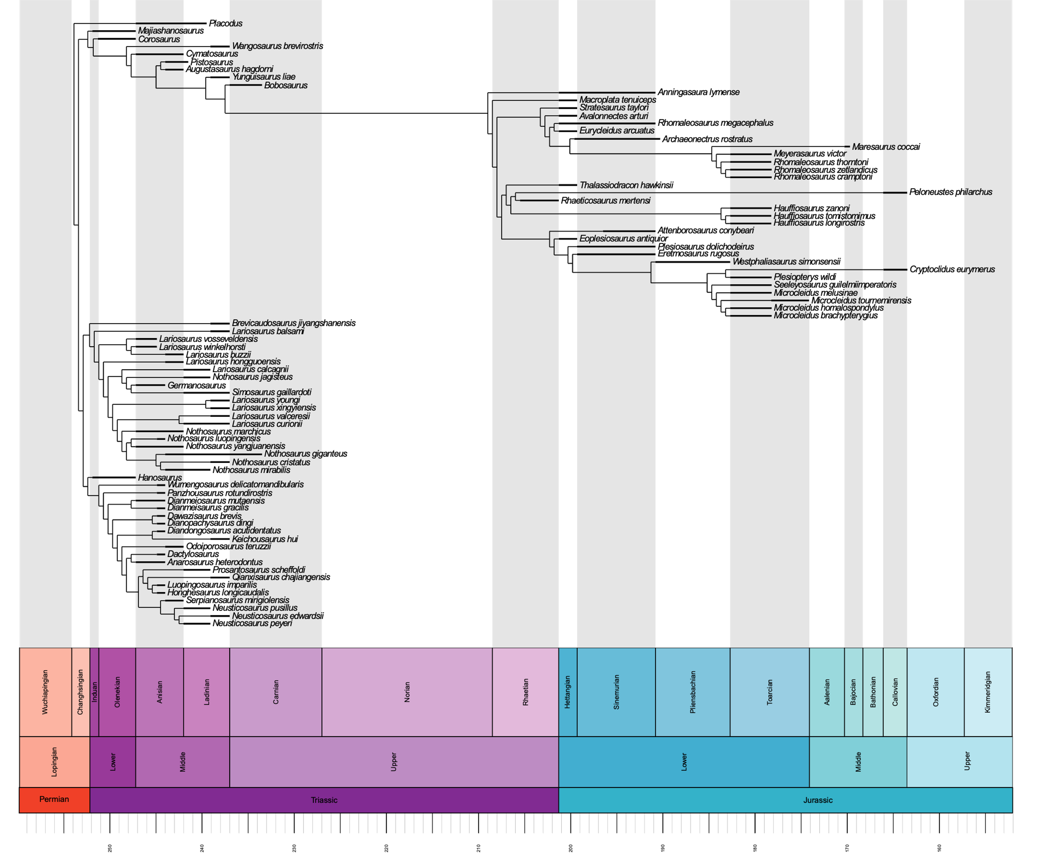

Supplementary figure 7. Time-scaled composite phylogenetic tree based on the phylogenetic analyses of Hu et al. (2024) and Wintrich et al. (2017) with the minimum branch length calibration method. Taxa present in our ecomorphological datasets but absent in both phylogenetic matrices have been added according to the literature (see the electronic supplementary material, supplementary methods).

Supplementary figure 8. Composite phylogenetic tree based on Xu et al. (2022) for Triassic eosauropterygians and Wintrich et al. (2017) for Jurassic plesiosaurians. Both phylogenetic matrices have been analysed within an implied weighting parsimony framework (k=12). Each tree has a length of 25.52 and 28.96 steps. Values of symmetric resampling have been generated for each phylogeny separately and values ≥ 50 are indicated at their corresponding nodes.
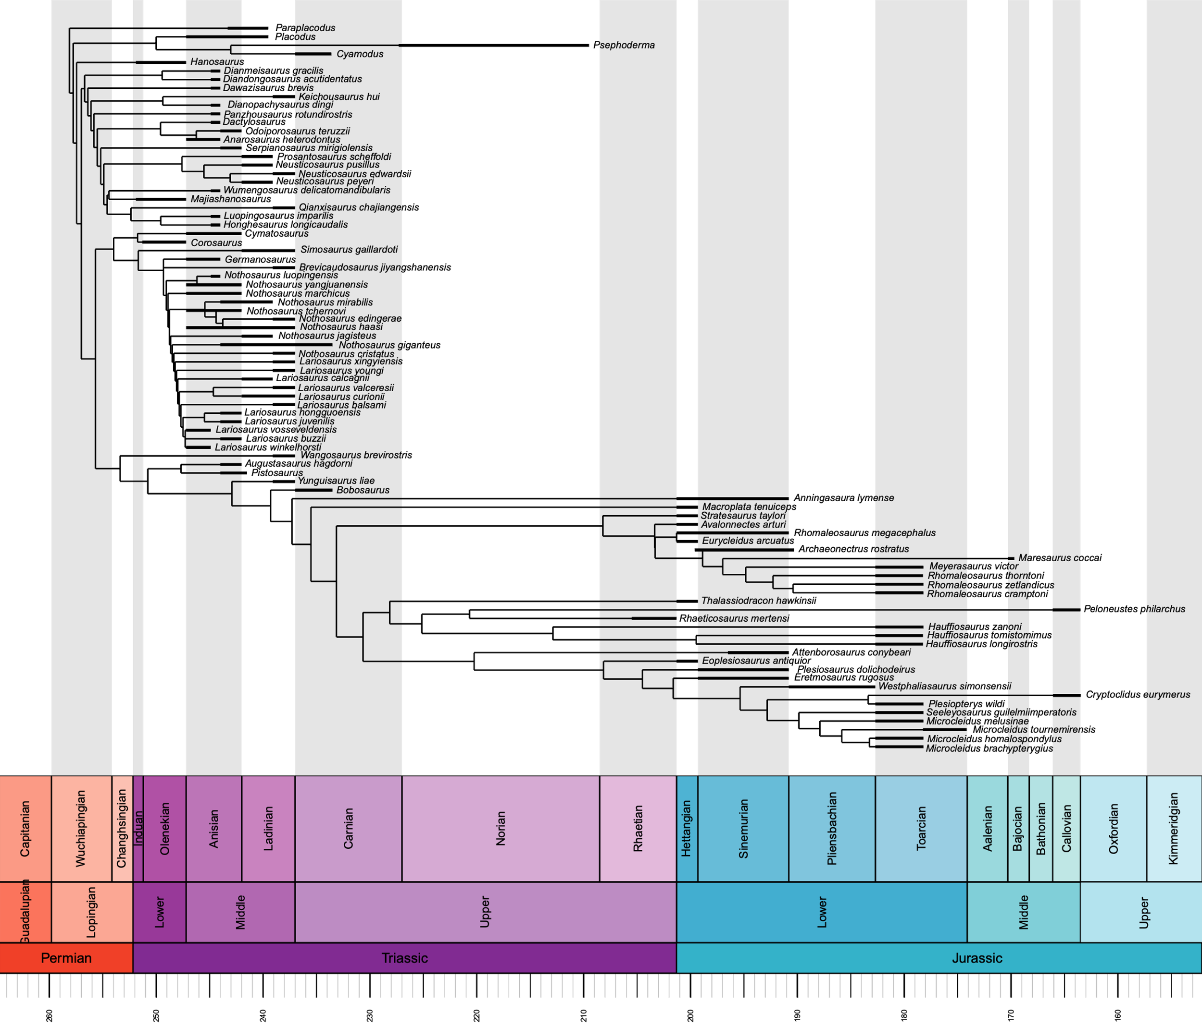

Supplementary figure 9. Time-scaled composite phylogenetic tree based on the phylogenetic analyses of Xu et al. (2022) and Wintrich et al. (2017) with the Hedman calibration method. Taxa present in our ecomorphological datasets but absent in both phylogenetic matrices have been added (see the electronic supplementary material, supplementary methods for more information).

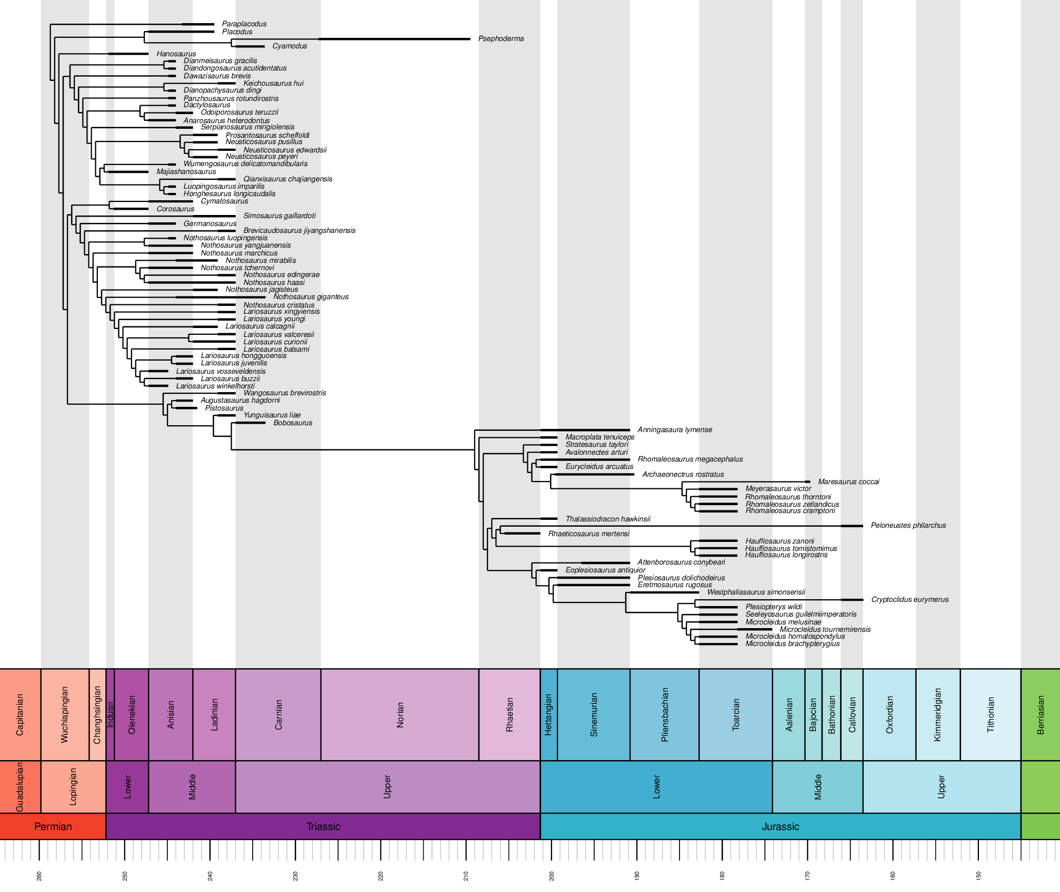

Supplementary figure 10. Time-scaled composite phylogenetic tree based on the phylogenetic analyses of Xu et al. (2022) and Wintrich et al. (2017) with the minimum branch length calibration method. Taxa present in our ecomorphological datasets but absent in both phylogenetic matrices have been added (see the electronic supplementary material, supplementary methods).

Supplementary figure 11. Ichthyosaurian quantitative craniodental trait histograms, pairwise distribution and correlation. The upper panel indicates the pairwise correlation (Pearson’s correlation coefficient, * indicates significance at alpha = 0.05, ** at alpha 0.01).

Supplementary figure 12. Ichthyosaurian quantitative postcranial trait histograms, pairwise distribution and correlation. The upper panel indicates the pairwise correlation (Pearson’s correlation coefficient, * indicates significance at alpha = 0.05, ** at alpha 0.01).

Supplementary figure 13. Eosauropterygian quantitative craniodental trait histograms, pairwise distribution and correlation. The upper panel indicates the pairwise correlation (Pearson’s correlation coefficient, * indicates significance at alpha = 0.05, ** at alpha 0.01).

Supplementary figure 14. Eosauropterygian quantitative postcranial trait histograms, pairwise distribution and correlation. The upper panel indicates the pairwise correlation (Pearson’s correlation coefficient, * indicates significance at alpha = 0.05, ** at alpha 0.01).

Supplementary figure 15. Ichthyosaurian tanglegram comparing the phylogeny with the hierarchy of a cluster dendrogram generated with the craniodental data. Each line is coloured with respect to its relative group (light green: early ichthyosaurians, green: shastasaurid-grade merriamosaurians, blue: early parvipelvians, dark blue: thunnosaurians). The phylogenetic tree has been generated in Maximum Parsimony framework under implied weighting (k=12). Only taxa present in the ecomorphological dataset were kept. Nodal support values (approximate unbiased p-value in percentage) are indicated at their corresponding nodes on the cluster dendrogram. Mantel test result (p-value = 0.34) does not indicate a strong correlation between the phylogenetic relationships and the hierarchy of the cluster dendrogram.

Supplementary figure 16. Ichthyosaurian tanglegram comparing the phylogeny with the hierarchy of a cluster dendrogram generated with the postcranial data. Each line is coloured with respect to its relative group (light green: early ichthyosaurians, green: shastasaurid-grade merriamosaurians, blue: early parvipelvians, dark blue: thunnosaurians). The phylogenetic tree has been generated in Maximum Parsimony framework under implied weighting (k=12). Only taxa present in the ecomorphological dataset were kept. Nodal support values (approximate unbiased p-value in percentage) are indicated at their corresponding nodes on the cluster dendrogram. Mantel test result (p-value = 0.001) indicates a strong correlation between the phylogenetic relationships and the hierarchy of the cluster dendrogram.

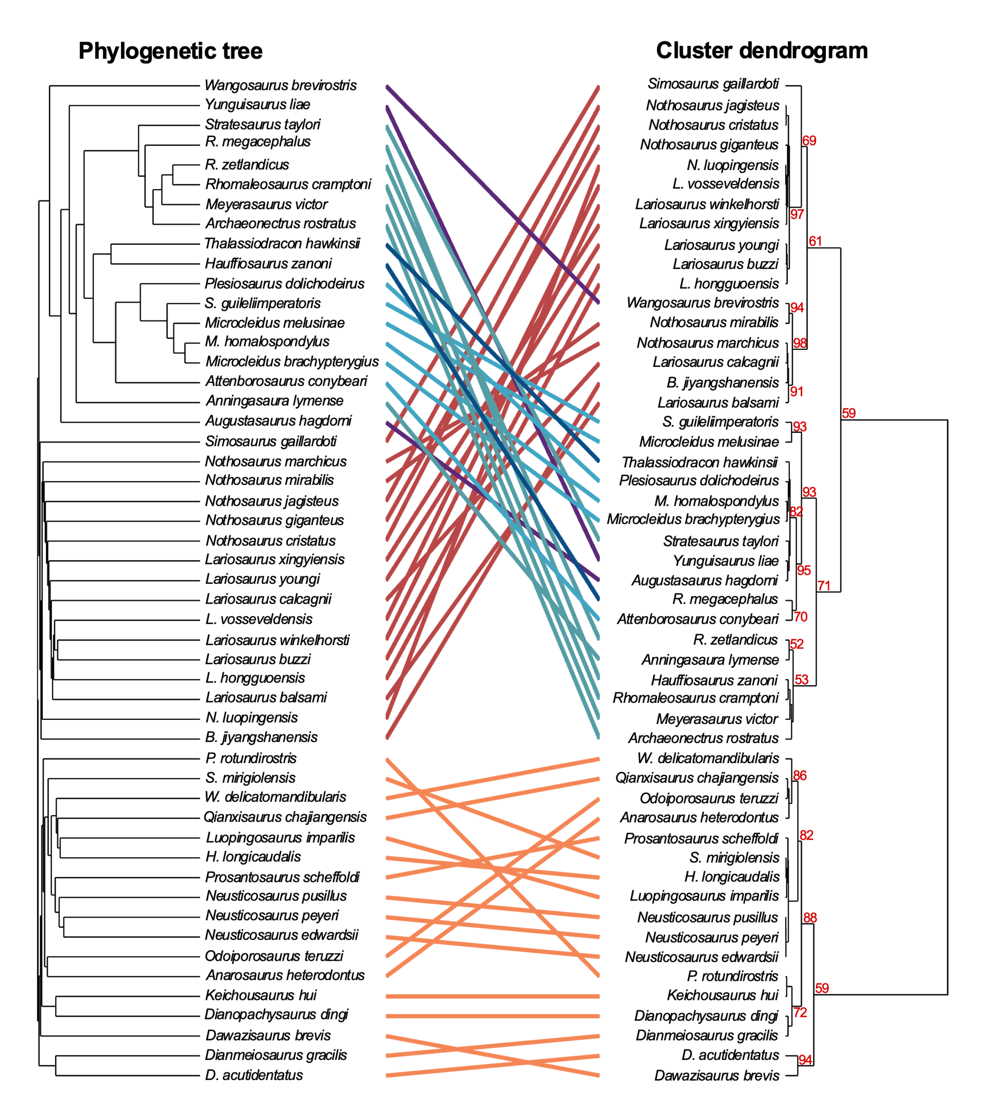

Supplementary figure 17. Eosauropterygian tanglegram comparing the phylogeny with the hierarchy of a cluster dendrogram generated with the craniodental data. Each line is coloured with respect to its relative group (orange: pachypleurosauroids, red: nothosauroids, purple: pistosauroids, light blue: plesiosauroids, dark blue: pliosauroids, turquoise: rhomaleosaurids). The composite phylogenetic tree has been created by merging the phylogenetic analyses of Hu et al. (2024) and Wintrich et al. (2017) datasets generated in Maximum Parsimony framework under implied weighting (k=12). Only taxa present in the ecomorphological dataset were kept. Nodal support values (approximate unbiased p-value in percentage) under 50% are indicated at their corresponding nodes on the cluster dendrogram. Mantel test result (p-value = 0.01) indicates a strong correlation between the phylogenetic relationships and the hierarchy of the cluster dendrogram.

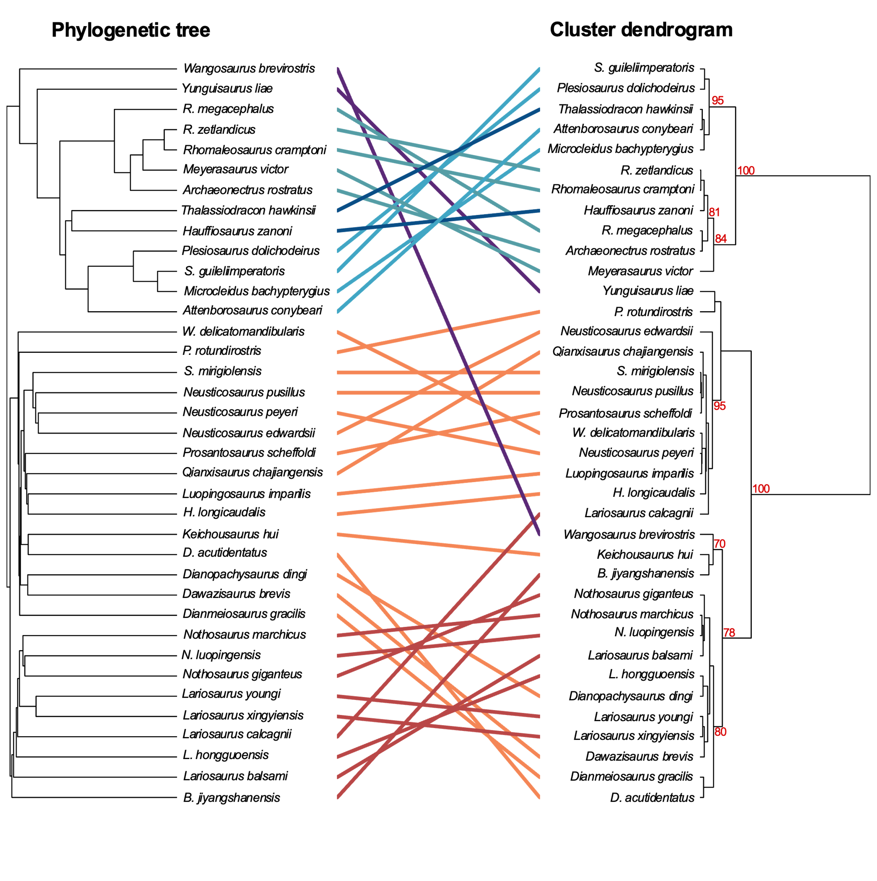
Supplementary figure 18. Eosauropterygian tanglegram comparing the phylogeny with the hierarchy of a cluster dendrogram generated with the postcranial data. Each line is coloured with respect to its relative group (orange: pachypleurosauroids, red: nothosauroids, purple: pistosauroids, blue: plesiosauroids, turquoise: pliosauroids, grey: rhomaleosaurids). The composite phylogenetic tree has been created by merging the phylogenetic analyses of Hu et al. (2024) and Wintrich et al. (2017) datasets generated in Maximum Parsimony framework under implied weighting (k=12). Nodal support values (approximate unbiased p-value in percentage) under 50% are indicated at their corresponding nodes on the cluster dendrogram.

Supplementary figure 19. Eosauropterygian tanglegram comparing the phylogeny with the hierarchy of a cluster dendrogram generated with the postcranial data. Each line is coloured with respect to its relative group (orange: pachypleurosauroids, red: nothosauroids, purple: pistosauroids, blue: plesiosauroids, turquoise: pliosauroids, grey: rhomaleosaurids). The composite phylogenetic tree has been created by merging the phylogenetic analyses of Xu et al. (2022) and Wintrich et al. (2017) datasets generated in Maximum Parsimony framework under implied weighting (k=12). Nodal support values (approximate unbiased p-value in percentage) under 50% are indicated at their corresponding nodes on the cluster dendrogram.
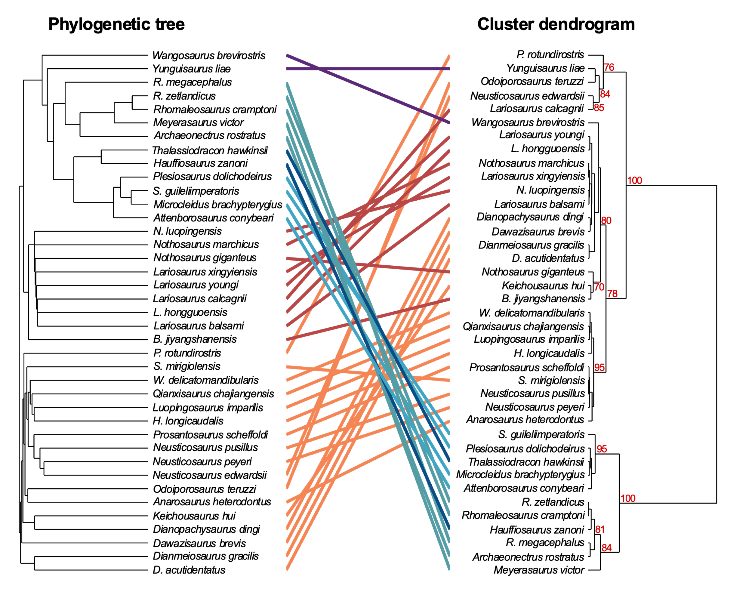

Supplementary figure 20. Eosauropterygian tanglegram comparing the phylogeny with the hierarchy of a cluster dendrogram generated with the postcranial data. Each line is coloured with respect to its relative group (orange: pachypleurosauroids, red: nothosauroids, purple: pistosauroids, blue: plesiosauroids, turquoise: pliosauroids, grey: rhomaleosaurids). The composite phylogenetic tree has been created by merging the phylogenetic analyses of Xu et al. (2022) and Wintrich et al. (2017) datasets generated in Maximum Parsimony framework under implied weighting (k=12). Nodal support values (approximate unbiased p-value in percentage) under 50% are indicated at their corresponding nodes on the cluster dendrogram.

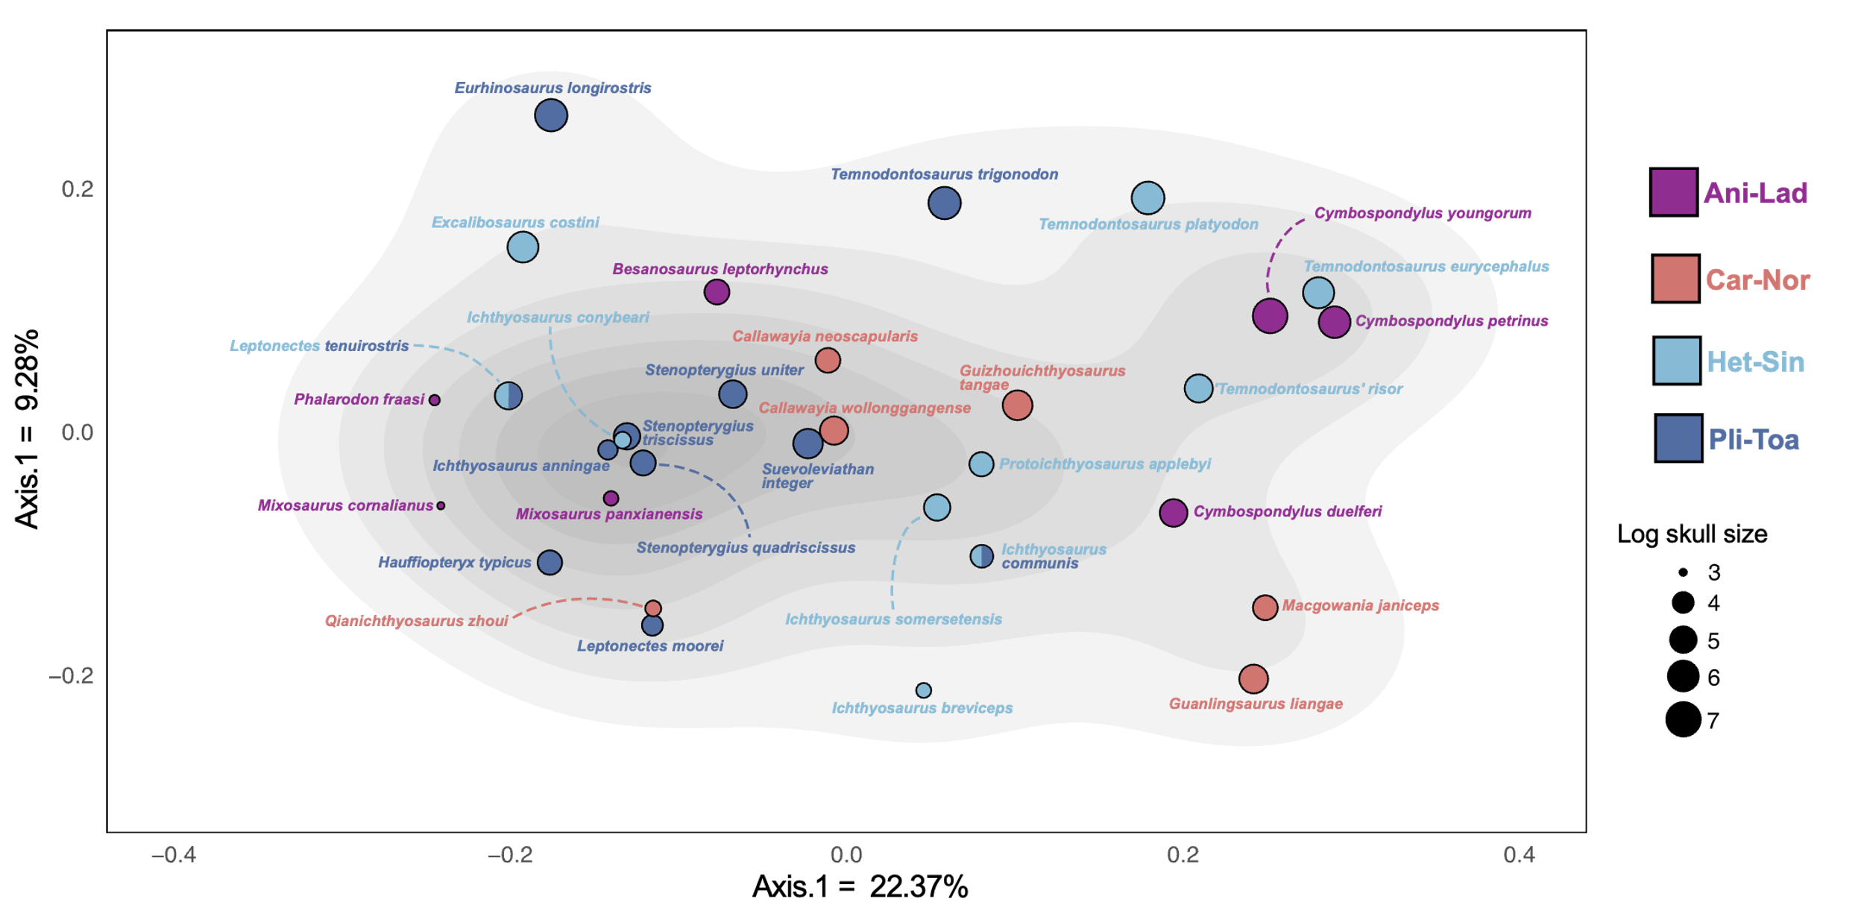

Supplementary figure 21. Ichthyosaurian craniodental functional morphospace occupation based on the first two axes of the PCoA superimposed on the density of taxa. Point sizes are scaled to the relative skull size of taxa (log skull length). Abbreviations: Ani-Lad, Anisian-Ladinian, Car-Nor, Carnian-Norian, Het-Sin, Hettangian-Sinemurian, Pli-Toa, Pliensbachian-Toarcian.

Supplementary figure 22. Ichthyosaurian craniodental nMDS stress plot, showing the relationship between the dissimilarities between taxa present in the craniodental dissimilarity matrix and the ordination on the NMDS morphospace (maximum number of random starts = 100).

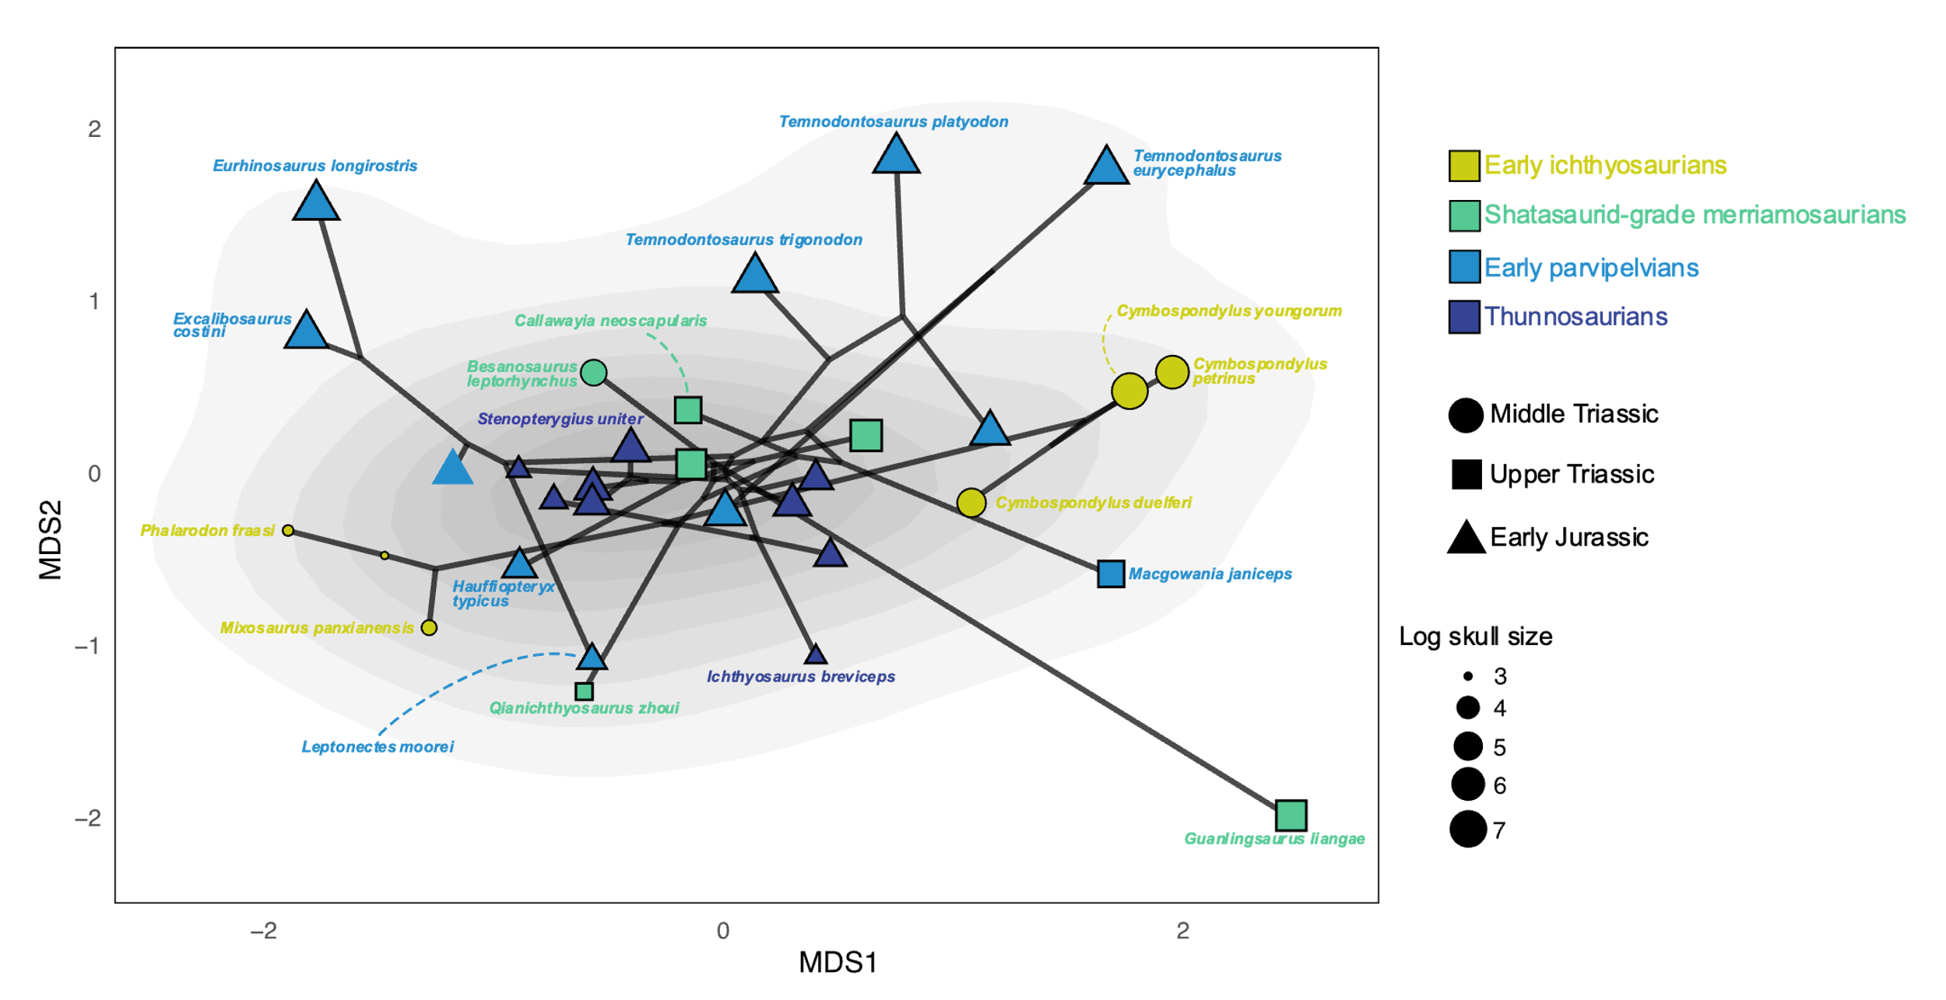

Supplementary figure 23. Ichthyosaurian craniodental phylo-ecomorphospace occupation generated by using nMDS (dimension=2), superimposed on the density of taxa. Point sizes are scaled to the relative skull size of taxa (log skull length).

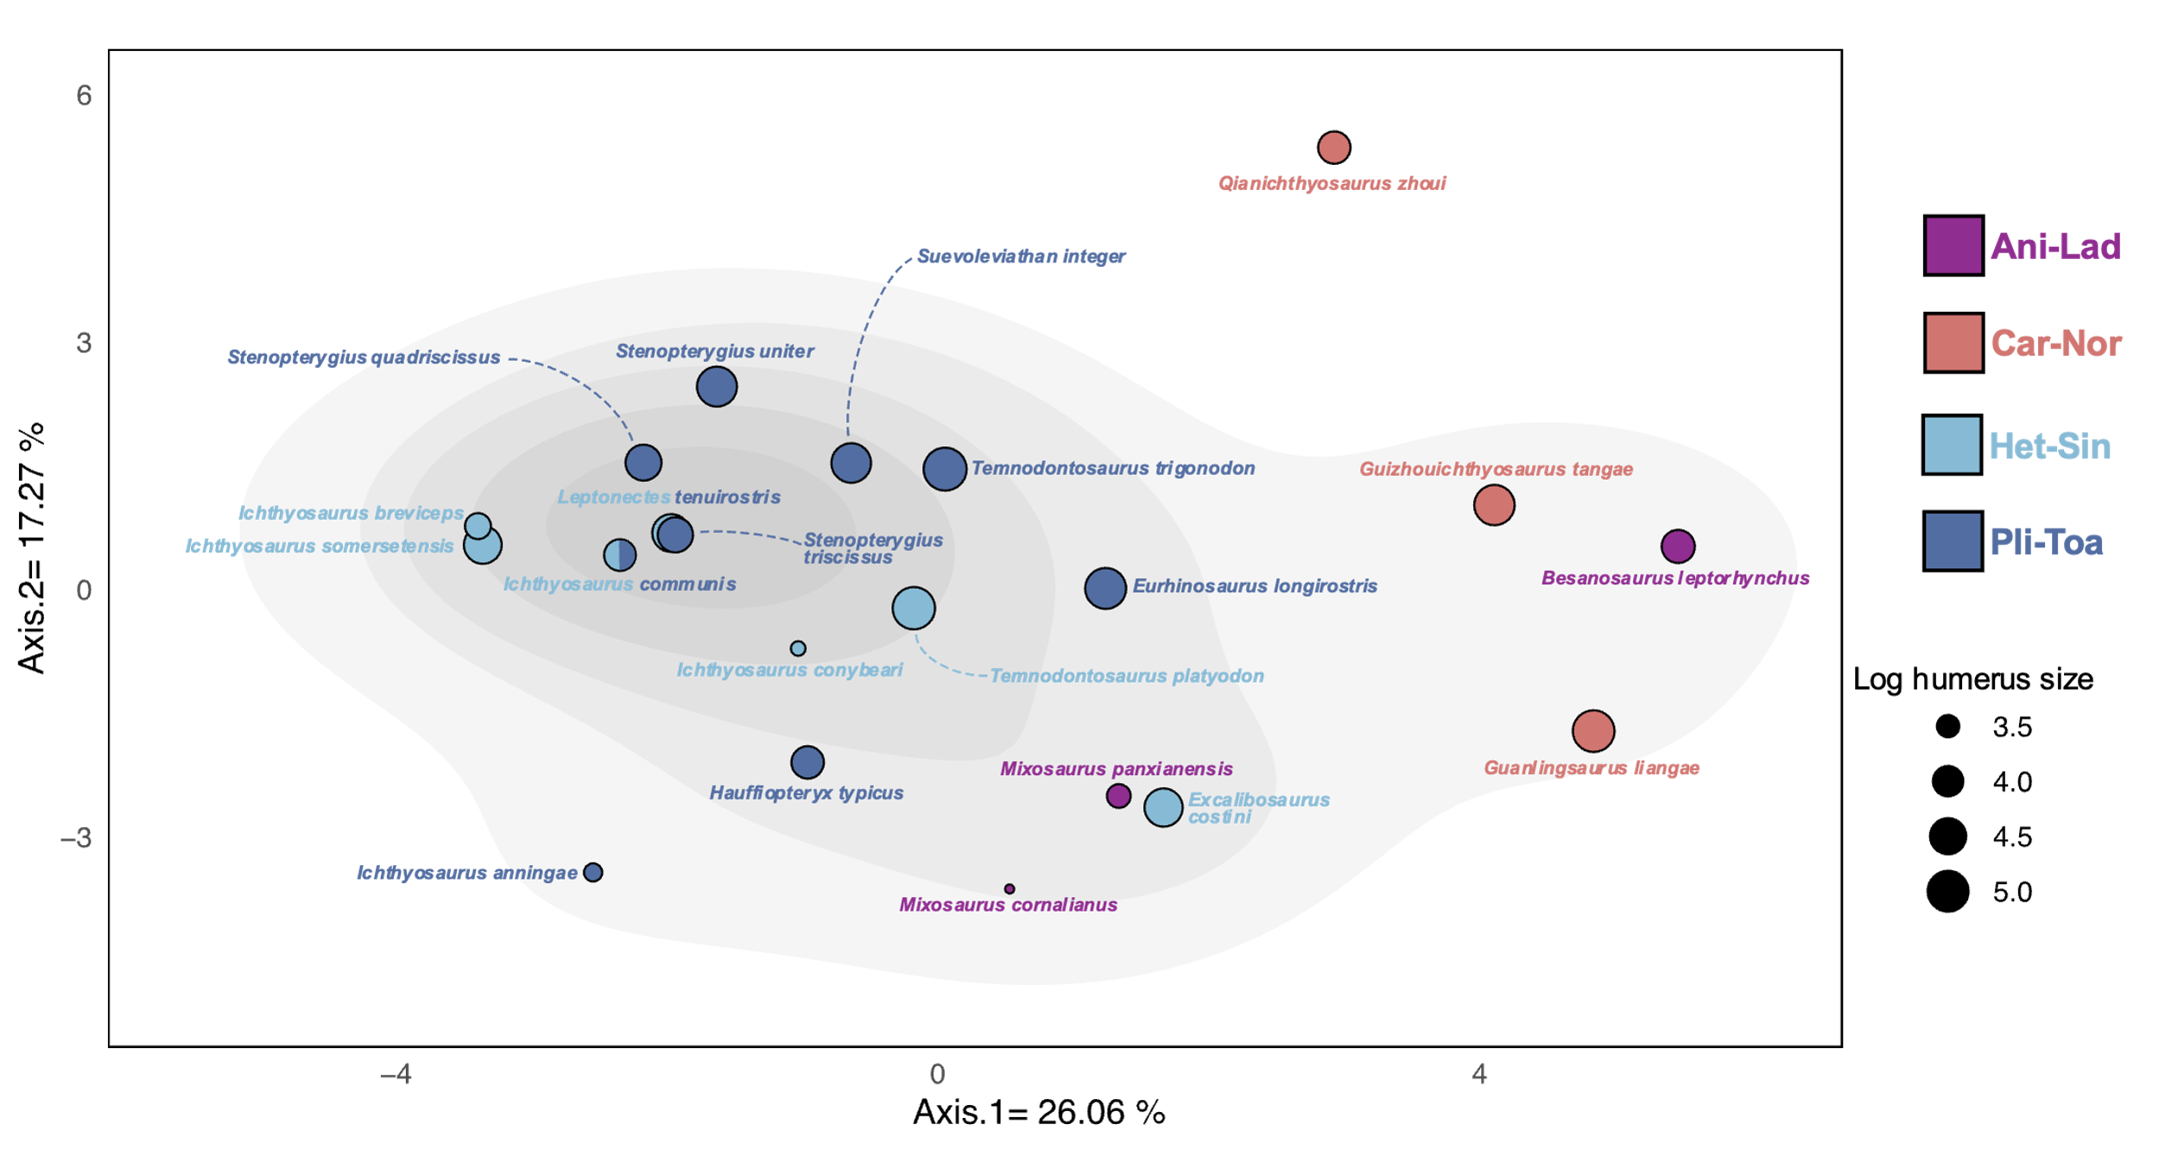

Supplementary figure 24. Ichthyosaurian postcranial functional morphospace occupation based on the first two axes of the PCoA superimposed on the density of taxa. Point sizes are scaled to the relative humerus size of taxa (log humerus length). Abbreviations: Ani-Lad, Anisian-Ladinian, Car-Nor, Carnian-Norian, Het-Sin, Hettangian-Sinemurian, Pli-Toa, Pliensbachian-Toarcian.

Supplementary figure 25. Ichthyosaurian postcranial nMDS stress plot, showing the relationship between the dissimilarities between taxa present in the postcranial dissimilarity matrix and the ordination on the NMDS morphospace (maximum number of random starts = 100).

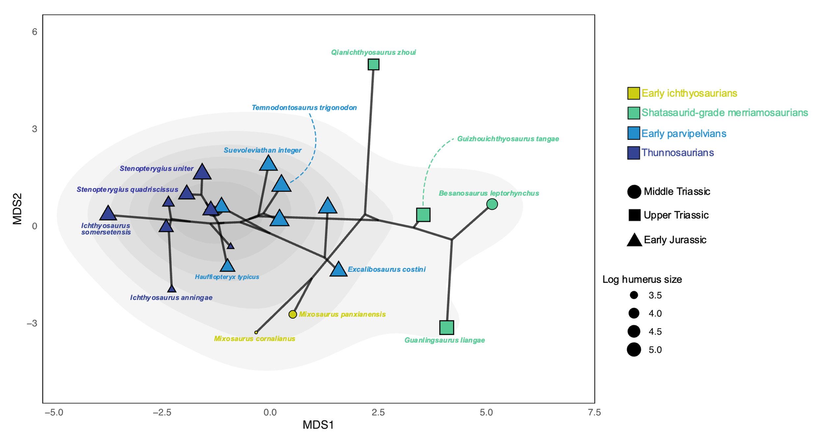

Supplementary figure 26. Ichthyosaurian postcranial phylo-ecomorphospace occupation generated by using nMDS (dimension=2), superimposed on the density of taxa. Point sizes are scaled to the relative humerus size of taxa (log humerus size).

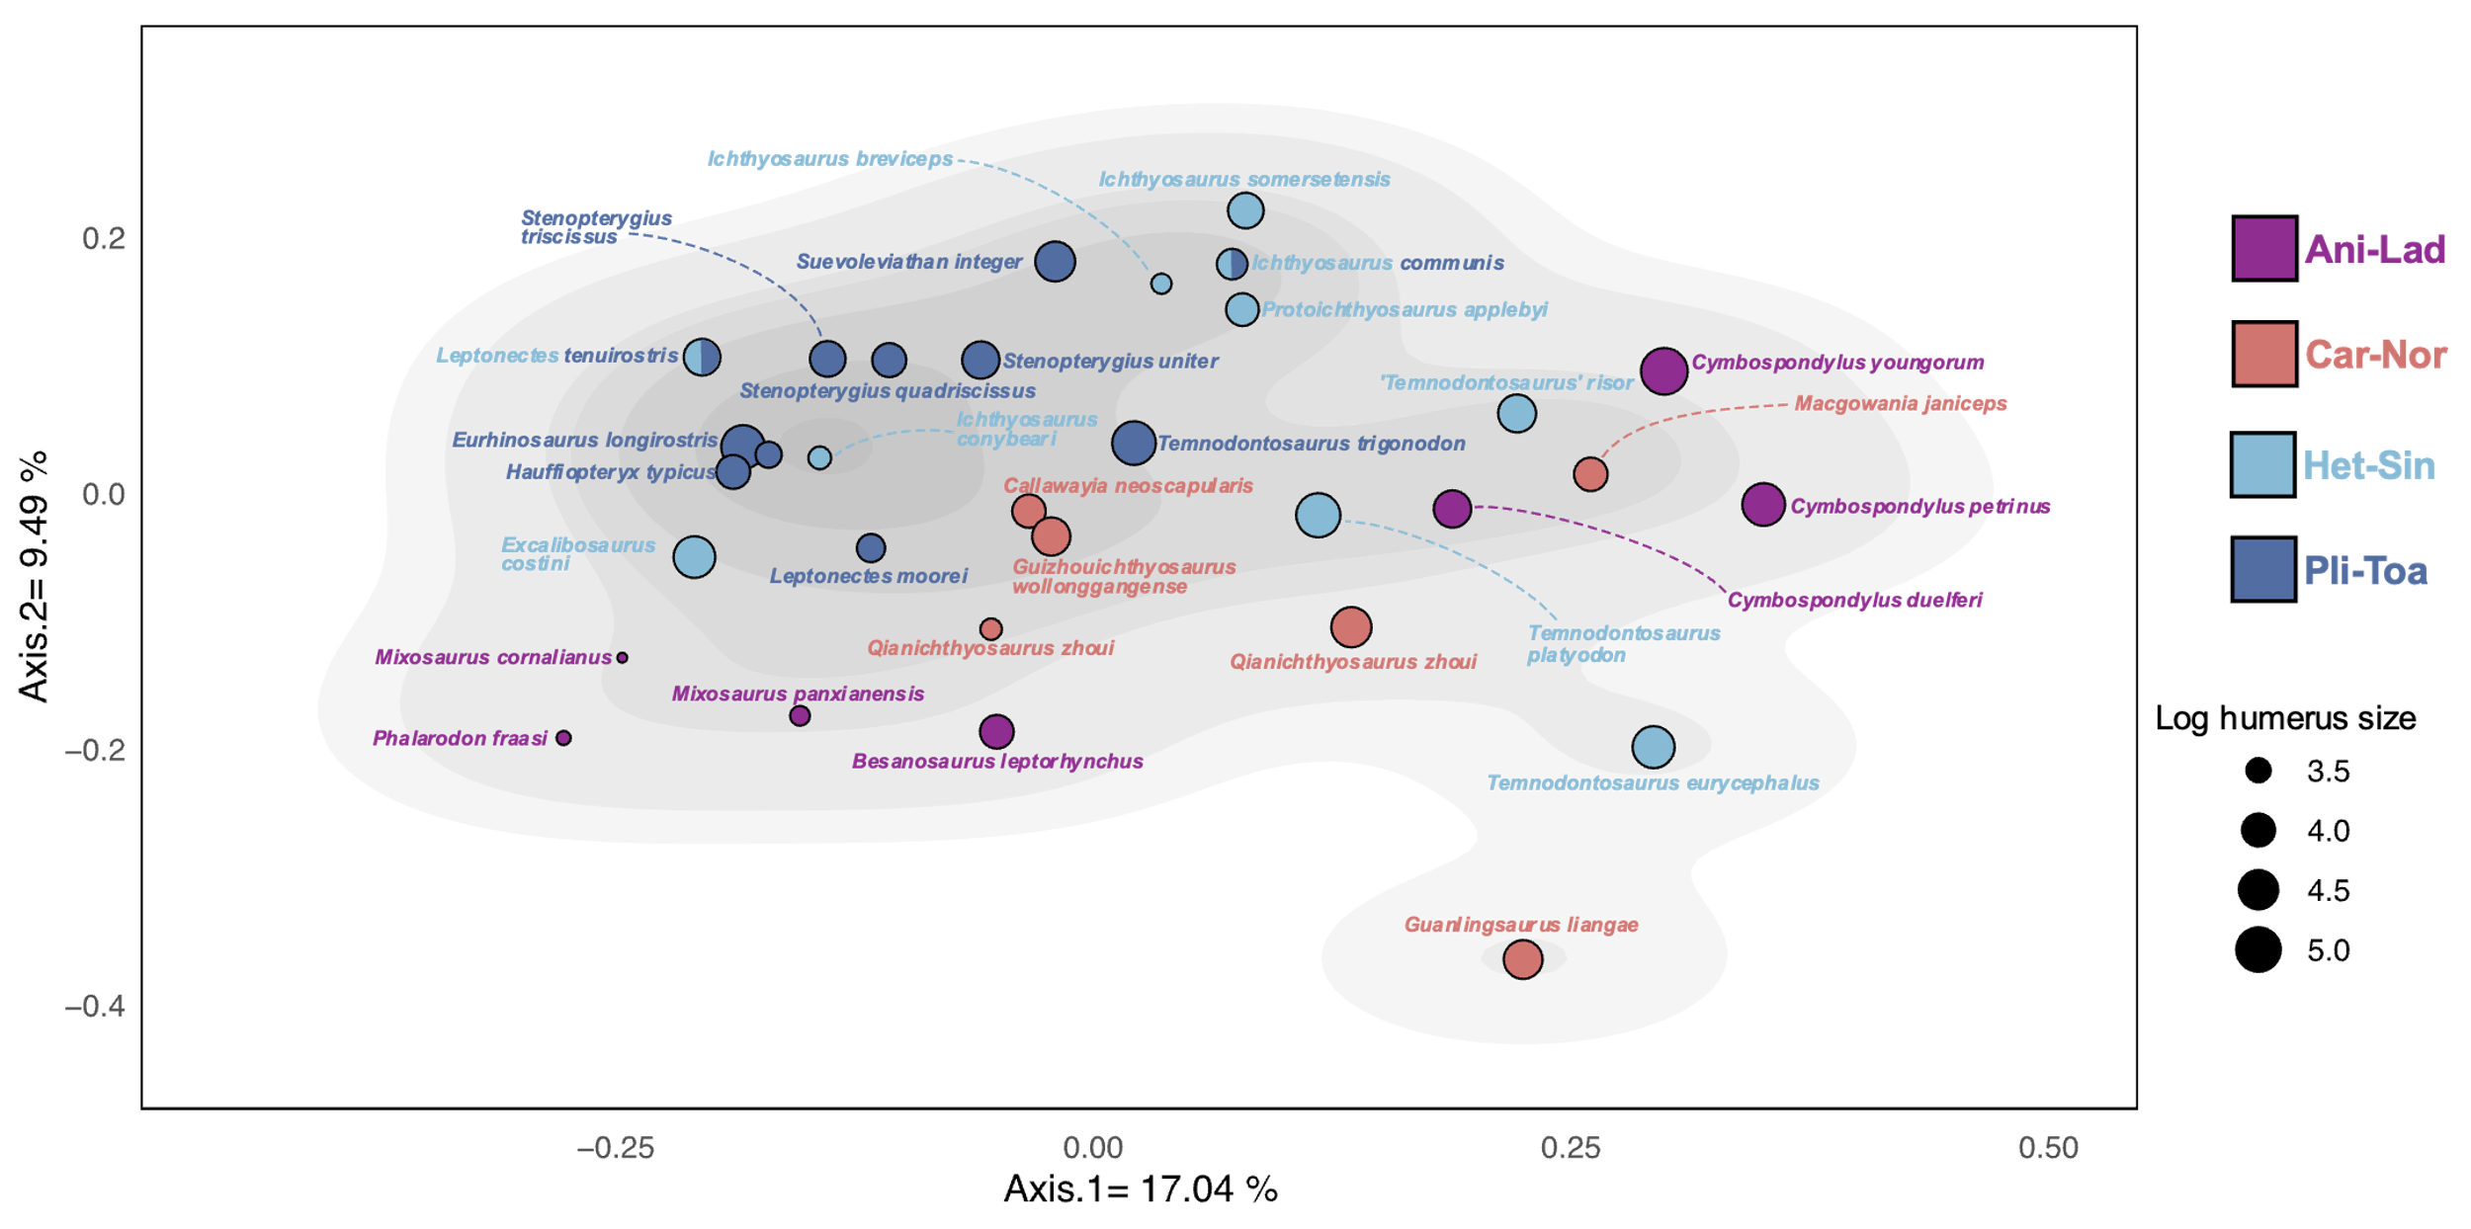

Supplementary figure 27. Ichthyosaurian whole-body functional morphospace occupation based on the first two axes of the PCoA superimposed on the density of taxa. Point sizes are scaled to the relative humerus size of taxa (log humerus length). Abbreviations: Ani-Lad, Anisian-Ladinian, Car-Nor, Carnian-Norian, Het-Sin, Hettangian-Sinemurian, Pli-Toa, Pliensbachian-Toarcian.

Supplementary figure 28. Ichthyosaurian whole-body NMDS stress plot, showing the relationship between the dissimilarities between taxa present in the whole-body dissimilarity matrix and the ordination on the NMDS morphospace (maximum number of random starts = 100).

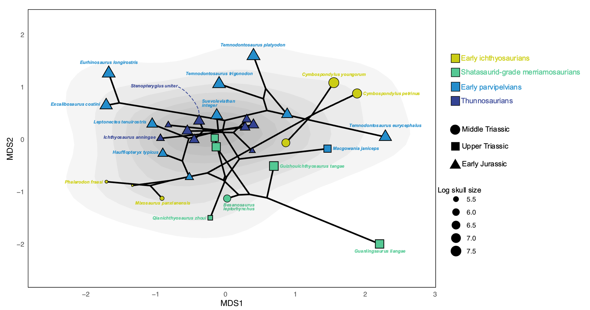

Supplementary figure 29. Ichthyosaurian whole-body phylo-ecomorphospace occupation generated by using nMDS (dimension=2), superimposed on the density of taxa. Point sizes are scaled to the relative skull size of taxa (log skull length).

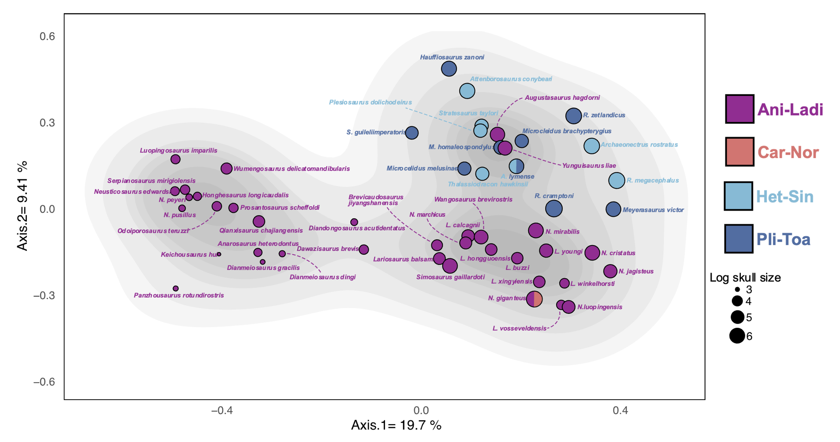

Supplementary figure 30. Eosauropterygian craniodental functional morphospace occupation based on the first two axes of the PCoA superimposed on the density of taxa. Point sizes are scaled to the relative skull size of taxa (log skull length). Abbreviations: Car-Nor, Carnian-Norian, Het-Sin, Hettangian-Sinemurian, Pli-Toa, Pliensbachian-Toarcian.

Supplementary figure 31. Eosauropterygian craniodental nMDS stress plot, showing the relationship between the dissimilarities between taxa present in the craniodental dissimilarity matrix and the ordination on the nMDS morphospace (maximum number of random starts = 100).

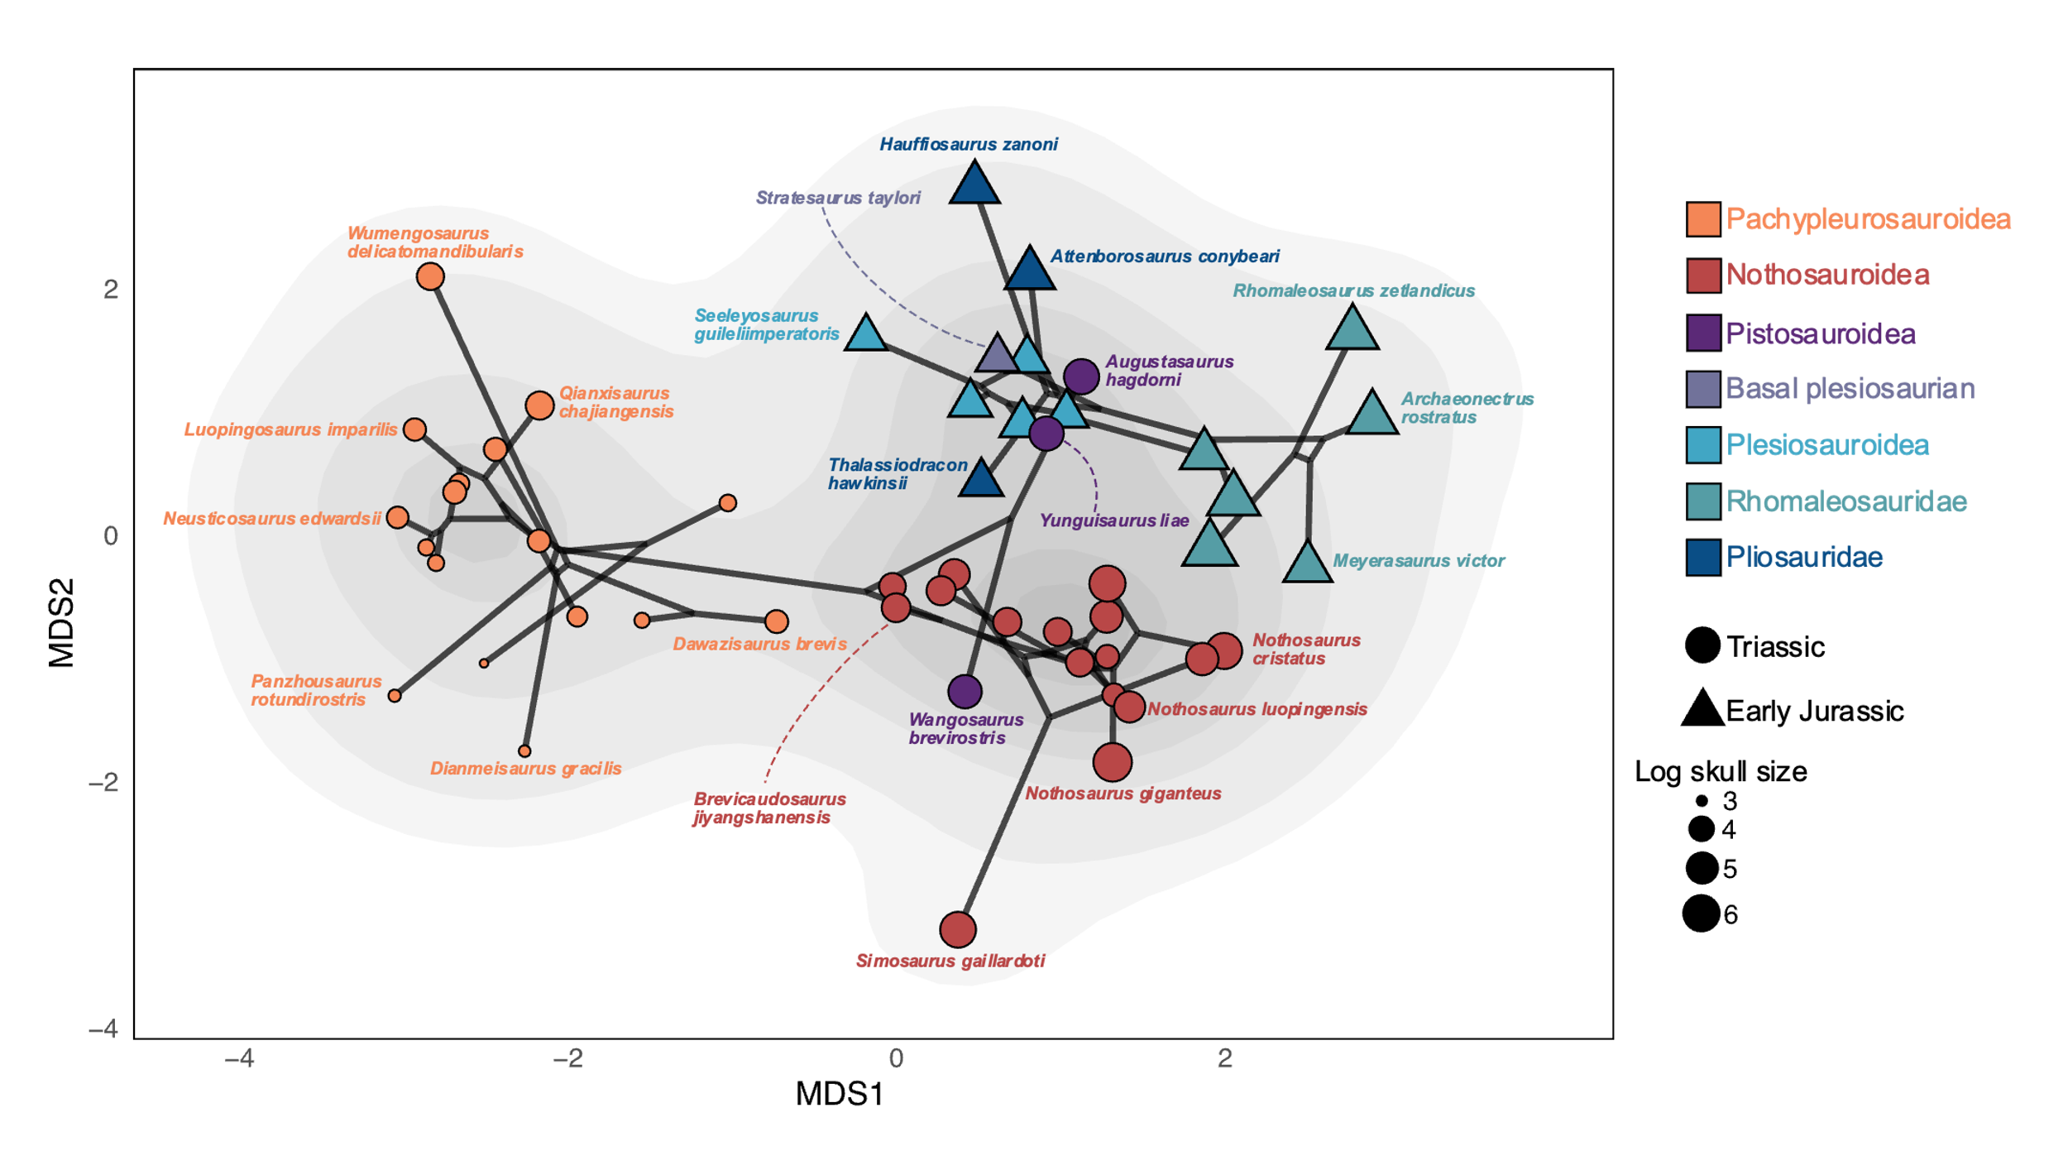

Supplementary figure 32. Eosauropterygian craniodental phylo-ecomorphospace occupation computed by using nMDS (dimension=2) and composite phylogenetic tree based on the phylogenetic analyses of Hu et al. (2024) and Wintrich et al. (2017). The phylo-ecomorphospace is superimposed on the density of taxa. Point sizes are scaled to the relative skull size of taxa (log skull size).

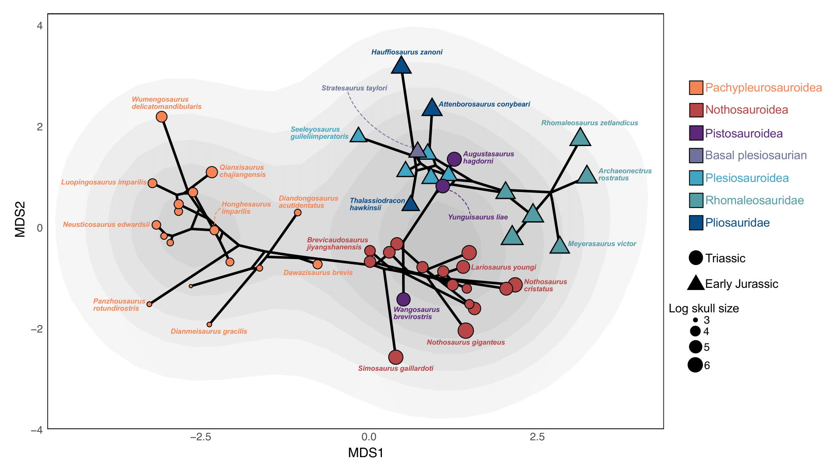

Supplementary figure 33. Eosauropterygian craniodental phylo-ecomorphospace occupation computed by using nMDS (dimension=2) and composite phylogenetic tree based on the phylogenetic analyses of Xu et al. (2022) and Wintrich et al. (2017). The phylo-ecomorphospace is superimposed on the density of taxa. Point sizes are scaled to the relative skull size of taxa (log skull size).

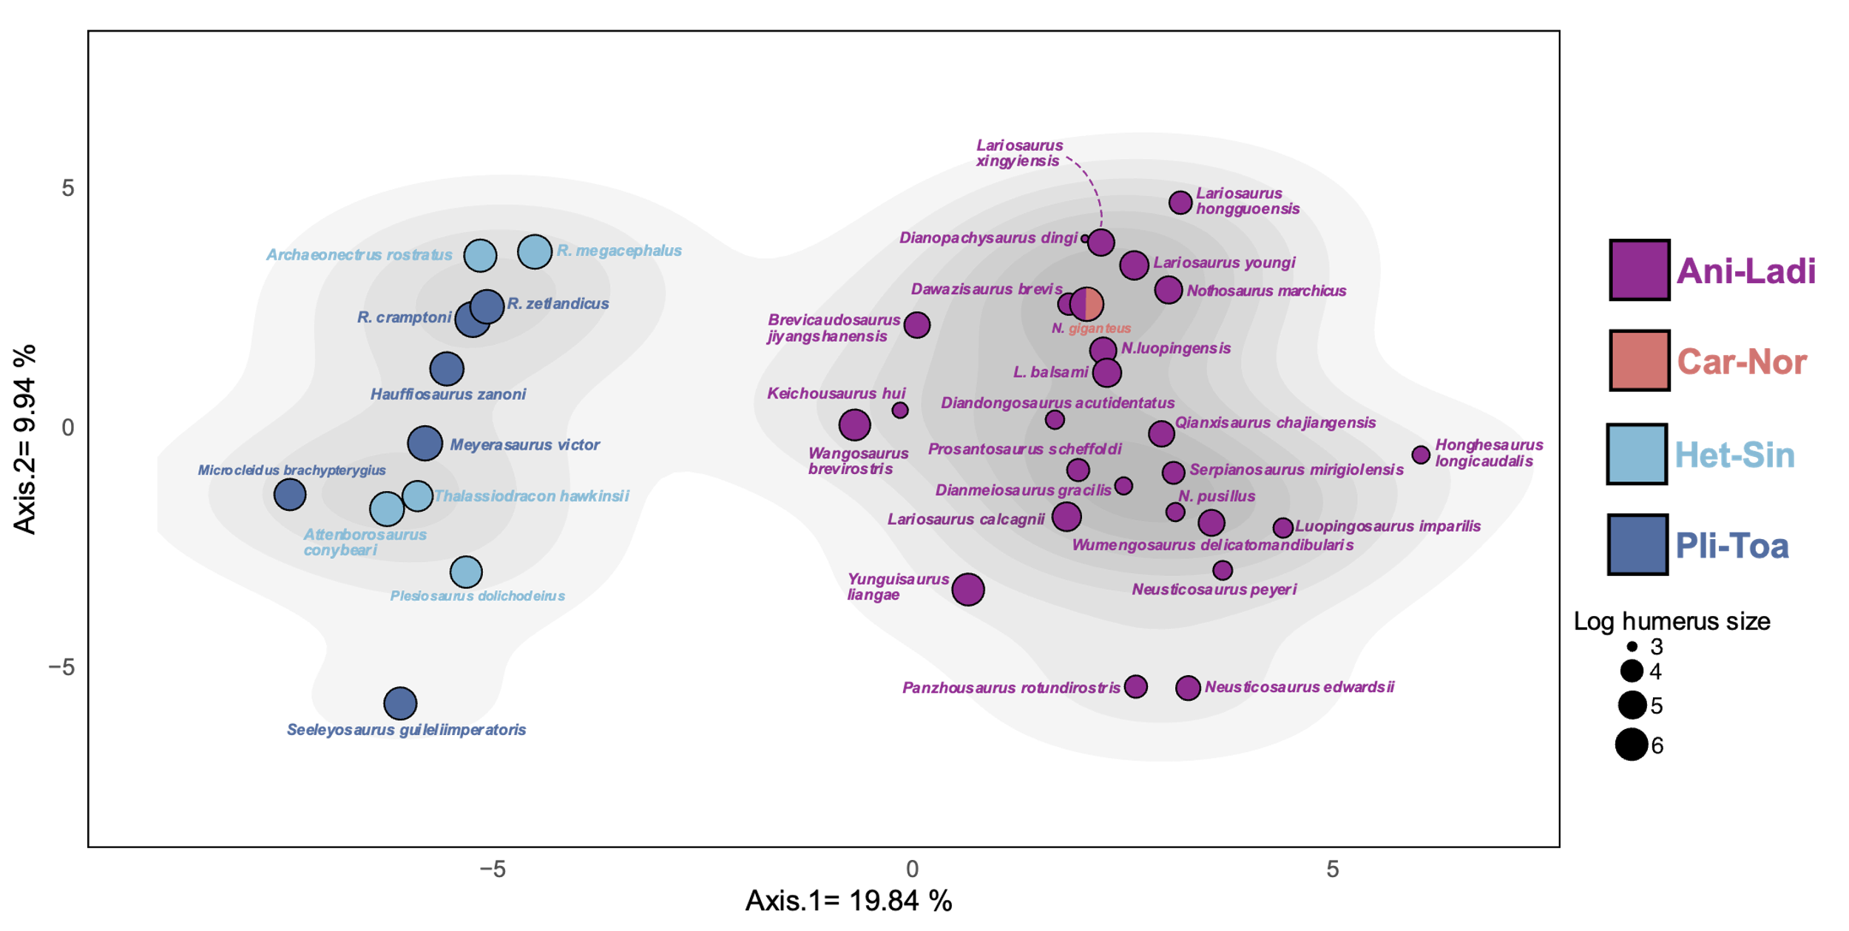

Supplementary figure 34. Eosauropterygian postcranial functional morphospace occupation based on the first two axes of the PCoA superimposed on the density of taxa. Point sizes are scaled to the relative humerus length of taxa (log humerus length). Abbreviations: Car-Nor, Carnian-Norian, Het-Sin, Hettangian-Sinemurian, Pli-Toa, Pliensbachian-Toarcian.

Supplementary figure 35. Eosauropterygian postcranial nMDS stress plot, showing the relationship between the dissimilarities between taxa present in the postcranial dissimilarity matrix and the ordination on the nMDS morphospace (maximum number of random starts = 100).

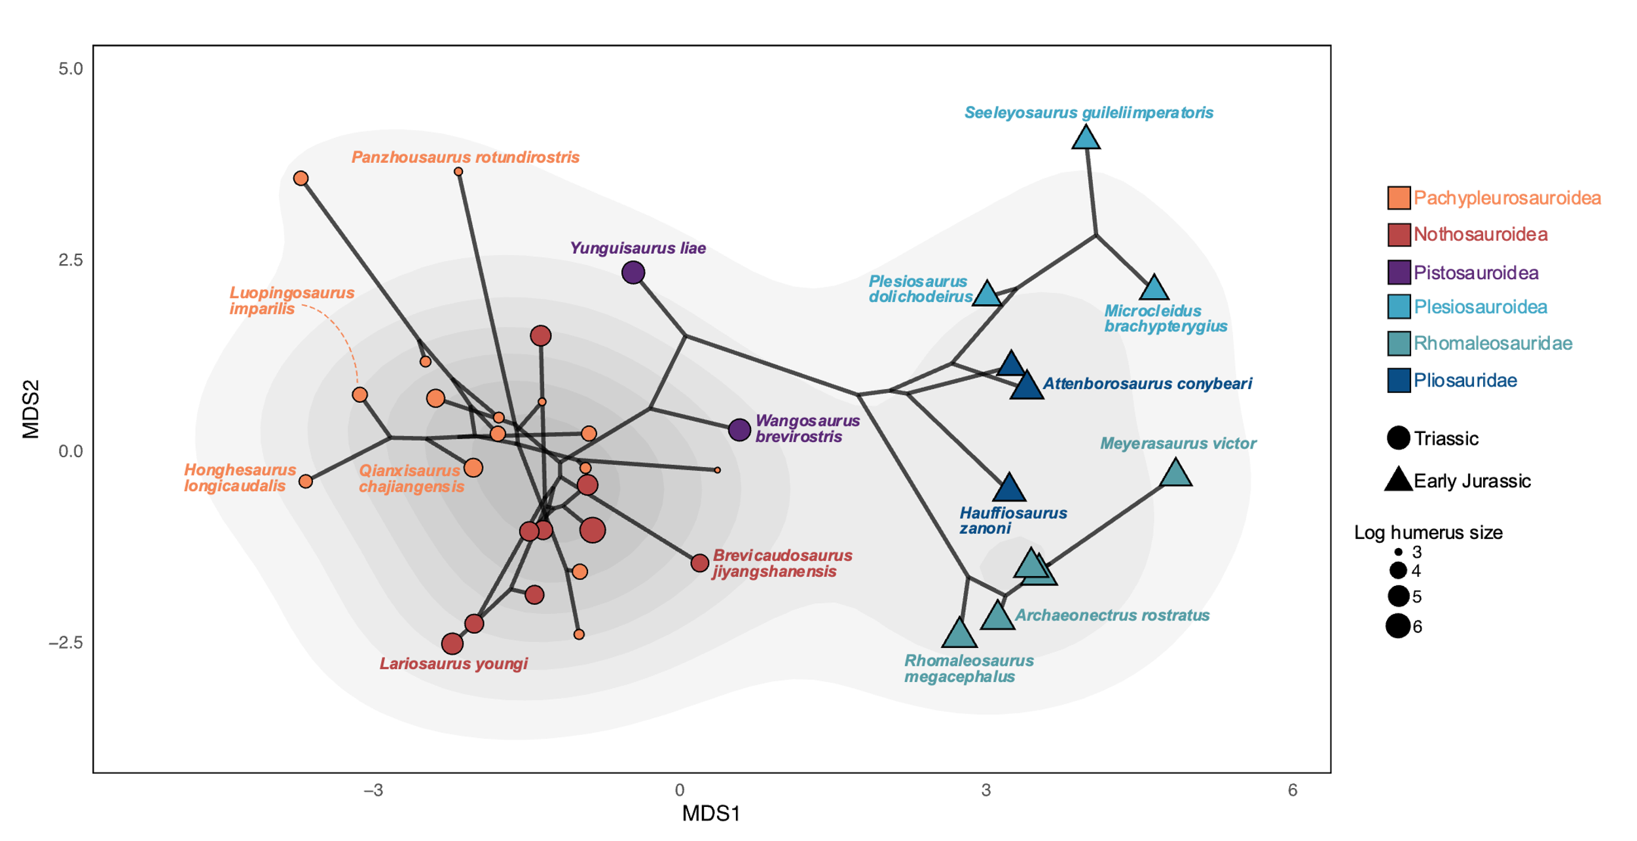

Supplementary figure 36. Eosauropterygian postcranial phylo-ecomorphospace occupation computed by using nMDS (dimension=2) and composite phylogenetic tree based on the phylogenetic analyses of Hu et al. (2024) and Wintrich et al. (2017). The phylo-ecomorphospace is superimposed on the density of taxa. Point sizes are scaled to the relative humerus length of taxa (log humerus size).

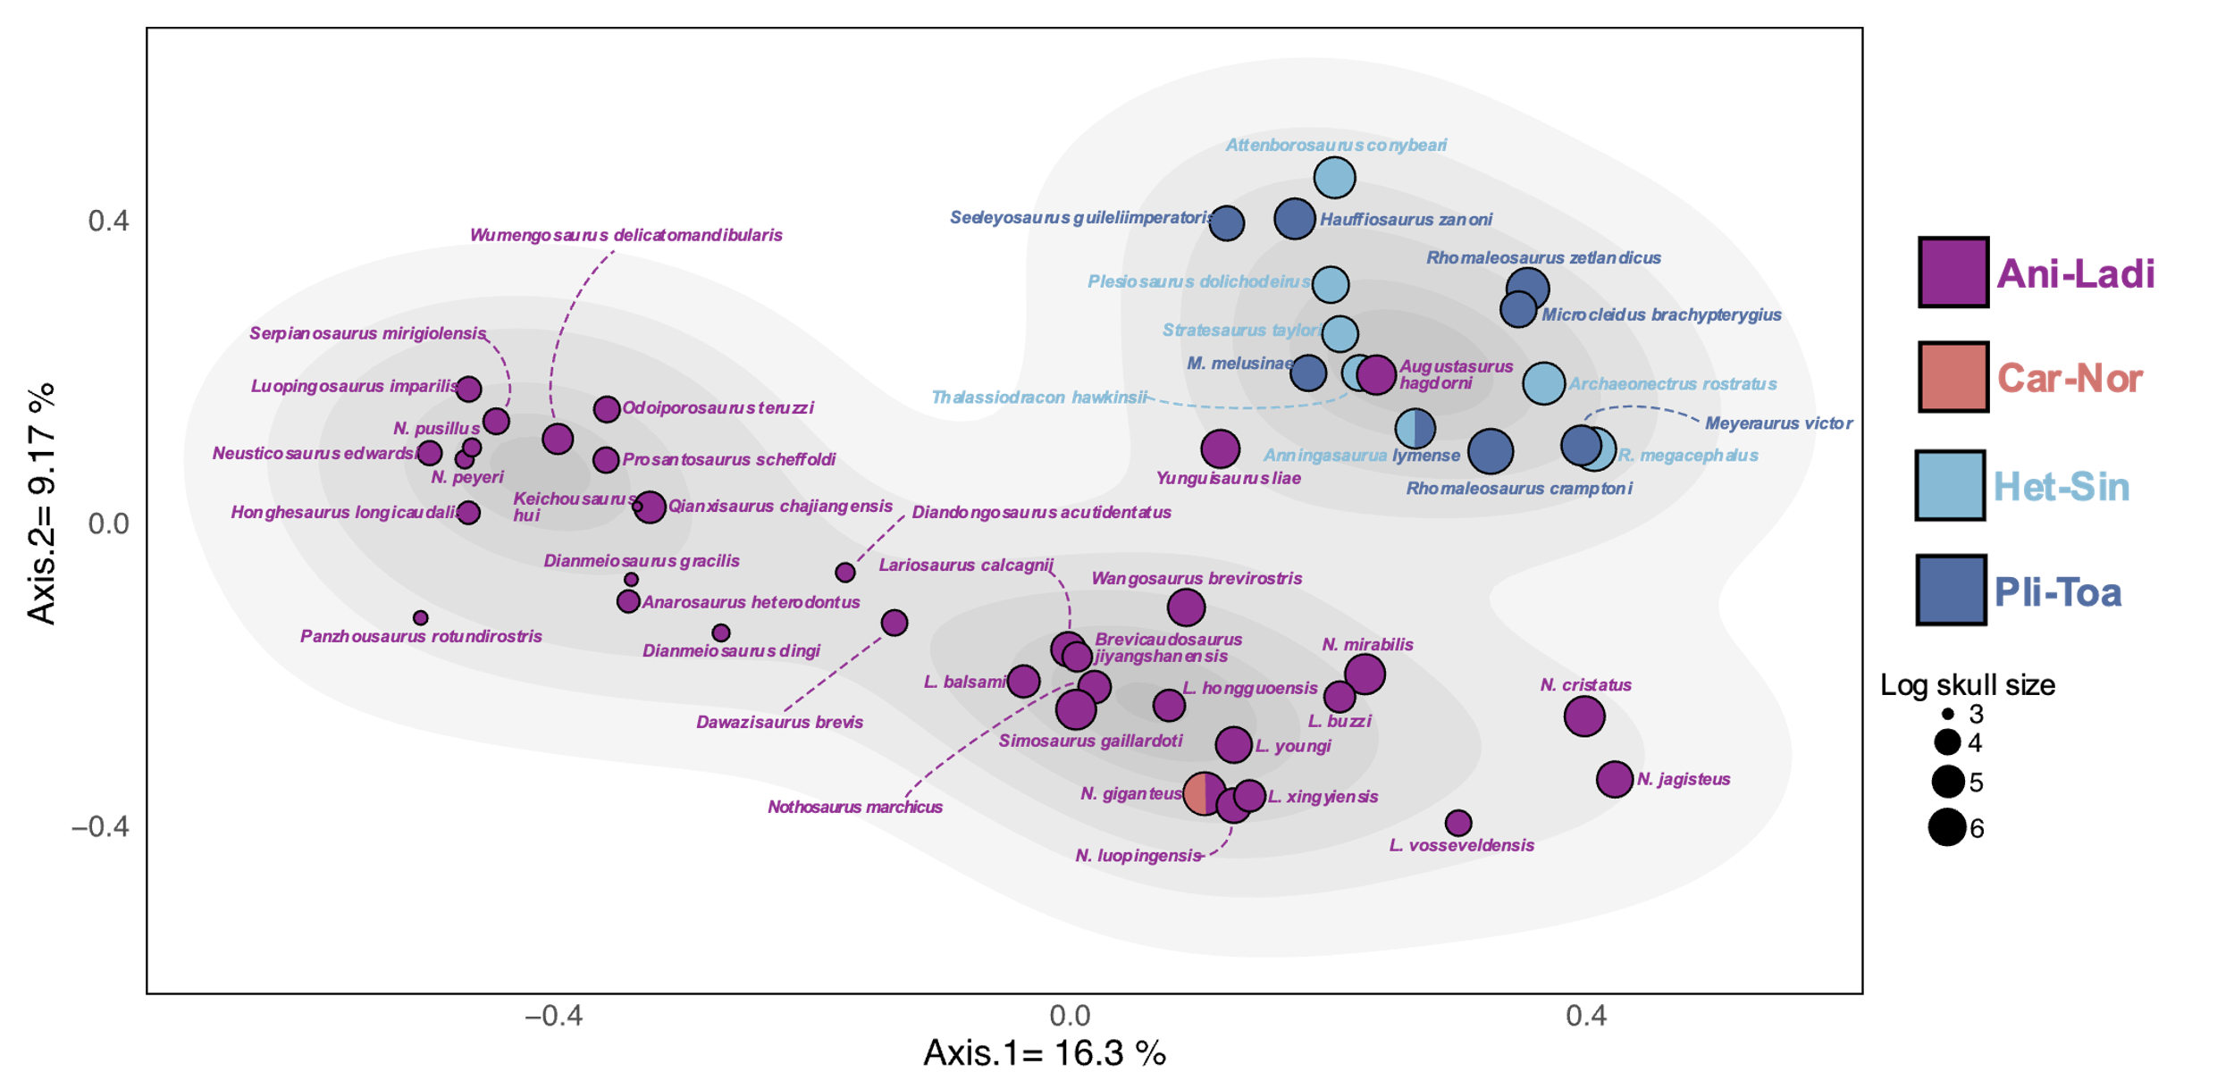

Supplementary figure 37. Eosauropterygian whole-body functional morphospace occupation based on the first two axes of the PCoA superimposed on the density of taxa. Point sizes are scaled to the relative skull size of taxa (log skull length). Abbreviations: Car-Nor, Carnian-Norian, Het-Sin, Hettangian-Sinemurian, Pli-Toa, Pliensbachian-Toarcian.

Supplementary figure 38. Eosauropterygian whole-body nMDS stress plot, showing the relationship between the dissimilarities between taxa present in the whole-body dissimilarity matrix and the ordination on the nMDS morphospace (maximum number of random starts = 100).

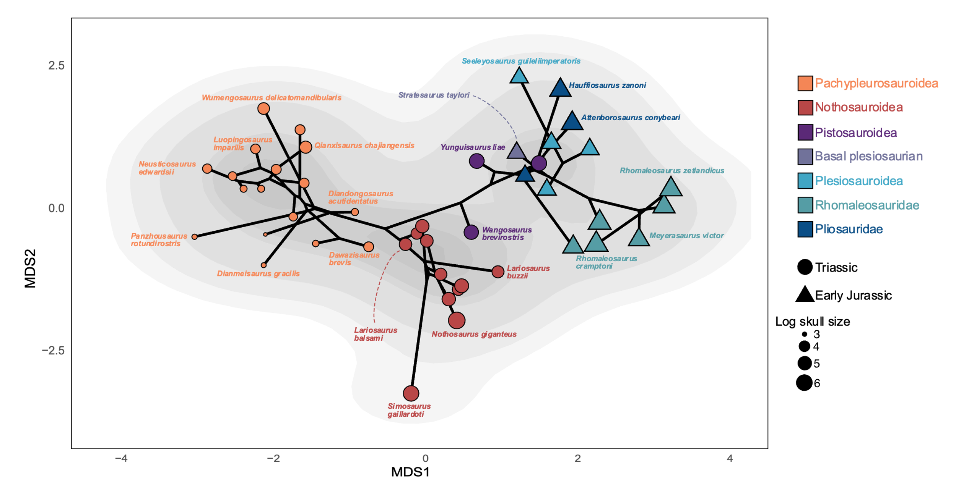

Supplementary figure 39. Eosauropterygian whole-body phylo-ecomorphospace occupation computed by using nMDS (dimension=2) and composite phylogenetic tree based on the phylogenetic analyses of Hu et al. (2024) and Wintrich et al. (2017). The phylo-ecomorphospace is superimposed on the density of taxa. Point sizes are scaled to the relative skull size of taxa (log skull size).

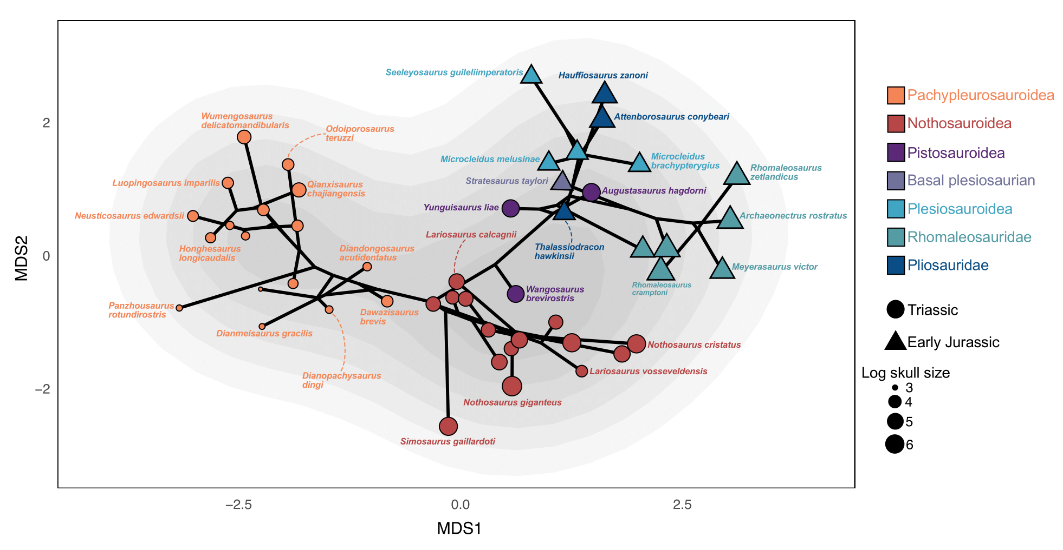
Supplementary figure 40. Eosauropterygian whole-body phylo-ecomorphospace occupation computed by using nMDS (dimension=2) and composite phylogenetic tree based on the phylogenetic analyses of Xu et al. (2022) and Wintrich et al. (2017). The phylo-ecomorphospace is superimposed on the density of taxa. Point sizes are scaled to the relative skull size of taxa (log skull size).

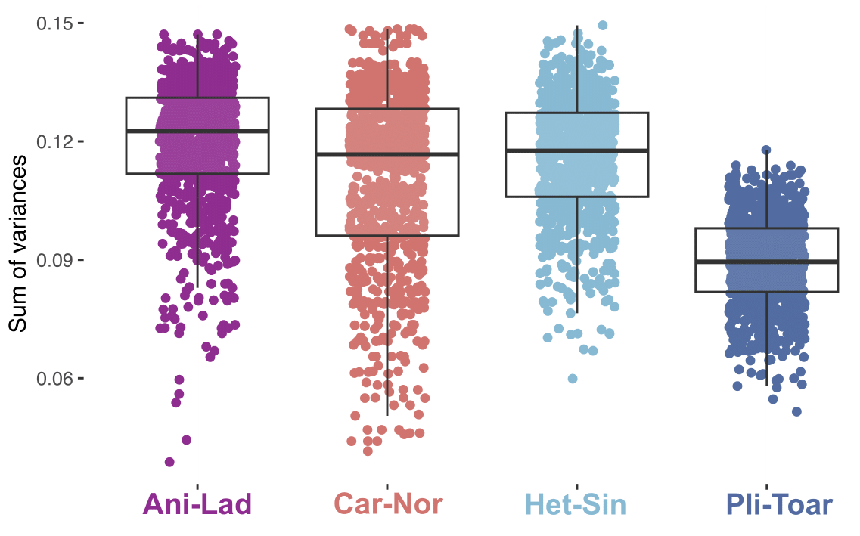

Supplementary figure 41. Comparison of ichthyosaurian temporal disparity distribution generated with the craniodental ecomorphological dataset. We used the sum of variances metric and 1000 bootstraps replications. Abbreviations: Ani-Lad, Anisian-Ladinian, Car-Nor, Carnian-Norian, Het-Sin, Hettangian-Sinemurian, Pli-Toa, Pliensbachian-Toarcian.

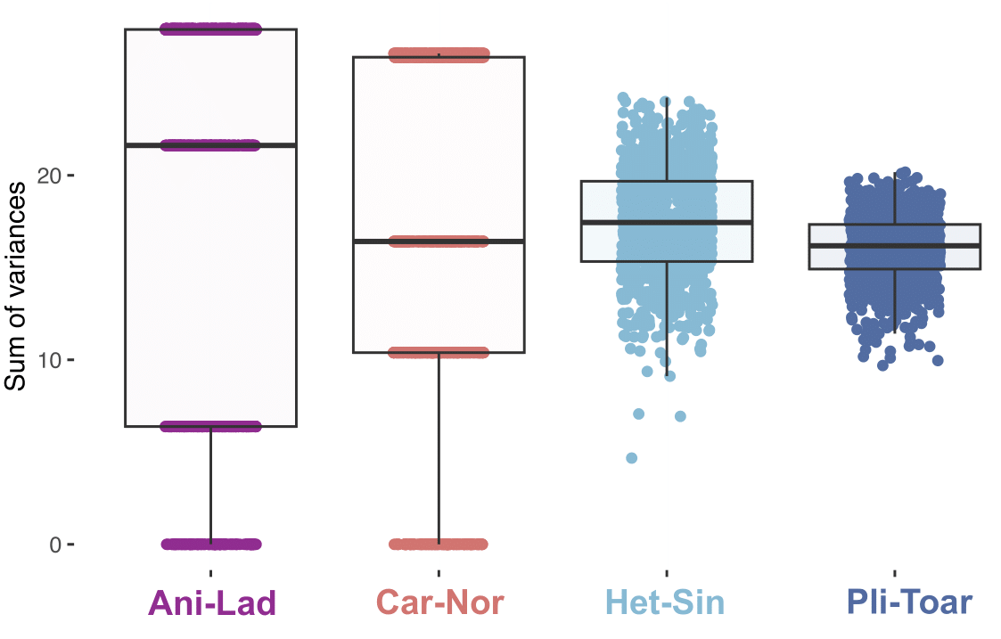

Supplementary figure 42. Comparison of ichthyosaurian temporal disparity distribution generated with the postcranial ecomorphological dataset. We used the sum of variances metric and 1000 bootstraps replications. The disparity distributions of Triassic time intervals (Ani-Lad and Car-Nor) should be carefully interpreted due to a poor and incomplete sampling as they both only contain three taxa. Abbreviations: Ani-Lad, Anisian-Ladinian, Car-Nor, Carnian-Norian, Het-Sin, Hettangian-Sinemurian, Pli-Toa, Pliensbachian-Toarcian.

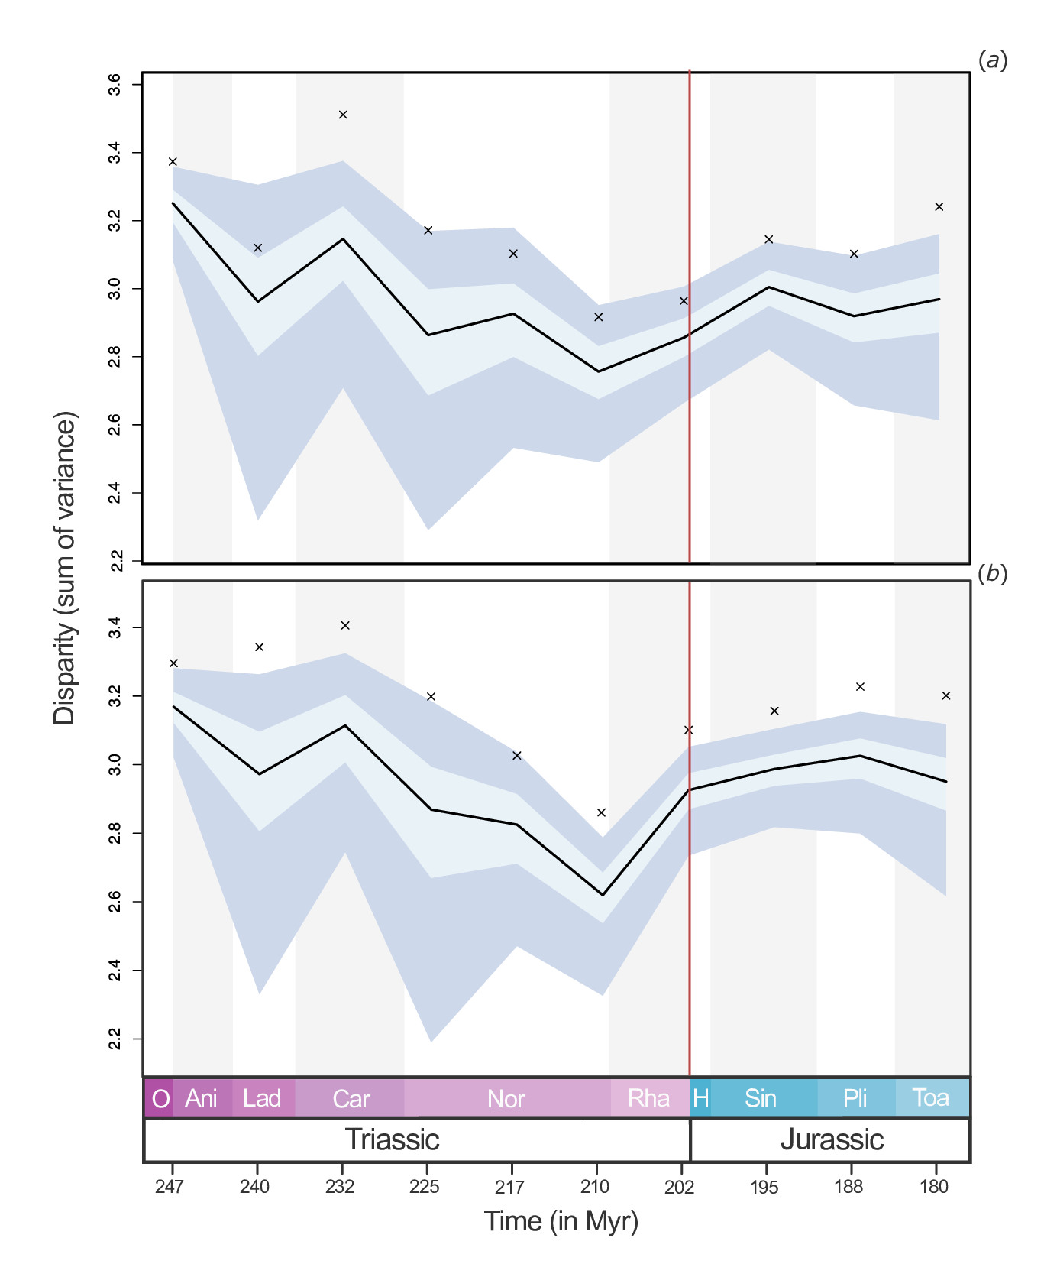

Supplementary figure 43. Ichthyosaurian disparity through time during the Triassic – Lower Jurassic interval. Disparity has been computed by using the modified character-taxon matrix of Laboury et al. (2022) by using the Hedman-dated tree and the time-slicing approach (see Material and Methods). Disparity have been calculated at 10 equidistant time slices under (a) ‘equal splits’ and (b) ‘proximity’ models of evolution. The ‘equal splits’ probabilistic model assigns the ordination score, with an equal probability, from both the ancestor and the descendant while the ‘proximity’ model selects the ordination of the ancestral node or the tips depending on which part of the branch the time-slice occurs. Light blue and blue envelopes represent respectively 95% and 50% confidence intervals based on 1000 bootstrap replicates. Red line indicates the Triassic-Jurassic transition and crosses indicate the observed disparity.

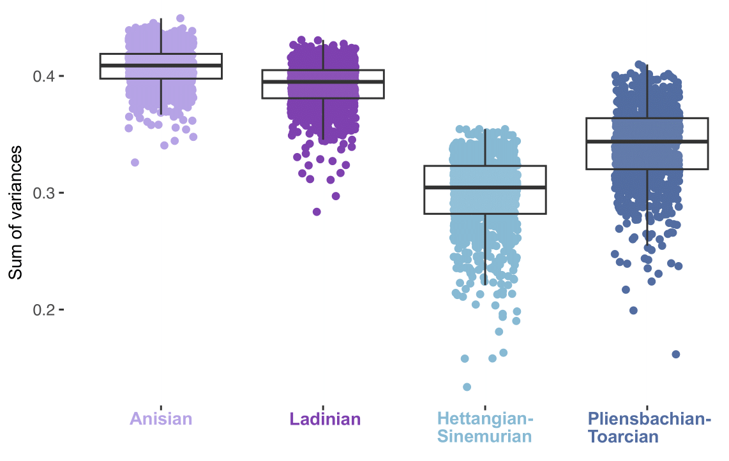

Supplementary figure 44. Comparison of eosauropterygian temporal disparity distribution generated with the craniodental ecomorphological dataset. We used the sum of variances metric and 1000 bootstraps replications. As the occurrence of Middle Triassic taxa is well known and sufficiently precise, here, we treated Anisian and Ladinian as two distinctive time intervals. The disparity distribution of the interval Car-Nor can’t be calculated as only one taxon is included (e.g. Nothosaurus giganteus). Abbreviations: Het-Sin, Hettangian-Sinemurian, Pli-Toa, Pliensbachian-Toarcian.

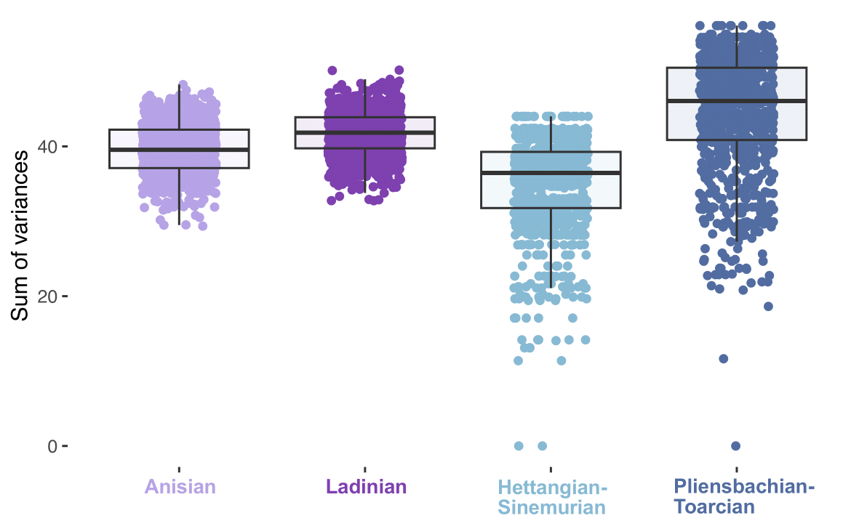

Supplementary figure 45. Comparison of eosauropterygian temporal disparity distribution generated with the postcranial ecomorphological dataset. We used the sum of variances metric and 1000 bootstraps replications. As the occurrence of Middle Triassic taxa is well known and sufficiently precise, here, we treated Anisian and Ladinian as two distinctive time intervals. The disparity distribution of the interval Car-Nor can’t be calculated as only one taxon is included (e.g. Nothosaurus giganteus). Abbreviations: Het-Sin, Hettangian-Sinemurian, Pli-Toa, Pliensbachian-Toarcian.

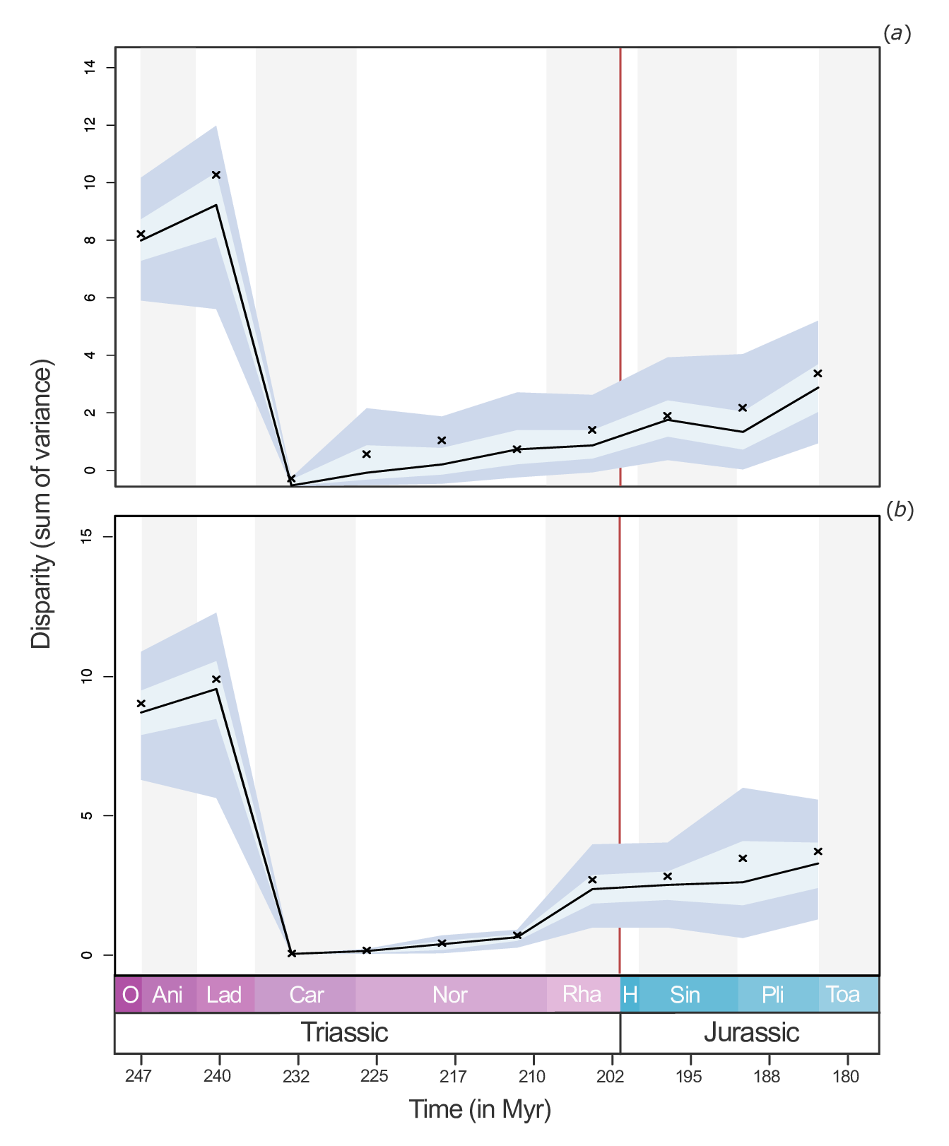

Supplementary figure 46. Eosauropterygian disparity through time during the Triassic – Lower Jurassic interval. Disparity has been calculated with the time-slicing approach (see Material and Methods) by using scores of tips and nodes present in the phylomorphospace computed with all morphological data and based on the phylogenetic analyses of Hu et al. (2024) and Wintrich et al. (2017). The phylogenetic tree is timescaled by using the Hedman method. Disparity have been calculated at 10 equidistant time under (a) ‘equal splits’ and (b) ‘proximity’ models of evolution. The ‘equal splits’ probabilistic model assigns the ordination score, with an equal probability, from both the ancestor and the descendant while the ‘proximity’ model selects the ordination of the ancestral node or the tips depending on which part of the branch the time-slice occurs. Light blue and blue envelopes represent respectively 95% and 50% confidence intervals based on 1000 bootstrap replicates. Red line indicates the Triassic-Jurassic transition and crosses indicate the observed disparity.

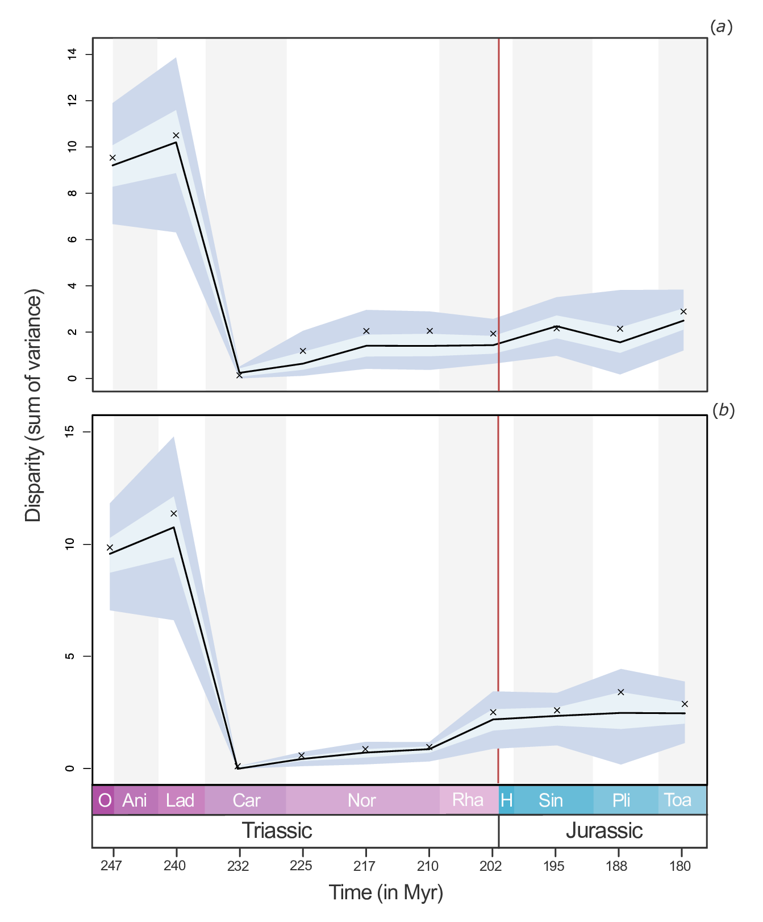

Supplementary figure 47. Eosauropterygian disparity through time during the Triassic – Lower Jurassic interval. Disparity has been calculated with the time-slicing approach (see Material and Methods) by using scores of tips and nodes present in the phylomorphospace computed with all morphological data and based on the phylogenetic analyses of Xu et al. (2022) and Wintrich et al. (2017). The phylogenetic tree is timescaled by using the Hedman method. Disparity have been calculated at 10 equidistant time under (a) ‘equal splits’ and (b) ‘proximity’ models of evolution. The ‘equal splits’ probabilistic model assigns the ordination score, with an equal probability, from both the ancestor and the descendant while the ‘proximity’ model selects the ordination of the ancestral node or the tips depending on which part of the branch the time-slice occurs. Light blue and blue envelopes represent respectively 95% and 50% confidence intervals based on 1000 bootstrap replicates. Red line indicates the Triassic-Jurassic transition and crosses indicate the observed disparity.

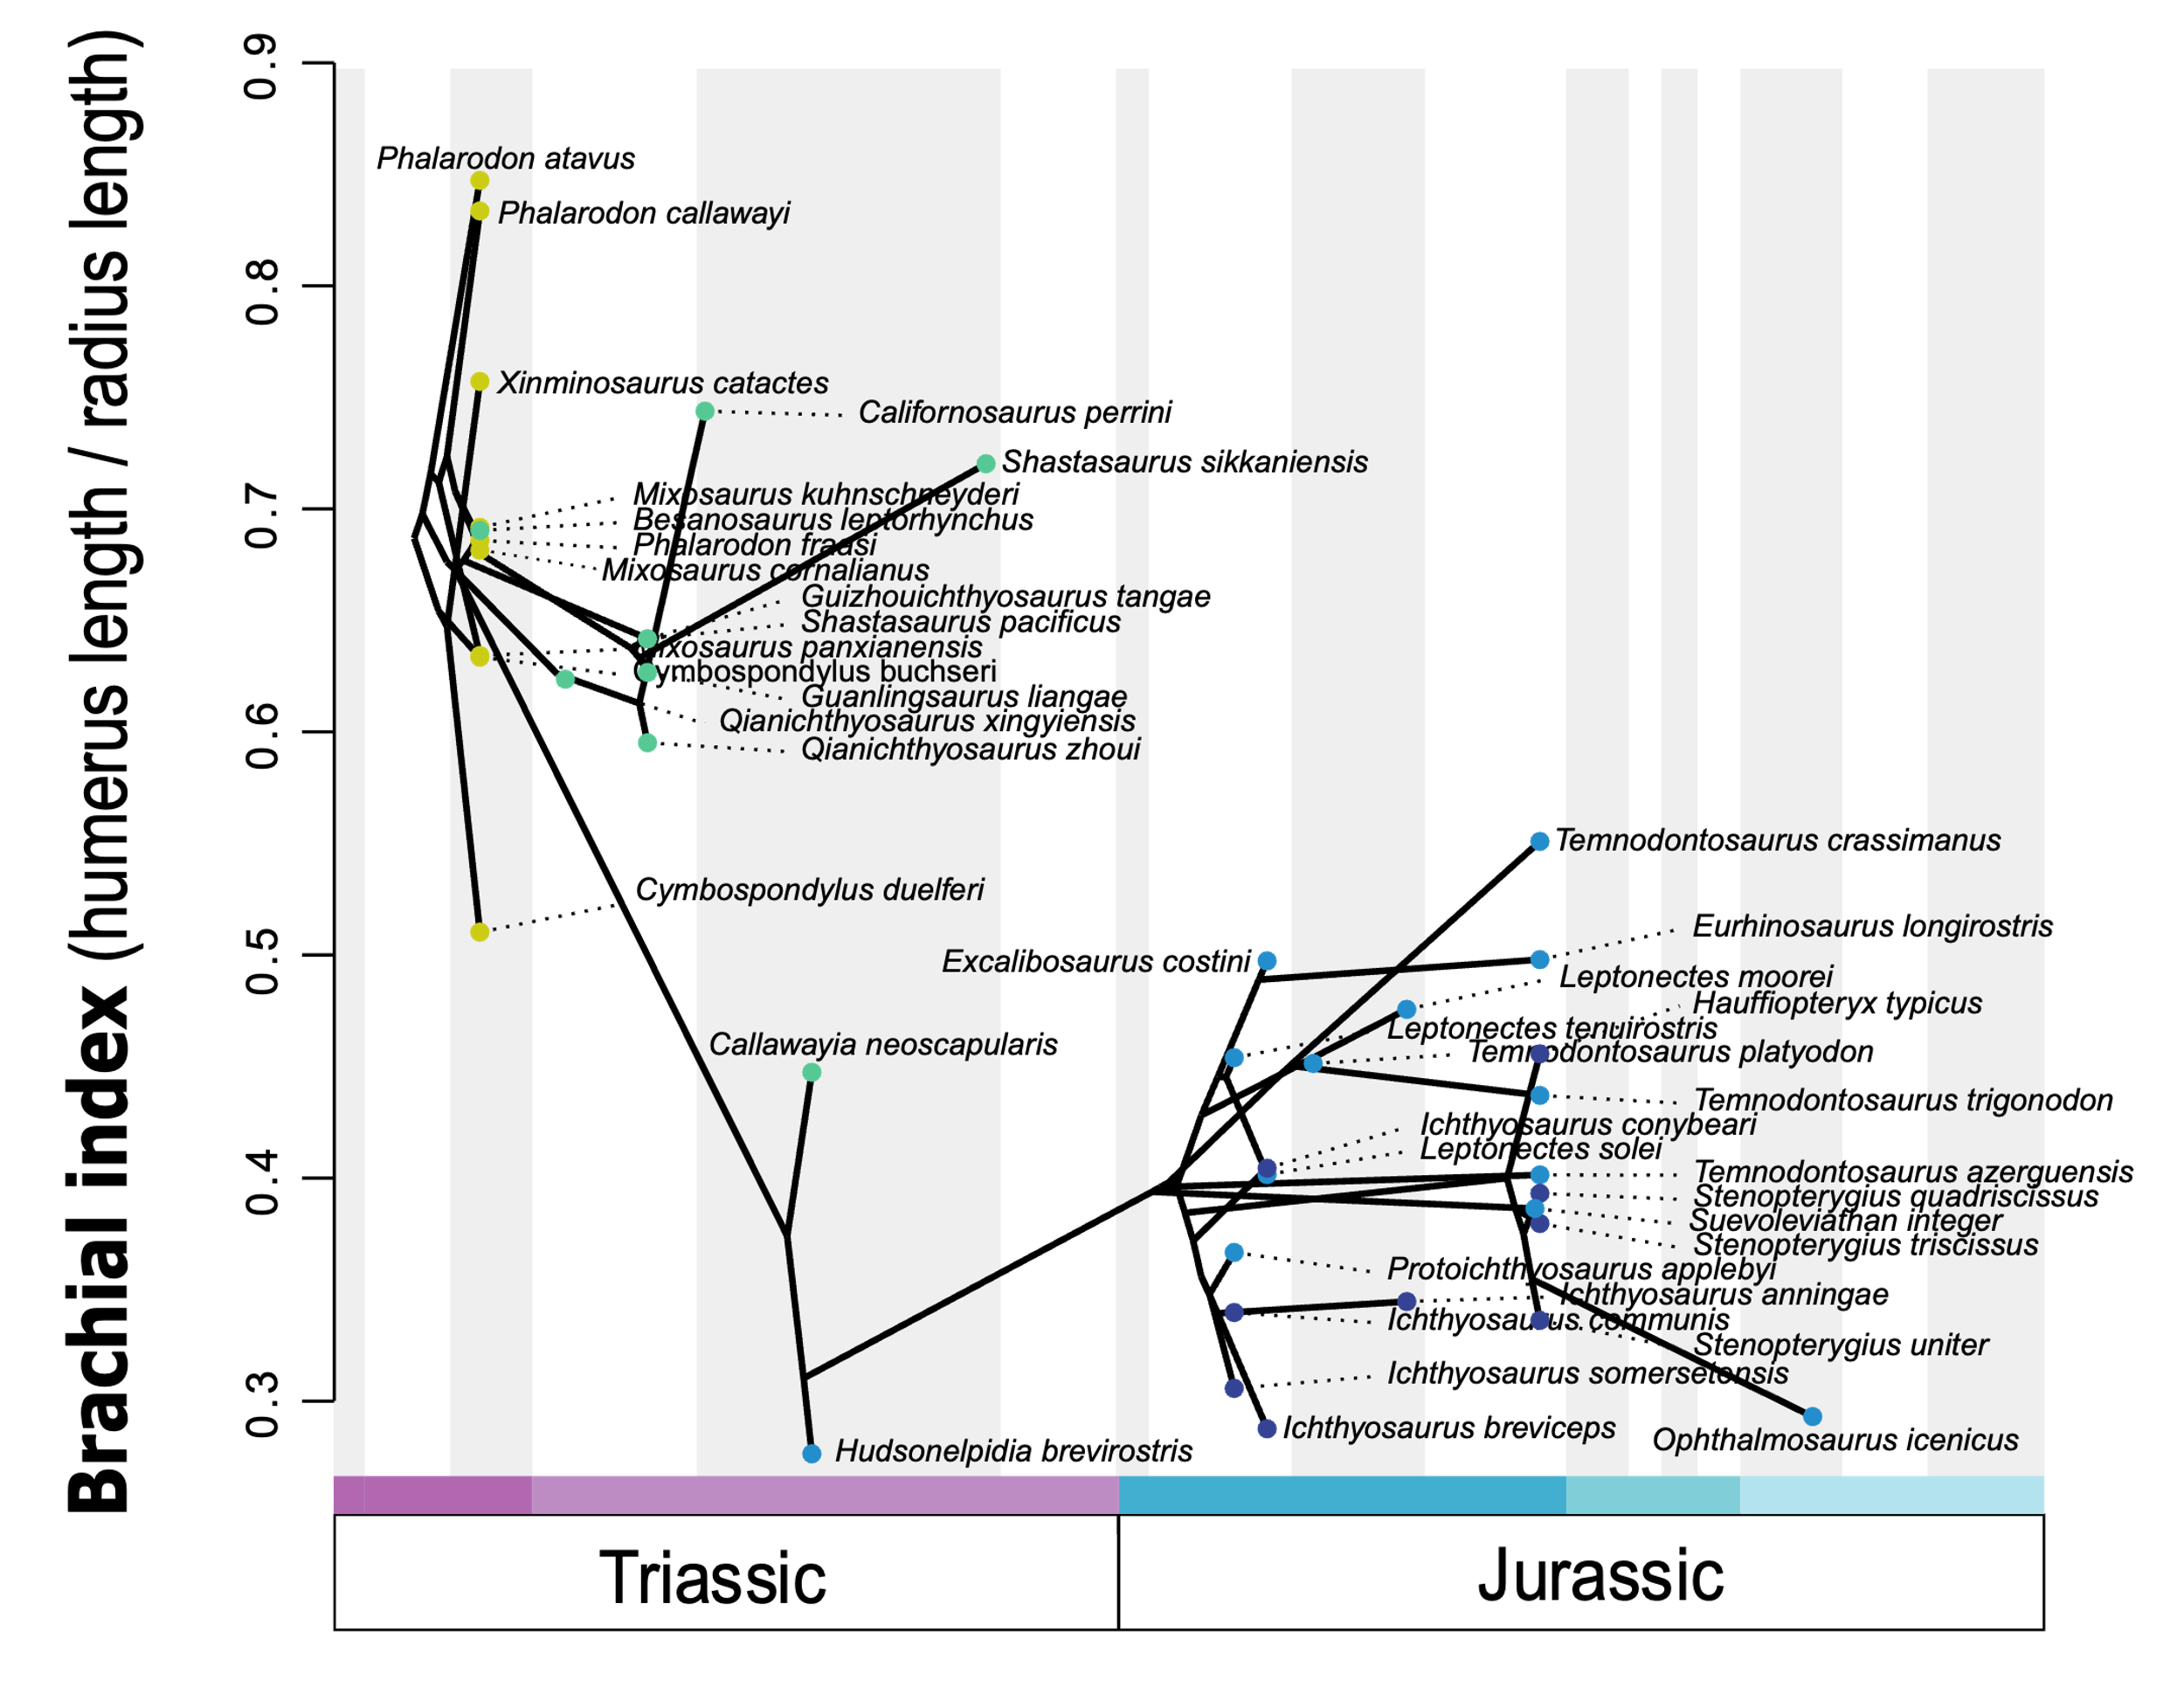
Supplementary figure 48. Pattern of brachial index evolution in ichthyosaurians through Middle Triassic – Early Jurassic time interval. The phenogram is generated analysing the modified phylogenetic matrix of Laboury et al. (2022) in a Maximum Parsimony framework under implied weighting (k=12) and time scaled with the minimum branch length approach. Each dot is coloured with respect to its relative group (light green: early ichthyosaurians, green: shastasaurid – grade merriamosaurians, light blue, early parvipelvians; dark blue, thunnosaurians).

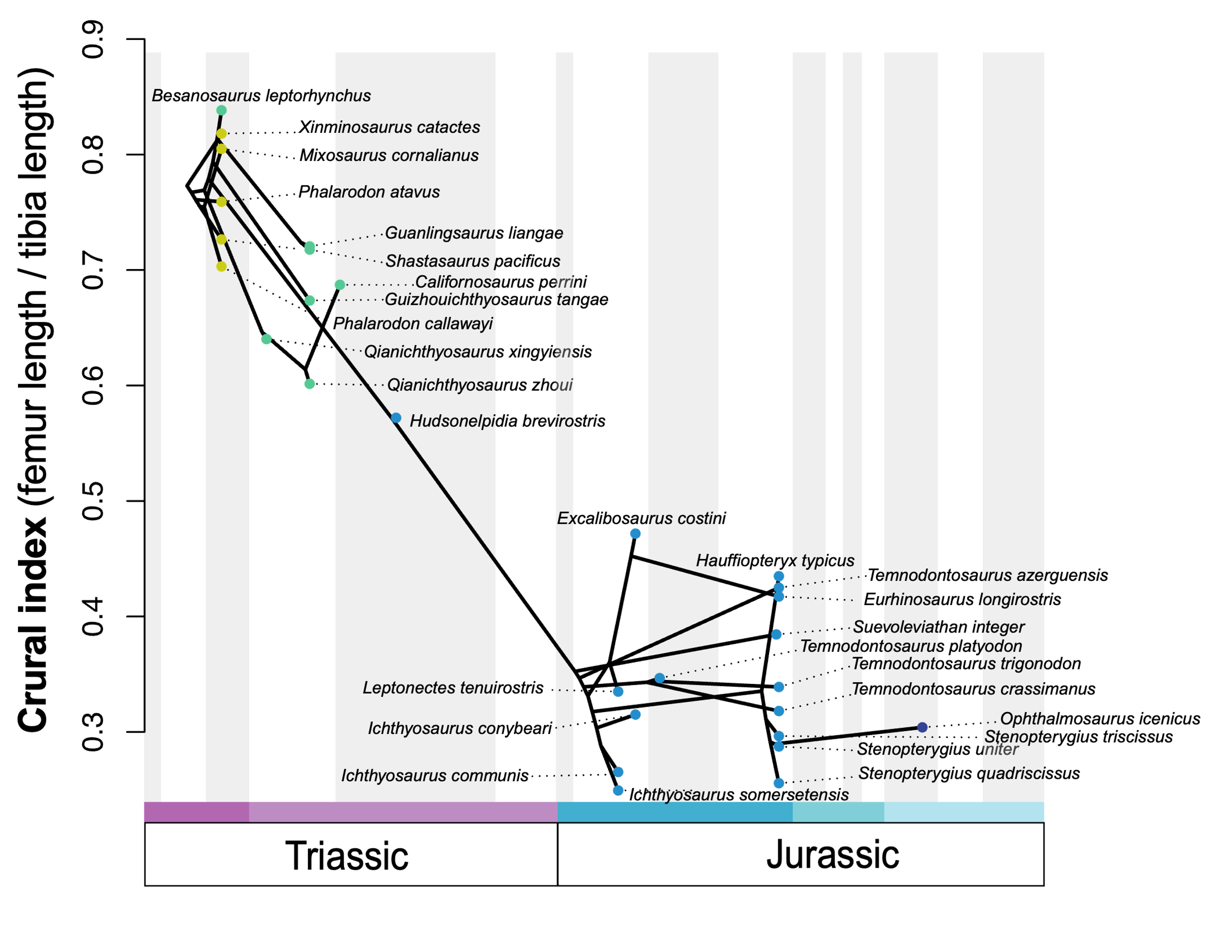

Supplementary figure 49. Pattern of crural index evolution in ichthyosaurians through Middle Triassic – Early Jurassic time interval. The phenogram is generated analysing the modified phylogenetic matrix of Laboury et al. (2022) in a Maximum Parsimony framework under implied weighting (k=12) and time scaled with the minimum branch length approach. Each dot is coloured with respect to its relative group (light green: early ichthyosaurians, green: shastasaurid – grade merriamosaurians, light blue, early parvipelvians; dark blue, thunnosaurians).

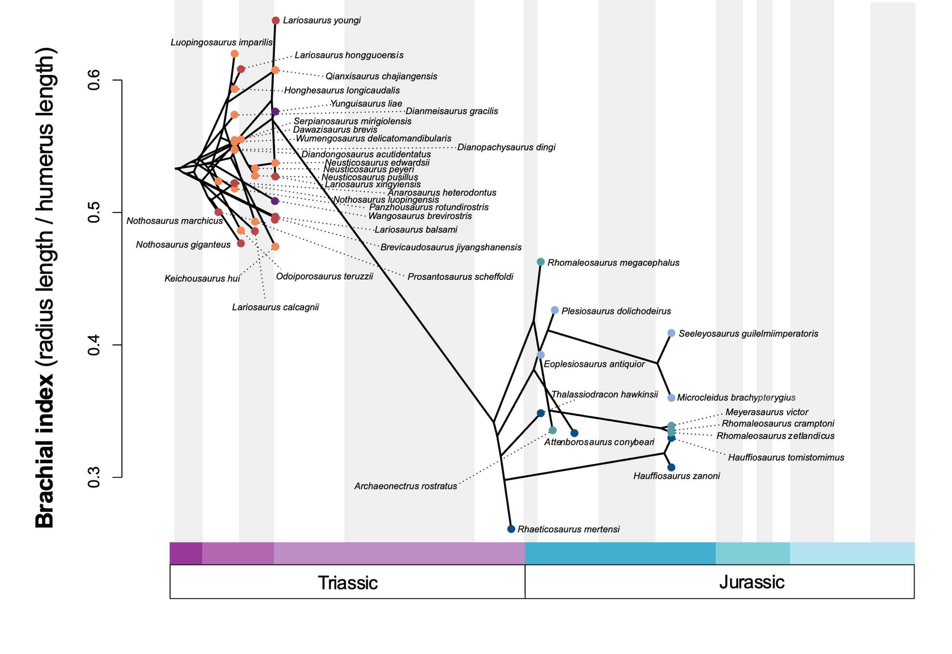
Supplementary figure 50. Pattern of brachial index evolution in eosauropterygians through Middle Triassic – Early Jurassic time interval. The phenogram is generated by using our composite phylogenetic tree created by merging analyses of Hu et al. (2024) and Wintrich et al. (2017) datasets in a Maximum Parsimony framework under implied weighting (k=12) and time scaled with the minimum branch length approach. Each dot is coloured with respect to its relative group (orange: pachypleurosauroids, red: nothosauroids, purple: pistosauroids, light blue: plesiosauroids, dark blue: pliosauroids, turquoise: rhomaleosaurids).

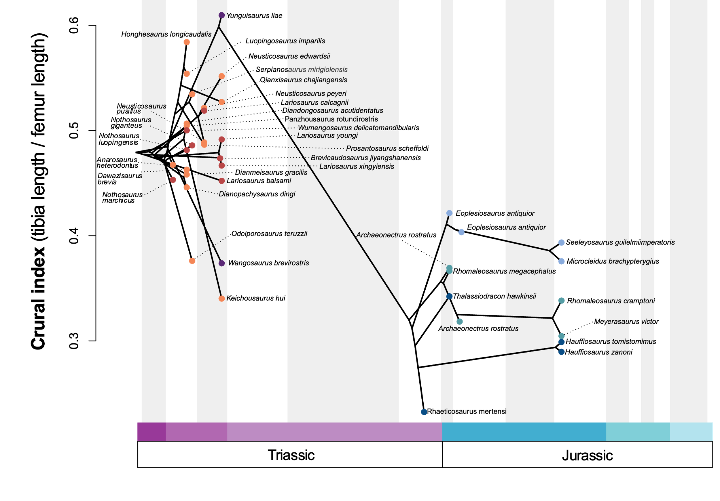

Supplementary figure 51. Pattern of brachial index evolution in eosauropterygians through Middle Triassic – Early Jurassic time interval. The phenogram is generated by using our composite phylogenetic tree created by merging analyses of Hu et al. (2024) and Wintrich et al. (2017) datasets in a Maximum Parsimony framework under implied weighting (k=12) and time scaled with the minimum branch length approach. Each dot is coloured with respect to its relative group (orange: pachypleurosauroids, red: nothosauroids, purple: pistosauroids, light blue: plesiosauroids, dark blue: pliosauroids, turquoise: rhomaleosaurids).
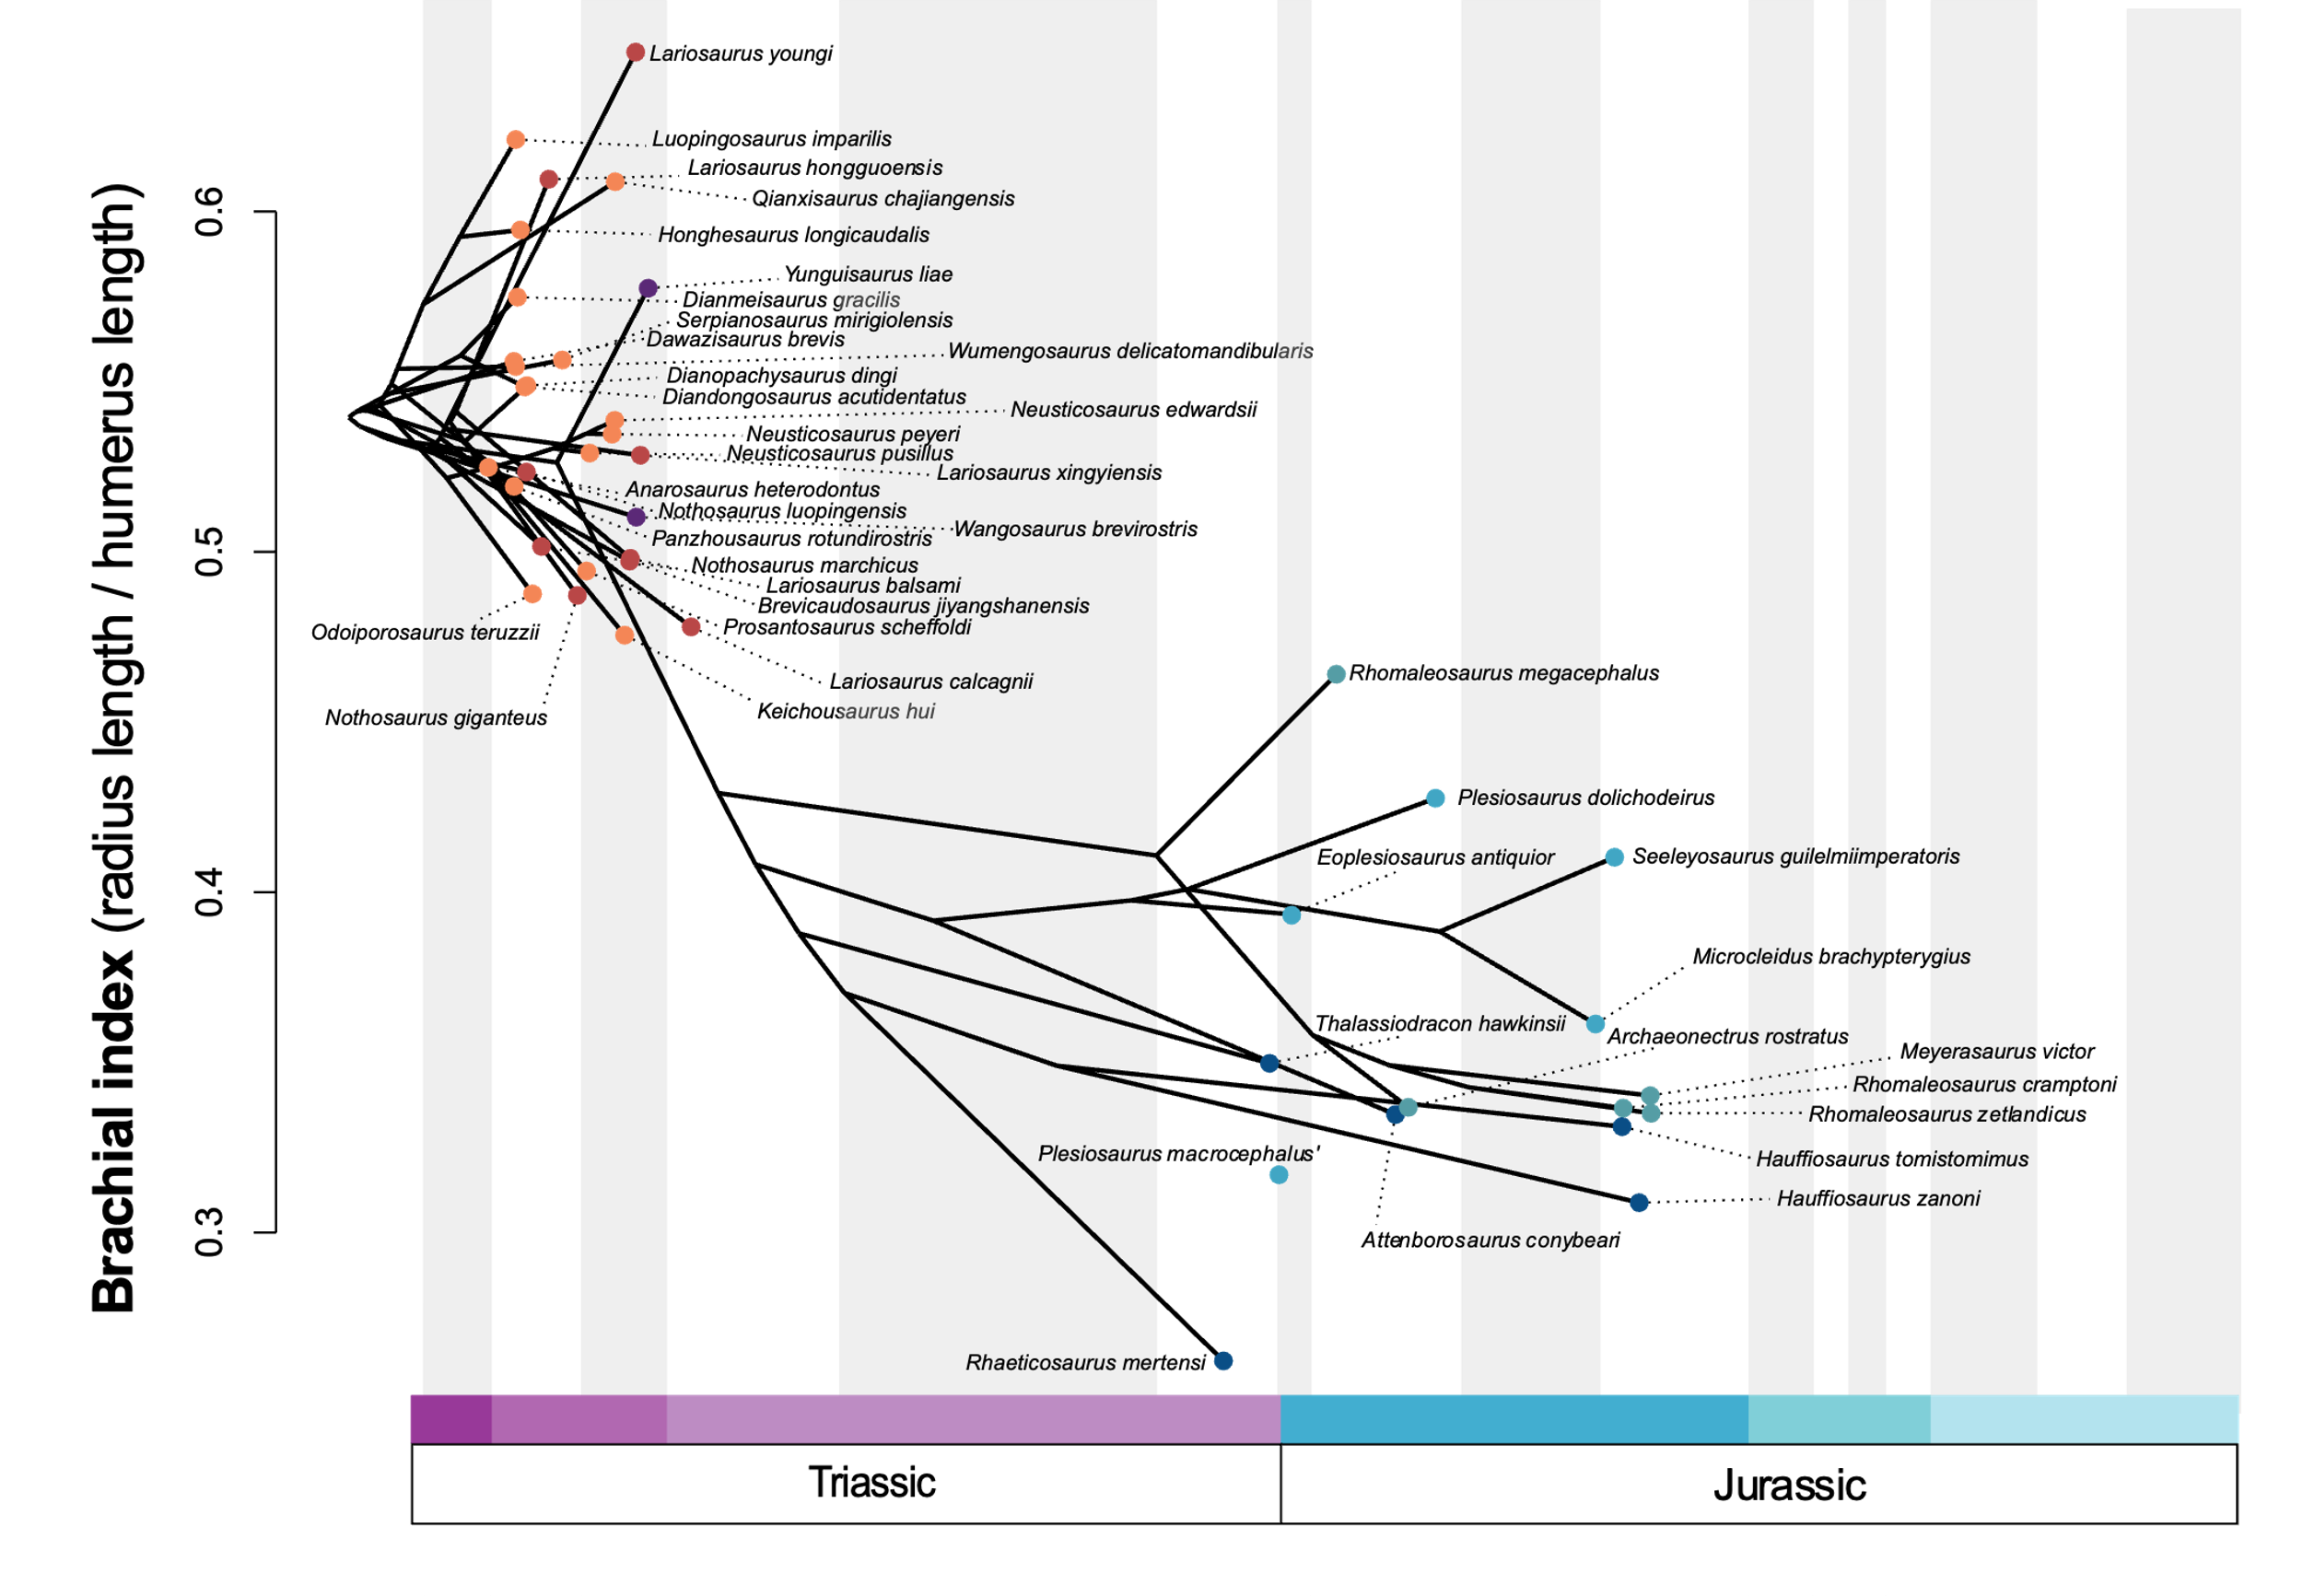
Supplementary figure 52. Pattern of brachial index evolution in eosauropterygians through Middle Triassic – Early Jurassic time interval. The phenogram is generated by using our composite phylogenetic tree created by merging analyses of Xu et al. (2022) and Wintrich et al. (2017) datasets in a Maximum Parsimony framework under implied weighting (k=12) and time scaled with the Hedman algorithm. Each dot is coloured with respect to its relative group (orange: pachypleurosauroids, red: nothosauroids, purple: pistosauroids, light blue: plesiosauroids, dark blue: pliosauroids, turquoise: rhomaleosaurids).

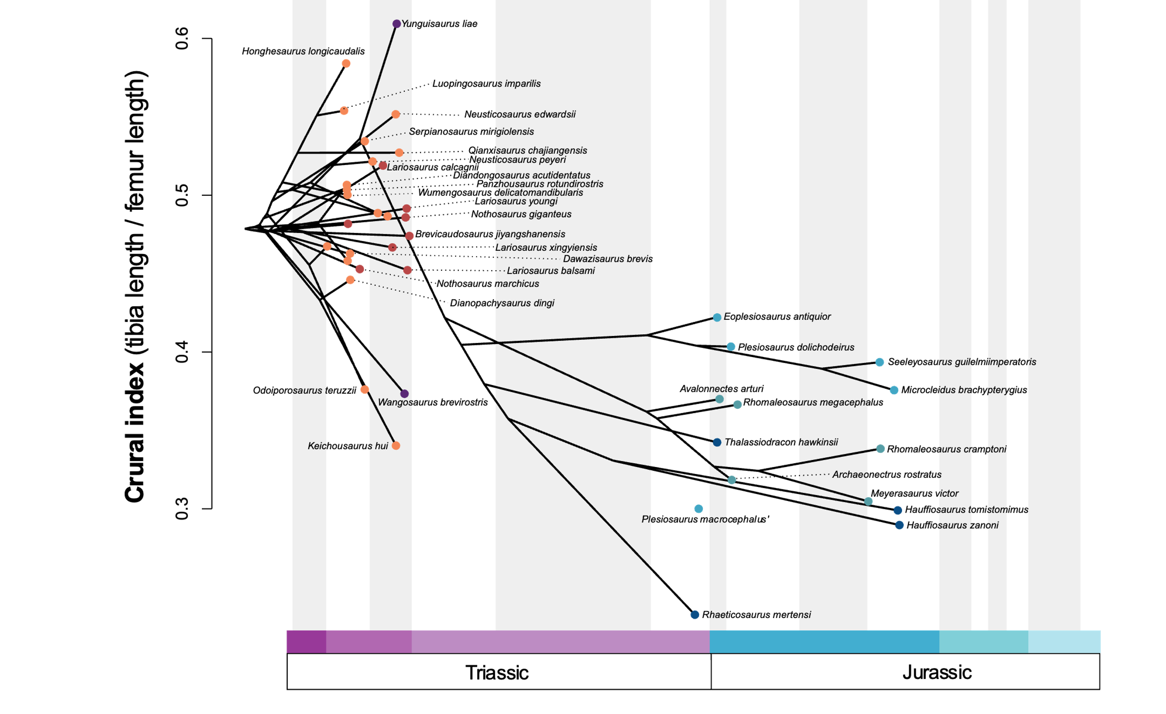

Supplementary figure 53. Pattern of crural index evolution in eosauropterygians through Middle Triassic – Early Jurassic time interval. The phenogram is generated by using our composite phylogenetic tree created by merging analyses of Xu et al. (2022) and Wintrich et al. (2017) datasets in a Maximum Parsimony framework under implied weighting (k=12) and time scaled with the Hedman algorithm. Each dot is coloured with respect to its relative group (orange: pachypleurosauroids, red: nothosauroids, purple: pistosauroids, light blue: plesiosauroids, dark blue: pliosauroids, turquoise: rhomaleosaurids).

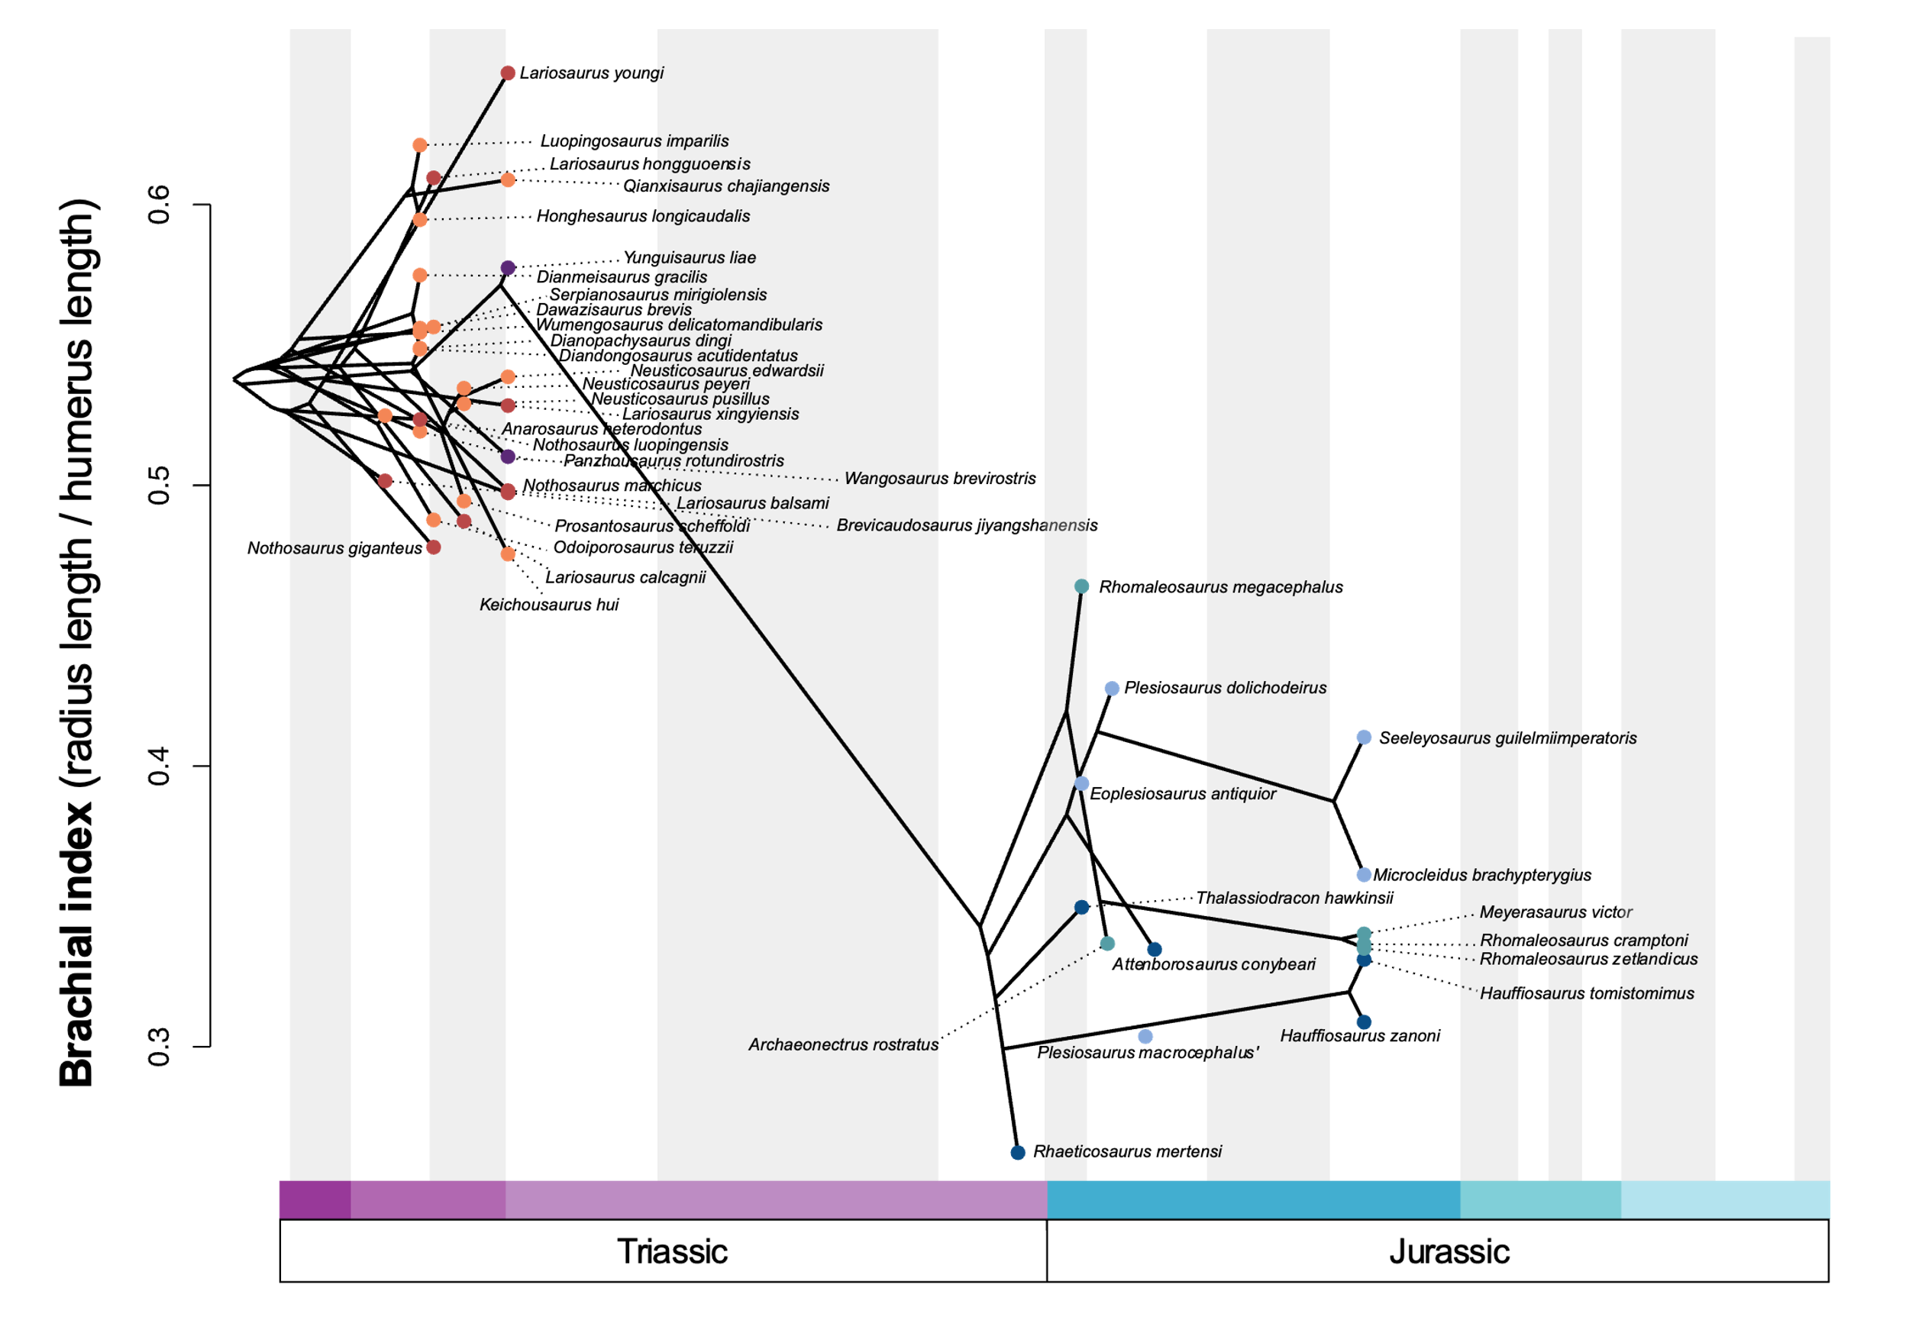

Supplementary figure 54. Pattern of brachial index evolution in eosauropterygians through Middle Triassic – Early Jurassic time interval. The phenogram is generated by using our composite phylogenetic tree created by merging analyses of Xu et al. (2022) and Wintrich et al. (2017) datasets in a Maximum Parsimony framework under implied weighting (k=12) and time scaled with the minimum branch length approach. Each dot is coloured with respect to its relative group (orange: pachypleurosauroids, red: nothosauroids, purple: pistosauroids, light blue: plesiosauroids, dark blue: pliosauroids, turquoise: rhomaleosaurids).

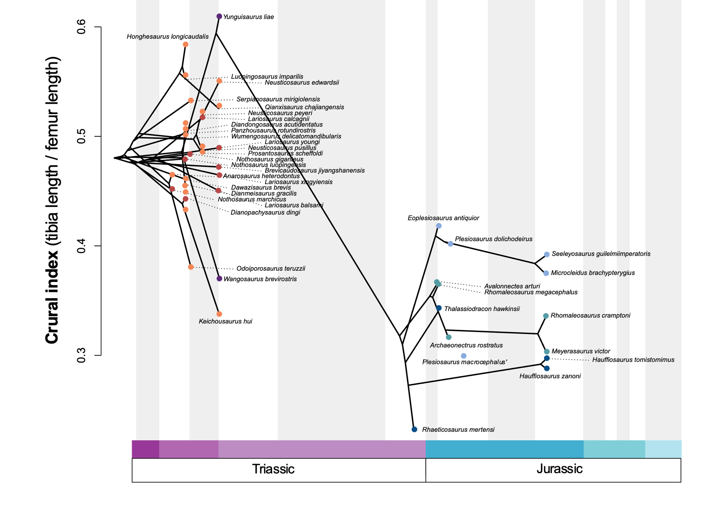
Supplementary figure 55. Pattern of crural index evolution in eosauropterygians through Middle Triassic – Early Jurassic time interval. The phenogram is generated by using our composite phylogenetic tree created by merging analyses of Xu et al. (2022) and Wintrich et al. (2017) datasets in a Maximum Parsimony framework under implied weighting (k=12) and time scaled with the minimum branch length approach. Each dot is coloured with respect to its relative group (orange: pachypleurosauroids, red: nothosauroids, purple: pistosauroids, light blue: plesiosauroids, dark blue: pliosauroids, turquoise: rhomaleosaurids).

Supplementary references

Anderson P. 2009. Biomechanics, functional patterns, and disparity in Late Devonian arthrodires. Paleobiology 35:321–342. DOI: 10.1666/0094-8373-35.3.321.

Anderson PSL, Friedman M, Brazeau MD, Rayfield EJ. 2011. Initial radiation of jaws demonstrated stability despite faunal and environmental change. Nature 476:206–209. DOI: 10.1038/nature10207.

Bapst DW. 2012. paleotree: an R package for paleontological and phylogenetic analyses of evolution. Methods in Ecology and Evolution 3:803–807. DOI: 10.1111/j.2041-210X.2012.00223.x.

Bardet N, Godefroit P, Sciau J. 1999. A new elasmosaurid plesiosaur from the Lower Jurassic of Southern France. Palaeontology 42:927–952.

Bennett SP, Barrett PM, Collinson ME, Moore-Fay S, Davis PG, Palmer CP. 2012. A new specimen of Ichthyosaurus communis from Dorset, UK, and its bearing on the stratigraphical range of the species. Proceedings of the Geologists’ Association 123:146–154.

Bennion RF, MacLaren JA, Coombs EJ, Marx FG, Lambert O, Fischer V. 2022. Convergence and constraint in the cranial evolution of mosasaurid reptiles and early cetaceans. Paleobiology:1–17. DOI: 10.1017/pab.2022.27.

Bennion RF, Maxwell EE, Lambert O, Fischer V. 2024. Craniodental ecomorphology of the large Jurassic ichthyosaurian Temnodontosaurus. Journal of Anatomy 244:22–41.
DOI: 10.1111/joa.13939.

Benson RBJ, Bates KT, Johnson MR, Withers PJ. 2011a. Cranial anatomy of Thalassiodracon hawkinsii (Reptilia, Plesiosauria) from the Early Jurassic of Somerset, United Kingdom. Journal of Vertebrate Paleontology 31:562–574. DOI: 10.1080/02724634.2011.572937.

Benson RBJ, Ketchum HF, Noè LF, Gómez-Pérez M. 2011b. New information on Hauffiosaurus(Reptilia, Plesiosauria) based on a new species from the Alum Shale member (Lower Toarcian: Lower Jurassic) of Yorkshire, UK. Palaeontology 54:547–571.

Benson RBJ, Evans M, Taylor MA. 2015. The anatomy of Stratesaurus (Reptilia, Plesiosauria) from the lowermost Jurassic of Somerset, United Kingdom. Journal of Vertebrate Paleontology.

Benson RBJ, Ketchum HF, Noè LF, Gómez-Pérez M. 2011b. New information on Hauffiosaurus (Reptilia, Plesiosauria) based on a new species from the Alum Shale member (Lower Toarcian: Lower Jurassic) of Yorkshire, UK. Palaeontology 54:547–571.

Bindellini G, Wolniewicz AS, Miedema F, Scheyer TM, Dal Sasso C. 2021. Cranial anatomy of Besanosaurus leptorhynchus Dal Sasso & Pinna, 1996 (Reptilia: Ichthyosauria) from the Middle Triassic Besano Formation of Monte San Giorgio, Italy/Switzerland: taxonomic and palaeobiological implications. PeerJ 9:e11179. DOI: 10.7717/peerj.11179.

Brightly WH, Stayton TC. convevol: Analysis of Convergent Evolution. R package version 2.0.1.

Brinkmann W. 1998. Die Ichthyosaurier (Reptilia) aus der Grenzbitumenzone (Mitteltrias) des Monte San Giorgio (Tessin, Schweiz) - neue Ergebnisse. Vierteljahrsschrift der Naturforschenden Gesellschaft in Zürich 143:165–177.

Boessenecker RW, Churchill M, Buchholtz EA, Beatty BL, Geisler JH. 2020. Convergent Evolution of Swimming Adaptations in Modern Whales Revealed by a Large Macrophagous Dolphin from the Oligocene of South Carolina. Current Biology 30:3267-3273.e2. DOI: 10.1016/j.cub.2020.06.012.

Busbey A. 1995. The structural consequences of skull flattening in crocodilians. In: Thomason J ed. Functional morphology in vertebrate paleontology. Cambridge University Press, 173–192.

Camp CL. 1980. Large ichthyosaurs from the Upper Triassic of Nevada. Paläontographica, Abteilung A 170:139–200.

Carroll RL, Gaskill P, Whittington HB. 1985. The nothosaur Pachypleurosaurus and the origin of plesiosaurs. Philosophical Transactions of the Royal Society of London. B, Biological Sciences 309:343–393. DOI: 10.1098/rstb.1985.0091.

Castiglione S, Serio C, Tamagnini D, Melchionna M, Mondanaro A, Di Febbraro M, Profico A, Piras P, Barattolo F, Raia P. 2019. A new, fast method to search for morphological convergence with shape data. PLOS ONE 14:e0226949-.

Castiglione S, Tesone G, Piccolo M, Melchionna M, Mondanaro A, Serio C, Di Febbraro M, Raia P. 2018. A new method for testing evolutionary rate variation and shifts in phenotypic evolution. Methods in Ecology and Evolution 9:974–983. DOI: https://doi.org/10.1111/2041-210X.12954.

Chen X, Cheng L, Sander PM. 2007. A new species of Callawayia (Reptilia: Ichthyosauria) from the Late Triassic in Guanling, Guizhou. Geology in China 34:974–982.

Cruickshank ARI. 1997. Cranial Anatomy of the Lower Jurassic Pliosaur Rhomaleosaurus megacephalus (Stutchbury) (Reptilia: Plesiosauria). Philosophical Transactions of the Royal Society of London. Series B: Biological Sciences 343:247–260. DOI: 10.1098/rstb.1994.0024.

Dal Sasso C, Pinna G. 1996. Besanosaurus leptorhynchus n. gen. n. sp., a new shastasaurid ichthyosaur from the Middle Triassic of Besano (Lombardy, N. Italy). Paleontologia Lombarda nuova serie 4:. 23.

Dalla Vecchia F. 1994. Reptile remains from the Middle-Upper Triassic of Carnic and Julian Alps (Friuli-Venezia Giulia, Northeastern Italy). Gortania - Atti Mus. Friul. St. Nat. 15(1993):15(1993).

Dalla Vecchia FM. 2008. First record of Simosaurus (Sauropterygia, Nothosauroidea) from the Carnian (Late Triassic) of Italy. Rivista Italiana di Paleontolgia e Stratigraphia 114:273–285.

Dalla Vecchia F, Avanzini M. 2002. New findings of isolated remains of Triassic reptiles from Northeastern Italy. Bollettino della Societa Paleontologica Italiana 41:215–235.

Ellis R. 2013. Swordfish: A Biography of the Ocean Gladiator. The University of Chicago Press.

Fischer V, Bennion RF, Foffa D, MacLaren JA, McCurry MR, Melstrom KM, Bardet N. 2022. Ecological signal in the size and shape of marine amniote teeth. Proceedings of the Royal Society B: Biological Sciences 289:20221214. DOI: 10.1098/rspb.2022.1214.

Fischer V, Benson RBJ, Zverkov NG, Soul LC, Arkhangelsky MS, Lambert O, Stenshin IM, Uspensky GN, Druckenmiller PS. 2017. Plasticity and convergence in the evolution of short-necked plesiosaurs. Current Biology 27:1667–1676. DOI: 10.1016/j.cub.2017.04.052.

Fischer V, Cappetta H, Vincent P, Garcia G, Goolaerts S, Martin JE, Roggero D, Valentin X. 2014. Ichthyosaurs from the French Rhaetian indicate a severe turnover across the Triassic–Jurassic boundary. Naturwissenschaften 101:1027–1040. DOI: 10.1007/s00114-014-1242-7.

Fischer V, Maclaren JA, Bennion RF, Druckenmiller PS, Benson RBJ. 2020. The macroevolutionary landscape of short-necked plesiosaurians. Scientific Reports. 10:16434. DOI: 10.1038/s41598-020-73413-5.

Foffa D, Young MT, Stubbs TL, Dexter KG, Brusatte SL. 2018. The long-term ecology and evolution of marine reptiles in a Jurassic seaway. Nature Ecology & Evolution 2:1548–1555. DOI: 10.1038/s41559-018-0656-6.

Fröbisch NB, Fröbisch J, Sander PM, Schmitz L, Rieppel O. 2013. Macropredatory ichthyosaur from the Middle Triassic and the origin of modern trophic networks. Proceedings of the National Academy of Sciences 110:1393–1397. DOI: 10.1073/pnas.1216750110.

Galili T. 2015. dendextend: an R package for visualizing, adjusting and comparing trees of hierarchical clustering. Bioinformatics 31:3718–3720. DOI: 10.1093/bioinformatics/btv428.

Goloboff PA, Morales E. 2023. TNT version 1.6, with a graphical interface for MacOS and Linux, including new routines in parallel. DOI: 10.1111/cla.12524.

Großmann F. 2007. The taxonomic and phylogenetic position of the Plesiosauroidea from the Lower Jurassic Posidonia shale of South-West Germany. Palaeontology 50:545–564. DOI: https://doi.org/10.1111/j.1475-4983.2007.00654.x.

Grossnickle DM, Brightly WH, Weaver LN, Stanchak KE, Roston RA, Pevsner SK, Stayton CT, Polly PD, Law CJ. 2023. A cautionary note on quantitative measures of phenotypic convergence. bioRxiv:2022.10.18.512739. DOI: 10.1101/2022.10.18.512739.

Gutarra S, Stubbs TL, Moon BC, Heighton BH, Benton MJ. 2023. The locomotor ecomorphology of Mesozoic marine reptiles. Palaeontology 66:e12645. DOI: https://doi.org/10.1111/pala.12645.

Hedman MM. 2010. Constraints on clade ages from fossil outgroups. Paleobiology 36:16–31. DOI: DOI: 10.1666/0094-8373-36.1.16.

Heyning JE, Mead JG. 1996. Suction feeding in beaked whales: morphological and observational evidence. Contributions in science:1–12.

Hinić-Frlog S, Motani R. 2010. Relationship between osteology and aquatic locomotion in birds: determining modes of locomotion in extinct Ornithurae. Journal of Evolutionary Biology 23:372–385. DOI: https://doi.org/10.1111/j.1420-9101.2009.01909.x.

Hinz JK, Matzke AT, Pfretzschner H-U. 2019. A new nothosaur (Sauropterygia) from the Ladinian of Vellberg-Eschenau, southern Germany. Journal of Vertebrate Paleontology 39:e1585364. DOI: 10.1080/02724634.2019.1585364.

Holzman R, Collar DC, Price SA, Hulsey CD, Thomson RC, Wainwright PC. 2012. Biomechanical trade-offs bias rates of evolution in the feeding apparatus of fishes. Proceedings of the Royal Society B: Biological Sciences 279:1287–1292.
DOI: 10.1098/rspb.2011.1838.

Hu Y-W, Li Q, Liu J. 2024. A new pachypleurosaur (Reptilia: Sauropterygia) from the Middle Triassic of southwestern China and its phylogenetic and biogeographic implications. Swiss Journal of Palaeontology 143:1. DOI: 10.1186/s13358-023-00292-4.

Jiang D, Motani R, Hao W, Schmitz L, Rieppel O, Sun Y, Sun Z. 2008. New primitive ichthyosaurian (Reptilia, Diapsida) from the Middle Triassic of Panxian, Guizhou, southwestern China and its position in the Triassic biotic recovery. Progress in Natural Science 18:1315–1319. DOI: 10.1016/j.pnsc.2008.01.039.

Karl H-V, Arp G, Siedersbeck E, Reitner J. 2014. A large ichthyosaur vertebra from the lower Kössen Formation (Upper Norian) of the Lahnewiesgraben near Garmisch-Partenkirchen, Germany. Göttingen Contributions to Geosciences 77:191–197.

Kelley NP, Irmis RB, dePolo PE, Noble PJ, Montague-Judd D, Little H, Blundell J, Rasmussen C, Percival LME, Mather TA, Pyenson ND. 2022. Grouping behavior in a Triassic marine apex predator. Current Biology 32:5398-5405.e3. DOI: https://doi.org/10.1016/j.cub.2022.11.005.

Kelley NP, Motani R. 2015. Trophic convergence drives morphological convergence in marine tetrapods. Biology Letters 11:1–5.

Klein N, Furrer H, Ehrbar I, Torres Ladeira M, Richter H, Scheyer TM. 2022. A new pachypleurosaur from the Early Ladinian Prosanto Formation in the Eastern Alps of Switzerland. Swiss Journal of Palaeontology 141:12. DOI: 10.1186/s13358-022-00254-2.

Klein N, Schmitz L, Wintrich T, Sander PM. 2020. A new cymbospondylid ichthyosaur (Ichthyosauria) from the Middle Triassic (Anisian) of the Augusta Mountains, Nevada, USA. Journal of Systematic Palaeontology 18:1167–1191. DOI: 10.1080/14772019.2020.1748132.

Krahl A. 2021. The locomotory apparatus and paraxial swimming in fossil and living marine reptiles: comparing Nothosauroidea, Plesiosauria, and Chelonioidea. PalZ 95:483–501. DOI: 10.1007/s12542-021-00563-w.

Laboury A, Bennion RF, Thuy B, Weis R, Fischer V. 2022. Anatomy and phylogenetic relationships of Temnodontosaurus zetlandicus (Reptilia: Ichthyosauria). Zoological Journal of the Linnean Society:zlab118. DOI: 10.1093/zoolinnean/zlab118.

Laboury A, Scheyer TM, Klein N, Stubbs TL, Fischer V. 2023. High phenotypic plasticity at the dawn of the eosauropterygian radiation. PeerJ 11:e15776. DOI: 10.7717/peerj.15776.

Li C, You H-L. 2002. Cymbospondylus from the Upper Triassic of Guizhou, China. Vertebrata PalAsiatica 40:9–16.

Lloyd GT. 2016. Estimating morphological diversity and tempo with discrete character-taxon matrices: implementation, challenges, progress, and future directions. Biological Journal of the Linnean Society 118:131–151. DOI: https://doi.org/10.1111/bij.12746.

Lomax D, Massare J. 2018. A second specimen of Protoichthyosaurus applebyi (Reptila: Ichthyosauria) and additional information on the genus and species. Paludicola 11 (4):164–178.

Lomax DR, Sachs S. 2017. On the largest Ichthyosaurus: A new specimen of Ichthyosaurus somersetensis containing an embryo. Acta Palaeontologica Polonica 62:In Press.

Lucas SG. 2002. Toretocnemus, a Late Triassic ichthyosaur from California, U.S.A. and Sonora, Mexico. New Mexico Museum of Natural History and Science Bulletin 21:275–278.

MacLaren JA, Anderson PSL, Barrett PM, Rayfield EJ. 2017. Herbivorous dinosaur jaw disparity and its relationship to extrinsic evolutionary drivers. Paleobiology 43:15–33. DOI: 10.1017/pab.2016.31.

MacLaren JA, Bennion RF, Bardet N, Fischer V. 2022. Global ecomorphological restructuring of dominant marine reptiles prior to the Cretaceous–Palaeogene mass extinction. Proceedings of the Royal Society B: Biological Sciences 289:20220585. DOI: 10.1098/rspb.2022.0585.

Massare JA. 1987. Tooth morphology and prey preference of Mesozoic marine reptiles. Journal of Vertebrate Paleontology 7:121–137. DOI: 10.1080/02724634.1987.10011647.

Maisch MW, Reisdorf AG. 2006. Evidence for the longest stratigraphic range of a post-Triassic Ichthyosaur: a Leptonectes tenuirostris from the Pliensbachian (Lower Jurassic) of Switzerland. Geobios 39:491–505. DOI: 10.1016/j.geobios.2005.04.005.

Massare JA. 1988. Swimming capabilities of Mesozoic marine reptiles: implications for the methods of predation. Palaeobiology 14:187–205.

Massare JA, Lomax DR. 2016. A new specimen of Ichthyosaurus conybeari (Reptilia, Ichthyosauria) from Watchet, Somerset, England, U.K., and a re-measurements of the species. Journal of Vertebrate Paleontology:e1163264. DOI: 10.1080/02724634.2016.1163264.

Maxwell E, Cortés D. 2020. A revision of the Early Jurassic ichthyosaur Hauffiopteryx (Reptilia: Ichthyosauria), and description of a new species from southwestern Germany. Palaeontologia Electronica. DOI: 10.26879/937.

McCurry MR, Evans AR, Fitzgerald EMG, McHenry CR, Bevitt J, Pyenson ND. 2019. The repeated evolution of dental apicobasal ridges in aquatic-feeding mammals and reptiles. Biological Journal of the Linnean Society 127:245–259. DOI: 10.1093/biolinnean/blz025.

McCurry MR, Fitzgerald EMG, Evans AR, Adams JW, Mchenry CR. 2017. Skull shape reflects prey size niche in toothed whales. Biological Journal of the Linnean Society In Press:1–11.

McGowan C. 1979. A revision of the Lower Jurassic ichthyosaurs of Germany with descriptions of two new species. Palaeontographica. Abteilung A. Paläozoologie, Stratigraphie 166:93–135.

McGowan C. 1986. A putative ancestor for the swordfish-like ichthyosaur Eurhinosaurus. Nature 322:454–456.

McGowan C. 1993. A new species of a large, long-snouted ichthyosaur from the English lower Lias. Canadian Journal of Earth Sciences 30:1197–1204. DOI: 10.1139/e93-101.

McGowan C. 1994. Temnodontosaurus risor is a juvenile of T. platyodon (Reptilia: Ichthyosauria). Journal of Vertebrate Paleontology 14:472–479. DOI: 10.1080/02724634.1995.10011573.

Mears EM, Rossi V, MacDonald E, Coleman G, Davies TG, Arias-Riesgo C, Hildebrandt C, Thiel H, Duffin CJ, Whiteside DI, Benton MJ. 2016. The Rhaetian (Late Triassic) vertebrates of Hampstead Farm Quarry, Gloucestershire, UK. Proceedings of the Geologists’ Association 127:478–505. DOI: 10.1016/j.pgeola.2016.05.003.

de Miguel Chaves C, Ortega F, Pérez-García A. 2018. New highly pachyostotic nothosauroid interpreted as a filter-feeding Triassic marine reptile. Biology Letters 14:20180130. DOI: 10.1098/rsbl.2018.0130.

Moon BC. 2017. A new phylogeny of ichthyosaurs Reptilia Diapsida. Journal of Systematic Palaeontology 17:129–155.

Moon BC, Kirton AM. 2016. Ichthyosaurs of the British Middle and Upper Jurassic Part 1, Ophthalmosaurus. Monographs of the Palaeontographical Society 170:1–84. DOI: 10.1080/02693445.2016.11963958.

O’Keefe FR. 2001. A cladistic analysis and taxonomic revision of the Plesiosauria (Reptilia:Sauropterygia). Acta Zoological Fennica 213:1–63.

Oksanen J, Simpson G, Blanchet FG, Kindt R, Legendre P, Minchin P, O’Hara RB, Solymos P, Stevens H, Szöcs E, Wagner H, Barbour M, Bedward M, Bolker B, Borcard D, Carvalho G, Chirico M, De Cáceres M, Durand S, Evangelist HB, FitzJohn RG, Friendly M, Furneaux B, Hannigan Geoffrey, Hill OO, Lahti L, McGlinn D, Ouellette M-H, Cunha ER, Smith T, Stier A, Ter Braak CJF, Weedon J. 2022. vegan community ecology package version 2.6-2 April 2022.

Pardo-Pérez JM, Kear BP, Mallison H, Gómez M, Moroni M, Maxwell EE. 2018. Pathological survey on Temnodontosaurus from the Early Jurassic of southern Germany. PloS one 13:e0204951. DOI: 10.1371/journal.pone.0204951.

Renesto S, Dal Sasso C, Fogliazza F, Ragni C. 2020. New findings reveal that the Middle Triassic ichthyosaur Mixosaurus cornalianus is the oldest amniote with a dorsal fin. Acta Palaeontologica Polonica 65:511–522.

Revell LJ. 2012. phytools: An R package for phylogenetic comparative biology (and other things). Methods in Ecology and Evolution E:217–223.

Ridgway SH, Harrison R. 1999. The Second Book of Dolphins and the Porpoise. Handbook of Marine Mammals. Cambridge: Academic Press.

Rieppel O. 1998. The status of the sauropterygian reptile genera Ceresiosaurus, Lariosaurus, and Silvestrosaurus from the Middle Triassic of Europe / Olivier Rieppel –.

Rieppel O. 2002. Feeding mechanics in Triassic stem-group sauropterygians: the anatomy of a successful invasion of Mesozoic seas. Zoological Journal of the Linnean Society 135:33–63.

Rieppel O, Wild R. 1996. A revision of the genus Nothosaurus (Reptilia: Sauropterygia) from the Germanic Triassic, with comments on the status of Conchiosaurus clavatus. Fieldana (Geology).

Sander PM, Chen X, Cheng L, Wang X. 2011. Short-snouted toothless ichthyosaur from China suggests Late Triassic diversification of suction feeding ichthyosaurs. PLoS ONE 6:e19480.

Sander PM, Griebeler EM, Klein N, Juarbe JV, Wintrich T, Revell LJ, Schmitz L. 2021. Early giant reveals faster evolution of large body size in ichthyosaurs than in cetaceans. Science 374. DOI: 10.1126/science.abf5787.

Schwermann L, Sander PM. 2011. Osteologie und Phylogenie von Westphaliasaurus simonsensii: Ein neuer Plesiosauride (Sauropterygia) aus dem Unteren Jura (Pliensbachium) von Sommersell (Kreis Höxter), Nordrhein-Westfalen, Deutschland. Geologie und Paläontologie in Westfalen 79:5–56.

Schmitz L, Sander PM, Storrs GW, Rieppel O. 2004. New Mixosauridae (Ichthyosauria) from the Middle Triassic of the Augusta Mountains (Nevada, USA) and their implications for mixosaur taxonomy. Palaeontographica Abteilung A (Paläozoologie, Stratigraphie) 270:133–162.

Sennikov AG, Arkhangelsky MS. 2010. On a typical Jurassic sauropterygian from the Upper Triassic of Wilczek Land (Franz Josef Land, arctic Russia). Paleontological Journal 44:567–572.

Shang Q-H, Li C. 2009. On the occurence of the ichthyosaur Shastasaurus in the Guanling biota (Late Triassic), Guizhou, China. Vertebrata PalAsiatica 47:178–193.

Shang Q-H, Li C, Wang W. 2022. Nothosaurus luopingensis n. sp. (Sauropterygia) from the Anisian, Middle Triassic of Luoping, Yunnan Province, China. DOI: 10.19615/j.cnki.2096-9899.220524.

Smith AS. Anatomy and systematics of the Rhomaleosauridae (Sauropterygia: Plesiosauria). Unpublished Ph.D. Thesis, University College Dublin.

Smith AS, Dyke GJ. 2008. The skull of the giant predatory pliosaur Rhomaleosaurus cramptoni: implications for plesiosaur phylogenetics. Naturwissenschaften 95:975–980. DOI: 10.1007/s00114-008-0402-z.

Smith AS, Vincent P. 2010. A new genus of pliosaur (Reptilia: Sauropterygia) from the Lower Jurassic of Holzmaden, Germany. Palaeontology 53:1049–1063. DOI: 10.1111/j.1475-4983.2010.00975.x.

Srdic A, Beardmore S, Lomax DR. 2019. A rediscovered Lower Jurassic ichthyosaur skeleton possibly from the Strawberry Bank Lagerstätte, Somerset, UK. Historical Biology 33:814–822. DOI: 10.1080/08912963.2019.1663840.

Stayton CT. 2006. Testing hypotheses of convergence with multivariate data: Morphological and functional convergence among herbivorous lizards. Evolution 60:824–841. DOI: https://doi.org/10.1111/j.0014-3820.2006.tb01160.x.

Stayton CT. 2015. The definition, recognition, and interpretation of convergent evolution, and two new measures for quantifying and assessing the significance of convergence. Evolution 69:2140–2153. DOI: 10.1111/evo.12729.

Stillwell C, Kohler N. 1985. Food and feeding ecology of the swordfish Xiphias gladius in the western North Atlantic Ocean with estimates of daily ration. Marine Ecology Progress Series 22:239–247.

Street H, LeBlanc A, Caldwell M. 2021. A histological investigation of dental crown characters used in mosasaur phylogenetic analyses. Vertebrate Anatomy Morphology Palaeontology 9:83–94. DOI: 10.18435/vamp29372.

Stubbs TL, Benton MJ. 2016. Ecomorphological diversifications of Mesozoic marine reptiles: the roles of ecological opportunity and extinction. Paleobiology:1–27. DOI: 10.1017/pab.2016.15.

Sues H-D. 1987. Postcranial skeleton of Pistosaurus and interrelationships of the Sauropterygia (Diapsida). Zoological Journal of the Linnean Society 90:109–131. DOI: 10.1111/j.1096-3642.1987.tb01351.x.

Suzuki R, Terada Y, Shimodaira H. 2019. pvclust: Hierarchical Clustering with P-Values via Multiscale Bootstrap Resampling.

Swaby EJ, Lomax DR. 2020. A revision of Temnodontosaurus crassimanus (Reptilia: Ichthyosauria) from the Lower Jurassic (Toarcian) of Whitby, Yorkshire, UK. Historical Biology:1–17. DOI: 10.1080/08912963.2020.1826469.

Taylor MA. 1987. How tetrapods feed in the water: a functional analysis by paradigm. Zoological Journal of the Linnean Society 91:171–195.

Vincent P. 2011. A re-measurements of Hauffiosaurus zanoni, a pliosauroid from the Toarcian (Early Jurassic) of Germany. Journal of Vertebrate Paleontology 31:340–351. DOI: 10.1080/02724634.2011.550352.

Vincent P, Weiss R, Kronz G, Delsate D. 2017. Microcleidus melusinae, a new plesiosaurian (Reptilia, Plesiosauria) from the Toarcian of Luxembourg. Geological Magazine 156:99–116. DOI: DOI: 10.1017/S0016756817000814.

Wintrich T, Hayashi S, Houssaye A, Nakajima Y, Sander PM. 2017. A Triassic plesiosaurian skeleton and bone histology inform on evolution of a unique body plan. Science Advances 3:e1701144. DOI: 10.1126/sciadv.1701144.

Xiaofeng W, Bachmann GH, Hagdorn H, Sander P, Cuny G, Xiaohong C, Chuanshang W, Lide C, Cheng L, Fansong M, Guanghong X. 2008. The Late Triassic Black Shales of the Guanling Area, Guizhou Province, South-West China: a unique marine Reptile and pelagic Crinoid fossil Lagerstätte. Palaeontology 51. DOI: 10.1111/j.1475-4983.2007.00735.x.

Xu G-H, Ren Y, Zhao L-J, Liao J-L, Feng D-H. 2022. A long-tailed marine reptile from China provides new insights into the Middle Triassic pachypleurosaur radiation. Sicentific reports 12. DOI: 10.1038/s41598-022-11309-2.

Xu G-H, Shang Q-H, Wang W, Ren Y, Lei H, Liao J, Zhao L, Li C. 2023. A new long-snouted marine reptile from the Middle Triassic of China illuminates pachypleurosauroid evolution. Scientific Reports 13:16. DOI: 10.1038/s41598-022-24930-y.

Yang P, Ji C, Jiang D-Y, Motani R, Tintori A, Sun Y-L, Sun Z-Y. 2013. A new species of Qianichthyosaurus (Reptilia: Ichthyosauria) from Xingyi Fauna (Ladinian, Middle Triassic) of Guizhou. Acta Scientiarum Naturalium Universitatis Pekinensis 49:1002–1008.

Yin G, Zhou X, Cao Z, yu Y, Luo Y. 2000. A preliminary study on the early Late Triassic marine reptiles from Guanling, Guizhou, China. Geology-Geochemistry 28:1–23.

Young MT, Steel L, Brusatte SL, Foffa D, Lepage Y. 2014. Tooth serration morphologies in the genus Machimosaurus (Crocodylomorpha, Thalattosuchia) from the Late Jurassic of Europe. Royal Society Open Science 1:140269. DOI: 10.1098/rsos.140269.

Zeffer A, Johansson LC, Marmebro Å. 2003. Functional correlation between habitat use and leg morphology in birds (Aves). Biological Journal of the Linnean Society 79:461–484. DOI: 10.1046/j.1095-8312.2003.00200.x.

Zverkov NG, Fischer V, Madzia D, Benson RBJ. 2018. Increased pliosaurid dental disparity across the Jurassic – Cretaceous transition. Palaeontology In Press:1–22. DOI: 10.1111/pala.12367.

Zverkov NG, Grigoriev D V, Wolniewicz AS, Konstantinov AG, Sobolev ES. 2022. Ichthyosaurs from the Upper Triassic (Carnian–Norian) of the New Siberian Islands, Russian Arctic, and their implications for the evolution of the ichthyosaurian basicranium and vertebral column. Earth and Environmental Science Transactions of the Royal Society of Edinburgh 113:51–74. DOI: 10.1017/S1755691021000372.

