Supplemental materials
Millennial-scale climate cycles modulated by Milankovitch forcing in the middle Cambrian (~500 My) Marjum Formation, Utah, USA

Damien Pas, Maya Elrick, Anne-Christine Da Silva, Linda Hinnov, Valentin Jamart, Marion Thaureau, Michiel Arts
Methods
Figures S1-S6
References

GEOLOGIC BACKGROUND

During the Cambrian greenhouse, global sea levels were high, resulting in wide epicontinental seas (Fig. 3) and Laurentia lay in the southern subtropics with its margins accumulating thick successions of passive-margin deposits (Stewart and Poole, 1974; Read, 1989). In western Laurentia, Cambrian and Ordovician passive-margin deposits are characterized by thick (100-600 m) shale-dominated intervals alternating with carbonate-dominated intervals referred to as ‘grand cycles’ (Aitken, 1966, 1978). The lithologic alternations of these laterally persistent grand cycles are interpreted as the result of eustatic and/or climatic drivers (Chow and James, 1987; Cowan and James, 1993; Osleger and Montañez, 1996). In the fault-bounded House Range Embayment study area of western Utah and Nevada (Rees, 1986) (Fig. 1), the mid-Cambrian grand cycle is comprised of the Wheeler (~145 m) overlain by the Marjum (~330 m) and Weeks formations (~360 m; Fig. 1). Both the shale-dominated and carbonate-dominated portions of the grand cycle are composed internally of smaller scale sequences and cycles which are the focus of this study.

METHODS

pXRF sampling strategy
Three-hundred-fifty rock samples were collected at minimum 10 cm-intervals exclusively in limestone beds of rhythmite couplets to avoid aliasing related to cm-scale limestone-marl rhythmite couplets. This sampling strategy was determined considering the maximum estimate duration for the Marjum Formation (~5.5 Ma, middle P. atavus to top of L. laevigata; Peng et al., 2020), and a maximum thickness of 330 m-thick (Elrick and Snider, 2002). This hypothesis implies a sediment accumulation rate (SAR; after compaction) of 6 cm/ky, and thus our 10 cm-intervals represent a time interval of 1.66 ky considering a constant sedimentation rate through the Marjum Formation. Following (Martinez et al., 2016) recommendations our sampling rate should preserve 95% significance levels of all orbital cycles.

Lithologic rank series

In cyclostratigrahy, visual inspection is fundamental to determining numerical methods and to highlight cyclical behavior that can be express through various forms such as change in color, lithology, thickness variations. To ensure the best chance of capturing Milankovitch- and millennial-scale climatic variations, we established a cm-scale stratigraphy of the 35 m-thick limestone-marl rhythmite succession at the Marjum Pass section in the central House Range (Elrick and Snider, 2002), measuring each individual bed and assigning a lithologic rank (0 = marl, 1 = limestone). These data were used in the StratigrapheR package (Wouters et al., 2021) to build a lithologic rank series. Considering the same hypothesis as those detailed above for the sampling strategy, our 1 cm sampling resolution represents a time interval of 0.16 ky considering a constant sedimentation rate.

pXRF measurements
All samples were cut using a circular to have a flat surface and to remove potential weathered material. Samples were then measured with a pXRF spectrometer Bruker Tracer 5 g (University of Liege, Belgium) equipped with 4 Watt, 200 µA and 50 keV X-Ray Rhodium source, with a 1µm graphene window, with a resolution <140 eV at 250 000 cps. Measurements were performed in dry air conditions (i.e., normal conditions without specific gas flow), using an 8 mm collimator and an acquisition time of 75 seconds, which is considered in the upper range to get accurate pXRF data (Da Silva et al., 2023). We used an in-house calibration made with 17 Certified Reference Material pellets, including carbonates, dolomites, sandstones, silts, shales and cherts, using the Bruker calibration tool EasyCal (details of the calibration and reference materials in Da Silva et al., 2023). In this study, we measured the well-known detrital sediment proxies SiO₂, K₂O, TiO₂ and Fe₂O₃ to track astronomical forcing in the stratigraphic record. We specifically use SiO₂ in the reported spectral analysis results because it records the highest variability among the different proxies. The fact that the SiO₂ time series trends mirror the three other detrital proxies supports the interpretation of minimal SiO₂-related diagenesis.

Spectral analysis
To detect and interpret potential orbital cycles, a time series analysis was conducted on SiO₂ detrital records as measured with pXRF and the lithologic rank series. Lithologic rank time series was developed for spectral analysis using the StratigrapheR package (Wouters et al., 2021). SiO₂ reflects variations in siliciclastic concentrations within limestone beds at a 10 cm-scale resolution, and the lithologic rank series provides fundamental information on couplet thickness changes through the Marjum section.

Time series analyses were conducted using different tools including Continuous Wavelet Transform (CWT) on the WaverideR R package (Arts, 2023) and Taner bandpass filtering, Hilbert transform, and multi-taper method (MTM) on the Astrochron R package (Meyers, 2014) and the “WaverideR packages (Arts, 2023). Time series analysis scripts are available in Supplemental Material File 3.

Depositional model
The fundamental and repeated pattern of thin limestone layers alternating with marl layers (millennial-scale rhythmite couplets) persists throughout the studied interval and throughout the entire Marjum Formation, regardless of stratigraphic position within meter-scale parasequences and small to large sequences. This suggests that millennial-scale driving forces persisted throughout Marjum deposition and were modulated by Milankovitch-scale drivers that controlled the relative abundance of fine siliciclastics versus detrital carbonate transport to the study area. A Milankovitch-driven climate model outlined by Elrick and Snider (2002) helps explain parasequence and larger scale sequence development and is expanded here to include interpretations of rhythmite couplet formation and monsoonal influences.
Previous studies along the extensive western Laurentian margin indicate that fine siliciclastic sediment characteristic of Cambrian successions (grand cycles in particular) was sourced from western Canada and was transported southward, in part, by geostrophic currents and accumulating as far south as Utah (Aitken, 1978; Aitken, 1997). A distal northern source for the fine terrigenous material in the Marjum Formation is also supported by the lack of coeval fluvial/deltaic deposits in local cratonic successions of Idaho or Utah (Robinson, 1964). In contrast, fine detrital carbonate sediment of the Marjum was transported locally from the adjacent House Range embayment carbonate ramp by turbidity and/or storm currents based on paleoflow indicators and regional facies relationships (Rees, 1986; Elrick and Snider, 2002).
On millennial time scales, we interpret that the transport of local-derived detrital carbonate sediment was relatively constant, whereas the influx of fine siliciclastic sediment was influenced by millennial-scale monsoon intensity changes, which controlled the concentration of suspended terrigenous sediment in geostrophic currents. In this interpretation, the rhythmite couplets are ‘dilution’ cycles (Einsele et al., 1991) wherein relatively constant carbonate sediment accumulation is diluted by higher siliciclastic flux during wetter climates (marl layers) and lower siliciclastic flux during drier climates (limestone layers).
On Milankovitch times scales associated with parasequence and sequence development, rising and highstand sea levels resulted in the House Range embayment carbonate factory shifting landward and farther away from the offshore study area resulting in less detrital carbonate input to the study area (i.e., marl-dominated rhythmite intervals of parasequences and sequences). During falling and lowstand sea levels, the carbonate factory prograded seaward, narrowing the transport distance between the factory and study area and resulting in limestone-dominated rhythmite intervals of parasequences and sequences. In addition to these shoreline controls on carbonate sediment influx, associated Milankovitch-driven monsoonal changes influenced changes in the concentration of fine siliciclastic sediment in geostrophic currents and enhancing the accumulation of more marl-rich intervals during wetter (rising/highstand) intervals and more limestone-rich intervals during drier (falling/lowstand) intervals. In this interpretation, the parasequences and sequences are considered both ‘carbonate transport’ (or ‘carbonate productivity’) and ‘dilution’ cycles.
Details on the conceptual model explaining the shift of the ITCZ over Laurussia (Fig. 3).
During the Southern Hemisphere (SH) summer (January), an interpreted strong low-pressure cell develops above Laurentia shifting and bending the ITCZ such that the trade winds transport moisture from the ocean onto the continent. During the ensuing SH winter (July), the low-pressure developed offshore Laurentia shifts and bends the ITCZ. The direction of the trade winds changes such that winds blow offshore and drier conditions prevail along western Laurentia. This conceptual model also illustrates how the study area experienced a bimodal seasonal precipitation rhythm due to the twice-annual migration of the ITCZ over the paleoequator. This phenomenon mirrors the modern monsoon rainfall fluctuations in equatorial East Africa (Verschuren et al., 2009). The lower inset shows the middle Cambrian global paleogeography (Scotese, 2014).

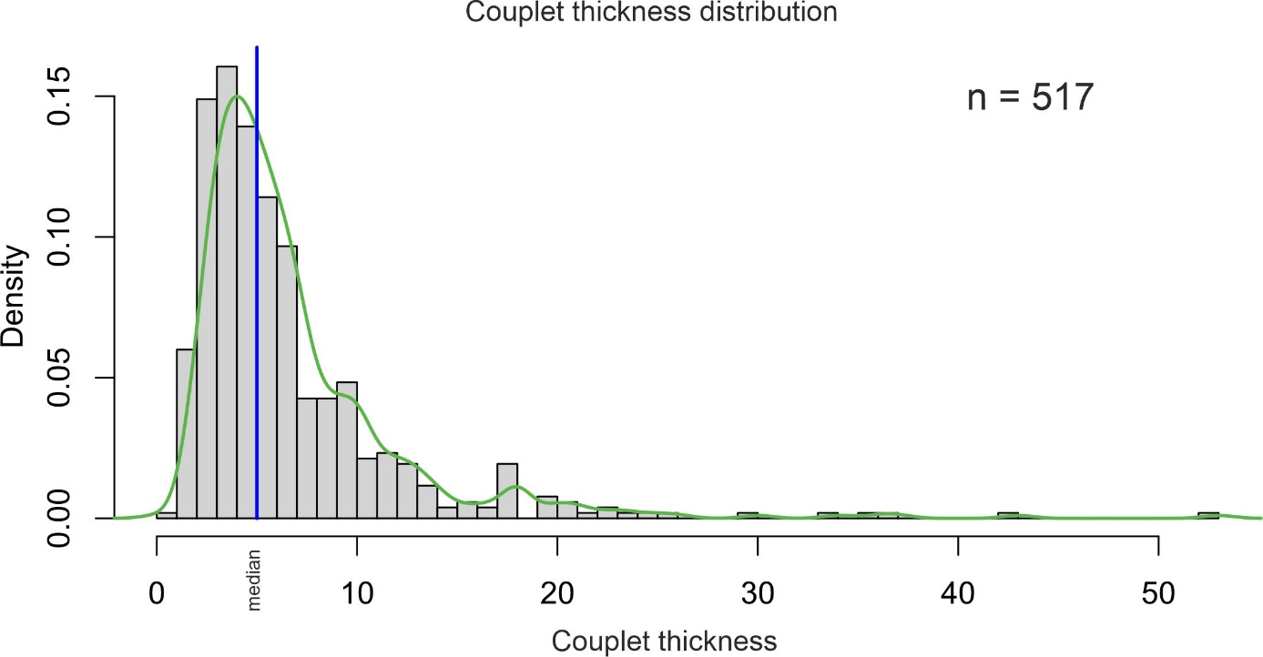
Fig. S1: Histogram of couplet thickness distribution (n = 517) showing the median thickness of 5 cm in blue vertical line and density distribution in green curve. The average couplet thickness is ~6.5 cm.
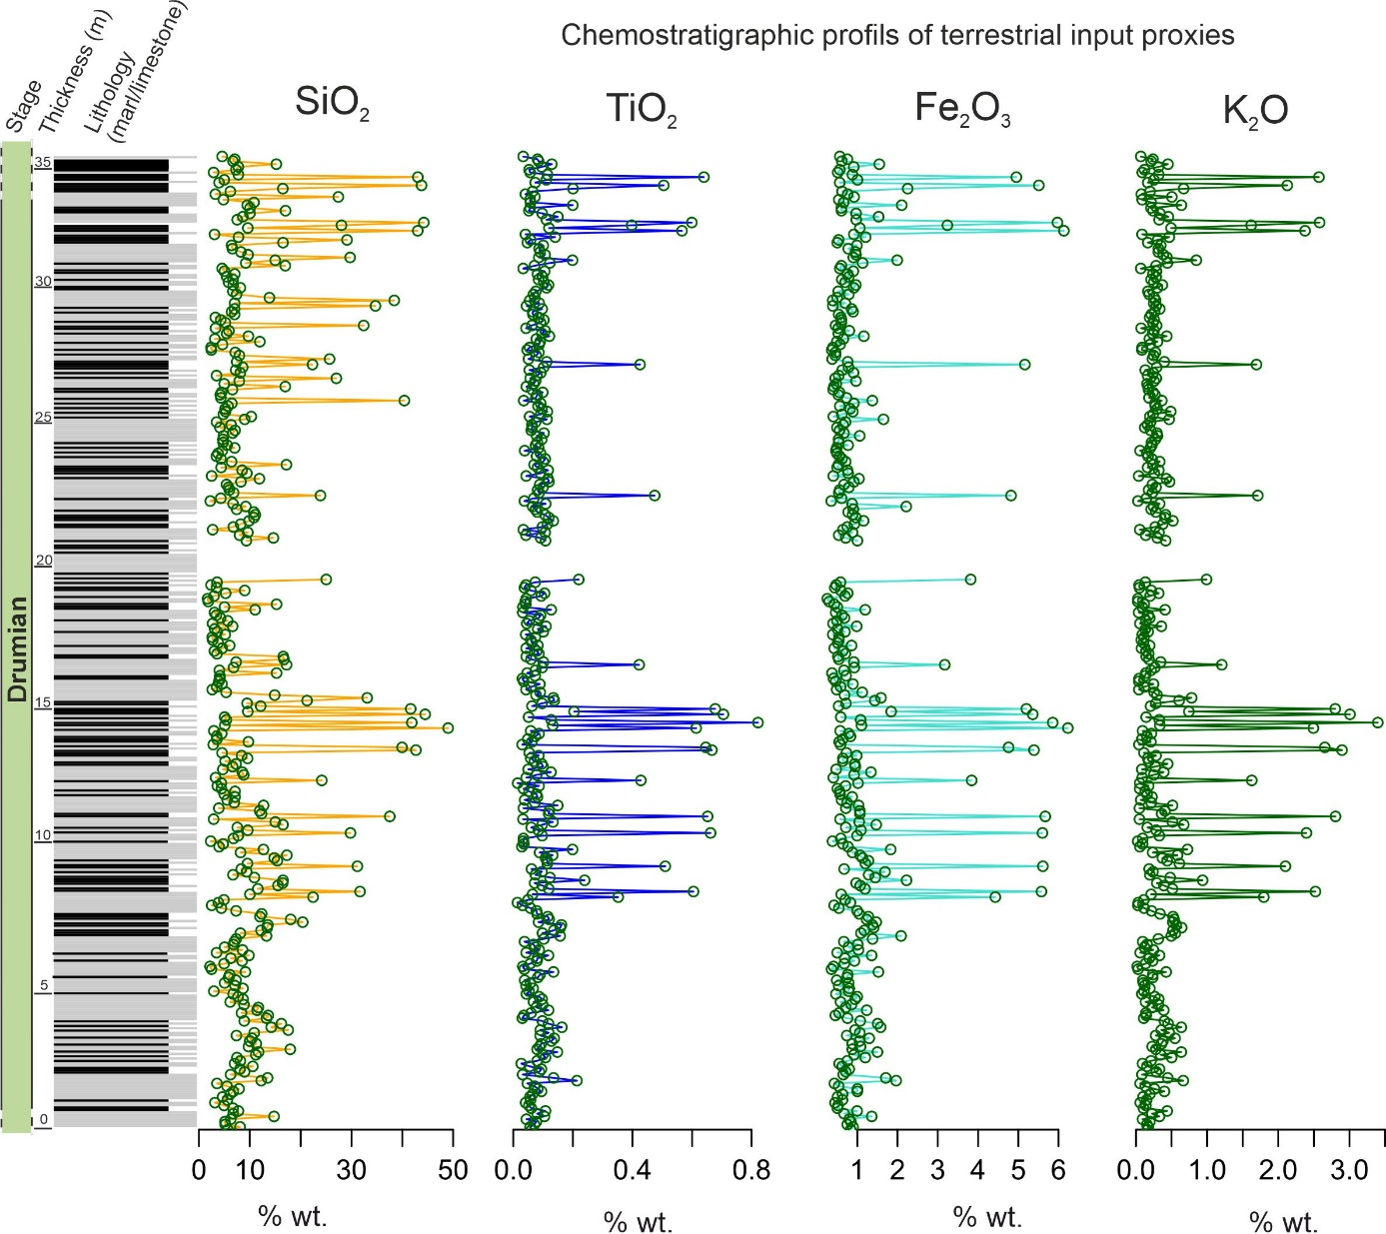
Fig. S2: Chemostratigraphic profiles of detrital sediment proxies measured using pXRF against the simplified Marjum lithologic column. Note the similar variations for all proxies and the consistent stratigraphic trends, with increased abundances aligning with marl-rich intervals, indicating that these proxies faithfully track variations in terrigenous input. SiO₂ was used in all subsequent time series analysis.

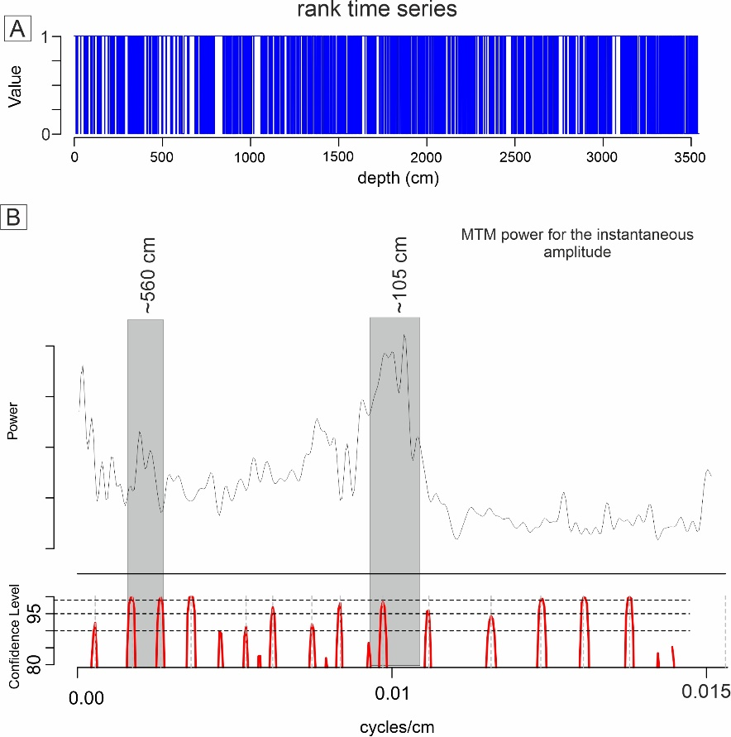

Fig. S3: Hilbert analysis of the amplitude modulation of the lithologic rank series in the stratigraphic domain. A) Lithologic rank series. B) Spectral analysis of the instantaneous amplitude series obtained after applying a Hilbert transform on the filtered rank series (Taner bandpass filter (bandpass 0.11 to 0.29 cycle/cm, i.e., 5 ± 2 cm). The MTM of the instantaneous amplitude reveals two amplitude modulation frequencies highlighted in grey-shaded areas at ~560 cm (0.0097 cycle/cm) and ~105 cm (0.0017 cycle/cm). In sum, couplet thicknesses in the Marjum section were modulated by two cycles.

Hilbert analysis of the amplitude modulation of the lithologic rank series indicates that couplet thicknesses in the Marjum section were modulated by two cycles

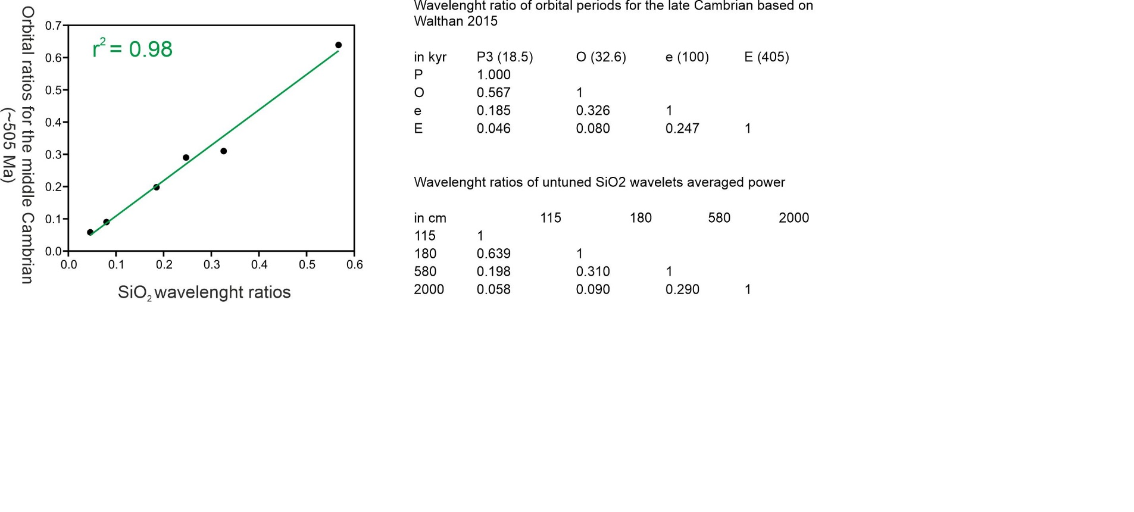
Fig. S4: Comparison between theoretical astronomical ratios for the middle Cambrian (Waltham, 2015) and SiO₂ period ratios obtained through the CWT analysis. The calculated 0.98 r² suggests a consistent astronomical attribution for the observed wavelengths in the SiO₂ record.

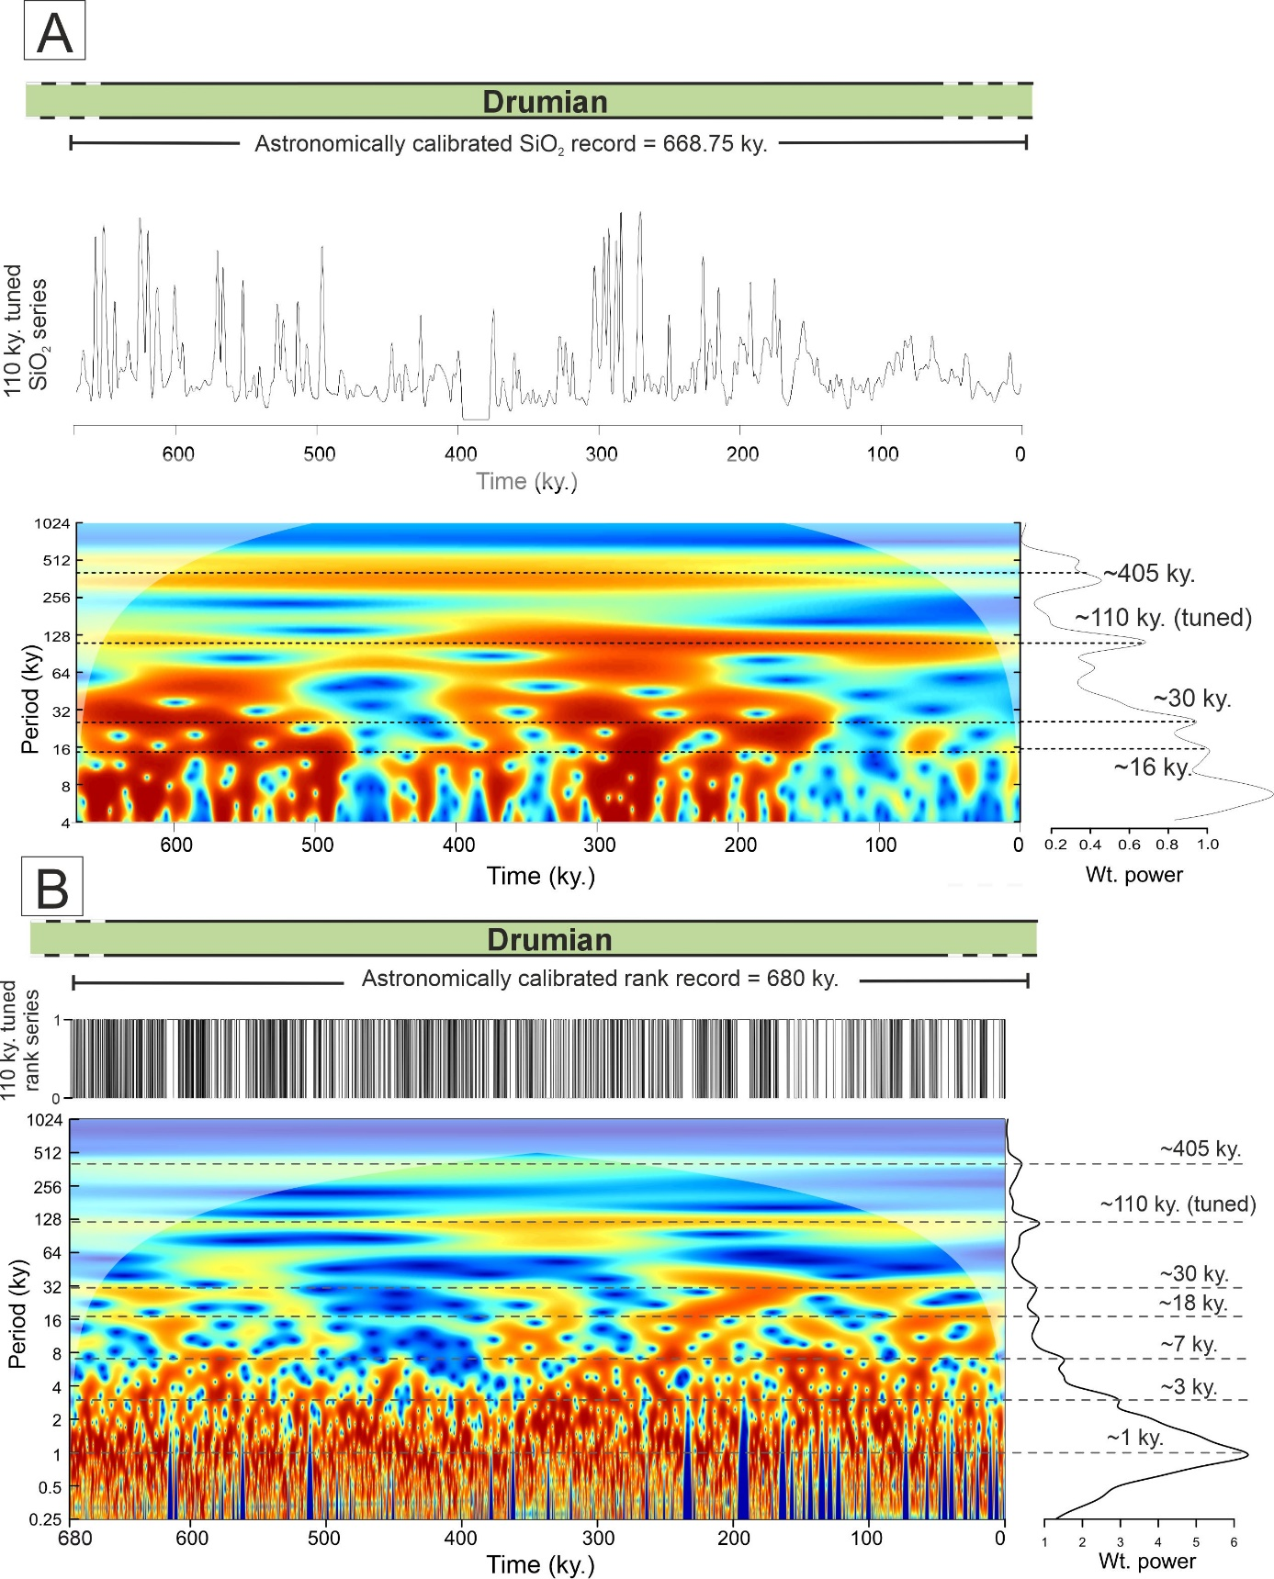
Fig. S5. Astronomical calibration of the two independent SiO₂ and rank datasets. A) Short orbital eccentricity (110 ky) tuned SiO₂ record (top) and corresponding CWT (bottom) with peak power at ~405 ky, ~110 ky, ~30 ky, and ~18 ky. Astronomical calibration for the Marjum section duration based on the SiO₂ record is 668.75 ky. B) 110 ky astronomically tuned lithologic rank record (top) with corresponding CWT with peak power at 405 ky, 110 ky (tuned), 30 ky, 18 ky, 7 ky, and 1 ky. Astronomical calibration for the Marjum section duration based on the lithologic rank series is 680 ky.

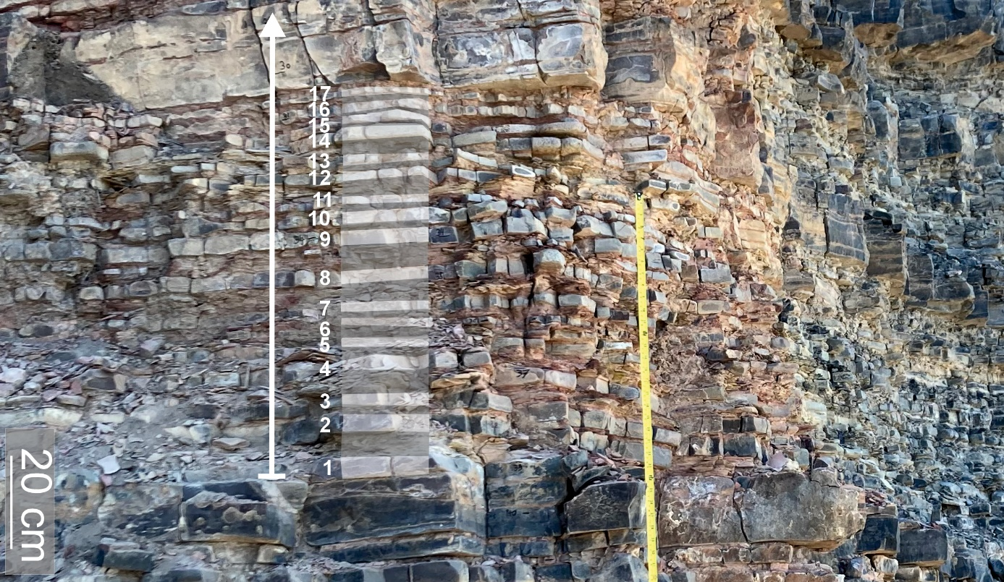
Fig. S6: Field photograph highlighting 17 individual rhythmite couplets composing a full parasequence (white line with arrow). Note each couplet is calculated to represent ~1ky, which supports interpretations of precession- (~18.5 ky) controlled parasequences.

REFERENCES
Aitken, J. D., 1966, Middle Cambrian to Middle Ordovician cyclic sedimentation, southern rocky Moutains of Alberta Bulletin of Canadian Petroleum Geology, v. 14, no. 4, p. 405-441. https://doi.org/10.35767/gscpgbull.14.4.405
-, 1978, Revised models for depositional grand cycles, Cambrian of the southern rocky mountains, Canada: Bulletin of Canadian Petroleum Geology, v. 26, no. 4, p. 515-542. https://doi.org/10.35767/gscpgbull.26.4.515
Aitken, J. D., 1997, Stratigraphy of the Middle Cambrian platformal succession, southern Rocky Mountains, Geological Survey of Canada.
Arts, M., 2023, WaverideR: Extracting Signals from Wavelet Spectra, https://cran.r-project.org/package=WaverideR.
Chow, N., and James, N. P., 1987, Cambrian Grand Cycles: A northern Appalachian perspective: GSA Bulletin, v. 98, no. 4, p. 418-429. https://doi.org/10.1130/0016-7606(1987)98<418:Cgcana>2.0.Co;2
Cowan, C. A., and James, N. P., 1993, The interactions of sea-level change, terrigenous-sediment influx, and carbonate productivity as controls on Upper Cambrian Grand Cycles of western Newfoundland, Canada: Geological Society of America Bulletin, v. 105, no. 12, p. 1576-1590. https://doi.org/10.1130/0016-7606(1993)105<1576:TIOSLC>2.3.CO;2
Da Silva, A. C., Triantafyllou, A., and Delmelle, N., 2023, Portable x-ray fluorescence calibrations: Workflow and guidelines for optimizing the analysis of geological samples: Chemical Geology, v. 623. https://doi.org/10.1016/j.chemgeo.2023.121395
Einsele, G., Ricken, W., and Seilacher, A., 1991, Cycles and events in stratigraphy:
Elrick, M., and Snider, A., 2002, Deep-water stratigraphic cyclicity and carbonate mud mound development in the Middle Cambrian Marjum Formation, House Range, Utah, USA: Sedimentology, v. 49, no. 5, p. 1021-1047. https://doi:10.1046/j.1365-3091.2002.00488.x
Martinez, M., Kotov, S., De Vleeschouwer, D., Pas, D., and Pälike, H., 2016, Testing the impact of stratigraphic uncertainty on spectral analyses of sedimentary series: Climate of the Past, v. 12, no. 9, p. 1765-1783. http://doi.org/10.5194/cp-12-1765-2016
Meyers, S., 2014, Astrochron: An R Package for Astrochronology,
Osleger, D., and Montañez, I. P., 1996, Cross platform architecture of a sequence boundary in mixed siliciclastic-carbonate lithofacies, Middle Cambrian, southern Great Basin, USA: Sedimentology, v. 43, no. 2, p. 197-217. https://doi.org/10.1046/j.1365-3091.1996.d01-13.x
Peng, S. C., Babcock, L. E., and Ahlberg, P., 2020, Chapter 19 - The Cambrian Period, in Gradstein, F. M., Ogg, J. G., Schmitz, M. D., and Ogg, G. M., eds., Geologic Time Scale 2020, Elsevier, p. 565-629. https://doi.org/10.1016/B978-0-12-824360-2.00019-X
Rees, M. N., 1986, A fault-controlled trough through a carbonate platform: The Middle Cambrian House Range embayment: GSA Bulletin, v. 97, no. 9, p. 1054-1069. https://doi.org/10.1130/0016-7606(1986)97<1054:Afttac>2.0.Co;2
Robinson, R. A., 1964, Upper Middle Cambrian Stratigraphy of Western Utah: GSA Bulletin, v. 75, no. 10, p. 995-1010. 10.1130/0016-7606(1964)75[995:Umcsow]2.0.Co;2
Scotese, C. R., 2014, Atlas of Cambrian and Early Ordovician Paleogeographic Maps.
Verschuren, D., Sinninghe Damsté, J. S., Moernaut, J., Kristen, I., Blaauw, M., Fagot, M., Haug, G. H., van Geel, B., De Batist, M., Barker, P., Vuille, M., Conley, D. J., Olago, D. O., Milne, I., Plessen, B., Eggermont, H., Wolff, C., Hurrell, E., Ossebaar, J., Lyaruu, A., van der Plicht, J., Cumming, B. F., Brauer, A., Rucina, S. M., Russell, J. M., Keppens, E., Hus, J., Bradley, R. S., Leng, M., Mingram, J., Nowaczyk, N. R., and members, C. p., 2009, Half-precessional dynamics of monsoon rainfall near the East African Equator: Nature, v. 462, no. 7273, p. 637-641. https://doi.org/10.1038/nature08520
Waltham, D., 2015, Milankovitch Period Uncertainties and Their Impact On Cyclostratigraphy: Journal of Sedimentary Research, v. 85, no. 8, p. 990. https://doi.org/10.2110/jsr.2015.66
Wouters, S., Da Silva, A.-C., Boulvain, F., and Devleeschouwer, X., 2021, StratigrapheR: Concepts for Litholog Generation in R: The R Journal, v. 13, no. 2

