**Additional File 1**



**Fig S1.**

Results of copy number (CN) ddPCR assays for *RBMX*, *GPR101* and *ZIC3* in subjects F2A and F3A. Both individuals harbor duplications that include *GPR101* but none of the neighboring centromeric (*RBMX*) or telomeric (*ZIC3*) genes. In comparison, a typical X-LAG subject (shown here is a familial male case [1]) harbors a duplication that extends further centromeric, including *RBMX*. Blood-derived DNA was used for analysis in all subjects. In F3A, buccal swab-derived DNA was also available and its analysis produced results comparable to those depicted here. The calculated CN along with Poisson-based 95% confidence intervals (CN range bars) are shown for each gene. Note that two assays located at the 5′ and 3′ end of *GPR101* coding sequence were employed. The dotted red lines crossing the y axis at CN values 1.5 and 2.5 represent the threshold for duplication in males and females, respectively.

**Fig S2.**

HD-aCGH results for the precise characterization of the duplication in subject F2A.

(A) The CMA revealed a complex genomic rearrangement at the *GPR101* locus consisting of a duplication-normal sequence-duplication pattern (DUP-NML-DUP).

(B) Potential replicative mechanism leading to DUP-NML-DUP formation.

(C) Final linear product. Determination of junctions (Jct) at nucleotide-level by PCR revealed a close match with HD-aCGH coordinates.

**Fig S3.** A growth chart from birth to two years in case SC1 with pituitary gigantism. This illustrates the very early-onset, rapid overgrowth, which met the criteria of > +2 standard deviations for the diagnosis of gigantism during infancy. Subsequently, the overgrowth continued, a large GH-secreting pituitary tumor was diagnosed and she was resistant to first-generation somatostatin analog therapy; she eventually underwent neurosurgery to resect the tumor. Her final adult height was +2.92 SD and +25.5 cm in excess of her target height. The profile of infant-onset pituitary gigantism due to a pituitary macroadenoma (>10 mm) led to a suspicion of X-LAG.

**Fig S4.**

HiC results in SC1. (A) HiC at the X-LAG locus (hg19, chrX:135,336,766-136,561,684), showing normalized contact matrices at 10-kb resolution from the X-LAG subject SC1 in a side-by-side comparison to control. Normal TAD configuration at the locus is highlighted by red arrows. (B) HiC difference maps from SC1 relative to control does not reveal changes in chromatin interactions at the X-LAG locus.

**Fig S5.**

Normalized 4C-seq profiles from the *GPR101* viewpoint in the three subjects of the current study are depicted. The size and position of each duplication are indicated below each 4C-seq profile (shown as a yellow bar), with corresponding subtraction profiles relative to control samples presented below.

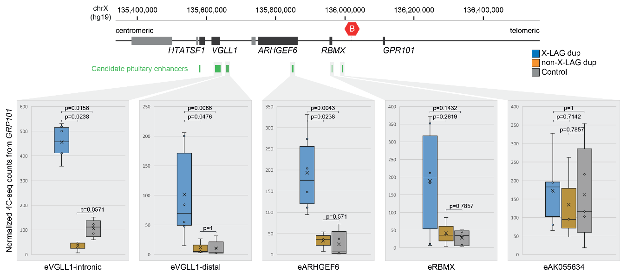

**Fig S6.**

Quantification of normalized contact frequencies from the *GPR101* viewpoint with candidate enhancer regions from X-LAG duplication (n=6), non-X-LAG duplication (n=3), and control group (n=5). Box and whisker plots show minimum and maximum values, data points (denoted as circles), 25th and 75th percentiles, median (denoted as a line), and average (denoted as an x). Note that the eHTATSF1 CRE is only included in the duplication of subject S13 (X-LAG duplication) and has been excluded from the analysis. Statistical significance was measured using a two-sided Wilcoxon rank-sum test.

**References**

[1] Trivellin G, Daly AF, Faucz FR, Yuan B, Rostomyan L, Larco DO, et al. Gigantism and Acromegaly Due to Xq26 Microduplications and GPR101 Mutation. New England Journal of Medicine 2014;371:2363–74. https://doi.org/10.1056/NEJMoa1408028.