**Public space and everyday heritage: An inquiry into children’s and adults’ perception**

# Abstract

This paper examines how the spatial environment and the activities within these spaces contribute to their social value in turn informing the concept of everyday heritage within urban public spaces. We develop a novel methodological framework that combines visual representation and narrative analysis to provide insights into how the physical, emotional and perceptual dimensions of a public open space translate into associative social values. By including both adults and children in our study, we capture a comprehensive range of perceptions, highlighting the diverse ways in which different user groups give meaning to everyday heritage. Children and their guardians showed agreement on natural elements and personal representations, but differed on the garden's spatial layout and activities. While they shared values like childhood memories and family time, children prioritized play, forming new friendships, and connecting with nature, whereas parents emphasized children's happiness and personal space. Notably, both groups indicate that childhood – both lived and remembered – is that which gives this public urban space its everyday heritage status. The findings advocate for an expanded understanding of urban public spaces, recognizing the significance of everyday heritage in shaping collective cultural identity.

# Keywords

Everyday heritage; Public space; Social value; Perceived image; Visual perception

**Public space and everyday heritage: An inquiry into children’s and adults’ perception**

# 1. Introduction

The cultural lens of this research reflects the concept of the city as a living heritage (Bandarin & Oers, 2015; Poulios, 2014a; Szilágyi et al., 2021): a complex layering of meanings where values associated with heritage attributes reinforce the spirit of a place and maintain the identity of the urban landscape (Martínez Pino, 2018; O’Donnell, 2008). From this perspective, urban cultural heritage extends beyond the so-called *historic center* to include the *everyday landscape*, where people’s interaction with the built environment, social practices, and lived-in experiences inform a collective identity referred to as everyday heritage which is intimately, spatially and socially interconnected with the urban context (Bollini, 2018; Mosler, 2019). Accordingly, the concept of everyday heritage can be understood as a place- and people-led approach to urban heritage (Giombini, 2020).

Everyday heritage production is a cultural process of meaning-making (Smith, 2010) in which regular use of everyday surroundings, such as open spaces, leads to appreciation by users (Swensen et al., 2011). This appreciation is a heritage value referred to as social value, comprising people’s collective attachment to place, memory, and practices that embody meanings that are important to a community (Jones, 2017). In this context, daily practices, such as walking and playing, translate into social values (Horton et al., 2014; Karsten, 2005). It is this social and living dimension of heritage that we identify as everyday heritage. The meanings that individuals attach to the built environment are affective and perceptual in nature (Ujang & Zakariya, 2015). Consequently, the ascribed social values can vary widely among stakeholder groups, who assign varying degrees of importance to the same public, urban asset, creating alternative narratives essential to the socio-cultural construct of heritage (Avrami et al., 2019).

Giombini (2020, p. 54) argues that the everyday dimension of heritage manifests the most in public open spaces. Nevertheless, public spaces, as designed landscapes, have been somewhat overlooked by heritage practitioners (Déom & Valois, 2020). Public urban spaces are integral to adults’ and children’s social interactions, through which everyday heritage is produced. Both the physical space and activities are sources of identity, belonging, and affective qualities that convey and sustain the idea of intangible cultural heritage (Zukin, 2012). Recent studies call for increased awareness of heritage values in the practices of everyday life using public space as a mediator (e.g. Zaninović et al., 2019). To this end, this paper investigates users’ perceptions of public open space and the associated social values that inform everyday heritage. It develops a methodological framework that integrates visual representation and narration to assess the perceived image and values of urban public spaces. Given that children are active agents in the urban environment and primary users of open spaces, this investigation considers the perceptions of both adults and children. By doing so, it captures the full range of ways in which everyday heritage is valued by different users and explores the complex interplay between visual representations, personal narratives, and emotional responses in shaping the collective perception of heritage in urban landscapes.

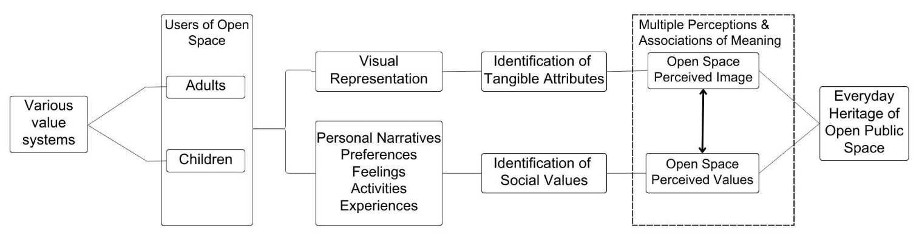In the following, we frame our investigation, first, by addressing the concepts of visual perception and perceived heritage values, specifically examining their application within open spaces and across various age groups of users. We then draw on critical heritage studies and urban studies to provide an overview of relevant concepts and theories related to the social significance of everyday heritage. Subsequently, we introduce the case study and our methodological framework guiding our research approach. Finally, we assess and discuss the empirical findings. Figure 1 illustrates the research framework.

Figure 1. Research Framework

# 2. Theoretical framework

In this section, we frame our investigation by first reviewing relevant concepts and theories of visual perception and perceived heritage values to highlight how individuals, including children and adults, perceive and attribute cultural significance to urban open spaces. We then address the concepts from critical heritage studies related to the translation of social values into the social significance of everyday heritage in the context of urban open public space. Our empirical study seeks to enrich current research by exploring the intricate interplay among spatial context, personal perceptions, narratives, and emotional responses. By doing so, we aim to elucidate how these elements collectively influence the attribution of cultural values to public spaces, thus asserting their significance as everyday heritage sites. This approach underscores the dynamic relationship between individuals and their urban environment, shedding light on the diverse ways in which cultural meanings are constructed and sustained within everyday landscapes.

## 2.1 Visual perception and perceived heritage values in urban open spaces

The visual landscape is integral to people’s everyday urban experience, influencing their personal interpretation and perception of the environment (Farahani et al., 2023). Visual perception involves individuals making sense of their surrounding environment through a complex interplay of spatial/contextual, emotional, and cognitive elements (Xiang et al., 2022; Lueg, 2013). The study of visual perception in urban landscapes developed within various disciplines, including heritage studies, leisure sciences, planning, geography, landscape architecture, and environmental psychology among others (Antrop & Van Eetvelde, 2017). Despite disciplinary variations, landscape perception research builds from two fundamental assumptions: first, visual perception is shaped by both the physical landscape and the cognitive processes involved; second, the mental process of perception is influenced by biological, cultural, and individual factors (Jacobs, 2006, 2011). Perception of open spaces encompasses both sensory experiences, often visual, and the meanings and values that users assign to them (Swanwick, 2009). In this context, urban open spaces serve as settings for the formation of users’ mental perceptions and collective memory (Gohari et al., 2016). Due to the intricate and subjective nature of landscape perception, our methodological framework integrates visual representations with personal narratives, landscape preference, landscape experience, and sentiment analysis to grasp the diverse interpretations and values evoked by users’ perceptions of open space.

The notion of perceived value closely approximates the concept of cultural value, which is integral to multiple fields including anthropology, sociology, and heritage studies. A value-based approach to heritage is a community-based approach that de-centers experts’ authentication (Winter, 2013). It aims to broaden the conventional understating of cultural heritage by considering local production and practices of heritage and multiple expressions of cultural identity and community perceptions (Poulios, 2014b; Silberman, 2018). This approach is coupled with a growing interest in recognizing heritage within everyday landscapes, daily practices, and shared experiences (Ginzarly & Teller, 2021), and in developing methods to evaluate the varied and sometimes conflicting cultural heritage value typologies within local contexts. Key value types in the cultural heritage discourse include aesthetic, historical, social, spiritual, and economic (De La Torre, 2013). Recent studies suggest employing context-driven cultural evaluations rather than relying on pre-defined and pre-constructed typologies to better understand how a heritage attribute is valued (Duval et al., 2019). Perceived heritage value is the subjective construct comprising different contextual dimensions: functional, historical, emotional, and social significance among others (Zhang et al., 2022). Place experience and personal emotions are drivers of value creation and therefore play a critical role in assessing cultural heritage via perceived values (Heredia-Carroza et al., 2021). The recognition of perceived values in shaping cultural heritage assessments contributes to a broader and more inclusive understanding of heritage places and values, ultimately informing more effective and meaningful heritage conservation and management practice.

When addressing the perception of open spaces, it is important to recognize the differing perspectives of adults and children, as studies show that they perceive and value open spaces differently. Children often prioritize active recreation, play opportunities, exploration, and sensory experiences in these environments (Chandwania & Natu, 2022; Korpela, 2002). For instance, they prefer water features to statues or sculptures (Bozkurt & Woolley, 2020). In contrast, adults prioritize aspects such spatial qualities, tranquility, aesthetics, and recreational facilities. For example, features like vegetation and water elements attract children for imaginative play and discovery, while for adults the perception of these features is more strongly associated with mental well-being (Houlden et al., 2018; Müderrisoğlu & Gültekin, 2015). Much of the literature suggests that children’s activities in urban public spaces improve their sense of place-attachment and place meaning (Weller & Bruegel, 2009; Spencer & Woolley, 2000; Luo, 2022). Fang and Lin (2016) emphasize the significance of understanding children’s perceptions of public spaces beyond the limits of play-inclusive practices and child-oriented design to address the space as a daily living environment. Even though in urban studies, children’s perception of public space serves to address a variety of topics, including, mobility, interaction, activities, safety concerns, affordance, and use in the outdoor environment (Mitchell et al., 2007; Niklasson & Sandberg, 2010), it wasn’t until recently, that scholars started to address urban parks and playgrounds as a form of heritage and to study children’s perception of these places as a means to derive their significance beyond child’s play (e.g. Chang & Mah, 2020).

## 2.2 Everyday heritage and the social value of public spaces

At the beginning of the 21st century, the scholarly debate about heritage value systems provoked discussions about how local production and practices of heritage build a sense of community and identity as a counterpoint to official and experts’ definitions of heritage (Smith, 2006; Herzfeld, 2015). This debate led to concepts such as heritage as social action (Harrison, 2010), heritage by appropriation (Tweed & Sutherland, 2007), heritage justice (Sitas & Stewart, 2023) and everyday heritage (Mosler, 2019). In 2016, Schofield argued that Cultural heritage is potentially “everywhere, for everyone, and we are all heritage experts”. Cultural heritage is a complex phenomenon that constantly evolves over time, depends largely on the values embodied in it, and encompasses the range of perceptions of its meanings for community groups of which children are a part (Harvey 2001; Ginzarly & Srour, 2021).

Heritage values are socially constructed, ambivalent, subject to diverse, sometimes conflicting associations of meanings, and constantly evolving with the communities that produce them (Ginzarly & Teller, 2021). Heritage values are contextual values and can be understood as assigned, expressed either individually or collectively as shared or social values (Azzopardi et al., 2023; Kenter et al., 2015). In the context of daily-life practices and everyday landscape, heritage values may not rank highly in terms of common indicators, such as scenic beauty, historic significance, and biodiversity, but they hold importance because they have value for “someone” (communities, cultures, and individuals) (Roe & Taylor, 2014). Landscapes reflecting everyday ways of life tell the story of people, events, and places through time, and at the same time, shape people’s lives through habitual interaction (Mosler, 2019). The European Landscape Convention (ELC) acknowledges ordinary landscapes as cultural landscapes defined as “an area, as perceived by people, whose character is the result of the action and interaction of natural and/or human factors” (CoE, 2000, Art.1). The cultural landscape construct has been an essential part of a broadening critical discourse on heritage (Taylor, 2022) that embraces concepts of living heritage to incorporate the full spectrum of people’s sense of place, mental subjective representation of the environment, experiential values, traditional knowledge, and cultural production among others (Harvey, 2001; Taylor, 2016; Thompson, 2013).

In the second half of the twentieth century, the social value of heritage emerged as an important topic in public policy and heritage conservation practice (Jones, 2017), as evidenced by *The Burra Charter, The Faro Convention,* and *The Historic Urban Landscape Recommendation* which highlighted *ascribed values* and heritage communities extending beyond cliques of heritage specialists and material views of heritage (Schofield, 2016a). As a result, various methods and models emerged to determine what is perceived to be of value and how it is valued (de la Torre, 2013; Havinga et al., 2020). However, models of heritage significance are often criticized for being static, reinforcing an assumption that “values always accord with typologies, and that typologies will encompass all values” (Stephenson, 2008, p. 128); they fail to account for cultural heritage as a social phenomenon capturing the dynamic, iterative and embodied nature of values expressed by communities who feel they belong to the landscape (Stephenson, 2008; Fredheim & Khalaf, 2016; Jones, 2017). To overcome the limitations of the prevailing linear approach to heritage knowledge production that relies on pre-established value typologies, we acknowledge the role of communities in the production of local heritage knowledge based on their engagement with everyday landscapes, personal perceptions, and experiences.

When considering the intersection of everyday heritage and public space, the scope of potential heritage values expands beyond intrinsic historic scientific values to include social values, which relate to the appreciation and significance communicated by those who use the public space (Déom & Valois, 2020). Through a case study in Drammen, Noway, Swensen et al. (2011) addressed the spatial and social dimensions of urban public spaces to claim different perceived qualities of these spaces as heritage values. Most germane to this work is that of Zukin (2012) who argued that public urban spaces are integral for adults’ and children’s social interactions by which cultural heritage is produced. In her book chapter, *the heritage of public space*, Ford (2016) presented the heritage significance of Sydney’s beachfront parks as open public spaces by elucidating their associated social values by different user groups, including children and adults, as a form of everyday living heritage. Cauchi-Santoro (2016) applied a similar approach to investigate the vital role that community memories play in preserving the intangible cultural heritage of a city's historic center through people’s narratives of landmark buildings. In line with the work of Cauchi-Santoro (2016), we apply an approach that provides insights into the range of potential cultural values in everyday landscapes, in our case open space, as expressed by associated communities through personal narratives. Away from the lens of common predetermined value typologies, this investigation elicits from an age-diverse community what they value about the everyday landscape. This paper raises a heritage claim to public space and develops a framework for the understanding of open public space as everyday heritage with diverse associative values assigned by different users, including children and adults, based on their personal experience of spaces, narratives, memories, and emotions.

# 3. Method

This work relies on a multi-faceted case study methodology, targeting children and adults, designed to capture both the visual perceptions and perceived values of an urban, public space. This section describes the study space along with the methods used to solicit and analyze responses from users of the space.

# 3.1 Case study

Beirut is the capital and largest city in Lebanon with an area of 67 square kilometers and a population of 2.4 million (world population review 2022). Very few spaces in Beirut are designated as public. In 2015, the percentage of green spaces in Beirut decreased by 13% leading to an 11% ratio of green areas in public spaces (Nazzal & Chinder, 2018). The René Moawad Garden, known to the public as *Sanayeh Garden*, is Beirut’s first municipal park established under late Ottoman rule in 1907. The garden’s link with the social, cultural and historical context of the city makes it a good case study site (Mady, 2022). Local residents and visitors use this urban garden daily where they engage in the routine activities of walking, playing, and relaxing.

# 3.2. Data collection and analysis

To capture interactions between the study population and the garden, we applied a mixed-method approach through a questionnaire with open-ended questions capturing qualitative and visual data. Children (6-12 years old) and the adults (older than 18) who accompanied them answered the same questions presented in the same order, but at two separate tables. The questionnaire included three sections. First, participants answered general questions related to their age and gender, mode of transportation, usual duration of visits, frequency of visits, and companion. Then, they were asked to draw their personal perception of Sanayeh garden. When the term *perception* raised confusion, the interviewer elaborated and, in some cases, said that they can for instance draw an image of their preferred spot or activity in this place. To support interpreting the drawings, interviewees were asked to write a few sentences about what their drawing means to them: why they decided to draw this specific spot or activity. For children too young to write, a member of the research team transcribed their reasoning. The third section captured the interviewees’ perceived values of the public space through a series of questions about what they like and don’t like in the place, how they feel in it, whether they like coming and why, what are the usual activities they engage in while in the place, whether they have any personal story related to this place and if so, what it is, and whether the place reminds them of somewhere else. Seven researchers conducted the in-situ survey.

Before proceeding with the field work, IRB approval was secured and all researchers completed training in social-behavioral-educational research. Data collection occurred on the weekend of May 20 and 21, 2022, in the garden. The surveyors worked in teams at two different stations strategically located in the shade but in highly visible places and at close proximity to busy areas in the garden to capture the attention of the users and at the same time avoid disrupting their activities. Members of the research team approached adults with children by explaining the study, inviting them to participate, and requesting permission for the children in their care to participate. Before starting the survey, researchers solicited the adult’s oral consent and the child(ren)’s oral assent. The researchers explained to the participants that there are no right or wrong answers and that the participants are the experts in this investigation. Adults and the children they accompanied took the questionnaire at the same time but separately. At each station, two tables were placed near each other so children could stay near their guardians but focus on their own work. Participants were invited to take as long or as short as they needed to create the image they wanted.

At the tables, in addition to papers and coloured pencils, printed questionnaires were available for the research team. While the participants were drawing, the survey was conducted in Arabic unless English was explicitly requested. The drawing activity was very popular with the children. When planning the study methodology, an initial time of 15 to 20 minutes was assumed for the drawing activity, but in some cases the participants worked beyond 30 minutes – all participants were welcomed to stay drawing as long as they wanted. In total, 122 children and 77 adults gave assent and consent, respectively, of which 121 children and 76 adults drew their visual perception of the garden. The questionnaire and the drawings were kept together through labelling with a unique anonymous code that also allowed pairing between guardians and their children.

All pictures were scanned to digital files to conduct the visual analysis whereby the different elements depicted in each visual representation were identified by three members of the research team who had been present in the park. Subsequently, the drawings were analysed within their peer groups and across guardian-child(ren) pairings. A content analysis was performed, in which the drawings were coded according to the different depicted elements, resulting in five thematic entries. The next step was to assign labels 1 and 0 under every theme for every respondent to respectively represent the presence (1) or absence (0) of a theme in a drawing. The resulting binary variables were further analyzed in Rstudio to explore the number and proportion of combined themes depicted in each drawing.

The interviews were transcribed and translated into English then uploaded to NVivo software for qualitative analysis. Instead of applying institutionalized typological categorization of heritage values that might obscure the complex nature of social values as they give rise to everyday heritage (Déom & Valois, 2020), this research extracts values through empirical inductive reasoning.

**4. Results**

We first present a general description of our sample followed by both the adults’ and children’s perceived image and perceived values both directly expressed and implied through affective expressions. Subsequent to the extraction of the perceived image and values, we build the adults’ and children’s perceptions into a collective statement on the importance of this location as everyday heritage. In what follows, direct quotes are not original but translated, and all have been edited for clarity.

## 4.1 Sample general information and demographics

Of the adult interviewees, 73% are female and 27% are male. As for children, 57% are female and 43% are male. The mode of transportation most commonly used to visit the garden was, walking (40%), followed by car (37%), motorcycle (17%), and bus (6%). Regarding the frequency of visits, 6% of the interviewees answered almost every day, 52% answered between one and four times per week, 32% answered between one and four times per month, and 10% answered once or twice a year. When it comes to the time usually spent in the garden, 33% of the interviewees spend between 1 and 2 hours, 25% between 2 and 3 hours, 30% between 3 and 4 hours, and 12% more than 4 hours. These results show that most of the interviewees visit the garden on a weekly basis for a significant amount of time making it part of their daily life activities.

## 4.2 Perceived Image

While the perceived image of the garden largely focused on tangible attributes, both activities and other locations evoking similar feelings (e.g. home) appeared in the drawings and narratives of the participants. Only 4% of children and 3% of adults delineated the urban open space and drew the gate; only 2% of children and 3% of adults depicted the garden’s surrounding urban context and drew the roads and cars. Thus, the majority of interviewees perceive the garden as a natural retreat and break from the urban environment. While both groups perceived amenities as equally important, each group depicted different features revealing different preferences among children and adults. For instance, the most frequent amenities in adults’ drawings are the fountain (42%) and the benches (33%) while playground equipment appears most frequently in children’s drawings, namely the slide (25%) and the swing (24%), followed by the fountain (23%). This reflects preferred activities – sitting and playing – and locations – the fountain and the playing area (See Figure 2). Playing dominates children’s perceived image of the garden. Affective aspects emerge through depictions of people, as most of them appear with smiling faces; the sun, bright sky with blue clouds, butterflies, and birds further emphasize the perception of the space as a natural area (See Figure 2). Of interest is that 11.5% of children drew a house, referring to it as home, in their representation of the garden reflecting the evocative nature of the perceived space. As shown in Table 1, the central perceptions are natural features, children’s activities, and playground equipment.

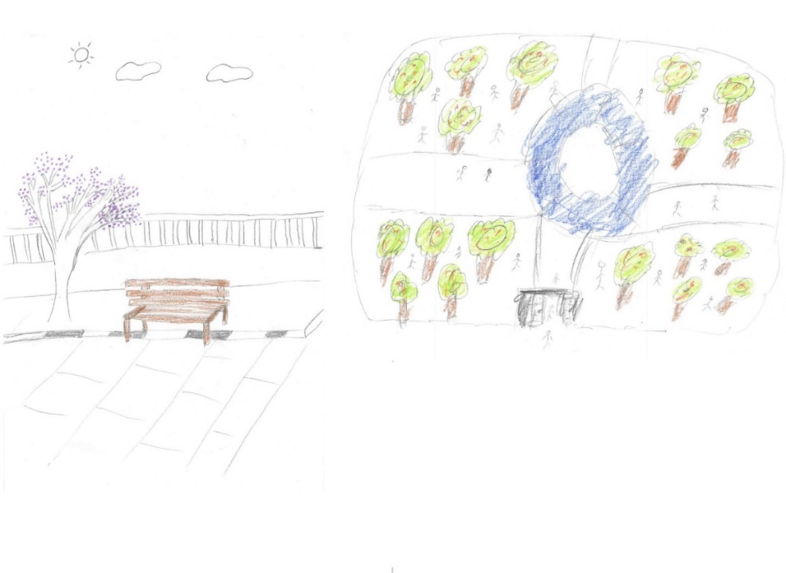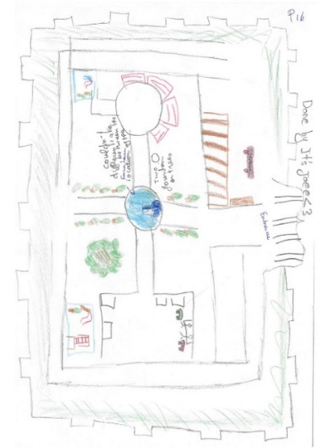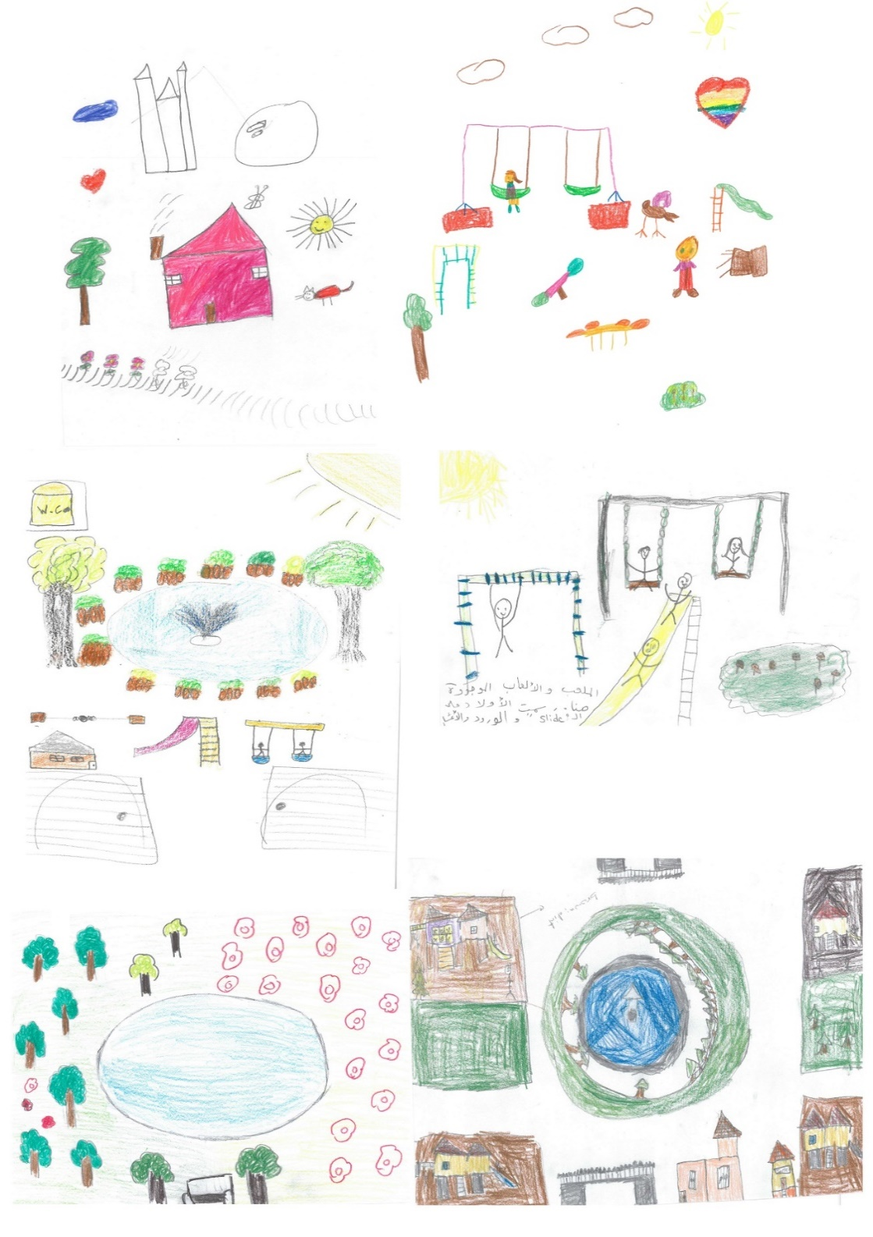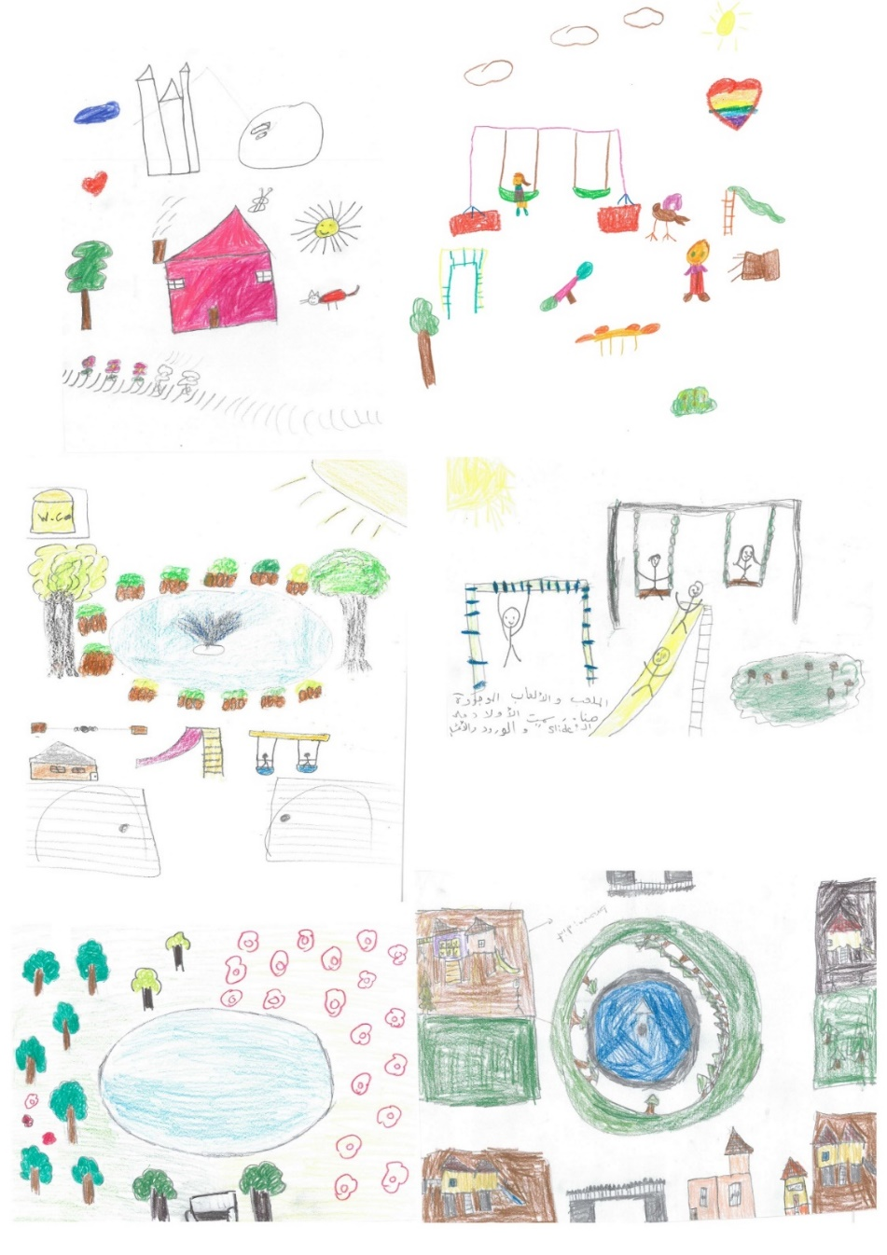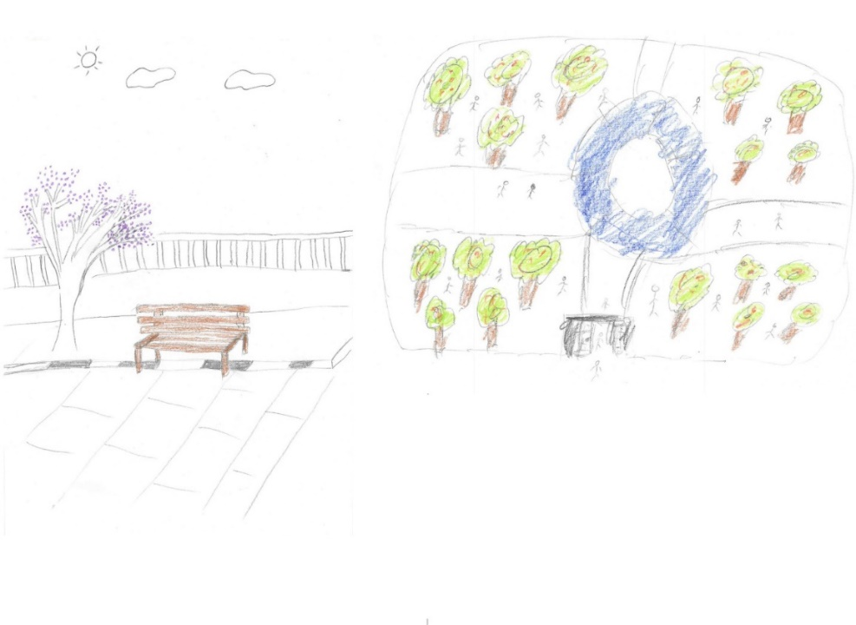

Figure 2. Up and down, respectively: Examples of children's and adults' perceived images of the garden.

Table 1. The different elements depicted in children’s and adults’ visual perception.

|  |  |  |  |  |  |
| --- | --- | --- | --- | --- | --- |
| **Drawing content** | **Depicted elements**  (most to least frequent) | **Frequency and Percentage** | | | |
| **Children** | | **Adults** | |
| Frequency | Percentage | Frequency | Percentage |
| **Natural Elements** | Trees, sun, grass, flowers, sky, birds, butterflies, shrubs, rainbow, mountains | 114 | 94% | 70 | 97% |
| **Amenities/ Artificial Elements** | Swing, slide, fountain, bench, monkey bars, pavement, gate, seesaw, merry go round, drinking  Water station, WC, security booth | 72 | 59.5% | 46 | 60.5% |
| **Spatial layout and surrounding context** | Pathway/walkway, Spatial organization/different playing areas, Bicycle lane, roads, cars | 17 | 14% | 15 | 20% |
| **People &**  **Activities** | Children, adults with children, cycling, sliding, swinging, sitting, playing with the scooter, playing with the ball, playing with the skateboard, walking, drinking coffee, writing, playing with the jump rope | 60 | 49.5% | 24 | 31.5% |
| **Personal/Imaginative** **representation** | Home, castle, out of prison | 14 | 11.5% | 2 | 3% |

The analysis of the interplay among all themes depicted in each drawing showed that while the majority of both children’s and adults’ drawings integrate natural elements with amenities and activities, different combinations appear when comparing children and adults. Among the children’s drawings, those depicting only one element are not very frequent, with 13% of drawings including only natural elements, 3% activities, and 0.8% amenities. Additionally, in the children’s drawings, the personal representation theme never appears in isolation; it is always paired with activities, amenities, natural items or a combination of these themes. As for adults, 24% of drawings depict natural elements in isolation, 3% activities, 3% amenities, and 1% personal representation.

Accordingly, we conclude that for both children and parents the dominant perceived image of the garden is that of a built, natural and social environment. At the same time, we can infer that, in our case, children integrate multiple tangible and intangible elements in their drawings showing their complex perception of the environment. These results demonstrate that children have their own preferences and thoughts, distinct from their parents, about the urban landscape. While 88 and 85% of the children’s drawings provided similar depictions of natural elements and personal representations relative to their guardians, differences arose in depictions of the physical environmental setting and occurring activities. In fact, around 40% of children did not depict the same amenities and activities as their parents and 30% did not depict the same spatial layout.

## 4.3 Perceived values

Considering that children approach drawing as a medium to represent their feelings, we see that feelings manifest through the presence of figures, shapes or facial expressions, such as a figure with a smiley face (Farokhi & Hashemi, 2011). Expressions of feelings are also manifest spatially through the size and location of figures in space, the choice to represent people playing, the choice of colors, and the thematic and structural arrangement of elements (Golomb, 1992). Through the positive feelings reflected in their art coupled with their responses to the interview questions, we can infer the children’s social values. When children were asked about their feelings in the public space, most of them expressed happiness and joy (70%), relaxation and calm (12%), nice feelings (8%), and fun and entertainment (4%), along with other emotional expressions (6%), including *feels like* *my home*, comfortable, serenity, and energetic. Most children used single words to communicate their feelings and primarily linked their positive emotional expressions to playing. In the case of children, seven perceived values emerged, including playing (39%), family time (16%), connection to nature (10%), new friendships (11%), childhood memory (9%), home (7%), and feelings (8%).

Adults expressed themselves differently when asked about their feelings. Most adults showed appreciation for the open space in a dense urban context and for the green natural elements:

*Adult1: Nature, I run away from overpopulation, comfort myself and see greenery here.*

*Adult6: In Beirut, there is no place like this garden, except in the village. There aren't spaces for the public in Beirut except this space.*

Among adults, 74% referred to nature, greenery, trees, fresh air, and birds while expressing feelings. Thirty-two percent referred to relaxation, 21% to serenity, 14% to calmness and peace of mind, and 13% to comfort. For the guardians, six perceived values emerged from the interviews, including childhood memory (30%), hometown (20%), personal emotional experience (16%), family time (13%), children’s happiness (14%), and personal space (7%).

# 4.4 Everyday Heritage

Among the perceived image and values shared by both adults and children are the constructs childhood, family, and home embedded in a natural environment. These are the values ascribed by the community to the “lived” everyday heritage and are an essential component of local identity, sense of place, community, and belonging (Jackson, 2013). For both children and their guardians, the space is associated with family time and “home”:

*Adult13: I get to play with the kids and spend some quality time with them.*

*Adult56: This place reminds me of my home town and my family’s place.*

*Adult31: It feels like home.*

*Child5: I make my sister and aunt run with me.*

*Child13: I play with my dad hide and seek.*

*Child42: Here, I play with my grandfather.*

Extending this to everyday heritage, we recognize the collective importance of this place as a multi-generational space where children engage with family heritage through the act of play and adults engage through nostalgic interactions evoking feelings of home.

Dominant among the value of this space as everyday heritage is the preservation of childhood memories both in the making and already made. These memories abound in both the narratives of adults and children playing a significant role in the collective memory of space. Collective memory captures “knowledge structures that serve to narrate the story of a people” (Roediger & Abel, 2015, p. 359) encompassing objective and subjective dynamics, including place, events/activities, history, and personal values/images (Cauchi-Santoro, 2016; Lak & Hakimian, 2019):

*Adult2: I used to come here with my grandfather, he used to play the oud and I played the flute.*

*Adult32: Last time I came with my girls. They were cycling. I got emotional as I remembered that I used to come here to cycle when I was their age.*

*Adult35: All my childhood stories are related to this place.*

*Adult59: I have an old picture of me with my grandmother taken here in this garden.*

*Adult63: In the 80’s, I used to spend most of my time here, all my childhood memories are linked to this place.*

*Child8: I and my brother came here. I was eating a croissant and my father took us a photo. I like this photo I still remember it.*

*Child11: The first time I came here I was maybe 4, I came after I finished kindergarten.*

In parallel, different personal emotional moments and experiences contribute to the interviewees’ perceived value of the space. For some adults this place has a special meaning relative to milestones in their children’s lives:

*Adult14: This is the place where my son biked by himself for the first time without needing any help from me.*

*Adult74: My oldest daughter learned how to walk here.*

Results show that public space is not solely defined by its spatial configuration and tangible attributes, but by how its collective meaning is co-produced by those who frequent the space and perpetuate the continuity of living cultures. For example, in this particular space, the ability to ride bicycles (a function of the garden’s tangible attributes) translates into the act of learning to ride a bike, the joy of cycling freely, and the memory of having biked in this space thus granting an important role to the everyday heritage of this urban space.

Public spaces in the city provide insights encompassing tangible and intangible elements of heritage that are part of everyday routines, traditions, and environments and are thus very important in preserving and celebrating a community’s unique identity and history (Zukin, 2012). This study focuses on a particular public space in Beirut and acknowledges that heritage is not only found in monumental sites or artefacts but also in the routines, activities and memories of ordinary people – both adults and children – and reiterates the importance of the collective memory of the community.

**5. Conclusion**

In this paper, we emphasized the significance of employing a multivocal narrative perspective to explore the social value of everyday heritage emerging from perceived images of the space. The perceived values that emerged from the qualitative analysis—such as family time, connection to nature, new friendships, and childhood memories—contribute to the notion of everyday heritage. While the tangible attributes of the space serve as attractors, it is the intense lived and remembered experience of childhood that gives this space its status in the everyday heritage landscape.

By highlighting the difference between children’s voices and their guardians', both in terms of what they value and how they value it, this study reveals the importance of capturing diverse voices, particularly those of children, as part of the daily practices and social interactions in public spaces. Our findings show that children primarily perceive public spaces as arenas for play (playing: 39%) and family time (16%), while their guardians focus on childhood memories—the memory of playing (childhood memory: 30%) and hometown connections (20%). The present act of play by children (e.g., riding a bicycle) not only creates new memories but also evokes memories of play for their accompanying adults (e.g., the time when they learned to ride a bicycle), illustrating the intergenerational transmission of cultural heritage. In this context, open spaces serve as dynamic sites where cultural heritage is continuously shaped and experienced, contributing significantly to the continuity of living cultures and community identity. This raises a critical question: Had we not included children in this method, would the concept of collective childhood memory be fully captured as a critical part of this site’s everyday heritage? Our results indicate, that if adults were the sole respondents, the site’s dominant value as everyday heritage would be one of the promotion of mental-health and serenity.

Another important aspect of this study is the promotion of a participatory approach that allows community members to act as experts contributing their knowledge and perspectives to foster a more inclusive and culturally sensitive approach in managing and revitalizing urban spaces (Khoo, 2020). This inclusive methodology has proven effective in capturing the diverse ways community members experience and value public spaces. Understanding the role of these spaces in both reflecting and shaping collective memory can guide urban planners and community stakeholders in making informed decisions to maintain their cultural significance.

Finally, this paper contributes to cultural heritage management by applying a mixed-method approach, integrating visual and qualitative techniques, to analyze the perceived image and values of everyday heritage. The systematic organization and evaluation of diverse interpretations can provide actionable information, supporting decision-making in community engagement initiatives. This is particularly crucial for initiatives, where understanding the cultural significance of heritage places from multiple perspectives can guide cultural heritage management efforts. Importantly, this approach allows for the identification of heritage places in the city that go beyond the historic to include the everyday, thus broadening the scope of what is considered culturally significant.

**References**

Antrop, M., & Van Eetvelde, V. (2017). Sensing and Experiencing the Landscape. In M. Antrop & V. Van Eetvelde (Eds.), *Landscape Perspectives: The Holistic Nature of Landscape* (pp. 103–139). Springer Netherlands.

Azzopardi, E., Kenter, J. O., Young, J., Leakey, C., O’Connor, S., Martino, S., Flannery, W., Sousa, L. P., Mylona, D., Frangoudes, K., Béguier, I., Pafi, M., da Silva, A. R., Ainscough, J., Koutrakis, M., da Silva, M. F., & Pita, C. (2023). What are heritage values? Integrating natural and cultural heritage into environmental valuation. *People and Nature*, *5*(2), 368–383.

Bandarin, F., & Oers, R. van. (2015). Introduction. In *Reconnecting the City: The Historic Urban Landscape Approach and the Future of Urban Heritage* (pp. 1–16). Wiley-Blackwell.

Bollini, L. (2018). The Urban Landscape and Its Social Representation. A Cognitive Research Approach to Rethinking Historical Cultural Identities. In G. Amoruso (Ed.), *Putting Tradition into Practice: Heritage, Place and Design* (pp. 834–842). Springer International Publishing.

Bozkurt, M., & Woolley, H. (2020). Let’s splash: Children’s active and passive water play in constructed and natural water features in urban green spaces in Sheffield. *Urban Forestry & Urban Greening*, *52*, 126696.

Cauchi-Santoro, R. (2016). Mapping community identity: Safeguarding the memories of a city’s downtown core. *City, Culture and Society*, *7*(1), 43–54. https://doi.org/10.1016/j.ccs.2015.12.003

Chandwania, D., & Natu, A. (2022). Study of perception of parents and their children about day-to-day outdoor play spaces. *Early Child Development and Care*, *192*(14), 2280–2295.

Chang, T. C., & Mah, O. B. P. (2020). Beyond child’s play: Heritage as process in Singapore’s playgrounds. *International Journal of Heritage Studies*, *0*(0), 1–17.

CoE. (2000). *The European Landscape Convention*. https://rm.coe.int/16807b6bc7

de la Torre, M. (2013). Values and Heritage Conservation. *Heritage & Society*, *6*(2), 155–166.

Déom, C., & Valois, N. (2020). Whose heritage? Determining values of modern public spaces in Canada. *Journal of Cultural Heritage Management and Sustainable Development*, *10*(2), 189–206.

Duval, M., Smith, B., Hœrlé, S., Bovet, L., Khumalo, N., & Bhengu, L. (2019). Towards a holistic approach to heritage values: A multidisciplinary and cosmopolitan approach. *International Journal of Heritage Studies*, *25*(12), 1279–1301.

Farahani, M., Razavi-Termeh, S. V., Sadeghi-Niaraki, A., & Choi, S.-M. (2023). A Hybridization of Spatial Modeling and Deep Learning for People’s Visual Perception of Urban Landscapes. *Sustainability*, *15*(13), Article 13.

Farokhi, M., & Hashemi, M. (2011). The Analysis of Children’s Drawings: Social, Emotional, Physical, and Psychological aspects. *Procedia - Social and Behavioral Sciences*, *30*, 2219–2224.

Ford, C. (2016). The heritage of public space: Bondi Beach, Luna Park and the politics of amusement in Sydney. In *The Amusement Park*. Routledge.

Fredheim, L. H., & Khalaf, M. (2016). The significance of values: Heritage value typologies re-examined. *International Journal of Heritage Studies*, *22*(6), 466–481.

Ginzarly, M., & Srour, F. J. (2021). Unveiling children’s perceptions of World Heritage Sites: A visual and qualitative approach. *International Journal of Heritage Studies*, *27*(12), 1324–1342.

Ginzarly, M., & Teller, J. (2021). Online communities and their contribution to local heritage knowledge. *Journal of Cultural Heritage Management and Sustainable Development*, *11*(4), 361–380.

Giombini, L. (2020). Everyday Heritage and Place-Making. *ESPES. The Slovak Journal of Aesthetics*, *9*(2), Article 2.

Gohari, A., Behbahani, H., & Salehi, I. (2016). Urban Landscape Perception in Relation to Collective Mentalities and Memories: Case Study: Tajrish District. *Journal of Environmental Studies*, *42*(1), 195–210.

Golomb, C. (1992). *The child’s creation of a pictorial world* (1. [print.]). Univ. of California Press.

Harrison, R. (2010). Heritage as Social Action. In S. West (Ed.), *Understanding heritage inpractice* (pp. 240–276).

Harvey, D. C. (2001). Heritage Pasts and Heritage Presents: Temporality, meaning and the scope of heritage studies. *International Journal of Heritage Studies*, *7*(4), 319–338.

Havinga, L., Colenbrander, B., & Schellen, H. (2020). Heritage significance and the identification of attributes to preserve in a sustainable refurbishment. *Journal of Cultural Heritage*, *43*, 282–293.

Heredia-Carroza, J., Palma Martos, L., & Aguado, L. F. (2021). How to Measure Intangible Cultural Heritage Value? The Case of Flamenco in Spain. *Empirical Studies of the Arts*, *39*(2), 149–170.

Herzfeld, M. (2015). Heritage and the Right to the City: When Securing the Past Creates Insecurity in the Present. *Heritage & Society*, *8*(1), 3–23.

Horton, J., Christensen, P., Kraftl, P., & Hadfield-Hill, S. (2014). ‘Walking … just walking’: How children and young people’s everyday pedestrian practices matter. *Social & Cultural Geography*, *15*(1), 94–115.

Houlden, V., Weich, S., Albuquerque, J. P. de, Jarvis, S., & Rees, K. (2018). The relationship between greenspace and the mental wellbeing of adults: A systematic review. *PLOS ONE*, *13*(9), e0203000.

Jackson, S. A. (2013). ‘A Tale of Two Theatres: Can the Localism Bill Provide a Sustainable Future for ‘Local’ Heritage in England? *International Journal of Heritage and Sustainable Development*, *3*(1), 103–112.

Jones, S. (2017). Wrestling with the Social Value of Heritage: Problems, Dilemmas and Opportunities. *Journal of Community Archaeology & Heritage*, *4*(1), 21–37.

Karsten, L. (2005). It all used to be better? Different generations on continuity and change in urban children’s daily use of space. *Children’s Geographies*, *3*(3), 275–290.

Kenter, J. O., O’Brien, L., Hockley, N., Ravenscroft, N., Fazey, I., Irvine, K. N., Reed, M. S., Christie, M., Brady, E., Bryce, R., Church, A., Cooper, N., Davies, A., Evely, A., Everard, M., Fish, R., Fisher, J. A., Jobstvogt, N., Molloy, C., … Williams, S. (2015). What are shared and social values of ecosystems? *Ecological Economics*, *111*, 86–99.

Khoo, S. L. (2020). Towards an inclusive creative city: How ready is the Historic City of George Town, Penang? *City, Culture and Society*, *23*, 100367.

Korpela, K. (2002). Children’s environment. In R. B. Bechtel & A. Churchman (Eds.), *Handbook of Environmental Psychology* (pp. 363–373).

Lak, A., & Hakimian, P. (2019). Collective memory and urban regeneration in urban spaces: Reproducing memories in Baharestan Square, city of Tehran, Iran. *City, Culture and Society*, *18*, 100290.

Lueg, C. (2013). Characteristics of Human Perception and Their Relevance When Studying Information Behaviour. *Journal of Documentation*, *70*, 562–574.

Luo (落鑫), X. (2022). Protecting and Scaffolding: How Parents Facilitate Children’s Activities in Public Space in Urban China. *ECNU Review of Education*, *5*(2), 242–257. https://doi.org/10.1177/20965311221084116

Mady, C. (2022). The Evolutions, Transformations, and Adaptations in Beirut’s Public Spaces. *Urban Planning*, *7*(1), 116–128.

Martínez Pino, J. (2018). The New Holistic Paradigm and the Sustainability of Historic Cities in Spain: An Approach Based on the World Heritage Cities. *Sustainability*, *10*(7), 2301.

Mitchell, H., Kearns, R. A., & Collins, D. C. A. (2007). Nuances of neighbourhood: Children’s perceptions of the space between home and school in Auckland, New Zealand. *Geoforum*, *38*(4), 614–627.

Mosler, S. (2019). Everyday heritage concept as an approach to place-making process in the urban landscape. *Journal of Urban Design*, *24*(5), 778–793.

Müderrisoğlu, H., & Gültekin, P. G. (2015). Understanding the children’s perception and preferences on nature-based outdoor landscape. *Indoor and Built Environment*, *24*(3), 340–354.

Nazzal, M., & Chinder, S. (2018). Lebanon Cities’ Public Spaces. *The Journal of Public Space*, *3*(1), 119–152.

Niklasson, L., & Sandberg, A. (2010). Children and the outdoor environment. *European Early Childhood Education Research Journal*, *18*(4), 485–496.

O’Donnell, P. M. (2008). *Urban Cultural Landscapes and the Spirit of Place*. 1–8. http://www.international.icomos.org/quebec2008/cd/toindex/77_pdf/77-hFCw-13.pdf

Poulios, I. (2014a). A living heritage approach: The main principles. In *The Past in the Present* (pp. 129–134). Ubiquity Press.

Poulios, I. (2014b). Discussing strategy in heritage conservation: Living heritage approach as an example of strategic innovation. *Journal of Cultural Heritage Management and Sustainable Development*, *4*(1), 16–34.

Roe, M. H., & Taylor, K. (2014). New cultural landscapes: Emerging issues, context and themes. In M. H. Roe & K. Taylor (Eds.), *New cultural landscapes* (pp. 1–23). Routledge, Taylor & Francis Group.

Roediger, H. L., & Abel, M. (2015). Collective memory: A new arena of cognitive study. *Trends in Cognitive Sciences*, *19*(7), 359–361.

Schofield, J. (2016a). Heritage expertise and the everyday: Citizens and authority in the twenty-first century. In *Who Needs Experts?: Counter-mapping Cultural Heritage* (pp. 1–11). Taylor and Francis.

Schofield, J. (Ed.). (2016b). *Who Needs Experts?: Counter-mapping Cultural Heritage*. Routledge.

Silberman, N. (2018). Heritage interpretation and human rights. In S. Watson, A. J. Barnes, & K. Bunning (Eds.), *A Museum Studies Approach to Heritage* (1st ed., pp. 587–597). Routledge.

Sitas, R., & Stewart, M. (2023). From heritage conservation to heritage justice in Cape Town. *City, Culture and Society*, *35*, 100551.

Smith, L. (2006). *Uses of heritage*. Routledge, Taylor & Francis Group.

Smith, L. (2010). Ethics or social justice? Heritage and the politics of recognition. *Australian Aboriginal Studies*, *2010*(2), 60–69.

Stephenson, J. (2008). The Cultural Values Model: An integrated approach to values in landscapes. *Landscape and Urban Planning*, *84*(2), 127–139.

Swanwick, C. (2009). Society’s attitudes to and preferences for land and landscape. *Land Use Policy*, *26*, S62–S75. https://doi.org/10.1016/j.landusepol.2009.08.025

Swensen, G., Krokann, B. S., & Sognnæs, J. (2011). A Heritage Claim to Public Space: Examples from a Mixed Neighbourhood in Drammen, Norway. In C. Perrone, G. Manella, & L. Tripodi (Eds.), *Everyday Life in the Segmented City* (Vol. 11, pp. 195–221). Emerald Group Publishing Limited.

Szilágyi, K., Lahmar, C., Pereira Rosa, C. A., & Szabó, K. (2021). Living heritage in the urban landscape. Case study of the Budapest world heritage site Andrássy avenue. *Sustainability (Switzerland)*, *13*(9).

Taylor, K. (2016). The Historic Urban Landscape paradigm and cities as cultural landscapes. Challenging orthodoxy in urban conservation. *Landscape Research*, *41*(4), 471–480.

Taylor, K. (2022). The intellectual context of the cultural landscape construct. In K. D. Silva, K. Taylor, & D. S. Jones (Eds.), *The Routledge Handbook of Cultural Landscape Heritage in The Asia-Pacific* (pp. 31–48). Taylor & Francis.

Thompson, C. W. (2013). Landscape Perception and Environmental Psychology. In P. Howard, I. Thompson, E. Waterton, & M. Atha (Eds.), *The Routledge Companion to Landscape Studies* (0 ed., pp. 25–42). Routledge.

Tweed, C., & Sutherland, M. (2007). Built cultural heritage and sustainable urban development. *Landscape and Urban Planning*, *83*(1), 62–69.

Ujang, N., & Zakariya, K. (2015). Place Attachment and the Value of Place in the Life of the Users. *Procedia - Social and Behavioral Sciences*, *168*, 373–380.

Weller, S., & Bruegel, I. (2009). Children’s “Place” in the Development of Neighbourhood Social Capital. *Urban Studies*, *46*(3), 629–643.

Winter, T. (2013). Clarifying the critical in critical heritage studies. *International Journal of Heritage Studies*, *19*(6), 532–545.

worldpopulationreview. (2022). *Beirut Population 2022 (Demographics, Maps, Graphs)*. https://worldpopulationreview.com/world-cities/beirut-population

Xiang, Y., Hedblom, M., Wang, S., Qiu, L., & Gao, T. (2022). Indicator selection combining audio and visual perception of urban green spaces. *Ecological Indicators*, *137*, 108772.

Zaninović, T., Palaiologou, G., & Bojanić Obad Šćitaroci, B. (2019). Walkspace as Cultural Heritage Within Urban Landscape. In M. Obad Šćitaroci, B. Bojanić Obad Šćitaroci, & A. Mrđa (Eds.), *Cultural Urban Heritage: Development, Learning and Landscape Strategies* (pp. 263–288). Springer International Publishing.

Zhang, L., Yang, S., Wang, D., & Ma, E. (2022). Perceived value of, and experience with, a World Heritage Site in China—The case of Kaiping Diaolou and villages in China. *Journal of Heritage Tourism*, *17*(1), 91–106.

Zukin, S. (2012). The social production of urban cultural heritage: Identity and ecosystem on an Amsterdam shopping street. *City, Culture and Society*, *3*(4), 281–291.