Supporting Information

Quinizarin-based Photoactive Porous Polymers from Emulsion Templates: Monoliths versus Membranes in Photobactericidal Applications.

Hassan Hayek^{a⸷}, Alison Rouxhet^{b⸷}, Samir abbad Andaloussi^{c}, Sebastijan Kovačič^{d,e}, Davy-Louis Versace^{a*}, Antoine Debuigne^{b}*

ª University Paris-Est Creteil, CNRS, ICMPE, UMR 7182, 94320 Thiais, France
^{b} Center for Education and Research on Macromolecules (CERM), CESAM Research Unit, Chemistry Department, University of Liège (ULiege), Quartier Agora, 13 Allée du Six Août, Sart-Tilman, B-4000 Liège, Belgium.
^{c} Université Paris-Est Créteil (UPEC), Laboratoire Eau, Environnement, Systèmes Urbains (LEESU), UMR-MA 102, 61 avenue Général de Gaulle, 94010 Créteil Cedex, France
^{d} Faculty of Chemistry and Chemical Engineering, University of Maribor, Smetanova 17, SI-2000 Maribor, Slovenia.
^{e} National Institute of Chemistry, Hajdrihova 19, SI-1001 Ljubljana, Slovenia
*Corresponding authors: Antoine Debuigne adebuigne@uliege.be , Davy-Louis Versace davy-louis.versace@u-pec.fr
⸷ The two first authors have contributed equally to the work and are considered as co-first authors.

Table S1. HIPE recipes for the synthesis of polyHIPEs.
W/O HIPE | PH₁ | PH₂ | PH₃ | PH₄ | PH₅ | PH₆ | PH₇ | PH₈ | PH₉
Oil Phase
QMA (g) | / | / | 0.004 | 0.004 | 0.008 | / | 0.004 | 0.004 | 0.003
AESO (g) | 0.218 | 0.218 | 0.218 | 0.218 | 0.218 | 0.218 | 0.218 | 0.218 | 0.131
Cyclohexane (g) | 0.218 | 0.218 | 0.218 | 0.218 | 0.218 | 0.218 | 0.218 | 0.218 | 0.305
Span 80 (g) | 0.044 | / | 0.044 | / | 0.044 | 0.044 | 0.044 | 0.044 | 0.026
PGPR 4125 (g) | / | 0.044 | / | 0.044 | / | / | / | / | /
AIBN (g) | 0.004 | 0.004 | 0.004 | 0.004 | 0.004 | / | / | / | /
I819 (g) | / | / | / | / | / | 0.004 | 0.004 | 0.004 | 0.003
Water phase
CaCl₂ aq 3wt% (g) | 2.606 | 2.606 | 2.627 | 2.627 | 2.649 | 2.606 | 2.627 | 2.627 | 2.656

Figure S1. Synthesis (A), ¹H NMR in CDCl₃ (B) and ¹³C NMR in CDCl₃ (C) of the monomethacrylated quinizarin (QMA).
Figure S2. N₂ isothermal adsorption curves and specific surface area (SBET) for A) PH₁ and B) PH₃.

Figure S3. Stress vs strain curve from compression test with DMA (at 100µm/min compression speed at 25°C) for QMA-free polyHIPEs PH₁ and PH₂ and QMA-functional polyHIPEs PH₃₋₅ from 0 % to 20 % of deformation.

Figure S4. Pictures and SEM images of the quinizarin-functionalized AESO-based porous membranes PH₈ obtained by photocuring using Irgacure 819 as photoinitiator.

Figure S5. Evolution of the UV-visible spectra of the TPCPD solution upon irradiation in the presence of polyHIPE monoliths PH₁ (A) and PH₃ (B) as well as polyHIPE membrane PH₉ (C).

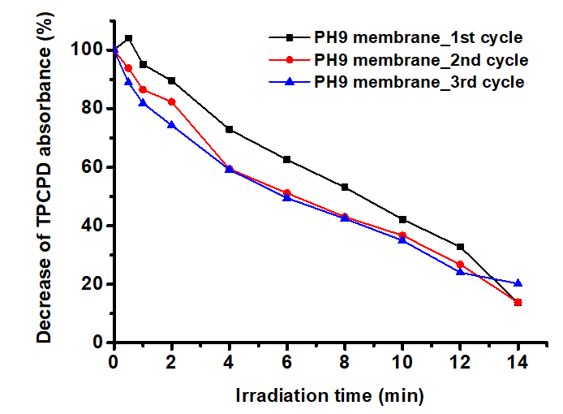
Figure S6. Decrease of the TPCPD absorbance as a function of the irradiation time in the presence of the PH₉ membrane after three cycles of light activation.

Figure S7. IR spectra of the quinizarin-functionalized porous monolith PH₃ before (black line) and after (red line) the photobactericidal tests. Samples were taken at the edge of the polyHIPE were light irradiation was maximal.

Figure S8. SEM analysis of the edge (A) and the center (B) of the quinizarin-functionalized porous monolith PH₃ after antibacterial test under irradiation.

