How environmental regulations affect rural residents’ willingness to pay for sustainable domestic sewage treatment?
Jian Jiao^{a,b}, Zihong Yangª, Boyang Shi^{a,c}, Ke Xuª, Thomas Dogot^{b}, Changbin Yinª
ª Institute of Agricultural Resources and Regional Planning, Chinese Academy of Agricultural Sciences, Beijing 100081, China
^{b} Economics and Rural Development Laboratory, TERRA Teaching and Research Centre, Gembloux Agro-Bio Tech, University of Liège, Gembloux B-5030, Belgium
^{c} Laboratory of Chemical Engineering, Department of Applied Chemistry, University of Liège, Liège, Belgium
Jian Jiao: jian.jiao@doct.uliege.be

Abstract
Exploring the construction of a payment mechanism for rural residents is one of the most effective approaches to promote the process of sustainable rural domestic sewage treatment (RDST). The behavior and willingness of rural residents were the results of a combination of internal and external factors, and as an important embodiment of external factors, environmental regulations have an irreplaceable role in rural environmental governance. Additionally, although the effects of environmental regulations have attracted extensive research interest, their effects on rural residents' willingness to pay (WTP) for sustainable RDST have not been revealed. Based on a dataset of 744 respondents in Jilin, Shandong and Gansu Provinces in Northern China, an integrated model covering both mediating and moderating effects was developed to verify the effects of diverse environmental regulations on rural residents' WTP and to explore the impact mechanisms.
The regression result illustrated that guiding regulation and incentive regulation passed the significance test at the 1% level (Fig. 1), indicating that the "top-down" governance model of environmental regulation has indeed had a positive impact on rural residents' WTP for sustainable RDST. In contrast, the effect of binding regulation was not significant, suggesting that the binding effect of environmental regulation was slightly deficient. This provides a new reference for the Chinese government in formulating policies related to rural environmental governance, especially in RDST.
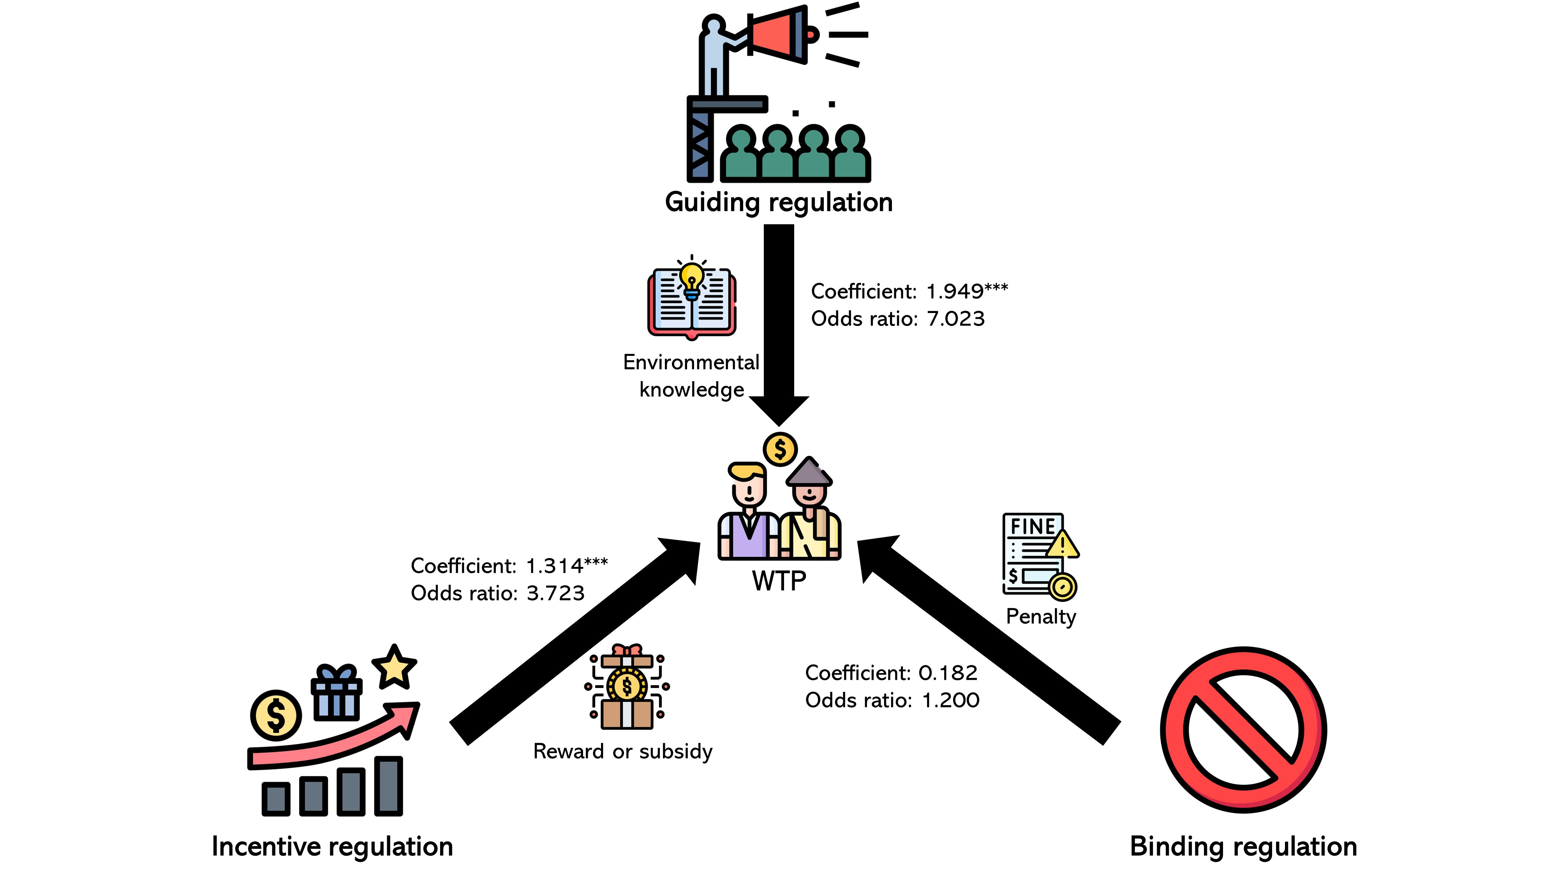
Fig.1 Influence framework of diverse environment regulations on rural residents’ WTP for sustainable RDST
It was also found that rural residents' cognition mediated the effect of environmental regulations on their WTP (Fig. 2). Both guiding regulation and incentive regulation had a positive effect on rural residents' cognition and were significant at the 1% and 5% levels respectively. And these two regulations remained positively influencing rural residents' WTP at the 1% significance level and the coefficients increased. In the influencing process of guiding and incentive regulations on rural residents' WTP, according to the determination criteria of mediating variables, rural residents' cognition had a partial mediating effect. The implication of this finding is that the publicity on the environmental hazards and the health hazards of rural domestic sewage should be strengthened to effectively raise rural residents' environmental cognition and environmental protection awareness, thereby increasing their WTP for sustainable RDST. Furthermore, rural residents' environment satisfaction positively moderates the effect of environmental regulations on their WTP (Fig. 2). The interaction terms had a significant positive effect at the 10% and 5% levels, respectively. Moreover, when the interaction terms were included in the regression model, the R² increased respectively to compare with the interaction term excluded from the model. With higher environmental satisfaction of rural residents, the impact of guiding environmental regulation and incentive environmental regulation will be enhanced. It should be coordinated to strengthen RDST, rural domestic waste treatment, toilet renovation and village appearance improvement, to improve the overall environmental satisfaction of rural residents.
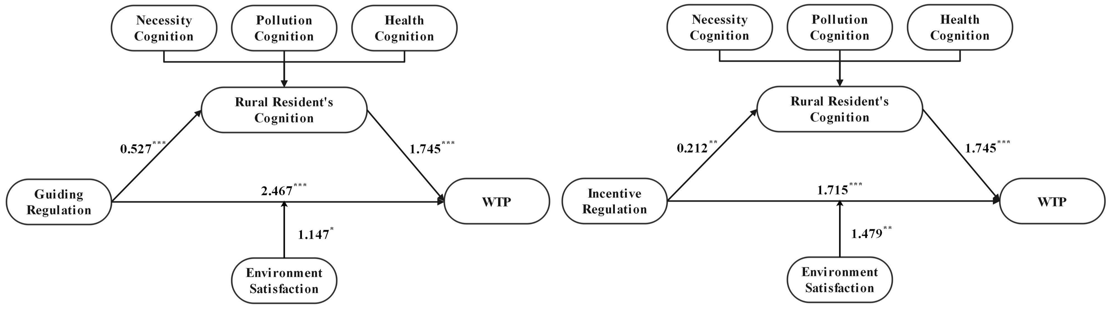
Fig.2 Diagram of mediating effect and moderating effect
In light of the above study results and discussions, this study proposes the following corresponding policy implications. Firstly, the environmental regulation system for rural areas requires further improvement. Secondly, the government should emphasize the differences between various environmental regulations when formulating relevant policies. Furthermore, the integration of government environmental regulations and informal regulations should be concerned. Finally, the importance of rural environmental protection should be further promoted. The results of this study may provide references and recommendations for the formulation of relevant environmental regulations in RDST, the construction of payment systems for rural residents, and implications for the implementation of other developing countries.

