Certificate of participation

and oral presentation

Ophélie Piedfort

17th ENII EFIS EJI

SUMMER SCHOOL

on advanced immunology

20 Hours of Lectures and Panel Sessions

Alghero, Sardinia May 17-24, 2024

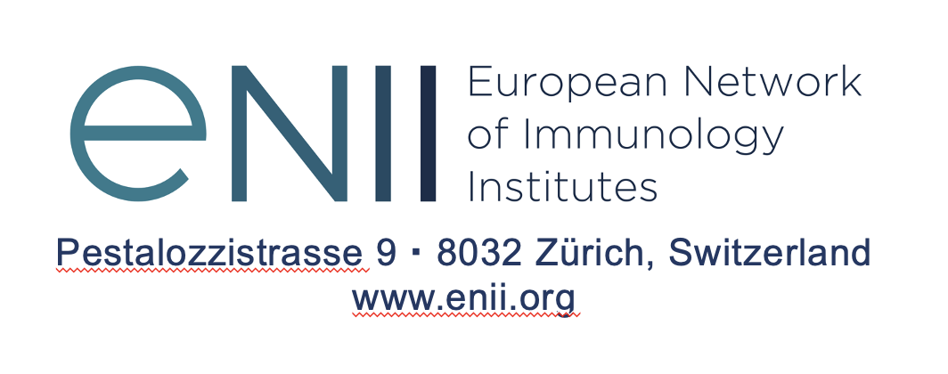

Prof. Maries van den Broek


ENII President

