A perspective on the synthetic potential of biobased building blocks for heterocyclic chemistry
Loïc Bovyª and Jean-Christophe M. Monbaliu^{a,b,}*
aCenter for Integrated Technology and Organic Synthesis, MolSys Research Unit, University of Lie`ge,
Lie`ge, Belgium
bWEL Research Institute, Wavre, Belgium
*Corresponding author: e-mail address: jc.monbaliu@uliege.be

Contents
- Introduction 2
- Transition from petro to biobased 3
  - Renewable feedstocks sources 3
  - Biorefineries challenges 5
  - Scaffold identification and selection 7
  - Building blocks and their synthetically relevant derivatives 9
- Isolated rings 15
  - Five-membered rings 15
  - Six-membered rings 29
  - Miscellaneous 32
- Fused rings 36
  - Five-membered rings 36
  - Six-membered rings 44
  - Miscellaneous 53
- Perspectives 56
- Conclusion 59
Acknowledgment 59
References 59
Abstract
Heterocycles are a wide occurrence in molecules with a variety of applications: from the pharmaceutical industry to polymers, cosmetics, food additives and dyes. However, most of their synthetic pathways are based on finite petrobased building blocks. This chapter discusses different renewable feedstock sources, their prominence and compo- sition as well as the challenges faced regarding their transformation into valuable primary building blocks. Following this, a brief overview of secondary building blocks
Advances in Heterocyclic Chemistry Copyright # 2024 Elsevier Inc.
ISSN 0065-2725 All rights are reserved, including those 1

https://doi.org/10.1016/bs.aihch.2024.04.003
for text and data mining, AI training,
and similar technologies.

2 Loïc Bovy and Jean-Christophe M. Monbaliu
is discussed before providing examples of their incorporation in (un)fused heterocycles with an emphasis on compounds with known applications. Building upon these separate topics, perspectives aiming at solving the encountered and discussed issues are provided.
Keywords: Biobased platforms, Green transition, Upgrading, Heterocycles

Introduction
Heterocycles, whether they are standalone structures or are fused to other rings, have helped develop society by providing solutions to a variety of problems. One of such instances is that of pharmaceuticals: more than 85% of compounds endowed with biological activity contain at least a heterocyclic core with 59% having nitrogen-containing rings.^{1,2} In addition to being a wide occurrence in pharmaceutical compounds, these can also be found in a broad panel of natural products as well as dye stuffs, cosmetics and insecticides.^{3–6} Despite being over 200 years old, the preparation of hetero- cycles and the discovery of new rings keeps being a prominent research topic.³ Most of the building blocks required for the preparation of hetero- cycles are petrobased and therefore have a dimmer future as fossil reserves are progressively depleted. Considering how central these cyclic structures are to maintaining the living standards of our modern society, finding alter- natives to rapidly depleting petrol resources becomes a pressing matter. One of such alternatives consists in progressively and partly transitioning from petro to biobased substrates as the essential starting materials for the preparation of both bulk and fine chemicals, heterocycles among them.
This chapter aims at describing the hurdles encountered on the way to a more sustainable sourcing of heterocycles as well as giving an overview of bio-sourced building block applications through three main sections. Section 2 will deal with building block renewable sources, identification of suitable targets, their selection and their derivatives. Following this, exam- ples concerning the upgrading of biobased building blocks through their incorporation into heterocycles will be discussed in Sections 3 and 4. The emphasis will be mostly placed on substrates with known applications. In addition to describing and discussing chemicals with established market application, other more fundamental yet innovative transformations will be showcased. Section 3 deals with unfused rings while Section 4 displays the incorporation of renewable building blocks in their fused counterparts. These two sections are articulated following ring size whose preparation incorporates the chosen renewable starting material. Entire sub-sections will be dedicated to 5 and 6-membered rings since they are the most prominently

A perspective on the synthetic potential of biobased building blocks 3
represented rings while a third subsection will deal with miscellaneous ring sizes (3, 4 andgreater than 6 atoms in the ring). This chapter does not aim at providing an exhaustive list of substrates whose preparation involves renewable reagents but to show the possibilities arising from the use of said reagents. Additionally, only final products whose heterocycles contain bio-sourced atoms will be presented here.
- Transition from petro to biobased
  - Renewable feedstocks sources
Coal extraction and consumption soared with the industrial revolution. This drastic increase in cheap and available feedstock paved the way for the production of equally impressive large quantities of chemicals, dyestuff and textiles but also enabling more efficient transportation and energy pro- duction. Coal reigned supreme as the source of energy and chemicals to feed the industrial effort until the 1960s where it was progressively replaced by oil.⁷ This increase in energy and chemicals production was accompanied with an increase in demography thanks to a drastic improvement in life quality.
Unfortunately, coal and oil are currently being depleted and the initial stocks will not be replenished before millions of years. Additionally, the extraction, consumption and combustion of these fossil resources releases previously stored carbon under the form of CO₂ in the atmosphere with a now well established impact on the environment. It is therefore paramount to find alternatives to these finite resources to maintain the actual living standards, as well as to limit their deleterious impact on the environment. Biomass, as opposed to coal or oil, is renewable and is defined as an inex- haustible organic material originating from plants and animals, which can be converted either to energy or into starting materials for various chemical applications.⁸ This, however, needs to be regarded as different to any mate- rial which is fossilized or stored in geological formation. Biomass comes in a broad variety of shapes and forms though it is mainly sourced from terrestrial and marine feedstocks: agricultural crops, fishery waste and forestry being the most prominent ones. These three sources provide the bulk of O and N-containing scaffolds under the form of cellulose (1), chitin (3), chitosan
(4) and lignin (7). These heteroatoms are indeed omnipresent in the endless
library of chemicals produced up to this day; however, sulfur and phospho- rus are equally important despite being less represented. Sulfur-containing scaffolds can be obtained from algae, more particularly brown algae, under the form of saccharide-based λ-carragean (16) and fucoidan (17) whose

4 Loïc Bovy and Jean-Christophe M. Monbaliu

treatment may provide thiophenes (18), surfactants (19), furans (20) and other sulfur-containing sugars (21). Phosphorylated scaffolds are even more difficult to obtain from renewable resources because of their naturally lower occurrence in biological scaffolds. However, extraction of phosphorus-
containing organic molecules from lipidic membranes has recently been envisioned. This results in the extraction, among others, of phosphocholine
(22) whose hydrolysis provides cholines 23 and 24 (Fig. 1).⁹
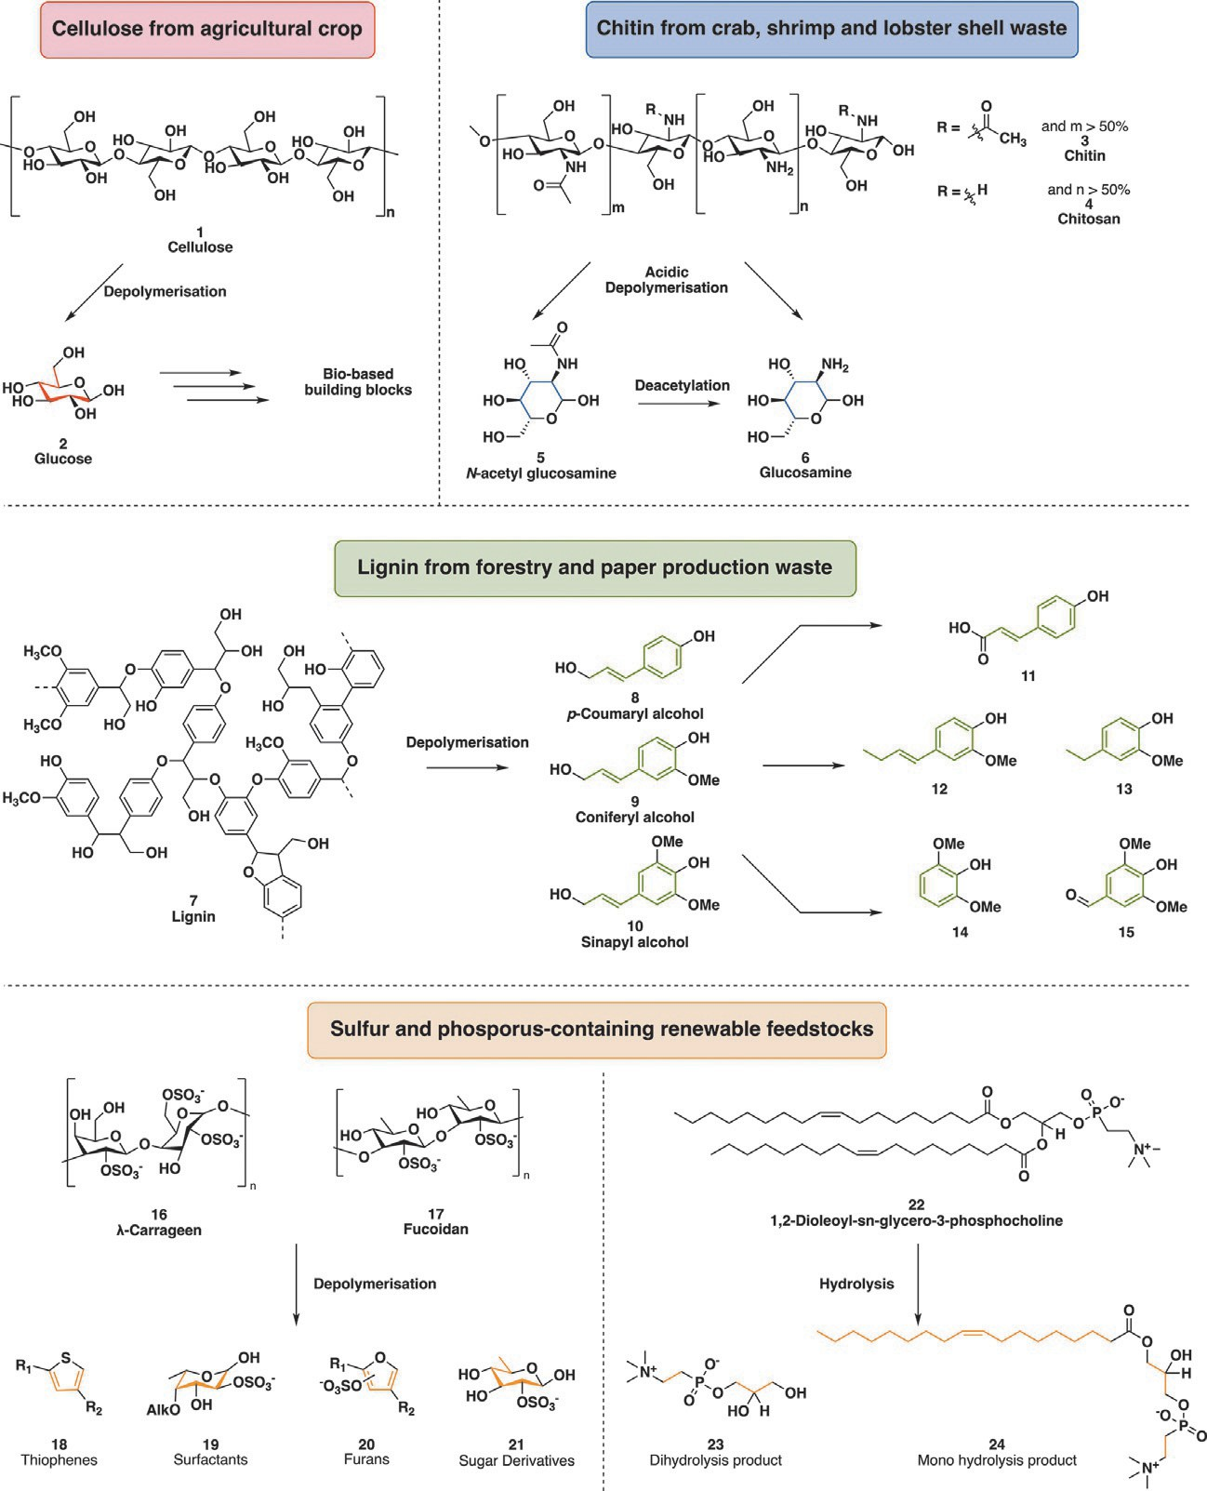
Fig. 1 Main biorefineries polymeric feedstocks, their origin, some of their derived monomers and derivatives.

A perspective on the synthetic potential of biobased building blocks 5

Primary biobased building blocks are obtained from raw biomass through a series of depolymerization, fractionation and defunctionnalization steps. For instance, agricultural-based feedstocks mostly contain cellulose (1) and hemicellulose which respectively represent 40–50% and 20–30% of ligno- cellulosic biomass.¹⁰ These are two polysaccharides which provide struc- tural integrity to plants and algae cell walls while also being the source of oxygen-rich substrates. The former is a linear polymer whose depoly-
merization results in glucose (2) monomers whereas the latter is a ramified polymer mostly containing 2 alongside other sugars such as xylose, arabinose or galactose. Chitin (3), an aminated polysaccharide, can be sourced from marine waste such as crustacean shells and is composed of N-acetyl- glucosamine (5), an amide analog of glucose. As for (hemi)cellulose, 3 plays a role in cell rigidity of fungi as well as previously mentioned crustacean shells
or insect exoskeleton by incorporating minerals in its network. In the case where the proportion of 5 is inferior to 50% of the polymer’s composition, chitin is referred to as chitosan (4). Depolymerization of either chitin or chitosan gives a mixture of 5 and glucosamine (6) which may then be exploited and transformed by biorefineries.¹¹ The third main renewable feedstock comes under the form of lignin (7), a phenolic polymer whose structure is neither well defined nor homogeneous. Lignin (7) is mostly obtained as waste from the forestry as well as paper production industry and its composition greatly differs depending on its origin. It is the second most abundant organic carbon source of the biosphere, making up to 30%.^{10,12} Lignin (7) has a central role in cell wall integrity, more specifically in that of wood and bark where it rigidifies their structure and renders them hydrophobic. These three abundant reservoirs of renewable organic material (Fig. 1) represent a virtually inexhaustible pool of substrates to feed biorefineries.

Biorefineries challenges
Petro and biorefineries both aim at the purification of raw materials toward valuable chemicals, whether they are for combustion and energy production such as (bio)fuels or for the production of chemical building blocks.¹³ Crude oil fed to petroleum refineries is a fairly homogeneous mixture of alkanes and aromatic compounds with a very low carbon to oxygen ratio whereas lignocellulosic feedstocks are highly functionalized and enriched in oxygen making their separation difficult.¹⁴ Additionally, crude oil is available throughout the year as opposed to biomass whose production is seasonal

6 Loïc Bovy and Jean-Christophe M. Monbaliu

and regional. These two fundamental differences in addition to the years of process polishing through minute engineering result in petroleum refineries being streamlined and very cost effective, providing valuable chemicals all year round with minimal waste generation. The greater heterogeneity of biobased feedstocks alongside their variable availability and provenance requires the development of multipurposed chemical processes able to accommodate such variations.
As mentioned previously, crude oil refining mostly provides unsub- stituted alkanes and aromatics. They are therefore of little synthetic use as such and require additional functionalization and/or activation to render them suitable for further chemical processes. These steps, as opposed to the initial extraction and refining, are very wasteful, energy intensive and mostly require harsh conditions alongside equally toxic reagents to balance the lack of reactivity of these substrates. On the complete opposites to these bare carbon scaffolds, substrates coming from biorefineries are highly func- tionalized molecules. This is advantageous because it prevents the highly energy-intensive grafting of substituents, activating, directing groups and other tethers. This high functionalization also represents a hurdle since puri- fication and refining of these often requires defunctionalization during which selectivity can be problematic leading to high waste production.¹⁵ These two different aspects related to the chemicals source can be simplified as follows: petrochemicals are upgraded and built from bottom to top, adding complexity with every step, whereas biobased chemicals require a top to bottom approach to yield valuable building blocks.¹⁴
Realizing that renewable feedstock upgrading requires the trimming of abundant functional groups, a very sensible question can be raised: what is the efficiency of a refining step? In other words, how much of the initial feedstock scaffold or atoms is retained in the final product? The answer can be found under the “Biomass Utilization Efficiency” (BUE) metric which was defined by Carus and coworkers in 2015 as “the percentage of initial
biomass ending up in the end product based on the molar mass of the reactant and
target biobased product.” This can be further divided into subcategories such as BUE_{L} and BUE_{H} which are the realistic lower and higher yield which can be obtained by a process. For instance, the BUE_{H} demonstrated that not all pathways are equally attractive when comparing the production of acetic acid directly from glucose to that of the oxidation of ethanol. The former showing a BUE_{H} of 90% while the latter had only a BUE_{H} of 60%. This percentage is particularly well illustrated when scrutinizing the process related to isoprene production from glucose which has a BUE_{H}

A perspective on the synthetic potential of biobased building blocks 7

of only 12%. This particularly low value is the result of significant amounts of oxygen being removed from the initial polymeric glucose to yield terpenic isoprene.¹⁶

Scaffold identification and selection
Renewable building blocks can be classified in three separate categories. The first one, drop-in chemicals, are molecules whose structure are identical to those of petrobased building blocks though the processes leading to them are not ripe yet, preventing them from being competitive replacements (EG: propylene or styrene).¹⁷ The second category is named “smart drop- in” and encompasses renewable molecules which are actually advantageous compared to their petrobased counterparts. Biobased substrates fall in this category if at least two of the following criteria are met in regards to tradi-
tional drop-in compounds: the BUE is significantly superior, their produc- tion is less energy intensive, is faster and less complex and/or requires fewer toxic reagents or generates drastically less harmful waste. Glycerol, acrylic acid, epichlorohydrin and succinic acid among others fall under this denom- ination.¹⁸ Finally, if a biobased scaffold has no petrobased counterpart, it is a “dedicated platform.” Some of these dedicated platforms may therefore repre- sent new market opportunities by opening the door to new molecular architectures and therefore, new applications. The down side of such new opportunity is that finding applications for these new building blocks may be troublesome. Additionally, cost-effectiveness may be harder to reach considering the amount of invested money to find interesting applications (Fig. 2).¹⁸

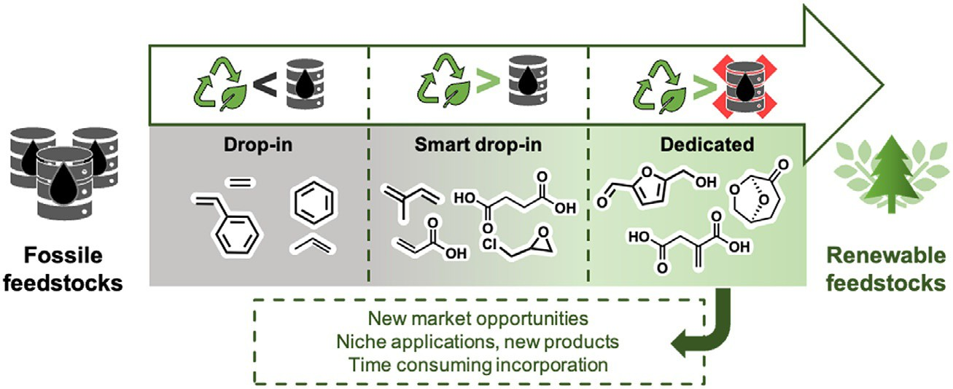
Fig. 2 Illustration of “drop-in,” “smart drop-in” and “dedicated” chemicals concept alongside some related compounds.

8 Loïc Bovy and Jean-Christophe M. Monbaliu

As it was mentioned and developed in the previous section, a very broad palette of biobased compounds can be obtained from renewable resources albeit not a lot of them can compete with their petrobased counterparts. Aiming at focusing research effort on a small group of highly promising substrates, the US Department of Energy (DoE) provided in 2004 a ratio- nalized list of platform molecules derived from starch and lignocellulosic origin. A platform molecule can be defined as “a chemical compound whose constituent elements originate wholly from biomass (material of biological origin, excluding fossil carbon sources), and that can be utilized as a building block for the production of other chemicals.”¹⁹ The list of retained substrates was obtained after a two-stage selection process which skimmed through roughly 300 biobased products to select 14 molecules. This first selection of biobased molecules is commonly referred to as the “DoE Top 10” despite being composed of 14 starch-derived compounds (underlined in red, Fig. 3).²⁰ This initial list was then revised and expanded in 2010 by Bozel and Petersen after a thorough examination of technology developments for their industrial production.²¹ The latest revision came about in 2016 when the DoE added five additional building blocks (underlined in blue, Fig. 3), reflecting the advances in industrial production of renewable build- ing blocks.²²
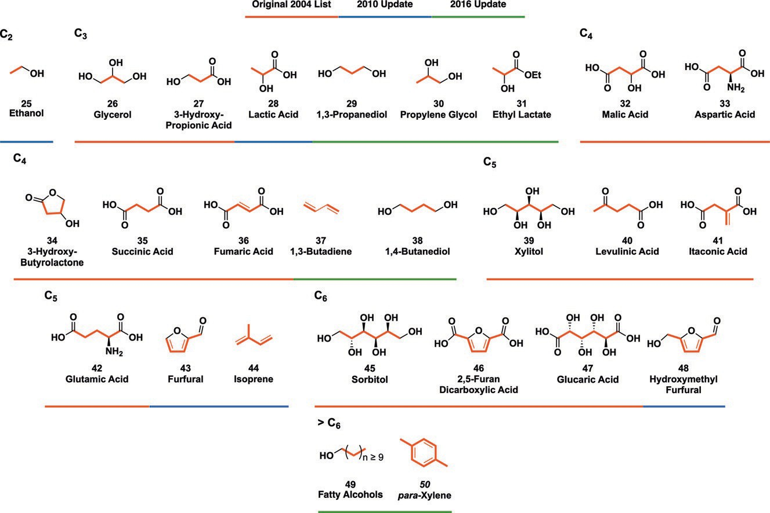
Fig. 3 List of promising building blocks selected in the 2004 DoE top 10 (underlined in red), 2010 new evaluation (underlined in blue) and the final additions of 2016 (underlined in green) sorted by number of carbons in their backbone. The carbonated backbone is highlighted in red for clarity.

A perspective on the synthetic potential of biobased building blocks 9

  - Building blocks and their synthetically relevant derivatives This sub-section aims at giving a broad overview and exemplifying the notion of “platform molecules” which was introduced before. The selected
building blocks sourcing is briefly developed before discussing some of the compounds which can be derived from these scaffolds. As these chemicals are discussed, it will become more and more evident that as the building blocks scaffold grow in size, the substrates derived from these become more structurally diverse.

    - C3—Glycerol, 3-hydroxypropionic acid and lactic acid
As highlighted in the section above, six of the reported platforms are composed of C3 backbones. Despite this, three central scaffolds can be isolated with derived products overlapping, namely glycerol (26), 3-hydroxypropionic acid
(27) and lactic acid (28). Some of the derivatives obtained from these central
scaffolds are part of the extended list of high potential molecules (1,3- propanediol (29) and propylene glycol (30)) and can be issued from one of the three central substrates. Some of these secondary building blocks obtained from the upgrading of these platforms will be very succinctly described below. Glycerol (26), also known as glycerin, is usually obtained by trans- esterifying or hydrolyzing oil and animal fat, though petrobased procedures are also reported. The latter is a lengthier process which ultimately classifies
26 as a smart drop-in chemical. Selective oxidation of 26 yields 1,3-dihydroxyacetone (51) which turns into 1,3-dichloroacetone (52) upon chlorination. Chlorination of 26 followed by a basic treatment provides reactive epichlorohydrin (53) and glycidol (54). Dehydration of glycerol results in allylic alcohol (55) while hydrogenolysis of 26 may also provide 1,3-propanediol (29) or propylene glycol (30), the latter is then ready to undergo epoxidation intro propylene oxide (56) (Fig. 4).²³
While 26 originates from fatty acid esters, 3-hydroxypropionic acid (27)
is mostly produced through a not yet fully understood fermentation process which still requires refining. Carboxylic acid 27 may undergo reduction toward its corresponding diol 29 while oxidation of its terminal carbon pro- vides malonic acid (57). Dehydration of 27 leads to acrylic acid (58) which can later on be transformed into its ester (59), amide (60) or nitrile (61) derivative (Fig. 4).²⁴
Lactic acid (28), like previously discussed 27, is mostly obtained through fermentation of carbohydrates. 28 can generate acrylic acid (58) through a dehydration reaction and the corresponding ester, much like 27. Its reduc- tion can also provide propylene glycol (30) and the corresponding epoxide

10 Loïc Bovy and Jean-Christophe M. Monbaliu

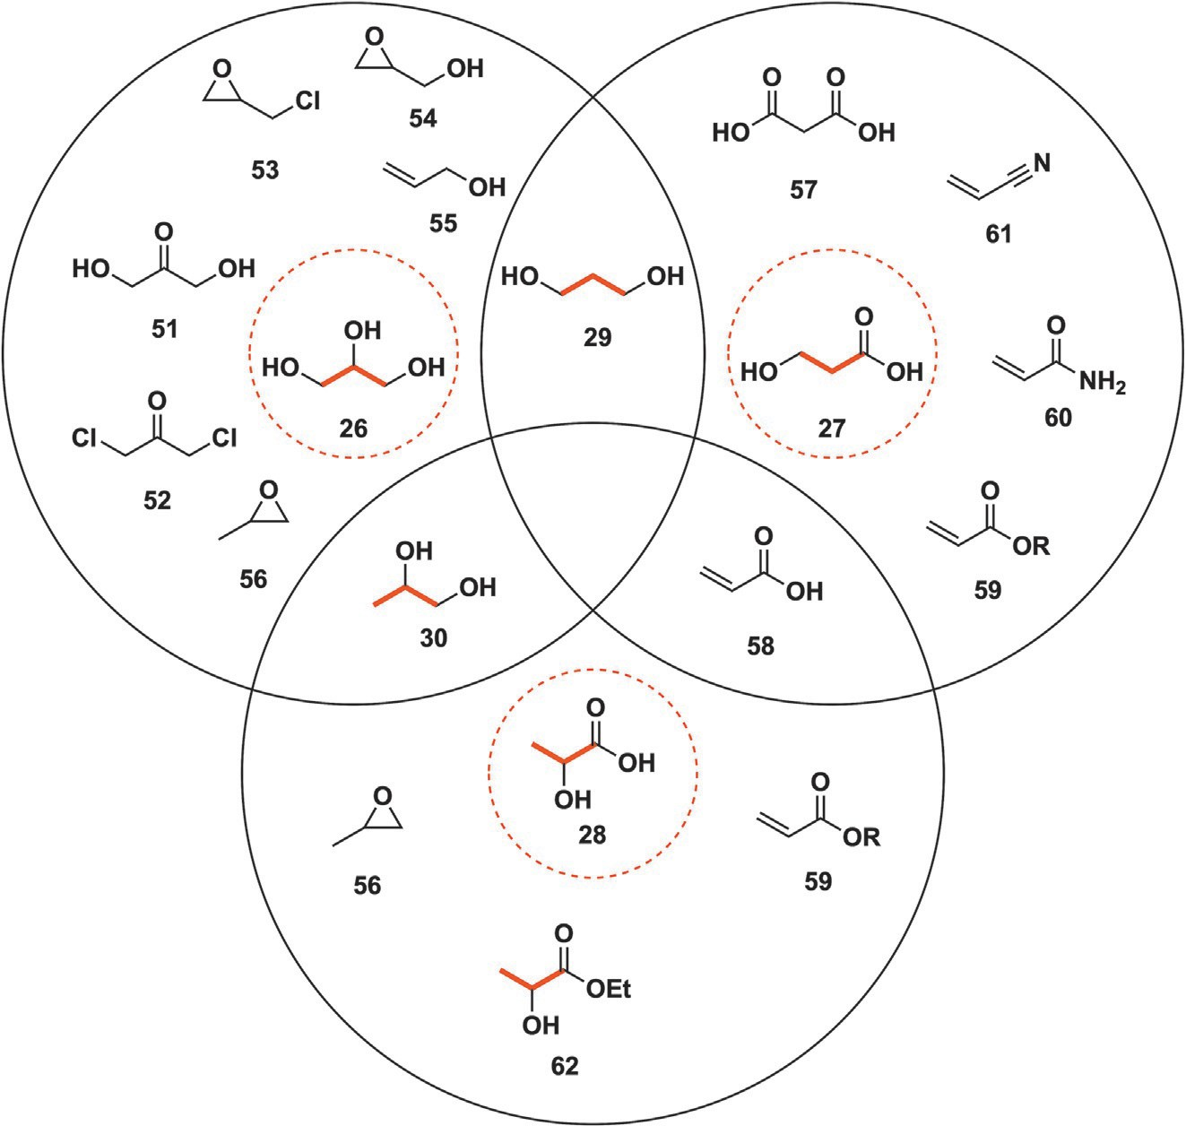
Fig. 4 Glycerol (26), 3-hydroxypropionic acid (27) and lactic acid (28) as central renew- able building blocks surrounded by chemicals deriving from them (among which are 1,3-propanediol (29), propylene glycol (30) and ethyl lactate (31)).

56 as for glycerol (26). Esterification of 28 with ethanol results in ethyl lac- tate (31), a biobased green solvent poised to replace some common chlori- nated solvents (Fig. 4).²⁵

    - C4—3-Hydroxybutyrolactone, malic, fumaric, succinic and aspartic acid
Aspartic acid (33) can be the result from the asymmetric amination of fumaric acid (36) with NH₃ or the Kreb’s cycle from oxaloacetate. The reduction of 33 results in aminated diol 62 while 33 can also cyclize in the presence of ammonia before partial reduction toward 63 or undergo dehydrative cycli- zation into 64 possibly followed by reduction of the anhydride into either aminated lactone (65) or 3-amino-tetrahydrofuran (66) (Fig. 5).²⁰

A perspective on the synthetic potential of biobased building blocks 11

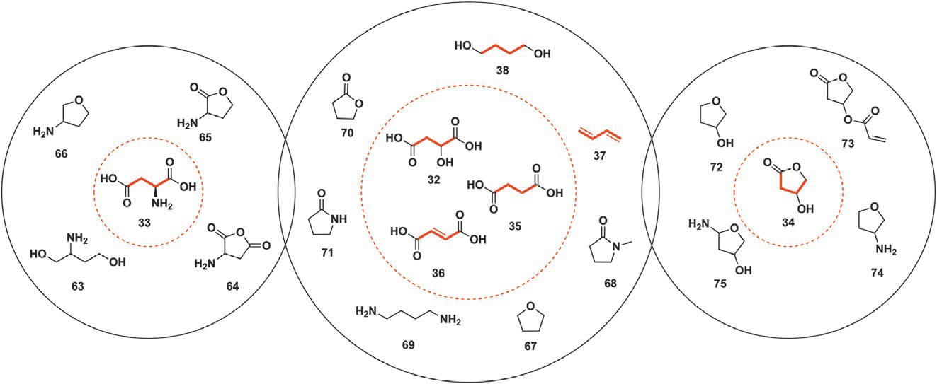
Fig. 5 C4 platform molecules as listed by the DoE in 2004 and their derived building blocks among which are 1,3-butadiene (37) and 1,4-butanediol (38).

Succinic (35), malic (32) and fumaric acid (36) are grouped together for the sake of simplicity and are so far obtained through fermentation by engi- neering bacteria to maximize the yield of these diacids. These three platform molecules can be modified to yield a variety of important compounds, starting from solvents such as tetrahydrofuran (67) or N-methylpyrrolidine (68). 1,4-Butanediol (38), one of the 2016s addition to the list of promising build- ing blocks, can be obtained from the reduction of these C4 diacids before undergoing a double dehydration into 1,3-butadiene (37), another 2016 addi- tion. Product 38 can undergo amination to obtain the corresponding diamine
69. Finally, lactone 70 and lactam 71 with applications in the polymer industry
can be obtained from these carboxylic acids (Fig. 5).²⁶
The last building block discussed in this sub-section is 3-hydroxybutyrolactone (34), a scaffold obtained from the chemical oxida- tive degradation of starch in a messy multistep procedure requiring further research. Its reduction provides 3-hydroxy-tetrahydrofuran (72) while its esterification with (for instance) acrylic acid (58) leads to compound 73 which is of interest in the polymer industry. Aminated derivatives 74 and 75 can also be obtained from lactone 34 (Fig. 5).²⁶

    - C5—Isoprene, itaconic acid, glutamic acid, levulinic acid and xylitol
This section related to C5 building blocks excludes furfural (43) which is
presented in the Section 2.4.4 with other furan derivatives for a more com- prehensive and compact approach.²⁷
Itaconic acid (41) is a chemical falling in the “dedicated” category which is the result of aerobic fungal fermentation. Branched diol 76 is the result of

12 Loïc Bovy and Jean-Christophe M. Monbaliu

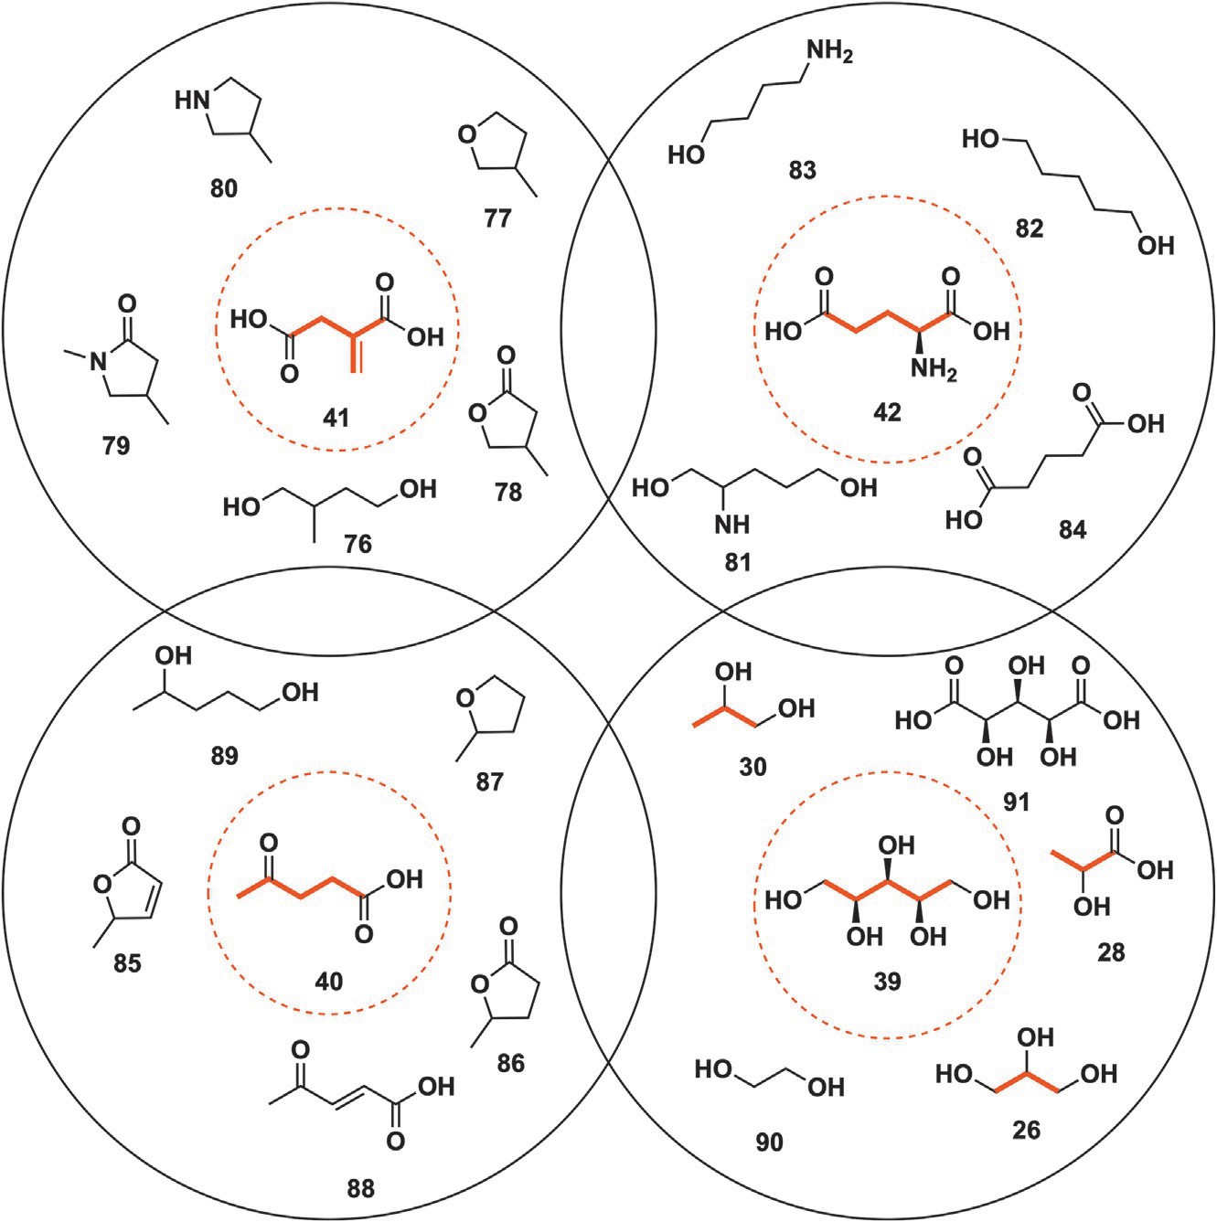
Fig. 6 Some of the C5 biobased scaffolds alongside their derivatives.

itaconic acid (41) reduction while an array of tetrahydrofurans (77), lactones (78), lactams (79) and pyrrolidines (80) can be derived from 41 (Fig. 6).²⁷ Fermentation of carbohydrates by some bacteria yields amino acid 42 also known as glutamic acid. Its hydrogenation provides glutaminol (81) and 1,5-pentanediol (82) while decarboxylation results in 4-aminobutanol
(83). Glutaric acid (84) can potentially be sourced from 42 (Fig. 6).²⁸ Levulinic acid (40) is the third carboxylic acid of the studied C5 category.
Acidic treatment of cellulosic material results in the production of acid 40 among other products. Levulinic acid (40) can afford different 5-membered rings such as 85 and 86 alongside 2-methyl tetrahydrofuran (2-MeTHF, 87), a now broadly used green and biobased solvent. Levulinic acid (40) oxi- dation converts it into conjugated 88 while its reduction yields diol 89 (Fig. 6).²⁹

A perspective on the synthetic potential of biobased building blocks 13

Xylitol (39) is the last C5 substrate developed in this section. It com- monly undergoes hydrogenolysis to yield smaller polyols such as glycerol (26), ethylene glycol (90), lactic acid (28) or propylene glycol (30) while its oxidation yields xylaric acid (91) with applications in the polymer industry (Fig. 6).³⁰
Last but not least, isoprene (44) is an unsaturated building block readily obtained from isopentyl diphosphate, a terpenoid found in a large variety of plants. Isoprene (44) is mostly used in the rubber industry. In fact, around 95% of the total production of isoprene is used by the rubber industry.³¹ It does not have an extended catalogue of derivative and therefore not the same “platform” title as other substrates yet it is essential to the world’s economics.

    - C6—Furans, sorbitol and glucaric acid
Furfural (43) is grouped with the other two furan-derived platform mole- cules 2,5-furandicarboxylic acid (46) and 2-hydroxyfurfural (48). These cyclic substrates can be converted into tetrahydrofuran (92), a highly con- sumed organic solvent as well as furfuryl alcohol (93), 5-hydroxymethyl furfuryl alcohol (94) or furan dicarboxaldehyde (95). These furanic sub- strates may undergo ring opening and yield levulinic acid (40) or succinic acid (35). Finally, disubstituted tetrahydrofuran derivatives 96 and 97 with applications as monomers for the plastic industry can be obtained (Fig. 7).³² Sorbitol (45) much like xylitol (39) can undergo several types of bond cleavage, providing polyols 26, 30 and 90. Upon acidic treatment, 45 can cyclize into polyol 98 before undergoing a second cyclization toward iso- sorbide (99), a substrate with high potential for multiple applications which are discussed in Section 4.1. A different cyclisation path can convert 45 into
polyol 100.³³
Finally, glucaric acid (47) is an “oxidized sugar” and can be sourced from the oxidation of glucose. The major obstacle toward an industrially viable production of 47 is the difficulty in selectively oxidizing glucose.
Potential solutions to this issue are however not solely useful to the prepa- ration of glucaric acid: other sugars could benefit from improved oxidation selectivity. Its combination of multiple alcohol moieties and carboxylic acids paves the way to multiple intramolecular esterification reactions providing monocyclic 101 and 102 as well as bicyclic lactone 103. These substrates have a great potential in the polymer industry thanks to their multiple func- tions, and they open the door to a new generation of highly branched plastics.²⁰

14 Loïc Bovy and Jean-Christophe M. Monbaliu

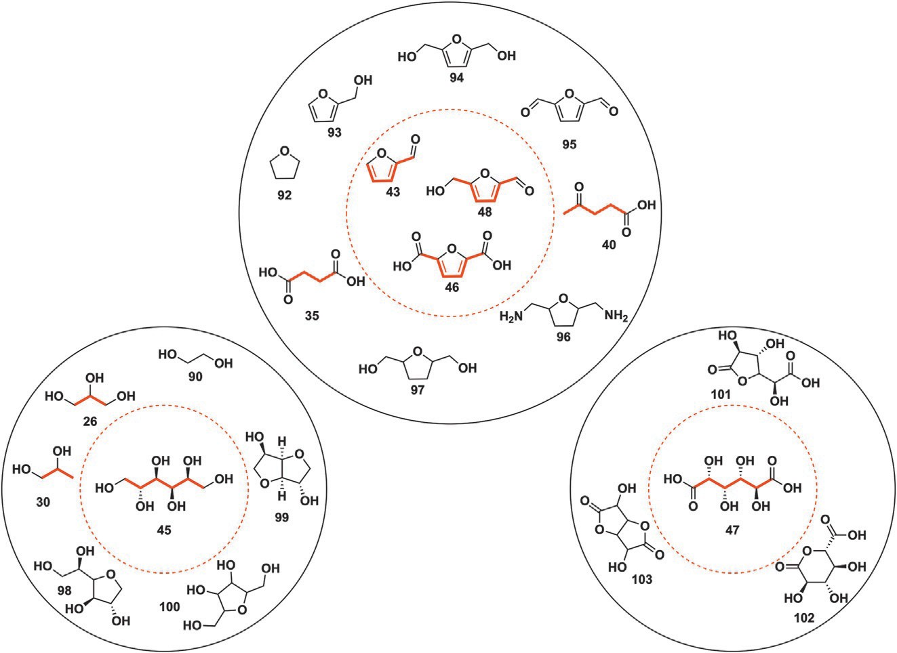
Fig. 7 Furans 43, 46, 48, sorbitol (45) and glucaric acid (47) alongside secondary build- ing blocks derived from them.

    - C2 and >C6—Ethanol, p-xylene and fatty alcohols
Ethanol (25) was initially not considered by the 2004 report because its important production volume qualified it as a “super commodity” chemical. Its main applications are as a biofuel as well as a relatively innocuous green and renewable solvent. More importantly, it is a direct precursor of ethylene, a key component of the polymer industry, through its dehydration.²¹
Para-xylene (50) may be converted in the corresponding dicarboxylic
acid (terephthalic acid) whose role is central in polymer sciences. It may also find applications as an apolar high boiling solvent. It may be obtained from sugar through fermentation and pyrolysis steps. Its preparation has also been reported from acrolein and isoprene through a Diels-Alder reaction followed by reduction.³⁴ Another route relies on 2,5-dimethylfuran and ethylene to yield para-xylene (50).³⁵
Fatty alcohols (49) (Fig. 3) are composed of linear backbones of twelve or
more carbons and find applications as ionic and non-ionic detergents in household products. They may be obtained from animal fat, vegetable oil or petroleum. The alcohol function is mostly functionalized through sulfation or sulfonation, among others, to yield the desired polar head granting it its detergent properties.²²

A perspective on the synthetic potential of biobased building blocks 15

- Isolated rings
  - Five-membered rings
The first family of discussed oxygenated heterocycles are organic carbonates, also known as carbonic acid esters, close relatives of the ester category. They are in fact the diester of a central carbonic acid. Alkyl and aryl chains can be grafted on to the planar carbonate moiety, with both linear or cyclic carbon- ates being reported. Additionally, depending on the substituents, carbonates can be both symmetric or non-symmetric. Cyclic carbonates can be obtained through three main synthetic pathways.
The first envisioned pathway relies on vicinal diols (104) (in the case of
5-membered rings) reacting with a variety of carbonating agents, each pro- cedure having its advantages and drawbacks. The first and senior procedure relies on phosgene (COCl₂) (105), a highly reactive and toxic gas at room temperature. It is also a very powerful carbonating agent and saw wide use in the chemical industry for this very same purpose. The reaction between organic substrates such as alcohols and phosgene is called “phosgenation” and can be viewed as the esterification of an alcohol with an acyl chloride. The gaseous nature of phosgene makes it extremely hazardous to handle even on the laboratory scale.³⁶ It is therefore more commonly generated in-situ from triphosgene, a more stable solid precursor.³⁷ Implementation of phosgenation on large scales raises a series of concerns related to the safety for operators handling the toxic gas as well as the amount of generated waste from the quenching of released HCl.³⁸ Phosgene can be replaced by more stable and less hazardous carbonyldiimidazole (CDI, 106) though it is a mere displacement of the safety concern since it is obtained by reacting phosgene with imidazole. It is also a rather expensive reagent as opposed to its more toxic precursor and displays poor atom economy (two imidazole rings are released as the leaving group per generated carbonate).³⁹ Urea (107) can be an answer to these security and atom economy concerns by gener- ating ammonia (which can easily be recycled) as the sole side product of its reaction with alcohols. It is also much more stable and innocuous to handle even at large scales though this comes at the cost of a stark decrease in reac- tivity and therefore the need for harsher conditions.⁴⁰ Carbonation directly from CO₂ or CO and an oxidizer has also been reported and shows the best atom economy compared to the other reported procedures so far. Unfortunately, as for urea (107), this requires harsh temperature and pressure conditions for this reaction to be efficient.⁴¹ Organic carbonates can also be obtained through transcarbonation reactions between a pre-existing carbonate

16 Loïc Bovy and Jean-Christophe M. Monbaliu

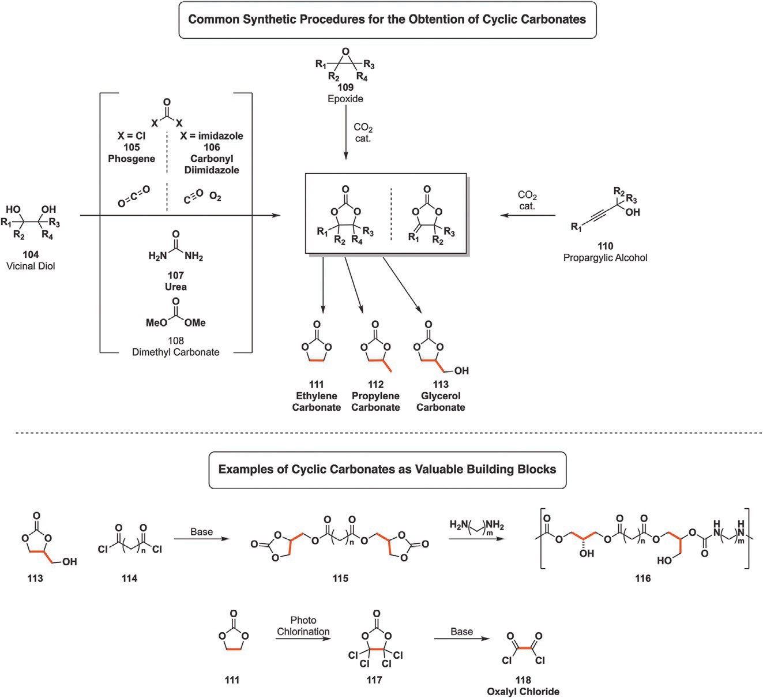
Fig. 8 Converging synthesis of organic carbonates from vicinal diols (104) or their corresponding epoxides (109) as well as alpha alkylidene carbonates from propargylic alcohols (110).

such as dimethyl carbonate (DMC, 108) (obtained through previously men- tioned pathway with CO₂ and methanol but most commonly with phosgene and methanol) and the desired alcohol.⁴² It displays intermediate reactivity and generates methanol as the result of transcarbonation, allowing for easy purification by distillation (Fig. 8).
An alternative to vicinal diols and carbonating agents consists in the trap- ping of CO₂ with epoxides (109) in the presence of a suitable catalyst, some of which can be biobased. This reaction shows the best atom economy com- pared to previously discussed methods. On the down side, epoxides are notoriously toxic to handle and are mostly obtained through petrobased alkene oxidation. Alternatively, epoxides can be obtained through a two-step process from renewable diols such as glycerol (26), propylene gly-
col (30) or ethylene glycol (90) among others. For instance, glycerol (26) is

A perspective on the synthetic potential of biobased building blocks 17

first reacted with concentrated HCl in the presence of a carboxylic acid cat- alyst before treating with a base the obtained mono or dichlorinated glycerol derivative, providing a mixture of epichlorohydrin (53) and glycidol (54): two very important epoxides falling in the “smart drop-in” category.⁴³ A third method is based on the trapping of CO₂ by propargylic alcohol
(110) derivatives in the presence of either a homogeneous or heteroge-
neous catalyst.⁴⁴ The first two described approaches can start from either ethylene glycol, propylene glycol and glycerol or their derived epoxides, making the resulting cyclic carbonate biobased if the initial feedstock is renewable. Unfortunately, reliable production of propargylic alcohols has not been reported from renewable materials and the derived carbonates are not discussed any further in this chapter.
Ethylene (111), propylene (112) and glycerol carbonate (113) derived
from the corresponding diols have found applications as solvents in the chemical industry as well as fuel additives and ion carrier solvents for batte- ries. Additionally, they have sparked new interest in the polymer field, either through ring-opening polymerization or as monomers for polyesters/poly- carbamates.⁴⁵ Aside from applications in the battery or polymer field, pho-
tochlorination of ethylene carbonate (111) followed by basic treatment of tetrachloroethylene carbonate (117) results in the formation of synthetically significant oxalyl chloride (118) (Fig. 8).⁴⁶
Dimethyl carbonate (DMC) (108), as stated previously, is less reactive
than its toxic phosgene counterpart but has the advantage of being poten- tially biobased with methanol as the only side product. Intensification of cyclic carbonates production from diols and DMC was allowed by the implementation of the process under continuous flow conditions by Monbaliu et al. in 2019. Flow chemistry is performed in narrow channels through which the different reagents, solvents, catalyst and other partners are continuously pumped. The nature of the reactor results in a higher sur- face to volume ratio compared to a batch reactor which in turn leads to supe- rior heat transfer. Micro/mesofluidic reactors are seamless which allows the reactors pressurization. This means that temperatures superior to that of the solvents boiling point can be applied, providing extra energy to the reaction at hand and accelerating it.^{14,47} In addition to these intensified thermal con- ditions, handling gases is more convenient and efficient thanks to the lack of headspace. This also correlates to a superior dissolution of said gas in the reaction medium, making the reaction more economical therefore reducing the amount of gas required and the overall footprint of the process.⁴⁸ The reported conditions rely on one equivalent of neat diols, such as glycerol

18 Loïc Bovy and Jean-Christophe M. Monbaliu

(26), and 3.5 mol% of tetrabutylammonium bromide (TBAB) or 4 M solu- tions of diol in dimethyl sulfoxide (DMSO) for the first feed. The second feed consists of three equivalents of neat DMC (108). The reaction is carried out at 180 °C with an 11 bar back-pressure to keep everything in the liquid phase during the 3 min required for the transformation. This set of condi- tions was amenable to producing a library of 20 carbonates with yields rang- ing from 45% to 93%. Three of these can be sourced from biobased ethylene glycol (90), propylene glycol (30) and glycerol (26) with glycerol carbonate production being scaled up with a daily productivity of 13.6 kg (Fig. 9A).⁴⁹ Extending their expertise in the field of glycerol carbonate production from renewable resources, Monbaliu et al. reported in early 2024 a proce- dure relying on the perks of continuous flow chemistry starting from poten-
tially biobased glycidol (54). The streamlined process required an equimolar ratio of 54 and gaseous CO₂ and Barton’s base (120). Epoxide 54 was fed to the fluidic reactor under the form of a 1.8 M solution in methyl ethyl ketone (MEK) alongside a 1 mol% catalyst loading. A stream of pre-heated CO₂ was
mixed with the organic phase and reacted for twenty eight seconds at 140 °C and 10 bar before being recovered and purified. Glycerol carbonate (113)

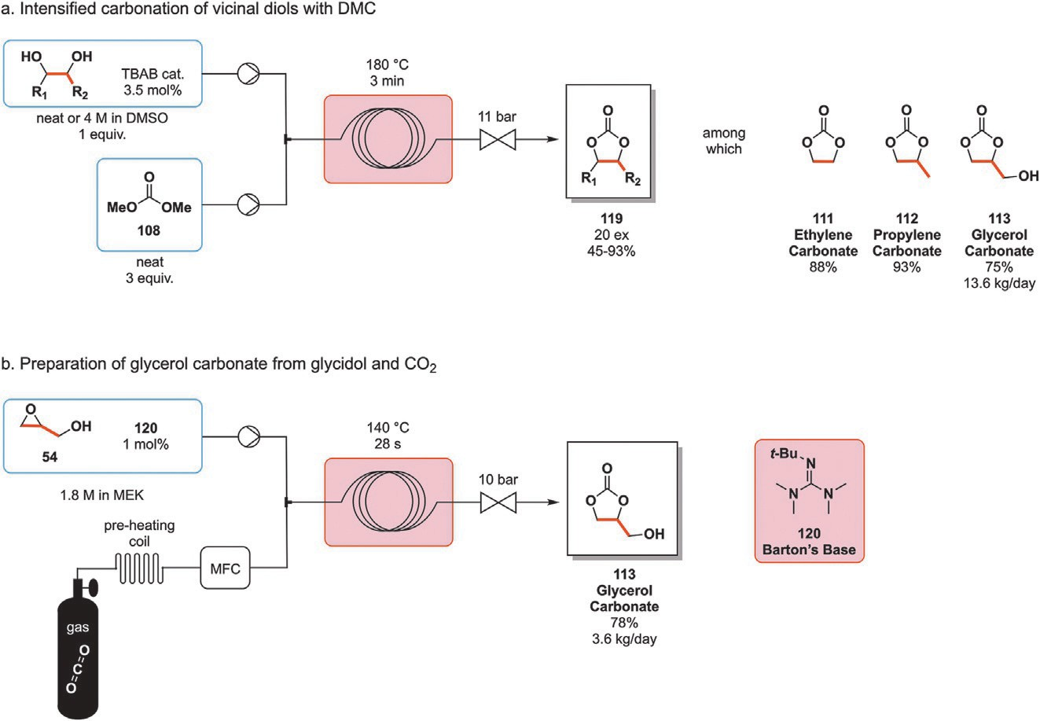
Fig. 9 (A) Intensified continuous flow upgrading of vicinal diols into cyclic carbonates with dimethyl carbonate (108). (B) Expedient preparation of high value-added glycerol carbonate (113) from renewable glycidol (54) and gaseous CO₂.

A perspective on the synthetic potential of biobased building blocks 19

was obtained in a 78% yield and a scale up of the process resulted in a daily
113 yield of 3.8 kg (Fig. 9B).⁵⁰
Acetals and ketals are common cyclic oxygenated structures acting as protecting groups in organic synthesis. These are obtained by reacting the desired carbonyl function and a diol. Despite being mostly known for their protecting properties, they may also be found in the final structure of com- pounds such as antifungals, pharmaceutical ingredients whose role is to treat and prevent mycosis induced diseases. Antifungals come in many forms and shapes which can be sorted into four main categories though new ones are cur- rently being studied and developed: (i) polyenes, (ii) azoles, (iii) echinocandins and (iv) 5-flucytosine derivatives.⁵¹ The main action mode of antifungals consists in disturbing the role of ergosterol, the fungal counterpart of cho- lesterol, playing a key role in cell wall structure integrity. Cell wall rigidi- fication through ergosterol binding causes the leaking of ions and small organic molecules from the fungal cells resulting in the death of the targeted fungi. Alternatively, the synthesis of ergosterol can be disturbed on different levels, preventing its incorporation in the cell wall with the same out- come.⁵² Among the four categories introduced above, the emphasis will be placed on azole-bearing antifungal compounds which are themselves divided between imidazoles, triazoles and thiazoles.
Though unsubstituted azoles cannot be synthesized from materials listed in the DoE top 10 and its further additions, ketoconazole (128a), ter- conazole (128b) and itraconazole (128c) bear a 1,3-dioxolane moiety whose synthesis starts from glycerol (26). Ketoconazole (128a) is historically the first member of the azole antifungal family, first patented in 1977 and later commercialized in 1981 by Jansen as a replacement of highly toxic polyenes commercialized before.⁵³ Terconazole (128b) quickly followed and was brought to the medical field in 1983, sparking serious interest in azole-based antifungal drug research.⁵⁴ Itraconazole (128c) is the last dioxolane repre- sentative to appear, being approved by the FDA in 1992 and added to the WHO list of essential medicines.^{55,56}
Ketoconazole (128a) was the 161th most prescribed drug in the US in 2021 owing to its broad range of indications. It can be applied topically to treat dermal and mucosal infections such as athletes’ foot, thrush, ringworm and seborrheic dermatitis. It can also be administered per os to deal with a range of fungi though this is now a rare occurrence because of 128a toxicity as well as lower spectrum of activity and bioavailability compared to other azole-derived drugs.⁵⁷ Terconazole (128b) has a broader spectrum of activity than imidazole derivatives though triazole derivatives surpass it. It is effective

20 Loïc Bovy and Jean-Christophe M. Monbaliu

against Candida species though it is mainly applied as a cream to treat vaginitis also known as vaginal thrush.⁵⁸ Finally, itraconazole (128c) is a drug on the WHO list of essential medicines thanks to the large group of fungi it can effectively target while its potential use for skin, lung and prostate cancer treatment is currently studied.^{59–61}
The first step toward these three antifungal compounds is identical, reacting glycerol (26) and 2,4-dichlorophenacetyl bromide (121) through an acid mediated ketalization to yield dioxolane intermediate 122. The remaining hydroxylic moiety is then protected before adding the azole group in the presence of a base: imidazole for ketoconazole (128a) and 1H-1,2,4-triazole for terconazole (128b) and itraconazole (128c). Following this, the intermediate is deprotected and the resulting alcohol is activated as a mesylate from mesyl chloride and a base to yield 126. The last step consists in the nucleophilic substitution of the activated intermediate with p-phenol derivatives 127 to obtain the desired antifungal compounds (Fig. 10).⁵³
After discussing antifungals bearing a 1,3-dioxolane ring, antibiotics and antimicrobials with applications in both the medical and veterinary field are hereby introduced. Nitrofurans are a group of compounds centered around a nitrated furan ring obtained from biobased furfural (43). To this nitrofuran ring can be grafted a variety of groups, yielding a dozen of commercially pro- duced drugs. Furaltadone (135) and nifuratel (136) are two of these whose side chain contains a heterocycle incorporating potentially biobased atoms. Furaltadone was commonly used as a food additive for livestock, aquaculture

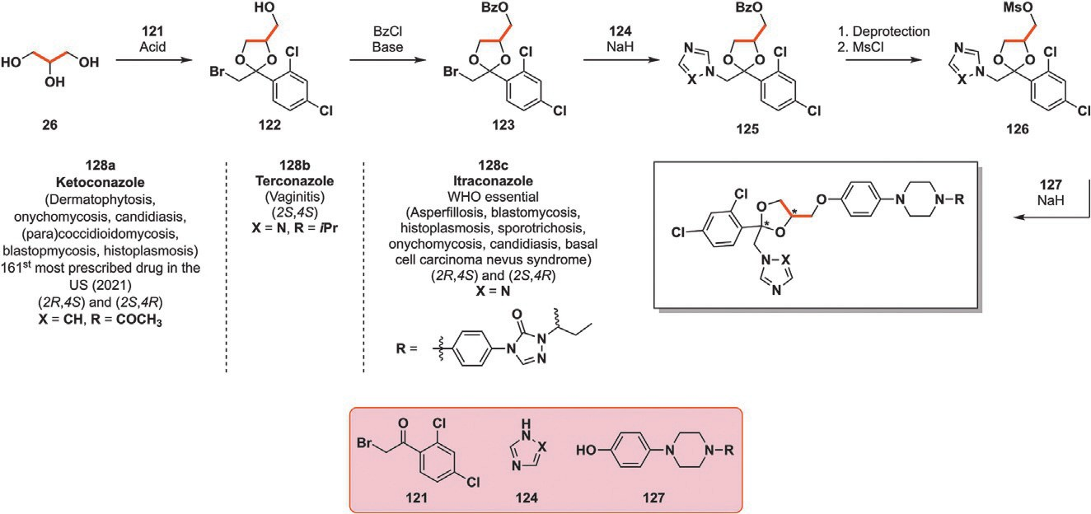
Fig. 10 Incorporation of glycerol (26) in the multistep synthesis of antifungal ketoco- nazole (128a) terconazole (128b) and itraconazole (128c). BzCl¼ benzoyl chloride, MsCl¼ mesyl chloride.

A perspective on the synthetic potential of biobased building blocks 21

and bee hives to protect them from gastrointestinal infections before its discontinuation in Europe, the US, Australia, Brazil, the Philippines and Thailand in 1995 following carcinogenicity supposition of residues found in food.⁶² Despite its discontinuation in the meat and fishery industry,
135 is essential to fight Chagas disease (South American trypanosomiasis).⁶³ Nifuratel (136) acts as a local antiprotozoal and antifungal in gynecology. Its
favorable toxicological profile, minimal side effects as well as large spectrum of action make it an ideal candidate in the treatment of diseases whose diag- nosis cannot be fully ascertained. It is particularly efficient against Chlamydia, Mycoplasma and Candida strains.⁶⁴
Synthesis of furaltadone (135) and nifuratel (136) both begin by the nucleophilic substitution of epichlorohydrin (53) by either methanethiol or morpholine (129) alongside a suitable base, providing substituted oxirane intermediate (130). Aminolysis of this epoxide by hydrazine followed by cyclization in the presence of diethyl carbonate (132) yields substituted N-amino oxazolidone 133 intermediate. Diethyl carbonate, much like dimethyl carbonate has the potential of being biobased, meaning that the
complete carbonated skeleton of the oxazolidone ring could be biosourced. The final step toward active 135 and 136 consists in the acid-mediated hydrazone formation by coupling previously obtained intermediate 133 with nitrofurfural (134) (Fig. 11).^{65–67}
Sulfolane (138) is a commonly used polar aprotic highly water-soluble
solvent with a high boiling point. It was initially developed by Shell in the 1960s as a solvent to purify butadiene (37). It is a major component of the Sulfinol process, a gas purification procedure which relies on a mix- ture of 40–60% of 138, 30–45% of diisopropanolamine and 5–15% of water to remove mercaptans, H₂S, CO₂ and carbonyl sulfides.⁶⁸ Shortly after the sulfinol process implementation, 138 was found to be highly effective for the selective extraction of aromatics from complex hydrocarbon mixtures. The use of 138 for the purification of aromatics from crude oil is particularly
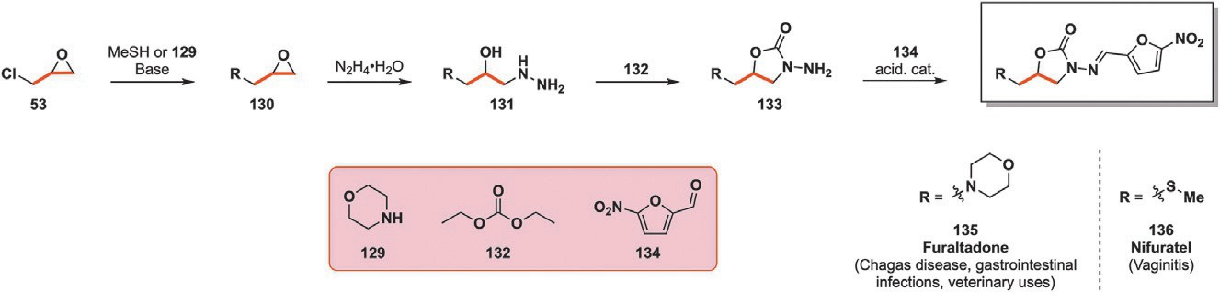
Fig. 11 Preparation of oxazolidone-bearing intermediates (133) from epichlorohydrin
(53) for the synthesis of furaltadone (135) and nifuratel (136).

22 Loïc Bovy and Jean-Christophe M. Monbaliu

interesting: a small ratio of solvent to crude feed is required. Retrieval of the separated compounds can then easily be performed by evaporation, either of the lower boiling product or of sulfolane, leaving the higher boiling compounds behind.
The most common synthetic route toward 138 starts from butadiene (37) which, ironically, Shell was aiming at purifying with the help of 138. This is reacted with SO₂ through a cheletropic reaction leading to sulfolene inter- mediate 137. The remaining double bond is then hydrogenated in the pres- ence of Raney-Nickel catalyst to obtain sulfone 138.⁶⁹ Alternatively, though this is uncommon, sulfolane (138) can be accessed from tetrahydrofuran (92) potentially sourced from furans such as furfural (43) or succinic acid (35). Reaction between 92 and H₂S in the vapor phase first yields tetrahydro- thiophene (139) which can then undergo oxidation toward 138.⁷⁰ The oxidation of thioethers toward sulfoxide and sulfones is a widely researched
topic. In 2022, a team of German researchers electrochemically generated peroxidicarbonate as a green yet elusive oxidizing agent by circulating an aqueous solution of K₂CO₃, Na₂CO₃ and KHCO₃ in an electrolytic cell as illustrated in Fig. 12. The generated aqueous solution of C₂O²⁻ was capa- ble of oxidizing thioethers, amines and performing epoxidation of alkenes. One equivalent of peroxidicarbonate at pH 11 was sufficient to oxidize
6

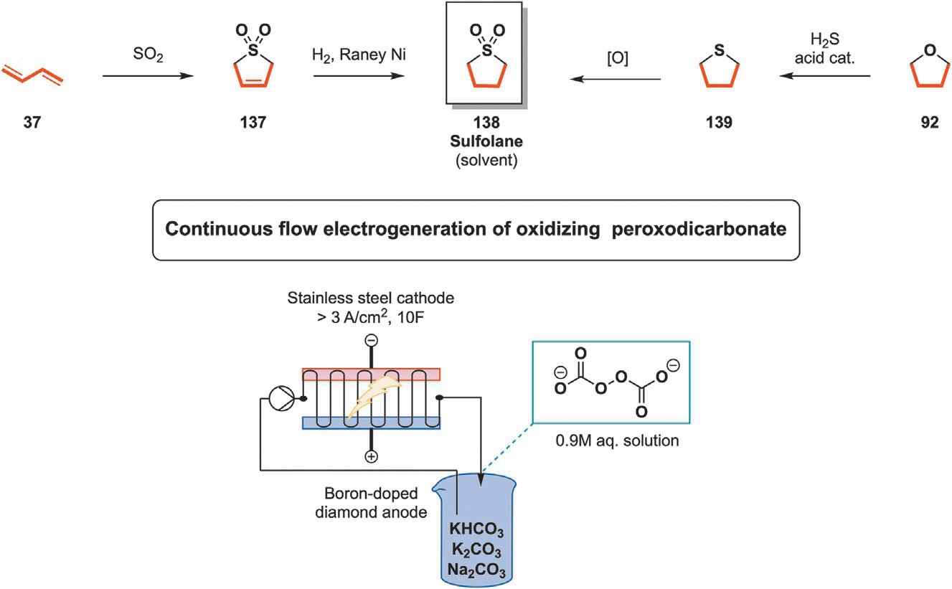
Fig. 12 Converging pathways for the preparation of common solvent sulfolane (138) from butadiene (37) or tetrahydrofuran (92).

A perspective on the synthetic potential of biobased building blocks 23

tetrahydrothiophene into its sulfoxide counterpart while five equivalents were required to yield sulfolane (138) within 16 h at 0 °C (Fig. 12).⁷¹
After discussing the preparation of sulfolane (138), the preparation of
another sulfur-containing heterocycle is discussed here under: thiazole, an unsaturated ring bearing both sulfur and nitrogen in the 1–3 positions. Substituted thiazoles are commonly prepared using a Hantzsch reaction involving suitable haloketone and thioamide partners.⁷² One such reac- tion is required to synthesize a key intermediate 141 of ritonavir (146), an antiretroviral pharmaceutical compound on the WHO list of essential medicines.^{55,73} It was first patented in 1995 by Abbot Laboratories before FDA approval for marketing in 1996.⁷⁴ Its main use is to mitigate the prop- agation of the HIV virus in infected patients by inhibiting HIV proteases, preventing or slowing down the onset of AIDS. Ritonavir 146 also found applications as a booster for other proteases by inhibiting the enzymes metabolizing them, effectively making them more available to interact with their designated targets.⁷⁵ As such, COVID-19 and hepatitis C can be treated by combining 146 with nirmatrelvir or ombitasvir and paritaprevir respectively.^{76,77}
Preparation of ritonavir (146) begins with the formation of substituted thi- azole 141 from 1,3-dichloroacetone (52). The cyclization results in chlori- nated intermediate 141 which then undergoes nucleophilic substitution by methylamine to obtain secondary amine 142. The urea scaffold of 144 is obtained by reacting activated L-valine 143 with previously synthesized amine 142 under basic conditions, resulting in the ejection of 4-nitrophenol. This step is quickly followed by the hydrolysis of the obtained ester with LiOH, yielding carboxylic acid derivative 144. Ritonavir (146) is finally obtained through 1-ethyl-3-(3-dimethylaminopropyl)carbodiimide (EDCI) and
hydroxybenzotriazole (HOBt) mediated peptidic coupling of intermedi- ates 144 and L-phenylalanine derived 145 (Fig. 13).
Aside from having implications in the synthesis of antiretrovirals, sulfur- containing rings such as thiazolidinedione are encountered in antidiabetic drugs such as pioglitazone (155). Diabetes accounts for the death of around
1.5 million individuals worldwide on a yearly basis according to the WHO while the International Diabetes Federation estimates that in 2021, around 10% of the worldwide adult population had diabetes with this proportion being expected to reach 12.5% in 2045.^{78,79} Two types of diabetes exist: the first one requiring insulin injections while the second one can be treated through a combination of lifestyle changes and medication, one of which comes in the form of insulin sensitizing drugs pioglitazone (155). It was first

24 Loïc Bovy and Jean-Christophe M. Monbaliu

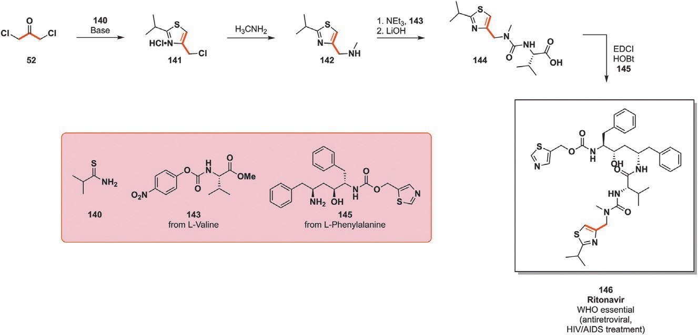
Fig. 13 Synthesis of antiretroviral drug ritonavir (146) through the Hanzsch thiazole reaction between glycerol-derived 1,3 dichloroacetone (52) and thioamide 140. EDCI¼ 1-ethyl-3-(3-dimethylaminopropyl)carbodiimide, HOBt¼ hydroxybenzotriazole.

patented in 1985 by Takeda before being commercialized in 1999.⁸⁰ Concerns related to increased bladder cancer occurrence among patients treated with 155 saw its removal from the French and German market in 2011 while it remains sold in the US, being FDA approved and the 129th most prescribed drug in 2021.^{81,82}
The preparation of antidiabetic drug 155 as patented by Takeda in 1985 begins with a sodium hydride promoted etherification between alcohol 147 and 4-fluoronitrobenzene 148.⁸⁰ The nitro substituent of 149 is then reduced into the corresponding amine 150 by carbon supported palladium and hydrogen. The next step prepares the ground for cyclization and consists
in a diazotization reaction followed by Meerwein arylation with methyl acrylate (151), incorporating three potentially biobased carbon atoms into the compound. The compound obtained after this series of reactions is the alpha-brominated ester 152 which then undergoes cyclization with thio- urea (153), yielding thiazolone intermediate 154. The final step toward 155 consists in treating 154 with an aqueous acid, yielding the desired thiazolidinedione derivative under its hydrochloride salt form (155, Fig. 14). Pyrrole, the aminated counterpart of furan and thiophene, is highly rep- resented in both natural as well as synthetic compounds. Unsubstituted pyr- role is industrially produced from furan and ammonia under heterogeneous acidic conditions.⁸³ However, if substituted pyrrole derivatives are desired, this approach is not sufficient and other reactions have to be considered. Three main pathways have been reported so far to produce substituted pyrrole

A perspective on the synthetic potential of biobased building blocks 25

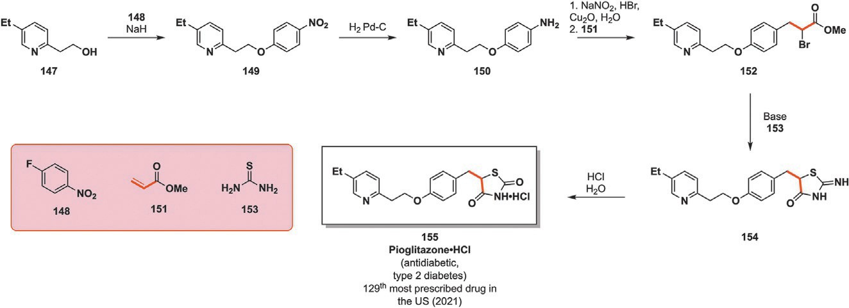
Fig. 14 Protocol integrating methyl acrylate (151) in the synthetic steps toward thiazolidinedione-derived antidiabetic pioglitazone (155).

rings. The Hantzsch pyrrole synthesis is a three-component reaction relying on β-ketoesters, ammonia or primary amines as well as α-haloketones.⁸⁴ Following this procedure and carefully selecting the involved molecules can virtually provide an endless combination of both C- and N-substituted pyrroles. A different approach is the Knorr reaction, which starts from not three but two components: an α-aminoketone and a β-ketoester. The main inconvenience lies in the instability and condensation reactions of α-aminoketones, requiring their generation in-situ to prevent side reac- tions.⁸⁵ The third main approach toward substituted pyrroles is the Paal-Knorr reaction: 1,4-diketones are reacted in the presence of a primary amine or ammonia to yield the desired pyrrole. This type of procedure also allows the preparation of furans (in acidic conditions) and thiophenes (in the presence of a sulfurizing agent).⁸⁶
Aside from these three main procedures providing substituted pyrroles, a relatively newer one is derived from van Leusen and coworkers’ use of tosyl methylisocyanate (TosMIC, 157). Although the original work from 1974 aimed at producing oxazoles from aldehydes or nitriles from ketones, the replacement of these carbonyl compounds by enones 156 as envisioned by Bolm and coworkers in 2021 led to the formation of pyrrole rings. The novelty of the reported procedure resides in the implementation of this reaction under mechanochemical conditions. As opposed to electro, photo and thermochemistry which rely on an electric current, light or heat to trig- ger reactions, mechanochemistry is an emerging field of organic synthesis which aims at promoting chemical reactions by mechanical energy transfer with bearings impacting the reaction medium. It has found applications in material sciences for the preparation of nanostructures, inorganic com- pounds usually requiring high temperatures for prolonged times as well as

26 Loïc Bovy and Jean-Christophe M. Monbaliu
¼

the synthesis of a broad panel of organic substrates.^{87–89} These reactions are mostly performed solventless since it is not required for reagent mixing or energy transfer, making workup and crude product retrieval simpler while generating much less solvent waste and therefore significantly lowering the environmental footprint. As such, Bolm et al. have reported the synthesis of pyrrole derivatives by reacting 157 and an electron-poor enone (156) in the presence of three equivalents of 1,8-diazabicyclo[5.4.0]undec-7-ene (DBU). The reaction proceeded by milling these reagents for 1 h at room temperature at a 35 Hz frequency. The method is robust and can proceed with 16 different substrates with low to excellent yields. Most of the lower yields result from tests with esters instead of ketones, among which possibly biobased dimethyl fumarate and maleate which resulted in 43% and 39% yields, respectively. Building on their synthesis of pyrrole derivatives, the researchers tried to synthesize porphyrins 161 derived from the produced pyrroles under mechanochemical conditions. The obtained pyrroles were first transformed in the corresponding alcohol 160 in two steps before attempting the synthesis of porphyrin with these newly obtained reagents, though this yielded a very complex crude mixture of porphyrin isomers. Despite not succeeding at preparing the desired porphyrins, this paper show- cased that these scaffolds are reachable and, with selectivity improvement, the desired porphyrin could be obtained (Fig. 15).⁹⁰
Imidazoles are another nitrogen-containing heterocycle of significant importance, being present in a plethora of natural and synthetic compounds such as eprosartan (169), which is an angiotensin II receptor antagonist with antihy- pertensive properties.⁹¹ It contains a substituted imidazole ring which can be obtained from the product of glycerol oxidation, 1,3-dihydroxyacetone (51)

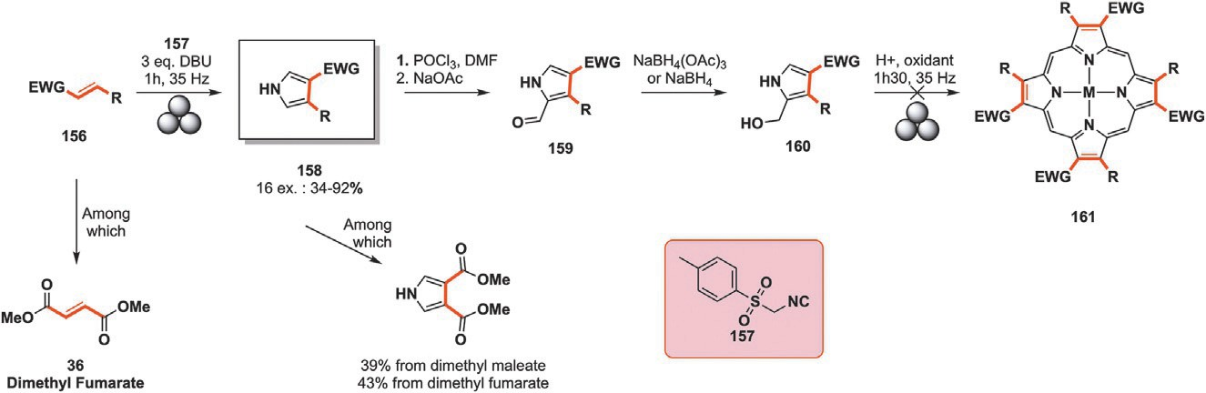
Fig. 15 Mechanochemical “van Leusen” type pyrrole synthesis from electron poor enone (156) and toluenesulfonylmethylisocyanide (TosMIC, 157). DBU 1,8- diazabicyclo[5.4.0]undec-7-ene.

A perspective on the synthetic potential of biobased building blocks 27

following the procedure patented by GSK in 1991.⁹² The first step involving 51 consists in the imidazole formation and its additional acetylation. It begins with the reaction between 51 and amidine 162 in the presence of liquid ammonia before undergoing acetylation by acetic anhydride. Imidazole 163 is then reacted with benzyl alcohol 164, trifluoroacetic anhydride and a base giving compound 165. Hydrolysis of both ester func- tions is performed with aqueous sodium hydroxide before the resulting free alcohol undergoes reduction by MnO₂ into the corresponding alde- hyde 166. The penultimate synthetic step consists of the addition of the thiophene ring to the whole backbone through an aldol condensation in the presence of lithium diisopropylamide (LDA) and 167 before acet- ylating the ensuing alcohol with acetic anhydride. The final step toward eprosartan (169) is a DBU-promoted elimination followed by the hydro- lysis of the methylic ester by aqueous NaOH (Fig. 16).⁹²
Pyrazolinediones are represented in a series of compounds such as kebuzone (173), mofebutazone (174), phenylbutazone (175), oxyphenbu- tazone (177) and sulfinpyrazone (179). The first four are endowed with anti-inflammatory properties with applications in the treatment of rheuma- toid arthritis, thrombophlebitis and muscular pain. Oxyphenbutazone was removed from the marked in the 1980s following bone marrow suppression and Steven-Johnson syndrome.⁹³ Sulfinpyrazone (179) has a different type of application despite being closely structurally related to its four other coun-
terparts. Indeed, it is commonly prescribed to treat gout thanks to its urico- suric properties: it promotes the evacuation of uric acid, preventing its painful accumulation in joints.⁹⁴

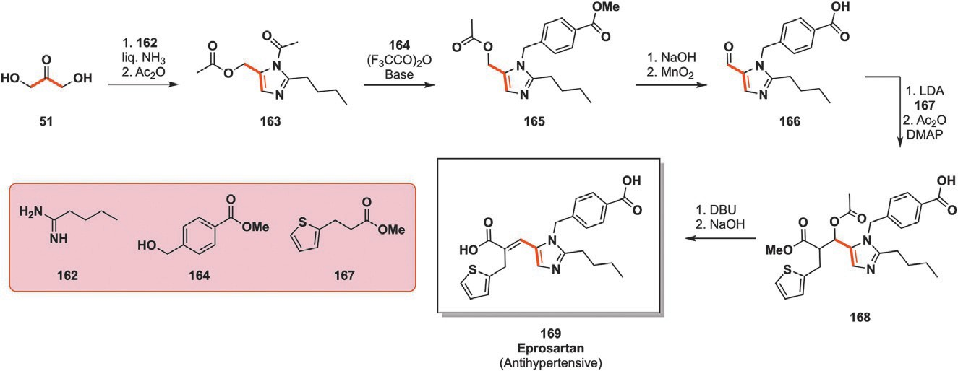
Fig. 16 Synthesis of antihypertensive eprosartan (169) bearing a substituted imidaz- ole ring from 1,3-dihydroxyacetone (51). LDA¼ lithium diisopropylamide, DMAP¼ 4-dimethylaminopyridine, DBU ¼ 1,8-diazabicyclo[5.4.0]undec-7-ene.

28 Loïc Bovy and Jean-Christophe M. Monbaliu

These procedures start from a common malonic ester scaffold bearing different substituents on its central carbon 170 and a suited phenylhydrazine (171). Mofebutazone (174) and phenylbutazone (175) are directly prepared through the activation of the substrates by a suitable base, leading to the ejection of two ethanol molecules alongside the formation of the central pyrazolinedione ring.⁹⁵ The swift acid deprotection of 172 generates kebuzone (173) while intermediate 176 is hydrogenated with Raney-Ni
catalyst to obtain oxyphenbutazone (177).^{96,97} Uricosuric drug 179 results from the selective oxidation of thioether intermediate 178 into its sulfoxide counterpart (Fig. 17).
Sleeping sickness, also known as African trypanosomiasis, is a parasitic infection transmitted by tsetse flies’ bites which comes in two forms. Trypanosoma brucei gambiense (TbG) represents about 90% of cases whereas
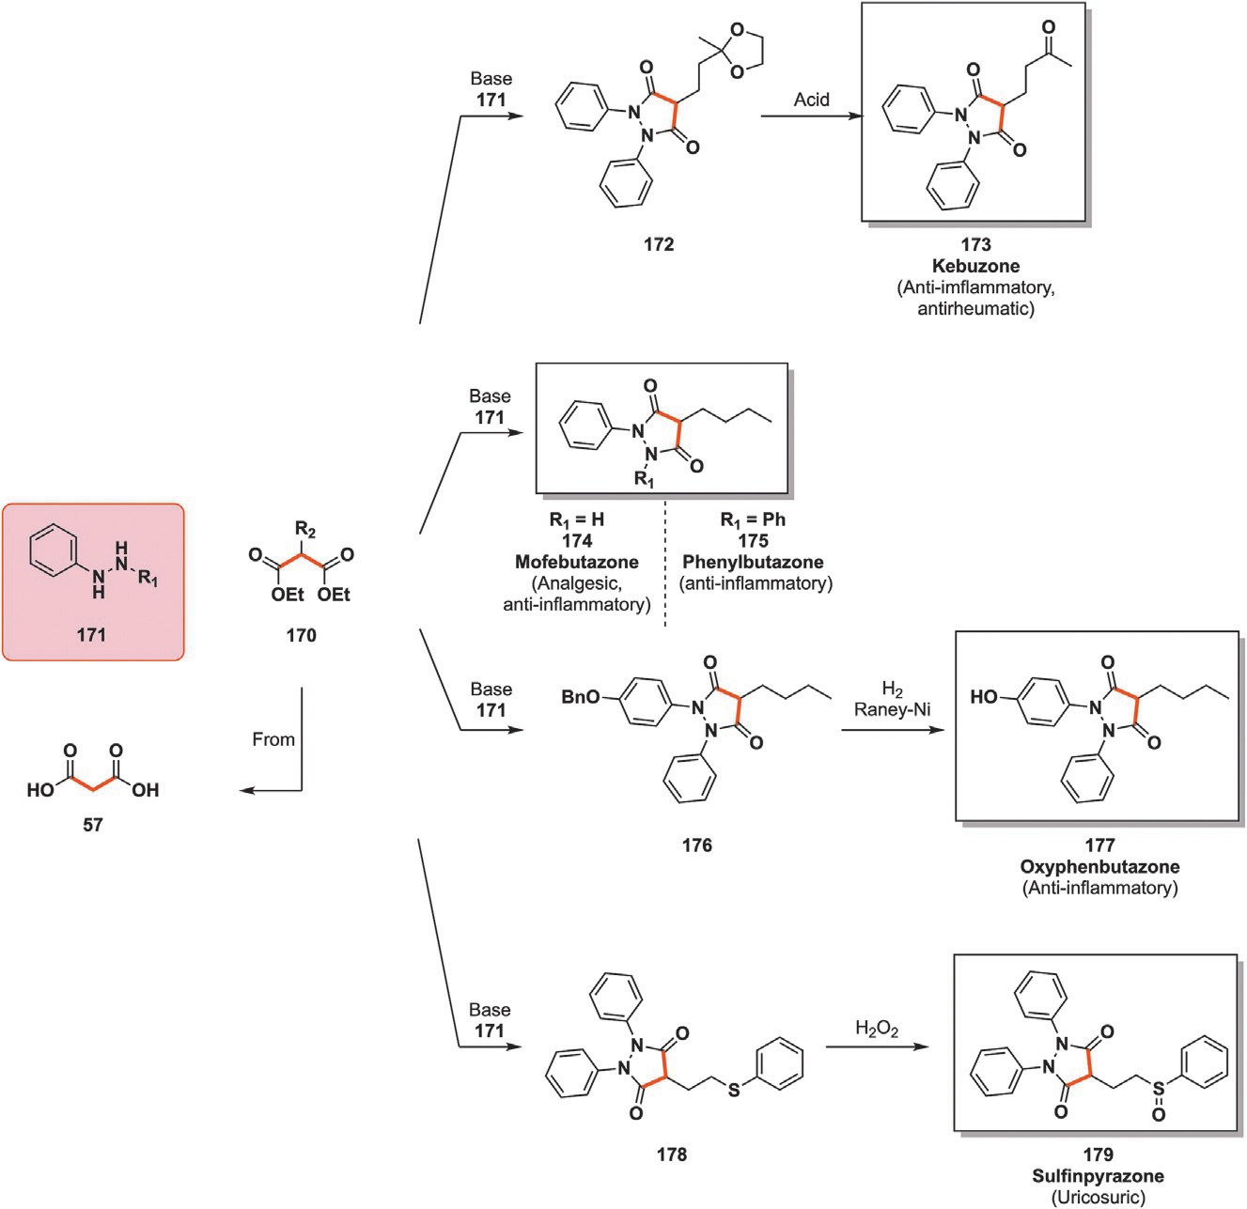
Fig. 17 Preparation of pyrazolinedione-containing active pharmaceutical ingredients (APIs) from substituted phenylhydrazines and malonic esters derivatives.

A perspective on the synthetic potential of biobased building blocks 29

trypanosoma brucei rhodesiense (TbR) makes up the remaining 10%. Fever, headache, itching and joint pain characterize the first stage of the disease while confusion, numbness, poor coordination and trouble sleeping are related to its second stage.⁹⁸ Nifurtimox, which is discussed in Section 3.2, is usually selected to treat the second stage of the disease in combination with eflornitine, a fluorinated non-natural amino acid. In the unfortunate case where these treatments are ineffective, organoarsenical melarsoprol (184) is the last resort to treat both first and second stage of the disease.⁹⁹ The “last line of defense” nature of melarsoprol justifies its presence on the WHO list of essential medicines despite its administration resulting in a 5% death rate.⁵⁵
Another drug containing a ring with embedded arsenic is arsthinol (185), a drug resulting from the combination of acetarsol (181b), an anti-infective drug, and dimercaprol (180). 185 is used to treat yaws and amoebias like its constituting acetarsol (181b) though it is tolerated much better.¹⁰⁰
Preparation of these two medications is achieved via the reaction of dimer- caprol (180) with intermediate 183a,b. The former is historically obtained from allyl alcohol (55) through a two-step synthesis starting by halogenation of the double bond before forming the thiol moieties with NaHS.¹⁰¹ The latter is produced by reacting arsonic acid derivatives 181a,b with thiol 182. The resulting products are mixed and reacted at pH 6 to finally yield the coveted drug (Fig. 18).¹⁰⁰

Six-membered rings
Viloxazine (192) is a psychoactive drug which was prescribed to cure depres- sion before being discontinued for commercial reasons in 2002 and rep- urposed in 2021 to treat attention deficit hyperactive disorder (ADHD).¹⁰² Most notably, it contains a well-known morpholine ring which can be

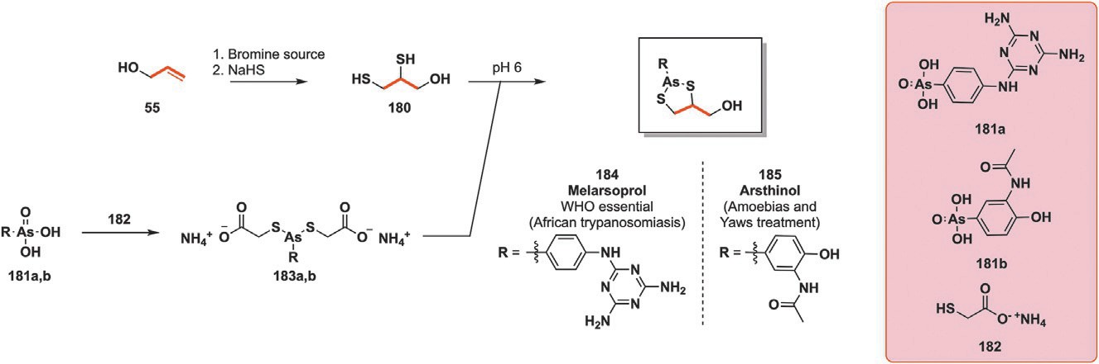
Fig. 18 Preparation of organoarsenical medications melarsoprol (184) and arsthinol
(185) from allyl alcohol (55).

30 Loïc Bovy and Jean-Christophe M. Monbaliu

obtained from glycerol-derived epichlorohydrin. This resulted from initial studies by Imperial Chemical Industries on beta blockers during which it was noticed that high doses impacted the patients’ brain serotonin uptake. To enhance the blood brain barrier passage, the free ethanolamine scaffold of the initial beta blocker was constrained under the form of a morpholine ring.¹⁰³
The first patented route to this drug dates from 1966 and begins with a Williamson etherification between epichlorohydrin (53) and phenol 186. Aminolysis of the remaining epoxide by benzylamine (188) followed by cyclization with chloroacetyl chloride (190) in the presence of triethylamine affords intermediate 191. Finally, the lactam is reduced by LiAlH₄ and the amine protection removed by hydrogenation with carbon supported palla- dium (Fig. 19).¹⁰⁴ An alternative and shorter procedure was patented in 1969 during which 192 is directly formed in a single step from 187 by
reacting aminomethanesulfonic acid (193) with it (Fig. 19).¹⁰⁵
A third representative of the nitrofuran family mentioned in Section 3.1 and containing a thiomorpholine dioxide ring is nifurtimox (198), which is a WHO list of essential medicine recipient.⁵⁵ Its importance in the treatment of Chagas’ disease is such that it is actually freely supplied by the WHO to infected inhabitants of areas heavily impacted by this condition.⁹⁸ Much like furaltadone (135) and nifuratel (136) discussed vide supra, 198 is still centered around the nitrofuran ring but differs from its two counterparts by the scaf- fold on the other end of the hydrazone link. In the case of 198, a thiomorpholine dioxide is in place of the oxazolidone heterocycle.
As opposed to the preparation of oxazolidone cycles related to furaltadone
(135) and nifuratel (136), the synthesis of thiomorpholine dioxide derivative
198 begins with the thiolysis of propylene oxide (56) by 2-mercaptoethanol in
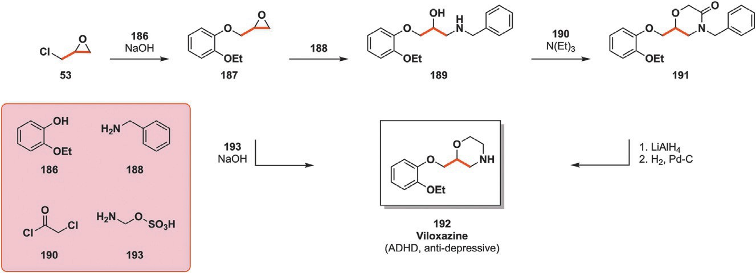
Fig. 19 Converging synthetic pathways toward morpholine-bearing viloxazine (192) starting from epichlorohydrin (53).

A perspective on the synthetic potential of biobased building blocks 31

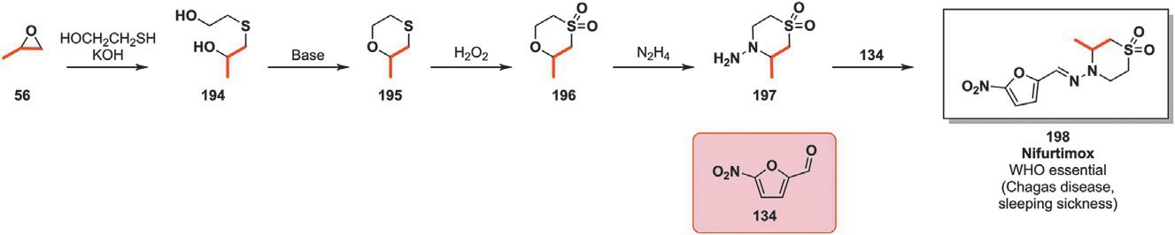
Fig. 20 Synthesis of thiomorpholine dioxide intermediate (196) from propylene oxide
(56) toward the preparation of nifurtimox (198).

the presence of a base. The resulting diol is then cyclized under basic condi- tions before oxidizing the cyclic thioether into the corresponding sulfone 196. Finally, 196 is opened and closed by hydrazine effectively providing the necessary aminated moiety to form the hydrazone of nifurtimox with nitrofurfural (134) (Fig. 20).¹⁰⁶
Spasmolytics, also called antispasmodics, are defined as “drugs preventing or arresting spasms, especially in smooth muscles.”¹⁰⁷ These can cause severe pain in the affected area in the case of skeletal muscle spasm but can also affect the bowels if smooth muscles are involved. The latter can cause sharp pain to the gastrointestinal tract, bladder and gall. Piperidolate is a medication sport- ing a substituted piperidine ring prescribed to kill cramp-like pain in the case of ulcers of the gastrointestinal tract, gastritis, enteritis or gall-related troubles.¹⁰⁸ It is a muscarinic receptor antagonist, therefore preventing the nervous transmission associated with muscarinic receptors. Muscarinic antagonists mostly interact with the parasympathetic nervous system, responsible for the “rest and digest” function resulting in heart rate lowering, digestion acceleration and sexual arousal among other effects.¹⁰⁹ Therefore, by mitigating the onset of this “rest and digest” function, especially when looking at the acceleration of digestion, the smooth muscles around the bowels are less activated, preventing or reducing the experienced cramps. Synthesis of piperidolate 202 is initiated by the reductive amination of fur-
fural (43) with ethylamine and palladium into N-ethyl tetrahydrofurfurylamine
(199). 199 then undergoes an acid-promoted ring expansion toward piper- idine 200. The final step consists in the ester formation by reacting the alco- hol of 200 with acyl-chloride 201 in the presence of a basic HCl scavenger (Fig. 21).¹¹⁰
Before the fortuitous discovery of penicillin, sulfonamides, commonly called sulfas, were the go-to antimicrobial drugs. Research around this now extensive category of molecules originated in the 1930s from work at Bayer with the realization that some aniline dyes could selectively bind to bacteria and attack them.¹¹¹ The first sulfa molecule, prontosil, was in fact

32 Loïc Bovy and Jean-Christophe M. Monbaliu

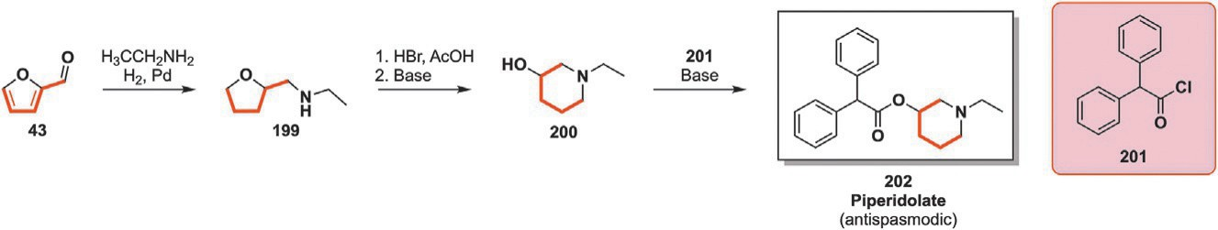
Fig. 21 Preparation of antispasmodic piperidolate (202) incorporating the complete carbon backbone of furfural (43) in its piperidine ring.

an azo dye which acted as a prodrug of sulfanilamide.¹¹² This had a rather broad spectrum of action, being particularly active against gram-positive cocci. A “sulfa craze” quickly ensued as dozens of derivatives were tested and studied, progressively eclipsing the original compound. Sulfadoxine
(209) is one of those drugs bearing the now well-established “sulfa” moiety. It is commonly administered in combination with pyrimethamine to treat malaria and is currently on the WHO list of essential medicines for the same reason.
Patented in 1961 by Roche, the preparation of sulfadoxine (209) starts from dimethyl oxalate and methyl methoxyacetate toward methoxy substituted malonate ester 202.¹¹³ However, alternative pathways starting from malonic esters to obtain 202 have been developed too.¹¹⁴ Diester 202 undergoes amidation by ammonia before cyclization with formamide under basic conditions to yield the pyrimidine 204. PCl₃ is then reacted with 204 to obtain the dihalogenated intermediate 205 which is again readily aminated by NH₃. The remaining chlorine is replaced by a methoxy func-
tion through the use of an excess of sodium methoxide. The final aminated pyrimidine 207 is ultimately coupled with p-acetamidobenzenesulfonyl chloride (208) and a base to conclude the preparation of antimalarial 209 (Fig. 22).

Miscellaneous
Antibiotics have already been discussed previously by introducing sulfa (209) and oxazolidone (nitrofuran 135 and 136) based drugs. A third and particu- larly prominent antibiotic category revolves around the β-lactam structure whose first appearance dates from 1928 when Alexander Fleming noticed that a bacterial culture was disrupted by contamination with Penicilium Rubens.¹¹⁵ This discovery opened the door to the new drug category falling under the general name “β-lactam.” Among these is cefotetan (215), an antibiotic with a cephamycin core, developed and marketed in Japan by Yamanouchi while Astra Zeneca sells it under the name Apatef or Cefotan outside of Japan.

A perspective on the synthetic potential of biobased building blocks 33

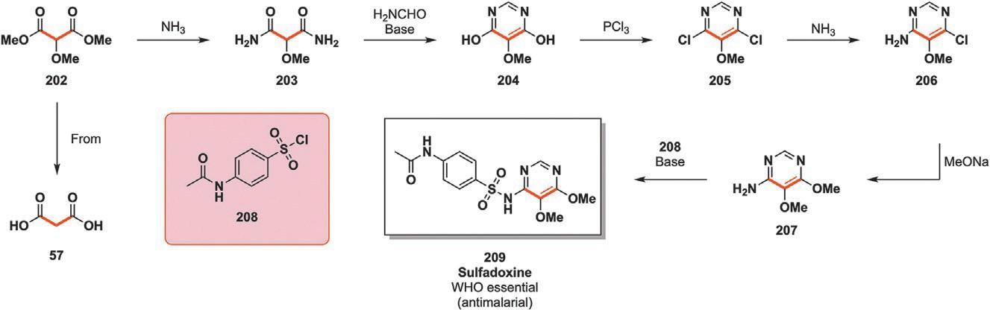
Fig. 22 Formation of sulfadoxine’s (209) pyrimidine core starting from substituted dimethyl malonate ester (202).
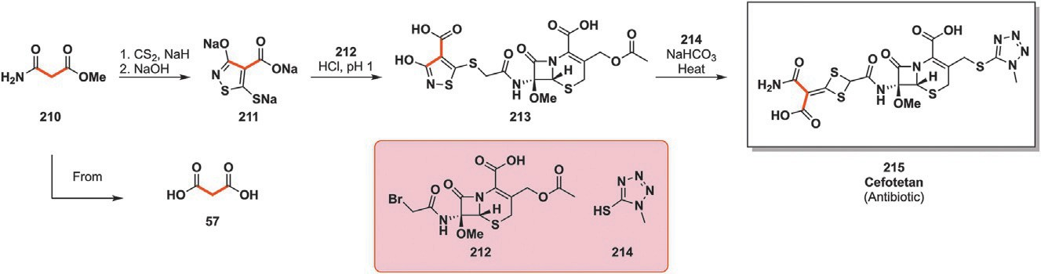
Fig. 23 Synthesis of isothiazole intermediate 211 from malonic acid derivative 210
toward diethietane antibiotic cefotetan (215).

Synthetic protocol toward 215 begins with the cyclization of malonic acid-derived methyl malonamate (210) with CS₂ and sodium hydride followed by a basic treatment with sodium hydroxide to yield trisodic salt
211. The coupling between the cephamycin scaffold 212 and isothiazole sodium salt 211 proceeds under acidic conditions, forming thioether 213. The last step toward 215 proceeds when mixing tetrazole 214 with 213 under basic conditions and heating. Rearrangement of the isothiazole ring under these conditions results in its opening and the formation of the unusual dithietane heterocycle while also grafting on the tetrazole ring 214 (Fig. 23).¹¹⁶
Immune system overreaction when in contact with an allergen is the cause of allergic reactions. Allergen binding to the antibodies triggers an allergic response alongside the related symptoms such as itchiness, swelling, shortness of breath and red eyes among others.¹¹⁷ Some of these symptoms may be benign or generate mild discomfort while others can be incapacitat- ing or even lethal in case of particularly violent allergic reaction. Prevention or symptom reduction is handled by administrating antihistaminic drugs which bind to histamine receptors, preventing the fixation of endogenous

34 Loïc Bovy and Jean-Christophe M. Monbaliu

histamine released upon allergen and antibody interaction. By doing so, the allergic symptoms are partly or totally muzzled and the patient is not inca- pacitated.¹¹⁸ One of the side effects of antihistaminic medications is its sedat- ing properties, making it also useful to treat some mild forms of insomnia. One of such histamine blocking drugs is azelastine (224), a long-lasting anti- histaminic medication used to treat hay fever and allergic conjunctivitis. It was patented in 1971 and marketed in 1986. It is now sold as generic med- ication in the US where it was the 145th most prescribed drug in 2021.⁸¹ The productions of 224 as patented in 1971 starts by the hydroamination
of ethyl acrylate (216) with N-methyl-4-aminobutyric acid (220) under basic
conditions. Carboxylic acid 220 is the product of N-methylpyrrolidone (68) ring opening under acidic conditions, itself a derivative of succinic acid (35) as it was introduced in Section 2.4.2. Cyclization of 218 is then performed in the presence of t-BuOK to yield 1-methyl-4-azepanone (219). Hydrazone coupling of the ketone moiety with 220 and subsequent reduction by NaBH₄ leads to intermediate 221. The latter is then split in a protic medium to retrieve the corresponding azepane 222 with a newly freed hydrazine moi- ety. Reaction between hydrazine 222 and benzylic acid derivative 223 quickly followed by reduction finalizes the multistep synthesis of 224. Azelastine (224) features two interesting particularities: it contains a rather unusual seven-membered ring and this ring can be prepared from fully bio- based materials (ethyl acrylate deriving from 3-hydroxypropionic acid (216) and 220 deriving from succinic acid (35)) (Fig. 24).
Calcium channel blockers (CCBs) are a drug category influencing the movement of Ca²⁺ ions through their dedicated channels with effects on patients’ blood pressure.¹¹⁹ They are currently prescribed to treat high blood pressure, alter heart rate and treat chest pain related to angina pectoris. CBBs come in three main categories: dihydropyridine, phenylalkylamines and benzothiazepines. Azeldinipine (234) is a recipient of the dihydropyridine category sporting a rare azetidine ring in its backbone. 234 was first described in 1980 though it appeared on the Japanese market under the
name Calblock, commercialized by Daiichi-Sankyo Pharmaceuticals only in 1995. As opposed to nicardipine which can be prescribed for similar con- ditions, azelnidipine has a slow onset with longer lasting antihypertensive effects while not drastically increasing the patients’ heart rate.¹²⁰
The synthesis of 234 and its azetidine ring as reported in 1988 begins by a reflux involving epichlorohydrin (53) and benzhydrylamine (225), forming the desired ring (226) while leaving a reactive alcohol function for further substi- tution. Intermediate 226 is then involved in a N,N⁰-dicyclohexylcarbodiimide

A perspective on the synthetic potential of biobased building blocks 35

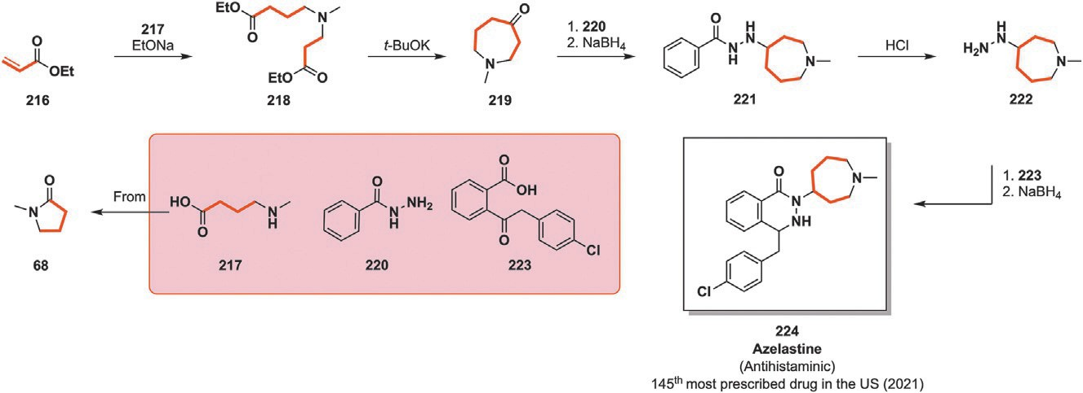
Fig. 24 Insertion of ethyl acrylate (216) and N-methyl pyrrolidone-derived 220 full carbon backbones in the azepane ring of antihistaminic azelastine (224).
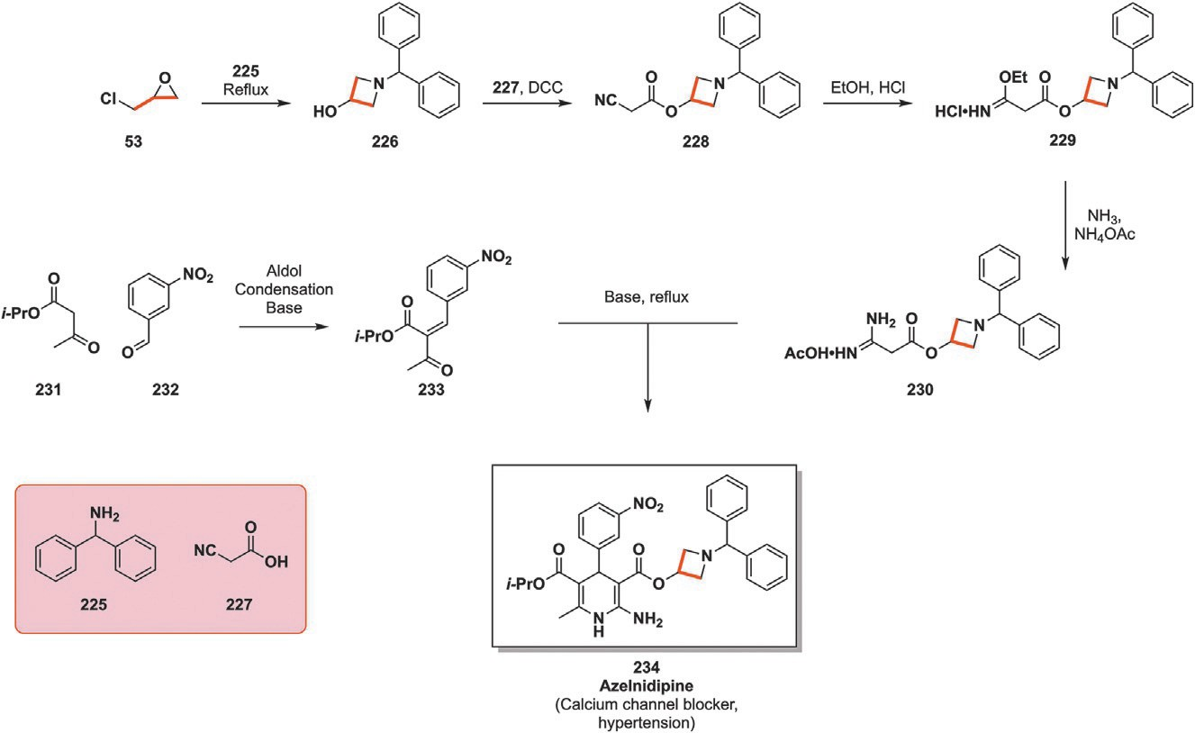
Fig. 25 Formation of azetidine-bearing azelnidipine (234) from epichlorohydrin (53) and benzhydrilamine (225). DCC¼ N, N0-Dicyclohexylcarbodiimide.
(DCC) promoted esterification with cyanoacetic acid 227 before being con- verted into the corresponding amidate HCl salt (229) with ethanol. Amidate 229 is later neutralized with ammonia before forming the acetate salt (230) of the resulting amidine in the presence of ammonium acetate. This sequence of events results in the preparation of the first key intermediate toward 234. The second partner for the Hatzsch dihydropyridine reaction, compound 233, is prepared through a standard aldol condensation between enolisable 231 and meta-nitrobenzaldehyde (232). Finally, the two partners for the dihydropyridine ring preparation are mixed under basic conditions to obtain azelnidipine 234 (Fig. 25).¹²¹

36 Loïc Bovy and Jean-Christophe M. Monbaliu

- Fused rings
  - Five-membered rings
A quick overview of sorbitol (45), a C-6 platform molecule, and some second- ary building blocks derived from it have been introduced in Section 2.4.4. One of such secondary building blocks is isosorbide (99) which is the result of the double dehydration of 45 through 1,4-sorbitan (98). Compound 99 has attracted strong attention as a versatile and biobased platform molecule. This has triggered a research frenzy regarding the acid-promoted dehydra- tion of 45 into 99. According to Scifinder, 500 publications regarding this procedure have been published since 2000; these are equally distributed
between research papers and patents whereas little more than 30 were published between the early 1970s and 2000.
Some of the most recent development came in early 2021 with the pub- lication of a procedure relying on continuous flow chemistry for the prepa- ration of isosorbide (99) from 45. A 0.17 M methylic solution of sorbitol (45) was flowed through a pellet of zeolite H-β 38, (SiO₂/Al₂O₃ ratio 38) at 200 °C for 8 min, resulting in 45 full conversion, 65% yield in 99 and 22% of 1,4-sorbitan (98) which can be recycled and fully dehydrated into 99. The setup was also tested under prolonged reaction conditions albeit at lower temperature and shorter residence time to preserve the catalysts activity. The catalyst retained its activity throughout the 55 h run at 170 °C with a 2.6 min residence time in contact with the catalyst resulting in a 46% 99 yield at the cost of a drop in 45 conversion (from 100% to 82%) (Fig. 26A).¹²² An alter- native procedure was reported in 2023 by Yuan et al. in which they relied on polymeric support-grafted ionic liquids as catalysts for 45 dehydration. Neat sorbitol (45) was heated to 140 °C for 6 h in the presence of 0.6 mol% of cat- alyst 235, retrieving isosorbide (99) with a 76% yield alongside 17% of 1,4-sorbitan (98) (Fig. 26B).¹²³ Later in 2023, the production of isorsorbide (99) from sorbitol (45) was reported by Jaˇsek and coworkers using para- toluenesulfonic acid (PTSA) as catalyst. As for the reaction reported by Yuan and coworkers, the reaction was performed with neat 45 heated at 130 °C with 1 mol% of catalyst for 5 h. The whole reaction system was placed under a 20 mbar vacuum, removing the released water and pushing the equi- librium toward the products, leading to an 82% isosorbide (99) yield (Fig. 26C).¹²⁴
¼
The first described procedure has the advantage of being performed under continuous flow conditions with a heterogeneous catalyst, theoretically

A perspective on the synthetic potential of biobased building blocks 37

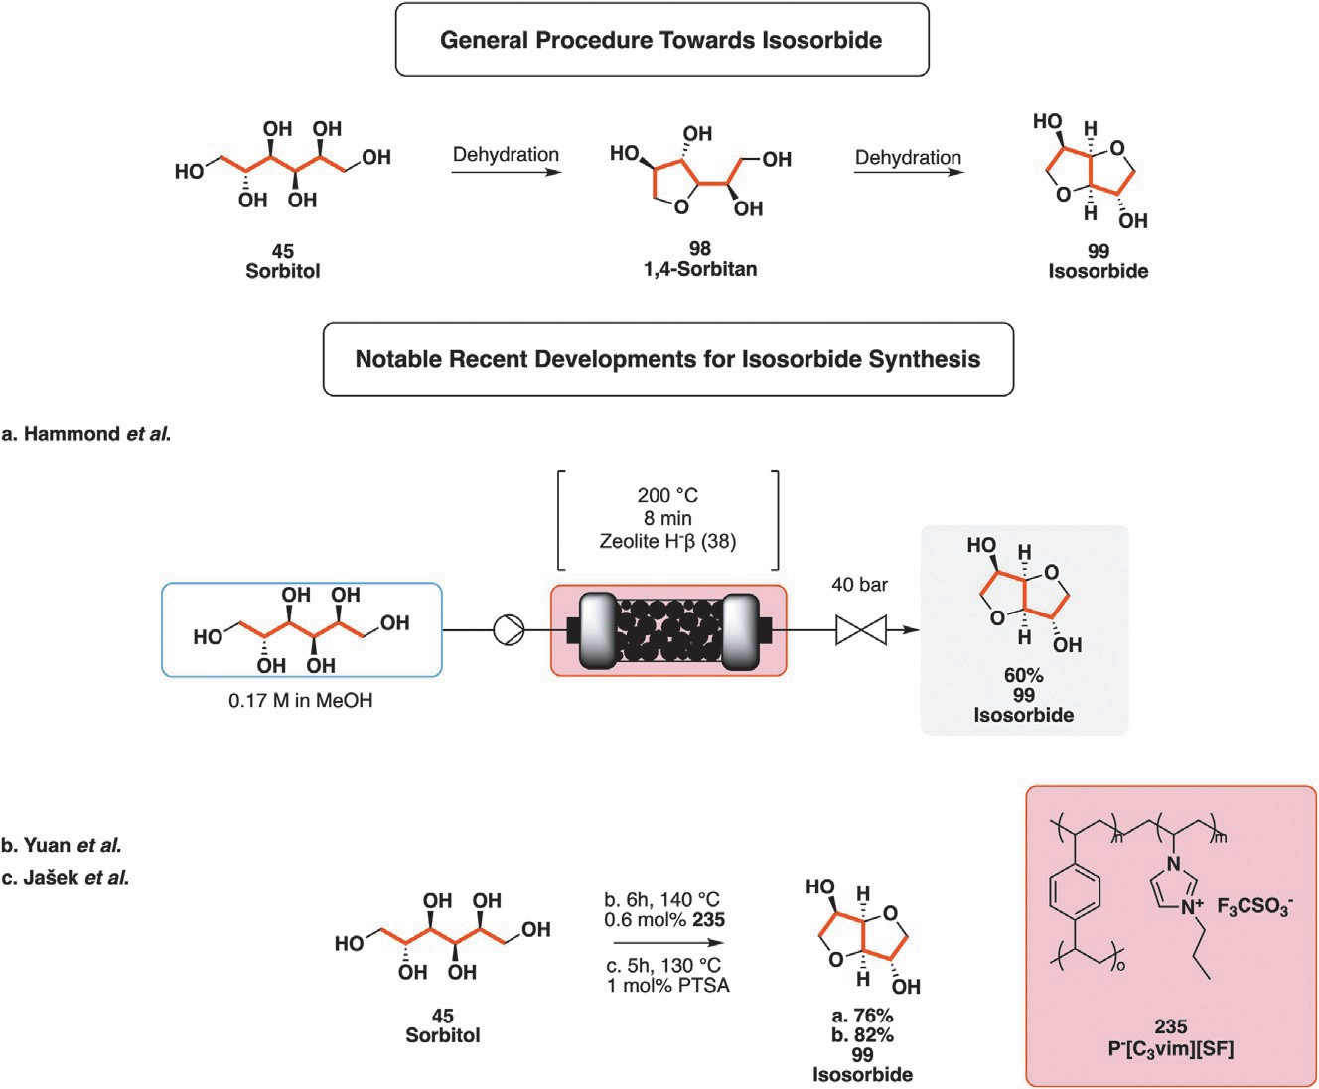
Fig. 26 General synthetic pathway toward isosorbide (99) and some recent updates.

providing isosorbide (99) in an uninterrupted fashion, especially considering the notable longevity of the catalyst. Additionally, the lack of side products aside from intermediate 98 or unreacted 45 means that recyclability of the out- let ensures a low footprint. The reaction is extremely fast (8 min Compared to 6 and 5 h, respectively), though this comes at the cost of a lower yield. Additionally, to ensure that no problem occurs throughout the flow experi- ment, the concentration in substrate is rather low (0.17 M) when comparing the procedure to the other two, relying on neat 45, decreasing the produc- tivity of the system. Yuan and Jaˇsek procedures are longer but proceed at lower temperatures (140 and 130 °C respectively) while providing 99 in supe- rior yields. Jaˇsek’s procedure is the most efficient one of the lot and relies on a widely available and cheap catalyst at the lowest temperature while applying vacuum to shift the equilibrium to the right.
As mentioned before, isosorbide 99 is a platform molecule with a broad panel of derivatives and applications. It can undergo fatty acid mono or di-esterification to obtain surfactant (236) or emulsifier (237).¹²⁵ Methylation of 99 results in dimethyl isosorbide (238), a new and promising

38 Loïc Bovy and Jean-Christophe M. Monbaliu

biobased solvent suggested to be a suitable replacement for toxic N, N-dimethylformamide (DMF) and N-methyl-2-pyrrolidone (NMP).¹²⁶ The bicyclic nature of isosorbide also makes it an attractive surrogate for petrobased and toxic bisphenol A in the polymer industry. As such, Williamson etherification of 99 with epichlorohydrin (53) produces a bisphenol A bis-epoxide monomer alternative (239).¹²⁷ Going in the same
direction, addition of the alcohol moieties of 99 onto the double bond of acrylonitrile (61) followed by reduction results in polyamide precursor 240, another alternative to bisphenol A-derived polymers.¹²⁸ Reaction of 99 with diphenylphosphate chloride yields 241, a possible replacement to halogenated fire retardant compounds whose toxicity has been highlighted in the recent years.¹²⁹ Finally, mono or dinitration of 99 leads to isosorbide mono/dinitrate, NO prodrugs with vasodilating properties.¹³⁰ Though mononitrated 242 is the most effective of the two, 243 is present on the WHO list of essential medicines (Fig. 27).
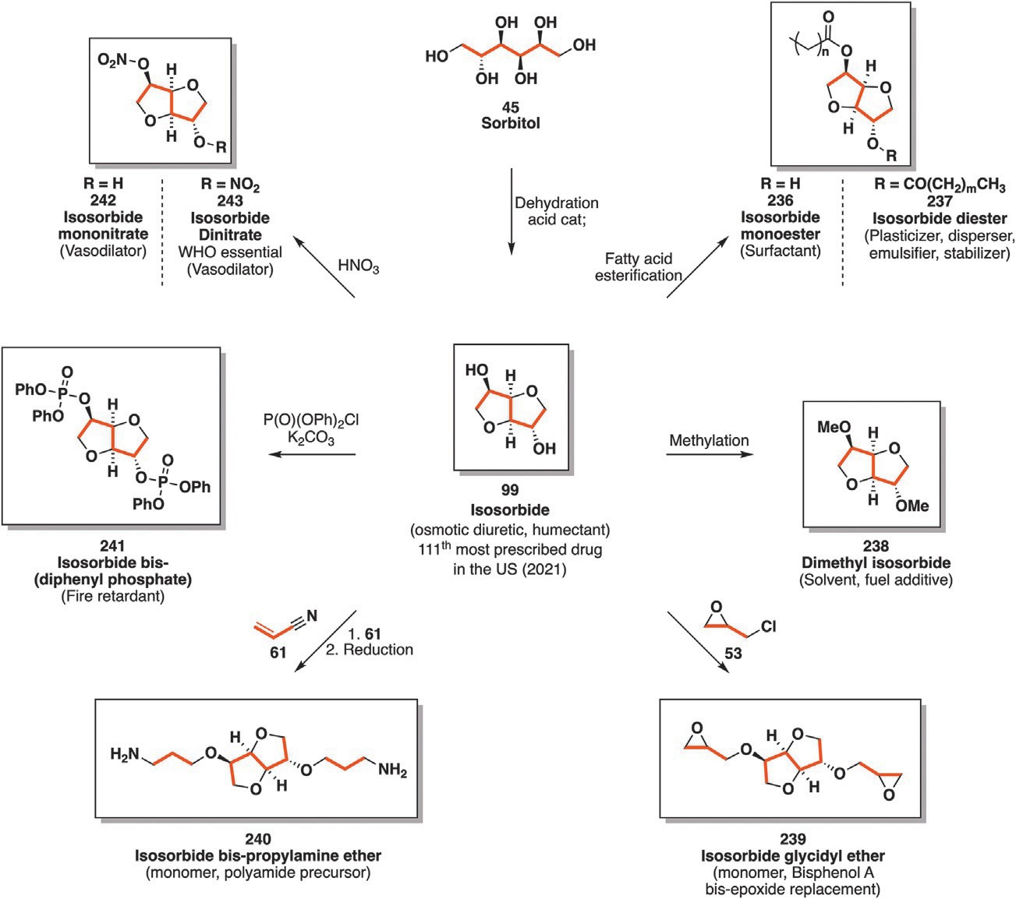
Fig. 27 Platform molecule isosorbide (99) surrounded by its derivatives and their applications.

A perspective on the synthetic potential of biobased building blocks 39

Another bicyclic oxygenated compound is endothall (247), a compound with herbicidal properties in use since the 1960s to deal with submerged aquatic plants in ponds, lakes and irrigation canals. It disrupts cell respiration, affecting protein and lipid biosynthesis of the algae or plants treated with 247 which in turn damages the cell wall and causes cellular death. Though con- cerns may arise from its application to waterways and subsequent consump- tion by humans or animals, the Environmental Protection Agency (EPA) deems it safe up to a 100 ppm concentration though much lower concen- trations are actually used.¹³¹
Preparation of endothall begins by a Diels-Alder reaction involving furan
(92) as the diene and maleic anhydride (244) in place of the dienophile. Newly formed tricyclic (245) undergoes palladium-catalyzed reduction of its CdC double bond before the anhydride is hydrolyzed under acidic con- ditions to yield the desired herbicide as a diacid (247, Fig. 28).^{132,133}
Non-steroidal anti-inflammatory drugs (NSAIDs) are a broad category of molecules with antipyretic, analgesic, antithrombotic and anti-inflammatory properties. “Non-steroidal anti-inflammatory drugs” is a term coined in the 1960s to clearly segregate them from corticosteroids which were recklessly used and prescribed from their introduction in 1948 through the 1950s, resulting in significant side-effect related troubles and subsequent public backlash.¹³⁴ These drugs prevent the endogenous production of prostaglan- dins (involved in inflammation and blood clotting) by inhibiting cyclooxy- genase enzymes. Some common NSAIDs comprise aspirin, ibuprofen, naproxen and indomethacin (253). The latter was patented in 1961 by Merck and co. before being approved for medical use in 1963.^{135,136} It is on the WHO list of essential medicines for pain, joint stiffness, fever, swelling and inflammation treatment and as of 2021, was the 253rd most prescribed drug in the US.^{55,81}
The preparation of indomethacin (253) as patented in 1961 begins with a Fischer indolization involving levulinate ester 248 and p-methoxyphenyl hydrazine (249) under acidic conditions, obtaining methoxy-substituted indole ring 250. The next step consists in the formation of an amide bond
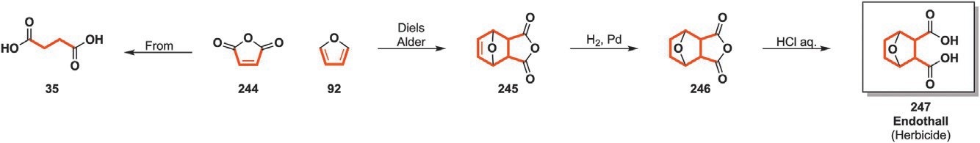
Fig. 28 Multistep synthesis of endothall (247) from maleic anhydride (244) and furan (92).

40 Loïc Bovy and Jean-Christophe M. Monbaliu

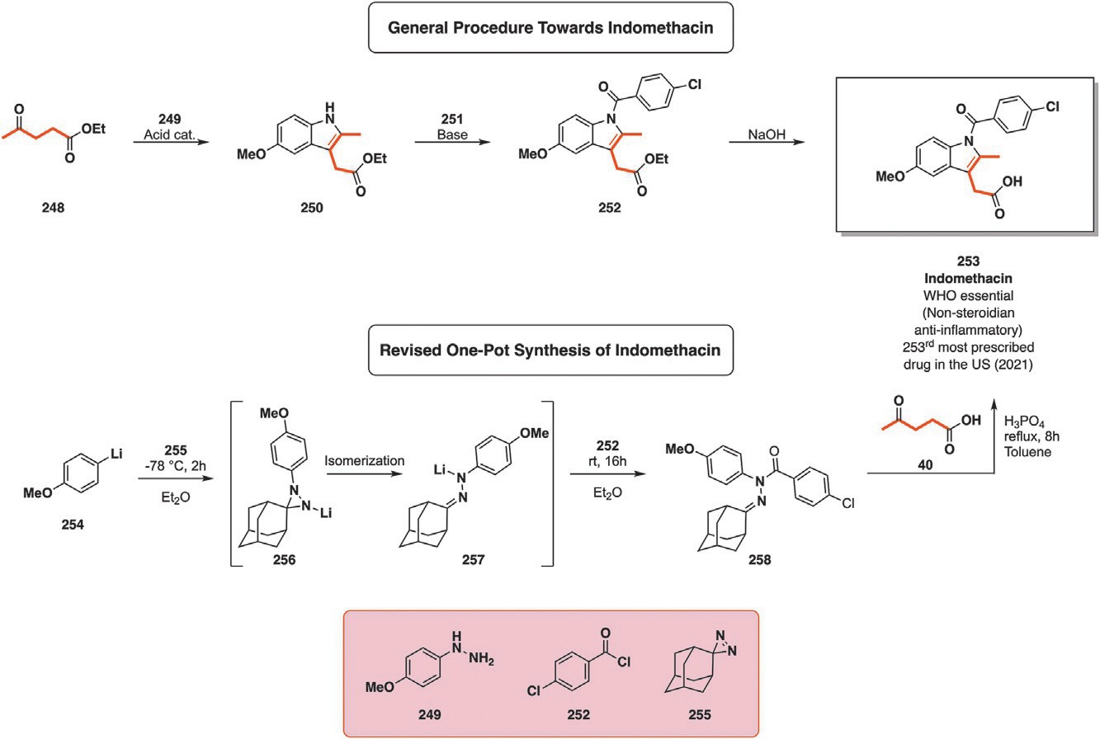
Fig. 29 Indomethacin (253) synthetic pathway from ethyl levulinate (243) and
p-methoxyphenylhydrazine (249) through Fischer indolization.

by reacting the indolic amine with acyl chloride 251 in the presence of a base as HCl scavenger before finally hydrolyzing the ester moiety of newly syn- thesized 252 to yield indomethacin (253) (Fig. 29).¹³⁶
Greatly diverging from this procedure, a Canadian team of researchers led by Claude Legault has published in 2023 an elegant one-pot procedure yielding 253. While the first patented procedure begins with the indole for- mation with ethyl levulinate (248), this newly reported procedure leaves that step as the final one. 255, an aziridine derived from adamantane plays a suc- cessive electrophilic and then nucleophilic role throughout this procedure. The first step involves 1.5 equivalents of lithiated aromatic rings, 254 among them, and one equivalent of previously mentioned aziridine at -78 °C in ether for 2 h. A first substituted diaziridine 256 is obtained which readily isomerizes into 257, a nucleophile. 257 is then reacted with two equivalents
of acyl chloride 252 to yield N,N-disubstituted hydrazone 258 before
removing diethyl ether under vacuum and replacing it with toluene. Finally, the Fischer indole reaction proceeds under acidic conditions with H₃PO₄ (2 equivalents), levulinic acid (40) (1.5 equivalents) and crude disub- stituted hydrazone 258 in toluene. The reaction was refluxed for 8 h before performing the workup. This complete sequence of reactions yields

A perspective on the synthetic potential of biobased building blocks 41

indomethacin (253) with an impressive total 71% yield. Additionally, adamantone, the scaffold bearing this reactive aziridine ring, was retrieved with yields 2:: 80%, further lowering the overall footprint of the procedure (Fig. 29). It is noteworthy that this one-pot procedure does not require an additional hydrolysis step as for the first patented route, since it relies on levulinic acid (40) instead of its ethyl ester 248 (Fig. 29).
137
Indomethacin 253 has since been considered as a template for new drug
development: acemetacin (255), glucametacin (256), indomethacin farnesil
(258) and proglumetacin (265) among them. These are built by taking advantage of 253 free carboxylic acid scaffold as an anchor to generate either its ester or amide. Most of these modifications aim at reducing the inflam- mation caused by indomethacin to the gastric tract. Acemetacin (255) is 253 glycolic acid ester prescribed to relieve rheumatoid, gout-induced and post-surgical pain. While it has been observed that 255 generates less damage to the gastric tract compared to indomethacin, it displays similar anti- inflammatory and analgesic properties as 253. Similarly, glucametacin (256) is the glucosamine (6) amide of indomethacin (253), treating light to medium pain related to arthritis. Indomethacin farnesil (258) is another ester derivative obtained by esterifying it with sesquiterpene farnesol (257). 257 is produced by plants and animals from isoprene (44) as sesquiterpenoid, themselves precursors of squalene. 257 can also be obtained through bioconversion of glucose (2) by engineered bacteria such as E. coli.¹³⁸ It has been approved for commercialization in Japan and Indonesia in 1991 but has
not reached occidental markets up to now.
The last discussed compound is proglumetacin (265), a prodrug of 253 and proglumide (263). A prodrug is a molecular entity which needs to be metab- olized before being active. In the case of 265, the piperazine linker has to be digested and cleaved before releasing proglumide (263), a drug treating stom- ach ulcers and indomethacin (253) with its anti-inflammatory properties.
Preparation of acemetacin from 253 as patented in 1973 is a two-step pro- cedure: benzyl bromoacetate 254 undergoes nucleophilic substitution by 253
under basic conditions before releasing the terminal carboxylic acid through hydrogenation with carbon-supported palladium and dihydrogen.¹³⁹ Glucametacin (256) and indomethacin farnesil (258) are prepared in the same manner though the grafted skeleton varies. SOCl₂ activates the car- boxylic acid of 253 before reacting glucosamine (6) which can be obtained from chitin (3) or 257 in the presence of an HCl trapping base respec- tively.¹⁴⁰ The preparation of the last discussed compound is a more complex one. Proglumide (263) can be sourced from glutamic acid (42) through a

42 Loïc Bovy and Jean-Christophe M. Monbaliu

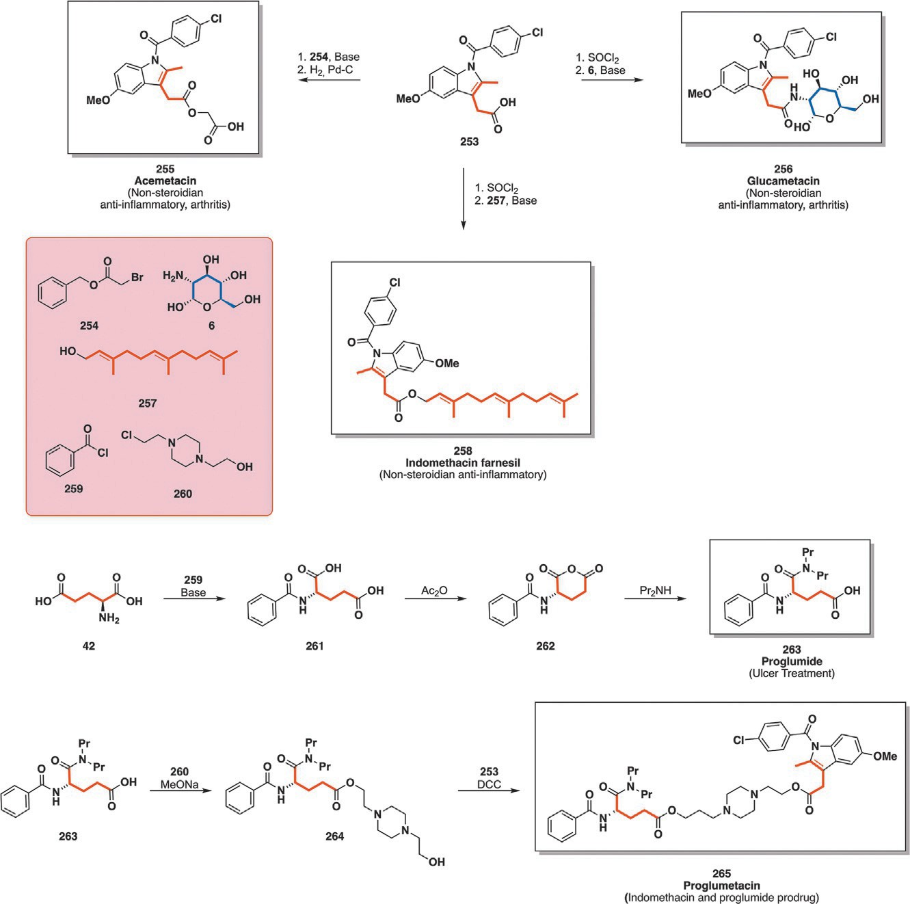
Fig. 30 Synthesis of indomethacin-derived acemetacin (255), glucametacin (256), indo- methacin farnesil (258) and proglumetacin (265). DCC¼ Dicyclohexylcarbodiimide.

three-step reaction sequence. Firstly, the free amine of 42 reacts with benzoyl chloride (259) under basic conditions to form the corresponding benzamide (261). Secondly, the diacid is dehydrated by acetic anhydride to form six-membered anhydride intermediate 262. Lastly, anhydride 262 is reacted with dipropylamine toward proglumide (263).¹⁴¹ With 263 ready, the prep- aration of proglumetacin 265 can be envisioned. The piperazine linker 260 is first connected with 263 through a base-mediated nucleophilic substitution yielding 264 which is then reacted in the presence of dicyclohexyl- carbodiimide as the coupling agent with 253 to obtain the coveted drug (Fig. 30).¹⁴²
Antipsychotics, also known as neuroleptics, are a family of drugs with psychotropic effects prescribed to manage psychosis as well as mood

A perspective on the synthetic potential of biobased building blocks 43
¼

disorders related to bipolar disorders.^{143,144} These are divided into two main classes depending on the receptors they interact with. Typical or first- generation antipsychotics are dopamine receptor antagonists while atypical or second-generation ones interact with both dopamine and serotonin receptors. Ziprasidone (274) falls in the second category and is used to treat schizophrenia and mood disorders. It was first patented by Pfizer in 1994 before being accepted by the FDA and subsequently entering the American market in 2001.¹⁴⁵
Ziprasidone 274 production as developed by Pfizer starts with the nitra- tion of dichlorinated toluene derivative 266 with concentrated nitric and sulfuric acid resulting in 2,5-dichloro-4-nitrotoluene (267). The latter is reacted with Bredereck’s reagent 268 in a complex one-pot reaction resulting in enamine 269. Piperazine derivative 270 is then reacted with the newly formed 269 in the presence of acetic acid before sodium triacetoxyborohydride (STAB) reduces the enamine to obtain 271. The last two reactions are the heterocycle-forming ones. The first one consists in the
nucleophilic aromatic substitution of the chlorine atom closest to the nitro group by dimethyl malonate (272) in the presence of a base. The second syn- thetic sequence consists in the acid mediated hydrolysis of the esters and decarboxylation before activating the resulting acid with SOCl₂ and reduc- ing the nitro group with Na₂S₂O₄. This last sequence ultimately results in the intramolecular cyclization and lactam formation leading to ziprasidone (274) (Fig. 31).¹⁴⁵

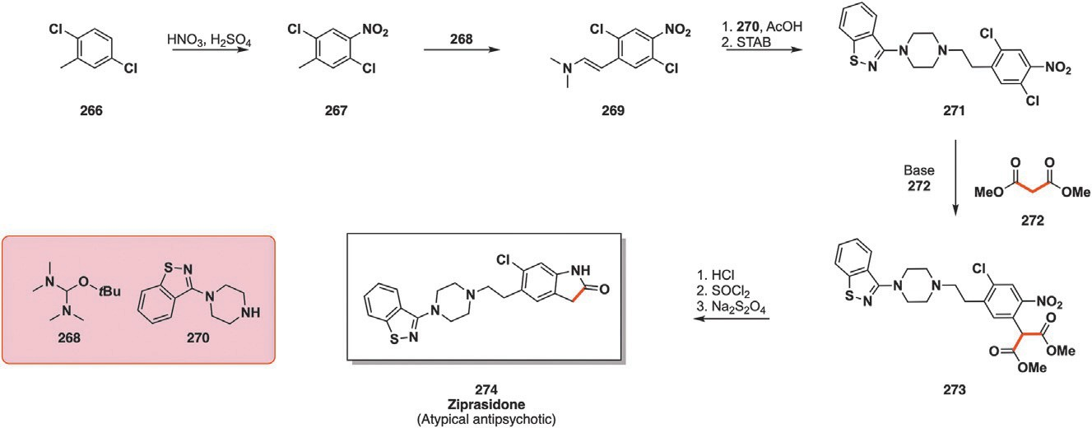
Fig. 31 Multistep procedure toward antipsychotic ziprazidone (274) involving nucleophilic aromatic substitution with dimethyl malonate (272). STAB sodium triacetoxyborohydride.

44 Loïc Bovy and Jean-Christophe M. Monbaliu

4.2 Six-membered rings
Fluoroquinones are a broad category of antibiotics which emerged follow- ing the discovery of nalidixic acid (even though it is only a quinone deriv- ative) while trying to produce chloroquine in 1960. Nalidixic acid was then introduced to treat urinary tract infections in 1962. The discovery and activity of this substrate paved the way to new analog synthesis with more than 10,000 combinations being tested for biological applications though few of them saw commercial release and medical use.¹⁴⁶ Fluoroquinones are divided into four generations with each generation having a broader spectrum of activity than the previous one. These antibiotics block DNA replication through DNA gyrase and topoisomerase inhibition with appli- cations in both human and veterinary medicine.¹⁴⁷ Ofloxacin is a racemic third-generation fluoroquinolone antibiotic first developed by scientist of Japanese company Daiichi Seyaku. 1985 saw the preparation and testing of pure levo ofloxacin (later shortened into levofloxacin) which was less toxic and more active than racemic ofloxacin. Levofloxacin (285) entered the Japanese market in 1993 before gaining FDA approval in 1996 while being distributed by Johnson and Johnson. It is currently used to treat com- plicated urinary tract infections, bacterial sinusitis and bronchitis, pneumo- nia and skin infections, reaching a grand total of 1.6 billion US$ cumulated levofloxacin and ofloxacin sales in 2009 for Johnson and Johnson alone. As of 2021 it was the 223rd most prescribed drug in the US while it also is on the WHO list of essential medicines.^{55,81}
Levofloxacin (285) preparation incorporates two different 3-carbon scaf- folds in its synthetic scheme, namely: epichlorohydrin (53) and diethyl ethoxymethylene malonate (278). Epichlorohydrin (53) is first reacted with fluorinated phenol 275 through a Williamson etherification in the presence of a base before undergoing oxirane methanolysis and oxidation by CrO₃ to yield ketone intermediate 277. Hydrogenation catalyzed by Raney Nickel of 277 before adding malonate 278 results in the formation 279, the first fused ring of levofloxacin (285). The second heterocycle is then prepared by reacting 279 with polyphosphate and then AlBr₃, resolution of the resulting alcohol produces enantiopure intermediate 280. Displacement of the hydroxy moiety by iodide is performed with the help of methyl- triphenylphosphonium iodide (281). The trihalogenated substrate then undergoes deiodination in the presence of tributyltin hydride which is quickly followed by ester hydrolysis under acidic conditions to yield 283, the last intermediate of this lengthy chain of reactions. The final step toward 285 involves the aromatic nucleophilic substitution with N-methyl-piperazine (284) (Fig. 32).¹⁴⁸

A perspective on the synthetic potential of biobased building blocks 45

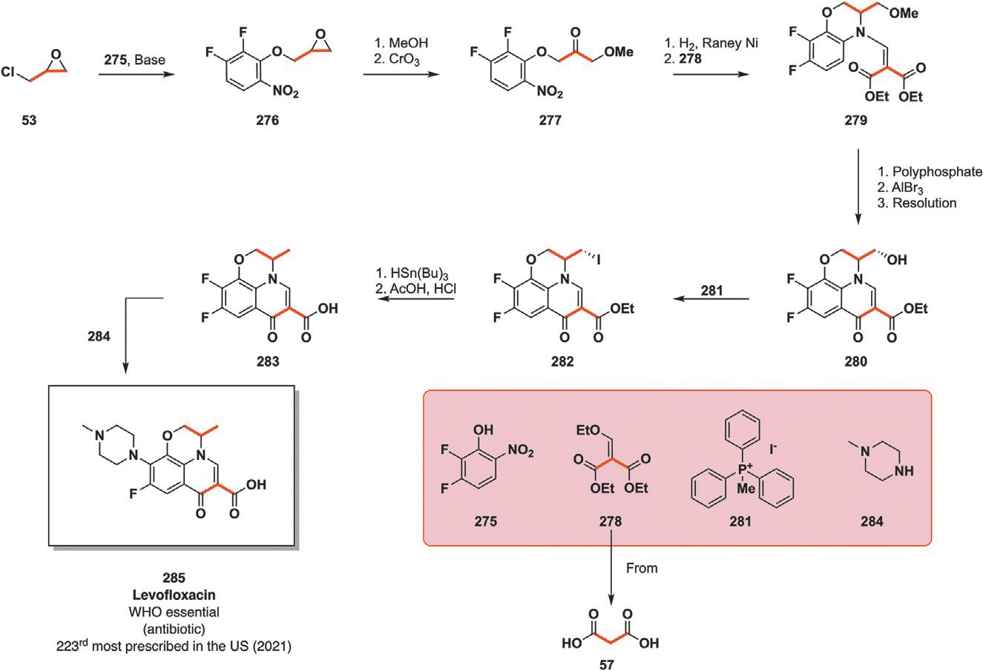
Fig. 32 Incorporation of epichlorohydrin (53) and diethyl malonate derivative (278) in the cyclic scaffolds of antibiotic levofloxacin (285).

Beta blockers (also spelled ß-blockers) are a drug category whose primary effect is blood pressure reduction. These drugs bind to beta adrenergic receptors which results in (nor)epinephrine (also known as (nor)adrenaline) blocking, modulating the fight or flight response responsible for increased heart rate and vasoconstriction. Hypertension or arrythmia can be treated by regulating this fight or flight response. Beta blockers can be selective to adrenergic receptors located in different areas of the body, therefore hav- ing a more targeted therapeutical impact while less selective others have a general impact on the organism.¹⁴⁹ Common features of beta blockers are their central beta amino alcohol scaffold which is generally obtained via glycerol-derived epoxide intermediates. Nipradilol (293) is a beta blocker which doubles down as a NO precursor whose vasodilating properties are akin to those of nitroglycerin.¹⁵⁰ Nipradilol also sees applications in ophthal- mology by preventing the onset of glaucoma triggered by hypertension.¹⁵¹ The preparation of bicyclic 293 as patented by Kowa co in 1981 begins
by reacting acrylonitrile (61) and phenol derivative 286 in the presence of a base before hydrolyzing the nitrile moiety of intermediate 287 into its corresponding carboxylic acid (288). The beta unsaturated carboxylic acid is then reacted in the presence of ethyl chloroformate, sodium azide and sul-
furic acid to yield the corresponding cyclic ketone (289). This substrate is then reduced in the presence of NaBH₄ before cleaving the methyl ether

46 Loïc Bovy and Jean-Christophe M. Monbaliu

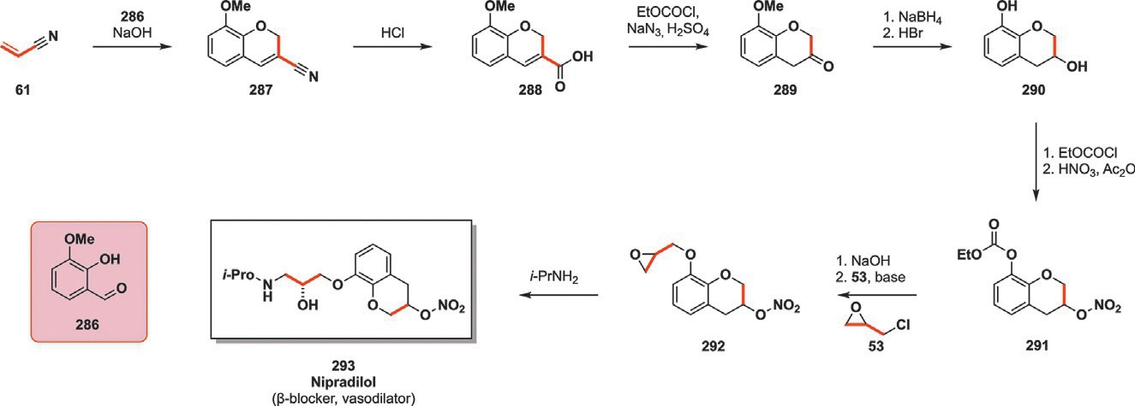
Fig. 33 Acrylonitrile-based production of beta blocker nipradilol (293) incorporating epichlorohydrin (53) in its beta amino alcohol scaffold.

into the corresponding phenol 290 with HBr. The protection of the phenol hydroxy moiety is performed with ethyl chloroformate before performing the nitration of the second alcohol with nitric acid. This yields nitric acid ester 291 whose role will be to provide vasodilating NO to the patient. The last synthetic steps toward nipradilol (293) consist in the basic deprotection of the phenolic carbonate followed by a Williamson etherification with epichlorohydrin (53), incorporating three more renewable carbons to the scaffold. Aminolysis of the epoxide by isopropylamine concludes the preparation of beta blocker 293 (Fig. 33).¹⁵²
4-Aza-sulfones are present in pharmaceutically active compounds such as anti-inflammatory drugs, antibacterials or antivirals for the treatment of hepatite C.^{153–155} However, more complex bridged bicycloaza-sulfone compounds have not been thoroughly studied nor was their pharmaceutical activity assessed. With this simple goal in mind, Banerjee and coworkers set out to synthesize these bridged heterocycles from aldehydes through aldoximes by harnessing the properties of mechanochemistry.¹⁵⁶
The reaction toward 296 started by reacting aldehyde derivative 294
with a 10% excess of hydroxylamine hydrochloride and K₂CO₃ to release the corresponding hydroxylamine free-base. Grinding at 30 Hz for 5 min at room temperature allowed the generation of the corresponding aldoxime
(295) with quantitative conversion of the starting material. To the obtained
aldoxime were added one equivalent of divinylsulfone (DVS in Fig. 34) alongside KCl as grinding auxiliary. The cell was then milled for an extra 4–8 h at 30 Hz before emptying the cell and performing the workup. This “one pot” procedure is robust with a substrate scope comprising 21 alde- hydes with yields ranging from 60% to 81%. Among the selected aldehydes, furfural (43) was submitted to these reaction conditions (6 h of milling),

A perspective on the synthetic potential of biobased building blocks 47

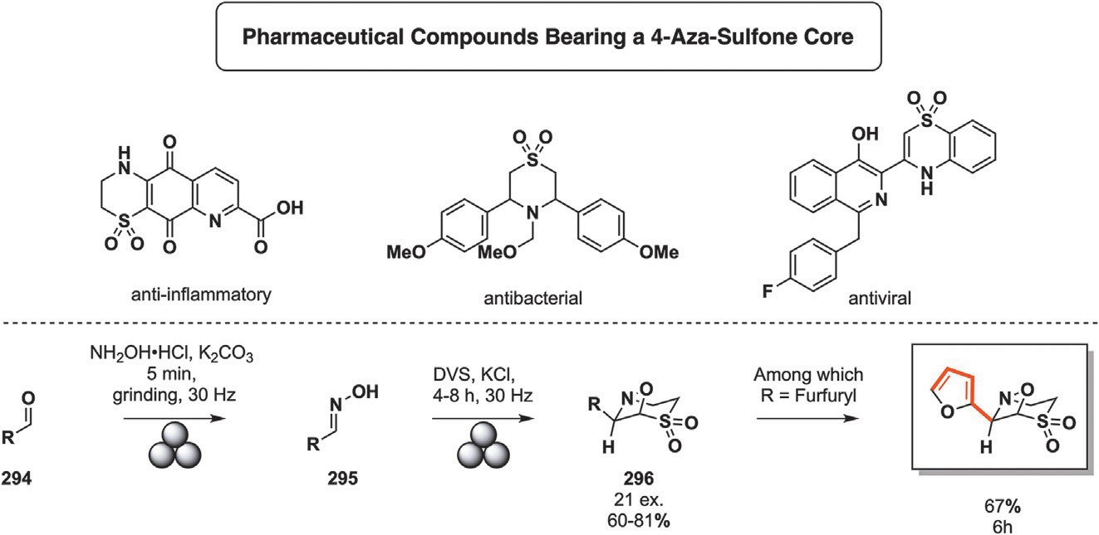
Fig. 34 Mechanochemical preparation of aldoxime intermediate 295 toward bridged bicyclo aza-sulfone (296) one of which derives from furfural (43) DVS¼ divinyl sulfone.

resulting in product 296 in a 67% yield (Fig. 34). These researchers successfully proved that more intricate rings can be synthesized via mechanochemistry. Later on, they determined the activity of the developed bicycloaza-sulfones against E. coli and Mycobacterium smegmatis with promising results.¹⁵⁶
Sulfur-containing heterocycles are a less common occurrence than their nitrogen counterparts; this does not mean that they have no concrete appli- cations. As such, benzothiazides are a well-represented class of heterocycles with diuretic properties. Diuretics are a category of pharmaceuticals whose administration results in increased urine production, therefore reducing the amount of fluids in cells and tissues. Hypertension as well as water reten- tion can be treated with diuretics as a first precautionary measure before switching to more specific medication. Benzothiazide-derived pharmaceu- ticals were first discovered and extensively researched by Merck and co. in the 1950s before the approval and commercialization of chlorothiazide.¹⁵⁷ Other drugs soon followed, meticrane (292) among them.
Alkene thiolation of acrylic acid (58) with 4-methylthiophenol (286) and
tetrabutylammonium hydroxide is the first step in the synthetic sequence toward meticrane (292). The newly formed thioether is then treated with sulfuric acid to yield bicyclic intermediate 288. Ketone reduction with zinc powder and hydrochloric acid followed by thioether oxidation into sulfone with H₂O₂ provides methylated thiochromane dioxide 290. The aromatic ring is then treated with chlorosulfonic acid before mixing it with ammonia to retrieve bicyclic sulfonamide (292) (Fig. 35).

48 Loïc Bovy and Jean-Christophe M. Monbaliu

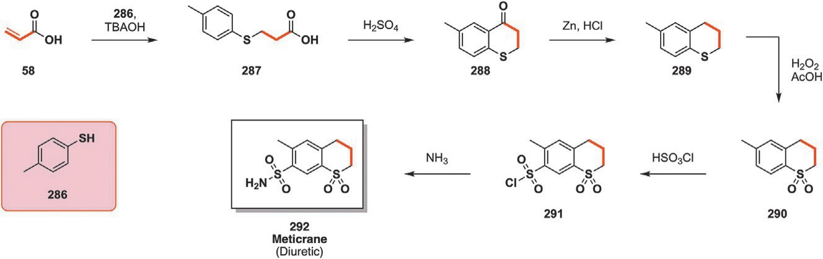
Fig. 35 Multistep synthesis of diuretic meticrane (292) from acrylic acid (58). TBAOH¼ tetra-n-butyl ammonium hydroxide.

Quinoline scaffolds are widespread across the chemical industry, whether it is in natural products such as quinine and cinchonine, as chelating agents for analytical purposes, as intermediates for the preparation of dyes such as quinoline yellow and blue or in the preparation of active pharmaceutical ingredients (APIs).¹⁵⁸ A small number of well-established reactions allow the preparation of quinolines and substituted quinolines starting from an ani- line derivative and a library of carbonyl compounds or in-situ generated car- bonyls. The simplest procedure is known as the Skraup synthesis where an (un)substituted aniline is reacted with glycerol (26) which is dehydrated into acrolein by H₂SO₄ and nitrobenzene, H₃AsO₄ or FeSO₄ as oxi- dizers.¹⁵⁹ Oxyquinoline (294) is a central building block for antiseptic com-
pounds such as nitroxoline (296) and clioquinol (295) or UV-protecting
actinoquinol (297). Similarly, antibiotic phanquinone (300) can be obtained from glycerol (26) and p-phenyldiamine derivative (298).
The simplest and oldest synthesis of oxyquinoline (294) relies on glycerol (26), o-aminophenol (293), sulfuric acid and nitrobenzene as both oxidizer and solvent for the reaction. Product 294 can then be further functionalized to access antiseptics clioquinol (295) through chlorination and iodination or nitrosation and further oxidation for nitroxoline (296). UV-blocking actinoquinol (297) can be obtained from oxyquinoline through etherification of the phenolic alcohol with ethyl bromide before going through sulfon-
ylation in the presence of chlorosulfonic acid. A double Skraup cyclization starting from glycerol (26) and 2,4-diaminoanisole (298) with H₃AsO₄ and H₂SO₄ leads to antibiotic phanquinone (300) after nitric and sulfuric acid oxi- dation of intermediate (299) (Fig. 36).¹⁶⁰
The Gould-Jacobs method presents an alternative method toward quino- lines while still relying on aniline. It replaces glycerol (26) or its dehydrated acro- lein by alkoxy methylenemalonic esters to obtain the 4-hydroxyquinoline

A perspective on the synthetic potential of biobased building blocks 49

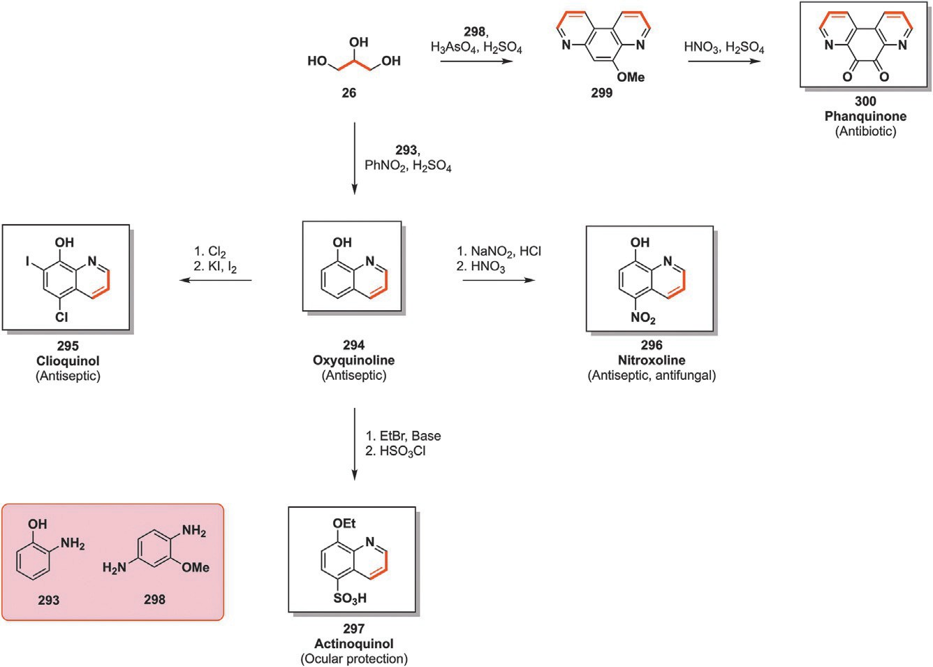
Fig. 36 Skraup synthesis of quinoleine derivatives (294–297) and 4,7-phenantroline derivative (300) from glycerol (26) and aniline (293) or 2,4-diaminoanisole (298).

nucleus which in turn can be upgraded toward derivatives such as glafenine
(309) and floctafenine (310). These are, like indomethacin (253) and its dis- cussed derivatives, non-steroidal anti-inflammatory drugs.¹⁶¹ They are used to treat pain of various origins though glafenine (309) prescription is strictly monitored due to severe side effects among which are anaphylaxis and acute kidney failure.¹⁶²
The first step toward 309 and 310 as patented by Roussel-Uclaf (now Sanofi) consists of the Gould-Jacobs synthesis of the ester 303.¹⁶¹ This begins with the condensation of diethyl ethoxymethylene malonate (278) to aniline derivative 301 before thermally cyclizing the enamine 302 into intermediate
303. The basic hydrolysis of intermediate 303 followed by its decarboxy- lation yields substituted 4-hydroquinoline (304). Displacement of the hydroxyl moiety in the presence of SOCl₂ leads to 305 which is then readily coupled with methyl anthranilate 306 toward 307. The last set of reactions consist of the base-mediated transesterification of 307 with glycerol-derived solketal (308). Finally, the ketal protecting group is removed under acidic conditions to yield glafenine (309) or floctafenine (310) (Fig. 37).

50 Loïc Bovy and Jean-Christophe M. Monbaliu

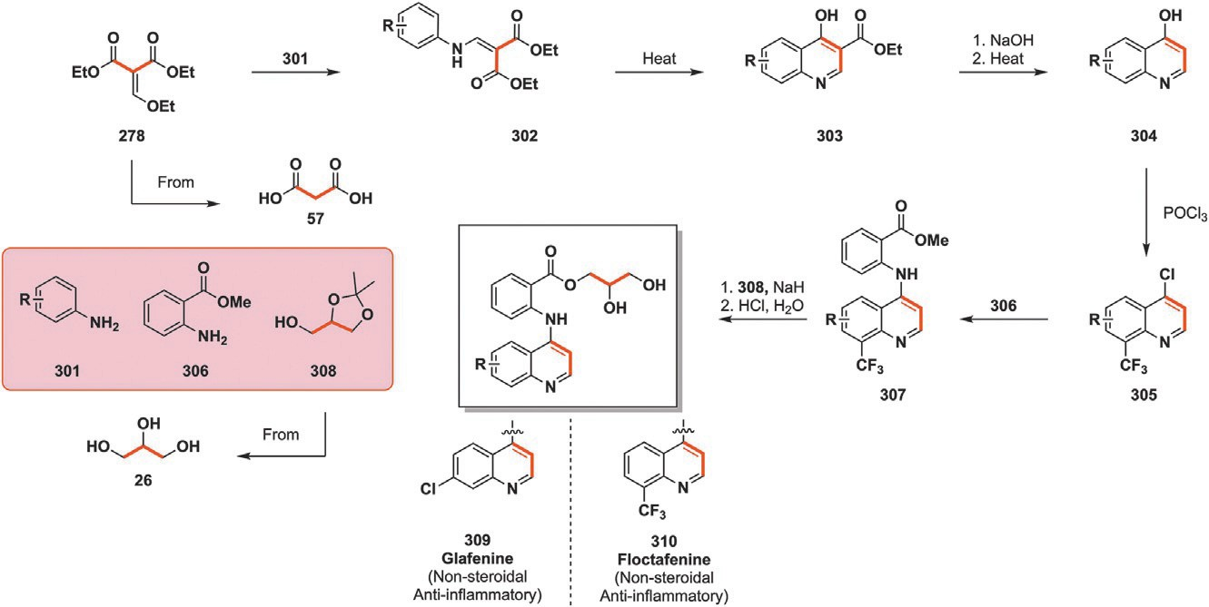
Fig. 37 Gould-Jacobs quinoline formation relying on diethyl malonate derivative (278) and solketal (308) inclusion in glafenine (309) and floctafenine (310) structure.

Folic acid (318), also known as vitamin B9, is metabolized into folate and plays a central role in cell division mechanisms by impacting DNA and RNA production as well as amino acid metabolism. Dietary deficiency in folic acid (318) may result in anemia while insufficient 318 intake during pregnancy can result in babies with neural tube defects, a condition in which spinal or cranial gaps remain open after birth with sometimes fatal outcomes.¹⁶³ As such, folic acid (318) is a widespread dietary supplement and is either added to food or consumed separately. As such, it currently sits on the WHO list of essential medicines and was the 132nd most prescribed drug in the US in 2021.⁸¹
Crystals of folic acid (318) were isolated in 1943 and this quickly resulted in the synthesis of antifolate medication aminopterin (319) and its use to treat
childhood leukemia.¹⁶⁴ This was prompted by the observation that patients who were administered folic acid supplements saw leukemia worsening while the opposite was noted when patients with folic acid deficiencies were studied. Folic acid analogues were further developed, which saw methotrex- ate proposed as a leukemia treatment in 1950 before replacing aminopterin
(319) in 1956, owing to its superior therapeutical index. Methotrexate (317)
is now used as a chemotherapeutical agent, treating breast, lung, bone and blood cancer, among others.¹⁶⁵
The synthesis of methotrexate 317 is the convergence of two separate
intermediates whose preparation start with potentially renewable scaffolds: 1,3-dihydroxyacetone (51) and glutamic acid (42). Intermediate 313 with its

A perspective on the synthetic potential of biobased building blocks 51

pteridine ring is obtained by reacting 51 with pyrimidine derivative 311 in the presence of oxygen before enduring bromination by Br₂ and triphenylphosphine. The second half of methotrexate (317) starts by the esterification of glutamic acid (42) through its activation as an acyl chloride by SOCl₂ which results in diethylglutamate (314). The free amine of the glutamate scaffold then reacts with acyl chloride 315 and a base before being subjected to acidic conditions in the presence of ethanol to free the previ- ously protected amine of 315. The coupling of 313 and 315 is then per- formed with the help of NaOH before hydrolyzing the ethyl ester with HCl to obtain anticancer drug methotrexate (317) (Fig. 38.¹⁶⁶
Beta blockers and their mode of action were succinctly introduced vide supra before discussing nipradilol (293) and its synthesis. Another beta blocker containing a cyclic moiety potentially sourced from renewable resources is carteolol (325). It sports a quinoline-2-one ring obtained from acrylic acid (58). Carteolol (325) was patented in 1972 and saw its medical debut in 1980. It is currently used as eye drops for the treatment of glaucoma, a condition resulting from optical nerve damage through excessive intraoc- ular pressure.¹⁶⁷
Beta-blocking carteolol (325) integrates two separate renewable building blocks in its scaffold, namely acrylic acid (58) and epichlorohydrin (53) though only 58 is effectively integrated in a heterocycle. Heating 58 and cyclic alpha-beta unsaturated ketone 320 leads to the formation of bicyclic 321 which is then reduced by carbon-supported palladium toward phenol
322.168 A Williamson etherification then quickly proceeds between the

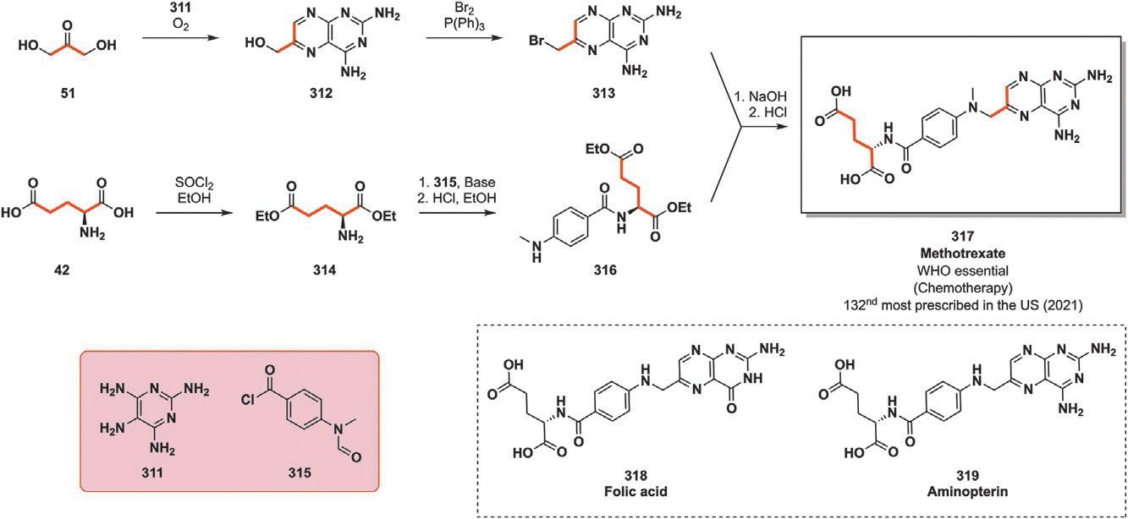
Fig. 38 Synthesis of chemotherapeutical agent methotrexate (317) from glycerol- derived 51 and glutamic acid (42).

52 Loïc Bovy and Jean-Christophe M. Monbaliu

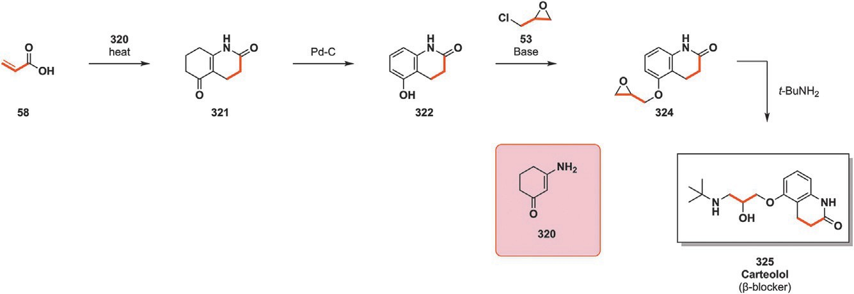
Fig. 39 Incorporation of acrylic acid (58) and epichlorohydrin (53) in the synthesis of beta blocker carteolol (325).

phenolic alcohol and epichlorohydrin (53) with an HCl scavenger before aminolysis of the epoxide by tert-butylamine finally yields carteolol (325) (Fig. 39).¹⁶⁹
Neurons are composed of a dendrite, receptor of upstream neural signal, the axon which propagates the signal until the synapse, the terminal part of a neuron from which the neural influx will be transmitted to another den- drite. The space between the first and second neuron is also called a synapse. Therefore, the “upstream” neuron is called presynaptic while the receiving or “downstream” neuron is called post synaptic. Neural communication can take place through electrical or chemical transmission. In the case of chemically-mediated neural transmission, neurotransmitters are released by the presynaptic neuron, intimately in contact with the post synaptic neu- rons. Receptors on the dendrite can then trap the transmitter and propagate the signal to its own synapse. The presynaptic neuron can however retrieve part of the excreted neurotransmitter through membrane-embedded trans- porters.¹⁷⁰ Reducing this reuptake of neurotransmitter is done by reuptake inhibitors which result in a higher concentration of neurotransmitter in the synaptic area and therefore a higher chance of interaction with the dendrite of post synaptic neurons. This reduces the chances of post synaptic neuro- transmitter binding and therefore neural signal transmission. Some of these inhibitors are antidepressants, drugs treating clinical depression, anxiety, chronic pain and addiction. These mostly target serotonin, norepinephrine and dopamine reuptake.¹⁷¹ Antidepressants can be sorted in different cate- gories, one of which is the “tetracyclic antidepressants” category. One such tetracyclic compound is setiptline, a selective norepinephrine and serotonine reuptake inhibitor whose preparation was patented in 1977 before being commercialized in Japan by Mochida in 1989 for the treatment of depression.¹⁷²

A perspective on the synthetic potential of biobased building blocks 53

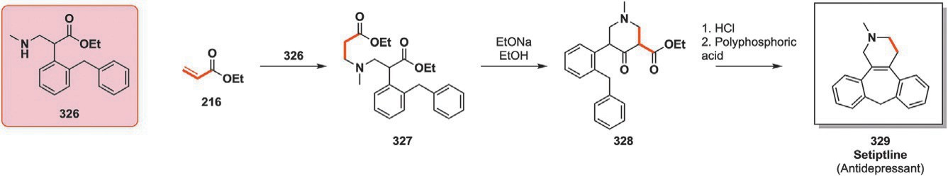
Fig. 40 Procedure toward tetracyclic setiptline (329) with ethyl acrylate (216) as the starting material.

Setiptline synthesis as patented proceeds through the hydroamination of ethyl acrylate (216) by secondary amine (326) to obtain the corresponding tertiary amine 327. Deprotonation of the enolizable position of 327 sets the stage for intramolecular cyclization, yielding tricyclic intermediate 328. The second cyclization to lock the tetracyclic core of setiptline (329) is per- formed in the presence of HCl before decarbonylation proceeds with the help of polyphosphoric acid (Fig. 40).¹⁷³
Similarly to piperidolate (202), tiquizium bromide (336) displays useful antispasmodic properties to treat gastritis, gastric and duodenal ulcers, irri- table bowel syndrome as well as gallbladder disease among others. 336 con- tains a quinolizidine ring whose synthesis starts from acrylonitrile (61). Hydroamination of 61 by the secondary amine of 330 followed by the activation of its primary alcohol with SOCl₂ provides nitrile derivative
331. This intermediate then undergoes cyclization in the presence of NaH, leading to quinolizidine intermediate 332. The nitrile moiety of 332 originat- ing from acrylonitrile (61) is then reacted with ethanol in the presence of HCl through a Pinner reaction, providing the corresponding ethyl ester (333). Tertiary alcohol 335 is obtained by reacting two equivalents of Grignard reagent 334 and ester 333 before an acid-mediated elimination followed by methylation with methyl bromide yields tiquizium bromide (336) (Fig. 41).¹⁷⁴

4.3 Miscellaneous
2019 saw the publication of lignin-derived dihydroconiferyl (337) and dihydrosynapyl alcohol (338) upgrading into tetrahydro-2-benzazepine derivatives. Benzazepines are present, among others, in capsazepine, which is a transient receptor potential channel of the vanniloid type (TRPV1)
antagonist with potential analgesic properties. TRPVs are responsible for the pain and burning sensation when ingesting capsaicin in spicy food, mod- ulating the response of these receptors results in analgesic effects, triggering intense research for the modulation of these receptor responses. Barta and coworkers reported in 2019 a procedure allowing for a three-step synthesis

54 Loïc Bovy and Jean-Christophe M. Monbaliu

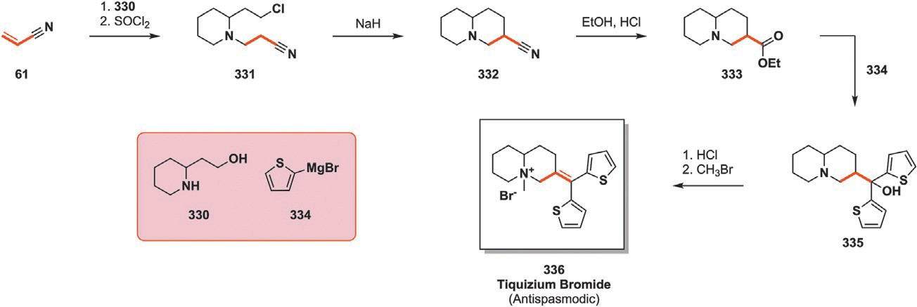
Fig. 41 5-step synthetic procedure involving acrylonitrile (61) toward antispasmodic tiquizium bromide (336).

of tetrahydro-2-benzazepine derivatives starting from raw lignin. The first step consists in the depolymerization of lignin from pine or poplar trees which result in different proportions of phenolic compounds in the reaction crude. This was performed following a procedure previously developed by the same team with the help of copper-doped porous metallic oxides.¹⁷⁵
Before probing the possibility of working with raw lignin-derived building blocks, the team of researchers worked on the selectivity of the amination procedure they aimed at implementing, worrying that the phe- nolic alcohol might interfere with the amination of the primary alcohol on the alkyl chain. They were delighted to observe that the reaction proceeded with total selectivity toward the desired primary amine (341) when reacting
aniline derivatives (339) with 1.2 equivalents of dihydroconiferyl alcohol
and 1 mol% of Shvo’s catalyst (340) in CPME for 20 h at 130 °C. With these different partners and ideal reaction conditions, the scope of the reaction was broadened to a total of 30 substrates, varying both the alcohol (337 or 338) and amine partners, whether they are substituted anilines, primary or secondary amines, resulting in isolated yields ranging from 43% to 98%. Building upon the newly synthesized library of amines (341 or 342), their cyclization through a Pictet-Spengler reaction was studied in deep-eutectic solvents (DES). Choline chloride and oxalic acid (ChCl/OA, 343) pro- vided the most interesting results and the resulting DES was selected for the reaction at hand. Suitable conditions were determined and accommo- dated 13 different substrates with isolated yields varying from 51% to 91% (344 or 345) after 20–48 h at 70–80 °C in ChCl/OA (343) with
formaldehyde (Fig. 42).
The most interesting aspect of the developed method concerns the ami- nation reaction described previously: this procedure can be implemented directly on raw depolymerized lignocellulose. Two separate phases are

A perspective on the synthetic potential of biobased building blocks 55

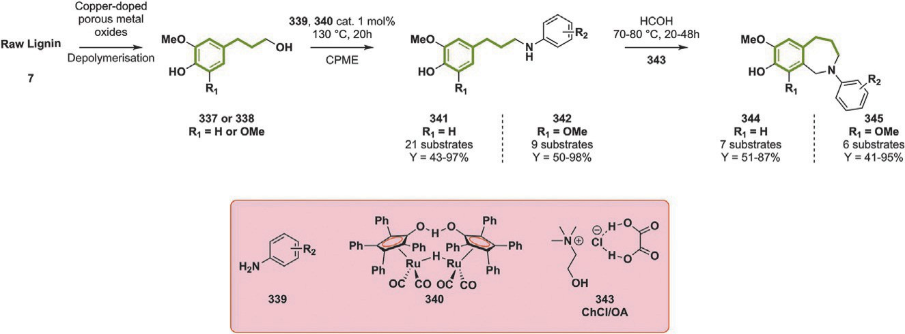
Fig. 42 Incorporation of dihydroconiferyl alcohol (337, R 5 H) or dihydrosynapyl alco- hol (338, R 5 MeO) obtained from raw lignin (7) in the two-step preparation of benzazepines (344 or 345) from substituted anilines (339). CPME cyclopentyl methyl ether.

retrieved from the depolymerization of lignocellulose, an ethyl acetate soluble one and the remaining insoluble and heavier fraction. The complexity of the reaction medium results in an increased catalyst loading (from 1 to 5 mol%), with the different alcohol moieties, such as those of glucose present in the matrix, hampering the catalyst efficiency, while two equivalents of amine derivatives are required instead of one for the reaction with clean phenolic alcohols. These conditions are applied to the soluble fraction retrieved from the depolymerization experiment, the remaining heavier solid fraction need- ing an additional doubling of catalyst and amine proportions to function.¹⁷⁶ The newly formed amines can then be more easily removed from the complex matrix and are therefore swiftly purified while having been upgraded without losing a single renewable carbon atom and having water as the sole by-product.
¼
While beta blockers are one approach to treating hypertension and heart conditions, it is not the sole category with such properties. Angiotensin- converting enzyme inhibitors (ACE inhibitors) are another drug category with such therapeutic properties. ACE inhibitors act by preventing the con- version of angiotensin I into angiotensin II, a peptide with vasoconstricting properties. ACE inhibitors are classified in three categories based on their structure: sulfhydryl, phosphonyl and carboxylate (by far the largest cate- gory) containing substrates. Cilazapril (357) is an ACE inhibitor of the car- boxylate category boasting a complex synthetic pathway as well as a fused saturated bicyclic central structure. It was first developed by Hoffman Laroche in 1982 before hitting the market in 1990. It is currently prescribed for congestive heart failure and hypertension.

56 Loïc Bovy and Jean-Christophe M. Monbaliu

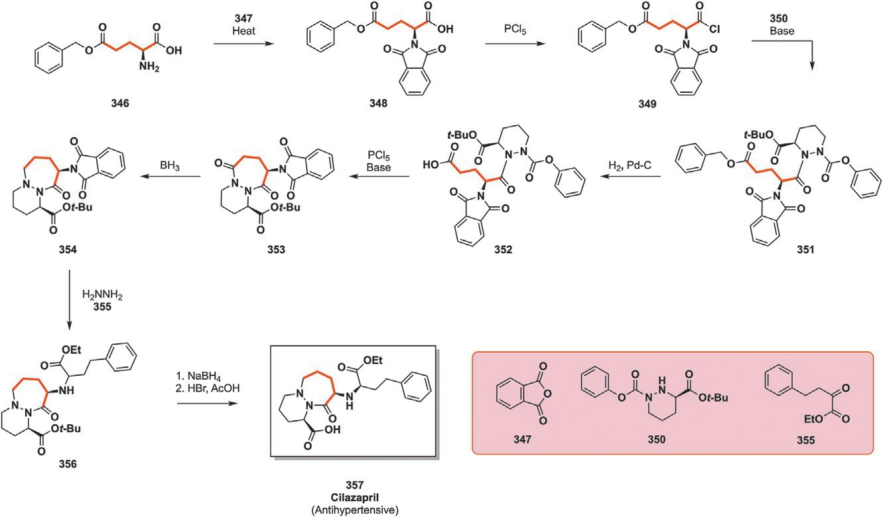
Fig. 43 Application of benzyl-protected glutamic acid (346) in the preparation of anti- hypertensive cilazapril (357).

The first step in the synthesis of 357 begins with the protection of amine 346 by heating it in the presence of phthalic anhydride (347) to yield 348 whose carboxylic acid is then activated into acyl chloride 349 with PCl₅. Intermediate 349 then reacts with cyclic hydrazine derivative 350 in the presence of a base to yield intermediate 351. The benzyl alcohol protecting group is removed by hydrogenation with carbon-supported palladium
before activating the resulting carboxylic acid and performing the intramo- lecular cyclization of intermediate 352 into 353. This series of reactions gives shape to the main scaffold of 357. BH₃ performs selective reduction of 353 toward 354. The phthalic moiety initially installed to protect glutamic acids amine is removed by hydrazine before coupling the free amine with keto ester 355. The final synthetic step for obtaining 357 consists of the selective deprotection of the tert-butyl ester in the presence of NaBH₄ followed by acidic treatment (Fig. 43).¹⁷⁷

Perspectives
In light of the elements displayed in Section 2.2, the transition from an exclusively petrobased chemical industry to a more sustainable one is mostly hindered by a lack of economic competitiveness as well as the excessive vol- umes of waste generated throughout the building blocks extraction and refining. This is coupled to the inherent complexity related to working with

A perspective on the synthetic potential of biobased building blocks 57

highly functionalized platforms. Finally, despite being incorporated in a variety of rings with different heteroatoms and sizes, only small proportions of renewable material seem to find their way in the final structure of the studied substrates.
These hurdles could be addressed at different production stages of these renewable polymer-derived compounds. Improving the efficiency and selectivity of primary building blocks production from raw biomass, whether it is through improved enzymatic or chemical pathways, would increase the overall attractiveness of renewable chemicals by reducing the costs related to the purification of cleaner outputs. In addition to this, devel- oping more resilient and robust synthetic processes feeding upon less refined primary platform molecules to produce secondary ones could reduce both waste generation and the cost of the final product. Furthermore, some path- ways illustrated in this perspective rely on primary platform molecule such as glycerol (26), furfural (43) or sorbitol (45) to initiate the long chain of chem- ical reactions toward fine chemicals. If the length of the synthetic procedure is considered, and with proper evaluation, less refined starting material could be envisioned too. A lower purity profile would inevitably require the devel- opment of more robust reaction conditions to counterbalance the impurities potentially hindering the considered reaction. Fortunately, new techniques allowing the intensification of reaction conditions and reduction of the pro- cess footprint are being developed under the form of continuous flow or mechanochemistry among others. On the one hand, conditions intensifica- tion as well as the reduced size of reactors coupled with the continuous oper- ation and the tight control of reaction parameters under microfluidic conditions could mitigate the upgrading cost of biobased platform molecules into their synthetically significant derived products. The feasibility of such has already been discussed when studying the production of glycerol carbon- ate (113) from glycerol (26) by Monbaliu and coworkers, resulting in signif- icant conversion drop while retaining good selectivity.⁴⁹ On the other hand, mechanochemically-driven reactions can be performed solventless, greatly reducing the cost related to the use and discarding of these products usually making up the bulk of the waste, especially when poorly soluble substrates such as polymeric cellulose (1), chitin (2) or lignin (7) are considered.
Lengthening the list of smart drop-in molecules may be one way to have
more renewable synthetic pathways. There is however so much that can be done and we are still far from completely replacing fossil fuel-derived chemicals for synthetic purposes. There is however one specific area where these substrates are conspicuous by their absence. This specific empty

58 Loïc Bovy and Jean-Christophe M. Monbaliu

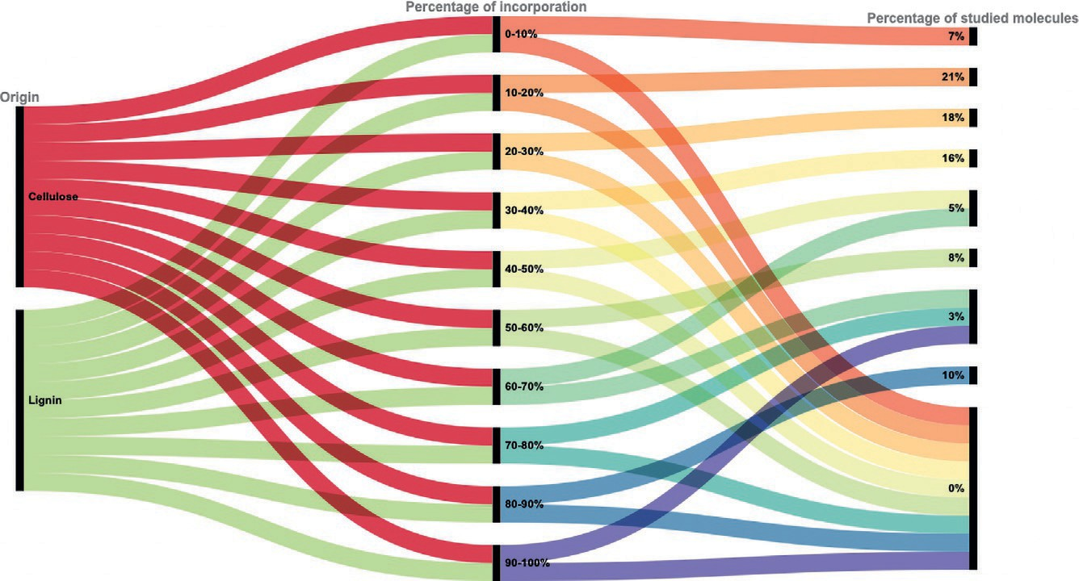
Fig. 44 Alluvial diagram showing the repartition of previously studied compounds between (hemi)cellulosic and lignin origin as well as the percentage of renewable atoms incorporated in the final product. Graph generated on rawgraphs.io.

chemical area is covered by dedicated platforms, a term introduced previ- ously referring to compounds lacking petrobased counterparts. They can therefore be involved in the discovery of new products and applications owing to their unique architecture, becoming a driving force toward the discovery and use of new renewable chemicals.
Last but not least, cellulose (1) and hemicellulose, being the most abun-
dant source of renewable feedstocks, have attracted the bulk of the research attention with very promising results and a bright future ahead (as seen in Fig. 44). Heterocycles rarely containing more than seven atoms in their scaf- fold, and very little room is left for the incorporation of significant propor- tions of renewable feedstocks in their structure. This has been broadly shown
in this document with rare occasions where >4 renewable atoms were incorporated such as for cilazapril (357) or two biobased platforms were integrated in a heterocycle, as for azelastine (224). This is illustrated in Fig. 44 which shows the percentage of renewable atoms incorporated in
the final structure of this chapters studied molecules. Out of the 59 com- pounds whose starting materials are sourced from (hemi)cellulose, only 10 of them are made up of >70% of biobased atoms. These are mostly small molecules whose preparations require few steps whereas the remaining 49 substrates are significantly larger, with more than half of the envisioned
substrates falling in the 10–40% incorporation rate. As opposed to this, the two compounds derived from lignin fall in the category incorporating between 60% and 70% of renewable atoms. Incorporation of more lignin

A perspective on the synthetic potential of biobased building blocks 59
derived substrates into valuable chemicals could therefore result in a larger proportion of renewable atoms. The products of lignin (7) depolymerization still contain reactive moieties under the form of alcohol functions and alkenes, all of which can undergo further modifications to yield the desired product. In addition to these functions, lignin-derived products contain aro- matic rings, something which the (hemi)cellulosic biomass can provide only at the cost of significant and heavy chemical transformations, providing an additional layer of prospective reactions for the upgrading of these substrates.

Conclusion
This perspective has shown that, despite the chemical industry relying on fossil fuels to source its reagents for the past 200 years, scaffolds with bio- based counterparts have already been broadly incorporated in heterocyclic chemicals with practical applications.⁷ These range in applications from pes- ticides to solvents or monomers though most of the compounds discussed vide supra are endowed with pharmaceutical properties. Some of these are of public health interest, being recognized by the World Health Organization as essential medicines while some others have gained a block- buster status by being present in the top 300 most prescribed drugs in the US in 2021.^{55,81} Part of the described substrates have been patented more than 50 years ago, confirming that the main hold up in the use of renewable feed- stocks is not the chemistry behind their incorporation but rather the eco- nomics related to their sourcing.^{70,110,178} In addition to having found their way in meaningful chemicals, biobased substrates can be envisioned to replace initially petrobased chemicals despite having diverging structures while sharing similar reactivities and physical properties. Despite these con- clusions, a lot remains to be done: the surface of what is possible has barely been scratched here and only a handful of renewable substrates presented in Section 2.4 have been integrated into heterocycles, leaving the door wide open for a plethora of new renewable cyclic scaffolds with an equally large range of applications.

Acknowledgment
The authors acknowledge the University of Lie`ge for funding.

References
- Jampilek, J. Heterocycles in medicinal chemistry. Molecules 2019, 24. https://doi.org/ 10.3390/molecules24213839.
- Vitaku, E.; Smith, D. T.; Njardarson, J. T. Analysis of the Structural Diversity, Substitution Patterns, and Frequency Of Nitrogen Heterocycles Among U.S. FDA

60 Loïc Bovy and Jean-Christophe M. Monbaliu

Approved Pharmaceuticals. J. Med. Chem. 2014, 57, 10257–10274. https://doi.org/ 10.1021/jm501100b.
- Ernest, C. Adrien Albert and the rationalization of heterocyclic chemistry. J. Chem. Educ. 1986, 63, 860–863.
- Shaun Murphree, S. Heterocyclic Dyes: Preparation, Properties, and Applications;
2011. https://doi.org/10.1016/S0959-6380(11)22002-6.
- Guin, M.; Roopa, R. A.; Jain, P.; Singh, N. B. Heterocyclic surfactants and their appli- cations in cosmetics. ChemistrySelect 2022, 7. https://doi.org/10.1002/slct.202103989.
- Ghareeb, E. A.; Mahmoud, N. F. H.; El-Bordany, E. A.; El-Helw, E. A. E. Synthesis, DFT, and Eco-Friendly Insecticidal Activity of Some N-Heterocycles Derived From 4-((2-Oxo-1,2-Dihydroquinolin-3-Yl)Methylene)-2-Phenyloxazol-5(4H)-One. Bioorg. Chem. 2021, 112. https://doi.org/10.1016/j.bioorg.2021.104945.
- Rowe, D. J. M. History of the Chemical Industry, 1750 to 1930; 1998. https://edu.rsc. org/download?ac=509455.
- US Energy Information Administration. Biomass—Renewable Energy from Plants and Animals; 2023. https://www.eia.gov/energyexplained/biomass/ (Accessed 21 February 2024).
- Hu€lsey, M. J.; Yang, H.; Yan, N. Sustainable Routes for the Synthesis of Renewable Heteroatom-Containing Chemicals. ACS Sustainable Chem. Eng. 2018, 6, 5694–5707. https://doi.org/10.1021/acssuschemeng.8b00612.
- Te Liao, Y.; Matsagar, B. M.; Wu, K. C. W. Metal-Organic Framework (MOF)- Derived Effective Solid Catalysts for Valorization of Lignocellulosic Biomass. ACS Sustainable Chem. Eng. 2018, 6, 13628–13643. https://doi.org/10.1021/ acssuschemeng.8b03683.
- Kaisler, M.; Van Den Broek, L. A. M.; Boeriu, C. G. Chitin and Chitosan as Sources of Bio-Based Building Blocks and Chemicals. In Chitin and Chitosan: Properties and Applications; Van Den Broek, L. A. M., Boeriu, C. G., Eds, 1st ed.; John Wiley & Sons, 2020; pp. 229–244.
- Boerjan, W.; Ralph, J.; Baucher, M. Lignin Biosynthesis. Annu. Rev. Plant Biol. 2003,
54, 519–546. https://doi.org/10.1146/annurev.arplant.54.031902.134938.
- de Jong, E.; Higson, A.; Walsh, P.; Wellisch, M. Value Added Products from Biorefineries; 2024. https://www.ieabioenergy.com/wp-content/uploads/2013/10/ Task-42-Biobased-Chemicals-value-added-products-from-biorefineries.pdf (Accessed 21 February 2024).
- G'erardy, R.; Debecker, D. P.; Estager, J.; Luis, P.; Monbaliu, J. C. M. Continuous Flow Upgrading of Selected C2-C6 Platform Chemicals Derived From Biomass. Chem. Rev. 2020, 120, 7219–7347. https://doi.org/10.1021/acs.chemrev. 9b00846.
- Huber, G. W.; Iborra, S.; Corma, A. Synthesis of Transportation Fuels From Biomass: Chemistry, Catalysts, and Engineering. Chem. Rev. 2006, 106, 4044–4098. https:// doi.org/10.1021/cr068360d.
- Iffland, K.; Sherwood, J.; Carus, M.; Raschka, A.; Farmer, T.; Clark, J. Definition, Calculation and Comparison of the “Biomass Utilization Efficiency (BUE)” of Various Bio-Based Chemicals. Polym. Fuels 2015,. www.bio-based.eu/nova-papers.
- Dutta, S. Sustainable Synthesis of Drop-In Chemicals from Biomass Via Chemical Catalysis: Scopes, Challenges, and the Way Forward. Energy Fuels 2023, 37, 2648–2666. https://doi.org/10.1021/acs.energyfuels.2c03891.
- Michael, C.; Lara, D.; Angel, P.; Achim, R.; Oliver, A. Bio-Based Drop-In Chemicals; 2017. http://bio-based.eu/nova-.
- Clark, J.; Deswarte, F.; Farmer, T. J.; Mascal, M. Platform Molecules. In Introduction to Chemicals From Biomass; James, C., Deswarte, F., Eds, 2nd ed.; 2015; pp. 89–155. https://doi.org/10.1002/9781118714478.ch4.

A perspective on the synthetic potential of biobased building blocks 61

- Program, B.; Werpy, T.; Petersen, G. Top Value Added Chemicals from Biomass, Vol. I; 2004. http://www.osti.gov/bridge.
- Bozell, J. J.; Petersen, G. R. Technology Development for the Production of Biobased Products From Biorefinery Carbohydrates—The US Department of Energy’s “Top 10” Revisited. Green Chem. 2010, 12, 539–555. https://doi.org/10.1039/b922014c.
- Biddy, M. J.; Scarlata, C.; Kinchin, C. Chemicals From Biomass: A Market Assessment of Bioproducts With Near-Term Potential; 2016. www.nrel.gov/publications.
- Alashek, F.; Keshe, M.; Alhassan, G. Preparation of Glycerol Derivatives by Entered of Glycerol in Different Chemical Organic Reactions: A Review. Results Chem. 2022, 4. https://doi.org/10.1016/j.rechem.2022.100359.
- Valdehuesa, K. N. G.; Liu, H.; Nisola, G. M.; Chung, W. J.; Lee, S. H.; Park, S. J. Recent Advances in the Metabolic Engineering of Microorganisms for the Production of 3-Hydroxypropionic Acid as C3 Platform Chemical. Appl. Microbiol. Biotechnol. 2013, 97, 3309–3321. https://doi.org/10.1007/s00253-013-4802-4.
- Dusselier, M.; Van Wouwe, P.; Dewaele, A.; Makshina, E.; Sels, B. F. Lactic Acid as a Platform Chemical in the Biobased Economy: The Role of Chemocatalysis. Energy Environ. Sci. 2013, 6, 1415–1442. https://doi.org/10.1039/c3ee00069a.
- Lee, S. H.; Park, O. J. Uses and Production of Chiral 3-Hydroxy-γ-Butyrolactones and Structurally Related Chemicals. Appl. Microbiol. Biotechnol. 2009, 84, 817–828. https://doi.org/10.1007/s00253-009-2143-0.
- Teleky, B. E.; Vodnar, D. C. Recent Advances in Biotechnological Itaconic Acid Production, and Application for a Sustainable Approach. Polymers (Basel) 2021, 13. https://doi.org/10.3390/polym13203574.
- Lammens, T. M.; Gangarapu, S.; Franssen, M. C. R.; Scott, E. L.; Sanders, J. P.
M. Techno-Economic Assessment of the Production of Bio-Based Chemicals From Glutamic Acid. Biofuels, Bioprod. Biorefin. 2012, 6, 177–187. https://doi.org/ 10.1002/bbb.349.
- Xu, W. P.; Chen, X. F.; Guo, H. J.; Li, H. L.; Zhang, H. R.; Xiong, L.; De Chen, X. Conversion of Levulinic Acid to Valuable Chemicals: A Review. J. Chem. Technol. Biotechnol. 2021, 96, 3009–3024. https://doi.org/10.1002/jctb.6810.
- Xia, Q.; Jin, X.; Zhang, G.; Liu, M.; Wang, J.; Li, Y.; Fang, T.; Ding, J.; Zhang, D.; Meng, K.; Chen, X.; Yang, C. Catalytic Deoxygenation of Xylitol to Renewable Chemicals: Advances on Catalyst Design and Mechanistic Studies. Chem. Rec. 2021, 21, 133–148. https://doi.org/10.1002/tcr.202000101.
- Greve, H. Rubber, 2 Natural. In Ullmann’s Encyclopedia of Industrial Chemistry; Wiley,
2000; pp. 583–596. https://doi.org/10.1002/14356007.a23_225.
- Bielski, R.; Grynkiewicz, G. Furan Platform Chemicals Beyond Fuels and Plastics.
Green Chem. 2021, 23, 7458–7487. https://doi.org/10.1039/d1gc02402g.
- Shahbudin, M. I.; Jacob, D. M.; Ameen, M.; Aqsha, A.; Azizan, M. T.; Yusoff, M. H. M.; Sher, F. Liquid Value-Added Chemicals Production From Aqueous Phase Reforming of Sorbitol and Glycerol Over Sonosynthesized Ni-Based Catalyst. J. Environ. Chem. Eng. 2021, 9. https://doi.org/10.1016/j.jece.2021.105766.
- Xiao, Y.; Meng, Q.; Pan, X.; Zhang, C.; Fu, Z.; Li, C. Selective Production of Bio- Based: Para-Xylene Over an FeOx-Modified Pd/Al₂O₃ Catalyst. Green Chem. 2020, 22, 4341–4349. https://doi.org/10.1039/d0gc00944j.
- Zhao, R.; Xu, L.; Huang, S.; Zhang, W. Highly Selective Production of Renewable: p-Xylene From Bio-Based 2, 5-Dimethylfuran and Ethylene Over Al-Modified H-Beta Zeolites. Catal. Sci. Technol. 2019, 9, 5676–5685. https://doi.org/10.1039/ c9cy01113g.
- Borak, J.; Diller, W. F. Phosgene Exposure: Mechanisms of Injury and Treatment Strategies. J. Occup. Environ. Med. 2001, 43, 110–119. https://doi.org/10.1097/ 00043764-200102000-00008.

62 Loïc Bovy and Jean-Christophe M. Monbaliu

- Heiner, E.; Barbaba, F. Triphosgene, a Crystalline Phosgene Substitute. Am. Ethnol.
1987, 9, 894–895. https://doi.org/10.1002/anie.198708941.
- Schneider, W.; Diller, W. Phosgene. In Ullmann’s Encyclopedia of Industrial Chemistry; 26; Wiley, 2000; pp. 623–632. https://doi.org/10.1002/14356007.a19_411.
- Bigi, F.; Maggi, R.; Sartori, G. Selected Syntheses of Ureas Through Phosgene Substitutes. Green Chem. 2000, 2, 140–148. https://doi.org/10.1039/b002127j.
- Li, Q.; Zhang, W.; Zhao, N.; Wei, W.; Sun, Y. Synthesis of Cyclic Carbonates From Urea and Diols Over Metal Oxides. Catal. Today 2006, 115, 111–116. https://doi. org/10.1016/j.cattod.2006.02.033.
- Lukato, S.; Kasozi, G. N.; Naziriwo, B.; Tebandeke, E. Glycerol Carbonylation With CO₂ to Form Glycerol Carbonate: A Review of Recent Developments and Challenges. Curr. Res. Green Sustainable Chem. 2021, 4, 100199. https://doi.org/10. 1016/j.crgsc.2021.100199.
- Buysch, H. Carbonic Esters. In Ullmann’s Encyclopedia of Industrial Chemistry; Wiley, 2000. https://doi.org/10.1002/14356007.a05_197.
- Morodo, R.; G'erardy, R.; Petit, G.; Monbaliu, J.-C. M. Continuous Flow Upgrading of Glycerol Toward Oxiranes and Active Pharmaceutical Ingredients Thereof. Green Chem. 2019, 21, 4422–4433. https://doi.org/10.1039/C9GC01819K.
- Li, M.; Abdolmohammadi, S.; Hoseininezhad-Namin, M. S.; Behmagham, F.; Vessally, E. Carboxylative Cyclization of Propargylic Alcohols With Carbon Dioxide: A Facile and Green Route to α-Methylene Cyclic Carbonates. J. CO₂ Util. 2020, 38, 220–231. https://doi.org/10.1016/j.jcou.2020.01.024.
- Sonnati, M. O.; Amigoni, S.; Taffin de Givenchy, E. P.; Darmanin, T.; Choulet, O.; Guittard, F. Glycerol Carbonate as a Versatile Building Block for Tomorrow: Synthesis, Reactivity, Properties and Applications. Green Chem. 2013, 15, 283–306. https://doi.org/10.1039/C2GC36525A.
- Pfoertner, K.-H. Photochemistry. In Ullmann’s Encyclopedia of Industrial Chemistry;
Wiley-VCH Verlag GmbH & Co. KGaA: Weinheim, Germany, 2000. https://doi. org/10.1002/14356007.a19_573.
- Razzaq, T.; Kappe, C. O. Continuous Flow Organic Synthesis Under High- Temperature/Pressure Conditions. Chem. - Asian J. 2010, 5, 1274–1289. https:// doi.org/10.1002/asia.201000010.
- Plutschack, M. B.; Pieber, B.; Gilmore, K.; Seeberger, P. H. The Hitchhiker’s Guide to Flow Chemistry. Chem. Rev. 2017, 117, 11796–11893. https://doi.org/10.1021/ acs.chemrev.7b00183.
- G'erardy, R.; Estager, J.; Luis, P.; Debecker, D. P.; Monbaliu, J.-C. M. Versatile and Scalable Synthesis of Cyclic Organic Carbonates Under Organocatalytic Continuous Flow Conditions. Catal. Sci. Technol. 2019, 9, 6841–6851. https://doi.org/10.1039/ C9CY01659G.
- Muzyka, C.; Renson, S.; Grignard, B.; Detrembleur, C.; Monbaliu, J. M. Intensified Continuous Flow Process for the Scalable Production of Bio-Based Glycerol Carbonate. Angew. Chem., Int. Ed. 2024,. https://doi.org/10.1002/anie. 202319060.
- Hoenigl, M.; Sprute, R.; Egger, M.; Arastehfar, A.; Cornely, O. A.; Krause, R.; Lass- Flo€rl, C.; Prattes, J.; Spec, A.; Thompson, G. R.; Wiederhold, N.; Jenks, J. D. The Antifungal Pipeline: Fosmanogepix, Ibrexafungerp, Olorofim, Opelconazole, and Rezafungin. Drugs 2021, 81, 1703–1729. https://doi.org/10.1007/s40265-021- 01611-0.
- Baginski, M.; Czub, J. Amphotericin B and Its New Derivatives—Mode of Action.
Curr. Drug Metab. 2009, 10, 459–469. https://doi.org/10.2174/138920009788898019.
- Heeres, J.; Backx, L. J. J. 1-(1,3-Dioxolan-2Ylmethyl)1H-12,4-Triazoles and Compositions; Patent HU177458B, 1980.

A perspective on the synthetic potential of biobased building blocks 63

- Heeres, J.; Hendrickx, R.; Van Cutsem, J. Antimycotic Azoles. 6. Synthesis and Antifungal Properties of Terconazole, a Novel Triazole Ketal. J. Med. Chem. 1983, 26, 611–613. https://doi.org/10.1021/jm00358a032.
- World Health Organization. Model List of Essential Medicines, Model List of Essential Medicines; 2023. https://list.essentialmeds.org (Accessed 21 February 2024).
- US Food and Drug Administration. FDA-Approved Drugs; 2022. https://www. accessdata.fda.gov/scripts/cder/daf/index.cfm?event=overview.process&ApplNo=
020083 (accessed February 21, 2024).
- Harvey, R.; Champe, P. Pharmacology, 4th ed.; Lippincott Williams and Wilkins, 2009.
- Tolman, E. L.; Isaacson, D. M.; Rosenthale, M. E.; McGuire, J. L.; Van Cutsem, J.; Borgers, M.; Van den Bossche, H. Anticandidal Activities of Terconazole, a Broad- Spectrum Antimycotic. Antimicrob. Agents Chemother. 1986, 29, 986–991. https:// doi.org/10.1128/AAC.29.6.986.
- Tang, N. Topical Itraconazole in the Treatment of Basal Cell Carcinoma; 2020. https:// clinicaltrials.gov/study/NCT02120677?term=itraconazole&cond=basal%20cell%20 carcinoma%20cancer&rank=3#publications (Accessed 22 February 2024).
- Carducci, M. A Two-Dose Level Clinical Trial of Itraconazole in Patients With Metastatic Prostate Cancer Who Have Had Disease Progression While on Hormonal Therapy; 2017. https://clinicaltrials.gov/study/NCT00887458?term=itraconazole&cond=prostate% 20cancer&rank=1#publications (Accessed 22 February 2024).
- Pelosof, L. Neoadjuvant Itraconazole in Non-Small Cell Lung Cancer; 2021. https:// clinicaltrials.gov/study/NCT02357836#study-record-dates (Accessed 22 February 2024).
- Martos, P.; Shurmer, B. Sample Preparation Techniques for the Determination of Veterinary Drugs in Food Matrices. In Comprehensive Sampling and Sample Preparation; Elsevier, 2012; pp. 405–414. https://doi.org/10.1016/B978-0-12-381373-2.00141-1.
- Landquist, J. K. Application as Pharmaceuticals. In Comprehensive Heterocyclic Chemistry; Elsevier, 1984; pp. 143–183. https://doi.org/10.1016/B978-008096519- 2.00006-0.
- Gruneberg, R. N.; Leakey, A. Treatment of Candidal Urinary Tract Infection With Nifuratel. BMJ 1976, 2, 908–910. https://doi.org/10.1136/bmj.2.6041.908.
- Smeets, A. A Process for the Preparation of a Morpholine Derivative; Patent GB1093345A,
1965.
- GB969126A. Substituted Oxazolidinones; 1964.
- Shu, J.; He, L.; Ding, H.; Wang, L.; Guo, H.; Gao, Y.; Dzakah, E. E.; Zeng, Z. Synthesis of Furaltadone Metabolite, 3-Amino-5-Morpholinomethyl-2-Oxazolidone (AMOZ) and Novel Haptens for the Development of a Sensitive Enzyme-Linked Immunosorbent Assay (ELISA). Anal. Methods 2014, 6, 2306. https://doi.org/10. 1039/c3ay41145a.
- Speight, J. G. Gas Cleaning Processes. In Natural Gas; Elsevier, 2019; pp. 277–324. https://doi.org/10.1016/B978-0-12-809570-6.00008-4.
- Douglas Walter, J. Sulpholanes and their Manufacture and Purification; GB1051089A, 1965.
- Loev, B.; Massengale, J. Synthesis of Tetrahydrothiophene; US2899444A, 1957.
- Seitz, A.; Kohlpaintner, P. J.; van Lingen, T.; Dyga, M.; Sprang, F.; Zirbes, M.; Waldvogel, S. R.; Gooßen, L. J. Concentrated Aqueous Peroxodicarbonate: Efficient Electrosynthesis and Use as Oxidizer in Epoxidations, S -, and N-Oxidations. Angew. Chem., Int. Ed. 2022, 61. https://doi.org/10.1002/anie. 202117563.
- Verma, D. K.; Dewangan, Y.; Verma, C. Reactions of Heterocyclic Compounds. In Handbook of Organic Name Reactions; Elsevier, 2023; pp. 269–298. https://doi.org/10. 1016/B978-0-323-95948-3.00004-0.

64 Loïc Bovy and Jean-Christophe M. Monbaliu

- American Society of Health-System Pharmacists. Ritonavir (Monograph); 2024. https:// www.drugs.com/monograph/ritonavir.html (Accessed 23 February 2024).
- Kempf, D.; Norbeck, D.; Sham, H. L.; Chen, Z. Retroviral Protease Inhibiting Compounds; US5541206A, 1995.
- Zeldin, R. K. Pharmacological and Therapeutic Properties of Ritonavir-Boosted Protease Inhibitor Therapy in HIV-Infected Patients. J. Antimicrob. Chemother. 2003, 53, 4–9. https://doi.org/10.1093/jac/dkh029.

- Buxeraud, J.; Faure, S.; Fougere,
E'. Le nirmatrelvir-ritonavir (Paxlovid®), un

traitement contre la Covid-19. Actual. Pharm. 2022, 61, 10–12. https://doi.org/10. 1016/j.actpha.2022.05.002.
- Menon, R. M.; Badri, P. S.; Wang, T.; Polepally, A. R.; Zha, J.; Khatri, A.; Wang, H.; Hu, B.; Coakley, E. P.; Podsadecki, T. J.; Awni, W. M.; Dutta, S. Drug-Drug Interaction Profile of the All-Oral Anti-Hepatitis C Virus Regimen of Paritaprevir/ Ritonavir, Ombitasvir, and Dasabuvir. J. Hepatol. 2015, 63, 20–29. https://doi.org/ 10.1016/j.jhep.2015.01.026.
- World Health Organization. Diabetes; 2021. https://www.who.int/health-topics/ diabetes#tab=tab_1 (accessed February 23, 2024).
- International Diabetes Federation, Facts & Figures., 2021. https://idf.org/about- diabetes/diabetes-facts-figures/ (Accessed 23 February 2024).
- Meguro, K. D'eriv'es de la thiazolidinedione, leur pr'eparation et leur utilisation; EP0155845A1, 1985.
- ClinCalc. The Top 300 Drugs of 2021; 2023. https://clincalc.com/DrugStats/ Top300Drugs.aspx (Accessed 23 February 2024).
- European Medicines Agency. European Medicines Agency Clarifies Opinion on Pioglitazone and the Risk of Bladder Cancer; 2011. https://www.ema.europa.eu/en/news/european- medicines-agency-clarifies-opinion-pioglitazone-and-risk-bladder-cancer (Accessed 23 February 2024).
- Harreus, A. L. Pyrrole. In Ullmann’s Encyclopedia of Industrial Chemistry; Wiley, 2000. https://doi.org/10.1002/14356007.a22_453.
- Leonardi, M.; Est'evez, V.; Villacampa, M.; Men'endez, J. The Hantzsch Pyrrole Synthesis: Non-Conventional Variations and Applications of a Neglected Classical Reaction. Synthesis (Stuttg) 2019, 51, 816–828. https://doi.org/10.1055/s-0037- 1610320.
- Bellingham, R. K.; Carey, J. S.; Hussain, N.; Morgan, D. O.; Oxley, P.; Powling, L. C. A Practical Synthesis of a Potent δ-Opioid Antagonist: Use of a Modified Knorr Pyrrole Synthesis. Org. Process Res. Dev. 2004, 8, 279–282. https:// doi.org/10.1021/op034198u.
- Khaghaninejad, S.; Heravi, M. M. Paal–Knorr Reaction in the Synthesis of Heterocyclic Compounds; Elsevier, 2014; pp. 95–146. https://doi.org/10.1016/B978-0-12- 420160-6.00003-3.
- Cuccu, F.; De Luca, L.; Delogu, F.; Colacino, E.; Solin, N.; Mocci, R.; Porcheddu, A. Mechanochemistry: New Tools to Navigate the Uncharted Territory of “Impossible” Reactions. ChemSusChem 2022, 15. https://doi.org/10. 1002/cssc.202200362.
- Auvray, T.; Friˇs~ci'c, T. Shaking Things From the Ground-Up: A Systematic Overview of the Mechanochemistry of Hard and High-Melting Inorganic Materials. Molecules 2023, 28, 897. https://doi.org/10.3390/molecules28020897.
- Xu, C.; De, S.; Balu, A. M.; Ojeda, M.; Luque, R. Mechanochemical Synthesis of Advanced Nanomaterials for Catalytic Applications. Chem. Commun. 2015, 51, 6698–6713. https://doi.org/10.1039/C4CC09876E.
- Schumacher, C.; Molitor, C.; Smid, S.; Truong, K.-N.; Rissanen, K.; Bolm, C. Mechanochemical Syntheses of N-Containing Heterocycles With TosMIC. J. Org. Chem. 2021, 86, 14213–14222. https://doi.org/10.1021/acs.joc.1c01529.

A perspective on the synthetic potential of biobased building blocks 65

- DailyMed. Eprosartan Mesylate; 2014. https://dailymed.nlm.nih.gov/dailymed/ archives/fdaDrugInfo.cfm?archiveid=475394 (Accessed 23 February 2024).
- Finkelstein, J.; Keenan, R.; Weinstock, J. Imidazolyl-Alkenoic Acids Useful as Angiotensin II Receptor Antagonists; US5185351A, 1991.
- Fung, M.; Thornton, A.; Mybeck, K.; Wu, J. H.-H.; Hornbuckle, K.; Muniz, E. Evaluation of the Characteristics of Safety Withdrawal of Prescription Drugs From Worldwide Pharmaceutical Markets—1960 to 1999. Drug Inf. J. 2001, 35, 293–317. https://doi.org/10.1177/009286150103500134.
- Underwood, M. Diagnosis and Management of Gout. BMJ 2006, 332, 1315–1319.
https://doi.org/10.1136/bmj.332.7553.1315.
- Preparation of 4-n-Butyl-2-Phenyl-Pyrazolidine-3:5-Dione and 1-Alkyl Substituents Thereof; 1957.
- Denss, R.; H€afliger, F.; Goodwin, S. U€ ber Derivate des Phenylbutazons. II. Derivate mit einer Hydroxylgruppe in der 4-st€andigen Seitenkette. Helv. Chim. Acta 1957, 40, 402–407. https://doi.org/10.1002/hlca.19570400219.
- H€afliger, F. Substituted 1.2-Diphenyl-3.5-Dioxo-Pyrazolidines; US2745783, 1954.
- World Health Organisation. Trypanosomiasis, Human African (Sleeping Sickness); 2023. https://www.who.int/news-room/fact-sheets/detail/trypanosomiasis-human-african- (sleeping-sickness (Accessed 23 February 2024).
- Lutje, V.; Seixas, J.; Kennedy, A. Chemotherapy for Second-Stage Human African Trypanosomiasis. Cochrane Database Syst. Rev. 2013. https://doi.org/10.1002/ 14651858.CD006201.pub3.
- Gibaud, S.; Jaouen, G. Arsenic-Based Drugs: From Fowler’s Solution to Modern Anticancer Chemotherapy; Springer, Berlin, Heidelberg, 2010; pp. 1–20. https://doi.org/10.1007/ 978-3-642-13185-1_1.
- Peppel, W.; Signaigo, F. Chemical Processes; US2402665, 1942.
- Findling, R. L.; Candler, S. A.; Nasser, A. F.; Schwabe, S.; Yu, C.; Garcia-Olivares, J.; O’Neal, W.; Newcorn, J. H. Viloxazine in the Management of CNS Disorders: A Historical Overview and Current Status. CNS Drugs 2021, 35, 643–653. https:// doi.org/10.1007/s40263-021-00825-w.
- Wermuth, C. G. Analogues as a Means of Discovering New Drugs. In Analogue-Based Drug Discovery; Wiley, 2006; pp. 1–23. https://doi.org/10.1002/3527608001.ch1.
- Mallion, K. B.; Turner, R. W.; Todd, A. H. Morpholine Derivatives; GB1138405, 1967.
- Lee, S. A. For Cyclising 1-Aryloxy-3 Beta-Substituted Ethylamino-2-Propanols; US3857839A, 1972.
- Herlinger, H.; Mayer, K.-H.; Petersen, S.; Bock, M. Verfahren Zur Herstellung von 5-Nitro-Furfuryliden-(2)-Iminoderivaten; DE1170957, 1962.
- Collins English Dictionary. Definition of “Antispasmodic”; 2024. https://www. collinsdictionary.com/dictionary/english/antispasmodic#: :text=An%20antispasmodic
~
%20is%20any%20drug,spasms%2C%20especially%20of%20smooth%20muscle (Accessed 23 February 2024).
- National Center for Advancing Translational Sciences. Piperidolate; 2024. https:// drugs.ncats.io/drug/RJO31255V9 (Accessed 23 February 2024).
- McCorry, L. K. Physiology of the Autonomic Nervous System. Am. J. Pharm. Educ.
2007, 71, 78. https://doi.org/10.5688/aj710478.
- Biel, J. Anti-Spasmodics Specific for Upper Gastrointestinal Pain and Spasm; US2918407, 1957.
- Torok, E.; Moran, E.; Cooke, F. Oxford Handbook of Infectious Diseases and Microbiology; Oxford University Press, 2009.
- Domagk, G. Ein Beitrag zur Chemotherapie der bakteriellen Infektionen. Deutsch. Med. Wochenschr. 1935, 61, 250–253. https://doi.org/10.1055/s-0028-1129486.
- Bretschneider, H.; Klotzer, W.; Schlantl, J. Process for the Preparation of Sulfonamides of the Pyrimidine Type; US3132139, 1962.

66 Loïc Bovy and Jean-Christophe M. Monbaliu

- Bell-Tyrer, J. J.; Hume, P. A.; Grant, P. S.; Brimble, M. A.; Furkert, D. P. Azide–Enolate Cycloaddition-Rearrangement Enables Direct α-Amination of Amides and Enelactam Synthesis From Esters. Chem. - Eur. J. 2023, 29. https://doi. org/10.1002/chem.202300261.
- Fleming, A. On the Antibacterial Action of Cultures of a Penicillium, With Special Reference to Their Use in the Isolation of B. influenzae. Clin. Infect. Dis. 1980, 2, 129–139. https://doi.org/10.1093/clinids/2.1.129.
- Iwanami, M.; Maeda, T.; Nagano, Y.; Fujimoto, M.; Nagano, N.; Yamazaki, A. 7 Alpha Methoxy-7 Beta-(1,3-Dithietane-2-Carboxamido)Cephalosporanic Acid Derivatives; US4263432, 1978.
- National Institute of Allergy and Infectious Diseases. Immunotherapy for Environmental Allergies; 2015. https://web.archive.org/web/20150617190743/http:// www.niaid.nih.gov/topics/environmental-allergies/Pages/immunotherapy.aspx (Accessed 23 February 2024).
- ConsumerReports. Using Antihistaminics to Treat: Allergies, Hay Fever & Hives; 2017. https://web.archive.org/web/20170517030305/http://consumerhealthchoices.org/wp- content/uploads/2012/02/BBD-Antihistamines-Full.pdf (Accessed 23 February 2024).
- Nelson, M. Drug Treatment of Elevated Blood Pressure. Aust Prescr 2010, 33, 108–112. https://doi.org/10.18773/austprescr.2010.055.
- Oizumi, K.; Nishino, H.; Koike, H.; Sada, T.; Miyamoto, M.; Kimura, T. Antihypertensive Effects of CS-905, a Novel Dihydropyridine Ca++ Channel Blocker. Jpn. J. Pharmacol. 1989, 51, 57–64. https://doi.org/10.1016/S0021-5198 (19)40137-6.
- Koike, H.; Nishino, H.; Yoshimoto, M. Dihydropyridine Derivatives, their Preparation and their Use; US4772596, 1987.
- Caiti, M.; Tarantino, G.; Hammond, C. Developing a Continuous Process for Isosorbide Production From Renewable Sources. ChemCatChem 2020, 12, 6393–6400. https://doi.org/10.1002/cctc.202001278.
- Yuan, D.; Xiao, F.; Zhao, N.; Deng, C.; Huang, X.; Zhang, H.; Yang, Q.; Qiao, Y. Mesoporous Poly(Ionic Liquid) Solid Acid for Sequential Dehydration of Sorbitol to Isosorbide. Chem. Eng. J. 2023, 460, 141780. https://doi.org/10.1016/j. cej.2023.141780.
- Jaˇsek, V.; Fu~c´ık, J.; Krhut, J.; Mravcova, L.; Figalla, S.; P~rikryl, R. A Study of Isosorbide Synthesis From Sorbitol for Material Applications Using Isosorbide Dimethacrylate for Enhancement of Bio-Based Resins. Polymers (Basel) 2023, 15, 3640. https://doi.org/10.3390/polym15173640.
- Breffa, C.; Beckedahln, B.; Dierker, M.; Behler, A.; Alexandre, T.; Lo€h, T.; Nieendick, C.; Both, S.; Weuthen, M. Isosorbide Monoesters And Their Use In Household Applications; US20120035090, 2010.
- Russo, F.; Galiano, F.; Pedace, F.; Arico`, F.; Figoli, A. Dimethyl Isosorbide as a Green Solvent for Sustainable Ultrafiltration and Microfiltration Membrane Preparation. ACS Sustainable Chem. Eng. 2020, 8, 659–668. https://doi.org/10. 1021/acssuschemeng.9b06496.
- East, A.; Jaffe, M.; Hammond, W.; Collins, G.; DeMartino, R.; Ophir, Z.
Polyoxazolidones Derived from Bisanhydrohexitols; US20100298520A1, 2009.
- Rose, M.; Palkovits, R. Isosorbide as a Renewable Platform Chemical for Versatile Applications—Quo Vadis? ChemSusChem 2012, 5, 167–176. https://doi.org/10. 1002/cssc.201100580.
- Hu, C.; Bourbigot, S.; Delaunay, T.; Collinet, M.; Marcille, S.; Fontaine, G. Synthesis of Isosorbide Based Flame Retardants: Application for Polybutylene Succinate. Polym. Degrad. Stab. 2019, 164, 9–17. https://doi.org/10.1016/j.polymdegradstab. 2019.03.016.

A perspective on the synthetic potential of biobased building blocks 67

- McEvoy, G. AHFS Drug Information, 46th ed.; American Society of Health-System Pharmacists, 2004.
- Cornell Cooperative Extension. Endothall FAQ; 2012. https://ccetompkins.org/ environment/aquatic-invasives/hydrilla/management-options/herbicides/endothall/ endothall-faq (Accessed 23 February 2024).
- Chen, G.; Gao, J.; Huang, W.; Li, Z.; Zhao, Y. Synthesis and Bioactivity Evaluation of 5,6-Epoxynorcantharidin Mono-Amide and Imide Derivatives. Monatsh. Chem. Chem. Monthly 2022, 153, 359–367. https://doi.org/10.1007/s00706-022-02905-z.
- Gesing, E. R.; Erdelen, C.; H€anssler, G.; Kuck, K.-H.; Lo€sel, P.; Andersch, W.; Xu, Y.-M.; Chen, L.; Tang, Q.; Cao, J. Utilisation de d'eriv'es Oxabicyclo[2.2.1] Heptane en Tant qu’agents Antiparasitaires; WO2002042310, 2001.
- Buer, J. K. Origins and Impact of the Term ‘NSAID’. Inflammopharmacology 2014, 22, 263–267. https://doi.org/10.1007/s10787-014-0211-2.
- Hart, F. D.; Boardman, P. L. Indomethacin: A New Non-Steroid Anti-Inflammatory Agent. BMJ 1963, 2, 965–970. https://doi.org/10.1136/bmj.2.5363.965.
- Shen, T.-Y. Alpha-(1-Aroyl-3-Indolyl) Alkanoic Acids; US3161654, 1963.
- Schneider, Y.; Jadhav, A. P.; Legault, C. Y. Synthesis of Indoles Using the Electrophilic Potential of Diazirines. J. Org. Chem. 2023, 88, 14809–14819. https://doi.org/10.1021/ acs.joc.3c01673.
- Daviet, L.; Huang, Y.; Harraca, V.; Michel, S.; Bandera, M. Huile de Bois de Santal Produite Par Voie Biochimique; WO2021130241A, 2020.
- Boltze, K.-H.; Brendler, O.; Dell, H.-D.; Jacobi, H. Novel Substituted Indole Compound, Process for the Preparation and Therapeutic Compositions Containing it; US3910952, 1973.
- Yamatsu, I.; Shinya, A.; Inai, Y.; Suzuki, T.; Kinoshita, K.; Mishima, M.; Katoh, Y.; Kobayashi, S.; Murakami, M.; Yamada, K. Polyprenyl Esters of Acemethacins and Anti-Inflammatory Method of Use Thereof; US4455316, 1982.
- Makovec, F.; Chiste`, R.; Rovati, C. L.; Rovati, A. L. Dervies Pharmaceutiquement Actifs d’acides Glutamiques et Aspartiques; WO1987003869A2, 1986.
- Makovec, F.; Senin, P.; Rovati, L. Anti-Inflammatory and Antirheumatic Compounds and Preparation; US3985878, 1975.
- Grande, I.; Berk, M.; Birmaher, B.; Vieta, E. Bipolar Disorder. Lancet 2016, 387, 1561–1572. https://doi.org/10.1016/S0140-6736(15)00241-X.
- Lally, J.; MacCabe, J. H. Antipsychotic Medication in Schizophrenia: A Review. Br. Med. Bull. 2015, 114, 169–179. https://doi.org/10.1093/bmb/ldv017.
- Urban, F. Processes and Intermediates for the Preparation of 5-[2-(4-(Benzoisothiazol-3-Yl)- Piperazin-1-Yl)Ethyl]-6-Chloro-1,3-Dihydro-Indol-2-One; US5359068, 1993.
- Norris, S.; Mandell, G. L. The Quinolones: History and Overview. In The Quinolones;
Elsevier, 1988; pp. 1–22. https://doi.org/10.1016/B978-0-12-059515-0.50005-6.
- Hooper, D. Emerging Mechanisms of Fluoroquinolone Resistance. Emerg. Infect. Dis.
2001, 7, 337–341. https://doi.org/10.3201/eid0702.010239.
- H. Isao, A. Shogo, Y. Shuichi, I. Masazumi, S. Katsuichi, H. Nobuyuki, O. Masayuki, D'eriv'es de la Pyridobenzoxazine Optiquement Actifs, EP0206283A2, n.d.
- Poole Arcangelo, V.; Peterson, A. Pharmacotherapeutics for Advanced Practice: A Practical Approach; Lippincott WIlliams & Wilkins, 2006.
- Um, S.; Nishida, O.; Tokubayashi, M.; Kimura, F.; Kita, T. Nipradilol, a New β-Blocker With Vasodilatory Properties, in Experimental Portal Hypertension: A Comparative Haemodynamic Study With Propranolol. J. Gastroenterol. Hepatol. 1993, 8, 414–419. https://doi.org/10.1111/j.1440-1746.1993.tb01540.x.
- Inoue, K.; Kei Noguchi, M.; Masumoto, M. W. Effect of Five Years of Treatment with Nipradilol Eye Drops in Patients with Normal Tension Glaucoma. Clin. Ophthalmol. 2011, 1211. https://doi.org/10.2147/OPTH.S23233.

68 Loïc Bovy and Jean-Christophe M. Monbaliu

- Masami, S.; Noboru, S.; Hiromichi, S.; Yoshinory, K.; Hisashi, K.; Kiyoshi, K.; Seiichi, S.; Toshihiro, A.; Masahiko, N.; Naotoshi, S.; Yasumi, U. Dihydrobenzopyran Compounds and Pharmaceutical Composition Comprising Said Compounds; US4394382, 1981.
- Chia, E. W.; Pearce, A. N.; Berridge, M. V.; Larsen, L.; Perry, N. B.; Sansom, C. E.; Godfrey, C. A.; Hanton, L. R.; (Leon) Lu, G.-L.; Walton, M.; Denny, W. A.; Webb, V. L.; Copp, B. R.; Harper, J. L. Synthesis and Anti-Inflammatory Structure– Activity Relationships of Thiazine–Quinoline–Quinones: Inhibitors of the Neutrophil Respiratory Burst in a Model of Acute Gouty Arthritis. Bioorg. Med. Chem. 2008, 16, 9432–9442. https://doi.org/10.1016/j.bmc.2008.09.052.
- Ogurok, V. M.; Siry, S. A.; Rusanov, E. B.; Vlasenko, Y. G.; Shermolovich, Y. G. Synthesis of the Symmetrical 3,5-bis(difluoromethyl)-1,4-Thiazine 1,1-Dioxides. J. Fluorine Chem. 2016, 182, 47–52. https://doi.org/10.1016/j.jfluchem.2015.12.004.
- Brown, C.; Davidson, R. Advances in Heterocyclic Chemistry; Academic Press: London,
1985.
- Bhutia, Z. T.; Das, A.; Biswas, M.; Chatterjee, A.; Banerjee, M. 7-Oxa-4-thia- 1-Aza-Bicyclo[3.2.1]Octane 4,4-Dioxides: Mechanochemical Synthesis by Tandem Michael Addition—1,3-Dipolar Cycloaddition of Aldoximes and Evaluation of Antibacterial Activities. Eur. J. Org. Chem. 2018, 2018, 506–514. https://doi.org/ 10.1002/ejoc.201701511.
- Beyer, K. H.; Chlorothiazide. How the Thiazides Evolved as Antihypertensive Therapy. Hypertension 1993, 22, 388–391. https://doi.org/10.1161/01.HYP.22.3.388.
- Prajapati, S. M.; Patel, K. D.; Vekariya, R. H.; Panchal, S. N.; Patel, H. D. Recent Advances in the Synthesis of Quinolines: A Review. RSC Adv. 2014, 4, 24463–24476. https://doi.org/10.1039/C4RA01814A.
- Collin, G.; Ho€ke, H. Quinoline and Isoquinoline. In Ullmann’s Encyclopedia of Industrial Chemistry; Wiley, 2000. https://doi.org/10.1002/14356007.a22_465.
- GB688802. Manufacture of Phenanthroline-Quinounes and Derivatives Thereof; 1951.
- Uclaf, R. Phenylamino-Trifluoromethylquinolines and Pharmaceutical Compositions Containing Them; GB1221600A, 1968.
- Kleinknecht, D.; Landais, P.; Goldfarb, B. Analgesic and Non-Steroidal Anti- Inflammatory Drug-Associated Acute Renal Failure: A Prospective Collaborative Study. Clin. Nephrol. 1986, 25, 275–281.
- Berry, R. J.; Bailey, L.; Mulinare, J.; Bower, C.; Dary, O. Fortification of Flour With Folic Acid. Food. Nutr. Bull. 2010, 31, S22–S35. https://doi.org/10.1177/ 15648265100311S103.
- Lanska, D. J. Chapter 30 Historical Aspects of the Major Neurological Vitamin Deficiency Disorders: The Water-Soluble B Vitamins. Handb. Clin. Neurol. 2009, 445–476. https://doi.org/10.1016/S0072-9752(08)02130-1.
- Cronstein, B.; Bertino, J. Methotrexate; Springer Science & Business Media, 2000.
- Ellard, J. Synthesis of Methotrexate; US4080325, 1976.
- Vidal. Substance Active Cart'eolol; 2013. https://www.vidal.fr/medicaments/substances/ carteolol-6529.html (Accessed 26 February 2024).
- Shono, T.; Matsumura, Y.; Kashimura, S. New Practical Synthesis of 5-Hydroxy- 3,4-Dihydrocarbostyril and 5-Hydroxycarbostyril. J. Org. Chem. 1981, 46, 3719. https://doi.org/10.1021/jo00331a027.
- Yasumitsu, T.; Kazuyuki, N.; Shiro, Y.; Nanami, M. 3,4-Dihydrocarbostyril Derivatives and a Process for Preparing the Same; US3910924, 1973.
- Ludwig, P. E.; Reddy, V.; Varacallo, M. Neuroanatomy. In Neurons; StatPearls
Publishing: Treasure Island, FL, 2024.
- Iversen, L. Neurotransmitter Transporters: Fruitful Targets for CNS Drug Discovery.
Mol. Psychiatry 2000, 5, 357–362. https://doi.org/10.1038/sj.mp.4000728.

A perspective on the synthetic potential of biobased building blocks 69

- Holenz, J.; D´ıaz, J. L.; Buschmann, H. Chemistry. In Antidepressants, Antipsychotics, Anxiolytics; Wiley, 2007; pp. 173–296. https://doi.org/10.1002/9783527619337.ch5.
- van der Burg, W. J. Tetracyclic Piperidino Derivatives; US4002632, 1975.
- H. Kato, E. Koshinaka, Anti-Spasmodic Substituted Quinolizidine and Indolizidine Compounds, US4205074A, n.d. 1079.
- Sun, Z.; Bottari, G.; Afanasenko, A.; Stuart, M. C. A.; Deuss, P. J.; Fridrich, B.; Barta, K. Complete Lignocellulose Conversion With Integrated Catalyst Recycling Yielding Valuable Aromatics and Fuels. Nat. Catal. 2018, 1, 82–92. https://doi. org/10.1038/s41929-017-0007-z.
- Elangovan, S.; Afanasenko, A.; Haupenthal, J.; Sun, Z.; Liu, Y.; Hirsch, A. K. H.; Barta, K. From Wood to Tetrahydro-2-Benzazepines in Three Waste-Free Steps: Modular Synthesis of Biologically Active Lignin-Derived Scaffolds. ACS Cent. Sci. 2019, 5, 1707–1716. https://doi.org/10.1021/acscentsci.9b00781.
- Attwood, M.; Hassall, C.; Lambert, R.; et al. Pyridazo[1,2-a][1,2]Diazepines;
US4512924, 1983.
- H€aflinger, F. Derivatives of 3.5-Dioxo-Pyrazolidine; US2700671, 1952.

