Research progress of chilled meat freshness detection based on nanozyme sensing systems
Guangchun Song^{1,2}, Cheng Li¹, Marie-Laure Fauconnier², Dequan Zhang¹, Minghui Gu¹, Li Chen¹, Yaoxin Lin³, Songlei Wang⁴, Xiaochun Zheng¹*
¹ Institute of Food Science and Technology, Chinese Academy of Agricultural Sciences, Key Laboratory of Agro-products Processing, Ministry of Agriculture and Rural Affairs, Beijing, 100193, China.
² Laboratory of Chemistry of Natural Molecules, Gembloux Agro-Bio Tech, University of Liege, Passage des déportés 2, B-5030, Gembloux, Belgium.
³ National Center for Nanoscience and Technology, Beijing, 100081, China.
⁴ Department of Food Science and Technology, Ningxia University, Yinchuan, 750021, China.
E-mail: zhengxiaochun321@163.com
Abstract
It is important to develop rapid, accurate, and portable technologies for detecting the freshness of chilled meat to meet the current demands of meat industry. This report introduces freshness indicators for monitoring changes in the freshness of chilled meat and systematically analyzes the current status of existing detection technologies, focusing on the feasibility of using nanozymes for meat freshness sensing detection. Furthermore, it examines the limitations and foresees the future development trends of utilizing current nanozyme sensing systems in evaluating chilled meat freshness. Harmful chemicals are generated through the degradation of spoiled food, including biogenic amines, volatile amines, hydrogen sulfide, and xanthine. These chemicals have emerged as new freshness indicators for evaluating the freshness of chilled meat. The recognition mechanisms are clarified based on the special chemical reaction with nanozyme or directly inducting the enzyme-like catalytic activity of nanozyme.
Keywords: Chilled meat; Freshness indicators; Enzyme-like catalysis; Nanozyme sensing systems

1. Introduction
During the process of meat processing, circulation, storage and sale, Maintaining meat at a temperature range of 0 to 4°C not only ensures its safety but also helps preserve its flavor, thereby reducing nutrient loss(J. Chen, et al., 2022). However, chilled meat still faces the challenges of quality and safety problems caused by spoilage. Microbial spoilage(Shao, et al., 2021), enzymatic spoilage, lipid oxidation, and protein oxidation(Bekhit, Holman, Giteru, & Hopkins, 2021; Ghaly, 2011) are four main spoilage forms of chilled meat, and protein oxidation has a significant impact on chilled meat freshness. Proteins and other nitrogenous compounds are highly vulnerable to degradation by enzymes and microorganisms, resulting in the production of harmful substances.(Pfmp, Phdsp, Vc, & Rvta, 2021). Such as volatile amines(Luo, Ho, Brankovan, & Lim, 2021; Vinci & Antonelli, 2002; Zhong, et al., 2018b), biogenic amines(Bhagavathi Sundaram Sivamaruthi, Periyanaina Kesika, & Chaiyavat Chaiyasut, 2021; X. Zhang, et al., 2021), organic sulfides(X. Guo, et al., 2022; Yuan, Bariya, Fahad, Wu, & Javey, 2020), aldehydes(Duan, Li, Wang, & Lin, 2022a), and organic acids(Duan, et al., 2022a). It is particularly important to strengthen the real-time and efficient detection of chilled meat freshness to ensure its quality and safety.
Nowadays, sensory evaluation(Fu, Wang, Zhang, Zhou, & Liu, 2019), chemical-microbiological measurements(Duan, Li, Wang, & Lin, 2022b), chromatography(Quan, et al., 2016), chromatography-mass spectrometry(Stillwell, Bryant, & Wishnok, 1987), spectroscopy(Keklik, Demirci, & Puri, 2010), electronic nose(Dowlati, Guardia, Dowlati, & Mohtasebi, 2012), and electronic tongue(H. Li, et al., 2023) are main existing detection methods. Although these methods enable detection the freshness of chilled meat, they all have limitations. Sensory evaluation methods are subjective and can not be quantified(Fu, et al., 2019). Chemical-microbiological measurements are time-consuming and complicated to perform. Chromatography methods usually require specialized personnel and are high-cost. Therefore, researchers urgently need some novel detection methods to achieve portable, rapid, sensitive, low-cost, and high-specificity testing(Mustafa & Andreescu, 2020). This has become a focal point of research in ensuring the quality and safety of chilled meat freshness(Erna, Rovina, & Mantihal, 2021).
Nanozyme-based detection method is listed as one of the top ten emerging technologies in chemistry in 2022 for “combining the power of natural and artificial catalysis”(Jiangjiexing, et al., 2018; X. Zhang, Lin, Liu, Tan, & Xia, 2020). Nanozymes are nanomaterials with catalytic active sites and mimic the kinetic process of enzymatic reactions(H. Wei & Wang, 2013). They can obtain promising applications in rapid food safety testing with the advantages of high stability, low cost, easy production, and resistance to harsh experimental conditions(Liang, Minmin, & Xiyun, 2019; Lunjie Huang, 2019). In the detection process, there are two main recognition mechanisms to realize the qualitative and quantitative detection of the target, including the direct reaction between targets and nanozymes, and the specific reaction between targets and the catalytic activity center of the nanozymes. Nanozyme sensing systems offer affordable, sensitive, specific, user-friendly, and rapid assessment of chilled meat freshness.
Hereby, this paper firstly summarized the main four types spoilage mechanisms of chilled meat, and their degradation products were used as indicators to evaluate the freshness of chilled meat. Secondly, the enzyme-like properties and recognition mechanisms of nanozyme sensing systems and their detection application for evaluating chilled meat freshness were analyzed in this paper. Thirdly, this paper was clearly elucidated two common recognition mechanisms between freshness indicators and nanozymes. At present, although nanozymes-based sensing systems had many superiorities in the biosensor detection field, we had to face some challenges in chilled meat freshness detection. This paper also provided some clues to overcome these problems, and to develop new intelligent, portable, rapid, and real-time efficient freshness detection methods in the future.
- Spoilage mechanisms of chilled meat
Meat is susceptible to spoilage due to internal factors and external environmental influences. Without timely monitoring, it can lead to significant resource and economic losses. Therefore, it is crucial to elucidate the spoilage mechanism of meat, identify key characterization indicators, and develop rapid and portable methods for freshness detection.
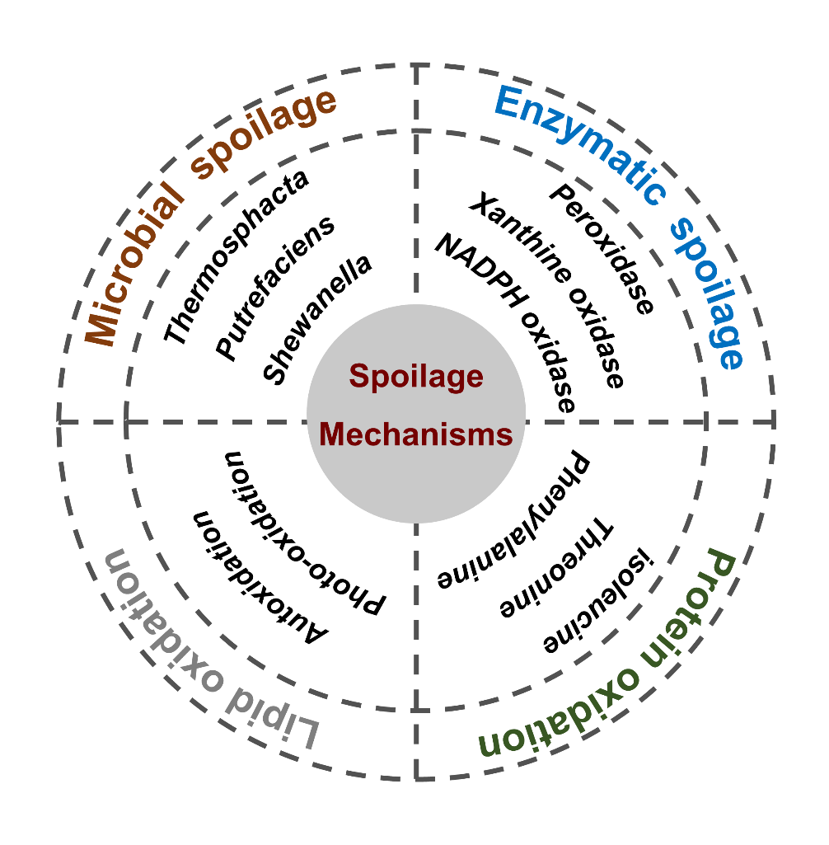
Fig.1. The spoilage mechanisms of chilled meat(Bekhit, et al., 2021; Mariutti & Bragagnolo, 2017; Odeyemi & Alegbeleye, 2020; Paczkowski & Schütz, 2011; H. Wang, et al., 2017).
2.1 Microbial spoilage
The Aeromonas salmonicida(H. Wang, et al., 2017), Lactic acid bacteria(Comi, Andyanto, Manzano, & Iacumin, 2016), and Serratia, Micrococcus, Shewanella, Brochothrix species(X. Zhang, Lin, et al., 2020) are considered as the dominant spoilage bacteria caused by chilled meat (Fig. 1)(Odeyemi & Alegbeleye, 2020; H. Wang, et al., 2017), which can make meat odor, discoloration, mucus, and so on(X. Zhang, Lin, et al., 2020). Some studies shown that Enterococcus casseliflavus can secrete fat-soluble pigments and produce colored spots on the surface of chilled meat(Tomasevic, Djekic, Furnol, Terjung, & Lorenzo, 2021), and identified the Vibrio and Shewanella species with high luminescence potential in meat products(Höll, Hilgarth, Geissler, Behr, & Vogel, 2019). Microbial spoilage depends largely on external environmental factors, such as the meat substrate, packaging, temperature, and humidity(X. Chen, et al., 2020).
2.2 Enzymatic spoilage
Increasing evidence found that many endogenous enzymes in animals play an important role in ensuring the quality of chilled meat after slaughter (Fig. 1)(Bekhit, et al., 2021). Calpains improve the tenderness of meat(Bhat, Morton, Mason, & Bekhit, 2018), and aminopeptidases regulate the flavor of meat (NISHIMURA, 1998). Meanwhile, exogenous proteases produced by bacteria also have similar roles (Jurado, García, Timón, & Carrapiso, 2007). Obviously, the process of enzymatic spoilage has a great influence on the freshness of chilled meat, which not only produce odor, but also produce harmful products. The packaging system, initial microbial composition and count, meat composition, pH value, temperature, and inhibitors can significantly impact the enzymatic spoilage process(Bekhit, et al., 2021).
2.3 Lipid oxidation
The autooxidation, photo-oxidation, and enzymatic hydrolysis are the three primary oxidation pathways of lipid oxidation in chilled meat. Among them, the first two are of great significance in evaluating the freshness of chilled meat (Fig. 1)(Mariutti & Bragagnolo, 2017). Increasing evidences have proposed that the process of lipid oxidation may be mediated by lipases, lipoxygenases, cyclooxygenases, and several enzymatic systems involved in cholesterol oxidation(Papuc, Goran, Predescu, & Nicorescu, 2017). The progress of lipid oxidation can further induce the protein degradation process, thus leading to the decline of chilled meat quality. Furthermore, adjusting technological parameters in processing effectively inhibits lipoxygenase activity and further prevents the process of lipid oxidation(Jin, Zhang, Yu, Lei, & Wang, 2011).
2.4 Protein oxidation
The process of protein oxidation can lead to significant changes in the nutritional quality, physical properties, and sensory properties of chilled meat(Bekhit, et al., 2021). Free amino acids (e.g., leucine, isoleucine, threonine, phenylalanine, and tryptophan) are produced by microbial proteases and endogenous proteases through the different degradation pathways of protein, which can be further utilized by decarboxylase to produce common biogenic amines and volatile amines. In addition, sulfur-containing amino acid can be utilized by specific sulfur-containing bacteria to produce hydrogen sulfide(Paczkowski & Schütz, 2011) (Fig. 1). Compared with the other three spoilage mechanisms, the process of protein oxidation is the major causes of spoilage, which can significantly reduce the freshness of chilled meat.
- Freshness indicators of chilled meat
During the process of meat spoilage, a variety of substances degrade, such as biogenic amines, volatile amines, hydrogen sulfide, and adenosine triphosphate degradation products, which have been identified as indicators for assessing changes in freshness. It is imperative to investigate the sources and content changes of these indicators in order to develop rapid detection methods in the future.
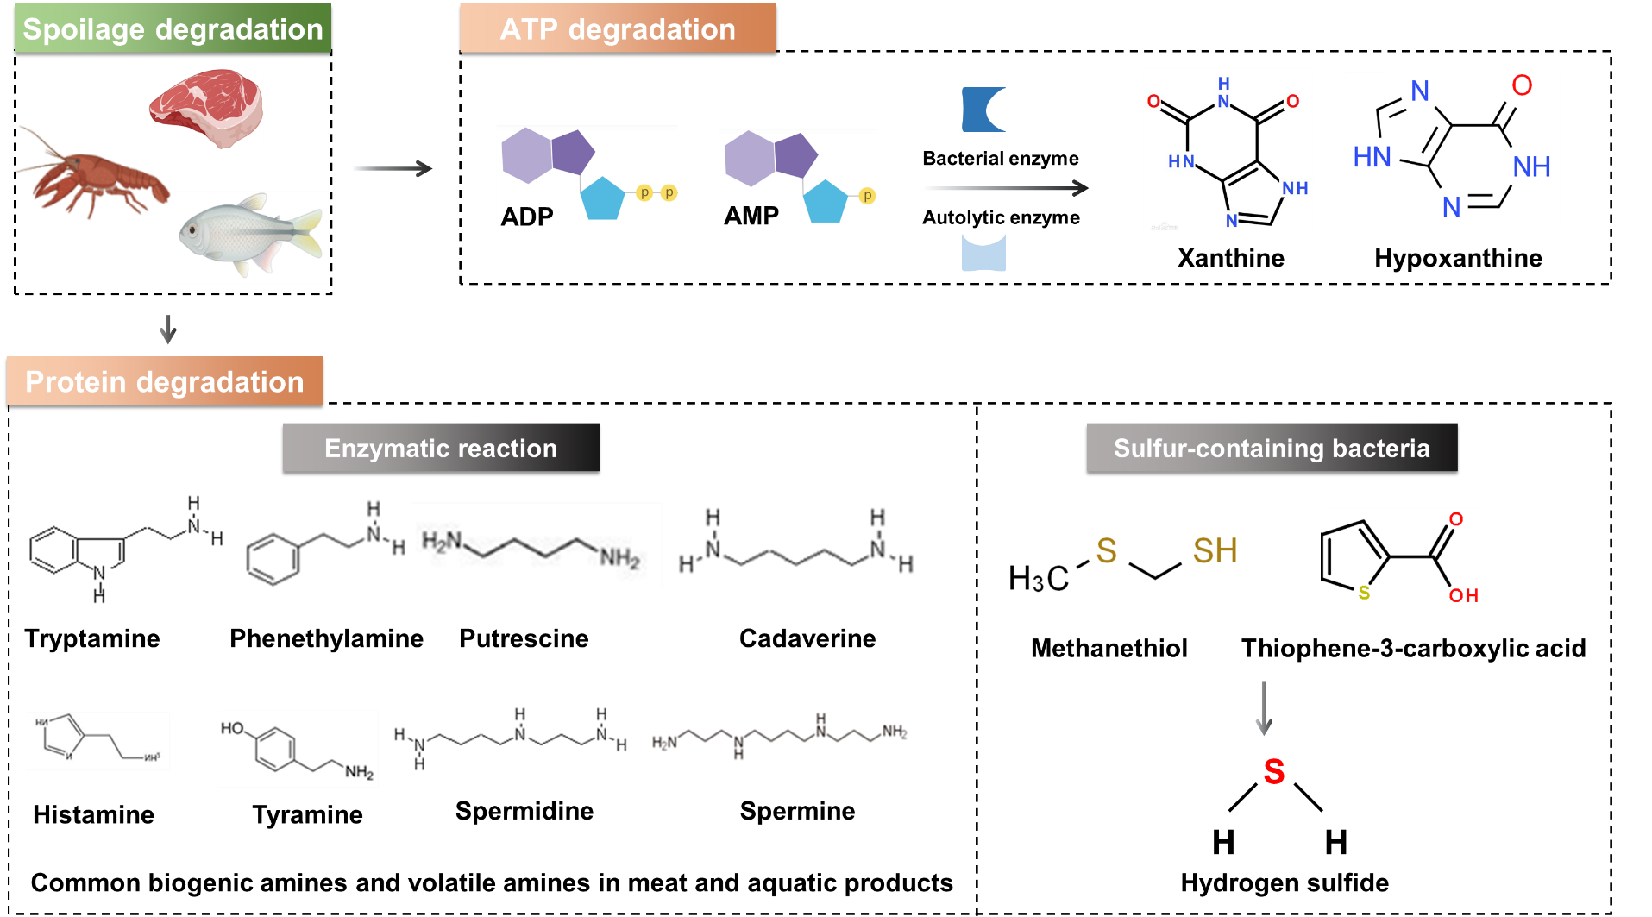
Fig. 2. The indicators used to assess chilled meat freshness(Bekhit, et al., 2021; Duan, et al., 2022b; Garg, Singh, Verma, & Monika, 2022; D. Li, et al., 2017; Lin, et al., 2022; Luo, et al., 2021; B. S. Sivamaruthi, P. Kesika, & C. Chaiyasut, 2021; Xue, et al., 2019; X. Zhang, et al., 2021).
Table 1 Detection of indicators for assessing the freshness of chilled meat
Freshness indictors | Probes | Systems | Methods | Detection indictors | Food matrices | Linear range | LOD | References
Biogenic amines | AG-AN / GG-2％TiO₂ | Film | Electrochemical | Trimethylamine | Pork; Silver carp | 0-0.330 mM | 0.018 mM | (Zhai, et al., 2020)
 | Au NPs | Solution | Colorimetric | Dimethyl Sulfide; Histamine | Meat / Fish | 0-2.5 μg/mL  0-0.12 μg/mL | 0.5 ppm; 0.035 ppm | (Chow, 2020)
 | DPA-Cu NPs | Solution | Fluorescent | Histamine | Pork / Fish | 0.05-5 μM | 30 nM | (X. Zhang, Liu, et al., 2020)
 | Au NRs; Au NSs | Solution | Multicolor sensor array | Spermine; Tryptamine; Ethylenediamine; Tyramine; Spermidine; Histamine | Meat / Fish | 10-800; 20-800; 40-800; 40-800; 60-800; 80-800 μmol/L | 2.46; 4.79; 8.58; 14.26; 10.03; 27.29 μmol/L | (Orouji, Ghasemi, Bigdeli, & Hormozi-Nezhad, 2021)
Volatile amines | Carbon nano dots | Film | Colorimetric | Ammonia | Pork | / | / | (Koshy, Koshy, Mary, Sadanandhan, & Pothan, 2021)
Adenosine triphosphate degradation product | Fe₃O₄ NPs | Solution | Electrochemical | Xanthine | Fish | 400-2400 μM | 4.94 μA/nΜ | (Dervisevic & Dervisevic, 2019)
 | Au NPs | Solution | Electrochemical | Xanthine | Fish, Beef  Chicken | 1-200 μM | 1.4 nA/μM | (Dervisevic & Dervisevic, 2019)
 | SWCNH | Solution | Electrochemical | Hypoxanthine | Fish | 1.5-35.4 μM | 202.4 mA M⁻¹ cm⁻² | (Dervisevic & Dervisevic, 2019)
 | RGO/ZnO | Solution | Electrochemical | Xanthine | Fish | 5-400 μM | 2.1 μA μM⁻¹ cm⁻² | (Dervisevic & Dervisevic, 2019)
 | MWCNT | Solution | Electrochemical | Hypoxanthine | Fish | 10-135 μM | 1235 nA μM⁻¹ cm⁻² | (Dervisevic & Dervisevic, 2019)
 | TiO₂-Gr | Solution | Electrochemical | Hypoxanthine | Meat | 20-512 μM | 9.5 μM | (Albelda, Uzunoglu, Santos, & Stanciu, 2017)
Organic sulfides | Cu NCs; CN QDs | Paper-base | Fluorescent | H₂S gas | Meat | 0-3 μM | 62.7 nM | (X. Huang, et al., 2022)
 | Ag NPs-BC NCs-MoO₃ NPs | Film | Colorimetric | H₂S gas | Meat | 24-0.12 μmol/mL | 3.27 ppm | (Sukhavattanakul & Manuspiya, 2021)
 | Ag NPs | Hydrogel | Colorimetric | H₂S gas | Meat | 0-15 μM | 1.09 μM | (Zhai, et al., 2019)

3.1 Biogenic amines
Biogenic amines are mainly produced by the enzymatic degradation of free amino acids or by amination and transamination of aldehydes and ketones (Fig. 2)(B. S. Sivamaruthi, et al., 2021). According to their chemical structures, biogenic amines can be divided into aliphatic amines (cadaverine, putrescine, spermine, and spermidine), aromatic amines (tyramine and 2-phenylethylamine), and heterocyclic amines (histamine and tryptamine) (Fig. 2)(Duan, et al., 2022b). Among them, the freshness indicators of tyramine, cadaverine, putrescine, histamine, and trimethylamine are usually used to evaluate the freshness of chilled meat(X. Zhang, et al., 2021). Currently, many rapid detection methods evaluate the freshness of meat by establishing a quantitative relationship with biogenic amines. A multicolor sensor array, consisting of two types of gold nanostructures (i.e., gold nanorods (Au NRs) and gold nanospheres (Au NSs)), was designed for the identification of spermine (SM), tryptamine (TT), ethylenediamine (EA), tyramine (TR), spermidine (SD), and histamine (HT) in meat(Orouji, et al., 2021). The linear range of the multicolor sensor array was 10-800, 20-800, 40-800, 40-800, 60-800, and 80-800 μmol/L. The limit of detection (LOD) was 2.46, 4.79, 8.58, 14.26, 10.03, and 27.29 μmol/L for SD, SM, TT, HT, EA, and TR, respectively.
3.2 Volatile amines
Volatile amines belong to a significant category of biogenic amines. During storage and transportation, microorganisms utilize glucose and amino acids to produce volatile amines that can generate obvious odors and reduce the freshness of chilled meat(Hazards, 2016) (Fig. 2). Nowadays, volatile amines serve as a crucial freshness indicator to evaluate the quality of chilled meat (Table 1)(Zhong, et al., 2018a). Rapid detection technology usually makes use of the alkaline properties of volatile amines, which can easily induce the change of pH value in the system, thus, leading to the change of signal output and making subsequent detection possible. For example, a nanofilm was constructed by Zhai and their coworkers to efficiently detect the content of trimethylamine, and its LOD was 0.018mM(Zhai, et al., 2020). Thereafter an intelligent biopolymer film based on starch/carbon nanodots was created, and the visual color of the film changes from purple to green during the storage of pork(Koshy, et al., 2021). It can be used as a low-cost portable visual indicator to monitor the freshness of pork.
3.3 Adenosine triphosphate degradation products
The activity of ATP degrading enzyme(Dervisevic & Dervisevic, 2019) gradually increases after slaughter, which can degrade ATP into adenosine diphosphate (ADP), adenosine monophosphate (AMP), and inosine monophosphate (IMP) in turn (Fig. 2)(Garg, et al., 2022; Tan, Zhao, Sivashanmugan, Squire, & Wang, 2019). The IMP further degrades into hypoxanthine nucleotide (HxR) through the catalysis of phosphatase and nucleoside phosphorylase(D. Li, et al., 2017). Then, hypoxanthine (Hx) and xanthine (XAN) produce by the autolysis and bacterial decomposition of HxR, respectively(X. Gao, et al., 2019). The freshness indicators Hx and XAN are more suitable for determining the early spoilage of chilled meat than others (Table 1)(J. Chen, et al., 2020; C. Guo, You, Li, Chen, & Wang, 2021). Therefore, it is possible to realize the rapid detection of hypoxanthine by constructing a cascade catalytic reaction system, which has a broad application prospect in the detection of freshness of aquatic products. An effective electrochemical detection sensor of graphene/titanium dioxide nanocomposite (TiO₂-Gr) was reported for the detection of Hx(Albelda, et al., 2017). The electrochemical sensor showed excellent detection performance for Hx, with a linear range of 20 to 512 μM, the LOD and sensitivity of sensor were 9.5 μM and 4.1 nA/μM, respectively.
3.4 Organic sulfides
Sulfur-containing amino acids (e.g., lysine and cysteine) can be decomposed by sulfur-containing bacteria into mercaptans (e.g., thiophenic acid, methanethiol), and further degraded to hydrogen sulfide (H₂S) (Fig. 2)(Lin, et al., 2022). Increasing evidences have proven that H₂S can be used as an important indicator to evaluate the freshness of chilled meat (Table 1)(Yuan & Bariya, 2020). Hydrogen sulfide is prone to ligand reaction with metals, thus causing changes in the properties of metal materials. Based on this characteristic, to construct a rapid detection method for meat freshness detection. For example, a H₂S in situ and nondestructive detection sensor based on gellan gum-capped silver nanoparticles was developed to monitor the meat spoilage process in real time. The LOD of sensor was 1.09 μM, which showed a good selectivity towards H₂S(Zhai, et al., 2019). Then, a novel nanocomposite film label (AgNPs-BCNCs-MoO₃NPs) was developed for the detection of H₂S gas in a 1% w/v solution system(Sukhavattanakul & Manuspiya, 2021). The LOD and limit of quantitation (LOQ) of film label for H₂S detection were 3.27 and 10.94 ppm, respectively.
4. Properties and mechanisms of nanozyme sensing systems
Based on the characteristic indicators in meat freshness assessment, specific construction of rapid detection method is particularly important at present. Nanozyme sensing technology has been widely used in food safety detection due to its advantages of fast response speed, low-cost and simple operation. Currently, nanozymes have been reported to exhibit multiple enzyme catalytic properties, such as mimicking peroxidase, oxidase, catalase, and others. Hence, we summarized the properties and mechanism of the nanozyme sensing system in order to better apply it to the freshness detection of meat.
Table 2 Enzyme-like type and catalytic performance of nanozymes
Enzyme-like | Enzyme type | Materials | [ E ] (M) | Substrate | SA (U mg⁻¹) | K_{m} (mM) | v_{max} (M s⁻¹) | K_{cat} (s⁻¹) | References
Peroxidases-like | Non-SAzymes | Fe₃O₄ NPs | 2.1×10⁻¹² | TMB | 5.143 | 0.2411 | 6.55×10⁻⁷ | 3.1×10⁵ | (Jiang, et al., 2018)
 |  | Au NPs | 3.4×10⁻¹⁰ | TMB | 1.633 | 0.1277 | 2.75×10⁻⁷ | 8.1×10² | (Jiang, et al., 2018)
 |  | HRP | 6.2×10⁻¹¹ | TMB | / | 0.4376 | 1.38×10⁻⁶ | 2.23×10⁴ | (Jiang, et al., 2018)
 |  | Carbon NPs | 2.2×10⁻¹¹ | TMB | 3.362 | 0.1037 | 5.62×10⁻⁷ | 2.6×10⁴ | (Jiang, et al., 2018)
 | SAzymes | FeN₄-SAzyme | 1.84×10⁻⁷ | TMB | 33.8 | 1.07×10⁻⁶ | 3.607×10⁻⁷ | 1.97 | (Ji, et al., 2021)
 |  | Fe BNC SAzyme | 3.45×10⁻⁶ | TMB | 15.41 | 2.22 | 1.81×10⁻⁶ | 0.52 | (Jiao, Xu, Zhang, Wu, & Guo, 2020)
 |  | Fe NC-PdNC | 2.14×10⁻³ | TMB | 95.68 | 1.97 | 1.43×10⁻⁵ | 6.68 | (X. Wei, Song, & Song, 2022)
 |  | Fe NC | 2.14×10⁻³ | TMB | 30.27 | 1.35 | 3.1×10⁻⁶ | 1.45 | (X. Wei, et al., 2022)
Oxidase-like | Non-SAzymes | Au@Pt | 5.0×10⁻¹² | TMB | / | 0.013 | 2.5×10⁻¹⁰ | 500 | (He, et al., 2011)
 |  | Co₃O₄ NPs | 1.0 Mg/mL | TMB | / | 0.051 | 3.3×10⁻⁸ | / | (Qin, et al., 2014)
 |  | Tb₄O₇ NPs | 7.04×10⁻¹⁰ | TMB | / | 1.24×10⁻⁴ | 4.31×10⁻⁸ | 1.61×10⁻⁴ | (C. Li, et al., 2019)
 |  | NiCo₂O₄ Ms | 20 μg/ mL | TMB | / | 0.127 | 9.99×10⁻⁹ | / | (Su, et al., 2017)
 | SAzymes | FeN₅ SA/ CNF | 5.37×10⁻⁷ | TMB | / | 0.148 | 7.58×10⁻⁷ | 0.708 | (L. Huang, Chen, Gan, Wang, & Dong, 2019)
 |  | MnN₅ SA/ CNF | 1.50×10⁻⁷ | TMB | / | 0.253 | 4×10⁻⁷ | 0.374 | (L. Huang, et al., 2019)
 |  | CoN₅ SA/ CNF | 0.31×10⁻⁷ | TMB | / | 0.682 | 1.77×10⁻⁷ | 0.174 | (L. Huang, et al., 2019)
 |  | FeN₄ SA/ CNF | 0.19×10⁻⁸ | TMB | / | 0.143 | 4.5×10⁻⁸ | 0.042 | (L. Huang, et al., 2019)
 |  | NiN₅ SA/ CNF | 3.6×10⁻¹³ | TMB | / | 0.120 | 6×10⁻¹⁰ | 0.0006 | (L. Huang, et al., 2019)
 |  | CuN₅ SA/ CNF | 2.35×10⁻¹³ | TMB | / | 0.124 | 4.7×10⁻¹⁰ | 0.0005 | (L. Huang, et al., 2019)
Catalase-like | Non-SAzymes | N-nanozyme | 10 μg/mL | H₂O₂ | / | 360 | 1.13 mg/L min | / | (Juqun Xi, 2020)
 |  | Pero-nanozysome | 10 μg/mL | H₂O₂ | / | 90 | 2.34 mg/L min | / | (Juqun Xi, 2020)
 |  | Co₃O₄ nanozyme | 2×10⁻⁴ | H₂O₂ | / | 38.7 | 3.57×10⁻⁵ | 0.179 | (Y. Chen, et al., 2023)
 | SAzymes | Co-N₄ SAzyme | 1×10⁻⁵ | H₂O₂ | / | 24.0 | 3.72×10⁻⁵ | 37.2 | (Y. Chen, et al., 2023)
 |  | Co-N₃P SAzyme | 4×10⁻⁷ | H₂O₂ | / | 31.8 | 3.15×10⁻⁵ | 78.8 | (Y. Chen, et al., 2023)
 |  | Co-N₃PS SAzyme | 1×10⁻⁷ | H₂O₂ | / | 6.10 | 5.20×10⁻⁵ | 520 | (Y. Chen, et al., 2023)
Superoxide dismutase-like | Non-SAzymes | Fe₃O₄ NPs | / | WST-1 by Dojindo | 5.6 | / | / | / | (Cui Liu, et al., 2023)
 |  | MnPS₃ | / | WST-1 by Dojindo | 721 | / | / | / | (Cui Liu, et al., 2023)
 |  | Pero-nanozysome | / | WST-1 by Dojindo | 1257 | / | / | / | (Cui Liu, et al., 2023)
 |  | C-dot SOD nanozyme | / | WST-1 by Dojindo | 10767 | / | / | / | (Cui Liu, et al., 2023)
 |  | Fluorescent C-dot SOD | / | WST-1 by Dojindo | 4049 | / | / | / | (Cui Liu, et al., 2023)
 | SAzymes | Cu-SAzyme | / | WST-1 by Dojindo | 449 | / | / | / | (Cui Liu, et al., 2023)
Glutathione peroxidase-like | Non-SAzymes | MNw | / | H₂O₂ | / | 5.61 | 0.84 | / | (Ghosh, Prasad, & Mugesh, 2019)
 |  | MNw | / | GSH | / | 3.06 | 0.323 | / | (Ghosh, et al., 2019)
 |  | VNw | / | H₂O₂ | / | 0.04 | 0.192 | / | (Ghosh, et al., 2019)
 |  | VNw | / | GSH | / | 1.28 | 0.279 | / | (Ghosh, et al., 2019)
Hydrolase-like | Non-SAzymes | OPH | / | Methyl parathion | / | 0.21 | 3.5×10⁵ | / | (Tong Fu, 2021)
 |  | VBDA-MIP nano capsule | / | Methyl parathion | / | 0.6 | 8.53.5×10⁻⁶ | / | (Tong Fu, 2021)
 |  | NIP-VBTN | / | Methyl parathion | / | / | 1.48×10⁻⁶ | / | (Tong Fu, 2021)
 |  | NIP-VBTNOH | / | Methyl parathion | / | / | 3.08×10⁻⁶ | / | (Tong Fu, 2021)
 |  | MIP-VBTN | / | Methyl parathion | / | 0.85 | 8.83×10⁻⁶ | / | (Tong Fu, 2021)
（[E] is the enzyme or nanozyme concentration. K_{m} is the Michaelis constant, ν_{max} is the maximal reaction velocity and K_{cat} is the catalytic constant, where K_{cat} = ν_{max}/[E] and the K_{cat}/ K_{m} value indicates the catalytic efficiency of the enzyme or nanozymes.）
4.1 Enzyme-like catalytic properties of nanozymes
4.1.1 Peroxidase-like activity
Peroxidases (POD) use H₂O₂ to generate hydroxyl radical (•OH) and further oxidize substrates for a redox reaction(Yan, et al., 2019). The inorganic Fe₃O₄ nanomaterials can mimic the POD-like catalytic activity reported for the first time in 2007(L. Gao, et al., 2007). Subsequently, precious metal nanomaterials (e.g., Au, Ag, Pt, and Pd), metal oxide/sulfide nanomaterials (e.g., Fe₃O₄, Fe₂O₃, CoFe₂O₄, MnFe₂O₄, and ZnFe₂O₄), carbon-based nanomaterials (e.g., C₆₀[C(COOH)₂]₂, Co-g-C₃N₄, and Fe-g-C₃N₄), and metal-organic frameworks (e.g., MIL-53 (Fe), MIL-101, Fe-MIL-88NH₂, Cu-MOFs, Co-MOFs, and Co/2Fe-MOFs) were investigated that can mimic the POD-like catalytic activity(Duan, et al., 2022b). Meanwhile, most nanozymes have lower K_{m} value and higher v_{max} value than natural peroxidases, which indicate that they have stronger catalytic properties (Table 2)(Ye, et al., 2017).
4.1.2 Oxidase-like activity
Oxidases (OXD) use oxygen to produce reactive oxygen species and further oxidize substrate for a redox reaction(Yan, et al., 2019). It has been found that a variety of metal-based and metal oxide-based inorganic nanomaterials (e.g., Ru, Au@Pt, CeO₂, and N-CNMs) can mimic the OXD-like catalytic activity (Table 2)(Ding, Wang, Sun, & Lin, 2018; Wu & Wang, 2019). Many researches have proved that the formation of intermediates(e.g., singlet oxygen, oxygen, and superoxide anion) and the process of electron transfer greatly affect the OXD-like catalytic properties(C. Liu, Sang, & Yu, 2021). The OXD-like catalytic properties of nanozymes also exhibit through the value of K_{m} and v_{max}, and usually show stronger catalytic activity than natural enzymes. However, the specific catalytic mechanism of OXD-like is unclear.
4.1.3 Catalase-like activity
Catalases (CAT) are a kind of binding enzymes with iron porphyrin as a cofactor, which can decompose H₂O₂ to produce O₂ and H₂O(Yan, et al., 2019). The CAT-like catalytic properties of nanozymes are closely related to the morphology, surface potency, and pH value (Table 2)(Wy, et al., 2021). And then, the optimum pH value of CAT-like catalytic is alkaline environment, which is different from POD-like and OXD-like catalytic. Currently, CAT-like catalytic mechanisms mainly involve adsorption activation and redox reactions(Wy, et al., 2021). Meanwhile, the intermediate products OH* (* referring to species adsorbed to the metal surface) and •OH play a crucial role in the catalytic process(J. Li, Liu, Wu, & Gao, 2015).
4.1.4 Superoxide dismutase-like activity
Superoxide dismutase (SOD) can catalyze the superoxide anion radical to produce O₂ and H₂O₂ through the electron gain and loss(Yan, et al., 2019). Nowadays, Pd, MnO₂, PB, and fullerene nanomaterials have been reported to have excellent SOD-like catalytic properties (Table 2)(Wy, et al., 2021). The chemical structure and surface ions of nanozymes jointly determine their SOD-like catalytic properties, and the optimum pH value is similar to CAT-like catalytic properties. The adsorption activation and electron transfer on the surface of the nanozymes are the two main SOD-like catalytic mechanisms.
4.1.5 Glutathione peroxidase-like activity
Glutathione peroxidase (GP_{x}) is an important peroxide-degrading enzyme with selenocysteine as its active center. Nicotinamide adenine dinucleotide phosphate (NADPH) can oxidize glutathione (GSSG) to generate glutathione (GSH) and promote the decomposition of H₂O₂ into H₂O. The GP_{x}-like catalytic activity of nanozymes can be obtained by calculating the reduction content of NADPH(Yan, et al., 2019). Currently, some nanomaterials (e.g., vanadium metal) have been shown that can mimic the catalytic activity of GP_{x}-like (Table 2). The oxidation groups amount on the materials surface and the reaction process of H₂O₂ to form peroxide bonds are two main reasons for inducing the catalytic activity of GP_{x}-like.
4.1.6 Hydrolase-like activity
Increasing studies have proposed that the catalytic mechanism of hydrolase-like (Hyd-like) is closely related to the breaking of chemical bonds and the generation of free radicals(Wy, et al., 2021). The CdTe nanoparticles modified by chiral cysteine that can mimic the catalytic properties of restriction endonuclease and specifically recognize and cleave restriction sites (Sun, et al., 2018). Moreover, the chiral copper sulfide quantum dots (d/l-QDs) can mimic the catalytic activity of Hyd-like and cause to the cleavage of peptide bonds between amino acids(Hao, et al., 2019). There is little research on the field of food safety detection by using the catalytic activity of Hyd-like.
4.2 Catalytic mechanism of nanozymes
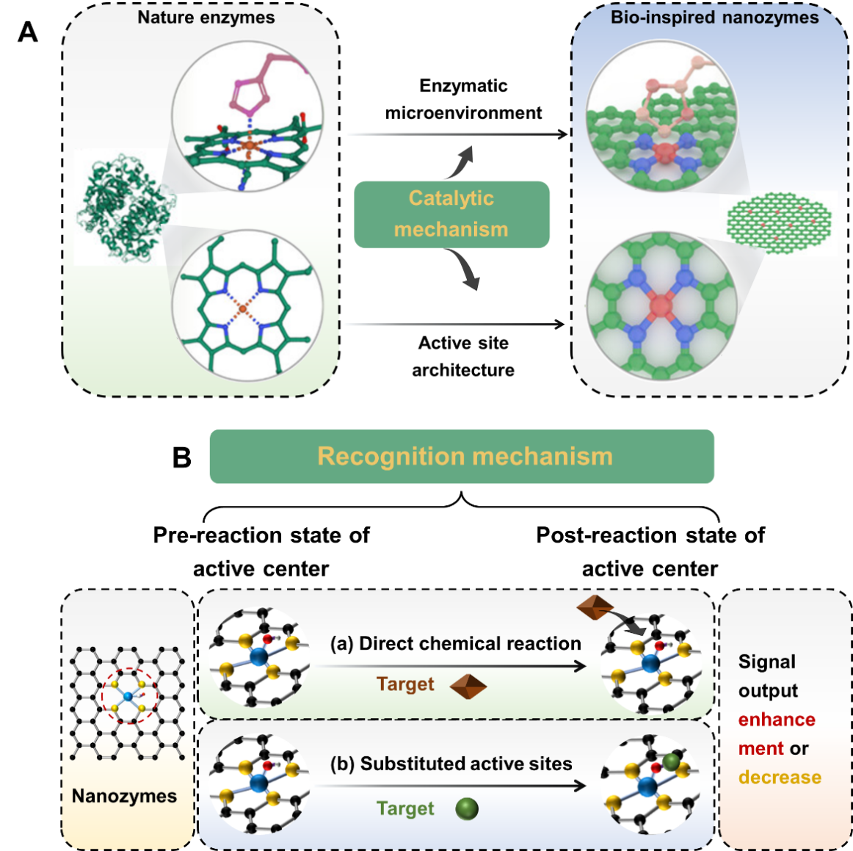
Fig. 3. The catalytic and recognition mechanism of nanozymes. A. Catalytic mechanism of nanozymes(Z. Chen, Vorobyeva, Mitchell, & Fako, 2018; C. P. Liu, et al., 2016; J. C. Liu & Xiao, 2020; Z. Wang, Zhang, Yan, & Fan, 2020; Xu, Wang, Wang, & Gao, 2019). B. Recognition mechanism of catalytic reaction between the targets and nanozymes(J. Chen, et al., 2022; Song, Li, et al., 2022; Song, Zhang, et al., 2022).
4.2.1 Mimicking the enzymatic microenvironment
Nanozymes have been reported to mimic the catalytic properties of many kinds of natural enzymes, and their catalytic mechanisms can be divided into two main types, the most important of which is to achieve enzyme-like catalysis by mimicking the catalytic microenvironment of natural enzymes (Fig. 3A)(Z. Wang, et al., 2020). For example, the construct of natural horseradish peroxidase consists of a heme center and a polypeptide chain, which sever as the active site and active site microenvironment, respectively. Among them, the hydrophilic histidine (His) residues in the polypeptide are involved in the localization of H₂O₂. The specific catalytic process includes two main steps, the hydrogen bonding enters active site cavity, and further promotes the O-O bond cleavage to form Fe⁴⁺=O(C. P. Liu, et al., 2016). It has been shown that a novel histidine-functionalized graphene quantum dot (His-GQD)/hemin complex can mimic the catalytic microenvironment of natural horseradish peroxidase for enzyme-like catalytic. Moreover, the AC@O group, O@CAOA group, and GQD group can mimic the heme active site, His ligand, and hydrophobic binding residues of natural horseradish peroxidase, respectively(C. P. Liu, et al., 2016).
4.2.2 Mimicking the enzymatic active site architecture
Meanwhile, the existence of metal atoms in the structure of nanozymes as the active site provides an important role in its enzyme-like activity (Fig. 3A)(Z. Wang, et al., 2020). With the development of nanotechnology, the synthesis of nanozymes with high catalytic activity and strong selectivity will effectively promote the development of food safety detection methods(Z. Chen, et al., 2018; J. C. Liu & Xiao, 2020). A type of M-N-C (M = Fe, Co, Mn, etc.) nanozyme is synthesis that can mimic the catalytic properties of natural enzyme. This design can reduce the phenomenon of easy aggregation and uneven distribution of metal atoms, and further improve the metal utilization rate and catalytic activity. Subsequently, a nanozyme (labeled as PMCS) with a remarkable POD-like catalytic activity was synthesized by using a metal-organic framework as a precursor, and the high catalytic property of PMCS is derived from the uniform distribution of single metal zinc atoms(Xu, et al., 2019).
5. Application of nanozyme sensing systems
Currently, nanozyme sensing systems are gradually applied in the field of food safety detection (Table 3). According to existing research reports, the recognition mechanisms of systems mainly divided into two types(Song, Li, et al., 2022; Song, Zhang, et al., 2022): (1) Constructed a specific chemical reaction between the targets and nanozymes; (2) Regulated the enzyme-like activity of nanozymes in the targets presence (Fig. 3B), where the latter occupies a more important position. Based on the recognition mechanism between nanozymes and targets, the rapid detection of targets is realized by constructing signal outputs such as colorimetric, fluorescence, and electrochemical.
Table 3 Application of enzyme-like catalytic activity in freshness detection
Methods | Nanozymes | Enzyme-like | Indictors | Food matrices | Linear range | Limit of detection | References
Colorimetric | Fe-PDA NPs | POD-like | Hypoxanthine | Meat | 5.13-200 μM | 1.54 μM | (Y. Zhang, Gao, Ye, & Shen, 2022)
 | Ce NPs | POD-like | Hypoxanthine | Shrimp | 6.2-200 μM | 35 μM | (Zheng, et al., 2023)
 | Cu NPs | POD-like | Dopamine | Beef | 0.05-100 mM | 0.13 mM | (Swaidan, et al., 2021)
 | Ag-Au NPs | POD-like | Spermine | / | 115-854 nM | 0.87 nM | (Kuo, et al., 2018)
 | Rh NPs | POD-like | Xanthine | Meat | / | / | (Shuangfei Cai, 2018)
 | Rh NPs | POD-like | Xanthine | Meat | 1-100 μM | ＜0.75 μM | (Choleva, Gatselou, Tsogas, & Giokas, 2017)
Fluorescent | Pt NPs | POD-like | Hypoxanthine | Fish, Shrimp, and Squid | 8-2500 μM | 2.88 μM | (J. Chen, et al., 2020)
Electrochemical | 3D porous graphene NPs | POD-like | Xanthine; Hypoxanthine | Fish | 0.3-179.9 μM;  0.3-159.9 μM | 0.26 μM;  0.18 μM | (Zhu, 2021)

5.1 Colorimetric detection methods
The colorimetric detection methods is widely used in rapid detection field because of its advantages of simplicity, portability, low cost, and so on(Duan, et al., 2022b). For example, an iron-doped polydopamine nanozyme (Fe-PDA) with POD-like catalytic activity was synthesized and used to detect the content of Hx(Y. Zhang, et al., 2022). The xanthine oxidase (XOD) catalyzes the reaction of Hx and O₂ to generate H₂O₂, which is further catalyzed by the Fe-PDA nanozyme to produce •OH. The •OH can oxidize the colorless reduced 3,3',5,5' -tetramethylbenzidine (_{re}TMB) into blue oxidized TMB (_{ox}TMB), which can be quantified by measuring the absorbance at 652 nm. The LOD of the Fe-PDA nanozyme-base sensing system was 1.54 μM in the linear range of 5.13-200 μM (Fig. 4A). Similarly, a novel cerium oxide film (Ce NPs) with POD-like catalytic activity was prepared for Hx detection(Zheng, et al., 2023). This detection mechanism is similar to the former, and it is also achieved by multi-enzyme cascade catalytic reaction. The LOD of the Ce-NPs-based nanozyme sensing system was 35 μM in the linear range of 6.2-200 μM (Fig. 4B). Then, a nano-sensor (CuS-BSA-Cu₃ (PO₄)₂) with POD-like catalytic activity was constructed for dopamine detection(Swaidan, et al., 2021). The presence of dopamine significantly inhibited the POD-like catalytic activity of the CuS-BSA-Cu₃ (PO₄)₂ nanozyme, and the LOD was 0.13 µM in the linear range of 0.05-100 µM. The CuS-BSA-Cu₃ (PO₄)₂ nanozyme sensing system has excellent detection performance in the practical beef samples (Fig. 4C). Meanwhile, a gold-silver nano complexes nanoprobe (Ag-Au/AgCl) with high OXD-like and POD-like catalytic activity was investigated for spermine detection. The spermine can inhibit OXD-like and POD-like catalytic activity of Ag-Au/AgCl nanozyme(Kuo, et al., 2018) (Fig. 4D). And then, a single-atom rhodium nanozyme (Rh SAzyme) with POD-like catalytic activity was prepared for XAN detection. XAN can be oxidized by XOD to produce H₂O₂, and the Rh SAzyme uses H₂O₂ to exert its POD-like catalytic properties. The LOD of Rh SAzyme-based sensing systems was 0.73 μM in the linear range of 2-80 μM(Shuangfei Cai, 2018) (Fig. 4E).
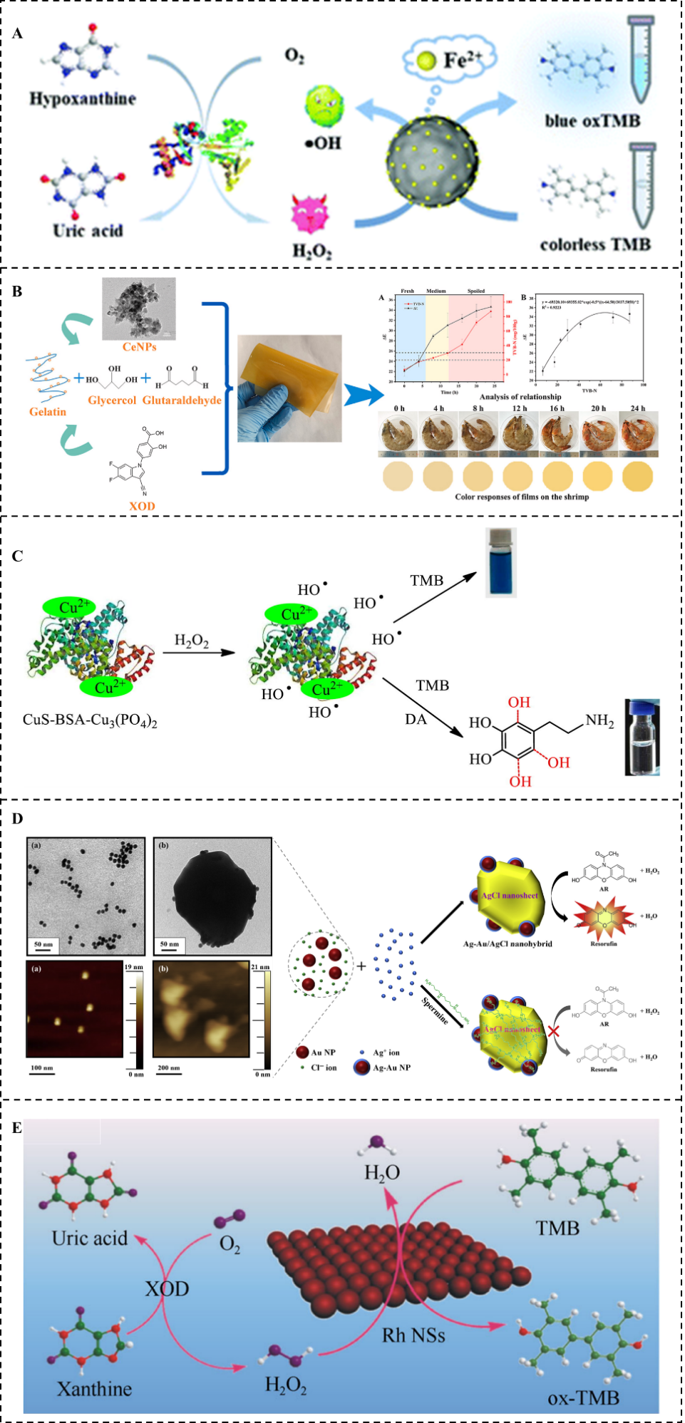
Fig. 4. The colorimetric detection methods are applied in detecting chilled meat freshness. A. Hypoxanthine detection(Y. Zhang, et al., 2022), B. Hypoxanthine detection(Zheng, et al., 2023), C. Dopamine detection(Swaidan, et al., 2021), D. Spermine detection(Kuo, et al., 2018), E. Xanthine detection(Shuangfei Cai, 2018).
5.2 Fluorescent detection methods
Nowadays, fluorescent detection methods play a vital role in the freshness indicators of chilled meat detection. For example, a platinum nanoparticles (Pt NPs) fluorescent biosensor with POD-like catalytic activity was prepared for Hx detection(J. Chen, et al., 2020). The fluorescence intensity of the Pt-NPs nanozyme sensing system is linearly proportional to the Hx concentration, and the LOD of system was 2.88 μM within the linear range of 8-2500 μM. The Pt NPs used in the sensing system can be reusable, and the recovery rate was 91% after three cycles (Fig. 5A-D). The methods for detecting chilled meat freshness based on the combination of nanozymes and fluorescence materials have the advantage of high sensitivity, velocity, low cost, and portability. However, the use of toxic and hazardous reagents hinders the application of fluorescent detection in food safety detection. The development of eco-friendly fluorescent materials has become one of the effective ways to solve the above problems.
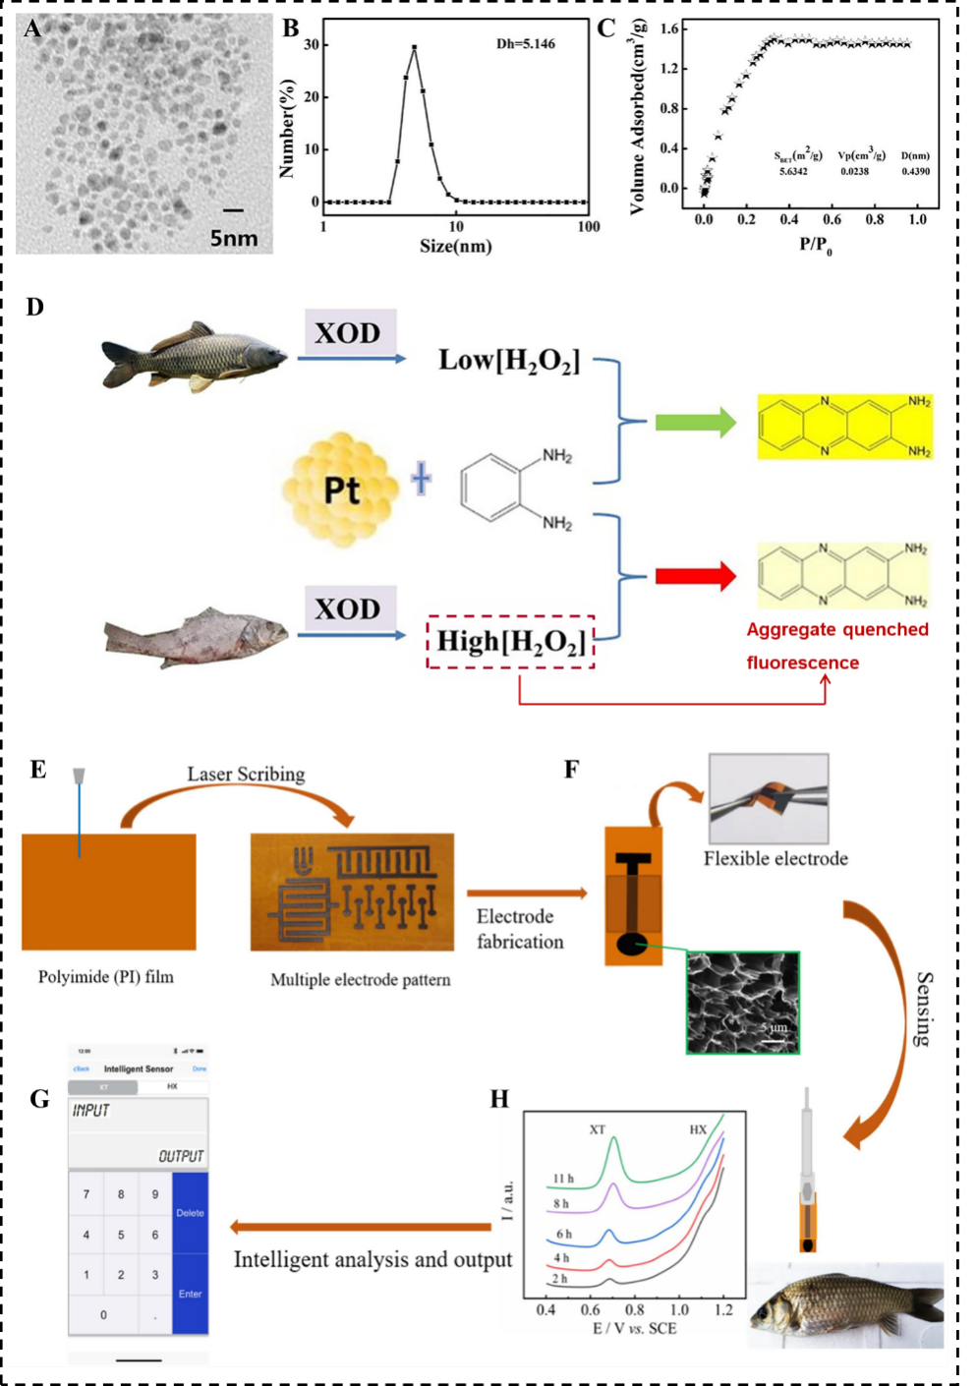
Fig. 5. The fluorescent and electrochemical detection method is applied in detecting hypoxanthine(J. Chen, et al., 2020). A. TEM image, B. DLS analysis, C. N₂ adsorption-desorption isotherms, D. Principle of detecting aquatic freshness based on the fluorescence biosensor. E-H. The electrochemical detection method is applied in xanthine and hypoxanthine detection(Zhu, 2021)
5.3 Electrochemical detection methods
Electrochemical detection methods are crucial in the applications of chilled meat freshness detection due to their high sensitivity, rapidity, and portability. At present, voltammetry, amperometry, conductivity, and impedance methods have been reported to be used for detecting the freshness of chilled meat(Johnson, Atkin, Lee, Sell, & Chandra, 2019). For instance, a three-dimensional porous graphene flexible nanozyme electrode with enzyme-like kinetic characteristics was constructed for detecting the freshness indicators of XAN and Hx. The LOD of this system were 0.26 μM and 0.18 μM within the linear range of 0.3-179.9 μM and 0.3-159.9 μM, respectively(Zhu, 2021) (Fig. 5E-H). The results provide a better sensing platform for further constructing other electrochemical detection method to assess the freshness of chilled meat. However, although electrochemical detection methods have many excellent catalytic properties for detecting trace targets, the disadvantage of poor stability has limited their practical application.
6. Conclusions and perspectives
Chilled meat can be spoiled because of the process of lipid oxidation, enzyme degradation, protein oxidation, and microbial spoilage. Among them, the products of protein and ATP degradation have been as reliable freshness indicators for assessing chilled meat freshness. Such as biogenic amines, hydrogen sulfide, hypoxanthine, volatile amines and so on. These degradation products may directly or indirectly regulate the enzyme-like catalytic properties of nanozymes, which can be achieve specific detection by the means of colorimetric, fluorescent, and electrochemical signal transmission. However, these methods also have some detection drawbacks. Firstly, chilled meat is a complex food matrixes and the spoilage mechanism is also not easy to elucidate, which makes it difficult to ensure the accuracy of detection process. Secondly, the enzyme-like catalytic properties of nanozymes are unstable and their catalytic activity is still generally low.
In order to ensure the stability and accuracy of the detection results, some measures should be taken to improve these problems existing in the current research. Firstly, the pre-treatment methods of practical samples need to be optimized and the specific freshness indicators need to be filtrated for different species of chilled meat. Secondly, the synthesis methods and conditions of nanozymes need to be improved and optimized, respectively. In this way, it can overcome the problems of catalytic properties. Thirdly, it is necessary to construct a novel cold-adapted nanozyme that can achieve better enzyme-like catalytic properties at cold temperature (0-4℃). In conclusion, the high enzyme-like catalytic properties of nanozymes occupy a very important position in the field of freshness detection for chilled meat. The nanozyme sensing systems can be made as kinds of rapid detection labels, such as test strip, film, hydrogel, and so on in the future, which have significant advantages to meet current detection needs.
CRediT authorship contribution statement
Guangchun Song: Writing-Original Draft, Conceptualization, Investigation, Visualization. Cheng Li: Writing-Review & Editing. Marie-Laure Fauconnier: Writing-Review & Editing. Dequan Zhang: Conceptualization, Writing-Review &Editing. Minghui Gu: Writing-Review & Editing. Li Chen: Conceptualization, Validation. Yaoxin Lin: Writing-Review & Editing. Songlei Wang: Writing-Review & Editing. Xiaochun Zheng: Project administration, Funding acquisition, Supervision.
Declaration of competing interest
The authors declare that they have no known competing financial interests or personal relationships.
Data availability
Data will be made available on request.
Acknowledgment
This work was financially supported by the National Key Research and Development Program of China (2022YFD2100500)
References
Albelda, J. A. V., Uzunoglu, A., Santos, G. N. C., & Stanciu, L. A. (2017). Graphene-titanium dioxide nanocomposite based hypoxanthine sensor for assessment of meat freshness. Biosensors and Bioelectronics, 89, 518-524.
Bekhit, E., Holman, B., Giteru, S. G., & Hopkins, D. L. (2021). Total volatile basic nitrogen (TVB-N) and its role in meat spoilage: A review. Trends in Food Science & Technology, 109, 280-302.
Bhat, Z., Morton, J. D., Mason, S., & Bekhit, E. (2018). Role of Calpain System in Meat Tenderness: A Review. Food Science and Human Wellness, 7, 196-204.
Chen, J., Lu, Y., Yan, F., Wu, Y., Huang, D., & Weng, Z. (2020). A fluorescent biosensor based on catalytic activity of platinum nanoparticles for freshness evaluation of aquatic products. Food Chem, 310, 125922-125928.
Chen, J., Zhang, X., Bassey, A. P., Xu, X., Gao, F., Guo, K., & Zhou, G. (2022). Prospects for the next generation of artificial enzymes for ensuring the quality of chilled meat: Opportunities and challenges. Crit Rev Food Sci Nutr, 1-21.
Chen, X., Zhao, J., Zhu, L., Luo, X., Mao, Y., Hopkins, D. L., Zhang, Y., & Dong, P. (2020). Effect of modified atmosphere packaging on shelf life and bacterial community of roast duck meat. Food Research International, 137, 109645-109655.
Chen, Y., Jiang, B., Hao, H., Li, H., Qiu, C., Liang, X., Qu, Q., Zhang, Z., Gao, R., Duan, D., Ji, S., & Wang, D. (2023). Atomic-Level Regulation of Cobalt Single-Atom Nanozymes: Engineering High-Efficiency Catalase Mimics. Angewandte Chemie International Edition, 62, 202301879-202301887.
Chen, Z., Vorobyeva, E., Mitchell, S., & Fako, E. (2018). A heterogeneous single-atom palladium catalyst surpassing homogeneous systems for Suzuki coupling. Nature Nanotechnology, 13, 702-707.
Choleva, T. G., Gatselou, V. A., Tsogas, G. Z., & Giokas, D. L. (2017). Intrinsic peroxidase-like activity of rhodium nanoparticles, and their application to the colorimetric determination of hydrogen peroxide and glucose. Microchimica Acta, 185, 22-31.
Chow, C. F. (2020). Biogenic amines- and sulfides-responsive gold nanoparticles for real-time visual detection of raw meat, fish, crustaceans, and preserved meat. Food Chem, 311, 125908-125914.
Comi, G., Andyanto, D., Manzano, M., & Iacumin, L. (2016). Lactococcus lactis and Lactobacillus sakei as bio-protective culture to eliminate Leuconostoc mesenteroides spoilage and improve the shelf life and sensorial characteristics of commercial cooked bacon. Food Microbiol, 58, 16-22.
Dervisevic, M., & Dervisevic, E. (2019). Recent progress in nanomaterial-based electrochemical and optical sensors for hypoxanthine and xanthine. A review. Microchimica Acta, 186, 749-774.
Ding, Y., Wang, G., Sun, F., & Lin, Y. (2018). Heterogeneous Nanostructure Design Based on the Epitaxial Growth of Spongy MoS (x) on 2D Co(OH)(2) Nanoflakes for Triple-Enzyme Mimetic Activity: Experimental and Density Functional Theory Studies on the Dramatic Activation Mechanism. Acs Applied Materials & Interfaces, 10, 32567-32578.
Dowlati, M., Guardia, M., Dowlati, M., & Mohtasebi, S. S. (2012). Application of machine-vision techniques to fish-quality assessment. Trac Trends in Analytical Chemistry, 40, 168-179.
Duan, X., Li, Z., Wang, L., & Lin, H. (2022). Engineered nanomaterials-based sensing systems for assessing the freshness of meat and aquatic products: A state-of-the-art review. Comprehensive Reviews in Food Science and Food Safety, 22, 430-450.
Erna, K. H., Rovina, K., & Mantihal, S. (2021). Current Detection Techniques for Monitoring the Freshness of Meat-Based Products: A Review. Journal of Packaging Technology and Research, 5, 127-141.
Fu, L., Wang, A., Zhang, H., Zhou, Q., & Liu, Q. (2019). Analysis of chicken breast meat freshness with an electrochemical approach. Journal of Electroanalytical Chemistry, 855, 113622-113627.
Gao, L., Zhuang, J., Nie, L., Zhang, J., Zhang, Y., Gu, N., Wang, T., Feng, J., Yang, D., Perrett, S., & Yan, X. (2007). Intrinsic peroxidase-like activity of ferromagnetic nanoparticles. Nature Nanotechnology, 2, 577-583.
Gao, X., Wang, Y., Liu, Y., Zhang, Q., Liu, X., Tang, Y., & Li, J. (2019). Construction of a novel xanthine biosensor using zinc oxide (ZnO) and the biotemplate method for detection of fish freshness. Analytical Methods, 11, 1021-1026.
Garg, D., Singh, M., Verma, N., & Monika. (2022). Review on recent advances in fabrication of enzymatic and chemical sensors for hypoxanthine. Food Chem, 375, 131839-131850.
Ghaly, D. D. a. A. E. (2011). Meat Spoilage Mechanisms and Preservation Techniques: A Critical Review. American Journal of Agricultural and Biological Sciences, 6, 486-510.
Ghosh, S., Prasad, S., & Mugesh, G. (2019). Understanding the role of oxo and peroxido species in the glutathione peroxidase (GPx)-like activity of metal based nanozymes. Inorganica Chimica Acta, 484, 283-290.
Guo, C., You, S., Li, C., Chen, T., & Wang, X. (2021). One-Step and Colorimetric Detection of Fish Freshness Indicator Hypoxanthine Based on the Peroxidase Activity of Xanthine Oxidase Grade I Ammonium Sulfate Suspension. Front Microbiol, 12, 791227-791235.
Guo, X., Ding, Y., Liang, C., Du, B., Zhao, C., Tan, Y., Shi, Y., Zhang, P., Yang, X., & He, Y. (2022). Humidity-activated H2S sensor based on SnSe2/WO3 composite for evaluating the spoilage of eggs at room temperature. Sensors and Actuators B: Chemical, 357, 131424-131435.
Höll, L., Hilgarth, M., Geissler, A. J., Behr, J., & Vogel, R. F. (2019). Prediction of in situ metabolism of photobacteria in modified atmosphere packaged poultry meat using metatranscriptomic data. Microbiol Res, 222, 52-59.
Hao, C., Gao, R., Li, Y., Xu, L., Sun, M., & Xu, C. (2019). Chiral Semiconductor Nanoparticles for Protein Catalysis and Profiling. Angewandte Chemie International Edition, 58, 7371-7374.
Hazards, E. P. o. B. (2016). Growth of spoilage bacteria during storage and transport of meat. EFSA Journal, 14, 04523-04561.
He, W., Liu, Y., Yuan, J., Yin, J. J., Wu, X., Hu, X., Zhang, K., Liu, J., Chen, C., Ji, Y., & Guo, Y. (2011). Au@Pt nanostructures as oxidase and peroxidase mimetics for use in immunoassays. Biomaterials, 32, 1139-1147.
Huang, L., Chen, J., Gan, L., Wang, J., & Dong, S. (2019). Single-atom nanozymes. Science Advances, 5, eaav5490.
Huang, X., Sun, W., Li, Z., Shi, J., Zhang, N., Zhang, Y., Zhai, X., Hu, X., & Zou, X. (2022). Hydrogen sulfide gas sensing toward on-site monitoring of chilled meat spoilage based on ratio-type fluorescent probe. Food Chem, 396, 133654-133662.
Ji, S., Jiang, B., Hao, H., Chen, Y., Dong, J., Mao, Y., Zhang, Z., Gao, R., Chen, W., Zhang, R., Liang, Q., Li, H., Liu, S., Wang, Y., Zhang, Q., Gu, L., Duan, D., Liang, M., Wang, D., Yan, X., & Li, Y. (2021). Matching the kinetics of natural enzymes with a single-atom iron nanozyme. Nature catalysis, 4, 407-417.
Jiang, B., Duan, D., Gao, L., Zhou, M., Fan, K., Tang, Y., Xi, J., Bi, Y., Tong, Z., Gao, G. F., Xie, N., Tang, A., Nie, G., Liang, M., & Yan, X. (2018). Standardized assays for determining the catalytic activity and kinetics of peroxidase-like nanozymes. Nat Protoc, 13, 1506-1520.
Jiangjiexing, Xiaoyu, Wang, Quan, Zhangping, Lou, Sirong, Yunyao, Zhu, & Qin. (2018). Nanomaterials with enzyme-like characteristics (nanozymes): next-generation artificial enzymes (II). Chemical Society Reviews, 48, 1004-1076.
Jiao, L., Xu, W., Zhang, Y., Wu, Y., & Guo, S. (2020). Boron-doped Fe-N-C single-atom nanozymes specifically boost peroxidase-like activity. Nano Today, 35, 100971-100981.
Jin, G., Zhang, J., Yu, X., Lei, Y., & Wang, J. (2011). Crude lipoxygenase from pig muscle: partial characterization and interactions of temperature, NaCl and pH on its activity. Meat Science, 87, 257-263.
Johnson, J., Atkin, D., Lee, K., Sell, M., & Chandra, S. (2019). Determining meat freshness using electrochemistry: Are we ready for the fast and furious? Meat Science, 150, 40-46.
Juqun Xi, R. Z., Liming Wang, Wei Xu, Qian Liang, Jingyun Li, Jian Jiang, Yili Yang, Xiyun Yan, Kelong Fan, Lizeng Gao. (2020). A Nanozyme‐Based Artificial Peroxisome Ameliorates Hyperuricemia and Ischemic Stroke. Advanced Functional Materials, 31, 2007130-2007143.
Jurado, A., García, C., Timón, M. L., & Carrapiso, A. I. (2007). Effect of ripening time and rearing system on amino acid-related flavour compounds of Iberian ham. Meat Science, 75, 585-594.
Keklik, N. M., Demirci, A., & Puri, V. M. (2010). Decontamination of unpackaged and vacuum-packaged boneless chicken breast with pulsed ultraviolet light. Poult, 89, 570-581.
Koshy, R. R., Koshy, J. T., Mary, S. K., Sadanandhan, S., & Pothan, L. A. (2021). Preparation of pH sensitive film based on starch/carbon nano dots incorporating anthocyanin for monitoring spoilage of pork. Food control, 126, 108039-108048.
Kuo, P. C., Lien, C. W., Mao, J. Y., Unnikrishnan, B., Chang, H. T., Lin, H. J., & Huang, C. C. (2018). Detection of urinary spermine by using silver-gold/silver chloride nanozymes. Analytica Chimica Acta, 1009, 89-97.
Li, C., Sun, Y., Li, X., Fan, S., Liu, Y., Jiang, X., Boudreau, M. D., & Pan, Y. (2019). Bactericidal effects and accelerated wound healing using Tb₄O₇ nanoparticles with intrinsic oxidase-like activity. 17, 54. Journal of Nanobiotechnology, 17, 54-64.
Li, D., Zhang, L., Song, S., Wang, Z., Kong, C., & Luo, Y. (2017). The role of microorganisms in the degradation of adenosine triphosphate (ATP) in chill-stored common carp (Cyprinus carpio) fillets. Food Chem, 224, 347-352.
Li, H., Wang, Y., Zhang, J., Li, X., Wang, J., Yi, S., Zhu, W., Xu, Y., & Li, J. (2023). Prediction of the freshness of horse mackerel (Trachurus japonicus) using E-nose, E-tongue, and colorimeter based on biochemical indexes analyzed during frozen storage of whole fish. Food Chem, 402, 134325-134335.
Li, J., Liu, W., Wu, X., & Gao, X. (2015). Mechanism of pH-switchable peroxidase and catalase-like activities of gold, silver, platinum and palladium. Biomaterials, 48, 37-44.
Liang, Minmin, & Xiyun. (2019). Nanozymes: From New Concepts, Mechanisms, and Standards to Applications. Accounts of chemical research, 52, 2190-2200.
Lin, Y., Zhan, Y., Luo, F., Lin, C., Wang, J., Qiu, B., & Lin, Z. (2022). Multicolor hydrogen sulfide sensor for meat freshness assessment based on Cu(2+)-modified boron nitride nanosheets-supported subnanometer gold nanoparticles. Food Chem, 381, 132278-132285.
Liu, C., Fan, W., Cheng, W. X., Gu, Y., Chen, Y., Zhou, W., Yu, X. F., Chen, M., Zhu, M., Fan, K., & Luo, Q. Y. (2023). Red Emissive Carbon Dot Superoxide Dismutase Nanozyme for Bioimaging and Ameliorating Acute Lung Injury. Advanced Functional Materials, 33, 2213856-2212869.
Liu, C., Sang, H. I., & Yu, T. (2021). Synthesis of Au–Cu Alloy Nanoparticles as Peroxidase Mimetics for H2O2 and Glucose Colorimetric Detection. Catalysts, 11, 343-355.
Liu, C. P., Wu, T. H., Lin, Y. L., Liu, C. Y., Wang, S., & Lin, S. Y. (2016). Tailoring Enzyme-Like Activities of Gold Nanoclusters by Polymeric Tertiary Amines for Protecting Neurons Against Oxidative Stress. Small, 12, 4127-4135.
Liu, J. C., & Xiao, H. (2020). Constructing High-Loading Single-Atom/Cluster Catalysts via an Electrochemical Potential Window Strategy. Journal of the American Chemical Society, 142, 3375-3383.
Lunjie Huang, D.-W. S., Hongbin Pu, Qingyi Wei. (2019). Development of Nanozymes for Food Quality and Safety Detection: Principles and Recent Applications. Comprehensive Reviews in Food Science and Food Safety, 18, 1496-1513.
Luo, X., Ho, I., Brankovan, S., & Lim, L. T. (2021). Inkjet-printed gradient colorimetric indicators for monitoring fish freshness. Food Packaging and Shelf Life, 29, 100719-100729.
Mariutti, L. R., & Bragagnolo, N. (2017). Influence of salt on lipid oxidation in meat and seafood products: A review. Food Research International, 94, 90-100.
Mustafa, F., & Andreescu, S. (2020). Nanotechnology-based approaches for food sensing and packaging applications. RSC Advances, 10, 19309-19336.
NISHIMURA, T. (1998). Mechanism Involved in the hnprovement of Meat Taste during Postnrortem Aging Food science and technology international, 4, 241-249.
Odeyemi, O. A., & Alegbeleye, O. O. (2020). Understanding spoilage microbial community and spoilage mechanisms in foods of animal origin. Comprehensive Reviews in Food Science and Food Safety, 19, 311-331.
Orouji, A., Ghasemi, F., Bigdeli, A., & Hormozi-Nezhad, M. R. (2021). Providing Multicolor Plasmonic Patterns with Au@Ag Core-Shell Nanostructures for Visual Discrimination of Biogenic Amines. Acs Applied Materials & Interfaces, 13, 20865-20874.
Paczkowski, S., & Schütz, S. (2011). Post-mortem volatiles of vertebrate tissue. Appl Microbiol Biotechnol, 91, 917-935.
Papuc, C., Goran, G. V., Predescu, C. N., & Nicorescu, V. (2017). Mechanisms of Oxidative Processes in Meat and Toxicity Induced by Postprandial Degradation Products: A Review. Comprehensive Reviews in Food Science and Food Safety, 16, 96-123.
Pfmp, A., Phdsp, B., Vc, C., & Rvta, D. (2021). Electrical gas sensors for meat freshness assessment and quality monitoring: A review. Trends in Food Science & Technology, 18, 36-44.
Qin, W., Su, L., Yang, C., Ma, Y., Zhang, H., & Chen, X. (2014). Colorimetric Detection of Sulfite in Foods by a TMB-O2-Co3O4 Nanoparticles Detection System. J Agric Food Chem, 62, 5827-5834.
Quan, Z., Xie, G., Peng, Q., Shan, J., Xing, W., Zhang, J., Li, S., Chan, Z., Chou, C., & Zou, H. (2016). Determining eight biogenic amines in surface water using high-performance liquid chromatography-tandem mass spectrometry. Pol. J. Environ. Stud, 25, 1669-1673.
Shao, L., Chen, S., Wang, H., Zhang, J., Xu, X., & Wang, H. (2021). Advances in understanding the predominance, phenotypes, and mechanisms of bacteria related to meat spoilage. Trends in Food Science & Technology, 118, 822-832.
Shuangfei Cai, W. X., Haohong Duan,Xixi Liang,Chen Wang,Rong Yang,Yadong Li. (2018). Single-layer Rh nanosheets with ultrahigh peroxidase-like activity for colorimetric biosensing. Nano Res, 11, 6304-6315.
Sivamaruthi, B. S., Kesika, P., & Chaiyasut, C. (2021). A narrative review on biogenic amines in fermented fish and meat products. Journal of food science and technology, 58, 1623-1639.
Song, G., Li, J. C., Majid, Z., Xu, W., He, X., Yao, Z., Luo, Y., Huang, K., & Cheng, N. (2022). Phosphatase-like activity of single-atom CeNC nanozyme for rapid detection of Al(3). Food Chem, 390, 133127-133134.
Song, G., Zhang, J., Huang, H., Wang, X., He, X., Luo, Y., Li, J. C., Huang, K., & Cheng, N. (2022). Single-atom Ce-N-C nanozyme bioactive paper with a 3D-printed platform for rapid detection of organophosphorus and carbamate pesticide residues. Food Chem, 387, 132896-132905.
Stillwell, W., Bryant, M. S., & Wishnok, J. S. (1987). GC/MS analysis of biologically important aromatic amines. Application to human dosimetry. Biomedical & environmental mass spectrometry, 14, 221-227.
Su, L., Dong, W., Wu, C., Gong, Y., Zhang, Y., Li, L., Mao, G., & Feng, S. (2017). The peroxidase and oxidase-like activity of NiCo(2)O(4) mesoporous spheres: Mechanistic understanding and colorimetric biosensing. Anal Chim Acta, 951, 124-132.
Sukhavattanakul, P., & Manuspiya, H. (2021). Influence of hydrogen sulfide gas concentrations on LOD and LOQ of thermal spray coated hybrid-bacterial cellulose film for intelligent meat label. Carbohydr Polym, 254, 117442-117454.
Sun, M., Xu, L., Qu, A., Zhao, P., Hao, T., Ma, W., Hao, C., Wen, X., Colombari, F. M., de Moura, A. F., & Kotov, N. A. (2018). Site-selective photoinduced cleavage and profiling of DNA by chiral semiconductor nanoparticles. Nat Chem, 10, 821-830.
Swaidan, A., Barras, A., Addad, A., Tahon, J. F., Toufaily, J., Hamieh, T., Szunerits, S., & Boukherroub, R. (2021). Colorimetric sensing of dopamine in beef meat using copper sulfide encapsulated within bovine serum albumin functionalized with copper phosphate (CuS-BSA-Cu₃PO₄)₂ nanoparticles. J Colloid Interface Sci, 582, 732-740.
Tan, A., Zhao, Y., Sivashanmugan, K., Squire, K., & Wang, A. X. (2019). Quantitative TLC-SERS detection of histamine in seafood with support vector machine analysis. Food control, 103, 111-118.
Tomasevic, I., Djekic, I., Furnol, M., Terjung, N., & Lorenzo, J. M. (2021). Recent advances in meat color research. Current Opinion in Food Science, 41, 81-87.
Tong Fu, C. X., Rongrong Guo, Changxu Lin*, Yanyan Huang, Yonghua Tang, Hao Wang, Qifan Zhou, and Youhui Lin*. (2021). Zeolitic Imidazolate Framework-90 Nanoparticles as Nanozymes to Mimic Organophosphorus Hydrolase. ACS Applied Nano Materials, 4, 3345-3350.
Vinci, G., & Antonelli, M. L. (2002). Biogenic amines: quality index of freshness in red and white meat. Food control, 13, 519-524.
Wang, H., Zhang, X., Wang, G., Jia, K., Xu, X., & Zhou, G. (2017). Bacterial Community and Spoilage Profiles Shift in Response to Packaging in Yellow-Feather Broiler, a Highly Popular Meat in Asia. Front Microbiol, 8, 2588-2600.
Wang, Z., Zhang, R., Yan, X., & Fan, K. (2020). Structure and activity of nanozymes: Inspirations for de novo design of nanozymes. Materials Today, 41, 81-119.
Wei, H., & Wang, E. (2013). Nanomaterials with enzyme-like characteristics (nanozymes): next-generation artificial enzymes. Chemical Society Reviews, 42, 6060-6093.
Wei, X., Song, S., & Song, W. (2022). Tuning iron spin states in single-atom nanozymes enables efficient peroxidase mimicking. Chemical Science, 13, 13574-13581.
Wu, J., & Wang, X. (2019). Nanomaterials with enzyme-like characteristics (nanozymes): next-generation artificial enzymes (II). Chemical Society Reviews, 48, 1004-1076.
Wy, A., Xin, Y. B., Lz, A., Hc, A., Xl, B., & Wx, A. (2021). Nanozymes: Activity origin, catalytic mechanism, and biological application. Coordination Chemistry Reviews, 448, 214170-214185.
Xu, B., Wang, H., Wang, W., & Gao, L. (2019). A Single-Atom Nanozyme for Wound Disinfection Applications. Angewandte Chemie International Edition, 58, 4911-4916.
Xue, G., Yu, W., Yutong, L., Qiang, Z., Xiuying, L., Yiwei, T., & Jianrong, L. (2019). Construction of a novel xanthine biosensor using zinc oxide (ZnO) and the biotemplate method for detection of fish freshness. Analytical Methods, 11, 1021-1026.
Yan, R., Sun, S., Yang, J., Long, W., Wang, J., Mu, X., Li, Q., Hao, W., Zhang, S., Liu, H., Gao, Y., Ouyang, L., Chen, J., Liu, S., & Zhang, X. D. (2019). Nanozyme-Based Bandage with Single-Atom Catalysis for Brain Trauma. Acs Nano, 13, 11552-11560.
Ye, H., Yang, K., Tao, J., Liu, Y., Zhang, Q., Habibi, S., & Nie, Z. (2017). An Enzyme-Free Signal Amplification Technique for Ultrasensitive Colorimetric Assay of Disease Biomarkers. Acs Nano, 11, 2052-2059.
Yuan, Z., Bariya, M., Fahad, H. M., Wu, J., & Javey, A. (2020). Trace‐Level, Multi‐Gas Detection for Food Quality Assessment Based on Decorated Silicon Transistor Arrays. Advanced Materials, 32, 1908385-1908393.
Zhai, X., Li, Z., Shi, J., Huang, X., Sun, Z., Zhang, D., Zou, X., Sun, Y., Zhang, J., Holmes, M., Gong, Y., Povey, M., & Wang, S. (2019). A colorimetric hydrogen sulfide sensor based on gellan gum-silver nanoparticles bionanocomposite for monitoring of meat spoilage in intelligent packaging. Food Chem, 290, 135-143.
Zhai, X., Zou, X., Shi, J., Huang, X., Sun, Z., Li, Z., Sun, Y., Li, Y., Wang, X., & Holmes, M. (2020). Amine-responsive bilayer films with improved illumination stability and electrochemical writing property for visual monitoring of meat spoilage. Sensors and Actuators B: Chemical, 302, 127130-127142.
Zhang, X., Fang, C., Huang, D., Yang, G., Tang, Y., Shi, Y., Kong, C., Cao, P., & Cai, Y. (2021). Determination of 8 biogenic amines in aquatic products and their derived products by high-performance liquid chromatography-tandem mass spectrometry without derivatization. Food Chem, 361, 130044-130050.
Zhang, X., Lin, S., Liu, S., Tan, X., & Xia, F. (2020). Advances in organometallic/organic nanozymes and their applications. Coordination Chemistry Reviews, 429, 213652-213671.
Zhang, X., Liu, Q., Wang, Z. W., Xu, H., An, F. P., Huang, Q., Song, H. B., & Wang, Y. W. (2020). D-penicillamine modified copper nanoparticles for fluorometric determination of histamine based on aggregation-induced emission. Mikrochim Acta, 187, 329-335.
Zhang, Y., Gao, X., Ye, Y., & Shen, Y. (2022). Fe-Doped polydopamine nanoparticles with peroxidase-mimicking activity for the detection of hypoxanthine related to meat freshness. Analyst, 147, 956-964.
Zheng, M., Ma, Q., Li, L., Wang, Y., Suo, R., Wang, W., Sun, J., Wang, J., & Liu, H. (2023). Gelatin-based smart film incorporated with nano cerium oxide for rapid detection of shrimp freshness. Lwt, 175, 114417-114426.
Zhong, X., Huo, D., Fa, H., Luo, X., Wang, Y., Zhao, Y., & Hou, C. (2018). Rapid and Ultrasensitive Detection of Biogenic Amines with Colorimetric Sensor Array. Sensors and Actuators B: Chemical, 274, 464-471.
Zhu, Y., PengXue, TingXu, JingkunQiu, DaoyangSheng, YingyingLi, WeiqiangLu, XinyuGe, YuWen, Yangping. (2021). Facile and rapid one-step mass production of flexible 3D porous graphene nanozyme electrode via direct laser-writing for intelligent evaluation of fish freshness. Microchemical Journal: Devoted to the Application of Microtechniques in all Branches of Science, 162, 105855-105865.

