Continuous flow intensification for the synthesis of high purity warfarin
Diana V. Silva-Brenes,^{1,2} Stephanie K. Reyes-Vargas,³ Jorge Duconge,⁴ Cornelis Vlaar, ⁴ Torsten Stelzer^{4,5} and Jean-Christophe M. Monbaliu^{1,2*}
¹Center for Integrated Technology and Organic Synthesis, MolSys Research Unit, University of Liège, B-4000 Liège (Sart-Tilman), Belgium
²FloW4all Flow Technology Resource center, University of Liège, B-4000 Liège (Sart-Tilman), Belgium
³Department of Chemistry, University of Puerto Rico, Río Piedras Campus, San Juan, Puerto Rico 00931, USA
⁴Department of Pharmaceutical Sciences, University of Puerto Rico, Medical Sciences Campus, San Juan, Puerto Rico 00936, USA
⁵Crystallization Design Institute, Molecular Sciences Research Center, University of Puerto Rico, San Juan, Puerto Rico 00926, USA
* jc.monbaliu@uliege.be
ORCID numbers:
- Diana V. Silva-Brenes 0000-0002-7613-8888
- Stephanie Reyes
- Jorge Duconge 0000-0002-5955-3449
- Cornelis Vlaar 0000-0001-5145-8300
- Torsten Stelzer 0000-0003-3881-0183
- Jean-Christophe M. Monbaliu 0000-0001-6916-8846

ABSTRACT While racemic warfarin was initially commercialized as a rodenticide, it has become the most prescribed anticoagulant for prevention of blood clots and is part of the World Health Organization’s list of essential medicines. The synthesis of warfarin appears straightforward, consisting of a single Michael addition reaction. However, the reaction is notoriously slow, with reflux times in the scale of days frequently affording the product in little more than 40% yield. Herein we report a highly intensified synthesis of warfarin exploiting the assets of flow chemistry and organocatalysis. The selection of a suitable catalyst to increase the rate of the reaction was crucial to obtain high conversion and selectivity, resulting in the development of a continuous flow protocol that affords warfarin in 85% isolated yield within 15 min of residence time. The product can be obtained in >97% purity by simple precipitation in acid. The achieved throughput of 9.4 g h⁻¹ with a space time yield (STY) of 1570.67 g h⁻¹ L⁻¹ is orders of magnitude higher than previously published flow protocols. Not only is this protocol more environmentally favorable, but also an estimated cost of 0.07 cents per dose hints that the novel process may be more economically favorable than the industrial patented synthesis.
KEYWORDS: Warfarin, Flow synthesis, Intensification, Organocatalysis, API synthesis, Michael addition
INTRODUCTION
Warfarin (brand names Coumadin, Marevan, Jantoven, CAS 81-81-2, 1) is a potent anticoagulation agent initially developed in the agricultural research environment in Wisconsin. The discovery that dicoumarol (2), formed from melilotic acid in moldy hay, was responsible for hemorrhagic death of cattle led to thorough exploration of hydroxycoumarin derivatives as potential pest control agents.¹ Among the derivatives tested, 4-hydroxy-3-(3-oxo-1-phenylbutyl)-2H-chromen-2-one (1), synthesized through the Michael addition of benzylideneacetone (3) and 4-hydroxycoumarin (4), was found to be a very potent anticoagulant. Compound 1 was given the name warfarin in honor of the Wisconsin Alumni Research Foundation (WARF) that had funded the research, was patented in 1947,² and has been marketed as a rodenticide since 1948.³
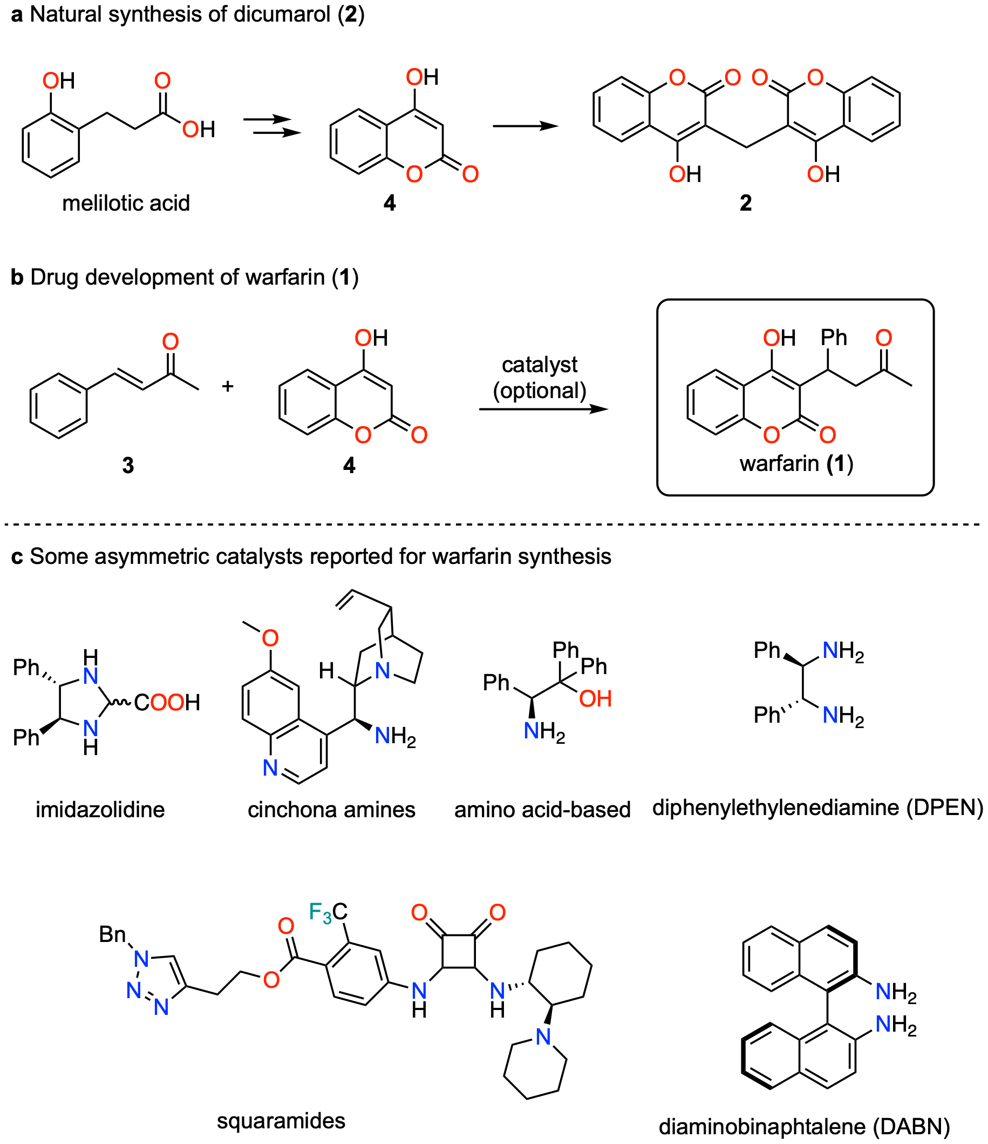
Figure 1. a 4-hydroxycoumarin (4), synthesized from melilotic acid by Aspergillus fumigatus,⁴ reacts with exogenous formaldehyde to form dicumarol 2 in moldy hay.⁵ b Common route for the synthesis of warfarin (1) from benzylideneacetone (3) and (4). c Main families of asymmetric catalysts for the enantioselective synthesis of warfarin.
Although initially used to kill rodents, warfarin was later shown to be a safe anticoagulation drug for humans, and approved by the FDA in 1954.⁶ Warfarin is used for the preventive treatment of thrombosis and myocardial infarction (commonly known as “heart attack”) in at-risk patients.⁶ Despite the development in recent years of new generation anticoagulants,⁷ warfarin is still one of the most prescribed medications, ranking #58 among all drugs prescribed in the US in 2020,⁸ and is part of the World Health Organization (WHO) list of essential medicines.⁹
The 1947 industrial patented synthesis of warfarin consists of refluxing 3 with 4 in pyridine for 24 h to afford the product in 40% yield.^{2, 10} The same patent also reported refluxing 3 and 4 in water for 48 hours to give 1 in 48% yield.² Both the (R)- and (S)-enantiomers of warfarin possess anticoagulation activity and the medication is only prescribed as the racemic mixture,¹¹ however it is known that (S)-warfarin produces a stronger response than (R)-warfarin.¹² This prompted investigations towards the enantioselective synthesis of the warfarin stereoisomers.¹³ In 2003, Jørgensen reported the first direct enantioselective synthesis of 1 using an imidazolidine catalyst (Figure 1c) to obtain warfarin in 80% ee and 90% yield after 130 h (>5 days) of reaction time.¹⁴ Although the enantioselectivity was initially ascribed to the formation of an aminal intermediate, it was later shown that the imidazolidine catalyst decomposes to a diamine under those reaction conditions, and instead the reaction was proposed to proceed through imine catalysis.¹⁵ A variety of amines have since been reported to catalyze the enantioselective formation of warfarin, such as derivatives obtained from cinchona amines,¹⁶ amino acids (e.g. phenylalanine, or phenylglycine),^{17, 18} 1,2-diphenyl-1,2-ethylenediamine (DPEN),^{15, 19, 20,21} squaramides,²² and 2,2′-diamino-1,1′-binaphthalene (DABN)²³ (Figure 1). Several of these catalysts were able to produce warfarin with good to excellent enantiomeric excess (80 to 90%), and moderate to good yields (63 to 99%). However, the reaction times were invariably long, ranging from 12 h to several days.
Efforts have also been directed towards improving the synthesis of racemic warfarin, with relatively modest gains. Refluxing 3 and 4 in methanol afforded the racemic product in 93% yield, but with a reaction time of 20 h and a subsequent 4-hour hydrolysis of the a methoxylated intermediate was required.²⁴ Other catalysts have been explored for the synthesis of warfarin including amine bases such as ammonia, triethylamine, aniline, or tributylamine,²⁵ as well as alkali fluorides, phosphates and quaternary ammonium salts.²⁶ However, the formation of a mixture of products is reported for at least some of these catalysts, and the procedure using pyridine remains the most frequently used protocol.^{2, 10, 27}
Thus far, there are three reports for the continuous flow synthesis of 1, all using asymmetric catalysis (Table 1). In 2015, the groups of Puglisi and Benaglia²⁸ reported the preparation of 1 using the cinchona amine catalyst developed by Kim.¹⁵ High enantioselectivity was obtained (95% ee), however with a low yield of 29%. Another flow synthesis for warfarin was reported in 2020,²⁹ using a DPEN-based catalyst.³⁰ The authors point out that the slow nature of the reaction required several reactors to be concatenated arriving at a residence time of 60 min. Despite obtaining good enantiomeric excess (90% ee), only a yield of 26% and 38% purity were obtained. The third flow synthesis was reported within the context of a platform designed to optimize asymmetric reactions.³¹ Using DPEN was selected as asymmetric catalyst and acetic acid as cocatalyst, a conversion of 21% and enantioselectivity of 99% were obtained, while no yield was reported.³¹
Table 1. Summary of the main results of the continuous flow protocols for the synthesis of 1. The concentration refers to the concentration of the limiting reagent in the reaction mixture.
Author | Catalyst | Solvent | Concentration (M) | Residence time (min) | Yield | Throughput (g h⁻¹) | STY  (g h⁻¹L⁻¹)
Puglisi & Benaglia²⁸ | Cinchona amine¹⁵ | Dioxane | 0.025 | 10 min | 29% | 6.71 x 10⁻³ | 13.41
Collins²⁹ | Zhu/Cheng³⁰ | THF | 0.2 | 60 min | 10%ª | 2.13 x 10⁻³ | 6.06
Organ³¹ | DPEN | MeOH:CH₃CN | 0.017 | 50 min | 21%^{b} | 1.30 x 10⁻³ | 1.30
This work | Morpholine | IPA:EtOAc | 1.5 | 15 min | 85% | 9.42 | 1570.67
ª This yield was calculated considering that the compound for which the authors report a 29% yield contains only 38% of 1. ^{b} This value corresponds to the conversion as the yield was not reported.

The development of a practical, high yielding and high throughput continuous flow synthesis at competitive costs remains a challenge. We set ourselves four main goals. First, short residence time (≤ 15 min) because commercial flow reactors are typically not compatible with longer residence times, indicating the importance of fast reactions to obtain a scalable process. Second, high concentrations of reactants since large amounts of solvent would increase both the cost and the environmental footprint of the reaction. The aim was to have at least a 0.1 M concentration of the final product in the crude reaction mixture. Third, high selectivity, to enable isolating the product in high purity by simple precipitation. This provides the opportunity for future incorporation of continuous, in-line isolation, purification, and crystallization,³² and avoids costly purification methods such as a column chromatography. Fourth, safe and environmentally conscious reaction conditions, adhering to the recommendations of regulatory agencies, and as such the FDA³³ or the CHEM21³⁴, by using solvents and reagents which are regarded as posing low risk to human health. Considering that warfarin is commercially sold as the racemic mixture, the use of enantioselective catalysts was avoided.
Results and discussion
Optimization of the synthesis of warfarin (1) via flow chemistry by reacting 3 with 4 in pyridine was discarded since pyridine is a class 2 solvent (FDA) and considered as a hazardous chemical according to the CHEM21 selection guide.³⁴ Our initial strategy was to exploit the protocol in which 1 was reported to be obtained by refluxing 3 and 4 in water.² The use of a flow reactor could have facilitated increased reaction rates by carrying out the reaction at temperatures above 100 °C and under increased pressure. However, the limited aqueous solubility of the starting materials in the feed solutions precluded the use of pure water as a solvent. To resolve solubility problems, we found that by using mixtures of isopropanol and water, we could obtain solutions with a 0.3 M concentration of 4 and 1.0 M of 3. Initially, a reaction temperature above the melting point of warfarin (>160 °C) was used to ensure that the product did not crystallize and clog the reaction tubing. These conditions resulted in limited conversion (>55%) and concomitant decomposition of the starting materials. It was observed that ring-opening hydrolysis and subsequent decarboxylation of hydroxycoumarin 4 to form 2-hydroxyacetophenone (5) was favored over the formation of 1 (Figure 2). Attempts at using triethylamine or acetic acid (both FDA class 3 substances) to catalyze the reaction resulted in increased decomposition of 4 to obtain 5, without improvement in the yield of 1 (not shown).
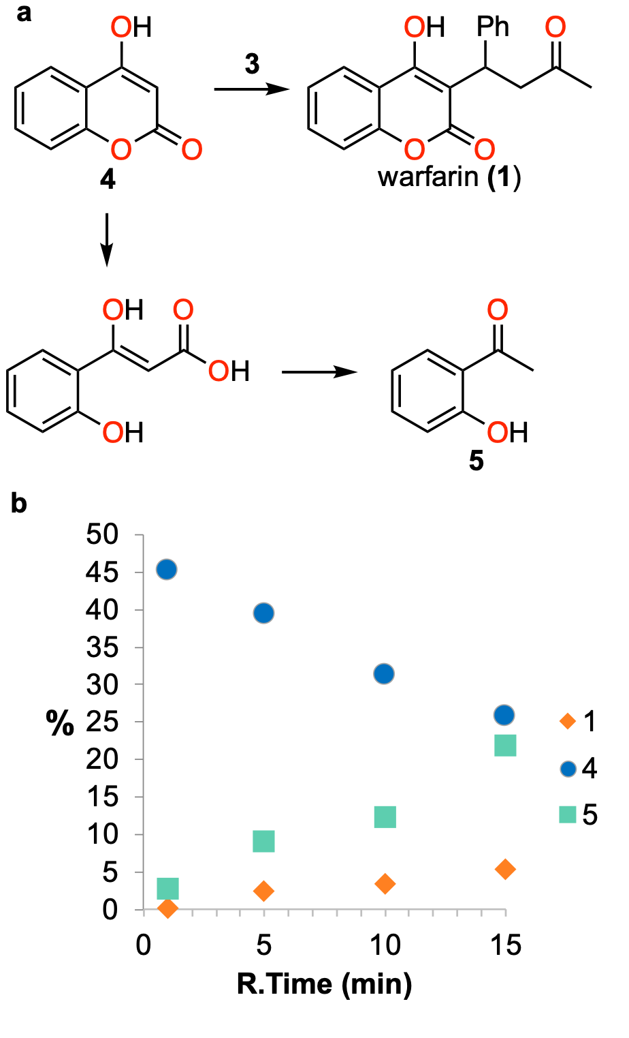
Figure 2. a The reaction of 4 with 3 to form warfarin (1) competes with the hydrolysis and decarboxylation of 4 to produce 2’-hydroxyacetophenone 5. b Graph showing the preferred formation of side product 5 over the formation of 1. The y-axis corresponds to the %Area (HPLC-DAD, 260 nm) of peaks obtained for compounds 1, 4 and 5 in the crude effluent of the reaction when performed at different residence times. Reaction were performed in a mixture of water and isopropanol at 160 °C with 16 bar counterpressure.
Because of the formation of undesired side product 5, we decided to reduce our reliance on increased temperature to intensify the reaction and turned our attention to the use of organocatalysts to decrease the reaction time. From the above-described examples for asymmetric syntheses of warfarin, it was observed that reaction yields of up to 99% were observed^{15, 18, 35} (Figure 1). However, the reaction times are reported to be multiple days instead of the required ≤ 15 minutes. Nevertheless, this led us to focus on amines that could promote the reaction through iminium catalysis. A quick batch screening of a few simple amines was conducted, including proline, which had been previously reported as a good catalyst for the synthesis of racemic warfarin.^{14, 36} We included morpholine, dimethylamine and pyrrolidine, as they previously were shown to form some of the most electrophilic iminium ions.³⁷ Of these three, dimethylamine is a gas at room temperature and is commonly used as a 40% aqueous solution. To reduce potential gas formation during flow synthesis, diethylamine with a higher boiling point was also included in the selected amines. Catalysis via formation of iminium ions with secondary amines is frequently enhanced with the aid of an acidic cocatalyst.³⁸ Among the reported iminium catalyzed reactions for the synthesis of 1, acetic acid (FDA class 3) was one of the most frequent co-catalysts used,^{15, 17, 19, 21} which led us to evaluate addition of acetic acid as a potential co-catalyst. The previously reported iminium-catalyzed reactions have been reported mostly using tetrahydrofuran (THF) as solvent.^{14, 15, 17, 19, 23} However, since THF is considered an FDA³³ class 2 solvent and rated as problematic by CHEM21,³⁴ this solvent was not considered for our conditions. Instead, preliminary batch test reactions of different amine catalyst using either iso-propanol or ethyl acetate as solvents were used. These solvents were used to elucidate potential differential effects of a protic versus aprotic solvents on the formation of the iminium imtermediate.³⁹ The formation of 1 from 3 and 4 catalyzed by different amines in ethyl acetate or iso-propanol was conducted at room temperature and analyzed by HPLC at 24 and 48 h (Figure 3).
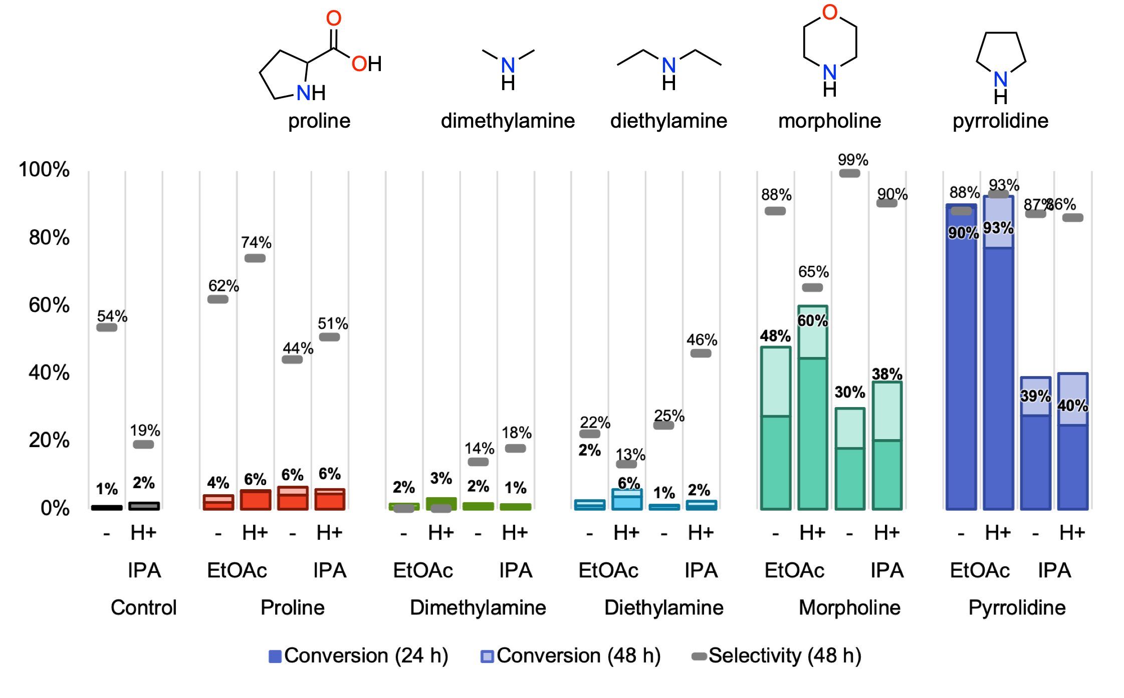
Figure 3. Structures of the amines tested for the racemic synthesis of 1 and the conversion obtained after 24 (dark colors) and 48 h (light colors), as well as the selectivity after 48 hours (grey bars). See SI section 2.1 for details on the determination of conversion and selectivity. All reactions were performed at room temperature at 0.1 M concentration and equimolar amounts of 3 and 4. “H+” indicates the addition of acetic acid as co-catalyst. Reactions contained 10 mol% of the catalyst and 20 mol% of acetic acid (when indicated).
The amine catalysts demonstrated significant differences in their activity. Although proline demonstrated a slight increase of reaction progress compared with the control, it performed very poorly and afforded much less conversion than expected based on literature precedence (≤6%).¹⁴ In contrast, pyrrolidine (proline without the carboxylic acid group) was by far the most efficient of the catalysts tested, achieving over 90% conversion in less than 24 h. Similarly, morpholine was also an effective catalyst, with ≤ 60% conversion obtained after 48 h. The effect of the addition of acetic acid as co-catalyst was dependent on the secondary amine and appeared at best only slightly beneficial. With respect to the solvent, higher conversions were obtained with ethyl acetate compared to iso-propanol for all catalysts except proline, with effects ranging from modest (diethylamine) to strong (e.g. pyrrolidine), perhaps due to an increased reactivity of the iminium intermediate under these conditions.
The above-presented screening of secondary amine catalysts at room temperature was conducted using a relatively low concentration of both 3 and 4 at 0.1 M, at which each of the reagents are completely soluble in both solvents. This approach allowed us to solely focus on the efficiency of the catalysts (at low concentration and room temperature). To intensify the formation of 1 in a continuous flow setup using high concentration, we attempted the use of pyrrolidine, morpholine and diethyl amine, which all are liquids at room temperature, as both the amine catalysts and as the solvent for the reaction. The attempted dissolution of 4 in these three amines gave rise to a (liquid-liquid) biphasic system. However, addition of DMSO (5% v/v) resulted in a homogenous solution, and a feed solution of 4 in a 3 M concentration in 5% DMSO/amine could be prepared. In a reaction using 5%DMSO/pyrrolidine as the solvent for both 3 and 4, a trial at 130 °C with a residence time of 2 min, the reaction resulted almost exclusively in decomposition of 3 to unknown products, whereas 4 remained mostly unreacted (Figure 4B). When using morpholine as the solvent for the reaction between 3 and 4, a high conversion of 3 was observed (>97%), but the selectivity of the formation of 1 was only 73%. Finally, although diethylamine did not display significant catalytic activity in the room temperature batch trials, under highly intensified flow conditions at 95 °C for 15 min, product 1 was obtained with excellent selectivity (97%), albeit with relatively low conversion (65%). Considering that one of our crucial goals was to obtain 1 with high selectivity to be able to obtain a highly pure crude product,⁴⁰ we decided to further explore the use of diethylamine under intensified conditions to promote the reaction.
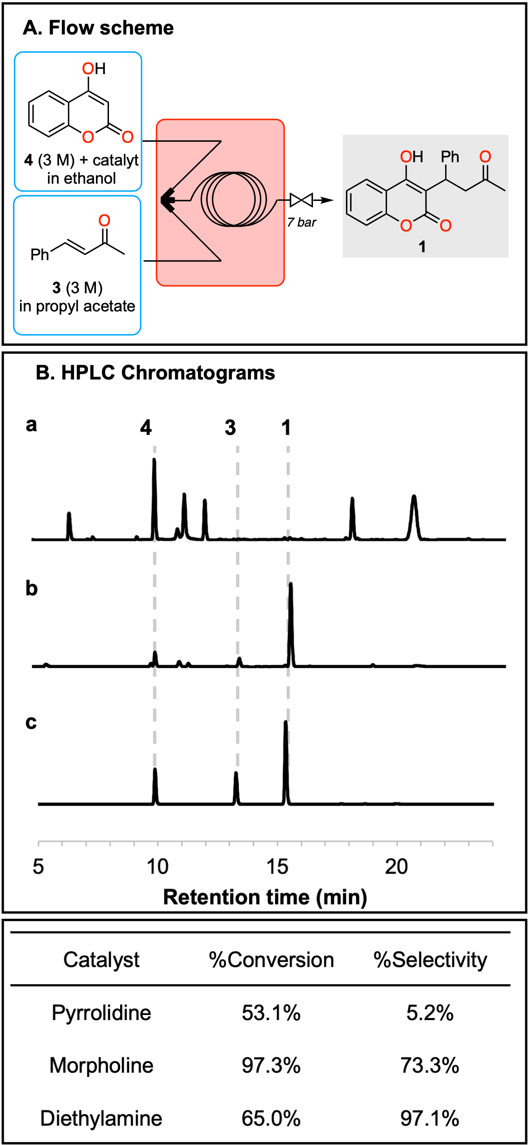
Figure 4. A. Scheme of the flow reactor used. B. Chromatograms (HPLC 260 nm), %conversion and %selectivity obtained for the synthesis of 1 catalyzed by (a) pyrrolidine, (b) morpholine (c) diethylamine. The unidentified peaks in (a) presumably arise from the decomposition of 3. For pyrrolidine and morpholine, the reaction was performed at 130 °C, residence time 2 min. For diethylamine, reaction was performed at 95 °C, residence time 15 min.
Following the initial selection of diethylamine as the catalyst and solvent, the use of higher reaction temperatures appeared promising (Table S5, entries 10-11). However, the low boiling point of diethylamine (55.5 °C) inevitably resulted in the formation of large gas segments, unsteady flow, and unstable pressure readings, even with a backpressure of 20 bars applied to the system. Therefore, addition of higher boiling solvents was examined to allow an increase of the reaction temperature without gas formation. We selected propyl acetate, an FDA class 3 solvent³³ with a relatively high boiling point (102 °C), to prepare a 3 M feed solution of starting material 3. Using a solution of 4 in pure diethylamine at 3 M in the second feed solution allowed us to explore higher temperatures (Table S6) while obtaining a 1.5 M concentration of the reactants in the reaction mixture. According to HPLC analysis (260 nm), a conversion of 94% and a selectivity of 91% was achieved via a reaction at 130 °C and a 15-min residence time (Table 2, entry 1).
We considered that the use of diethylamine as both catalyst and solvent for 4-hydroxycoumarin (4) was not optimal, as the amount of amine catalyst used represents approximately 3 equivalents compared to the reagents. To be able to reduce the amount of diethylamine without reducing the concentration of 4 posed a greater challenge. Of the solvents cited in the literature that solubilize 4, ethanol was the only attractive option.⁴¹ However the maximum concentration of 4 that could be reached with this solvent at room temperature was approximately 0.8 M. We found that by adding 1 equivalent of diethylamine to the feed containing 4 in ethanol provided a homogenous 3 M feed solution. The use of only 1 equivalent of diethylamine catalyst in a 3 M solution of 4 in ethanol and a 3 M solution of 3 in propyl acetate (130 °C; 15 min) resulted in an 85% conversion (Table 2, entry 2). A quick scan of temperature and residence time conditions (SI section 4.2) determined that conversion could be increased by raising the reaction temperature to 140 °C, which resulted in a conversion of up to 91% (selectivity 92%) in 15 min (Table 2, entry 3). Further increasing the temperature to 150 °C did not result in better conversion, but instead led to a lower selectivity of 80.6% (Table 2, entry 4). Tests using 2 equivalents of diethylamine did not increase the conversion and instead lead to a decrease in selectivity (Table 2, entry 5; SI section 4.3).
When the reaction was carried out at lower concentrations of 1 M (Table 2, entry 6) and 0.5 M (Table 2, entry 7) conversion decreased to 84% and 66% respectively (SI section 4.4). This decrease in conversion can be explained by considering that the rate of a (non-zero order) reaction increases with increasing concentration. Selectivity also decreased at these lower concentrations. An attempt at carrying out the reaction at higher concentrations was done by increasing the concentration of the feed solution of 3 to 4.5 M in propyl acetate and adjusting the flow rates to maintain a 1:1 stoichiometry with 4. Although a 1% increase in conversion was obtained (Table 2, entry 8), at this concentration, 3 easily precipitated out of solution with minor fluctuations in temperature, thereby causing clogging problems. Finally, longer residence times of up to 30 min were probed (SI section 4.5), however the selectivity was negatively impacted (Table 2, entry 9).
Table 2. Summary of the main results for the optimization of the synthesis of warfarin (1) catalyzed by diethylamine. Conversion and selectivity are reported as the average and standard deviation of triplicate measurements.
Entry | T (°C) | Conc. (M) | R.time (min) | Eq. | %Conversion | %Selectivity
1 | 130 | 1.5 | 15 | 3 | (94.2 ± 0.1)% | (91 ± 2)%
2 | 130 | 1.5 | 15 | 1 | (84.9 ± 0.4)% | (91 ± 3)%
3 | 140 | 1.5 | 15 | 1 | (91.3 ± 0.2)% | (92.3 ± 0.3)%
4 | 150 | 1.5 | 15 | 1 | (90.7 ± 0.2)% | (80.7 ± 0.1)%
5 | 140 | 1.5 | 15 | 2 | (92.1 ± 0.4)% | (82 ± 2)%
6 | 140 | 1.0 | 15 | 1 | (84.0 ± 0.1)% | (80.4 ± 0.1)%
7 | 140 | 0.5 | 15 | 1 | (66 ± 1)% | (82 ± 4)%
8 | 140 | 2.25 | 15 | 1 | (92.1 ± 0.8)% | (80 ± 2)%
9 | 140 | 1.5 | 30 | 1 | (94 ± 3)% | (75 ± 6)%
10ª | 140 | 1.5 | 15 | 1 | (92.3 ± 0.6)% | (93 ± 1)%
The reactions were carried out with a solution of 3 in propyl acetate and a solution of 4 in ethanol with the indicated equivalents of diethylamine. ªReaction performed using isopropanol for the feed solution of 3 and ethanol for the feed solution of 4. Values for conversion and selectivity were obtained by HPLC (260 nm) and are reported as the average and standard deviation of triplicate measurements.
The results presented in Table 2 indicated that the reaction at 140 °C for 15 min, with a reaction concentration of 1.5 M provided the optimum conversion and selectivity (entry 5). At this stage, we re-evaluated our solvent selection. Propyl acetate had been chosen during the development of the reaction because it’s relatively high boiling point would provide flexibility to explore high temperatures. Having fixed the optimal temperature at 140 °C, we considered that ethyl acetate (as solvent for 3) would be sufficient to reach this temperature under 7 bars of counterpressure. On the other hand, ethanol, chosen during method development for its solubilizing properties, could be changed for isopropanol as the solvent for 4 without reducing the feed solution concentration. These changes were estimated to decrease the cost of the synthesis by half (SI section 4.7). The reaction produced equally good results in terms of conversion and selectivity with this change of solvents (Table 2, entry 10).
With the optimized procedure and more economical solvents in hand, we proceeded to perform flow-synthesis campaigns with longer collection times to be able to obtain significant amounts of the product. However, unexpectedly an impurity which had previously been of only minor importance (< 2% by HPLC), appeared to be formed in almost 20%. Attempts at removing this impurity from the crude reaction through multiple solvent washes or precipitation still resulted in an impurity content of ca. 8% at best. We isolated and purified this impurity and were able to perform NMR and X-Ray crystallography analysis that determined the identity of the impurity to be dicoumarol 7 (Figure 5, SI section 4.12). Dicoumarols are known to form from the addition of two molecules of 4 with benzaldehyde (6). ⁴² Although there is no benzaldehyde present in the starting materials, it can be easily produced in the reaction mixture through a retro-aldol reaction of 3.^{43, 44} Formation of dicoumarols has been previously reported under amine catalysis, with diethylamine standing out as one of the most effective amine catalysts for this reaction.⁴² These dicoumarols form a strong ion pair with ammonium which readily crystallizes.⁴⁵
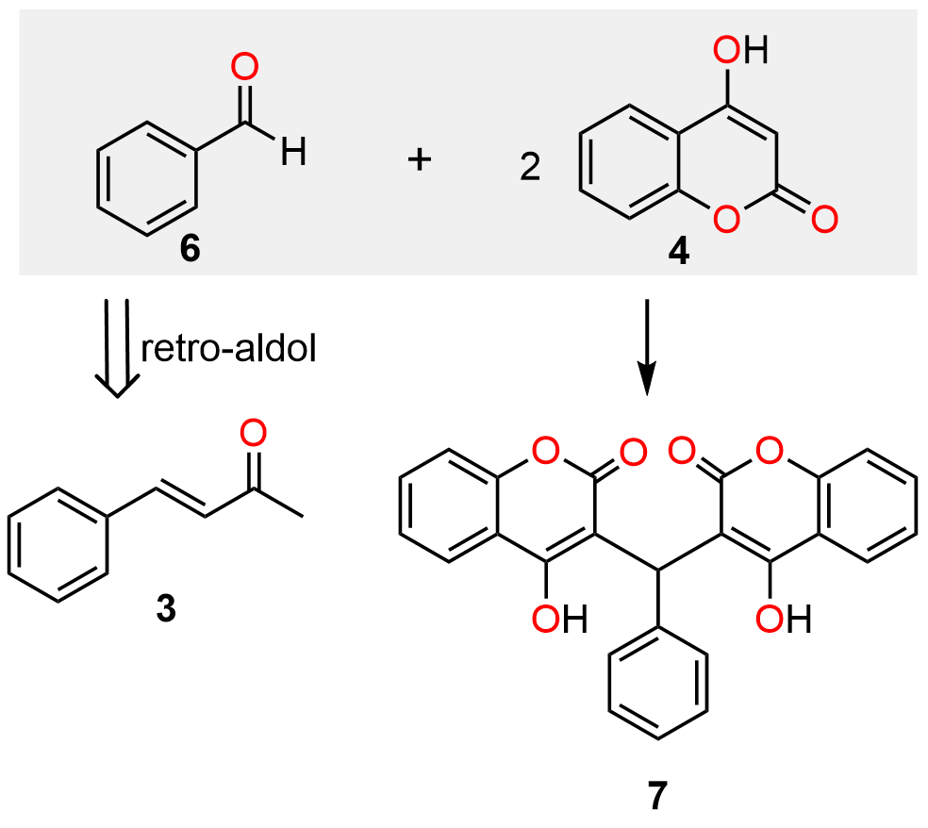
Figure 5. Synthetic scheme of the synthesis of dicumarol from two molecules of 4 and benzaldehyde (6). The most probable source of benzaldehyde lies in the retro-aldol reaction of 3.
Despite the early success of the use of diethylamine as organocatalyst for the reaction of 3 with 4 to obtain 1, it was rejected for further development. Diethylamine not only appeared responsible for catalyzing the formation of dicoumarol 7, but also the temperature of 140 °C that is needed to obtain high conversion likely contributes to promote the retro-aldol reaction of benzylidene acetone 3, leading to the formation of benzaldehyde, that is incorporated into impurity 7.
In hopes of catalyzing the reaction at a lower temperature, we turned our attention to morpholine, which had shown higher conversion than diethylamine in the batch trials (Figure 3). Morpholine was also attractive due to its benign nature, being approved by the US Food and Drug Administration (FDA) as a food additive to be used in the protective coating added to fresh fruits and vegetables,^{46, 47} aside from other applications in adhesives⁴⁸ and paper coating.⁴⁹
Transposing the reaction conditions to morpholine required adjustment of the feed solutions as an isopropanol solution containing 4 in a 3 M concentration with 1 eq. of morpholine resulted in the formation of a gel. Addition of 20% (v/v) of water was necessary to obtain a homogenous solution that could be pumped. Reaction temperatures from 100 °C to 140 °C were tested, with a residence time of 15 min. The reaction performed at 110 °C gave a satisfying compromise between conversion and selectivity (Figure 6). At this lower temperature the formation of dicoumarol 7 remained below 2%.
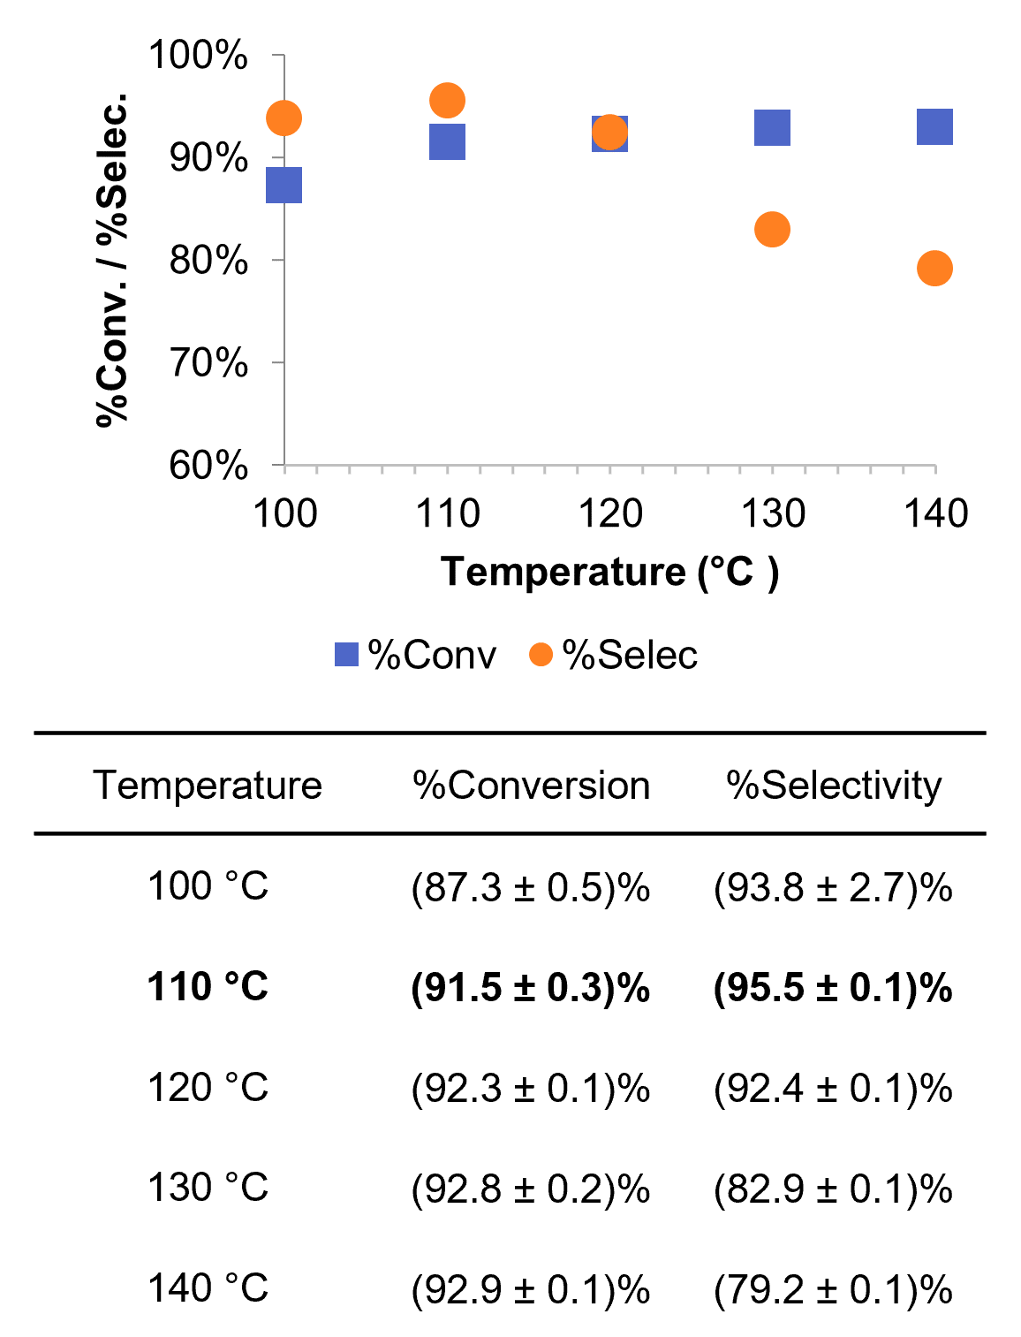
Figure 6. %Conversion and %selectivity for the morpholine catalyzed synthesis of 1 at different temperatures (reaction concentration: 1.5 M, residence time: 15 min). Values for conversion and selectivity were obtained by HPLC (260 nm) and are reported as the average and standard deviation of triplicate measurements.
Characterization of the compounds in the reaction mixture
A 2 h long flow synthesis campaign was performed. Monitoring of the reactor effluent over time by HPLC, showed that the reaction was highly stable, with a standard deviation for the 0.8% for the conversion and 0.1% for the selectivity throughout the campaign (SI section 4.10). For this reaction, the conversion was confirmed to be (90 ± 1)% by ¹H-NMR (SI section 4.9). A representative chromatogram of the crude reactor effluent obtained using morpholine as catalyst can be seen in Figure 7.
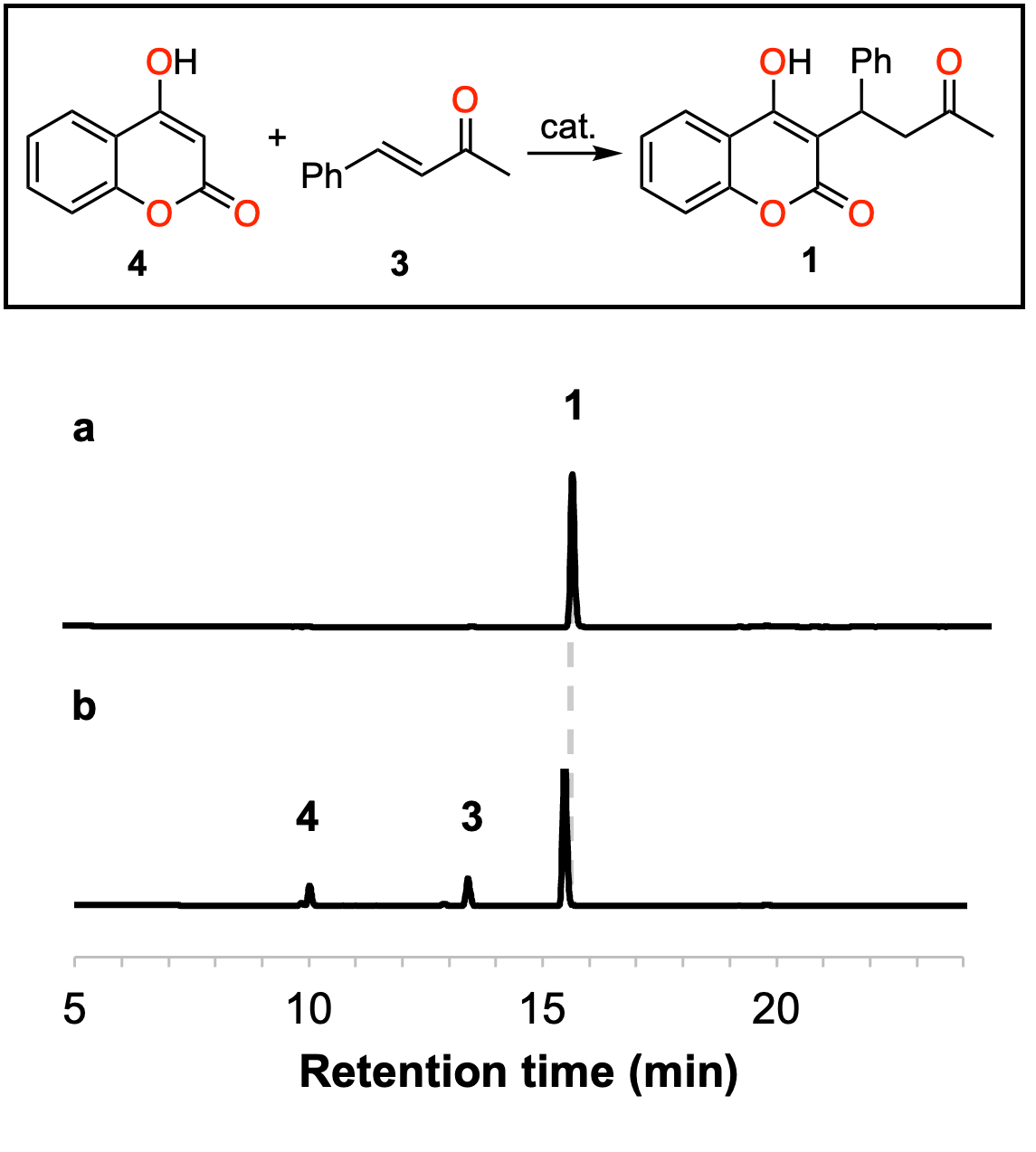
Figure 7. Representative chromatogram (HPLC 260 nm) for the morpholine catalyzed synthesis of warfarin (1): a compound obtained after isolation (the signal for 1 corresponds to 97.6%Area) and b sample of the crude reactor effluent (the signal for 1 corresponds to 75.7%Area).
The major impurities present were hydroxyacetophenone 5 (1.2%) and dicoumarol 7 (0.6%). The absence of Alice’s ketone (Warfarin Related Compound A, SI section 4.11.3), a known impurity in the synthesis of warfarin,⁵⁰ was confirmed after synthesis of the compound (SI section 4.12.3) and comparison of the latter with chromatograms of the reaction mixture.
Isolation of the products
The difference in pKa between the phenolic proton in 4 (pKa ~4) and warfarin (pKa ~6)⁵¹ provided a convenient handle to distinguish these two compounds. Initially a concentrated sodium acetate buffer (pH of 5) was used to both quench the reaction and recover warfarin as a solid, while keeping 4 in solution. This method was effective in selectively removing both remaining starting materials. Switching to HCl (3 M) showed an increased efficiency and this was favored for the purification of 1. Isolation of the product was carried out by adding 4x volume of HCl (3 M) to the crude efflux, sonicating for ca. 15 min and separating the solid by centrifugation. This process was repeated twice by suspending the solid in 1x volume isopropanol and precipitating using 4x HCl, to afford warfarin with 97.6% purity in 85% isolated yield.
Conclusion
The entire protocol for the flow-based synthesis of warfarin (1) is very robust considering the highly stable effluent observed during the entire 2-h synthesis campaign. Furthermore, the conversion and selectivity obtained in different synthesis campaigns differed in only ± 1% (data not shown). The offline batch isolation of the product was performed immediately after synthesis, however a sample of the crude reactor effluent was kept to evaluate its stability over time. After three months, the purity of the reaction mixture remained the same, as determined by HPLC. If stored at room temperature, the conversion increased to 99% and the color of the reaction crude became darker over time. However, storing at -10 °C maintained the reaction mixture unchanged. The feed solutions can also be stored for at least a month without degradation.
A residence time of 15 min is still relatively long if considering a scale up and production of this process. The reaction however has a low sensitivity to mixing, with experiments showing that a threefold increase in flow rate (maintaining the same residence time) led to results with negligible difference (SI section 4.6). This suggests that prolonging the residence time by using slower flow rates is a viable option to perform this reaction in a conventional commercial reactor. Our work overcomes limitations in the solubility of 4 through its combination with the catalyst in the feed solution of 4, using the high pH to increase solubility (Table 1). In doing so, we also avoided the use of problematic solvents such as dioxane, or THF, while also reducing the amount of solvent used. Whereas previous flow protocols obtained the product in a yield of 29% at most, the method we report affords 1 in 85% isolated yield (Table 1). This continuous flow protocol for the synthesis of warfarin (1) has a throughput of 9.4 g h⁻¹ and a spacetime yield (STY) of 1570 g h⁻¹L⁻¹, several orders of magnitude higher than most of the previously published flow syntheses for 1 (Table 1). Compared to the 12 h reaction reported for the batch production with a 40% yield,² the use of continuous flow affords the product with 85% isolated yield after a residence time of only 15 min. To compare our process in terms of economy, we estimated the cost of producing a 5 mg dose of warfarin using prices available for the compounds from VWR. According to this estimate, warfarin produced using our intensified continuous flow conditions is around 3 times cheaper than the patented process² using pyridine (SI section 4.2). As a last test, we used Ecoscale,⁵² a convenient online tool to assess the environmental and safety hazards posed by a chemical process. Comparison with the patent revealed that our process is more favorable, obtaining a score of 73, which is 11 points higher than the patented process² (score of 62; SI section 4.3). All these observations highlight the practicality of the continuous flow process to synthesis racemic warfarin.

EXPERIMENTAL SECTION
Microfluidic setup
Microfluidic setups were constructed from PFA tubing (1.58 mm outer diameter, 762 μm internal diameter) equipped with SuperFlangelessTM PEEK connectors and ferrules (IDEX/Upchurch Scientific). Feed and collection lines consisted of PFA (1.58 mm outer diameter, 750 μm internal diameter) equipped with SuperFlangelessTM PEEK connectors and ferrules (IDEX/Upchurch Scientific). Liquid feeds were handled using Chemyx Fusion 6000 syringe pumps (stainless steel (SS) syringes equipped with DuPont Kalrez O-rings). The temperature was regulated with a Heidolph MR Hei-Tec equipped with a Pt-1000 temperature sensor. Downstream pressure was regulated with back pressure regulators from Zaiput Flow Technologies (BPR-10). See Supporting Information, Section 1 for details of the microfluidic setups.
Typical run for the continuous flow preparation of warfarin (1) using morpholine
For a typical experiment, hydroxycoumarin 4 (12.16 g, 0.075 mol) was transferred to a 50 mL graduated cylinder. Morpholine (6.5325 g, 0.77 mol) was diluted in 80% isopropanol (20% water) and added to 4. This dissolution was exothermic, and reagents were added slowly. The volume was completed to 25 mL using 80% isopropanol. The second feed solution was prepared by transferring benzylideneacetone 3 (11.70 g, 0.08 mol) to a 25 mL volumetric flask and solubilizing in ethyl acetate. Two Chemyx 6000 Fusion syringe pumps were used to deliver the feeds at a flow rate of 0.2 mL min⁻¹ per pump (0.4 mL min⁻¹ total flow rate). Both streams were mixed through a High Pressure mixing Tee (arrow mixer) and the resulting mixture was flowed through a 6 mL PFA capillary coil (ID 0.03’, 13.16 m length) to obtain a residence time of 15 min. The reactor coil, including the mixer were immersed in an oil bath at 110 °C using. A dome-shaped back pressure regulator (BPR, Zaiput) was used to maintain the pressure at 7 bar. The system was allowed to equilibrate for at least 24 min before collecting the first sample. The output solution was analyzed by HPLC-DAD (monitoring at 260 nm). The product was isolated by addition of 3x volume of HCl (3M) and washed three times with HCl (3M). Warfarin (1) was obtained as a white powder and characterized by ¹H NMR (400 MHz, DMSO) δ 7.77 (dd, J = 7.8, 1.8 Hz, 1H), 7.37 (d, J = 7.6 Hz, 2H), 7.28 (ddd, J = 8.5, 7.3, 1.8 Hz, 1H), 7.12 (t, J = 7.5 Hz, 2H), 7.07 – 6.94 (m, 3H), 4.86 (t, J = 7.8 Hz, 1H), 3.31 – 3.20 (m, 2H), 2.03 (s, 3H). See Supporting Information, Section 4.8 for details.

ASSOCIATED CONTENT
Supporting Information. A pdf document containing further details of experiments, general experimental procedures, synthesis of reference compounds, suppliers of microfluidic parts and of chemical reagents, detailed experimental setups, NMR spectra, additional HPLC chromatograms, and crystallographic data is available online.
AUTHOR INFORMATION
Corresponding Author
Jean-Christophe M. Monbaliu − Center for Integrated Technology and Organic Synthesis, MolSys Research Unit, University of Liège (Sart Tilman), B-4000 Liège, Belgium;
orcid.org/0000-0001-6916-8846; Email: jc.monbaliu@uliege.be
Author Contributions
DSB designed and performed the experiments, analyzed the results, and wrote the manuscript. Stephanie performed some preliminary experiments. J.C.M.M. supervised the project, advised, and corrected the manuscript. NASA EPSCoR co-PIs TS (Torsten Stelzer), and JD (Jorge Duconge) proofread the manuscript. CV (Cornelis Vlaar) contributed to the analysis of the results and proofread the manuscript.

Funding Sources
This work was funded by the NASA EPSCoR grant (Personalized Medication System for Deep Space Missions, NASA grant 80NSSC19M0148), and the University of Liège and the F.R.S.-FNRS (Incentive grant for scientific research MIS F453020F, JCMM).
Notes
The authors declare no competing financial interest.
ACKNOWLEDGMENT
The authors acknowledge Dr. Aliou Mbodji (UPR) for the determination of the XRD analysis of 7. The Rigaku XtaLAB SuperNova X-ray micro diffractometer was acquired through the support of the National Science Foundation under the Major Research Instrumentation Program (CHE-1626103).

ABBREVIATIONS
NMR, nuclear magnetic resonance; BPR, back-pressure regulator; HPLC, high pressure liquid chromatography; DAD, Diode array detector; STY, Space-time yield; THF, tetrahydrofuran; DMSO, dimethylsulfoxide; IPA, isopropyl alcochol; EtOAc, ethyl acetate.
REFERENCES
1. Lim, G. B., Warfarin: from rat poison to clinical use. Nature Reviews Cardiology 2018.
2. Stahmann, M. A.; Ikawa, M.; Link, K. P. 3-substituted 4-hydroxycoumarin and process of making it. US2427578A, Sept 16, 1947, 1947.
3. Walters, K. The Invention of Warfarin. https://www.acs.org/education/whatischemistry/landmarks/warfarin.html (accessed June 24, 2023).
4. Bye, A.; King, H. K., The biosynthesis of 4-hydroxycoumarin and dicoumarol by Aspergillus fumigatus Fresenius. Biochemical Journal 1970, 117 (2), 237-245.
5. Spring, M. S.; Stoker, J. R., Dicoumarol biosynthesis: origin of the methylene bridge. Canadian Journal of Biochemistry 1968, 46 (10), 1247-1251.
6. Administration, U. S. F. a. D. Full prescribing information: Coumadin. https://www.accessdata.fda.gov/drugsatfda_docs/label/2011/009218s107lbl.pdf (accessed June 24, 2022).
7. Brem, E.; Koyfman, A.; Foran, M., Review of Recently Approved Alternatives to Anticoagulation with Warfarin for Emergency Clinicians. The Journal of Emergency Medicine 2013, 45 (1), 143-149.
8. ClinCalc Warfarin: Drug Usage Statistics, United States. https://clincalc.com/DrugStats/Drugs/Warfarin, (accessed June 25, 2023).
9. World Health Organization Model List of Essential Medicines: 22nd list (2021); World Health Organization: Geneva, 2021, 2021.
10. Kleemann, A.; Engel, J.; Kutscher, B.; Reichert, D., Pharmaceutical Substances: Syntheses, Patents and Applications of the most relevant APIs. 4th Edition ed.; Georg Thieme Verlag: Stuttgart, 2009.
11. Robinson, A.; Li, H.-Y.; Feaster, J., The first practical asymmetric synthesis of R and S-Warfarin. Tetrahedron Lett. 1996, 37 (46), 8321-8324.
12. West, B. D.; Preis, S.; Schroeder, C. H.; Link, K. P., Studies on the 4-Hydroxycoumarins. XVII.1a The Resolution and Absolute Configuration of Warfarin1b. J. Am. Chem. Soc. 1961, 83 (12), 2676-2679.
13. Ricci, A., Asymmetric Organocatalysis at the Service of Medicinal Chemistry. ISRN Organic Chemistry 2014, 2014, 531695.
14. Halland, N.; Hansen, T.; Jørgensen, K. A., Organocatalytic Asymmetric Michael Reaction of Cyclic 1,3-Dicarbonyl Compounds and α,β-Unsaturated Ketones—A Highly Atom-Economic Catalytic One-Step Formation of Optically Active Warfarin Anticoagulant. Angew. Chem. Int. Ed. 2003, 42 (40), 4955-4957.
15. Kim, H.; Yen, C.; Preston, P.; Chin, J., Substrate-Directed Stereoselectivity in Vicinal Diamine-Catalyzed Synthesis of Warfarin. Org. Lett. 2006, 8 (23), 5239-5242.
16. Xie, J.-W.; Yue, L.; Chen, W.; Du, W.; Zhu, J.; Deng, J.-G.; Chen, Y.-C., Highly Enantioselective Michael Addition of Cyclic 1,3-Dicarbonyl Compounds to α,β-Unsaturated Ketones. Org. Lett. 2007, 9 (3), 413-415.
17. Kristensen, T. E.; Vestli, K.; Hansen, F. K.; Hansen, T., New Phenylglycine-Derived Primary Amine Organocatalysts for the Preparation of Optically Active Warfarin. Eur. J. Org. Chem. 2009, 2009 (30), 5185-5191.
18. Dong, Z.; Wang, L.; Chen, X.; Liu, X.; Lin, L.; Feng, X., Organocatalytic Enantioselective Michael Addition of 4-Hydroxycoumarin to α,β-Unsaturated Ketones: A Simple Synthesis of Warfarin. Eur. J. Org. Chem. 2009, 2009 (30), 5192-5197.
19. Yang, H.-M.; Li, L.; Jiang, K.-Z.; Jiang, J.-X.; Lai, G.-Q.; Xu, L.-W., Highly enantioselective synthesis of warfarin and its analogs by means of cooperative LiClO4/DPEN-catalyzed Michael reaction: enantioselectivity enhancement and mechanism. Tetrahedron 2010, 66 (51), 9708-9713.
20. Kucherenko, A. S.; Kostenko, A. A.; Zhdankina, G. M.; Kuznetsova, O. Y.; Zlotin, S. G., Green asymmetric synthesis of Warfarin and Coumachlor in pure water catalyzed by quinoline-derived 1,2-diamines. Green Chemistry 2018, 20 (3), 754-759.
21. Rogozińska-Szymczak, M.; Mlynarski, J., Asymmetric synthesis of warfarin and its analogues on water. Tetrahedron: Asymmetry 2014, 25 (10), 813-820.
22. Modrocká, V.; Veverková, E.; Mečiarová, M.; Šebesta, R., Bifunctional Amine-Squaramides as Organocatalysts in Michael/Hemiketalization Reactions of β,γ-Unsaturated α-Ketoesters and α,β-Unsaturated Ketones with 4-Hydroxycoumarins. J. Org. Chem. 2018, 83 (21), 13111-13120.
23. Sonsona, I. G.; Marqués-López, E.; Gimeno, M. C.; Herrera, R. P., First aromatic amine organocatalysed activation of α,β-unsaturated ketones. New J. Chem. 2019, 43 (31), 12233-12240.
24. Bush, E.; Trager, W. F., High-Yield Synthesis of Warfarin and Its Phenolic Metabolites: New Compounds. J. Pharm. Sci. 1983, 72 (7), 830-831.
25. Starr, D. F.; Haber, K. K. Manufacture of 3-(alpha-phenyl-beta-acetylethyl)-4-hydroxycoumarin. US2666064A, Jan. 12, 1954, 1952.
26. Ivanov, I. C.; Manolov, I.; Alexandrova, L. A., New Efficient Catalysts in the Synthesis of Warfarin and Acenocoumarol. Archiv der Pharmazie 1990, 323 (8), 521-522.
27. Ikawa, M.; Stahmann, M. A.; Link, K. P., Studies on 4-Hydroxycoumarins. V. The Condensation of α,β-Unsaturated Ketones with 4-Hydroxycoumarin1. J. Am. Chem. Soc. 1944, 66 (6), 902-906.
28. Porta, R.; Benaglia, M.; Coccia, F.; Rossi, S.; Puglisi, A., Enantioselective Organocatalysis in Microreactors: Continuous Flow Synthesis of a (S)-Pregabalin Precursor and (S)-Warfarin. Symmetry 2015, 7 (3), 1395-1409.
29. Collins, N.; Stout, D.; Lim, J.-P.; Malerich, J. P.; White, J. D.; Madrid, P. B.; Latendresse, M.; Krieger, D.; Szeto, J.; Vu, V.-A.; Rucker, K.; Deleo, M.; Gorfu, Y.; Krummenacker, M.; Hokama, L. A.; Karp, P.; Mallya, S., Fully Automated Chemical Synthesis: Toward the Universal Synthesizer. Org Process Res Dev 2020, 24 (10), 2064-2077.
30. Zhu, X.; Lin, A.; Shi, Y.; Guo, J.; Zhu, C.; Cheng, Y., Enantioselective Synthesis of Polycyclic Coumarin Derivatives Catalyzed by an in Situ Formed Primary Amine-Imine Catalyst. Org. Lett. 2011, 13 (16), 4382-4385.
31. Kwak, J. S.; Bizarri, N.; Sharif, S.; Zhang, W. P.; Mallik, D.; Organ, M. G., The Synthesis of Warfarin Using a Reconfigurable-Reactor Platform Integrated to a Multiple-Variable Optimization Tool. Chem.-Eur. J. 2020, 26 (67), 15505-15508.
32. George De la Rosa, M. V.; Santiago, R.; Malavé Romero, J.; Duconge, J.; Monbaliu, J.-C.; López-Mejías, V.; Stelzer, T., Solubility Determination and Correlation of Warfarin Sodium 2-Propanol Solvate in Pure, Binary, and Ternary Solvent Mixtures. Journal of Chemical & Engineering Data 2019, 64 (4), 1399-1413.
33. Q3C — Tables and List Guidance for Industry. https://www.fda.gov/regulatory-information/search-fda-guidance-documents/q3c-tables-and-list-rev-4 (accessed July 25, 2023).
34. Prat, D.; Wells, A.; Hayler, J.; Sneddon, H.; McElroy, C. R.; Abou-Shehada, S.; Dunn, P. J., CHEM21 selection guide of classical- and less classical-solvents. Green Chemistry 2016, 18 (1), 288-296.
35. Dong, J.; Du, D.-M., Highly enantioselective synthesis of Warfarin and its analogs catalysed by primary amine–phosphinamide bifunctional catalysts. Org. Biomol. Chem. 2012, 10 (40), 8125-8131.
36. Tomer, S. O.; Soni, H. P., Fe3O4@l-Proline/Pd nanocomposite for one-pot tandem catalytic synthesis of (±)-warfarin from benzyl alcohol: synergistic action of organocatalyst and transition metal catalyst. Catalysis Science & Technology 2019, 9 (22), 6517-6531.
37. Lakhdar, S.; Tokuyasu, T.; Mayr, H., Electrophilic Reactivities of α,β-Unsaturated Iminium Ions. Angew. Chem. Int. Ed. 2008, 47 (45), 8723-8726.
38. Erkkilä, A.; Majander, I.; Pihko, P. M., Iminium Catalysis. Chem. Rev. 2007, 107 (12), 5416-5470.
39. Mayr, H.; Ofial, A. R.; Würthwein, E.-U.; Aust, N. C., NMR Spectroscopic Evidence for the Structure of Iminium Ion Pairs. J. Am. Chem. Soc. 1997, 119 (52), 12727-12733.
40. Monbaliu, J.-C. M.; Stelzer, T.; Revalor, E.; Weeranoppanant, N.; Jensen, K. F.; Myerson, A. S., Compact and Integrated Approach for Advanced End-to-End Production, Purification, and Aqueous Formulation of Lidocaine Hydrochloride. Org Process Res Dev 2016, 20 (7), 1347-1353.
41. The other solvents are DMF (FDA class 2) and DMSO (safety concerns, especially with a base and high temperature).
42. Montagut-Romans, A.; Boulven, M.; Lemaire, M.; Popowycz, F., 3-Methylene-2,4-chromandione in situ trapping: introducing molecular diversity on 4-hydroxycoumarin. RSC Advances 2016, 6 (6), 4540-4544.
43. Enders, D.; Nguyen, T. V., Secondary amine catalyzed retro-aldol reactions of enals and enones: one-pot conversion of enals to α-substituted derivatives. Tetrahedron Lett. 2012, 53 (16), 2091-2095.
44. Westheimer, F. H.; Cohen, H., The Amine Catalysis of the Dealdolization of Diacetone Alcohol. J. Am. Chem. Soc. 1938, 60 (1), 90-94.
45. El-Samahy, F. A.; Salam, H. A. A. E.; El-Sayed, N. F.; Shalaby, E. M.; Dondeti, M. F., Synthesis of unexpected novel bis-coumarin derivatives via three component reactions of 4-hydroxycoumarin, aldehydes and cyclic secondary amines. Conformation in the solid state and pharmacological evaluation. Zeitschrift für Naturforschung B 2017, 72 (10), 705-716.
46. Food Additive Status List. https://www.fda.gov/food/food-additives-petitions/food-additive-status-list (accessed July 25, 2023).
47. Morpholine. U.S. Food and Drug Administration: Silver Spring, Maryland.
48. Adhesives. US Food and Drug Administration: Silver Spring, Maryland.
49. Paper Coating. US Food and Drug Administration: Silver Spring, Maryland.
50. USP Monographs, Warfarin Sodium. In USP-NF, United States Pharmacopeia: Rockville, MD, 2023.
51. Nowak, P. M.; Sagan, F.; Mitoraj, M. P., Origin of Remarkably Different Acidity of Hydroxycoumarins-Joint Experimental and Theoretical Studies. J Phys Chem B 2017, 121 (17), 4554-4561.
52. Van Aken, K.; Strekowski, L.; Patiny, L., EcoScale, a semi-quantitative tool to select an organic preparation based on economical and ecological parameters. Beilstein J. Org. Chem. 2006, 2, 3.

Graphical Abstract
