Hoof mediolateral imbalance: the radiologist point of view.
Valeria Busoni

In many horses the visual external assessment already provides information about dorsopalmar and mediolateral (im)balance. However, the exact position of the distal phalanx in the hoof and its relative position to the ground and to the proximal phalanx can only be determined.
Mediolateral (im)balance can be assessed on dorsopalmar radiographs obtained on the weight-bearing limb. It is our practice to obtain 2 dorsopalmar views without changing the position of the foot in between the 2 radiographs: the first in bibodal stance, with the horse weightbearing as equally as possible and standing square as much as possible, and the second in unipodal stance with the opposite limb lifted up. Ideally, in bipodal stance, the metacarpus should be vertical to the ground when looking from the side and front.
On the dorsopalmar radiographic view, the height of the medial and lateral palmar processes of the distal phalanx (distance to the ground) should be equal laterally and medially and, when the view is obtained in bipodal stance, the thickness of the radiolucent joint space of the distal interphalangeal joint should be even medial to lateral (Figure 1). The distal interphalangeal joint radiolucent cartilage should also always be much thicker than the proximal interphalangeal cartilage (Figure 1).

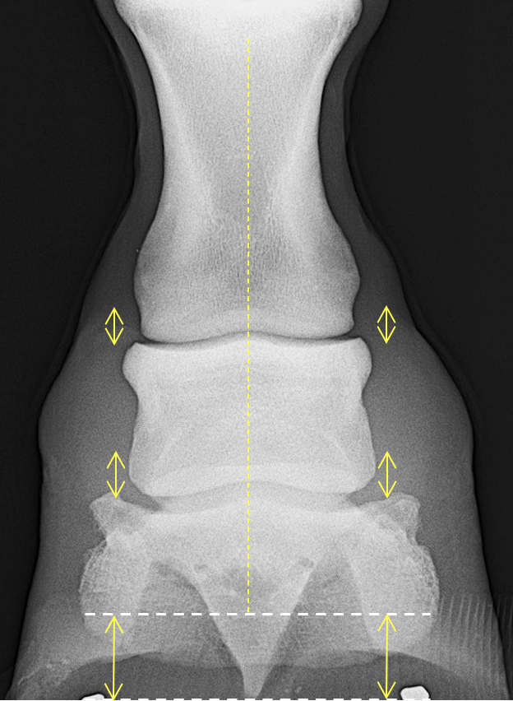
Figure 1: Dorsopalmar radiograph of a front foot obtained in a bipodal stance. On this radiographic view it is possible to evaluate the height of the distal phalanx from the ground and the thickness of the joint space medialy. Photo credit: V.Busoni

Again, the appearance of the joints will change with the stance of the horse, and it will be essential to standardize the positioning as much as possible. For example, if the horse does not stand square and the limb is positioned in abduction, the dorsopalmar radiograph will show a medial compression of the distal interphalangeal joint space, even if the horse is in a bipodal stance, and the hoof has the same height medially and laterally (Figure 2).

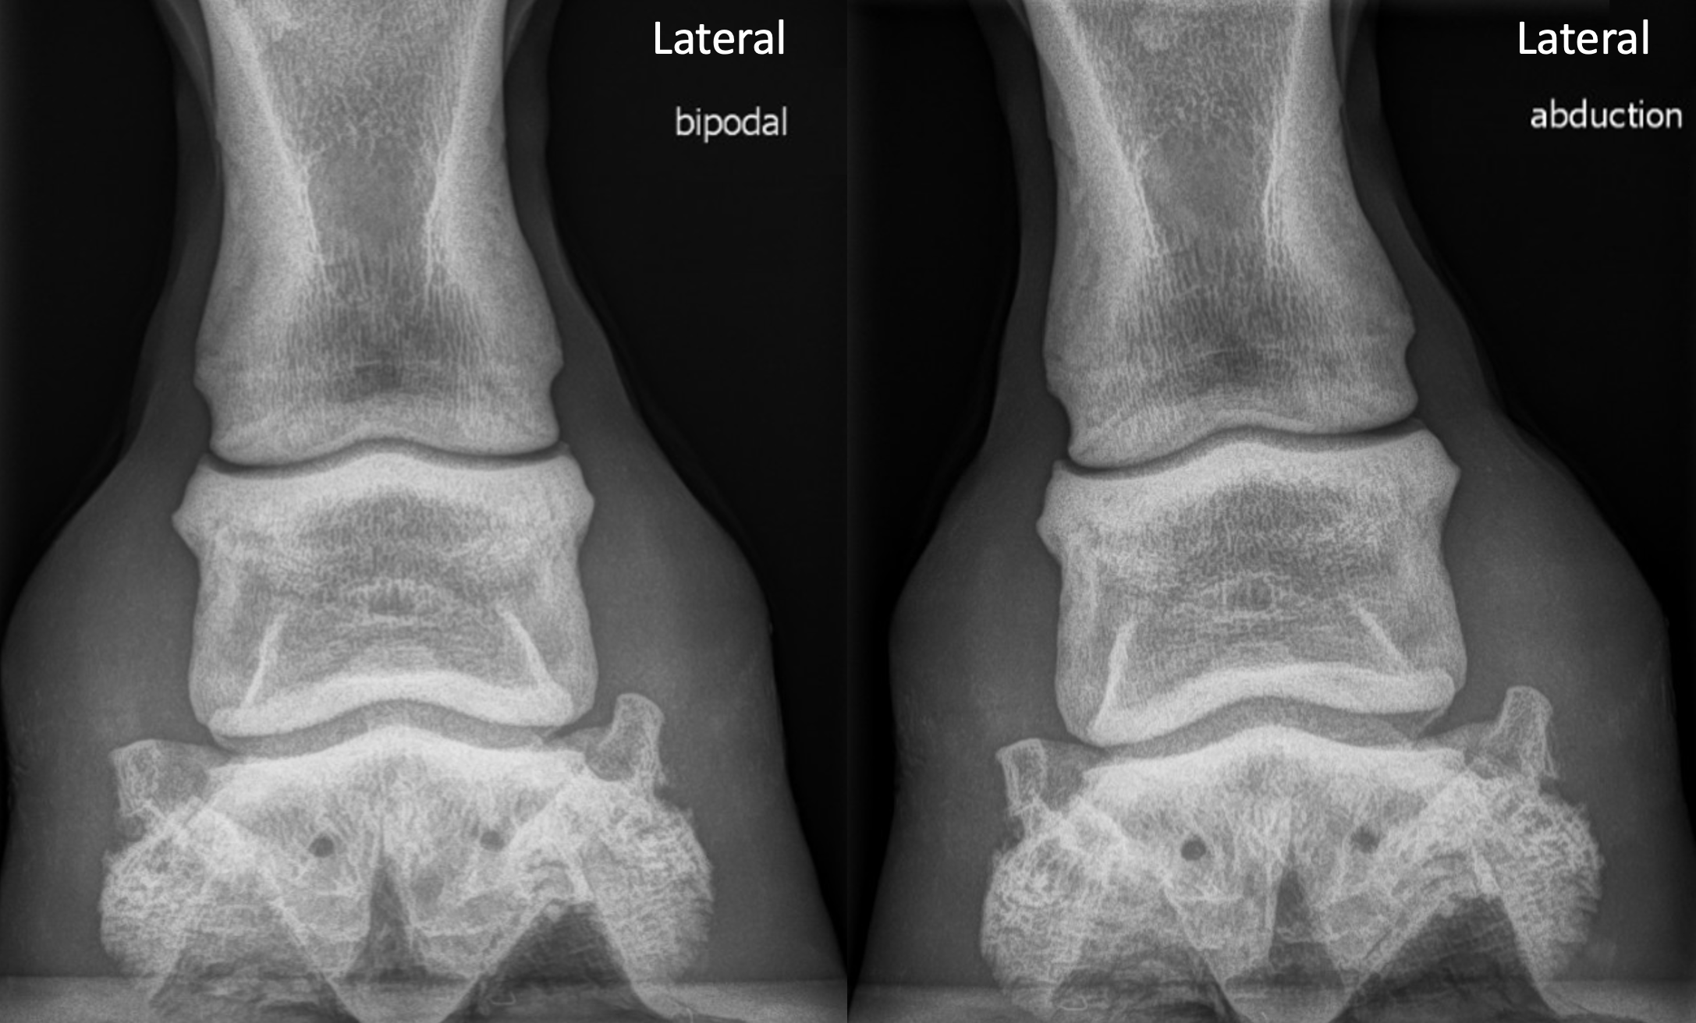
Figure 1: Dorsopalmar radiographs of the same foot obtained in a bipodal stance in a neutral position (left) and in with the limb in abduction (right). Lateral to the right. Note the reduction of the medial joint space on the limb in abduction. Photo credit: V.Busoni

On the dorsopalmar radiographic view obtained in unipodal stance, in contrary to the bipodal stance, there will be an uneven interphalangeal joint space thickness with a reduction of the radiolucent joint space laterally. The distal phalanx will remain horizontal and parallel to the ground and the distal interphalangeal joint will be more affected in comparison to the proximal interphalangeal joint (Figure 2).

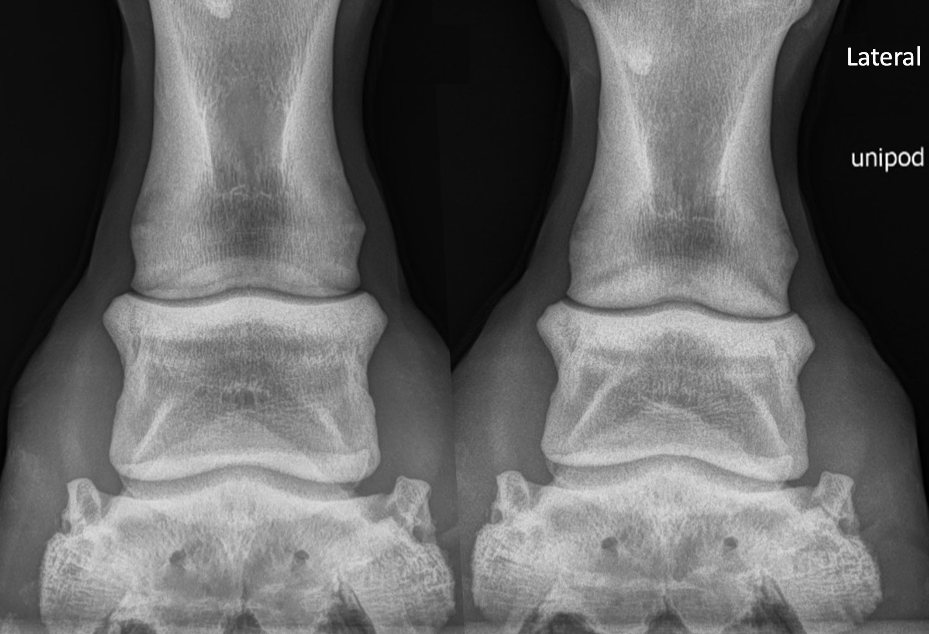
Figure 2: Dorsopalmar radiographs of the same foot obtained in a bipodal stance in a neutral position (left) and in unipodal stance (right). Lateral to the right. The foot has not been moved and only the contralateral limb has been lifted between the 2 radiographs. Note the reduction of the lateral joint space on the limb in unipodal stance. Photo credit: V.Busoni

Mediolaterally imbalanced feet will show a lateromedial slope of the distal interphalangeal joint and an uneven distal interphalangeal joint space (Figure 3).

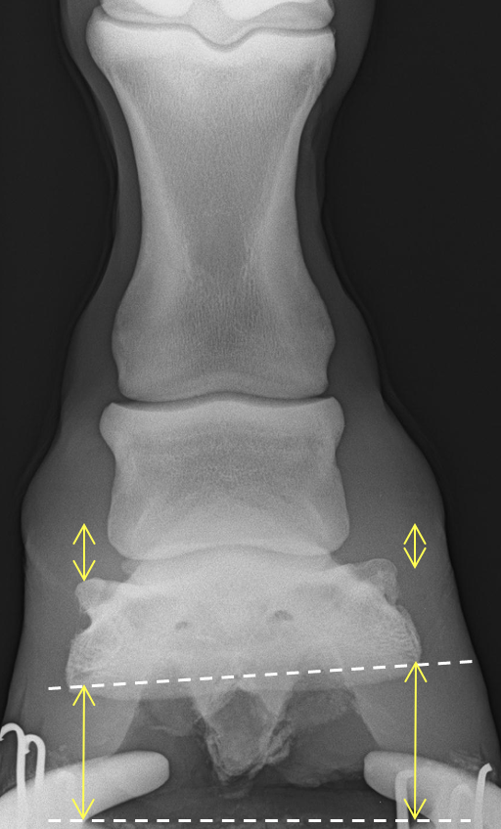
Figure 2: Dorsopalmar radiograph of foot with a radiographic mediolateral imbalance. Photo credit: V.Busoni

