**Hoof dorsopalmar imbalance: the radiologist point of view.**

Valeria Busoni

Imbalance can be defined as a loss of equilibrium or lack of equality between opposing forces.

Dorsopalmar balance is evaluated radiographically on a lateromedial view of the foot.

The lateromedial radiographs to assess dorsopalmar balance should ideally be obtained in a bipodal weight-bearing stance to maintain the natural phalangeal alignment. In fact, stance and weightbearing strongly affect radiographic appearance of equine feet on radiographs and should therefore be taken into consideration when interpreting radiographs, especially when assessing foot balance and conformation. If the lateromedial view is obtained in unipodal stance, the stance would mimic the stance phase of the stride and the increase weight will induce a distal interphalangeal joint flexion, an increase of the angle between the *planum cutaneum* of the distal phalanx and the deep digital flexor tendon, a descent or hyperextension of the metacarpophalangeal joint and a subjective flattening of the dorsal soft tissues at the coronary band (**Figure 1**).

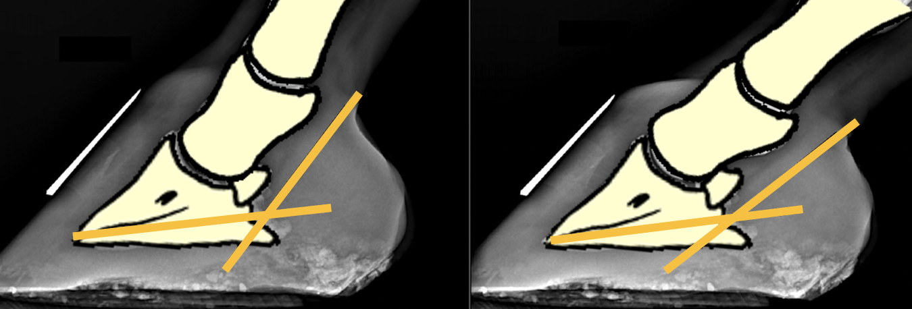

***Figure 1****: Schematic of the lateromedial radiographs of the same foot obtained in a bipodal stance (left) and in an unipodal stance (right). The yellow lines outline the angle between the planum cutaneum of the distal phalanx and the deep digital flexor tendon.* ***Photo credit: V.Busoni***

Radiographic technique will also affect the radiographic image obtained, as image projection on the detector is correlated to relative angle (and distance) between object, x-ray beam and detector. The most important consequences of beam angle change on lateromedial feet radiographs would be due to a too proximal centering or to a beam angle non perpendicular to the sagittal plane of the foot. A proximal centering will induce a descending x-ray beam to the foot and can be recognized as it produces a lack of superimposition (a proximo-distal “separation”) of the palmar processes of the distal phalanx (**Figure 2**).

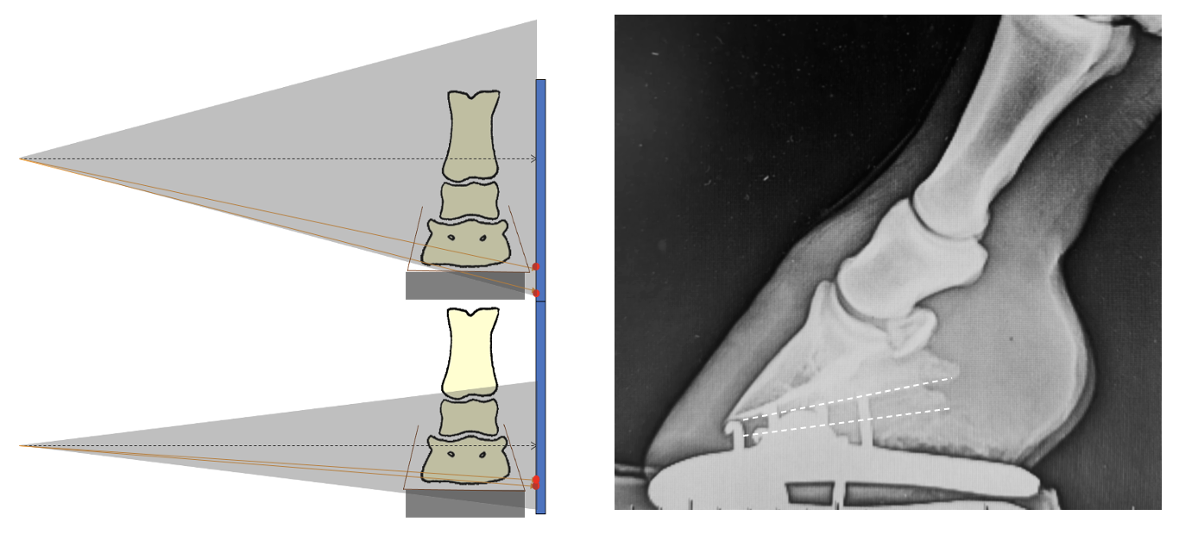

***Figure 2:*** *The height of the x-ray centering in the lateromedial radiographic view will influence the superimposition of the palmar processes of the distal phalanx and may mimic a difference in height between the medial and lateral aspects of the hoof. On the radiograph on the right the centering is slightly proximal to the proximal interphalangeal joint and the lateral palmar process is projected more distally than the medial one (white dotted lines).* ***Photo credit: V.Busoni***

An x-ray beam lacking perpendicularity to the sagittal plane of the foot can be recognized as there will be a lack superimposition (with a dorsopalmar “separation”) of the middle phalanx condyles (**Figure 3**).

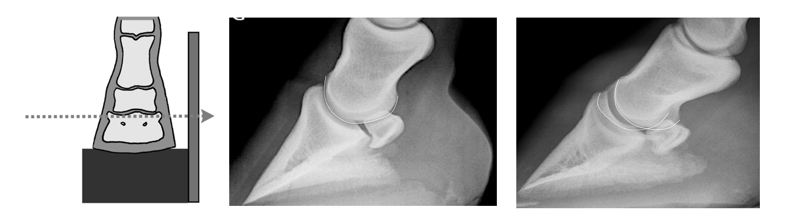

***Figure 3:*** *Positioning of the foot and centering for a weight-bearing lateromedial radiographic view of the foot and 2 lateromedial radiographs. In the radiograph on the left the x-ray beam is perpendicular to the sagittal plane of the foot. In the radiograph on the right the beam is not perpendicular to the sagittal plane of the foot and the condyles of the middle phalanx are not superimposed (white lines).* ***Photo credit: V.Busoni***

Although minimal imperfection will not drastically change the image, each deviation may increase the difficulty to delineate and interpret anatomical structures and landmarks and influence some radiographic measurements.

In a balanced foot, the phalanges should be aligned, the distal phalanx should be at an angle between 5 to 10° to the ground and a line dropped perpendicularly to the ground from the center of the distal condyles of the middle phalanx should divide the foot mass in a dorsal and palmar portion, whose proportion (dorsal to palmar) should not ideally exceed 65% (**Figure 4**).

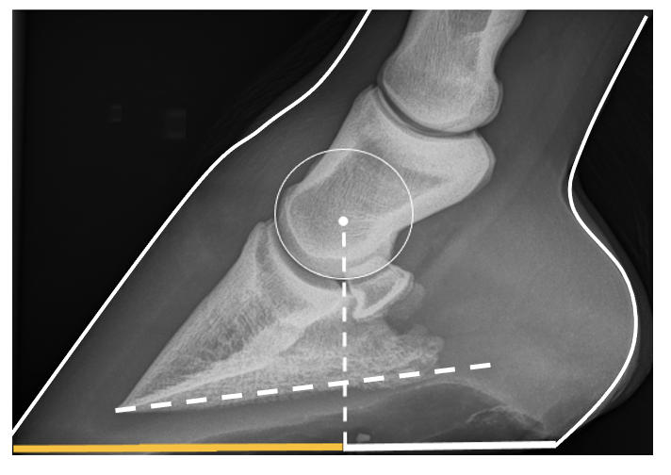

***Figure 4:*** *In a balanced foot, the distal phalanx angle to the ground should be 5 to 10° and the proportion dorsal to palmar foot mass should not exceed 65%.* ***Photo credit: V.Busoni***

Horses with long-toe and low-heels will have a low (< 2°, sometimes 0° or even negative) distal phalanx angle and an imbalance of the foot mass with excessive mass dorsal to line dropped perpendicular form the center of the middle phalanx (Figure 5). This imbalance will lead to a longer lever arm at break over and a hyperextension of the distal interphalangeal joint, inducing stress on the distal interphalangeal joint at break over and increasing deep digital flexor tendon strain and navicular bone pressure.

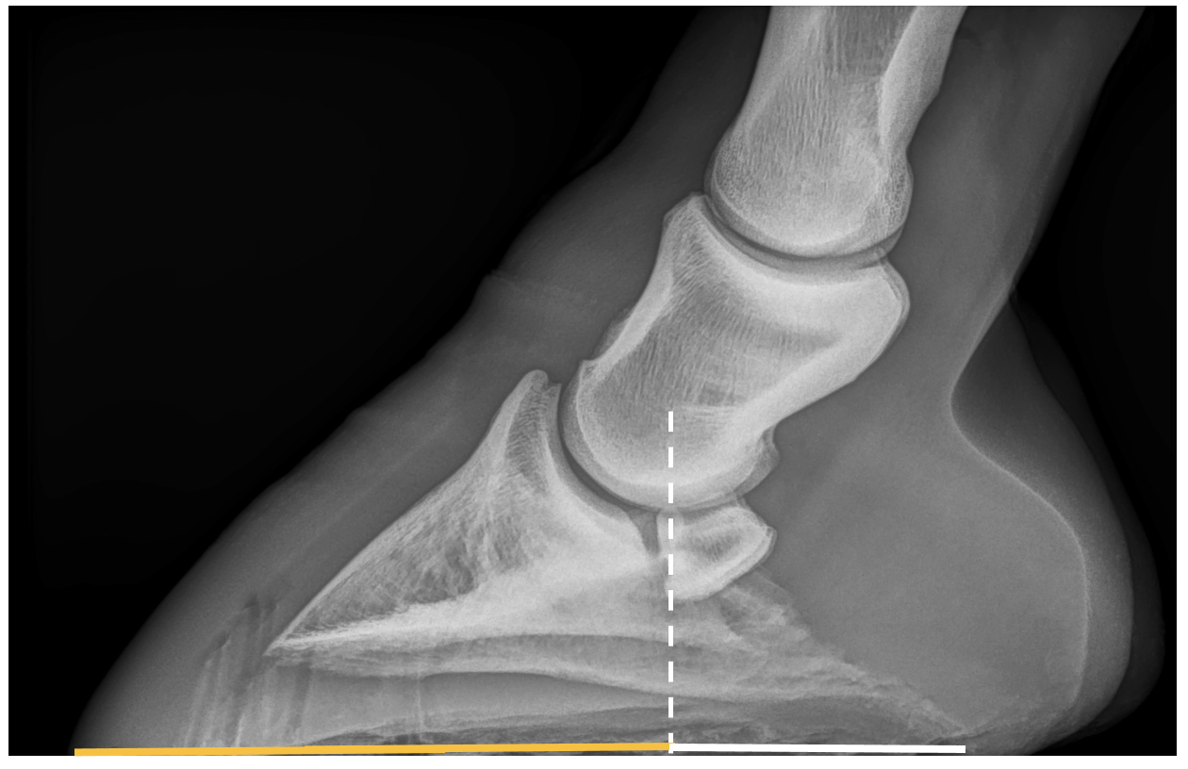

**Figure 5:** Forefoot with reverse distal phalanx angle and dorso-palmar imbalance.  ***Photo credit: V.Busoni***