Superparamagnetic Colloids: Formation and Dynamics of Chains and Disk-like Clusters under External Magnetic Fields

Colloids made of superparamagnetic microbeads offer the possibility to be controlled remotely with a magnetic field. This enables various applications such as mixing, transport of fluids through microscale channels, or propulsion in a viscous fluid. In order to achieve such goals, understanding the interactions between the field, the microbeads and the liquid medium is fundamental.
Indeed, superparamagnetic colloids exposed to an external magnetic field form specific structures that are dependent on the features of the external field. If the magnetic field remains constant over time, superparamagnetic colloids self-organize into chains oriented in the direction of the field. If the magnetic field is rotating in the plane of the suspension, below a critical frequency, the superparamagnetic beads still aggregate into chains, and these chains rotate with the magnetic field. As the rotation speed increases, the length of these rotating chains decreases, due to the competition between magnetic and viscous effects. When the rotation reaches a certain speed, the colloids aggregate in rotating disk-like clusters.
In this presentation, we will focus on the aggregation dynamics of both chains and disklike clusters, including the transition between those two states, as well as the influence of the magnetic field rotation frequency and the colloidal volume fraction. We will also review the effects of this aggregation process on characteristic features of the colloidal suspension, such as the coffee-ring effect.

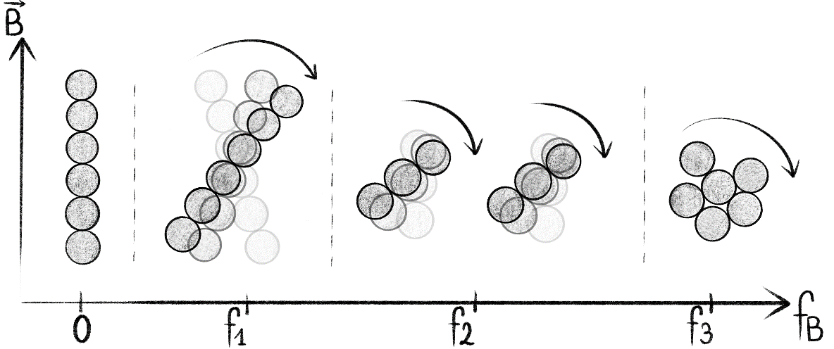

Bibliography:

Ribbons of superparamagnetic colloids in magnetic field, A. Darras, J. Fiscina, M. Pakpour, N. Vandewalle and G. Lumay, European Physical Journal E 39, 47 (2016)

Effect of volume fraction on chains of superparamagnetic colloids at equilibrium, A. Darras, E. Opsomer, N. Vandewalle and G. Lumay, European Physical Journal E 42, 13 (2019)

Combined effects of Marangoni, sedimentation and coffee-ring flows on evaporative deposits of superparamagnetic colloids, A. Darras, N. Vandewalle and G. Lumay, Colloids and Interface Science Communications 32, 100198 (2019)

Superparamagnetic colloids in rotating field : transition state from chains to disks, F. Mignolet, A. Darras, and G. Lumay, Physical Review E

