Cropland abandonment across the Yangtze River Basin does provide only limited benefits for C sequestration.

**Yuqiao long, Jing Sun, Joost Wellens, Gilles Colinet, Wenbin Wu, Jeroen Meersmans**

**Abstract:** Recent estimates from satellite imageries indicated that extensive cropland abandonment took place across China due to rural outmigration, agricultural policy, and environment changes[1-3]. Cropland abandonment provides an opportunity for C sequestration, and therefore climate change mitigation, soil retention and food security. However, this depends on the duration of cropland abandonment, which lacks comprehensive research. In this study, we map cropland abandonment and recultivation across the Yangtze River Basin in central China using a series of annual land cover maps of the period 2000 - 2020. The InVEST model is used to study the spatial distribution of carbon storage. We found that cropland abandonment is widespread, but last on average only 5.5 years. In addition, over 50% of the abandoned croplands will be recultivated (i.e. back into cropland) or convert into impervious surfaces (i.e. urban) within 20 years, limiting its ability to provide ecosystem services, such as climate regulation, soil retentio, due to a relatively small capacity of C sequestration. More precisely, the combined effect of recultivation and conversion into impervious surfaces resulted in an accumulated loss of 74% of abandoned croplands [Figure 1] and 48% of carbon [Figure 2] as compared to a situation without recultivation or conversion into impervious surfaces. In conclusion, this study highlights the need for land policymakers to make careful reflections as regards the conversion of abandoned croplands to mitigate climate change and combat soil degradation. Hence, it could be interesting to set up incentives for ecological restoration to valorize opportunities that cropland abandonment may provide us with when aiming to achieve the UN Sustainable Development Goals (SDGs).

References:

1. Liang, X.; Jin, X.; Yang, X.; Xu, W.; Lin, J.; Zhou, Y. Exploring cultivated land evolution in mountainous areas of Southwest China, an empirical study of developments since the 1980s. *Land Degradation & Development* **2021**, *32*, 546-558.

2. Long, Y.; Wu, W.; Wellens, J.; Colinet, G.; Meersmans, J. An In-Depth Assessment of the Drivers Changing China’s Crop Production Using an LMDI Decomposition Approach. *Remote Sensing* **2022**, *14*, 6399.

3. Yan, J.; Yang, Z.; Li, Z.; Li, X.; Xin, L.; Sun, L. Drivers of cropland abandonment in mountainous areas: A household decision model on farming scale in Southwest China. *Land Use Policy* **2016**, *57*, 459-469.

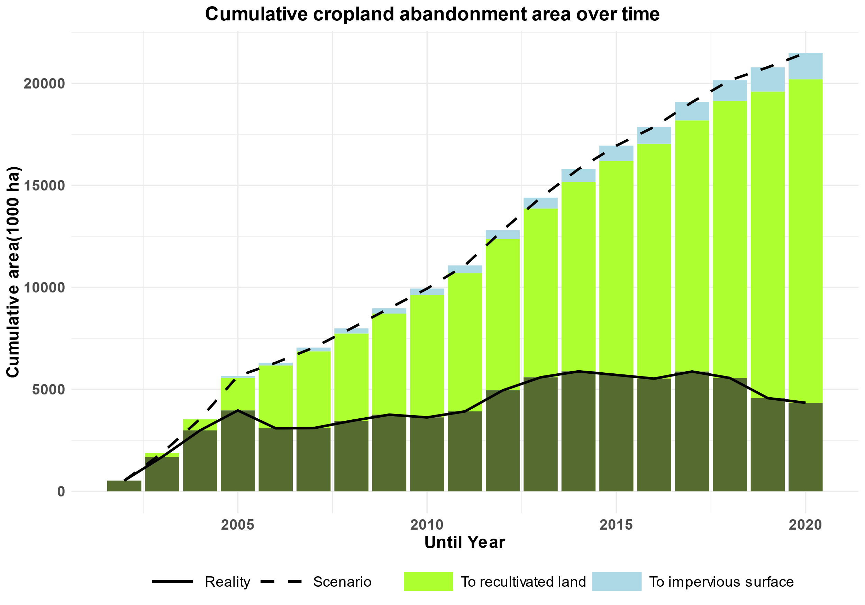

**Fig.1 Temporal trend of cropland abandonment.** The solid black line represents the total cumulative observed area of abandoned cropland, and the dashed black line represents the potential area of abandoned cropland, assuming a scenario without recultivation and conversion to impervious surfaces.

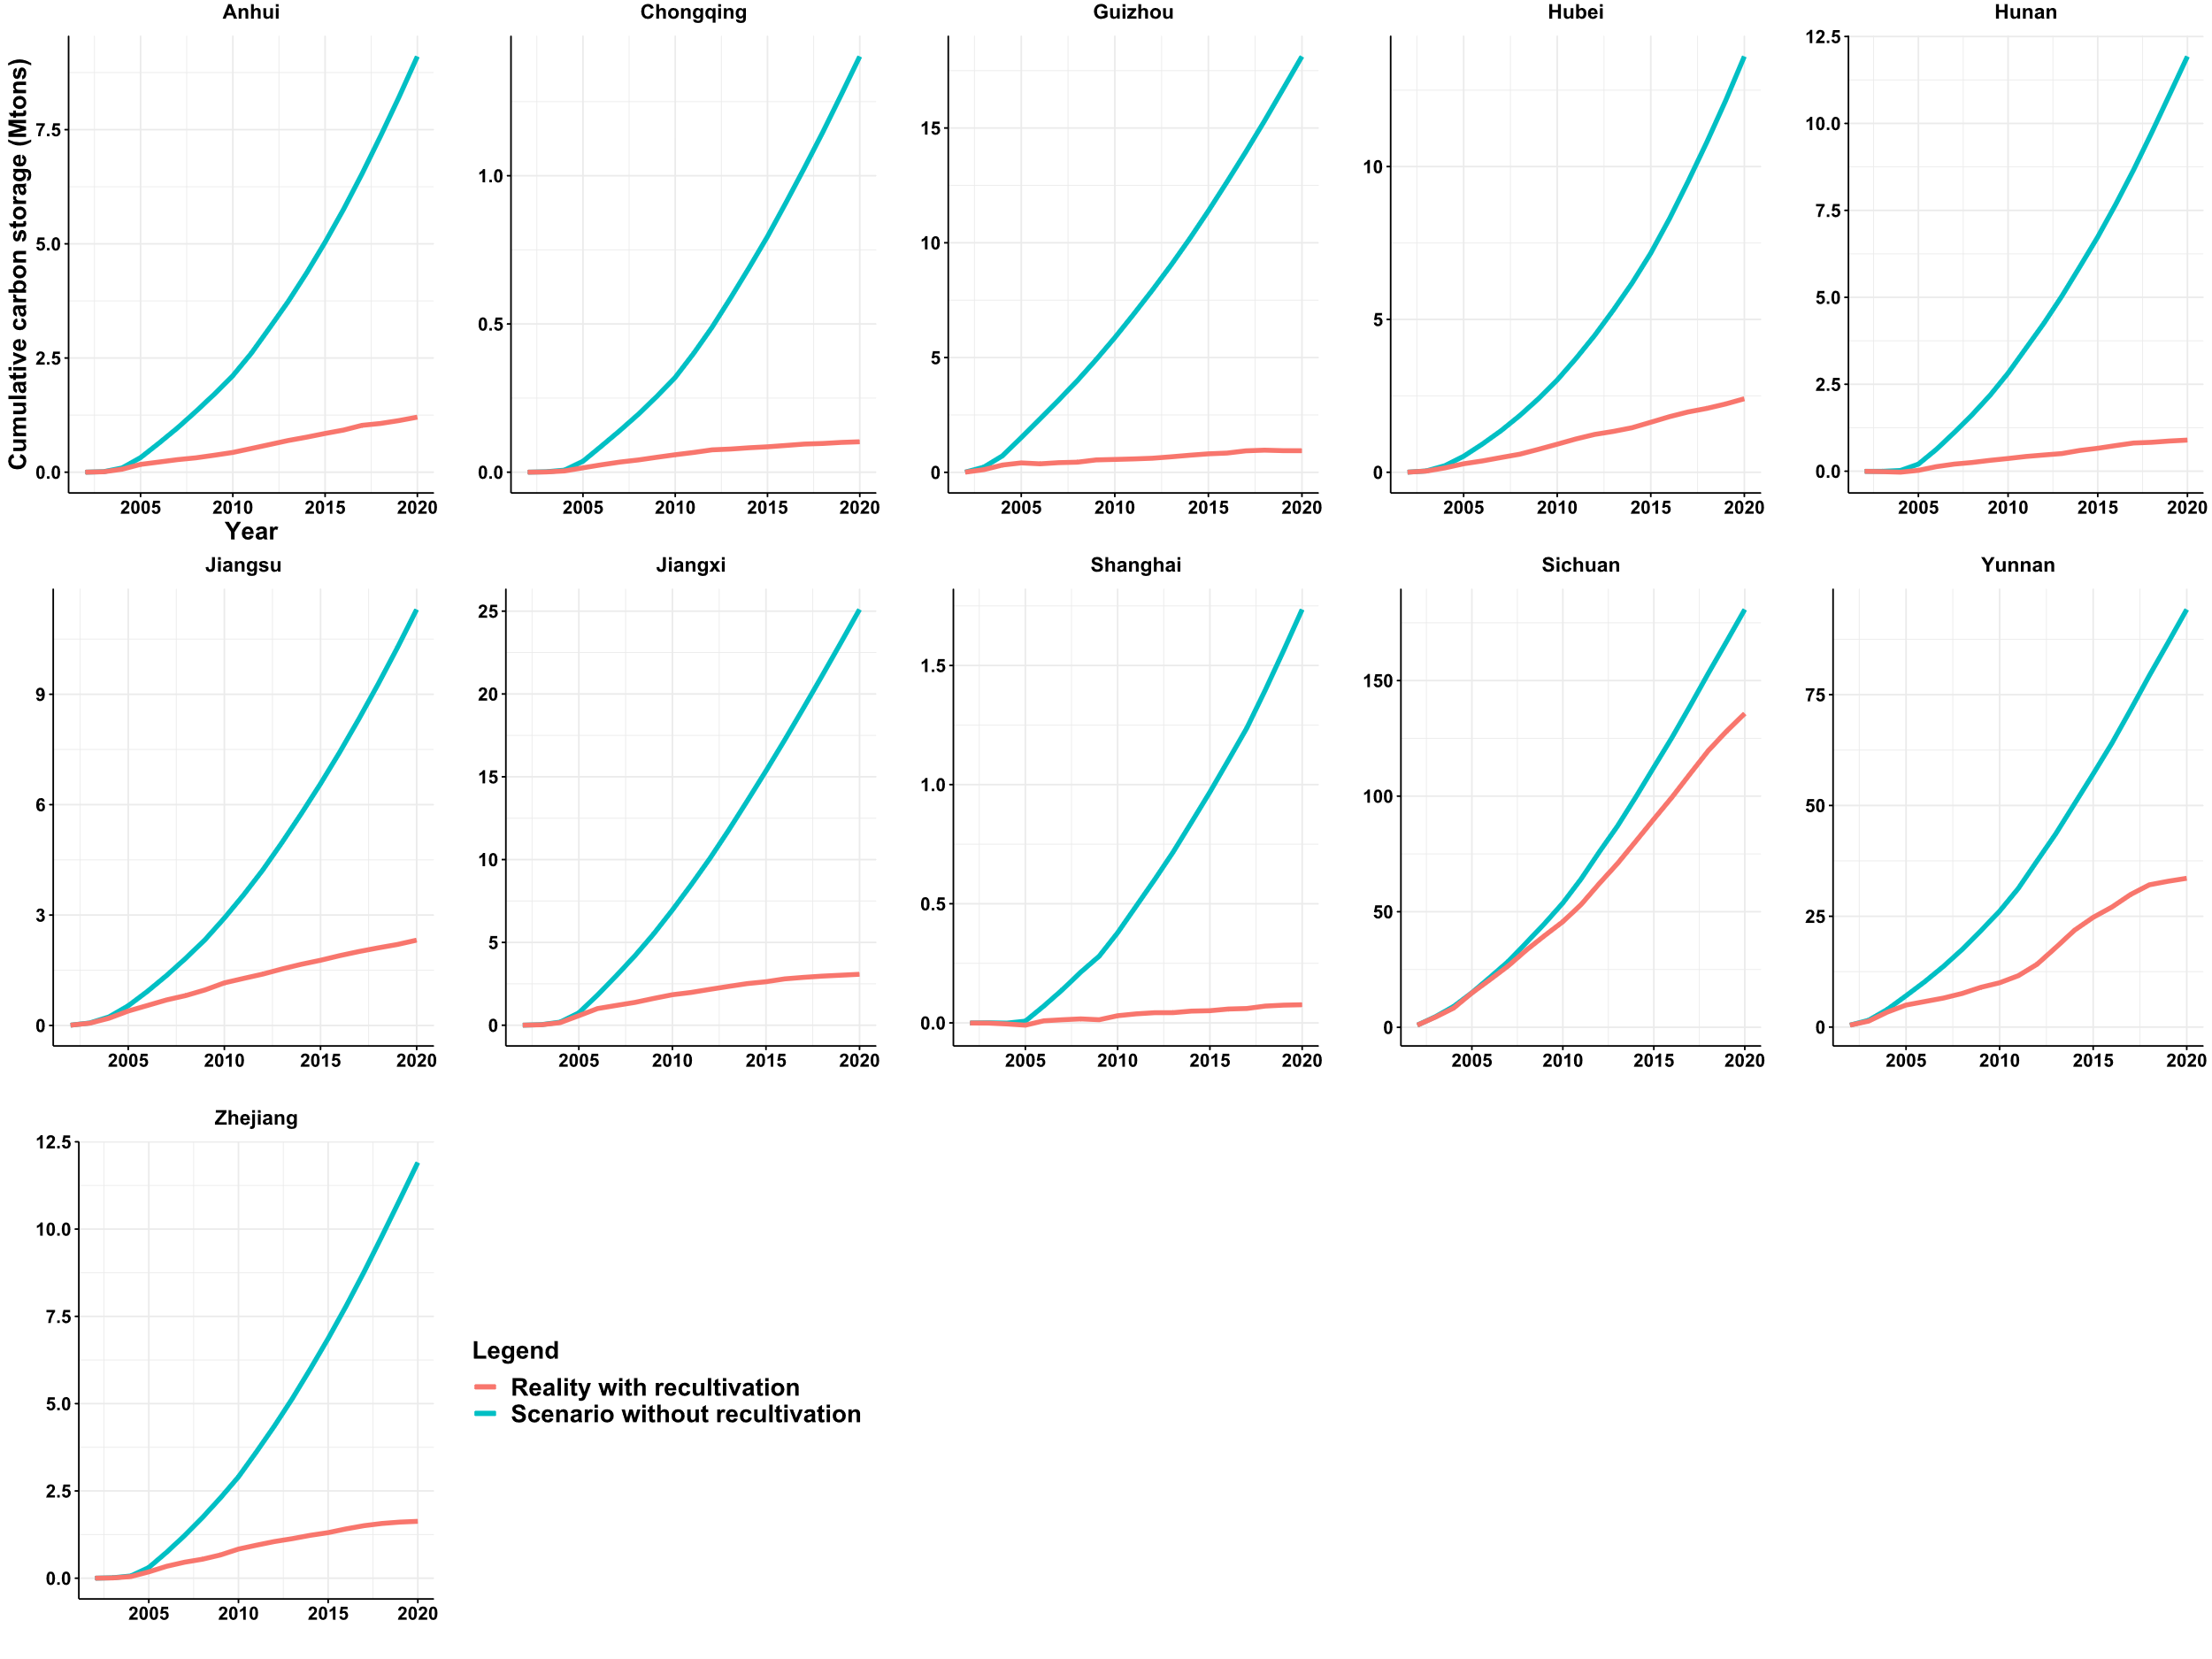

**Fig.2 Temporal trend of carbon sequestration following cropland abandonment**. Carbon accumulation following abandonment in each province over time, in terms of Mton C (106 tons C). The solid orange line represents the total observed carbon accumulation in each province, and the solid red line represents the potential carbon accumulation, assuming a scenario without recultivation and other conversions.