Isolation and functional analysis of SaFLC during vernalization and flowering in the long-day plant Sinapis alba

Maria D’Aloia, Pierre Tocquin and Claire Périlleux

ABSTRACT
Onset of flowering is a major transition in the plant life cycle and is controlled by environmental factors including photoperiod, light quality and temperature. Prevalence of controlling factors depends on species, hence physiological models were selected for their strong requirement for one or another environmental cue. Among Brassicaceae, Sinapis alba was intensively studied for its strong response to photoperiod while molecular-genetic analyses of Arabidopsis thaliana disclosed complex interactions between pathways inducing flowering in response to photoperiod and other environmental cues, such as vernalization. We were therefore interested in studying the vernalization process in S. alba and its interactions with the previously characterized floral response to long days (LDs). Two-week old seedlings grown in non-inductive short days (SDs) were vernalized at 7°C for increasing durations and a strong promotive effect of vernalization was observed. In contrast to the common view of vernalization as a preliminary step bringing the competence to flower, we observed that vernalization had a direct inductive effect on flowering: floral buds were initiated during cold-exposure. Floral integrator genes SaMADSA (homologous to SUPPRESSOR OF OVEREXPRESSION OF CO 1) and SaLEAFY were up-regulated in the shoot apex after 3-4 weeks of vernalization.
To monitor the vernalization process at the molecular level, we isolated SaFLC which, based on sequence analysis, expression patterns and complementation test, appeared as orthologous to FLOWERING LOCUS C. Down-regulation of SaFLC by vernalization was fast since transcript level was already very low after one week of vernalization, but stability of the repression required longer exposure to cold. To test the physiological significance of these observations, we studied the floral response to 16-h LDs after unstable and stable repression of SaFLC. We observed that one week of vernalization – which was sufficient for SaFLC repression but not for maintenance of the silenced state - increased the flowering response of S. alba to LDs when the LDs just followed the cold treatment. This effect was lost after two weeks post-vernalization. In contrast, the promotive effect of longer vernalization on flowering response to LDs was maintained post-vernalization. These results suggested that vernalization not only works when plants experience long exposure to cold in Winter: short cold periods might stimulate flowering of LD-plants if occurring when photoperiod is increasing, i.e. in Spring.

INTRODUCTION

Important progress towards understanding the flowering process was made with genetical studies focused on Arabidopsis thaliana. This species is a quantitative long-day (LD) and cold- requiring plant, hence primary screenings and characterizations of mutants were based on flowering response to photoperiod and vernalization (Koornneef et al., 1991; Martínez-Zapater et al., 1994). Mutants and genes were then classified into three main classes which, after further epistasis and molecular analyses, defined three genetical pathways controlling flowering time in A. thaliana: the LD-promoting pathway, the vernalization-promoting pathway, and the ‘autonomous’ pathway which is defective in mutants that are late flowering but still sensitive to photoperiod and vernalization. A fourth route – the GA pathway - was added based on the observation that flowering of gibberellin-deficient mutants is much delayed, mainly in short days (SD). Downstream of these flowering pathways is a set of ‘integrator’ genes, which include FLOWERING LOCUS T (FT), SUPPRESSOR OF OVER-EXPRESSION OF CO 1 (SOC1) and LEAFY (LFY) (reviewed in Boss et al., 2004; Bernier and Périlleux, 2005; Corbesier and Coupland, 2005).

The photoperiodic pathway involves interactions between light signalling and the circadian clock. LDs promote flowering in A. thaliana by the activation of the transcription factor CONSTANS (CO): the abundance of CO exhibits circadian oscillations (Suárez-López et al., 2001) and only in LDs does a peak in protein amount coincide with the presence of light. Far red and blue lights perceived by phytochrome A and cryptochrome 2 stabilize the protein (Valverde et al., 2004). This ‘external coincidence’ allows CO to activate its targets FT (Onouchi et al., 2000) and SOC1 (Samach et al., 2000).
Both the vernalization- and the autonomous pathways act by repressing an inhibitor of flowering: FLOWERING LOCUS C (FLC) (Michaels and Amasino, 2000). FLC is activated by FRIGIDA (FRI), which is the major-determinant of flowering time variation between summer- and winter- accessions of A. thaliana: active FRI alleles confer late flowering and a strong vernalization requirement (Johanson et al., 2000). Vernalization downregulates the FLC mRNA level, with longer periods of cold exposure leading to less FLC mRNA (Sheldon et al., 2000). The process is saturated after several weeks of cold; the vernalized state then remains stable for the rest of plant life cycle. This epigenetic silencing of FLC is mediated by histone modifications in the 5’ region of FLC: an early step in this process is H3 deacetylation, and the stable maintenance of FLC repression involves H3K9 and H3K27 methylation. These modifications create an ‘histone code’ associated with FLC repression (reviewed in Sung and Amasino, 2006).

The identification of distinct genetical pathways controlling flowering time in A. thaliana was consistent with the fact that environmental factors participating in the control of flowering time are not all perceived by the same organ(s). While photoperiod is perceived by expanded leaves and requires systemic signalling toward the shoot apical meristem (SAM) to induce flowering, vernalization is mostly sensed by the SAM and can induce flowering of isolated apices (Bernier et al., 1981; Metzger, 1988). In nature, vernalised plants often require LD exposure after winter hence vernalization has long been regarded as bringing the competence to flower (Chouard, 1960). Both steps were then studied in separate genetical analyses, until recently. FLC was indeed found to play a role in both the leaves and the SAM, by repressing FT and SOC1 (Searle et al., 2006). FLC was also shown to be involved in thermal control of floral induction (Blásquez et al., 2003; Balasubramanian et al., 2006) and circadian clock (Edwards et al., 2006; Salathia et al., 2006). Hence modelling flowering pathways is becoming much more complex and FLC might have broader functions that initially thought. In this context, we were interested in studying vernalization in a plant that has long been used for dissecting the photoperiodic pathway. Sinapis alba (white mustard) is a Brassicaceae which has been described as a facultative LD-, vernalization-requiring plant in natural conditions (Bernier, 1969; Bodson, 1985). Interestingly, S. alba exhibits a caulescent growth habit from sowing, in contrast to the great majority of LD- and vernalization- requiring plants which grow as rosettes when in the vegetative state (Lang, 1965). In phytotronic cabinets, non-vernalized plants of S. alba can be maintained vegetative in SDs, then induced to flower by a single LD when 2-month old (Bernier et al., 1981). This system was extensively used to analyse physiological signals leading to flowering, and a detailed picture of sequential events of floral transition was described (reviewed in Bernier et al., 1993; Bernier and Périlleux, 2005).
We report here isolation and characterization of SaFLC, which we suggest is orthologous to AtFLC. The quantitative effect of increasing durations of cold was observed at both the physiological and molecular levels: longer periods of vernalization led to earlier flowering in SDs and lower SaFLC transcript levels. Initiation of flowers actually occurred during vernalization. Most interestingly, we found that a short vernalization treatment – which was not sufficient for stable repression of SaFLC and promotion of flowering in SDs – significantly increased plant sensitivity to LDs. This result suggests that cold experienced in spring, when photoperiod is increasing, might have a vernalizing effect in S. alba.

EXPERIMENTAL PROCEDURES

Plant growth conditions
Plants were grown in 8-hr SDs as described by Lejeune et al. (1988). The irradiance at the top of the plants was 150 µmol.m⁻².sec⁻¹ and was provided by very-high-output Sylvania fluorescent white tubes (Zaventem, Belgium). Temperature was kept constant at 20°C except during the vernalization treatments where 2-week old plants were transferred to 7°C - 85 µmol.m⁻².sec⁻¹ for 1 to 6 weeks before being returned to 20°C. Flowering time was scored as ‘days to macroscopic appearance of floral buds’.
In experiments where plants were transferred transiently to 16h-LDs, flowering was measured by dissection of the apical buds under the binocular microscope 2 weeks after start of exposure to LDs and expressed as % of floral plants. A plant was classified as floral when at least one flower primordium was present within the apical bud. Each experimental batch counted 15 – 20 individual plants.

Isolation of SaFLC cDNA and sequence analysis
A λgt10 cDNA library made from S. alba leaf mRNA (Menzel et al., 1996) was screened with a cDNA probe of A. thaliana FLC (AtFLC). For probe synthesis, cDNA was prepared from fca mutant mRNA. A fragment of AtFLC cDNA was amplified with primers: AtFLC-fwd: 5’-TCATCATGTGGGAGCAGAAG-3’ and AtFLC-rev: 5’-TACAAACGCTCGCCCTTATC-3’.
About 150,000 clones of the library were screened and one positive was isolated, subcloned into pGEM®-T Vector (Promega, http://www.promega.com/) and sequenced. Sequence alignment showed a high identity with BnFLC1 and AtFLC; we thereafter called the isolated sequence SaFLC. To isolate a full length cDNA, we designed a pair of primers based on the nucleotide sequence of BnFLC1 (GenBank Accession No. AY036888) for the 5’ region (BnFLC1-fwd: 5’-AGGGCGCAAAGCAC
TGTTGGAGAC) and on the partial SaFLC clone for the 3’ region (SaFLC-rev: 5’-TTACAAGGGGATAAATACACATCTTG-3’). RT-PCR was performed on cDNA prepared from RNA extracted from aerial part of 2-week old S. alba plants. A fragment of 702 bp was obtained, cloned into pGEM®-T Vector and sequenced (Genbank Accession No EF542803).
Amino acid sequence alignment of SaFLC and other FLC proteins from Arabidopsis thaliana, A. arenosa, A. suecicea, A. lyrata, Brassica napus, B. oleracea, B. rapa, B. juncea and Raphanus sativus was generated using the ClustalW program (http://www.infobiogen.fr/
services/analyseq/cgi-bin/clustalw_in.pl). Partial amino acid sequences were used for alignment because the sequence of the MADS box is unavailable for some FLC genes (BoFLC, BrFLC and BjFLC) (Schranz et al., 2002; Martynov and Khavkin, 2004). Aligned sequences were analyzed using the PAUP* program (Phylogenetic Analysis Using Parsimony, Sinaur Associates, Sunderland, MA).

Construction of binary vector and A. thaliana transformation
The SaFLC cDNA was fused to a portion of AtFLC promoter (1886 bp upstream of the ATG codon) and inserted into a binary vector derived from the pPZP200 (Hajdukiewicz et al., 1994). After sequencing, the resulting plasmid was transformed into Agrobacterium tumefaciens strain GV3101 (Koncz and Schell, 1986). A chloramphenicol resistant clone was selected for A. thaliana transformation by the floral dipping method (Clough and Bent, 1998).
Complementation test was performed with the flc-3 mutant of A. thaliana. This mutant was obtained in a late-flowering line homozygous for the late-flowering FRI allele from the ecotype San Feliu-2 (FRI-SF2) introgressed in the Columbia (Col) background (Michaels and Amasino, 1999). T1 plants were selected by spraying seedlings with BASTA (0.15%, AgrEvo); 15 transgenics were recovered and self-fertilized. T2 plants were also treated with BASTA, then grown in 8-h SDs, 20°C, 85 µmol.m⁻².sec⁻¹, for flowering time recording. Controls were Col WT (FLC fri), Col FRI (FLC FRI) and the flc-3 mutant (flc FRI). Flowering time was scored as ‘days from sowing to floral bud appearance’, for 12 – 15 plants per line. Three lines were selected for characterization of T3 generation.

RNA extraction and quantification
Total RNA was extracted from tissues using the TRIzol method (Invitrogen, http://www.invitrogen.com/). DNA-free RNA was obtained by DNase treatment (0.2 U DNase µg⁻¹) according to the manufacturer’s instructions (Promega). First strand cDNA was synthesized from 5 µg total RNA with the Moloney murine leukemia virus reverse transcriptase and an Oligo(dT)₁₅ primer according to the manufacturer’s protocol (Promega) in a reaction volume of 40 µl. The cDNA was diluted 2.5 fold with water and 5 µl of diluted cDNA was used for quantification.

qRT-PCR for SaFLC mRNA quantification
For quantification of SaFLC transcripts by quantitative real-time PCR, cDNA was prepared from 3-mm high shoot apices (at least 15 apices per sample). Serial dilutions of a concentrated first-strand cDNA stock were used as relative standards. The PCR reaction mix was prepared using a commercially available master mix containing Taq DNA polymerase, SYBR-Green I, dNTPs and MgCl₂ (iQ SYBR Green Supermix; Bio-Rad). Primers were used in a final concentration of 0.5µM. PCR program was: 95°C, 5 min; 40x (95°C, 30 sec, 57°C, 30 sec, 72°C, 1 min); 72°C, 10 min. All reactions were performed in triplicate with the iCycler iQ real-time PCR detection system of Bio-Rad. Transcript levels were normalized with the amount of transcripts from β-tubulin gene (SaTUB). Specificity of the amplification was confirmed by melting curve analysis and agarose gel electrophoresis. Primers used (SaFLC-fwd, SaFLC-rev, SaTUB-fwd and SaTUB-rev) are given below.

Semi-quantitative RT-PCR for SaFLC and AtFLC expression analyses in the complementation test
For SaFLC and AtFLC quantification in the complementation test experiments, cDNA were prepared from two leaves of 15 plants for each sample. For the semi-quantitative RT-PCR, each 40µl reaction mix contained 1.5 mM MgCl₂, 1 × PCR buffer, 1 µM primers, 200 µM dNTPs, 0.6 U Taq DNA polymerase. PCR program was: 95°C, 5 min; 30 cycles (95°C, 30 sec; 55°C, 30 sec; 72°C, 1 min); 72°C, 10 min. TUBULIN2 was used as a control gene (same PCR program, 25 cycles). PCR products were separated by electrophoresis in an 1.2 % agarose gel. Primers used (SaFLC-fwd, SaFLC-rev, AtFLC2-fwd, AtFLC2-rev, AtTUB-fwd, AtTUB–rev) are given below.

Semi-quantitative RT-PCR for SaMADSA mRNA quantification
For SaMADS A expression analyses, cDNA was prepared from 3-mm high shoot apices (at least 15 apices per sample). PCR program was: 95°C, 5 min; 25 cycles (95°C, 30 sec; 55°C, 30 sec; 72°C, 1 min); 72°C, 10 min. SaTUB was used as a control gene (same PCR program, 20 cycles). PCR products were transferred into a nylon Hybond-N membrane (Amersham) and hybridized with a digoxigenin-labeled probe prepared according to manufacturer’s instructions (Roche). The SaMADSA probe was a fragment amplified by PCR from a full length cDNA clone (Bonhomme et al., 2000). Primers used (SaMADSA-fwd, SaMADSA-rev, SaTUB-fwd and SaTUB-rev) are given below.

Sequences of primers were: SaFLCRT-fwd: 5’-GAAAAGGAGAAATTGCTGGAAGAGGA-3 and SaFLCRT-rev: 5’-GGAGCGTTACCGGAAGATTGATGT-3’ for SaFLC; SaTUB-fwd: 5’-CGAAAACGCTGACGAGTGTATG-3’ and SaTUB-rev: 5’-TTAAGCTGGCCAGGGAAACGAA-3’ for SaTUB, SaMADSA-fwd: 5’-TAGCTGCAGAAAACGAGAAG-3’ and SaMADSA-rev: 5’-ACTTTCTGGAAGAACAAGGTAAC-3’ for SaMADSA; AtFLC-fwd: 5’-CCCCATATGGGAAGAAAAAAACTAG-3’ and AtFLC-rev: 5’-CCCGGATCCCTAATTAAGTAGTGGGAG-3’ for AtFLC (Lee et al., 2000) and AtTUB-fwd: 5’-CTCAAGAGGTTCTCAGCAGTA-3’ and AtTUB-rev: 5’-TCACCTTCTTCATCCGCAGTT-3’ for AtTUB (Yamaguchi et al., 2005).

In situ hybridization
Shoot apices of S. alba plants were fixed in 2% formaldehyde, 100 mM phosphate buffer, pH 7.2 (16 h at 4°C). Fixed tissues were dehydrated, embedded in paraffin according to standard procedures and cut with a rotary microtome. Longitudinal sections (8 µm) were mounted onto poly-L-lysine-coated slides and pretreated for hybridization according to Angerer and Angerer (1992). ³⁵S-UTP-labelled antisense riboprobes were synthesized from truncated SaFLC cDNA lacking the MADS box (377 bp) and cloned in pGEM-T vector or from a complete SaLFY cDNA (1374 bp) cloned in pBluescript II SK+ (Melzer et al., 1999) using T7 and T3 RNA polymerases according to the manufacturer’s instructions (Promega). The hybridization mix was prepared as described by Bonhomme et al. (1997). Incubation, RNase treatment, washing steps, coating with Kodak NTB-2 nuclear Track emulsion, and development of slides were performed according to Angerer and Angerer (1992). Slides were exposed for 2 weeks and stained with 0.1% calcofluor. Autoradiographs were observed with dark-field illumination and the underlying tissue visualized using UV fluorescence.

RESULTS

Effect of vernalization on flowering time in short days
To analyse the process of vernalization in S. alba, we first decided to grow the plants in non-inductive 8-h SD and to start the vernalization treatments when they were 2-week old. At that stage, plants had their cotyledons plus two leaves expanded and shoot apices could easily be harvested. Vernalization was always given at 7°C (day and night).
Different durations of vernalization (1 to 6 weeks) were tested in three independent experiments, where flowering time was recorded as ‘days to macroscopic appearance of floral buds’. As shown in Figure II.3, the effect of vernalization was clearly duration-dependent: while 1 week had no effect on flowering time, 2-week and longer treatments clearly accelerated flowering. After 6 weeks of vernalization, flowering of S. alba in SDs occurred twice as fast as in non-vernalized pants. The vernalization response was saturated after 6 weeks: plants actually initiated flower primordial during their growth in cold (Figure II.7d) and floral buds became macroscopically visible ~70 days after sowing.

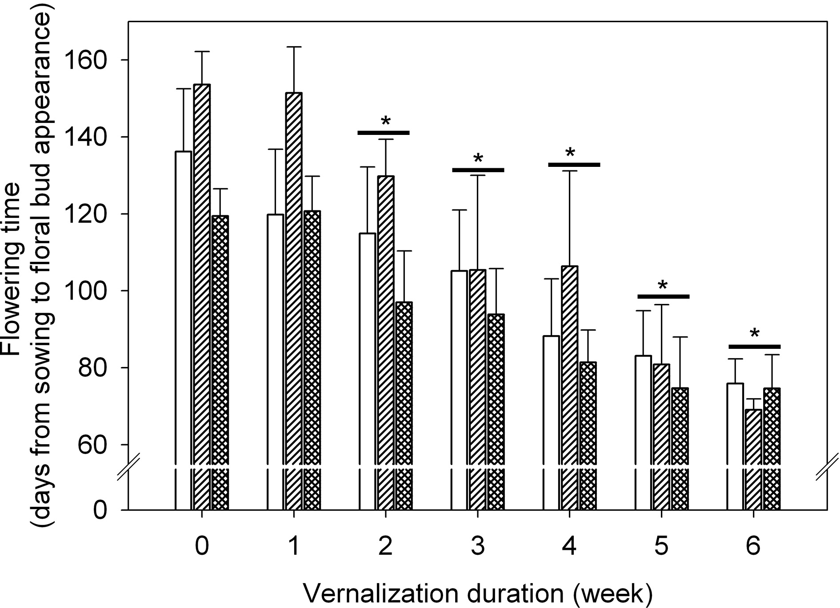

Figure II.3. Vernalization effect on flowering time
Effect of vernalization duration on flowering time of S. alba grown in 8-h SDs. Vernalization treatments started when plants were 2-week old, and were given at 7°C (day/night) for 1, 2, 3, 4, 5, or 6 weeks. Flowering time is expressed as ‘days to macroscopic appearance of floral buds’. Results of three independent experiments are shown. Data are means ± standard deviation for a minimum of 15 plants. *: statistically different from non-vernalized plants (Student’s t test).

Isolation and characterization of SaFLC
An FLC-like cDNA from S. alba (hereafter referred to as SaFLC) was obtained in two steps: screening of a leaf cDNA library with an AtFLC cDNA probe, followed by full-length cDNA cloning by RT-PCR (see Material and methods). SaFLC (702 bp, GenBank accession no. EF542803) encoded a MADS-box protein with predicted amino acid sequence showing 95% identity with BnFLC1 and 85% identity with AtFLC (Figure II.4a). Phylogenetic analyses performed with Brassicaceae sequences indicated that the predicted SaFLC protein felt into one well segregated clade with BnFLC1, BoFLC1 and BrFLC1 proteins (Figure II.4b). This group was the closest to the Arabidopsis genus FLC proteins.
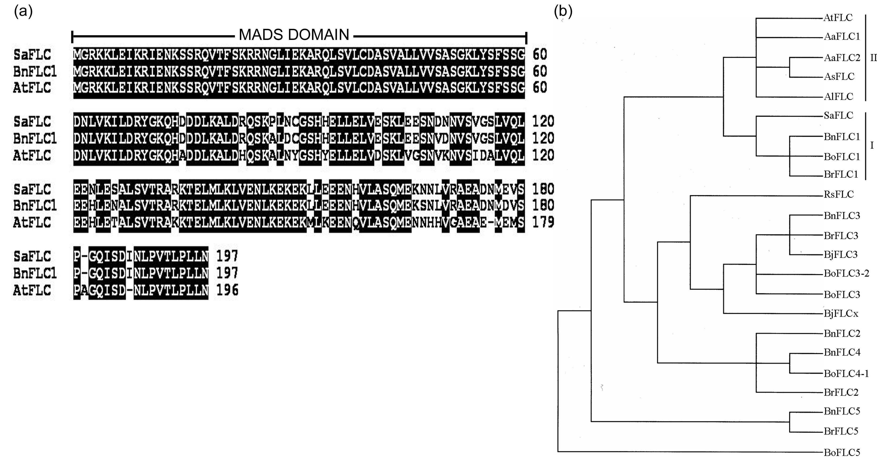
Figure II.4. FLC proteins in Brassicaceae species
(a) Alignment of the deduced amino acid sequences of SaFLC from S. alba, BnFLC1 from Brassica napus, and AtFLC from Arabidopsis thaliana.
(b) Maximum parsimony tree based on amino acid sequences excluding the MADS box domain. Tree includes FLC proteins from A. thaliana (AtFLC, NP_196576), A. arenosa (AaFLC1, AAZ92552; AaFLC2, AAZ92550), A. suecicea (AsFLC, AAZ92553), A. lyrata (AlFLC, AAV51231) S. alba (SaFLC, …), B. napus (BnFLC1, AAK70215; BnFLC2, AAK70216; BnFLC3, AAK70217; BnFLC4, AAK70218 and BnFLC5, AAK70219), B. oleracea (BoFLC1, AAN87902; BoFLC3, AAN87901, BoFLC5, AAN87900; BoFLC3-2, AAQ76274 and BoFLC4-1, AAQ76275), B. rapa (BrFLC1, AAO13156; BrFLC2, AAO86066/AAO86067; BrFLC3, AAO13158 and BrFLC5, AAO13157), Raphanus sativus (RsFLC, AAP31676) and B. juncea (BjFLC3, AAP42143 and BjFLCx, AAP31243). Symbols I and II indicate the groups formed by FLC1 proteins from S. alba and other Brassica species (I) and by FLC proteins from Arabidopsis genus (II).
To estimate the number of FLC copies in S. alba genome, we used a PCR approach developed in B. rapa (Schranz et al., 2002). The methodology was based on the fact that the structure of the AtFLC gene - containing 7 exons and 6 introns - is conserved among Brassica species while length of introns is highly variable. In B. rapa, 4 different PCR products were amplified with conserved primers of exons 2 and 7, indicating the existence of 4 BrFLC copies (Schranz et al., 2002). With the same strategy, we obtained a single 1693-bp amplicon in S. alba, suggesting that SaFLC was a unique gene. The 1693-bp PCR fragment was sequenced and showed 87% identity with the genomic region from exon 2 to exon 7 of BrFLC1 (AY115678) (not shown).

SaFLC was used for complementation tests, by transforming an A. thaliana flc mutant. The SaFLC cDNA was therefore placed under the control of a 2-kb AtFLC promoter and the ProAtFLC::SaFLC construct was used to transform the flc-3 (flc FRI) mutant. This mutant was produced in a Col FRI background, obtained by introgression of the FRI allele from the San Feliu-2 accession (FLC FRI) (Michaels and Amasino, 1999). Because of the flc mutation, the extreme late flowering of Col FRI was suppressed and we expected ProAtFLC::SaFLC (SaFLC FRI) to restore lateness. In a first round of transformation, 15 independent transgenic lines were obtained. Transformants and control plants were grown side by side in SDs; flowering time of T2 plants was scored as ‘days to macroscopic appearance of floral buds’. Only a slight delay in flowering - ranging from 6 to 12 days - was observed in the ProAtFLC::SaFLC transformants (SaFLC FRI), as compared to flc-3 (flc FRI) controls which flowered after ~111 SDs (Figure II.5b). The same result was obtained with T3 plants (Figure II.5c) in which expression of ProAtFLC::SaFLC was checked (Figure II.5d). The slight delay in flowering was statistically significant as compared to flc-3 (flc FRI) controls and ProAtFLC::SaFLC (SaFLC FRI) transgenics flowered at the same time than Col WT (FLC fri). Flowering of Col FRI (FLC FRI) plants was so late that it was not even observed for most of the individuals within the duration of the experiment (6 months).

Expression pattern of SaFLC and downstream genes during vernalization
Expression of SaFLC was detected by in situ hybridization in the shoot apex of 8-week old non-vernalized plants (Figure II.6a), but not in plants that had been vernalized for 6 weeks (Figure II.6b). Note that the apex shown in Figure II.6b was initiating flower primordia during the vernalization treatment.
Real-time RT-PCR was then carried out for a time-course analysis of SaFLC expression during vernalization. Shoot apices were harvested weekly; four independent experiments were conducted.
As can be seen in Figure II.6c, SaFLC transcript level remained quite high and constant in non-vernalized controls during the time course of the experiment. On the opposite, SaFLC sharply decreased in apices of vernalized plants, and transcript level was already very low after one week at 7°C. Further exposure to cold yet correlated with fainting of the SaFLC transcript level.

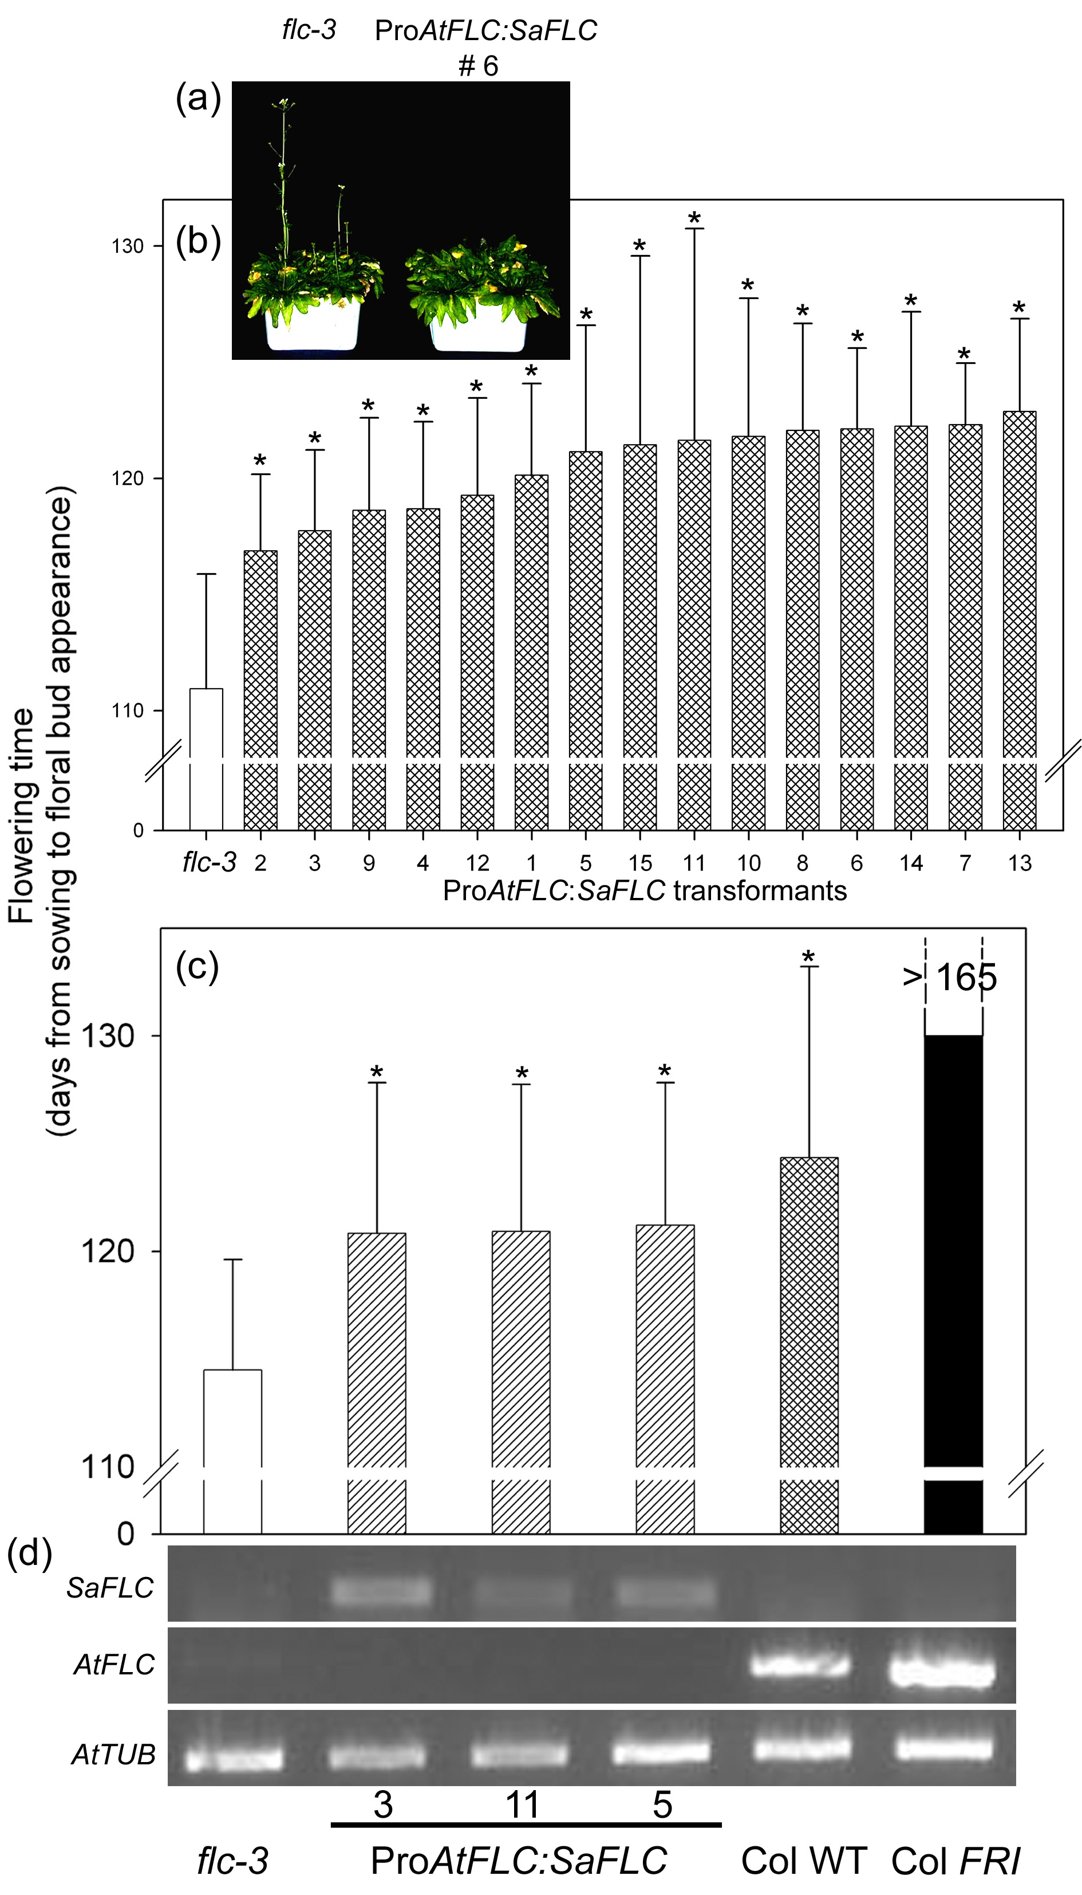

Figure II.5. Flowering phenotype of ProAtFLC:SaFLC plants in 8-h SDs
(a) Late flowering phenotype of one T₂ transgenic line expressing ProAtFLC::SaFLC (right) compared with untransformed flc-3 mutant (left) 115 days after sowing.
(b) Flowering time of fifteen T2 transgenic lines expressing ProAtFLC::SaFLC. Controls are flc-3 mutants (white). Flowering time was scored as days to macroscopic appearance of floral buds in 8-h SDs. Data are means ± standard deviation of 12-15 plants for each line. *: statistically different from flc-3, non-parametric Mann-Whitney U-test.
(c) Flowering time of three T3 transgenic lines expressing ProAtFLC::SaFLC. Controls are flc-3 mutants (white), Col WT (dark grey) and Col FRI (black). Flowering time was scored as in (b). *: statistically different from flc-3, non-parametric Mann-Whitney U-test.
(d) RT-PCR analysis of SaFLC and AtFLC in the different genotypes shown in (c). AtTUBULIN2 was used as a control.

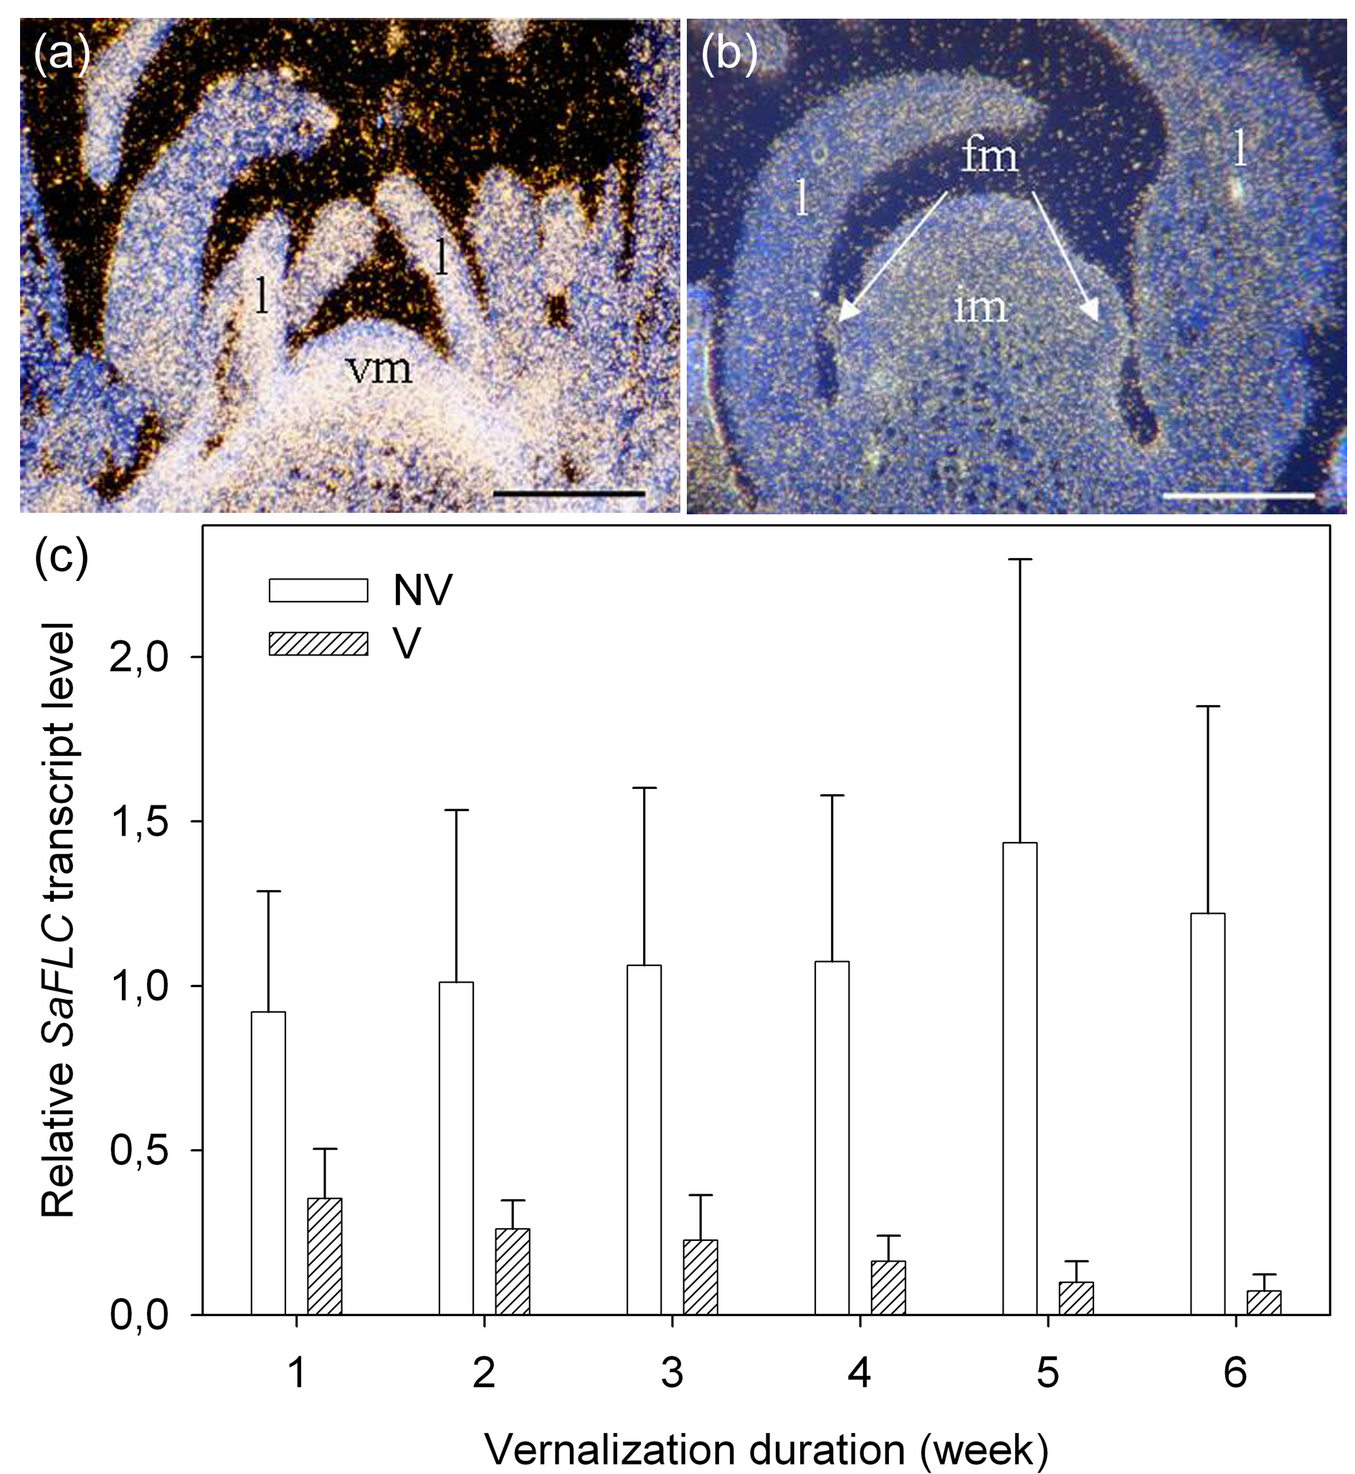

Figure II.6. SaFLC expression patterns
(a-b): In situ hybridization pattern of SaFLC at the shoot apex of 8-week old plants of S. alba grown in SDs, either non-vernalized (a) or vernalized for 6 weeks (b). Bar = 100 µm. fm: flower meristem, im: inflorecence meristem; l: leaf; vm: vegetative meristem. (c) Time course analysis of SaFLC transcripts in shoot apices of plants of S. alba grown in 8-h SDs. Plants were either vernalized at 7°C (V) or non-vernalized at 20°C (NV). Shoot apices were harvested on 15 plants for each sample. qRT-PCR was used on total RNA and expression of SaTUBULIN was used for data normalization. Results shown are means ± standard deviation of four independent experiments.

AtFLC was shown to repress SOC1 in the SAM (Searle et al., 2006). We therefore examined by RT-PCR the expression pattern of the homologous gene SaMADSA (Bonhomme et al., 2000) during the vernalization treatment. As shown in Figure II.7a, expression of SaMADSA was not detected in non-vernalized apices, as already shown by Bonhomme et al. (2000). SaMADSA transcript level increased in the shoot apex from the 3rd week of vernalization and was highest after 6 weeks of vernalization. Since, as mentioned before, floral buds were initiated during long vernalization treatments, we also performed in situ hybridizations with a SaLFY probe. In non-vernalized apices, expression of SaLFY was detected at the tip of leaf primordia, but not in the SAM (Figure II.7b). After 4 weeks of vernalization, upregulation of the gene was observed in the whole SAM, which showed obvious bombing (Figure II.7c). After 6 weeks of vernalization, SaFLY was highly expressed in flower primordia and in the flanks of the SAM (Figure II.7d).

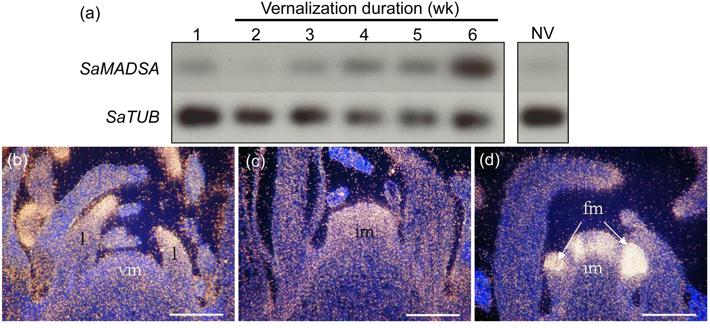

Figure II.7. Expression of SaMADSA and SaLFY during vernalization
(a) Time course analysis of SaMADS A expression during vernalization in 8-h SDs, 7°C. Shoot apices were harvested on 15 plants for each sample. RT-PCR was used on total RNA and expression of SaTUBULIN was used as a control. (b-d) In situ hybridization pattern of SaLFY at the shoot apex of plants of S.alba grown in SDs and either non-vernalized (8-week old plants shown in a) or vernalized for 4 weeks (6-week old plants shown in b) or vernalized for 6 weeks (8-week old plants shown in d). Bar = 100µm.

Expression pattern of SaFLC post-vernalization
Effect of vernalization appeared much sharper on SaFLC repression (Figure II.6c) than on flowering time (Figure II.3). We therefore quantified SaFLC transcripts after vernalization. In two independent experiments, plants were vernalized for 1 or 3 weeks and harvested straight after the vernalization treatment (Post Vernalization Time PVT0), or 2 weeks later (PVT2) (Figure II.8a). Non-vernalized controls were harvested at each sampling time. As shown in Figure II.8b, it was observed that the level of SaFLC transcript, although very low at the end of the vernalization treatment, resumed when plants were returned to 20°C. When plants had been vernalized for only one week, the level reached at PVT2 was not different than in non-vernalized controls (Figure II.8b). When plants had been vernalized for 3 weeks, SaFLC transcript level remained lower than in non-vernalized controls (Figure II.8b).

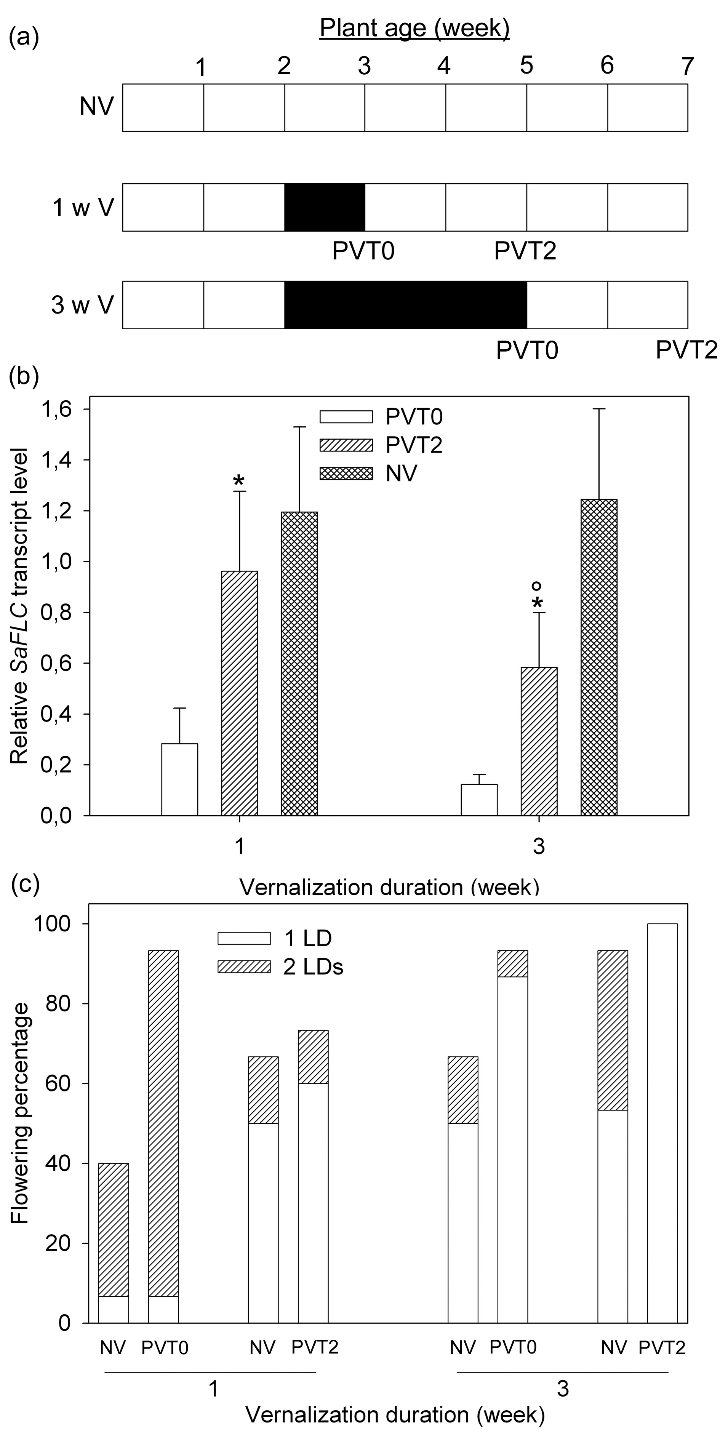
Figure II.8. Effect of vernalization duration on stability of SaFLC downregulation and plant response to LDs
(a) Experimental set-up. Two-week old plants were vernalized for one (1 wk V) or three (3 wk V) weeks and compared to non-vernalized (NV) controls. Shoot apices were harvested at the end of vernalization (PVT0) or two weeks later (PVT2) for SaFLC transcript quantification in SDs. (b). At the same times PVT0 and PVT2, vernalized and non-vernalized plants were exposed to one or two 16-h LDs for flower induction (c).
(b) SaFLC transcript level in shoot apices of plants vernalized for 1 or 3 weeks and harvested at PVT0 or PVT2. NV controls were sampled at the same times than PVT2. Plants were maintained in SDs throughout the experiment. SaFLC transcripts were quantified by qRT-PCR on total RNA and the expression of SaTUBULIN was used for data normalization. Data are means ± standard deviation of two independent experiments. *: statistically different from PVT0 (Student’s t test).
(c) Flowering response of plants vernalized for 1 or 3 weeks and exposed to one or two 16-h LD(s) either at PVT0 or PVT2. Flowering response was evaluated as ‘% of floral plants’ as observed by dissecting the shoot apices of 15 plants two weeks after the LD(s). Results of a representative experiment.

Effect of vernalization and SaFLC on plant sensitivity to photoperiod
The importance of stable repression of SaFLC was further examined by looking at its consequence on plant response to LDs. Two vernalization durations were therefore compared: 1-week – which transiently repressed SaFLC – and 3-week which stably downregulated SaFLC (Figure II.8b). Plants were exposed to one or two 16-h LD(s) just after (PVT0) the vernalization treatment, or after having been returned to 20°C for two weeks (PVT2). Non-vernalized controls were exposed to the LD(s) at the same times (Figure II.8a). The flowering response was evaluated two weeks after the LD(s) by dissecting apical buds and calculating the ‘% of floral plants’. As can be seen in Figure II.8c, 1-week and 3-week vernalization treatments had a strong promotive effect on floral response to LD(s) when LD(s) immediately followed vernalization. The positive effect was clearly visible for 3-week old plants exposed to two 16-h LDs, and for 5-week old plants exposed to one 16-h LD. Now, when two weeks at 20°C were interpolated between the vernalization treatments and LD-exposure, the short vernalization treatment appeared as insufficient to promote the flowering response, as we found previously (Figure II.3), while the positive effect of the 3-week vernalization treatment was still significant on plant response to one 16-h LD. These results clearly indicated that plant sensitivity to photoperiod was correlated with increased repression of SaFLC; this required stable repression by long vernalization treatments, unless inductive photoperiod occurred just after the cold period.

DISCUSSION

The vernalization response of S. alba is quantitative
The aim of the research was to investigate the vernalization pathway of flowering time control in S. alba, a species that was mostly used as a model LD-plant (Bernier et al., 1993). S. alba was previously shown to be sensitive to vernalization at the seed- and adult stages (Bernier, 1969; Bodson, 1985). We show here that vernalization of 2-week old seedlings could cause flowering in non-inductive SDs, and that floral transition occurred during the vernalization period when it was extended over ~4 weeks. This result somehow questions the classical definition of vernalization as the acquisition of plant competence to flower (Chouard, 1960). On the other hand, plants of S. alba do not require vernalization since non-vernalized plants do flower – albeit very late - even in SDs (Figure II.3). Hence S. alba appears as a facultative vernalization- and LD-responsive species.

The flowering response to vernalization was observed only in plants that had been exposed to cold for at least 2 weeks (Figure II.3). When macroscopic appearance of floral buds was used as a criterion of flowering, the positive effect of increasing vernalization duration was observed up to 5-6 weeks of cold. However, the use of SaMADSA and SaLFY as earlier markers of the SAM floral shift showed that floral transition actually started after 3-4 weeks at 7°C (Figure II.7).

SaFLC is an AtFLC orthologous candidate
SaFLC was cloned to allow us to investigate the molecular mechanisms of S. alba response to vernalization. The sequence that was isolated showed a strong homology with AtFLC1. Phylogenetic data presented herein demonstrate that the predicted SaFLC protein clusters with the FLC1 sequences found in different members of the Brassicaceae family (BnFLC1, BoFLC1 and BrFLC1; Figure II.4b). This is consistent with the fact that S. alba is called B. hirta by some authors (Primard et al., 1988). Among all the amino acid sequences found in the tree, the group made up of FLC1 is the closest to FLC proteins from Arabidopsis genus, suggesting that SaFLC could be orthologous to AtFLC. This hypothesis was further investigated by a complementation test of the A. thaliana flc-3 mutant (in a Col FRI background). The construct used for transformation was made up with a 2-kb fragment of the AtFLC promoter fused to SaFLC cDNA. Flowering was slightly – but significantly – delayed by expression of the ProAtFLC::SaFLC transgene. The weak phenotype could be regarded as indicating that SaFLC has a low biological activity in A. thaliana. This was argued in the case of B. napus by Tadege et al. (2001) who observed very different phenotypes when overexpressing in A. thaliana WT (Ler) any of the 5 BnFLC cDNAs. However, with BnFLC1 – which is the closest to SaFLC – a clear delay in flowering was observed. We rather believe that the ProAtFLC::SaFLC transgene we used for complementation might lack regulatory sequences necessary for up-regulation by FRI. We observed indeed that the ProAtFLC::SaFLC flc-3 transgenics flowered at the same time than Col WT plants (harboring functional native AtFLC and recessive fri) (Figure II.5). This observation suggested that FRI was unable to act as an activator of the transgene. Whether the missing elements are from AtFLC promoter or SaFLC gene is unknown at this stage.

SaFLC was found here as a single copy gene although S. alba genome is assumed to have been triplicated during evolution, containing three Arabidopsis genome equivalents (Nelson and Lydiate, 2006). A high rate of chromosomal rearrangement (fusion and fission) following polyploidy events might explain discrepancies between expected and actual gene copy numbers (Lysak et al., 2005; Town et al., 2006). For example in B. napus, which originated from an interspecific hybridization between B. rapa and B. oleracea, Tadege et al. (2001) found five FLC genes instead of six. We then hypothesize that S. alba lost two copies of FLC from its ancestor.

Expression of SaFLC was detected in the shoot apex of non-vernalized plants and its expression level seemed to be independent of plant age, at least up to 8 weeks of growth at 20°C (Figure II.6), as previously reported in A. thaliana (Sheldon et al., 1999; Michaels and Amasino, 1999; Rouse et al., 2002; Sheldon et al., 2006). It is well known however that plants of increasing age are more and more sensitive to flower inducing signals (Bernier et al., 1981) and we did observe an increased response to 16h-LD with non-vernalized plant age in Figure II.8c. We can thus infer that this increased sensitivity was not due to a developmental decrease in FLC activity. Eight-week old non-vernalized plants of S. alba are fully responsive to a single LD (Bernier et al., 1981) - although SaFLC is highly expressed in the SAM - hence the photoperiodic pathway can completely overcome inhibition by SaFLC.

We observed a clear down-regulation of SaFLC by vernalization, which is in agreement with its expected biological function. The amount of transcripts was already much lowered by a short cold-treatment of one-week (Figure II.6c), but stabilization of the repression required longer exposure to cold (Figure II.8b). The longer the vernalization treatment, the lower the remaining SaFLC transcript level, and the stronger the effect on flowering time (Figure II.3).
AtFLC targets include SOC1 in the SAM and FT in the leaves (Searle et al., 2006), which are repressed unless AtFLC is down-regulated by vernalization. Since our analyses focused on shoot apices, we followed expression of SaMADSA, which is homologous to SOC1 (Bonhomme et al., 2000), during vernalization and observed that it indeed came up after 3 weeks of cold (Figure II.7), i.e. after down-regulation of SaFLC. It is still possible however, that SaMADSA was also upregulated by cold independently of SaFLC, since – in A. thaliana - vernalization may cause induction of SOC1 in an flc mutant (Moon et al., 2003). SaLFY appeared in the SAM approximately one week after SaMADSA (Figure II.7), which is consistent with the idea that LFY is activated by SOC1 (Moon et al., 2005). Although our timing should be sharpened by more frequent sampling, a rather long lapse of time between upregulation of SaMADSA and SaLFY could be expected since this occurred at 7°C.

Stabilization of SaFLC down-regulation requires cold exposure longer than 1 week
Although the expression pattern of SaFLC (Figure II.6) nicely fits with the quantitative effect of vernalization on the flowering response of S. alba (Figure II.3), a major discrepancy appeared: one week vernalization was enough for SaFLC downregulation (Figure II.6c), but not for flowering stimulation (Figure II.3). This suggested that down-regulation of SaFLC by 1 week vernalization was transient. Quantification of SaFLC transcript post-vernalization indeed showed that, when plants were transferred back at 20°C, its level returned to that of non-vernalized plants when vernalization was short (1-week) but remained lower if vernalization was longer (Figure II.8b) This result clearly indicated that 1 week of vernalization was not sufficient for a stable repression of SaFLC, while a 3-week duration was; this difference may explain the ineffectiveness of the shortest treatment to accelerate flowering.
In A. thaliana, maintenance of AtFLC repression after cold requires VERNALIZATION 1 (VRN1), VRN2 and LIKE HETEROCHROMATIN PROTEIN 1 genes (Gendall et al., 2001; Levy et al., 2002; Bastow et al., 2004; Mylne et al., 2006; Sung et al., 2006). Stabilization of the AtFLC silenced state also depends on cis regulatory sequences, as shown by the fact that AtFLC promoter and intron 1 are sufficient for downregulation and maintenance of repression by cold (Sheldon et al., 2002; Sheldon et al., 2006; Sung et al. 2006). Recently, natural variation in vernalization response was correlated with the stability of AtFLC repression and with the rate of accumulation of AtFLC histone H3 K27 trimethylation (Shindo et al., 2006).
Maintenance of SaFLC down-regulation might be controlled by similar mechanisms in S. alba as in A. thaliana, hence regulatory sequences may account for the degree of stability of the vernalized state. Variations in AtFLC intron 1 sequences have been already described in the literature (Lempe et al., 2005). For instance, a mutator-like sequence found at the 3’ end of intron 1 in the Ler AtFLC allele seems to limit FLC RNA accumulation (Gazzani et al., 2003; Michaels et al., 2003). Also, A. thaliana transgenic lines containing the BoFLC4-1 transgene (from B. oleracea var Capitata) displayed a variable repression of the transgene, which could be due to a 2.6-kb deletion in BoFLC4-1 intron 1, as compared to AtFLC (Lin et al., 2005). The regulatory function of SaFLC intron 1 remains to be investigated.

Down-regulation of SaFLC enhances sensitivity to photoperiod
We observed that 1-week vernalization – which was sufficient for SaFLC downregulation but insufficient for stabilization of the repressed state - did not stimulate flowering in SDs (Figure II.3), but had a clear promotive effect when just followed by inductive LDs. This positive effect was observed on 3-week old seedlings exposed to two 16-h LDs (Figure II.8c): the percentage of plants that flowered in response to two 16-h LDs was more than doubled when they had been vernalized for one week, as compared to non-vernalized plants (Figure II.8c). However, the vernalizing effect of the 1-week treatment did not persist : when the LDs were given after 2 weeks of growth post-vernalization, vernalized and non-vernalized plants showed a similar flowering response to LDs. Extrapolation of these results to natural conditions means that vernalization requirement is longer when experienced in winter – because LDs do not immediately follow and FLC repression requires stabilization - while short periods of cold occurring in spring or summer could enhance plant response to increasing photoperiod. Such environmental conditions are far from rare in temperate regions where fresh temperatures may occur in spring, when photoperiod is increasing.
How down-regulation of AtFLC stimulates the photoperiodic pathway might be directly through FT and SOC1, since recent literature has provided evidence that these integrator genes are repressed by AtFLC (Searle et al., 2006). This could probably account for the promotive effect of short vernalization treatments. Cold could also have a less direct effect on the floral response to LDs. Salathia et al. (2006) indeed reported that vernalization of A. thaliana seedlings led to a shortening of the circadian period of leaf movements and period-shortening can be associated with earlier flowering under shorter photoperiods (Yanovsky and Kay, 2002). This result was all the most puzzling since temperature compensation is a defining feature of circadian rhythms. However, natural variation in circadian period and in the temperature-compensation mechanisms identified AtFLC and the flowering-time gene GIGANTEA as clock-regulators (Swarup et al., 1999; Edwards et al., 2005; Edwards et al., 2006). Whether the effect of vernalization on plant sensitivity to photoperiod passes through such complex networks warrants further investigation and is of great ecological significance.

Acknowledgments
We thank Prof. G. Bernier and Dr L. Corbesier for critical reading of the manuscript. We are much indebted to A. Pieltain and N. Detry for excellent technical assistance and to A. Havelange, P. Perruzza and D. Libion for taking care of the plants. We acknowledge Dr. S. Melzer for the opportunity to screen the S. alba cDNA library he had constructed and for providing us with the SaLFY probe. The flc-3 mutant and Col FRI-SF2 control were kindly supplied by Prof. R. Amasino (Department of Biochemistry, University of Wisconsin, Wisconsin, USA). The AtFLC promoter fragment was a gift from Prof. C. Dean (Department of Cell and Developmental Biology, John Innes Centre, Norwich, UK). M.D. is grateful to the F.R.I.A. for the award of a PhD fellowship. The research was funded by Interuniversity Attraction Poles Programme, Belgian State, Federal Office for Scientific, Technical and Cultural Affaires, P5/13.
REFERENCES
Angerer, L.M. and Angerer, R.C. (1992) In-situ hybridization to cellular RNA with radiolabelled RNA probes. In In-situ Hybridization. A practical approach. The practical approach series (Wilkinson, D.G., ed). Oxford: IRL Press, pp. 15–32.
Balasubramanian, S., Sureshkumar, S., Lempe, J. and Weigel, D. (2006) Potent induction of Arabidopsis thaliana flowering by elevated growth temperature. PLoS Genet., 27, http://dx.doi.org/10.1371/journal.pgen.0020106.eor.
Bastow, R., Mylne, J.S., Lister, C., Lippman, Z., Martienssen, R.A. and Dean, C. (2004) Vernalization requires epigenetic silencing of FLC by histone methylation. Nature, 427, 164–167.
Bernier, G. (1969) Sinapis alba L. In The induction of flowering. Some case histories (Evans, L.T., ed). Canberra pp. 305–327.
Bernier, G., Kinet, J.-M. And Sachs, R.M. (1981) The physiology of flowering, Vol. 1. Boca Raton: CRC Press.
Bernier, G., Havelange, A., Houssa, C., Petitjean, A. and Lejeune, P. (1993) Physiological signals that induce flowering. Plant Cell, 5, 1147–1155.
Bernier, G. and Perilleux, C. (2005) A physiological overview of the genetics of flowering time control. Plant Biotechnol. J., 3, 3–16.
Blazquez, M.A., Ahn, J.H. and Weigel, D. (2003) A thermosensory pathway controlling flowering time in Arabidopsis thaliana. Nature Genet., 33, 168–171.
Bodson, M. (1985) Sinapis alba. In CRC Handbook of Flowering (Halevy, A.H., ed). Boca Raton, Florida: CRC Press, pp. 336–354.
Bonhomme, F., Sommer, H., Bernier, G. and Jacqmard, A. (1997) Characterization of SaMADS D from Sinapis alba suggests a dual function of the gene: In inflorescence development and floral organogenesis. Plant Mol. Biol., 34, 573–582.
Bonhomme, F., Kurz, B., Melzer, S., Bernier, G. and Jacqmard, A. (2000) Cytokinin and gibberellin activate SaMADS A, a gene apparently involved in regulation of the floral transition in Sinapis alba. Plant J., 24, 103–111.
Boss, P.K., Bastow, R.M., Mylne, J.S. and Dean, C. (2004) Multiple pathways in the decision to flower: Enabling, promoting, and resetting. Plant Cell, 16, S18–S31.
Chouard, P. (1960) Vernalization and its relations to dormancy. Annu. Rev. Plant Physiol., 11: 191–238.
Clough, S.J. and Bent, A.F. (1998) Floral dip: a simplified method for Agrobacterium-mediated transformation of Arabidopsis thaliana. Plant J., 16, 735–743.
Corbesier, L. and Coupland, G. (2005) Photoperiodic flowering of Arabidopsis: integrating genetic and physiological approaches to characterization of the floral stimulus. Plant Cell and Environ., 28, 54–66.
Edwards, K.D., Lynn, J.R., Gyula, P., Nagy, F. and Millar, A.J. (2005) Natural allelic variation in the temperature-compensation mechanisms of the Arabidopsis thaliana circadian clock. Genetics, 170, 387–400.
Edwards, K.D., Anderson, P.E., Hall, A., Salathia, N.S., Locke, J.C.W., Lynn, J.R., Straume, M., Smith, J.Q. and Millar, A.J. (2006) FLOWERING LOCUS C mediates natural variation in the high-temperature response of the Arabidopsis circadian clock. Plant Cell, 18, 639–650.
Gazzani, S., Gendall, A.R., Lister, C. and Dean, C. (2003) Analysis of the molecular basis of flowering time variation in Arabidopsis accessions. Plant Physiol., 132, 1107–1114.
Gendall, A.R., Levy, Y.Y., Wilson, A. and Dean, C. (2001) The VERNALIZATION 2 gene mediates the epigenetic regulation of vernalization in Arabidopsis. Cell, 107, 525–535.
Hajdukiewicz, P., Svab, Z. and Maliga, P. (1994) The small, versatile pPZP family of Agrobacterium binary vectors for plant transformation. Plant Mol. Biol., 25, 989–994.
Johanson, U., West, J., Lister, C., Michaels, S., Amasino, R. and Dean, C. (2000) Molecular analysis of FRIGIDA, a major determinant of natural variation in Arabidopsis flowering time. Science, 290, 344–347.
Koncz, C. and Schell, J. (1986) The promoter of T_{L}-DNA gene 5 controls the tissue-specific expression of chimaeric genes carried by a novel type of Agrobacterium binary vector. Molecular and General Genetics, 204, 383–396.
Koornneef, M., Hanhart, C.J. and van der Veen, J.H. (1991) A genetic and physiological analysis of late flowering mutants in Arabidopsis thaliana. Molecular and General Genetics, 229, 57–66.
Lang, A. (1965) Physiology of flower initiation. In Encyclopedia of Plant Physiology, vol 15 (W. Ruhland, ed) Berlin: Springer-Verlag, pp. 1371–1536.
Lee, H., Suh, S.S., Park, E., Cho, E., Ahn, J.H., Kim, S.-G., Lee, J.S., Kwon, M.Y. and Lee, I. (2000) The AGAMOUS-LIKE 20 MADS domain protein integrates floral inductive pathways in Arabidopsis. Genes & Dev., 14, 2366-2376.
Lejeune, P., Kinet, J.-M. and Bernier, G. (1988) Cytokinin fluxes during floral induction in the long day plant Sinapis alba L. Plant Physiol., 86, 1095–1098.
Lempe, J., Balasubramanian, S., Sureshkumar, S., Singh, A., Schmid, M. and Weigel, D. (2005) Diversity of flowering responses in wild Arabidopsis thaliana strains. PLoS Genet., doi: 10.1371/journal.pgen.0010006.
Levy, Y.Y., Mesnage, S., Mylne, J.S., Gendall, A.R. and Dean, C. (2002) Multiple roles of Arabidopsis VRN1 in vernalization and flowering time control. Science, 297, 243–246.
Lin, S.-I., Wang, J.-G., Poon, S.-Y., Su, C.-L., Wang, S.-S. and Chiou, T.-J. (2005) Differential regulation of FLOWERING LOCUS C expression by vernalization in cabbage and Arabidopsis. Plant Physiol., 137, 1037–1048.
Lysak, M.A., Koch, M.A., Pecinka, A. and Schubert, I. (2005) Chromosome triplication found across the tribe Brassicacea. Genome Res., 15, 516–525.
Martinez-Zapater, J.M., Coupland, G., Dean, C. and Koornneef, M. (1994) The transition to flowering in Arabidopsis. In Arabidopsis (Meyerowitz, E.M. and Somerville, C.R., eds). New York: Cold Spring Harbor Laboratory Press, pp. 403–433.
Martynov, V.V. and Khavkin, E.E. (2004) Two homologs of the FLOWERING LOCUS C gene from leaf mustard (Brassica juncea). Russ. J. Plant Physiol., 51, 234–240.
Melzer, S., Kampmann, G., Chandler, J., and Apel, K. (1999) FPF1 modulates the competence to flowering in Arabidopsis. Plant J., 18, 395–405.
Menzel, G., Apel, K., and Melzer, S. (1996) Identification of two MADS box genes that are expressed in the apical meristem of the long-day plant Sinapis alba in transition to flowering. Plant J., 9, 399–408.
Metzger, J.D. (1988) Localization of the site of perception of thermoinductive temperatures in Thlaspi arvense L. Plant Physiol., 88, 424–428.
Michaels, S.D. and Amasino, R.M. (1999) FLOWERING LOCUS C encodes a novel MADS domain protein that acts as a repressor of flowering. Plant Cell, 11, 949–956.
Michaels, S.D. and Amasino, R.M. (2000) Memories of winter: vernalization and the competence to flower. Plant Cell and Environ., 23, 1145–1153.
Michaels, S.D., He, Y., Scortecci, C. and Amasino, R.M. (2003) Attenuation of FLOWERING LOCUS C activity as a mechanism for the evolution of summer-annual flowering behavior in Arabidopsis. Proc. Nati. Acad. Sci., 100, 10102–10107.
Moon, J., Suh, S.S., Lee, H., Choi, K.R., Hong, C.B., Paek, N.C., Kim, S.G., & Lee, I. (2003) The SOC1 MADS-box gene integrates vernalization and gibberellin signals for flowering in Arabidopsis. Plant J., 35, 613–623.
Moon, J., Lee, H., Kim, M., & Lee, I. (2005) Analysis of flowering pathway integrators in Arabidopsis. Plant Cell Physiol., 46, 292–299.
Mylne, J.S., Barrett, L., Tessadori, F., Mesnage, S., Johnson, L., Bernatavichute, Y.V., Jacobsen, S.E., Fransz, P. and Dean, C. (2006) LHP1, the Arabisopsis homologue of HETEROCHROMATIN PROTEIN 1, is required for epigenetic silencing of FLC. Proc. Nati. Acad. Sci., 103, 5012–5017.
Nelson, M.N. and Lydiate, D.J. (2006) New evidence from Sinapis alba L. for ancestral triplication in a crucifer genome. Genome, 49, 230–238.
Onouchi, H., Igeño, I., Périlleux, C., Graves, K. and Coupland, G. (2000) Mutagenesis of plants overexpressing CONSTANS demonstrates novel interactions among Arabidopsis flowering-time genes. Plant Cell, 12, 885–900.
Primard, C., Vedel, F., Mathieu, C., Pelletier, G. and Chèvre, A.M. (1988) Interspecific somatic hybridization between Brassica napus and Brassica hirta (Sinapis alba L.). Theor. Appl. Genet., 75, 546–552.
Rouse, D.T., Sheldon, C.C., Bagnall, D.J., Peacock, W.J. and Dennis, E.S. (2002) FLC, a repressor of flowering, is regulated by genes in different inductive pathways. Plant J., 29, 183–191.
Salathia, N.S., Davis, S.J., Lynn, J.R., Michaels, S.D., Amasino, R.M. and Millar, A.J. (2006) FLOWERING LOCUS C –dependent and –independent regulation of the circadian clock by the autonomous and vernalization pathways. BMC Plant Biology, 6, 10.
Samach, A., Onouchi, H., Gold, S.E., Ditta, G.S., Schwarz-Sommer, Z., Yanofsky, M.F. and Coupland, G. (2000) Distinct roles of CONSTANS target genes in reproductive development of Arabidopsis. Science, 288, 1613–1616.
Schranz, M.E., Quijada, P., Sung, S.B., Lukens, L., Amasino, R. and Osborn, T.C. (2002) Characterization and effects of the replicated flowering time gene FLC in Brassica rapa. Genetics, 162, 1457–1468.
Searle, I., He, Y., Turck, F., Vincent, C., Fornara, F., Kröber, S., Amasino, R.A. and Coupland, G. (2006) The transcription factor FLC confers a flowering response to vernalization by repressing meristem competence and systemic signaling in Arabidopsis. Genes & Dev., 20, 898–912.
Sheldon, C.C., Burn, J.E., Perez, P.P., Metzger, J., Edwards, J.A., Peacock, W.J. and Dennis, E.S. (1999) The FLF MADS box gene: A repressor of flowering in Arabidopsis regulated by vernalization and methylation. Plant Cell, 11, 445–458.
Sheldon, C.C., Rouse, D.T., Finnegan, E.J., Peacock, W.J. and Dennis, E.S. (2000) The molecular basis of vernalization: The central role of FLOWERING LOCUS C (FLC). Proc. Nati. Acad. Sci. USA, 97, 3753– 3758.
Sheldon, C.C., Conn, A.B., Dennis, E.S. and Peacock, W.J. (2002) Different regulatory regions are required for the vernalization-induced repression of FLOWERING LOCUS C and for the epigenetic maintenance of repression. Plant Cell, 14, 2527–2537.
Sheldon, C.C., Finnegan, E.J., Dennis, E.S. and Peacock, W.J. (2006) Quantitative effect of vernalization on FLC and SOC1 expression. Plant J., 45, 871–883.
Shindo, C., Lister, C., Crevillen, P., Nordborg, M. and Dean, C. (2006) Variation in the epigenetics silencing of FLC contributes to natural variation in Arabidopsis vernalization response. Genes & Dev., 20, 3079–3083.
Suárez-López, P., Wheatley, K., Robson, F., Onouchi, H., Valverde, F. and Coupland, G. (2001) CONSTANS mediates between the circadian clock and the control of flowering in Arabidopsis. Nature, 410, 1116–1120.
Sung, S.B. and Amasino, R.M. (2006) Molecular genetic studies of the memory of winter. J. Exp. Bot., 57, 3369-3377.
Sung, S.B., He, Y., Eshoo, T.W., Tamada, Y., Johnson, L., Nakahigashi, K., Goto, K., Jacobsen, S.E. and Amasino R.M. (2006) Epigenetic maintenance of the vernalized state in Arabidopsis thaliana requires LIKE HETEROCHROMATIN PROTEIN 1. Nature genet., 38, 706–710.
Swarup, K., Alonso-Blanco, C., Lynn, J.R., Michaels, S.D., Amasina, R.M., Koornneel, M. and Millar, A.J. (1999) Natural allelic variation identifies new genes in the Arabidopsis circadian system. Plant J., 20, 67–77.
Tadege, M., Sheldon, C.C., Helliwell, C.A., Stoutjesdijk, P., Dennis, E.S., and Peacock, W.J. (2001) Control of flowering time by FLC orthologues in Brassica napus. Plant J., 28, 545–553.
Town, C.D., Cheung, F., Maiti, R., Crabtree, J., Haas, B.J., Wortman, J.R., Hine, E.E., Althoff, R., Arbogast, T.S., Tallon, L.J., Vigouroux, M., Trick, M. and Bancroft, I. (2006) Comparative genomics of Brassica oleracea and Arabidopsis thaliana reveal gene loss, fragmentation, and dispersal after polyploidy. Plant Cell, 18, 1348–1359.
Valverde, F., Mouradov, A., Soppe, W., Ravenscroft, D., Samach, A. and Coupland, G. (2004) Photoreceptor regulation of CONSTANS protein in photoperiodic flowering. Science, 303, 1003–1006.
Yamaguchi, A., Kobayashi, Y., Goto, K., Abe, M. and Araki, T. (2005) TWIN SISTER OF FT (TSF) acts as a floral pathway integrator redundantly with FT. Plant Cell Physiol., 46, 1175–1189.
Yanovsky, M.J. and Kay, S.A. (2002) Molecular basis of seasonal time measurement in Arabidopsis. Nature, 419, 308–312.

