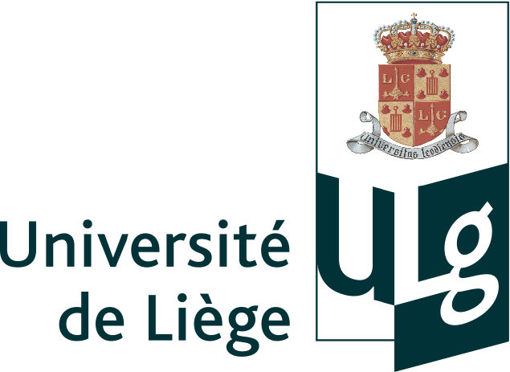 June 2009

Droplet manipulation

by

Tristan Gilet

A dissertation submitted in partial fulfillment of the requirements for the degree of

Doctor of Philosophy in Physical Sciences

At the University of Liège

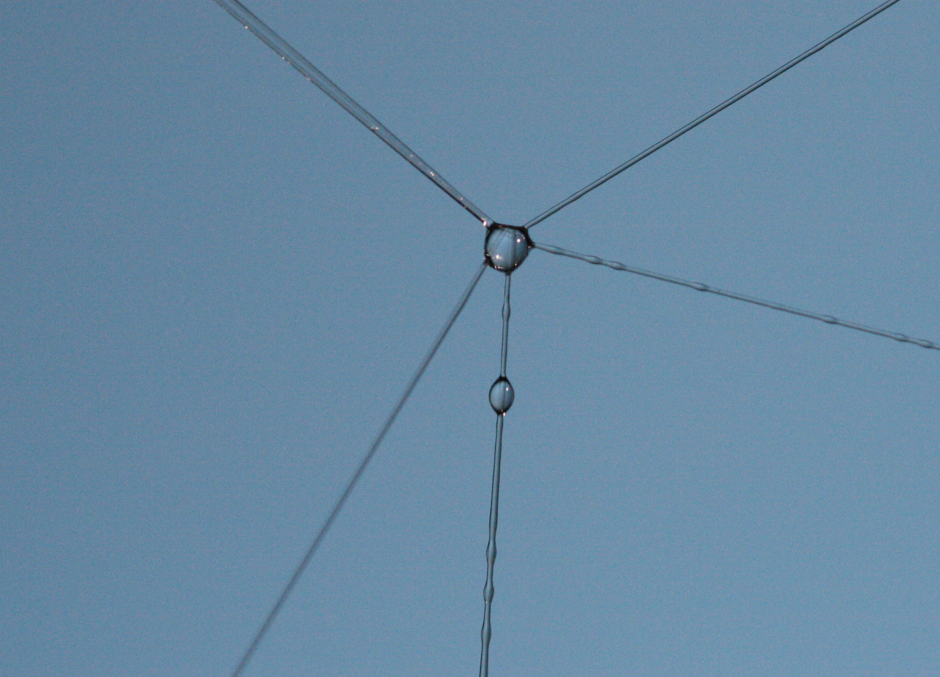

Committee in charge

Professor Thierry Bastin (Chairman)
Professor Nicolas Vandewalle (Thesis supervisor)
Doctor Stéphane Dorbolo
Doctor Philippe Brunet
Professor John W.M. Bush

