Changes in the fatty acid profiles and health indexes of bovine colostrum during the first days of lactation and their impact on human health
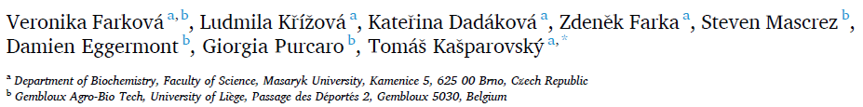

Keywords: Bovine colostrum Fatty acid Two-dimensional gas chromatography with vacuum ultraviolet detector GC×GC-VUV Lactation Days in milk
Abstract
Our objective was to analyze the changes in fatty acid (FA) profiles of bovine colostrum and immature milk during the first four days of lactation and assess their potential impact on human health. Colostrum and immature milk samples were collected from Czech Fleckvieh cows during their first to third lactation and the FA profiles were analyzed using multidimensional gas chromatography with a vacuum ultraviolet detector (GC×GC-VUV). The colostrum of primiparous cows contained lower levels of medium-chain and saturated fatty acids, and higher levels of mono- and unsaturated fatty acids compared to that of multiparous cows. The atherogenic and thrombogenicity indexes, as well as the hypocholesterolemic-to-hypercholesterolemic fatty acid ratio, were more favourable in primiparous cows. This makes colostrum fat an attractive product for human nutrition. To obtain the maximum health benefits, we recommend collecting and processing the colostrum of primiparous cows and immature milk at the end of the milk transition separately.

Introduction
Bovine colostrum is the initial milk produced by cows after giving birth. Although not exactly standardized across the studies, colostrum is the secretion harvested at the first postpartum milking. Subsequently, this secretion is referred to as immature or transition milk (harvested at second to sixth milking postcalving, or until it becomes saleable whole milk). After 6–7 days postpartum, it turns into mature milk (Chandler, Newman, Cha, Sipka, & Mann, 2023; Godden, 2008; Guberti et al., 2021; Playford & Weiser, 2021; Rathe, Müller, Sangild, & Husby, 2014). Bovine colostrum contains various bioactive and nutritional components including fatty acids (FAs), amino acids, or minerals (for a detailed classification, see Mehra et al., 2022). Newborn calves require all of these nutrients (Rathe et al., 2014; Santoro et al., 2023), and all except for lactose are present in higher amounts in colostrum compared to mature milk (McGrath, Fox, McSweeney, & Kelly, 2016). The levels of these nutrients rapidly decline during the first three days after parturition (Playford & Weiser, 2021). Colostrum is an attractive raw material for the production of functional foods, food supplements, nutraceuticals, or pharmaceuticals (Playford & Weiser, 2021) due to its biological activity across species and the proven positive effects on human health (Kaplan et al., 2022). The production of colostrum exceeds the needs of the calves (Linehan, Ross, & Stanton, 2023), making it a valuable resource. Most studies and commercial productions concentrate on the immunological benefits of specific nutrients (Linehan et al., 2023), while the fat content of colostrum is often overlooked. Moreover, the fat is frequently removed during processing (Linehan et al., 2023). Nevertheless, full-fat colostrum or colostrum fat may be attractive for human consumption due to its higher fat content (ca 7%; Sats et al., 2022) and a more favourable profile of FAs compared to mature milk (Wilms et al., 2022). Milk fat is a complex substance due to the synthesis of its triacylglycerols from over 400 different FAs, although the majority of these are present in trace amounts (Jensen, 2002; Lindmark Månsson, 2008). Additionally, milk fat is highly variable and can be influenced by various biological and external factors, resulting in changes to its quantity and fatty acid composition (Hanuˇs, Samkov´a, Kˇríˇzov´a, Hasoˇnov´a, & Kala, 2018). The FA profile undergoes significant changes during the first few days after parturition due to hormonal and metabolic changes and increased mobilization of body reserves associated with lactation onset. (Rico & Razzaghi, 2023; Schuh et al., 2019; Wilms et al., 2022). Several factors affect the composition and physical properties of bovine colostrum, including parity, season, colostrum yield, the time interval between calving and colostrum collection (Soufleri et al., 2021), breed, stage of lactation, and feeding practices (O'Callaghan et al., 2020; Wilms et al., 2022). Although the variation in the content of many nutritional and bioactive compounds has been widely studied for use in human nutrition (Alexieva, Markova, & Nikolova, 2004; Kaplan et al., 2022; Kim et al., 2009) or from the view of processing and manufacturing (Mehra et al., 2022), there is limited information available on changes in FA profiles during the first days of lactation. Existing studies primarily focus on gaining a better understanding of the needs of neonatal calves and the physiology of dairy cows around parturition (Contarini et al., 2014; O'Callaghan et al., 2020; Wilms et al., 2022). Moreover, these studies were performed on Holstein or Holstein-Friesian cows and information on other breeds is currently lacking. The objective of our study was to analyze changes in FA profiles in Czech Fleckvieh cows, a representative of dual-purpose breeds, in bovine colostrum and immature milk during the first four days of lactation and assess their potential impact on human health. We also took into account the parity of cows.

Materials and methods

Animals and feeding
The colostrum was obtained from 20 Czech Fleckvieh cows in a private dairy farm (L. Klíˇcov´a, Boˇzice, Czech Republic). The cohort comprised 8 cows on their first lactation, 5 on their second lactation, and 7 on their third or higher lactation. The cows were fed a total mixed ration consisting of maize silage, lucerne haylage, brewers spent grain silage, lucerne hay, rolled oats, a mineral mixture, and a supplemental feed in the form of pellets. The nutrient contents and FA profiles of the diets are provided in the Supplementary Material (Table S1). The milk samples were collected during the first four days of lactation from the morning milking. Following collection, the samples were stored at 􀀀 20 ◦C until analysis.

Fatty acid profile analysis

Chemicals and reagents
All chemicals and solvents, including cyclohexane and hydrochloric acid in methanol, as well as fatty acid methyl esters (FAMEs) reference standards (Supelco C37 FAME MIX) were obtained from MilliporeSigma (Darmstadt, Germany).

Sample extraction and derivatization
Colostrum samples (1.0 g) were weighed into microwave-assisted extractor vessels. Then, 10 mL of 1.25 M HCl in MeOH and 25 mL of cyclohexane were added. The samples were placed inside a microwave-assisted extractor ETHOS X (Milestone, Italy) under continuous stirring. The temperature was ramped up to 120 ◦C in 2 min and held for 13 min. All the samples were prepared in triplicate using the simultaneous microwave-assisted extraction and derivatization procedure, as reported by Fina et al. (2022).

GC×GC-VUV analysis
The samples that underwent derivatization were analyzed using a Shimadzu GCMS-TQ8050 NX system (Shimadzu, Duisburg, Germany) consisting of a GC2030 fitted with a vacuum-ultraviolet detector (VUV), and a VGA-101 Analyzer (VUV Analyzer, Texas, USA). The system was equipped with an INSIGHT reversed fill/flush flow modulator with a bleeding line flow controller (SepSolve, Peterborough, UK). The GC×GC parameters are adapted from Fina et al. (2022), taking into account the slight overpressure of the VUV detector. The analysis was conducted using two SepSolve columns: a 1D-FAMEs 20 m × 0.18 mm × 0.1 μm polar fused silica capillary column and a 2D-FAMEs 5 m × 0.25 mm × 0.1 μm non-polar fused silica capillary column. The flow rates for the first and second columns were 0.4 mL/min and 20 mL/min respectively, while the bleeding line flow was set at 0.45 mL/min. Helium was used as the carrier gas. The modulation period was set at 3 s with a 100 ms reinjection time. The oven temperature program was optimized as follows: 3 min at 35 ◦C, followed by an increase to 260 ◦C at a rate of 9 ◦C/min and a 2- min hold at the final temperature. The injection was performed in split mode with a 1:10 ratio, and 1 μL was injected at 250 ◦C at 60 psi for 1 min in pulsed mode with overpressure. The VUV wavelength detection range was from 125 nm to 430 nm, with a detection frequency of 25 Hz. We used VUVision 3.4.0 software (VUV analytics, USA) for data acquisition and ChromSpace 2.1.4 software (SepSolve) for processing, which utilized the 125–160 nm wavelength range. A sample chromatogram of colostrum is shown in the Supplementary Material (Fig. S1). Pseudo-quantity calculations were performed based on the theory reported in Bai et al. (2017). The measured data were recalculated based on the cross-section of each identified analyte. To account for systematic errors and determine the amount of any unknown analyte in a sample, an internal standard of known amount and cross-section can be used. The relative amounts of target analytes can be directly determined based on the measured peak areas if their cross-sections are known and the analytes are subjected to identical analysis conditions, even without the internal standard.

Calculation of indexes
Atherogenicity index (AI) predicts the risk of cardiovascular disease associated with dietary components (Ulbricht & Southgate, 1991):
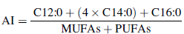
MUFAs – monounsaturated fatty acids; PUFAs – polyunsaturated fatty acids. Thrombogenicity index (TI) shows the leaning to form clots in the blood (Ulbricht & Southgate, 1991):
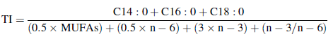
n-3 – omega-3 FAs, n-6 – omega-6 FAs. Hypocholesterolemic-to-hypercholesterolemic ratio (h/H) evaluates the effect of FA composition on cholesterol (Mierliț˘a, 2018):
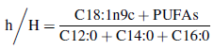

Statistical analyses
The study evaluated the impact of “lactation” and “days in milk (DIM)” on the relative content of fatty acids and health indexes using factorial ANOVA and Kruskal-Wallis ANOVA, respectively. A p-value cut-off of 0.05 was used to determine statistical significance. The results are presented using box plots of interquartile ranges, with medians shown as lines and means as empty squares. Error bars represent 1.5 times the interquartile range, and outliers are represented by diamonds.

Results and discussion

Fatty acid profiles according to the degree of saturation

Saturated fatty acids
Our study found that saturated fatty acids (SFAs) accounted for an average of 74% of the total FA content. The most prevalent SFAs were myristic (C14:0), palmitic (C16:0), and stearic (C18:0) acids, representing on average 12%, 28%, and 7%, respectively (see Table S2 in the Supplementary Material). The predominance of myristic and palmitic acids is consistent with the typical composition of bovine milk (Jensen, 2002). The percentage representation of palmitic acid in our study was lower than in O'Callaghan et al. (2020) or Wilms et al. (2022), while the content of myristic acid was similar to that reported by Wilms et al. (2022), but higher than reported by O'Callaghan et al. (2020). A possible explanation for this discrepancy is the breed effect (Samkov´a, ˇSpiˇcka, Peˇsek, Pelik´anov´a, & Hanuˇs, 2012). ˇStolcov´a, ˇReh´ak, and Bartoˇn (2021) described differences in the contents of C18:1, short-chain fatty acids (SCFAs), long-chain FAs, saturated fatty acids, and monounsaturated fatty acids between Holstein and Czech Fleckvieh cows in early lactation that were kept under the same feeding conditions. The amount of butyric acid was comparable to that reported by O'Callaghan et al. (2020) but considerably higher than that reported by Wilms et al. (2022). Moreover, the butyric acid content varied significantly depending on the cows' lactation number (Table 1; p = 0.007), with the highest value found in first parity cows and the lowest in second parity cows. Our study did not observe any effect of DIM on butyric acid content (Table 1; p > 0.05). However, O'Callaghan et al. (2020) reported a positive effect of DIM only during the first two days of lactation, with no significant effect thereafter. Butyric acid is synthesized de novo in the mammary gland of lactating cows from precursors originating from microbial metabolism in the rumen. Wang et al. (2023) found that dietary interventions, such as an increased proportion of grass hay in the feed, can stimulate the de novo synthesis of SCFAs, mainly butyric acid. In early calf nutrition, butyric acid is essential for the development and maturation of the digestive tract. Supplementation of butyric acid to the calf's diet increases the abundance of desirable bacteria in the hindgut and the amount of SCFAs produced there (G´orka, Kowalski, Zabielski, & Guilloteau, 2018). From the viewpoint of human health, SCFAs, which are produced by gut bacteria and can be transported directly to the mammary gland, have anti-inflammatory, immunoregulatory, anti-obesity, anti-diabetes, and cardiovascular protection (den Besten et al., 2013; Wilms et al., 2022; Xiong et al., 2022). Butyric acid, in particular, has been extensively studied for its anticarcinogenic properties due to its ability to inhibit the progression and proliferation of colon tumor cells. Furthermore, butyric acid plays a crucial role in maintaining intestinal barrier functions and facilitating communication between the gut and microbes (Huang et al., 2023). As butyric acid is primarily obtained from ruminant meat and milk in human diet (Shingfield, Chilliard, Toivonen, Kairenius, & Givens, 2008), colostrum fat-based products with higher butyric acid content may be appealing and beneficial for individuals with inadequate endogenous butyric acid production in the gut. From this perspective, early secretions from primiparous cows appear to be the most appropriate for producing these dietary supplements. The total SFAs were found to be affected by lactation number (p = 0.009) but not by the number of DIM (Table 2; p > 0.05). However, myristic and palmitic acid contents generally decreased with the increasing DIM (Table 1; both p = 0.001). On average, the relative content of myristic acid was 14% on the first day, 12% on the second day, 11% on the third day, and 10% on the fourth day. The proportion of palmitic acid in the milk samples was 32% on the first day, 30% on the second day, 26% on the third day, and 25% on the fourth day (see Table 1). This can be attributed to metabolic processes during milk FA synthesis. Myristic acid is a de novo synthesized FA, while palmitic acid belongs to a group of mixed FAs that are partly synthesized de novo and partly preformed. De novo FA synthesis is influenced by various factors, including long-chain unsaturated FAs, particularly oleic acid (C18:1n9c) (Rodríguez-Bermúdez et al., 2023). This fatty acid increases with increasing DIM and inhibits de novo synthesis. Notably, the abundance trend of myristic and palmitic acids was less pronounced in the first lactation compared to later lactations (see Fig. 1D and E). As for myristic acid, previous studies (O'Callaghan et al., 2020; Wilms et al., 2022) have noted increased levels of this acid in colostrum during the onset of lactation. Guti´errez-García, Contreras, and Díaz-Marte (2017) described a positive effect on the appetite of neonates in humans. Therefore, it is possible that myristic acid may have a stimulatory effect on colostrum intake in calves as well. Palmitic acid plays a crucial role in the early development of the digestive tract and immune response in neonates (Havlicekova, Jesenak, Banovcin, & Kuchta, 2015), and also serves as a substrate for the synthesis of ceramides and sphingomyelins, which are necessary for many cellular functions and for the early development of the brain and immune system in newborn animals (Dei Cas et al., 2020). Furthermore, neonates show a stimulatory effect on appetite from palmitic acid, although to a lesser extent than myristic acid (Guti´errez- García et al., 2017). The relative content of stearic acid increased significantly with increasing DIM (p < 0.001). Specifically, the relative content was 6% on the first day, 7% on the second day, 9% on the third day, and 10% on the fourth day (Table 1). This pattern of increase is consistent with the findings of O'Callaghan et al. (2020) within the first five days postpartum. However, Wilms et al. (2022) did not observe any significant changes in stearic acid content during the first five days of lactation. The stearic acid contents found in our study were within the recommended nutritionally desirable levels for humans, which is 6–11% (Chilliard & Ferlay, 2004). DIM did not affect minor SFAs (p > 0.05). However, the content of pentadecanoic acid (C15:0) tended to decrease with the increasing DIM (Table 1; p = 0.085), which is consistent with the findings of O'Callaghan et al. (2020). Our study found that the total content of SFAs in milk was influenced by the cow's lactation number (Table 2; p = 0.009) with the lowest value observed in primiparous cows. Additionally, the colostrum of primiparous cows had a significantly lower relative content of palmitic acid, representing on average 25%, compared to the colostrum from multiparous cows, which had an average 30% of palmitic acid of the total FA content (Table 1; p = 0.002). The same trend was found also for myristic acid, which represented on average 12% of the total FA content during the second and third lactation, and 11% during the first lactation (p = 0.026). This trend is consistent with the findings of O'Callaghan et al. (2020) and Wilms et al. (2022) regarding palmitic acid, but they did not observe any effect on myristic acid.

Table 1
 |  |  |  | Days in milk (DIM) |  |  |  | p-value
 | L1 | L2 | L3 | D1 | D2 | D3 | D4
 | n = 28 | n = 14 | n = 23 | n = 19 | n = 16 | n = 16 | n = 14
 | mean ± sd | mean ± sd | mean ± sd | mean ± sd | mean ± sd | mean ± sd | mean ± sd | L | DIM | L×DIM
C4:0 | 6.9 ± 5.9 | 2.0 ± 2.2 | 4.8 ± 4.2 | 4.2 ± 4.6 | 2.5 ± 3.9 | 5.4 ± 5.8 | 6.1 ± 5.6 | 0.007 | 0.180 | 0.088
C6:0 | 5.7 ± 1.7 | 6.3 ± 1.8 | 5.1 ± 2.1 | 4.4 ± 2.0 | 5.9 ± 1.7 | 6.3 ± 1.6 | 6.2 ± 1.4 | 0.106 | 0.005 | 0.137
C8:0 | 3.9 ± 1.2 | 3.9 ± 1.3 | 3.2 ± 1.4 | 3.2 ± 1.0 | 4.2 ± 1.7 | 3.6 ± 1.3 | 3.7 ± 1.0 | 0.065 | 0.095 | 0.061
C10:0 | 4.7 ± 1.4 | 4.8 ± 1.4 | 4.7 ± 1.6 | 4.0 ± 1.2 | 5.3 ± 1.7 | 5.0 ± 1.4 | 4.6 ± 1.3 | 0.931 | 0.052 | 0.213
C12:0 | 5.0 ± 1.3 | 5.2 ± 0.8 | 4.9 ± 1.1 | 5.2 ± 1.1 | 5.2 ± 0.9 | 4.7 ± 1.4 | 5.1 ± 1.3 | 0.702 | 0.582 | 0.993
C14:0 | 10.6 ± 3.1 | 12.3 ± 2.7 | 12.4 ± 3.1 | 13.9 ± 3.5 | 12.0 ± 1.8 | 11.1 ± 2.1 | 10.0 ± 2.3 | 0.026 | 0.001 | 0.933
C14:1 | 1.4 ± 0.7 | 1.4 ± 1.2 | 1.5 ± 1.0 | 2.1 ± 1.0 | 1.1 ± 0.7 | 1.4 ± 0.8 | 1.2 ± 0.8 | 0.937 | 0.006 | 0.376
C15:0 | 1.9 ± 0.8 | 2.1 ± 0.7 | 1.7 ± 0.9 | 2.1 ± 0.8 | 2.0 ± 1.0 | 2.0 ± 0.6 | 1.4 ± 0.5 | 0.270 | 0.085 | 0.755
C16:0 | 24.6 ± 7.6 | 29.6 ± 6.8 | 29.7 ± 7.1 | 31.7 ± 8.4 | 29.9 ± 3.3 | 25.5 ± 6.3 | 24.7 ± 2.3 | 0.002 | 0.001 | 0.596
C16:1 | 3.2 ± 0.7 | 3.1 ± 0.6 | 2.9 ± 0.9 | 3.4 ± 0.8 | 3.0 ± 0.6 | 2.8± 0.7 | 3.1 ± 0.9 | 0.533 | 0.163 | 0.582
C17:0 | 1.3 ± 0.5 | 1.2 ± 0.6 | 1.1 ± 0.7 | 1.0 ± 0.6 | 1.3 ± 0.9 | 1.3 ± 0.3 | 1.2 ± 0.5 | 0.304 | 0.448 | 0.742
C17:1 | 0.6 ± 0.3 | 0.5 ± 0.3 | 0.4 ± 0.3 | 0.5 ± 0.4 | 0.4 ± 0.3 | 0.6 ± 0.2 | 0.5 ± 0.4 | 0.035 | 0.172 | 0.024
C18:0 | 7.6 ± 1.5 | 7.8 ± 2.7 | 8.1 ± 2.1 | 6.0 ± 2.0 | 7.2 ± 1.2 | 8.6 ± 1.4 | 9.6 ± 1.2 | 0.403 | < 0.001 | 0.107
C18:1n9c | 17.9 ± 3.6 | 14.7 ± 3.8 | 14.5 ± 10.3 | 13.4 ± 4.9 | 15.3 ± 3.2 | 16.5 ± 3.3 | 17.6 ± 2.7 | 0.001 | 0.005 | 0.113
C18:2n6t | 0.3 ± 0.4 | 0.3 ± 0.3 | 0.2 ± 0.3 | 0.2 ± 0.3 | 0.3 ± 0.4 | 0.2 ± 0.4 | 0.4 ± 0.4 | 0.338 | 0.566 | 0.837
C18:2n6c | 2.8 ± 0.8 | 2.9 ± 0.6 | 3.3 ± 1.1 | 2.8 ± 1.1 | 2.9 ± 1.0 | 3.2 ± 0.9 | 3.0 ± 0.7 | 0.093 | 0.587 | 0.055
C18:3n3 | 1.0 ± 0.6 | 0.9 ± 0.5 | 0.6 ± 0.5 | 0.6 ± 0.6 | 0.9 ± 0.6 | 1.0 ± 0.7 | 0.9 ± 0.6 | 0.090 | 0.224 | 0.819
C20:4n6 | 0.7 ± 0.5 | 0.5 ± 0.4 | 0.5 ± 0.6 | 0.7 ± 0.6 | 0.5 ± 0.5 | 0.7 ± 0.5 | 0.5 ± 0.4 | 0.425 | 0.405 | 0.662
Major FAs* (relative abundance, %) with means and standard deviations (sd) in milk from cows with different lactation number (L) and days in milk (DIM).

* minor FAs with relative abundance under 0.5 % are not shown (C11:0, C13:0, C15:1, C18:3n6, C20:1n9, C20:2, C20:3n6, C20:3n3, C20:5n3, C22:6n3) C4 – butyric acid; C6 – caproic acid; C8 – caprylic acid; C10 – capric acid; C12 – lauric acid; C14 – myristic acid; C14:1 – myristoleic acid; C15 – pentadecylic acid; C16 – palmitic acid; C16:1 – palmitoleic acid; C17 – margaric acid; C17:1 – heptadecanoic acid; C18 – stearic acid; C18:1n9c – oleic acid; C18:2n6t – linolelaidic acid; C18:2n6c – linoleic acid; C18:3n3 – α-linoleic acid; C20:4n6 – arachidonic acid n =number of samples; L =lactation; DIM =days in milk; L×DIM =interaction of the L and DIM factors; p-values of statistically significant effects are highlighted in red (p < 0.05).

Table 2
Sums of FAs (relative abundance, %) and calculated indexes* with means and standard deviations (sd) from cows with different lactation numbers (L) and days in milk (DIM).
 |  |  |  |  | Days in milk (DIM) |  |  | p-value
 | L1 n = 28 | L2 n = 14 | L3 n = 23 | D1  n = 19 | D2  n = 16 | D3  n = 16 | D4  n = 14
 | mean ± sd | mean ± sd | mean ± sd | mean ± sd | mean ± sd | mean ± sd | mean ± sd | L | DIM
SCFAs | 21.2 ± 6.7 | 16.7 ± 3.6 | 17.5 ± 5.1 | 15.9 ± 5.2 | 17.8 ± 4.1 21.4 ± 7.0 |  | 21.4 ± 5.3 | 0.052 0.009
MCFAs | 48.5 ± 7.1 | 57.1 ± 8.7 | 55.0 ± 8.3 | 59.3 ± 10.4 | 54.3 ± 4.2 48.5 ± 6.5 |  | 46.6 ± 4.2 | 0.004 <0.001
LCFAs | 30.2 ± 4.4 | 26.2 ± 6.8 | 27.5 ± 5.9 | 24.9 ± 6.9 | 27.9 ± 4.9 30.1 ± 4.6 |  | 31.9 ± 2.9 | 0.157 0.003
SFAs | 72.2 ± 4.1 | 75.9 ± 4.4 | 75.6 ± 4.9 | 75.4 ± 5.3 | 74.8 ± 4.9 73.4 ± 4.5 |  | 72.8 ± 4.1 | 0.009 0.429
MUFAs | 22.9 ± 4.0 | 19.5 ± 3.6 | 19.1 ± 3.9 | 19.6 ± 4.9 | 20.4 ± 3.5 21.5 ± 4.1 |  | 22.3 ± 4.1 | 0.001 0.175
PUFAs | 4.9 ± 1.1 | 4.6 ± 1.3 | 5.3 ± 2.5 | 5.1 ± 2.6 | 4.8 ± 1.7 5.1 ± 1.0 |  | 4.9 ± 0.9 | 0.894 0.566
UFAs | 27.8 ± 4.1 | 24.1 ± 4.4 | 24.4 ± 4.9 | 24.6 ± 5.3 | 25.1 ± 4.9 26.6 ± 4.5 |  | 27.2 ± 4.1 | 0.009 0.429
PUFAs/SFAs | < 0.1 | < 0.1 | < 0.1 | < 0.1 | < 0.1 < 0.1 |  | < 0.1 | 0.790 0.439
EFAs | 3.8 ± 0.9 | 3.6 ± 0.9 | 3.9 ± 1.2 | 3.5 ± 1.0 | 3.7 ± 1.4 4.1 ± 0.9 |  | 3.9 ± 0.6 | 0.449 0.243
n-6 PUFAs | 3.8 ± 0.9 | 3.8 ± 0.8 | 4.1 ± 1.4 | 4.0 ± 1.4 | 3.7 ± 1.3 4.1 ± 0.8 |  | 3.9 ± 0.7 | 0.661 0.888
n-3 PUFAs | 1.0 ± 0.6 | 0.9 ± 0.7 | 1.2 ± 1.9 | 1.1 ± 2.1 | 1.1 ± 0.7 1.0 ± 0.7 |  | 1.0 ± 0.6 | 0.579 0.492
n-6/n-3** | 3.9 ± 2.5 | 3.7 ± 1.3 | 4.5 ± 3.8 | 4.1 ± 2.3 | 3.3 ± 1.6 4.2 ± 3.0 |  | 4.7 ± 4.2 | 0.523 0.333
AI | 2.7 ± 0.7 | 3.8 ± 1.3 | 3.7 ± 1.4 | 4.0 ± 1.4 | 3.5 ± 1.2 2.8 ± 0.7 |  | 2.6 ± 0.7 | 0.001 0.006
TI | 2.7 ± 0.7 | 3.8 ± 1.5 | 3.6 ± 1.4 | 3.9 ± 1.7 | 3.2 ± 1.0 2.9 ± 0.8 |  | 2.8 ± 0.8 | 0.003 0.178
h | 22.7 ± 3.5 | 18.8 ± 4.5 | 19.6 ± 4.6 | 18.8 ± 5.4 | 20.6 ± 4.3 21.7 ± 3.8 |  | 22.5 ± 2.7 | 0.012 0.134
H | 40.2 ± 7.3 | 48.5 ± 7.9 | 47.5 ± 7.9 | 50.2 ± 10.4 | 40.6 ± 5.2 40.2 ± 6.3 |  | 39.4 ± 4.6 | 0.002 < 0.001
h/H | 0.6 ± 0.2 | 0.4 ± 0.1 | 0.4 ± 0.2 | 0.4 ± 0.2 | 0.5 ± 0.1 0.6 ± 0.2 |  | 0.6 ± 0.1 | 0.002 0.005
* also including minor FAs (C11:0, C13:0, C15:1, C18:3n6, C20:1n9, C20:2, C20:3n6, C20:3n3, C20:5n3, C22:6n3)
** for statistics calculations, zero values of n-3 were replaced with 0.1 n = number of samples; L = lactation; DIM = days in milk; p – values of statistically significant effects are highlighted in red (p < 0.05).
SCFAs – short-chain fatty acids (sum of FAs with chain length <12); MCFAs – medium-chain fatty acids (sum of FAs with chain length ≥ 12 and < 18); LCFAs – long- chain fatty acids (sum of FAs with chain length ≥ 18); SFAs – saturated fatty acids; MUFAs – monounsaturated fatty acids; PUFAs – polyunsaturated fatty acids; UFAs – unsaturated fatty acids; EFAs – essential fatty acids; AI – atherogenicity index; TI – thrombogenicity index; h – hypocholesterolemic fatty acids; H – hypercholesterolemic fatty acids; h/H – hypocholesterolemic-to-hypercholesterolemic ratio

Unsaturated fatty acids
Unsaturated FAs accounted for an average of 26% of the total FA content and were found to be affected by lactation number (p = 0.009) but not by DIM (p > 0.05, Table 2). Monounsaturated FAs were the most prevalent, representing 21% of the total FAs and were also affected only by lactation number (p = 0.001, Table 2). Polyunsaturated FAs were present in small amounts, accounting for an average of 5% of the total FAs and were not influenced by the factors studied (p > 0.05, Table 2). Oleic acid (C18:1n9c) was the most abundant unsaturated FA in the samples, comprising 16% of the total (Table S2 in the Supplementary Material). This finding is in agreement with previous studies (O'Callaghan et al., 2020; Wilms et al., 2022). The content of oleic acid was affected by both DIM and lactation number. Specifically, the content of oleic acid generally increased with increasing DIM, rising from 13% on the first day to 18% on the fourth day of lactation (p = 0.005, Table 1). This closely aligns with the results of O'Callaghan et al. (2020) who observed a decrease in oleic acid levels in colostrum compared to mature milk. The increase in oleic acid levels during the first days of lactation is associated with the lipolysis of body fat reserves. During the negative energy balance that commonly occurs in cows at the beginning of lactation, oleic acid, which is the predominant FA in adipose tissue, is released into the bloodstream and used for incorporation into milk fat (Rodríguez-Bermúdez et al., 2023). During the second and third lactation, the relative content of oleic acid was noted to be lower, on average 15% of the total FA content. However, during the first lactation, the relative content of oleic acid was significantly higher, representing on average 18% (p = 0.001, Table 1). The trend in the abundance changes of oleic acid connected to DIM was much less pronounced for the first lactation compared to the later lactations (Fig. 2A). Our results are in agreement with those of Rodríguez- Bermúdez et al. (2023), who also reported differences in oleic acid content between primiparous and multiparous Holstein cows. Oleic acid is valued for its anti-inflammatory properties and its positive effects on immunomodulation and cardiovascular health in humans (Linehan et al., 2023; Liu et al., 2023). The desirable range for oleic acid levels in food is between 18 and 23% (Chilliard & Ferlay, 2004). Thus, the colostrum and immature milk from first-lactation cows and from the fourth day postpartum meets this requirement.
Among the other unsaturated FAs, palmitoleic acid (C16:1) and linoleic acid (C18:2n6c) were the most abundant, each representing an average of 3% of the total FA content. These FAs were not affected by lactation number or DIM (p > 0.05, Table 1, Fig. 2B). According to O'Callaghan et al. (2020), the content of linoleic acid in colostrum decreased between days 0 and 1 and then remained constant. Although day 0 was not included in our study, our findings support the conclusion that linoleic acid levels remained consistent from the first to the fourth day.

Figure 1
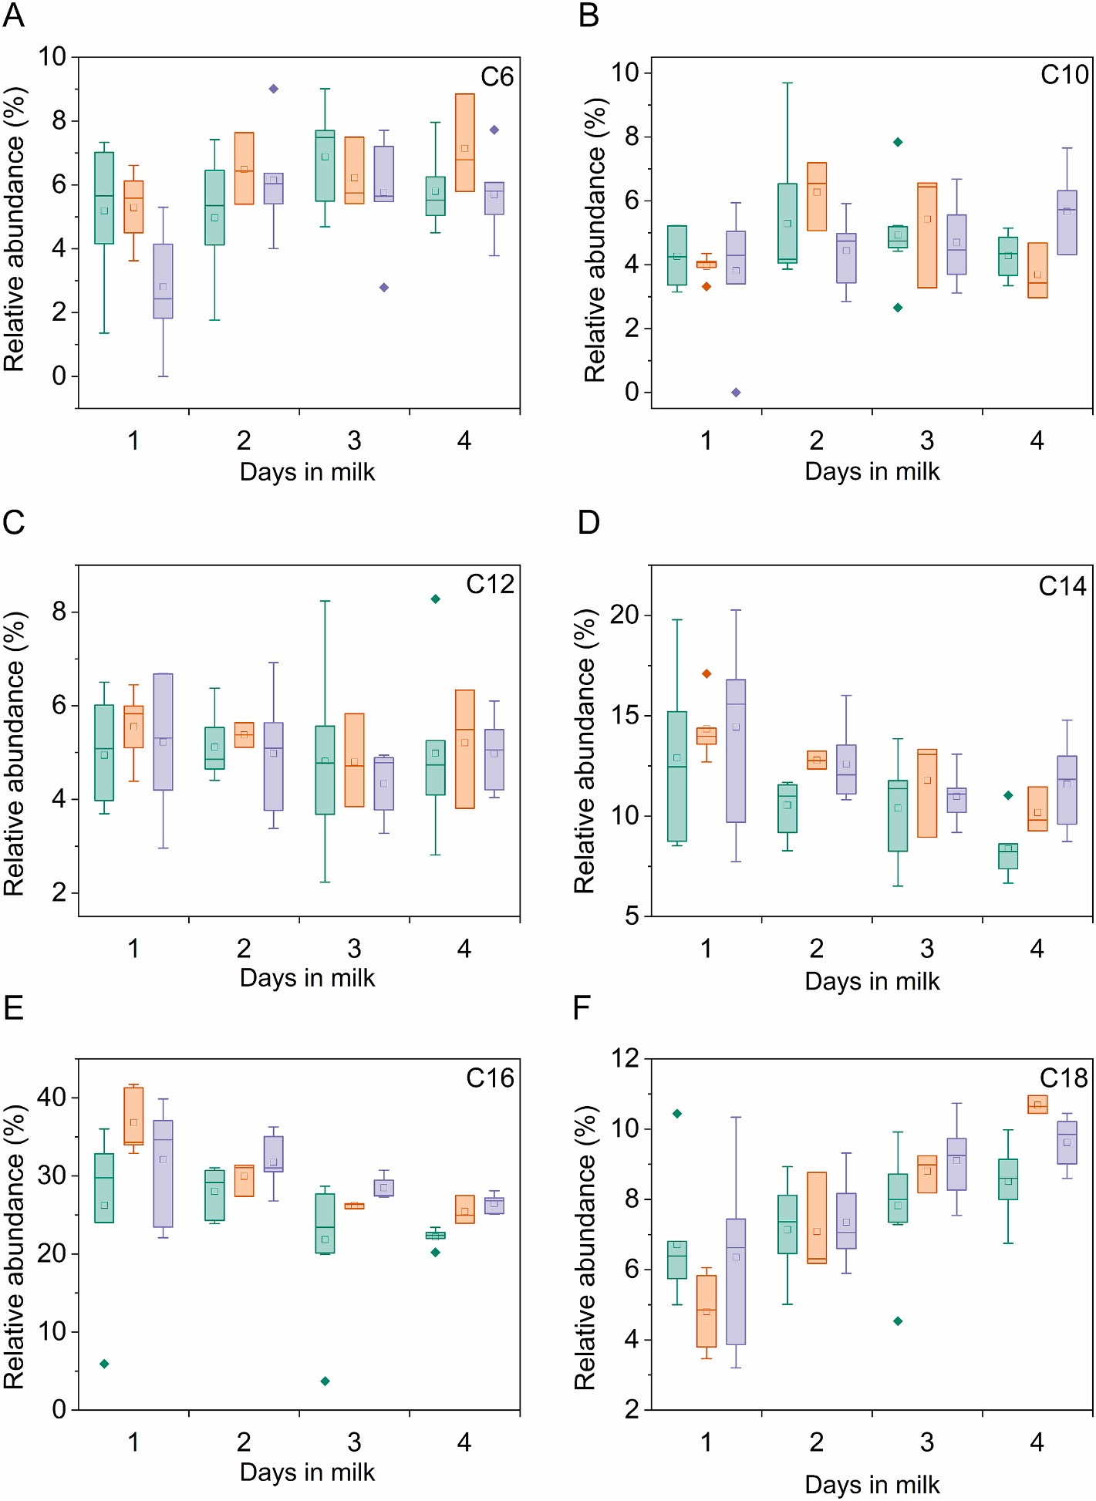
Fig. 1. Relative abundances of the major saturated FAs in milk from cows lactating for the first (green), second (orange), and third time (violet). (A) Caproic acid (C6:0), (B) capric acid (C10:0), (C) lauric acid (C12:0), (D) myristic acid (C14:0), (E) palmitic acid (C16:0), and (F) stearic acid (C18:0). (For interpretation of the references to color in this figure legend, the reader is referred to the web version of this article.)

Fatty acid profiles according to chain length
SCFAs and MCFAs are important components of bovine milk fat (Liu et al., 2023). In humans, SCFAs C6:0, C8:0, and C10:0 exhibit antimicrobial and antiviral activities in the gastric lining and proximal intestine (Calvo, Fontecha, Perez-G´ alvez, ´ & Rodríguez-Alcala, 2023´ ) and regulate immune functions by affecting the intestinal flora (Dai et al., 2020). We found that SCFAs, which are the sum of FAs with chain length <12, accounted for an average of 19% of the total FA content. The SCFA content was affected by DIM (p = 0.009) and tended to be affected by lactation number (p = 0.052, Table 2). The most abundant SFCAs were butyric acid (C4), caproic acid (C6) and capric acid (C10), accounting for an average of 5% of the total FA content each. Previous research on the effects of parity and DIM effects on the content of SCFAs in colostrum has yielded inconsistent results. In contrast to our findings, Rodríguez- Bermúdez et al. (2023) did not observe any effect of lactation number on the mentioned FAs. However, they did find that SCFAs tended to have higher concentrations in multiparous cows. On the other hand, Contarini et al. (2014) found lower concentrations of short-chain saturated FAs (C4–C10) in colostrum than in mature milk. Additionally, O'Callaghan et al. (2020) reported a DIM effect on de novo synthesized FAs. However, it is important to note that de novo-synthesized FAs also include some MCFAs (C14–C15). Therefore, our results cannot be directly compared to the previous study. SCFAs are synthesized de novo in the mammary gland from the volatile FAs produced during microbial fermentation in the rumen, with acetate- and butyrate-derived β-hydroxybutyrate being the major precursors for de novo synthesis. De novo synthesis depends greatly on the animal feeding, rumen metabolism, and substrate availability for FA synthesis. Furthermore, long- chain unsaturated FAs, particularly oleic acid, released during lipolysis, inhibit synthetic processes in the mammary gland (Rodríguez- Bermúdez et al., 2023). Liu et al. (2023) also suggested that the animal genotypes may contribute to differences in SCFA profiles found in the literature.
In colostrum fat, SCFAs (sum of FAs with chain length < 12) accounted for an average of 19% of total FAs. MCFAs (sum of FAs with chain length ≥ 12 and < 18) accounted for an average of 53% of total FAs, and long-chain FAs (sum of FAs with chain length ≥ 18) accounted for an average of 28% of total FAs. All FA groups were affected by DIM. The SCFAs and LCFAs exhibited a gradual increase over time (p = 0.009 and 0.003, respectively; Table 2) while MCFAs showed the opposite trend (p < 0.001, Table 2). Moreover, lactation number had an impact on MCFAs (p = 0.004, Table 2), with the lowest value observed in primiparous cows. Apart from myristic, palmitic, and oleic acids discussed earlier, the most prevalent MCFAs and LCFAs were lauric acid (C12:0) and stearic acid (C18:0), respectively. On average, they represented 5% and 7% of the total FA content.
Lauric acid has been found to have inhibitory effects on some pathogenic bacteria and exhibits antimicrobial and antiviral activity, as well as boosting the immune system in humans (Calvo et al., 2023). However, it is important to note that lauric acid is included in the group of hypercholesterolemic FAs, as mentioned below. Our study did not find any significant effect of lactation or DIM on lauric acid content (p > 0.05, Table 1, Fig. 1C). In contrast, O'Callaghan et al. (2020) reported a significant decrease in lauric acid content in colostrum between the second and third DIM, following steady concentrations during the first two days of lactation. Lauric acid is synthesized de novo in the mammary gland, and its concentration in milk fat can be influenced by various factors including nutrition, rumen metabolism, substrate availability for FA synthesis, and inhibitory effects of long-chain unsaturated FAs.
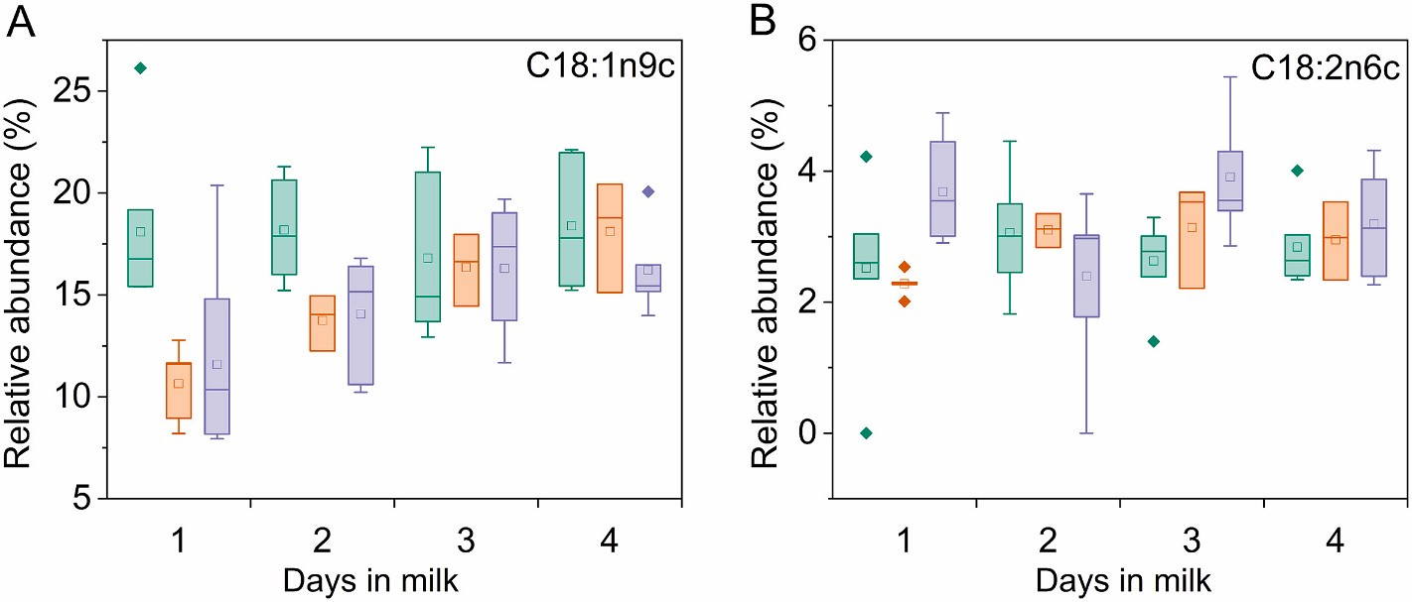
Figure 2

Fig. 2. Relative abundances of the major unsaturated FAs in milk from cows lactating for the first (green), second (orange), and third time (violet). (A) Oleic acid (C18:1n9c) and (B) linoleic acid (C18:2n6c). (For interpretation of the references to color in this figure legend, the reader is referred to the web version of this article.)
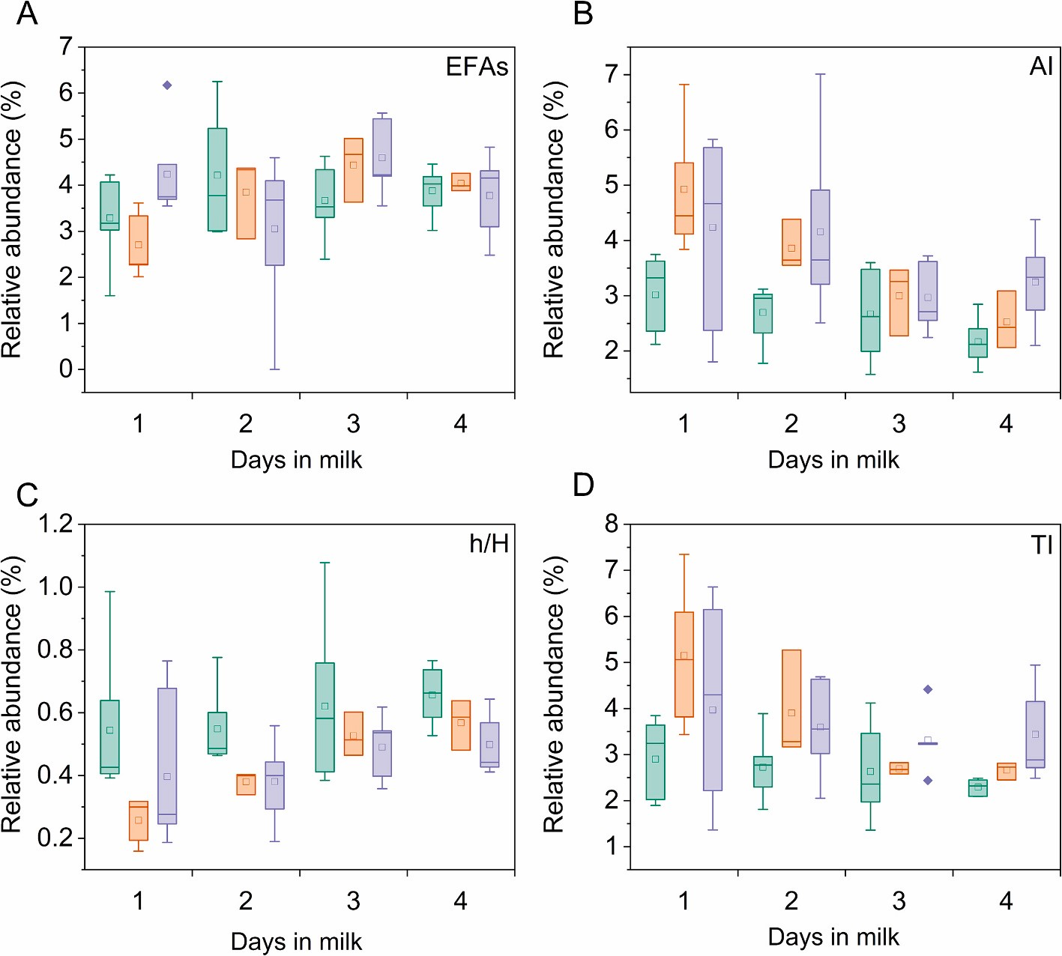
Figure 3
Fig. 3. Ratios and indexes of milk from cows lactating for the first (green), second (orange), and third time (violet). (A) Essential fatty acids (EFAs), (B) atherogenic index (AI), (C) hypocholesterolemic-to-hypercholesterolemic ratio (h/H), (D) thrombogenicity index (TI). (For interpretation of the references to color in this figure legend, the reader is referred to the web version of this article.)

Health-promoting and desirable FAs and indexes
Table 2 shows the sums of selected health-promoting FAs and milk fat indexes. The polyunsaturated-to-saturated FA ratio is the basic ratio used for the evaluation of FA profiles. In this study, the ratio was 0.07 and was not affected by the studied factors (p > 0.05). The value for bovine milk falls within the ranges reported by Hanuˇs et al. (2018) and Chen and Liu (2020). However, it is considerably lower than the recommended values for humans, which are above 0.45, in order to reduce the risk of coronary heart disease and cancer (Simopoulos, 2002). It is necessary to note that this value is too general and does not take into account the effects of individual FAs on cardiovascular health (Chen & Liu, 2020).
We found that essential fatty acids, specifically linoleic acid (C18:2n6c) and α-linolenic acid (C18:3n-3), made up an average of 4% of the total FA content. These essential fatty acids were not affected by lactation number or DIM (p > 0.05, see Table 2, and Fig. 3A). Essential FAs serve as precursors for long-chain FAs, which are necessary for hormone production and neural development. Furthermore, linoleic acid has the ability to inhibit the production of pro-inflammatory factors, slow down the onset of oxidative stress, and plays a neuroprotective role. Also, α-linolenic acid can lower the risk of cardiovascular diseases and arrhythmia, as well as prevent vascular complications of diabetes (Liu et al., 2023).
In humans, n-6 (omega-6) FAs play a critical role in many physiological functions and their derivatives are involved in complex molecular pathways. When consumed in appropriate amounts (n-6 PUFA intake from 5% to 20% of the energy intake), n-6 FAs reduce the risk of chronic diseases, lower blood low density lipoprotein (LDL)-cholesterol levels, and are associated with a decreased risk of coronary heart disease.
Nonetheless, excessive intake should be avoided. Excessive consumption of n-6 PUFA may have adverse effects on health, including an increase of several cardiovascular disease risk factors, such as blood pressure, inflammatory markers, and obesity. Therefore, the level of FA intake plays a key role in the biological effects of these FAs (Czernichow, Thomas, & Bruckert, 2010). On the other hand, n-3 (omega-3) FAs are valued for their anti-inflammatory, antioxidant, and neuroprotective properties. They are important in preventing and inhibiting the development of most chronic inflammatory diseases (Huang et al., 2023; Liput et al., 2021). However, the effects of n-3 FAs depend on their ratio to n-6 FAs (Simopoulos, 2010). Therefore, the ideal n-6/n-3 ratio for humans should be between 1:1 and 2:1. Nevertheless, in developed countries consuming a Western diet, the real n-6/n-3 ratio reaches up to 20:1 (Liput et al., 2021). Bovine milk contains both n-6 and n-3 FAs in a ratio between 1.71 and 4.29, depending on the type of diet or rearing (Hanuˇs et al., 2018). Our study found that the average content of n-6 FAs in colostrum fat was 3.9%, while the content of n-3 FAs was 1%, resulting in an n-6/n-3 ratio of 4:1. The content of these FAs and their ratio were not affected by DIM or lactation number (p > 0.05, Table 2). These findings contrast with those of Wilms et al. (2022), who reported higher levels of n-3 and n-6 PUFAs in colostrum compared to mature milk. Apart from the type of diet and rearing, the proportion and ratio of n-3 and n-6 FAs can also be influenced by the breed and stage of lactation (Kaya et al., 2023). In humans, a dietary n-6/n-3 ratio lower than 4 is expected to reduce the risk of coronary heart disease (Simopoulos, 2002). Therefore, the n-6/n-3 ratio found in our study is very close to the desirable values.
The atherogenic index (AI) is the ratio between pro-atherogenic FAs that favour the adhesion of lipids to cells in the circulatory system and anti-atherogenic FAs that inhibit adhesion and reduce the concentration of cholesterol and esterified FAs in the blood. The thrombogenicity index (TI) is the ratio between pro-thrombogenic and anti-thrombogenic FAs and indicates the risk of clot formation in blood vessels (Ulbricht & Southgate, 1991). Although no optimum values for these indexes have been established, it is suggested that consuming food with lower AI or TI values is beneficial for human health. This is because it could reduce the risk of cardiovascular diseases (Chen & Liu, 2020).
Our study found that AI decreased significantly with increasing DIM (p = 0.006, Table 2, Fig. 3B). Additionally, we saw a significant decrease in the concentrations of myristic and palmitic acids and an increase in oleic acid in relation to DIM (p-values of 0.001, 0.001, and 0.005, respectively, Table 1, Figs. 1 and 2). These findings are consistent with those of O'Callaghan et al. (2020), who also reported similar changes in the aforementioned FAs and a significant decrease in AI in relation to DIM.
In our study, we found that TI was not affected by DIM (p > 0.05, Table 2). This contrasts with the findings of O'Callaghan et al. (2020) who reported a significant decrease in TI with increasing DIM. However, in both studies, the TI values were primarily influenced by the decreased contents of myristic and palmitic acids (both with p = 0.001) and the increased contents of oleic and stearic acids (p = 0.005 and p < 0.001, respectively), (see Table 1, Figs. 1D-F and 2A).
During the first lactation, both AI and TI were lower compared to later lactations (p-values of 0.001 and 0.003, respectively; see Table 2 and Fig. 3B, D). This can be explained by the decreased contents of myristic and palmitic acids (p-values of 0.026 and 0.002, respectively) and increased content of MUFAs, mainly oleic acid (p = 0.001), in the milk of primiparous cows compared to multiparous cows. The AI and TI values reported here fall within the average range found in milk, as summarized by Chen and Liu (2020), with values of 1.42–5.13 and 0.39–5.04 respectively.
Over the past few decades, milk fat has been linked with negative impacts on human health due to high proportion of saturated FAs. However, only excessive consumption of lauric, myristic, and palmitic acids appears to be related to cardiovascular diseases due to their contribution to increased levels of total and LDL-cholesterol in the blood. Therefore, these three FAs are referred to as hypercholesterolemic (Hanuˇs et al., 2018). However, their effect on human health is still debated because they may also have positive effects when consumed in moderation (Calvo et al., 2023), as discussed above. We found that DIM (p < 0.001, Table 2) and lactation number (p = 0.002, Table 2) affected the content of hypercholesterolemic acids. The lowest content of hypercholesterolemic FAs was observed in the colostrum of primiparous cows and it decreased with increasing DIM. In contrast, oleic acid and polyunsaturated FAs are considered to be health-beneficial and are referred to as hypocholesterolemic (Hanuˇs et al., 2018). The sum of these FAs was not affected by DIM (p > 0.05, Table 2), but lactation number did have an effect (p = 0.012, Table 2). The colostrum of primiparous cows had the highest content of hypocholesterolemic FAs, while the third-lactation cows had the lowest. Therefore, the h/H index was influenced by both lactation number and DIM (p = 0.002 and 0.005, respectively, Table 2, Fig. 3C). The h/H index values we found in our study fall within the general average range of 0.32–1.29 for milk and dairy products, as reported by Chen and Liu (2020).

Possible uses of colostrum and immature milk for production of functional food
Previous research has focused on the protein fractions of colostrum for human consumption, while the potential health benefits of colostrum fat have been largely overlooked. Nevertheless, FAs found in colostrum have been shown to have positive effects on human health. The high content and complex composition of colostrum fat make it a promising source for the production of health-promoting commodities. It is anticipated that the global market value of colostrum will increase by 6.4% per year between 2020 and 2030, as a result of the rising demand for colostrum and colostrum-based products (Global Cow Colostrum Market Snapshot (2023 to 2033), n.d). This, along with recent advancements in processing technologies and innovative confinement and identification techniques, will result in the discovery and utilization of previously overlooked or concealed constituents of colostrum (Linehan et al., 2023). The potential health benefits of colostrum include its fat content, which contains a variety of lipids and fatty acids that differ in molecular configuration, chain length, and degree of saturation (Table 1, Jensen, 2002) and have a specific impact on human health.
The FA profile in colostrum fat is influenced by various factors, including hormonal and metabolic changes associated with parturition and lactation onset. These changes cause rapid alterations in the FA profile within the first four days after parturition. We have shown that the DIM has an impact on the profile of individual FAs. Specifically, there is a decrease in the relative content of myristic and palmitic acids and an increase in the relative content of caproic, stearic, and oleic acids with an increasing number of DIM (Figs. 1, 2). The profile of individual FAs is affected by the lactation number (primiparous vs. multiparous cows) – the colostrum of primiparous cows was found to have a relatively low content of myristic and palmitic acids and a high content of butyric and oleic acid (Figs. 1, 2). Furthermore, the lactation number affected the sums of FAs – the colostrum of primiparous cows had a lower content of MCFAs and SFAs and a higher content of MUFAs compared to multiparous ones (Table 2). Overall, there is a statistically significant difference in the fat composition of colostrum between primiparous and multiparous individuals.
To evaluate the health benefits of milk fat with varying in FA profiles, it is appropriate to use sums of specific FAs and indexes that factor potentially beneficial or hazardous FAs. While recommended optimal values are lacking for widely used indexes, it is worth noting that the colostrum of primiparous cows exhibits the most favorable values of AI, TI, and h/H when compared to multiparous cows. The same was observed for AI and h/H in immature milk at the end of the milk transition (3–4 days after parturition) in comparison to the beginning of lactation.

Conclusions
In summary, if appropriate collecting and processing methods are used, colostrum fat can be a valuable product that provides health benefits to consumers. This is especially true for colostrum from primiparous cows and the immature milk at the end of the milk transition. We recommend that colostrum and immature milk from primiparous cows be collected and processed separately for targeted production of nutraceuticals with specific health properties. This is due to their naturally higher content of butyric acid, which is applicable to humans with insufficient endogenous production of butyric acid in the gut. On the other hand, secretion from cows, particularly primiparous cows, at the end of the milk transition (4 days postpartum), can be used to produce oleic acid-enriched products with anti-inflammatory properties. These products are useful in preventing heart disease. Moreover, secretions from primiparous cows and immature milk at the end of the milk transition have the highest anti-atherogenic properties. They can help reduce the risk of cardiovascular diseases. Further studies are required to specify the factors that influence the FA profiles in colostrum fat.

CRediT authorship contribution statement
Veronika Farkova: ´ Conceptualization, Data curation, Investigation, Visualization, Writing – original draft, Writing – review & editing. Ludmila Kˇríˇzova: ´ Conceptualization, Methodology, Writing – review & editing. Kateˇrina Dadakov´ a: ´ Data curation, Writing – review & editing. Zdenek Farka: ˇ Data curation, Visualization, Writing – review & editing. Steven Mascrez: Data curation, Methodology. Damien Eggermont: Data curation, Validation, Writing – review & editing. Giorgia Purcaro: Data curation, Supervision, Writing – review & editing. Toma´ˇs Kaˇsparovský: Conceptualization, Funding acquisition, Supervision, Writing – review & editing.

Declaration of competing interest
The authors declare that they have no competing financial interests or personal relationships that could have influenced the work reported in this paper.

Data availability
Data will be made available on request.

Acknowledgments
Special thanks go to farm manager Ing. Marek Klíˇc for his help with the organization of the experiment and to the farm workers for their help with sample collection. GP, SM and DE thank Shimadzu, Sepsolve, and VUV Analytics for their continuous support. Graphical abstract was created in PowerPoint and BioRender.com.
This work was funded by the Grant Agency of Masaryk University, grant number MUNI/A/1313/2022.

Appendix A. Supplementary data
Supplementary data to this article can be found online at https://doi.org/10.1016/j.foodchem.2024.139042.

References
Alexieva, B., Markova, T., & Nikolova, E. (2004). Bovine colostrum—The promising nutraceutical. Czech Journal of Food Sciences, 22(2), 73–79. https://doi.org/ 10.17221/3409-CJFS
Bai, L., Smuts, J., Walsh, P., Qiu, C., McNair, H. M., & Schug, K. A. (2017). Pseudo- absolute quantitative analysis using gas chromatography – Vacuum ultraviolet spectroscopy – A tutorial. Analytica Chimica Acta, 953, 10–22. https://doi.org/
10.1016/j.aca.2016.11.039
den Besten, G., van Eunen, K., Groen, A. K., Venema, K., Reijngoud, D.-J., & Bakker, B. M. (2013). The role of short-chain fatty acids in the interplay between diet, gut microbiota, and host energy metabolism. Journal of Lipid Research, 54(9),
2325–2340. https://doi.org/10.1194/jlr.R036012
Calvo, M. V., Fontecha, J., P´erez-Galvez, A., & Rodríguez-Alcal´ a, L. M. (2023). Milk lipids ´ and their nutritional importance. In Bioactive lipids (pp. 269–295). Elsevier. https:// doi.org/10.1016/B978-0-12-824043-4.00015-4.
Chandler, T. L., Newman, A., Cha, J. E., Sipka, A. S., & Mann, S. (2023). Leukocytes, microRNA, and complement activity in raw, heat-treated, and frozen colostrum and their dynamics as colostrum transitions to mature milk in dairy cows. Journal of Dairy Science, 106(7), 4918–4931. https://doi.org/10.3168/jds.2022-22876
Chen, J., & Liu, H. (2020). Nutritional indices for assessing fatty acids: A mini-review. International Journal of Molecular Sciences, 21(16), 5695. https://doi.org/10.3390/ ijms21165695
Chilliard, Y., & Ferlay, A. (2004). Dietary lipids and forages interactions on cow and goat milk fatty acid composition and sensory properties. Reproduction Nutrition
Development, 44(5), 467–492. https://doi.org/10.1051/rnd:2004052
Contarini, G., Povolo, M., Pelizzola, V., Monti, L., Bruni, A., Passolungo, L., Abeni, F., & Degano, L. (2014). Bovine colostrum: Changes in lipid constituents in the first 5 days after parturition. Journal of Dairy Science, 97(8), 5065–5072. https://doi.org/ 10.3168/jds.2013-7517
Czernichow, S., Thomas, D., & Bruckert, E. (2010). n− 6 fatty acids and cardiovascular health: A review of the evidence for dietary intake recommendations. British Journal of Nutrition, 104(6), 788–796. https://doi.org/10.1017/S0007114510002096
Dai, X., Yuan, T., Zhang, X., Zhou, Q., Bi, H., Yu, R., Wei, W., & Wang, X. (2020). Short- chain fatty acid (SCFA) and medium-chain fatty acid (MCFA) concentrations in human milk consumed by infants born at different gestational ages and the variations in concentration during lactation stages. Food & Function, 11(2),
1869–1880. https://doi.org/10.1039/C9FO02595B
Dei Cas, M., Paroni, R., Signorelli, P., Mirarchi, A., Cerquiglini, L., Troiani, S., … Albi, E. (2020). Human breast milk as source of sphingolipids for newborns: Comparison with infant formulas and commercial cow’s milk. Journal of Translational Medicine,
18(1), 481. https://doi.org/10.1186/s12967-020-02641-0
Fina, A., Mascrez, S., Beccaria, M., De Luca, C., Aspromonte, J., Cordero, C., & Purcaro, G. (2022). A high throughput method for fatty acid profiling using simultaneous microwave-assisted extraction and derivatization followed by reversed fill/flush flow modulation comprehensive multidimensional gas chromatography.
Advances in Sample Preparation, 4, Article 100039. https://doi.org/10.1016/j.
sampre.2022.100039
Global Cow Colostrum Market Snapshot (2023 to 2033) (2023, august 12) https://www. futuremarketinsights.com/reports/cow-colostrum-market.
Godden, S. (2008). Colostrum Management for Dairy Calves. The Veterinary Clinics of North America. Food Animal Practice, 24(1), 19–39. https://doi.org/10.1016/j. cvfa.2007.10.005
Gorka, P., Kowalski, Z. M., Zabielski, R., & Guilloteau, P. (2018). Invited review: Use of ´ butyrate to promote gastrointestinal tract development in calves. Journal of Dairy
Science, 101(6), 4785–4800. https://doi.org/10.3168/jds.2017-14086
Guberti, M., Botti, S., Capuzzo, M. T., Nardozi, S., Fusco, A., Cera, A., … De Marinis, M. G. (2021). Bovine colostrum applications in sick and healthy people: A systematic review. Nutrients, 13(7), 2194. https://doi.org/10.3390/nu13072194
Guti´errez-García, A. G., Contreras, C. M., & Díaz-Marte, C. (2017). Myristic acid in amniotic fluid produces appetitive responses in human newborns. Early Human Development, 115, 32–37. https://doi.org/10.1016/j.earlhumdev.2017.08.009
Hanuˇs, O., Samkova, E., K´ _{ˇ}ríˇzova, L., Haso´ novˇ a, L., & Kala, R. (2018). Role of fatty acids ´ in Milk fat and the influence of selected factors on their variability—A review. Molecules, 23(7), 1636. https://doi.org/10.3390/molecules23071636
Havlicekova, Z., Jesenak, M., Banovcin, P., & Kuchta, M. (2015). Beta-palmitate – A natural component of human milk in supplemental milk formulas. Nutrition Journal,
2015(15). https://doi.org/10.1186/s12937-016-0145-1
Huang, C., Deng, W., Xu, H., Zhou, C., Zhang, F., Chen, J., Bao, Q., Zhou, X., Liu, M., Li, J., & Liu, C. (2023). Short-chain fatty acids reprogram metabolic profiles with the induction of reactive oxygen species production in human colorectal adenocarcinoma cells. Computational and Structural Biotechnology Journal, 21,
1606–1620. https://doi.org/10.1016/j.csbj.2023.02.022
Jensen, R. G. (2002). The composition of bovine Milk lipids: January 1995 to December 2000. Journal of Dairy Science, 85(2), 295–350. https://doi.org/10.3168/jds.S0022-
0302(02)74079-4
Kaplan, M., Arslan, A., Duman, H., Karyelioglu, M., Baydemir, B., Günar, B. B., ˘ … Karav, S. (2022). Production of bovine colostrum for human consumption to improve health. Frontiers in Pharmacology, 12, Article 796824. https://doi.org/ 10.3389/fphar.2021.796824
Kaya, U., Ozkan, H., Yazlik, M. O., Çamdevi¨ ˙Ren, B., Güngor, G., Karaaslan, ¨ I., ˙ …
Yakan, A. (2023). Comparative evaluation of major milk quality parameters of Holstein and Simmental cows at different lactation stages under similar environmental conditions. Medycyna Weterynaryjna, 79(06). https://doi.org/ 10.21521/mw.6779, 6779–2023.
Kim, J. H., Jung, W. S., Choi, N.-J., Kim, D.-O., Shin, D.-H., & Kim, Y. J. (2009). Health- promoting effects of bovine colostrum in type 2 diabetic patients can reduce blood glucose, cholesterol, triglyceride and ketones. The Journal of Nutritional Biochemistry, 20(4), 298–303. https://doi.org/10.1016/j.jnutbio.2008.04.002
Lindmark Månsson, H. (2008). Fatty acids in bovine milk fat. Food & Nutrition Research,
52(1), 1821. https://doi.org/10.3402/fnr.v52i0.1821
Linehan, K., Ross, R. P., & Stanton, C. (2023). Bovine colostrum for veterinary and human health applications: A critical review. Annual Review of Food Science and Technology, 14(1), 387–410. https://doi.org/10.1146/annurev-food-060721-014650 Liput, K. P., Lepczynski, A., Og´ _{ł}uszka, M., Nawrocka, A., Poławska, E., Grzesiak, A., … Pierzchała, M. (2021). Effects of dietary n–3 and n–6 polyunsaturated fatty acids in inflammation and cancerogenesis. International Journal of Molecular Sciences, 22(13),
6965. https://doi.org/10.3390/ijms22136965
Liu, Y., Shen, N., Xin, H., Yu, L., Xu, Q., & Cui, Y. (2023). Unsaturated fatty acids in natural edible resources, a systematic review of classification, resources, biosynthesis, biological activities and application. Food Bioscience, 53, Article
102790. https://doi.org/10.1016/j.fbio.2023.102790
McGrath, B. A., Fox, P. F., McSweeney, P. L. H., & Kelly, A. L. (2016). Composition and properties of bovine colostrum: A review. Dairy Science & Technology, 96(2),
133–158. https://doi.org/10.1007/s13594-015-0258-x
Mehra, R., Garhwal, R., Sangwan, K., Guin´e, R. P. F., Lemos, E. T., Buttar, H. S., …
Kumar, H. (2022). Insights into the research trends on bovine colostrum: Beneficial health perspectives with special reference to manufacturing of functional foods and feed supplements. Nutrients, 14(3), 659. https://doi.org/10.3390/nu14030659
Mierlița, D. (2018). Effects of diets containing hemp seeds or hemp cake on fatty acid ˘ composition and oxidative stability of sheep milk. South African Journal of Animal Science, 48(3), 504. https://doi.org/10.4314/sajas.v48i3.11
O’Callaghan, T. F., O’Donovan, M., Murphy, J. P., Sugrue, K., Mannion, D., McCarthy, W. P., … Tobin, J. T. (2020). Evolution of the bovine milk fatty acid profile – From colostrum to milk five days post parturition. International Dairy Journal, 104, Article 104655. https://doi.org/10.1016/j.idairyj.2020.104655
Playford, R. J., & Weiser, M. J. (2021). Bovine colostrum: Its constituents and uses. Nutrients, 13(1), 265. https://doi.org/10.3390/nu13010265
Rathe, M., Müller, K., Sangild, P. T., & Husby, S. (2014). Clinical applications of bovine colostrum therapy: A systematic review. Nutrition Reviews, 72(4), 237–254. https:// doi.org/10.1111/nure.12089
Rico, D. E., & Razzaghi, A. (2023). Animal board invited review: The contribution of adipose stores to milk fat: Implications on optimal nutritional strategies to increase milk fat synthesis in dairy cows. Animal, 17(4), Article 100735. https://doi.org/ 10.1016/j.animal.2023.100735
Rodríguez-Bermúdez, R., Fouz, R., Rico, M., Camino, F., Souza, T. K., Miranda, M., & Dieguez, F. J. (2023). Factors affecting fatty acid composition of Holstein cow´ ’s milk.
Animals, 13(4), 574. https://doi.org/10.3390/ani13040574
Samkova, E., ´ Spi^{ˇ} _{ˇ}cka, J., Peˇsek, M., Pelikanov´ a, T., & Hanu´ _{ˇ}s, O. (2012). Animal factors affecting fatty acid composition of cow milk fat: A review. South African Journal of
Animal Science, 2012(42), 1–18. https://doi.org/10.4314/sajas.v42i2.1
Santoro, J., Mukhopadhya, A., Oliver, C., Brodkorb, A., Giblin, L., & O’Driscoll, L.
(2023). An investigation of extracellular vesicles in bovine colostrum, first milk and milk over the lactation curve. Food Chemistry, 401, Article 134029. https://doi.org/ 10.1016/j.foodchem.2022.134029
Sats, A., Yurchenko, S., Kaart, T., Tatar, V., Lutter, L., & Joudu, I. (2022). Bovine ˜ colostrum: Postpartum changes in fat globule size distribution and fatty acid profile.
Journal of Dairy Science, 105(5), 3846–3860. https://doi.org/10.3168/jds.2021-
20420
Schuh, K., Sadri, H., Haussler, S., Webb, L. A., Urh, C., Wagner, M., ¨ … Sauerwein, H. (2019). Comparison of performance and metabolism from late pregnancy to early lactation in dairy cows with elevated v. normal body condition at dry-off. Animal, 13 (7), 1478–1488. https://doi.org/10.1017/S1751731118003385
Shingfield, K. J., Chilliard, Y., Toivonen, V., Kairenius, P., & Givens, D. I. (2008). Trans fatty acids and bioactive lipids in ruminant Milk. In Z. Bosze (Ed.), ¨ Bioactive components of milk (606, 3–65). New York: Springer. https://doi.org/10.1007/978-0- 387-74087-4_1.
Simopoulos, A. P. (2002). The importance of the ratio of omega-6/omega-3 essential
fatty acids. Biomedicine & Pharmacotherapy, 56(8), 365–379. https://doi.org/ 10.1016/S0753-3322(02)00253-6
Simopoulos, A. P. (2010). The omega-6/omega-3 fatty acid ratio: Health implications. Ol´eagineux, Corps gras, Lipides, 17(5), 267–275. https://doi.org/10.1051/ ocl.2010.0325
Soufleri, A., Banos, G., Panousis, N., Fletouris, D., Arsenos, G., Kougioumtzis, A., & Valergakis, G. E. (2021). Evaluation of factors affecting colostrum quality and quantity in Holstein dairy cattle. Animals, 11(7), 2005. https://doi.org/10.3390/ ani11072005
Stolcov^{ˇ} a, M., ´ Reh^{ˇ} ak, D., & Barto´ n, L. (2021). Changes in milk ketone and fatty acid ˇ concentrations during early lactation in Holstein and Fleckvieh cows. Czech Journal of Animal Science, 66(12), 477–486. https://doi.org/10.17221/122/2021-CJAS
Ulbricht, T. L. V., & Southgate, D. A. T. (1991). Coronary heart disease: Seven dietary factors. The Lancet, 338(8773), 985–992. https://doi.org/10.1016/0140-6736(91)
91846-M
Wang, E., Cha, M., Wang, S., Wang, Q., Wang, Y., Li, S., & Wang, W. (2023). Feeding corn silage or grass hay as sole dietary forage sources: Overall mechanism of forages regulating health-promoting fatty acid status in milk of dairy cows. Foods, 12(2),
303. https://doi.org/10.3390/foods12020303
Wilms, J. N., Hare, K. S., Fischer-Tlustos, A. J., Vahmani, P., Dugan, M. E. R., Leal, L. N., & Steele, M. A. (2022). Fatty acid profile characterization in colostrum, transition milk, and mature milk of primi- and multiparous cows during the first week of lactation. Journal of Dairy Science, 105(3), 2612–2630. https://doi.org/10.3168/ jds.2021-20880
Xiong, R.-G., Zhou, D.-D., Wu, S.-X., Huang, S.-Y., Saimaiti, A., Yang, Z.-J., … Li, H.-B.
(2022). Health benefits and side effects of short-chain fatty acids. Foods, 11(18),
2863. https://doi.org/10.3390/foods11182863

