Theory and Building Practice
Vol. 2, No.2, 2023

DOI
Piotr Harassek¹, Luc Courard², Andrzej Garbacz^{1*}
DETECTION OF “ZERO-VOLUME” DEFECTS IN CONCRETE REPAIR SYSTEMS USING IMPACT-ECHO METHOD
¹Warsaw University of Technology
²University of Liege
andrzej.garbacz@pw.edu.pl

© Piotr Harassek, Luc Courard, Andrzej Garbacz. 2023
Adhesion in this system is one of the most important factors that affect the reliability and durability of repair. According to the many standards and guidelines, a pull-off test is recommended for assessment of a bond quality in repair systems. However, a growing interest in development of non-destructive techniques (NDT) for evaluation of concrete structures is recently noted. A majority of NDT methods mentioned in EN 1504-10 for repair efficiency assessment are based on propagation of stress waves. The impact echo method is considered as a one of the promising. The literature data confirmed that the “non-zero volume” defects containing air are relatively easy to detect with impact-echo method if they are large enough. It is more complex to detect “zero-volume” defects, e.g dust or any other antiadhesion material. In this work usability of impact-echo for detection of “zero-volume” defects in repair systems is discussed.

Keywords: impact echo, repair efficiency evaluation, “zero-volume” defects, frequency and wavelet analysis.

Introduction
Recently, concrete structures deterioration has become one of the most important technical, economic and social problems in many countries. What more last recommendation of the European Union “Fit for 55” implies necessity for their repair and strengthening. As a result of repair or protection of the building structure a composite system (concrete substrate in contact with repair material) is produced (Czarnecki & Emmons, 2002, Mechtcherine, 2013). Adhesion in this system is one of the most important factors that affect the reliability and durability of repair (Bissonnette et al, 2016, Korayem et al., 2020). According to the many standards and guidelines, e.g. new European Standard EN 1504-10 and ACI Concrete Repair Manual, a pull-off test is recommended for assessment of a bond quality in repair systems. However, the non-destructive methods (NDT) are preferred for this purpose (Ju et al., 2017, Helal et al., 2015, ). This is reason why a growing interest in development of non-destructive techniques (NDT) for evaluation of concrete structures is recently noted (Hoła & Schabowicz, 2010, , Villain, 2019, Schabowicz, 2019). A majority of NDT methods mentioned in EN 1504-10 for repair efficiency assessment are based on propagation of stress waves. Particularly, ultrasonic methods and impact echo method are recommended.
Propagation of stress waves through a repair system is a complex phenomenon depending on acoustic properties of repair material and its thickness as well as a quality of interface. Taking into account the classification proposed by Adams and Drinkwater (1997), two main types of defects can occur in this system that can affect stress wave propagation (Fig.1):
- adhesion type (at the interface zone: overlay - substrate): various types of “non-zero volume” disbonds (e.g., voids, delaminations) and “zero-volume” disbonds - weak adhesion areas (e.g. due to a presence of dust, oil, etc.);
- cohesion type (in repair material or/and concrete substrate): porosity, cracks, honeycombing, partially non-hardened resin in the case of polymer material.
During selection of NDT method, the following factors should be taken into account (Garbacz, 2015; Hoła et al., 2011)):
- type, size and location of defect to be investigated;
- type of repair material (effect of acoustic properties);
- thickness of overlay;
- roughness of concrete substrate.
There is the preference to apply the methods requiring the access from once side of tested object only.
Fig. 1. Scheme of possible defects in the system: repair material (R) – concrete substrate (CS)

Impact-echo method is one of the most promising methods for repair efficiency assessment. It based on the use of an elastic, low energy impact with steel ball (Fig.2a) on the surface generating low frequency stress waves (mainly below 60kHz). These waves consist of compression (P), shear (S) and Rayleigh (surface) (R) components which propagate through the structure and are reflected by interfaces within the material (internal flaws such as voids, honeycomb, cracks, delaminations) or external boundaries. They are less sensitive to natural heterogeneity of concrete. Additional feature of I-E method is an application of frequency analysis besides only time-domain analysis (Fig 2b). The selection of the impact source is a critical factor for defect detection in multilayer system with impact–echo. The impact duration determines the frequency content of the stress wave and determines the minimum flaw depth that can be detected. The impact duration depends on the diameter of the impactor (Fig.2c).
Fig. 2: Scheme of impact-echo method (a), examples of waveform and corresponding
frequency spectrum (b) and effect of ball size on depth and size of defect possible to detect
(c) days after casting. The results are 22,6 MPa and 29,9 MPa respectively.

Impact-echo is successfully used for quality control of various types of repair, eg. injection of cable ducts, overlays and patches, etc. (eg. Sansalone & Streett, 1997; Abraham & Cote, 2002; Garbacz et al., 2017). The literature data confirmed that the “non-zero volume” defects containing air like voids, delaminations, etc are relatively easy to detect if they are large enough. This is because the reflection coefficient for concrete/air interface is equals nearly to 1.0, which means there is almost total reflection at the interface. It is more complex to detect “zero-volume” defects, e.g dust or any other material on concrete substrate, which can decrease bond strength between repair material and concrete as well.
In this work usability of impact-echo for detection of “zero-volume” defects in repair systems is discussed.

Materials and methods
In order to carry out the research program, twelve concrete substrate slabs (600 x 800 x 80 mm) have been prepared of concrete C20/25. The following materials have been used to prepare concrete slabs: portland cement CEM I 52,5; crushed sand 0/2 mm; crushed limestone aggregate 2/8, 8/14, 14/20; water. Preparation of samples included casting twelve substrate slabs (800 x 600 x 80 mm). Straight after casting, samples have been covered with plastic sheet for twenty four hours. Afterwards, samples have been demolded and stored for the next twenty eight days in standardized curing conditions (20°C, 90% relative humidity) in humidity chamber.
Five types of interface separating materials have been applied to ten concrete slabs (Fig.3). The appearance of separating material is meant to simulate different kind of “zero-volume” defects which may occur during application of repair material. The five types of defects were as follows:
- expanded polystyrene of 5 mm thick, 60 x 40 cm
- expanded polystyrene of 5 mm thick, 60 x 10 cm
- plastic sheet, rectangle shaped, 40 x 20 cm
- plastic sheet, trapezoidal shaped, 5/10 x 25 cm
- demoulding oil, 55 x 35 cm.
Figure 4 presents the location of each type of defect at the interface. Two slabs were left without any defect as a reference.
After the defects were applied, repair material has been put on as a second layer. Commercial PCC (polymer-cement composite) mortar has been used. The mortar is a self-compacting composite, consisting of high alumina cement, aggregate, supplementary binders and chemical admixtures. For each type of defect repair material was applied with two different thickness – 5 and 8 cm.
The impact echo measurements was made 14 days after execution of repair. Basing on the results from before-repair measurements, 5 mm ball has been chosen as an impactor. Each slab has been measured every 10 cm lengthwise and crosswise, that is 35 times in rectangular mesh in order to cover whole slab’s surface.

(a) | (b) | (c)
(d) | (e) | (f)
Fig. 3. Different types of defects: (a) no defect – reference, (b) rectangular plastic sheet, (c) trapezoidal-shaped plastic sheet, (d) polystyrene 40x60 cm, (e) polystyrene 10x60 cm, (f) demoulding oil.

The principle of the impact-echo bases on the waveform and frequency analysis. The transformation results in a frequency (amplitude) spectrum, which shows the amplitudes of various frequencies contained in the waveform – Fig 4a). The frequency corresponding to the arrival of the P-wave, reflected from the interface or bottom of an investigated system, is the inverse of the time interval visible in the original signal. Therefore, knowing the peak frequency (f) and the pulse velocity (Cp), the depth of this interface (T) may be calculated by modifying the equation (7):
 | $$T=\frac{C_{p}}{2f} [mm]$$ | (1)
Recently, a new tool for signal analysis – wavelet analysis - is being implemented in NDT assessment, also in the case of concrete structure, e.g. for analysis of acoustic emission or ultrasound signal (Kurtz et al.2003, Grosse & Reinhardt 2003). This method is more flexible for signal analysis in comparison to Fourier analysis. It is a multiresolution time-scale methods which enables to extract information like instantaneous frequency, tiny echoes embedded in complex signal or to suppress noise. Contrary to the Fourier transform, wavelet transform does not use periodical and infinite sine function but finite (“short-time”) wavelet, called mother wavelet function. The original signal is, therefore, divided into a set of shifted and scaled versions of the mother wavelet. As a result, the wavelet transform also produces time-frequency “windows” which, however, differ in time-scale. This allows for the creation of short-time windows for high frequencies and long-time sections when analyzing low frequencies (Fig. 4b). Two types of wavelet transforms may be performed: continuous (CWT) and discreet (DWT). The principle of the continuous wavelet transform consists in presentation of the signal as a composition of a sum of shifted and scaled mother wavelets multiplied by the vector C. Resulting density plot of CWT is called scalogram. Discreet wavelet transform is performed by the use of scaling parameters of power of two. In fact, DWT works as a filtering process: it decomposes the signal into low and high frequency contents. As a result, the approximation of signal and set of coefficient/time diagrams on scale levels of power of two are performed.

a)

Signal | Analysis | Principle | Result form
 | FT | constituent sinusoid of given frequencies (f)
 | STFT | constituent sinusoid of given frequencies (f)
b)
Signal | Analysis | Principle | Result form
 | CWT | constituent wavelets of different scales  and shifts
 | DWT
Fig. 4. Schemes of: a) Fourier (FT), short time Fourier (STFT) transforms
b) Continuous wavelet (CWT) and discreet wavelet (DWT) transforms

Results and discussions
After measurements, impact-echo signals from each slab were analysed using computer program IE Analyst developed in the MatLab environment. The following procedure was done for each signal:
- surface (Rayleigh’s) waves were localised and removed from the raw signal,
- fast Fourier transform of the signal was performed,
- for each signal amplitude of bottom/interface peak was obtained,
- maps of bottom/interface peaks’ amplitudes were performed.
Afterwards the following wavelet analysis was performed with use of MatLab wavelet toolbox. The performed continuous wavelet analysis was based on the db2 wavelet.
In the Tables 1 the results of the analysis signal: the interface amplitude value distribution and the signal waveforms obtained at the centre points of each slab for two thicknesses of repair are presented.
The impact echo measurements performed on the slabs where plastic sheet was introduced resulted in an ambiguous outcome. To some extent, the similar effect was also observed in the case of polystyrene placed at the depth of 50 mm. The obtained signals and their frequency spectra provided obvious information about some kind of non-homogeneity in the investigated system (in this case concrete substrate and repair mortar may be treated as materials acoustically homogeneous). On the other hand, those signals did not provide information about the depth of the interface where the defect occurs nor the type of it. The most important indication of the defects existence is in those cases was lack of bottom peaks in the frequency spectra.

Table 1
The results of the analysis signal: the interface amplitude value distribution
and the signal waveforms obtained at the centre points of each slab are presented
Repair mortar of 5 cm |  | Repair mortar of 8 cm
IE interface amplitude value distribution | Continues wavelet diagram in the defect place | IE interface amplitude value distribution | Continues wavelet diagram in the defect place
Reference plate – no defects at the interface
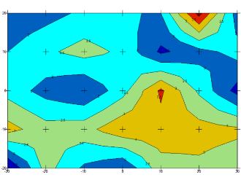 | 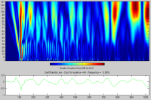 | 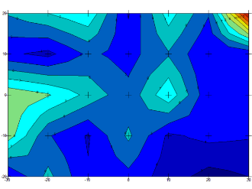 | 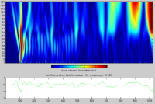
Rectangular plastic sheet
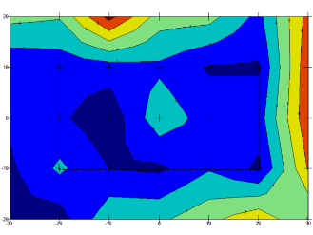 | 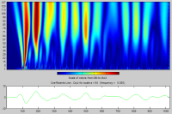 | 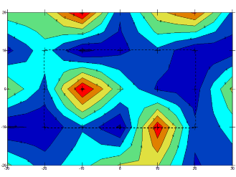 | 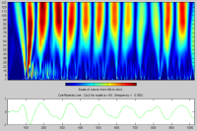
Trapezoidal plastic sheet
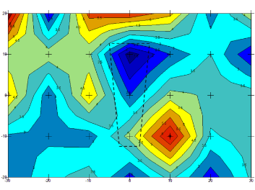 | 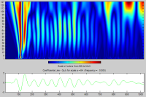 | 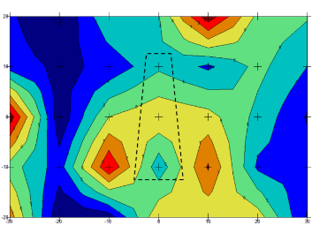 | 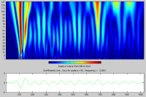
Polystyrene 40x60 cm
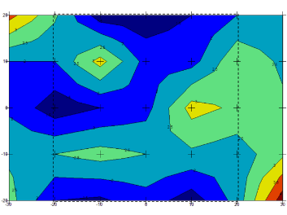 | 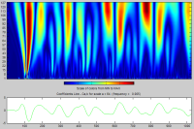 | 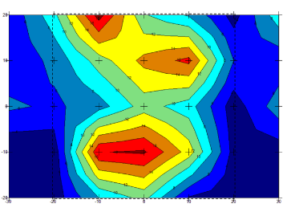 | 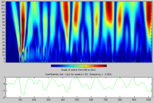
Polystyrene10x60
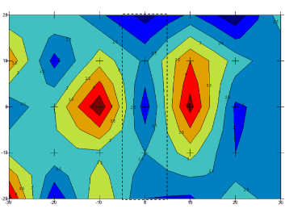 | 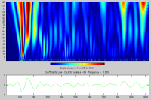 | 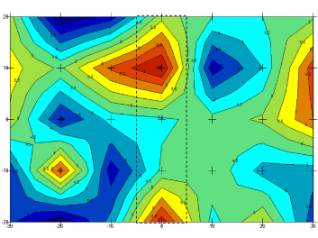 | 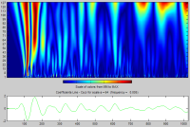
Demolding oil
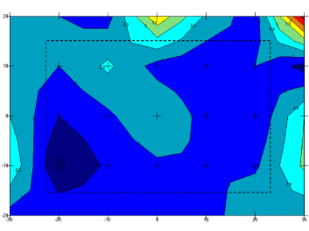 | 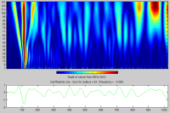 | 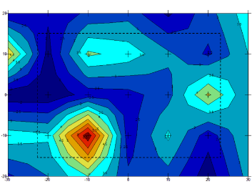 | 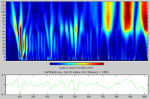

Particular results obtained at the centre points of each slab (see Tab.1) indicate the influence of the dimensions of introduced material. This is well observed in the cases of rectangular 40 x 20 cm piece of plastic sheet and trapezoidal stripe of the same material. The greater area covered by plastic sheet restrain the stress waves from passing through the interface. This results in very low values of bottom peak amplitudes. The same effect of plastic on stress waves was not observed in the case of smaller piece (trapezoidal stripe), the bottom peak amplitudes was higher. This is most probably a result of the stress wave passing around the existing ‘obstacle’ – stripe of plastic sheet.
The influence of interface depth is less clear than of the defect type or its shape. However, it was observed that in case of small defects the interface and bottom peak amplitudes were higher. This may find its explanation in the amount of stress waves energy that is absorbed by the separating material at the interface. The stress waves (P-waves and S-waves) propagate through the medium along spherical fronts. Thus, depending on the distance to the interface, the angle at which the stress wave arrives to the edge of the ‘obstacle’ differ (Figure 28). The higher the angle, the less of the wave’s energy is absorbed by the material at the interface and, therefore, wave with more energy arrive to the bottom.
Presented CWT scalograms being results of wavelet analysis of the impact-echo signals may be categorized into three groups. The first group (see Table 1) contains the signals obtained from slabs without any type of defect and from the ones where demolding oil was introduced. In the scalograms of those signals, surface wave is well visible at the left hand side. Also, at the end of the signals, the high frequencies are less visible.
In the second group are the signals the strong influence of the surface wave was observed. High and medium frequencies are almost not visible in the obtained CWT scalograms. These signals descend from the measurements of slabs with rectangular plastic sheet and 40x60 cm piece of polystyrene placed at the interface.
The last two signals are somewhat ‘in-between’ the two previous groups. However these CWT scalograms look similar to the ones obtained from slabs with no defect and demolding oil, the lack of high frequencies may be observed. This is probably result of placement of stripes of polystyrene and plastic sheet, as the high frequency ‘information’ must have been lost in contact with those materials.

Conclusion
On the base of the results obtained the following main conclusions can be drawn:
- the detection of different kinds of “zero-volume” defects in the case of impact echo method may be described as relatively good, however, doubtful in some cases;
- in cases of plastics and polystyrene, stress waves are likely to subject absorption, which in some cases may cause the investigation impossible to succeed; the signals reveal lack of information corresponding to the depth of the interface or the system bottom, however clearly indicate some type of discontinuity in the repair system;
- the detection of poor adhesion zones within the interface caused by materials such as oil or any other liquid is very unlikely for the stress based methods, as the continuity between repair mortar and concrete is not disturbed – oil can be considered acoustic coupling agent;
- the influence of the type of material was observed; depending on the introduced material at the interface, obtained signals vary in content of high and medium frequencies; this is especially visible in case of artificial materials, such as plastics and polystyrene, which absorb most of the stress wave energy;
- the dimensions of the material at the interface and the horizontal distance between its edge and the point of measurement have significant influence on the ability of the signal to penetrate through all of the system layers;
- the proximity to the system edges strongly influences the obtained signal, as the stress waves subject multiple reflexions from both internal and external boundaries; therefore, data from those points is almost impossible to be analysed correctly.

References
O. Abraham, P. Cote (2002). Impact Echo Thickness Frequency Profiles for detection of voids in tendon ducts. ACI Structural Journal 3 (3) 239-248
R.D. Adams, B.W.Drinkwater (1997). Nondestructive testing of adhesively bonded joints. NDT&E Int. 30, 93-98.
B. Bissonnette, L.Courard, A.Garbacz (2016). Concrete Surface Engineering, series: Modern Concrete Technology, CRC Press Taylor & Francis Group, ISBN 9781498704885, pp.258.
L. Czarnecki, P.H. Emmons (2002). Naprawa i ochrona konstrukcji betonowych. Polski Cement, Kraków.
Concrete Repair Manual, ACI International, Farmington Hills, MI, USA, pp.862
T. Epp, Y.-J. Cha (2016). Air-coupled impact-echo damage detection in reinforced concrete using wavelet transforms. Smart Materials and Structures 26 (2). https://doi.org/10.1088/1361-665X/26/2/025018
EN 1504. Products and systems for the protection and repair of concrete structures - Definitions - Requirements - Quality control and evaluation of conformity.
A. Garbacz A. (2015). Application of stress based NDT methods for concrete repair bond quality control. Bulletin of the Polish Academy of Sciences Technical Sciences 63 (1), 77-85.
A. Garbacz, T. Piotrowski, L. Kwasniewski, L. Courard (2017). On the evaluation of interface quality in concrete repair system by means of impact-echo signal analysis. Construction and Building Materials 134, 311-323. https://doi.org/10.1016/j.conbuildmat.2016.12.064
Grosse Ch.U., Reinhardt H-W. (2003). New developments in quality control of concrete using ultrasound. In Proc. BB 85-CD (ISBN 3-931381-49-8) International Symposium (NDT-CE 2003) Non-Destructive Testing in Civil Engineering, Berlin
J. Hoła, K. Schabowicz (2010). State-of-the-art non-destructive methods for diagnostic testing of building structures – anticipated development trends. Archives of Civil and Mechanical Engineering 10 (3), 5–18. https://doi.org/10.1016/S1644-9665(12)60133-2
J. Hoła, L. Sadowski, K. Schabowicz (2011). Nondestructive identification of delaminations in concrete floor toppings with acoustic methods. Automation in Construction 20 (7), 799–807. https://doi.org/10.1016/j.autcon.2011.02.002
Kurz J.H., Finck F., Grosse Ch.U., Reinhardt H-W. (2003). Automatic analysis of acoustic emission measurements on concrete. In Proc. BB 85-CD (ISBN 3-931381-49-8) International Symposium (NDT-CE 2003) Non-Destructive Testing in Civil Engineering, Berlin
M. J. Sansalone, W. B. Streett (1997). Impact-echo. Non-destructive evaluation of concrete and masonry. Bullbrier Press. ISBN: 0961261064
Mechtcherine, V. (2013). Novel cement-based composites for the strengthening and repair of concrete structures. Construction and building materials, 41, 365-373.
Korayem, A. H., Ghoddousi, P., Javid, A. S., Oraie, M. A., & Ashegh, H. (2020). Graphene oxide for surface treatment of concrete: A novel method to protect concrete. Construction and Building Materials, 243, 118229.
Ju, M., Park, K., & Oh, H. (2017). Estimation of compressive strength of high strength concrete using non-destructive technique and concrete core strength. Applied Sciences, 7(12), 1249.
Helal, J., Sofi, M., & Mendis, P. (2015). Non-destructive testing of concrete: A review of methods. Electronic Journal of Structural Engineering, 14(1), 97-105.
Schabowicz, K. (2019). Non-destructive testing of materials in civil engineering. Materials, 12(19), 3237.
Villain, G., Garnier, V., Sbartaï, Z. M., Dérobert, X., & Balayssac, J. P. (2018). Development of a calibration methodology to improve the on-site non-destructive evaluation of concrete durability indicators. Materials and Structures, 51, 1-14.

Piotr Harassek¹, Luc Courard², Andrzej Garbacz^{1*}

¹Warsaw University of Technology

²University of Liege

ВИЯВЛЕННЯ ДЕФЕКТІВ «НУЛЬОВОГО ОБ’ЄМУ» В СИСТЕМАХ РЕМОНТУ БЕТОНУ ЗА ДОПОМОГОЮ ЕХО-УДАРНОГО МЕТОДУ

© Piotr Harassek, Luc Courard, Andrzej Garbacz, 2023

Адгезія в цій системі є одним з найважливіших факторів, що впливають на надійність і довговічність ремонту. Згідно з багатьма стандартами та настановами, для оцінки якості зчеплення в системах ремонту рекомендується тест на відрив. Проте останнім часом спостерігається зростаючий інтерес до розробки неруйнівних методів для оцінки бетонних конструкцій. Більшість методів неруйнівних методів, згаданих у EN 1504-10 для оцінки ефективності ремонту, засновані на поширенні хвиль напруги. Метод ударної луни вважається одним із перспективних. Літературні дані підтвердили, що дефекти «ненульового об’єму», що містять повітря, відносно легко виявити за допомогою ударно-ехо-методу, якщо вони досить великі. Складніше виявити «нульові» дефекти, наприклад, пил або будь-який інший антиадгезійний матеріал. У даній роботі обговорюється можливість використання ударно-ехосигналу для виявлення «нульових» дефектів у системах ремонту. Для виконання дослідницької програми було виготовлено дванадцять бетонних плит (600 x 800 x 80 мм) з бетону C20/25. Для виготовлення бетонних плит використовували такі матеріали: портландцемент СЕМ І 52,5; пісок подрібнений 0/2 мм; щебінь вапняковий 2/8, 8/14, 14/20; води. Підготовка зразків включала відливання дванадцяти плит підкладки (800 x 600 x 80 мм). Відразу після відливання зразки накривали поліетиленовою плівкою на двадцять чотири години. Після цього зразки вийняли з форми та зберігали протягом наступних двадцяти восьми днів у стандартизованих умовах затвердіння (20°C, відносна вологість 90%) у камері вологості. На десять бетонних плит було застосовано п’ять типів матеріалів, що розділюють межі розділу. Зовнішній вигляд розділового матеріалу призначений для імітації різного роду «нульових» дефектів, які можуть виникнути під час нанесення ремонтного матеріалу. Зразки досліджувались за принципом ударного відлуння сигналу. Принцип ударного відлуння базується на аналізі форми сигналу та частоти. Результатом перетворення є частотний (амплітудний) спектр, який показує амплітуди різних частот, що містяться у формі сигналу – рис. 4a). Частота, що відповідає приходу Р-хвилі, відбитої від межі розділу або дна досліджуваної системи, є зворотною часовому інтервалу, видимому в вихідному сигналі.

Ключові слова: ударна луна, оцінка ефективності ремонту, «нульові» дефекти, частотний та хвильовий-аналіз.

