Is Bitcoin… a financial insurrection?

Jean-Marie Choffray*
Liège, March 11, 2024

One of the best, and certainly one of the funniest, videos ever produced on What is Bitcoin: https://www.youtube.com/watch?v=GhAOScxAH60. A must watch… Several times! Of course, it shouldn’t prevent you from doing your homework. A good place to start is to discover the many resources available at https://bitcoin.org/en/. Bitcoin is an innovative payment network and a new kind of money. It’s a store of value. It’s an elegant system aimed at building trust in a digital environment. Today, it enables instant payments to anyone, anywhere in the world. It uses cryptography to protect transactions’ contents and history. Bitcoins are portable, durable, divisible, recognizable, fungible, scarce, and hard to counterfeit (https://en.bitcoin.it/wiki/Main_Page). For Cathie Wood, CEO of ARK Invest, it’s a Monetary Revolution. “It’s the first, global, private (no Government oversight), digital, decentralized, rules-based, Monetary System.” Four key players: Swan, Block, MicroStrategy, and Coinbase provide useful additional sources of information.

* Emeritus Professor of Computer Science, University of Liege School of Management.
PhD-77, Management Science, Massachusetts Institute of Technology.
Gold is stuck in your butt. Bitcoin is safe in your brain.
Jack Mallers, Bitcoin Atlantis, 2024

Is Bitcoin… a financial insurrection?

One of the best, and certainly one of the funniest, videos ever produced on What is Bitcoin: https://www.youtube.com/watch?v=GhAOScxAH60. A must watch… Several times! Of course, it shouldn’t prevent you from doing your homework. A good place to start is to discover the many resources available at https://bitcoin.org/en/. Bitcoin is an innovative payment network and a new kind of money. It’s a store of value. It’s an elegant system aimed at building trust in a digital environment. Today, it enables instant payments to anyone, anywhere in the world. It uses cryptography to protect transactions’ contents and history. Bitcoins are portable, durable, divisible, recognizable, fungible, scarce, and hard to counterfeit (https://en.bitcoin.it/wiki/Main_Page). For Cathie Wood, CEO of ARK Invest, it’s a Monetary Revolution. “It’s the first, global, private (no Government oversight), digital, decentralized, rules-based, Monetary System.” Four key players: Swan, Block, MicroStrategy, and Coinbase provide useful additional sources of information.

Over the last fifteen years… Bitcoin has died 476 times !

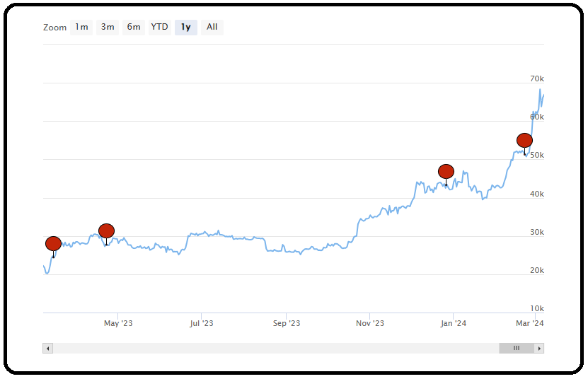
Most recent (last year) Bitcoin Obituary Stats

