Absolute-separability witnesses for symmetric multiqubit states

Eduardo Serrano-Ensastiga , Jérôme Denis, and John Martin
Institut de Physique Nucléaire, Atomique et de Spectroscopie, CESAM, University of Liège, B-4000 Liège, Belgium

ABSTRACT
The persistent separability of certain quantum states, known as symmetric absolutely separable (SAS), under symmetry-preserving global unitary transformations is of key significance in the context of quantum resources for bosonic systems. In this paper, we develop criteria for detecting SAS states of any number of qubits. Our approach is based on the Glauber-Sudarshan P representation for finite-dimensional quantum systems. We introduce three families of SAS witnesses, one linear and two nonlinear in the eigenvalues of the state, formulated respectively as an algebraic inequality or a quadratic optimization problem. These witnesses are capable of identifying more SAS states than previously known counterparts. We also explore the geometric properties of the subsets of SAS states detected by our witnesses, shedding light on their distinctions.

- INTRODUCTION
Quantum entanglement is a pivotal concept in the foundations of quantum theory, with significant implications for various quantum technology applications, including quantum cryptography, quantum sensing, metrology, and quantum simulation [1-6]. Understanding how to generate, detect, and quantify entanglement is crucial, akin to managing any valuable resource. One established method for creating entanglement is to apply a global unitary transformation to a system of interest via a unitary channel or a smooth unitary evolution driven by a control Hamiltonian. Nonetheless, it is possible that even after such transformations, an initially separable state remains separable [7], i.e., unentangled. The characterization of these states, known as absolutely separable (AS) [8], helps identify necessary conditions in a state’s spectrum to turn it into an entangled state after a unitary gate. In particular, such characterizations can provide valuable insights about entangled states very close to the maximally mixed state [9-12]. This question is particularly relevant in systems subjected to noisy environments [13,14] as seen, e.g., in NMR settings [15,16]. Determining whether the quantum state of a multipartite system is separable is a NP-hard problem [17,18]. Consequently, the absolute version of the problem may share the same complexity. So far, the characterization of AS states has been limited to qubit-qudit systems [19-21]. For larger multiqudit systems, there are several works defining witnesses of (non)absolute separability [22-24].
In addition to the problem of implementing unitary operations, the permissible unitary transformations on a quantum system are sometimes limited by its very physical nature, such as the physical properties of its constituents. In this paper, we focus on permutation-invariant mixed states of a system composed of many qubits, i.e., symmetric multiqubit states. This type of states appears naturally in bosonic systems such as multiphotonic [25,26] or atomic systems with a collective angular momentum, be it spin, orbital, or a combination of both. Formally speaking, the set of physical states valid for bosonic systems reduces de facto to the symmetric subspace 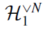 of the full Hilbert space 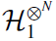formed by the tensor product of N single-qubit spaces 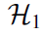. This symmetric subspace has dimension N + 1, indicating that the global unitary transformations permitted are limited to operations of the group SU(N + 1), acting solely within , instead of the whole SU(2^{N} ) unitary group. The entanglement in bosonic systems has been shown to be also a relevant resource for applications in quantum metrology and quantum information [27].
In the context described above, the question of absolute separability arises in the following form: which symmetric states do maintain their separability even after undergoing any global symmetry-preserving unitary transformation? These particular states are referred to as symmetric absolutely separable (SAS) states [28,29], or absolutely classical states in the framework of spin systems [30] (as elaborated in Sec. II). Previous research has provided a complete characterization of SAS states for two-qubit systems, and a numerical exploration has been conducted for three-qubit systems [29]. For an arbitrary number of qubits N, a nonlinear SAS witness based on a purity condition of the state has been derived in a prior study [30]. The primary objective of the present paper is to introduce SAS witnesses based on the Glauber-Sudarshan representation for spin states [31,32]. This representation, originally developed for the quantum harmonic oscillator [33,34], provides a P representation of symmetric multiqubit states useful to describe quantum states in terms of classical- like probability distributions and study the separability problem [30,32].
The absolute symmetric version of properties other than separability has also been explored, such as absolutely positive Wigner functions states [35-37] or absolutely symmetric positive partial transpose (PPT) states when the partial transposed state is also restricted to the symmetric subspace [28]. Additionally, it has been shown that an arbitrary qubit-qudit state is absolutely PPT if and only if it is AS [21]. For a general system, however, it is only known that absolute separability implies absolutely PPT, a natural consequence of the Peres criterion [38].
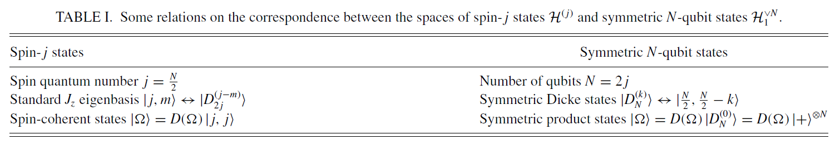
This paper is organized as follows: Sec. II reviews the necessary physical concepts and mathematical methods. In Secs. III and IV, we calculate and formulate three families of SAS witnesses. We explain the methods to calculate the witness functionals for two- and three-qubit cases in Sec. V. We analyze the sets of SAS states detected by these witnesses for a general number of qubits and compare them with each other in Sec. VI. Finally, we conclude with some closing remarks in Sec. VII.

- CONCEPTS AND METHODS
  - Equivalence between symmetric multiqubit states and spin- j states
Starting with the Hilbert space of a single-qubit system, which is spanned by two basis vectors, denoted as and 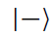, we proceed to define the Hilbert space for a collection of N qubits, 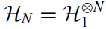, spanned by the 2^{N} product states with for k = 1, ..., N. For our purposes, we will consider only the symmetric subspace of dimension N + 1, spanned by the symmetric Dicke states 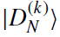 defined as [39]
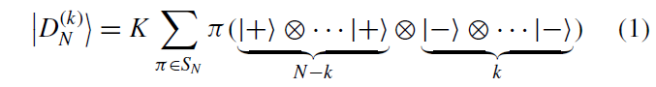
for k = 0, ...,N, where K is a normalization constant and the sum runs over all permutations of N elements S_{N} .In , the product states have the form 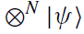 f^{N} | 0 ), with 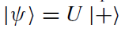 and U ε SU(2). They are generally referred to as spin-coherent states [40], due to the isomorphism between the symmetric N-qubit space and the spin-j = N/2 Hilbert space H^{( j)} (see Table I). The rule of correspondence associates the basis vectors of H₁ with the J_{z} eigenbasis of a spin-1/2 system, . Consequently, the Dicke basis corresponds to the eigenbasis of the J_{z} angular momentum operator in the (2j + 1)-dimensional irreducible representation (spin-j irrep), 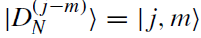. The diagonal SU(2) transformations on the symmetric multiqubit states are translated to rigid rotations R ε SO(3) according to the spin- j irrep D^{(j)}(R), or just D(R ) for short. The entries of these (N + 1) x (N + 1) matrices can be expressed in the Euler angles as [41]. Another correspondence given by the isomorphism is between the symmetric product states and the spin-coherent states 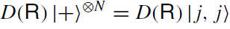. The symmetric product states can then be parametrized just by the orientation Q of the rotated quantization axis:
With 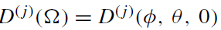the rotation that reorients the z axis to the n axis with spherical angles 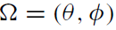[41]. We can conclude by the previous observation that the symmetric product states constitute a two-dimensional sphere S² .We summarize the correspondence between symmetric multiqubit states and spin-j states in Table I. While most of the discussion throughout the paper is explained in the multiqubit framework, the calculations are mostly done in the spin language where the SU(2) irreps appear naturally.

  - Multipole operators
We summarize below the basic properties of the set of multipole operators {T_{LM}}, with L = 0,...,2j and M = —L , ..., L [41,42]. They form an orthonormal basis in the space of operators acting on spin- j states, 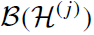, i.e.,
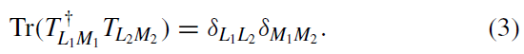
In addition, they satisfy
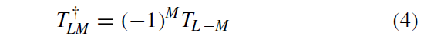
and transform block diagonally under rotations R ∈ SO(3) according to the spin-L irrep D^{(L)}(R):

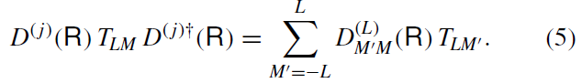
The T_{LM} operators can be given explicitly in terms of the Clebsch-Gordan coefficients 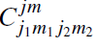 C^{jm} as follows [41]:
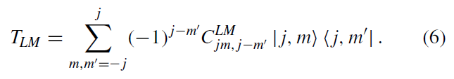

A mixed spin-j state ρ can always be expanded in the T_{LM} basis, which gives

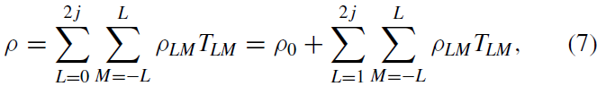

with 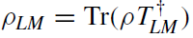and p₀ = (2j + 1)^{—1}1 the maximally mixed state in the symmetric sector. The hermiticity of the density matrix enforces that 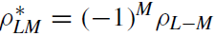. We will denote by r the Hilbert-Schmidt distance between p and p₀ . It reads
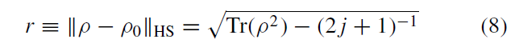

or, in terms of ρ_{LM}, as
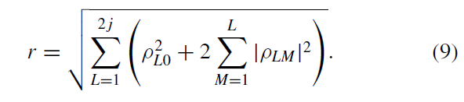

  - Separability in terms of P representation
The Glauber-Sudarshan representation for spin states involves expressing the density operator in a form that resembles a classical probability distribution function on the sphere [31]:
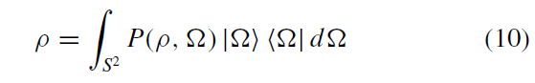
where d Ω = dμ (Ω ) is the area element of the sphere S², and with 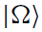 given by Eq. (2). The expression (10) is called a P representation of ρ. The correspondence described in Sec. IIA allows us to establish a P representation of symmetric multi-qubit states 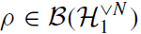 straightforwardly:
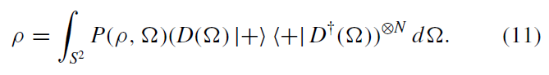
We are interested in separable multiqubit states [7], i.e., those that can be written in terms of a classical (positive) probability distribution over the whole set of product states . However, we do not need to consider the whole set for symmetric states. Indeed, it was shown in Refs. [43,44] that a symmetric state is separable if and only if it can be written in terms of a positive probability distribution over the smaller set of symmetric product states 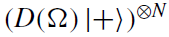. It follows that a symmetric multiqubit state p is separable if and only if there exists a P representation of the form (11) with a positive P function defined on the sphere:
In the language of spin states, the question of separability is that of classicality because the symmetric product states correspond to spin-coherent states (see Table I), considered to be the most classical spin states [32,40].
The most general P representation of a state 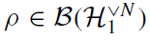 has the form [32]
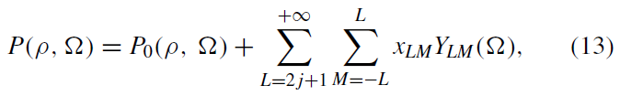
where P_{o}(p, Ω) is uniquely defined for p and given a posteriori by Eqs. (15) and (16), x_{LM} are complex numbers, and Y_{lm}(Ω) are spherical harmonies. The P function of a state is not unique because the variables x_{LM} can be any complex number provided that (13) is real and covariant under rotations [45]:
On the other hand, P_{o}(p, Ω) is a function uniquely defined for each p, referred to here as the truncated P function of p and given by
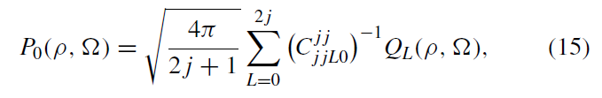
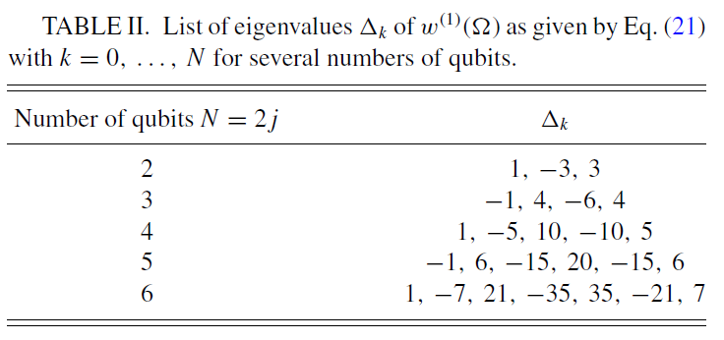
with real functions (by the hermiticity of p)
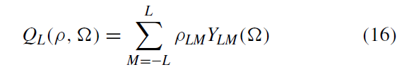
which are covariant under rotations, just as P is [see Eq. (14)]. The latter equations come from the expansion of the operator 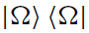in terms of the multipole operators [32,46,47]
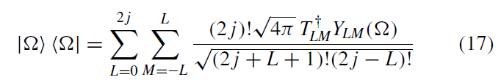
combined with Eqs. (7) and (10). The function P0(ρ,Ω) is also obtained by applying the Stratonovich-Weyl map w^{(s)}(Ω) for s = 1 [45], which reads
to the state ρ:
In Appendix A, we show that the eigendecomposition of the kernel w ⁽¹⁾( Ω) for a general spin j reads
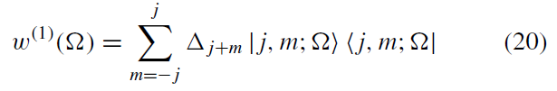
With
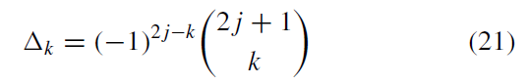
for k = o, ..., 2 j and 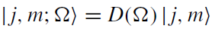. In particular, the value of P_{o}(p, Ω) at the north pole , denoted as Ω = o, reads
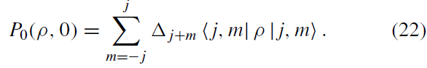

As an illustration, we plot the spectrum Δ _{j} _{+ m} for small numbers of qubits in Table II. The truncated P_{o} function is a valid P function by itself because it is real, is covariant under rotations (14), and fulfills Eq. (11). However, it generally does not satisfy the positivity condition, even for separable states. Hence, the additional terms in Eq. (13) play a crucial role, as illustrated by examining a spin-coherent state oriented along a specific direction Ω_{o}. A positive P realization of 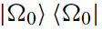 is a Dirac delta function on the sphere, 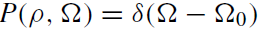 . However, it is clear that such a delta function cannot be obtained by truncating the infinite sum in Eq. (13). Indeed, if we did this, the resulting P function would always be negative somewhere on the sphere, as discussed in Ref. [30].

  - Symmetric absolute separability
Finally, we introduce the concept of SAS states, and denote their set by A_{sym}. SAS states are characterized by the property that every element within their full unitary orbit is separable. The SAS condition can be reformulated as the existence of a positive P function
for , that is,
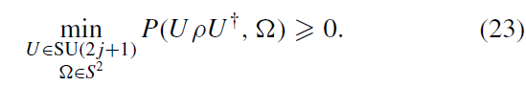

This formulation implicitly assumes that the x_{LM} variables in the P function (13) can depend on the state p and the applied unitary transformation U.
A SAS witness [48], i.e., a functional of the state ρ that detects some SAS states, can be written only in terms of the eigenvalues of ρ because these form a basis for SU(2 j + 1) invariant quantities. For example, in the particular case of a two-qubit system, it was shown in Ref. [29] that a symmetric state ρ with eigenspectrum (λ₀, λ₁, λ2 ) sorted in descending order is SAS if and only if
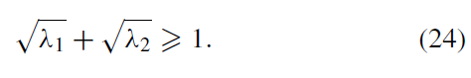
For N = 3, numerical evidence and conjectures about the structure of the set A_{sym} are also reported in Ref. [29]. More generally, for an arbitrary N, there is a SAS witness derived in Ref. [30] based on the distance r (8). It is denoted here by W₀, and reads as follows.

WitnessW₀ [30]: A symmetric N-qubit state ρ is SAS if its Hilbert-Schmidt distance to the maximally mixed state in the symmetric sector r satisfiesµ
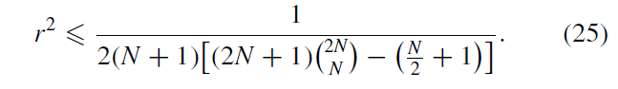
We use the symbol S₀ to denote the subset of SAS states witnessed by W₀. We use the same notation for subsequent witnesses.

  - Unistochastic and bistochastic matrices
We end this section by introducing the concept of d × d bistochastic matrix B ∈ B_{d} [49]. Bistochastic matrices possess positive entries, and the sum of entries in each column or row equals 1. The set of bistochastic matrices, denoted as B_{d} , forms a polytope in 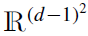. One approach to parametrize
this set involves introducing free variables in a (d − 1) × (d − 1) minor of the matrix B, and then the remaining entries are determined by satisfying the bistochastic conditions. For instance, B₃ can be parametrized by b = (b1, b2, b3, b4 ) ∈ [0, 1]⁴ as
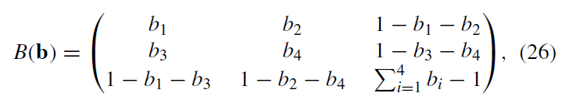
where the positivity condition of the entries of B defines the domain of the b_{k} variables [50,51]:
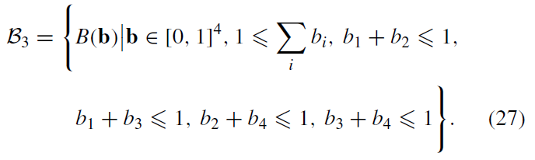

For the sake of simplicity, we simply write b ∈ B3 whenever b satisfies these conditions. Another useful parametrization of bistochastic matrices follows from the fact that they are the convex hull of permutation matrices [49]:
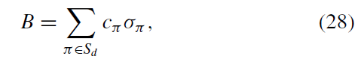
where 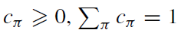.

A special subset of bistochastic matrices is the unistochastic matrices B ∈ U_{d} whose entries are specified by a unitary matrix V ∈ SU(d), 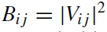. While for d = 2, U₂ = B₂, a similar equality does not hold for d 3 [50–52]. For example, the vectors b defining a unistochastic matrix B ∈ U3 must satisfy, in addition to the condition b ∈ B3, an extra condition related to the positive area of a triangle (see Refs. [50,51,53] for more details), such that
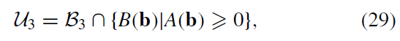
With
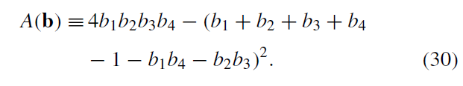
Note that there is no known full characterization of unistochastic matrices for d > 3 [52,53], with the exception of partial results, such as the characterization of circulant matrices for d = 4 [54] or the study of subsets of bistochastic matrices relevant to quantum information for the general dimension d [55].

- POLYTOPES OF SAS STATES
Our first family of SAS witnesses, linear in ρ, is obtained by analyzing the truncated P function (P₀), i.e., Eq. (13) with x_{LM} = 0 for all L and M. Throughout this section, we use a method similar to that in Ref. [37]. First, we write a state in the form 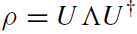 , with a diagonal matrix in the 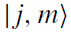 basis with eigenvalues λ_{k} sorted in nonincreasing order. The SAS criterion (23) is then translated by the following condition for P₀:
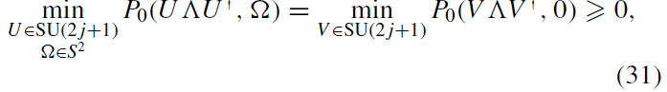
where we have used the covariance property of P₀ [see Eq. (14)] to absorb the rotation in the unitary transformation 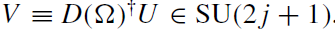Using Eq. (22), the previous expression can be written in terms of the entries 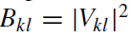of a unistochastic matrix B as follows:
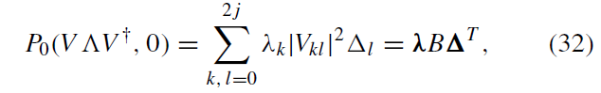

FIGURE 1. Polytope of SAS states S₁ (dark red) for N = 2 in the simplex of eigenvalues, displayed in barycentric coordinates. The blue dotted lines, whose equations are given by the equality condition in Eq. (34), define the edges of the polytope. The green area delimited by the condition (24) represents all SAS states (see Ref. [29]).
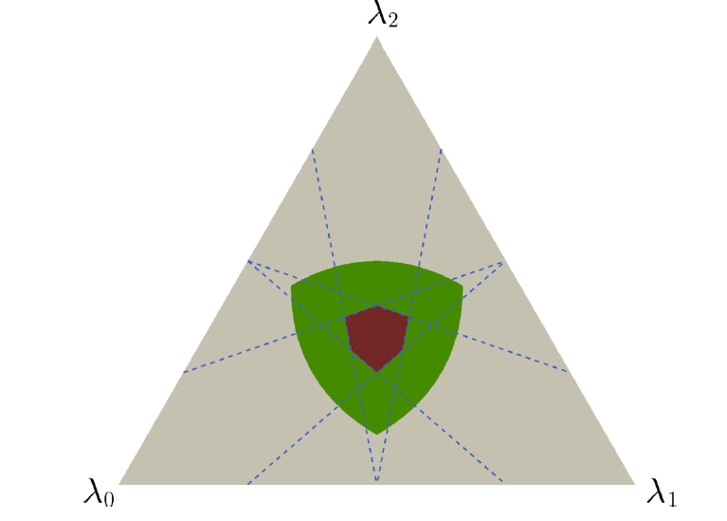

FIGURE 2. Polytope S1 for N = 3 next to the full tetrahedron of eigenstates in barycentric coordinates. The vertices of the polytope are indicated by the blue dots. The twice degenerate eigenvalues of (see second row of Table II) produce degeneracy in the faces. As a result, some of the blue dots are in the middle of the edges of the polytope. The green points are SAS states obtained by numerical optimization as described in Ref. [29].
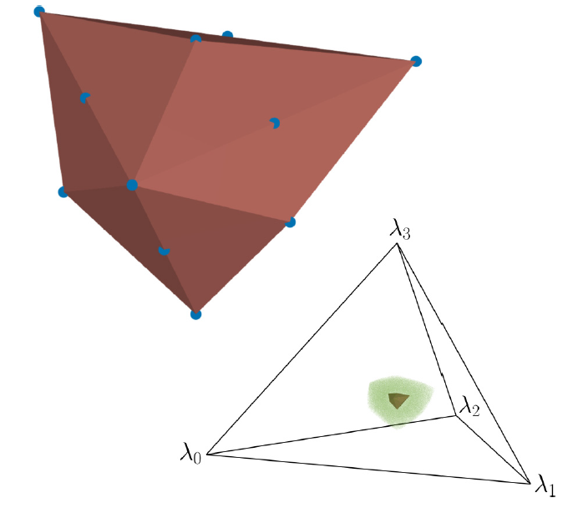
where λ = (λ₀, ..., λ_{2j} ) is the state eigenspectrum and (Δ₀, ..., Δ_{2j}) is the kernel eigenspectrum (21). Using the decomposition of B into permutation matrices (28), we get
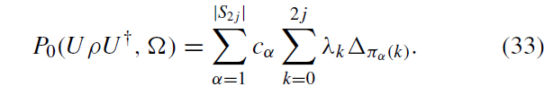
Now, Birkhoff-von Neumann’s theorem (see, e.g., Theorem 8.7.2 of Ref. [56]) establishes that a convex function with respect to the entries B_{kl} has extremal values in the permutation matrices. Moreover, since our function is linear in B, the global minimum is then achieved in one of the permutation matrices. In particular, and by following the same line of reasoning as in Ref. [37], the SAS condition (23) is met for states whose spectrum satisfies
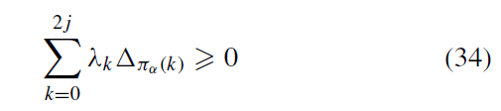

for each permutation . As explained in Ref. [37], all in- equalities (34) are fulfilled if p satisfies the strictest inequality given by
where the upper arrow indicates ascending (↑) or descending (↓) order of the eigenvalues. In this way, we have derived our first family of SAS witnesses valid for any number of qubits.
Witness W₁ : A symmetric N -qubit state p is SAS if its eigenspectrum λ fulfills 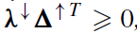 where 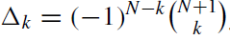 for k=0,...,N.
The set S₁ of SAS states detected by the witness W₁ typically constitutes a polytope featuring (N + 1)! faces, cor- responding to the number of inequalities given by (34), and a total of
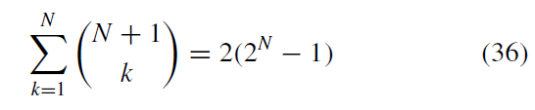

vertices [37], each one given by the intersection of N faces. As an illustration, we plot in Figs. 1 and 2 the resulting polytope S₁ for N = 2 and 3, respectively, in the barycentric coordinate system (see the Appendix of Ref. [37] for more details on this representation). For N = 2, S₁ has six faces and six vertices according to the previous discussion. However, when dealing with odd values of N, the degeneracy in the Δ_{k} eigenvalues, as shown in Table II, leads to a degeneracy among the faces of S₁. Consequently, some vertices are positioned in the middle of an edge. We observe this degeneracy for N = 3 in Fig. 2, where S₁ contains 12 faces instead of 24, and 6 out of the 14 vertices are situated along the middle of certain edges.

- NONLINEAR SAS WITNESSES
Now that we have characterized all detectable SAS states on the basis of the truncated P₀ function, S₁, let us consider additional terms of the P function present in the general form (13) to derive stronger nonlinear witnesses. In order to simplify the complexity of the minimization problem presented in Eq. (23) and facilitate the derivation of analytical results, we choose to focus exclusively on additional terms (terms with L > 2j) that arise from the product of Q_{L} functions, as defined in Eq. (16). Specifically, we consider only those extra terms, denoted hereafter as 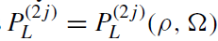, obtained by squaring the Q_{L} functions and then subtracting their lower angular momentum components so that only spherical harmonics with L > 2 j are involved. We thus add to the truncated p function terms proportional to
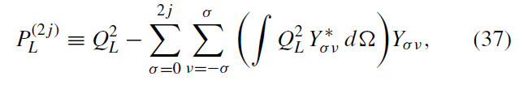
where only the integrals with σ even are nonzero. It is important to note that, by construction, the functions (37) are nonzero only for L > j and are covariant under rotations as inherited from the Q_{L} ’s. Consequently, we can work only with the P functions of a unitarily transformed state p' evaluated at Ω = 0:
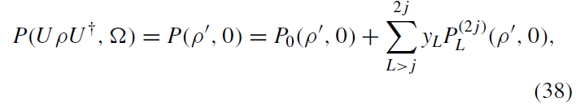
with 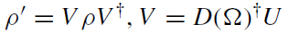 and y_{L} real numbers. Just like the x_{LM} variables in Eq. (13), the y_{L} ’s can depend on the state p and u. However, for the sake of simplicity, we will only consider them as variables independent of the unitary and the state. The general idea for obtaining a SAS witness is to reduce the minimization problem on the full unitary orbit formulated in Eq. (23) to a problem that requires minimization on the unistochastic matrices only, as in the developments for obtaining the polytopes of SAS states.
A direct application of a formula giving the integral of a triple product of spherical harmonics [see, e.g., Eq. (4), p. 148 of Ref. [41]] together with the equality 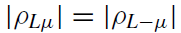lead us to an algebraic expression for the functions 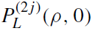 defined in Eq. (37):
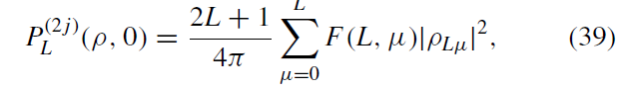
with F (L, μ) state-independent coefficients given by
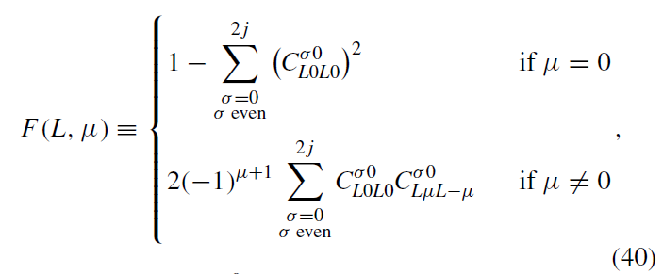
where the identity 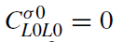 for σ odd restricts the sum to σ even. Some values of F(L, μ) are given in Table IV. Note that these coefficients are real and can be positive or negative. The factors (2L + 1)/4π in Eq. (39) can be absorbed into the variables y_{L} without loss of generality to rewrite Eq. (38) as follows:
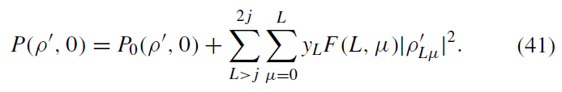

Using Eq. (9) squared, we can isolate the component 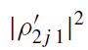 as
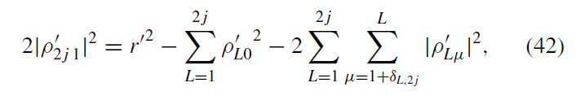

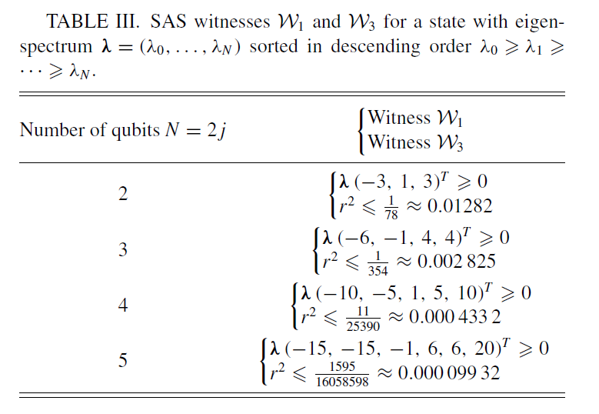

and then insert this expression into Eq. (41) to get
With
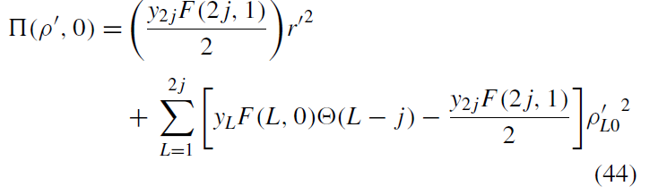
And
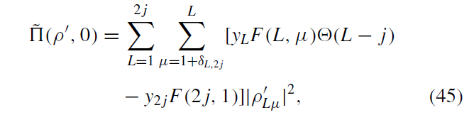
where 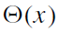 is the Heaviside step function defined here as
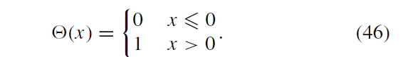
In what follows, we will omit the contribution of in Eq. (43), under the assumption that it is positive: 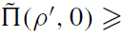0. This simplification allows us to reduce the requirement of positivity for P to the simpler condition of positivity for P_{LB} = P₀ + . The general form of the remaining function P_{LB} reads
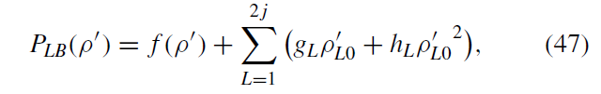
where the function 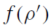 and the coefficients g_{L} and h_{L} are deduced from Eqs. (15) and (43) as being
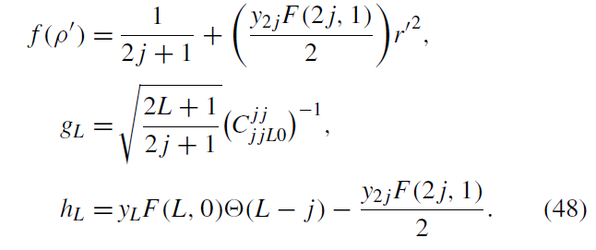

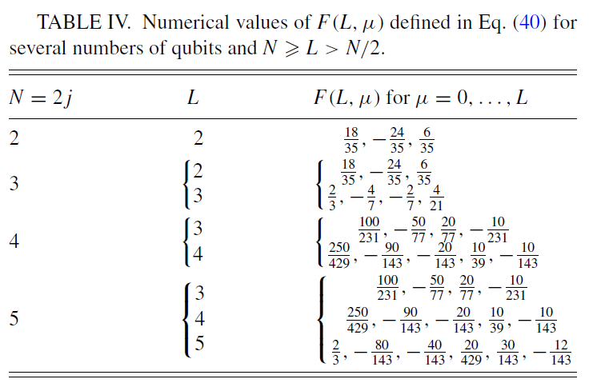
Note that g_{L} is a constant, h_{L} depends on the y_{L} variables, while the function ƒ (p’) depends only on the SU(2j + 1)- invariant distance to the maximally mixed state r' given by Eq. (8). Hence, ƒ, g_{L} , and h_{L} are constant along the unitary orbit of p'. In the end, the function P_{LB} only depends on the components 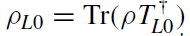 which, for a general element of the unitary orbit 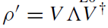 reads
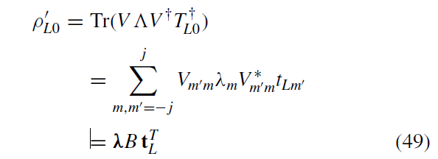

with t_{L} = (t_{L}, j , ,...,t_{L},-j ) the vector containing the eigenvalues of TL₀ (6), t_{L-m} = , and B the unistochastic matrix defined from V, with entries 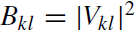. The expression of P_{LB} eventually reduces to
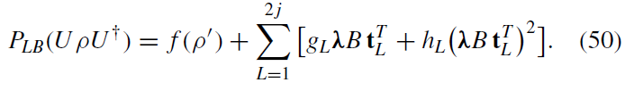
As a result, we have moved from a minimization problem over the full unitary orbit of a state to a simpler problem that necessitates a minimization over the unistochastic matrices only:
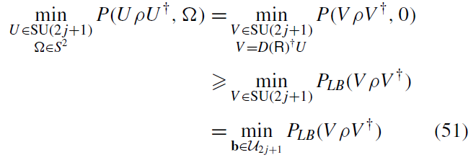
where in the second line we have used our assumption 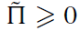 and in the last line we refer to a parametrization b of 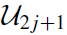, as discussed in Sec. IIE. In particular, the terms 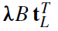in P_{LB} are linear expressions of the b variables of the bistochastic matrices. It follows that P_{LB} is quadratic over b (see also Appendix B). The inequality (51) is valid as long as the contribution 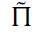 given in Eq. (45) is positive, which defines the admissible range of variation of the parameters y_{L} in our approach.
In principle, the minimization on the unistochastic matrices U_{2j}+1 presented in Eq. (51) seems intractable to perform for 2j = N > 3 due to the lack of a complete characterization of U_{2j} +1. However, we can extend the minimization domain to the bistochastic matrices 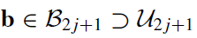 as follows,
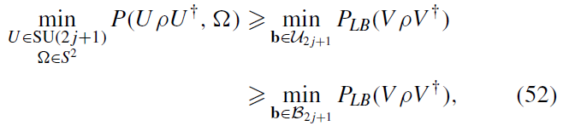
and prove that the second inequality is in fact always tight. This follows from two key facts:
- For any bistochastic matrix B, one can always find a unistochastic matrix B' such that for any vector 1 [57].
- The bistochastic matrix appears in the objective function (50) only in the form λB.
From Eq. (52), we can now derive another family of SAS witnesses, denoted as 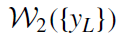, or just 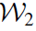 for short, taking the form of a quadratic optimization problem on the b variables of the bistochastic matrix [see Appendix B, in particular Eq. (B3)], with the y_{L} parameters constrained by the positivity condition 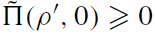 (45). These witnesses are expressed as follows.
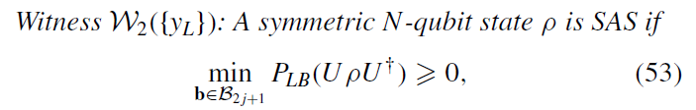

where 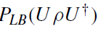is given by Eq. (50) and y_{L} are real parameters restricted by the inequalities
(53)
for L = 1, ..., 2j and μ = 1, ..., L, where the coefficients F(L, μ) are defined in Eq. (40).
One can relax the minimization problem to the whole real domain 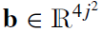 while retaining a useful SAS witness provided that h_{L} > 0, otherwise the Hessian (B4) of the quadratic function P_{LB} (50) has a negative eigenvalue and hence P_{LB} has a minimum equal to negative infinity. The latter requirement implies that
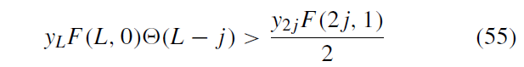
for all L . Under these assumptions, the global minimum of P_{LB} on 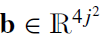 has an algebraic solution given by (see Appendix B for details)
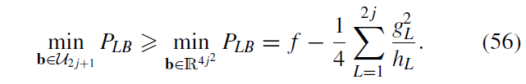
Any state for which the right-hand side of Eq. (56) is positive is then SAS, which after a bit of algebra can be rewritten as an upper bound on r :
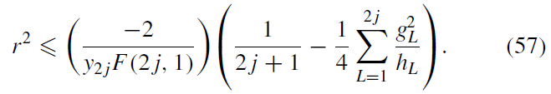

Note that we have used the inequality 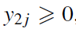, which is a direct consequence of F(2j, 1) < 0 shown in Appendix C [see Eq. (C1)] and the inequality (54) for L = 1. In order to obtain the best SAS witness, we need to maximize the right-hand side of the last equation over the admissible parameters y_{L} . If we first maximize Eq. (57) with respect to y_{L} for L = 2 j , we find that we need to maximize the h_{L} variables (48) and consequently maximize the y_{L} variables, which are upper bounded by the conditions (54). Our numerical observations [see Eq. (C2)] show that the strictest upper bound is 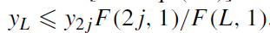We can then evaluate y_{L} at these apparently tight upper bounds. Finally, we maximize Eq. (57) with respect to y_{2j}, to obtain the extremal point:
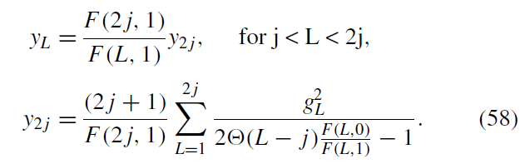

In particular, 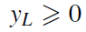 implies that 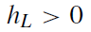 is fulfilled, as required above. Thus, we obtain a simpler SAS witness , weaker than 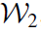, but with an analytical expression.
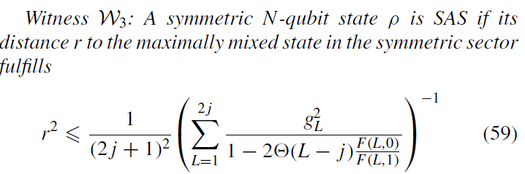
with F(L, μ) and g_{L} state-independent constants defined in Eqs. (40) and (48).
One final remark needs to be made about . We can eliminate another in Eq. (42) instead of 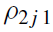 . However, the witnessed SAS set does not change substantially.

- TWO- AND THREE-QUBIT CASES
In this section, we exemplify our witnesses in the specific cases of N = 2 and 3, in order to clarify all the technical aspects of our method.
  - N = 2 qubits
In this case, the witness 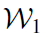 is given by
We plot in Figs. 1 and 3 the witnessed set S₁ in the whole eigenspectra simplex of the state and in one Weyl chamber, respectively. In contrast, the other two witnesses, 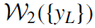 and 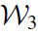, rely on the P function (38) with only one extra term:
With
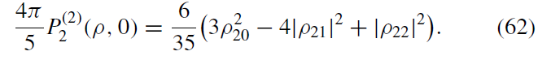

By scaling y₂ with the factor 5/4π, and performing the change of variable (42) in Eqs. (61) and (62), reading explicitly
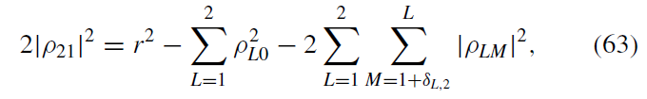

FIGURE 3. SAS states in the first Weyl chamber 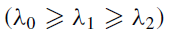 for N = 2 represented in barycentric coordinates. The curves correspond to the bounds of the sets S₀ (blue) and S₃ (orange), established by the purity-based witnesses W₀ and W₃, respectively. The green area encompasses all the remaining SAS states, as completely characterized by the condition (24). The witnessed states S₁ are depicted in light red. Lastly, S₂ with y₂ = 455/12 is formed by the light and dark red regions. We note that S₂ is only very slightly bigger than S₃.
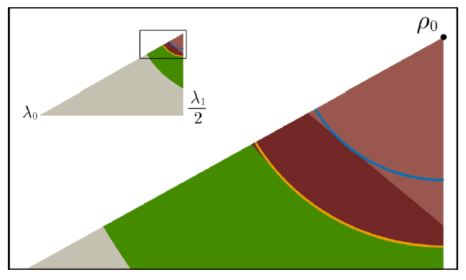

we get
With
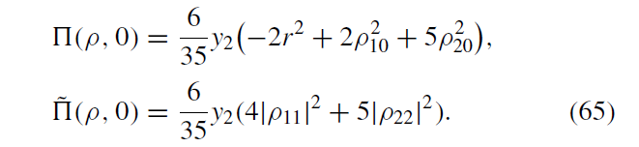

The inequality 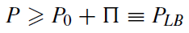 defines the admissible region (54) of the y₂ variable, here y₂ 0. The function P_{LB} has now the form (47) with factors (48) given by
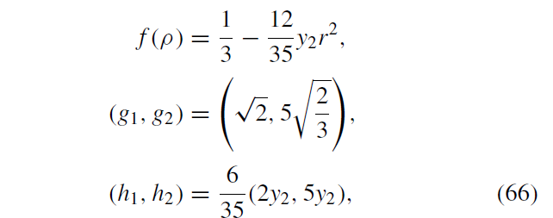

which are the elements needed to calculate the witness 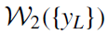 defined by Eq. (53). Lastly, we use Eq. (59) to calculate our third witness at y₂ = 455/12 (58):
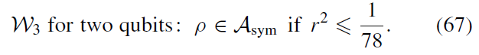
  - N = 3 qubits
The linear witness W₁ is given by
Its corresponding witnessed SAS set S₁ is plotted in Figs. 2 and 4 in dark red. Now, for the nonlinear witnesses, we start by defining the respective P function (38) which has two additional terms:

FIGURE 4. SAS states in the first Weyl chamber (λ₀ λ₁ λ₂ λ₃) for N = 3. The dark red and orange surfaces are the boundaries of S₁ and S₃, respectively. The dark red points are the states contained in S₂({y_{L}}) with y_{L} equal to Eq. (58). The green points are SAS states obtained numerically as described in Ref. [29].
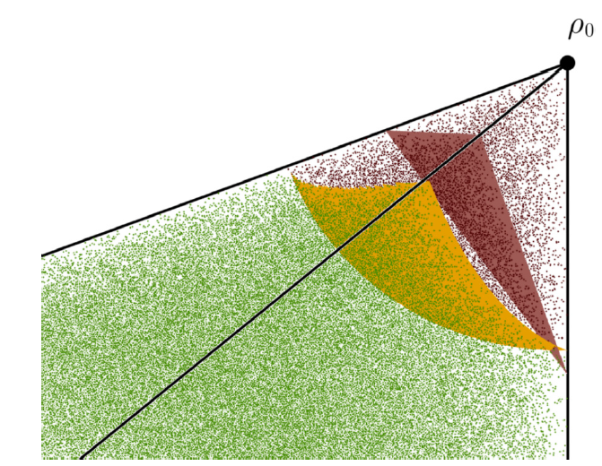
Where 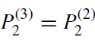 [given by Eq. (62)] and
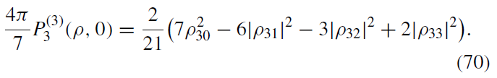

By using Eq. (42) to substitute 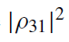 in the P function, we get 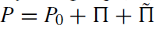with
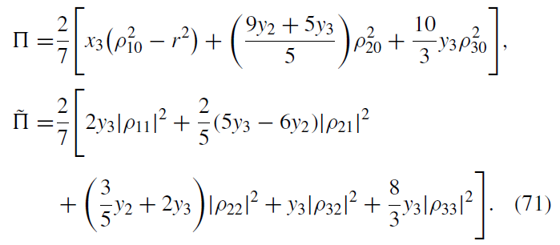

Again, 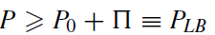 when all the coefficients of the terms in are positive, i.e.,

Let us remark that y₂ may take negative values. Now, we can calculate the factors (48) which are necessary to calculate P_{LB} and the witness W₂({y_{L}}). They are given by
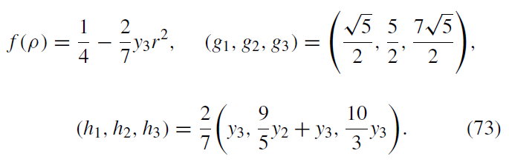

Finally, for W₃, we have the extra condition h_{L} > 0 (55) for the y_{L} values

which is always satisfied for the extremal y_{L} values given in Eq. (58), which read
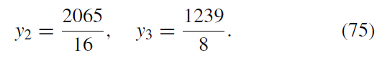
The witness W₃ eventually reads

- DISCUSSION AND COMPARISONBETWEEN SASWITNESSES
Let us now discuss the physical implications of our SAS witnesses (W₁, W₂, and W₃) and explore their differences. In Table III, we present the witnesses W₁ and W₃ for N ranging from 2 to 5, while the witness W₂({y_{L}}) generally requires a numerical optimization. To highlight the differences between these witnesses, we illustrate their corresponding sets S_{k} in Figs. 1-4 for N = 2 and 3, respectively, alongside the set S₀ defined by the witness W₀ previously obtained in Ref. [30]. In addition, we provide a video in the Supplemental Material [58] showing S₂({y_{L}})as y_{L} varies for N = 2. Below, we give some general observations and remarks about our witnesses.
The sets S_{k} exhibit diverse geometric forms. S₁ is represented as a polytope, in contrast to S₀ and S₃, which appear as balls centered around p₀. Furthermore, S₂ generally exhibits a more complex and nontrivial shape. By construction, S₁ = S₂({y_{L} = 0}) and S₃ C S₂ ({y_{L}}) for {y_{L}} given by Eq. (58). A detailed analysis reveals that the ball S₀ is included in and tangent to S₁, meaning that the largest inner SAS ball contained within S₁ actually coincides with S₀. We prove this result for all values of N in Appendix D.
For N = 2 and 3, we observe that 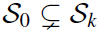 for k = 1, 2, 3.
This result is expected since S₀ is tangent to S₁, S₃ is maximized such that it witnesses a bigger SAS ball than S₀, and 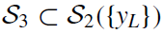for the y_{L} values (58). We can appreciate this behavior in Fig. 5 where we plot the distances
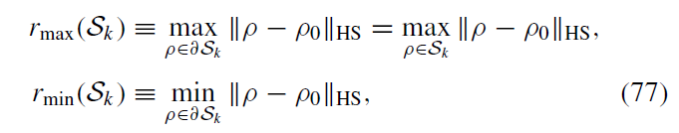

Where 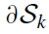 is the boundary of S_{k} . In particular,
and the same holds for S₃. Specifically, we can observe in Fig. 5 that 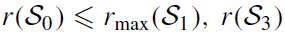. By the previous remark, we also have that 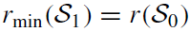 . The discrepancy between the SAS states identified by S₂({y_{L}}) and S₃ is notably small for N = 2 when y_{L} is determined by Eq. (58) (see Fig. 3).
This difference is even less pronounced for N = 3, making it difficult to discern visually.
For N = 2, S₁ is a proper subset of S₃, while for N = 3, the sets identified by the two witnesses are complementary. We anticipate a similar behavior for larger values of N, as confirmed by Fig. 5 showing that r_{max}(S₁ ) from N = 11 to 65. A noteworthy consequence of the previous observation is that the furthest away vertex of S₁ from ρ₀ is not contained in S₃. Conversely, the closest vertex of S₁ to ρ₀ is included in S₃, a characteristic that has been observed, as depicted in Fig. 5, where we present the minimal distance between ρ₀ and the vertices of the polytope W₁, denoted as 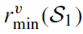. The values of r(S₃ )/r(S₀ ) and 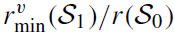reach asymptotic values, observed at around 1.849 and 1.423, respectively.

FIGURE 5. Top: Distances r(S₀ ) (blue) and r(S₃ ) (orange) as defined in Eq. (77). The black crosses show r_{GHZ}, defined by the NPT entangled state of the form (79) closest to ρ0, which provides an upper bound to the radius of the largest inner ball contained in A_{sym}. The red line shows the radius r_{NS} of the largest ball containing only AS states in the full Hilbert space [see Eq. (80)]. Bottom: Distances r_{max}(S₁ ) (purple), 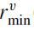 (S₁ ) (blue), and r(S₃ ) (orange), rescaled by the distance of the witness r(S⁰ ), as a function of the number of qubits. (S₁ ) corresponds to the minimal distance between ρ₀ and the vertices of the polytope S₁. Note that all ratios are larger than 1, indicating an improvement on previous results.
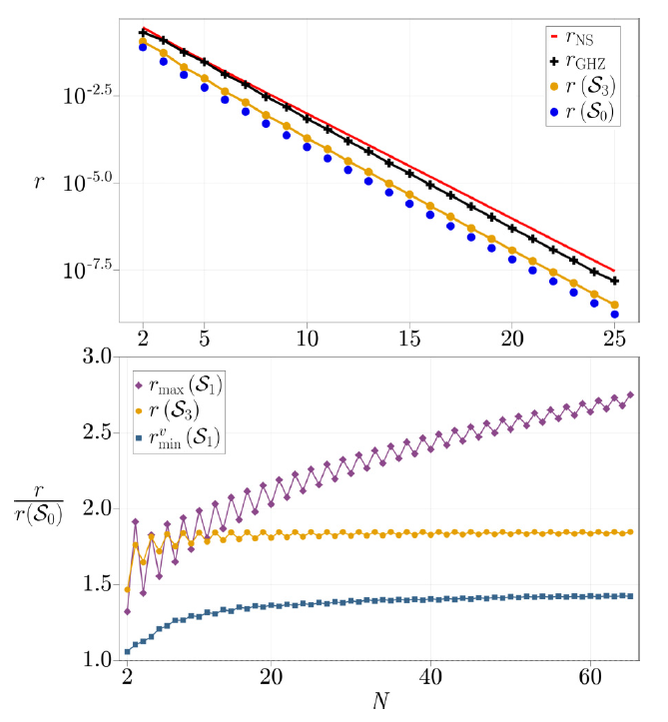
Finally, we stress once again that our witnesses do not detect the whole A_{sym} set. To get a better idea of its size, we can establish an upper bound on the radius of the largest ball contained within A_{sym}, denoted by r_{min}(A_{sym} ). Such a bound can be obtained by computing for example the distance r_{GHZ}
above which the mixture of a pure GHZ state and ρ0,
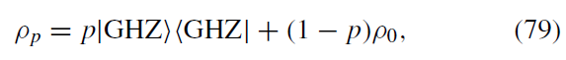
has a negative partial transpose (NPT) and thus entanglement that can be detected by the PPT criterion. The resulting upper bound, which is not tight but improves the numerical bound
found in Ref. [30], is plotted in Fig. 5 along with the radii of the other witnessed SAS sets S₀ and S₃. The radius of the largest inner ball in A_{sym} lies between the yellow and the black lines of Fig. 5. For comparison, we also plot the radius of the largest ball containing only AS states in nonsymmetric
multiqubit systems [10]:
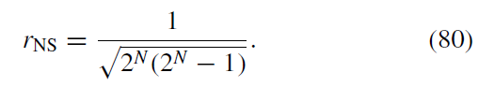

- CONCLUSIONS AND PERSPECTIVES
In this paper, we have derived three families of SAS wit- nesses for mixed symmetric multiqubit states, one linear (W₁) and two nonlinear (W₂ and W₃) in the eigenvalues of the state. Each of these witnesses detects a greater number of SAS states than the witness W_{o} previously established in Ref. [3o]. We have thoroughly explored their distinctions and delved into their geometric properties. Particularly, we showed that the set S₁ of SAS states detected by W₁ is a polytope that encompasses and is tangent to the SAS ball defined by W_{o}. To get the formal proof of this result, we derived an analytical expression for the eigenvalues of the Stratonovich-Weyl kernel w⁽¹⁾(Ω) (21). This expression can be useful beyond this paper, in contexts where quantum states are examined in their phase space (see Ref. [45] for a review). Furthermore, all the SAS witnesses introduced in this paper can be applied to detect absolute classicality [3o] in the framework of spin-j systems via the correspondence explained in Sec. II. Among our witnesses, W₁ and W₃ are simple functionals on the spectrum and the purity of the state. In contrast, W₂({y_{L}}), which is capable of detecting a larger subset of SAS states, necessitates solving a quadratic optimization problem over the bistochastic matrices. Nevertheless, our observations on the cases N = 2 and 3 indicate that the disparity between the SAS subsets detected by W₃ compared to W₂ is minimal, as illustrated in Fig. 3. It is also important to note that none of our witnesses provides complete detection of all SAS states, i.e., the full A_{sym} set. This limitation highlights the need for further exploration towards complete detection of SAS states. To efficiently uncover more SAS states, instead of scrutinizing W₂ , a viable approach is to include additional terms in the P function, as outlined in Eq. (37). The minimum number of terms to be added for a complete characterization remains as an open question, even in the case of two qubits.
Another strategy for witnessing larger sets of SAS states is to use the convexity property of A_{sym} [59]. In particular, we can immediately establish a stronger SAS witness defined by the convex hull of all S_{k} found in this paper. Moreover, as N increases, the discrepancy between S₁ and S₃ (see Fig. 5) increases and, subsequently, the convex union of the sets becomes larger, as does the number of SAS states detected. The convexity of A_{sym} in the eigenspectra simplex could be also exploited to define a notion of optimal SAS witness that depends linearly on the spectrum of the state. This would be the analogous concept of optimal linear witnesses for entanglement [18]. In terms of experimental implementation, measuring the state spectrum is required for W₁ and W₂ , while W₃ relies on evaluating the state’s purity. Importantly, both the spectrum and purity of a quantum state can be estimated without the need for full quantum tomography [6o], which facilitates the implementation of our witnesses.
Lastly, it should be mentioned that there is a debate in the literature about whether entanglement in systems of indistinguishable particles can arise artificially from their exchange symmetry. Consequently, alternative definitions of entanglement have been introduced that extend the set of separable states to include those states whose entanglement comes solely from exchange symmetry (see, e.g., Ref. [61]). Nevertheless, it is interesting to note in this context that if a state is not entangled in the usual sense of the term, neither will it be entangled in the alternative definitions of entanglement.
Consequently, the SAS states detected by the witnesses W₁,W₂, and W₃ are also SAS for alternative definitions of entanglement.

ACKNOWLEDGMENTS
E.S.E. acknowledges support from the postdoctoral fellowship of the IPD-STEMA program of the University of Liège (Belgium). Computational resources were provided by the Consortium des Equipements de Calcul Intensif, funded by the Fonds de la Recherche Scientifique de Belgique under Grant No. 2.5020.11. Most of the computations were done with the JULIA programming language. The authors thank Grzegorz Rajchel for his fruitful correspondence.
APPENDIX A: EIGENDECOMPOSITION OF THE STRATONOVICH-WEYL MAP
Here we derive the eigendecomposition of Eqs. (20) and (21) of w(¹)(Ω). We start with the expression of the Stratonovich-Weyl map w(¹)(Ω) (18) evaluated at Ω = 0:
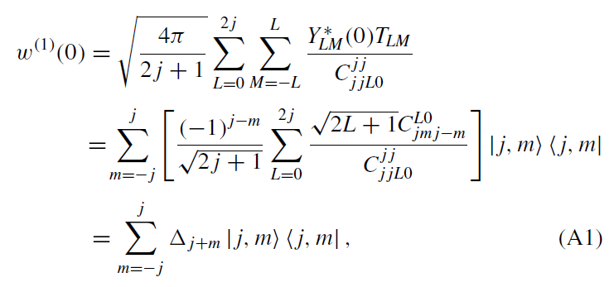

where we used Eq. (6) for the multipole operators. The operator w(¹)(Ω) is covariant under rotations [45], i.e.,
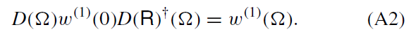
Therefore, the eigenvectors of w(¹)(Ω) are the standard spin eigenstates over the quantization axis in the direction Ω, 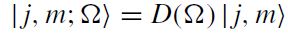. On the other hand, the eigenvalues can be rewritten as
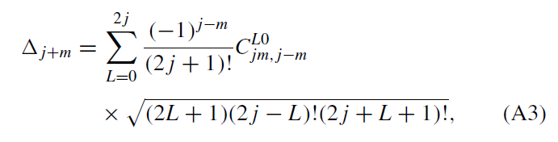
by using the identity [41]
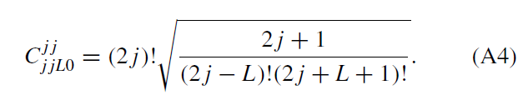

In order to evaluate the sum in (A3), our strategy is to write a polynomial whose coefficients are proportional to the eigenvalues deduced above. We start with a generating function of the Clebsch-Gordan coefficients in terms of the Legendre polynomials, given through the hypergeometric
function ₂F₁(a₁, a₂; b₁; t ) [see Eq. (5), p. 263 of Ref. [41] or Ref. [62], and Eq. (4), pp. 976 and 1005 of Ref. [63])]:
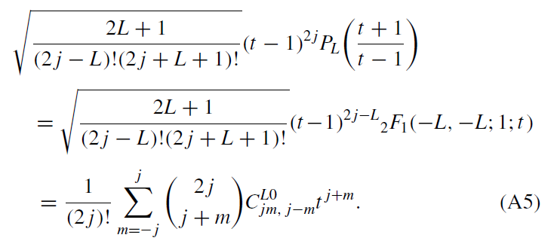

We now multiply Eq. (A5) by the necessary factors and sum over L to bring out the eigenvalues :
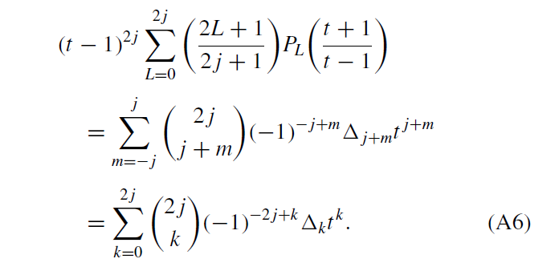
Now, we can rewrite the left-hand side of Eq. (A6) as
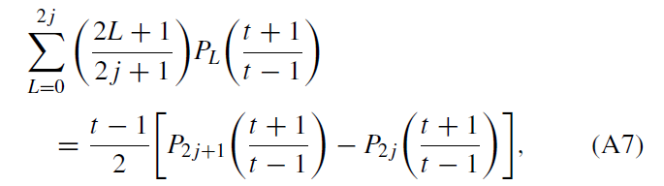

where we used Christoffel’s identity [see, e.g., Eq. (1), p. 986 of Ref. [63]] with 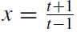, y = 1, and n = 2 j, that is,
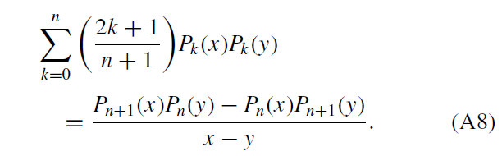

Lastly, we use the power expansion of the Legendre polynomials [63]
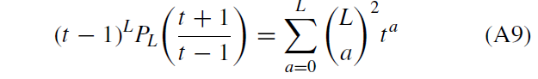

to get
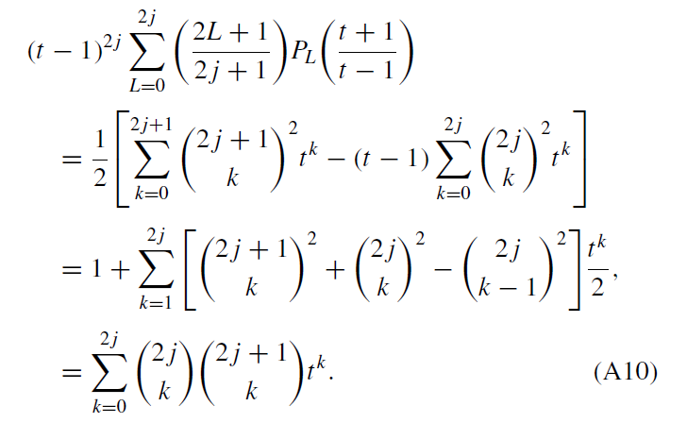

By comparing Eqs. (A6) and (A10), we deduce that
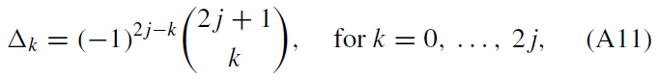

which is the result stated in Eq. (21).

APPENDIX B: PROOF OF EQ. (56)
We begin by noting that P_{LB} (p ), as given in Eq. (47), depends only on the components p_{L0}, and on r, which, however, is constant along the unitary orbit of p . These components can be expressed for a generic state within the unitary orbit, 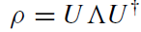 with being a diagonal matrix in the 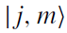 basis whose diagonal entries are the eigenvalues of p, as follows:

where t_{L} is the vector of eigenvalues of T_{L0} with the entries is a unistochastic matrix (hence also bistochastic) parametrized by a generalization of Eq. (26) in the b_{k} variables, and the new variables 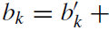 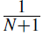are defined to remove an irrelevant constant term. The vectors v_{L} have the components
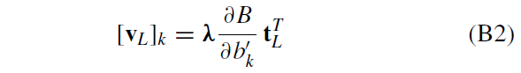

for k = 1, ...,N², where the derivative of B has all elements zero with the exception of
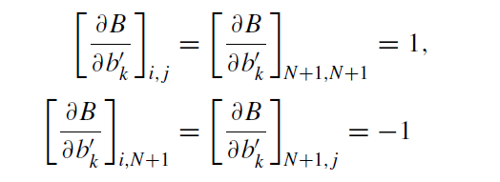
Where 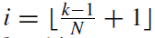 and 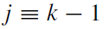 (mod N). The function P_{LB} defined in Eq. (47), written as a quadratic function on the coefficients of b', then reads
with
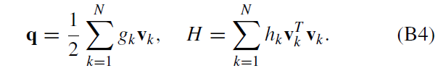

We assume in Sec. IV that the eigenvalues h_{L} of the matrix H are non-negative. On the other hand, the vectors v₁ , ..., v_{L} can be completed to form an orthogonal basis 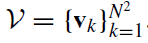.
We now define the dual basis 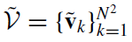of V as the set of vectors satisfying

We use this basis to define a new affine transformation b' = 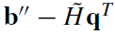 with
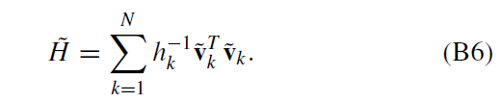
Now, P_{LB} written in terms of the new variables reads
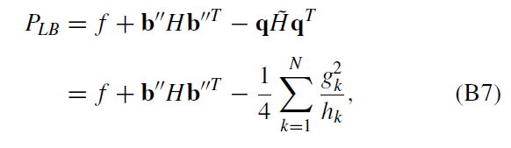

where we have used that 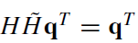. The global minimum of P_{LB} is achieved for b'' = 0 because H is a non-negative matrix, which proves the result (56). Note that the global minimum of P_{LB} is strongly degenerate because we can move b'' through the directions of the kernel H without affecting the value of P_{LB}. To illustrate this, let us look at the procedure described above for N = 2. The vectors v_{L} are
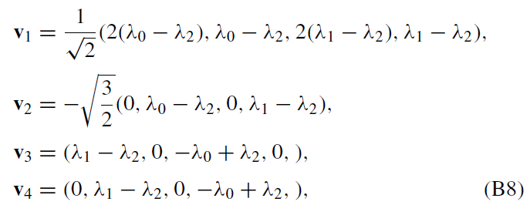

where we have completed the basis with two other vectors v₃ and v₄ which are orthogonal and satisfy the condition 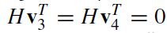. The corresponding vector b which satisfies the condition b'' = 0 is
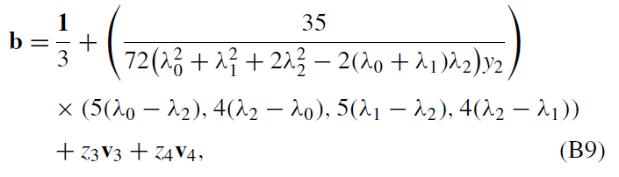

where 1 is the vector with all the components equal to 1, and z₃ and z₄ are arbitrary real numbers.

APPENDIX C: PROPERTIES OF F(L, μ)
Here we present some inequalities associated with the function F (L, μ) defined in Eq. (40).
Property 1.
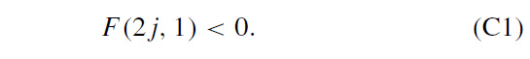
Proof. Writing N = 2j , we have
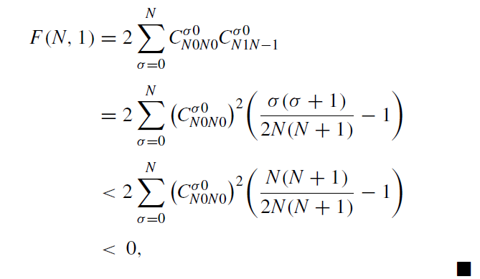
where we used an identity between the 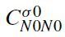 and 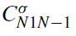 given in Eq. (7), p. 253 of Ref. [41].
Property 2. For all μ = 0, ..., L,
This inequality is a conjecture supported by the explicit evaluation of F (L, μ) for several (L, μ) values, as shown in Table IV for 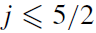. These inequalities become relevant for specifying the allowed domain of the x_{L} parameters restricted by Eqs. (54) and (55). If we assume that Eq. (C2) is true, then the inequality that gives the best upper bound on x_{L} for L > j comes from μ = 1:
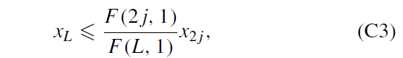

where we have used that F (2 j, 1) < 0 (C1) and that 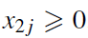.

APPENDIX D: CALCULATION OF r_{min} (S₁)
We present here the calculation of r_{min} (S₁ ) which, by convexity of S₁ , is equal to the radius r_{SAS} of the largest inner ball within 51 centered on the maximally mixed state p₀ = 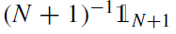 in the symmetric sector. In this Appendix, we closely follow the method proposed in Ref. [37]. Before starting, it is convenient for our calculations to evaluate the norm of the (2j + 1) vector 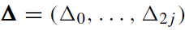. Using the explicit expression of the eigenvalues (21), we get
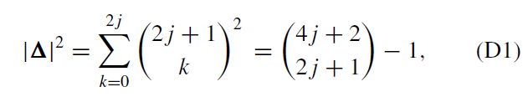

where we used 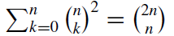 for the second equality. Then, we write the Hilbert-Schmidt distance (8) in terms of the Euclidean distance in the simplex between the spectra λ and λ₀ of p and p₀, respectively,
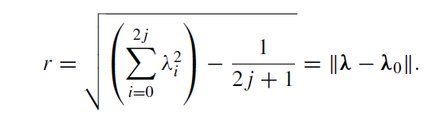

By definition, r_{min}(S₁ ) is the minimum distance between ρ₀ and the hyperplanes restricting the polytope S₁. Mathematically, this translates to the following constrained minimization problem:
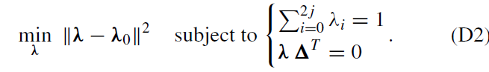
To solve this problem, we employ the method of Lagrange multipliers, introducing the Lagrangian
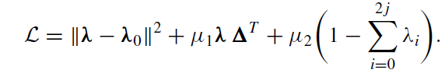

Here, μ₁ and μ₂ represent Lagrange multipliers that will be determined. The stationary points, denoted as , of the Lagrangian must satisfy the following condition:
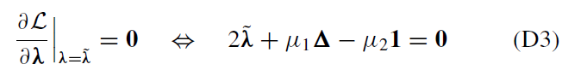

with the vector 1, which consists of elements all equal to 1 and has a length of 2j + 1. By summing across the components of (D3), we get
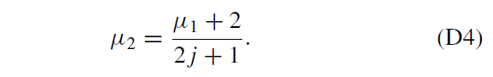
Next, by performing the scalar product of (D3) with and using (D4), we obtain the following Lagrange multipliers:
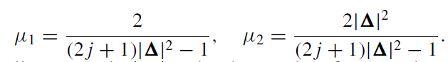
Finally, upon substituting the above values for μ₁ and μ₂ into Eq. (D3) and solving for the stationary point , we arrive at the following expression:
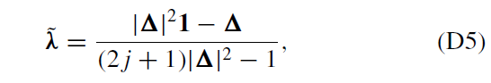
which leads us to
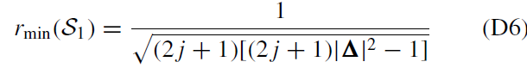

Since with any state with eigenspectrum (D5). Remarkably, the radius (D6) is exactly the same as that deduced in Ref. [30] [see Eq. (25)], as can be verified by inserting Eq. (D1) into Eq. (D6).
We close this Appendix by noting that the same calculation generalizes directly to the general Stratonovich-Weyl kernel 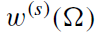 defined by
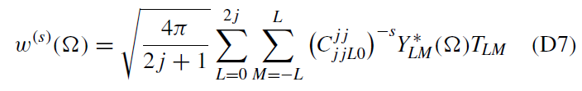
Where 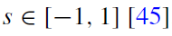
BIBLIOGRAPHY
[1] D. Deutsch and R. Jozsa, Proc. R. Soc. A 439, 553 (1992).
[2] C. H. Bennett,G. Brassard, C. Crepeau, R. Jozsa, A. Peres, and W. K. Wootters, Phys. Rev. Lett. 70, 1895 (1993).
[3] L. K. Grover, Phys. Rev. Lett. 79, 325 (1997).
[4] P. W. Shor, SIAM Rev. 41, 303 (1999).
[5] M. A. Nielsen and I. L. Chuang, Quantum Computation and Quantum Information: 10th Anniversary Edition (Cambridge University Press, New York, 2010).
[6] I. Bengtsson and K. ˙ Zyczkowski, Geometry of Quantum States: An Introduction to Quantum Entanglement, 2nd ed. (Cambridge University Press, New York, 2017).
[7] R. F. Werner, Phys. Rev. A 40, 4277 (1989).
[8] M. Ku´s and K. ˙ Zyczkowski, Phys. Rev. A 63, 032307 (2001).
[9] K. ˙ Zyczkowski, P. Horodecki, A. Sanpera, and M. Lewenstein, Phys. Rev. A 58, 883 (1998).
- L. Gurvits and H. Barnum, Phys. Rev. A 66, 062311 (2002).
- R. Hildebrand, Phys. Rev. A75, 062330 (2007).
- S. Adhikari, Eur. Phys. J. D 75, 92 (2021).
- S. Halder, S. Mal, and A. Sen(De), Phys. Rev. A 103, 052431 (2021).
- S. N. Filippov, A. A. Melnikov, and M. Ziman, Phys. Rev. A 88, 062328 (2013).
- S. L. Braunstein, C. M. Caves, R. Jozsa, N. Linden, S. Popescu, and R. Schack, Phys. Rev. Lett. 83, 1054 (1999).
- J. A. Jones, Prog. Nucl. Magn. Reson. Spectrosc. 59, 91 (2011).
- L. Gurvits, in Proceedings of the Thirty-Fifth Annual ACM Symposium on Theory of Computing (Association for Computing Machinery, New York, 2003), pp. 10-19.
- O. Gühne and G. Toth, Phys. Rep. 474, 1 (2009).
- F. Verstraete, K. Audenaert, and B. De Moor, Phys. Rev. A 64, 012316 (2001).
- R. Hildebrand, Phys. Rev. A 76, 052325 (2007).
- N. Johnston, Phys. Rev. A 88, 062330 (2013).
- A. Patra, S. Mal, and A. Sen(De), Phys. Rev. A 104, 032427 (2021).
- W. Thirring, R. A. Bertlmann, P. Kohler, and H. Narnhofer, Eur. Phys. J. D 64, 181 (2011).
- B. Leggio, A. Napoli, H. Nakazato, and A. Messina, Entropy 22, 62 (2020).
- P. Kok, W. J. Munro, K. Nemoto, T. C. Ralph, J. P. Dowling, and G. J. Milburn, Rev. Mod. Phys. 79, 135 (2007).
- J.-W. Pan, Z.-B. Chen, C.-Y. Lu, H. Weinfurter, A. Zeilinger, and M. Zukowski, Rev. Mod. Phys. 84, 777 (2012).
- B. Morris, B. Yadin, M. Fadel, T. Zibold, P. Treutlein, and G. Adesso, Phys. Rev. X 10, 041012 (2020).
- G. Champagne, N. Johnston, M. MacDonald, and L. Pipes, Linear Algebra and its Applications 649, 273 (2022).
- E. Serrano-Ensastiga and J. Martin, SciPost Phys. 15, 120 (2023).
- F. Bohnet-Waldraff, O. Giraud, and D. Braun, Phys. Rev. A 95, 012318 (2017).
- F. T. Arecchi, E. Courtens, R. Gilmore, and H. Thomas, Phys. Rev. A 6, 2211 (1972).
- O. Giraud, P. Braun, and D. Braun, Phys. Rev. A 78, 042112 (2008).
- E. C. G. Sudarshan, Phys. Rev. Lett. 10, 277 (1963).
- R. J. Glauber, Phys. Rev. 131, 2766 (1963).
- N. Abbasli, V. Abgaryan, M. Bures, A. Khvedelidze, I. Rogojin, and A. Torosyan, Phys. Part. Nuclei 51, 443 (2020).
- V. Abgaryan, A. Khvedelidze, and A. Torosyan, J. Math. Sci. 251, 301 (2020).
- J. Denis, J. Davis, R. B. Mann, and J. Martin, arXiv:2304.09006.
- A. Peres, Phys. Rev. Lett. 77, 1413 (1996).
- R. H. Dicke, Phys. Rev. 93, 99 (1954).
- J. M. Radcliffe, J. Phys. A 4, 313 (1971).
- D. A. Varshalovich, A. N. Moskalev, and V. K. Khersonskii, Quantum Theory of Angular Momentum (World Scientific, Singapore, 1988).
- U. Fano, Phys. Rev. 90, 577 (1953).
- J. K. Korbicz, J. I. Cirac, and M. Lewenstein, Phys. Rev. Lett.
- 120502 (2005).
- F. Bohnet-Waldraff, D. Braun, and O. Giraud, Phys. Rev. A 94, 042343 (2016).
- A. B. Klimov, J. L. Romero, and H. De Guise, J. Phys. A 50, 323001 (2017).
- E. Serrano-Ensastiga and D. Braun, Phys. Rev. A 101, 022332 (2020).
- J. Denis and J. Martin, Phys. Rev. Res. 4, 013178 (2022).
- Here, we use the term witness for both linear and nonlinear functionals. This generalization has already been used in the literature (see, e.g., [64,65]).
- A. W. Marshall, I. Olkin, and B. C. Arnold, Inequalities: Theory of Majorization and its Applications, 2nd ed. (Springer, New York, 2010).
- C. Dunkl and K. Zyczkowski, J. Math. Phys. 50, 123521 (2009).
- P. Dijâ, J. Math. Phys. 47, 083510 (2006).
- A. C. Smith, in Mathematics and Computing, edited by R. N. Mohapatra, D. R. Chowdhury, and D. Giri (Springer, New York, 2015), pp. 239-250.
- I. Bengtsson, Å. Ericsson, M. Ku´s, W. Tadej, and K. Zyczkowski, Commun. Math. Phys. 259, 307 (2005).
[54] G. Rajchel-Mieldzio´c, K. Korzekwa, Z. Puchała, and K. Zyczkowski, J. Math. Phys. 63, 012202 (2022).
[55] G. Rajchel, A. Ga˛siorowski, and K. Z˙ yczkowski, Math. Comput. Sci. 12, 473 (2018).
[56] R. A. Horn and C. R. Johnson, Matrix Analysis (Cambridge University Press, New York, 2012).
[57] In fact, for any product of a vector and a bistochastic matrix , one can find an orthostochastic matrix A, i.e., that comes from an orthogonal matrix, such that = (see Theorem B.6 of Ref. [49]).
[58] See Supplemental Material at http://link.aps.org/supplemental/10.1103/PhysRevA.109.022430 for video by E. Serrano- Ensástiga, J. Denis, and J. Martin (2023).
[59] The proof of the convexity of the set of symmetric absolutely separable states is a special case of the convexity of the absolutely separable case [66].
[60] A. K. Ekert, C. M. Alves, D. K. L. Oi, M. Horodecki, P. Horodecki, and L. C. Kwek, Phys. Rev. Lett. 88, 217901 (2002).
[61] G. Ghirardi, L. Marinatto, and T. Weber, J. Stat. Phys. 108, 49 (2002).
[62] È. L. Akim and A. Levin, Dokl. Akad. Nauk. SSSR 138, 503 (1961).
[63] I. S. Gradshteyn and I. M. Ryzhik, Table of Integrals, Series, and Products (Academic Press, New York, 2014).
[64] O. Gühne and N. Lütkenhaus, Phys. Rev. Lett. 96, 170502 (2006).
[65] C.-J. Zhang, Y.-S. Zhang, S. Zhang, and G.-C. Guo, Phys. Rev. A 76, 012334 (2007).
[66] N. Ganguly, J. Chatterjee, and A. S. Majumdar, Phys. Rev. A, 89, 052304 (2014).

