Disruption of Biofilm Formation and Quorum Sensing in Pathogenic Bacteria by Compounds from Zanthoxylum Gilletti (De Wild) P.G. Waterman
Hermia Nalova Ikome^{1,2} · Alfred Ngenge Tamfu^{3,4} · Jean Pierre Abdou⁵ · Hugues Fouotsa¹ · Pamela Kemda Nangmo^{1,2} · Fidèle Castro Weyepe Lah^{1,2} · Alembert Tiabou Tchinda² · Ozgur Ceylan⁴ · Michel Frederich⁶ · Augustin Ephrem Nkengfack¹
1 Department of Organic Chemistry, University of Yaounde I, P.O. Box 812, Yaoundé, Cameroon
2 Laboratory of Phytochemistry, Center for Studies on Medicinal Plants and Traditional Medicine, Institute of Medical Research and Medicinal Plants Studies (IMPM), P.O. Box 13033, Yaounde, Cameroon
3 School of Chemical Engineering and Mineral Industries, University of Ngaoundere, P.O. Box 454, Ngaoundere, Cameroon
4 Food Quality Control and Analysis Program, Ula Ali Kocman Vocational School, Mugla Sitki Kocman University, 48147 Mugla, Turkey
5 Department of Chemistry, Faculty of Science, University of Ngaoundere, P.O. Box 454, Ngaondere, Cameroon
6 Laboratory of Pharmacognosy, Center for Interdisciplinary Research on Medicine, CIRM, University of Liege, 4000 Liege, Belgium

KEYWORDS : Zanthoxylum gilletii · Secondary metabolites · Antimicrobial activity · Antibiofilm · Anti-quorum sensing

ABSTRACT
Microbial resistance is facilitated by biofilm formation and quorum-sensing mediated processes. In this work, the stem bark (ZM) and fruit extracts (ZMFT) of Zanthoxylum gilletii were subjected to column chromatography and afforded lupeol (1), 2,3-epoxy-6,7-methyl-enedioxyconiferyl alcohol (3), nitidine chloride (4), nitidine (7), sucrose (6) and sitosterol-β-D-glucopyranoside (2). The compounds were characterized using MS and NMR spectral data. The samples were evaluated for antimicrobial, antibiofilm and antiquorum sensing activities. Highest antimicrobial activity was exhibited by compounds 3, 4 and 7 against Staphylococcus aureus (MIC 200 μg∕mL), compounds 3 and 4 against Escherichia coli (MIC = 100 μg∕mL) and compounds 4 and 7 against Candida albicans (MIC = 50 μg∕mL). At MIC and sub-MIC concentrations, all samples inhibited biofilm formation by pathogens and violacein production in C. violaceum CV12472 except compound 6. Good disruption of QS-sensing in C. violaceum revealed by inhibition zone diameters were exhibited by compounds 3 (11.5 ± 0.5 mm), 4 (12.5 ± 1.5 mm), 5 (15.0 ± 0.8 mm), 7 (12.0 ± 1.5 mm) as well as the crude extracts from stem barks (16.5 ± 1.2 mm) and seeds (13.0 ± 1.4 mm). The profound inhibition of quorum sensing mediated processes in test pathogens by compounds 3, 4, 5 and 7 suggests the methylenedioxy-group that these compounds possess as the possible pharmacophore.

Introduction
Infectious diseases including bacterial infections continue to plague populations of the world and the situation is complicated by the appearance of multidrug-resistant (MDR) pathogens [1]. The continuous emergence of MDR pathogens drastically reduces the efficacy of available antibiotics consequently there will always be a need for new classes of lead structures [2]. The emergence of antibiotic resistant microorganisms requires novel antibiotics as well as other (non-antibiotic) strategies, different from the classical antibiotics developed to kill bacteria because their poor usage contributes to the occurrence of resistant strains [3]. Scientists are therefore searching for new classes of antibiotics, from natural and synthetic sources, which are not only limited to inhibition of growth or death of bacterial cells, but equally able to inhibit virulence factors in bacteria as well as prevent them from developing resistance [3-5]. Such as inhibition of biofilm formation which is a mechanism of drug resistance utilized by diverse microorganisms living within formed biofilms that help them to survive adverse conditions such as starvation, antimicrobial agents, and immunological defense response from host [6]. Antibiotic resistance of various pathogenic bacteria towards available antibiotics constitutes a global health problem and natural products are gaining ground as great source of new drugs that can fulfill the conditions for eradicating or eliminating microbial resistance.
Quorum Sensing (QS) is achieved by bacteria through the production of small chemical signaling molecules, collectively known as auto-inducers and different bacteria are capable of producing various kinds of auto-inducers that differ in chemical structure and mechanism of action. Broadly, autoinducers are categorized into three types: (i) acylhomoserine lactones (AHLs), (ii) auto-inducing peptides (AIPs), and (iii) auto-inducer 2 (AI-2) [7]. QS is used by bacteria to regulate biofilm formation, conjugal DNA transfer, pathogenesis, production of extracellular polysaccharides, and other processes [8]. QS takes place when the concentration of autoinducers released by bacteria reaches a critical threshold concentration, at which they bind to receptors and activate them to trigger genes that encode information associated with several characteristics, like bioluminescence, plasmid conjugation, biofilm formation, toxin production, exo-polysaccharide production, siderophore synthesis, sporulation, and motility [9, 10] several of which determine pathogenicity and severity of infection. Hence, disrupting the bacterial QS activity leads to the attenuation of bacterial virulence factors and resistance [11].
Researchers are working in the direction to discover new antimicrobial agents from natural sources such as microorganisms, animals and plants and therefore antimicrobial drugs obtained from herbal sources provide novel effective compounds that are devoid of side effects [12, 13]. Bacterial biofilms are communities of bacteria, embedded in a selfproducing polymeric matrix and which can be established on living and non-living solid surfaces [14]. Biofilms provide protection and stability to bacteria when they are living under adverse conditions like nutrient limitations, desiccation, pH, temperature changes and complex host immune responses [15]. For controlling the biofilm formation, a variety of antimicrobial agents have been used but their low efficacy and increased resistance of the biofilm towards these them, limit their effective applications [16]. Natural products from plants constitute a valuable source of new drugs for the human race. It is estimated that over half of the world’s best selling pharmaceuticals since from the nineties owed their origin to natural source or are inspired by natural molecular scaffolds [17]. Futhermore, natural compounds and the derivatives have been discovered to be potential QS inhibitors [18, 19].
The genus Zanthoxylum (Rutaceae) has approximately 250 species distributed in the tropics, subtropics and the temperate regions of the world [20, 21] and over 14 species have been identified in the Cameroonian flora: including Zanthoxylum gilletii (De Wild) P.G. Waterman [22]. Both taxa, Fagara and Zanthoxylum were merged into Zanthoxylum after thorough research [23]. Zanthoxylum gilletii (De Wild) Waterman (synonyms: Fagara marcrophylla and Fagara gilletii), is an indigenous deciduous tree with varied applications in African folk medicine. It is used to treat stomachache, joint pain, toothache, fever, rheumatism, urogenital infections as an antibiotic, colds, venereal infections, snakebite, wounds as antiseptic and analgesic [24-27]. In fact, the traditional use of this plant is based on its importance on the alleviation of human pathogens. For this plant and other plants of same genus, several biological activities have been reported such as antimicrobial, larvicidal, antioxidant, anti-inflammatory, analgesic, antinociceptive, hepato-protective, antiplasmodial, cytotoxic, antiproliferative, antihelminthic, antiviral and antifungal, mainly due to the presence of alkaloids and essential oils [21, 28]. Alkaloids (which are present in most of the species and abundantly in the entire plant organ), coumarins, triterpenoids, limonoids, sesquiterpene lactones amides, flavonoids have been reported as common secondary metabolites from this plant [29, 30]. It is worth noting that the potential for development of drug leads from Zanthoxylum continues to grow, particularly in the development of new antimicrobial, antiparasitic and antitumor agents. This work reports the effect of Zanthoxylum gilletii and its chemical constituents on quorum-sensing mediated factors of pathogenic microbes.

Materials and methods

General Experimental Procedure
¹H and ¹³ C NMR spectra were recorded on a Bruker AM-400 (400 MHz) apparatus using MeOH-d₄ as solvent. The solvent signals were used as references. Multiplicities are described by the following abbreviations: s = singlet, d = doublet, t = triplet, q = quadruplet, brs = broad singlet, brd = broad doublet, brt = broad triplet. Analytical TLC was performed on precoated silica gel F254 (Merck 1.05735) plates. After development, the dried plates were examined under short-wave (254 nm) or long-wave (366 nm) UV light and sprayed with Dragendorff and H₂SO₄/EtOH reagent. Melting points were obtained using a digital electrothermal melting point apparatus. Optical densities were measured on a Thermo Scientific Multiskan FC, Vantaa, Finland for antimicrobial, quorum sensing inhibition and antibiofilm assays.

Plant Material
The stem bark and fruits of Zanthoxylum gilletii (De Wild) P.G. Waterman were harvested in September 2017 at Awae locality, Centre Region of Cameroon by Dr. Tsabang Nole, a Botanist of the Institute of Medical Research and Medicinal Plants Studies (IMPM). The plant was authenticated and deposited at the National Herbarium of Yaoundé, Cameroon under the Voucher specimen (6168 SRFZCAM). Immediately after the collection, the plant materials were chopped into smaller pieces and dried in a ventilated oven at 40 °C for two consecutive days and then pulverized into fine powder.

Extraction and Isolation of Chemical Constituents
The powdered stem bark (5.8 kg) and fruits (925.3 g) of Z. gilletii was exhaustively extracted with a mixture of MeOH:CH₂Cl₂ 1:1. The filtrates were evaporated using a rotating evaporator (BUCHI 011) to obtain 335.5 g (5.6%) and 252.1 g (27.2%) of the crude extracts (MeOH:CH₂Cl₂ 1:1) respectively.
Part of the crude stem bark extract (200 g) of was adsorbed onto an equal amount of silica gel (200 g) and loaded onto 600 g of silica gel column under 100% n-C₆H₁₄. The column was eluted serially with solvent system of increasing polarity, initially with hexane and subsequently with increasing amounts of EtOAc up to 100% followed by 2% MeOH in EtOAc in increasing polarity. A similar procedure was performed on (252.1 g) the fruit extract. A total of 300 fractions (250 mL each) were collected from the main column, concentrated in vacuo on a rotatory evaporator and their compound profiles monitored using analytical TLC plates. Similar fractions were combined eventually as follows; 15-97 (25.94 g), 104-137 (22.74 g), 193-196 (13.74 g), 197-212 (26.71 g), 213-260 (21.51 g) and 270-283 (19.41 g), 284-286 (13.51 g) and 287-300 (23.41 g). Lupeol (1, 2.9 g) [31] was isolated as white crystalline powder from the fractions of the main column eluted with 10% EtOAc in n-hexane. Fractions of the main column eluted with 15% EtOAc in n-hexane crystallized in the conical flask. The crystals were filtered out in vacuo using a Buchner funnel and washed several times using 70% Dichloromethane in n-hexane and dried in open air to afford a shiny white powder; 2-Oxiranemethanol, 3-(1,3-benzodioxl-5-yl) (3, 1.03 g) [32]. Fagaramide (5, 3.1 g) [33] was obtained as a white powder from the main column eluted with 25% EtOAc in n-hexane that precipitated in the conical flask and was washed with 100% MeOH., Sucrose (6, 16 mg) [34] was obtained from the main column as white crystals with 30% MeOH in EtOAc. Nitidine chloride (7, 50 mg) [35] was obtained as yellow powder from the main column eluted with 40% MeOH in EtOAc. Fraction 287-300 (23.41 g) was subjected to silica gel CC using methanol in dichloromethane in increasing polarity. At 10% MeOH in CH₂Cl₂, nitidine (4, 537 mg) [36] was obtained. The fruit extract (252.1 g) was chromatographed on silica gel column eluted with hexane, hexane/ EtOAc gradient and then EtOAc. A total of 150 fractions (250 mL each) were collected from the main column, concentrated in vacuo on a rotatory evaporator and their compound profiles monitored using analytical TLC plates yielding six sub-fractions combined as follows; 1-33 (19.04 g), 34-57 (21.11 g), 58-76 (15.24 g), 77-92 (11.91 g), 93-118 (26.43 g) and 119-150 (23.61 g). β-Sitosterol glucoside (2, 11 mg) [37, 38] was isolated as white powder which crystallized in the conical flask from the fractions of the main column of the fruit with 60% EtOAc in n-hexane. The crystals were filtered out in vacuo using a Buchner funnel and washed several times using 50% methanol in dichloromethane and then dried in open air.

Microorganisms and Cultivation Conditions
Staphylococcus aureus ATCC 25,923, Escherichia coli ATCC 25,922 and Candida albicans ATCC 10,239 were selected for the in vitro antimicrobial and anti-biofilm activities. The above-mentioned bacteria except C. albicans were grown in Nutrient Broth (NB, Difco); C. albicans was grown in Sabouraud Dextrose Broth (SDB, Difco). The cultures of microorganisms were maintained in their appropriate agar slants at 4 °C throughout the study and used as stock cultures. Chromobacterium violaceum CV12472 and Chromobacterium violaceum CV026 were biosensor strains used for violacein inhibition and quorum sensing assays, respectively.

Determination of Minimal Inhibitory Concentration (MIC)
MICs were determined by the microtitre broth dilution method as recommended by the Clinical and Laboratory Standards Institute (CLSI, 2006) [13, 39]. The MIC was defined as the lowest extract or compound concentration that yielded no visible growth. The test medium was Mueller-Hinton Broth (MHB) and the density of bacteria was 5 × 10⁵ colony-forming units (CFU)∕mL. Cell suspensions (100 μL) were inoculated in to the wells of 96-well microtiter plates in the presence of test sample (extract or compound) with different final concentrations (12,800, 6400, 3200, 1600, 800, 400, 200, 100, 50, 25, 12.5 μg∕ mL). The inoculated microplates were incubated at 37°C for 24 h before being read.

Effect of Extracts and Compounds on Bacterial Biofilm Formation
The effect of extracts and compounds at MIC and sub-MIC concentrations including 1, 1/2, 1/4, 1/8, 1/16 MIC on biofilm-forming ability of test microorganisms were tested by the microplate biofilm assay method [40, 41]. Briefly, 1% of overnight cultures of isolates were added into 200 μL of fresh Tryptose-Soy Broth (TSB) supplemented with 0.25% glucose and cultivated in the presence and absence of test sample (extract or compound) without agitation for 48 h at 37 °C. The wells containing TSB + cells served as control. After incubation, the wells were washed with water to remove planktonic bacteria. The remaining bacteria were subsequently stained with 0.1% crystal violet solution for 10 min at room temperature. Wells were washed once again to remove the crystal violet solution. A volume of 200 μL of 33% glacial acetic acid or ethanol were poured in wells. After shaking and pipetting of wells, 125 μL of the solution from each well were transferred to a sterile tube and volume was adjusted to 1 mL with distilled water. Finally, optical density (OD) of each well was measured at 550 nm (Thermo Scientific Multiskan FC, Vantaa, Finland). Percentage of inhibition of the tested sample was calculated using the formula in Eq. 1 below.

Bioassay of Violacein Inhibition Using C. violaceum CV12472
All extracts and test compounds were subjected to qualitative analysis to find their violacein inhibition potentials against C. violaceum CV12472 [13, 42]. Overnight culture (10 μL) of C. violaceum (adjusted to 0.4 OD at 600 nm) was added into sterile microtiter plates containing 200 μL of LB broth and incubated in the presence and absence of various concentrations of tested agents (MIC-MIC/256). LB broth containing C. violaceum was used as a positive control. These plates were incubated at 30 °C for 24 h and observed for the reduction in violacein pigment production. Each experiment was performed in triplicate. The absorbance was read at 585 nm. The percentage of violacein inhibition was calculated by following formula in Eq. 2 below.
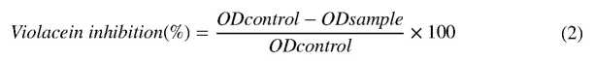

Bioassay for Quorum-Sensing Inhibition (QSI) Activity Using C. violaceum CV026
Quorum sensing inhibition was evaluated as described elsewhere [43, 44] with slight modifications. Five milliliters of warm molten Soft Top Agar (1.3 g agar, 2.0 g tryptone, 1.0 g sodium chloride, 200 mL deionized water) was seeded with 100 μL of an overnight mutant strain C. violaceum CV026 culture, and 20 μL of 100 μg∕mL C₆HSL was added as exogenous acylhomoserine lactone (AHL) source. This was gently mixed and poured immediately over the surface of a solidified Luria Bertani Agar (LBA) plate as an overlay. Wells of 5 mm in diameter were made on each plate after the overlay had solidified. Each well was filled with 50 μL of sub-MIC concentrations filter sterilized test sample (extract or compound). A white or cream-colored halo around this well against a purple lawn of activated CV026 bacteria was an indication of quorum sensing inhibition (QSI). The limit of detection of activity was also determined by applying serial dilutions of the extracts or compounds (MIC to MIC∕8, using LB broth as diluent). Each experiment was done in triplicate and the assay plates were incubated at 30 °C for 3 days after which the diameters of the quorum sensing inhibition zones were measured.

Statistical Analysis
Each experiment for bioassays was done in triplicate. The results were recorded as the means ± standard error of the mean for all the three parallel measurements for each sample. Statistical analysis was further performed with MINITAB 16 and ANOVA (analysis of variance) procedure was employed to determine the significant differences between means and the level of p < 0.05 were regarded as significant.
NMR data of the isolated compounds (structures in Fig. 1).
Lupeol (1): White solid, m.p. 191-192 °C; 1 H-NMR (400 MHz, CDCl₃) δ_{Η}, 0.91 (m, 1 H, H-1a), 1.67(m, 1 H, H-1b), 1.61 (m, 1 H, H-2a), 1.09 (m, 1 H, H-2b), 3.19 (dd,1 H, J = 11.6, 5.2, H-3), 0.66 (dd, 1 H, J=9.5, H-5), 1.38 (m, 2 H, J = 6.1, H-6), 1.51, 1.38 (m, 2 H, H-7),1.28 (m, 1 H, J = 9.3, H-9), 1.25 (m, 2 H, H-11), 1.51 (m, 2 H, H-12), 1.62 (m, 1 H, H-13), 1.68 (m, 1 H, H-15), 1.38 (m, 2 H, H-16), 1.35 (t, 1 H, J = 10.1, H-18), 2.35 (m, 1 H, H-19), 1.32 (m, 1 H, H-21a), 1.92 (m, 1 H, H-21b), 1.19 (m, 1 H, H-22a), 1.41 (m, 1 H, H-22b), 0.96 (s, 3 H, H-23) 0.88 (s, 3 H, H-24) 0.82 (s, 3 H, H-25), 1.03 (s, 3 H, H-26), 0.94 (s, 3 H, H-27), 0.79 (s, 3 H, H-28), 4.51 (dd, 1 H, J = 2.4, 1.3, H-29a), 4.20 (d, 1 H, J = 2.2, H-29b), 1.68 (s, 3 H, H-30).¹³ C- NMR (125 MHz, CDCl₃): δ_{c}, 38.9 (C-1), 27.6 (C-2), 79.3 (C-3), 39.1 (C-4), 56.3 (C-5), 18.5(C-6), 34.5 (C-7), 41.0 (C-8), 50.7 (C-9), 37.4 (C-10), 21.2 (C-11), 25.3 (C-12), 38.3 (C-13), 42.8 (C-14), 27.7 (C-15), 35.8 (C-16), 42.6. (C-17), 48.1 (C-18), 48.0 (C-19), 151.0 (C-20), 30.1 (C-21), 40.2 (C-22), 28.2 (C-23), 15.6 (C-24), 16.4 (C-25), 16.2 (C-26), 14.8 (C-27), 18.2 (C-28), 109.5 (C-29), 19.5 (C-30).
β-Sitosterol glucoside (2): White solid, m.p. 215-217 ⁰ C; ¹H-NMR (400 MHz, CD₃OD): δ_{Η}, 1.01 (m, 1H, H-1a), 2.02 (m, 1H, H-1b), 1.58 (m, 1H, H-2a), 1.26 (m, 1H, H-2b), 2.01 (m,1H, H-3), 2.26 (dt, 1H, J = 8.1; J=4.7, H-4a), 1.98 ( ddd, 1H, J = 12.0, J = 1.9; H-4b), 5.37 ( t, 1H, J = 3.6, H-6), 1.73 (ddd, 1H, J = 7.0, J=2.5, J = 16.1, H-7a), 1.95 (ddd, 1H, J = 16.1, J=2.5, J = 7.0, H-7b), 1.34 (m, 1H, H-8), 0.85 (m, 1H, H-9), 1.42 (m, 1H, H-11a), 1.41 (m, 1H, H-11b), 1.52 (dd, 1H, J=4.3, J = 12.4, H-12a), 1.20 (m, 1H, H-12b), 0.95 (m, 1H, H-14), 1.05 (m, 1H, H-15a), 1.57 (m, 1H, H-15b), 1.25 (m, 1H, H-16a), 1.85 (m, 1H, H-16b), 1.20 (m, 1H, H-17), 0.70 (s, 3H, H-18), 0.94 (s, 3H, H-19), 1.40 (m, 1H, H-20), 0.91 (d, 3H, J=6.5, H-21), 1.20 (m, 2H, H-22), 1.25 (m, 2H, H-23), 0.91 (m, 1H, H-24), 0.87 (d, 3H, J=7.0, H-26), 0.88 (d, 3H, J=7.0, H-27), 1.02 (t, 3H, J=7.1, H-29), 4.24 (d, 1H, J=7.9, H-1’), 2.39 (dt, 1 H, J = 8.0, H-2’), 3.85 (1 H, dt, J = 8.0, H-3’), 3.22 (1 H, dt,, J = 8.0, H-4’), 3.30 (1 H, dt,, J = 8.0, H-5’), 4.47 (1 H, dd, J = 11.7, H-6a’), 4.47 (dd, 1 H, J = 11.7, H-6b’). ¹³ C- NMR (125 MHz, CD₃OD): δ_{c} 144.12 (C-5), 125.63 (C-6), 104.84 (C-1’), 83.14 (C-3), 81.47 (C-5’), 81.23 (C-3’), 79.59 (C-2’), 77.53(C-4’), 74.03 (C-6’), 67.25 (C-14), 65.13 (C-17), 60.68 (C-9), 59.78 (C-24), 54.85 (C-13), 53.68 (C-4), 52.04 (C-12), 49.50 (C-20), 45.95 (C-22), 31.70 (C-15), 29.63 (C-23), 27.99 (C-28), 26.82 (C-11), 24.70 (C-26), 22.85 (C-29), 15.38 (C-18).
2-Oxiranemethanol, 3-(1,3-benzodioxl-5-yl) (3): White solid, m.p.123-125°C, ¹H- NMR (400 MHz, CDCl₃) δ_{Η}, 3.87 (dd, 1H, H-1a), 4.23 (dd, 1H, H-1b), 3.10 (m, 1H, H-2), 4.71 (d, 1H, H-3), 6.79 (s, 1H, H-5), 6.02 (s, 2H, H-7’), 6.84 (d, 1 H, J = 8.0, 0.8, H-8), 6.81 (d, 1 H, J = 8.0, 1.2, H-9); ¹³ C- NMR (125 MHz, CDCl₃): δ_{c} ppm 148.0 (C-6), 147.2 (C-7), 135.3 (C-4), 119.3 (C-5), 108.3 (C-8), 106.3 (C-9), 101.1 (C-7’), 85.4 (C-3), 71. (C-1), 54.2 (C-2).
Nitidine (4): Yellow solid, m.p. 269-271°C; ¹H-NMR (400 MHz, DMSO): δ_{H} ppm 7.76 (s, 1H, H-1), 7.78 (s, 1H, H-4), 9.84 (s, 1H, H-6), 7.89 (s, 1H, H-7), 8.15 (s, 1H, H-10), 8.86 (d, 1H, J = 8.8, H-11), 8.30 (d, 1H, J = 8.6, H-12), 6.15 (s, 2H, H-2’), 4.05 (s, 3 H, -H3CO), 4.16 (s, 3 H, - H₃CO), 4.87 (s, 3 H, N- CH₃ ).¹³ C- NMR (125 MHz, DMSO): δ_{c}, 105.9 (C-1),, 149.2 (C-2), 148.3 (C-3), 109.1 (C-4), 120.9 (C-4a), 124.3 (C-4b), 151.6 (C-6), 119.5 (C-6a), 109.1 (C-7), 158.6 (C-8), 148.7 (C-9), 108.1 (C-10), 133.3 (C-10a), 124.3 (C-10b), 119.8 (C-11), 103.7 (C-12), 132.4 (C-12a), 103.7 (C-2’), 56.4 (-OCH₃-8), 56.3 (-OCH₃-9), 41.6 (N-CH₃).
Fagaramide (5) : Colourless solid, m.p. 113-115 °C; ¹H-NMR (400 MHz, CDCl3): δ_{Η}, 3.22 (m, 2H, H-1’), 1.98 (m,1 H, J=7.2, H-2’), 0.98 (d,3 H, J = 7.2, H-3’), 0.95 (d,3 H, J = 7.2, H-4’), 6.70 (d,1 H, H-2), 6.98 (d,1 H, J = 8.2, H-5), 6.99 (dd,1 H, J = 8.2, 2.0, H-6), 6.23 (d, 1 H, J = 15.2, H-7), 5.98 (s, 2 H, H-7’), 6.78 (d, 1 H, J = 15.2, H-8). ¹³ C- NMR (125 MHz, CDCl3): δ_{c,} 140.8 (C-1), 119.5 (C-2), 148.4 (C-3), 149.2 (C-4), 129.5 (C-5),124.0 (C-6), 106.5 (C-7), 108.7 (C-8), 166.4 (C-9), 47.3 (C-1'), 28.9 (C-2'), 20.4 (C-3'), 20.4 (C-4'), 101.6 (OCH2O).
Sucrose (6): White solid, m.p.191-193°C; ¹H-NMR (400 MHz, DMSO): δ_{Η}, 5.75 (d,1H, J = 3.9, 1H), 3.16 (d, 1H, J = 9.9, 6.5, H-2), 3.17 (d, 1H, J = 6.5, H-3), 3.11(d, 1H, J = 8.9, H-4), 3.73 (d, 1H, J = 12.6, H-5), 3.65 (d, 1H, J = 11.7, H-6a), 3.39 (d, 1H, J = 11.7, H-6b), 3.54 (d, 1H, J = 12.0, H-1’a), 3.40 (d, 1H, J = 12.0, H-1’b), 3.88 (d, 1H, J = 3.9, H-3’), 3.77 (t, 1 H, J = 3.9, H-4’), 3.57 (m, 1 H, J = 3.2, H-5’), 3.58 (dd, 1 H, J = 12.1, H-6’a), 3.48 (dd, 1 H, J = 12.1, H-6’b).¹³ C- NMR (400 MHz, DMSO): δ_{c,} 93.1 (C-1), 72.4 (C-2), 75.0 (C-3), 67.4 (C-4), 73.0 (C-5), 48.5 (C-6), 62.1 (C-1’), 104.1 (C-2’), 79.0 (C-3’), 77.1 (C-4’), 81.4 (C-5’), 51.1 (C-6’).
Nitidine chloride (7): Light yellow solid, m.p.285-290°C; ¹H-NMR (400 MHz, DMSO): δ_{Η} ppm 7.71 (s, 1H, H-1), 8.20 (s, 1H, H-4), 9.73 (s, 1H, H-6), 7.85 (s, 1H, H-7), 8.25 (s, 1H, H-10), 8.79 (d, 1H, J = 8.8, H-11), 8.23 (d, 1H, J = 8.6, H-12), 6.29 (s, 2H, H-2’), 4.03 (s, 3 H, -H₃CO), 4.19 (s, 3 H, - H₃CO), 4.85 (s, 3 H, N- CH₃ ).¹³ C- NMR (125 MHz, DMSO): δ_{c}, 106.1 (C-1), 149.2 (C-2), 148.6 (C-3), 104.8 (C-4), 120.9 (C-4a), 132.7 (C-4b), 151.6 (C-6), 109.1 (C-7), 151.9 (C-8), 158.7 (C-9), 133.3 (C-10a), 124.3 (C-10b), 119.8 (C-11), 103.7 (C-12), 132.7 (C-12a), 103.7 (C-2’), 56.7 (-OCH3-8), 56.6 (-OCH₃-9), 51.6 (N-CH₃).

Results and Discussion

Phytochemical Screening of Extract
The phytochemical screening performed on the stem bark extract revealed the presence of high contents of alkaloids, phenolic compounds and flavonoids (Table 1). This was shown by the amount of precipitate in the Dragendorff or Mayer’s test for alkaloids, ferric chloride for phenolic compounds, and by the intense coloration in the Shinoda test for flavonoids. These results are not surprising since several alkaloids, flavonoids and terpenoids have been isolated from the stem bark of Z. gilletii [45].

Table 1. Phytochemical screening results of Z. gilletii stem bark extract
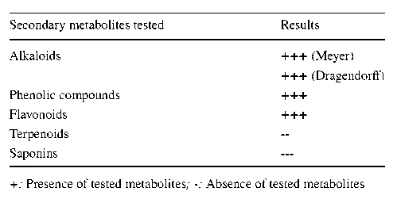

Isolated Compounds
The stem bark and fruits of Z. gilletti yielded six compounds and one compound respectively. The structures of the isolated compounds were elucidated using physical and NMR data and comparison with literature. They were identified as lupeol (1), β-Sitosterol glucoside (2), 2-Oxiranemethanol, 3-(1,3-benzodioxl-5-yl) (3) reported for the first time from this species, two alkaloids with benzophenanthridine skeleton, nitidine (4) and nitidine chloride (7), Fagaramide (5) and sucrose (6). The structures of the isolated compounds are given in Fig. 1.

Figure 1. Structures of compounds isolated from Zanthoxylum gilletti
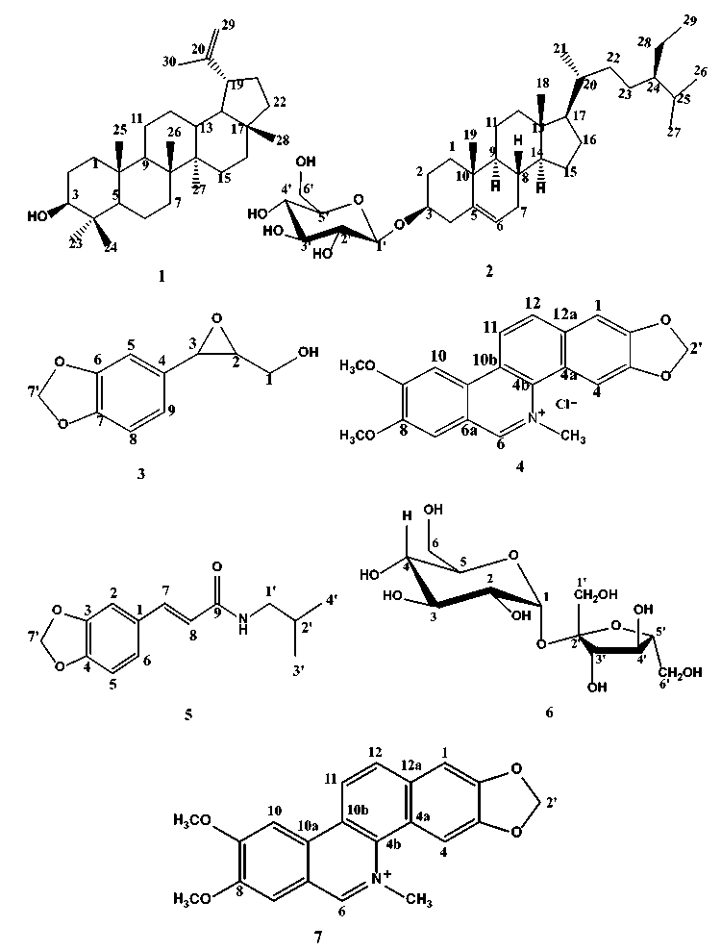

Minimal Inhibitory Concentrations
The minimal inhibitory concentrations of the test samples against Staphylococcus aureus, Escherichia coli and Candida albicans were measured (Table 2). Compounds 3, 4 and 7 were most active on the S. aureus with MIC value of 200 μg∕mL each, while compound 5 had MIC value of 400 μg∕mL. On the E. coli, compounds 3 (100 μg∕mL), 4 (100 μg∕ mL), 5 (200 μg∕mL) and 7 (400 μg∕mL) were active as well as on C. albicans on where MIC values were 50 μg∕mL for compounds 4 and 7, 200 μg∕mL and 100 μg∕mL for compounds 3 and 5, respectively. The structural feature common to these tested compounds 3, 4, 5 and 7 is the presence of methylenedioxyl function linked to a benzene ring. The good antimicrobial activity of these compounds could therefore be attributed to this structural feature. Compounds 1 and 2 had MIC values of 800 μg∕mL (S. aureus), 400 μg∕mL ( E. coli) and 400 μg∕mL for compound 1 against C. albicans and 200 μg∕mL for compound 2 against C. albicans. Compound 6 didn’t inhibit bacterial growth within tested concentrations. The active pure compounds showed higher activity than the crude extracts. The stem bark extract was more active on S. aureus while the fruit extract was more active on E. coli. Antimicrobial potential of extracts of Z. gilletii have been reported against some strains of Escherichia coli, Staphylococcus aureus, Bacillus subtilis, Klebsiella pneumoniae, Pseudomonas aeruginosa, Providencia stuartii, and Enterobacter aerogenes and Z. gilletii was suggested as potential control against some infections [23, 46]. In one study, Fagara macrophylla (Z. gilletii) bark extract had lower MIC values than a reference antibiotic chloramphenicol [46]. However, reports on the chemical constituents of Z. gilletii responsible for the antimicrobial activity are scarce. The good antimicrobial activity reported for the compounds from this plant suggests the fact that these compounds are responsible for the antimicrobial activity of the plant and justifies its traditional use in the management of infectious conditions.

Table 2. MIC results for test samples
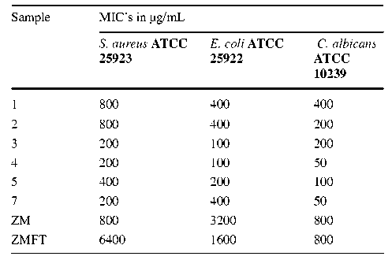

Antibiofilm Activity of test Samples
Prior to investigation of biofilm inhibitory potential of test samples, MIC values of test samples were determined on the selected microorganisms and biofilm inhibition assay was performed at MIC and sub-inhibitory or sub-MIC concentrations. This is because at weak concentrations, chances of development of resistant strains are low and equally the assay will be done under conditions which do not cause cell death or growth inhibition. The antibiofilm activity results were expressed in percentage inhibitions as shown on graphical representations (Figs. 2, 3 and 4). Compounds 3, 4, 5, and 7 as well as the crude extracts showed good antibiofilm activity against test pathogens. The stem bark extract showed highest activity on S. aureus with percentage biofilm inhibition ranging from 84.5 ± 2.5% (MIC) to 11.8 ± 0.1 (MIC/16) as presented on Fig. 2. On the E. coli, compound 7 exhibited the best biofilm inhibition of 88.5 ± 2.3% (MIC) and 13.5 ± 0.6% (MIC/16) as shown on Fig. 3. On the yeast, compound 4 showed the best biofilm inhibition compared to other test samples and the % inhibition varied from 87.1 ± 4.1 (MIC) to 11.9 ± 0.5 (MIC/16) as represented on Fig. 4. Antibiofilm activities were low for compounds 1 and 2 while compound 6 did not inhibit biofilm formation. MIC values of test samples were used to decide sub-inhibitory concentrations at which biofilm inhibition was measured. Most microorganisms like those selected for study, form three-dimensional communities, known as biofilms that protect and help them to survive adverse conditions such as antibiotics, starvation and immunological defense of host thereby contributing to the persistence and severity of infectious diseases [13, 33, 47]. The ability of the extracts and compounds to disrupt biofilms formation by the pathogenic bacteria is a suitable strategy to eliminate resistance because biofilms provide the protective shield in harsh and unfavorable conditions such as host defense mechanism, starvation and in the presence of antibiotics posing a serious health threat [36, 48]. Most conventional existing antibiotics and able to target only the effects caused by planktonic bacteria which are outside the biofilms while the sessile bacteria within established biofilms remain alive and can subsequently grow and multiply leading to a re-establishment of bacterial colonies and communicative networks with the aid of as quorum sensing mediated processes [33, 36, 48, 49]. Therefore, it is important to search for compounds and extracts that can inhibit biofilm formation and make bacterial cells more vulnerable and susceptible to antibiotic effect of the compounds, breaking biofilms and exposing bacterial cells such that they do not develop resistance towards antimicrobial drugs. The extracts and compounds from Z. gilletii have displayed good antibiofilm activity and can find applications in controlling microbial resistance.

Figure 2. Antibiofilm activity of samples against S. aureus ATCC 25923
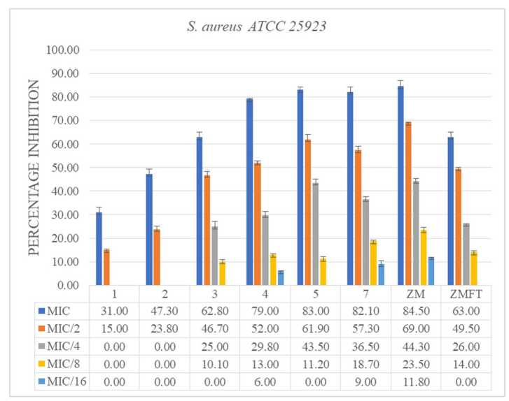

Figure 3. Antibiofilm activity of samples against E. coli ATCC 25922
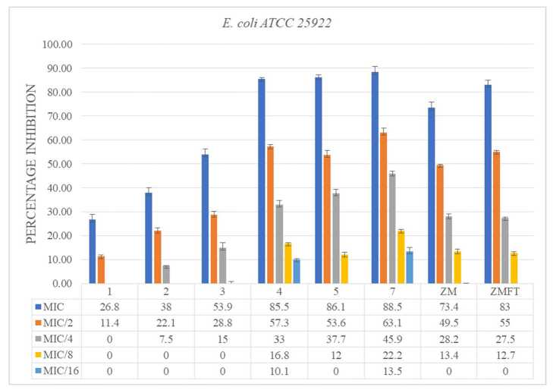

Figure 4. Antibiofilm activity of samples against C. albicans ATCC 10239
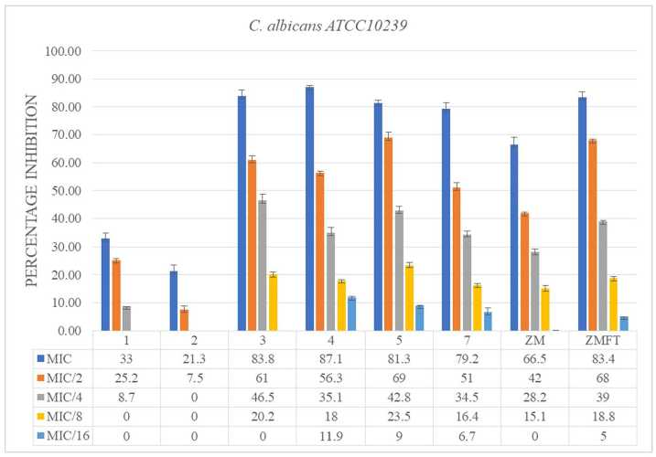

Violacein Inhibition of Test Samples on Chromobacterium violaceum CV12472
The violacein production inhibition was performed using the indicator strain C. violaceum 12472 and is believed to usually result from either disruption of quorum-sensing (QS) signals or inhibition of cell growth [50, 51]. Chromobacterium violaceum is a Gram negative bacterium having a wide geographic distribution, produces the pigment violacein in response to QS regulated gene expression [52]. Prior to violacein inhibition, the MIC values for each sample was determined and the violacein inhibition assay conducted and lesser concentrations to eliminate the hypotheses of growth inhibition. The capacity of the compounds and extracts to inhibited violacein formation (% inhibition) where measured at MIC and sub-MIC (sub-inhibitory) concentrations, that is at concentrations where bacterial cells were still viable so as to see the expression of quorum-sensing under selective pressure on the bacteria and the results are reported in Table 3. Compounds 3, 4, 5 and 7 showed profound violacein inhibition of 100% at MIC to MIC/4 concentrations (Fig. 5). Other compounds equally showed moderate capacity of inhibiting violacein production at sub-MIC concentrations. The compounds from stem barks were more active than those from the fruits. In all tested samples, the % violacein inhibition was concentration-dependent and even in wells where violacein inhibition was observed, cell growth was visible thus implying that samples inhibited violacein inhibition without necessarily causing cell death. Violacein plays a protective role for the bacteria, preventing it from oxidative stress and also plays the role of a signal molecule [53]. This implies that inhibiting violacein inhibition, disrupts the protective and signaling effects thereby reducing the virulence of bacteria.
Table 3. Qualitative violacein inhibition of test samples on C. violaceum CV12472
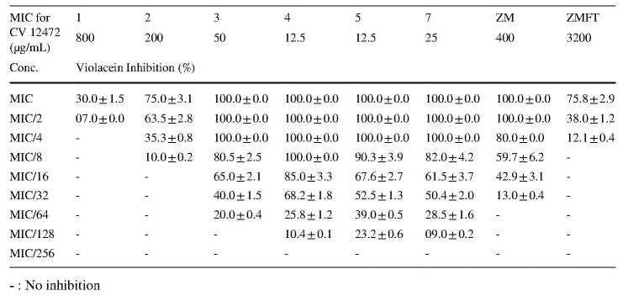

Anti-Quorum Sensing Activity of Test Samples on Chromobacterium violaceum CV026
C. violaceum, a Gram-negative bacterium which synthesizes the pigment violacein as a response to QS regulated gene expression and it has a wide geographic distribution. The mutant and biosensor strain, C. violaceum CV026 is deficient in autoinducer synthase and cannot produce its own violacein. However, under the influence of externally supplied acylhomoserine lactone (AHL), C. violaceum CV026 can produce violacein and this effect is an appropriate tool for biological assay and screening of QS inhibitors applied in the study of various QS mechanisms [54, 55]. The zones over which a cream colour is observed against a violet lawn on the plates surface, as shown on Fig. 5, corresponds to the anti-QS zone [56-58] whose diameter was measured in millimeters and reported on Table 4. Compounds 1 and 6 had no anti-quorum sensing effects while the other samples showed moderate to relatively high QS disruption. At MIC concentration, compounds 3 (11.5 ± 0.5 mm), 4 (12.5 ± 1.5 mm), 5 (15.0 ± 0.8 mm) and 7 (12.0 ± 1.5 mm) as well as the crude extracts from stem barks (16.5 ± 1.2 mm) and seeds (13.0 ± 1.4 mm) showed appreciable anti-QS activity which varied from sample to sample and for the same sample, the anti-QS zones decreased with decrease in concentration (concentration-dependent manner). There is an increasing search for new, more effective and safer alternatives to available antibiotics which are gradually falling out of use and natural sources is a good potential source [13, 57]. For this reason, there is increasing investigating of herbal products in the quest for new therapeutic and antipathogenic compounds with lower side effects and capacity of disrupting QS networks in bacteria colonies thus controlling infections and avoiding the emergence of resistant bacterial strains [34, 48, 58-60]. QS plays a key role during bacterial pathogenesis, influencing this behaviour in bacteria can be considered as good strategy to eliminate microbial virulence. Hence the capacity exhibited by these compounds and extracts to inhibited QS mediated processes in bacteria is a valuable lead to the development of antibiotic therapeutics.

Figure 5. Quorum sensing plates (A) and violacein inhibition plate (B)
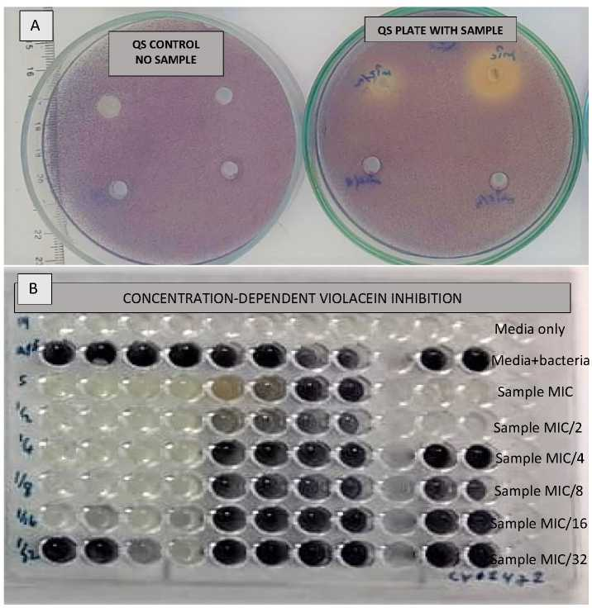

Table 4. Anti-quorum sensing activity of test samples on C. violaceum CV026
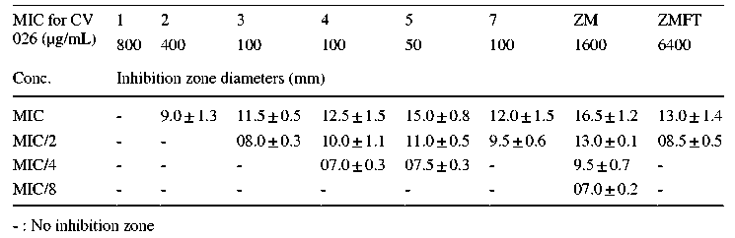

Conclusion
Zanthoxylum gilletii has been identified as a valuable medicinal plant with numerous therapeutic properties. Many chemical studies report diverse compounds occurring in this plant and with a few biological studies especially antimicrobial assays. In this study, seven compounds have been isolated and characterized with compounds 3 and 6 being reported for the first time from this species. These compounds and extracts have shown good antibiofilm and anti-QS activities and therefore are potent drug lead in the discovery of novel antibiotics capable of alleviating the emergence of antimicrobial resistance which is a global health problem. When the concentration of autoinducers attain a threshold amount, QS is achieved and several virulence characteristics like biofilm formation and pigment production are triggered. Therefore, the tested compounds and extracts displayed anti-QS properties and they do not necessarily kill bacteria like the conventional antibiotics but disrupt cell-to-cell communication in bacteria thereby reducing virulence and severity of infection. Z. gilletii metabolites and extracts used in this study can disrupt QS mediated factors of tested microorganisms and thus can be used to reduce severity of infectious diseases and eliminate microbial resistance and therefore justifies its use in the treatment of infectious diseases in ethnomedicine. The effect of these phyto-compounds on pathogenic bacteria is an interesting domain and further investigation of compounds from this plant can be a promising field of discovery of antibiotics.

Acknowledgements
The authors are thankful to the pharmacognosy team of the University of Liège for undertaking the structural analysis of the compounds. The authors are also grateful to the Mugla Sitki Koçman University in Turkey for the biological part of this work.

Author Contribution
All authors contributed to the study methodology, writing review, and editing. Investigation, formal analysis were performed by Hermia Nalova Ikome, Alfred Ngenge Tamfu, Jean Pierre Abdou, Hugues Fouotsa, Pamela Kemda Nangmo and Fidèle Castro Weyepe Lah. Conceptualisation, meth-odology, visualisation, funding acquisition, project administration, analysis, supervision, resources and validation Alembert Tiabou Tchinda, Ozgur Ceylan, Michel Frederich and Augustin Ephrem Nkengfack. The first draft of the manuscript was written by Hermia Nalova Ikome and Alfred Ngenge Tamfu. All authors read and approved the final manuscript.

References
1. Tankeo, S. B., Damen, F., Awouafack, M. D., Mpetga, J., Tane, P., Eloff, J. N., & Kuete, V. (2015). Antibacterial activities of the methanolic extracts, fractions and compounds from Fagara tesmannii Journal of Ethnopharmacology, 169, 275–279.
2. Rice, L. B. (2006). Unmet medicinal needs in antibacterial therapy. Biochemical Pharmacology, 71, 991–995.
3. Tamfu, A. N., Boukhedena, W., Boudiba, S., Deghboudj, S., & Ceylan, O. (2022). Synthesis and evaluation of inhibitory potentials of microbial biofilms and quorum-sensing by 3-(1, 3-dithian-2-ylidene) pentane-2, 4-dione and ethyl-2-cyano-2-(1, 3-dithian-2-ylidene) acetate. Pharmacia, 69(4), 973–980.
4. Arab, Y., Sahin, B., Ceylan, O., Zellagui, A., Olmez, O. T., Kucukaydin, S., Tamfu, A. N., Ozturk, M., & Gherraf, N. (2022). Assessment of in vitro activities and chemical profiling of Senecio hoggariensis growing in Algerian Sahara. Biodiversitas, 23, 3498–3506.
5. Tamfu, A. N., Kucukaydin, S., Quradha, M. M., Ceylan, O., Ugur, A., & Duru, M. E. (2022). Ultrasound-assisted extraction of Syringa vulgaris Mill., Citrus sinensis L. and Hypericum perforatum L.: phenolic composition, enzyme inhibition and anti-quorum sensing activities. Chemistry Africa, 5(2), 237–249.
6. Jin-Hyung, L., Yong-Guy, K., Khadke, S. K., Yamano, A., Je-Tae, W., & Jintae, L. (2019). Antimicrobial and antibiofilm activities of prenylated flavanones from Macaranga tanarius Phytomedicine, 63, 153033.
7. Huang, J. H., Shi, Y. H., Zeng, G. M., Gu, Y. L., Chen, G. Q., & Shi, L. X. (2016). Acyl-homoserine lactone-based quorum sensing and quorum quenching hold promise to determine the performance of biological wastewater treatments: an overview. Chemosphere, 157, 137–151.
8. Galloway, W. R., Hodgkinson, J. T., Bowden, S. D., Welch, M., & Spring, D. R. (2011). Quorum sensing in gram-negative bacteria: small-molecule modulation of AHL and AI-2 quorum sensing pathways. Chemical Reviews, 111, 28–67.
9. Gonzalez, J. E., & Keshavan, N. D. (2006). Messing with bacterial quorum sensing. Microbiology and Molecular Biology Reviews, 70(4), 859–887.
10. Vasha, S., & Zarine, B. (2016). Broad spectrum anti-quorum sensing activity of tannin-rich crude extracts of Indian medicinal plants. Scientifica, 5823013.
11. Asafour, H. Z. (2018). Anti-quorum sensing natural compounds. Journal of Microscopyic and Ultrastructures, 6(1), 1–10.
12. Ahmad, I., Mehmood, Z., & Mohammad, F. (1998). Screening of some indian medicinal plants for their antimicrobial properties. Journal of Ethnopharmacology, 62, 183–193.
13. Tamfu, A. N., Ceylan, O., Fru, G. C., Ozturk, M., Duru, M. E., & Shaheen, F. (2020). Antibiofilm, anti-quorum sensing and antioxidant activity of secondary metabolites from the seeds of Annona senegalensis, Persoon. Microbial Pathogenesis, 144, 104191.
14. Vasudevan, R. (2014). Biofilms: microbial cities of scientific significance. Journal of Microbiology and Experimentation, 1(3), 1–16.
15. Kumar, L., Chibber, S., & Hazare, K. (2013). Zingeron inhibit biofilm formation and improve antibiofilm efficacy of ciprofloxacin against Pseudomonas aeruginosa PA01. Fitoterapia, 90, 73–78.
16. Dusane, D. H., Damare, S. R., Nancharaiah, Y. V., Ramaiah, N., Venugopalan, V. P., Kumar, A. R., & Zinjarde, S. S. (2013). Distruption of microbial biofilms by an extra-cellular protein isolated from epibiotic marine strain of Bacillus licheniformis PLoS One1, 8, 6450.
17. Koehn, F. E., & Carter, G. T. (2005). Rediscovering natural product as a source of new drugs. Discovery Medicine, 5(26), 159–164.
18. Sampathkumar, S. J., Srivastava, P., Ramachandran, S., Sivashanmugam, K., & Muthukaliannah, G. K. (2019). Lutein: a potential antibiofilm and antiquorum sensing molecule from green microlagia. Chlorella Pyrenoidosa Microbial Pathogenesis, 135, 103658.
19. Tamfu, A. N., Munvera, A. M., Botezatu, A. V. D., Talla, E., Ceylan, O., Fotsing, M. T., Mbafor, J. T., Shaheen, F., & Dinica, R. M. (2022). Synthesis of benzoyl esters of β-amyrin and lupeol and evaluation of their antibiofilm and antidiabetic activities. Results Chemistry, 4, 100322.
20. Adesina, S. K. (2005). The nigerian Zanthoxylum; chemical and biological values. African Journal of Complementary and Alternative Medicine, 2(3), 282–301.
21. Negi, J. S., Bisht, V., Bhandari, A. K., Sing, P., & Sundriyal, R. C. (2011). Chemical constituents and biological activities of the genus Zanthoxylum. A review. African Journal of Pure and Applied Chemistry, 5(12), 412–416.
22. Letouzey, R. Flora of Cameroon I., & Rutaceae (1963). Zygophyllaceae, Balanitaceae (p. 174). Musee Nationale.
23. Fish, F., & Waterman, P. G. (1973). Chemosystematics in the Rutaceae II. The Chemosystematics of the Zanthoxylum Fagara complex. Taxonomy, 22(2/3), 177–203.
24. Agyare, C., Mensah, A., & Osei-Asante, S. (2006). Antimicrobial activity and phytochemical studies of some medicinal plants from Ghana. Boletín Latinoamericano y del Caribe de Plantas Medicinales y Aromáticas, 5(6), 113–117.
25. Gaya, C. H., Kawaka, J. F., Muchugi, A., & Ngeranwa, J. J. (2013). Variation of alkaloids in the kenyan Zanthoxylum gilletii (De Wild Waterman). African Journal of Plant Science, 7(9), 438–444.
26. Orsotet, B. A. M. B., Soro, S., Kone, D., & Zirihi, G. N. (2016). Étude ethnobotanique et évaluation in vitro de l’activité antifongique des extraits de l’écorce de Zanthoxylum gilletii (de Wild Waterman) sur deux souches phytopathogenes de sclerotium rolfsii Journal of Applied Bioscience, 98, 9309–9322.
27. Wanga, L. A., Wagara, I. N., Ramadhan, M., & Matasyoh, J. C. (2018). Antimicrobial activity of metabolites extracted from Zanthoxylum gilletii, Markhamia lutea and their endophytic fungi against common bean bacterial pathogens. African Journal of Biotechnology, 17(26), 870–879.
28. Sinan, K. I., Zengin, G., Bene, K., & Mahomoodally, M. F. (2019). Chemistry and pharmacology of three antiplasmodial traditional medicinal plants from tropical Africa – A review. South African Journal of Botany, 126, 265–276.
29. Omosa, L. K., & Okemza, E. K. (2017). Antiplasmodial activities of the stem bark extract and compounds of Zanthoxylum gilletii (de wild) PG Waterman. Pharmacognosy Communications, 7(1), 41–46.
30. Claudio, R. N., & Lopes, L. M. X. (2011). Antiplasmodial natural products (review). Molecules, 16, 2146–2190.
31. Tamfu, A. N., Sawalda, M., Fotsing, M. T., Kouipou, R. M. T., Talla, E., Chi, G. F., Epanda, J. J. E., Mbafor, J. T., Baig, T. A., Jabeen, A., & Shaheen, F. (2020). A new isoflavonol and other constituents from cameroonian propolis and evaluation of their anti-inflammatory, antifungal and antioxidant potential. Saudi Journal of Biological Sciences, 27(6), 1659–1666.
32. Anza, M., Haile, E., Tadesse, S., Mammo, F., & Endale, M. (2014). A corniferyl alcohol derivative from the roots of Zanthoxylum chalybeum Journal of Coastal Life Medicine, 2(12), 970–974.
33. Nna, P. J., Tor-Anyiin, T. A., & Igoli, J. O. Fagaramide and Pellitorine from the stem bark of Zanthoxylum zanthoxyloides and their antimicrobial activities. SARJNP, 2(3), 1–8.
34. Ngenge, T. A., Jabeen, A., Maurice, T. F., Baig, T. A., & Shaheen, F. (2019). Organic and mineral composition of seeds of Afrostyrax lepidophyllus Mildbr. And evaluation of ROS inhibition and cytotoxicity of isolated compounds. Chemistry Africa, 2(4), 615–624.
35. Marek, R., Toušek, J., Dostál, J., Slavík, J., Dommisse, R., & Sklenář, V. (1999). H and. Magnetic Resonance in Chemistry, 37(11), 781–787.
36. Rashid, M. A., Kashuanlb, G. K. R., Cardellina, Y., Mcmahon, J. H., & Boyd, M. R. (1995). Antihiv alkaloids from. Natural Products Letters, 6, 153–156.
37. Peshin, T., & Kar, H. K. (2017). Isolation and characterization of β-Sitosterol-3-O-β-D-glucoside from the extract of the flowers of. British Journal of Pharmaceutical Research, 16(4), 1–8.
38. Mofiz, N. M., & Sagar Hossan, M. D. (2015). Scopoletin and β-sitosterol glucoside from roots of Ipomoea digitate Journal of Pharmacognosy and Phytochemistry, 4(2), 05–07.
39. Tamfu, A. N., Ceylan, O., Kucukaydin, S., Ozturk, M., Duru, M. E., & Dinica, R. M. (2020). Antibiofilm and enzyme inhibitory potentials of two annonaceous food spices, african pepper (Xylopia aethiopica) and african nutmeg (Monodora myristica). Foods, 9(12), 1768.
40. Merritt, J. H., Kadouri, D. E., & O’Toole, G. A. (2005). Growing and analysing static biofilms. Current Protocols in Microbiology. https:// doi. org/ 10. 1002/ 97804 71729 259. mc01b 01s00
41. Ceylan, O., Tamfu, A. N., Dogaç, Y. I., & Teke, M. (2020). Antibiofilm and antiquorum sensing activities of polyethylene imine coated magnetite and nickel ferrite nanoparticles. 3 Biotech, 10, 315.
42. Alfred Ngenge, T., Kucukaydin, S., Ceylan, O., & Duru, M. E. (2021). Evaluation of enzyme inhibition and anti-quorum sensing potentials of Melaleuca alternifolia and Citrus sinensis essential oils. Natural Product Communications, 16(9), 1–8.
43. Koh, K. M., & Tham, F. Y. (2011). Screening of traditional chinese medicinal plants for quorum-sensing inhibitors activity. Journal of Microbiology Immunology and Infection, 44, 144–148.
44. Tamfu, A. N., Ceylan, O., Kucukaydin, S., & Duru, M. E. (2020). HPLC-DAD phenolic profiles, antibiofilm, anti-quorum sensing and enzyme inhibitory potentials of Camellia sinensis (L.) O. Kuntze and Curcuma longa L. LWT-Food Science Technology, 133, 110150.
45. Mbaze, L. M., Lado, J. A., Wansi, J. D., Shiao, T. C., Chiozem, D. D., Mesaik, M. A., Choudhary, M. I., Lacaile-Dubois, M. A., Wandji, J., Roy, R., & Sewald, N. (2009). Oxidative burst inhibitory and cytotoxicity amides and lignans from the stem bark of Fagara heitzii. Phytochemistry, 70(11–12), 1442–1447.
46. Youssef, S. B., Fakhfakh, J., Tchoumchoua, J., Halabalaki, M., & Allouche, N. (2016). Efficient purification and complete NMR characterization of galactinol, sucrose, raffinose and stachyose isolated from Pinus halepensis (Aleppo pine) seeds using acetylation procedure. Journal of Carbohydrate Chemistry, 35(4), 224–237.
47. Seukep, J. A., Ngadjui, B., & Kuete, V. (2015). Antibacterial activities of Fagara macrophylla, Canarium schweinfurthii, Myrianthus arboreus, Dischistocalyx grandifolius and Tragia benthamii against multi-drug resistant gram-negative bacteria. Springerplus, 4, 567.
48. Costerton, J. W., Stewart, P. S., & Greenberg, E. P. (1999). Bacterial biofilms a common cause of persistent infection. Science, 284, 1318–1322.
49. Popova, M., Gerginova, D., Trusheva, B., Simova, S., Tamfu, A. N., Ceylan, O., Clark, K., & Bankova, V. (2021). A preliminary study of chemical profiles of honey, cerumen, and propolis of the african stingless bee Meliponula ferruginea Foods, 10(5), 997.
50. Kocak, G., Tamfu, A. N., Bütün, V., & Ceylan, O. (2021). Synthesis of quaternary piperazine methacrylate homopolymers and their antibiofilm and anti-quorum sensing effects on pathogenic bacteria. Journal of Applied Polymer Science, 138(21), 50466.
51. Tamfu, A. N., Kucukaydin, S., Ceylan, O., Sarac, N., & Duru, E. M. (2021). Phenolic composition, enzyme inhibitory and anti-quorum sensing activities of cinnamon (Cinnamomum zeylanicum Blume) and Basil (Ocimum basilicum Linn). Chemistry Africa, 4(4), 759–767.
52. Adonizio, A. L., Downum, K., & Bennett, B. C. (2006). Anti-quorum sensing activity of medicinal plants in Southern Florida. Journal of Ethnopharmacology, 105(3), 427–435.
53. Tamfu, A. N., Ceylan, O., Cârâc, G., Talla, E., & Dinica, R. M. (2022). Antibiofilm and anti-quorum sensing potential of cycloartane-type triterpene acids from cameroonian grassland propolis: phenolic profile and antioxidant activity of crude extract. Molecules, 27(15), 4872.
54. Suryanarayana, H. V., Arun, A. B., & Rekha, P. D. (2013). Inhibition of quorum sensing in Chromobacterium violaceum by Syzygium cumini L. and Pimenta dioica L. Asian Pacific Journal of Tropical Biomedicine, 3(12), 954–959.
55. McClean, K. H., Winson, M. K., Fish, L., Taylor, A., Chhabra, S. R., & Camara, M. (1997). Quorum sensing and Chromobacterium violaceum: exploitation of violacein production and inhibition for the detection of N-acylhomoserine lactones. Microbiology, 143, 3703–3711.
56. Halkare, S. V., Ananthapadmanabha, B. A., & Punchapady-Devasya, R. (2014). Anti-quorum sensing activity of Psidium guajava L. flavonoids against Chromobacterium violaceum and Pseudomonas aeruginosa PA01. Microbiology and Immunology, 58, 286–293.
57. Ngenge, A., Ceylan, O., Fru, G., Arab, Y., Emin, D., & Ozturk, M. (2021). Antimicrobial, antibiofilm, antiquorum sensing and motility inhibition activities of essential oil from seeds of food spice Xylopia aethiopica (Dunal) A. Rich. On some pathogenic bacteria. Research Journal of Biotechnology, 16, 68–76.
58. Alfred, T. N., Ceylan, O., Kucukaydin, S., Olmez, O. T., Godloves, C. F., Sylvain, S. K., Yeskaliyeva, B., Duru, M. E., & Ozturk, M. (2020). HPLC-DAD and GC-MS characterization of cameroonian honey samples and evaluation of their antibiofilm, anti-quorum sensing and antioxidant activities. Bulletin of Environment Pharmacology and Life Sciences, 9(10), 132–142.
59. Boudiba, S., Tamfu, A. N., Berka, B., Hanini, K., Hioun, S., Allaf, K., Boudiba, L., & Ceylan, O. (2021). Anti-quorum sensing and antioxidant activity of essential oils extracted from Juniperus species, growing spontaneously in Tebessa Region (East of Algeria). Natural Products Communication, 16(6), 1–11.
60. Beddiar, H., Boudiba, S., Benahmed, M., Tamfu, A. N., Ceylan, Ö., Hanini, K., Kucukaydin, S., Elomri, A., Bensouici, C., Laouer, H., Akkal, S., Boudiba, L., & Dinica, R. M. (2021). Chemical composition, anti-quorum sensing, enzyme inhibitory, and antioxidant properties of phenolic extracts of Clinopodium nepeta L. Kuntze. Plants, 10(9), 1955.

