ACCEPTED MANUSCRIPT
Published in Consciousness and Cognition, 10.1016/j.concog.2024.103649

Goal characteristics predict the occurrence of goal-related events through belief in future occurrence

Claudia Garcia Jimenez, & Arnaud D’Argembeau

Psychology and Neuroscience of Cognition Research Unit, University of Liège, Belgium.

Claudia Garcia Jimenez, https://orcid.org/0000-0003-3089-0609, Email: cgarciajimenez@uliege.be;

Arnaud D’Argembeau, https://orcid.org/0000-0003-3618-9768, Email: a.dargembeau@uliege.be.

Correspondence concerning this article should be addressed to Claudia Garcia Jimenez, Department of Psychology, Psychology and Neuroscience of Cognition, University of Liège, Place des Orateurs 1 (B33), 4000 Liège. Email: cgarciajimenez@uliege.be

1. Introduction
When pursuing personal goals, we develop various forms of mental representations that serve to guide us toward desired outcomes (Dweck, 2017). In this context, episodic future thinking allows us to form mental simulations of specific events that could unfold in the future, providing us with the opportunity to pre-experience how we might feel and react in a given situation (Atance & O’Neill, 2001; Kvavilashvili & Rummel, 2020; Schacter & Addis, 2007; Suddendorf & Corballis, 2007; Szpunar, 2010). This capacity to envision what might happen in the future enables us to plan and prepare for different possibilities that are relevant to our goals and needs (Baumeister et al., 2016; Bulley et al., 2016; Kvavilashvili & Rummel, 2020). However, while prior research points to the role of episodic future thinking in goal pursuit, the underlying cognitive mechanisms are not fully understood. The purpose of the present research is to shed light on how goal-related information is translated into episodic future thoughts and how this may ultimately influence behavior. More specifically, we sought to investigate how various goal characteristics influence the subjective belief that goal-related events will transpire in the future, and how this belief is related to their subsequent realization.
Goals are cognitive representations of desired states or outcomes (Austin & Vancouver, 1996), and personal goals refer to salient objectives that people pursue in their lives (Emmons, 1986; Klinger, 2013; Little, 1983; Milyavskaya & Werner, 2018). From their inception to their realization or abandonment, personal goals explicitly and implicitly shape our daily decisions and behaviors (Chartrand & Bargh, 2002; Ferguson & Porter, 2010; Milyavskaya & Werner, 2021). Goal representations are organized in the cognitive system as a hierarchical structure in which higher-order goals (e.g., having a successful career) determine the content of lower-order goals (e.g., passing a specific exam) (Austin & Vancouver, 1996). Thus, one way higher-order goals influence everyday actions and decisions is by giving rise to representations of specific future events. Such episodic future thoughts allow the detailed simulation of possible occurrences, plans, and outcomes that are related to higher-order personal goals (D’Argembeau, 2016).
Previous research has consistently demonstrated that personal goals play a pivotal role in shaping episodic future thinking. They guide and constrain the construction of episodic future thoughts (D’Argembeau & Mathy, 2011), organize them in coherent themes and sequences (D’Argembeau & Demblon, 2012; Demblon & D’Argembeau, 2014), and help localize imagined events in time (Ben Malek et al., 2018). Moreover, the presence and strength of the connection between personal goals and envisioned events influence how future thoughts are subjectively experienced. For instance, goal-related episodic future thoughts are associated with enhanced feelings of pre-experiencing and mental time travel into the future, compared to goal-unrelated future thoughts (Lehner & D’Argembeau, 2016). Goal-related thoughts are also evaluated as more emotionally intense and positive, and are considered more important to one’s identity and life story (Cole & Berntsen, 2016). These findings show that personal goals drive and constrain episodic future thoughts, which in turn may promote goal attainment by increasing motivation and enabling one to plan and prepare for action (Conway et al., 2019).
To date, most studies have examined the influence of personal goals on episodic future thinking by comparing mental representations of goal-related and goal-unrelated future events (e.g., Cole & Berntsen, 2016; D’Argembeau & Mathy, 2011; Lehner & D’Argembeau, 2016). However, not all goals are created equal (Ryan et al., 1996). The various goals that people pursue in their daily life are characterized by multiple features that influence goal attainment (e.g., Emmons, 1986; Little, 1983). Using an individual differences approach, Gamble et al. (2021) recently found that participants who pursued goals that were perceived as more attainable and important, and who formed clearer and more positive simulations of goal-related future events, were more likely to make progress towards their goals. Notwithstanding the importance of these individual differences, there is evidence that most of the variance in goal characteristics comes from differences between the various goals of an individual (i.e., variations at the within-person level) rather than between individuals (e.g., Nurmi et al., 2009; see Milyavskaya & Werner, 2018, for a review). In the same vein, most of the variance in the characteristics of episodic future thoughts lies at the within-person level (i.e., between the multiple events imagined by an individual) (D’Argembeau & Garcia Jimenez, 2020). Consequently, our understanding of the role of episodic future thinking in goal pursuit would benefit from an in-depth investigation of within-person relations between personal goal qualities and the characteristics of goal-related episodic future thoughts.
The source of motivation underlying goal pursuit is one of the most frequently researched qualities of personal goals (Milyavskaya & Werner, 2018). The self-concordance model (Sheldon & Elliot, 1999) describes two types of goals, depending on their orientation: self-concordant goals have an underlying autonomous motivation and are pursued because individuals genuinely want to, whereas non-self-concordant goals are pursued with controlled motivation because individuals feel they have to (Milyavskaya et al., 2015). When goals are self-concordant, individuals make sustained efforts that lead to more progress and success in achieving goals (Sheldon & Elliot, 1999). Besides self-concordance, goals differ on several characteristics that can influence goal pursuit (for a review, see Austin & Vancouver, 1996). The feasibility (or perceived likelihood of success) and importance of goals are two characteristics that play a crucial role in deciding which goals to set and keep pursuing (Wigfield & Eccles, 2000). Feasibility is related to the perceived competence or self-efficacy to achieve the goal, the difficulty of the upcoming tasks and actions required for goal attainment, and the perceived control over goal pursuit (Bandura, 1997; Gollwitzer, 1990; Klein et al., 1999). The importance of a goal depends on the extent to which it meets the individual’s motives, needs, and values, considering various factors such as incentives, costs, and consequences associated with achieving the goal (Gollwitzer, 1990; Oettingen, 2000). Importance and perceived likelihood of success both contribute to the formation of goal commitment, defined as the determination to reach a goal, which has a positive effect on performance (Gollwitzer, 1990; Klein et al., 1999; Locke et al., 1988).
The present study aimed to examine how the various qualities of a personal goal translate into mental representations of specific future events, and how these episodic future thoughts can ultimately influence our decisions and actions in favor of goal pursuit. The future is inherently uncertain and is mentally represented as a set of alternative possibilities – a matrix of multiple actions and contingent outcomes (Baumeister et al., 2018). For this myriad of possibilities to be useful in guiding behavior toward desired outcomes, one must be able to identify and prioritize mental scenarios that are most relevant and adapted to one’s current context and goals (Ernst et al., 2019). One possible cognitive mechanism by which episodic future thinking may promote goal pursuit is by modulating the feeling that imagined events will happen in the future – referred to as belief in future occurrence (Ernst et al., 2019; Ernst & D’Argembeau, 2017). Belief in future occurrence may serve as a useful indicator of the relevance of an envisioned scenario (Ernst & D’Argembeau, 2017). Indeed, such belief is largely based on the integration and consistency of the imagined event with autobiographical knowledge (i.e., with our personal characteristics, goals, life circumstances, and general expectations for the future). An imagined future event might not feel “real” because it does not fit with one’s traits, values, and goals for the future, or because it conflicts with other events that have already been planned (Ernst et al., 2019). Conversely, future events that are personally important, detailed, and goal-relevant tend to be associated with higher levels of belief in future occurrence (D’Argembeau & Garcia Jimenez, 2020; Ernst et al., 2019; Ernst & D’Argembeau, 2017). Importantly, D’Argembeau and Garcia Jimenez (2020) found that belief in future occurrence predicts the actual event occurrence at 1-week and 1-month delays, showing that varying degrees of belief are sensitive to the actual occurrence of events. These results suggest that belief in future occurrence may act as a cognitive feeling (Clore & Parrott, 1994) that marks scenarios that are most relevant for decision-making and action implementation, given one's goals and personal context.
From a broader perspective, better understanding the role of belief in future occurrence in goal pursuit might have important clinical implications. Episodic future thinking has been linked to a range of goal-related processes, such as planning, decision-making, emotion regulation, and prospective memory (for reviews, see Bulley & Irish, 2018; Schacter et al., 2017). Deficits in episodic future thinking in clinical populations might thus disrupt these processes, ultimately contributing to poorer mental health (Amlung et al., 2019; Brunette & Schacter, 2021; Hallford et al., 2018). However, the precise mechanisms that make episodic future thinking adaptive (or maladaptive) remain unclear (Hallford et al., 2018; Rösch et al., 2022). Examining the cognitive mechanisms underlying the relationship between episodic future thinking and goal pursuit, and notably the role of belief in future occurrence, may benefit our understanding of pathological processes and support the development of clinical interventions.
To assess the role of belief in future occurrence in the relationship between episodic future thinking and goal pursuit, we investigated whether and how goal self-concordance (Experiment 1) and other goal characteristics such as commitment and expected likelihood of success (Experiment 2) shape belief in the future occurrence of goal-related events and predict the actual occurrence of these events. Specifically, we tested the hypothesis that belief in future occurrence mediates the relationship between goal characteristics and the actual occurrence of goal-related future events.

2. Experiment 1
In Experiment 1, we sought to investigate whether the source of motivation underlying goal pursuit affects belief in the future occurrence, as well as the actual occurrence, of goal-related events. Ernst et al. (2018) found that events that were related to self-concordant goals were associated with a stronger belief in their future occurrence. In the present experiment, we aimed to replicate and extend these results by investigating whether goal self-concordance impacts the actual event occurrence. We expected that events related to self-concordant goals would be associated with a higher belief in their future occurrence (Ernst et al., 2018), and that this belief would predict the actual event occurrence (D’Argembeau & Garcia Jimenez, 2020). Most importantly, we tested the hypothesis that goal self-concordance impacts event occurrence through belief in future occurrence (see Figure 2A).

2.1 Methods
2.1.1 Participants
Thirty-four participants were recruited (17 women and 17 men, aged between 18 and 35 years; M = 22.30, SD = 3.55). This sample size was determined with an a priori power analysis for linear multilevel regression models using SIMR (Green & MacLeod, 2016), based on data from Ernst et al. (2018). This indicated that a sample size of 34 participants with 10 events per participant (5 for each goal condition) provided a statistical power above 90% to detect a significant difference between the two goal conditions on the belief in future occurrence scale, with the same effect size as Ernst et al. (b = 0.68) and an alpha of .05. All participants provided written informed consent and the experiment was approved by the Ethics Committee of the Faculty of Psychology of the University of Liège.
2.1.2 Materials and Procedure
The experiment consisted of two testing sessions (lasting approximately 90 and 30 min, respectively), spaced a month apart. In the first session, participants were asked to select a series of personal goals. These goals were defined as personal projects that one strives to achieve, frequently thinks about, and makes plans for (Lehner & D’Argembeau, 2016). It was specified that these goals could be more or less difficult to implement and more or less rapid to achieve and that they could be related to any life domain, including family, intimate relationships, school, work, leisure activities, and material goods. In addition, participants were told that personal goals can be categorized according to the reason they are pursued: self-concordant goals are mostly driven by autonomous reasons and reflect projects that are pursued out of personal importance and interest, are in line with their core values (i.e., identified motivation), or because the goal pursuit in itself is satisfying or fun (i.e., intrinsic motivation); non-self-concordant goals are mainly motivated by controlled reasons and are pursued because one feels obliged to (i.e., external motivation), for example, because a person or a situation requires it, or because one would feel guilty, ashamed, or anxious about not doing so (i.e., introjected motivation). This distinction is based on Sheldon and Elliot's (1999) model of self-concordance, which categorizes personal goals according to the primary motivations driving their pursuit. Note that these categories are not mutually exclusive (goals can be pursued for a variety of reasons and can include both autonomous and controlled motives), but participants were asked to identify personal goals that fit as distinctly as possible with these two types of goals. There was no set number of goals to select and no time limit, but participants were recommended to find at least three goals per category before moving on to the next task. The experimenter ensured that the goals matched the categories by discussing them with the participants. Note that this goal selection phase was only used to find future events related to both types of goals, so the selected goals were not recorded.
After selecting personal goals, participants were asked to provide ten future events that might occur in the coming month and that were directly linked to these goals: five events that were related to their self-concordant goals, and five events that were related to their non-self-concordant goals. It was mentioned that events should be unique (i.e., not identical to an event that has been experienced before) and specific (i.e., taking place in a specific time and place and lasting no more than a day). The events could be planned or not, positive or negative, but they had to be personal and plausible. Participants gave a brief title and a date for each event.
Once the ten events had been selected, participants engaged in episodic future thinking for each event: they were asked to imagine each event in as much detail as possible. Directly after each imagination and while keeping the event in mind, they rated the characteristics of their mental representation by responding to the following set of 7-point Likert scales selected from previous studies on episodic future thinking (D’Argembeau et al., 2011; Ernst & D’Argembeau, 2017). Belief in future occurrence was measured with the four items having the highest loading on the scale developed by Scoboria et al. (2020) (Cronbach’s alpha = 0.93 in the current sample). Three items were used to measure the integration of the event into an autobiographical context: personal importance, links to personal goals, and the extent to which the future events were previously planned. The subjective quality of mental imagery was assessed with four items (the amount of sensory details, the clarity of the location, the sense of experiencing the event, and the feeling of mentally traveling into the future; Cronbach’s alpha = 0.78), and another item evaluated the ease of imagination. Participants also indicated whether they had thought of the imagined event on a previous occasion, whether they had experienced a similar event in the past, and they assessed the familiarity of the imagined location. One item assessed the subjective temporal distance of the imagined event. Another item measured the valence of the emotion felt when imagining the event. Three items measured how much control in the occurrence of the event participants attributed to themselves, other people, and circumstances (Merck et al., 2016; Roseman et al., 1990). Finally, future events were characterized according to their level of psychological need satisfaction (Ryan & Deci, 2000). The extent to which an event satisfied the need for autonomy, competence, and relatedness was assessed using six items coming from previous research on need satisfaction for autobiographical memories (Bouizegarene & Philippe, 2016; Philippe et al., 2011, 2012) and adapted by Ernst et al. (2018).
One month after the first session, participants returned to the lab and were presented with the titles of the ten events they selected and imagined a month ago. For each event, participants were asked whether they remembered imagining this event during the first session and whether the event actually occurred in the past month. If the event happened, they had to report the day of its occurrence. If it did not happen, they were asked if the event was abandoned or reported to another date. During debriefing, participants were asked whether thinking about the events in the context of this study influenced the actual occurrence of any event (e.g., they forced an event to happen because they thought it would be addressed in the second session). If this was the case, the event was discarded for the analyses. The instructions and materials that were used in this experiment are openly available in OSF at https://osf.io/xe7ra/.
2.1.3 Statistical analyses
The influence of goal self-concordance on belief in future occurrence was examined using a linear multilevel regression model (two-level random effects models, with events as level 1 units and participants as level 2 units; Hox, 2010), with belief in future occurrence ratings as outcome, and goal self-concordance as predictor. To investigate the extent to which belief in future occurrence predicted the actual occurrence of events, we fitted a multilevel logistic regression model with actual occurrence as outcome and belief in occurrence as predictor. In this model, belief ratings were centered on each subject’s mean (cluster-mean centering) to obtain an unbiased estimate of the within-subject association between the predictor and the outcome (Brauer & Curtin, 2018). The effect of self-concordance on the actual occurrence of goal-related events was examined using a multilevel logistic regression model with goal self-concordance as predictor and actual event occurrence as outcome.
As the results suggested an indirect effect of goal self-concordance on actual event occurrence through belief in future occurrence, we proceeded on to investigate the magnitude of this effect. Following the Monte Carlo Method for Assessing Mediation (MacKinnon et al., 2004; Preacher & Selig, 2008, 2012), parameter estimates, asymptotic variances and covariance of the effect of goal self-concordance on belief, and the effect of belief on actual event occurrence in a model when goal self-concordance is also a predictor, were used to compute the 95% confidence interval of the true indirect effect value through a resampling method using 20,000 simulations.
Multilevel regressions were conducted in R using the lme4 package (Bates et al., 2015) and parameters were tested for significance with the lmerTest package (Kuznetsova et al., 2017). The full random structure (i.e., by-subject random intercepts and random slopes) was included in the models; when the model failed to converge or led to a singular fit, the random slopes were removed (Matuschek et al., 2017). All data and analysis code are available in OSF at https://osf.io/xe7ra/.

2.2 Results
A total of 340 future events were collected. However, nine events were excluded due to ambiguous information about the event’s actual occurrence, and another eight events were excluded because participants stated that they had purposefully influenced their occurrence because they thought the second session of the study would address this aspect. In the end, 323 events were included in the analyses, 162 of which were related to self-concordant goals and 161 of which were related to non-self-concordant goals. In total, 52% of the imagined events actually occurred. The distribution of belief in occurrence ratings for each imagined future event is presented in Figure 1, as a function of the actual event occurrence.
Figure 1
Belief in Future Occurrence Ratings by Occurrence Status in Study 1
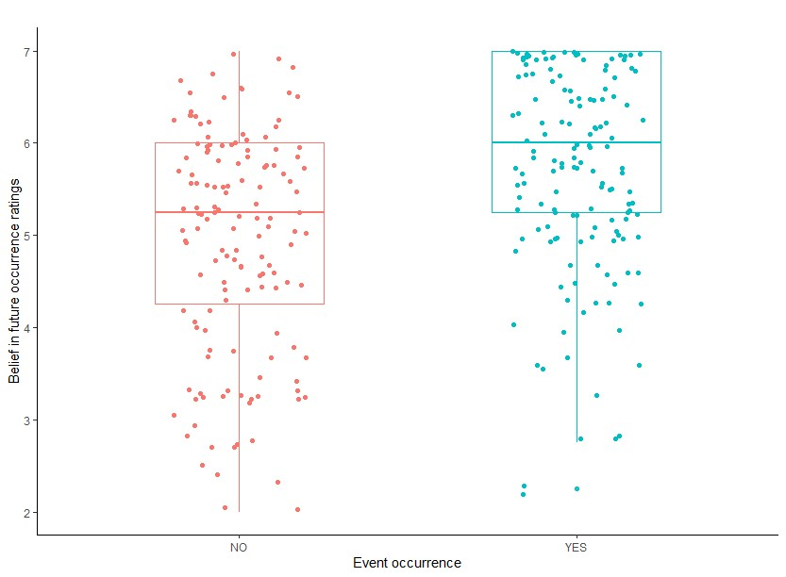
First, we examined the influence of goal self-concordance on belief in future occurrence. Consistent with previous research (Ernst et al., 2018), future events deriving from self-concordant goals were associated with higher belief in future occurrence (b = 0.29, SE = 0.13, t = 2.31, p = .022). The influence of goal self-concordance on event characteristics also replicated the main findings of Ernst et al. (2018): future events associated with self-concordant goals benefitted from better integration with autobiographical knowledge, a greater subjective quality of mental imagery, and were associated with more positive emotions and need satisfaction than events derived from non-self-concordant goals (see Supplemental Materials).
We then tested the predictive validity of belief in future occurrence. As expected, the multilevel logistic regression analysis showed that belief predicted the actual occurrence of events (b = 0.62, SD = 0.12, z = 4.96, p < .001); the odds of occurrence were 1.85 times higher with an increase of 1 unit on the belief scale. The actual event occurrence did not significantly differ between events related to self-concordant and non-self-concordant goals (respectively 53% and 52% of occurrence, OR = 1.06; b = 0.06, SE = 0.28, z = -0.44, p = .778).
Taken together, these results are in favor of an indirect effect of goal self-concordance on actual event occurrence, as mediated by belief in future occurrence. We then sought to investigate the magnitude of this effect using the Monte Carlo Method for Assessing Mediation (MacKinnon et al., 2004; Preacher & Selig, 2008, 2012). To do so, we ran a multilevel logistic regression with belief in future occurrence and goal self-concordance as predictors and actual event occurrence as outcome to obtain the parameters estimate of the effect of belief on actual event occurrence, when goal self-concordance is also a predictor. In this model, belief in future occurrence predicted actual event occurrence (b = 0.62, SE = 0.13, z = 4.97, p <.001), whereas the effect of goal self-concordance was not statistically significant (b = -0.10, SE = 0.24, z = -0.44, p = .664). Figure 2A shows a graphic representation of the indirect effect components a and b, and the total and direct effects c and c’. The Monte Carlo analysis revealed that the indirect effect of goal self-concordance on the actual occurrence of future events through belief in future occurrence was significant (Med = 0.18, 95% CI [0.03, 0.37]), based on 20,000 simulations (see Figure 2B). Events deriving from self-concordant goals benefited from a higher belief in future occurrence, which increased their odds of occurrence.

Figure 2
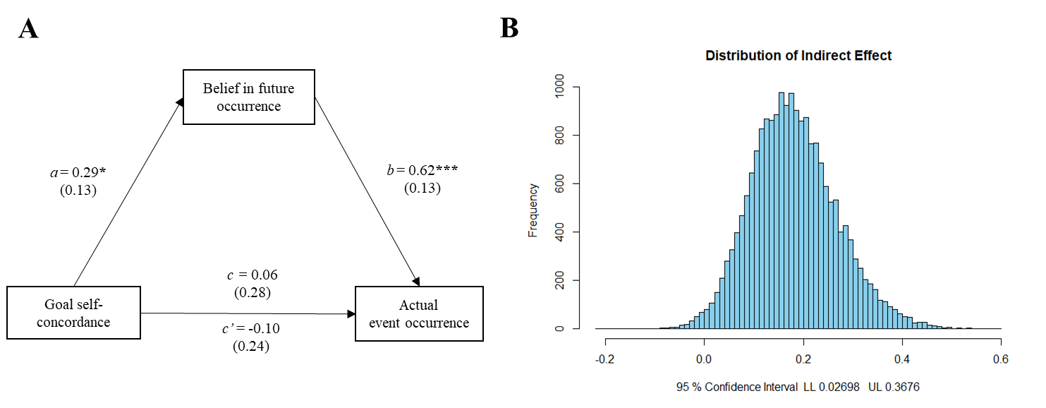
The Mediating Role of Belief in Future Occurrence in the Relationship Between Goal Self-Concordance and the Actual Occurrence of Goal-Related Events
Note. (A) Representation of the indirect effect components a and b, and the total and direct effects c and c’. (B) Distribution of the indirect effect of goal self-concordance on actual event occurrence via belief in future occurrence. Asterisks indicate statistically significant regression coefficients (*p <.05, ***p <.001).

2.3 Discussion
The results of Experiment 1 replicate previous findings showing that events derived from self-concordant goals are associated with a higher belief in their future occurrence (Ernst et al., 2018), and that varying degrees of belief in future occurrence across imagined events are sensitive to the actual occurrence of these events (D’Argembeau & Garcia Jimenez, 2020). Most importantly, this experiment offers preliminary evidence that the qualities of personal goals have an indirect effect on the actual occurrence of goal-related events through the mediating role of belief in future occurrence. Specifically, goal self-concordance increased the belief that associated events will actually happen in the future, which in turn predicted the odds of event occurrence.

3. Experiment 2
Experiment 1 provided initial evidence that belief in future occurrence is modulated by the characteristics of personal goals. However, this study was limited to a single binary dimension of goals (i.e., self-concordance). In Experiment 2, we aimed to further specify how personal goals shape belief in the future occurrence of related events, and ultimately predict the actual event occurrence, using a more exhaustive measurement of goal characteristics. Thus, we sought to capture a broad range of goal qualities that have been recognized as influential in goal pursuit (e.g., progress, importance, expectancy of success, and commitment; Emmons, 1986; Klinger, 2013; Little, 1983). This allowed us to determine which characteristics of personal goals shape belief in the future occurrence of associated events, and indirectly predict their actual occurrence through the mediating role of belief in future occurrence.

3.1 Methods
3.1.1 Participants
Thirty-five participants were recruited (17 women and 18 men, aged between 18 and 35 years; M = 22.63, SD = 4.19). An a priori power analysis for linear multilevel regression models (predicting belief in future occurrence) using SIMR (Green & MacLeod, 2016) indicated that this sample size (with 10 events per participant) provided a statistical power of 90% to detect an effect size b = 0.2 for fixed effects (values for random effects were estimated using data from Ernst et al., 2018). The experiment was approved by the Ethics Committee of the Faculty of Psychology at the University of Liège, and all participants gave written informed consent.
3.1.2 Materials and Procedure
Materials and procedures were similar to Experiment 1, except for the selection and assessment of personal goals. Participants were asked to select ten personal goals, using the same definition as in Experiment 1: personal projects that they strive to achieve, frequently think about and make plans for. In Experiment 2, we were interested in natural variations in the different dimensions of goals, so participants were not asked to select their goals based on self-concordance as was the case in Experiment 1. After selecting ten goals, participants were asked to rate them on several dimensions using a matrix questionnaire where goals were displayed on the first column and dimensions on the first row (Little, 1983). The following goal dimensions were assessed using scales from 0 (not at all) to 10 (very much): goal importance, alignment with personal values, representativeness to one’s identity, difficulty of pursuit, control on the pursuit and achievement, likelihood of success, perceived competence to achieve the goal (adapted from Little, 1983; Little & Chambers, 2001), commitment to achieve the goal, deployment of effort in the pursuit, and clarity of the necessary steps and actions to reach the goal (adapted from Emmons, 1986). Finally, participants were asked at which stage of progress the goal was, on a timeline from 0 = “I just came up with the idea for this goal” to 10 = “The pursuit of this goal is nearing completion or has just been completed” (Little, 1983).
After evaluating the ten goals, participants were asked to select and imagine a future event related to each goal that would occur in the next month. After imagining each event, event characteristics were assessed using the same rating scales as in Experiment 1, with two exceptions: there was no evaluation of psychological need satisfaction and two items were added to measure the extent to which the future event was linked to the corresponding personal goal and was important for the pursuit of this goal. Cronbach’s alpha for the four items measuring belief in future occurrence in this sample was 0.90. One month later, participants were contacted by videoconference and were asked if each event had occurred or not. The instructions and materials that were used in this experiment are openly available in OSF at https://osf.io/xe7ra/.
3.1.3 Statistical analyses
First, we examined whether the 11 goal dimensions measured in this study could be reduced in goal indices for further analysis. To do so, ratings for the 350 goals provided by participants were submitted to a Multilevel Exploratory Factor Analysis (MEFA; Muthén, 1994; Reise et al., 2005) computed with Mplus 6.11 (Muthén & Muthén, 1998-2010). This analysis provides the factor structure of the data at the within and between individual levels. The maximum likelihood EFA performed on the within correlations matrix revealed three factors with eigenvalues above one (respectively, 3.90, 2.19, 1.13), explaining 65.62% of the variance between goals, within participants. Intraclass correlations indicated that most variance in goal dimensions (from 77 to 99%) was due to differences between goals within participants rather than differences between participants. Thus, results from the within participants EFA were chosen to determine goal indices. Results for the complete MEFA can be found in the Supplemental Materials. The first index is composed of importance, commitment, effort, and progress status (Cronbach’s alpha = 0.82) – it will be referred to as the engagement index. Difficulty, clarity of the steps, competence, expected likelihood of success, and control constitute the expectancy index (Cronbach’s alpha = 0.73). The third index includes the scores for goal alignment with values and identity (Spearman-Brown’s coefficient = 0.81).
Next, we examined whether these goal dimensions predicted belief in the future occurrence of associated events using a series of linear multilevel regression models (two-level random effects models, with events as level 1 units and participants as level 2 units; Hox, 2010), with belief in future occurrence as outcome and each goal index as predictor. Significant predictors of belief were then included in a single linear multilevel regression model to test their unique contribution to the prediction of belief in future occurrence. Then, to investigate the extent to which belief in future occurrence predicted the actual occurrence of goal-related events, we fitted a multilevel logistic regression model with actual occurrence as outcome and belief in occurrence as predictor. To assess the effect of goal dimensions on the actual occurrence of events, we fitted multilevel logistic regression models with actual event occurrence as outcome and goal indices as predictors.
The obtained results supported a mediation of the effect of goal dimensions on actual event occurrence via belief in future occurrence, thus we proceeded on to investigate these indirect effects. As in Experiment 1, indirect effects were calculated using a Monte Carlo analysis (MacKinnon et al., 2004; Preacher & Selig, 2008, 2012). Parameter estimates, asymptotic variances and covariance of the effects of goal dimensions on belief and the effects of belief on actual event occurrence when goal dimensions are inserted as predictors were used to compute the 95% confidence interval of the true indirect effect value through a resampling method using 20,000 simulations.
Continuous predictors were centered on each subject’s mean (cluster-mean centering) to obtain an unbiased estimate of the within-subject association between the predictor and the outcome (Brauer & Curtin, 2018). Multilevel regressions were conducted in R using the lme4 package (Bates et al., 2015) and parameters were tested for significance with the lmerTest package (Kuznetsova et al., 2017). The full random structure (i.e., by-subject random intercepts and random slopes) was included in the models; when the model failed to converge or led to a singular fit, the random slopes were removed (Matuschek et al., 2017). All data and analysis code are available in OSF at https://osf.io/xe7ra/.

3.2 Results
All 350 future events imagined by the participants were included in the analyses. In total, 54% of the imagined events actually occurred. The distribution of belief in occurrence ratings for each imagined future event sorted by occurrence status is presented in Figure 3.
Figure 3
Belief in Future Occurrence Ratings by Occurrence Status in Study 2
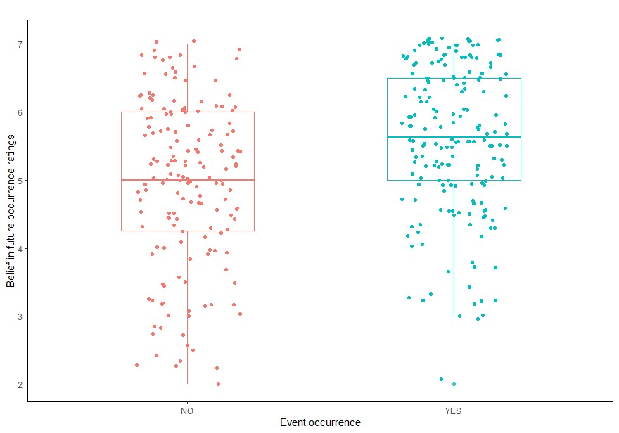

The main goal of this study was to test the hypothesis that goal dimensions shape belief in the future occurrence of related events, which in turn predict their actual occurrence. To test this hypothesis, we first examined the relations between each of the identified goal indices and belief in the future occurrence of associated events. Multilevel linear regressions showed that belief in future occurrence was related to goal engagement (b = 0.20, SE = 0.03, z = 6.32, p <.001), expectancy (b = 0.16, SE = 0.04, z = 4.44, p <. 001), and value-identity (b = 0.12, SE = 0.03, z = 4.35, p <.001). When the three goal indices were simultaneously included as predictors of belief in future occurrence in the model, engagement (b = 0.15, SE = 0.04, z = 4.03, p = <.001) and expectancy (b = 0.11, SE = 0.04, z = 3.02, p = .003) uniquely contributed to belief, whereas the value-identity index was not statistically significant (b = 0.05, SE = 0.03, z = 1.47, p = .144).
Next, a multilevel logistic regression with event occurrence as outcome and belief as predictor tested whether belief in future occurrence predicted the actual occurrence of events. Belief in future occurrence indeed predicted the actual occurrence of events (b = 0.49, SE = 0.11, z = 4.33, p < .001), such that an increase of 1 on the belief scale increased the odds of occurrence by 1.63. The effect of goal dimensions on the actual event occurrence was also assessed with multilevel logistic regressions. The odds of event occurrence significantly increased with goal engagement (OR = 1.24, b = 0.21, SE = 0.06, z = 3.32, p <.001) and expectancy (OR = 1.22, b = 0.20, SE = 0.07, z = 2.80, p = .005). The value-identity index did not significantly predict the actual event occurrence (OR = 1.03, b = 0.03, SE = 0.05, z = 0.50, p = .615). A multilevel logistic regression model with goal engagement and expectancy as predictors and actual event occurrence as outcome indicated that both indices contributed uniquely to the prediction of event occurrence (engagement: OR = 1.20, b = 0.18, SE = 0.07, z = 2.74, p = .006; expectancy: OR = 1.16, b = 0.15, SE = 0.07, z = 2.06, p = .040).
Together, these results suggest the presence of an indirect effect of goal dimensions on the actual event occurrence, via belief in future occurrence. The indirect effects of goal engagement and goal expectancy on the actual event occurrence were each measured using the MCMA. For the mediation model including goal engagement, we ran a multilevel logistic regression with belief in future occurrence and goal engagement as predictors and the actual event occurrence as outcome to obtain the parameter estimates of the effect of belief on the actual event occurrence, when goal engagement was taken into account. In this model, both belief in future occurrence (OR = 1.52, b = 0.42, SE = 0.12, z = 3.53, p <.001), and goal engagement (OR = 1.15, b = 0.14, SE = 0.07, z = 2.06, p = .040) predicted the actual event occurrence. Figure 4A shows a graphic representation of the indirect effect components a and b, and the total and direct effects c and c’. The Monte Carlo analysis revealed that the indirect effect of goal engagement on the actual event occurrence through belief in future occurrence was significant (Med = 0.08, 95% CI [0.03, 0.14]), based on 20,000 simulations (see Figure 4B). Belief in future occurrence partially mediated the relationship between goal engagement and the actual event occurrence: events related to goals with higher engagement benefited from an increased belief in future occurrence, which ultimately increased the odds of event occurrence.

Figure 4
The Mediating Role of Belief in Future Occurrence in the Relationship Between Goal Qualities and the Actual Occurrence of Goal-Related Events
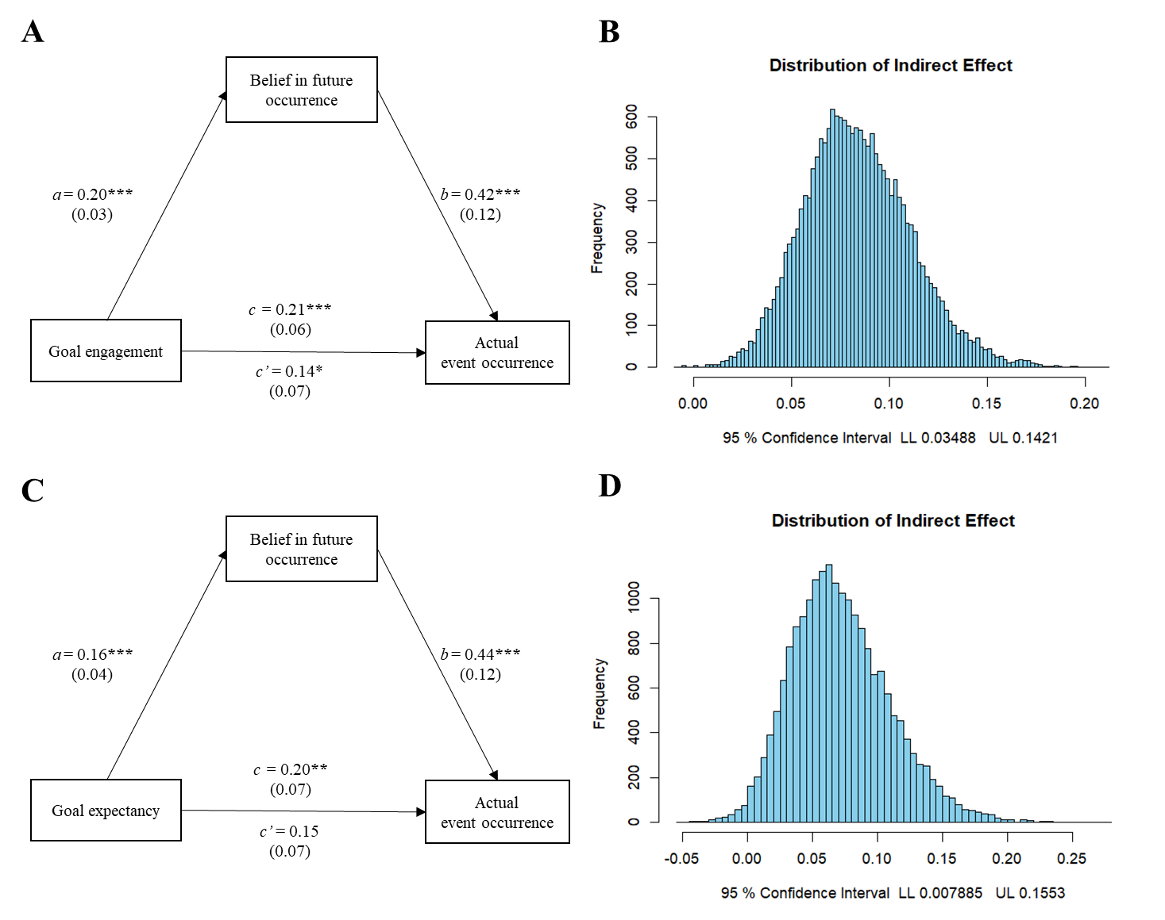
Note. (A, C) Representation of the indirect effect components a and b, and the total and direct effects c and c’. (B, D) Distribution of the indirect effect of goal engagement and expectancy on actual event occurrence via belief in future occurrence. Asterisks indicate statistically significant regression coefficients (*p <.05, **p <.01, ***p <.001).
Next, we tested the mediation model including goal expectancy. Following the same steps as the previous analysis, we ran a multilevel logistic regression with belief in future occurrence and goal expectancy as predictors and actual event occurrence as outcome to obtain the parameter estimate of the effect of belief on actual event occurrence, when goal expectancy was taken into account. In this model, belief in future occurrence predicted the actual event occurrence (OR = 1.56, b = 0.44, SE = 0.12, z = 3.85, p <.001), whereas the effect of goal expectancy was no longer significant (OR = 1.15, b = 0.14, SE = 0.07, z = 1.95, p = .060). Figure 4C shows a graphic representation of the indirect effect components a and b, and the total and direct effects c and c’. The indirect effect of goal expectancy on the actual occurrence of future events through belief in future occurrence was significant (Med = 0.087 95% CI [0.01, 0.16]), according to the Monte Carlo analysis, using 20,000 simulations (see Figure 4D). Belief in future occurrence partially mediated the relationship between goal expectancy and actual event occurrence: events related to goals with higher expectancy benefited from an increased belief in future occurrence, which ultimately increased the odds of occurrence of these events.

3.3 Discussion
Findings from Experiment 2 provide additional evidence that belief in the future occurrence of imagined events is influenced by personal goal characteristics and that this belief mediates the relationship between goal characteristics and the actual occurrence of goal-related events. Specifically, goal engagement and expectancy indirectly predicted the actual occurrence of goal-related future events through their influence on belief in future occurrence.

4. General discussion
While important progress has recently been made in understanding the interplay between personal goals and episodic future thoughts, the cognitive mechanisms by which future thinking may contribute to adaptive goal pursuit are not fully understood. Here, we tested the hypothesis that personal goals influence episodic future thinking to promote goal pursuit by shaping levels of belief in the future occurrence of goal-related events. By assessing various characteristics of personal goals and measuring their influence on belief in future occurrence and on the actual occurrence of events associated with these goals, we found that goal self-concordance (Experiment 1), engagement, and expectancy (Experiment 2) had an indirect effect on the actual occurrence of events, which was (partially) mediated by belief in future occurrence.
Our study extends previous research (Cole & Berntsen, 2016; D’Argembeau & Mathy, 2011; Lehner & D’Argembeau, 2016) by demonstrating that the characteristics of episodic future thoughts, including belief in future occurrence, are not only influenced by the presence or strength of the association between imagined future events and personal goals, but also by qualities of personal goals. In a first experiment, we found that the self-concordant quality of the motivation underlying goal pursuit was reflected in the subjective experience of imagined events: events derived from self-concordant goals were associated with higher belief in future occurrence than events derived from non-self-concordant goals. Capturing a broader range of goal qualities that have been identified as influential in goal pursuit (Emmons, 1986; Little, 1983; Milyavskaya & Werner, 2018), the second experiment showed that goal engagement (i.e., an index composed of goal importance, commitment, effort, and progress status) and goal expectancy (i.e., an index composed of expected likelihood of success, competence, difficulty, clarity of the steps, and control) both uniquely predicted levels of belief in the future occurrence of associated events. Taken together, these results shed new light on the relationship between personal goals and episodic future thinking by showing that the varying qualities of higher-order goals that play a crucial role in their pursuit are reflected in mental representations of specific goal-related future events.
Goals are structured hierarchically, with higher-order (abstract) goal representations shaping the content of lower-order (concrete) goals and plans (Austin & Vancouver, 1996). Translating higher-order goals into actionable steps is crucial for guiding goal-directed behavior (Gollwitzer, 1999). In this context, episodic future thinking enables the mental simulation of specific events, such as means, outcomes, and obstacles, that are related to higher-order personal goals (D’Argembeau, 2016). These episodic simulations allow individuals to mentally engage in concrete situations that could facilitate or hinder goal pursuit, and to envision ways of navigating these scenarios toward goal achievement (Oettingen, 2000; Taylor et al., 1998). A valuable theoretical perspective for understanding the transfer of goal-related information from higher-order cognitive representations of desired outcomes to concrete representations of specific events can be found in goal-systems theory (Kruglanski et al., 2002). One of its principles is that the strength of the cognitive association between goals and means (i.e., activities that one believes could help attain the goal) serves as the foundation for the transfer of motivational properties from higher-order goals to the concrete means to attain them. In line with our results, research investigating this principle indicates that the level of commitment and the quantity and quality of affect associated with goals can be transferred from goals to means (Fishbach et al., 2004). An important contribution of our study is to show that goal qualities affect the subjective experience associated with mental simulations of specific events, notably belief in future occurrence.
While episodic future thinking allows us to imagine and prepare for a multitude of possibilities, it is essential to have a sense of which imagined scenarios will likely transpire in order to set up adaptive actions (Roese & Sherman, 2007). Belief in future occurrence may be understood as a cognitive feeling imbuing imagined future scenarios with a sense of personal “truth” that reflects the state of our knowledge and expectations (Schwarz, 2012). This feeling may then be used as a source of information (Clore & Parrott, 1994), in a similar way as affective feelings, to orient our judgments and actions. Here, we replicated the finding that belief in future occurrence is indeed sensitive to actual event occurrence (D’Argembeau & Garcia Jimenez, 2020). Furthermore, we found that the effect of goal qualities on the actual occurrence of associated events was mediated by belief in their future occurrence. These results are consistent with our hypothesis that levels of belief in occurrence when envisioning future events contribute significantly to goal pursuit. The mediating role of belief in future occurrence between personal goals and the actual occurrence of goal-related events lends support to the notion that belief in future occurrence conveys useful information, allowing us to make informed decisions and undertake adaptive actions in the process of goal pursuit (Ernst & D’Argembeau, 2017).
In everyday life, episodic future thinking can help manage complex situations involving conflicting demands, or the pursuit of a goal requiring multiple sequences of action, deliberation, and alternative plans (Kvavilashvili & Rummel, 2020). Thus, deficits in episodic future thinking have been identified as potential contributors to maladaptive behaviors and emotions that characterize mental health disorders (Brunette & Schacter, 2021; Hallford et al., 2018). Understanding the cognitive mechanisms that make episodic future thinking (mal)adaptive has potential implications for the theoretical comprehension of these difficulties, as well as for the development of interventions that attempt to mitigate them. In this context, the present results suggest that it is important to ensure that the events imagined during clinical interventions are genuinely considered by participants as possible future occurrences. For instance, Kinley et al. (2022) suggested that an intervention aimed at increasing belief in future occurrence for goal-directed rewards may encourage the belief that long-term goals are achievable in people suffering from addiction. Our results suggest that belief is shaped by the mental representation of these long-term goals and that this information may be used to predict what will actually happen in the future. If one does not believe that a goal is achievable, imagining an event in which one attains that goal may not be useful – this event would not be conceived as a possible future occurrence. Interventions aimed at increasing belief in the event occurrence (such as repeated simulation) may be useful, but only if the event is consistent with our autobiographical knowledge (Garcia Jimenez et al., 2023). A possible approach to increasing belief in future occurrence would be to draw attention to autobiographical elements that are consistent with the achievement of the goal.
Since our primary focus in this study was to investigate the pragmatic function of episodic future thinking, participants were asked to mentally simulate events before associated degrees of belief in occurrence were measured. The influence of episodic simulation on belief in future occurrence is highlighted by results showing the quality of mental imagery and the ease of imagining events predict degrees of belief (D’Argembeau & Garcia Jimenez, 2020; Ernst et al., 2019; see also Supplemental Materials). However, this does not exclude the possibility that belief in the occurrence of future events may affect decisions and actions even in the absence of episodic simulations. For instance, the theory of planned behavior considers behavioral beliefs (i.e., accessible beliefs and expectancies regarding a behavior's likely consequences) as an important factor of behavior change (Ajzen & Kruglanski, 2019), without considering the role of episodic simulations. Therefore, the question of whether the predictive validity of belief in future occurrence differs according to whether or not people engage in episodic simulation remains open.
Beyond belief in future occurrence, episodic future thoughts are characterized by other cognitive and affective feelings such as autonoetic experience, belief in accuracy, ease of imagination, anticipatory and anticipated pleasure (e.g., Ernst & D’Argembeau, 2017; Hallford et al., 2022; Lehner & D’Argembeau, 2016) – all being sources of information that could be used to promote goal pursuit. Our results showed that goal engagement had a positive effect on the odds of occurrence of events that persisted when the mediating role of belief was accounted for. This suggests that besides belief in future occurrence, other cognitive and affective dimensions of episodic future thoughts may also be affected by goals and, in turn, influence goal attainment. Of particular interest, recent studies demonstrated that engaging in vivid imagery of future activities can enhance engagement in those activities, anticipatory pleasure, motivation, behavioral intention, and activation (Hallford et al., 2020; Renner et al., 2017, 2019). It has also been shown that ease of imagination and the clarity of representations are significant predictors of belief in future occurrence (D’Argembeau & Garcia Jimenez, 2020; Ernst & D’Argembeau, 2017; Scoboria et al., 2020), and may modulate its increase over repeated simulation (Garcia Jimenez et al., 2023). Investigating how the phenomenological characteristics of imagined future events and their associated cognitive and affective feelings interact in the course of goal pursuit represents a fruitful avenue of research.
In conclusion, the present research suggests that personal goals influence episodic future thinking to promote goal pursuit through goal qualities shaping levels of belief in the future occurrence of goal-related events. Imagined future events feel more ‘real’ when the goals they are associated with are characterized by higher degrees of engagement, expectancy, and self-concordance. This subjective experience of truth accompanying envisioned future events is in turn sensitive to the actual occurrence of the events. The transfer of goal qualities from higher-order representations of desired outcomes to concrete representations of future events may help to set adaptive plans and actions accordingly. As a whole, this study also adds to a growing body of research showing that for an event represented in our minds to be perceived as a personal future occurrence, it has to be meaningfully connected with personal goals and general expectations about one’s life (D’Argembeau, 2016, 2020).

Acknowledgments
Arnaud D'Argembeau is a Research Director of the Fonds de la Recherche Scientifique - FNRS, Belgium. We thank Marine Saint-Mard for her help with data collection.
Funding
This research did not receive any specific grant from funding agencies in the public, commercial, or not-for-profit sectors.
Author contributions (CRediT)
Claudia Garcia Jimenez: Conceptualization, Methodology, Formal analysis, Investigation, Data curation, Visualization, Writing – original draft, Writing - review & editing.

Arnaud D’Argembeau: Conceptualization, Methodology, Writing - review & editing.

References
Ajzen, I., & Kruglanski, A. W. (2019). Reasoned action in the service of goal pursuit. Psychological Review, 126(5), 774‑786. https://doi.org/10.1037/rev0000155
Amlung, M., Marsden, E., Holshausen, K., Morris, V., Patel, H., Vedelago, L., Naish, K. R., Reed, D. D., & McCabe, R. E. (2019). Delay Discounting as a Transdiagnostic Process in Psychiatric Disorders : A Meta-analysis. JAMA Psychiatry, 76(11), 1176‑1186. https://doi.org/10.1001/jamapsychiatry.2019.2102
Atance, C. M., & O’Neill, D. K. (2001). Episodic future thinking. Trends in Cognitive Sciences, 5(12), 533‑539. https://doi.org/10.1016/S1364-6613(00)01804-0
Austin, J. T., & Vancouver, J. B. (1996). Goal constructs in psychology : Structure, process, and content. Psychological Bulletin, 120(3), 338‑375. https://doi.org/10.1037/0033-2909.120.3.338
Bandura, A. (1997). Self-efficacy : The exercise of control. Self-efficacy: The exercise of control., ix, 604‑ix, 604.
Bates, D., Mächler, M., Bolker, B., & Walker, S. (2015). Fitting Linear Mixed-Effects Models Using lme4. Journal of Statistical Software, 67(1). https://doi.org/10.18637/jss.v067.i01
Baumeister, R. F., Maranges, H. M., & Sjåstad, H. (2018). Consciousness of the future as a matrix of maybe : Pragmatic prospection and the simulation of alternative possibilities. Psychology of Consciousness: Theory, Research, and Practice, 5(3), 223‑238. https://doi.org/10.1037/cns0000154
Baumeister, R. F., Vohs, K. D., & Oettingen, G. (2016). Pragmatic Prospection : How and Why People Think about the Future. Review of General Psychology, 20(1), 3‑16. https://doi.org/10.1037/gpr0000060
Ben Malek, H., Berna, F., & D’Argembeau, A. (2018). Envisioning the times of future events : The role of personal goals. Consciousness and Cognition, 63, 198‑205. https://doi.org/10.1016/j.concog.2018.05.008
Bouizegarene, N., & Philippe, F. L. (2016). Episodic memories as building blocks of identity processing styles and life domains satisfaction : Examining need satisfaction and need for cognitive closure in memories. Memory, 24(5), 616‑628. https://doi.org/10.1080/09658211.2015.1034138
Brauer, M., & Curtin, J. J. (2018). Linear mixed-effects models and the analysis of nonindependent data : A unified framework to analyze categorical and continuous independent variables that vary within-subjects and/or within-items. Psychological Methods, 23(3), 389‑411. https://doi.org/10.1037/met0000159
Brunette, A. M., & Schacter, D. L. (2021). Cognitive mechanisms of episodic simulation in psychiatric populations. Behaviour Research and Therapy, 136, 103778. https://doi.org/10.1016/j.brat.2020.103778
Bulley, A., Henry, J., & Suddendorf, T. (2016). Prospection and the Present Moment : The Role of Episodic Foresight in Intertemporal Choices between Immediate and Delayed Rewards. Review of General Psychology, 20(1), 29‑47. https://doi.org/10.1037/gpr0000061
Bulley, A., & Irish, M. (2018). The Functions of Prospection – Variations in Health and Disease. Frontiers in Psychology, 9, 2328. https://doi.org/10.3389/fpsyg.2018.02328
Chartrand, T. L., & Bargh, J. A. (2002). Nonconscious motivations : Their activation, operation, and consequences. Self and motivation: Emerging psychological perspectives., 13‑41. https://doi.org/10.1037/10448-001
Clore, G. L., & Parrott, W. G. (1994). Cognitive feelings and metacognitive judgments. European Journal of Social Psychology, 24(1), 101‑115. https://doi.org/10.1002/ejsp.2420240108
Cole, S. N., & Berntsen, D. (2016). Do future thoughts reflect personal goals? Current concerns and mental time travel into the past and future. Quarterly Journal of Experimental Psychology, 69(2), 273‑284. https://doi.org/10.1080/17470218.2015.1044542
Conway, M. A., Justice, L. V., & D’Argembeau, A. (2019). The self-memory system revisited : Past, present, and future. In The organization and structure of autobiographical memory. (p. 28‑51). Oxford University Press. https://doi.org/10.1093/oso/9780198784845.003.0003
D’Argembeau, A. (2016). The role of personal goals in future-oriented mental time travel. In Seeing the future : Theoretical perspectives on future-oriented mental time travel. (p. 199‑214). Oxford University Press. https://doi.org/10.1093/acprof:oso/9780190241537.003.0010
D’Argembeau, A. (2020). Zooming In and Out on One’s Life : Autobiographical Representations at Multiple Time Scales. Journal of Cognitive Neuroscience, 32(11), 2037‑2055. https://doi.org/10.1162/jocn_a_01556
D’Argembeau, A., & Demblon, J. (2012). On the representational systems underlying prospection : Evidence from the event-cueing paradigm. Cognition, 125(2), 160‑167. https://doi.org/10.1016/j.cognition.2012.07.008
D’Argembeau, A., & Garcia Jimenez, C. (2020). The predictive validity of belief in future occurrence. Applied Cognitive Psychology, 34(6), 1265‑1276. https://doi.org/10.1002/acp.3708
D’Argembeau, A., & Mathy, A. (2011). Tracking the construction of episodic future thoughts. Journal of Experimental Psychology: General, 140(2), 258‑271. https://doi.org/10.1037/a0022581
D’Argembeau, A., Renaud, O., & Van der Linden, M. (2011). Frequency, characteristics and functions of future-oriented thoughts in daily life. Applied Cognitive Psychology, 25(1), 96‑103. https://doi.org/10.1002/acp.1647
Demblon, J., & D’Argembeau, A. (2014). The organization of prospective thinking : Evidence of event clusters in freely generated future thoughts. Consciousness and Cognition, 24, 75‑83. https://doi.org/10.1016/j.concog.2014.01.002
Dweck, C. S. (2017). From needs to goals and representations : Foundations for a unified theory of motivation, personality, and development. Psychological Review, 124(6), 689‑719. https://doi.org/10.1037/rev0000082
Emmons, R. A. (1986). Personal Strivings : An Approach to Personality and Subjective Weil-Being. Journal of Personality and Social Psychology, 51(5), 1058‑1068.
Ernst, A., & D’Argembeau, A. (2017). Make it real : Belief in occurrence within episodic future thought. Memory & Cognition, 45(6), 1045‑1061. https://doi.org/10.3758/s13421-017-0714-3
Ernst, A., Philippe, F. L., & D’Argembeau, A. (2018). Wanting or having to : The role of goal self-concordance in episodic future thinking. Consciousness and Cognition, 66, 26‑39. https://doi.org/10.1016/j.concog.2018.10.004
Ernst, A., Scoboria, A., & D’Argembeau, A. (2019). On the role of autobiographical knowledge in shaping belief in the future occurrence of imagined events. Quarterly Journal of Experimental Psychology, 72(11), 2658‑2671. https://doi.org/10.1177/1747021819855621
Ferguson, M. J., & Porter, S. C. (2010). What is implicit about goal pursuit? Handbook of implicit social cognition: Measurement, theory, and applications., 311‑331.
Fishbach, A., Shah, J. Y., & Kruglanski, A. W. (2004). Emotional transfer in goal systems. Journal of Experimental Social Psychology, 40(6), 723‑738. https://doi.org/10.1016/j.jesp.2004.04.001
Gamble, B., Tippett, L. J., Moreau, D., & Addis, D. R. (2021). The Futures We Want : How Goal-Directed Imagination Relates to Mental Health. Clinical Psychological Science, 9(4), 732‑751. https://doi.org/10.1177/2167702620986096
Garcia Jimenez, C., Mazzoni, G., & D’Argembeau, A. (2023). Repeated simulation increases belief in the future occurrence of uncertain events. Memory & Cognition, 51, 1593‑1606. https://doi.org/10.3758/s13421-023-01414-6
Gollwitzer, P. M. (1990). Action phases and mind-sets. Handbook of motivation and cognition: Foundations of social behavior, Vol. 2., 53‑92.
Gollwitzer, P. M. (1999). Implementation Intentions. American Psychologist, 11.
Green, P., & MacLeod, C. J. (2016). SIMR: an R package for power analysis of generalized linear mixed models by simulation. Methods in Ecology and Evolution, 7(4), 493‑498. https://doi.org/10.1111/2041-210X.12504
Hallford, D. J., Austin, D. W., Takano, K., & Raes, F. (2018). Psychopathology and episodic future thinking : A systematic review and meta-analysis of specificity and episodic detail. Behaviour Research and Therapy, 102, 42‑51. https://doi.org/10.1016/j.brat.2018.01.003
Hallford, D. J., Farrell, H., & Lynch, E. (2020). Increasing anticipated and anticipatory pleasure through episodic thinking. Emotion. https://doi.org/10.1037/emo0000765
Hox, J. J. (2010). Multilevel analysis : Techniques and applications, 2nd ed. Multilevel analysis: Techniques and applications, 2nd ed., x, 382‑x, 382.
Kinley, I., Amlung, M., & Becker, S. (2022). Pathologies of precision : A Bayesian account of goals, habits, and episodic foresight in addiction. Brain and Cognition, 158, 105843. https://doi.org/10.1016/j.bandc.2022.105843
Klein, H. J., Wesson, M. J., Hollenbeck, J. R., & Alge, B. J. (1999). Goal commitment and the goal-setting process : Conceptual clarification and empirical synthesis. Journal of Applied Psychology, 84(6), 885‑896. https://doi.org/10.1037/0021-9010.84.6.885
Klinger, E. (2013). Goal Commitments and the content of thoughts and dreams : Basic principles. Frontiers in Psychology, 4. https://doi.org/10.3389/fpsyg.2013.00415
Kruglanski, A. W., Shah, J. Y., Fishbach, A., Friedman, R., Woo Young Chun, & Sleeth-Keppler, D. (2002). A theory of goal systems. In Advances in Experimental Social Psychology (Vol. 34, p. 331‑378). Elsevier. https://doi.org/10.1016/S0065-2601(02)80008-9
Kuznetsova, A., Brockhoff, P. B., & Christensen, R. H. B. (2017). lmerTest Package : Tests in Linear Mixed Effects Models. Journal of Statistical Software, 82(13). https://doi.org/10.18637/jss.v082.i13
Kvavilashvili, L., & Rummel, J. (2020). On the Nature of Everyday Prospection : A Review and Theoretical Integration of Research on Mind-Wandering, Future Thinking, and Prospective Memory. Review of General Psychology, 24(3), 210‑237. https://doi.org/10.1177/1089268020918843
Lehner, E., & D’Argembeau, A. (2016). The role of personal goals in autonoetic experience when imagining future events. Consciousness and Cognition, 42, 267‑276. https://doi.org/10.1016/j.concog.2016.04.002
Little, B. R. (1983). Personal Projects : A Rationale and Method for Investigation. Environment and Behavior, 15(3), 273‑309. https://doi.org/10.1177/0013916583153002
Little, B. R., & Chambers, N. C. (2001). Analyse des projets personnels : Un cadre intégratif pour la psychologie clinique et le counselling. Revue québécoise de psychologie, 21(2), 37.
Locke, E. A., Latham, G. P., & Erez, M. (1988). The determinants of goal commitment. The Academy of Management Review, 13(1), 23‑39. https://doi.org/10.2307/258352
MacKinnon, D. P., Lockwood, C. M., & Williams, J. (2004). Confidence Limits for the Indirect Effect : Distribution of the Product and Resampling Methods. Multivariate Behavioral Research, 39(1), 99‑128. https://doi.org/10.1207/s15327906mbr3901_4
Matuschek, H., Kliegl, R., Vasishth, S., Baayen, H., & Bates, D. (2017). Balancing Type I error and power in linear mixed models. Journal of Memory and Language, 94, 305‑315. https://doi.org/10.1016/j.jml.2017.01.001
Merck, C., Topcu, M. N., & Hirst, W. (2016). Collective mental time travel : Creating a shared future through our shared past. Memory Studies, 9(3), 284‑294. https://doi.org/10.1177/1750698016645236
Milyavskaya, M., Inzlicht, M., Hope, N., & Koestner, R. (2015). Saying “no” to temptation : Want-to motivation improves self-regulation by reducing temptation rather than by increasing self-control. Journal of Personality and Social Psychology, 109(4), 677‑693. https://doi.org/10.1037/pspp0000045
Milyavskaya, M., & Werner, K. M. (2018). Goal pursuit : Current state of affairs and directions for future research. Canadian Psychology/Psychologie Canadienne, 59(2), 163‑175. https://doi.org/10.1037/cap0000147
Milyavskaya, M., & Werner, K. M. (2021). An integrative model of goal pursuit [Preprint]. PsyArXiv. https://doi.org/10.31234/osf.io/qydpv
Muthén, B. O. (1994). Multilevel Covariance Structure Analysis. Sociological Methods & Research, 22(3), 376‑398. https://doi.org/10.1177/0049124194022003006
Muthén, L. K., & Muthén, B. O. (1998). Mplus User’s Guide (Sixth Edition).
Nurmi, J.-E., Salmela-Aro, K., & Aunola, K. (2009). Personal goal appraisals vary across both individuals and goal contents. Personality and Individual Differences, 47(5), 498‑503. https://doi.org/10.1016/j.paid.2009.04.028
Oettingen, G. (2000). Expectancy Effects on Behavior Depend on Self-Regulatory Thought. Social Cognition, 18(2), 101‑129. https://doi.org/10.1521/soco.2000.18.2.101
Philippe, F. L., Koestner, R., Beaulieu-Pelletier, G., & Lecours, S. (2011). The Role of Need Satisfaction as a Distinct and Basic Psychological Component of Autobiographical Memories : A Look at Well-Being: Need Satisfaction and Memories. Journal of Personality, 79(5), 905‑938. https://doi.org/10.1111/j.1467-6494.2010.00710.x
Philippe, F. L., Koestner, R., Beaulieu-Pelletier, G., Lecours, S., & Lekes, N. (2012). The Role of Episodic Memories in Current and Future Well-Being. Personality and Social Psychology Bulletin, 38(4), 505‑519. https://doi.org/10.1177/0146167211429805
Preacher, K. J., & Selig, J. P. (2008). Monte Carlo method for assessing multilevel mediation : An interactive tool for creating confidence intervals for indirect effects in 1-1-1 multilevel models [Computer software] [Logiciel]. Available from http://quantpsy.org/
Preacher, K. J., & Selig, J. P. (2012). Advantages of Monte Carlo Confidence Intervals for Indirect Effects. Communication Methods and Measures, 6(2), 77‑98. https://doi.org/10.1080/19312458.2012.679848
Reise, S. P., Ventura, J., Nuechterlein, K. H., & Kim, K. H. (2005). An Illustration of Multilevel Factor Analysis. Journal of Personality Assessment, 84(2), 126‑136. https://doi.org/10.1207/s15327752jpa8402_02
Renner, F., Ji, J. L., Pictet, A., Holmes, E. A., & Blackwell, S. E. (2017). Effects of Engaging in Repeated Mental Imagery of Future Positive Events on Behavioural Activation in Individuals with Major Depressive Disorder. Cognitive Therapy and Research, 41(3), 369‑380. https://doi.org/10.1007/s10608-016-9776-y
Renner, F., Murphy, F. C., Ji, J. L., Manly, T., & Holmes, E. A. (2019). Mental imagery as a “motivational amplifier” to promote activities. Behaviour Research and Therapy, 114, 51‑59. https://doi.org/10.1016/j.brat.2019.02.002
Roese, N. J., & Sherman, J. W. (2007). Expectancy. In Social psychology : Handbook of basic principles (A. W. Kruglanski&E. T. Higgins, p. 91‑115). The Guilford Press.
Rösch, S. A., Stramaccia, D. F., & Benoit, R. G. (2022). Promoting Farsighted Decisions via Episodic Future Thinking : A Meta-Analysis. 151(7), 1606‑1635. https://doi.org/doi: 10.1037/xge0001148
Roseman, I. J., Spindel, M. S., & Jose, P. E. (s. d.). Appraisals of Emotion-Eliciting Events : Testing a Theory of Discrete Emotions. 17.
Ryan, R. M., & Deci, E. L. (2000). Self-Determination Theory and the Facilitation of Intrinsic Motivation, Social Development, and Well-Being. American Psychologist, 11.
Ryan, R. M., Sheldon, K. M., Kasser, T., & Deci, E. L. (1996). All goals are not created equal : An organismic perspective on the nature of goals and their regulation. The psychology of action: Linking cognition and motivation to behavior., 7‑26.
Schacter, D. L., & Addis, D. R. (2007). The cognitive neuroscience of constructive memory : Remembering the past and imagining the future. Philosophical Transactions of the Royal Society B: Biological Sciences, 362(1481), 773‑786. https://doi.org/10.1098/rstb.2007.2087
Schacter, D. L., Benoit, R. G., & Szpunar, K. K. (2017). Episodic future thinking : Mechanisms and functions. Current Opinion in Behavioral Sciences, 17, 41‑50. https://doi.org/10.1016/j.cobeha.2017.06.002
Schwarz, N. (2012). Feelings-as-Information Theory. In P. Van Lange, A. Kruglanski, & E. Higgins, Handbook of Theories of Social Psychology : Volume 1 (p. 289‑308). SAGE Publications Ltd. https://doi.org/10.4135/9781446249215.n15
Scoboria, A., Mazzoni, G., Ernst, A., & D’Argembeau, A. (2020). Validating “belief in occurrence” for future autobiographical events. Psychology of Consciousness: Theory, Research, and Practice, 7(1), 4‑29. https://doi.org/10.1037/cns0000193
Sheldon, K. M., & Elliot, A. J. (1999). Goal Striving, Need Satisfaction, and Longitudinal Weil-Being : The Self-Concordance Model. Journal of Personality and Social Psychology, 76(3), 482‑497.
Suddendorf, T., & Corballis, M. C. (2007). The evolution of foresight : What is mental time travel, and is it unique to humans? Behavioral and Brain Sciences, 30(3), 299‑313. https://doi.org/10.1017/S0140525X07001975
Szpunar, K. K. (2010). Episodic Future Thought : An Emerging Concept. Perspectives on Psychological Science, 5(2), 142‑162. https://doi.org/10.1177/1745691610362350
Taylor, S. E., Pham, L. B., Rivkin, I. D., & Armor, D. A. (1998). Harnessing the imagination : Mental simulation, self-regulation, and coping. American Psychologist, 53(4), 429‑439. https://doi.org/10.1037/0003-066X.53.4.429
Wigfield, A., & Eccles, J. S. (2000). Expectancy–Value Theory of Achievement Motivation. Contemporary Educational Psychology, 25(1), 68‑81. https://doi.org/10.1006/ceps.1999.1015

