2 BE or not 2 BE reproducible: The Belgian Reproducibility Network as part of the European Network of Reproducibility Networks

Julia Eberlen¹, Rrita Bajraktari¹, Patrick Onghena², Christophe Phillips³, Roosmarijn Vandenbroucke^{4,5}

¹Université libre de Bruxelles, ²Katholieke Universiteit Leuven, ³Université de Liège, ⁴Universiteit Gent, ⁴Vlaams Instituut voor Biotechnologie

The Belgian Reproducibility Network (BE-RN) was launched in November 2022, with the mission to support reproducibility in all academic disciplines in the Belgian research landscape. It is modelled after existing reproducibility networks such as the UK-RN, the Swiss RN, and the German RN. In those networks, the term reproducibility is used as an umbrella term that includes open science practices, computational reproducibility, replicability, transparency, and accessibility of scientific work. The BE-RN consists of a national steering group and an international advisory board but is based on the grassroots activities of local nodes increasingly active within different Belgian universities. The aim is not only to support researchers striving to improve their own scientific practices, but also to unite already existing initiatives, and ultimately, become a voice in support of reproducibility in contact with universities, funding bodies, academies, and other scientific organisations. The BE-RN thus creates a network of Belgian initiatives while being part of the European and Global Network of Reproducibility Networks.

As the aim of the BE-RN is not to replace existing initiatives, but rather to promote them and help them to reach a larger audience or to be reached by researchers in need of support, we collaborate with existing initiatives such as the Flemish Research Data Network and the Data Ambassadors initiative of the universities of the Brussels – Wallonia Federation. We share upcoming events of different projects and events across our – currently still irregular – newsletter and our website. Ultimately, we would also like to provide a library of resources on our website, enabling researchers and people interested in reproducibility to make use of both national, in-person resources in the form of contacts to local colleagues who can assist directly, e.g., members of a university’s local node, and international online resources such as the FORRT Educational Nexus.

The Belgian Reproducibility Network is currently coordinated by members of four of the Belgian universities, however, they do not represent the universities in an official capacity. Currently active in the steering group are Prof. Patrick Onghena (KU Leuven), Prof. Christophe Phillips (Université de Liège), Prof. Roosmarijn Vandenbroucke (UGent, VIB), Dr. Julia Eberlen (Université libre de Bruxelles ULB) and Rrita Bajraktari (ULB). It is guided by an international advisory board, including members of other Reproducibility Networks to support and accompany the still tentative steps of the BE-RN, but also international experts in topics relating to open science and reproducibility.

Our first local nodes are now launched at the Université de Liège, Gent University, KU Leuven, and the Institute of Tropical Medicine in Antwerp, with an additional local node at ULB currently in planning. Another of our ongoing projects at the ULB is led by students who want to make research more reproducible and open, in their initiative called the Student BE-RN. The students are planning to meet researchers and other students to understand the reality and the specific demand on research in Belgium. With this ‘state of art’, we expect to have a better understanding of the way the Belgian Reproducibility Network can support the next generation of researchers and contribute to improved scientific understanding in the professional population. More precisely, they will question the knowledge about reproducibility and Open science, the place it takes in the cursus of the universities, and the current knowledge of students about these topics. We fully support those students, and we will assist them in identifying researchers and other students to interview.
All members and contributors of the BE-RN are involved as volunteers. While this is a strength, allowing independence and flexibility from institutional regulations, it is also a difficulty, as we have to prioritize our day-to-day work over our involvement in the BE-RN. The result is an initiative that moves forward slowly, but steadily, towards its full role as the Belgian representation within the larger international network of reproducibility networks in Europe and worldwide (Figure 1).

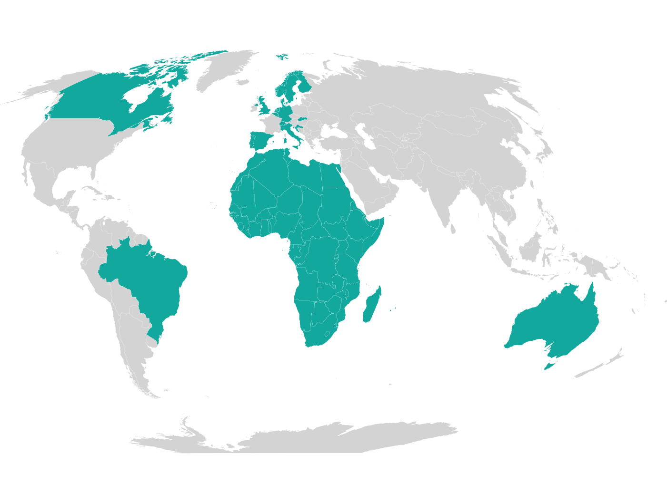
Figure 1: Locations of currently active Reproducibility Networks. Since the creation of this map, France has also launched its own network. Image source: https://www.ukrn.org/global-networks/

