Supplementary Material
A carbonate system time series in the Eastern Mediterranean Sea. Two years of high-frequency in-situ observations and remote sensing
Frangoulis C.*, Stamataki N., Pettas M., Michelinakis S., King A. L., Giannoudi L., Tsiaras K., Christodoulaki S., Seppälä J., Thyssen M., Borges A.V., Krasakopoulou E.
* Correspondence: Frangoulis Constantin : cfrangoulis@hcmr.gr

Supplementary material concerning internal consistency
For the Mediterranean Sea, to our knowledge, there is only one study examining the internal consistency of CO₂ analysis in seawater and its dissociation constants. This study by Alvarez et al. (2014) using three measured variables AT, CT and pH, stressed the need of studies with an additional fourth measurement to confirm the internal consistency of K1 and K2. The present study is the first in the Mediterranean Sea measuring four variables: AT, CT, pH (bottle data) and CO₂ (sensor data), and thus could be used to examine internal consistency. For estimations of pCO₂ (using AT&CT, pH&AT, pH&CT) we tested various CO2SYS program combinations of dissociation constants to identify the K1, K2 option giving lowest ΔCO_{2 obs-est}. This test was abandoned, as it showed high sensitivity (i.e. change in optimum K1, K2 set) when removing a few data. This sensitivity was probably due to the combination of a) the available dataset having all four variables being small (31 values), b) the uncertainty of the CO₂ sensor (9 μatm±14 μatm when operating on a mooring, including uncertainties of the reference gases, Jiang et al., 2014) and c) the fact that some data were not well collocated in time. The latter occurred when the CO₂ sensor was not well operating during the discrete sampling time (of AT&CT&pH), so the data were flagged bad and the closest in time and temperature good value was taken. We also examined which pairs gave better estimates. For estimating pCO_{2,} the pH-AT pair performed better. This was expected as this combines one temperature and pressure independent measurement (CT or AT) with a temperature and pressure dependent measurement (pH or fCO₂) (Woosley, 2021). The pH-AT pair was the most consistent pair, compared to CT-AT and pH-CT, due to the higher precision of AT vs CT measurements (respectively <2 μmol kg⁻¹ and <5 μmol kg⁻¹) and not due to the choice of K1, K2 since this choice affects pCO₂ estimations from AT and CT in the same way.
Jiang, Z., Hydes, D. J., Hartman, S. E., Hartman, M. C., Campbell, J. M., Johnson, B. D., et al. (2014). Application and assessment of a membrane‐based pCO₂ sensor under field and laboratory conditions. Limnol. Oceanogr. Methods12, 264–280. doi: 10.4319/lom.2014.12.264
Woosley, R. J. (2021). Evaluation of the temperature dependence of dissociation constants for the marine carbon system using pH and certified reference materials. Mar. Chem. 229, 103914. doi: 10.1016/j.marchem.2020.103914.

Supplementary Figures

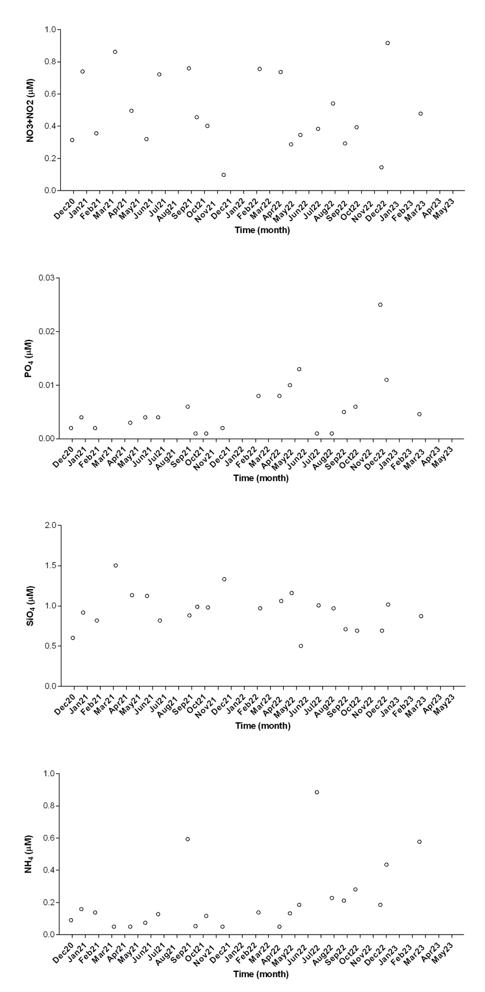
Supplementary Figure 1. Time series of dissolved inorganic nutrients from discrete measurements at HCB.

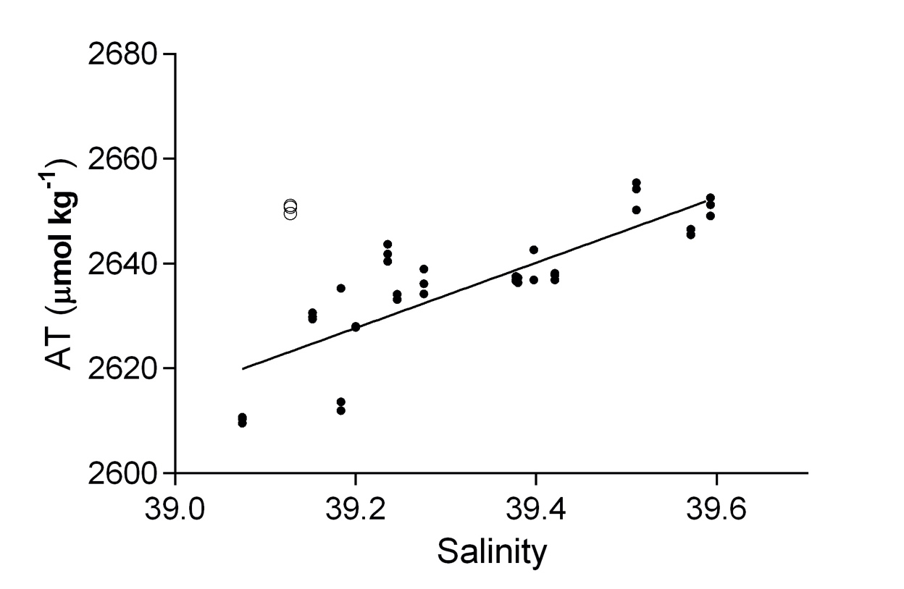
Supplementary Figure 2. Relationship between salinity and AT (equation 5) obtained from discrete measurements at HCB (data from December 2020 shown as white points, were excluded for the relationship).
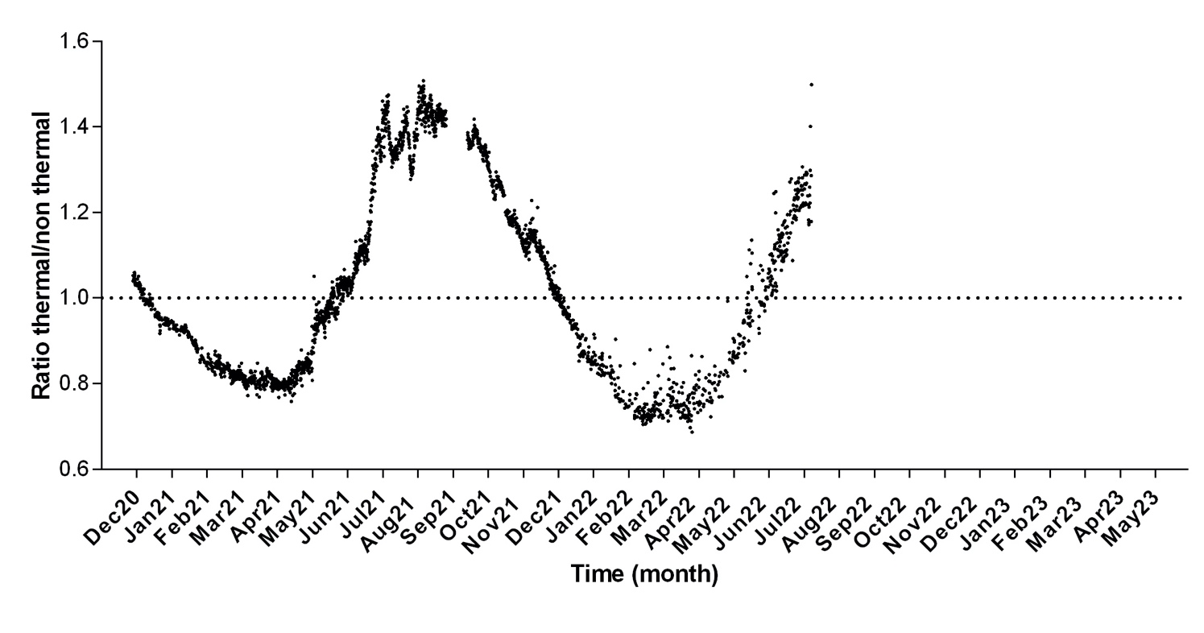
Supplementary Figure 3. Ratio between the thermal and non-thermal of pCO₂ (μatm) calculated respectively from equations 1 and 2 (shown independently on Fig. 6).

