HPLC/ESI-MS Characterization of Phenolic Compounds from Cnicus benedictus L. Roots: A Study of Antioxidant, Antibacterial, Anti-inflammatory, and Anti-Alzheimer's Activity

Khalid Rezigª, FaridBenkaci-Ali^{b}, Marie-Laure Foucaunier^{c}, Sophie Laurent ^{d} , HarunaIsiyakuUmar^{e}, OmoboyowaDamilola Alex ^{f}, Samira Tata ª
ª EcoleNormale Supérieure El Bachir El-Ibrahimi (E.N.S)^{e}Ecology and Animal Laboratory, Department of Biology, BP 92, Kouba-Algiers, Algeria
^{b} University of Sciences and Technology HouariBoumediene (U.S.T.H.B), Laboratory of Functional Organic Analysis, Department of Organic Chemistry, Faculty of Chemistry, El Alia, BP 32,
Bab Ezzouar, 16111 Algiers, Algeria
^{c}University of Liège ^{c} Laboratory of Chemistry of Natural Molecules, Gembloux Agro-Bio Tech, Passage des Déportés 2, B-5030 Gembloux, Belgium
^{d}University of Mons, Unit of General, Organic and Biomedical Chemistry, NMR and Molecular
Imaging Laboratory, 20, Place du Parc, B-7000 Mons, Belgium, sophie.laurent@umons.ac.be
^{e}Department of Biochemistry, Federal University of Technology, Akure, Nigeria
^{f} Biochemical Pharmacology and Computational Biology Unit, Department of Biochemistry,
AdekunleAjasin University, Akungba-Akoko, Ondo State, Nigeria.

Abstract:
The phenolic composition of Cnicus benedictus roots from four Algerian regions was investigated. Extractions were performed in both hydro-methanolic (30:70, v/v) and hydro-ethanolic (30:70, v/v) solvents. Their efficiency was determined in terms of the qualitative and quantitative composition in phenolic compounds by HPLC-LC/MS of the different extracts isolated from C. Benedictus roots. Cnicus benedictus roots extract have been characterized by high content of phenolic compounds, where the trans chalcone, 2,3-dihydro flavone, 3-hydroxy flavone and cinnamic acid constitute the major components, in addition to fourteen minor acidic compounds and flavonoids as rutin. The hydro-methanolic extract was the richest in phenolic compounds yield from C benedictus. On the other hand, hydro methanolic (30:70, v/v) and hydro ethanolic (30:70, v/v) extracts exhibited a high anti-inflammatory activity by in vitro 5-lipoxygenase inhibitory activity (IC₅₀: 6.05 ± 94.16 µg/mL) as well as by in silico docking according two methods. Likewise, anti-Alzheimer activity of extracts was confirmed by this last technique taking into account the major compounds identified. Antibacterial tests revealed interesting results compared to amoxicillin for the different regions studied with a high content in trans chalcone and 3-hydroxy flavone.

Keywords: Cnicus benedictusL; Phytochemical Characterization; biological activities;in silico docking.

Introduction
Cnicus benedictuscommonly known as blessed thistle is a wild medicinal plant belonging to the Asteraceae family. The Asteraceae family is rich in natural antioxidants and is widely used for medicinal purposes, especially in Asia Minor, Eastern Europe and the Mediterranean regions^{[1]}. C. Benedictus L. is native to Turkey, where it is widely distributed, and it can also be found in several other Mediterranean countries, However,it has also been cultivated in variousgeographical areas extending from South Africa to South America ^{[2]}
The Greeks named to it as "Knekos" and It has a long andrich history of traditional medicinal uses;Due to its curative properties, in the middle ages, this plant was given the denominationsCarduus Benedictusand blessed thistle because of its caring effects, others mentioned that the scientific name (Cnicus Benedictus) it came in honor of saint “Benedict " ^{[3]}.
It is an annual plant that grows up to 60 cm tall, with leathery leaves up to 30 cm long and 8 cm wide, with small spines on the edges. The yellow flowers are contained in a capitulum3-4 cm in diameter, surrounded by numerous spiny basal bracts ^{[4]}.
It is known as a traditional indigenous medicine in numerous countries for the use of stomachic and toniceffects^{[5]}, antidepressant ^{[6]}, anti-inflammatory ^{[7]},antipyretic ^{[8]}, antibiotic and antiseptic properties, effective against wounds healing^{[9]}, skin diseases ^{[10]} .
Due to its high levels amount of phenolic compounds and flavonoids, Cnicus benedictus has shown excellent antioxidant activity ^{[2]}.
Polyphenols, the most prevalent and abundant natural antioxidants, are highly valued due to theirgreat interest for their bioactivities, such as neuroprotective, anti-inflammatory, anti-cancer, anti-genotoxic, and antiglycative effects, all of these bioactivities are essentially related to their antioxidant properties ^{[11]}.
In addition, pharmacological studies of crude extracts from this plant have reported neuroprotective and antioxidant activities (neurodegenerative diseases) ^{[6]}, anti-inflammatory ^{[2, 12]}, antioxidant ^{[2]}, cytotoxicity ^{[13]} and anti-tumour^{[14]}. In addition, previous phytochemical investigationsofthis plant revealed the existence of lignans^{[15]}, terpenoidsand steroids ^{[16]} and sesquiterpene lactone ^{[17]}.
The present study was carried out to investigate the composition of polyphenol fraction using HPLC-DAD and HPLC- ESI-MS, as well as the anti-inflammatory (in vitro and in silico), antibacterial and anti-Alzheimer (in silico) activities of therich extracts.
to date, there have been no studies onthe characteristics of polyphenolic-rich extracts ofC. Benedictusin Algeria; therefore, there isno informationavailable onthepolyphenolic compounds of these herbs. Besides,phytochemical screening methods were applied to identify the main chemical compound groups of these species.

Results and discussions
Extraction
Phenolic extracts were isolated from Cnicus benedictus roots from four wild regions (R1: Boumerdès- Ammal, R2: Bouira-Ain El Hdjar , R3: Médéa-Meghraoua and R4: Médéa-Bir Ben Abed) by cold maceration (Table 01). Although the fluctuation in extracted yield values does not appear significant, the highest yield was observed in R4 (4.82%) followed by R3 (4.24 %) , R2 (4.19%), and R1 (3.77%). This variation in yield is probably due to variable parameters such as geographical conditions, such as altitude, climate, and soils (Table 1). Samples from R2, R3 and R4 (sub-humid regions of Bouira and Médéa) showed the highest yields of phenolic extract compared to the humid region R1 (Boumerdès). To date, no experimental data on the yield of C. Benedictus roots extract was published and most work has been carried out on the aerial part of the plant.

Table 1:The yields ofPhenolic compounds extracted by cold maceration from C. benedictus roots
Localities | Area | Yield (%)
R1 (Boumerdès) | Ammal | 3.77
R2 (Bouira) | Ain El Hdjar | 4.19
R3 (Médéa) | Meghraoua | 4.24
R4 (Médéa) | Bir Ben Abed | 4.82

Lipoxygenase Inhibitory Activity (LOX)
In this study, we investigatedthe in vitro anti-inflammatory activity of polyphenols-rich extractsfrom Cnicus benedictus against5-Lipoxygenase (LOX). As shown in figure 1, all extracts inhibited inhibitory effecton LOX activity, consistentwith previousfindings ^{[2]}. The hydro-methanolic extract had the highest inhibitory concentration (IC₅₀) in R1 (6.05 ± 0.10 µg/mL), followed by R4 (16.17 ± 1.23 µg/mL) R2 (17.81 ± 0.61 µg/mL).The lowestIC₅₀ was observed in R3 (40.88 ± 0.046 µg/mL).
However, hydro-ethanolic extract showed loweranti-inflammatory activity than the hydro-methanolic extract, with thehighest activity in R3 (28.44 ± 1.26 µg/mL), followed by R4 (48,18 ± 1,24 µg/mL), R2 (75.10 ± 0.55 µg/mL), and R1 (94.16 ± 0.55 µg/mL).Points of note, all results were compared to the quercetin standard (IC₅₀: 25.95 ± 1.07 µg/mL).[µg/mL]
Significant differences in anti-inflammatory activity wereobserved between the different regions studied. This finding suggests that the phenolic compounds responsible for the beneficial effects of the extracts may vary depending on the geographical origin of the plant material.
Our results also show that the hydro-methanolic and hydro-ethanolic extracts exhibited significant anti-inflammatory activity, in agreement with previous results ^{[18]}, which reported 5-lipoxygenase inhibitory activity of Cnicus benedictus extract fractions using two methods: microfiltration (IC₅₀: 115.1 ± 7.2 µg/mL) and nanofiltration retentate (IC₅₀: 52.7 ± 3.4 µg/mL).
.
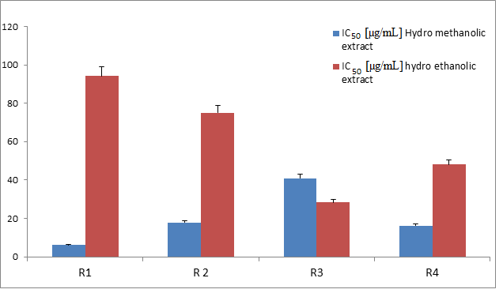
IC₅₀ ₍µg/mL)
Figure 1: 5-Lipoxygenase inhibitory activity of the hydro-methanolic (30:70, v/v) and hydro-ethanolic (30:70, v/v) extracts fromR1 (Boumerdès: Ammal), R2 (Bouira: Ain El hdjar), R3 (Médéa: Meghraoua) and R4 (Médéa: Bir Ben Abed) regions.

In fact, both methods confirm that the presence of phenolic acids, flavonoids and flavonols, isoflavones and ellagitannins in the roots may probably contribute to the anti-inflammatory activity significantly.
The anti-inflammatory properties of polyphenolic-rich extracts from C. Benedictus may be assigned to other polyphenols such as daidzein, rosmarinic acid as well as rutin, chlorogenic acid and genistein previously investigated and confirmed ^{[19]}.

HPLC and LC-MS composition
The C. Benedictus extracts were analyzed by HPLC-MS for further identification of compounds. Table 2 showed the identified compounds from the fraction isolated. Structure assignments of flavonoids were determined using the same standards as the HPLC analysis. 22 components were identified in LC-MS (Figures 1S to 8S). These compounds were identified by the accurate mass information and retention times of targeted reference substances (Standards). The structural characterizations of the remaining compounds isolated by HPLC-MS were elucidated on the basis of the accurate mass and the registered mass spectra fragmentation patterns and literature data. The phenolic compounds present in the C. Benedictus extracts were separated and analyzed by HPLC-MS (Table 2) in order to confirm qualitatively the HPLC analysis. The HPLC-ESI(+)-MS/MS results confirms the presence of all phenolic compounds already isolated by HPLC–DAD such asp-hydroxy benzoic acid (m/z : 139.10), ferulic acid (m/z : 195.12), sinapic acid (m/z: 225.08), syringic acid (m/z :199.07), gallic acid (m/z : 171.12), coumaric acid (m/z: 165.08), catechin hydrate (m/z: 291.08), Cinnamic acid (m/z: 149.16) and ellagic acid (m/z: 303.70). The rutin hydrate (m/z: 611.26), kaempferol (m/z: 287.20) and naringenin (m/z: 273.01) as well as other flavonols as epigallocatechingallate (m/z : 459.13), were identified for the first time in present works.
It is interesting to note that hydroxyCinnamic acid compounds present in all samples studied such as ferulic acid (m/z:195.12), p-coumaric acid (165.08), sinapic acid (m/z: 225.07) were previously identified by other authors ^{[6, 18]}
Isoflavones such as genistein and daidzein were also reported by earlier studies^{[6]}. Although, genistein was not detected in our extracts, alsorosmarinic acid (m/z: 359) was identified in all of the samples studied herein
In addition, some flavonolssuch asepigallocatechingallate (m/z: 459.13), catechin hydrate (m/z: 291.08) were not reported in previous works from this plant. Other non-negligible compounds were also exclusively found in thispresentwork such as salicylic acid (m/z: 139.03), syringic acid (m/z: 199.07), ascorbic acid (m/z: 177.05), p-hydroxy benzoic acid (m/z: 139.10), flavanone (m/z: 225.10), orcinol (m/z: 125.05), 3-hydroxy flavone (m/z: 239.01) and TranshydroxyCinnamic acid (m/z: 165.18).
Overall, the total phenolic yields (Table 2) of R1 (7.10%), R2 (7.89%) and R3 (7.43%) were relatively higher than R4 (5.94%). In addition, a significant difference in composition were observed according tothe regions studied especially for the major phenolic compounds such as trans chalcone (R1: 1.82 %, R2: 1.50%, R3: 1.58%, R4: 1.85%) , flavanone (R1: 0.97%, R2: 1.28%, R3: 1.20%, R4: 1.12%), 3-hydroxy flavone (R1: 0.85 %, R4: 0.94%), Cinnamic acid (R1: 0.81%, R2: 0.56%, R3: 0.72 %, R4:0.46%), catechin hydrate (R1: 0.52%R2: 0.23 %, R3: 0.31%, R4: .32%), trans hydroxyCinnamic acid (R1: 0.38 %,R3: 0.39 %, R4: 0.32 %).Noting that C. Benedictus from R2 is clearly distinguished from the remaining regions since the 3-hydroxy flavone and transhydroxycinnamic acid were not detected there, whereas a high content of flavanone, trans chalcone as well as cinnamic acid and catechinhydrate were isolated.
Compounds as quercetin and chlorogenic acid were not detected in our samples whereas some phenolic compounds are common for all regions studied such as trans chalcone, flavanone, cinnamic acid, ellagic acid, catechinhydrate,gallic acid and ascorbic acid.
In addition, some samples showed notable differences in composition compared to other regions as Médéa (Bir Ben Abed) where compounds as kaempferol, Rutin hydrate, salicylic acid, sinapic acid, epigallocatechin gallate were not detected.
Due to the high content in trans-chalcone, C. benedictus roots could exhibit numerous bioactive properties against nearly alleukaryotes and some prokaryotes ^{[20]}. In addition, a number of chalcones have been successfully developed as commercial drugs for treatment of some digestive system diseases including the treatments of cancer, cardiovascular diseases^{[21]}, viral infections^{[22]}.
On the other hand, the flavanone detected as major polyphenolic compound in all samples studied constitutes also a supplementary advantage in the bioactivity of the roots as strong antioxidant and radical scavenging activity ^{[23]},reducing risk of certain chronic diseases and anticancer ^{[24]}, antiviral ^{[25]} , and anti-inflammatory activities ^{[26]}.
In addition, R1, R2 and R3 samples presented a high yield in Cinnamic acid, endoyed of antioxidant, antimicrobial ^{[27]},neuroprotective, anti-inflammatory and anti-diabetic properties ^{[28]}. While 3-hydroxy flavone mainly present in R1 and R2 can help strengthen antibacterial and antifungal activities as well as antiviral and anti-inflammatory effect as a promising treatment against COVID-19 ^{[29]} .
Other important compound, the trans-cinnamic acid detected in R1, R2 and R3 areas, has a broad spectrum of biological activities as antioxidant, antimicrobial ^{[30]}, antiviral ^{[31]}, anticancer and anti-inflammatory ^{[32]}. Add to that syringic acid found in R2, R3 and R4 having a strong antioxidant activity and other properties as anti-diabetic, anti-inflammatory, anticancer and anti-angiogenesis ^{[26]}.

Table 2: Phenolic compounds composition in hydro-methanolic extract by according the different regions studied
Polyphenol identified | T_{R} | T_{R*} | Boumerdès (Ammal)  R1 (%) | Bouira (Ain El Hdjar)  R2 (%)  (%) | Médéa (Meghraoua)  R3 (%) | Médéa (Bir Ben Abed)  R4 (%) | [M+H] ⁺ | Fragments (m/z)
Ascorbic acid | 0.40 | 0.41 | 0.07 ± 0.01 | 0.04 ± 0.0 | 0.06 ± 0.0 | 0.05 ± 0.0 | 177.05 | 159.04/141.03 /113.02
Gallic acid | 0.66 | 0.65 | 0.03 ± 0.007 | 0.01± 0.0 | 0.03 ± 0.009 | 0.03 ± 0.0 | 171.12 | 172.04/154.03/126.03
Orcinol | 2.39 | 2.35 | 0.10± 0.01 | 0.42± 0.05 | 0.04± 0.01 | 0.04± 0.02 | 125.06 | 107.0493/93.0347/79.0199/91.0544
p-Hydroxy benzoic acid | 2.70 | 2.71 | 0.10±0.02 | 0.05±0.01 | 0.37±0.05 | nd | 139.10 | 121.08/103.07/109.09/123.08
Catechin hydrate | 2.71 | 2.74 | 0.52 ± 0.04 | 0.23 ± 0.04 | 0.31 ± 0.05 | 0.32±0.03 | 291.08 | 103.07/109.09/123.08
Chlorogenic acid | 2.98 | 3.01 | 0.28 ± 0.06 | 0.19 ± 0.01 | 0.22 ± 0.02 | 0.21 ± 0.01 | 355.12 | 289.11/145.09/163.14
Syringic acid | 3.41 | 3.42 | nd | 0.27 ± 0.20 | 0.39 ± 0.24 | nd | 199.07 | 181.06/167.05/137.02/123.02
Coumaric acid | 4.82 | 4.83 | 0.11± 0.01 | 0.27 ±0.02 | 0.32 ± 0.05 | 0.073 ± 0.01 | 165.08 | 147/119/77
Epigallocatechin gallate | 5.30 | 5.35 | nd | 0.27 ± 0.19 | 0.36 ± 0.25 | nd | 459.13 | 290.08/142.06/154.03/140.05/306.07
Ferulic acid | 6.20 | 6.21 | nd | 0.31 ± 0.06 | 0.33 ± 0.16 | 0.063±0.01 | 195.12 | 177.03/150.07/180.08/146.04  /150.07/146.04  /177.03
Trans hydroxy-Cinnamic acid | 6.30 | 6.34 | 0.38 ± 0.09 | nd | 0.39 ± 0.1 | 0.32±0.1 | 165.18 | 132.06/104.06/86.04/78.05
Sinapic acid | 6.91 | 6.90 | 0.11 ±0.01 | nd | 0.13 ± 0.02 | nd | 225.08  \  ] | 207.07/179.03/175.05/209.03
Ellagic acid | 9,67 | 9.67 | 0.26 ± 0.05 | 0.073± 0.02 | 0.07±0.012 | 0.12±0.08 | 303.70 | 304.02/102.03/138.02/262
Salicylic acid | 9.91 | 9.91 | nd | nd | 0.11± 0.02  1 | nd | 139.03 | 121.02/107.03/109.02/81.03
Rutin hydrate | 10.44 | 10.43 | 0.11±10 | nd | 0.11 ± 0.06 | nd | 611.26 | 303.06/289.06/165.04/255.05
Cinnamic acid | 12.87 | 12.86 | 0.81 ± 0.11 | 0.56 ± 0.1 | 0.72 ± 0.17 | 0.46±0.07 | 149.16 | 132.06/104.06/67.05/86.04
Quercetin | 19.54 | nd | nd | nd | nd | nd | 303.05 | 179.034/285.042/269.044
Naringenin | 21.81 | 21.89 | 0.24 ± 0.12 | nd | nd | nd | 273.07 | 189.12/153.09/147.11
Kaempferol | 25.17 | 25.16 | 0.15 ± 0.07 | 0.052 | nd | nd | 287.20 | 258.94/240.42
3-Hydroxy flavone | 36.43 | 36.40 | 0.85 ± 0.15 | nd | nd | 0.94 ± 0.14 | 239.01 | 179.23/165.18/194.23
2,3-Dihydroflavone  (flavanone) | 36.84 | 36.85 | 0.97 ± 0.26 | 1.28 ± 0.22 | 1.20±0.15 | 1.12 ± 0.19 | 225.10 | 144/104.06/77.04/96.02
Trans chalcone | 37.80 | 37.84 | 1.82 ± 0.18 | 1.50 ± 0.12 | 1.58±0.16 | 1.85±0.18 | 209.26 | 120.06/148.05/78.05/104.06
Total polyphenols (%) |  |  | 6.97 | 5.61 | 6.83 | 5.62

RT: Retention time of standard used, RT*: Retention time of peak in the extract, values are the mean of three replicates ± standard deviation (SD) and are expressed as the percentage of compound in the dry weight of the sample (DW%)

Antioxidant activity of Cnicus benedictus extracts

All samples showed strong antioxidant activity with inhibition concentration IC₅₀ values ranging from 15, 34 ± 1.12 to 54, 14 ± 1.19 µg/mL (Figure 2a). R3 showed the most potent DPPH free radical scavenging activity compared to the other regions and the positive control, ascorbic acid (IC₅₀ : 29.0 ± 3.1 µg/mL). These results showed significant scavenging activity and more higher than those obtained by Paun et al. for the ethanolic extract (IC₅₀, 0.609±0.04mg/mL) and the aqueous extract (IC₅₀, 0.715±0.05 mg/mL)of C. benedictus aerial part^{[18]}
The occurrence of other polyphenols, even in small proportions, may also contribute to the antioxidant activity ^{[2]}.This explains the lower antioxidant activity of R1 extract, in comparison with R3 extract in which lower amounts of these compounds were isolated, but other constituents may contribute to its antioxidant activity with a synergistic effect.
In addition, the most potent DPPH free radical scavenging activity of R3 and R4 compared to R1 and R2 could be explained to the presence of other phenolic compounds exclusively or mainly present in the two samples (R3 and R4) such as p-hydroxy benzoic acid, coumaric acid, epigallocatechin gallate and flavanone in R3, 3-hydroxy flavone and flavanone in R4. These compounds have significantly enhanced their antioxidant activity.
Whereas, the results obtained by phosphomolybdenum assay (Figure 2b) are in agreement and concordance with those of the obtained with the DPPH technique showing EC50 values close to those of control (ascorbic acid: 435 μg/mL). As the DPPH assay the higher activity was recorded by the R3 (EC50: 280.27 ±6.63 μg/mL) followed by other regions R1 (228.88±0.63 μg/mL), R2 (EC50: 267.37±4.20 μg/mL) and R4 (EC50: 252.07±2.45 μg/mL).
The FRAP (Ferric Reducing Antioxidant Power) assay was also performed to evaluate the antioxidant potential of different regions studied of Cnicus benedictus roots (Figure 2c). R3 (9.65 ± 0.05 μM Trolox/g d.w.). and R4 (8.40 ± 0.05 μM Trolox/g d.w.) showed the highest antioxidant activity of EC₅₀ compared to the other samples R1 (7.90 ± 0.1 μM Trolox/g d.w.), and R2 (7.23± 0.06. μM Trolox/g d.w.). These values correspond to significative antioxidant activity according the control used and the previous work ^{[2]}.
In the same context, the antioxidant potential of Cnicus benedictus using hydroxyl radical Scavenging activity (HRSA) was determined for the different regions studied of the plant extract, as well as for ascorbic acid as a control (Figure 2d). the R3 sample exhibited still the highest activity (8.32 ± 0.04 μg/mL) compared to other regions (R1: 27.12 ± 0.03 μg/mL, R4: 22.4 ±0.04 μg/mL, R: 32.55 ± 0.05 μg/mL) and the control (3.08±0.02μg/mL). Thus, all the protocols investigated confirm the high antioxidant activity of the C. Benedictus of the different region specially Médéa (Meghraoua) which constitutes the best sample for this activity.
In addition, overall, the results suggest that the antioxidant activity varies among the different regions. These findings highlight regional differences in the antioxidant potential and emphasize the importance of considering geographical factors when evaluating the antioxidant activity of natural compounds. Further investigations could explore the factors contributing to these regional variations in antioxidant activity and their potential implications.

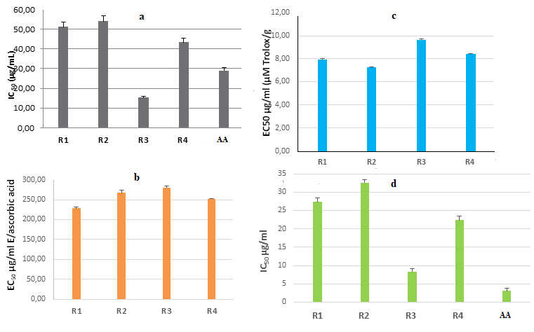
Figure 2: antioxidant activity of Cnicus benedictusextract by 2, 2-diphenyl-1-picrylhydrazyl (a) (DPPH), phosphomolybdate (b), FRAP assay (c) HRSA (d).

Evaluation of antimicrobial activity
The antimicrobial activities of Cnicus benedictus extract against microorganisms examined in this work and its potency were qualitatively and quantitatively assessed by the presence or the absence of inhibition zone diameter (MIC values). The results given in Table 3 showed a substantial antimicrobial activity against 5 bacteria tested.
In fact, the results obtained of zones of growth inhibition (mm) recorded in Mueller–Hinton agar demonstrated that Gram-positive bacteria, Listeria monocytogenes ATCC 13932 and Escherichia coli 252922 exhibited the highest diameters of growth inhibition, 24 ± 1 mm (R2) to 33 ± 1 (R3) mm and 29,23 ± 2 mm (R4) to 32 ± 1 mm (R3) respectively.
The antibacterial effect was also tested against Klebsiella Pneumoniae (CIP 82.91), pathogen responsible for various infections present in the digestive tract and upper airways of humans and animals ^{[33]}.
The staphylococcus aureus MRSA 639c (15.12 ± 0.5 mm to 20 ± 1 mm) and Bacillus subtilis ATCC 6633 (11.32 ± 1.5 mm to 17.23 ± 2 mm) bacteria were less sensitive to Cnicus benedictus extracts compared to other bacterial strains such as Listeria monocytogenes and Escherichia coli.
Overall, according the results displayed in the Table 3, we noted that the fluctuation in sensitivity to the different bacteria studied was not significative according to the area studied, although R1 and R3 phenolic extracts exhibited appreciable microbial growth inhibiting against Listeria monocytogenes, which was significantly higher than other region studied.
At first sight, it seems that all Cnicus benedictus hydro-methanolic (30:70, v/v) extracts have no sensitivity against Staphylococcus aureus 44340. This behavior is probably due to the composition or the synergic effect of the different phenolic compounds identified. Thus the major compounds as flavanone and trans-chalcone (in all samples) could be responsible essentially of the high sensitivity of Listeria monocytogenes ATCC 13932 and Escherichia coli 252922 to the hydro-methanolic (30:70, v/v) extracts.
Previous studies revealed that 3-hydroxy flavone and derivatives were found to be most active against Gram negative and Gram positive bacteria ^{[34]}.
On the other hand, the presence of Cinnamic (0.46 ± 0.07 - 0.81 ± 0.35%), ferulic (0.063 ± 0.01 - 0.33 ± 0.16), gallic (0.03%) and trans-hydroxycinnamic (0.316 ± 0.1 - 6 0.39 ± 0.1 %) acids can be responsible of the antibacterial activity ^{[35]}. Although these compounds are considered to be minor components they might contribute to an increase in activity ^{[36]} in addition to the occurring synergetic and antagonistic effects ^{[37]}.
In addition, the antibacterial activities of the different extracts were globally close to that exhibited by amoxicillin antibiotic (Table 3) for Escherichia coli and Listeria monocytogenes ATCC 13932. However, it is important to underline that R1 and R3 extracts presented a high activity against Bacillus subtilis ATCC 6633 (14.12 ± 0.5 mm - 17.23± 2 mm) which is closer to that of amoxicillin antibiotic (17.16 ± 1.40 mm).
The phenolic extracts exhibited appreciable microbial growth-inhibiting properties, especially R1 and R3 regions as well as R4 against Listeria monocytogenes (R1: 32 ± 1.5 mm, R3: 33 ± 1 mm and R4: 30
± 2 mm) which was significantly higher than R2 region, whereas R1 (31.23 ± 2 mm), R2 (30± 1.0 mm) and R3 (32± 1.3mm) extracts revealed significantly higher inhibition on E. coli 252922 than R4 extract.
Furthermore, an affinity (inhibition zone diameter) between Escherichia Coli (ATCC 252922) and Klebsiella pneumoniae (CIP 82.91) was observed for all regions studied as well as a higher inhibition against Bacillus subtilis ATCC 6633 and Klebsiella Pneumoniae (CIP 82.91) (17٫23 ± 2 mm, 24± 1 mm respectively) for R1.
Finally, Listeria monocytogenes ATCC 13932 had he greater sensitivity compared to Gram-positive towards phenolic compounds studied and appeared as the most sensitive bacterium, whereas Bacillus subtilis ATCC 6633 was much more resistant. In fact, many studies reported this difference and attributed it to the cell wall structures complexity. Therefore, the greater resistance of Gram-negative bacteria is probably due to the double membrane structure.

Table 3: Disk diffusion of Cnicus benedictus L. Spreng phenolic compounds (10 μl) isolated by the cold maceration method
 | Staphylococcus aureus 44340 | Klebsiella Pneumoniae  (CIP 82.91) | Listeria monocytogenes  ATCC 13932 | Staphylococcus aureus MRSA 639c | E .coli 252922 | Bacillus subtilis ATCC 6633
Boumerdès (R1) (mm) | / | 24± 1.0 | 32± 1.5 | 17.0 ± 1 | 31.23± 2 | 17.23± 2
MIC (μg/ml) | > 100 | 15 | 2 | 5 | 2 | 10
Bouira (R2) | / | 19± 1.5 | 24± 1.0 | 15.12± 0.5 | 30± 1.0 | 11.32± 1.5
MIC | > 100 | 25 | 25 | 20 | 15 | 15
Meghraoua (R3)(mm) | / | 23± 2.0 | 33± 1.1 | 19.23± 2.05 | 32± 1.3 | 14.12± 0.5
MIC (μg/ml) | > 100 | 5 | 1 | 2 | 1 | 5
Bir Ben Abed (R4)(mm) | 0 | 23 ± 1.4 | 30± 2.3 | 20± 1 | 29.23± 2.1 | 12.23± 2.1
MIC (μg/ml) | > 100 | 10 | 5 | 10 | 20 | 30
Amoxicillin  (30 μg /disc) | 26±0.33 | 40.17 ± 0.29 | 30.33 ± 1.04 | 17.83 ± 0.76 | 29.50 ± 0.50 | 17.16 ± 1.40
MIC Amoxicillin  (μg /ml) | 1.25 | 0.1 | 0.25 | 1.25 | 0.25 | 0.87

Note: The diameter of the disc is included in the measurement of antibacterial activity, ±: represent the standard deviations calculated from three repetitions, /: No bacterial growth.

Determination of minimum inhibitory concentration (MIC)
According tothe data presented inTable 3, the minimum inhibitory concentrations (MIC) values for eachisolated extractof Cnicus benedictus were evaluated. These results were consistent with those obtainedfrom thedisc diffusion tests, specifically, Cnicus benedictusdisplayed a significant efficacy against several bacterial strains, including E. coli 252922 (1-20 μg/mL), Staphylococcus aureusMRSA 639c (2-20 μg/ml) and Listeria monocytogenes ATCC 13932 (1-25 μg/mL), in addition, the extracts showed moderately inhibitory activity against Bacillus subtilis ATCC 6633 (5- 30 μg/mL) and Klebsiella pneumoniae(5- 25 μg/mL). However,it is Important to note that the MIC values showed variability depending on the geographical origin of the plant source. Extracts from regions R1 and R3 extracts presented higher efficacy against most bacterial strainscompared to regions R2 and R4.On the other hand, staphylococcusaureus 44340 was identified as the most resistant bacterium, against the extract tested where no antibacterial activity was noted with the samples tested.
Nevertheless, the extract from the R3 (Médéa-Meghraoua) was the most effective against the most tested microorganisms, probably due to the richness in some polyphenols (trans-chalcone, flavanone, epigallocatechin gallate) and aids (syringic acid, trans hydroxycinnamic acid and coumaric acid) previously mentioned in addition to the synergetic and antagonistic effects that must be taken in consideration ^{[38]}.

In silico molecular docking for anti-Alzheimer and anti-inflammatory Activity
The molecular docking evaluation in this current work involved six phenolic compounds (Table7)fromC. Benedictus extract against enzymes linked to Alzheimer’s disease and inflammation namely; acetylcholine esterase (AChE), butyl choline esterase (BChE) and cyclooxygenase-2 (Cox-2) (Table 4). The outcomes of this evaluation are presented in binding energy (kcal/mol) and molecular interaction analyses (Table 4 and Figures 3 to 5).
In Table 4, we observed that catechin hydrate, flavanone and 3-hydroxy flavone have the best binding energy after docking with AChE, BChE and Cox-2. However, catechin hydrate and 3-hydroxy flavone showed the utmost binding energy with AChE and BChE. However, flavanone and 3-hydroxyflavone were better binders to Cox-2.
The molecular interactions that resulted from the protein-ligand complexes were elucidated using BIOVIA’s discovery studio 2016. The findings are presented in Figures 3 to 5. The interaction between catechin hydrate and 3-hydroxy flavone with the amino acid residues within the binding pocket of AChE is shown in Figure 3. Catechin hydrate was observed to interact with His447 and Trp86 through hydrogen bond and pi-pi stacking respectively. In addition, the compound was able to interact hydrophobic ally with Val73, Gln71, Asn87, Ser125, Pro88, Tyr72, Asp74, Tyr124, Gly126, Gly120, Gly121, Glu202, Ile451, Tyr133, Gly448 and Tyr449. However, 3-hydroxyflavone was observed to interact with Ser125 and Gly126 via hydrogen bonds; while establishing pi-stacking bonds with Trp86 and Tyr337. His447, Gly448, Tyr133, Gly120, Gly126, Pro88, Asn87, Tyr72, Val73, Asp74 and Tyr124 formed hydrophobic bonds.
The interactions between the atoms of Catechin hydrate and 3-hydroxyflavone with the amino acids occupying the binding region of BChE is presented in Figure 4. Catechin hydrate established hydrogen bonds with Asp70, Asn83 and Asn68 while its aromatic rings were involved with Asp70 and Trp82 via Pi-Pi stacking and Pi-Anion bond respectively. Hydrophobic interactions were observed to occur with Met437, His438, Gly439, Glu197, Ile442, Gly116, Thr120, Ile69, Pro84, Ser79, Tyr332, Trp430, Tyr440 and Ala328. Ala199 was observed to be linked via hydrogen bond with 3-hydroxy flavone concurrently establishing links between its aromatic rings and side chains of Trp82, His438, Gly116, Phe329, Trp231 and Leu286. Phe398, Val288, Ser198, Gly117, Glu197 and Gly115 were found to established hydrophobic interactions.
The interaction that results from the atoms of flavanone and 3-hydroxyflavone with the amino acids residues present within the active gouge of Cox-2 is provided in Figure 5. Flavanone interacted with side chains of Val444, Leu391 and Ala202 through its aromatic rings (pi-bonds); while hydrophobic ally interacting with Val447, His388, Ala199, Leu390, Trp387, Tyr385, Thr206, His207 and Gln203. 3-hydroxyflavone interacted with Tyr385 and Thr206 by hydrogen bonding; while forming a pi-bonds with side chains of His386, His207 and Ala202. Trp387, Gln203, Ala199, Leu390, Leu391, and Asn382 side chains were linked with 3-hydroxyflavone via hydrophobic interactions.

Table 4: Binding energy (kcal/mol) of compounds docked against AChE, BChE and COX-2
Compounds | Bindingenergy (kcal/mol)
 | AChE | BChE | COX-2
Catechin hydrate | -10.1 | -9.4 | -7.9
Flavanone | -9.3 | -8.6 | -8.4
3-Hydroxy flavone | -9.7 | -9.2 | -8.9
Cinnamicacid | -6.7 | -6.4 | -6.3
Trans hydroxy cinnamicacid | -7.1 | -6.6 | -6.4
Trans Chalcone | -8.7 | -8.3 | -7.9
Galanthamine* | -10.6 | - | -
Butyl* | - | -4.2 | -
Ibuprofen* | - | - | -6.9

*Controls

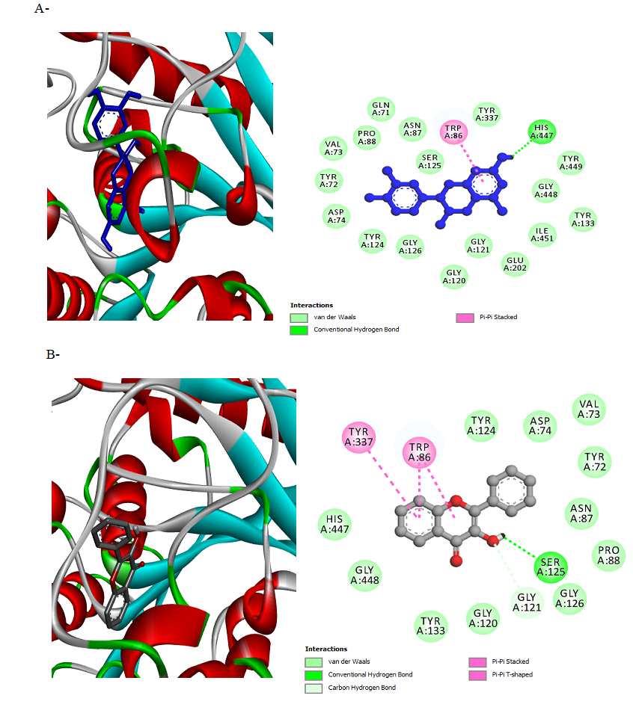
Figure 3:Molecular interaction between hit compounds and AChE in 2D and 3D representationusing BIOVIA’s Discovery Studio 2016. A) Catechinhydrate, B) 3-hydroxy flavone(Ain El hdjar), R3 (Médéa: Meghraoua) and R4 (Médéa: Bir Ben Abed)

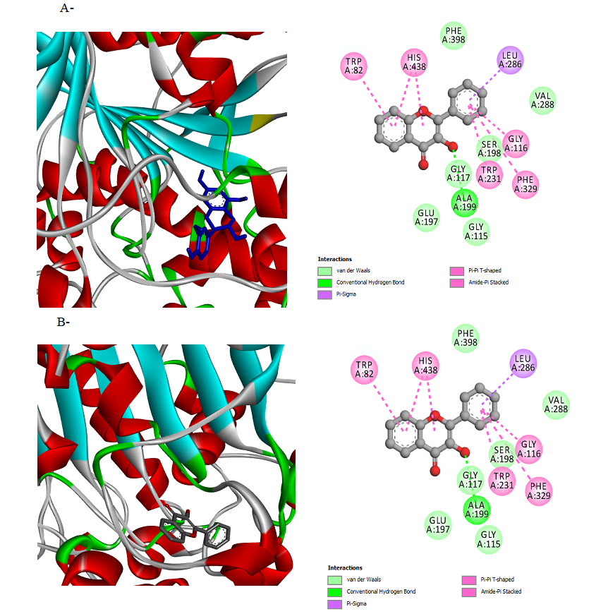

Figure 4: Molecular interaction between hit compounds and BChE in 2D and 3D representation using BIOVIA’s Discovery Studio 2016. A) Catechin hydrate B) 3-hydroxy flavone

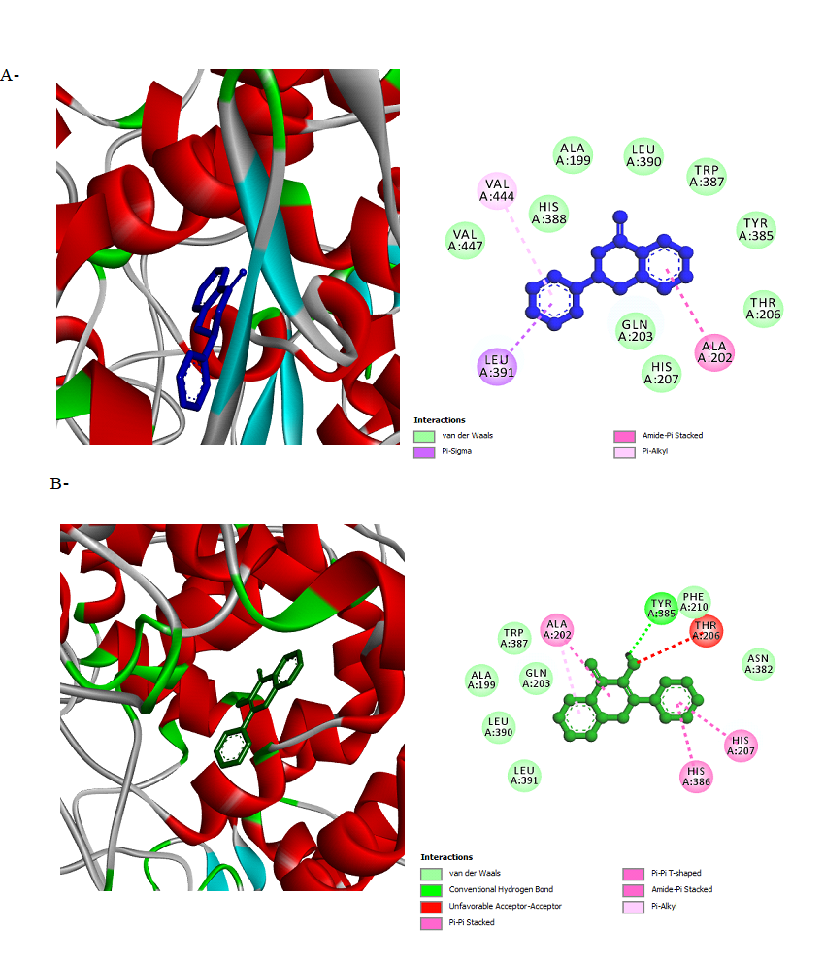
Figure 5: Molecular interaction between hit compounds and COX-2 in 2D and 3D representation using BIOVIA’s Discovery Studio 2016. A) Flavanone B) 3 - hydroxy flavone

In silico anti-inflammatory activity with 5-lipoxygenase (3V99)
Prediction of the interaction mode of a binding site of a protein by molecular docking analysis of the protein and natural compounds enables virtual screening of natural compounds within limited time; facilitate the selection of lead compound(s) for further validation. The strength and affinity of the protein-compound(s) interaction is expressed via the binding energy ^{[39]} . Herein, the molecular interaction of six polyphenols was studied within the binding site of 5-lipoxygenase to estimate their ant-inflammatory potential using computational approach as confirmatory model to the in vitro experiment in this study. As shown in Table 5, all the polyphenolic compounds except cinnamic acid (-5.8 kcal/mol) were observed to have higher binding affinity compared with the reference compound (quercetin = -7.1 kcal /mol). Flavanone with docking score of -7.7 kcal/mol has the highest binding affinity among the studied polyphenols followed by 3-hydroxyflavone (-7.5 kcal/mol). This was based on the fact that, the more negative the docking score, the stronger the interaction and binding affinity ^{[39-40]} . Several studies have reported phytocompounds and synthetic molecules as inhibitors of 5- lipoxygenase activity ^{[41]}. Hence, the results obtained in this study is consistent with previous reports that lead anti-inflammatory compounds exhibit inhibitory potential against the active site of 5-lipoxygenase.
The interaction of small molecules with the residues at the binding site of the target is vital for their reported inhibitory activity ^{[39]} . Table 6 and 10 showed the various interactions between the polyphenols and the amino acid residues at the binding site of the target (3V99) which contributes to the binding affinity of polyphenols-3V99 complexes (figure 6). All the polyphenols except flavanone showed hydrogen bond interaction with one or more amino acid, trans-hydroxycinnamic acid showed four (4) hydrogen bond interactions with ASN 669, GLU 614, GLU 622 and ARG 401 within 5 Å distance.^{[42]} has reported that, favoured binding energy of natural compounds result from H-bond interaction between the functional group of the compounds ad amino acid residues of the target. Hence, the presence of H-bond interaction as shown in figure 6 and table 6 might contributed to the favoured binding affinity of the polyphenols.

Table 5: Structure and binding energy of polyphenols with 5-lipoxygenase (3V99) with Quercetinas standard
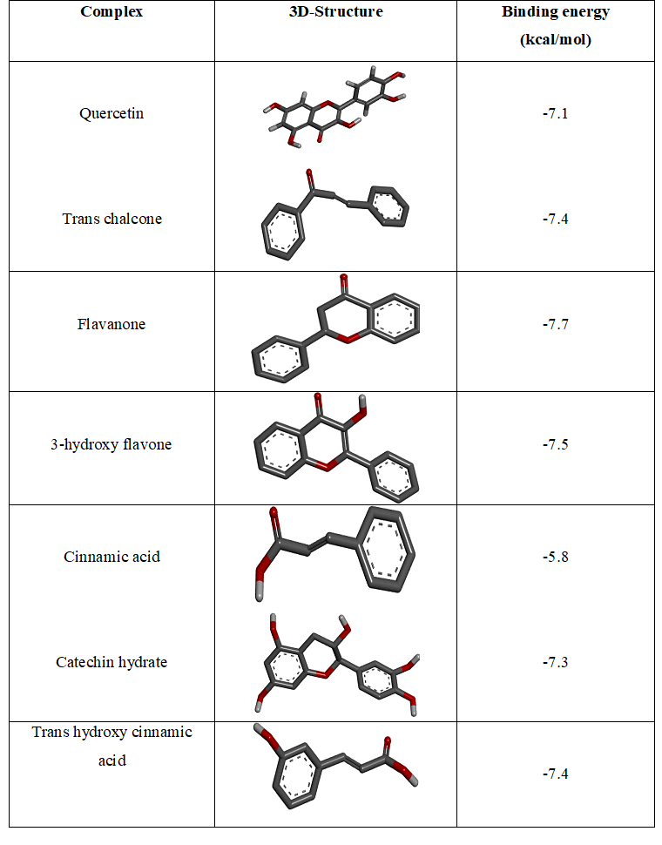

Table 6: Hydrogen bond interactions of polyphenols and 5-Lipoxygenase (3V99) with Quercetin as standard

Complex | Number of H-bonds | Amino acids of 5-LOP involved in H-bonding | Hydrogen bond  distance (Å)
Quercetin | 2 | GLN 609; PHE 177 | 1.89; 2.20
Trans chalcone | 1 | GLN 557 | 5.35
Flavanone | 0 | Nil | Nil
3-hydroxy flavone | 2 | GLN 413; PHE 177 | 3.94; 3.93
Cinnamic acid | 1 | ASN 554 | 4.03
Catechin hydrate | 2 | ASN 554; HIS 367 | 4.16; 5.18
Trans hydroxycinnamic acid | 4 | ASN 669; GLU 614; GLU 622; ARG 401 | 3.83; 5.52; 3.43; 3.39

Table 07: Non-covalent interactions of polyphenols and 5-Lipoxygenase (3V99) with quercetin as standard

Complex | Number of Hydrophobic interaction | Amino acids of 5-LOP involved in Hydrophobic-bond | Hydrophobic bonddistance (Å)
Quercetin | 4 | LEU 607; ASN 108, LEU 607; PHE 610 | 4.91; 2.85; 2.24; 4.99
Trans chalcone | 2 | PHE 610; LEU 607 | 4.79; 4.38
Flavanone | 3 | ALA 410; PHE 177; LYS 409 | 3.98; 4.04; 4.00
3-Hydroxy flavone | 7 | ILE 406; PHE 177; PHE 177; ALA 410; ALA 410; LYS 409; LYS 409 | 5.12; 5.58; 4.23; 3.80; 4.85; 5.91; 4.25
Cinnamic acid | 1 | LEU 607 | 4.51
Catechin hydrate | 3 | ALA 410; PHE 177; LEU 607 | 4.12; 4.23; 6.39
Trans hydroxy  cinnamic acid | 2 | LEU 615; ALA 672 | 4.61; 6.53

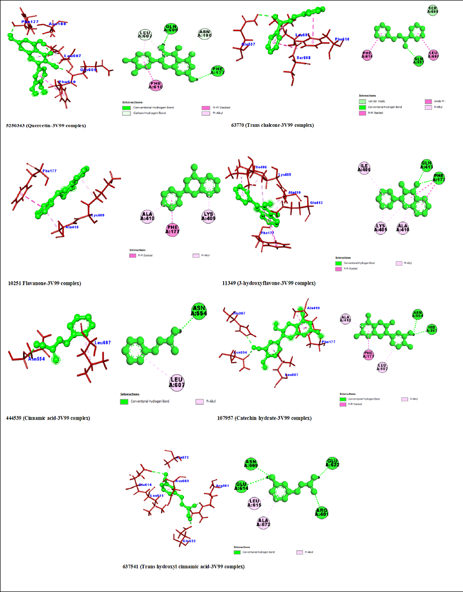
Figure 6: 3D and 2D interactions of polyphenols and 5-Lipoxygenase with quercetin as standard
Statistical study
In order to high light the variability of qualitative and quantitative (HPLC/LC-MS) composition of Cnicus benedictus extracts according to areas studied, data analysis with hierarchical cluster analysis (HCA) and principal component analysis (PCA) were performed using R language and statistical software Xlstat based on a scaled and centered matrix linking the quantitative flavonoids identified from Algerian areas R1, R2, R3 and R4.
According F1 axe (88.85%), the regions studied R1 with R4 as well R2 withR3presented a good correlation generally due to the close composition of the most compounds specially R1 and R4 (Figure 7 -a). In addition, there is no negative or inverse correlation which explains that all the variables have the same statistical behavior.
Indeed, R1 and R3 share similar profile mainly rich in 3-hydroxy Flavone, trans chalcone and catechin hydrate. However, the good correlation between R2 and R3 is due to their specific composition dominated by ferulic acid, epigallocatechingallate, coumaric acid, 2, 3-dihydro flavone and the absence of3-hydroxy Flavone.
In addition, the PCA-HPLC (Figure 7-a) showed that the two compounds flavanone and chalcone were considered as the major compounds for all the regions studied due to their extreme position on the PCA graph.
The surprising result was that R3 (Médéa: Meghraoua) and R4 (Médéa: Bir Ben Abed) from the same state distant of 30 km, did not present a good correlation as R1 (Boumerdès) and R4 (Médéa) distant approximately of 100 km.
CPA classification permitted to distinguish four classes of compounds, the classes A (EGATG, OR, SA, FA, COUM, AA, ELLAG, NAR, SALAC, KAMP, RUT, NAR, AA, GA, ELLAG, CAFA), B (FLAV and CHALC) and C (CATHD, 3HFLAV, CINAC). Group A was constituted generally of minor compounds compared to B group including the major compounds as trans chalcone and flavanone shared by all regions studied. Whereas, Class C groups the compounds isolated at medium contents.
Thus, as showed in figure 7-a, R1 and R4 rich in CATHD, 3HFLAV and FLAV (2.34 and 2.38 % respectively) exhibited a high anti-Alzheimer and anti-inflammatory activities compared to R2 and R3 (1.51%). These results are in agreement with those obtained by 5-lipoxygenase inhibitory activity of the hydro-methanolic extract (R1) and hydro-ethanolic extract (R2) extracts.
On the other hand, according to the HCA dendrogram reported in Figure 7.b, three major clusters were revealed (A, B and C) corresponding to almost the same distribution groups of compounds previously mentioned in PCA method (Figure 7.a).
PCA analysis was also employed for the antibacterial results. The first two PCA axes (Figure 8) explained 79.2% of total information. Indeed, R1extract presented a high effectiveness against SA, MRSA and LM compared to R3 especially effective against EC, whereas R2 isolated in the left seems to be less sensitive to the different bacterial strains compared to other extracts. The plotting of R2 in the left shows a specific composition compared to other regions. Thus, it is possible that a synergistic effect between some of its polyphenolic compounds is at the origin of this lower sensitivity against the tested strains.

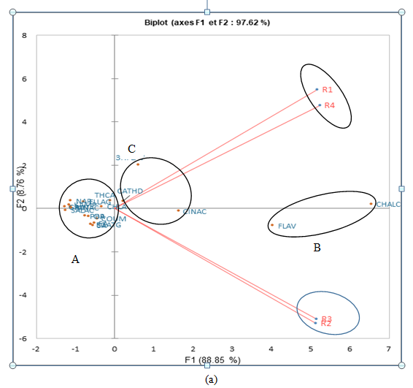
A

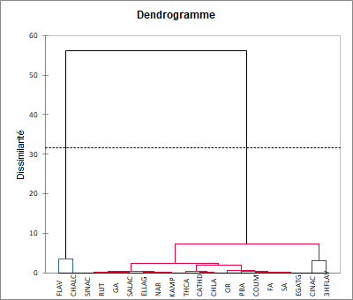
A
B
C

C
(b)
Figure 7. (a): Two-dimensional plot of principal component analysis (PCA). (b) Dendrogram showing the chemical variability of polyphenolic compounds under different regions using Euclidian distance (Extracts R1 (Boumerdes:Ammal), R2 (Médéa: Ain El hdjar), R3 (Médéa: Meghraoua) and R4 (Médéa: Bir Ben Abed)
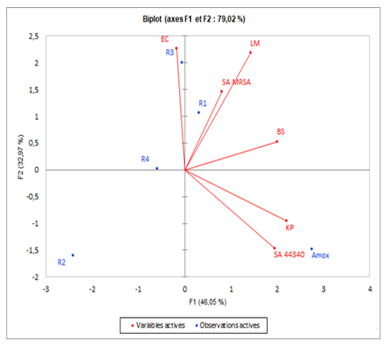
Figure 8: Two-dimensional plot of principal component analysis (PCA). (Extracts R1 (Boumerdes: Ammal), R2 (Médéa: Ain El hdjar), R3 (Médéa: Meghraoua) and R4 (Médéa: Bir Ben Abed)

Conclusion
Analysis of the polyphenolic composition of simple from different regions revealed a moderate difference in the percentage of compounds using HPLC and LC-MS. This variation in composition had a clear impact on the different antioxidant and biological properties of the samples, as highlighted by the statistical analysis PCA and HCA.
On the other hand, in silico molecular docking for anti-inflammatory activity supports the findings ofthe in vitro enzymatic assay, which are directly related to the qualitative and quantitative polyphenols composition. Similarly, the anti-Alzheimer activity was strongly dependent on the composition of the major compounds identified and their molecular structure.
Overall , our data on antimicrobial activity assessed using the disk diffusion method and the minimum inhibitory concentration revealed that Cnicus benedictus extract presented different behavior against the tested microorganisms, noting that with each strain being was particularly more susceptible to one region than to others.
It is difficult to predict the antibacterial activity of the different root samples according to the phenolic composition because of the synergistic effect of the different compounds present in the extracts on the strains or because of the extraction technique used causing thermal degradation at high temperature such as microwave or sonication ^{[43]}.
Nevertheless, R1 and R3 were the most effective against the majority of tested microorganisms essentiallyE. coli and Listeria monocytogenes due to their very particular composition represented by the richness in antibacterial compounds previously cited, which can act either individually or by synergy.
The binding affinity and molecular interaction of the polyphenols and 5-lipooxyganase (3V99) suggest the anti-inflammatory potential of polyphenols. This may be explored, for further study to design a new therapeutic agent for the management of inflammation and its associated complications.

Experimental Section
Plant material
Cnicus Benedictus(Asteraceae) roots were collected in May 2021 during the flowering from different locations of Algeria: Boumerdès (R1), Bouira (R2) and Médéa (R3: Meghraoua and R4: Bir Ben abed) (Table 08). Identification of the investigated specie was confirmed in the herbarium of Botany Department, National Higher School of agronomy (ENSA) by Pr Mohamed Toumi, Algiers. At each site 50 individuals were sampled. The voucher specimens were deposited in a botanical collection of ENSA herbarium (CB05062021).
The plant material was air-dried in the shade; the roots were separated and stored at room temperature in a moisture-free atmosphere until extraction. The roots collected were dried between 25 and 30°C to reduce moisture content in plant. The mass of Cnicus benedictus roots used was 100 g for cold maceration.

Table 08: Geographic locations of studied samples of Cnicus Benedictus L. in Algerian
Région | Locality | Location (UTM) |  | Altitude  (m) | Climat
 |  | latitude | longitude
Boumerdès (R1) | Ammal | 36°38’05" N | 3°35’ 26"E | 191 | Humid
Bouira (R2) | Ain El Hdjar | 36°20’21" N | 3°48’ 23"E | 691 | Sub-humid
Médéa (R3) | Meghraoua | 36°21’05" N | 3°32’ 07"E | 815 | Sub-humid
Médéa (R4) | Bir Ben Abed | 36°13’03" N | 3°25’ 36"E | 666 | Sub-humid

Extraction
Extraction was carried out by maceration in shaker (Promax 1020; Heidolph, Schwa Bach, Germany) at room temperature for 24 hours at 25˚C (250 mL), then sonicated for 3 hours with a ultra sonicator bath (BandelinSonorex RK514H, Germany). The extraction procedure was repeated twice, and the collected solvent was removed under vacuum using a rotary evaporator (Buchi, Rotavapor R-210) at 40°C. The extracts were stored at –8°C until analyzed. The yield was calculated according the formula: Yield (%) = (W1*100)/W2
Where, W1: weight of the extract residue obtained after solvent removal. W2: weight of the plant powder.

Chemical standards
Reagents and Solvents
Solvents including methanol (99.8% purity), ethanol (99.8% purity) and isopropanol (IPA), (99.8% purity) were purchased from Sigma-Aldrich Chemie (St. Louis, MO, USA). Sigma Aldrich (Darmstadt, Germany) supplied Boric Acid, linoleic acid, 5-lipoxygénase, dimethylsulfoxide (DMSO) and quercetin. Hydrochloric acid, sodium hydroxide, Tween 80, disodium hydrogen phosphate and potassium dihydrogen phosphate were bought from Sigma Aldrich. Sulfuric acid, sodium phosphate and ammonium molybdate, tripyridyl-s-triazine (TPTZ), pure acetic acid, ferric chloride,sodium acetate trihydrate
The following phenolic compounds were purchased from Sigma-Aldrich Chemie (St. Louis, MO, USA): ascorbic acid, orcinol, catechin hydrate, coumaric acid, trans-hydroxycinnamic acid, rutinhydrate, naringenin, kaempferol, 3-hydroxy flavone, flavanone,ferulic acid, cinnamic acid, syringic acid, ellagic acid, salicylic acid, chlorogénic acid, gallic acid, epigallocatechin gallate, quercetin, p-hydroxy benzoic acid, trans chalcone, sinapic acid. The standard solutions were diluted in 70% methanol-30% water solvent (standard dilutions: 1 mg/mL) and injected in triplicate.

HPLC-DAD analysis
The hydro-methanolic extract was dissolved with 15 mL of acidified distilled water (pH=2) and then extracted to three successive extraction using a 15 mL mixture of diethyl ether and ethyl acetate (1:1 v/v). After extraction, the organic phase was recovered and the organic solvents removed using a rotary evaporator. The residue was dissolved in a hydro methanolic extract: (30:70 v/v) before injected to HPLC.
Twenty-two phenolic compound standards were analyzed using HPLC. The diluted samples from Cnicus Benedictus roots were injected to HPLC. Phenolic compounds separation was performed with an Agilent 1260 series HPLC system equipped with quaternary pump with degasser (G1311B) associated with a thermostatic auto sampler (G 1329 B).
Instrument control and data analysis were carried out using Agilent HPLC Chemstation (B 04.01). Phenolic compounds separation was carried out on a reverse phase C₁₈ column (5 µm, 150 mm × 3 mm i.d) thermostated at 35 °C by HPLC equipped with a diode array detector. The solvent system used was a gradient of A (water + 0.1 % formic acid) and B (acetonitrile + 0.1 % formic acid) according to the method described by ^{[44]} with minor modification. The solvent flow rate was 1.5 mL/min. The sample volume injection was 20 µL. The elution gradient was as follows: 0–5 % B (0–10 min); 5 –17 % B (10–18 min);17–25% B (18–33 min); 25-100 % B (33–48 min); 100–5 % B (48–51 min). Detection and the identification of phenolic compounds were carried out at 254.4 nm using a diode array detector (DAD); peak identification was obtained comparing the retention time and the UV spectra of the chromatogram with those of pure standards.

HPLC-MS Analysis:
All the analysis were performedusing liquid chromatography followed by tandem mass spectrometry with an electrospray ionization source (LC–ESI-MS-MS) based on the previous method ^{[45]}. An Agilent 2695 series liquid chromatography system equipped with aquaternary pump with degasser, an electrospray ionization system,and a quadruple mass spectrometer,Waters 2695 Separations Module-QDa Detector (AcquityQDa Belgium) was used. For analysis, the column heaterwas set to30°C, Theauto sampler was set to25°C and the multi-wavelength detector was used. The mobile phase was composed of solvent A (formic acid in water, pH=3.0) and solvent B (formic acid in acetonitrile, pH=3.0). The polyphenoliccompounds were separated usinga binary gradient elution: 0 min, 5% solvent B; 0.01-20 min, 5-30% solvent B; 20-40 min, 30% solvent B; 40.01-50 min, 30-50% solvent B; and 50.01-52 min, 50-5% solvent B. The flow rate was 0.1 mL/min for 0 -5 min, 0.2 mL/min for 5.01-15 min,0.1 mL/min for15.01-35 min, 0.2 mL/min for 35.01-50 min, and 50-52 min: 0.1 mL/min. The MS (QDa, Waters) was operated in positive scan mode. The capillary voltage was set at 0.8 kV, the cone voltage was 10 V, the source temperature was 600°C, and the desolvation gas flow was 800 L/h. The acquisition mass scan is 100–1000 m/z with a sampling rate of 5 scans per second in scan mode. Analyses were carried out using the external standard calibration method.

Identification of peaks and peak purity
All constituents were identified by HPLC-DAD and LC-MS analysis by comparing their retention time, UV spectra and MS spectra with those of authentic reference samples. The purity of eachpeak was checked using a Diode Array Detector coupled to the HPLC system,by comparingits UV spectrum of each peak with those of authentic references samples, taking into account of the MS spectra.

Lipoxygenase Inhibitory Activity (LOX)
For the 5-lipoxygenase inhibitory activity of the phenolic extract of Cnicus benedictus roots, the spectrophotometric method described by ^{[46]} was used with some minor modifications. A reaction mixture containing both a hydro methanolic and hydro ethanolic extracts in isopropanol in various concentrations (100,75, 50, and 25 µg/mL) (in triplicate for each concentration), 5-lipoxygenase (Sigma, Darmstadt, Germany) and 35 µL (0.1 mg/mL) of a 0.2 M borate buffer solution with a pH=9 was incubated for 15 min at 25 °C. The reaction was then initiated by addition of 35 µL of a substrate solution (linoleic acid 250 µM) and the absorbance was measured at 234 nm using an Ultrospec 7000 UV– vis dual beam spectrophotometer (GE Healthcare, Chicago, IL, USA). Quercetin (Sigma, Darmstadt, Germany) was used as a standard inhibitor at the same concentration as the phenolic compounds. All the tests were performed in triplicate.
Inhibition percentage % = (Abs B-Abs S)/(Abs B)× 100, where Abs B represents the absorbance of the reaction medium without the extract, and Abs S is the absorbance of the reaction medium with the extract minus the Abs value of the diluted extract (to compensate the absorbance due to the extract themselves).

DPPH radical scavenging assay
DPPH radical scavenging activity was determined as described by ^{[47]},with slight modifications. Briefly, 0.5 mL of a methanolic solution of the hydro-methanolic extract (30:70, v/v) at different of concentrations (25, 50, 75 and 100 µg/mL) was mixed with 0.5 mL of a methanolic DPPH solution (0.004% w/v). The mixture was incubated at room temperature for 30 min; the absorbance was measured at 517 nm using an Ultrospec 7000 UV–vis dual beam Spectrophotometer (GE Healthcare, Chicago, IL, USA). Ascorbic acid was used as a positive standard. The inhibition percentage of the DPPH free radical (I%) was calculated by using the following formula:
I% = [(Ab – Aa)/Ab] x 100. All tests were performed in triplicate. Where, Ab is the absorbance of the reaction media without extract and Aa is the absorbance of the test sample.

Hydroxyl Radical Scavenging Activities (HRSA)
We determined the Hydroxyl Radical Scavenging Activities HRSA by following the method described by Sroka et al ^{[48]} with a slight modification. The procedure involved sequentially mixing FeSO4 (9 mM, 1 mL), H₂O₂ (45 μL, 0.15%), and salicylic acid (9 mM, 1 mL) with distilled water (4 mL). sequentially , we added 1 mL from The sample hydro-methanolic extract (30:70,v/v) to this mixture and allowed it to react for 30 min at 37 °C. The absorbance of the resulting colored product was measured at 536 nm. To calculate the percentage of free radical scavenging activity, we used the following formula: Scavenging effect (%) = [1 − (ASample − AControl)] × 100%

Phosphomolybdenum assay
To perform the phosphomolybdenum assay we followed the method described by prieto et al ^{[49]} (1999) with slight modification. In this procedure, an aliquot of 0.1 mL of the sample solution at various concentrations (ranging from 25 to 100 μg/mL) was mixed with 1 mL of a reagent solution containing 0.6 M sulfuric acid, 28 mM sodium phosphate and 4 mM ammonium molybdate. The tubes were then placed in a water bath at 95°C for 90 min. after cooling the samples to room temperature, their absorbance at 765 nm was measured. As the positive control, Ascorbic acid was used. The antioxidant capacity was determined by using the following equation:
Antioxidant activity % = [(Absorbance control− Absorbance sample)/Absorbance control] × 100
The term "Absorbance control" refers to the absorbance value of a control sample, which typically contains a known or standard antioxidant compound. The term "Absorbance sample" represents the absorbance value of the sample being tested for its antioxidant capacity.

Ferric Reducing Antioxidant Power (FRAP) assay
The FRAP assay was conducted following the protocol outlined by Liao et al. ^{[49]} with slight modifications The FRAP reagent used in the experiment was prepared daily by combining a solution of FeCl₃ ·6H₂O (20 mM in water), a solution of TPTZ (10 mM in 40 mM HCl), and a sodium acetate buffer (300 mM, pH 3.6) in a ratio of 1:1:10 (v/v/v). Then, 0.50 ml of different concentrations of sample (ranging from 25 to 100 μg/mL) was thoroughly mixed with 1.00 ml of the freshly prepared FRAP solution. The mixture was then allowed to react in the dark for 10 minutes at a temperature of 37 ℃. The absorbance of the reaction mixture was measured at a wavelength of 593 nm. Trolox was used as a calibration standard, and the FRAP values were reported as mg TE/g.

Evaluation of antimicrobial activity
The hydro-methanolic (30:70, v/v) extracts were individually tested against pathogenic microbes including six bacteria used to evaluate the antimicrobial activity of C. Benedictus extracts. Two Gram-negative bacteria (Escherichia coli ATCC 252922, Klebsiella pneumoniae (CIP 82.91)) bacteria and four Gram-positive (Listeria monocytogenes ATCC 13932, Bacillus subtilis ATCC 6633, Staphylococcus aureus MRSA 639c, Staphylococcus aureus 44340) were selected. These target-microorganisms included Gram-positive and gram-negative bacteria are mostly pathogenic or toxigenic for humans, and generally present multiple antibiotic resistance ^{[48]}.
Microorganisms were obtained from the Microbiological Laboratory, Department of Biology, ENS, Algeria. Except the strains of Staphylococcus aureus MRSA 639c were isolated from sick patients in Algerian hospitals ^{[48]}. In all tests, bacterial strains were cultured in Muller–Hinton agar (Institut Pasteur, Algeria). All microbial strains were incubated for 24 h at 37°C ^{[49]}.

Agar disk diffusion method
Paper disk diffusion method was used for the purpose of antimicrobial activity as earlier described ^{[50]} . Microbial suspensions were prepared by mixing fresh active cultures with physiological water. Optical densities were adjusted to 1×106 CFU/ml for bacterial strains and to 1×106 spore/ml for fungal strains. The distribution was achieved using a sterile cotton swab in post-autoclaving MHA medium for bacterial strains and SDA medium for fungal strains (100 μL suspension /100 ml medium) in Petri dishes (90 mm Φ). Filter paper discs (6 mm Φ) were purified under UV hood for 45 min. Then, individually infused with 10 μL of hydro methanolic-extract (30:70, v/v) and, positioned at the surface of agar Petri dishes using sterilized tweezers. These Petri dishes were kept at 4 °C for 1 h for hydro-methanolic extract (30:70, v/v) diffusion in the medium, then, hatched at 30 °C during 24 h for bacterial strains. Antimicrobial activity was estimated by measuring diameter of inhibition zones (mm). Amoxicillin was used as constructive control. The antimicrobial activity is expressed as the zone of inhibition (mm) surrounding the discs (including diameter of disc). All essays were done three times.

Determination of Minimum Inhibitory Concentration (MIC)
Minimum inhibitory concentrations (MICs) of the extracts were determined using the same protocol as previously described ^{[51]}, with slight modifications. For each extract, a primary solution of 1500 mg/mL was prepared in Dimethyl Sulfoxide (DMSO).This solution was serially dilutedin DMSO to obtain concentrations ranging from 1 to 1500 μg/mL. Each dilution was then added to Muller–Hinton agar medium in a 10:90ratio (v/v) to prepare concentrations ranging from 0.1 to 150 mg/mL. The solutions were then poured into Petri dishes. Fresh cultures of each strain tested into the agar disc diffusion method (1×106 CFU/ ml for bacterial strains) were inoculated in those Petri dishes, which were then incubation at 30°C during 24h. As a comparison, antibiotic amoxicillin (standard) was tested using the same concentrations, while DMSO was used as negative control. All experiments were performed in triplicate.

In silico molecular docking (simulation) for anti-Alzheimer and anti-inflammatory Activity
Ligand selections
Three-dimensional conformers of ligands (Table 09) in structure data format (SDF) were sourced from a chemical repository server known as PubChem (https://pubchem.ncbi.nlm.nih.gov/compound/). These compounds including the co-crystallized molecules of protein targets were adopted as ligands in our study.
Table 09: Ligands with PUBCHEM ID and canonical smiles
Name | PUBCHEM ID | SMILES
Trans  chalconne | 637760 | C1=CC=C(C=C1)C=CC(=O)C2=CC=CC=C2
Flavanone | 10251 | C1C(OC2=CC=CC=C2C1=O)C3=CC=CC=C3
3-Hydroxy flavone | 11349 | C1=CC=C(C=C1)C2=C(C(=O)C3=CC=CC=C3O2)O
Cinnamic acid | 444539 | C1=CC=C(C=C1)C=CC(=O)O
Catechin hydrate | 107957 | C1C(C(OC2=CC(=CC(=C21)O)O)C3=CC(=C(C=C3)O)O)O.O
Trans hydroxycinnamic acid | 637541 | C1=CC(=CC(=C1)O)/C=C/C(=O)O

Selection and Preparation of Protein Target
Three Dimensional (3D) structures of humans’ AChE, BChE, and Cox-2 with PDB IDs 4EY6 ^{[52]}, 1P0I ^{[53]}, and 5F1A ^{[54]} respectively were retrieved from the Protein Database (PDB) (www.pdb.org/pdb). After which they were prepared for docking and minimized using the relevant tools in UCSF-Chimera© (version 1.13) software (http://www.cgl.ucsf.edu/chimera) ^{[55]} .

Molecular Docking
The molecular docking was achieved through flexible docking procedure ^{[56]} previously used by Umar et al. ^{[57]}. PyRx 0.8, a suite integrated with Auto Dock Vina, was utilized for the molecular docking study. The specific target site for the receptors corresponding to the substrate-binding regions were adjusted using the grid box with dimensions and the centre was attuned based on the site of substrate binding in the protein (Table 10). The compounds with best binding score at the end of the experiment were subjected to molecular interaction analysis with the aid of BIOVIA’s Discovery studio 2016.

Table 10: Grid box parameters selected and active site of the target proteins
Target Proteins | Center grid box (XYZ), Å | Dimension (XYZ), Å | Active site amino acid residues
Acetylcholine esterase (PDB ID: 4EY6) | -11.441 X -42.981 X 31.37 | 24.867 X 20.367 X 55.8043 | Trp286, Tyr124, Tyr337, Asp74, Trp86, Ala204, Gly121, Gly122, Ser203, Phe338, Tyr341, Tyr72, His447, Glu334 and Tyr133 ^{[58]}
Butyl choline esterase (PDB ID: 1P0I) | 137.582 X 118.198 X 42.1641 | 24.3306 X 20.9913 X 18.0223 | Ser198, Leu286, Val288, Ser287, Ala199, His438, Trp82 and Glu197 ^{[53]}
Cox-2 (PDB code: 5F1A) | 43.047 X 36.6684 X 236.2794 | 25.928 X 48.9905 X 36.5275 | Tyr385, Ser53, Leu531, Arg513, Tyr348, Val523, Trp387, Leu384, Val349, Ile124, Val344, His90, Arg120, Val434, Tyr355, Ser353, Glu524, Leu352, Phe518, Ala527, Phe201 and Lys248 ^{[54]}

In silico anti-inflammatory activity with 5-lipoxygenase (3V99)
Preparation of ligands and protein for molecular docking analysis
The SDF structure of the polyphenols and standard compound were retrieved from pubchem database server (https://pubchem.ncbi.nlin.nih.gov). Each of the compounds was loaded to PyRx for minimization and conversion to pdbqt format. The crystallographic structure of 5-lipoxygenase (3V99) was retrieved in pdb format from protein data bank (https://rcsb.org).The target was prepared by assigning bond orders, adding missing hydrogen using UCSF chimera 1.14. The optimized protein was loaded on the PyRx workspace and further minimized by make macromolecule in the PyRx tool.
The polyphenols and standard compound (quercetin) were docked against the active site of the target using the binding site of the co-crystalized ligand, which was removed during protein preparation. Grid coordinate 27.59, 18.35, 25.00 for x, y, z respectively of the binding pocket of 3V99 was employed with the binding energies estimated by auto dock vina from PyRx^{[59]}.Visualization of the molecular interaction of the polyphenols and amino acid residues of the binding site was carried out using discovery studio 2020.

Author contributions
Khalid Rezig established the major part of the results and contributed significantly to the manuscript, conducted fieldwork for collects of samples and extraction, prepared samples for HPLC and HPLC/ESI-MS analysis and conducted the antioxidant and the in vitro anti-inflammatory activity test. FaridBenkaci-Ali conceived the project and contributed to the manuscript. F. HarunaIsiyakuUmare and OmoboyowaDamilola Alex conducted the in silico anti-Alzheimer and anti-inflammatory activities. Samira Tata carried out the antibacterial activity while Marie-Laure Foucaunierinitiated, directed and supported the research. Sophie Laurent supported the HPLC/ESI-MS analysis. All authors edited and approved the final manuscript.

Acknowledgments
This work was supported by Laboratory of Functional Organic Analysis, Department of Organic Chemistry, Faculty of Chemistry, USTHB. We would like to thank Laboratory of Chemistry of Natural Molecules, Gembloux Agro-Bio Tech and Unit of General, Organic and Biomedical Chemistry, NMR and Molecular Imaging Laboratory, University of Liège for their collaboration.

References
References
[1] S. M. Bessada, J. C. Barreira, M. B. P. Oliveira, Ind. Crops Prod. 2015, 76, 604-615.
[2] Z. Can, N. Baltaş, S. Keskin, O. Yıldız, S. Kolaylı, Turk. J. Agric. Food Sci. Technol.
2017, 5, 308-314.
[3] CARD, D. R. The benefits of Blessed thistle in herbal preparations. 2010. Thèse de doctorat. Thesis on Blessed thistle. p.
[4] GRIGORESCU, E., CIULEI, J., & STĂNESCU, U. Index Fitoterapeutic, ed Medicală. 1986.
[5] Bown, D.The Royal Horticultural Society encyclopedia of herbs & their uses, Dorling Kindersle Limited, 1995.
[6] G. Paun, E. Neagu, C. Albu, G. L. Radu, Pharmacogn. Mag. 2015, 11, S110.
[7] N. Mascolo, G. Autore, F. Capasso, A. Menghini, M. P. Fasulo, Phytother. Res 1987, 1, 28-31.
[8] Peirce, A. American pharmaceutical association practical guide to natural medicines, Morrow, 1999.
[9] K. Reichard, 2007.
[10] U. Mabona, S. Van Vuuren, S. Afr. J. Bot. 2013, 87, 175-193.
[11] J. Xiao, G. Kai, Crit. Rev. Food Sci. Nutr. 2012, 52, 85-101.
[12] G. Schneider, I. Lachner, Planta Med, 53, 1987, pp. 247-251.
[13] V. Steenkamp, M. Gouws, S. Afr. J. Bot. 2006, 72, 630-633.
[14] E. Cobb, Patent Brit 1973, 335, 181.
[15] a) A. Sólyomváry, G. Tóth, M. Kraszni, B. Noszál, I. Molnár-Perl, I. Boldizsár, Microchem. J. 2014, 114, 238-246; b) M. Vanhaelen, R. Vanhaelen Fastré, Phytochem. 1975, 14, 2709.
[16] a) A. Ulubelen, T. Berkan, Planta Med 1977, 31, 375-377; b) H. Kataria, Asian J. Chem. 1995, 7, 227.
[17] a) Y. Peng, Y. Jian, A. Zulfiqar, B. Li, K. Zhang, F. Long, C. Peng, X. Cai, I. A. Khan, W. Wang, Nat. Prod. Res. 2017, 31, 2211-2217; b) H. Mizuno, T. Usuki, Chemistry Select. 2018, 3, 1781-1786.
[18] G. Paun, E. Neagu, V. Moroeanu, C. Albu, S. Savin, G. Lucian Radu, Biomed. Res. Int. l 2019, 2019.
[19] C. Danciu, S. Avram, I. Z. Pavel, R. Ghiulai, C. A. Dehelean, A. Ersilia, D. Minda, C. Petrescu, E.-A. Moaca, C. Soica, Curr. Drug Targets 2018, 19, 841-853.
[20] B. Zhou, C. Xing, Med. Chem.2015, 5, 388.
[21] P. Zhong, L. Wu, Y. Qian, Q. Fang, D. Liang, J. Wang, C. Zeng, Y. Wang, G. Liang, Biochim. Biophys. Acta - (BBA)-Molecular Basis of Disease 2015, 1852, 1230-1241.
[22] L. Ni, C. Q. Meng, J. A. Sikorski, Expert Opin. Ther. Pat. 2004, 14, 1669-1691.
[23] J.-H. Lee, Food Biosci. 2015, 11, 1-7.
[24] Y. Murti, P. Mishra, Indian J. Pharm. Sci.2014, 76, 163.
[25] A. Paredes, M. Alzuru, J. Mendez, M. Rodríguez-Ortega, Biol. Pharm. Bull.2003, 26, 108-109.
[26] L. Frattaruolo, G. Carullo, M. Brindisi, S. Mazzotta, L. Bellissimo, V. Rago, R. Curcio, V. Dolce, F. Aiello, A. R. Cappello, Antioxidants 2019, 8, 186.
[27] O. M. Abd El‐Raouf, E. S. M. El‐Sayed, M. F. Manie, J. Biochem. Mol. Toxicol. 2015, 29, 426-431.
[28] R. Wang, W. Yang, Y. Fan, W. Dehaen, Y. Li, H. Li, W. Wang, Q. Zheng, Q. Huai, Bioorg. Chem. 2019, 88, 102951.
[29] H. Tutunchi, F. Naeini, A. Ostadrahimi, M. J. Hosseinzadeh‐Attar, Phytother. Res. 2020, 34, 3137-3147.
[30] M. Sova, Mini Rev. Med. Chem.2012, 12, 749-767.
[31] H. Gravina, N. Tafuri, A. S. Júnior, J. Fietto, T. Oliveira, M. Diaz, M. Almeida, Res.Vet.Sci. 2011, 91, e158-e162.
[32] L. Zhang, Z. Ji, Yao xue xue bao= Acta Pharm. Sin. B.1992, 27, 817-823.
[33] R. Podschun, S. Pietsch, C. Höller, U. Ullmann, Appl. Environ. Microbiol.2001, 67, 3325-3327.
[34] K. Kamlesh, T. Sivakumar, A. Afroze, J. Appl. Pharm. 2017, 9, 1000232.
[35] a) K. Tonari, K. Mitsui, K. Yonemoto, J. Oleo Sci. 2002, 51, 271-273; b) A. Borges, C. Ferreira, M. J. Saavedra, M. Microb. Drug Resist. 2013, 19, 256-265.
[36] D. Lopes-Lutz, D. S. Alviano, C. S. Alviano, P. P. Kolodziejczyk, Phytochem. 2008, 69, 1732-1738.
[37] B. Saka, A. Djouahri, Z. Djerrad, S. Terfi, S. Aberrane, N. Sabaou, A. Baaliouamer, L. Boudarene, Chem. Biodivers. 2017, 14, e1600452.
[38] L. Sanhueza, R. Melo, R. Montero, K. Maisey, L. Mendoza, M. Wilkens, PLoS One 2017, 12, e0172273.
[39] D. A. Omoboyowa, Chem. Afr.2022, 1-11.
[40] C. M. Nisha, A. Kumar, P. Nair, N. Gupta, C. Silakari, T. Tripathi, A. Kumar, Adv. Bioinformatics . 2016, 2016.
[41] a) H. Khan, M. Zafar, H. Den-Haan, H. Perez-Sanchez, M. A. Kamal, Comb Chem High Throughput Screen. 2018, 21, 215-221; b) S. P. Rai, K. K. Rai, D. Tripathi, V. K. Singh, J. Sci. Res. 2021, 65; c) J. S. Ley-Martínez, J. E. Ortega-Valencia, O. García-Barradas, M. Jiménez-Fernández, E. Uribe-Lam, C. I. Vencedor-Meraz, J. Oliva-Ramírez, Int. J. Mol. Sci. 2022, 23, 6093; d) O. Werz, Planta Med. 2007, 73, 1331-1357.
[42] F. Olawale, K. Olofinsan, O. Iwaloye, P. O. Chukwuemeka, O. O. Elekofehinti, Comput. Toxicol.2022, 21, 100200.
[43] H. Annegowda, L. Anwar, M. Mordi, S. Ramanathan, S. Mansor, Pharmacogn. Res.2010, 2, 368.
[44] A. Bakhouche, J. Lozano-Sánchez, R. Beltrán-Debón, J. Joven, A. Segura-Carretero, A. Fernández-Gutiérrez, Food Res. Int. 2013, 50, 401-408.
[45] D. Borgognone, M. Cardarelli, E. Rea, L. Lucini, G. Colla, J. Sci. Food Agric. 2014, 94, 1231-1237.
[46] I. Lyckander, K. Malterud, Acta Pharm. Nord.1992, 4, 159-166.
[47] J. Bicas, I. Neri-Numa, A. Ruiz, J. De Carvalho, G. Pastore, Food Chem. Toxicol. 2011, 49, 1610-1615.
[48] a) S. Tata, A. Aouiche, C. Bijani, N. Bouras, F. Pont, F. Mathieu, N. Sabaou, Saudi Pharm. J.
2019, 27, 907-913. b) Sroka, Z., & Cisowski, W. H. P. S. Food Chem. Toxicol. 2003.
[49] a) S. Krimat, T. Dob, M. Toumi, A. Kesouri, A. Noasri, J. Mater Environ Sci.2015, 6, 70-78. b) P. Prieto, M. Pineda, M. Aguliar (1999), Anal. Biochem. 269, 337–341
[50] A. Djouahri, B. Saka, L. Boudarene, L. Lamari, N. Sabaou, A. Baaliouamer, Chem. Biodivers. 2017, 14, e1600216.
[51] F.-Z. Bellik, F. Benkaci-Ali, Z. Alsafra, G. Eppe, S. Tata, N. Sabaou, R. Zidani, Ind. Crops Prod. 2019, 139, 111505.
[52] J. Cheung, M. J. Rudolph, F. Burshteyn, M. S. Cassidy, E. N. Gary, J. Love, M. C. Franklin, J. J. Height, J. Med. Chem. 2012, 55, 10282-10286.
[53] Y. Nicolet, O. Lockridge, P. Masson, J. C. Fontecilla-Camps, F. Nachon, J. Biol. Chem. 2003, 278, 41141-41147.
[54] M. J. Lucido, B. J. Orlando, A. J. Vecchio, M. G. Malkowski, Biochem. 2016, 55, 1226-1238.
[55] E. F. Pettersen, T. D. Goddard, C. C. Huang, G. S. Couch, D. M. Greenblatt, E. C. Meng, T. E. Ferrin, J. Comput. Chem.2004, 25, 1605-1612.
[56] O. Trott, A. J. Olson, J. Comput. Chem.2010, 31, 455-461.
[57] H. I. Umar, I. O. Awonyemi, S. M. Abegunde, F. O. Igbe, B. Siraj, Chem. Afr. 2021, 4, 161-174.
[58] J. Chlebek, J. Korábečný, R. Doležal, Š. Štěpánková, D. I. Pérez, A. Hošťálková, L. Opletal, L. Cahlíková, K. Macáková, T. Kučera, Molecules. 2019, 24, 1340.
[59] D. A. Omoboyowa, T. A. Balogun, O. M. Omomule, O. A. Saibu, Bioinformatics Biol. Insights. 2021, 15, 11779322211050757.

