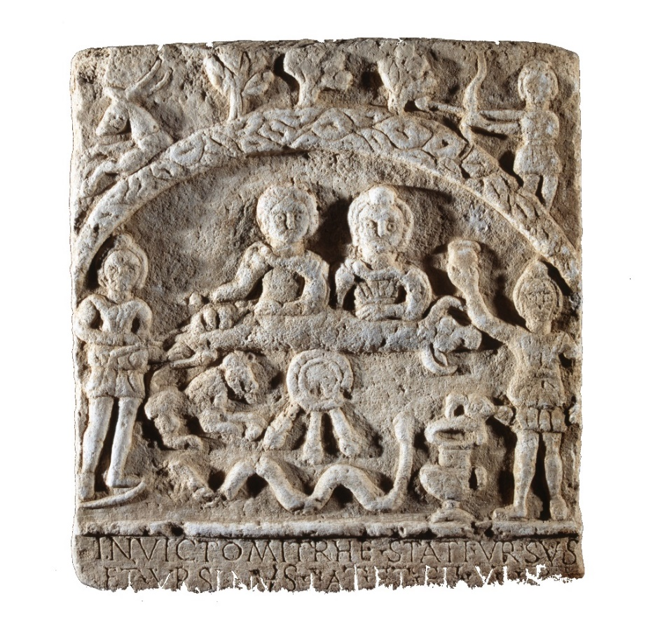
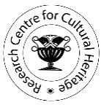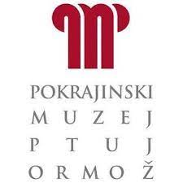

CONTEXTUALIZING ''ORIENTAL'' CULTS
New Lights on the Evidence between the Danube and the Adriatic

BOOK OF ABSTRACTS

Faculty of Humanities and Social Sciences, University of Zagreb
Archaeological Museum in Zagreb, Regional Museum Ptuj Ormož

15-17 September 2022

15th September

CONFERENCE HALL, FACULTY OF HUMANITIES AND SOCIAL SCIENCES, ZAGREB UNIVERSITY

Morning (Chair: Bruna Kuntić-Makvić)
9:15–9:45 Welcome, Introduction
[Political and social context]
9:45–10:15 Inga Vilogorac-Brčić, Cults of Isis and Imperial cult
10.15–10.45 Anja Ragolič, Mithraism in Poetovio: old data, new findings
10:45–11:15 Ljubica Perinić & Ivan Radman Livaja, “Orientals” and “Oriental” cults in Southern Pannonia: is there a correlation?
11:15–11:45 Nadežda Gavrilović, „Oriental“ cults in Moesia Superior through the eyes of their worshippers

ZAGREB ARCHAEOLOGICAL MUSEUM

Afternoon (Chair: Ante Rendić-Miočević)
[Private context and ritual practice]
15:00–15:30 Aleksandra Nikoloska, Duško Temelkoski, Olivera Jandreska, The sculpture of Faustina, Isis, and the trade of grain in Styberra
15:30–16:00 Arnaud Saura & Dan Deac, Music in Isiac Contexts
16:00–16:30 Palma Karković Takalić, Monuments dedicated to Leo and Fons from Golubić (Bosnia and Herzegovina). A particular form of worship of Mithra’s cult in the territory of Raetinium?
16:30–17.00 Željko Miletić, Architectural elements on the Tauroctonies from the Diocese of Pannonia

17:30-18.30 Visit of Museum

16th September

CONFERENCE HALL, FACULTY OF HUMANITIES AND SOCIAL SCIENCES, ZAGREB UNIVERSITY

Morning (Chair: Boris Olujić)
[Impulses and Methodology]
9:00–9:30 Laurent Bricault & Richard Veymiers, Les cultes de Mithra: un état de la question
9:30–10:00 Gabrielle Kremer, «Oriental» gods as a Romanizing factor?
10:00–10:30 Csaba Szabo, Religious communication and space sacralisation in the mithraea. Cases studies from Daciae and Pannoniae

[Symbolism]
11.00–11:30 Dilyana Boteva, Lion attacking a bull on the votive reliefs of the so-called Thracian Rider: an alternative approach
11.30–12:00 Eleni Tsatsou, Alexander the magician: Receptions of Alexander the Great in the
Roman provinces in Southeast Europe - The testimony of amulets and inscriptions

REGIONAL MUSEUM PTUJ – ORMOŽ

Afternoon (Chair: Dino Milinović)
[Topographic context]
17:30–18:00 Nirvana Silnovic, Contextualizing Mithras Cult in the Roman Province of Dalmatia
18:00–18:30 Szilvia Bíró & Ottó Sosztarits, Iseum – A Cohabitation: The Micro-Topographical and Functional Environment of the Isis Sanctuary in Savaria in the 1st and 2nd centuries AD
18:30–19:00 Christoph Hinker, Archaeological Finds from a Small Cave in Carinthia (Austria) as Indicators for the Worship of Mithras at a Rural Site in Southern Noricum

17th September

CONFERENCE HALL, FACULTY OF HUMANITIES AND SOCIAL SCIENCES, ZAGREB UNIVERSITY

Morning (Chair: Laurent Bricault)
[Case studies]
9:00–9:30 Perikles Christodoulou, Osiris in Thessaloniki. Revisiting the votive relief to Osiris mystes
9:30 – 10:00 Annareta Touloumtzidou, Isiaca from graves in Thessaloniki
10:00–10:30 Lenče Jovanova, Romanized Oriental Cults from Scupi in an Archaeological-Historical Context
10:30–11.00 Mirna Cvetko,

12.00-13.00. Wolfgang David, Mysterium Mithras: Annäherungen an einen römischen Kult (exhibition of Archaeological Museum Frankfurt, November 2022)

