A comprehensive analysis of CO₂ exchanges in agro-ecosystems based on a generic soil-crop model-derived methodology

Mathieu Delandmeter^{1*}, Joël Léonard², Fabien Ferchaud^{2,5}, Bernard Heinesch³, Tanguy Manise¹, Ariane Faurès¹, Jérôme Bindelle⁴, Benjamin Dumont¹
¹ Liege University, Gembloux Agro-Bio Tech, AgroBioChem/TERRA, Crop Science Unit, Passage des Déportés, 2, 5030 Gembloux, Belgium
² INRAE, BioEcoAgro Joint Research Unit, 02000 Barenton-Bugny, France
³ Liege University, Gembloux Agro-Bio Tech, AgroBioChem/TERRA, Biosystems Dynamics and Exchanges Unit, Passage des Déportés, 2, 5030 Gembloux, Belgium
⁴ Liege University, Gembloux Agro-Bio Tech, AgroBioChem/TERRA, Precision Livestock and Nutrition Unit/AgricultureIsLife, Passage des Déportés, 2, 5030 Gembloux, Belgium
⁵ Montpellier University, CIRAD, INRAE, IRD, InstitutAgro Montpellier, UMR Eco&Sols, 34060 Montpellier, France
*Passage des Déportés, 2, 5030 Gembloux, Belgium - @ : mathieu.delandmeter@uliege.be

Abstract
Carbon emissions in agriculture play a major role in climate change. Modelling studies enable to investigate the impacts of climate change in crops, accounting for soil organic carbon feedbacks and CO₂ concentrations. But it is primordial that crop models properly consider the CO₂ exchanges at the level of crop rotations beyond the cycle of a single crop. With this goal in mind, we used the outputs of the soil-crop model STICS in its standard pre-parameterized version to model (i) the Gross Primary Productivity (GPP), derived from the autotrophic respiration and the Net Primary Productivity, which is computed through the daily change in plant carbon (C) pools; (ii) the Ecosystem Respiration (RECO), with the autotrophic component being derived from the plant biomass, plant nitrogen concentration and GPP, and the heterotrophic component from the mineralization of residues and organic matter; and (iii) the Net Ecosystem Exchange, equal to the sum of GPP and RECO. The comparison of simulations with field observations indicates that the model is able to simulate accurately daily CO₂ fluxes originating from a long-term and diversified crop rotation (efficiency EF equal to 0.79 for GPP, 0.59 for RECO and 0.67 for NEE). Concerning the evaluation of the cumulated fluxes over the 16-year rotation, the model is able to evaluate it accurately for RECO, with a slight underestimation (normalized deviation ND = 15.7%), and very accurately for GPP (ND = 5.12%). But for NEE, the relative overestimation is higher (ND = 62.2%), indicating that a more precise estimation of HR is required to obtain reliable net C budgets. The model also succeeds to capture the trends in the influence of several environmental drivers on CO₂ fluxes. It globally proves to be a valuable tool in the investigation of CO₂ exchanges of crop rotations in historical and future climatic conditions.
Keywords: Net Ecosystem Exchange; Crop model; Gross Primary Productivity; Autotrophic respiration; Heterotrophic respiration; Carbon balance
- Introduction
Climate change causes widespread negative impacts, not only on ecosystems but also on people, settlements and infrastructure. Among these, extreme events such as heatwaves, heavy precipitations, droughts, fires, etc. are impacting ecosystems, human health and the economy and causing humanitarian crises. Furthermore, these effects are expected to intensify with a very high level of confidence (IPCC, 2022).
Among greenhouse gases, that are directly responsible for climate change, CO₂ emissions constitute 75% of global net anthropogenic emissions (IPCC, 2013). Agricultural lands generate very large CO₂ fluxes, but the balance between their source and sink capacities is subject to large uncertainties and high annual and spatial variability (Smith et al., 2007; Wattenbach et al., 2010). Globally, soils are known to store more than twice as much carbon as is contained in the vegetation or the atmosphere (Bellamy et al., 2005). Croplands have thus potential to mitigate climate change, but this requires a deep understanding of soil CO₂ fluxes and how agricultural management and environmental variables affect them.
The two major CO₂ fluxes between the atmosphere and the terrestrial biosphere result from the photosynthesis by vegetation and the respiration from autotrophic and heterotrophic organisms (Klosterhalfen et al., 2017). It is photosynthesis that is the primary source of carbon (C) in ecosystems, by fixing C in plants and adding it to soil as above- and belowground organic matter (Bolinder et al., 2007). This amount of C fixed is referred to as the Gross Primary Productivity (GPP). About half of this photosynthetically fixed carbon is lost by internal plant metabolism for plant growth and maintenance processes. These processes are called the Autotrophic Respiration (AR) (Kirschbaum and Mueller, 2001). The difference between GPP and AR is called Net Primary Productivity (NPP). The other part of the respiration is called Heterotrophic Respiration (HR). It refers to the carbon that is lost by all organisms in ecosystems other than plants: animals that live aboveground, but mostly all macro- and micro-organisms that live in the soil and the litter and decompose organic matter. The sum of the autotrophic and heterotrophic respirations is referred to as Ecosystem Respiration (RECO). Finally, Net Ecosystem Exchange (NEE) is the balance between photosynthesis, that fixes carbon, and respiration, that releases it.
The standardization of eddy-covariance measurements (Aubinet et al., 1999) has allowed the development of regional flux-tower networks (such as EUROFLUX which later morphed into CARBOEUROPE and ICOS, or AMERIFLUX) that produce standardized and long-term observations on the carbon balance of various terrestrial ecosystems ( Baldocchi et al., 2008). They have notably led to studies investigating the carbon budgets of crops using datasets ranging from one to multiple experimental sites and from one cropping season to full crop rotations. Globally, agro-ecosystems had negative annual NEE, indicating that the plants sequester more carbon than what is respired. However, they were found to be C sources when considering Net Biome Production (NBP) that also considers lateral C fluxes such as manure and harvest (Aubinet et al., 2009; Kutsch et al., 2010; Buysse et al., 2017; Dold et al., 2017). Such C losses lead to a decrease in soil organic carbon (SOC) stocks, threatening soils fertility on the long term but also potential of crops for climate mitigation.
Globally, longer-term studies are necessary to consider the inter-annual variability of C fluxes in agro-ecosystems, which is large and influenced by genetics (e.g. crop type), environment (e.g. radiation, temperature or water availability) and management (e.g. tillage) (Chi et al., 2016; Buysse et al., 2017). The determination of GPP and RECO fluxes may require combining altogether the use of eddy-covariance with soil chambers measurements, which is both time- and money-consuming and does not allow to deal easily with plot scales (Vuichard et al., 2016). An alternative consists in using partitioning methods such as non-linear regressions, look-up tables or statistical analyses, which might induce some errors (Smith et al., 2010). Moreover, if one wants to separate soil respiration into its autotrophic and heterotrophic components, additional experimental effort is needed, for example keeping a plot without vegetation nor roots in order to have a heterotrophic-only respiration area (Suleau et al., 2011), at the cost of high labour requirements. This is why it is particularly interesting to be able to estimate the components of CO₂ fluxes from a crop modelling-based approach.
Process-based models are essential research tools for extrapolating field results in both time and space. They not only allow assessing the impact of climate change on these systems through the account for soil-plant feedback mechanisms considering notably the interaction between soil organic carbon and carbon dioxide (Basso et al., 2018), but also their potential to mitigate it (Kang et al., 2009; Rosenzweig et al., 2014; Asseng et al., 2015; Lobell et al., 2017). They also help to represent current understanding of the impacts of drivers such as temperature or water content on agronomic and physical processes (Sándor et al., 2020).
Several process-based models like Agro-C (Huang et al., 2009), DNDC (Li et al., 2005), SPAc (Sus et al., 2010) or ORCHIDEE-STICS (Krinner et al., 2005) have already been developed for modelling CO₂ fluxes of the soil-plant system and compared to each other (Wattenbach et al., 2010; Lokupitiya et al., 2016; Sándor et al., 2020). It appears that most of these models either under- or overpredict CO₂ fluxes, with the most precise models limited either in their range of simulated crops or in their type of modelled flux (GPP or RECO). This restrains their ability to simulate the full carbon balance of diversified crop rotations. This is why simulating CO₂ fluxes with a process-based model such as the soil-crop model STICS (Brisson et al., 2008), already able to simulate a wide range of agronomic and environmental indicators in various agro-environmental conditions (Coucheney et al., 2015), might be profitable.
Several methods are used to model these CO₂ fluxes. Heterotrophic respiration is computed via the mineralization of humus, mulch and residues, with a dependence on different factors such as temperature (Tuomi et al., 2008), moisture availability or quality and supply of decomposable substrate material (Trumbore, 2006).
GPP and/or NPP are usually calculated by multiplying the amount of solar radiation intercepted by a coefficient of conversion of this radiation into biomass, this coefficient depending on several factors such as green leaf nitrogen content, air temperature, soil moisture and atmospheric CO₂ concentration (Kirschbaum and Mueller, 2001; Huang et al., 2009). If it is NPP that is calculated, GPP will be obtained by adding autotrophic respiration, whereas if GPP is directly derived, respiration is implicitly taken into account into the parameterization of growth functions.
To model crop respiration, a first simple approach involves using photosynthesis (GPP) and multiplying it by a respiration:photosynthesis ratio. This ratio of respiration to gross photosynthesis might be assumed to be constant over a wide range of plant sizes and growth rates, CO₂ concentrations and temperatures, but this could induce modelling uncertainties since whole-plant chambers measurements reported that this ratio might vary from 0.35 to 0.6 (Kirschbaum and Mueller, 2001; Gifford, 1995). A second approach to derive plant respiration consists in partitioning respiration into the components of growth and maintenance (Amthor, 1984). The growth respiration allows the synthesis of new tissues, while the maintenance respiration represents the cost of maintaining the existing biomass, i.e. the costs of protein synthesis and replacement, membrane repair and the maintenance of ion gradients. The advantage of this approach is that growth costs are fixed for a unit of new tissue whereas maintenance respiration varies with environment (e.g. temperature), protein turnover, plant species and even organs (greater in roots than in the shoot) (Amthor, 1984; Ryan, 1991). However, it remains theorical since maintenance and growth respiration are not biochemically distinct and cannot be differentiated experimentally. To consider the energy requirement for maintenance due to protein turnover, we can take advantage of the correlation between maintenance respiration and tissue nitrogen concentration (Ryan, 1991; Sun et al., 2007).
In this paper, we present an innovative methodology to model the CO₂ exchanges of a crop rotation. Data recorded over a 16-year crop rotation at the ICOS site of Lonzée in Belgium (BE-LON), comprising winter wheat, sugarbeet, potato, maize and cover crops, allow to calibrate and validate our approach. The soil-crop model STICS is used to model the crop rotation and as a basis to derive CO₂ fluxes. The objectives of this study are (i) to elaborate the methodology to compute GPP, RECO and NEE; (ii) to assess its validity and accuracy by a comparison with observed CO₂ fluxes; and (iii) to discuss the influence of various environmental drivers on crop rotations CO₂ fluxes, based on both field observations and simulations.
- Material and Methods
  - Site description
The BE-LON experimental site is situated in Lonzée, about 45 km at the south-east of Brussels in Belgium (50°33’08’’N, 4°44’42’’E, 165 m asl). It belongs to the Integrated Carbon Observations Systems (ICOS) network, a European infrastructure, since the 17th November of 2017. Fluxes and meteorological variables were measured with eddy-covariance following ICOS protocols, except for the period before 2014 when CARBOEUROPE-IP and FLUXNET network standards were used (Buysse et al., 2017). The measured fluxes, after correction, filtering and gap-filling, provide the NEE, following the ONEFlux processing pipeline methodology (Pastorello et al., 2020). The later partitioning of experimentally measured NEE into GPP and RECO components was conducted following the procedures used and described by Reichstein et al. (2005). Both raw fluxes measurements and treated fluxes are available in Heinesch et al. (2021). Later in the manuscript, we will refer to these fluxes as observed, despite GPP and RECO being computed from NEE which was the only flux actually measured on the field.
In Lonzée, the climate is temperate maritime (classified as Cfb in the Köppen classification; Köppen, 1984). Mean annual temperature and precipitation are about 10°C and 800 mm respectively.
The field of BE-LON experimental site covers about 12 ha on a fairly flat plateau with a quadrilateral shape. The soil is classified as a Luvisol with, in August 2007, a soil organic C stock of 46.7 tC ha⁻¹ over the 0-30 cm soil layer (Buysse et al., 2017). Records indicate that the field has been cultivated for over 80 years. Since 2004, crop rotation has been stabilized to the following 4-year sequence: sugarbeet, winter wheat, seed potatoes and winter wheat. An exception occurred in 2012 when sugarbeet was replaced by maize. Mustard was sown as cover crop and N trap in 2009, 2013, 2015 and 2017 (Table A1 in Appendices). Fertilization, mainly as nitrogen, and pesticide applications for weeding, growth regulator, control of insects and fungal followed Belgian common practices (Buysse et al., 2017). Regular soil tillage, namely 25-cm deep tillage after each winter wheat crop, was practiced.
The dataset that was used includes both agronomic and environmental data. The first category comprises Leaf Area Index (LAI), shoot biomass, yield, and N concentration in the plant and in the grain. The latter involves soil organic carbon, standard meteorological variables, evapotranspiration and CO₂ fluxes (GPP, RECO and NEE).
Further details about the BE-LON experimental site, crop management activities and data collection procedures are available e.g. in Aubinet et al. (2009), Suleau et al. (2011) or Buysse et al. (2017).
  - The STICS soil-crop model (v9.2)
In this study, we used the standard version 9.2 of STICS (Simulateur mulTIdisciplinaire pour les Cultures Standard in French); see Beaudoin et al. (2022) for a detailed description of the different versions of the model. STICS is a soil-crop model which computes changes in both agronomic (e.g. biomass and yield) and environmental variables (e.g. soil organic carbon, nitrate leaching, soil water and nitrogen, etc.) from input variables and parameters relating to weather conditions, soils and cropping systems (Brisson et al., 2009). It is a process-based model that simulates plant growth as well as water, C and N fluxes. Biomass is computed from the radiation intercepted by foliage (LAI), that is incremented on a daily basis as a logistic function of phasic development. The amount of N taken up by the plant is assumed to be the daily minimum between soil N supply and crop N demand.
STICS does not explicitly simulate neither GPP nor autotrophic respiration since it relies on the concept of radiation use efficiency that combines photosynthesis and respiration. Yet it explicitly simulates heterotrophic respiration from mineralization of all crop residues and soil organic matter (humus). The decomposition of residues follows a first-order kinetics, with a rate depending on their nature, their C:N ratio, soil temperature, water and mineral nitrogen content. The decomposition of humified organic matter depends on a mineralization rate constant (calculated according to the soil characteristics) that is multiplied by stress factors accounting for the effects of soil temperature and moisture.
  - Deriving GPP, AR and NEE from STICS output variables
The Gross Primary Productivity is the sum of the Net Primary Productivity and the autotrophic respiration (Kirschbaum and Mueller, 2001). Taking as a convention that fluxes towards the soil are regarded as negative and those leaving from the soil as positive (as e.g. in Buysse et al. (2017)), this gives:
$$\begin{aligned}GPP=NPP-AR\#\left(1\right)\end{aligned}$$
The approach used to compute the different CO₂ fluxes from STICS outputs is represented on Figure 1 and detailed hereafter..
Figure 1. Overview of the methodology used to compute the different CO₂ fluxes from STICS outputs. STICS variables are written in italic.

2.3.1 Net Primary Productivity
NPP is the daily change in the total carbon content (TCC) of the aboveground and belowground parts of the plant. Considering the different biomass pools in STICS (Brisson et al., 2009), a first method to compute the TCC is:
$$\begin{aligned}TCC=masecveg*0.42+mafruit*0.44+msrac*0.38+mafeuiltombe*0.42\#\left(2\right)\end{aligned}$$
with the STICS variables masecveg, mafruit, msrac and mafeuiltombe standing for the biomass of respectively vegetative organs, harvested organs, roots and fallen leaves due to senescence, and where each pool is multiplied by a carbon content coefficient, as defined in the STICS model.
However, this first method reveals limitations, that we hypothesize to be linked to (i) the uncertainty associated with the simulated roots biomass and C content, which might be of importance since a significant proportion of NPP is allocated to belowground plant parts (Bolinder et al., 2007; Pausch and Kuzyakov, 2018), and (ii) the carbon fraction being actually different between crops. Indeed, root biomass is not explicitly simulated at a daily time-step in STICS v9.2 (it is only calculated at harvest when roots become belowground crop residues). Furthermore, STICS assumes the carbon fraction as constant, but it actually varies, especially for the carbon contained in harvested organs (Penning de Vries, 1989).
To address these limitations, we chose to not use directly the roots biomass simulated by STICS, because (i) we lacked field data to validate belowground simulations, and, most of all, (ii) we wanted to use the standard version of STICS to avoid overfitting and keep generality and usability. In the standard parameterization of STICS, there is no dependence between root length expansion and shoot growth, which is indispensable to obtain a reliable soil-crop C balance. Instead, to derive belowground NPP, we used a constant coefficient coming from shoot-root ratios and harvest indices. It allowed to estimate NPP due to roots based on aboveground organs simulations, following the coefficients for several crops including sugarbeet, potato and maize provided by Bolinder et al. (2007) and Bolinder et al. (2015). As mentioned in these papers, this allows the approach to be easily transferable and updated with new experimental results. Rhizodeposition was considered, as carbon is exudated into the soil from the extra-root component (Asseng et al., 1997; Bolinder et al., 2007). For mustard used as cover crop, a shoot-root ratio of 5 was used, from De Baets et al. (2011). For winter wheat, we took benefit from the more extensive literature to use a dynamic shoot-root ratio evolving along the crop season, following the coefficients used in Asseng et al. (1997) which also consider exudation. This dynamic shoot-root ratio is equal to 0.66 before the maximal rate of leaf growth (end of juvenile phase), 2.33 between the maximal rate of leaf growth and flowering and 3 after flowering. This is in accordance with the constant value of 2.46 proposed by Bolinder et al. (2007). All allocation coefficients used for computing carbon stored in roots and rhizodeposition from aboveground vegetative biomass are summarized in Table A2. Secondly, for the carbon contained in harvested organs (linked to mafruit), a carbon fraction specific to each crop, lying in the interval 0.42-0.45, was proposed (Penning De Vries et al, 1989). Two reasons explain this choice. Firstly, not referring to the carbon content of harvested organs prescribed within STICS is not problematic, since i) our module is external to the crop model and ii) these organs are exported and therefore not returned to the soil. Secondly, while the model is known to be reliable as a source of biomass simulation (Coucheney et al., 2015), as it uses a constant carbon fraction within harvested organs for all crops (equal to 0.44), we believe that it is not as trustworthy for carbon estimates across a crop rotation including a diversity of plants (sugarbeet, wheat, etc.).

2.3.2 Autotrophic respiration
For the autotrophic respiration calculation, we separated it between its two components for growth (GR) and maintenance (MR):
$$\begin{aligned}AR=GR+MR \#\left(3\right)\end{aligned}$$
Growth respiration is the CO₂ emitted resulting from growth processes that convert glucose into other organic components (Penning de Vries, 1989). Therefore, from the amount of glucose required to synthetize 1g of plant material, Ruimy et al. (1996) found a growth coefficient of 0.28 $(∈[0.25, 0.29])$, based on various natural ecosystems and various organs. This role of glucose molecules, serving as building components for virtually all organic constituents, is common and almost constant to all plants (Penning de Vries, 1972; Amthor, 1984; Penning de Vries, 1989; Ryan, 1991; Poorter, 1994).
To compute GR, we used the equation of the ORCHIDEE model described in Krinner et al. (2005) and Vuichard et al. (2016). A fixed fraction (28%) of the available carbon for growth (GPP-MR) was used for GR. As highlighted in Figure 1, GPP, AR and GR are interlinked. To deal with computation issues, we computed GR at day i as being a function of GPP at day i-1, such a correlation being suggested in Suleau et al. (2011):
$$\begin{aligned}{GR}_{i}=\left({GPP}_{i-1}-{MR}_{i}\right)*0.28 \#\left(4\right)\end{aligned}$$
Initial values GPP₁ and GR₁ are null since we started the simulations in STICS, specific to each crop season, before sowing.

2.3.3 Maintenance respiration
To simulate maintenance respiration, we used the correlation between plant maintenance respiration and tissue N, as reported by Ryan (1991). This relationship conceives that a major energy demand for plant tissue maintenance is for protein turnover, to support protein repair and replacement (Ryan et al., 1991; Kirschbaum and Mueller, 2001; Sun et al., 2007). Following Amthor (2000), Kirschbaum and Mueller (2001) and Sun et al. (2007), we used the following relationship between the maintenance respiration MR [kg C m⁻² day⁻¹], the aboveground plant biomass W [kg m⁻²], the environmental temperature T [°C] and the tissue N content [%]:
$$\begin{aligned}MR=(aN+b) * Q_{10}^{\frac{T-25}{10}}*W \#\left(5\right)\end{aligned}$$
with $Q_{10}$ a temperature coefficient of respiration equal to 2 (the Q₁₀ value and the reference temperature are widely confirmed by the literature, e.g. in Vandendriessche (2000)). Sun et al. (2007) found from pot experiments, for wheat and rice and for the aboveground AR, coefficients a and b respectively equal to 2.16 and -0.66 (when converted to the units we used). These are also used for several crops in the Agro-C model (Huang et al., 2009).
However, since we made the choice to compute AR from its maintenance and growth components, we need to calculate the coefficients a and b of Eq. (5) for maintenance respiration only. We took benefit from our long-term dataset to separate it into randomly selected independent calibration and validation sets for each crop (Table A3). Since the amount of data did not allow an independent validation for maize and cover crops, we decided to use for these crops the coefficients obtained from winter wheat. It appeared that the coefficients should be fitted separately for winter wheat, sugarbeet and potato. Indeed physiological differences exist between organs respiration rates. For example, Amthor (1984) indicated that the maintenance respiration coefficient is greater in roots than in the shoot, and Suleau et al. (2011) suggested that the storage organs of sugarbeet respire less than fine roots.
For the fitting process, we started from the equality
$$\begin{aligned}RECO=HR+GR+MR\#\left(6\right)\end{aligned}$$
and substituted GR and MR by their expressions in Eq. (4) and Eq. (5), leading to the following relationship:
$$\begin{aligned}\underset{⇔}{} RECO-HR=\left(GPP-MR\right)*0.28+MR\#\left(7\right)\end{aligned}$$
$$\begin{aligned}\underset{⇔}{} RECO-HR=0.28*GPP+\left(1-0.28\right)* \left(aN+b\right)* Q_{10}^{\frac{T-25}{10}}*W\#\left(8\right)\end{aligned}$$
where all indicators are replaced by their estimated values except for RECO which is observed. This allowed to estimate by linear regression the values of the coefficients a and b for the different crops with the following equality, with i and i-1 indicating the day:
$$\begin{aligned}\underset{⇔}{} aN_{{sim}_{i}}+b=\frac{{RECO}_{{obs}_{i}}-{HR}_{{sim}_{i}}-0.28*{GPP}_{{sim}_{i-1}}}{\left(1-0.28\right)*Q_{10}^{\frac{T_{i}-25}{10}}*W_{{sim}_{i}}} \#\left(9\right)\end{aligned}$$
We finally computed total autotrophic respiration with Eq. (3).

2.3.4 Net Ecosystem Exchange
Using the soil heterotrophic respiration (HR) simulated by STICS, we computed the Net Ecosystem Exchange (NEE) with
$$\begin{aligned}NEE=AR \left(>0\right)+HR\left(>0\right)+GPP \left(<0\right) \#\left(10\right)\end{aligned}$$
One should note that, if its objective is to compute NEE with no regard to autotrophic respiration, combining Eqs. (1) and (10), it is similar to compute NEE with
$$\begin{aligned}NEE=HR \left(>0\right)+NPP \left(<0\right) \#\left(11\right)\end{aligned}$$
  - Environmental drivers of NEE
NEE is known to vary between cropping years, even for a given crop (Aubinet et al., 2009; Buysse et al., 2017). The BE-LON dataset allowed us to study the influence of environmental factors on NEE inter-annual variability. Indeed, the same management was applied to same crops for different cropping years. As in the study of Buysse et al. (2017), we explored using linear regressions between seasonal NEE (from emergence to harvest) and environmental drivers such as (i) the number of days of active vegetation (NDAV), i.e. days when daily GPP was in absolute value over a certain threshold estimated to be optimal to avoid the influence of weeds that the model is unable to reproduce (50 g C m⁻² d⁻¹ for winter wheat and 10 g C m⁻² d⁻¹ for the other crops as in Ceschia et al. (2010) and Buysse et al. (2017)), (ii) the cumulated radiation (Q_{cum}) during active vegetation period, (iii) the average air temperature (T_{air,av}) during the active vegetation period, (iv) the water balance (precipitation minus evapotranspiration) and (v) the SPEI. The Standardized Precipitation-Evapotranspiration Index (SPEI) characterizes the onset, duration and magnitude of a drought based on the difference between precipitations and evapotranspiration (Vicente-Serrano et al., 2010). It then captures the impact of temperature on water demand. Correlations were tested for the SPEI at different months as well as for different durations.
  - Crop model parameterization and validation

2.5.1 Parameterization
Soil parameters initializing the simulations originated from observations used to define a standard profile, because no initial values were available. For the plants, we used the standard parameters provided with STICS v9.2 that were validated on the large and diversified datasets of the STICS core team (Beaudoin et al., 2022). Few slight modifications were made for winter wheat, according to Dumont et al. (2016), and for potato, according to M. Launay (personal communication). All simulations files related to soil and plant parameterization, crop management and outputs are available in Appendix A3.

2.5.2 Validation
To evaluate the accuracy of the model simulations, three different indicators were used: the Root Mean Square Error (RMSE), the Model Efficiency (EF) and the Normalized Deviation (ND):
$$RMSE= \sqrt{ \frac{1}{n} \sum_{i=1}^{n}{{(S_{i}-O_{i})}^{2}}}$$
$$EF=1- \frac{\sum_{i=1}^{n}{{(S_{i}-O_{i})}^{2}}}{\sum_{i=1}^{n}{{(O_{i}-\overline{O})}^{2}}}$$
$$ND= \frac{ \sum_{i=1}^{n}{O_{i}}- \sum_{i=1}^{n}{S_{i}}}{\sum_{i=1}^{n}{O_{i}}}$$
with $S_{i}$ the simulations and $O_{i}$ the observations. We consider that the model is adequate for a given variable of interest if $EF ≥0.5$ and $|ND| ≤ 0.1$ (Beaudoin et al., 2008). A graphical analysis based on RMSE decomposition between its systematic (RMSEs) and unsystematic (RMSEu) components (Willmott et al., 1981), initially proposed in Taylor (2001), was used to assess model global performance. They were calculated as follows:
$$RMSEs= \sqrt{ \frac{1}{n} \sum_{i=1}^{n}{{(\overset{̿}{S_{i}}-O_{i})}^{2}}}$$
$$RMSEu= \sqrt{ \frac{1}{n} \sum_{i=1}^{n}{{(S_{i}- \overset{̿}{S_{i}})}^{2}}}$$
with $\overset{̿}{S_{i}}=c_{1}+d_{1}* O_{i}$ the linear regression of observed versus simulated values. This was utilized for example by Coucheney et al. (2015), which established criteria allowing to qualify an indicator simulation as satisfactory, good or very good. RMSE components were standardized to compare the performance of simulation between variables having different units.
We also used the parameters $c_{2}$and $d_{2}$of the linear regression $\overset{̿}{O_{i}}=c_{2}+d_{2}* S_{i}$ of simulated versus observed values as supplementary indicators of the goodness of fit: the intercept $c_{2}$ and the slope $d_{2}$ being as close as possible to respectively 0 and 1 (Pineiro et al., 2008).
- Results and Discussion
  - Relationship between plant N concentration and maintenance respiration
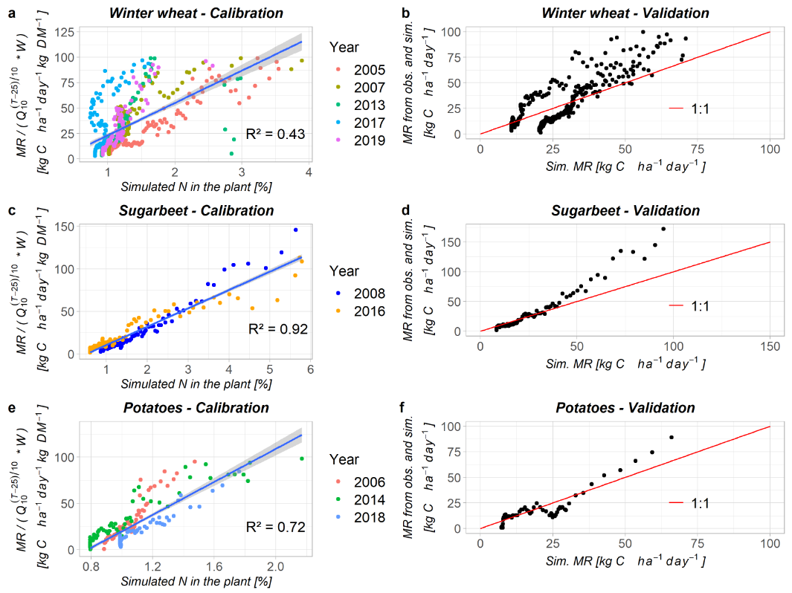
Figure 2. Fitting results to compute maintenance respiration (MR) from plant N concentration for winter wheat (2a and 2b), sugarbeet (2c and 2d) and potatoes (2e and 2f). Fig. 2a, 2c and 2e show, for each crop, the relationship between plant N concentration and simulated MR (divided by the Q₁₀-coefficient and biomass W) in the calibration set, with in blue the linear regression and its 95%-confidence interval. Fig. 2b, 2d and 2f compare, in the independent validation set, the simulated MR on the x-axis, and the MR computed with observed RECO (as defined in Eq. (9)) on the y-axis. Regression coefficients and goodness of fit indicators are summarized in Table A4.
As illustrated in Fig. 2, calibration proved that the model is adequate to predict maintenance respiration (R² between 0.43 and 0.92 for calibration), with however a higher variability in winter wheat response (Fig. 2a). Such a variability may be caused by the different varieties that were sown and/or different turnover rates for the enzymatic processes of respiration (Ryan, 1991). Similarly, the potato cropping season of 2006 (red points in Fig. 2e) is seen to observe a different respiration rate compared to the two other seasons. We believe it is because of the different cultivar sown during that year (cv. Spunta) compared to 2014 and 2018 cropping seasons (cv. Draga). Bouma et al. (1992) indicated that differences in potato leaf respiration rates between cultivars might be due to contrasted general metabolic activity due to different optima for temperature. The maintenance coefficient a, which represents the dependence of maintenance respiration (per unit of dry matter) on nitrogen content, is higher for potato compared to the two other crops (Table A4). This might be due to (i) the lower variability of simulated N concentration in its aboveground tissues, (ii) the difference of maintenance respiration rates between above- and belowground parts of the plant (Amthor, 1984), and (iii) the energy cost associated to nocturnal carbohydrate export (proportional to the total dark respiration) within starch-storing species (Bouma et al., 1995). Validation confirmed the model pertinence (Fig. 2b, 2d, 2f and Table A4).
  - Model performance
The STICS model satisfactorily simulated the agronomic indicators that are involved in CO₂ fluxes computation: shoot biomass, yield, N concentration in the grain and evapotranspiration were all well simulated (Fig. 3). We see on Figure 3 that the RMSE is largely dominated by its unsystematic component, indicating that model errors are mainly related to data dispersion rather than due to a systematic bias in the model (Willmott, 1981; Coucheney et al., 2015). For the soil organic carbon, field observations were only made in 2007 and 2017, but they confirm that soil C content simulations were realistic over the long-term period (Fig. A1). The ‘good’ simulation of daily evapotranspiration (EF = 0.65), and the ‘very good’ simulation associated to the prediction of biomass and yield $(EF≥0.88)$ and to N concentration in harvested organs $(EF=0.73$ for the grain) provided a reliable basis to further proceed with CO₂ fluxes modelling.
Figure 3. Model performance for the main indicators over the 16-year dataset in Lonzée (Belgium).
Calculation performance of daily GPP, RECO and NEE ranged from satisfactory to very good (Fig. 3). Figure 4 illustrates the advantages of the approach allowing to distinguish the different pools in GPP allocation (Fig. 4a) and RECO (Fig. 4b). For each cropping season, the dynamics of the observed and simulated CO₂ fluxes (GPP, RECO and NEE) are available in Appendix A2. Globally, we noticed that a bias in GPP estimation during the growth period was often concomitant with a similar bias in RECO estimation; these underestimations are illustrated respectively on Fig. 4a and Fig. 4b. As exemplified on Fig. 4c, these mismatches might compensate for each other and provide a better estimation of NEE. For RECO, an underestimation of plant nitrogen content, that would induce an underestimation of maintenance respiration, might be at play – see e.g. Fig. A2. However, too few data were available for the validation of total plant N uptake over the different crops. Therefore, the standard parameterization of each crop was used to simulate plant N uptake. We believe this might be a point of attention for future researches and improvement of our methodology.
Figure 4. Dynamics of the CO₂ fluxes related to NEE, GPP and RECO, observed and simulated, for the winter wheat cropping season of 2010-2011. For GPP and RECO, the contribution of the different pools or sources to the global fluxes are presented.
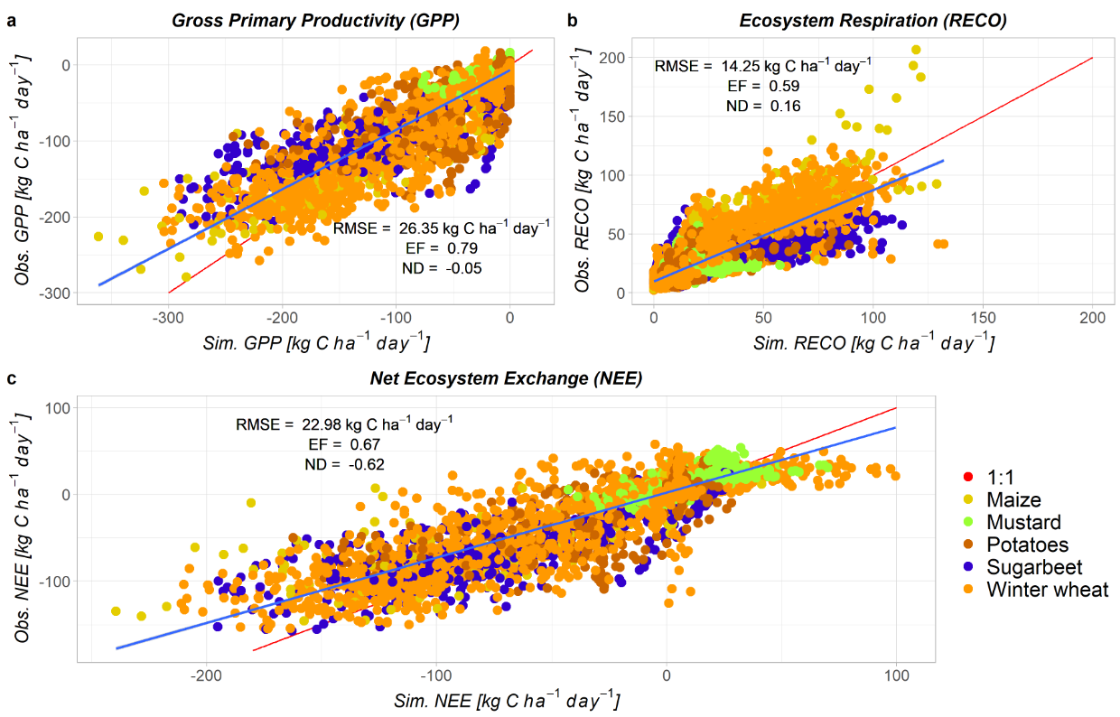
Figure 5. Comparison between observations and simulations for a) GPP b) RECO and c) NEE. The red line represents the ideal 1:1 trajectory and the blue line designates the linear regression of observations-simulations pairs.
All three global efficiencies for CO₂ fluxes simulation were satisfactory to very good (Table 1). Yet while the model offered good results on RMSEs, EF and ND criteria, the goodness of fit indicators $c_{2}$ and $d_{2}$ - respectively statistically different from 0 and 1 (Table 1) - suggest that the model would benefit from additional calibration for plant parameterization. Potatoes and cover crops results were slightly less satisfying than other crops (Table A5). For potatoes, this might be due to the different varieties that were sown, all simulated with the same standard parameters. For cover crops, few agronomic data such as LAI, biomass or N content were available to validate the simulations. Underestimations of RECO were notably noticed for some cover crop seasons (Appendix A2). Hence errors in CO₂ fluxes estimations can be ascribed to a bias in biomass and/or N content simulations at daily time scale impacting the inferred calculations of CO₂ fluxes. Regarding future research, we recommend to investigate further on the calibration related to the winter periods and/or cover crop seasons. Indeed we noticed that RECO was also sometimes underestimated over the early winter months of winter wheat seasons (Appendix A2). Since HR is predominant at these periods, it might be valuable to explore further the parameterization of mineralization rates. Moreover, we used for cover crops the coefficients between plant N concentration and maintenance respiration derived for winter wheat, but we believe that specific calibration of these coefficients for mustard cover crop would be helpful. We lacked data to investigate further these suggested improvements, but we believe they might be worth to be explored in future work.
 | GPP | RECO | NEE
RMSE  EF | 26.35 | 14.25 | 22.98
EF | 0.79 | 0.59 | 0.67
ND | -0.05 | 0.16 | -0.62
Intercept $c_{2}$ | -6.82  [-7.48, -6.15] | 9.73  [9.27, 10.19] | 2.27  [1.76, 2.78]
Slope $d_{2}$ | 0.78  [0.78, 0.79] | 0.78  [0.76, 0.79] | 0.75  [0.74, 0.76]
Table 1. Global performance indicators for CO₂ fluxes modelling. RMSE is given in [kg C ha⁻¹ day⁻¹]. The coefficients of the regression of all daily points with simulated C flux in abscissa and observed one in ordinate axis, $c_{2}$ (in [kg C ha⁻¹ day⁻¹]) and $d_{2}$, are given with their 95%-confidence interval.
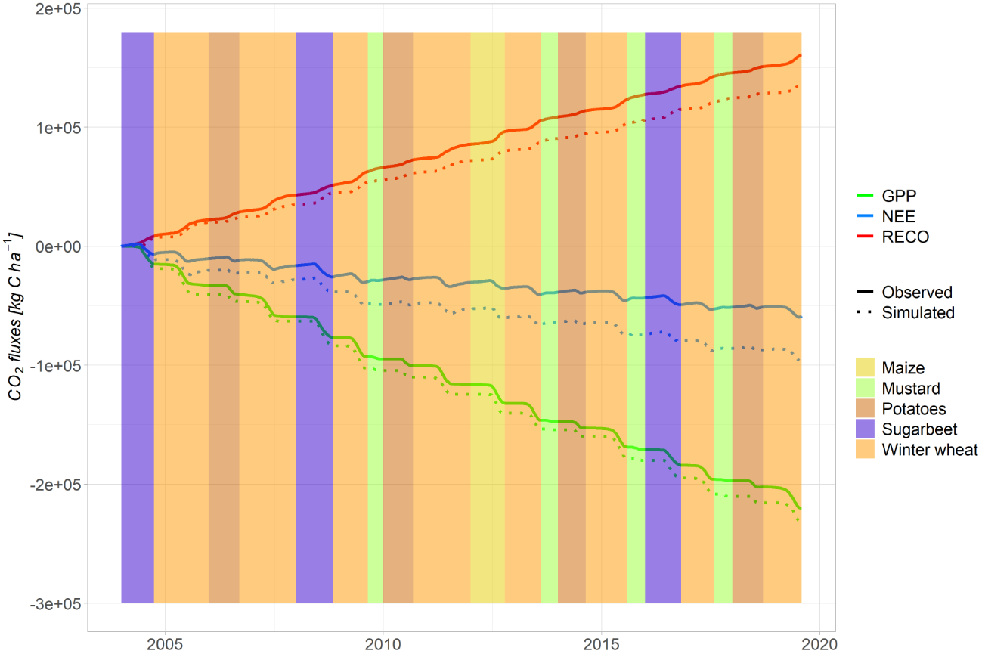
Figure 6. Cumulated CO₂ fluxes for the whole 16-year period. We use as convention that fluxes towards the soil are regarded as negative and those leaving from the soil as positive.
We see with Figure 6, that illustrates cumulated CO2 fluxes for the 16-year period, and with ND criteria of Figure 5, summarized in Tables 1 and A5 (for separate crops), that the model might be considered as satisfying to elaborate the cumulated fluxes of a long-term and diversified crop rotation, with a global error equal to 5.12% for GPP (overestimated in absolute value) and 15.7% for RECO (underestimated). It is possible that our overestimation of GPP might be slightly greater than observed on Fig. 5 and Fig. 6 since the model does not consider weeds nor crop re-growth after harvest. Yet the observations might include the CO2 fluxes they generate, and this tends to increase (in absolute value) GPP (Ceschia et al., 2010; Sus et al., 2010; Klosterhalfen et al., 2017; Pique et al., 2020).
ND was much greater for NEE (62.2%). This poor performance might be explained by the presence in daily NEE of both positive and negative values, leading to lower absolute mean value and therefore to a relative error much greater. However, in this case, reliable crop rotations NEE budgets would require, in view of the ND value associated to RECO, better estimates of HR (since NEE does not involve AR), as already suggested above. This is in accordance with Vuichard et al. (2016) which indicated that current crop models fail to establish precise net CO₂ fluxes budgets and that a bias in NEE budgets is often explained by a bias in RECO. This suggests that the model is more suitable to establish comparisons between crops, environments and management rather than to provide absolute carbon budgets.
We compared our results with those obtained by the multi-models and multi-sites comparisons of Sándor et al. (2020) and Wattenbach et al. (2010) (Table A6). Sándor et al. (2020) compared individually 23 models at three different cropping sites, with full calibration based on data such as biomass, phenology, soil temperature, moisture, mineral N, N₂O emissions and soil organic C and N flux. They also compared the multi-model median (MMM) describing the models ensemble performance (with some models specialized in one or two kinds of CO₂ fluxes). Wattenbach et al. (2010) compared four models at five cropping sites. Globally, our approach performed better on RECO, GPP and NEE, even if one must retain that our study dataset is limited to one experimental site. Our approach is however outperformed for NEE prediction by the Soil Plant Atmosphere model (SPA), which obtained better results for GPP and NEE in Wattenbach et al. (2010). This model is specialized in predicting photosynthesis and water balance (Williams et al., 1996) and requires a granular parameterization since it uses very fine temporal and spatial scales (30 min time step, ten canopy and twenty soil layers, leaf-level photosynthesis and transpiration) (Williams et al., 2000; Wattenbach et al., 2010).
We also compared our results with those of the ORCHIDEE-STICS model. It combines the ORCHIDEE ecosystem model to STICS (Li et al., 2011). The main difference between ORCHIDEE-STICS and our methodology lies in the calculation of maintenance respiration (MR), which we based on a linear relationship between N content in biomass and MR with a $Q_{10}$-Van’t Hoff equation temperature dependence, whereas the ORCHIDEE model estimates MR as a function of the C:N ratio of each tissue plus a linear increase with the temperature (Krinner et al., 2005). The ORCHIDEE model also computes photosynthesis with a 30 min time step at the canopy scale. ORCHIDEE-STICS was used at seven wheat cropping seasons in Vuichard et al. (2016) and five maize cropping seasons in Li et al. (2011) (Table A6). Our approach performed globally better, both for winter wheat and maize, even if one must notice that studies concerned different agro-environmental conditions. When compared with the model ORCHIDEE-CROP, a small variant of ORCHIDEE-STICS, it appeared graphically -the study does not report indicators- that our approach performed better for estimating NEE for the 2006-07 wheat cropping season at the same experimental site of BE-LON (Wu et al., 2016).
  - Roots NPP
As detailed above, roots NPP was computed from shoot-root ratios rather than from root biomass simulated by STICS. This choice was motivated by the desire to use the standard version (v9.2) released, for generality and usability purposes. In that version, all crops are parameterized without dependence of root length expansion on shoot growth, which might be detrimental to roots C balance simulation. The proposed methodology allows to obtain reliable C simulations without any specific parameterization relative to plant roots. This is interesting because of the typical difficulty to gather roots experimental data. Our results reported that the importance of roots and rhizodeposition into global NPP ranges in average from 24.3% for winter wheat to only 2.15% for potato and 0.7% for sugarbeet. For wheat, this is in line with Bolinder et al. (2007), that estimated to 19.6% the relative proportion of NPP due to roots and rhizodeposition. For sugarbeet and potatoes, this is also consistent with Bolinder et al. (2015), that provided the shoot-root ratios that we used for these crops and estimated this relative proportion to 2.5% for potato and 1.7% for sugarbeet, suggesting that it is much lower for root crops than for other annual crops. However, whereas our objective was to estimate NPP continuously along the growing season, Bolinder et al. (2015) focused on estimating annual C inputs to soil, hence not considering for example coarse lateral roots that are attached to the beet (because it is removed at harvest). This suggests that roots NPP might be slightly higher for sugarbeet than estimated from our methodology.
  - NEE inter-annual variability and relation to driving variables
variable1, variable2 | $$β_{1}$$ |  | $$β_{2}$$ |  | $$γ$$ |  | R² |  | p
 | Obs. | Sim. | Obs. | Sim. | Obs. | Sim. | Obs. | Sim. | Obs. | Sim.
Winter wheat cropping seasons (n = 8)
NDAV | -150.63 (53.68) | -161.32 (25.38) | - | - | 9314 (5533) | 7485 (2645) | 0.57 | 0.87 | 0.03** | 7.1e-4**
Q_{cum} | -4.33 (2.79) | -15.95 (1.69) | - | - | -4261 (1866) | 1340 (1127) | 0.29 | 0.94 | 0.172 | 7.9e-5**
Q_{cum}, T_{air, av} | -4.21 (3.03) | -15.98 (1.85) | 244 (611.1) | -74.78 (373.37) | -7777 (9034) | 2418 (5519) | 0.31 | 0.94 | 0.398 | 9.7e-4**
Potato cropping seasons (n = 4)
T_{air, av} | 174.7 (142.7) | 198.3 (105.1) | - | - | -5491 (2419) | -6283 (1782) | 0.43 | 0.64 | 0.288 | 0.199
Q_{cum}, T_{air, av} | -2.67 (3.18) | -2.33 (1.99) | 137.1 (161.02) | 165.46 (100.42) | -3863 (3262) | -4863 (2034) | 0.67 | 0.85 | 0.579 | 0.389
Surgarbeet cropping seasons (n = 3)
NDAV | -205.59 (64.69) | 40.1 (133.8) | - | - | 22798 (9950) | -15649 (18030) | 0.91 | 0.08 | 0.194 | 0.815
T_{air, av} | 1318.9 (460.5) | 804 (1514) | - | - | -29639 (7202) | -23255 (23685) | 0.89 | 0.22 | 0.214 | 0.689
SPEI-3 in month preceding harvest | -822.6 (1875.9) | -2602 (1041) | - | - | -9571 (2198) | -12731 (1220) | 0.16 | 0.86 | 0.737 | 0.243
Cover crop periods (n = 4)
NDAV | 0.47 (3.74) | -27.29 (8.11) | - | - | 214 (243) | 1646 (537) | 0.008 | 0.85 | 0.829 | 0.078*
Q_{cum} | 1.42 (1.37) | -10.55 (3.72) | - | - | -199 (148) | 703 (401) | 0.35 | 0.80 | 0.408 | 0.105
Q_{cum}, T_{air, av} | 1.23 (1.62) | -11.18 (3.93) | -84.5 (122.42) | -274.32 (297.27) | 717 (1339) | 3678 (3251) | 0.56 | 0.89 | 0.663 | 0.328
Table 2. Regression coefficients of the relation $NEE= β_{1} variable1+ β_{2} variable2$ for the different crops between crop emergence and harvest. Only the regressions that are significant (**p < 0.05, *p < 0.1) or almost significant for at least the observations and/or the simulations are displayed. $β_{1}$ is expressed in kg C ha⁻¹ d⁻¹ with variable1 = NDAV, in kg C ha⁻¹ (MJ m⁻²)⁻¹ with variable1 = Q_{cum}, in kg C ha⁻¹ °C⁻¹ with variable1 = T_{air, av} and in kg C ha⁻¹ with variable1 = SPEI-3. $β_{2}$ is expressed in kg C ha⁻¹ °C⁻¹. Values between brackets are the standard errors of the coefficients.
Globally, most significant correlations were found for winter wheat, which is explained by its higher number of cropping seasons. Yet global trends were similar between crops.
For winter wheat and cover crops, NDAV was negatively correlated with NEE, indicating a greater C sequestration when the number of active vegetation days increases (Table 2 and Fig. A3a). Similar behaviour was reported by Ceschia et al. (2010) and Buysse et al. (2017), the latter reporting an R²-value of 0.58 when considering all winter wheat cropping seasons between 2005 and 2015. This result emphasizes the importance of extending the vegetation period whenever it is possible, e.g. by early sowing or long cover crops, for greater environmental performance such as C sequestration.
Based on simulations, NEE was also correlated with the photosynthetic active radiation intercepted by the canopy, Q_{cum} (Table 2 and Fig. A3b). The correlation was even stronger when the regression also included air temperature. This relates to the positive influence of these two drivers on crop growth. No significant correlation was found based on observations.
No significant correlations were found either between NEE and any SPEI. However, for sugarbeet, a non-significant correlation (R² = 0.86, p = 0.243) between simulations and the SPEI-3, based on the last 3 months preceding harvest (i.e. August or September), was suggested (correlation significancy is difficult to satisfy because of the low number of sugarbeet cropping seasons). A wetter end of the cropping season, leading to a higher SPEI-3, was associated to an increase in C sequestration, suggesting that the better water availability increased crop growth (Shrestha et al., 2010).
Globally, we observed that, except in some cases for potato and sugarbeet, correlations, even when not significant, were higher when obtained from the simulated NEE than from the observed one. The model is deterministic and process-based; therefore it is coherent that simulated physiological processes and our new external algorithms are found to be correlated to driving variables. However, in real life, external events might increase the dispersion of observed values and decrease the strength of the correlation. Such events might be material failure, gap filling, wheat lodging that would slow down maturity and increase the growing period, etc.
  - Respiration components

3.5.1 Influence of management operations on heterotrophic respiration
As exemplified on Figure 7, we noticed that there was a systematic peak in simulated HR when crops were harvested. We believe that this is associated to two modelling assumptions. Firstly, organic residues mineralization rate might be overestimated, which would also explain the sudden peak at stubble breaking not observed in the field. Indeed mineralization rates used in STICS were calibrated on really finely crushed residues whereas crop residues in the field often form bigger pieces (Nicolardot et al., 2001). STICS tends to overestimate carbon mineralization, and a previous sensitivity analysis showed that the decomposition rate of residues has an influence on the shape of the kinetics at the beginning of decomposition (Nicolardot et al., 2001). Secondly, in STICS v9.2, root biomass is computed at harvest and returned to the soil as belowground residues. This might contribute to the simulated HR peak at harvest, not observed in field data because part of the roots actually died along the season before harvest.
Figure 7. Ecosystem respiration during the 2006-07 season of winter wheat. The arrows show the harvest (in orange) and the stubble breaking (in blue) dates.

3.5.2 Contribution of autotrophic to total respiration
We compared the mean daily ratios of autotrophic respiration to total ecosystem respiration for specific seasons (Table A7). The work of Suleau et al. (2011), performed at the same experimental site of BE-LON with soil chambers, allows us to compare the respective importance of observed versus simulated autotrophic and heterotrophic components of ecosystem respiration. The comparison between observations and simulations gave very satisfying results (Table A7), except for potatoes for which the difference was greater. The global AR/RECO ratios obtained for the different crops (Table A7) seem to confirm the assumption of Buysse et al. (2017) which suggested that the autotrophic contribution of sugarbeet to total ecosystem respiration is lower than the one for maize and winter wheat. The reported domination of the autotrophic component of ecosystem respiration is also confirmed by many studies such as Moureaux et al. (2008), Wang et al. (2015) and Demyan et al. (2016). Suleau et al. (2011) suggested that this is due to the relatively low SOC level and limited manure input which are typical of the loam region where BE-LON is situated.

3.5.3 Influence of temperature on respiration components
Partitioning of respiration allows us to investigate the influence of temperature on respiration components. They all include a dependance on temperature in their calculation, directly for MR (Eq. (5)) and for HR (with an exponential increase in mineralization rates with higher soil temperatures (Brisson et al. (2009)), and indirectly for GR (depending on GPP and MR). Such a dependance is thus induced by the parameters that we use in our methodology and in the STICS model, and can be compared with field or lab experiments results. Figure A4 presents the evolution of AR and HR with the soil temperature for winter wheat, the most represented crop in our dataset. Using Van’t Hoff equation, we obtained $Q_{10}=2.49 (∈[2.3, 2.71]$ with 95%-confidence) for HR and $Q_{10}=2.93 (∈[2.74, 3.15]$) for AR. This contrasts with Suleau et al. (2011) which found a bigger correlation with temperature for HR than for AR (Q₁₀ = 2.11 for HR and Q₁₀ = 1.76 for AR). They however utilized only one crop season (against eight in our study) and warned that their results were difficult to generalize. Zhang et al. (2020) suggested that soil respiration, including HR but also below-ground AR, is largely influenced by soil temperature whereas above-ground AR is largely influenced by air temperature. Very few studies investigate the autotrophic component of respiration, and as Suleau et al. (2011), we believe that field or laboratory experiments that would directly measure AR (instead of estimating it for example with root exclusion zones) would be helpful.
In an attempt to push further the analysis, we investigated the potential interactive effect of respiration sensitivity to temperature with soil moisture. We found that the soil water content (SWC), in the first horizon 0-30cm, was a factor significantly improving linear models that correlate AR/HR with soil temperature (R² = 0.51 and p < 0.01 for AR, R² = 0.34 and p < 0.01 for HR). By taking the first order derivative of these models with respect to soil temperature, it appeared that the sensitivity of HR to soil temperature depends on SWC, but it is not the case for AR which includes above-ground plant respiration (Fig. A5). This goes in line with Zhang et al. (2013) which also found a correlation between HR and SWC but no significative impact of SWC on soil autotrophic respiration. We found that the soil temperature significatively decreases as SWC increases (R² = 0.32, p < 0.01). Therefore we would have expected that the temperature sensitivity of HR would decrease as SWC increases (and not the opposite as illustrated with the brown line of Fig. A5), since a decrease of SWC is correlated with an increase of soil temperature and that the mineralization rate exponentially increases with temperature in the STICS model (Brisson et al., 2009). But this means that, in our temperate soil, the effect of SWC on HR, inducing an increase in HR with increasing SWC, is more important than temperature, as represented by the coefficients of the regression y₂ (Fig. A5). As suggested above with Q₁₀ relationships, the sensitivity of AR to soil temperature is almost always greater than for HR, except when the soil water content is above field capacity, i.e. 30%. As Ding et al. (2007), we believe that further study is required to investigate the interaction between soil moisture and temperature on CO₂ fluxes, which seems important for future modelling efforts.
- Conclusions
The present study demonstrates that it is possible, from the outputs of a soil-crop model (STICS in this study), to obtain a reliable estimation of CO₂ fluxes originating from a diversified crop rotation, with model efficiencies ranging from satisfactory to very good. The genericity of the proposed methodology makes it transferable to any soil-crop model. It computes separately the evolution of photosynthesis (GPP) and ecosystem respiration (RECO). This could help verifying the partitioning of the NEE observed with eddy covariance into GPP and RECO components, since many different statistical flux-partitioning methods exist (Moffat et al., 2007; Desai et al., 2008; Smith et al., 2010; Wohlfahrt and Galvagno, 2017). Moreover, the identification of autotrophic and heterotrophic components of RECO is useful to predict the evolution of RECO with climate and/or soil- and crop management (Trumbore, 2006). Measuring that on-field is not possible with eddy covariance and requires the combined use of soil chambers (Suleau et al., 2011; Zhang et al., 2013; Whang et al., 2015), that are time- and energy-consuming. Process-based models are key tools to extrapolate these results. We emphasize the importance of delivering accurate simulations of biomass, yields and nitrogen concentration prior reliable CO₂ fluxes estimations, with a particular attention to crop residues management and operations that have a significative impact on these fluxes.
The model was proven to capture the inter- and intra-annual variability of CO₂ fluxes associated to several environmental drivers. It turns out to be a suitable tool for investigating these trends whereas field observations sometimes miss them because of the influence of external events or data inconsistency. We believe that the proposed methodology might be used to project the CO₂ exchanges of various crop rotations under different management schemes and climate change scenarios, to investigate the impact of crop rotations on climate change but also their potential of adaptation and mitigation.
Yet we believe that there is still room for improvement. A new version of STICS (v10) offers the possibility to consider the daily N allocation to roots, as well as the daily computation of roots mortality and soil restitution. It should help to use roots biomass simulations directly in NPP computation. This might enhance our estimation of roots NPP which was based, for crops other than winter wheat, on a constant average shoot-root ratio measured near plant maturity.
Further validation with other agricultural systems, such as crops in varied pedo-climatic conditions but also grasslands, would be interesting to fully validate our methodology. A granular analysis of the model performance under contrasted management practices might also be relevant (e.g. tillage or cover crops). The ever increasing impacts of climate change should motivate us in conducting such research for an ever better understanding of the role of agricultural systems in ecosystem carbon exchanges.
- Declarations of interest
The authors declare no conflicts of interest.
- Acknowledgement
This study was funded by the F.R.S-FNRS (Belgian Fund for Scientific Research; Research Fellow grant (number 44221) awarded to M. Delandmeter). The authors thank the farmer, Philippe Van Eyck, for everyday field management, and the Lonzée ICOS station team for site maintenance, data acquisition, treatment and delivery. We also thank the reviewers that made insightful comments which improved the contents of this manuscript.
- References
Amthor, J. S. (1984). The role of maintenance respiration in plant growth. Plant, Cell & Environment, 7(8), 561-569. https://doi.org/10.1111/1365-3040.ep11591833
Amthor, J. S. (2000). The McCree–de Wit–Penning de Vries–Thornley respiration paradigms: 30 years later. Annals of Botany, 86(1), 1-20. https://doi.org/10.1006/anbo.2000.1175
Asseng, S., Richter, C., & Wessolek, G. (1997). Modelling root growth of wheat as the linkage between crop and soil. Plant and Soil, 190(2), 267-277. https://doi.org/10.1023/A:1004228201299
Asseng, S., Zhu, Y., Wang, E., & Zhang, W. (2015). Crop modeling for climate change impact and adaptation. In Crop physiology (pp. 505-546). Academic Press. https://doi.org/10.1016/B978-0-12-417104-6.00020-0
Aubinet, M., Grelle, A., Ibrom, A., Rannik, Ü., Moncrieff, J., Foken, T., ... & Vesala, T. (1999). Estimates of the annual net carbon and water exchange of forests: the EUROFLUX methodology. In Advances in Ecological Research (Vol. 30, pp. 113-175). Academic Press. https://doi.org/10.1016/S0065-2504(08)60018-5
Aubinet, M., Moureaux, C., Bodson, B., Dufranne, D., Heinesch, B., Suleau, M., ... & Vilret, A. (2009). Carbon sequestration by a crop over a 4-year sugar beet/winter wheat/seed potato/winter wheat rotation cycle. Agricultural and Forest Meteorology, 149(3-4), 407-418. https://doi.org/10.1016/j.agrformet.2008.09.003
Baldocchi, D. (2008). ‘Breathing’ of the terrestrial biosphere: lessons learned from a global network of carbon dioxide flux measurement systems. Australian Journal of Botany, 56(1), 1-26. https://doi.org/10.1071/BT07151
Basso, B., Dumont, B., Maestrini, B., Shcherbak, I., Robertson, G. P., Porter, J. R., ... & Rosenzweig, C. (2018). Soil organic carbon and nitrogen feedbacks on crop yields under climate change. Agricultural & Environmental Letters, 3(1), 180026. https://doi.org/10.2134/ael2018.05.0026
Beaudoin, N., Launay, M., Sauboua, E., Ponsardin, G., & Mary, B. (2008). Evaluation of the soil-crop model STICS over 8 years against the “on farm” database of Bruyères catchment. European Journal of Agronomy, 29(1), 46-57. https://doi.org/10.1016/j.eja.2008.03.001
Beaudoin N., Lecharpentier P., Ripoche D., Strullu L., Mary B., Leonard J., Launay M., Justes E., eds. 2022. STICS soil-crop model. Conceptual framework, equations and uses, Versailles, Éditions Quæ.
Bellamy, P. H., Loveland, P. J., Bradley, R. I., Lark, R. M., & Kirk, G. J. (2005). Carbon losses from all soils across England and Wales 1978–2003. Nature, 437(7056), 245-248. https://doi.org/10.1038/nature04038
Bolinder, M. A., Janzen, H. H., Gregorich, E. G., Angers, D. A., & VandenBygaart, A. J. (2007). An approach for estimating net primary productivity and annual carbon inputs to soil for common agricultural crops in Canada. Agriculture, Ecosystems & Environment, 118(1-4), 29-42. https://doi.org/10.1016/j.agee.2006.05.013
Bolinder, M. A., Kätterer, T., Poeplau, C., Börjesson, G., & Parent, L. E. (2015). Net primary productivity and below-ground crop residue inputs for root crops: Potato (Solanum tuberosum L.) and sugar beet (Beta vulgaris L.). Canadian Journal of Soil Science, 95(2), 87-93. https://doi.org/10.4141/cjss-2014-091
Bouma, T. J., Spitters, C. J. T., & De Visser, R. (1992). Variation in respiration rate between potato cultivars: effect of developmental stage. In Molecular, biochemical and physiological aspects of plant respiration (pp. 515-522). SPB Academic Publishing. https://edepot.wur.nl/216693
Bouma, T. J., De Visser, R., Van Leeuwen, P. H., De Kock, M. J., & Lambers, H. (1995). The respiratory energy requirements involved in nocturnal carbohydrate export from starch-storing mature source leaves and their contribution to leaf dark respiration. Journal of Experimental Botany, 46(9), 1185-1194. https://doi.org/10.1093/jxb/46.9.1185
Brisson, N., Launay, M., Mary, B., Beaudoin, N. (2009). Conceptual basis, formalizations and parameterization of the STICS crop model. Ed. Quae. 297
Buysse, P., Bodson, B., Debacq, A., De Ligne, A., Heinesch, B., Manise, T., ... & Aubinet, M. (2017). Carbon budget measurement over 12 years at a crop production site in the silty-loam region in Belgium. Agricultural and Forest Meteorology, 246, 241-255. https://doi.org/10.1016/j.agrformet.2017.07.004
Ceschia, E., Béziat, P., Dejoux, J. F., Aubinet, M., Bernhofer, C., Bodson, B., ... & Wattenbach, M. (2010). Management effects on net ecosystem carbon and GHG budgets at European crop sites. Agriculture, Ecosystems & Environment, 139(3), 363-383. https://doi.org/10.1016/j.agee.2010.09.020
Chi, J., Waldo, S., Pressley, S., O’Keeffe, P., Huggins, D., Stöckle, C., ... & Lamb, B. (2016). Assessing carbon and water dynamics of no-till and conventional tillage cropping systems in the inland Pacific Northwest US using the eddy covariance method. Agricultural and forest meteorology, 218, 37-49. https://doi.org/10.1016/j.agrformet.2015.11.019
Coucheney, E., Buis, S., Launay, M., Constantin, J., Mary, B., de Cortázar-Atauri, I. G., ... & Léonard, J. (2015). Accuracy, robustness and behavior of the STICS soil–crop model for plant, water and nitrogen outputs: evaluation over a wide range of agro-environmental conditions in France. Environmental Modelling & Software, 64, 177-190. https://doi.org/10.1016/j.envsoft.2014.11.024
De Baets, S., Poesen, J., Meersmans, J., & Serlet, L. (2011). Cover crops and their erosion-reducing effects during concentrated flow erosion. Catena, 85(3), 237-244. https://doi.org/10.1016/j.catena.2011.01.009
Demyan, M. S., Ingwersen, J., Funkuin, Y. N., Ali, R. S., Mirzaeitalarposhti, R., Rasche, F., ... & Cadisch, G. (2016). Partitioning of ecosystem respiration in winter wheat and silage maize - Modeling seasonal temperature effects. Agriculture, Ecosystems & Environment, 224, 131-144. https://doi.org/10.1016/j.agee.2016.03.039
Desai, A. R., Richardson, A. D., Moffat, A. M., Kattge, J., Hollinger, D. Y., Barr, A., ... & Stauch, V. J. (2008). Cross-site evaluation of eddy covariance GPP and RE decomposition techniques. Agricultural and Forest Meteorology, 148(6-7), 821-838. https://doi.org/10.1016/j.agrformet.2007.11.012
Ding, W., Cai, Y., Cai, Z., Yagi, K., & Zheng, X. (2007). Soil respiration under maize crops: effects of water, temperature, and nitrogen fertilization. Soil Science Society of America Journal, 71(3), 944-951. https://doi.org/10.2136/sssaj2006.0160
Dold, C., Büyükcangaz, H., Rondinelli, W., Prueger, J. H., Sauer, T. J., & Hatfield, J. L. (2017). Long-term carbon uptake of agro-ecosystems in the Midwest. Agricultural and Forest Meteorology, 232, 128-140. https://doi.org/10.1016/j.agrformet.2016.07.012
Dumont, B., Basso, B., Bodson, B., Destain, J. P., & Destain, M. F. (2016). Assessing and modeling economic and environmental impact of wheat nitrogen management in Belgium. Environmental Modelling & Software, 79, 184-196. https://doi.org/10.1016/j.envsoft.2016.02.015
[dataset] Heinesch, B., Bodson, B., Chopin, H., De Ligne, A., Demoulin, L., Douxfils, B., Engelmann, T., Faurès, A., Longdoz, B., Manise, T., Piret, A., Thyrion, T. (2021). Fluxnet Product, Lonzee, 2003-12-31–2020-12-31, Miscellaneous, https://hdl.handle.net/11676/ql2ZkJ2Xx4a4yOyG3cd5lsBS
Gifford, R. M. (1995). Whole plant respiration and photosynthesis of wheat under increased CO2 concentration and temperature: long‐term vs. short‐term distinctions for modelling. Global Change Biology, 1(6), 385-396. https://doi.org/10.1111/j.1365-2486.1995.tb00037.x
Huang, Y., Yu, Y., Zhang, W., Sun, W., Liu, S., Jiang, J., ... & Yang, Z. (2009). Agro-C: A biogeophysical model for simulating the carbon budget of agroecosystems. Agricultural and forest meteorology, 149(1), 106-129. https://doi.org/10.1016/j.agrformet.2008.07.013
IPCC (2013). Climate Change 2013: The Physical Science Basis. Contribution of Working Group I to the Fifth Assessment Report of the Intergovernmental Panel on Climate Change [Stocker, T.F., D. Qin, G.-K. Plattner, M. Tignor, S.K. Allen, J. Boschung, A. Nauels, Y. Xia, V. Bex and P.M. Midgley (eds.)]. Cambridge University Press, Cambridge, United Kingdom and New York, NY, USA, 1535 pp.
IPCC (2022). Climate Change 2022: Impacts, Adaptation, and Vulnerability. Contribution of Working Group II to the Sixth Assessment Report of the Intergovernmental Panel on Climate Change [H.-O. Pörtner, D.C. Roberts, M. Tignor, E.S. Poloczanska, K. Mintenbeck, A. Alegría, M. Craig, S. Langsdorf, S. Löschke, V. Möller, A. Okem, B. Rama (eds.)]. Cambridge University Press. Cambridge University Press, Cambridge, UK and New York, NY, USA, 3056 pp. https//doi.org/10.1017/9781009325844.
Kang, Y., Khan, S., & Ma, X. (2009). Climate change impacts on crop yield, crop water productivity and food security–A review. Progress in natural Science, 19(12), 1665-1674. https://doi.org/10.1016/j.pnsc.2009.08.001
Kirschbaum, M. U. F. and Mueller, R. (2001). Net Ecosystem Exchange: Workshop Proceedings. Cooperative Research Centre for Greenhouse Accounting.
Klosterhalfen, A., Herbst, M., Weihermüller, L., Graf, A., Schmidt, M., Stadler, A., ... & Vereecken, H. (2017). Multi-site calibration and validation of a net ecosystem carbon exchange model for croplands. Ecological modelling, 363, 137-156. https://doi.org/10.1016/j.ecolmodel.2017.07.028
Köppen, W. (1884). Die Wärmezonen der Erde, nach der Dauer der heissen, gemässigten und kalten Zeit und nach der Wirkung der Wärme auf die organische Welt betrachtet. Meteorologische Zeitschrift, 1(21), 5-226.
Krinner, G., Viovy, N., de Noblet‐Ducoudré, N., Ogée, J., Polcher, J., Friedlingstein, P., ... & Prentice, I. C. (2005). A dynamic global vegetation model for studies of the coupled atmosphere‐biosphere system. Global Biogeochemical Cycles, 19(1). https://doi.org/10.1029/2003GB002199
Kutsch, W. L., Aubinet, M., Buchmann, N., Smith, P., Osborne, B., Eugster, W., ... & Ziegler, W. (2010). The net biome production of full crop rotations in Europe. Agriculture, Ecosystems & Environment, 139(3), 336-345. https://doi.org/10.1016/j.agee.2010.07.016
Li, C., Frolking, S., Xiao, X., Moore III, B., Boles, S., Qiu, J., ... & Sass, R. (2005). Modeling impacts of farming management alternatives on CO2, CH4, and N2O emissions: A case study for water management of rice agriculture of China. Global Biogeochemical Cycles, 19(3). https://doi.org/10.1029/2004GB002341
Li, L., Vuichard, N., Viovy, N., Ciais, P., Wang, T., Ceschia, E., ... & Bernhofer, C. (2011). Importance of crop varieties and management practices: evaluation of a process-based model for simulating CO2 and H2O fluxes at five European maize (Zea mays L.) sites. Biogeosciences, 8(6), 1721-1736. https://doi.org/10.5194/bg-8-1721-2011
Lobell, D. B., & Asseng, S. (2017). Comparing estimates of climate change impacts from process-based and statistical crop models. Environmental Research Letters, 12(1), 015001. https://doi.org/10.1088/1748-9326/aa518a
Lokupitiya, E., Denning, A. S., Schaefer, K., Ricciuto, D., Anderson, R., Arain, M. A., ... & Xue, Y. (2016). Carbon and energy fluxes in cropland ecosystems: a model-data comparison. Biogeochemistry, 129(1), 53-76. https://doi.org/10.1007/s10533-016-0219-3
Moffat, A. M., Papale, D., Reichstein, M., Hollinger, D. Y., Richardson, A. D., Barr, A. G., ... & Stauch, V. J. (2007). Comprehensive comparison of gap-filling techniques for eddy covariance net carbon fluxes. Agricultural and Forest Meteorology, 147(3-4), 209-232. https://doi.org/10.1016/j.agrformet.2007.08.011
Moureaux, C., Debacq, A., Hoyaux, J., Suleau, M., Tourneur, D., Vancutsem, F., ... & Aubinet, M. (2008). Carbon balance assessment of a Belgian winter wheat crop (Triticum aestivum L.). Global Change Biology, 14(6), 1353-1366. https://doi.org/10.1111/j.1365-2486.2008.01560.x
Nicolardot, B., Recous, S., & Mary, B. (2001). Simulation of C and N mineralisation during crop residue decomposition: a simple dynamic model based on the C: N ratio of the residues. Plant and soil, 228(1), 83-103. https://doi.org/10.1023/A:1004813801728
Pastorello, G., Trotta, C., Canfora, E., Chu, H., Christianson, D., Cheah, Y. W., ... & Law, B. (2020). The FLUXNET2015 dataset and the ONEFlux processing pipeline for eddy covariance data. Scientific data, 7(1), 1-27. https://doi.org/10.1038/s41597-020-0534-3
Pausch, J., & Kuzyakov, Y. (2018). Carbon input by roots into the soil: quantification of rhizodeposition from root to ecosystem scale. Global change biology, 24(1), 1-12. https://doi.org/10.1111/gcb.13850
Penning de Vries (1972). Respiration and growth. In Crop processes in controlled environments (No. 2, pp. 327-347). Academic Press.
Penning de Vries (1989). Simulation of ecophysiological processes of growth in several annual crops (Vol. 29). Int. Rice Res. Inst.
Piñeiro, G., Perelman, S., Guerschman, J. P., & Paruelo, J. M. (2008). How to evaluate models: observed vs. predicted or predicted vs. observed?. Ecological modelling, 216(3-4), 316-322. https://doi.org/10.1016/j.ecolmodel.2008.05.006
Pique, G., Fieuzal, R., Al Bitar, A., Veloso, A., Tallec, T., Brut, A., ... & Ceschia, E. (2020). Estimation of daily CO2 fluxes and of the components of the carbon budget for winter wheat by the assimilation of Sentinel 2-like remote sensing data into a crop model. Geoderma, 376, 114428. https://doi.org/10.1016/j.geoderma.2020.114428
Poorter, H. (1994). Construction costs and payback time of biomass: a whole plant perspective. A whole plant perspective on carbon-nitrogen interactions, 111-127.
Reichstein, M., Falge, E., Baldocchi, D., Papale, D., Aubinet, M., Berbigier, P., ... & Valentini, R. (2005). On the separation of net ecosystem exchange into assimilation and ecosystem respiration: review and improved algorithm. Global change biology, 11(9), 1424-1439. https://doi.org/10.1111/j.1365-2486.2005.001002.x
Rosenzweig, C., Elliott, J., Deryng, D., Ruane, A. C., Müller, C., Arneth, A., ... & Jones, J. W. (2014). Assessing agricultural risks of climate change in the 21st century in a global gridded crop model intercomparison. Proceedings of the national academy of sciences, 111(9), 3268-3273. https://doi.org/10.1073/pnas.1222463110
Ruimy, A., Dedieu, G., & Saugier, B. (1996). TURC: A diagnostic model of continental gross primary productivity and net primary productivity. Global Biogeochemical Cycles, 10(2), 269-285. https://doi.org/10.1029/96GB00349
Ryan, M. G. (1991). Effects of climate change on plant respiration. Ecological Applications, 1(2), 157-167. https://doi.org/10.2307/1941808
Sándor, R., Ehrhardt, F., Grace, P., Recous, S., Smith, P., Snow, V., ... & Bellocchi, G. (2020). Ensemble modelling of carbon fluxes in grasslands and croplands. Field Crops Research, 252, 107791. https://doi.org/10.1016/j.fcr.2020.107791
Shrestha, N., Geerts, S., Raes, D., Horemans, S., Soentjens, S., Maupas, F., & Clouet, P. (2010). Yield response of sugar beets to water stress under Western European conditions. Agricultural Water Management, 97(2), 346-350. https://doi.org/10.1016/j.agwat.2009.10.005
Smith, P., D. Martino, Z. Cai, D. Gwary, H. Janzen, P. Kumar, B. McCarl, S. Ogle, F. O’Mara, C. Rice, B. Scholes, O. Sirotenko (2007). Agriculture. In Climate Change 2007: Mitigation. Contribution of Working Group III to the Fourth Assessment Report of the Intergovernmental Panel on Climate Change [B. Metz, O.R. Davidson, P.R. Bosch, R. Dave, L.A. Meyer (eds)], Cambridge University Press, Cambridge, United Kingdom and New York, NY, USA.
Smith, P., Lanigan, G., Kutsch, W. L., Buchmann, N., Eugster, W., Aubinet, M., ... & Jones, M. (2010). Measurements necessary for assessing the net ecosystem carbon budget of croplands. Agriculture, Ecosystems & Environment, 139(3), 302-315. https://doi.org/10.1016/j.agee.2010.04.004
Suleau, M., Moureaux, C., Dufranne, D., Buysse, P., Bodson, B., Destain, J. P., ... & Aubinet, M. (2011). Respiration of three Belgian crops: partitioning of total ecosystem respiration in its heterotrophic, above-and below-ground autotrophic components. Agricultural and Forest Meteorology, 151(5), 633-643. https://doi.org/10.1016/j.agrformet.2011.01.012
Sun, W., Huang, Y., Chen, S., Zou, J., & Zheng, X. (2007). Dependence of wheat and rice respiration on tissue nitrogen and the corresponding net carbon fixation efficiency under different rates of nitrogen application. Advances in Atmospheric Sciences, 24(1), 55-64. https://doi.org/10.1007/s00376-007-0055-4
Sus, O., Williams, M., Bernhofer, C., Béziat, P., Buchmann, N., Ceschia, E., ... & Wattenbach, M. (2010). A linked carbon cycle and crop developmental model: Description and evaluation against measurements of carbon fluxes and carbon stocks at several European agricultural sites. Agriculture, Ecosystems & Environment, 139(3), 402-418. https://doi.org/10.1016/j.agee.2010.06.012
Taylor, K. E. (2001). Summarizing multiple aspects of model performance in a single diagram. Journal of Geophysical Research: Atmospheres, 106(D7), 7183-7192. https://doi.org/10.1029/2000JD900719
Trumbore, S. (2006). Carbon respired by terrestrial ecosystems–recent progress and challenges. Global Change Biology, 12(2), 141-153. https://doi.org/10.1111/j.1365-2486.2006.01067.x
Tuomi, M., Vanhala, P., Karhu, K., Fritze, H., & Liski, J. (2008). Heterotrophic soil respiration—comparison of different models describing its temperature dependence. Ecological Modelling, 211(1-2), 182-190. https://doi.org/10.1016/j.ecolmodel.2007.09.003
Vandendriessche, H. J. (2000). A model of growth and sugar accumulation of sugar beet for potential production conditions: SUBEMOpo I. Theory and model structure. Agricultural Systems, 64(1), 1-19. https://doi.org/10.1016/S0308-521X(00)00005-6
Vicente-Serrano, S. M., Beguería, S., & López-Moreno, J. I. (2010). A multiscalar drought index sensitive to global warming: the standardized precipitation evapotranspiration index. Journal of climate, 23(7), 1696-1718. https://doi.org/10.1175/2009JCLI2909.1
Vuichard, N., Ciais, P., Viovy, N., Li, L., Ceschia, E., Wattenbach, M., ... & Wu, X. (2016). Simulating the net ecosystem CO2 exchange and its components over winter wheat cultivation sites across a large climate gradient in Europe using the ORCHIDEE-STICS generic model. Agriculture, Ecosystems & Environment, 226, 1-17. https://doi.org/10.1016/j.agee.2016.04.017
Wang, Y., Hu, C., Dong, W., Li, X., Zhang, Y., Qin, S., & Oenema, O. (2015). Carbon budget of a winter-wheat and summer-maize rotation cropland in the North China Plain. Agriculture, Ecosystems & Environment, 206, 33-45. https://doi.org/10.1016/j.agee.2015.03.016
Wattenbach, M., Sus, O., Vuichard, N., Lehuger, S., Gottschalk, P., Li, L., ... & Smith, P. (2010). The carbon balance of European croplands: A cross-site comparison of simulation models. Agriculture, Ecosystems & Environment, 139(3), 419-453. https://doi.org/10.1016/j.agee.2010.08.004
Williams, M., Rastetter, E. B., Fernandes, D. N., Goulden, M. L., Wofsy, S. C., Shaver, G. R., ... & Nadelhoffer, K. J. (1996). Modelling the soil‐plant‐atmosphere continuum in a Quercus–Acer stand at Harvard Forest: the regulation of stomatal conductance by light, nitrogen and soil/plant hydraulic properties. Plant, Cell & Environment, 19(8), 911-927. https://doi.org/10.1111/j.1365-3040.1996.tb00456.x
Williams, M., Eugster, W., Rastetter, E. B., Mcfadden, J. P., & Chapin Iii, F. S. (2000). The controls on net ecosystem productivity along an Arctic transect: a model comparison with flux measurements. Global Change Biology, 6(S1), 116-126. https://doi.org/10.1046/j.1365-2486.2000.06016.x
Willmott, C. J. (1981). On the validation of models. Physical geography, 2(2), 184-194. https://doi.org/10.1080/02723646.1981.10642213
Wohlfahrt, G., & Galvagno, M. (2017). Revisiting the choice of the driving temperature for eddy covariance CO2 flux partitioning. Agricultural and forest meteorology, 237, 135-142. https://doi.org/10.1016/j.agrformet.2017.02.012
Wu, X., Vuichard, N., Ciais, P., Viovy, N., de Noblet-Ducoudré, N., Wang, X., ... & Ripoche, D. (2016). ORCHIDEE-CROP (v0), a new process-based agro-land surface model: model description and evaluation over Europe. Geoscientific Model Development, 9(2), 857-873. https://doi.org/10.5194/gmd-9-857-2016
Zhang, Q., Lei, H. M., & Yang, D. W. (2013). Seasonal variations in soil respiration, heterotrophic respiration and autotrophic respiration of a wheat and maize rotation cropland in the North China Plain. Agricultural and Forest Meteorology, 180, 34-43. https://doi.org/10.1016/j.agrformet.2013.04.028
Zhang, Q., Lei, H., Yang, D., Xiong, L., Liu, P., & Fang, B. (2020). Decadal variation in CO 2 fluxes and its budget in a wheat and maize rotation cropland over the North China Plain. Biogeosciences, 17(8), 2245-2262. https://doi.org/10.5194/bg-17-2245-2020
- Appendices

A1. Supplementary Tables and Figures
Crops | Sowing date | Harvest date
Sugarbeet | 30-03-04 | 29-09-04
Winter wheat | 14-10-04 | 3-08-05
Potatoes | 1-05-06 | 15-09-06
Winter wheat | 13-10-06 | 5-08-07
Sugarbeet | 22-04-08 | 4-11-08
Winter wheat | 13-11-08 | 7-08-09
Cover crop (mustard) | 1-09-09 | 1-12-09
Potatoes | 25-04-10 | 5-09-10
Winter wheat | 14-10-10 | 16-08-11
Maize | 14-05-12 | 13-10-12
Winter wheat | 25-10-12 | 12-08-13
Cover crop (mustard) | 5-09-13 | 15-11-13
Potatoes | 7-04-14 | 22-08-14
Winter wheat | 15-10-14 | 2-08-15
Cover crop (mustard) | 26-08-15 | 9-12-15
Sugarbeet | 12-04-16 | 27-10-16
Winter wheat | 29-10-16 | 30-07-17
Cover crop (mustard) | 7-09-17 | 6-12-17
Potatoes | 23-04-18 | 11-09-18
Winter wheat | 10-10-18 | 30-07-19
Table A1. 16-year crop rotation at the experimental site of Lonzée (Belgium). More information is available in Buysse et al. (2017).

Crop |  | Roots + rhizodeposition coefficient
Winter wheat | Before maximal rate of leaf growth (end of juvenile phase) | 1.5
 | Between maximal rate of leaf growth and flowering | 0.43
 | After flowering | 0.33
Sugarbeet |  | 0.05
Potato |  | 0.11
Maize |  | 0.59
Mustard cover crop |  | 0.2
Table A2. Coefficient used to compute carbon pool contained in roots and rhizodeposition, as described in NPP computation (Section 2.3.1). The coefficient is multiplied to aerial vegetative organs biomass.

Crop | Crop seasons used for calibration | Crop seasons used for validation
Winter wheat | 2004-05, 2006-07, 2012-13, 2016-17, 2018-19 | 2008-09, 2010-11, 2014-15
Sugarbeet | 2008, 2016 | 2004
Potatoes | 2006, 2014, 2018 | 2010
Table A3. Calibration and validation sets for the fitting process used to compute coefficients of maintenance respiration.

 | Calibration |  |  | Validation
Crop | a  [kg C ha⁻¹ day⁻¹ / % of N in the plant / kg DM] | b  [kg C ha⁻¹ day⁻¹] | R² | EF | ND | RMSE  [kg C ha⁻¹ day⁻¹]
Winter wheat | 3.18  (2.86, 3.51) | -0.87  (-1.32, -0.41) | 0.43 | 0.66 | 0.08 | 142.8
Sugarbeet | 2.15  (2.08, 2.23) | -1.10  (-1.23, -0.97) | 0.92 | 0.78 | 0.14 | 159.8
Potatoes | 8.90  (8.19, 9.6) | -6.91  (-7.65, -6.17) | 0.72 | 0.82 | -0.11 | 70.8
Table A4. Linear regression of Eq. (9) results. The regression coefficients a and b are displayed for each of the three crops fitted separately on calibration datasets, with their 95%-confidence interval. Indicators EF, ND and RMSE show the model performance on an independent validation dataset.
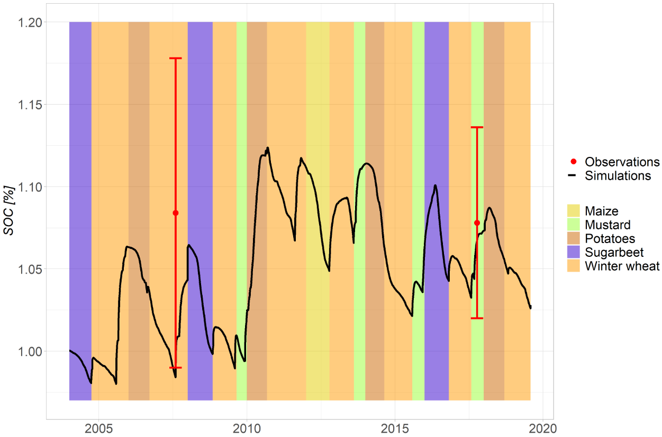
Figure A1. Soil organic carbon dynamics. The two field observations, in 2007 and 2017, are given with their standard deviation.

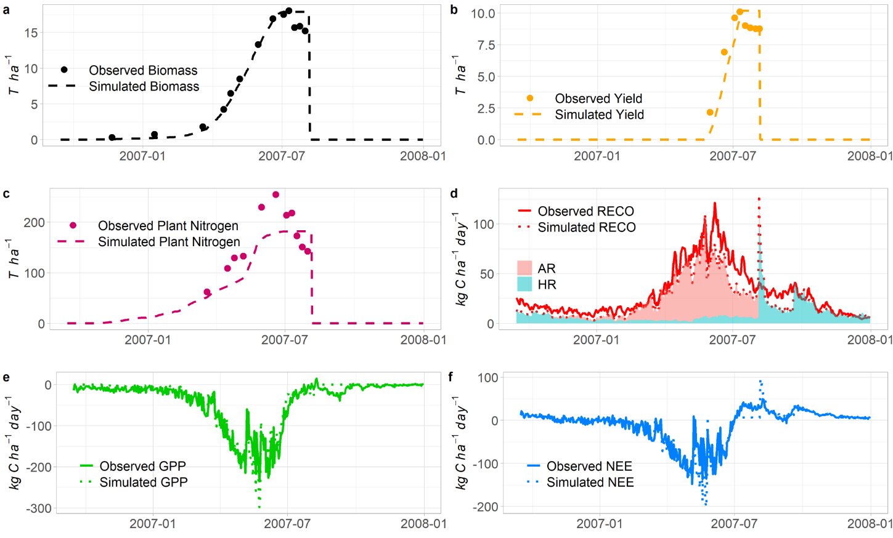
Figure A2. Comparison between observations and simulations for a) total aerial biomass, b) yield, c) plant nitrogen content, d) RECO, e) GPP and f) NEE, for the winter wheat cropping season of 2006-2007.

 |  | RMSE [kg C ha⁻¹ day⁻¹] | EF | ND
Winter wheat | NEE | 23.70 | 0.69 | -0.59
 | RECO | 13.33 | 0.72 | 0.19
 | GPP | 24.17 | 0.85 | -0.04
Potatoes | NEE | 19.68 | 0.54 | -5.53
 | RECO | 11.69 | 0.37 | 0.24
 | GPP | 25.44 | 0.60 | 0.07
Sugarbeet | NEE | 25.36 | 0.69 | -0.26
 | RECO | 18.07  .07 | -0.34 | -0.11
 | GPP | 37.35 | 0.60 | -0.18
Maize | NEE | 32.92 | 0.36 | -0.57
 | RECO | 20.32 | 0.72 | 0.27
 | GPP | 32.41  .92 | 0.80 | 0.01
Cover crop | NEE | 12.06 | 0.37 | 0.32
 | RECO | 12.25 | -0.61 | 0.19
 | GPP | 8.85 | 0.56 | 0.08
Table A5. Performance indicators for CO₂ fluxes modelling for the different crops.

ALL CROPS | Our results at Lonzée experimental site | Sándor et al. (2020)  Model comparison | Wattenbach et al. (2010)  Model comparison
Crops | Winter wheat, sugarbeet, potatoes, maize, mustard cover crop | Spring wheat, soybean, rapeseed, maize, spring wheat, triticale, phacelia, rice | Winter wheat
Crop sites | 1 | 3 | 5
Total years of data | 16 | 19 | 5
GPP | EF = 0.79 | Best EF between 0.43 and 0.44  MMM EF between 0.32 and 0.58 | Best mean EF = 0.69  Mean of mean EFs = 0.65
RECO | EF = 0.59 | Best EF between -100.46 and 0.37  MMM EF between -3.53 and 0.03 | Best mean EF = 0.44  Mean of mean EFs = -0.14
NEE | EF = 0.67 | Best EF between 0.15 and 0.26  MMM EF between 0.22 and 0.55 | Best mean EF = 0.76  Mean of mean EFs = 0.55
WINTER WHEAT | Our results at Lonzée experimental site | Vuichard et al. (2016)  ORCHIDEE-STICS
Crops | Subset with winter wheat | Winter wheat
Crop sites | 1 | 7
Total years of data | 8 | 7
GPP | Mean R = 0.95  Best R = 0.97  Worst R = 0.88 | Mean R = 0.91  Best R = 0.97  Worst R = 0.80
RECO | Mean R = 0.89  Best R = 0.95  Worst R = 0.76 | Mean R = 0.88  Best R = 0.95  Worst R = 0.76
NEE | Mean R = 0.90  Best R = 0.95  Worst R = 0.80 | Mean R = 0.87  Best R = 0.95  Worst R = 0.74
MAIZE | Our results at Lonzée experimental site | Li et al. (2011)  ORCHIDEE-STICS
Crops | Subset with maize | Maize
Crop sites | 1 | 5
Total years of data | 1 | 5
GPP | R² = 0.88 | Mean R² = 0.58  Best R² = 0.83  Worst R² = 0.32
RECO | R² = 0.79 | Mean R² = 0.42  Best R² = 0.81  Worst R² = 0.03
NEE | R² = 0.72 | Mean R² = 0.55  Best R² = 0.73  Worst R² = 0.23
Table A6. Comparison of CO₂ fluxes simulations performance with other CO₂ fluxes simulations studies. For the winter wheat, we used the goodness of fit indicator R as in Vuichard et al. (2016), from Taylor (2001). For the maize, we used the goodness of fit indicator R² as in Li et al. (2011). One must be aware that R² differs from the efficiency EF, used in this present study.

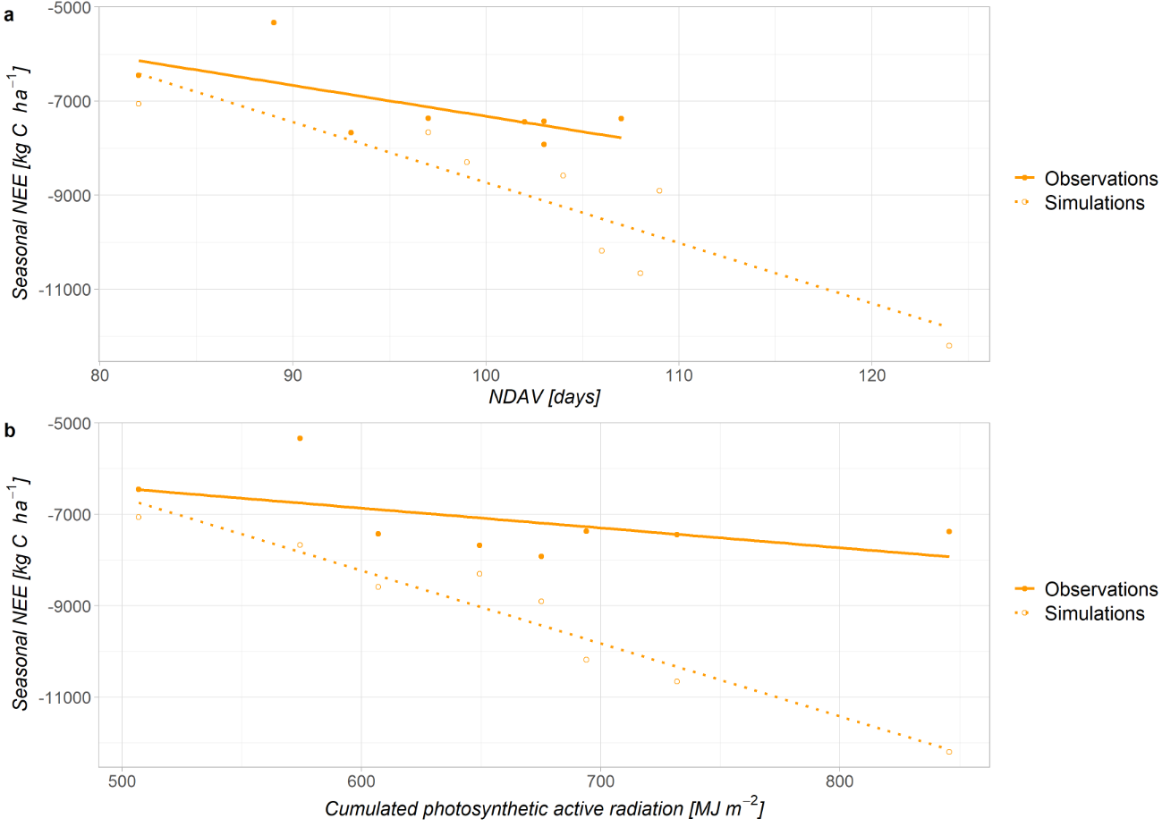
Figure A3. Correlation between cumulated seasonal NEE and a) the number of days of active vegetation (NDAV) b) the cumulated photosynthetic active radiation intercepted by the canopy (Qcum), for winter wheat (WW) between emergence and harvest.

Crop season | Observed AR/RECO  (Suleau et al., 2011) | Computed AR/RECO
Potatoes 2006  (DOY 153-220) | 67% | 81%
Winter wheat 2006-07  (DOY 92-200) | 89% | 89%
Sugarbeet 2008  (DOY 136-262) | 62% | 64%
 | Computed total AR/total RECO (between emergence and harvest)
Maize | 81.9%
Potatoes | 64.8%
Winter wheat | 80.6%
Sugarbeet | 76.8%
Table A7. Ratios of AR to RECO. For the single seasons, means were computed over the observations periods of Suleau et al. (2011). For the global crop percentages, means were computed between crop emergence and harvest.
Figure A4. Correlation between daily respiration components (HR and AR) and soil temperature (over the soil profile 0-30cm) for winter wheat. The Q10 relationship is represented with its 95%-confidence interval.
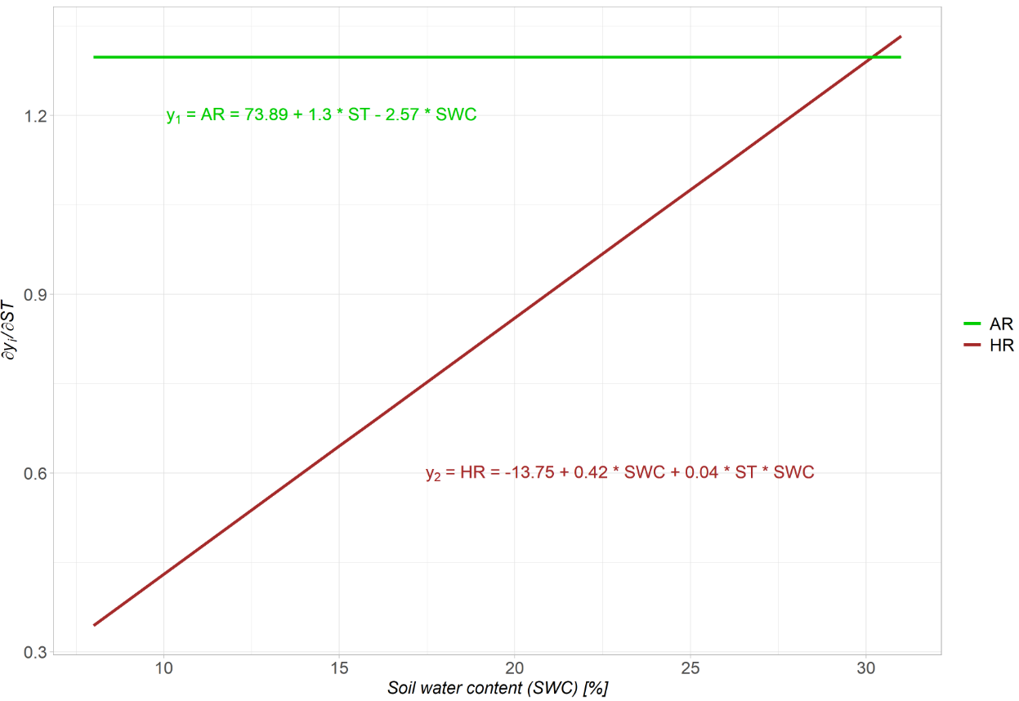
Figure A5. Temperature sensitivity for AR and HR as a function of soil water content in the first horizon (0-30cm). The sensitivity is expressed as the first order derivative of the linear models y₁ and y₂ with respect to soil temperature. The x-axis takes the range of simulated SWC values throughout the whole experiment.

A2. Comparisons between observed and simulated CO₂ fluxes
For each cropping season, the dynamics of the observed and simulated CO₂ fluxes (GPP, RECO and NEE) are available in the following shared repository: https://doi.org/10.6084/m9.figshare.23540472.

A3. STICS simulations data
All inputs and outputs, soil and plant parameterization and crop management files that were used for simulating the BE-LON field experiment with the soil-crop model STICS are available in the following shared repository: https://doi.org/10.6084/m9.figshare.23260772.

