**Bitcoin: The Internet of Money?**

[Jean-Marie Choffray](https://www.amazon.com/kindle-dbs/entity/author/B00DNUGN64?_encoding=UTF8&node=283155&offset=0&pageSize=12&searchAlias=stripbooks&sort=author-sidecar-rank&page=1&langFilter=default#formatSelectorHeader)*

Liège, Oct. 21, 2023. Revised Oct. 24, 2023

While madmen and criminals slaughter innocent people (cf. René Girard: [I See Satan Fall Like Lightning](https://www.amazon.com/See-Satan-Fall-Like-Lightning-ebook/dp/B008KO4MGG/ref=sr_1_1?crid=2O56IOAN9MW6H&keywords=i+see+satan+fall+like+lightning+ren%C3%A9+girard&qid=1697798721&sprefix=girard+satan%2Caps%2C483&sr=8-1)) – demonstrating their ignorance of the Lessons of History (cf. Aleksandr Solzhenitsyn: [That’s why all this has happened](https://www.templetonprize.org/laureate-sub/solzhenitsyn-acceptance-speech/)) – computer scientists devote time and effort to developing new technologies that respect everyone’s hard work and protect personal freedom. “Être plus, c’est s’unir davantage” reminds [Pierre Teilhard de Chardin](https://www.amazon.com/Human-Phenomenon-Translation-phenomene-Appleton-Weber/dp/1902210301/ref=sr_1_1?crid=1WMMMAO3ZPNIE&keywords=teihard+de+chardin+the+human+phenomena&qid=1697801442&sprefix=teihard+de+chardin+the+human+phenomena%2Caps%2C152&sr=8-1). **Bitcoin** is the computer (numerical) expression of the principle: “tous [… échanges] en tout [… bitcoin], et tout en tous”. **Lightning** allows this protocol to be generalized to all types of transactions. This is why, assuming the core values and founding principles underlying these technologies do last, **Lightning labs**’ recent software release ([Taproot-Assets, v0.3.0.](https://lightning.engineering/posts/2023-10-18-taproot-assets-v0.3/)), allowing developers to issue all sorts of financial assets on-chain in a scalable manner, potentially makes **Bitcoin** the global network for the **Internet of Money**.

* Emeritus Professor of Computer Science, University of Liege School of Management.

PhD-77, Management Science, Massachusetts Institute of Technology.

*“I think that the Internet is going to be one of the major forces for reducing the role of government. The one thing that’s missing, but that will soon be developed, is a reliable e-cash. A method whereby on the internet you can transfer funds from “a” to “b” without “a” knowing “b” or “b” knowing “a”. The way in which I can take a 20 $ bill and hand it over to you and there’s no record of where it came from. And you may get that without knowing who I am. That kind of thing will develop on the Internet and that will make it even easier for people to use the internet […] I think that the tendency to make it harder to collect taxes will be a very important positive effect of the internet.”*

[Milton Friedman](https://www.youtube.com/watch?v=_YEotCxF48I)

*“This rally today is way beyond the Bitcoin spot ETF rumor. The rally today is about a flight to quality.”*

Larry Fink, CEO of Blackrock

**Bitcoin: The Internet of Money?**

**Key take-aways from Lightning Labs’ recent release of: *Taproot Assets, a protocol for assets on Bitcoin and Lightning.***

(Source: [Taproot Assets on Mainnet: A New Era for Bitcoin and Beyond](https://lightning.engineering/posts/2023-10-18-taproot-assets-v0.3/)).

“The **Taproot Assets** daemon, provides a feature-complete developer experience for issuing, managing, and exploring stablecoins or other assets on the **Bitcoin Blockchain**.”

“With [Taproot Assets v0.3.0.](https://github.com/lightninglabs/taproot-assets/releases/tag/v0.3.0), builders have all the tools needed to make **Bitcoin** a multi-asset network, but in a scalable manner that upholds bitcoin’s core values.”

“Early adopters have continually iterated with our team over the last several months of *TestNet* development, minting nearly 2,000 assets on *TestNet* and syncing their nodes with our **Universe Server**, a repository holding all the information needed for a wallet to initialize and download the state of a specific **Taproot Asset**, over 420,000 times.”

“Against the backdrop of El Salvador making bitcoin legal tender in 2021, the Lightning community experienced an explosion of growth especially in emerging markets. Users all around the world are enjoying instantly settled, low fee, peer-to-peer bitcoin transactions without financial intermediaries.”

“We believe bitcoin’s global liquidity, decentralization, and security provides the optimal platform upon which to bring these experiments to mass market.”

“With **Taproot Assets**, we’re bringing all of this global user demand back to Bitcoin and Lightning.”

“Multiple **Universe Servers** can be operated as a Federation that all stay in sync for a given asset, so even if the issuer’s server is offline a receiver can have many different data sources to verify the sender’s assets are legitimate.”

“Users will be able to send and receive the currency of their choice over the **Lightning Network**, using the existing bitcoin liquidity as a global routing currency and Medium of Exchange. Leveraging a distributed liquidity network to serve a global market will be a major paradigm shift for how global money flows operate.”

“The Bitcoin developer community has been busy building new experiences with the protocol’s on-chain capabilities […] On last week’s community call, a number of these developers showcased the applications they are developing with **Taproot Assets**, and we were astounded by the progress that’s been made!”

**A Bitcoin Renaissance.**

(Source: [James Hunt, The Blok](https://www.theblock.co/post/258634/taproot-assets-bitcoin-renaissance-elizabeth-stark?utm_source=twitter&utm_medium=social))

“The **Lightning Network** operates as a network of bi-directional payment channels on top of the **Bitcoin Blockchain**, designed to enable fast and cost-effective micropayments.”

“Over 18,000 distinct assets have been minted since **Taproot Assets MainNet** release on Wednesday October 18, 2023.”

“**Lightning Labs** CEO and co-founder Elizabeth Stark says **Taproot Assets** can help usher in the Bitcoin Renaissance.”

**Lightning** is cementing **Bitcoin**'s place as the **Internet of Money**.

**Market reaction (last seven days)**

(Source: CoinMarketCap.com).

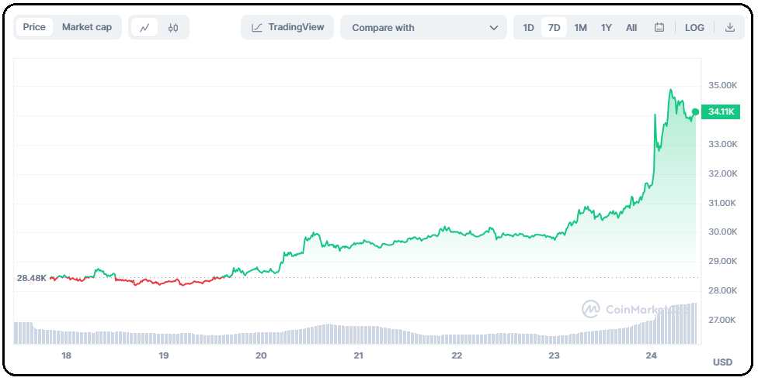

**Market reaction (Year To Date)**

(Source: [Sam Callahan, Lead Analyst at Swan Bitcoin](https://www.swanbitcoin.com/the-government-is-spending/?mkt_tok=ODc1LVhLUS02MzQAAAGO7fwBz-d33ikpGdbu9FdK0xP4by-zCWCJ_i_uUBSNhKTGfkyFDeETU47bqbKxJBSyQZ7r7oGO1vcS4gENMNK09h99j73yl9FsU7HZiw)).

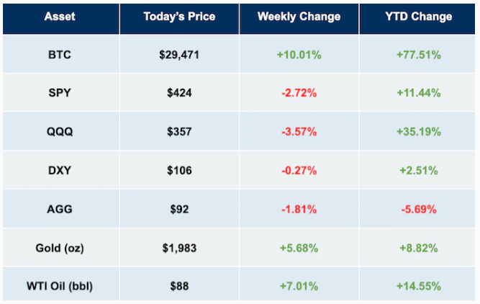

But…, **past performance is no guarantee of future results!**

**\* * \***

*Everyone knows — it’s not a secret… We know that we are on an unsustainable path fiscally.*

Jerome Powell, Chair of the Federal Reserve.

**\* * \***

*Want to get started exploring Taproot Assets?*[*Download the daemon*](https://github.com/lightninglabs/taproot-assets/releases/tag/v0.3.0)*,*[*check out the API documentation*](https://lightning.engineering/api-docs/api/taproot-assets/)*, and*[*read the getting started guide*](https://docs.lightning.engineering/lightning-network-tools/taproot-assets/get-tapd)*. For a more extensive technical explanation on how Taproot Assets works, take a deep dive into the*[*BIPs*](https://github.com/bitcoin/bips/pull/1489)*and*[*our documentation*](https://docs.lightning.engineering/the-lightning-network/taproot-assets/)*. If you haven't already,*[*join our Slack community*](https://lightning.engineering/slack.html)*,*[*follow us on Twitter*](https://twitter.com/lightning)*,*[*attend the Taproot Assets Community Calls*](https://x.com/lightning/status/1709938038359646325)*,*[*contribute a PR*](https://github.com/lightninglabs/taproot-assets)*, or*[*subscribe to our newsletter*](https://lightninglabs.substack.com/)*!*

**Lightning Labs**

**\* * \***

Four recent interviews from credible business leaders on what’s really at stake:

Chris Kuiper, Director of Research at Fidelity DigitalAssets.

<https://twitter.com/natbrunell/status/1715005622331015292>

Cathie Wood, Founder, CEO and CIO at ARKinvest.

<https://twitter.com/natbrunell/status/1712488662393319818>

Ricardo Salinas Pliego, chairman of Grupo Salinas (starting at 5:45).

<https://twitter.com/isabellasg3/status/1715889434053218608>

Michael Saylor, executive chairman and co-founder of MicroStrategy.

<https://twitter.com/saylor/status/1716561330755277207>

**\* * \***