Supplementary material

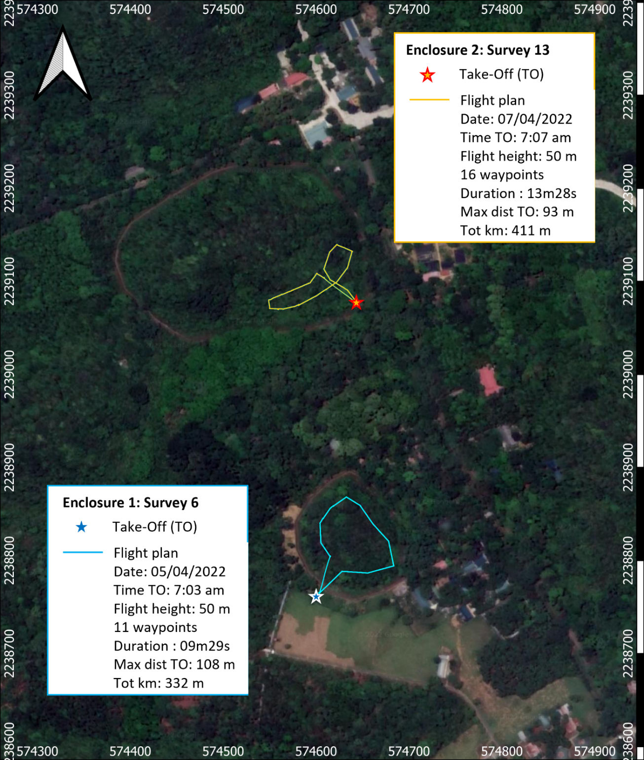
Fig. 2 Pre-programmed mission flight with the thermal drone (DJI Mavic 2 enterprise advanced) for survey 6 (enclosure 1) and for survey 13 (enclosure 2) in the the Endangered Primate Rescue Center’s semi-wild enclosures
Table 2. Drone survey details for enclosure 1 and enclosure 2: date, time, environment data (T: external temperature, CC: cloud cover, P: atmospheric pressure, H: humidity, WS: wind speed at ground level), flight parameters (gimbal setting, thermal imaging colour palettes, flight height, number of waypoints, *indicates when mission flights are the same), flight output (Dur: duration, Max dist: Maximum distance from takeoff point, Tot m: Total meters), and Delacour’s Langur (DL), southern Yellow-Cheeked Gibbons (YCG), Grey-Shanked Douc Langur (GSDL), and Hatinh langur (HL) detection and count.
Survey  No. | Date  Time | Environmental data | Flight parameters | Flight output | Primate detection | Notes
Enclosure 1
1 | 04/04/2022  07:09 am | T : 15.5 °C, CC : 66 %,  P : 1023 hPA , H: 73 %, WS: 1.5 m/s | Gimbal focus on flight plan  WhiteHot palette  Flight height: 60 m  10 waypoints | Dur : 7m53s  Max dist: 119 m  Tot m: 386 m | No detection | Impossible to detect individuals due to wrong gimbal setting.  YCG stressed by takeoff: flight and cover under canopy.
2 | 04/04/2022  07:23 am | T : 15.9 °C, CC : 68 %, P : 1023 hPA , H: 71 %, WS: 1.5 m/s | Gimbal manual  WhiteHot palette  Flight height: 50 m  8 waypoints | Dur : 9m00s  Max dist: 116 m  Tot m: 317 m | 3 DL | Detection not clear enough with WhiteHot palette and low detection due to lack of drone rotation during survey (yaw axis). DL: avoidance when drone is sighted. YCG stressed by takeoff: flight and cover under canopy.
3 | 04/04/2022  04:06 pm | T : 22.9 °C, CC : 21 %, P : 1018 hPA , H: 48 %, WS: 4.0 m/s | Gimbal manual  Ironbow palette  Flight height: 50 m  10 waypoints | Dur : 7m25s  Max dist: 109 m  Tot m: 398 m | 3 DL and 2 YCG | DL: avoidance when drone is sighted.  YCG: avoidance when drone is sighted.
4 | 04/04/2022  4:21 pm | T : 22.8 °C, CC : 19 %, P : 1018 hPA , H: 49 %, WS: 4.0 m/s | Gimbal manual  Ironbow palette  Flight height: 50 m  11 waypoints* | Dur : 8m38s  Max dist: 108 m  Tot m: 330 m | 6 DL and 1 YCG | DL : Flight when drone is sighted.  YCG: avoidance when drone is sighted.
5 | 05/04/2022  6:43 am | T : 15.7 °C, CC : 64 %, P : 1022 hPA , H: 80 %, WS: 1.4 m/s | Gimbal manual  Ironbow palette  Flight height: 50 m  11 waypoints* | Dur : 9m53s  Max dist: 107 m  Tot m: 407 m | 4 DL and 2 YCG | DL: avoidance when drone is sighted.
6 | 05/04/2022  7:03 am | T : 16.4 °C, CC : 63 %, P : 1022 hPA , H: 82 %, WS: 1.5 m/s | Gimbal manual  Ironbow palette  Flight height: 50 m  11 waypoints* | Dur : 9m29s  Max dist: 108 m  Tot m: 332 m | 6 DL | DL: continue to forage once drone is sighted.
Enclosure 2
7 | 05/04/2022  5:05 pm | T : 24.3 °C, CC : 70 %, P : 1017 hPA , H: 57 %, WS: 3.0 m/s | Gimbal manual  Ironbow palette  Flight height: 80 m  7 waypoints | Dur : 6m15s  Max dist: 37 m  Tot m: 164 m | 1 GSDL | External temperature too high for good detection.
8 | 05/04/2022  05:16 pm | T : 24.1 °C, CC : 69 %, P : 1017 hPA , H: 57 %, WS: 3.0 m/s | Gimbal manual  Ironbow palette  Flight height: 60 m  10 waypoints | Dur : 7m19s  Max dist: 438 m  Tot m: 205 m | 1 GSDL | External temperature too high for good detection.
9 | 05/04/2022  05:32 pm | T : 23.9 °C, CC : 67 %, P : 1017 hPA , H: 58 %, WS: 3.1 m/s | Gimbal manual  Ironbow palette  Flight height: 50 m  13 waypoints** | Dur : 9m36s  Max dist: 61 m  Tot m: 302 m | 1 GSDL | External temperature too high for good detection.
10 | 06/04/2022  7:03 am | T : 18.3 °C, CC : 39 %, P : 1020 hPA , H: 77 %, WS: 1.2 m/s | Gimbal manual  Ironbow palette  Flight height: 50 m  13 waypoints** | Dur : 8m54s  Max dist: 78 m  Tot m: 344 m | 3 GSDL | GSDL stressed by takeoff: flight coupled with alarm call.
11 | 06/04/2022  7:23 am | T : 18.9 °C, CC : 39 %, P : 1020 hPA , H: 74 %, WS: 1.3 m/s | Gimbal manual  Ironbow palette  Flight height: 50 m  16 waypoints*** | Dur : 10m40s  Max dist: 95 m  Tot m: 383 m | 2 GSDL,  (1 HL) | GSDL watch curiously and then avoidance of drone takeoff. Suspected detection of one other GSDL and one HL but no confirmation possible.
12 | 07/04/2022  6:53 am | T : 20.9 °C, CC : 68 %, P : 1018 hPA , H: 74 %, WS: 2.0 m/s | Gimbal manual  Ironbow palette  Flight height: 50 m  16 waypoints*** | Dur : 11m21s  Max dist: 93 m  Tot m: 385 m | 4 GSDL,  5 HL (1 young HL) | Video did not save when we tried to performed manual flight. One larger shape detected: likely to be female carrying young. GSDL: continue to forage once drone is sighted.
13 | 07/04/2022  7:07 am | T : 21.2 °C, CC : 68 %, P : 1018 hPA , H: 71 %, WS: 2.1 m/s | Gimbal manual  Ironbow palette  Flight height: 50 m  16 waypoints*** | Dur : 13m28s  Max dist: 93 m  Tot m: 411 m | 4 GSDL, 5 HL (1 young HL) | Survey confirmed detection during survey 12.  GSDL: continue to forage once drone is sighted.

Table 3. Maximum surface temperatures of primate species detected (above and below canopy cover) and surrounding temperatures (temp.) measured with the thermal camera (extracted from picture). Thermal Signature: identifiable Body Shape (BS) or thermal Spot (S).
Survey  No. | Det. No. | External temp. (°C) | Background surface temp. (°C) | Species surface temp. (°C) | Thermal signature
Delacour’s Langur
3 | 2 | 22.9 | 18.6, 18.0 | 21.9, 20.5 | 1 BS, 1 S
3 | 3 | 22.9 | 20.8 | 25.6 | 1 S
4 | 2 | 22.8 | 23.6 | 26.8 | 1 S
5 | 1 | 15.7 | 12.9 | 18.1 | 1 S
5 | 3 | 15.7 | 12.1 | 17.7 | 1 S
5 | 4 | 15.7 | 14.2 | 22 | 1 S
6 | 1 | 16.4 | 18.4 | 24.7 | 1 S
6 | 1 | 16.4 | 16.5 | 19.1 | 1 S
6 | 1 | 16.4 | 13.9 | 23 | 1 S
6 | 1 | 16.4 | 14.4, 14.4, 14.5 | 21.2, 18.3, 23.7 | 1 BS, 2 S
6 | 2 | 16.4 | 13.5, 13.6 | 16.2, 15.3 | 2 BS
6 | 2 | 16.4 | 13.2, 13.1, 13.1, 13.3 | 16.5, 20.4, 14.8, 20.7 | 4 S
6 | 2 | 16.4 | 14.4, 14.3, 14.3, 14.4 | 16.3, 19.4, 21.4, 22.8 | 2 BS, 2 S
6 | 2 | 16.4 | 14.1, 14.1, 14.0 | 20.9, 21.2, 24.0 | 1 BS, 2 S
6 | 2 | 16.4 | 13.7, 13.6, 13.8, 13.5, 13.5, 13.5 | 23.9, 22.2, 16.6, 18.4, 22.8, 15.6 | 1 BS, 5 S
6 | 2 | 16.4 | 14.3, 14.3, 14.2, 14.3, 14.1 | 17.6, 24.0, 21.2, 17.0, 15.2 | 1 BS, 4 S
Southern yellow-cheeked gibbon
3 | 1 | 22.9 | 21.2 | 23.2 | 1 BS
5 | 1 | 15.7 | 11.5, 12.0 | 15.7, 14.0 | 2 S
Grey-shanked douc langur
10 | 1 | 18.3 | 20.3, 19.4, 21.0 | 32.2, 30.0, 32.4 | 3 BS
10 | 1 | 18.3 | 20.6 | 26.1 | 1 S
10 | 1 | 18.3 | 21.2 | 29.2 | 1 S
10 | 2 | 18.3 | 15.6 | 18.8 | 1 S
10 | 2 | 18.3 | 16.0 | 21.6 | 1 S
11 | 1 | 18.9 | 22.9 | 28.0 | 1 BS
11 | 1 | 18.9 | 20.2 | 26.1 | 1 S
11 | 2 | 18.9 | 17.5 | 19.3 | 1 S
11 | 2 | 18.9 | 16.2 | 19.8 | 1 S
12 | 1 | 20.9 | 23.5 | 28.7 | 1 BS
12 | 1 | 20.9 | 23.6 | 29.1 | 1 BS
12 | 2 | 20.9 | 23.0 | 29.9 | 1 BS
12 | 2 | 20.9 | 23.3 | 30.6 | 1 BS
12 | 2 | 20.9 | 22.8 | 31.2 | 1 S
12 | 2 | 20.9 | 22.7, 22.4 | 24, 28.3 | 3 S
12 | 2 | 20.9 | 22.5, 22.9 | 27.6, 24.8 | 3 S
12 | 2 | 20.9 | 23.5, 23.0, 23.1 | 26.8, 28.6, 24.4 | 2 BS, 1 S
12 | 2 | 20.9 | 23.0, 23.0, 22.9 | 26.2, 25.3, 24.6 | 3 S
13 | 2 | 21.2 | 23.1 | 25.8 | 1 S
13 | 2 | 21.2 | 22.4 | 26.0 | 1 S
13 | 2 | 21.2 | 22.3 | 26.0 | 1 BS
13 | 2 | 21.2 | 22.2 | 25.6 | 1 BS
13 | 2 | 21.2 | 24.8 | 28.8 | 1 BS
Hatinh langur
12 | 1 | 20.9 | 23 | 26.1 | 1 S
12 | 1 | 20.9 | 23.3, 23.1, 22.9 | 24.5, 26.9, 26.2 | 2 BS
13 | 1 | 21.2 | 24.5 | 26.8 | 2 S

Online Resource 4.
Thermal Video montage of Delacour’s langurs playing in the semi-wild enclosure in the Endangered Primate Rescue Center in Northern Vietnam.

